Gerstein lab experience with molecular mechanisms underlying diseases using large language models (LLMs): We demonstrated that the attention mechanism of the ESM2-LLM effectively captures biologically meaningful signals related to underlying disease mechanisms by highlighting regions associated with protein aggregation – a key mechanism in Alzheimer’s disease[1]. Specifically, elevated attention was observed in the APP region (corresponding to the Aβ42 peptide, residues 701–713), suggesting it as a potential drug-target site. The attention patterns align with disease-relevant features embedded within the protein sequence—such as intrinsically disordered regions, mutation hotspots, and proteolytic cleavage sites—that are known to influence protein function and can serve as actionable drug targets.

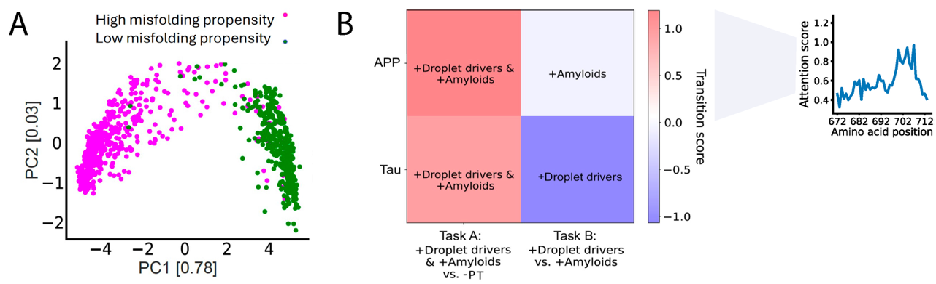

Gerstein lab experience with gene regulatory networks (GRNs) construction: In parallel, our GRNs illuminate gene-associated pathways that are directly implicated in the disease mechanism, facilitating the prioritization of the most critical targets for therapeutic intervention.

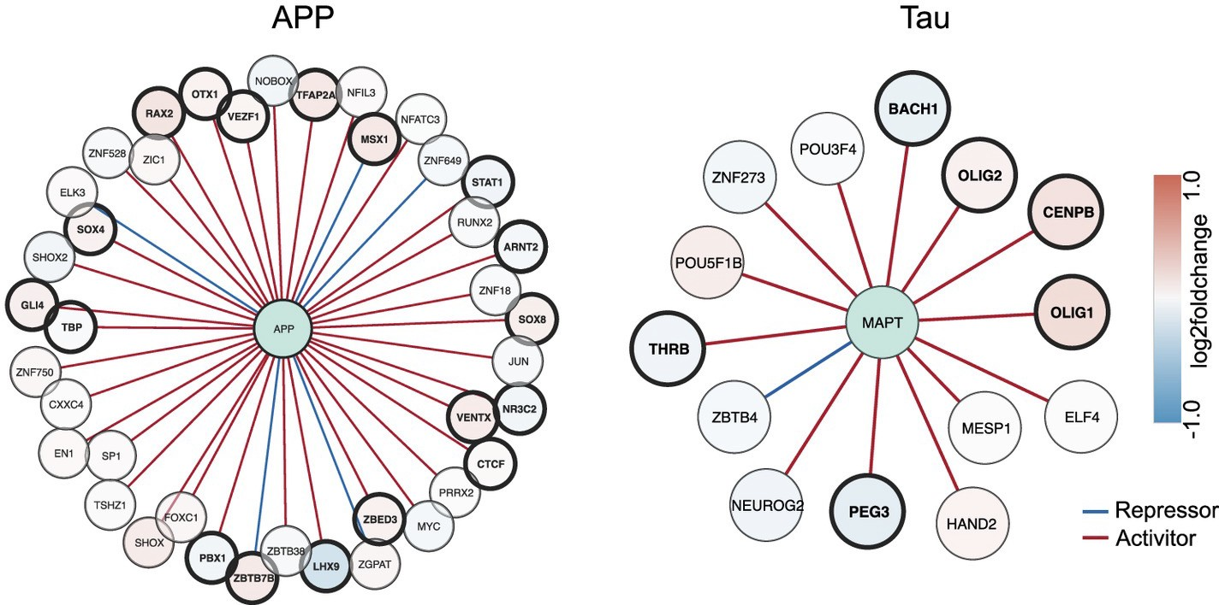

Additionally, by integrating multiple data modalities, including snATAC-seq, TF-binding sites, and gene coexpression, we constructed GRNs for PFC cell types and linked TFs to potential target genes based on their coexpression relationships from snRNA- seq data and mapped scQTLs to connect promoters and enhancers. Our findings showed that TF expression in the GRNs explains an average of 52% of the variation in target gene expression[2].

Gerstein lab experience with prediction of ligand–protein binding affinities: To rank molecular compounds based on protein-ligand affinity, we developed a meta modeling approach[3] showing that integrating outputs from multiple complementary models outperforms traditional methods in both accuracy and robustness. In the process we evaluate many combinations of individual base models, training databases, and several meta-modeling approaches.

References:

- Frank M, Ni P, Jensen M, Gerstein MB. Leveraging a large language model to predict protein phase transition: A physical, multiscale, and interpretable approach [Journal Article]. Proc Natl Acad Sci U S A. 2024.

- Emani PS, Liu JJ, Clarke D, Jensen M, Warrell J, Gupta C, et al. Single-cell genomics and regulatory networks for 388 human brains [Journal Article]. Science. 2024.

- Lee HJ, Emani PS, Gerstein MB. Improved Prediction of Ligand–Protein Binding Affinities by Metamodeling. Journal of Chemical Information and Modeling. 2024.

