Hedi

Venn Diagram --

Table_ClassSummary

Table_GenomesSingleMultiRep
Table: Conserved Superfamily Combination Patterns
The longest repetitious proteins in each of the 20 genomes

2-3 tables

JIMMY

Table_Coverage
http://bioinfo.mbb.yale.edu/genome/20genomes/data/ORF_AA_Coverage
-->
20/overall-coverage.txt

Species | ORFs |  |  | AA
Species | Total | Matching | m/t | Total | Matching | m/t
mgen | 479 | 164 | 34.2% | 174566 | 39680 | 22.7%
mpne | 677 | 178 | 26.3% | 237651 | 43222 | 18.2%
rpro | 837 | 264 | 31.5% | 280233 | 60285 | 21.5%
ctra | 894 | 259 | 29.0% | 312553 | 60295 | 19.3%
tpal | 1031 | 252 | 24.4% | 350676 | 58542 | 16.7%
cpne | 1052 | 274 | 26.0% | 361694 | 66160 | 18.3%
aaeo | 1522 | 527 | 34.6% | 482512 | 116664 | 24.2%
hpyl | 1577 | 381 | 24.2% | 500616 | 89025 | 17.8%
bbur | 1638 | 289 | 17.6% | 432219 | 65816 | 15.2%
hinf | 1707 | 528 | 30.9% | 520930 | 125776 | 24.1%
mjan | 1771 | 470 | 26.5% | 501793 | 93299 | 18.6%
mthe | 1871 | 522 | 27.9% | 526205 | 105553 | 20.1%
phor | 2064 | 461 | 22.3% | 568544 | 97276 | 17.1%
aful | 2409 | 650 | 27.0% | 663320 | 146655 | 22.1%
syne | 3168 | 882 | 27.8% | 1119717 | 196041 | 17.5%
mtub | 3924 | 1198 | 30.5% | 1335687 | 291496 | 21.8%
bsub | 4100 | 1121 | 27.3% | 1217000 | 276596 | 22.7%
ecol | 4290 | 1191 | 27.8% | 1363501 | 296762 | 21.8%
scer | 6218 | 1699 | 27.3% | 2906890 | 434481 | 14.9%
cele | 19099 | 4586 | 24.0% | 8096713 | 1136801 | 14.0%

Table 2 (Table_Coverage). The coverage of the 20 genomes by the matches to the SCOP 1.39 domains. The second column contains the total number of ORFs in the genomes, the third one denotes the number of ORFs that have at least one match with one of the SCOP domains. The fifth and sixth column denote the total number of amino acids in each proteome and the number of amino acids matched by a domain, respectively. The fourth and seventh column contain the percentage value of the matched ORFs and matched amino acids, respectively.

Graph of duplications
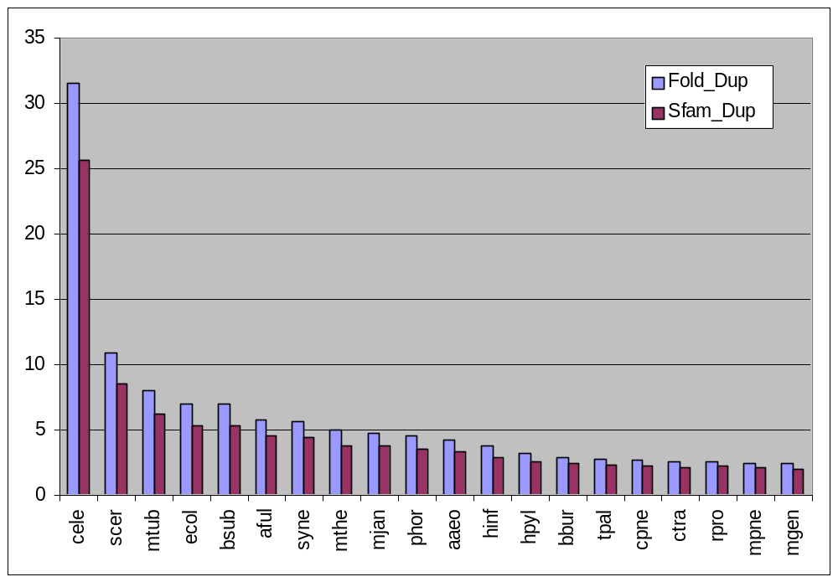
Table 4 (Table_Duplications). The duplication levels for the 20 genomes in terms of folds and superfamilies. The second and third column denote the number of folds and the number of superfamilies, repectively, found in the 20 genomes. The fourth column lists the total number of matches (having eliminated the overlapping matches earlier) for each genome. In the last two columns we calculated the fold and superfamily duplication levels, by dividing the total number of matches by the number of folds and superfamilies, respectively, present in that particular genome.

Table_Duplications in caption
sort, species names

http://bioinfo.mbb.yale.edu/genome/20genomes/data/Duplication_Levels
-->
genome/db99/20/duplication-level.txt

Sp | Fold_Dup | Sfam_Dup
Cele | 31.5911 | 25.6678
Scer | 10.9116 | 8.59341
Mtub | 7.97487 | 6.27273
Ecol | 7.03493 | 5.31683
bsub | 7.01923 | 5.28986
aful | 5.77551 | 4.56452
syne | 5.68342 | 4.43529
mthe | 5 | 3.77095
mjan | 4.78906 | 3.7378
phor | 4.58678 | 3.58065
aaeo | 4.25926 | 3.36585
hinf | 3.73684 | 2.92181
hpyl | 3.25658 | 2.56477
bbur | 2.92857 | 2.44371
tpal | 2.81301 | 2.30667
cpne | 2.69853 | 2.22424
ctra | 2.59701 | 2.13497
rpro | 2.59259 | 2.1875
mpne | 2.48515 | 2.12712
mgen | 2.4 | 2.05405

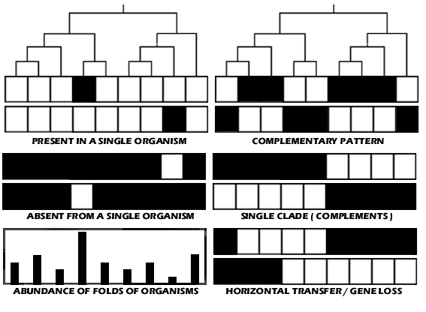
SCHEMATIC

FIGURE CAPTION

This schematic shows some representative “fold profiles” along with a chart of the abundance of folds of organisms. The first pair of profiles shows two profiles/patterns in which the fold is only present in one genome, while the second pair shows profiles/patterns where the fold is absent from a single organism. The graph of the abundance of folds of organisms can be used to derive more information from the two aforementioned pairs of profiles. It is expected that the organisms with more folds are more likely to have many folds which is unique to the organisms. Therefore, there is greater significance when a fold is only present in an organism with few total folds (bottom of the pair) then when a fold is present in an organism with a larger number of folds (top of the pair). The reverse applied with folds that absent from organisms with a large number of folds (bottom of pair).
The right half of the schematic shows more examples of representative “fold patterns/profiles.” The top shows complementary pattern, in which some organisms have apparently one fold, and the organisms, which do not have that particular fold, are present in another fold. This could suggest that the two different folds have the similar function, and organisms have one fold or another. However, this is less likely as folds are transferred between closely related organisms. What is more possible is complementary pattern in which one clade of organisms have one fold, while the other clade have another, which is shown on the middle right. One such example is when eukaryotes have one specific fold for a specific process (e.g.??) while prokaryotes use another fold for that purpose. The last schematic shows possible evidence for horizontal transfer (top of the pair) and gene loss (bottom of the pair). Horizontal transfer can be observed by seeing one clade of organisms having that fold, and just one member of the other clade having the same fold. It is then possible that the fold is transferred from the dominant clade to the single organism. Gene loss can be observed by seeing most members of the clade having the fold, but one or two organisms do not have the fold. It is possible that the one or two organisms lost the gene through evolutionary processes.

* overall tables

genome/db99/20/folds.data.txt
genome/db99/20/sfams.data.txt
foldpairs.data.txt
sfampairs.data.txt

Fold Usage Image

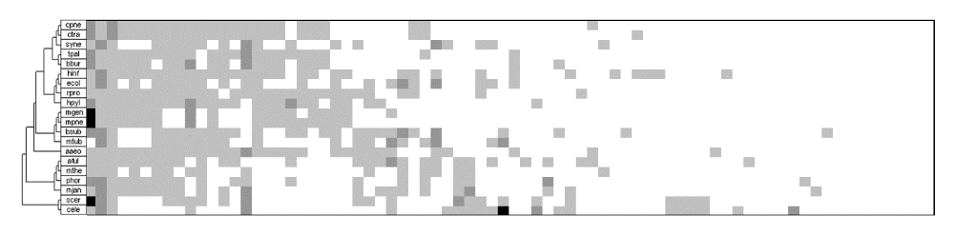

Fold A
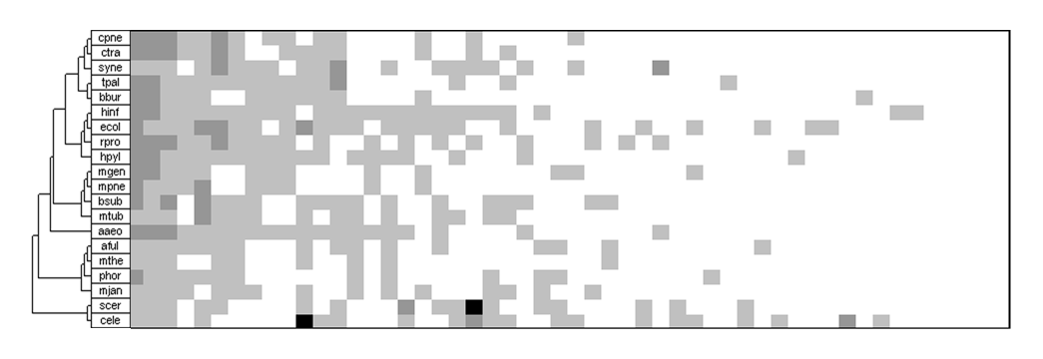

Fold B
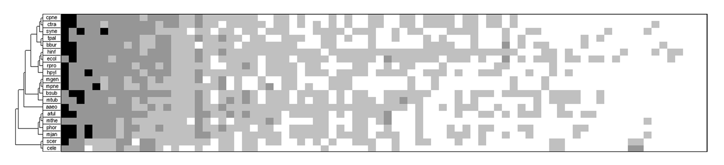

Fold C
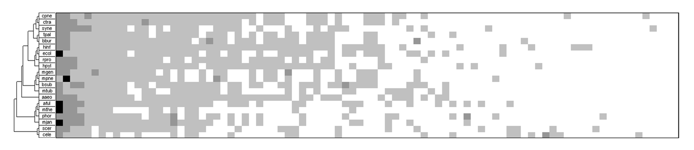

Fold D
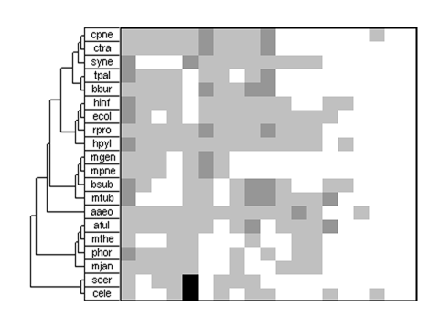 | 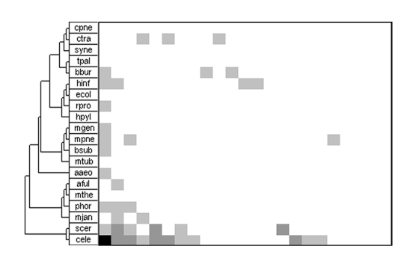
Fold M | Fold S

*** First sort on fold class, then on sum of occurs or absent in genomes
and then total percentage value sum

These above images are pictorial representation of the fold data. First, the folds are placed into their fold class. Then, they are sorted horizontally so that the folds that occur in the most number of distinct genomes (e.g. 20) are placed on the furthest right. Because there are many folds that are present in 20, 19 etc number of genomes, they were sorted further internally. The percentage of the genome the fold comprised was calculated for the genomes summed, arriving at the total percentage in all the genomes. This value was used for internal sorting.

The coloring of the block is based on the percentage of the genome the fold comprised. There are four logarithmic increments, 0.0, 0.1, 1, 5, and 100%. Between 0 and 0.1%, the cell was colored white. Between 0.1 and 1%, the cell was color light grey. Between 1 and 5%, the cell was colored dark grey. For folds that comprised of more than 5% of the genome, it was colored black.

As can be seen, Fold C has the most number of folds that is colored black, meaning that is comprised of more than 5% of the genomes, which is significant.

Super Family Usage Image

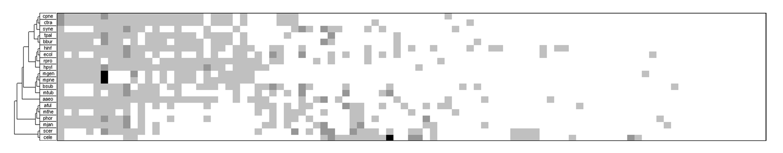

Superfam A
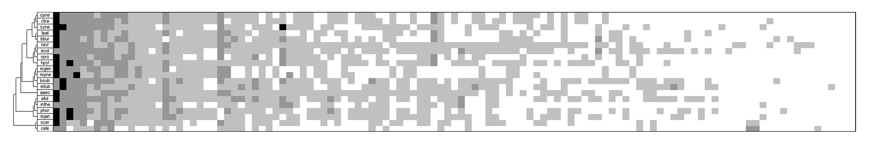

Superfam B
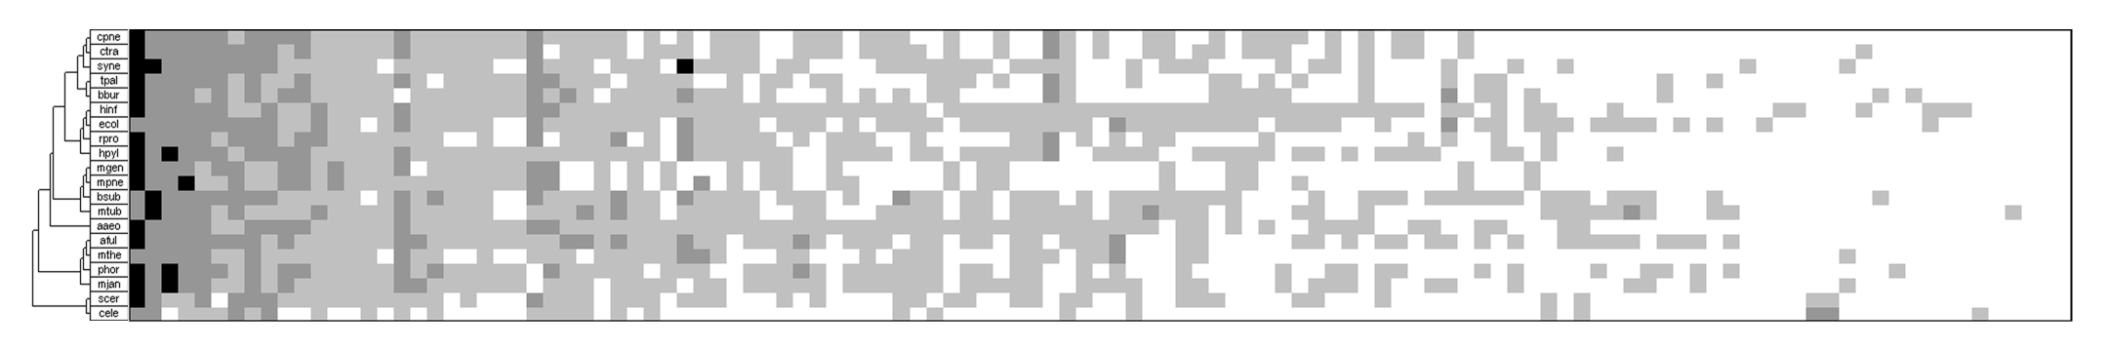

Superfam C
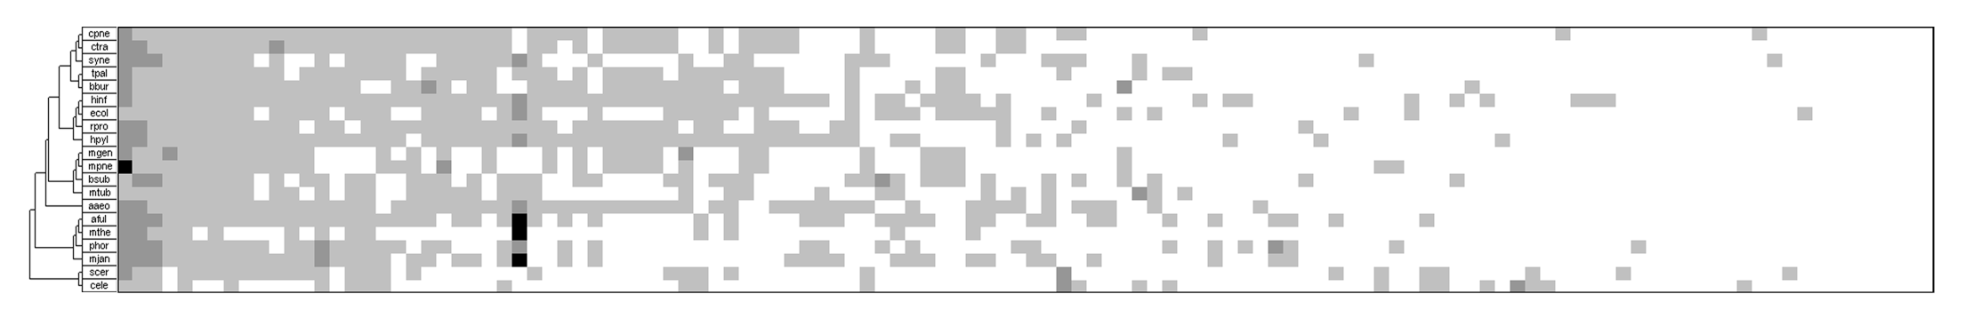

Superfam D
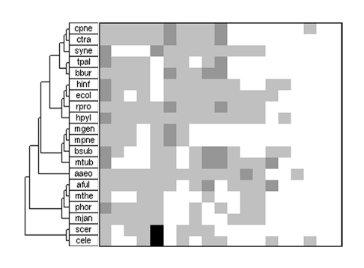 | 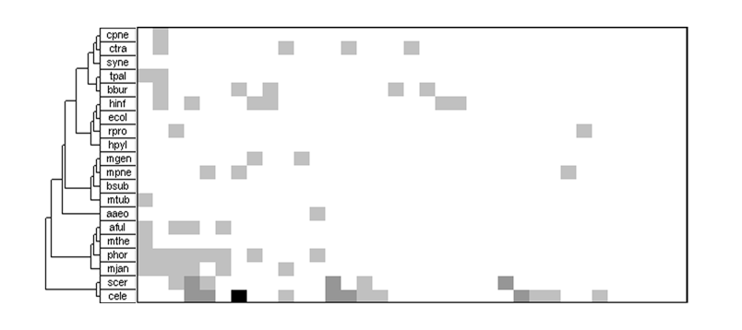
Superfam M | Superfam S

Fold Pair Usage Image

(NEED TO DETERMINE SORTING PATTERN)

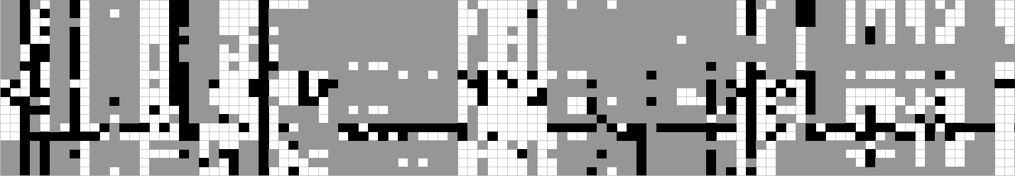

Fold A
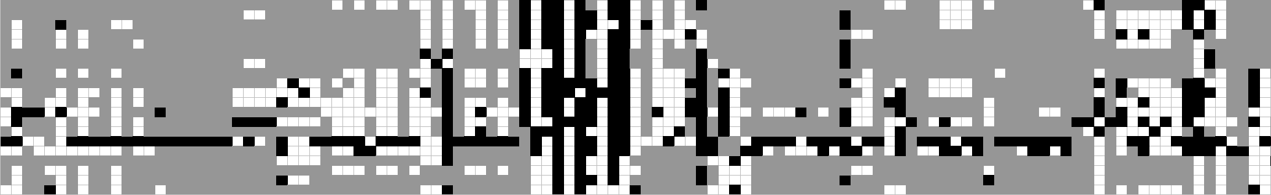

Fold B

Fold C
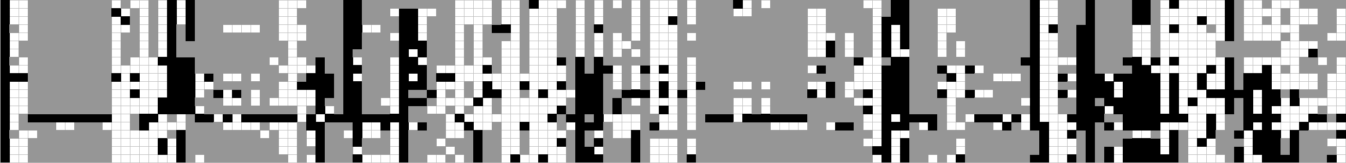

Fold D
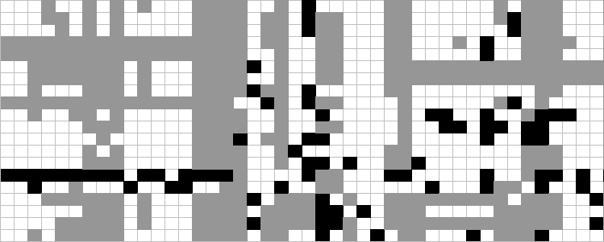 | 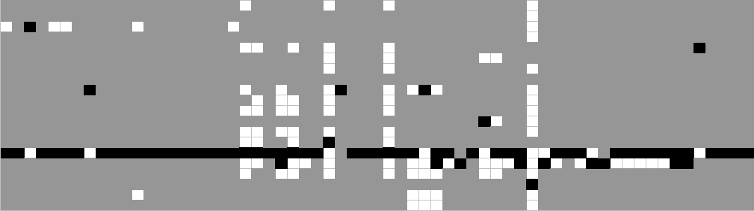
Fold M | Fold S

Super Family Pair Usage Image

(NEED TO DETERMINE SORTING PATTERN)

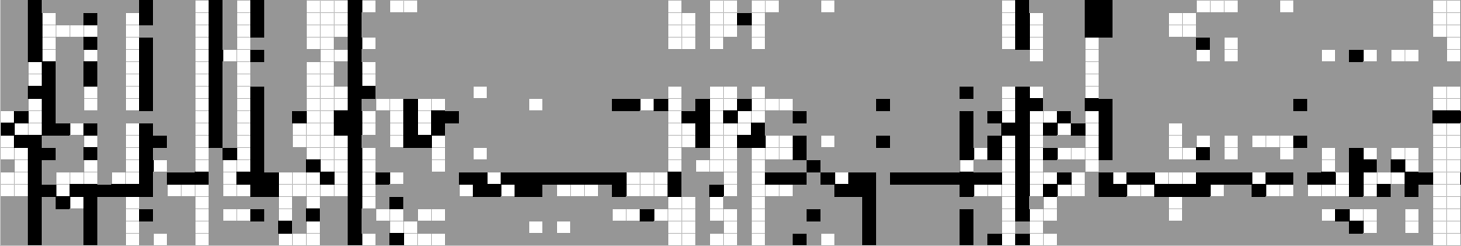

Superfam A
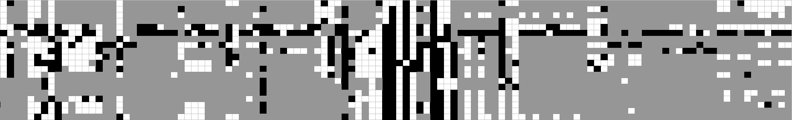

Superfam B

Superfam C
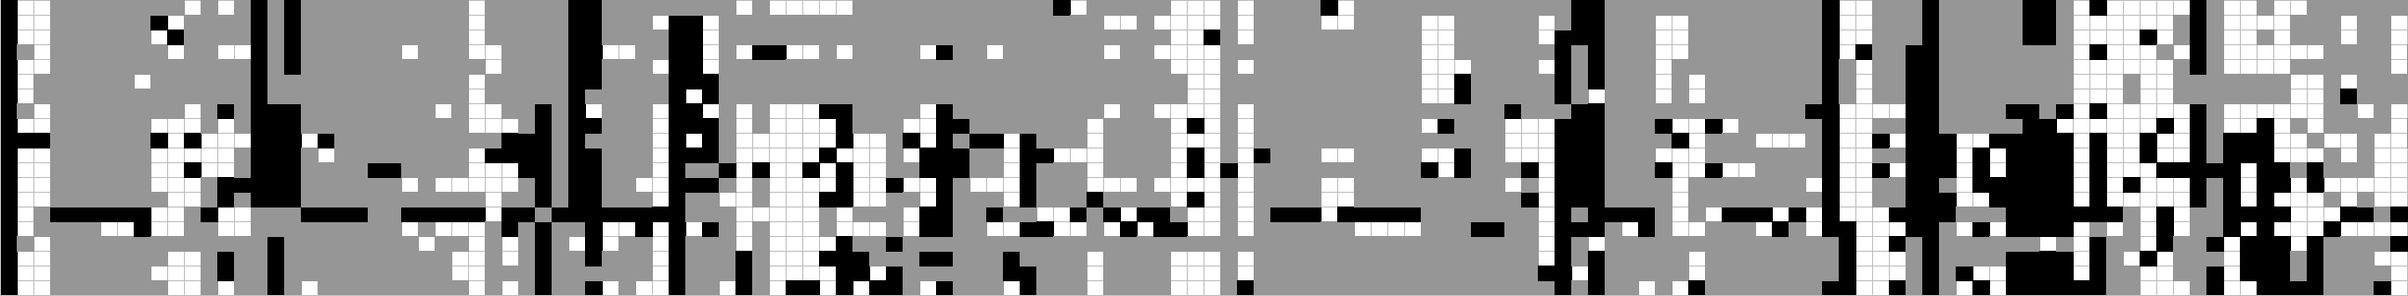

Superfam D
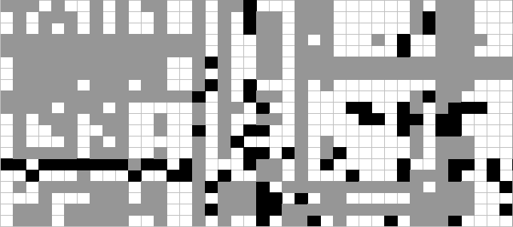 | 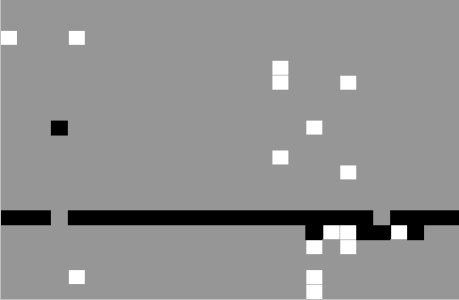
Superfam M | Superfam S

TOP-10 SORTED BASED ON AVERAGE PERCENTAGE OCCURENCE

FOLD
 | cele | scer | mjan | phor | mthe | aful | aaeo | mtub | bsub | mpne | mgen | hpyl | rpro | ecol | hinf | bbur | tpal | syne | ctra | cpne | SUM | %SUM
3.29 | ## | ## | 61 | 61 | 53 | 56 | 57 | 54 | 64 | 33 | 34 | 46 | 38 | 72 | 51 | 67 | 43 | 68 | 36 | 39 | 1286 | #####
3.1 | ## | 84 | 37 | 30 | 43 | 45 | 28 | 77 | 88 | 8 | 7 | 22 | 9 | 93 | 35 | 20 | 14 | 51 | 19 | 19 | 852 | 91.8%
4.34 | ## | ## | 87 | 21 | ## | 93 | 31 | 44 | 26 | 3 | 3 | 21 | 8 | 82 | 32 | 6 | 11 | 38 | 5 | 6 | 946 | 91.4%
3.22 | ## | 72 | 16 | 19 | 26 | 31 | 33 | ## | 98 | 5 | 4 | 21 | 9 | 79 | 25 | 5 | 5 | 59 | 10 | 10 | 783 | 70.2%
3.53 | 4 | 23 | 35 | 32 | 16 | 26 | 23 | 52 | 30 | 5 | 3 | 29 | 9 | 31 | 19 | 10 | 5 | 35 | 9 | 9 | 405 | 55.2%
3.14 | 14 | 19 | 11 | 15 | 24 | 32 | 13 | 25 | 55 | 2 | 1 | 14 | 7 | 67 | 17 | 7 | 5 | 74 | 3 | 4 | 409 | 44.5%
3.17 | 11 | 14 | 22 | 19 | 15 | 17 | 15 | 12 | 18 | 9 | 9 | 15 | 10 | 16 | 12 | 10 | 7 | 14 | 8 | 9 | 262 | 43.0%
4.61 | 17 | 24 | 11 | 11 | 11 | 11 | 14 | 13 | 14 | 11 | 10 | 11 | 9 | 15 | 14 | 10 | 13 | 13 | 11 | 12 | 255 | 42.3%
3.4 | 28 | 21 | 9 | 18 | 13 | 34 | 26 | 42 | 31 | 8 | 7 | 6 | 9 | 38 | 11 | 4 | 6 | 20 | 5 | 4 | 340 | 41.5%
3.47 | 87 | 85 | 4 | 1 | 6 | 12 | 9 | 34 | 24 | 5 | 5 | 7 | 12 | 50 | 23 | 12 | 13 | 17 | 6 | 5 | 417 | 39.9%
3.54 | 40 | 32 | 16 | 18 | 15 | 18 | 19 | 33 | 43 | 2 | 2 | 9 | 5 | 36 | 15 | 3 | 5 | 23 | 8 | 10 | 352 | 38.4%
1.105 | 16 | ## | 3 | 7 | 6 | 4 | 3 | 1 | 16 | 16 | 13 | 9 | 1 | 5 | 2 | 6 | 6 | 8 | 4 | 7 | 250 | 31.8%
2.29 | 22 | 15 | 5 | 7 | 6 | 2 | 9 | 12 | 16 | 8 | 8 | 8 | 8 | 19 | 11 | 5 | 6 | 9 | 8 | 8 | 192 | 29.0%
1.91 | ## | ## | 21 | 4 | 7 | 0 | 25 | 0 | 1 | 0 | 0 | 0 | 3 | 6 | 1 | 6 | 11 | 42 | 1 | 2 | 494 | 27.7%
3.82 | 14 | 1 | 3 | 12 | 5 | 9 | 5 | 15 | 24 | 3 | 2 | 6 | 2 | 36 | 16 | 9 | 7 | 26 | 8 | 8 | 211 | 27.6%
3.56 | ## | 38 | 1 | 5 | 2 | 13 | 3 | 70 | 33 | 4 | 4 | 1 | 9 | 19 | 5 | 2 | 2 | 24 | 5 | 3 | 418 | 27.4%
3.28 | 11 | 21 | 8 | 9 | 15 | 13 | 9 | 25 | 18 | 3 | 3 | 6 | 2 | 22 | 12 | 0 | 5 | 11 | 7 | 7 | 207 | 25.5%
3.38 | ## | 33 | 2 | 4 | 4 | 7 | 13 | 13 | 17 | 1 | 1 | 6 | 6 | 22 | 14 | 1 | 3 | 22 | 4 | 4 | 287 | 21.6%
3.58 | 33 | 15 | 4 | 14 | 4 | 6 | 5 | 13 | 20 | 3 | 4 | 6 | 3 | 17 | 9 | 5 | 4 | 6 | 3 | 5 | 179 | 21.1%
4.89 | 17 | 13 | 13 | 7 | 11 | 15 | 11 | 14 | 16 | 2 | 1 | 6 | 5 | 13 | 6 | 1 | 3 | 12 | 4 | 3 | 173 | 20.8%

SFAM
 | cele | scer | mjan | phor | mthe | aful | aaeo | mtub | bsub | mpne | mgen | hpyl | rpro | ecol | hinf | bbur | tpal | syne | ctra | cpne | SUM | %SUM
3.29.1 | ## | ## | 61 | 61 | 53 | 56 | 57 | 54 | 64 | 33 | 34 | 46 | 38 | 72 | 51 | 67 | 43 | 68 | 36 | 39 | 1286 | 177.3%
3.22.1 | ## | 72 | 16 | 19 | 26 | 31 | 33 | ## | 98 | 5 | 4 | 21 | 9 | 79 | 25 | 5 | 5 | 59 | 10 | 10 | 783 | 70.2%
3.53.1 | 4 | 23 | 35 | 32 | 16 | 26 | 23 | 52 | 30 | 5 | 3 | 29 | 9 | 31 | 19 | 10 | 5 | 35 | 9 | 9 | 405 | 55.2%
4.34.1 | 3 | 1 | 73 | 15 | 97 | 77 | 18 | 11 | 6 | 0 | 0 | 9 | 2 | 61 | 18 | 0 | 3 | 14 | 0 | 0 | 408 | 52.7%
4.61.1 | 17 | 24 | 11 | 11 | 11 | 11 | 14 | 13 | 14 | 11 | 10 | 11 | 9 | 15 | 14 | 10 | 13 | 13 | 11 | 12 | 255 | 42.3%
3.4.1 | 28 | 21 | 9 | 18 | 13 | 34 | 26 | 42 | 31 | 8 | 7 | 6 | 9 | 38 | 11 | 4 | 6 | 20 | 5 | 4 | 340 | 41.5%
3.54.1 | 40 | 32 | 16 | 18 | 15 | 18 | 19 | 33 | 43 | 2 | 2 | 9 | 5 | 36 | 15 | 3 | 5 | 23 | 8 | 10 | 352 | 38.4%
3.82.1 | 14 | 1 | 3 | 12 | 5 | 9 | 5 | 15 | 24 | 3 | 2 | 6 | 2 | 36 | 16 | 9 | 7 | 26 | 8 | 8 | 211 | 27.6%
1.105.4 | 2 | ## | 3 | 6 | 4 | 4 | 2 | 0 | 14 | 15 | 12 | 8 | 0 | 4 | 1 | 5 | 5 | 7 | 2 | 6 | 208 | 27.4%
3.56.1 | ## | 38 | 1 | 5 | 2 | 13 | 3 | 70 | 33 | 4 | 4 | 1 | 9 | 19 | 5 | 2 | 2 | 24 | 5 | 3 | 418 | 27.4%
3.47.1 | 60 | 62 | 0 | 0 | 4 | 6 | 8 | 9 | 21 | 4 | 4 | 4 | 7 | 27 | 15 | 10 | 10 | 12 | 4 | 4 | 271 | 26.7%
3.1.5 | 26 | 26 | 15 | 11 | 21 | 15 | 8 | 14 | 26 | 1 | 1 | 5 | 4 | 20 | 6 | 6 | 5 | 13 | 5 | 5 | 233 | 26.7%
3.28.1 | 11 | 21 | 8 | 9 | 15 | 13 | 9 | 25 | 18 | 3 | 3 | 6 | 2 | 22 | 12 | 0 | 5 | 11 | 7 | 7 | 207 | 25.5%
2.29.4 | 21 | 12 | 4 | 5 | 4 | 2 | 7 | 11 | 13 | 7 | 6 | 7 | 7 | 18 | 8 | 5 | 6 | 8 | 7 | 7 | 165 | 24.6%
3.14.2 | 0 | 4 | 0 | 2 | 12 | 11 | 6 | 12 | 36 | 0 | 0 | 10 | 5 | 38 | 5 | 7 | 3 | 62 | 1 | 2 | 216 | 23.3%
3.17.2 | 6 | 5 | 17 | 13 | 11 | 11 | 8 | 6 | 11 | 4 | 4 | 7 | 3 | 10 | 6 | 4 | 3 | 8 | 3 | 4 | 144 | 22.3%
3.38.1 | ## | 33 | 2 | 4 | 4 | 7 | 13 | 13 | 17 | 1 | 1 | 6 | 6 | 22 | 14 | 1 | 3 | 22 | 4 | 4 | 287 | 21.6%
4.89.1 | 16 | 12 | 13 | 7 | 11 | 15 | 11 | 14 | 16 | 2 | 1 | 6 | 5 | 13 | 6 | 1 | 3 | 12 | 4 | 3 | 171 | 20.8%
3.17.1 | 5 | 9 | 5 | 6 | 4 | 6 | 7 | 6 | 7 | 5 | 5 | 8 | 7 | 6 | 6 | 6 | 4 | 6 | 5 | 5 | 118 | 20.6%
4.97.1 | 8 | 6 | 15 | 17 | 10 | 25 | 6 | 14 | 17 | 2 | 1 | 2 | 2 | 8 | 3 | 2 | 2 | 12 | 3 | 3 | 158 | 20.2%

TOP-10 SORTED BASED ON AVERAGE PERCENTAGE OCCURENCE
FOLD
 | cele | scer | mjan | phor | mthe | aful | aaeo | mtub | bsub | mpne | mgen | hpyl | rpro | ecol | hinf | bbur | tpal | syne | ctra | cpne
3.29 | 9 | 2 | 2 | 1 | 2 | 2 | 1 | 4 | 3 | 1 | 1 | 1 | 1 | 4 | 1 | 1 | 1 | 2 | 1 | 1
3.1 | 16 | 8 | 3 | 3 | 3 | 3 | 4 | 2 | 2 | 5 | 6 | 3 | 5 | 1 | 2 | 2 | 2 | 4 | 2 | 2
4.34 | 10 | 6 | 1 | 4 | 1 | 1 | 3 | 9 | 11 | 15 | 16 | 5 | 10 | 2 | 3 | 10 | 5 | 6 | 13 | 13
3.22 | 14 | 10 | 7 | 6 | 4 | 6 | 2 | 1 | 1 | 8 | 9 | 4 | 6 | 3 | 4 | 13 | 14 | 3 | 4 | 4
3.53 | ## | 20 | 4 | 2 | 6 | 9 | 7 | 5 | 9 | 9 | 15 | 2 | 4 | 10 | 6 | 4 | 12 | 7 | 5 | 6
3.14 | 81 | 28 | 12 | 10 | 5 | 5 | 12 | 18 | 4 | 25 | 40 | 7 | 12 | 5 | 7 | 9 | 13 | 1 | 27 | 25
3.17 | 93 | 43 | 5 | 5 | 7 | 12 | 9 | 33 | 20 | 4 | 4 | 6 | 3 | 26 | 15 | 6 | 7 | 18 | 8 | 7
4.61 | 70 | 19 | 11 | 13 | 11 | 19 | 11 | 30 | 31 | 3 | 3 | 8 | 7 | 28 | 11 | 5 | 4 | 20 | 3 | 3
3.4 | 52 | 24 | 14 | 8 | 10 | 4 | 5 | 10 | 8 | 6 | 7 | 14 | 8 | 7 | 16 | 18 | 11 | 12 | 15 | 19
3.47 | 23 | 7 | 26 | 72 | 29 | 18 | 16 | 13 | 13 | 10 | 8 | 13 | 2 | 6 | 5 | 3 | 3 | 13 | 11 | 16
3.54 | 38 | 14 | 8 | 7 | 8 | 11 | 8 | 14 | 5 | 26 | 23 | 10 | 14 | 8 | 9 | 25 | 17 | 10 | 7 | 5
1.105 | 76 | 4 | 33 | 20 | 26 | 37 | 48 | ## | 29 | 2 | 2 | 9 | 63 | 71 | 76 | 11 | 9 | 33 | 23 | 11
2.29 | 60 | 37 | 23 | 19 | 25 | 60 | 17 | 34 | 28 | 7 | 5 | 11 | 11 | 19 | 17 | 15 | 10 | 30 | 9 | 9
1.91 | 7 | 5 | 6 | 31 | 21 | ## | 6 | ## | ## | ## | ## | ## | 34 | 62 | ## | 12 | 6 | 5 | 59 | 59
3.82 | 82 | ## | 43 | 12 | 31 | 24 | 29 | 24 | 14 | 16 | 21 | 17 | 36 | 9 | 8 | 7 | 8 | 8 | 6 | 8
3.56 | 11 | 12 | 76 | 30 | 52 | 17 | 44 | 3 | 6 | 11 | 10 | 80 | 9 | 18 | 28 | 36 | 44 | 9 | 14 | 27
3.28 | 94 | 25 | 16 | 16 | 9 | 16 | 15 | 19 | 17 | 18 | 17 | 16 | 35 | 14 | 14 | ## | 20 | 26 | 10 | 10
3.38 | 21 | 13 | 46 | 34 | 36 | 26 | 13 | 31 | 22 | 47 | 48 | 20 | 13 | 13 | 10 | 59 | 34 | 11 | 18 | 20
3.58 | 45 | 35 | 27 | 11 | 33 | 33 | 33 | 32 | 16 | 17 | 14 | 15 | 23 | 23 | 20 | 16 | 21 | 40 | 32 | 18
4.89 | 71 | 46 | 10 | 17 | 12 | 14 | 14 | 26 | 26 | 28 | 42 | 19 | 16 | 30 | 26 | 61 | 35 | 22 | 20 | 28

SFAM
 | cele | scer | mjan | phor | mthe | aful | aaeo | mtub | bsub | mpne | mgen | hpyl | rpro | ecol | hinf | bbur | tpal | syne | ctra | cpne | SUM | %SUM
3.29.1 | 8 | 2 | 2 | 1 | 2 | 2 | 1 | 3 | 2 | 1 | 1 | 1 | 1 | 2 | 1 | 1 | 1 | 1 | 1 | 1 | 1 | 1
3.22.1 | 15 | 7 | 6 | 3 | 3 | 4 | 2 | 1 | 1 | 6 | 7 | 3 | 3 | 1 | 2 | 10 | 10 | 3 | 3 | 3 | 2 | 2
3.53.1 | ## | 21 | 3 | 2 | 5 | 7 | 5 | 4 | 8 | 7 | 13 | 2 | 2 | 8 | 3 | 2 | 8 | 4 | 4 | 5 | 8 | 3
4.34.1 | ## | ## | 1 | 7 | 1 | 1 | 7 | 34 | 54 | ## | ## | 7 | 30 | 3 | 4 | ## | 39 | 13 | ## | ## | 7 | 4
4.61.1 | 79 | 20 | 11 | 11 | 11 | 18 | 8 | 30 | 25 | 3 | 3 | 4 | 4 | 26 | 9 | 4 | 2 | 16 | 2 | 2 | 18 | 5
3.4.1 | 56 | 27 | 12 | 5 | 8 | 3 | 3 | 8 | 7 | 4 | 4 | 12 | 5 | 4 | 11 | 13 | 7 | 10 | 10 | 15 | 10 | 6
3.54.1 | 42 | 14 | 7 | 4 | 6 | 9 | 6 | 11 | 3 | 24 | 22 | 6 | 12 | 6 | 6 | 23 | 13 | 8 | 6 | 4 | 9 | 7
3.82.1 | 89 | ## | 46 | 9 | 26 | 24 | 30 | 24 | 12 | 14 | 20 | 14 | 32 | 7 | 5 | 5 | 5 | 6 | 5 | 6 | 23 | 8
1.105.4 | ## | 4 | 35 | 21 | 30 | 41 | 67 | ## | 26 | 2 | 2 | 8 | ## | 94 | ## | 12 | 11 | 34 | 36 | 10 | 24 | 9
3.56.1 | 10 | 12 | 85 | 31 | 59 | 15 | 45 | 2 | 5 | 9 | 8 | 87 | 6 | 17 | 30 | 40 | 47 | 7 | 9 | 23 | 6 | 10
3.47.1 | 30 | 8 | ## | ## | 43 | 34 | 15 | 40 | 14 | 10 | 9 | 22 | 9 | 9 | 7 | 3 | 4 | 20 | 18 | 18 | 16 | 11
3.1.5 | 58 | 17 | 8 | 10 | 4 | 11 | 13 | 27 | 10 | 41 | 44 | 19 | 19 | 16 | 24 | 8 | 9 | 17 | 11 | 11 | 21 | 12
3.28.1 | ## | 28 | 15 | 15 | 7 | 14 | 12 | 15 | 16 | 15 | 14 | 13 | 31 | 14 | 10 | ## | 15 | 24 | 7 | 7 | 25 | 13
2.29.4 | 69 | 42 | 27 | 26 | 31 | 69 | 20 | 35 | 27 | 5 | 5 | 10 | 8 | 20 | 16 | 11 | 6 | 31 | 8 | 8 | 32 | 14
3.14.2 | ## | 95 | ## | 75 | 9 | 16 | 22 | 32 | 4 | ## | ## | 5 | 11 | 5 | 29 | 7 | 21 | 2 | 61 | 59 | 22 | 15
3.17.2 | ## | 87 | 5 | 8 | 10 | 17 | 14 | 59 | 32 | 11 | 10 | 11 | 23 | 39 | 26 | 18 | 23 | 32 | 25 | 21 | 37 | 16
3.38.1 | 21 | 13 | 50 | 33 | 35 | 27 | 9 | 31 | 20 | 43 | 45 | 17 | 10 | 13 | 8 | 61 | 35 | 9 | 16 | 16 | 15 | 17
4.89.1 | 84 | 43 | 10 | 16 | 12 | 12 | 11 | 26 | 23 | 26 | 39 | 16 | 13 | 30 | 25 | 62 | 36 | 21 | 19 | 24 | 31 | 18
3.17.1 | ## | 56 | 23 | 19 | 29 | 33 | 18 | 60 | 51 | 8 | 6 | 9 | 7 | 64 | 27 | 9 | 17 | 40 | 12 | 12 | 47 | 19
4.97.1 | ## | 82 | 9 | 6 | 13 | 8 | 21 | 28 | 19 | 25 | 38 | 56 | 44 | 48 | 52 | 42 | 48 | 22 | 24 | 27 | 33 | 20

TOP-10 SORTED BASED ON TOTAL SUM
FOLD
 | cele | scer | mjan | phor | mthe | aful | aaeo | mtub | bsub | mpne | mgen | hpyl | rpro | ecol | hinf | bbur | tpal | syne | ctra | cpne | SUM | %SUM
3.29 | ## | ## | 61 | 61 | 53 | 56 | 57 | 54 | 64 | 33 | 34 | 46 | 38 | 72 | 51 | 67 | 43 | 68 | 36 | 39 | 1286 | #####
4.34 | ## | ## | 87 | 21 | ## | 93 | 31 | 44 | 26 | 3 | 3 | 21 | 8 | 82 | 32 | 6 | 11 | 38 | 5 | 6 | 946 | 91.4%
2.1 | ## | 4 | 2 | 0 | 1 | 2 | 2 | 2 | 2 | 0 | 0 | 2 | 0 | 18 | 0 | 2 | 1 | 11 | 1 | 0 | 879 | 15.7%
3.1 | ## | 84 | 37 | 30 | 43 | 45 | 28 | 77 | 88 | 8 | 7 | 22 | 9 | 93 | 35 | 20 | 14 | 51 | 19 | 19 | 852 | 91.8%
3.22 | ## | 72 | 16 | 19 | 26 | 31 | 33 | ## | 98 | 5 | 4 | 21 | 9 | 79 | 25 | 5 | 5 | 59 | 10 | 10 | 783 | 70.2%
5.1 | ## | ## | 3 | 3 | 2 | 2 | 1 | 15 | 3 | 1 | 1 | 1 | 1 | 1 | 0 | 0 | 0 | 13 | 3 | 3 | 636 | 18.4%
7.3 | ## | 3 | 0 | 3 | 0 | 0 | 0 | 1 | 2 | 1 | 1 | 0 | 1 | 0 | 2 | 2 | 0 | 1 | 0 | 0 | 573 | 10.0%
1.91 | ## | ## | 21 | 4 | 7 | 0 | 25 | 0 | 1 | 0 | 0 | 0 | 3 | 6 | 1 | 6 | 11 | 42 | 1 | 2 | 494 | 27.7%
3.56 | ## | 38 | 1 | 5 | 2 | 13 | 3 | 70 | 33 | 4 | 4 | 1 | 9 | 19 | 5 | 2 | 2 | 24 | 5 | 3 | 418 | 27.4%
3.47 | 87 | 85 | 4 | 1 | 6 | 12 | 9 | 34 | 24 | 5 | 5 | 7 | 12 | 50 | 23 | 12 | 13 | 17 | 6 | 5 | 417 | 39.9%
3.14 | 14 | 19 | 11 | 15 | 24 | 32 | 13 | 25 | 55 | 2 | 1 | 14 | 7 | 67 | 17 | 7 | 5 | 74 | 3 | 4 | 409 | 44.5%
3.53 | 4 | 23 | 35 | 32 | 16 | 26 | 23 | 52 | 30 | 5 | 3 | 29 | 9 | 31 | 19 | 10 | 5 | 35 | 9 | 9 | 405 | 55.2%
3.54 | 40 | 32 | 16 | 18 | 15 | 18 | 19 | 33 | 43 | 2 | 2 | 9 | 5 | 36 | 15 | 3 | 5 | 23 | 8 | 10 | 352 | 38.4%
3.4 | 28 | 21 | 9 | 18 | 13 | 34 | 26 | 42 | 31 | 8 | 7 | 6 | 9 | 38 | 11 | 4 | 6 | 20 | 5 | 4 | 340 | 41.5%
2.51 | ## | ## | 0 | 0 | 0 | 0 | 0 | 1 | 0 | 0 | 0 | 0 | 1 | 0 | 1 | 0 | 0 | 10 | 1 | 1 | 323 | 10.1%
4.105 | ## | 1 | 0 | 0 | 0 | 0 | 0 | 0 | 0 | 0 | 0 | 0 | 0 | 0 | 0 | 0 | 0 | 0 | 0 | 0 | 323 | 4.2%
7.31 | ## | 77 | 2 | 2 | 0 | 1 | 0 | 0 | 0 | 0 | 0 | 0 | 0 | 0 | 1 | 0 | 0 | 0 | 0 | 0 | 321 | 7.3%
1.4 | ## | 31 | 10 | 7 | 6 | 6 | 3 | 29 | 23 | 1 | 1 | 4 | 3 | 24 | 13 | 1 | 2 | 15 | 2 | 3 | 314 | 20.7%
7.33 | ## | 10 | 0 | 1 | 0 | 0 | 0 | 0 | 0 | 1 | 0 | 0 | 0 | 1 | 0 | 0 | 0 | 0 | 0 | 0 | 297 | 4.7%
3.38 | ## | 33 | 2 | 4 | 4 | 7 | 13 | 13 | 17 | 1 | 1 | 6 | 6 | 22 | 14 | 1 | 3 | 22 | 4 | 4 | 287 | 21.6%
SFAM
 | cele | scer | mjan | phor | mthe | aful | aaeo | mtub | bsub | mpne | mgen | hpyl | rpro | ecol | hinf | bbur | tpal | syne | ctra | cpne | SUM | %SUM
3.29.1 | ## | ## | 61 | 61 | 53 | 56 | 57 | 54 | 64 | 33 | 34 | 46 | 38 | 72 | 51 | 67 | 43 | 68 | 36 | 39 | 1286 | 177.3%
3.22.1 | ## | 72 | 16 | 19 | 26 | 31 | 33 | ## | 98 | 5 | 4 | 21 | 9 | 79 | 25 | 5 | 5 | 59 | 10 | 10 | 783 | 70.2%
5.1.1 | ## | ## | 3 | 3 | 2 | 2 | 1 | 15 | 3 | 1 | 1 | 1 | 1 | 1 | 0 | 0 | 0 | 13 | 3 | 3 | 636 | 18.4%
7.3.9 | ## | 0 | 0 | 0 | 0 | 0 | 0 | 0 | 1 | 1 | 0 | 0 | 0 | 0 | 0 | 1 | 0 | 0 | 0 | 0 | 543 | 7.7%
2.1.1 | ## | 1 | 1 | 0 | 1 | 1 | 0 | 1 | 0 | 0 | 0 | 0 | 0 | 0 | 0 | 1 | 0 | 1 | 1 | 0 | 460 | 7.0%
3.56.1 | ## | 38 | 1 | 5 | 2 | 13 | 3 | 70 | 33 | 4 | 4 | 1 | 9 | 19 | 5 | 2 | 2 | 24 | 5 | 3 | 418 | 27.4%
4.34.1 | 3 | 1 | 73 | 15 | 97 | 77 | 18 | 11 | 6 | 0 | 0 | 9 | 2 | 61 | 18 | 0 | 3 | 14 | 0 | 0 | 408 | 52.7%
3.53.1 | 4 | 23 | 35 | 32 | 16 | 26 | 23 | 52 | 30 | 5 | 3 | 29 | 9 | 31 | 19 | 10 | 5 | 35 | 9 | 9 | 405 | 55.2%
3.54.1 | 40 | 32 | 16 | 18 | 15 | 18 | 19 | 33 | 43 | 2 | 2 | 9 | 5 | 36 | 15 | 3 | 5 | 23 | 8 | 10 | 352 | 38.4%
3.4.1 | 28 | 21 | 9 | 18 | 13 | 34 | 26 | 42 | 31 | 8 | 7 | 6 | 9 | 38 | 11 | 4 | 6 | 20 | 5 | 4 | 340 | 41.5%
4.105.1 | ## | 1 | 0 | 0 | 0 | 0 | 0 | 0 | 0 | 0 | 0 | 0 | 0 | 0 | 0 | 0 | 0 | 0 | 0 | 0 | 323 | 4.2%
2.51.3 | ## | ## | 0 | 0 | 0 | 0 | 0 | 1 | 0 | 0 | 0 | 0 | 1 | 0 | 1 | 0 | 0 | 10 | 1 | 1 | 321 | 10.0%
7.31.1 | ## | 77 | 2 | 2 | 0 | 1 | 0 | 0 | 0 | 0 | 0 | 0 | 0 | 0 | 1 | 0 | 0 | 0 | 0 | 0 | 321 | 7.3%
7.33.1 | ## | 10 | 0 | 1 | 0 | 0 | 0 | 0 | 0 | 1 | 0 | 0 | 0 | 1 | 0 | 0 | 0 | 0 | 0 | 0 | 297 | 4.7%
3.38.1 | ## | 33 | 2 | 4 | 4 | 7 | 13 | 13 | 17 | 1 | 1 | 6 | 6 | 22 | 14 | 1 | 3 | 22 | 4 | 4 | 287 | 21.6%
3.47.1 | 60 | 62 | 0 | 0 | 4 | 6 | 8 | 9 | 21 | 4 | 4 | 4 | 7 | 27 | 15 | 10 | 10 | 12 | 4 | 4 | 271 | 26.7%
1.95.1 | ## | 0 | 0 | 0 | 0 | 0 | 0 | 0 | 0 | 0 | 0 | 0 | 0 | 0 | 0 | 0 | 0 | 0 | 0 | 0 | 257 | 3.3%
4.61.1 | 17 | 24 | 11 | 11 | 11 | 11 | 14 | 13 | 14 | 11 | 10 | 11 | 9 | 15 | 14 | 10 | 13 | 13 | 11 | 12 | 255 | 42.3%
1.91.3 | ## | 26 | 0 | 0 | 0 | 0 | 0 | 0 | 0 | 0 | 0 | 0 | 3 | 3 | 0 | 2 | 11 | 4 | 0 | 0 | 244 | 8.7%
4.34.7 | ## | 91 | 0 | 0 | 0 | 0 | 0 | 0 | 0 | 0 | 0 | 1 | 0 | 0 | 0 | 0 | 1 | 3 | 0 | 1 | 244 | 6.8%

TOP-10 SORTED BASED ON TOTAL SUM
FOLD
 | cele | scer | mjan | phor | mthe | aful | aaeo | mtub | bsub | mpne | mgen | hpyl | rpro | ecol | hinf | bbur | tpal | syne | ctra | cpne
3.29 | 9 | 2 | 2 | 1 | 2 | 2 | 1 | 4 | 3 | 1 | 1 | 1 | 1 | 4 | 1 | 1 | 1 | 2 | 1 | 1
4.34 | 10 | 6 | 1 | 4 | 1 | 1 | 3 | 9 | 11 | 15 | 16 | 5 | 10 | 2 | 3 | 10 | 5 | 6 | 13 | 13
2.1 | 1 | 82 | 59 | ## | ## | 80 | 78 | 97 | ## | ## | ## | 75 | ## | 21 | ## | 55 | 67 | 27 | 61 | ##
3.1 | 16 | 8 | 3 | 3 | 3 | 3 | 4 | 2 | 2 | 5 | 6 | 3 | 5 | 1 | 2 | 2 | 2 | 4 | 2 | 2
3.22 | 14 | 10 | 7 | 6 | 4 | 6 | 2 | 1 | 1 | 8 | 9 | 4 | 6 | 3 | 4 | 13 | 14 | 3 | 4 | 4
5.1 | 3 | 3 | 32 | 42 | 56 | 64 | ## | 25 | 94 | 57 | 56 | 86 | 86 | ## | ## | ## | ## | 21 | 28 | 30
7.3 | 2 | ## | ## | 49 | ## | ## | ## | ## | ## | 71 | 66 | ## | ## | ## | ## | 52 | ## | ## | ## | ##
1.91 | 7 | 5 | 6 | 31 | 21 | ## | 6 | ## | ## | ## | ## | ## | 34 | 62 | ## | 12 | 6 | 5 | 59 | 59
3.56 | 11 | 12 | 76 | 30 | 52 | 17 | 44 | 3 | 6 | 11 | 10 | 80 | 9 | 18 | 28 | 36 | 44 | 9 | 14 | 27
3.47 | 23 | 7 | 26 | 72 | 29 | 18 | 16 | 13 | 13 | 10 | 8 | 13 | 2 | 6 | 5 | 3 | 3 | 13 | 11 | 16
3.14 | 81 | 28 | 12 | 10 | 5 | 5 | 12 | 18 | 4 | 25 | 40 | 7 | 12 | 5 | 7 | 9 | 13 | 1 | 27 | 25
3.53 | ## | 20 | 4 | 2 | 6 | 9 | 7 | 5 | 9 | 9 | 15 | 2 | 4 | 10 | 6 | 4 | 12 | 7 | 5 | 6
3.54 | 38 | 14 | 8 | 7 | 8 | 11 | 8 | 14 | 5 | 26 | 23 | 10 | 14 | 8 | 9 | 25 | 17 | 10 | 7 | 5
3.4 | 52 | 24 | 14 | 8 | 10 | 4 | 5 | 10 | 8 | 6 | 7 | 14 | 8 | 7 | 16 | 18 | 11 | 12 | 15 | 19
2.51 | 12 | 1 | ## | ## | ## | ## | ## | ## | ## | ## | ## | ## | ## | ## | ## | ## | ## | 29 | 63 | 65
4.105 | 4 | ## | ## | ## | ## | ## | ## | ## | ## | ## | ## | ## | ## | ## | ## | ## | ## | ## | ## | ##
7.31 | 8 | 9 | 45 | 53 | ## | ## | ## | ## | ## | ## | ## | ## | ## | ## | ## | ## | ## | ## | ## | ##
1.4 | 15 | 15 | 13 | 18 | 24 | 31 | 46 | 16 | 15 | 45 | 47 | 26 | 25 | 12 | 12 | 60 | 53 | 17 | 39 | 38
7.33 | 5 | 49 | ## | ## | ## | ## | ## | ## | ## | 98 | ## | ## | ## | ## | ## | ## | ## | ## | ## | ##
3.38 | 21 | 13 | 46 | 34 | 36 | 26 | 13 | 31 | 22 | 47 | 48 | 20 | 13 | 13 | 10 | 59 | 34 | 11 | 18 | 20

SFAM
 | cele | scer | mjan | phor | mthe | aful | aaeo | mtub | bsub | mpne | mgen | hpyl | rpro | ecol | hinf | bbur | tpal | syne | ctra | cpne | SUM | %SUM
3.29.1 | 8 | 2 | 2 | 1 | 2 | 2 | 1 | 3 | 2 | 1 | 1 | 1 | 1 | 2 | 1 | 1 | 1 | 1 | 1 | 1 | 1 | 1
3.22.1 | 15 | 7 | 6 | 3 | 3 | 4 | 2 | 1 | 1 | 6 | 7 | 3 | 3 | 1 | 2 | 10 | 10 | 3 | 3 | 3 | 2 | 2
5.1.1 | 2 | 3 | 34 | 43 | 64 | 73 | ## | 25 | ## | 58 | 58 | 97 | 91 | ## | ## | ## | ## | 19 | 23 | 26 | 3 | 22
7.3.9 | 1 | ## | ## | ## | ## | ## | ## | ## | ## | ## | ## | ## | ## | ## | ## | ## | ## | ## | ## | ## | 4 | 60
2.1.1 | 3 | ## | ## | ## | ## | ## | ## | ## | ## | ## | ## | ## | ## | ## | ## | ## | ## | ## | ## | ## | 5 | 64
3.56.1 | 10 | 12 | 85 | 31 | 59 | 15 | 45 | 2 | 5 | 9 | 8 | 87 | 6 | 17 | 30 | 40 | 47 | 7 | 9 | 23 | 6 | 10
4.34.1 | ## | ## | 1 | 7 | 1 | 1 | 7 | 34 | 54 | ## | ## | 7 | 30 | 3 | 4 | ## | 39 | 13 | ## | ## | 7 | 4
3.53.1 | ## | 21 | 3 | 2 | 5 | 7 | 5 | 4 | 8 | 7 | 13 | 2 | 2 | 8 | 3 | 2 | 8 | 4 | 4 | 5 | 8 | 3
3.54.1 | 42 | 14 | 7 | 4 | 6 | 9 | 6 | 11 | 3 | 24 | 22 | 6 | 12 | 6 | 6 | 23 | 13 | 8 | 6 | 4 | 9 | 7
3.4.1 | 56 | 27 | 12 | 5 | 8 | 3 | 3 | 8 | 7 | 4 | 4 | 12 | 5 | 4 | 11 | 13 | 7 | 10 | 10 | 15 | 10 | 6
4.105.1 | 4 | ## | ## | ## | ## | ## | ## | ## | ## | ## | ## | ## | ## | ## | ## | ## | ## | ## | ## | ## | 11 | ##
2.51.3 | 11 | 1 | ## | ## | ## | ## | ## | ## | ## | ## | ## | ## | ## | ## | ## | ## | ## | 27 | 65 | 71 | 12 | 41
7.31.1 | 7 | 6 | 49 | 56 | ## | ## | ## | ## | ## | ## | ## | ## | ## | ## | ## | ## | ## | ## | ## | ## | 13 | 62
7.33.1 | 5 | 52 | ## | ## | ## | ## | ## | ## | ## | ## | ## | ## | ## | ## | ## | ## | ## | ## | ## | ## | 14 | 97
3.38.1 | 21 | 13 | 50 | 33 | 35 | 27 | 9 | 31 | 20 | 43 | 45 | 17 | 10 | 13 | 8 | 61 | 35 | 9 | 16 | 16 | 15 | 17
3.47.1 | 30 | 8 | ## | ## | 43 | 34 | 15 | 40 | 14 | 10 | 9 | 22 | 9 | 9 | 7 | 3 | 4 | 20 | 18 | 18 | 16 | 11
1.95.1 | 6 | ## | ## | ## | ## | ## | ## | ## | ## | ## | ## | ## | ## | ## | ## | ## | ## | ## | ## | ## | 17 | ##
4.61.1 | 79 | 20 | 11 | 11 | 11 | 18 | 8 | 30 | 25 | 3 | 3 | 4 | 4 | 26 | 9 | 4 | 2 | 16 | 2 | 2 | 18 | 5
1.91.3 | 9 | 18 | ## | ## | ## | ## | ## | ## | ## | ## | ## | ## | 29 | ## | ## | 58 | 3 | 61 | ## | ## | 20 | 46
4.34.7 | 13 | 5 | ## | ## | ## | ## | ## | ## | ## | ## | ## | ## | ## | ## | ## | ## | ## | 87 | ## | ## | 19 | 68

TREES
Traditional 20 Genome Tree
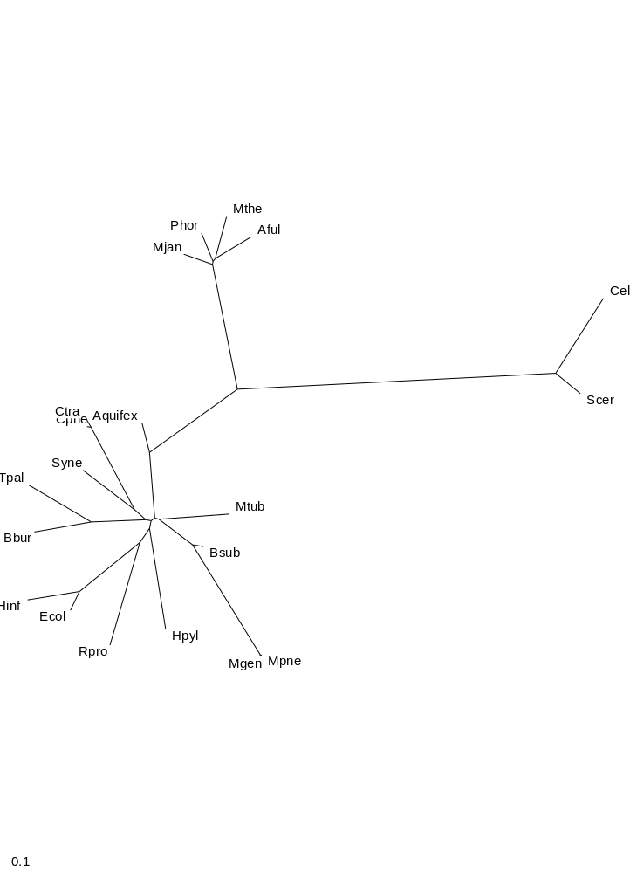
The above is the tree based on the sequence similarity of the small ribosomal subunit, which is the traditional method of generating phylogenetic trees. This is used as a comparison for the trees generated in this survey, as it is the most accurate tree to date.

SUPERFAMILY TREE
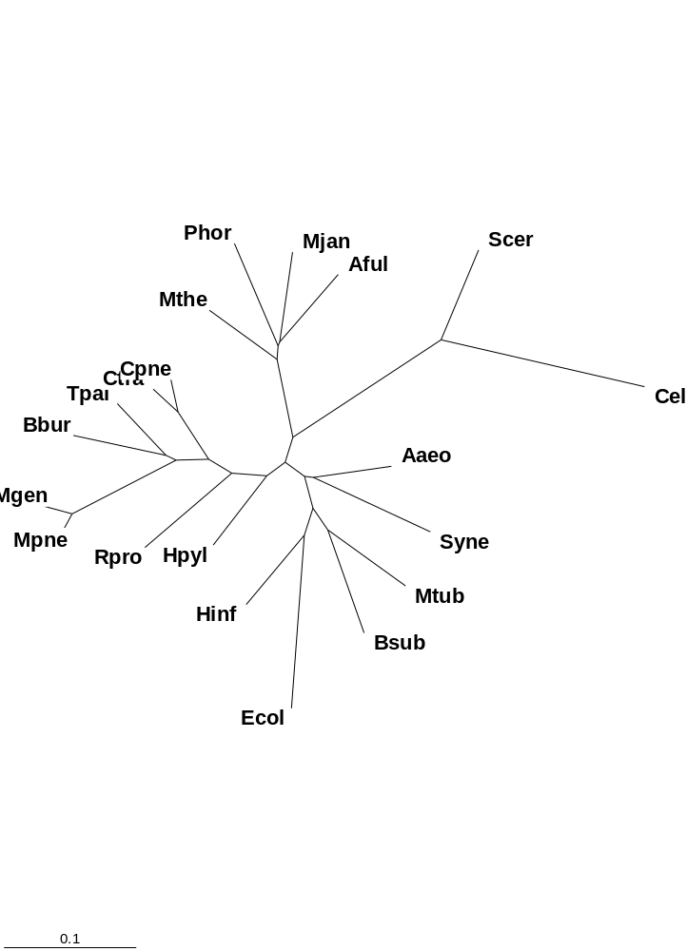

The above shows a comparison of using fold and using superfamily data of the 20 genomes for tree construction. As seen above, the superfamily tree provides a tree that is much closer to the traditional tree. Although close topology is similar, but the superfamily tree places the archea closest to the eukaryotes. However, there is still misplacements in the tree caused by what we believe to be effects of the differing size of genomes. Later attempts will try to normalize for this size effect.

HEDI

http://bioinfo.mbb.yale.edu/genome/20genomes/data/Most_Combining
-->
most-combining-folds.txt

for figure

*
http://bioinfo.mbb.yale.edu/genome/20genomes/garbage/data/most_combining_folds.data.txt

http://bioinfo.mbb.yale.edu/genome/20genomes/data/Uniq_Micro_Sfams_14Genomes

uniq-sfams.txt

* talk about top-10 sfams, folds, foldpairs

http://bioinfo.mbb.yale.edu/genome/20genomes/data/Class_Summary , THINK

http://bioinfo.mbb.yale.edu/genome/20genomes/data/Single_Multi_Repeat_ORFs
-->
single-multi-reps.txt

TABLES
Aaeo | Aquifex aeolicus | Bacteria | Aquificales | Aquificaceae
Aful | Archaeoglobus fulgidus | Archaea | Euryarchaeota | Archaeoglobales
Bsub | Bacillus subtilis | Bacteria | Firmicutes | Bacillus/Clostridium group
Bbur | Borrelia burgdorferi | Bacteria | Spirochaetales | Spirochaetaceae
Cpne | Chlamydia pneumoniae | Bacteria | Chlamydiales | Chlamydiaceae
Ctra | Chlamydia trachomatis | Bacteria | Chlamydiales | Chlamydiaceae
Ecol | Escherichia coli | Bacteria | Proteobacteria | gamma subdivision
Hinf | Haemophilus influenzae Rd | Bacteria | Proteobacteria | gamma subdivision
Hpyl | Helicobacter pylori | Bacteria | Proteobacteria | epsilon subdivision
Mthe | Methanobacterium thermoautotrophicum | Archaea | Euryarchaeota | Methanobacteriales
Mjan | Methanococcus jannaschii | Archaea | Euryarchaeota | Methanococcales
Mtub | Mycobacterium tuberculosis | Bacteria | Firmicutes | Actinobacteria
Mgen | Mycoplasma genitalium | Bacteria | Firmicutes | Bacillus/Clostridium group
Mpne | Mycoplasma pneumoniae | Bacteria | Firmicutes | Bacillus/Clostridium group
Phor | Pyrococcus horikoshii | Archaea | Euryarchaeota | Thermococcales
Rpro | Rickettsia prowazekii | Bacteria | Proteobacteria | alpha subdivision
Scer | Saccharomyces cerevisiae | Eukaryota | Fungi | Ascomycota
Syne | Synechocystis sp. | Bacteria | Cyanobacteria | Chroococcales
Tpal | Treponema pallidum | Bacteria | Spirochaetales | Spirochaetaceae

Table 1. The list of the 20 genomes analyzed. The first column shows the 4-letter abbreviation used throughout the paper, the second column contains the full Latin names of the organisms, columns 3-5 describe the phylogenetic classification of each organism.

A/ Total Number And Average Occurrence of the Represented Superfamilies in Each Fold Class in the
17 Microbial Genomes, E.coli, Yeast and Worm (from data in ~/u1/all/*_summary_sfams.txt)
 | All-Alpha |  |  | All-Beta |  |  | Alpha/Beta |  |  | Alpha+Beta |  |  | Multi-domain |  |  | Small
 | #Match | #Sfam | Avg | #Match | #Sfam | Avg | #Match | #Sfam | Avg | #Match | #Sfam | Avg | #Match | #Sfam | Avg | #Match | #Sfam | Avg
17g | 1276 | 513 | 2.49 | 933 | 378 | 2.47 | 5949 | 1154 | 5.16 | 2754 | 848 | 3.25 | 717 | 186 | 3.85 | 79 | 59 | 1.34
ecol | 160 | 56 | 2.86 | 182 | 45 | 4.04 | 877 | 106 | 8.27 | 319 | 78 | 4.09 | 81 | 16 | 5.06 | 6 | 6 | 1.00
scer | 452 | 56 | 8.07 | 336 | 35 | 9.60 | 824 | 88 | 9.36 | 351 | 67 | 5.24 | 204 | 14 | 14.57 | 187 | 13 | 14.38
cele | 1330 | 62 | 21.45 | 1648 | 52 | 31.69 | 1487 | 81 | 18.36 | 1147 | 73 | 15.71 | 602 | 14 | 43.00 | 1790 | 22 | 81.36
B/ Total Number and Average Occurrence of the Represented Folds in Each Fold Class in the
17 Microbial Genomes, E.coli, Yeast and Worm (from data in ~/u1/all/*_summary_folds.txt)
 | All-Alpha |  |  | All-Beta |  |  | Alpha/Beta |  |  | Alpha+Beta |  |  | Multi-domain |  |  | Small
 | #Match | #Fold | Avg | #Match | #Fold | Avg | #Match | #Fold | Avg | #Match | #Fold | Avg | #Match | #Fold | Avg | #Match | #Fold | Avg
17g | 1276 | 452 | 2.82 | 933 | 306 | 3.05 | 5949 | 830 | 7.17 | 2754 | 687 | 4.01 | 717 | 186 | 3.85 | 79 | 41 | 1.93
ecol | 160 | 47 | 3.40 | 182 | 33 | 5.52 | 877 | 75 | 11.69 | 319 | 59 | 5.41 | 81 | 16 | 5.06 | 6 | 3 | 2.00
scer | 452 | 45 | 10.04 | 336 | 27 | 12.44 | 824 | 66 | 12.48 | 351 | 53 | 6.62 | 204 | 14 | 14.57 | 187 | 10 | 18.70
cele | 1330 | 52 | 25.58 | 1648 | 41 | 40.20 | 1487 | 61 | 24.38 | 1147 | 62 | 18.50 | 602 | 14 | 43.00 | 1790 | 18 | 99.44

Table 5 (Table_ClassSummary). The total number and average occurrence of the represented folds (Part A) and superfamilies (Part B) in the six soluble fold classes.
The first row in each part represents the sum values for the total of 17 microbial genomes, except E.coli, yeast and worm, which are listed separately. For each structural class three values are listed: i/ the number of matches, ii/ number of different folds (Part A) and different superfamilies (Part B) present in the organism(s) in question and iii/ the average presence of each structural class, calculated by dividing i/ (number of matches) by ii/ [number of different structural entities – folds or superfamilies - present in the organism(s) in question].

Distribution of Single-, Multidomain and Repetitive Proteins in the 20 Genomes
 | MULTI | REALSINGLE | TENTMULTI | REPEAT
aaeo | 82 | 209 | 197 | 40
aful | 102 | 257 | 240 | 51
bbur | 45 | 121 | 106 | 20
bsub | 190 | 496 | 378 | 57
cele | 823 | 1161 | 1977 | 625
cpne | 54 | 108 | 98 | 14
ctra | 52 | 95 | 101 | 11
ecol | 248 | 488 | 390 | 66
hinf | 100 | 245 | 150 | 33
hpyl | 61 | 156 | 139 | 25
mgen | 35 | 57 | 64 | 10
mjan | 55 | 174 | 199 | 43
mpne | 36 | 63 | 67 | 12
mthe | 63 | 196 | 219 | 45
mtub | 198 | 435 | 497 | 70
phor | 48 | 170 | 211 | 32
rpro | 53 | 107 | 91 | 14
scer | 229 | 389 | 874 | 209
syne | 123 | 346 | 361 | 52
tpal | 48 | 83 | 102 | 20

Table 6 (Table_GenomesSingleMultiRep). The distribution of single-, multidomain, tentative multidomain and repetitive proteins in the 20 genomes.

Table: Conserved Superfamily Combination Patterns
Sfam | Combining_Sfam(s) | #Occurrence
1.100.1 | 3.5.4 | 20
1.105.8 | 2.55.1 | 15 +
1.2.1 | 4.19.4 | 12
1.2.4 | 4.26.1 | 14
1.28.1 | 3.29.1 | 20
1.58.1 | 3.17.1 | 13
1.59.1 | 2.37.1 & 3.29.1 | 12
1.75.1 | 3.17.1 | 14
1.76.1 | 3.3.1 | 16
1.79.1 | 3.22.1 | 16
1.9.1 | 2.65.1 & 3.35.1 | 10
2.33.1 | 2.32.3 & 3.29.1 | 20
2.37.1 | 3.29.1 | 14
2.37.2 | 3.1.18 | 10 *
2.44.1 | 3.1.9 | 11
2.55.1 | 1.105.8 | 15 ++
3.1.14 | 4.23.2 | 12 *
3.1.18 | 2.37.2 | 10 *
3.1.6 | 4.32.1 | 19 *
3.14.3 | 3.22.1 & 4.89.1 | 14
3.14.9 | 3.22.1 | 14
3.39.1 | 3.28.1 | 14
3.42.1 | 4.61.1 | 17
3.5.4 | 1.100.1 | 20
4.100.1 | 3.22.1 | 17
4.11.7 | 4.36.1 | 14 *
4.11.8 | 4.78.1 | 11
4.110.1 | 5.4.1 | 12
4.19.4 | 1.2.1 | 12
4.23.2 | 3.1.14 | 12 *
4.28.1 | 3.29.1 | 14
4.29.1 | 4.10.1 | 17
4.29.2 | 3.82.1 | 11
4.31.1 | 3.17.2 | 15
4.32.1 | 3.1.6 | 19 *
4.33.1 | 1.100.1 & 3.5.4 | 12
4.34.13 | 2.32.3, 3.29.1, 4.10.1 | 20
4.36.1 | 4.11.7 | 14 *
4.42.1 | 3.22.1 | 19
4.48.1 | 3.4.1 | 19 +++
4.91.1 | 4.90.1 | 12
5.13.1 | 4.72.1 | 17
5.17.1 | 3.47.1 | 17
5.4.1 | 4.110.1 | 12
* These superfamilies always occur with each other only, in a mutually exclusive way
+ Besides the combinations in 15 genomes, in C.tra 1.105.8 occurs as a single domain and
2.55.1 is missing completely.
++ Besides the combinations in 15 genomes, in M.tub 2.55.1 occurs as a single domain and
1.105.8 is missing completely.
+++ Besides the combinations in 19 genomes, in H.pyl 4.48.1 occurs as a single domain and
3.4.1 occurs as a single domain and also in tandem repeats.

Table: Conserved Superfamily Combination Patterns

The most complex proteins in the 20 genomes
A/ The longest multidomain proteins in each of the 20 genomes (in terms of number of domains)
aaeo | 5 | gi|2982926 | 3.4.1*2 | 4.34.24 | 4.83.1*2
aful | 6 | AF1274 | 3.23.1 | 4.89.1 | 1.71.1 | 3.23.1 | 4.89.1 | 3.15.1
bbur | 4 | BB0691 | 3.29.1 | 2.32.3 | 4.10.1 | 4.34.13
bsub | 7 | PksP | 5.19.1 | (3.83.1 | & 3.22.1)*3
cele | 61 | ZK617.1b | 2.1.1*55 | 5.1.1 | 2.1.1*4
cpne | 4 | gi|4376841 | 3.29.1 | 2.32.3 | 4.10.1 | 4.34.13
ctra | 5 | gi|3328868 | 3.29.1 | 2.32.3 | 7.11.1 | 4.10.1 | 4.34.13
ecol | 6 | carB | 3.23.1 | 4.89.1 | 1.71.1 | 3.23.1 | 4.89.1 | 3.15.1
hinf | 5 | HI1478 | 1.4.3 | 1.4.1*2 | 3.47.3 | 2.36.1
hpyl | 6 | HP0919 | 3.23.1 | 4.89.1 | 1.71.1 | 3.23.1 | 4.89.1 | 3.15.1
mgen | 4 | MG392 | 1.100.1 | 4.33.1 | 3.5.4 | 1.100.1
mjan | 4 | MJ1378-C | 1.71.1 | 3.23.1 | 4.89.1 | 3.15.1
mpne | 19 | gi|1674136 | 3.4.1*18 | 4.48.1
mthe | 30 | MTH105 | 4.34.1*29 | 3.1.7
mtub | 11 | Rv2048c | 3.83.1 | 3.13.1 | 2.25.1 | 3.22.1*2 | 1.27.1 | 3.83.1 | 3.13.1 | 2.25.1 | 3.22.1*2
phor | 4 | gi|3258339 | 3.29.1 | 2.32.3 | 4.10.1 | 4.34.13
rpro | 4 | RP618 | 3.23.1 | 4.89.1 | 2.65.2 | 2.65.1
scer | 10 | YJL130C | 3.5.3 | 3.55.1 | 3.23.1 | 4.89.1 | 1.71.1 | 3.23.1 | 4.89.1 | 3.15.1 | 3.66.1*2
syne | 6 | sll0370 | 3.23.1 | 4.89.1 | 1.71.1 | 3.23.1 | 4.89.1 | 3.15.1
tpal | 4 | TP0767 | 3.29.1 | 2.32.3 | 4.10.1 | 4.34.13

Table: The most complex proteins in the 20 genomes

B/ The longest repetitious proteins in each of the 20 genomes (in terms of number of domains)
aaeo | 4 | gi|2983399 | 1.91.8
aful | 6 | AF1644 | 4.34.1
bbur | 3 | BB0633 | 3.29.1
bsub | 4 | Smc | 1.105.4
cele | 32 | Y64G10.f | 7.3.9
cpne | 3 | gi|4377044 | 3.29.1
ctra | 4 | gi|3329087 | 3.29.1
ecol | 3 | yacK | 2.5.1
hinf | 3 | HI1321 | 3.29.1
hpyl | 3 | HP1553 | 3.29.1
mgen | 9 | MG218 | 1.105.4
mjan | 10 | MJ1303 | 4.34.1
mpne | 10 | gi|1674221 | 1.105.4
mthe | 88 | MTH1241 | 4.34.1
mtub | 3 | Rv3201c | 3.29.1
phor | 2 | gi|3258419 | 3.29.1
rpro | 3 | RP734 | 3.29.1
scer | 10 | YIL149C | 1.105.4
syne | 10 | slr2046 | 2.1.5
tpal | 10 | TP0835 | 1.91.3

Table: B/ The longest repetitious proteins in each of the 20 genomes
(in terms of number of domains)

PRESENT IN A SINGLE ORGANISM
The most obvious pattern is when the fold is only present in a single organism, as shown in the figure. However, from the figure showing the Abundance of Folds or Organisms, we can see that different organisms have different number of folds.
since different organisms have different number of folds, genomes with more folds are expected to have more folds occurrences.
Cele |  |  | Ecol | scer | bsub | mtub | syne | hinf | Aaeo | hpyl
  1.4
  1.68
  1.94
  2.12
  2.51
  2.62
  2.7
  3.38
  3.73
  3.79
  4.2
  4.34
  4.57
  4.7
  7.16
  7.19
  7.4
  4.63
  4.47
  4.9
  2.21
  4.89
  2.6
  4.43
  4.105
  3.14
  3.22
  7.6
  1.15
  1.21
  1.44
  4.79
  3.12
  3.72
  4.111
  4.39
Aful | rpro | cpne | Mthe | ctra | mjan | bbur | tpal | phor | Mpne | mgen
  3.68
  3.4
  7.2
  2.23
  2.19
  1.95

Present in a single organism

The organisms which have the greater number of folds would be expected to have more unique folds, which are not present in the other organisms. Such a trend is consistent with our findings. Cele has the most number of unique folds, with 17, followed by Ecol, with 5, then Scer, with also 5, followed by Bsub, Mtub, Syne, and Hinf, with 3,2, and 2 unique folds respectively. Therefore, the most interesting unique folds are in organism which have smaller number of total folds. For the sake of simplicity, the 20 organisms are divided into two subsets, the top ten organisms with the greatest number of folds and the lowest ten. Therefore, the unique folds are in the bottom ten organism. The folds are listed as follows:

LISTING

Unique folds in a genome with few folds

Mpne | 1.95 | Ligand-binding domain of nuclear receptor
Phor | 2.19 | Osmotin, thaumatin-like protein
Bbur | 2.23 | Rieske iron-sulfur protein (ISP)
Mjan | 7.2 | Toxic hairpin
Mthe | 3.4 | FAD/NAD(P)-binding domain
Cpne | 3.68 | Rhodanese

ABSENT FROM A SINGLE ORGANISM
cele | ecol | scer | bsub | mtub | syne | hinf | Aaeo | hpyl | aful
  5.8
rpro | cpne | mthe | Ctra | mjan | bbur | tpal | Phor | mpne | mgen
  3.45
  3.13
  7.12
  4.54
  1.83
  4.42
  4.82
  5.15

missing folds in CE
Aaeo | 5.8 | Sugar phosphatases

In the same way that organisms with larger number of folds are expected to have more unique folds, they are also expected to have fewer folds in which they are the only organism missing the specific fold, as illustrated in the SCHEMATIC. Again as expected, the genomes in the lower ten would have more folds missing only from the specific genomes. There are 8 such total folds in the bottom ten organisms. Furthermore, as predicted, there are few such folds in the top ten organisms. Only one such fold is present -- Aaeo having fold 5.8, which is a sugar phosphatase.

COMPLEMENTARY PATTERN
4.16
  0 | 0 | 0 | 0 | 0 | 0 | 0 | 0 | 0 | 0 | 0 | 0 | 0 | 0 | 0 | 0 | 1 | 0 | 0 | 1
3.24
  1 | 1 | 1 | 1 | 1 | 1 | 1 | 1 | 1 | 1 | 1 | 1 | 1 | 1 | 1 | 1 | 0 | 1 | 1 | 0

From the analysis, there are actually very few examples of perfect complementary patterns and the ones observed are only different by less than 3 genomes.
Thus the ones observed are mostly a result of chance.

SINGLE CLADE ( COMPLEMENTS )

CLADES
EU | EU + ARCHAE | NO EU + ARCHAE
  1.14 | 2.39 | 5.1
  1.48 | 3.6 | 5.12
  1.91 | 3.67 | 5.9
  1.98 | 4.2 | 7.35
  2.1 | 4.4 | 7.4
  2.11 | 4.41
  2.38 | 4.95
  4.35
  1.3
  1.46
  2.3
  4.103
  1.38
  1.88
  5.4
NO E + S |  | NO E + A + AQ
  2.66
  1.6
NO M + S | NO E + A + M | NO E + A + MG
  2.49
  2.18
  3.78
  2.37
  1.33
  7.15
 |  | NO S + C + M
1.27
3.35
3.81

The above shows a summarized schematic with the fold patterns that is present in different clades in the data. What is most interesting are the eukaryotic only folds, which is shown in the EU box. Another possible interest are folds that only eukaryotes and archae have, which is shown in the EU + ARCHAE box, which can be compared with the NOEU + ARCHAE, which means that these folds are not present in EU but present in ARCHAE. The significance of these findings are to be expanded upon. The other potential patterns are less interesting.

HORIZONTAL TRANSFER / GENE LOSS
3.51 | E/A | ecol/hinf
  0 | 0 | 0 | 0 | 0 | 1 | 1 | 0 | 0 | 0 | 0 | 0 | 0 | 0 | 1 | 1 | 1 | 1 | 1 | 1
3.71
  0 | 0 | 1 | 0 | 0 | 1 | 1 | 1 | 1 | 0 | 0 | 1 | 1 | 1 | 1 | 1 | 1 | 1 | 0 | 0
2.31 | B+aq | cele
  1 | 1 | 1 | 1 | 1 | 1 | 1 | 1 | 1 | 1 | 1 | 1 | 1 | 1 | 0 | 0 | 0 | 0 | 0 | 1
2.26 | B(m)+aq+U | aful
  1 | 1 | 1 | 1 | 1 | 1 | 1 | 1 | 1 | 0 | 0 | 1 | 1 | 1 | 1 | 0 | 0 | 0 | 1 | 1

