Patterns with schematic
The presence or absence of specific folds are marked with black if the organism has the fold and white if it doesn’t. This creates some interesting patterns, which we will call fold profiles. When these fold profiles are compared with the phylogenetic tree, we can potentially observe different events of the folds in the genomes.
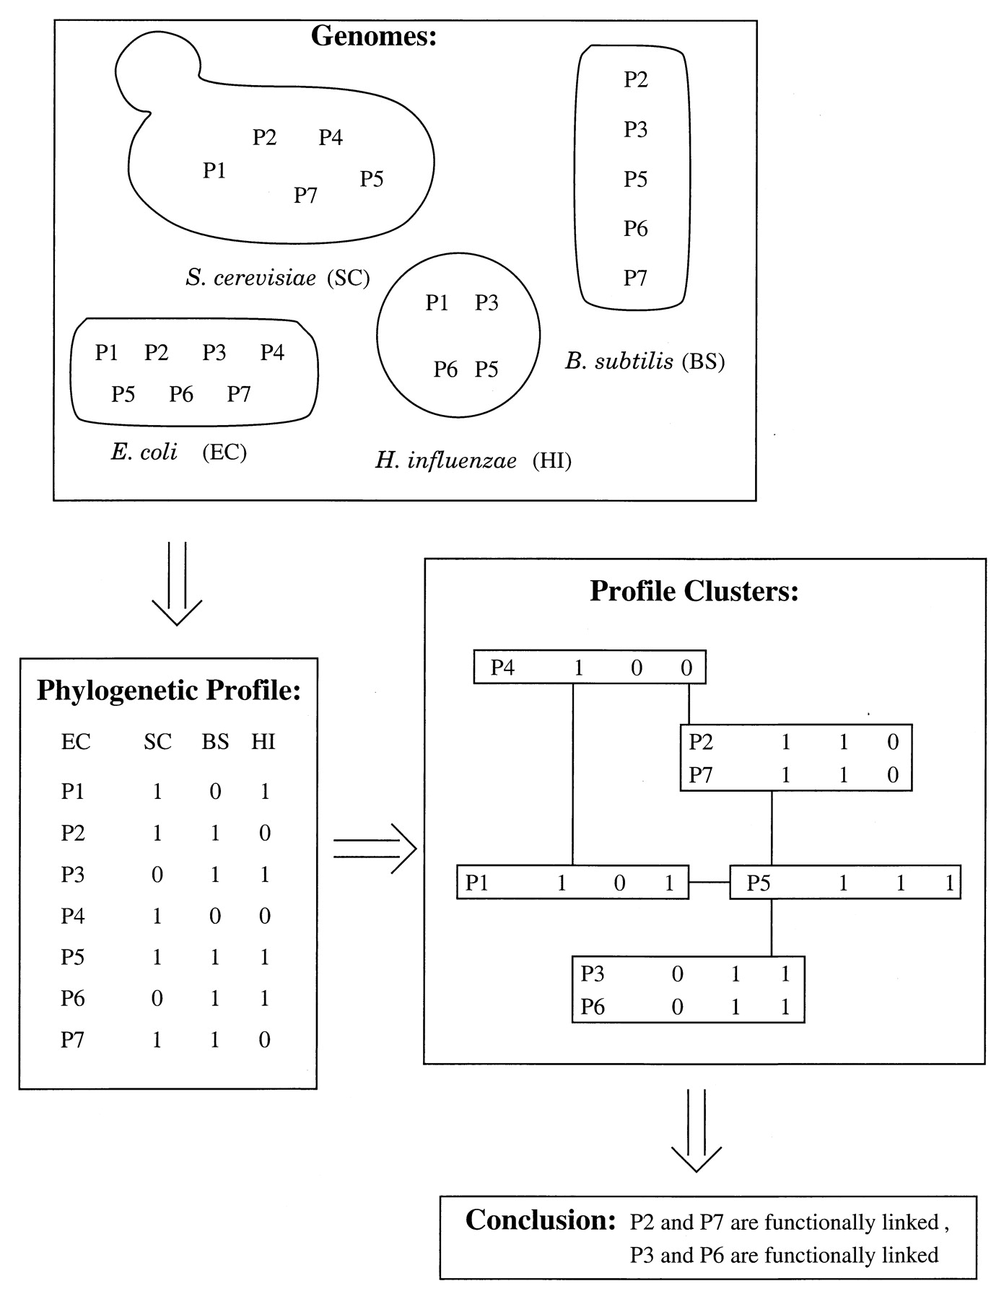

To represent the subset of organisms that contain a homolog, we constructed a phylogenetic profile for each protein. This profile is a string with n entries, each one bit, where n corresponds to the number of genomes (16 in the present article). We indicate the presence of a homolog to a given protein in the nth genome with an entry of unity at the nth position. If no homolog is found, the entry is zero. Proteins are clustered according to the similarity of their phylogenetic profiles. Similar profiles show a correlated pattern of inheritance and, by implication, functional linkage. The method predicts that the functions of uncharacterized proteins are likely to be similar to characterized proteins within a cluster
We computed phylogenetic profiles for the 4,290 proteins encoded by the genome of E. coli by aligning (6) each protein sequence (Pi) with the proteins from 16 other fully sequenced genomes (listed at the web site of The Institute for Genome Research: www.tigr.org). Proteins coded by the nth genome are defined as including a homolog of Pi if they align to Pi with a score that is deemed statistically significant.
The above is from the (Pellegrini et al., 1999) about phylogenetic profiles. Do we want to use similar vocabulary as bit and n and stuff, or should we just stick with the graphical representation? Do we need a similar schematic as above?

mgen | 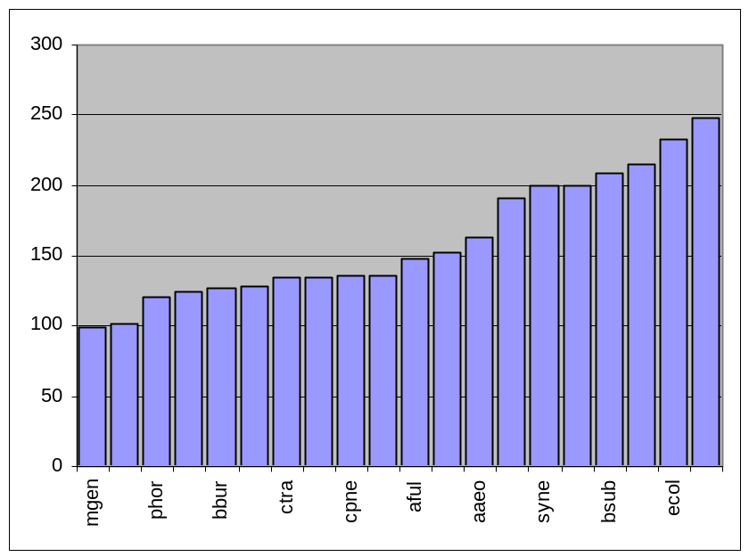99
mpne | 102
phor | 121
tpal | 124
bbur | 127
mjan | 128
ctra | 135
mthe | 135
cpne | 136
rpro | 136
aful | 147
hpyl | 152
aaeo | 163
hinf | 191
syne | 199
mtub | 199
bsub | 208
scer | 215
ecol | 233
cele | 248

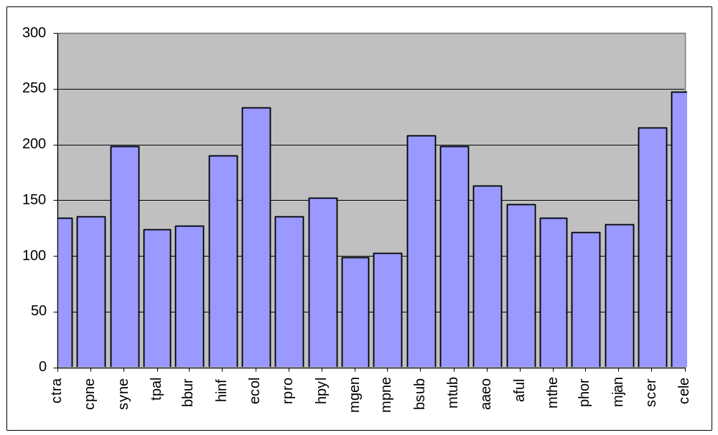
FIGURE CAPTION
This figure shows the number of total folds each organisms has, sorted from the organisms with the fewest number of folds (Mgen, 99) to the organisms with the most folds (Cele, 248). The lower graph has the X axis sorted according to the traditional phylogenetic ribosomal tree.

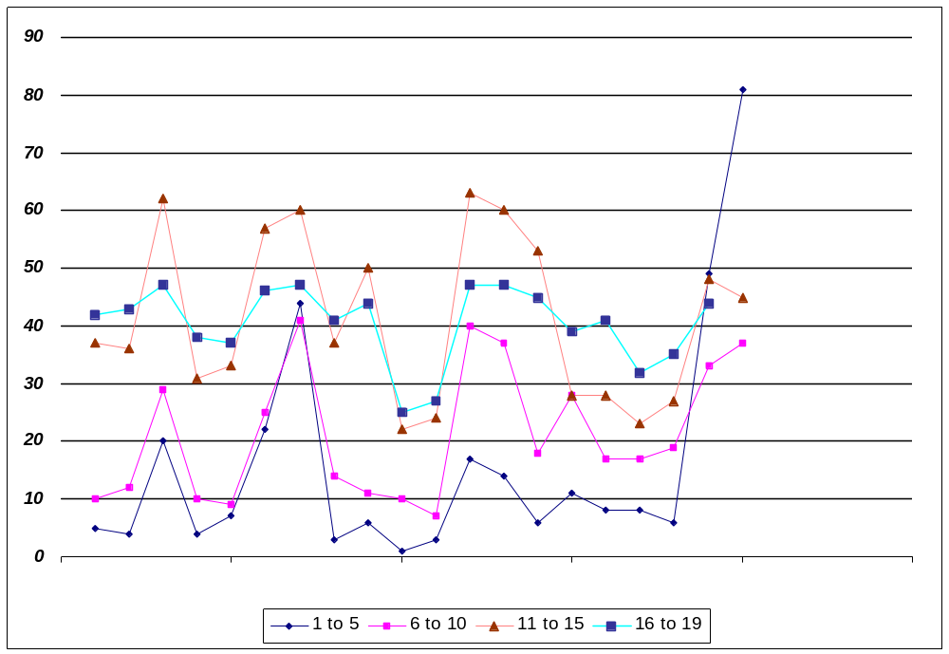

FIGURE CAPTION
This figure shows the number of total folds each organisms has, partitioned into four separate groups. The first group “1 to 5” is the subset of the total folds that one to five organisms have. Similarly, the groups “6 to 10”, “11 to 15”, and 16 to 19” are subsets of folds in which the respective number of organisms possess that fold.
P.S. Bar graphs were not used because it does not allow for layered representation as shown.
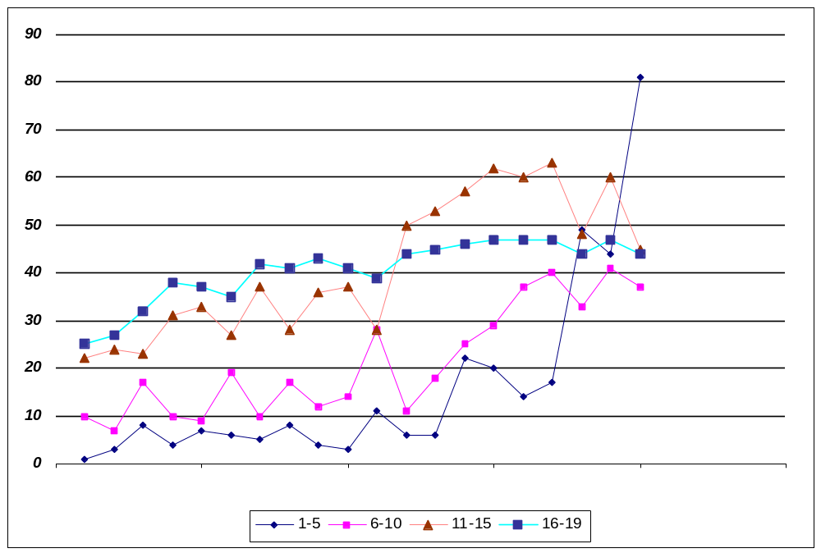
 | 1-5 | 6-10 | 11-15 | 16-19 | total
mgen | 1 | 10 | 22 | 25 | 99
mpne | 3 | 7 | 24 | 27 | 102
phor | 8 | 17 | 23 | 32 | 121
tpal | 4 | 10 | 31 | 38 | 124
bbur | 7 | 9 | 33 | 37 | 127
mjan | 6 | 19 | 27 | 35 | 128
ctra | 5 | 10 | 37 | 42 | 135
mthe | 8 | 17 | 28 | 41 | 135
cpne | 4 | 12 | 36 | 43 | 136
rpro | 3 | 14 | 37 | 41 | 136
aful | 11 | 28 | 28 | 39 | 147
hpyl | 6 | 11 | 50 | 44 | 152
aaeo | 6 | 18 | 53 | 45 | 163
hinf | 22 | 25 | 57 | 46 | 191
syne | 20 | 29 | 62 | 47 | 199
mtub | 14 | 37 | 60 | 47 | 199
bsub | 17 | 40 | 63 | 47 | 208
scer | 49 | 33 | 48 | 44 | 215
ecol | 44 | 41 | 60 | 47 | 233
cele | 81 | 37 | 45 | 44 | 248

FOLD TREES with 8, 12, 16 Genomes

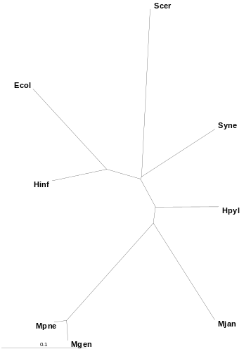 | 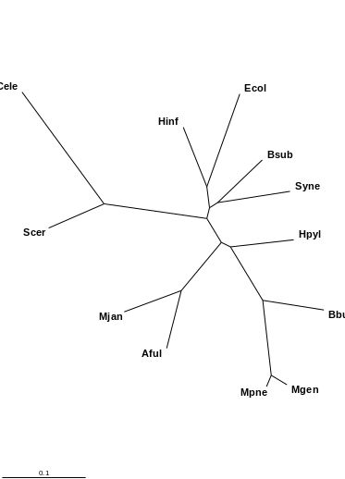 | 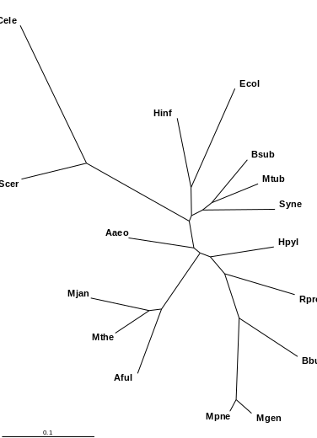
8-DISTANCE  PAUP – 0 and 1 | 12 - DISTANCE  PAUP – 0 and 1 | 16- DISTANCE  PAUP – 0 and 1
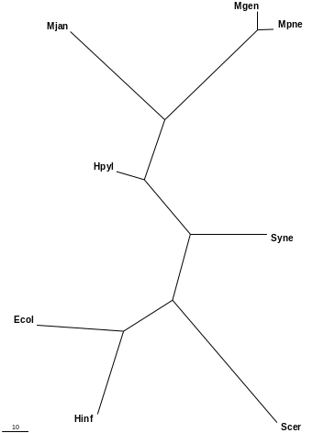 | 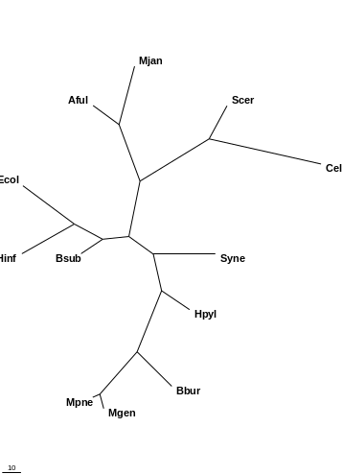 | 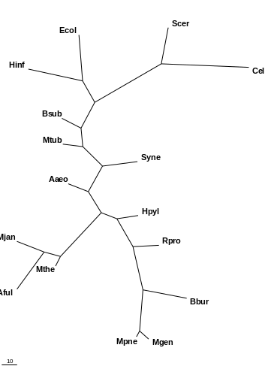
8-PARSIMONY  PAUP – 0 and 1 | 12 – PARSIMONY  PAUP – 0 and 1 | 16 PARSIMONY  PAUP – 0 and 1

In the first study, we examined the effects of different number of organisms on the final generated tree. We started out from the original 8 genomes and added successively 4 genomes to the final number of 20. Trees were built using data based on the presence or absence of a fold in a genome marked using binary bits of 0 and 1. PAUP was used to generate the final tree with both distance and parsimony based methods. What we found was that the addition of extra genomes to the tree did not have an overall effect to the tree, meaning that it only added the species onto the tree, without changing the original topology of the tree very much. This can be seen from the above trees. The tree with 20 genomes is showed in a later diagram, which compares it with other methods of generating trees of the 20 genomes.

20 FOLD TREE based on Occurrence using PAUP
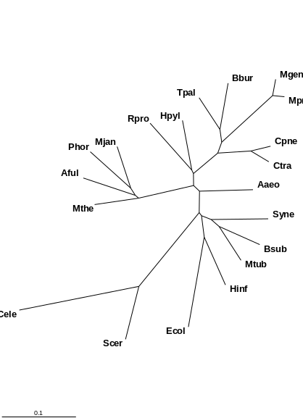 | 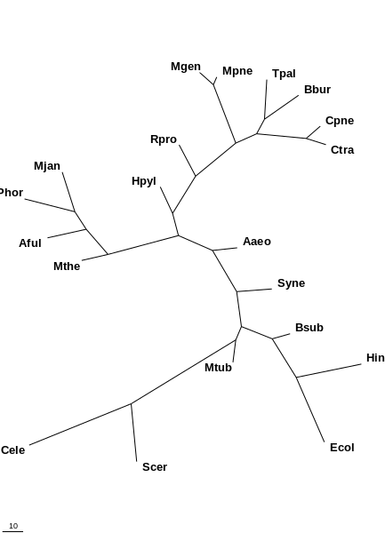
DISTANCE – PAUP – 0 and 1 | PARSIMONY – PAUP – 0 and 1

20 SUPERFAMILY based on Occurrence using PAUP
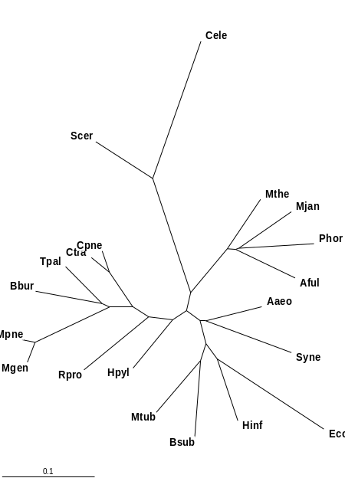 | 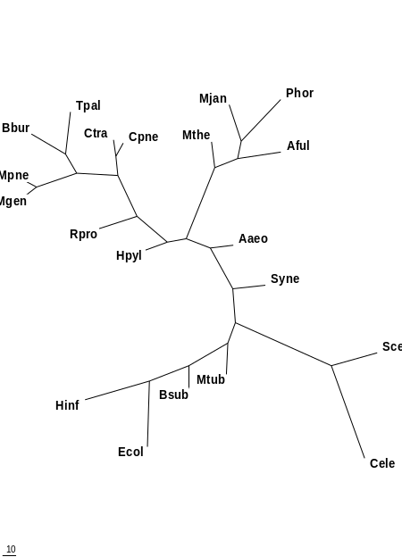
DISTANCE – PAUP – 0 and 1 | PARSIMONY – PAUP – 0 and 1

The above shows a comparison of using fold and using superfamily data of the 20 genomes for tree construction. As seen above, the superfamily tree provides a tree that is much closer to the traditional tree. Although close topology is similar, but the superfamily tree places the archea closest to the eukaryotes. However, there is still misplacements in the tree caused by what we believe to be effects of the differing size of genomes. Later attempts will try to normalize for this size effect.

