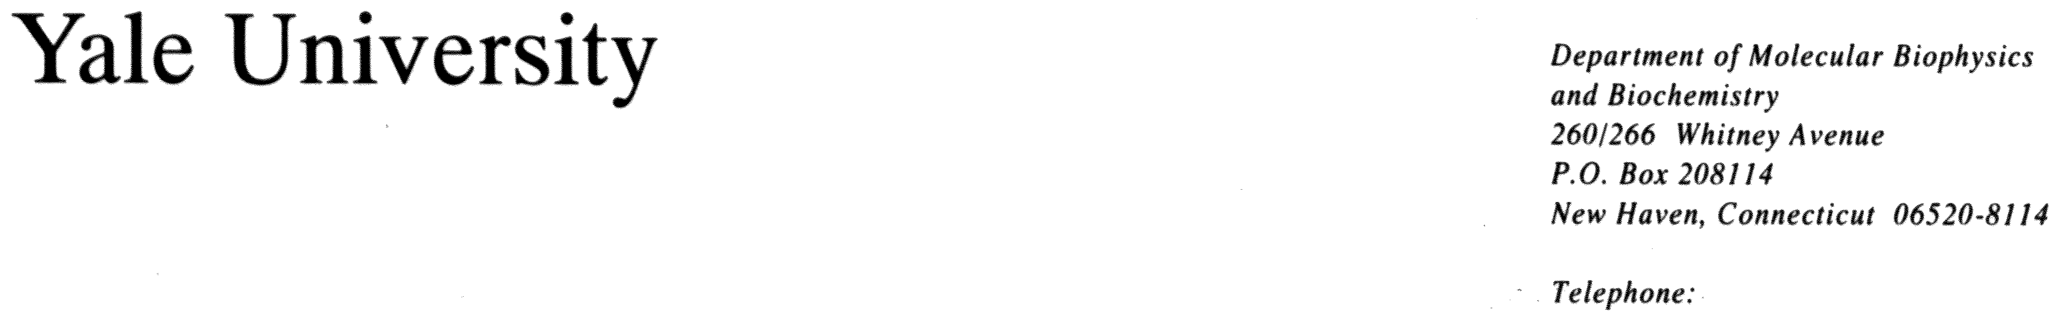
203 432 6105
360 838 7861 (fax)
Mark.Gerstein@yale.edu

21 September 2001
The Editor-in-Chief, Proteins: Structure, Function, and Genetics
Department of Biophysics
Johns Hopkins University
Charles & 34 Streets
Baltimore, MD 21218-2684

Re: Ms #20230R “Structural Genomics Analysis: Special characteristics of

unique, common and horizontally transferred folds.”

Dear Editor,

We enclose a revised version of the above reference paper for consideration by Proteins. We believe in the revision that have completely addressed the referees and managers comments and have substantially improved the paper. We hope that it is now acceptable for publication.

Yours sincerely,

Mark Gerstein
Associate Professor of
Molecular Biophysics and Biochemistry
and Computer Science

