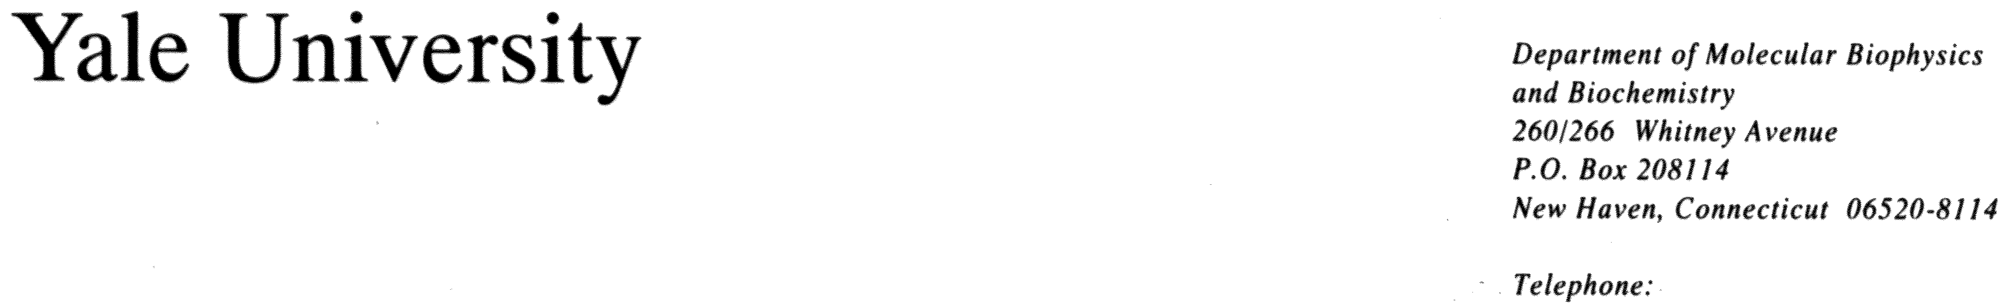
203 432 6105
360 838 7861 (fax)
Mark.Gerstein@yale.edu

19 September 2001
The Editor-in-Chief, Proteins: Structure, Function, and Genetics
Department of Biophysics
Johns Hopkins University
Charles & 34 Streets
Baltimore, MD 21218-2684

Re: Ms #20230R “Structural Genomics Analysis: Special characteristics of

unique, common and horizontally transferred folds.”

Dear Editor,

We enclosed the latest revised version of the paper. Please excuse the delay in the resubmission. During this time, one of the authors left the lab, another went to Taiwan, and we added another author. We have substantially revised the paper and responded to the comments of the reviewer. Hopefully, it is now ready for publication.

Yours sincerely,

Mark Gerstein
Assistant Professor of
Molecular Biophysics and Biochemistry
and Computer Science

