**Previous experience:**

The goal of the Neuroimaging Core is to incorporate leading advances in multi-modal neuroimaging, including blood-oxygen-level-dependent (BOLD) signal measurement for resting-state functional connectivity determination (rs-fcMRI) and diffusion-weighted-imaging (DWI) for structural connectivity determination. Parallel analytic advances in our center allow network-driven and hypothesis-grounded examination of multi-modal structural and functional network connectivity focused on distributed neural circuits, as well as fully data-driven methods.

We have recently quanitified whole-brain global functional connectivity in a large sample (N=300) of college-age adults, in relation to behavioral measures of substance use (drinking) and impulsivity, which may relate to markers of chronic pain. We identified robust relationships between global connectivity in prefrontal motor planning areas and maximum lifetime drinks, which was fully mediated by self-reported impulsivity (**Figure 2**)[14]. These results replicate existing effects[15] and establish the viability of proposed methods to discover novel relationships betweeen neural functional architecture and altered behavior.

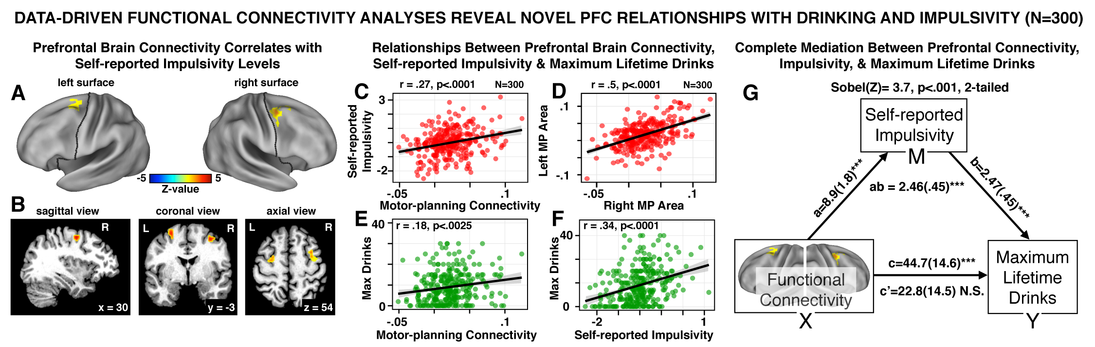

Figure 2. (A-B) Data-driven global whole-brain connectivity reveals premotor PFC area that is related to self-reported impulsivity and in turn drinking, shown on the surface and in the volume representation. (C) Relationship between bilateral premotor connectivity and impulsivity, replicating prior findings. (D) Relationship across two bilateral premotor areas, illustrating that they likely form a ‘network’. (E) Relationship between maximum lifetime drinks and premotor connectivity (r=.18, p<.0025, 2-tailed) and (F) impulsivity (r=.34, p<.0001, 2-tailed). (G) Direct relationship between premotor connectivity and drinking is fully mediated by impulsivity, establishing a possible causal model.

All necessary pipelines for the processing and analysis of anatomical, BOLD functional connectivity, and structural connectivity data have been fully implemented at Yale. These analyses will be greatly facilitated by sophisticated processing protocols developed by the Human Connectome Project (HCP)[23-25]. We have implemented the HCP pre-processing and analysis pipeline on Yale’s High Performance Computing Cluster. All analyses relating imaging and clinical measures will be performed in collaboration with the investigators of the DIRC.

We have developed the Multimodal Neuroimaging Analysis Platform (MNAP) suite of tools, which integrates several packages that support an extensible framework for data organization, preprocessing, quality assurance, and various analyses across neuroimaging modalities. The MNAP suite architecture is robust yet flexible and can be readily extended by adding functions developed by its core tools. It provides a high throughput ‘batch’ engine and seamless analytic integration with other widely-adopted community tools such as FSL, Connectome Workbench, HCP Pipelines, PALM, Octave/Matlab, AFNI, R Statistical Environment, FreeSurfer, and AFNI packages. Overall, the MNAP suite supports full ‘turnkey’ workflow, from imaging data upload to derived neuro-behavioral phenotypes (<https://dev-mnap-tools-yale-edu.pantheonsite.io/>).

**Proposed research:**

Few studies have systematically studied concurrent multi-modal alterations in this condition or linked such impairments to its genetic risk, functional outcome, and individual differences in clinical outcome in chronic pain disorders. This Neuroimaging component of the proposal has the potential to map hitherto undiscovered neural network alterations in pain disorders with unprecedented level of data integration quality. The approach is further strengthened by the use of the following key innovative tools in the analyses of the DIRC DIAC:

***Seed-based Analyses Focused on Subcortical Reward Pathways****.* Our seed-based approach will closely follow our prior studies using subcortical anatomically-defined nuclei[31]. The analysis starts using individual-specific, anatomically defined subcortical seeds focused on reward pathways (e.g. accumbens, see **Figure 2C-E**) to test whether there is widespread reward-related ‘connectomic’ signature in chronic pain. Here we will use our validated in-house Matlab tools[32, 33] to examine subcortical coupling with all voxels in the brain. First, we compute a seed-based correlation map by extracting average time-series across all voxels in each subject’s bilateral anatomically defined seed through FreeSurfer-based segmentation[20, 34] (or any other subcortical seed of interest). This signal is then correlated with each gray matter voxel. In turn, the computed Pearson correlation values are transformed to Fisher Z values (Fz). This yields a map for each subject, where each voxel’s value represents connectivity with the anatomically-defined subcortical seed.

***Network-level Analyses Based on Existing Parcellations*.** We will perform regionally constrained analyses based on well-established functional network segmentation, consisting of ~100 brain areas in 7 functional networks, derived from resting-state connectivity analyses in large datasets[35]. We will also use state-of-the-art network parcellation schemes made available by David Van Essen’s lab (see Letter of Support). This approach accomplishes a dimensional reduction, while also reducing noise. This, however, reduces spatial resolution and could potentially mask disorder-specific alterations below the level of network parcellation. Thus, we use this strategy in parallel with, rather than in place of, voxel-wise analyses. For functional connectivity analyses, we will average fluctuations in BOLD signal within an area for each network and compute co-variation among the resulting regional signals. For structural connectivity, we sum streamlines within each of the cortical areas, generating a ‘parcellated’ Connectome for each subject, resulting in a data-reduced structural connectivity matrix on a standard cortical mesh. This will provide a reduced large-scale functional and structural connectivity matrix for each subject.

***[[shorten???]]***

***Data-driven Analyses*.** Strong evidence implicates specific networks and regions as a source of functional impairment in chronic pain. However, functional and structural dysconnectivity in chronic pain disorders, especially within cortical network circuits, may be highly variable, given clinical heterogeneity. To address this, we designed and optimized new neuroimaging techniques to identify dysconnectivity in a data-driven fashion, termed global brain connectivity (GBC)[7, 10, 11]. We have applied GBC-type measures to clinical questions in collaboration with the developer of the measure, Dr. Michael Cole, who will consult with the PIs to optimize the GBC analyses (see Letters of Support). Briefly, GBC examines connectivity from a given voxel (or area) to all other voxels (or areas) simultaneously by computing average connectivity strength – thereby producing an unbiased approach as to the location of dysconnectivity. Unlike typical seed-based approaches, if a given area is perturbed in its functional or structural connectivity consistently, irrespective of the target location, GBC is sensitive to this alteration. Further, unlike seed approaches, GBC involves one statistical test per voxel rather than one test per voxel-to-voxel pairing, substantially reducing multiple comparisons (e.g., 30,000 rather than ~450 million tests). These improvements dramatically increase the chances of identifying group differences in connectivity, or individual differences correlated with symptoms, as we recently demonstrated[7, 11, 36, 37]. By extension, this approach can be applied to structural connectivity derived from DWI, either at the whole-brain level or within associative networks.

***Group-level Analyses.*** To examine between-group differences or relationships with Clinical Core assessments, Fz maps are entered into an independent samples t-test (or other appropriate 2nd-level tests) (**Figure 2**). Whole-brain type I error correction is accomplished via threshold-free cluster enhancement (TFCE) non-parametric techniques implemented in FSL’s *Randomise* tool[39]. This approach was chosen because the studies will not necessarily recruit demographically matched samples.