MB&B
Yale University
260/266 Whitney Avenue
PO Box 208114
New Haven, CT 06520-8114

Phone: 1-203-432-6105
Fax: 1-360-838-7861

Mark.Gerstein@yale.edu
http://www.gersteinlab.org
Editor
Genome Biology
May 10, 2018
Re: Comparative analysis across ENCODE, modENCODE and mouseENCODE data reveals the hourglass pattern of developmental gene networks

Dear Editor,

We would like to make a pre-submission inquiry. In particular, we would like to submit a manuscript entitled “Comparative analysis across ENCODE-associated functional data reveals the hourglass pattern of developmental gene networks” by Wang et al. for publication as a research paper in Genome Biology.
The large genomic projects such as ENCODE and the earlier modENCODE and mouseENCODE projects provide large-scale datasets and enable the comparative genomic analysis across multiple organisms to discover the evolutionary genomic functions, especially for development. However, the comparative data integration and analysis across all the ENCODE related projects is still a challenge. To this end, this manuscript demonstrates a case study and tests the developmental hourglass model at gene network level, across model organisms including worm, fly, zebrafish and mouse. Hourglass behaviors have previously been observed at gross morphological and single-gene transcriptome levels during embryogenesis, with the largest constraint occurring at the phylotypic stage (the “pinch” of the hourglass). In this paper, we further comparatively analyzed and found the developmental hourglass patterns at the gene network structures (see left figure) for model organisms.
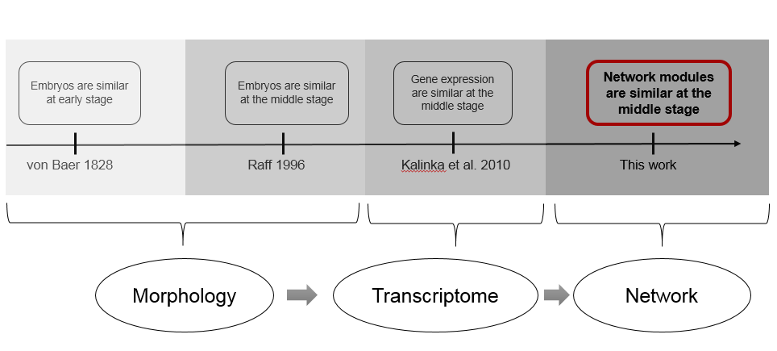

In particular, this work is substantially advancing our previous work (Gerstein, et al., Nature 2014). Here, we integrate RNA-seq and ChIP-seq data from ENCODE, modENCODE and mouseENCODE along with zebrafish data to build and comparatively analyze cross-species gene networks and find that their developmental gene networks follow hourglass patterns (e.g., interconnectivity among gene co-expression modules). Moreover, our integrative analyses of gene expression and ChIP-seq data indicate that the hourglass pattern at gene module level is probably due to various conserved functions become activated around the pinch of the hourglass. In addition, the “network” hourglass pattern is also observed at non-canonical stages; e.g., in mouse, suggesting the widely use of hourglass pattern to gain complexity and novel functions in development.

We hope that our novel analysis will be of interest to the readers of Genome Biology.

Thank you for your consideration.

Yours faithfully,

Mark Gerstein

Albert L. Williams Professor
of Biomedical Informatics

