Supplement to Comprehensive functional genomic resource and integrative model for the adult brain

Quick Guide to Finding Information in the Supplement
To most clearly link and cross-reference between the main text and this supplement, we use common section headings for both. Thus, supplementary content to a given main text section within the supplementary section is named in a parallel fashion:
S1. Supp. content to main text section "Resource construction" [pg. 2]
S2. Supp. content to main text section "Transcriptome analysis" [pg. 3]
S3. Supp. content to main text section "Enhancers" [pg. 20]
S4. Supp. content to main text section "Consistent comparison" [pg. 22]
S5. Supp. content to main text section "QTL analysis" [pg. 27]
S6. Supp. content to main text section "Regulatory networks" [pg. 31]
S7. Supp. content to main text section "Linking GWAS variants" [pg. 39]
S8. Supp. content to main text section "Deep-learning model” [pg. 42]
S9. Resource website [pg. 46]
S10. Supp. References [pg. 51]

Supplementary methods, figures and tables are contained within their respective sections. Items are numbered to provide ease of access to supplementary content. For instance, “Fig. S2.1b” refers to panel b within the first figure within section S2.

Introduction on PsychENCODE data & more on the supplement
This document provides an organized reference to support datasets, pipelines, and analyses associated with this study. It is presented in a parallel fashion to the main text. It is also connected to the main text through the major results presented in the form of main text figures – captions associated with main text figures point to relevant subsections within this supplement. In cases where the related supplementary section is not readily apparent, we note "see supp. section xyz” to refer to a specific section.
Large datasets produced by the psychENCODE consortium include over 2,000 human brain samples for healthy controls and individuals afflicted by neuropsychiatric diseases. These include full genotyping, RNA-seq, ChIP-seq, and single-cell data. It also includes processed data such as expression QTLs and chromatin QTLs trait loci, enhancers that are active in different brain regions, in addition to differentially expressed genes, transcripts, and novel non-coding RNAs. These are also provided at the resolution of brain sub-regions, thereby providing valuable resources for investigating potential underlying factors for an array of psychiatric diseases.
However, the very richness of this data introduces considerable challenges with respect to data organization. Our analyses rely on multiple methodologies, the details of which are difficult to include within the main text of this paper.
The data resources may be organized into a pyramid-like structure, with large raw data files at the base, and more processed summary data organized at higher levels. The raw data files include datasets from PyschENCODE, ENCODE, CommonMind, GTEx, Epigenomics Roadmap, and others. These comprise RNA-seq expression quantification data, ChIP-seq signal track qualifications and peak identifications using ENCODE standard pipelines, in addition to private data such as imputed genotypes. Further up the pyramid, more readily human-interpretable data and descriptors populate the top. These more processed datasets include patient metadata and phenotypes (such as disease status), fully processed epigenomic signals and peaks, active enhancers, QTLs, differentially expressed genes and transcripts, and regulatory networks.
With the aim of presenting data and results (including software packages) in an organized way, we have written about this study in roughly a hierarchical fashion. The main text lies at the top of this hierarchy and synthesizes everything in a broad manner. It refers to more detailed descriptions of our methods and datasets, as provided in this supplement. Raw data files, which lie at the bottom of the hierarchy (and which are hosted as online resources) form the bedrock from which our results are built.

S1. Supp. content to main text section "Resource construction"
The PsychENCODE data covers a number of phenotypes on mental health. These include normal controls (n=1104), as well as schizophrenia (n=558), bipolar (n=217), autism spectrum disorder, (n=44), and affective disorder (n=8) (Fig. 1). There include 1246 males and 685 females. We integrated standard pipelines to uniformly process raw sequencing and genotyping data (Fig. S1.1). Details are provided in following Sections S2.1, S2.2, S3.1, S5.1, and S6.1-6.2.

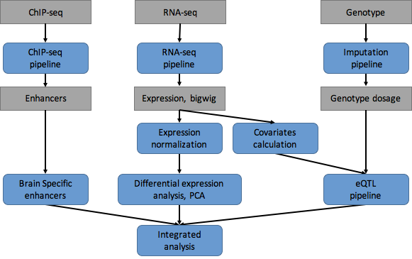
Fig. S1.1 - Integrated analysis pipeline of PsychENCODE. We used the standard pipelines from ENCODE and other large consortia to uniformly processed the raw sequencing data from PsychENCODE, including RNA-seq, ChIP-seq and Genotype, and identified functional genomic elements such as brain enhancers, expressed genes and eQTLs. We also processed other data types such as Hi-C and single cell and provided details on data processing in the following sections. As shown by this flowchart, we then performed the integrative modeling and analysis for functional genomic elements in adult brain.

S2. Supp. content to main text section "Transcriptome analysis”

Note that the data files for this section are described in detail in Section S9 (Resource website).

S2.1.1 GTEx brain and other tissues

We use several types of data from the GTEx version 7 dataset (GTEx Consortium, 2017). GTEx version 7 contains RNAseq and matching genotype data for 10 brain regions (Anterior cingulate cortex, Caudate nucleus, Cerebellar hemisphere, Cerebellum, Cortex, Frontal cortex, Hippocampus, Hypothalamus, Nucleus accumbens, and Putamen). We use the raw RNA sequencing data to quantify the proportion of the transcribed non-coding genome. For eQTL calculations and WGCNA analysis, we used individual TPM data, and renormalized it using the PEER factors calculated in combination with PsychENCODE data. Further, for the eQTL calculations, we re-imputed the genotype data using from the raw genotype calls using the pipeline described below to match the processing of the PsychENCODE data.
We used data from GTEx7 (GTEx Consortium, 2017) to compare the brain transcriptome to that of other tissues. GTEx7 contains RNAseq data from 34 other tissues. As above, we use the raw RNA sequencing data to quantify the proportion of transcribed non-coding regions. For WGCNA analysis, we used the individual TPM data, pre-normalized by the PEER factors calculated in GTEx7 to identify modules in individual tissues, and the median TPM data by tissue to identify modules across tissues.

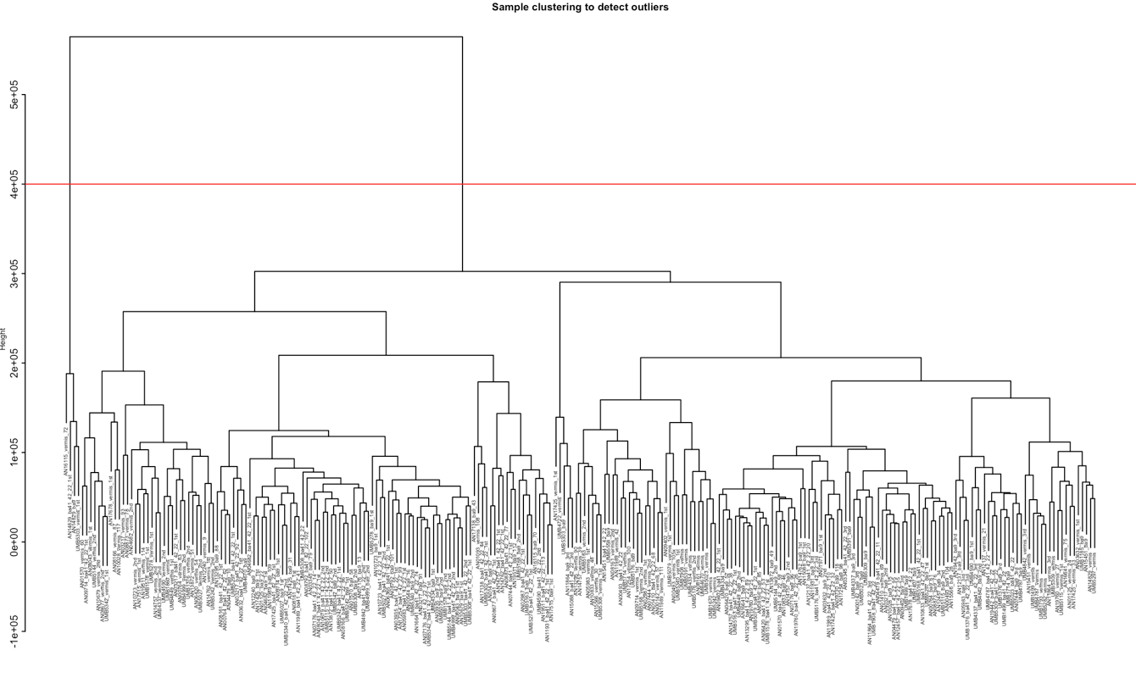
Fig. S2.1 Dendrogram of clustering analysis for identifying outliers of gene expression. This is an example showing we removed 4 outlier samples from UCLA-ASD study according to hierarchical clustering of the gene expression data..

Table S2.1 Summary of dataset This table provides the number of samples incorporated into the integrative analyses in this manuscript, categorized by study, the disease status of the individual from which the sample is acquired (CTL = Control, SCZ = Schizophrenia, BPD = Bipolar Disorder, ASD = Autism Spectrum Disorder, AFF = Affective Disorder), the source tissue(s), and the downstream analyses conducted as a part of this manuscript.
Study | Disease | Brain Tissue(s) | Assay | Analyses done | No. of Samples
Roadmap | CTL | Dorsolateral Prefrontal Cortex | ChIP-seq: H3K27ac | Chromatin RCA | 1
 | CTL | Caudate nucleus, Cingulate gyrus, Hippocampus, Cortex | ChIP-seq: H3K27ac | Chromatin RCA | 4
ENCODE | CTL | Frontal Cortex | DNase-seq | TF imputation | 2
GTEx | CTL | Frontal Cortex (BA9) | RNA-seq | QTL analyses, Gene Expression RCA | 138
 | CTL | Cerebellum | RNA-seq | Gene Expression RCA | 298
 | CTL | Amygdala,  Anterior Cingulate Cortex, Caudate (basal ganglia),  Cortex,  Hippocampus, Hypothalamus, Nucleus Accumbens (basal ganglia), Putamen (basal ganglia), Spinal cord (cervical c-1), Substantia Nigra | RNA-seq | Gene Expression RCA | 1196
 | CTL | Frontal Cortex (BA9) | Genotypes | QTL analyses | 25
 | CTL | All non-brain tissues | RNA-seq | Weighted Gene Co-expression Analysis (WGCNA) | 11688 (GTEx V7)
PEC: BrainSpan | CTL | Dorsolateral Prefrontal Cortex | RNA-seq | eQTL | 6
Published Single-cell: Lake et al. | CTL | Dorsolateral Prefrontal Cortex (BA10) | scRNA-seq | Bulk Tissue Deconvolution and Decomposition, fQTL | 575
 | CTL | Temporal Cortex (BA21, BA22, BA41) | scRNA-seq | Bulk Tissue Deconvolution and Decomposition, fQTL | 1771
 | CTL | Intermediate Frontal Cortex (BA8) | scRNA-seq | Bulk Tissue Deconvolution and Decomposition, fQTL | 490
 | CTL | Primary Visual Cortex X1 (BA17) | scRNA-seq | Bulk Tissue Deconvolution and Decomposition, fQTL | 391
Published Single-cell: Darmanis et al., 2015 | CTL | Temporal Cortex | scRNA-seq | Bulk Tissue Deconvolution and Decomposition, fQTL | 332
 | CTL | Developmental Cortex | scRNA-seq | Bulk Tissue Deconvolution and Decomposition, fQTL | 134
PEC: scRNA-seq | CTL | Dorsolateral Prefrontal Cortex | scRNA-seq | Bulk Tissue Deconvolution and Decomposition, fQTL | 459
 | CTL | Dorsal Pallium | scRNA-seq | Bulk Tissue Deconvolution and Decomposition, fQTL | 473
PEC: Reference Brain | CTL | Dorsolateral Prefrontal Cortex | ChIP-seq: H3K27ac | Enhancer Definition | 1
 | CTL | Dorsolateral Prefrontal Cortex | HiC | Enhancer Definition | 1
 | CTL | Dorsolateral Prefrontal Cortex | ATAC-seq | Enhancer Definition | 1
PEC: CommonMind | CTL | Dorsolateral Prefrontal Cortex | RNA-seq | eQTL | 295
 | SCZ | Dorsolateral Prefrontal Cortex | RNA-seq | eQTL | 263
 | BPD | Dorsolateral Prefrontal Cortex | RNA-seq | eQTL | 47
 | AFF | Dorsolateral Prefrontal Cortex | RNA-seq | eQTL | 8
 | CTL | Dorsolateral Prefrontal Cortex | Genotypes | eQTL | 285
 | SCZ | Dorsolateral Prefrontal Cortex | Genotypes | eQTL | 263
 | BPD | Dorsolateral Prefrontal Cortex | Genotypes | eQTL | 47
 | AFF | Dorsolateral Prefrontal Cortex | Genotypes | eQTL | 8
PEC: CommonMind-HBCC | CTL | Dorsolateral Prefrontal Cortex | RNA-seq | eQTL | 220
 | SCZ | Dorsolateral Prefrontal Cortex | RNA-seq | eQTL | 97
 | BPD | Dorsolateral Prefrontal Cortex | RNA-seq | eQTL | 70
 | CTL | Dorsolateral Prefrontal Cortex | Genotypes | eQTL | 191
 | SCZ | Dorsolateral Prefrontal Cortex | Genotypes | eQTL | 85
 | BPD | Dorsolateral Prefrontal Cortex | Genotypes | eQTL | 25
PEC: BrainGVEX | CTL | Dorsolateral Prefrontal Cortex | RNA-seq | eQTL | 259 + 3(?)
 | SCZ | Dorsolateral Prefrontal Cortex | RNA-seq | eQTL | 95
 | BPD | Dorsolateral Prefrontal Cortex | RNA-seq | eQTL | 73
 | CTL | Dorsolateral Prefrontal Cortex | Genotypes | eQTL | 47
 | SCZ | Dorsolateral Prefrontal Cortex | Genotypes | eQTL | 45
 | BPD | Dorsolateral Prefrontal Cortex | Genotypes | eQTL | 45
PEC: LIBD_szControl | CTL | Dorsolateral Prefrontal Cortex | RNA-seq | eQTL | 320
 | SCZ | Dorsolateral Prefrontal Cortex | RNA-seq | eQTL | 175
 | CTL | Dorsolateral Prefrontal Cortex | Genotypes | eQTL | 96
 | SCZ | Dorsolateral Prefrontal Cortex | Genotypes | eQTL | 104
PEC: BipSeq | BPD | Dorsolateral Prefrontal Cortex | RNA-seq | eQTL | 69
 | BPD | Dorsolateral Prefrontal Cortex | Genotypes | eQTL | 55
PEC: UCLA-ASD | CTL | Dorsolateral Prefrontal Cortex | RNA-seq | eQTL | 46
 | ASD | Dorsolateral Prefrontal Cortex | RNA-seq | eQTL | 43
 | CTL | Dorsolateral Prefrontal Cortex | Genotypes | eQTL | 35
 | ASD | Dorsolateral Prefrontal Cortex | Genotypes | eQTL | 31
 | CTL | Dorsolateral Prefrontal Cortex | ChIP-seq: H3K27ac | cQTL, Enhancer Definition | 50
 | ASD | Dorsolateral Prefrontal Cortex | ChIP-seq: H3K27ac | cQTL | 31
 | CTL | Cerebellar Cortex | ChIP-seq: H3K27ac | Enhancer Definition | 50
 | CTL | Temporal Cortex | ChIP-seq: H3K27ac | Enhancer Definition | 50
PEC: Yale-ASD | CTL | Dorsolateral Prefrontal Cortex | RNA-seq | eQTL | 23
 | ASD | Dorsolateral Prefrontal Cortex | RNA-seq | eQTL | 3
PEC: EpiDiff | CTL | NeuN+/- from Dorsolateral Prefrontal Cortex | ChIP-seq: H3K27ac | cQTL | 117
 | SCZ | NeuN+/- from Dorsolateral Prefrontal Cortex | ChIP-seq: H3K27ac | cQTL | 109

S2.1.2 RNA-seq processing
The PsychENCODE RNA-seq pipeline (Fig. S2.2) is mostly based on that of ENCODE, which is compatible with stranded and unstranded mRNAs from (poly-A(+)), rRNA-depleted total RNA, or poly-A(-) RNA libraries. The inputs are RNA-seq reads (from paired-end stranded or single end unstranded libraries), a reference genome and a gene annotation file (by default GENCODE). We used GRCh37 (hg19) as reference genome and Gencode v19 as gene annotation. Coding and non-coding transcripts were used to quantify gene expression. For each sample the pipeline outputs: A bam file with reads mapped to the genome, a bam file with reads mapped to the transcriptome, bigwig files with normalized RNA-seq signal track for unique and multi-mapping reads (splitted between +strand and -strand if the library is stranded), gene quantifications and transcript quantifications.
The mapping of the reads is done using STAR (2.4.2a) and the quantification of genes and transcripts is done with RSEM (1.2.29). Although there is general agreement between the mappings and the gene quantifications produced by different RNA-seq pipelines, quantifications of individual transcript isoforms, being much more complex, can differ substantially depending on the processing pipeline employed, and are of unknown accuracy. Therefore, mapping and gene quantifications can be used confidently, while transcript quantifications should be used with care. Quality control metrics were calculated using RNA-SeQC (v1.1.8), featureCounts (v1.5.1), PicardTools (v1.128), and Samtools (v1.3.1). Pipeline source code can be found at doi:10.7303/syn12026837.1 at Synapse. All PsychENCODE sample FASTQ files were run through a unified RNA-seq processing pipeline (Fig. S1.1) run at the University of Chicago on an OpenStack cloud system and GTEx samples were processed at Yale University.
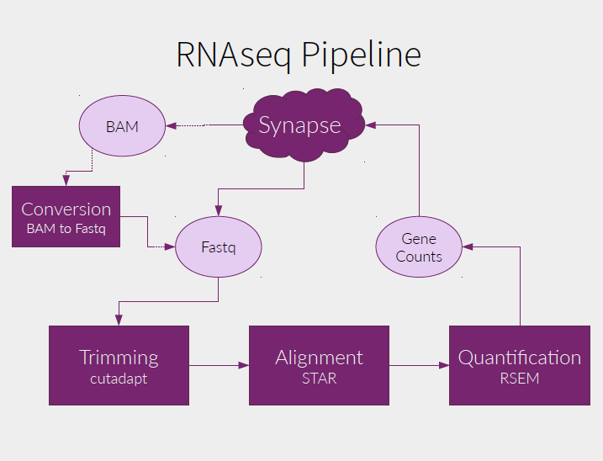
Fig. S2.2 PsychENCODE RNA-seq pipeline. This is the flowchart of the uniform RNA-seq pipeline. This pipeline was modified based on the long-rna-seq-pipeline used by the ENCODE Consortium.

S2.2 Single cell RNA-seq

S2.2.1 Datasets of single cell transcriptomics.
We integrated and used the same pipeline including ENCODE RNA-seq analysis to uniformly process single cell RNA-seq data for ~900 cells from PsychENCODE with 11 novel cell types in embryonic and developmental tissues. The expression of ~3000 neuronal cells with 8 excitatory and 8 inhibitory types (Lake et al., 2016), and ~400 cells including two developmental types, one adult neuronal type and 5 adult non-neuronal types, astrocytes, endothelial, microglia, oligodendrocytes and OPC (Darmanis et al., 2015) were downloaded from corresponding publications. The details of cell types were shown in Table S2.2.
The basic cell types have been shared and used by other PsychENCODE capstone projects focusing on non-coding regulation and development. For PsychENCODE single cell data, we first apply quality control on ~900 cells using R ‘scater’ package (McCarthy et al., 2017) to filter the cells with low library size and high mitochondrial RNA concentration. Furthermore, the cells with total library size less than 0.2 million were also filtered for future analysis. In total, we built a gene expression profile of ~800 high quality cells quantified in TPM. We merged the PsychENCODE data, Lake et al data and Quake et al. by matching the gene names. As the single cell data suffers from high dropout rates, we used MAGIC (van Dijk et al., 2017) to impute the missing values in the expression matrix. We compared these single cells based on the (biomarker) gene expression similarity using tSNE, and found that the same-type cells generally can be clustered together (Fig. S2.3). In particular, 99.4% PsychENCODE cells have been found to cluster together with known developmental cell types from Darmanis et al. (Darmanis et al., 2015).
We also found that the gene expression changes across individual tissue samples can be largely explained by the single cell gene expression, and the changes of single cell fractions are also associated with the individual phenotypes. Therefore, we deconvolved the tissue-level gene expression data of all 1866 individuals’ tissue samples using single-cell gene expression data of 457 biomarker genes to find the fraction of different cell types corresponding, and compare cell fractions across different phenotypes.

S2.2.2 Quantification of gene expression
The gene expression in both bulk and single-cell RNA-seq data were quantified in TPM and further transformed into log scale by log2(TPM+1). The transformed gene expression will be used in the decomposition and devolution analysis.

S2.3 Decomposition of brain tissue gene expression data
To check if the brain tissue expression is attributed to the combinations of single cell types in Section 2.4; i.e., the cell fractions, we decomposed the brain tissue gene expression data using unsupervised approach to find the principal components of tissue data, and compared them with single cell expression data. Specifically, given the brain tissue gene expression matrix X (N by M) for a phenotype/disorder where M is the number of tissue samples and N is the number of select genes (e.g., the cell biomarker genes), we used non-negative matrix factorization (NMF) to decompose X into the product of two matrices, H and V so that ||X-V*H||^2 is minimized with constraints that all elements of H. H is an K by M matrix with the (i,j) element describing the contribution coefficient of jth NMF topl component (NMF-TC) to ith tissue sample, K is the number of select NMF-TCs (e.g., equal to the number of select cell types as above), and V is a N by K matrix with the (i,j) element being the expression level of jth select gene on ith NMF-TC.
We then correlated NMF-TCs with the select gene expression data of different single cell types, and obtain the correlation map between NMF-TCs and single cells (Fig. 2B). For example, No. 10 and 19 NMF-TCs of the non-neuronal group highly correlate with astrocytes, No. 21 NMF-TC correlate with developmental cells, and No. 4, 7, 12 and 25 NMF-TCs of the neuronal group correlate with excitatory neuronal cell types. This suggests that the large portion of tissue gene expression changes is a linear combination of these cell types’ gene expression. Thus, we want to further identify the cell fractions showing how individual single cells contribute the tissue’s gene expression, using the deconvolution. In addition, previous studies have identified cell type specific expression patterns from co-expression analysis (Oldham et al., 2008). We found here that some of our NMF-TCs correlate with the eigengenes of gene co-expression modules (Gandal, M.J. et al., submitted), especially for the cell type modules, supporting again that they connect the cell type information from the bulk tissue data.

Table S2.2 Summary of cell types. This table includes PsychENCODE developmental cell types and public adult cell types from Lake et al. 2016 and Darmanis et al. 2015.
Abbreviation | Adult/Developmental | Full name | Source
Ex | Adult | Excitatory Neuron | Lake et al. 2016
In | Adult | Inhibitory Neuron | Lake et al. 2016
OPC | Developmental | Oligodendrocyte progenitor cells | Li, M. et al. (submitted)
Trans | Developmental | Transient cell type (nascent neurons) | Li, M. et al. (submitted)
NEP | Developmental | Neuroepithelial cells | Li, M. et al. (submitted)
IPC | Developmental | Intermediate progenitor cells | Li, M. et al. (submitted)
Quiescent/Quies | Developmental | Quiescent newly born neurons | Darmanis et al., 2015
Replicating/Repli | Developmental | Replicating neuronal progenitors | Darmanis et al., 2015
IntN | Developmental | Inhibitory Neuron | Li, M. et al. (submitted)
ExtN | Developmental | Excitatory Neuron | Li, M. et al. (submitted)
Oligo | Developmental | Oligodendrocyte cells | Li, M. et al. (submitted)
Astrocytes/Astro | Developmental | Astrocytes | Li, M. et al. (submitted)
Pericytes/Peri | Developmental | Pericytes | Li, M. et al. (submitted)
Endothelial/Endo | Developmental | Endothelial cells | Li, M. et al. (submitted)
Microglia/Micro | Developmental | Microglia | Li, M. et al. (submitted)
Microglia/Micro | Adult | Microglia | Darmanis et al., 2015
OPC | Adult | Oligodendrocyte progenitor cells | Darmanis et al., 2015
Endothelial/Endo | Adult | Endothelial cells | Darmanis et al., 2015
Astrocytes/Astro | Adult | Astrocytes | Darmanis et al., 2015
Oligo | Adult | Oligodendrocyte | Darmanis et al., 2015
OtherNeuron | Adult | Mixed of excitatory and inhibitory neuronal cells | Darmanis et al., 2015
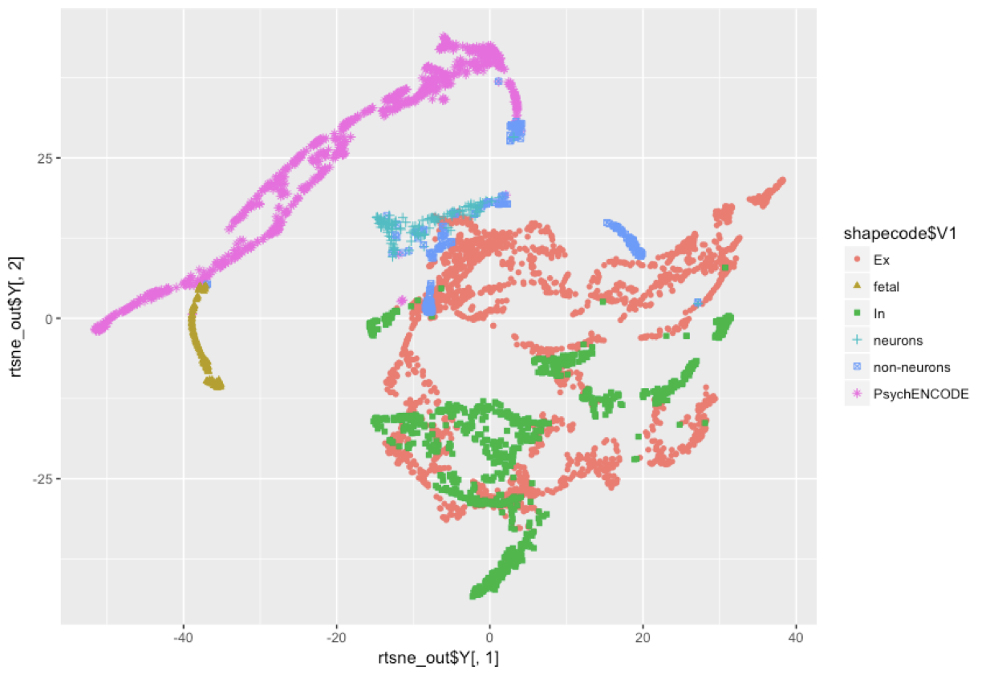
Fig. S2.3 t-SNE plot of the PsychENCODE and public single cell data Most of the PsychENCODE data were found to be clustered together with public developmental data in Darmanis et al. 2015.

S2.4 Deconvoluting brain tissue gene expression data using single cell data to estimate cell fractions
Since we used unsupervised approach (NMF) to decompose tissue expression and found NMF-PCs recovered the expression patterns (spaces) of both neuronal and non-neuronal cells. This suggests that the brain tissue expression is highly likely contributed by a linear combination of single cells. Thus, to more accurately identify the single cell fractions that determine the tissue expression, especially for various phenotypes/disorders, we further applied the supervised approach that uses the single cell expression data to deconvolve brain tissue expression data to find the fractions of different cell types of individual tissues.
In particular, the brain tissue gene expression matrix B (N by M) for a phenotype/disorder, where M is the number of tissue samples and N is the number of select genes (e.g., the cell biomarker genes), and the single cell gene expression matrix C(N by K), where K is the number of select cell types, we used the non-negative least square method to find a non-negative K by M matrix, W to minimize ||B-C*W||^2. The (i,j) element of W represents the linear combination coefficient of ith single cell type to jth tissue expression, which is proportional to the jth single cell fraction. In the deconvolution analysis, the gene expression quantified in TPM was transformed into log scale by log2(TPM+1).
We further evaluate the goodness-of-fit for the deconvolution model by calculating the coefficient of determination (also known as R^2), which accounts for the percentage of variance in the individual gene expression of tissue samples that has been explained by varying the cell proportions of cell types. Specifically, the variance in the gene expression of tissue samples is ||B||^2 and the variance that has not been explained by the model is ||B-C*W||^2. The R^2 can be calculated as 1-||B-C*W||^2/||B||^2, which was further normalized to adjusted R^2 by incorporating the degree of freedom. In addition, we deconvolved the tissue expression data and compared the cell fraction changes for various phenotypes and psychiatric disorders (Figs. S2.6 and S2.7). Fig. S2.8 shows the cell fractions across different ages. We found that Ex3 and Ex4 have significant increasing trend across age (trend analysis p<6.3e-10 and 1.5e-6), but some non-neuronal types such as oligodendrocyte are found to decrease (p<2.1e-14). Furthermore, these age-related cell changes are potentially associated with differentially expressed genes across age groups -- eg the gene involved in early growth response is down-regulated in older age groups, whereas ceruloplasmin is down-regulated among middle-aged groups (Fig. 2F). Also reduced microglia fractions for Bipolar and increased astrocyte fractions for SCZ.
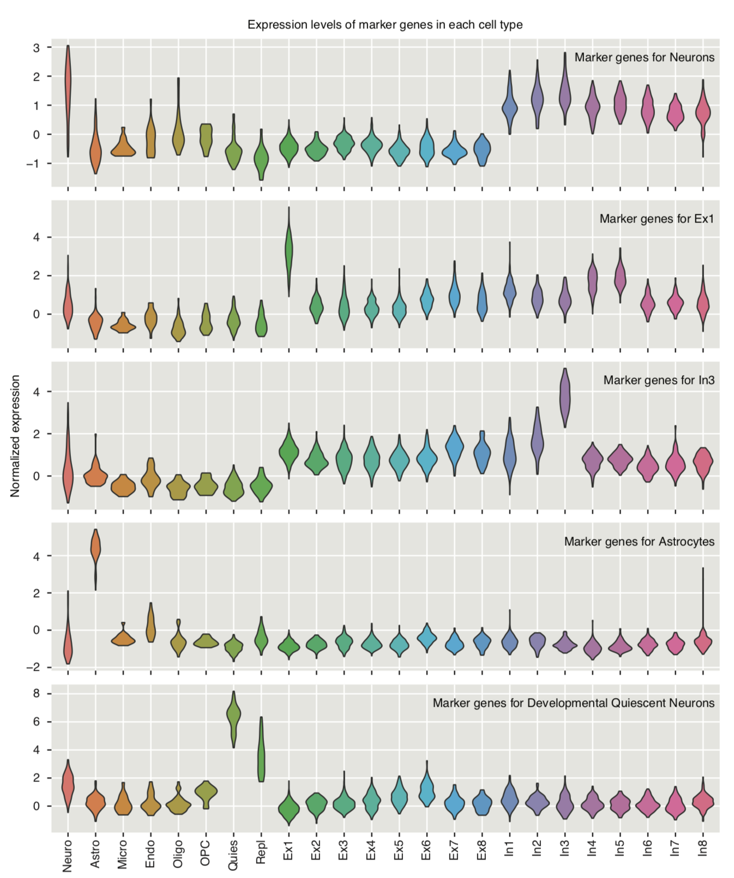
Fig. S2.4 Biomarkers show higher expression in the cell type from which they were defined than other cell types. Expression signatures of biomarkers are conserved in the newly constructed expression matrix which integrated multiple sources of single cell expression data.
We have validated our estimated cell fractions on a subset of samples from EPIMAP study with experimental measured NeuN+ fractions. Fig. S2.9 shows the NeuN+ fractions measured in experiment and estimated in our deconvolution analysis on 14 samples with RIN > 7.3. It can be seen that our estimation is very close to the experimental NeuN+ fractions.
We further compare the performance of deconvolution with one popular deconvolution tool CIBERSORT (Newman et al., 2015). We performed CIBERSORT to deconvolve the tissue expression data with given single cell data of selected 24 types and further calculated the variance explained as adjusted R-square (0.8132), which is lower than that of our deconvolution method (0.8779).

S2.5 Differentially expressed genes for brain phenotypes
We used the limma R package for linear modeling to find genes that are differentially expressed for neuropsychiatric disorders, sex, and brain regions. Normalized gene expression data is partitioned into the control and schizophrenia samples or male and female samples using the merged matrix. We then construct a design matrix representing these partitions, which we use to fit a linear model and estimate fold changes/standard errors, and then apply empirical Bayes smoothing to the standard errors. Output is represented in a table form or as a heatmap using the heatmap.2 R package. This pipeline is used for brain region analysis using gene expression data from GTEx, where either brain regions (Amygdala, Anterior cingulate cortex, Caudate, Cerebellar Hemisphere, Cerebellum, Cortex, Frontal Cortex, Hippocampus, Hypothalamus, Nucleus accumbens, Putamen, Spinal cord, Substantia nigra) or all brain samples are compared with select control tissues (Liver, Colon, Lung, Esophagus, Pancreas, Spleen, Stomach) for region-specific or brain-specific differential gene expression, respectively. In addition, the differentially expressed genes for psychiatric disorders were identified by (Gandal, M.J. et al., submitted).

S2.6 Gene co-expression network analysis
We use Weighted Gene Co-expression Network Analysis (WGCNA) to identify modules of co-expressed genes, both within tissues and between tissues (Zhang et al., 2005). Briefly, each gene is associated with a vector of normalized expression values across either individuals or tissues (using median expression). A weighted network is constructed where the weight between any two genes is a similarly score, calculated by normalizing the Pearson correlation of their expression vectors to lie between 0 and 1, and raising this to the power $β$.
We follow Zhang et. al. in setting $β$ such that connectivity of the network is as close to scale-free as possible (using the $R^{2}$ statistic described in Zhang et. al.). The genes are then hierarchically clustered using a topological overlap score, which compares how similar the patterns of connection are from each node to all other nodes, and disjoint modules are extracted using the Dynamic Tree Cut algorithm (Langfelder et al., 2008). We further extract further submodules in addition to the disjoint modules extracted by WGCNA, by adding the subtrees formed on each merge where both left and right subtrees are larger than a minimal size (which we take to be 30 genes). To find brain specific modules/submodules using clusters calculated on median expression variation across tissues, we further calculate the module eigengenes (as described in Zhang et. al.), and calculate the correlation of each eigengene with a binary vector which is 1 for brain regions and 0 otherwise. We call a module ‘brain specific’ if this correlation is significant at the 0.001 level (under a permutation test of the tissue labels).
Our co-expression analysis indeed found several modules with eigengenes showing very different expression levels between brain and non-brain samples (Fig. S2.5), which suggests that brain-specific regulatory mechanisms drive these brain co-expression modules (Gandal, M.J. et al., submitted).

S2.7 Gene expression and DNA Methylation over aging
To find the effect of age in gene expression, we selected genes which had significant correlation with age. Samples were segregated by age bins of 20 years and five bins were used (0-20, 20-40, 40-60, 60-80, 80-100). Gene expression was estimated using the unformily processing with PsychENCODE RNA-seq pipeline (See S2.1.3). Fig. S2.10 displays 90 protein-coding and non-coding genes that correlate with age. In particular, EGR1 (early growth response - ENSG00000120738.7) and CP (ceruloplasmin - ENSG00000047457.9) are displayed. Similarly, we processed array methylation data to investigate the effect of aging in promoter and enhancer methylation. Data from (Jaffe et al., 2016) was used. We used the normalized (scaled) proportion of methylated CpGs across individuals age bins near gene TSS (Fig. S2.11).
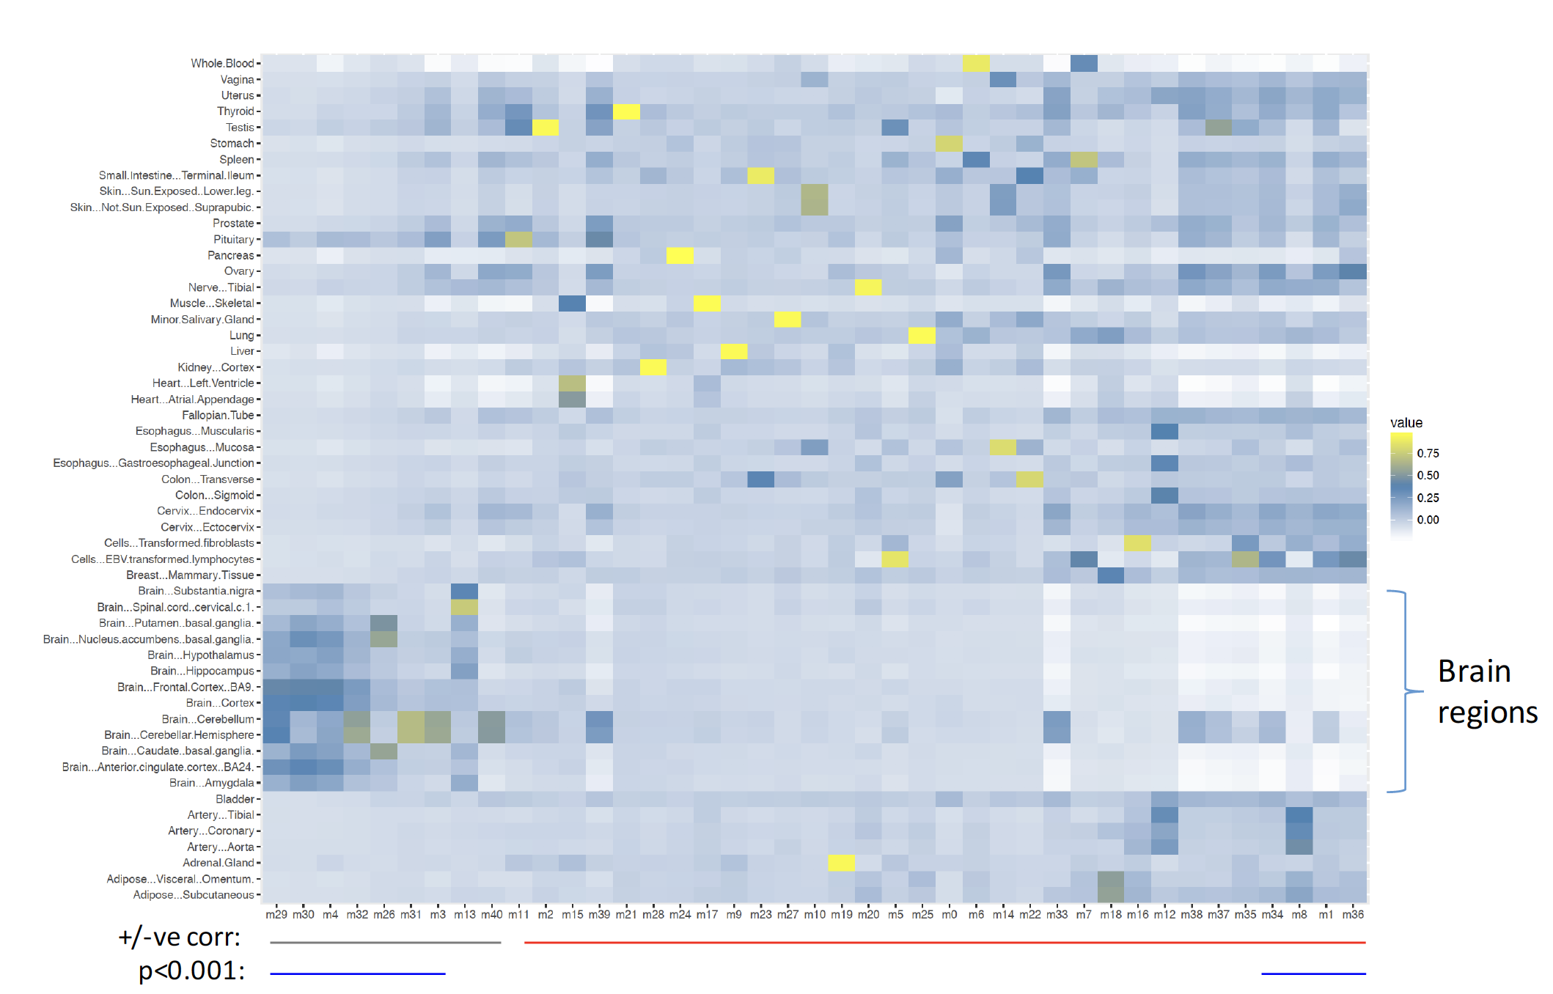
Fig. S2.5 Brain specific co-expression modules and submodules Module eigengenes are plotted as columns, which are ordered by the degree to which their expression is specific to the brain (see text). Lines beneath the plot show positive (green) and negative (red) correlations, with correlations which are significant at the p<0.001 level (either positive or negative) highlighted (blue).

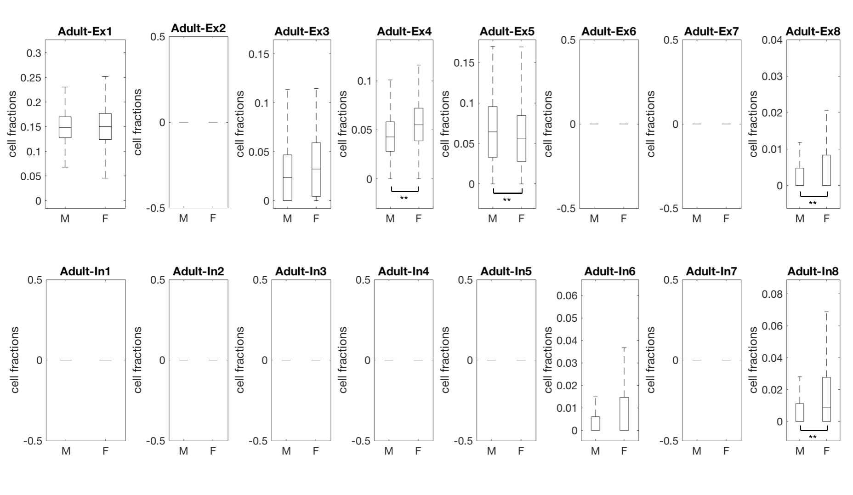
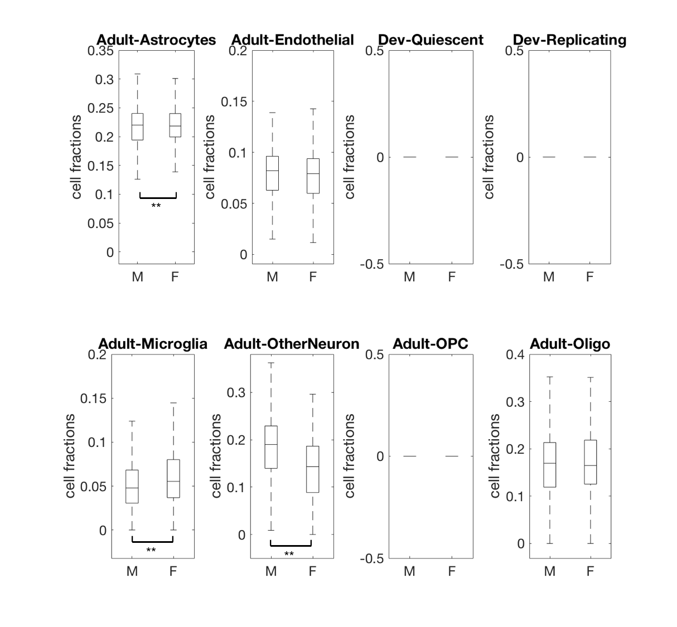
Fig. S2.6 Estimated cell fractions of 24 selected cell types in control samples The cell types with significant changes (FDR < 0.05) between genders after balancing age distribution are labeled with **.
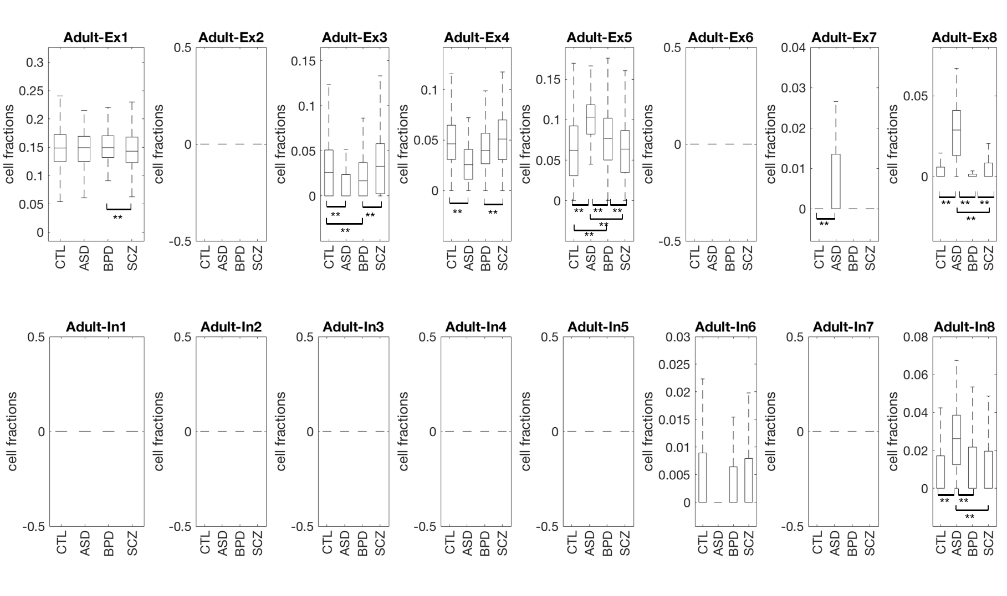
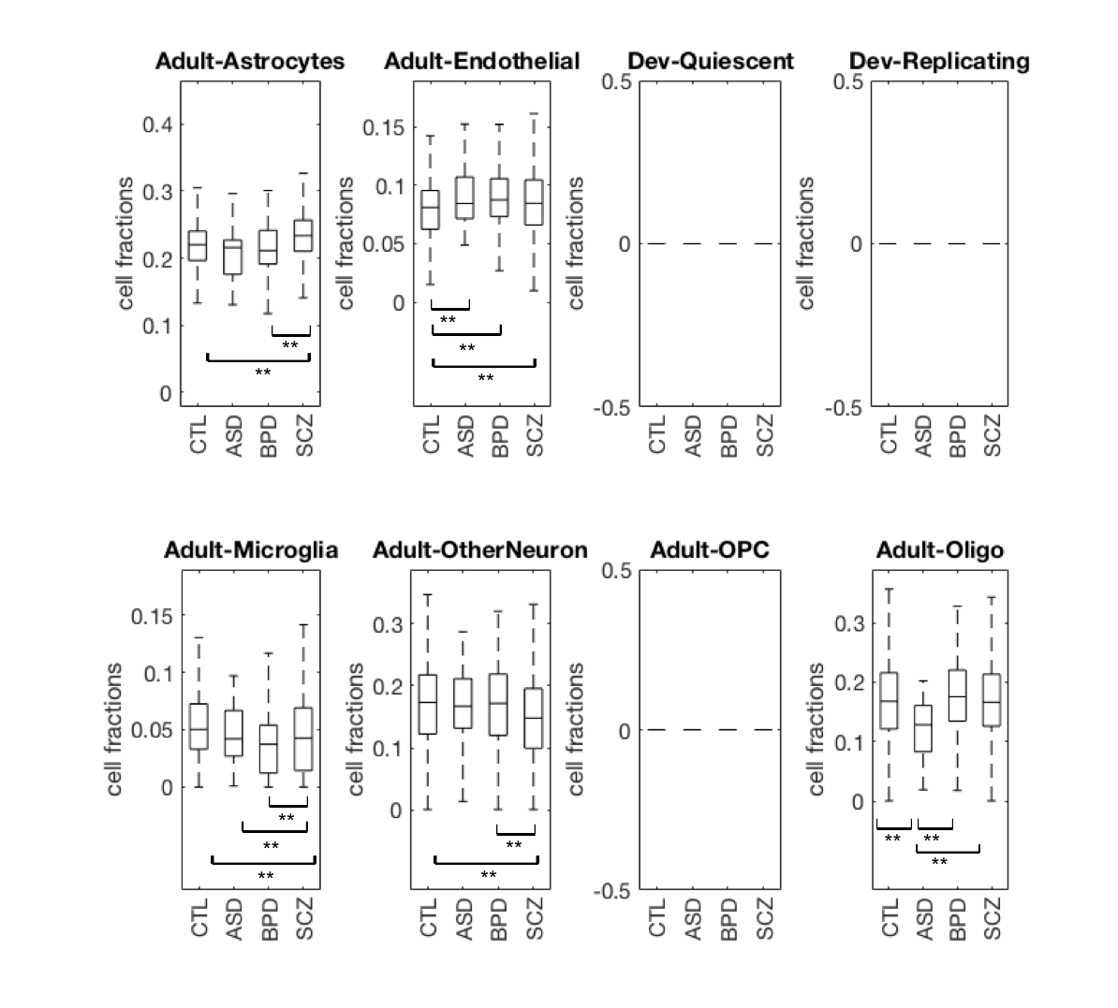
Fig. S2.7 Estimated cell fractions of 24 selected cell types in samples with different disorders For each cell type, the boxes with double stars (**) indicate the disorder types that show significant difference (FDR < 0.05) after balancing the age distribution.

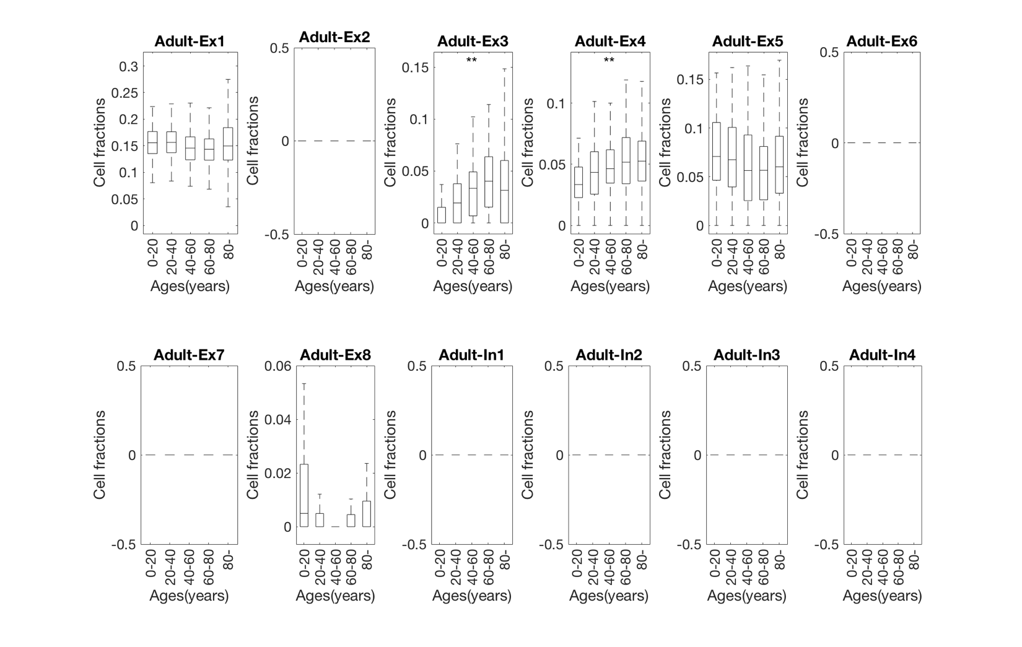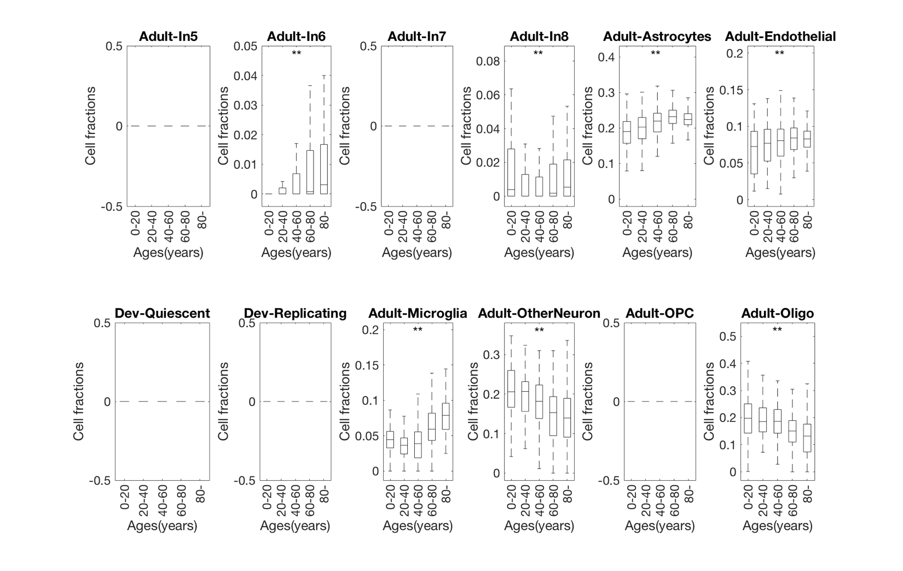
Fig. S2.8 Estimated cell fractions of 24 selected cell types in control samples with different ages The cell types showing significant increasing/decreasing trend across ages (trend analysis p-value < 1e-2) were labeled with double stars (**).
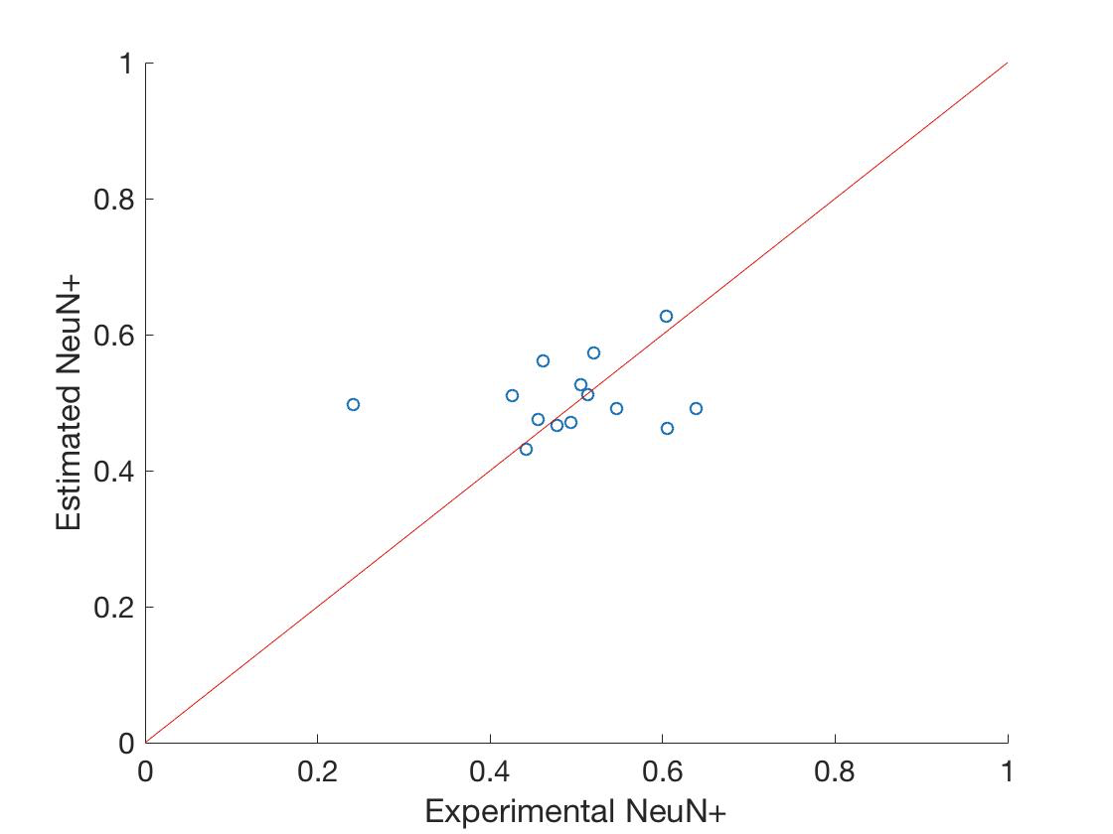
Fig. S2.9 Validation of estimated cell fractions from deconvolution X-axis shows the NeuN+ cell fractions measured in experiments and y-axis shows the NeuN+ cell fractions estimated from deconvolution. The median error is 0.04.

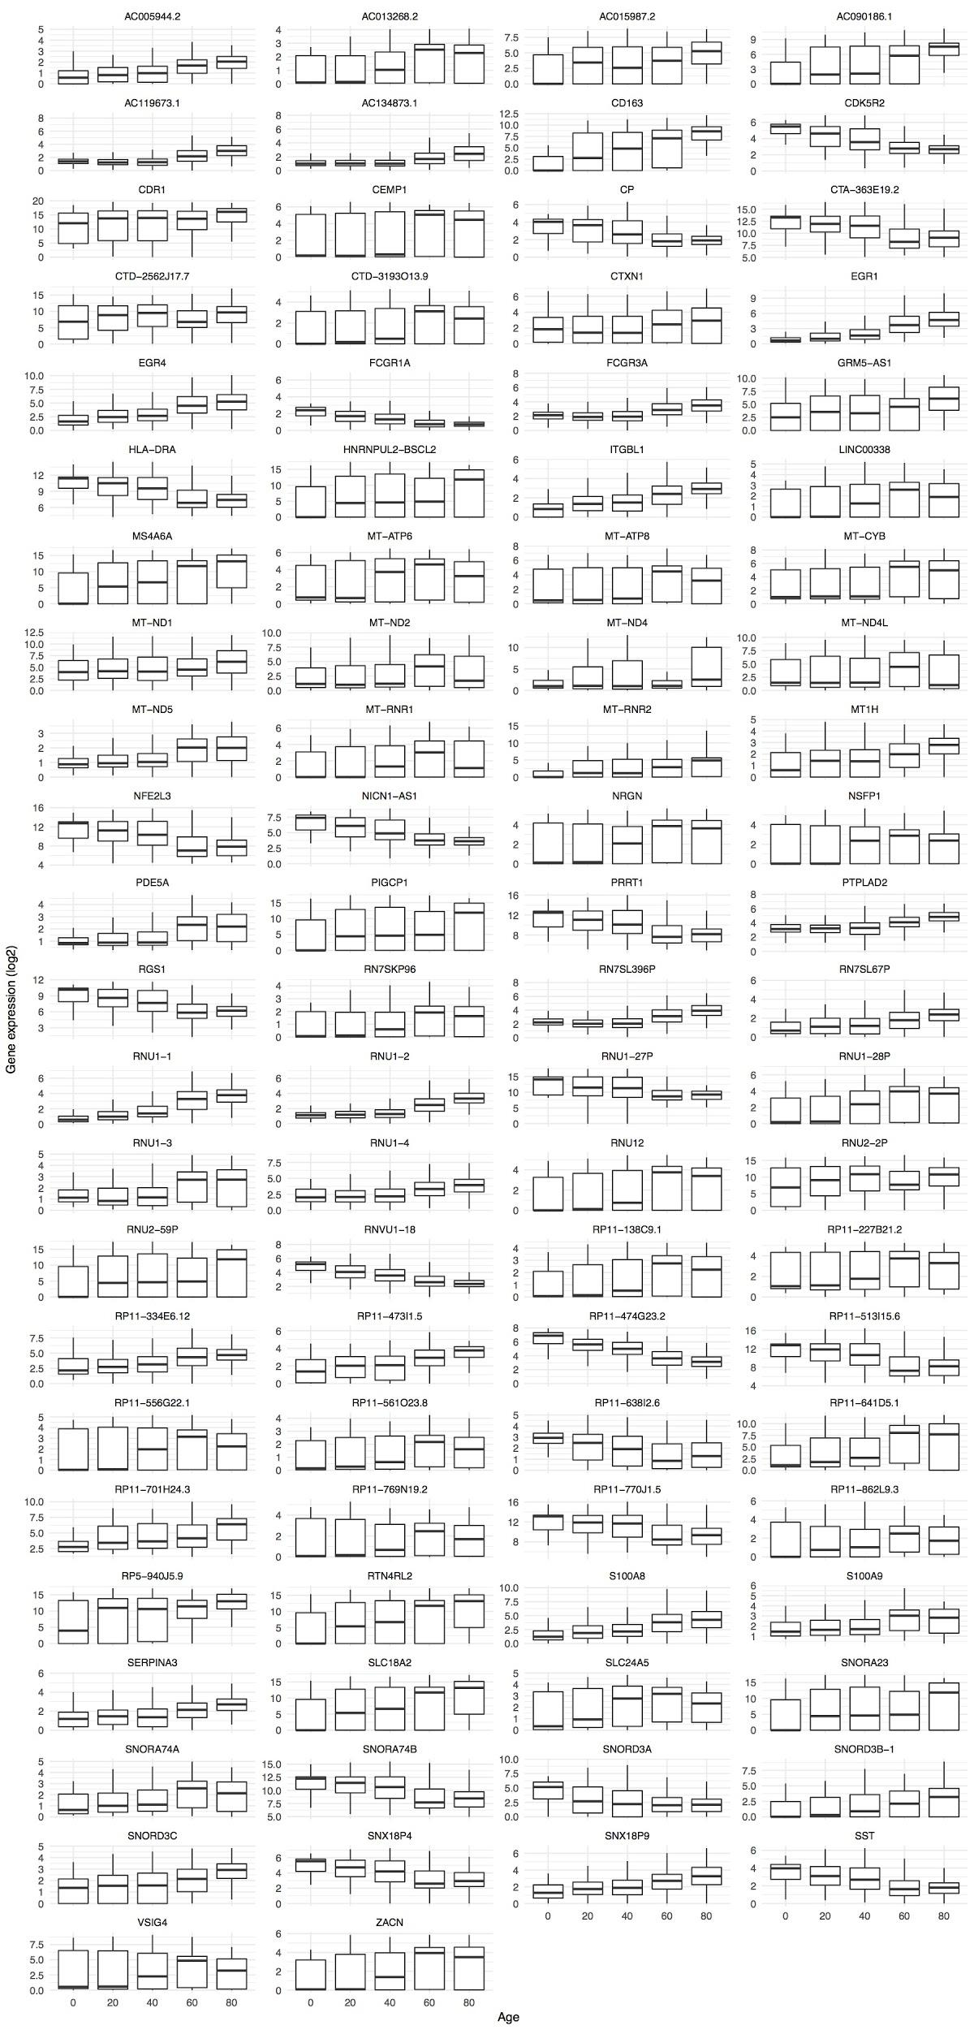
Fig. S2.10 Gene expression variation in the human brain across ages. X axis shows 5 bins of age and Y axis the log2(rpkm) for genes positively or negatively correlated with age. Each panel refers to a gene, identification is made by ENSEMBL id.
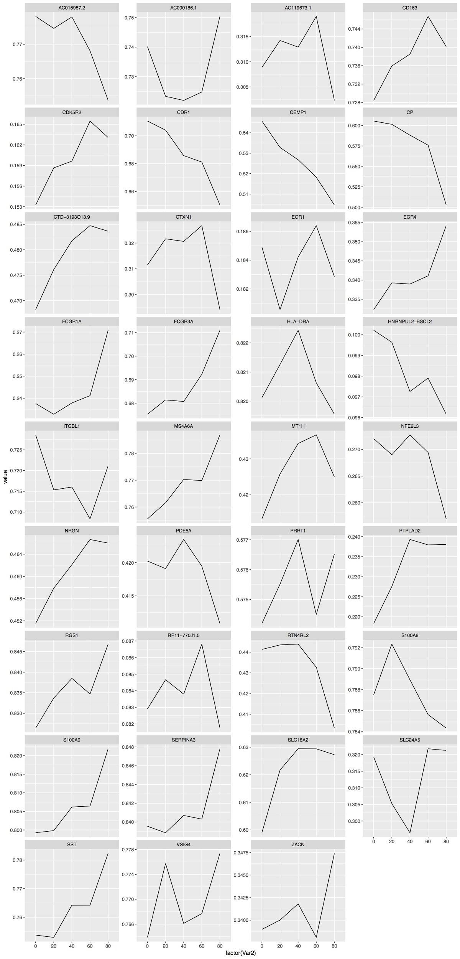
Fig. S2.11 Promoter and Enhancer region methylation of genes correlated to aging. Genes with methylation data available were assessed for their methylation status. X axis shows 5 bins of age and Y axis the normalized distribution of methylation near the gene TSS. Each panel refers to a gene, identification is made by gene name.

S3. Supp. content to main text section "Enhancers"

S3.1 PsychENCODE ChIP-seq
We use the modified parallel version of ENCODE ChIP-seq pipeline (Fig. S3.1). This is improved over the ENCODE pipeline for histone marks using the workflow system snakemake for more efficient computation(https://github.com/weng-lab/psychip_snakemake ). The original ENCODE pipeline can be found at https://goo.gl/KqHjKH.

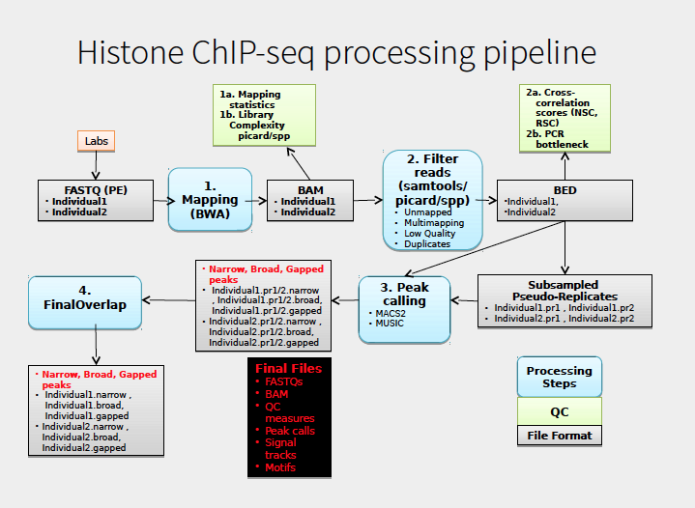
Fig. S3.1 PsychENCODE Histone ChIP-seq processing pipeline. This pipeline is modified based on ENCODE pipeline for histone. FASTQ files were aligned using BWA and then the reads were filtered to get only unique mapped reads for peak calling using MACS2. Pseudo-Replicates were generated before peak calling for each individual to find robust peaks. NSC, RSC and PCR bottleneck were generated for QC.

S3.2 Epigenomics Roadmap, ENCODE ChIP-seq for identifying regulatory regions
We incorporated ChIP-seq datasets from the Roadmap Epigenomics Consortium and the ENCODE project in our analysis. To integrate them consistently with the PsychENCODE dataset, ChIP-seq experiments are uniformly processed using ENCODE standard pipeline (See below section 2.3 S), including alignment, quality control and peak-calling. Each released experiment consists of the raw sequencing data (in FASTQ), and processed output, including alignment files, signal files and peak files.
With the set of uniformly processed ChIP-seq experiments, a comprehensive statistical model was used to generate a registry of candidate regulatory elements (cREs) for major cell lines and tissues (Moore et al, under review). The cREs are based on a combined set of high quality DHSs. For a particular cell or tissue, z-scores for DNase, H3K4me3, H3K27ac and CTCF is calculated for these high-quality DHSs. Using the maximum z-score across all cell types and the distance to the nearest TSS, the cREs were classified into promoter-like elements, enhancer-like elements and regions bound by CTCF only. As described in later sections (2.6 S and 2.10 S), we use the epigenetics signals of these cREs to annotate enhancers, calculate cQTLs, and perform comparative chromatin signal RCA analysis.

S3.3 Activated brain enhancers
To annotate a set of active enhancers, we uniformly processed the H3K27ac, H3K4me1 and H3K4me3 ChIP-seq data from the reference brain using the standard ENCODE pipeline. We also processed the ATAC-seq data generated on the same reference. Supplemented by the DNase-seq and ChIP-seq data of the PFC from ENCODE and Roadmap Epigenomics project, we identified 79,056 active enhancers. An active enhancer is considered to be in open chromatin regions (ATAC-seq signal or DNase signal Z-score > 1.64), with H3K27ac and H3K4me1 signals (Z-score > 1.64), which are characteristic markers for enhancers. To exclude promoters, we excluded regions with enriched H3K4me3 signals. These identified enhancer regions largely overlap with ChromHMM enhancer annotations of the prefrontal cortex (>90%).
We uniformly processed 150 H3K27ac ChIP-seq data from healthy individuals, 50 each from PFC, PC and CB respectively. For each sample we called H3K27ac peaks using the standard ENCODE ChIP-seq pipeline. The H3K27ac peaks were pooled across the cohort, generating a total of 37,761 H3K27ac pooled peaks in PFC, 42,683 in TC, and 26,631 in CB. Each pooled peak is present in more than half of the samples in its corresponding brain region. Note that while the numbers of aggregate peaks are smaller than the number of reference enhancers, they actually cover a larger fraction of the genome as the average width of H3K27ac peaks was larger than that of reference enhancers).
To investigate the enhancer activity across population, we intersected the set of active enhancers identified in the reference sample with the H3K27ac PFC ChIP-seq peaks in each individual from the cohort. Any H3K27ac peaks intersecting with the reference enhancers are considered as active enhancers in the corresponding individual. Among the 50 healthy samples, a median of 53,976 (~70%) enhancers from the reference brain were found active in the cohort. We also examined the cumulative number of reference enhancers that could be found in the cohort with individuals sorted by the number of overlapping enhancers, as shown in Fig. S3.2. The cumulative number grows fast at the beginning, and saturates at the 20th person of the sorted cohort. We hypothesis that pooling together the active enhancers of 20 people should recover most of the potential regulatory elements in brain prefrontal cortex.
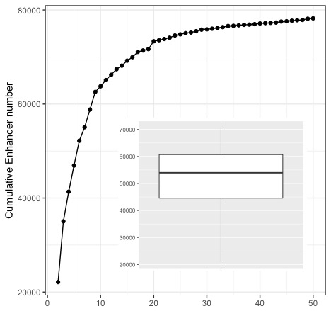
Fig. S3.2 Active reference brain enhancers in the population The dotted line shows the cumulative number of identified reference sample enhancers in the cohort, which saturates at the 20th individual from the sorted cohort. The boxplot shows the number of identified reference enhancers found active in each individual, with the lower and the upper boundaries of the box showing the first and the third quantiles.

S4. Supp. content to main text section "Consistent comparison"

S4.1 Spectral analytic approaches (PCA, tSNE, RCA) to compare transcriptomic and epigenomic data across brain and other tissues
One key aspect of our analysis is that we, as consistently as possible, processed the transcriptomic and epigenomic data from PEC, GTEx (GTEx Consortium, 2017) and Epigenetic Roadmap (Kundaje et al., 2015). This consistent processing allows us to compare the brain to other organs in a consistent fashion to assess if the human brain has unique gene expression and chromatin activities. This comparison could not be achieved without such a large-scale uniform data processing. We attempted several methods for an appropriate comparison, in particular, we used methods to reduce the dimensionality of genes or enhancers to compare the underlying structure of brains and other tissues. Principal component analysis and t-SNE are two popular techniques, but we found the former tend to be overly influenced by data outliers, and t-SNE tends to just uniformly separate all the clusters and not give one a sense of the overall effect; i.e., PCA tends to capture global structures, ignoring most of the local structure, but it can easily be influenced by outliers (Johnstone et al., 2009).
On the other hand, t-SNE tends to separate samples from the same tissue so that the cluster distances on t-SNE space are not proportional to real gene expression dissimilarities, and thus does not give a sense of overall effects (Maaten et al., 2008). Therefore, we found another very useful technique to be Reference Component Analysis (RCA), which projects the gene expression in individual sample against a reference panel, and then essentially reduces dimensionality of individual projections (Li et al., 2017). Moreover, as shown in Fig. 3E, all the brain tissue samples from the different projects tend to group together, which is a consequence of our uniformly processing.
In order to perform a RCA analysis, we first built a reference gene expression panel based on GTEx which consists of the average expression for genes across a panel of tissues. To select the genes in this panel we searched for expression outliers, e.g. genes which at least one sample had delta log10(rpkm) higher than 1. This yielded 4,162 coding and non-coding genes in the reference panel. Average expression level for these genes were extracted from the GTEx v6 average expression file. We next used the gene expression from uniformly processed PsychENCODE and GTEx samples and select only the genes in the 4,162 genes in reference panel. We then calculated the correlation between each sample x reference tissue pair and built a correlation matrix.
Finally, to extract structures from the dataset, we performed PCA on the correlation matrix. Median sample was defined as the median PC1 and PC2. In order to account for sample variance within tissues we fit the PC1 and PC2 into a multivariable Gaussian distribution and plot the ellipse defined by median PC1, PC2; width and height equal to one standard deviation in PC1 and PC2 space respectively. We calculated the distances between tissues and samples. Overall, the distance of the brain centroid to other tissues is approximately an order of magnitude higher than the distance between brain samples. Distance was calculated using Euclidean distance on RCA space (Fig. S4.1, Table S4.1 and S4.2).
In order to assess which genes were responsible for differences in RCA PC1 space we simulated RNA-seq samples with a step function equal to discrete changes in gene expression. For each step we selected the gene representing the biggest change in the PC1 dimension. We simulated 5,253 steps, path is represented by the dark like moving from brain to other tissues (Fig. S4.2). In total 1,226 gene selected multiple times as the biggest change in the PC1 dimension. Selecting top ranked genes and performing Reactome term enrichment analysis with panther resulted in enriched for brain pathways.
Similar to the transcriptome RCA analysis, we built a reference panel using H3K27ac signals overlapping CREs as previously define. For reference tissues, we used uniformly processed Epigenome RoadMap samples and calculated the average H3K27ac signals across CREs. We further filter outlier CREs to select informative CREs. Similar to the transcriptome analysis we selected CREs with average signal across the CRE higher than 0.1 from 40 tissues. That filter yielded 5,506 reference CREs. Similar to the transcriptome analysis we calculated the correlation between each sample and the reference tissue pair and built a correlation matrix and perform PCA analysis at the correlation space. Median and Ellipses were calculated as described above. To remove batch effects from H3K27Ac we used well established methods. First we computed the PCA in RCA space and selected the first principal component, indeed, most of the variance in the first component was derived from experimental differences. In order to consistently compare transcriptome and epigenome we selected tissues on roadmap that were also represented in the transcriptome RCA analysis. Namely, we used roadmap_brain, esophagus, liver, lung, pancreas, spleen and uterus. We also calculated a PCA analysis for these samples (Fig. S4.3).

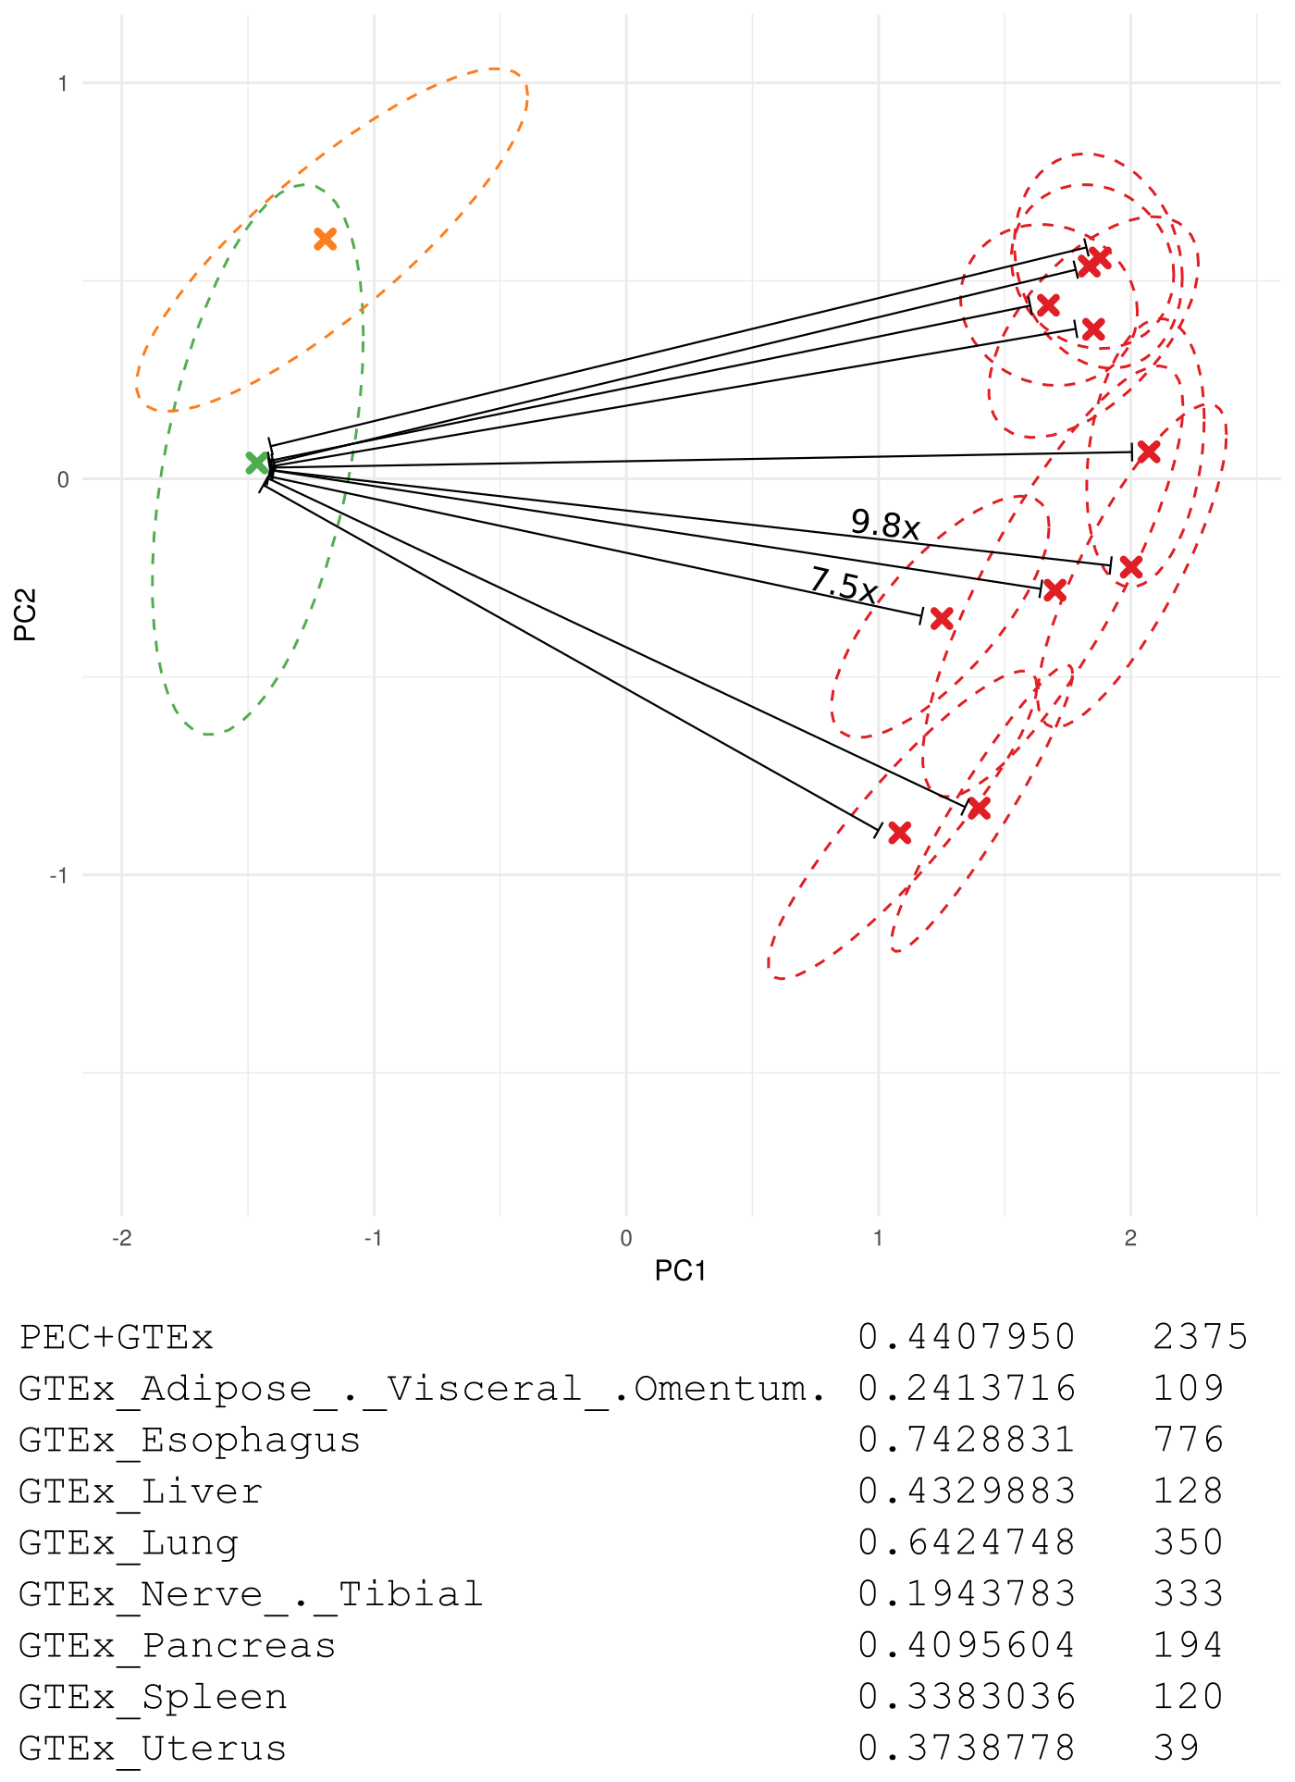
Fig. S4.1 Distances between brain to other tissues centroids Transcriptome RCA plot as in Fig. 3, brain samples distribution are displayed in green and orange. Other tissues in red. Euclidean distance was calculated between all centroids (Table S4.1) and normalized by the median brain distance (Table S4.2)

 | PEC | Adipose | Esophagus | Liver | Lung | Nerve | Pancreas | Spleen | Uterus
PEC | 0.00
Adipose | 4.32 | 0.00
Esophagus | 4.01 | 0.56 | 0.00
Liver | 3.32 | 1.69 | 1.85 | 0.00
Lung | 4.25 | 0.37 | 0.84 | 1.39 | 0.00
Nerve | 3.86 | 0.67 | 0.15 | 1.78 | 0.90 | 0.00
Pancreas | 3.35 | 1.13 | 1.17 | 0.69 | 0.93 | 1.10 | 0.00
Spleen | 3.66 | 1.38 | 1.63 | 0.39 | 1.05 | 1.59 | 0.61 | 0.00
Uterus | 4.07 | 0.46 | 0.10 | 1.82 | 0.76 | 0.23 | 1.16 | 1.58 | 0.00
Table S4.1 RCA centroid distances Euclidean distance was calculated between all tissue centroids in RCA space.

 | PEC | Adipose | Esophagus | Liver | Lung | Nerve | Pancreas | Spleen | Uterus
PEC | 0.00
Adipose | 9.80 | 0.00
Esophagus | 9.11 | 1.27 | 0.00
Liver | 7.54 | 3.83 | 4.19 | 0.00
Lung | 9.64 | 0.83 | 1.91 | 3.16 | 0.00
Nerve | 8.76 | 1.51 | 0.35 | 4.05 | 2.05 | 0.00
Pancreas | 7.61 | 2.56 | 2.66 | 1.57 | 2.12 | 2.49 | 0.00
Spleen | 8.31 | 3.12 | 3.69 | 0.89 | 2.38 | 3.61 | 1.39 | 0.00
Uterus | 9.24 | 1.05 | 0.22 | 4.13 | 1.72 | 0.53 | 2.63 | 3.59 | 0.00
Table S4.2 RCA centroid distances normalized by median interbrain distance. Euclidean distance was calculated between all tissue centroids in RCA space and normalized by median brain distance.
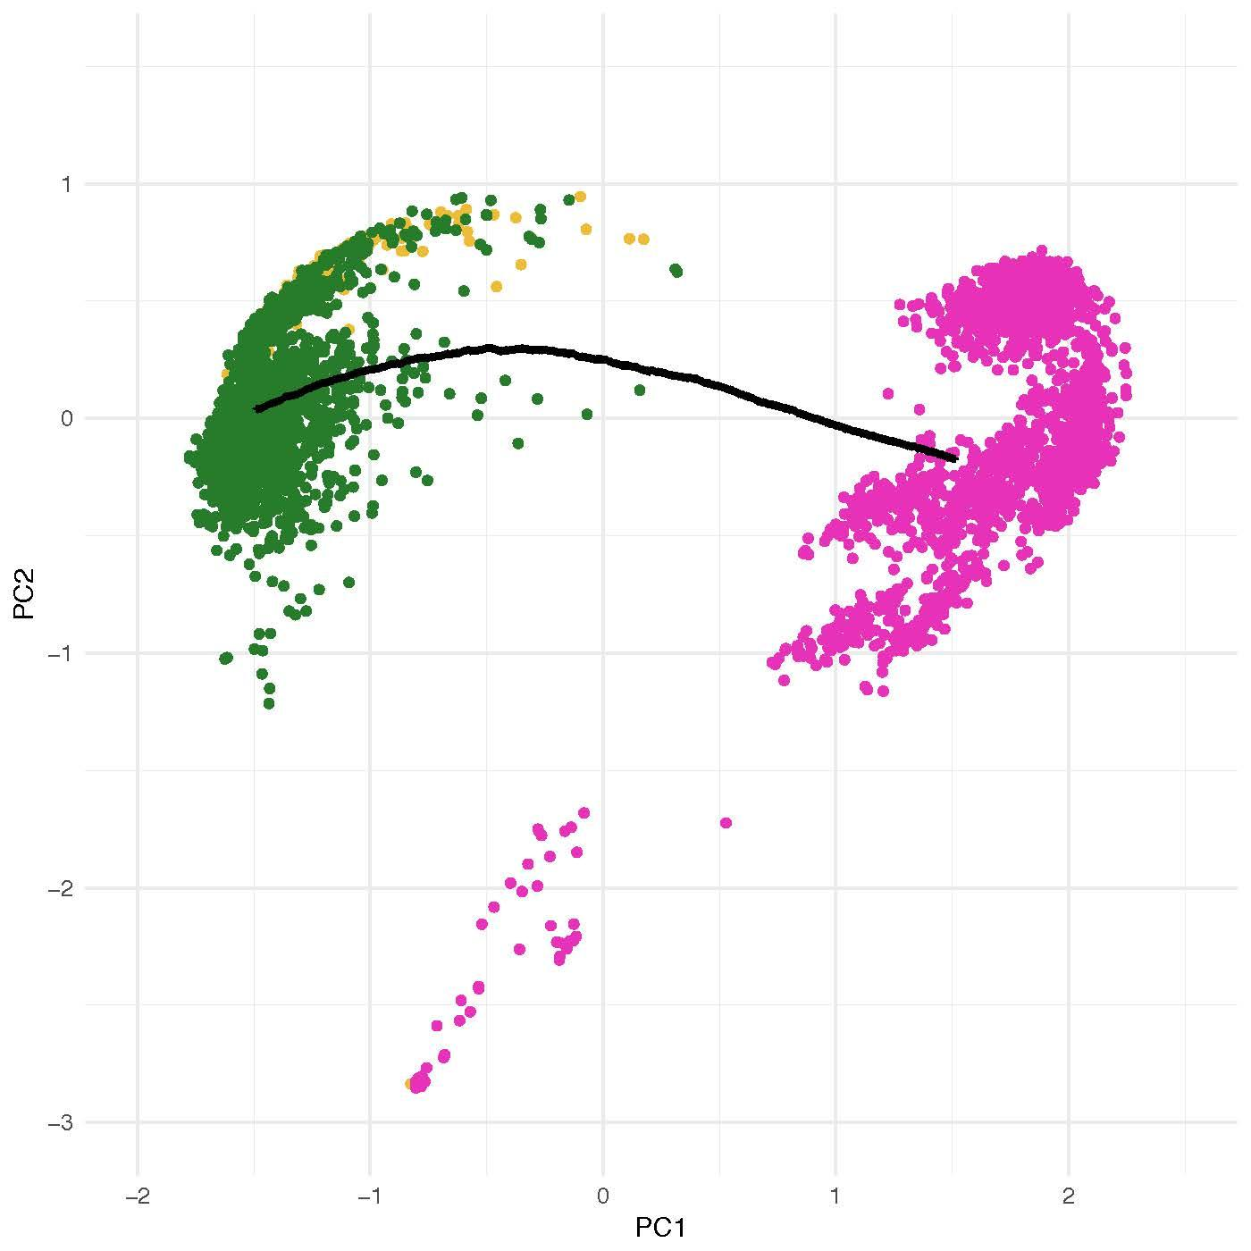
Fig. S4.2 Assessment of most impactful genes in PC1 dimension. All analyzed RNA-seq samples are displayed. Green and yellow samples are brain samples and pink samples were extracted from other tissues. Dark line represents hypothetical samples with gene expression changes.

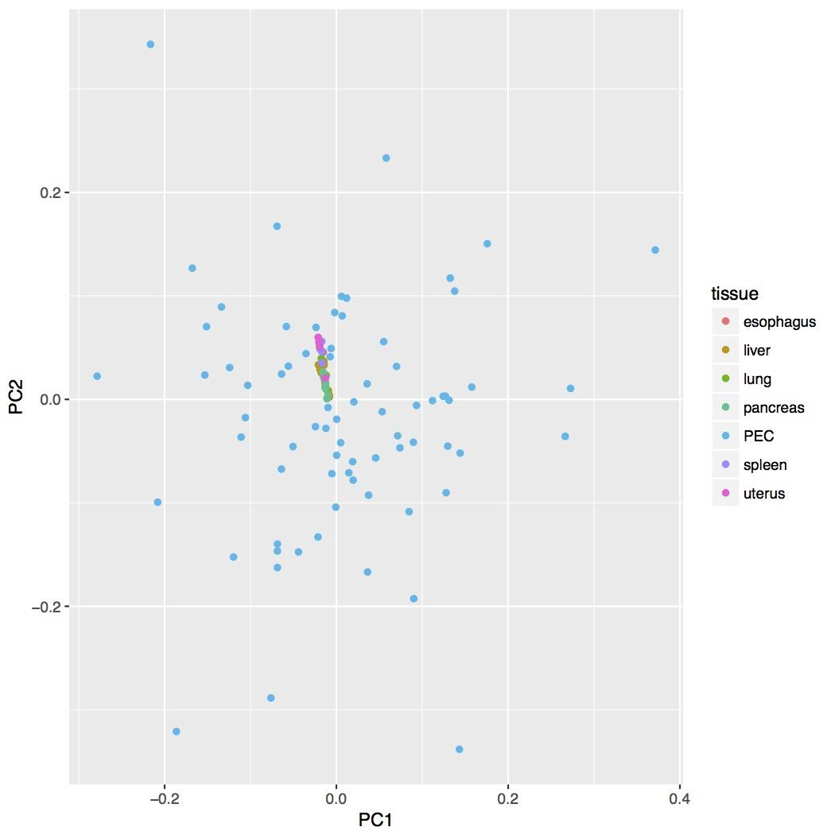
Fig. S4.3 PCA plot for regulatory data. H3K27Ac signals were used to calculate the PCA after batch correction. Brain samples are scattered in both PC1 and PC2 while roadmap samples are clustered together.

Reactome pathways | # | # | expected | Fold Enrichment | +/- | P value
Serotonin Neurotransmitter Release Cycle | 17 | 4 | .16 | 25.01 | + | 4.14E-02
Neurotransmitter Release Cycle | 50 | 6 | .47 | 12.75 | + | 1.68E-02
Neuronal System | 337 | 14 | 3.17 | 4.41 | + | 8.43E-03
Dopamine Neurotransmitter Release Cycle | 22 | 5 | .21 | 24.15 | + | 4.52E-03
Table S4.3 Reactome pathway enrichment for most impactful genes in RCA PC1 dimension. Pathway enrichment for the pop genes selected in the Fig. S4.2 analysis

S4.2 Non-coding RNAs and TARs
We used uniformly processed RNA-seq signal data from healthy individuals from GTEx 6p and PsychENCODE to quantify the expression activity of annotated and non-annotated regions of the human genome. In order to create signal files we used alignment files (bam files) as input to RSEM to create both uniquely aligned and multiple aligned signal tracks. Singal values were normalized within samples using the total number of reads mapped to the genome and generating RPM values. We divided the genome into bins of 100 base pairs of the genome and calculated the average expression (RPM) in windows. We finally selected regions in the genome with RPM higher than 0.1 to filter transcriptionally active regions. The union of all bins in the human genome above the threshold was used to build the resource of active regions of the human brain. To estimate the proportion of coding and non-coding (i.e. non-coding and unannotated) regions we overlapped active regions to the GENCODE v19 annotation. For each annotation class we estimated the cumulative proportion of coding and non-coding regions (Fig. S4.4).
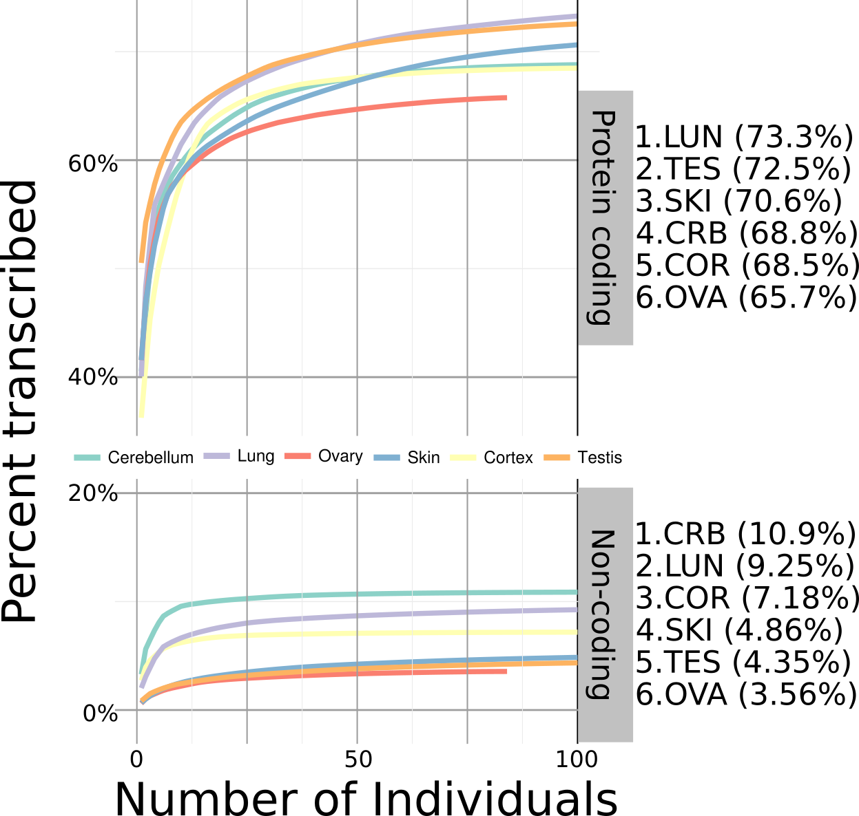
Fig. S4.4 Cumulative distribution of transcribed regions in the human brain and other tissues. Y axis shows the cumulative transcribed proportion of annotated and unanotated regions (coding or non-coding). X axis shows the number of transcriptomes (or individuals) analyzed. Labels on the right hand side of the figure display the max cumulative proportion found.

We finally fit the curves on Fig. S4.4 to cumulative exponential curves to estimate a per tissue upper bound of the proportion of coding and non-coding transcribed regions. We observe that most tissues are transcriptomically saturated at approximately one hundred individuals. Moreover, while a large (65-75%) of the coding transcriptome is active, only (3-10%) of the non-coding transcriptome is active. On the other hand, the absolute number of nucleotides active in non-coding regions (which include non-annotated regions) is much larger than coding regions. On Fig. 3, we estimated inter-tissue variability by calculating the cumulative transcriptome diversity as stated above, inter sample diversity is was defined as the average diversity across samples in a tissue based fashion. Values displayed on Fig. 3 are normalized by average diversity in coding and non-coding regions respectively. The Inter sample variability was estimated by calculating the mean difference. Absolute values for coding and non-coding transcriptome diversity were also estivated.

S5. Supp. content to main text section "QTL analysis"

S5.1 Genotype data processing
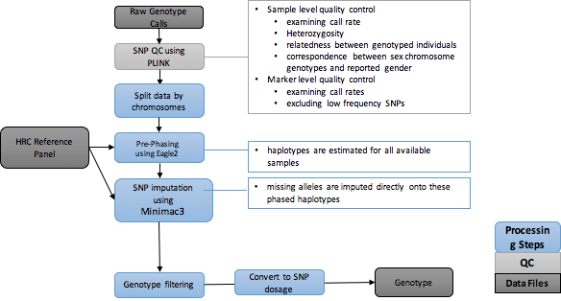
Fig. S5.1 PsychENCODE genotype data processing pipeline The raw genotype data were called and converted to PLINK files. We run initial quality sample level and marker level using PLINK. The QCed genotype data were then prepared by prephasing using Eagle2. The prephased data were imputed using Minimac3 and HRC. After imputation we filtered genotype using R2>0.3 to get high quality impuation data.
(The later required large-scale imputation for all the PsychENCODE datasets, and we make full genotype sets available).

S5.1.1 Genotyping arrays, data generation and quality control
Genotyping was done on several different genotyping platforms listed in supplemental table S5.1 and section S9. Initial QC was performed using PLINK (Purcell et al., 2007) to remove markers with: zero alternate alleles, genotyping call rate < 0.95, Hardy-Weinberg p-value < 1 x 10-6, and individuals with genotyping call rate < 0.95. We also corrected strand flipping problem using snpflip (https://github.com/biocore-ntnu/snpflip).

S5.1.2 Imputation of genotypes
Genotypes of all studies were imputed using an uniform genotype QC and imputation pipeline in order to streamline quality control and genotype imputation of genome-wide single nucleotide polymorphism (SNP) data. This imputation pipeline consists of three primary, independent modules: (1) pre-imputation data processing and quality control; (2) principal components analysis (PCA) of raw genotype data; (3) genotype imputation of untyped variants; and (4) post-imputation statistical analysis. Briefly, in the pre-imputation step, input genotype data (PLINK binary format) is reformatted for downstream analysis, and initial summaries of classic technical parameters (e.g. minor allele frequency, per-individual and per-site missing rates, case/control missingness, Hardy-Weinberg equilibrium) are produced.
Datasets | #samples | DataPlatform
BipSeq | 179 | Illumina_1M and Illumina_h650
LIBD_szControl | 493 | Illumina_1M, Illumina_Omni5, Illumina_h650
CMC_HBCC | 696 | Illumina_1M, Illumina_Omni5, Illumina_h650
BrainSpan | 41 | HumanOmni2.5
CommonMind | 620 | IlluminaInfiniumHuman Omni Express Exome 8 v 1.1b chip
GTEx | 450 | Illumina OMNI 5M or 2.5M
BrainGVEX | 418 | Affymetrix6.0, PsychChips
UCLA-ASD | 97 | Omni-2.5 and Omni-2.5-Exome
Table S5.1. Summary of genotype data generated in PsychENCODE and used in our paper Most of these studies used different genotyping platforms. There were overlap of the individuals in BipSeq, LIBD_szControl and CMC_HBCC studies and the number of total individuals of these three studies are 896.

The second module consists of genotype PCA using peddy (Pedersen et al., 2017) to identify ancestry structure (Fig. S5.2). In the third module, prior to imputation, SNP positions, identifiers, and alleles are aligned to the relevant reference genome assembly using LiftOver, and genotype data is divided into chromosomes and overlapping segments for parallel haplotype pre-phasing and imputation using eagle2 and Minimac3 on the Michigan Imputation Server (Das et al., 2016). We used the recently released HRC Reference Panel for imputation. In the final module, we use the summary of R2 from Minimac3 to evaluate the imputation accuracy and only keep imputed snps with R2>0.3 for QTL analysis.

S5.2 eQTL and isoform QTL
We used a very conservative approach for eQTL and isoQTL processing. We adhered closely to the GTEx pipeline, and we benchmarked our results with direct comparisons to available data files in the GTEx portal (gtexportal.org) and published GTEx results. We used the QTLtools software package for eQTL and isoform QTL (iso-QTL) identification. Following the normalization scheme used by GTEx, the gene expression matrix was normalized using quantile normalization, followed by inverse quantile normalization to map to a standard normal distribution. Probabilistic Estimation of Expression Residuals (PEER) factors, genotype PCs, gender and respective study were used as covariates in our calculations to identify cis-eQTL and trans-eQTLs. For cis-eQTLs, we calculated the associations between gene expression and variants within 1Mb window of each gene TSS. These calculations were performed using genotype and gene expression data from 1387 individuals (associations between a total of 43,854 genes and 5,312,508 variants were evaluated for potential QTLs).
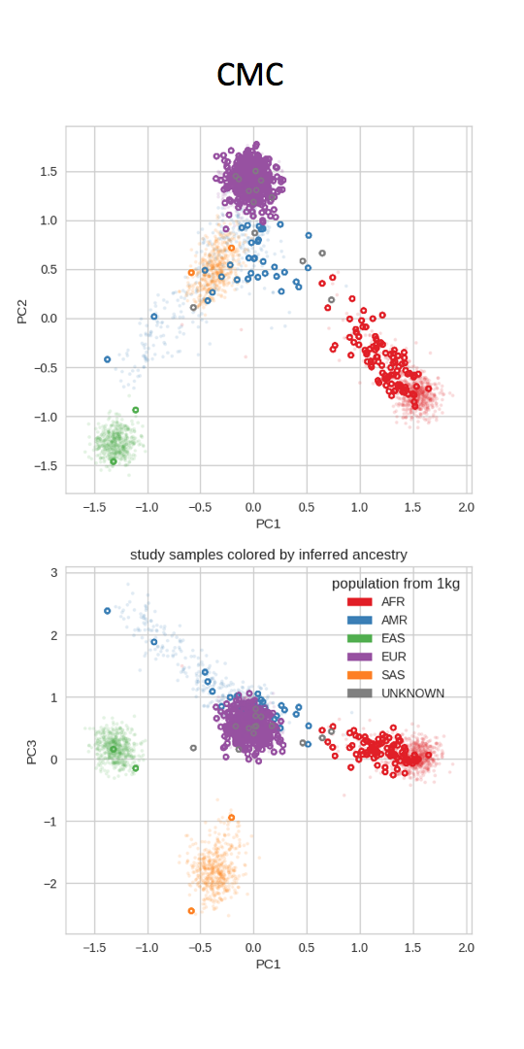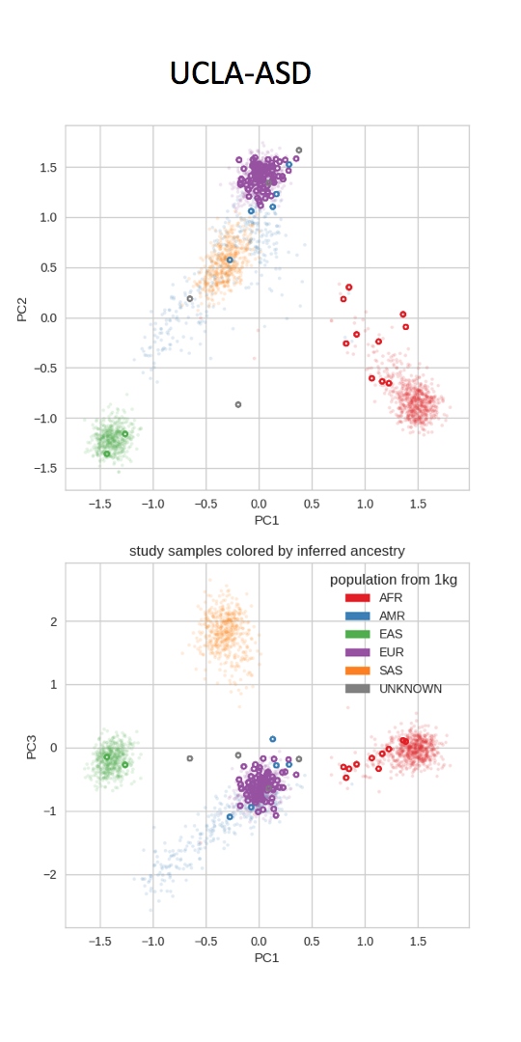
Fig. S5.2 Genotype PCs showing the population structure in CMC and UCLA-ASD studies. These figures showed that the first 3 genotype PCs could capture most of the population structures. The top panels showing genotype PC1 vs PC2. The bottom panels showing genotype PC1 vs PC3. We could see that a majority of the individuals in these two studies are from EUR population.

We then performed multiple testing correction on nominal P values by limiting FDR values to those below 0.05. At this FDR threshold, we identified 2,542,908 significant cis-eQTLs. Because of the effects of linkage disequilibrium (LD), many of the eQTL SNPs for the same gene were correlated. We thus pruned such SNPs for a given gene by restricting the genotype correlation coefficient (r² ) values to exceed 0.5. Enforcing this threshold of r² >0.5 resulted in 373,686 eQTLs.
These conservative approaches for searching for eQTLs identified a substantially larger number of cis-eQTLs and eGenes than previous brain eQTL studies. This may reflect the greater statistical power offered by our very large sample size.
We also identified 157,592 iso-QTLs. iso-QTLs were identified using the similar pipeline to that in our search for eQTLs. For 1,147 individuals, we used isoform percentages of 43,820 transcripts using the same set of variants that were used in our search for eQTLs.

S5.3 cQTL
To calculate cQTLs, we used the uniformly processed ChIP-seq data from PsychENCODE (3 different brain regions) and Roadmap ChIP-seq data for different tissues. cQTLs were calculated using candidate regulatory regions (cREs). We first extend (in rare cases truncate) each cRE to 1kb (a typical enhancer’s size). We calculate the average signal on each of the extended regions across PsychENCODE and roadmap samples. We identified 74 individuals from UCLA_ASD and 218 from Epidiff correlating this signal matrix with nearby variants within 1Mb window of the peak center. Then we use the QTLtools for cQTL calculation using FDR<0.05 and identified the most significant snp for each enhancer.

S5.4 Cell fraction & residual QTL
We used the QTLtools package (Delaneau et al., 2017) to calculate the cell fraction and residual QTLs based on the cell fractions and estimated residuals. QTLtools was run in nominal pass mode to identify fQTLs. We used gender and disease as covariates. To best deal with population structure as potential confounding factor, we restricted our analysis to European adult samples, which comprise a substantial subset of all available genotyped data (Fig. S5.3A).
We take the conservative approach of defining significant fQTLs to be those associated with Bonferroni-corrected p-values of no more than 0.05. Taking this approach, we identified 9 different cell types (Ex3, Ex4, Ex5, In6, In8, Astrocytes, Microglia, and Endothelial cells). These 9 cell types are those which exhibit fQTLs when using gender and disease status as covariates. We find that different cell types exhibit considerable heterogeneity in terms of their abundance within the set of high-confidence fQTLs (Fig. S5.3B). The SNVs associated with these fQTLs coincide with 106 distinct SNVs associated with cis-eQTLs. A supplementary data file listing all fQTLs (along with associated data) is available online.
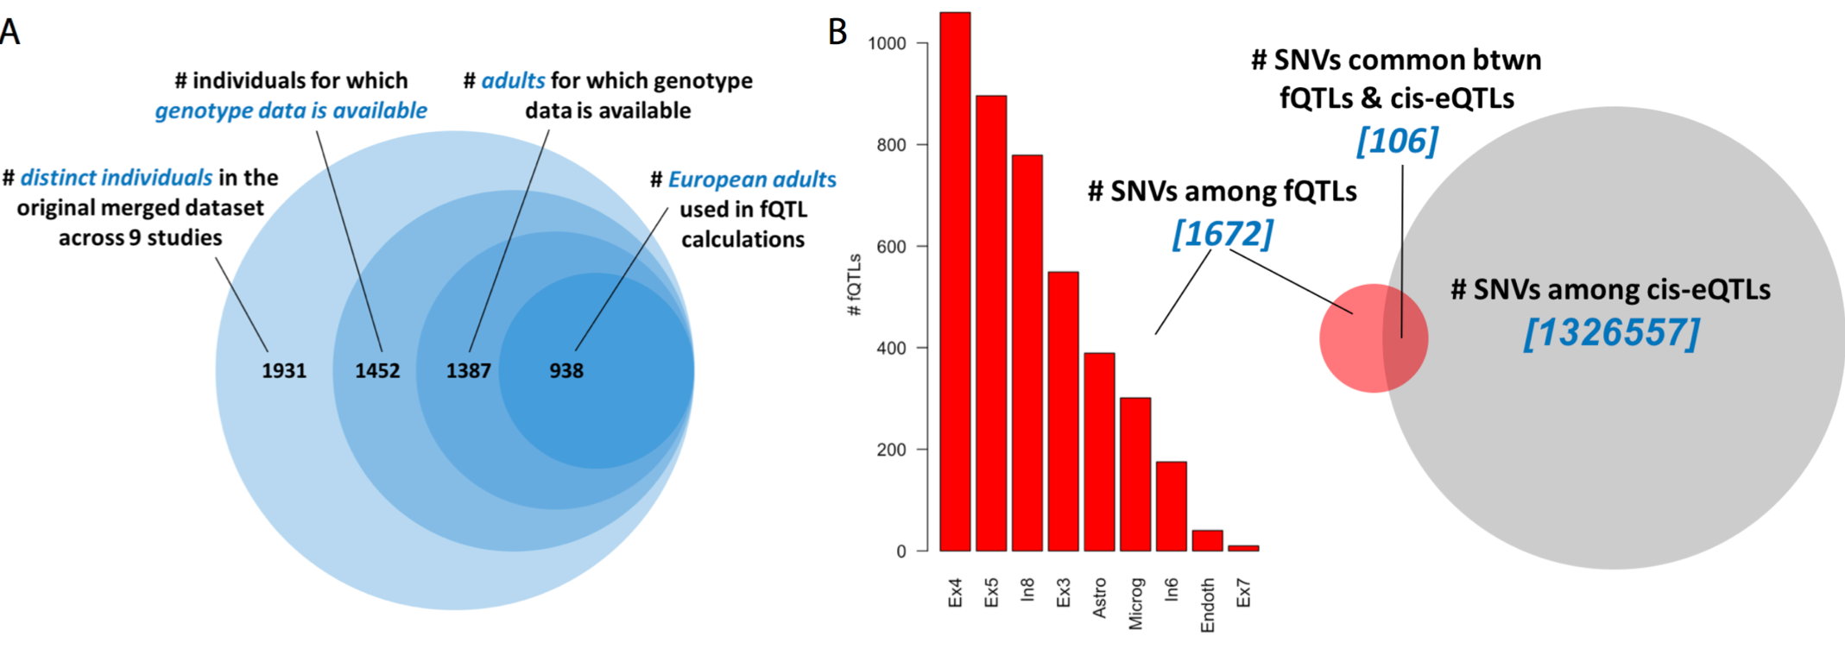
Fig. S5.3 Datasets, counts, and cis-eQTL overlaps associated with fQTLs A. In calculating fQTLs, we restricted our analyses to a 938 European adult samples for which genotype data is available. B. The histogram on the left represents the counts for the number of fQTLs across 10 different cell types. These fQTLs encompass 1672 distinct SNVs, of which 106 (6.3%) also appear among the cis-eQLTs.

S5.5 QTL replication and sharing
We evaluated the replication of GTEx and CommonMind PFC eQTLs in our study using π₁ statistic (Storey et al., 2003; Ng et al., 2017) which could estimate the proportion of eQTLs that were significant based on the p value distribution in our dataset. In this calculation, we used top SNPs from our eQTLs and find the overlap with the eQTL SNPs in GTEx and CommonMind. Then we used the p values of associations between these overlapped SNPs with protein coding genes in 1Kb window to calculate π₁. We got π₁ values of 0.93 and 0.9 for GTEx and CommonMind respectively which indicated good replication rate. We also use π₁ statistic to investigate the sharing of SNPs between different types of QTLs in our study. In this case, we find the sharing SNPs between eQTL top SNPs and other QTL SNPs. Then the π₁ statistic was calculated based on the p values of the associations of these sharing SNPs with all genes in 1Kb window. We found that the π₁ value of cQTL is 0.89, which is the highest among all QTL SNP sharing comparisons.

S6. Supp. content to main text section "Regulatory networks"

S6.1 Generation of Hi-C libraries
Hi-C libraries were generated as previously described (Won et al., 2016). Briefly, adult dorsolateral prefrontal cortices (DLPFC) from three individuals (sample information provided below) were acquired through a Reference Brain Project as a component of the psychENCODE project. Frozen pulverized tissue (100mg) was homogenized in 2mL of ice-cold lysis buffer (10mM Tris-HCl pH8.0, 10mM NaCl, 0.2% NP40, protease inhibitor). Ten million nuclei were collected and chromatin was crosslinked in 1% formaldehyde (diluted in 1X PBS) for 10 min. Crosslinked chromatin was first digested by HindIII (NEB, R0104), and digested sites were labelled by biotin-14-dCTP (ThermoFisher, 19518-018). Proximity-based ligation was performed within nuclei to prevent random collision-based ligation (Rao et al., 2014). Biotin-marked DNA was then purified and sequenced by Illumina 50 bp paired-end sequencing.

S6.2 Hi-C data processing
Hi-C reads were mapped and filtered as previously described (Won et al., 2016) using hiclib (https://bitbucket.org/mirnylab/hiclib). Only cis reads (which refer to intra-chromosomal interactions) were used to construct contact matrices at 40kb and 10kb resolution for compartment and loop analyses, respectively. To obtain maximum resolution for loop detection (10kb), we pooled datasets from three individuals (see below for read depths for pooled samples). To compare interaction profiles in adult and fetal brain, we combined previously generated Hi-C datasets from two fetal cortical laminae to obtain comparable read depths (Won et al., 2016; see below for read depths for pooled samples).
Compartments were analyzed by calculating the leading principal component (PC1) values from Pearson’s correlation matrix generated from contact matrices in 40kb resolution. Regions with PC1s positively and negatively correlated with the gene density were defined as compartment A and B, respectively. TADs were called based on contact matrices in 40kb resolution using Hi-C domain callers (http://chromosome.sdsc.edu/mouse/hi-c/download.html). Briefly, the directionality index was calculated by measuring the degree of interaction bias of a given 40kb bin to its upstream (2Mb) and downstream (2Mb) regions, which was subsequently processed by a hidden Markov model.

Table S6.1 Summary of Hi-C datasets
Samples | Sample information | cis filtered reads | total filtered reads
HBS189 | Male 36yr  (Ancestry unknown) | 197,394,146 | 251,515,059
HBS106 | Male 64yr  (Ancestry unknown) | 170,057,582 | 209,571,512
HBS181 | Male 44yr  (Caucasian) | 243,396,052 | 299,801,452
Pooled samples Adult brain |  | 610,847,780 | 760,888,023
Pooled samples Fetal brain | Won et al., 2016 | 855,987,816 | 1,834,759,860

S6.3 Detection of promoter-based interactions
Promoter-based interactions were identified as previously described (Won et al., 2016). Briefly, we constructed background interaction profiles from randomly selected length- and GC content-matched regions to promoters (defined as 2kb upstream of transcription start sites based on Gencode v19). Using these background interaction profiles, we fit interaction frequencies into Weibull distribution at each distance for each chromosome using the fitdistrplus package in R. Significance of interaction from each promoter was calculated as the probability of observing higher interaction frequencies under the fitted Weibull distribution, and interactions with FDR<0.01 (which corresponds to P-values~1x10^{–4}) were selected as significant promoter-based interactions. In total, we detected 149,098 promoter-based interactions. We overlapped promoter-based interactions with genomic coordinates of TADs, and found that the majority (~75%) of promoter-based interactions were located within the same TADs.
We used a binomial test as previously described (McLean et al., 2010) to evaluate the epigenetic state enrichment of regions that interact with promoters, using a 15 state chromatin state model in adult prefrontal cortices (PFC) from Roadmap Epigenomics (Kundaje et al, 2015). To assess whether promoter-interacting regions are enriched in enhancer states, we calculated the significance of the overlaps by binomial probability of P=Pbinom(k>=s, n=n, p=p), when p = fraction of genome in enhancer states, n = the number of promoter-interacting regions, s = the number of promoter-interacting regions that overlap with enhancer states.
To assess whether epigenetic states affect their target gene expression levels, we used transcriptomic profiles of PFC from neurotypical individuals (see section S2.1). Quantile normalized expression values were log transformed and centered to the mean expression level for each sample using a scale(center=T, scale=F)+1 function in R. The centered expression values denote each gene’s relative expression level in a given individual, and were used throughout the integrative analysis. We selected genes that interact with enhancers (EnhG=Genic enhancers, Enh=Enhancers), promoters (TssA=Active transcription start sites, TssAFlnk=Active transcription start site flanking regions), bivalent enhancers (EnhBiv), and repressive states (Het=Heterochromatin, ReprPC=Polycomb repressive sites) and average centered expression values for each group were calculated and plotted.

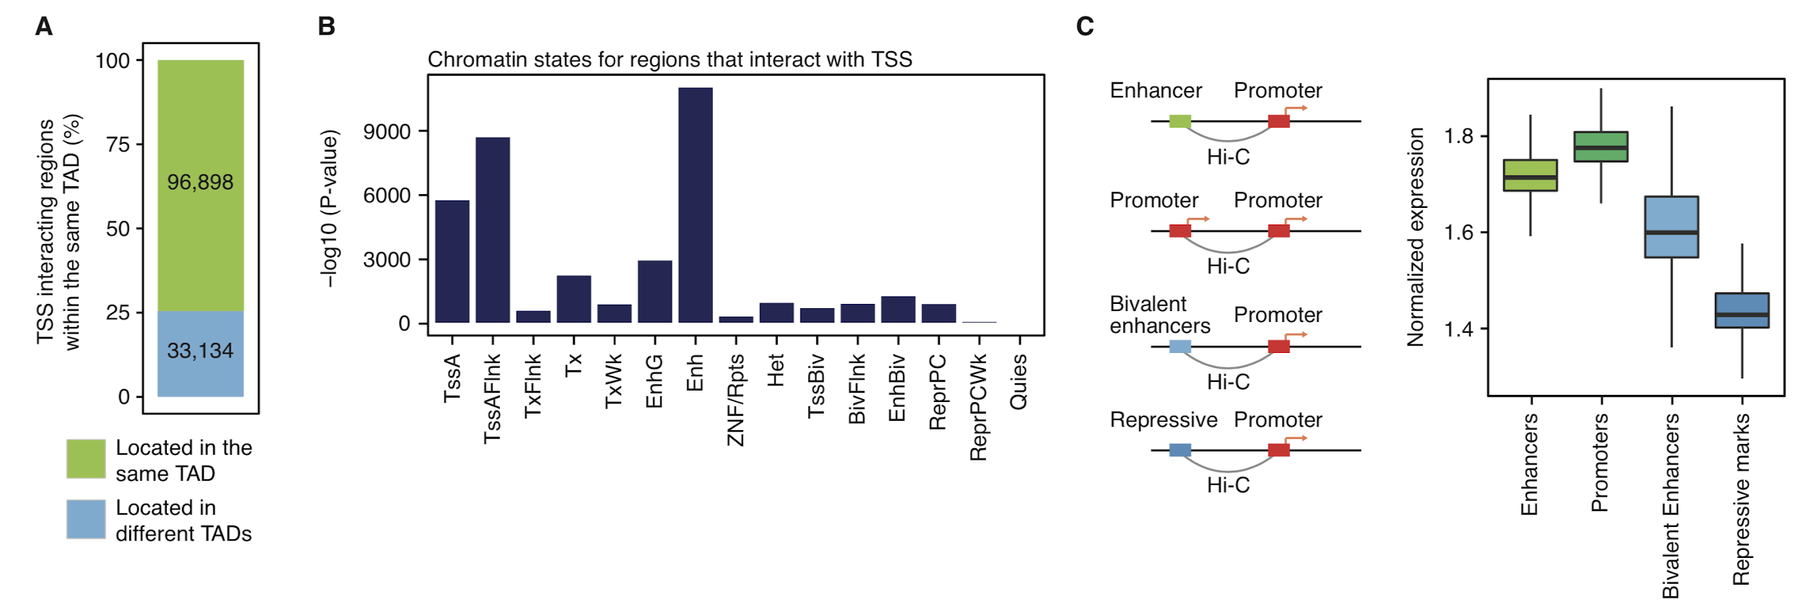
Fig. S6.1 Regulatory relationships in the adult cortex A. The majority of promoter-based interactions reside within the same topologically associating domains (TADs). B. Regions that interact with transcription start sites (TSS) are enriched with other TSS and enhancers. D. Distribution of the number of putative enhancers assigned to each promoter. E. Genes that interact with enhancers or promoters are more highly expressed than genes that interact with bivalent enhancers or repressive marks.

S6.4 Integrative analysis
Compartment changes across brain development. Genomic regions were classified into (1) regions that undergo compartment A to B switching from fetal to adult brain, (2) regions that undergo compartment A to B switching from adult to fetal brain, (3) regions that do not switch their compartments across brain development (stable).
Genes were then grouped according to the compartment categories they locate in, and centered expression values for each group were calculated. As our RNA-seq data mainly focus on adult brain transcriptome, we processed expression values from Kang et al. to generate centered expression values (Kang et al., 2011). Prenatal and postnatal centered expression values were plotted for each group of genes. We also overlapped chromatin states in adult PFC and fetal brain defined by chromHMM with compartment categories. We then counted the total number of each chromatin state in a given compartment category, which was subsequently normalized by the size and the number of total chromatin states in that compartment category. We compared these normalized counts for each chromatin state between fetal and adult brains using the Fisher’s exact test.
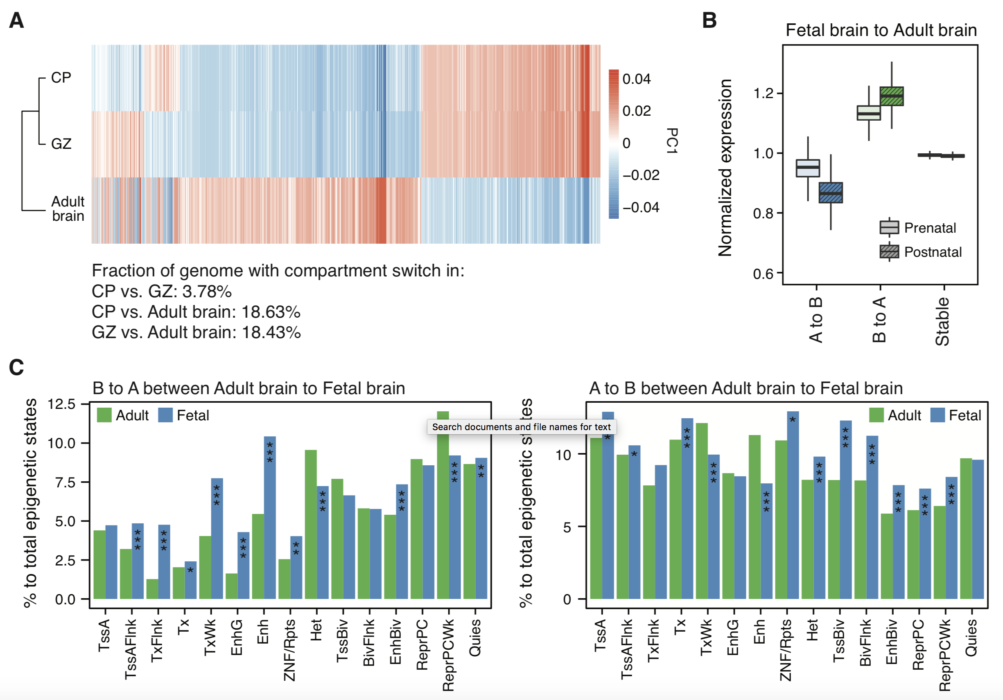
Fig. S6.2 Compartment switching across brain development is associated with expression and epigenetic changes A. Heat map of the first principal component (PC1) values for regions that undergo compartment switching between fetal brain (CP and GZ) and adult brain. B. Brain expression levels for genes located in compartments that switch during development. C. Fraction of epigenetic states for regions that undergo compartment switching across brain development. For example, B to A shift in adult to fetal brain is accompanied by an increased proportion of active promoters (TssA, TssAFlnk), transcribed regions (Tx, TxWk), and enhancers (EnhG, Enh), and a decreased proportion of repressive elements (ReprPCWk) and heterochromatin (Het) in fetal brain compared with adult brain. *P < 0.05, **P < 0.01, ***P < 0.001. P values from Fisher’s test.

Regulatory relationships across brain development. To compare the shared proportion of enhancer-promoter interactions in fetal vs. adult brain, we first collapsed putative enhancers (identified as promoter-based interactions) to each gene. We generated enhancer-gene links (e.g. chr10:100130000:ENSG00000230928) from fetal and adult brain and directly compared them. According to this analysis, 30.8% of enhancer-gene links detected from adult brain were also detected in fetal brain.
Using chromatin states defined by chromHMM (Kundaje et al., 2015) in fetal brain and adult PFC, we defined regulatory regions according to their developmental state changes: (1) Both active: elements that are active in both adult and fetal brain, (2) Fetal active: elements that are active in fetal brain and become repressive in adult brain, (3) Adult active: elements that are repressive in fetal brain then become active in adult brain. Active elements were defined as TssA, TssAFlnk, EnhG, Enh, while repressive elements were defined as Het, ReprPC, ReprPCWk (weak Polycomb repressive sites), and Quies (quiescent states). These elements are referred as developmental regulatory elements. Since developmental regulatory elements contain both promoters and enhancers, we then overlapped them with the promoter coordinates used to detect promoter-based interactions (see section S6.3). In total, we identified 6 types of developmental regulatory elements: both active promoters, both active enhancers, fetal active promoters, fetal active enhancers, both active promoters, both active enhancers.
We next assigned genes to developmental regulatory elements: elements that overlap with promoter coordinates were directly assigned to their genes based on linear genome, while the ones that do not overlap with promoter coordinates were thought as enhancers and assigned based on promoter-based interactions either from adult or fetal brain. Fetal active enhancers were assigned to their target genes based on fetal brain Hi-C, adult active enhancers were assigned based on adult brain Hi-C data, while both active enhancers were assigned based on both adult and fetal brain Hi-C data. In total, this analysis leads to 7 groups of genes that were linked to each element: both active promoters-linear assignment, fetal active promoters-linear assignment, adult active promoters-linear assignment, both active enhancers-fetal Hi-C, both active enhancers-adult Hi-C, fetal active enhancers-fetal Hi-C, adult active enhancers-adult Hi-C. Average centered expression values were calculated and plotted for each group, and gene ontology (GO) enrichment for each group was assessed using GoElite v77 (http://www.genmapp.org/go_elite/).
We also processed single cell expression values (in log2(TPM+1) forms, see Section S2.2.2) by centering to the mean expression level for each cell using a scale(center=T, scale=F) function in R. This results in centered expression values denoting each gene’s relative expression level in a given cell, hereby referred as cell-level centered expression values. We then calculated average cell-level centered expression values for each group of genes mapped to distinct types of developmental regulatory elements.

Relationships between the enhancer number and gene expression. To measure the relationship between enhancer numbers and gene expression level, we integrated promoter-based interactions, brain active enhancers, and expression data. As enhancers and Hi-C interactions were defined in different resolution (Hi-C was defined at 10kb bin level, while enhancers were defined at much higher resolution), we clumped enhancers within 10kb bins so that they match with the Hi-C resolution. Intersecting brain active enhancers and promoter-based interactions led to 17,719 bin-level enhancer-promoter interactions. We grouped genes based on their number of interacting enhancers and their average centred expression values were calculated and plotted for each group. We also identified 90,015 enhancer-promoter interactions when we didn’t clump enhancers into a bin-level..

Cis-regulatory relationship mediated by chromatin interactions. We overlapped eQTLs, isoQTLs, and cQTLs (hereby referred as QTLs) with Hi-C to measure the proportion of cis-regulatory relationship mediated by 3D interactions. As the type of chromatin interactions that mediate cis-regulatory relationship has not been well understood, we did not want to restrict our interaction search space into promoter-based interactions. Therefore, we first obtained chromatin interaction profiles of QTLs and then overlapped the profiles with (1) gene coordinates both at the exon and promoter levels (eQTL/isoQTL) or (2) coordinates of chromatin marks (cQTL).

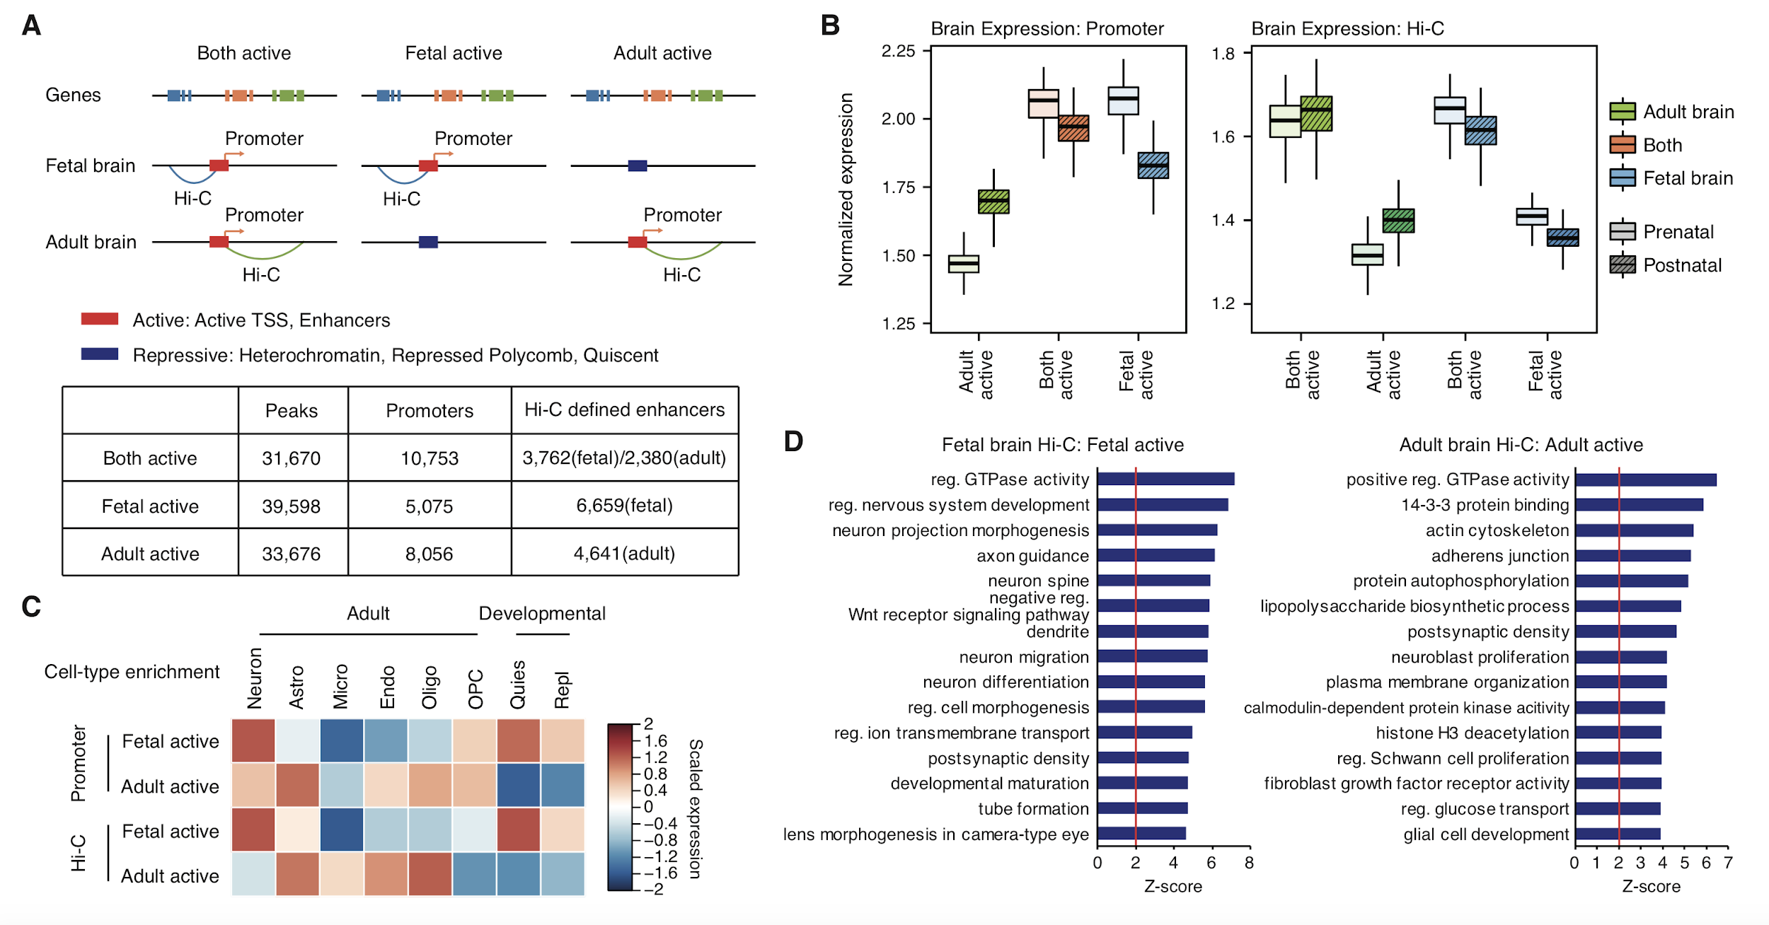
Fig. S6.3 Dynamics of chromatin landscape across brain development A. A schematic showing how brain regulatory elements were mapped to their putative target genes based on chromatin interaction profiles. Brain regulatory elements were first grouped into three categories: regulatory elements that are active in both developmental epochs (both active), regulatory elements in fetal brain (fetal active), and regulatory elements in adult brain (adult active). Brain regulatory elements that reside within promoters were directly assigned to their target genes (promoter-based assignment), while intergenic/intronic regulatory elements were assigned based on chromatin interactions either in fetal or adult brain (Hi-C based assignment). The number of brain regulatory elements (peaks) and genes mapped to regulatory elements by promoter- and Hi-C-based assignment is described in the bottom. B. Genes assigned to fetal active elements are prenatally enriched, while genes assigned to adult active elements are postnatally enriched. C. Genes assigned to fetal active elements are relatively more enriched in neurons in the adult (Adult-Neuron) and fetal brain (Developmental-Quies and Repl), while genes assigned to adult active elements are relatively more enriched in glia (astrocytes, endothelial cells, and oligodendrocytes). D. Gene ontology enrichment for genes that are assigned to fetal and adult active regulatory elements based on chromatin interactions. Fetal active elements were assigned to genes associated with neuronal differentiation and synaptic formation, while adult active elements were assigned to genes involved in gliogenesis and synaptic maturation.

We constructed background interaction profiles from all SNPs with the imputation score > 0.9 in the genome to fit null distribution of the expected interaction frequencies given the chromosome and distance (see section S6.3 for more details). Significance of interaction from each QTL was calculated as the probability of observing higher interaction frequencies under the fitted null distribution. Interactions with FDR<0.01 were selected as significant interactions, and the regions that significantly interact with QTLs were overlapped with genomic coordinates of promoter (defined as 2kb upstream of every TSS), exon coordinates (based on Gencode v19), and coordinates of chromatin marks used to detect cQTLs. When conducting chromatin interaction analysis for eQTL/isoQTL, we excluded QTLs that are located within promoter or exons (promoter/exonic QTLs) because there is a high probability that they are directly associated with the genes/chromatin marks in which they locate. We also excluded cQTLs within 20kb from chromatin marks as chromatin interactions within this range is undetectable.
An e-Gene/chromatin often has multiple QTLs due to the linkage disequilibrium (LD), which makes it difficult to identify causal variants. Therefore, instead of a direct comparison between eGenes/chromatin and genes/chromatin that physically interact with QTLs, we measured the fraction of eGenes/chromatin that also have Hi-C evidence. For this purpose, we grouped QTLs based on eGenes/chromatin and checked whether any of the QTLs for a given e-Gene/chromatin also physically interacts with the same e-Gene/chromatin.
According to this analysis, 31.9% of eQTLs and 12.4% of isoQTLs had Hi-C evidence, indicating that chromatin interactions may impact cis-regulatory relationships via gene regulation than isoform switching. We also found that 6.5% of cQTLs have Hi-C evidence. Although this overlap is lower than what we found from eQTLs and isoQTLs, we think this reflects the low power of cQTLs (292 samples for cQTL vs. 1,387 samples for eQTL). In details, 27.4% of eQTLs were supported by promoter-based interactions, while 30.9% were supported by exon-based interactions, suggesting that exon-level interactions also have potentials to affect gene regulation, which has not been previously studied. Given that 31.9% (< 27.4% promoter-based interactions + 30.9% exon-based interactions = 58.4%) of eQTLs are supported by either promoter or exon-level interactions, most of the exon-/promoter-based interactions are redundant, indicating a complex gene regulatory network. On the contrary, 10.9% of sQTLs were supported by promoter-based interactions, while 3.7% were supported by exon-based interactions, which are largely non-redundant (12.4% total Hi-C supported sQTL ~ 10.9% promoter-based interactions + 3.7% exon-based interactions = 14.6%). In total, 32% of the eGenes showed evidence of chromatin interactions, accounting for 239,837 eQTLs, 3,235 isoQTLs.
We then compared the significance of associations for Hi-C supported QTLs, promoter/exonic QTLs, and non-supported QTLs (intronic/intergenic QTLs that do not have Hi-C evidence). We grouped QTLs based on these three categories and compared the significance of associations for each group. We compared the distribution of -log10(P-values) for each group using a (pairwise) Wilcoxon test. When there are more than two groups to compare, multiple testing correction was performed using FDR.
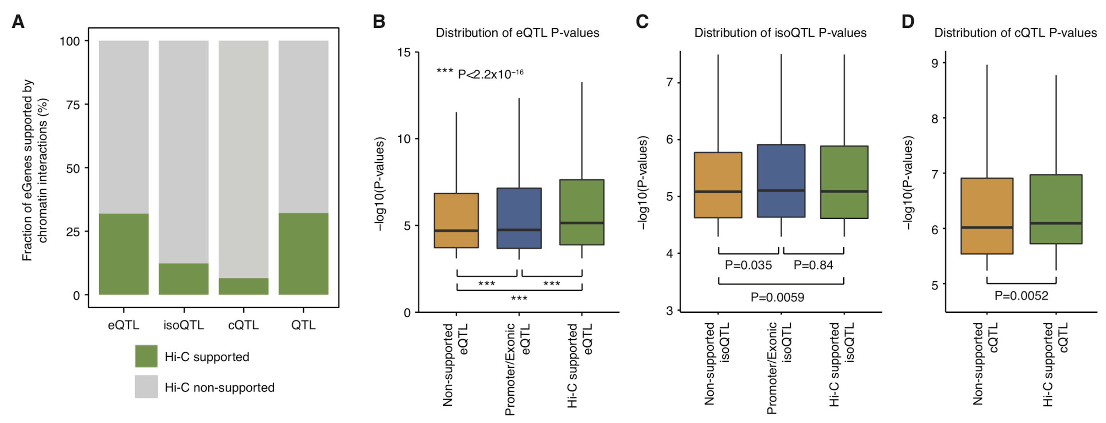
Fig. S6.4 Chromatin interactions mediate cis- and trans-regulatory relationships A. A proportion of QTL-associated genes (eQTLs), isoforms (isoQTLs) and chromatin marks (cQTLs) that have Hi-C evidence. B. eQTLs supported by Hi-C evidence show stronger associations not only to eQTLs without genomic annotations (non-supported), but also to exonic and promoter eQTLs. C-D. isoQTLs (C) and cQTLs (D) supported by Hi-C evidence show stronger associations than those without genomic annotations (non-supported).

S6.5 Imputed gene regulatory networks (TFs)
We integrated and imputated all possible regulatory relationships in the frontal cortex including the enhancers, transcription factors (TFs), miRNAs and target genes in this resource (Methods). The first step involved inferring the positions of the TF binding sites (TFBSs) within the key regulatory elements in our model, namely, promoters and enhancers in TADs. To do this, we started with a previously generated genome-wide map of all the TFBSs using the list of TFs and associated motif position weight matrices (PWMs) from the ENCODE consortium.
Next, we defined the promoter regions by a window of $±$1.25 kb (=2.5 kb in total) relative to the transcription start site (TSS), while the PEC enhancer regions of uniform length 1 kb were used. The ENCODE DNase hypersensitivity site (DHS) datasets for the frontal cortex (in .bed format) were then used to find open chromatin regions within the promoters, and the TFs with TFBSs within these open chromatin regions of the regulatory elements were linked to the corresponding elements. Since the PEC enhancers were already defined within regions of open chromatin, there was no need to further filter them out using DHS data, hence the TFs within the enhancers were directly linked to them. Finally, we tentatively link all enhancers and promoters within the same TADs determined from the Hi-C data on the reference brains (pooled data from three reference brains). The net result is a set of preliminary linkages in the form of [Enhancer TFs]-Enhancers-Promoters-[Promoter TFs].
There are some noteworthy points on this analysis. Firstly, when the PEC enhancers were expanded to a uniform size of 1 kb, there were some overlaps between adjacent enhancers. With regard to the TF linkages, we resolved these overlaps by assigning a TF within the overlap region only to the first enhancer encountered in the sorted enhancer list. Secondly, there are two experimental DHS files for the frontal cortex from the ENCODE consortium, resulting in two different sets of TF linkages for the promoters. The results from the two replicates were merged into a single consensus set of linkages.
In total, we included 675,061 enhancer-target-promoter in TADs and 823,946 TF-target-promoter binding linkages, providing a reference wiring network on gene regulation in brain, which consists of the regulatory factors and elements (e.g., TFs, enhancers) and target genes.
In order to identify the activated regulatory wires for a particular phenotype or disorder, we further used the computational method to determine such activated regulation. In particular, given a gene and a phenotype/disorder, we applied the Elastic net regression, linearly combining the L₁ and L₂ regularizations to predict its gene expression data from the expression data of the TFs that have the binding sites on the gene’s enhancers and promoter and overlap the QTLs; i.e., the QTLs break the binding sites. We then identified the activated TF-target regulatory relationships if TFs have large regression coefficients. In detail, suppose Y is an N-dimensional vector with elements being the gene’s expression levels across samples, where N is the sample number for the phenotype/disorder. X is an N by M matrix whose columns are the TFs’ expression levels, where M is the number of potential TFs. The Elastic net regression estimates the coefficients of M TFs, denoted by an M-dimensional vector, B= argmin_B ||Y-XB||^2+alpha*||B||^2+beta*||B||_1, where alpha and beta are parameters to adjust the contributions from L₂ and L₁ regularizations of B. The mean square error of Elastic net regression is equal to ||Y-XB||^2/N based on ⅔ training and ⅓ test data. For each gene and its TFs, we used the gene expression data across all adult samples (N=1866) in the resource to run the Elastic net regression. For example, we identified a strong regulatory relationship between four promoter TFs (NKX2-4, FOXE3, FOXI1, TFAP2B, coefficients >0.2) and three enhancer TFs (FOXA2, FOXI2, HMX2, coefficients > 1) with CHD8, a chromatin remodeler strongly associated with ASD. In total, we could predict the expression level of CHD8 with mean square error < 0.034.
Furthermore, we compared the HiC enhancer-promoter interactions and the interactions between eGenes and associated e/isoQTLs on enhancers with TF activity to determine a highly confident, overlapped enhancer-target-promoter linkages. In summary, there were 43,181 TF-to-target and 447,919 enhancer-to-target-promoter linkages among the top 5% Elastic net regression coefficients (absolute value >0.2). from at least two of these types: (i) activity relationships (~577k enhancer-to-target-promoter linkages), (ii) physical chromatin interactions (~91k Hi-C enhancer-promoter interactions), and (iii) 36,293 QTLs (e/isoQTL-SNP on brain enhancers to eGene).
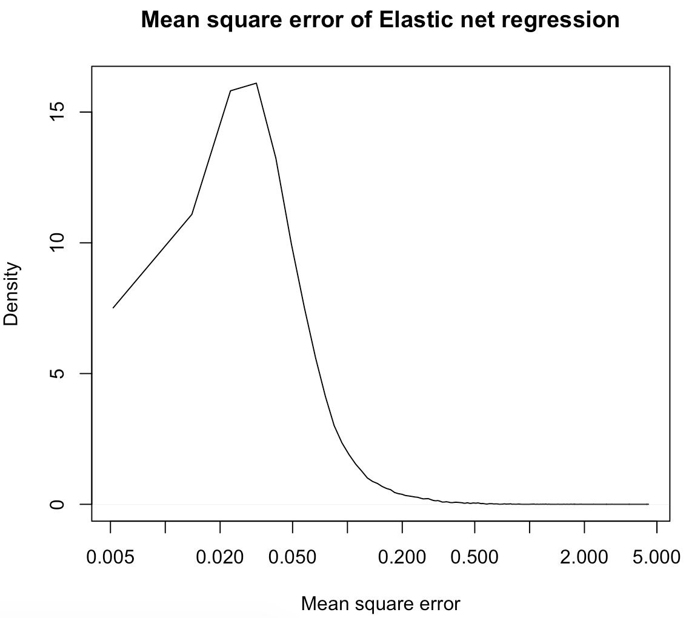
FIg. S6.5 Mean square error distribution of Elastic net regression predicting target gene expression from TF expression The x-axis is the mean square error range across protein-coding target genes. The y-axis is the density of target genes.

S7. Supp. content to main text section "Linking GWAS variants"

S7.1 Identification of GWAS associated genes for schizophrenia
We used 5,996 schizophrenia (SCZ)-associated autosomal putative causal (credible) SNPs reported in the original study (Pardiñas et al., 2018) and categorized them into promoter/exonic and intergenic/intronic SNPs. Promoter/exonic SNPs were directly assigned to the target genes based on the genomic coordinates, while intergenic/intronic SNPs were annotated based on chromatin interactions and enhancer-target-gene linkages supported by activity relationships from Elastic net regression. We used promoter-based interactions defined by Hi-C and enhancer-target-gene linkages to assess whether credible SNPs reside in (1) regions that physically interact with promoters of any genes (see Section S6.3) and/or (2) enhancer regions supported by activity relationships (see Section S6.5).
Credible SNPs colocalize with 2,064 eQTLs associated with 282 eGenes, 91 of which overlap with those identified by the Hi-C driven approach. To confirm this overlap is mediated by the shared causal variants in GWAS and eQTLs, we performed a colocalization test (Giambartolomei et al., 2014), from which we identified 293 genes across 79 loci in which GWAS and eQTLs share causal variants.
Collectively, we identified 176 genes across 83 loci from the direct assignment, 597 genes across 92 loci from the Hi-C driven approach, 388 genes across 37 loci from enhancer-target links, 293 genes across 79 loci from eQTL associations, and 29 genes across 23 loci from isoQTL associations. In total, this leads to 1,097 genes across 119 loci, which are referred as SCZ genes. We also selected risk genes that are identified by two or more metrics to obtain SCZ high-confidence (HC) genes (304 genes).
We compared SCZ risk genes defined by each metric (QTL=eQTL and isoQTL, Hi-C, and enhancer-target links) by performing an over-representation test. One key thing for an over-representation test is to define a background gene set, because each metric has different background genes. For example, 13,304 genes have enhancer-target links (hereby referred as E-T genes), 33,217 genes have QTLs, while Hi-C has the genome-wide search space. Therefore, we defined a background gene list by taking an intersect of eGenes and E-T genes. For each metric, we took an intersect of SCZ risk genes and the background gene set and used them for the Fisher’s exact test.
To assess what fraction of SCZ genes have distal regulatory relationships with putative causal SNPs, we compared SCZ genes with the genes that locate within the LD regions with the index SNPs (r2>0.6, includes genes partly overlapping with LDs). We also ran the colocalization test using the currently largest public dataset of eQTLs from the CMC (Fromer et al., 2016), assigning 137 genes to 68 loci. Notably, our newly generated eQTLs identified twice more genes than CMC eQTLs.

S7.2 Functional enrichment analysis
To assess whether SCZ genes and SCZ HC genes are dysregulated in neuropsychiatric disorders, we performed enrichment analysis by logistic regression on (1) differentially expressed genes (DEGs) in three types of disorders (ASD=autism spectrum disorder, SCZ=schizophrenia, BD=bipolar disorder) identified by (Gandal, M.J. et al., submitted), (2) genes affected by rare LoF variants in SCZ (TADA<0.3; Singh et al., 2016), and (3) genes located in recurrent SCZ copy number variation (CNVs) (Marshall et al., 2017). For the enrichment analysis on SCZ rare variants and CNVs, we used protein-coding genes for a background gene list and regressed exon lengths out. For the enrichment analysis on DEG, we used a union of eGenes and E-T genes detected in our study as a background gene list.
We analyzed GO enrichment for SCZ genes and SCZ HC genes using GOElite. We used the union of detected eGenes and E-T genes as a background gene list.
We used cell-level centered expression values to get average centered expression values for SCZ and SCZ HC genes in each cell type. Cell types were grouped into the clusters neurons, astrocytes, OPC, oligodendrocytes, microglia, endothelial cells, fetal neurons, and the neuronal subcluster (excitatory and inhibitory neurons) and measured relative expression levels in a given cluster by a scale function in R.

S7.3 Identification of TFs associated with schizophrenia risk genes
TF-target regulatory relationships (see Section S6.5) were used to detect TFs that are enriched either in (1) promoters of SCZ genes or (2) enhancers that overlap with SCZ credible SNPs. We calculated the significance of the enrichment by P=Pbinom(k>=s, n=n, p=p), when p = fraction of promoters/enhancers associated with credible SNPs, n = the number of total binding sites of a TF A (TFBSA) in promoters/enhancers, s = the number of total promoter/enhancer TFBSA associated with credible SNPs.
For promoter enrichment, p = the number of SCZ genes / the number of genes that have TF-target-promoter links from the elastic net; s = the number of TFBSA within promoters of SCZ risk genes. For enhancer enrichment, p = the length of enhancers that harbor SCZ credible SNPs / the length of enhancers that have TF-enhancer-target links from the elastic net; s = the number of TFBSA within enhancers that harbor SCZ credible SNPs. For promoter enrichment, we calculated an enrichment P-value for each TF, which was subsequently corrected for the number of TFs bound to gene promoters. For enhancer enrichment, an enrichment P-value for each TF was subsequently corrected for the number of TFs within enhancers that harbor SCZ credible SNPs.

S7.4 Partitioned heritability
We assessed heritability explained by brain regulatory elements (enhancers) and variants (eQTLs) for different GWAS using partitioned LD score regression (LDSC, Finucane et al., 2015; https://github.com/bulik/ldsc/wiki/Partitioned-Heritability). We included 9 brain disorder GWAS and 3 non-brain disorder GWAS (GWAS sets and sources described below) in an attempt to test that partitioned heritability estimates of brain disorders are more strongly enriched in brain enhancers and eQTLs than in non-brain disorders. For eQTLs, we included all eQTLs in the model, since LD scores count for LD. We also used top SNPs (pruned for LD r2>0.5) to ensure that the enrichment signal doesn’t come from the spurious LD structures, where we got similar enrichment results.

Disorders | Source
ADHD | Demontis et al. 2017
ASD | Grove et al. 2017
Bipolar disorder | Ruderfer et al. 2014
Depression (Broad General Practice) | Howard et al. 2017
Schizophrenia | Pardinas et al. 2018
Educational attainment | Okbay et al. 2016
Intelligence | Sniekers et al. 2017
Alzheimer’s disease | Lambert et al. 2013
Parkinson’s disease | Nalls et al. 2014
Type 2 diabetes (T2D) | Morris et al. 2012

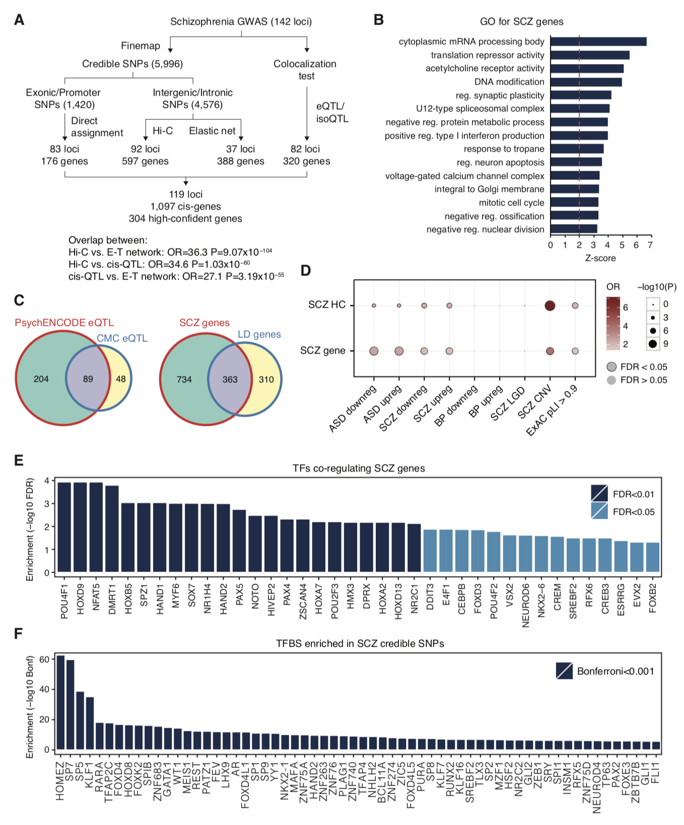
Fig. S7.1 Identification of schizophrenia risk genes A. A schematic depicting how SCZ GWAS loci were assigned to putative genes. B. Gene ontology enrichment for SCZ-genes demonstrates that cholinergic receptors, synaptic genes, calcium channels, immune response-related genes, translational regulators, and RNA splicing regulators are associated with SCZ GWAS. C. Left, Colocalization analysis with eQTLs identified 2.13 fold more genes than the CMC eQTLs (Fromer et al., 2016). Right, Most SCZ genes (66.2%) are not located in the genome-wide significant loci (LD defined as r2>0.6). D. SCZ risk genes are enriched for dysregulated genes in ASD and SCZ, genes affected by recurrent copy number variations (CNV) in SCZ (SCZ CNV), and genes intolerant to loss-of-function mutations (ExAC pLI>0.9). SCZ LGD, genes that harbor likely gene disrupting (LGD) mutations in SCZ; HC, SCZ high-confidence genes; Downreg, downregulation; Upreg, upregulation. E. TFs that are significantly enriched in promoter regions of SCZ genes. F. TFs that are significantly enriched in enhancers that harbor SCZ credible SNPs.

S8. Supp. content to main text section "Deep-learning model”

[[JW placeholder -- text in separate word docx file]]

S8.1 Genotype - gene expression/enhancers - modules - phenotype
S8.1.1 Balanced Datasets

S8.2 Deep learning model for predicting brain genotype-phenotype
S8.2.1 Logistic Regression (LR)
S8.2.2 Conditional Restricted Boltzmann Machine (cRBM)
S8.2.3 Conditional Deep Boltzmann Machine (cDBM)
S8.2.4 Deep Structured Phenotype Network (DSPN)

S8.3 Imputation using integrative modeling
S8.3.1 Deep Structured Phenotype Network for Imputation (DSPN-Imput)

S8.4 Variance explained on liability scale and heritability

S8.5 DSPN enrichment analysis for prioritized modules and higher-order groupings

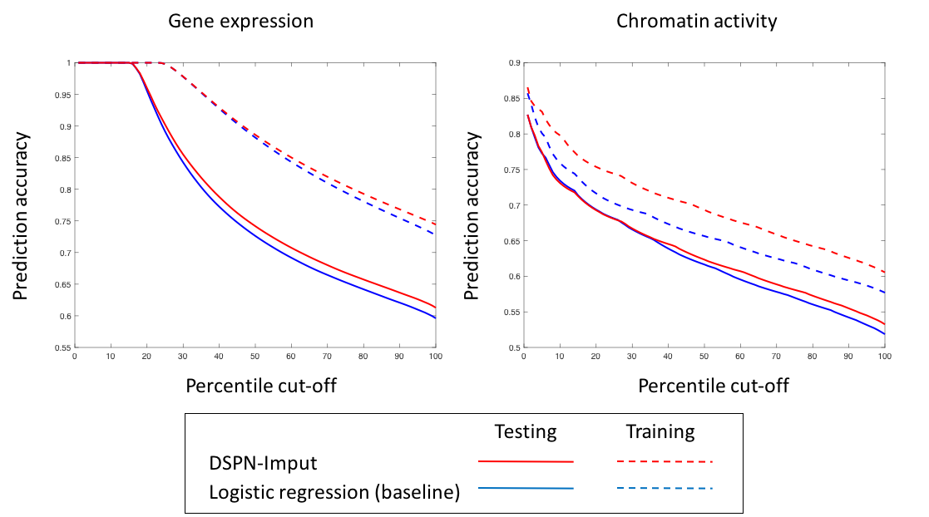
Fig. S8.1 Accuracy of intermediate phenotype imputation using DSPN-Imput model Figure compares prediction accuracy for gene expression and chromatin activity using the full DSPN-Imput model (with GRN structure included) vs prediction with a logistic model (independent prediction). Performance on training and testing partitions is shown.

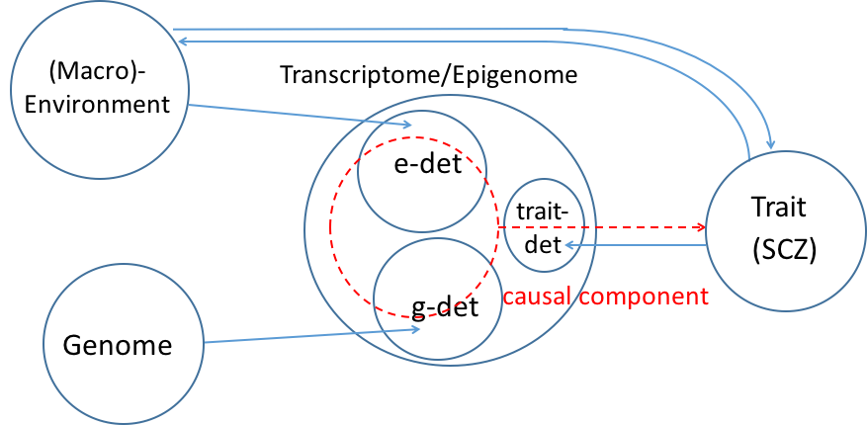
Fig. S8.2 Potential causal relationships between genome, transcriptome/epigenome, macro-environment and high-level traits A schematic of possible decomposition of variation in the indicated variables. Large circles represent total entropy of each variable, and smaller circles (e-det, g-det, trait-det) represent multivariate mutual information shared between variables linked by arrows (directionality represents causation). The red dotted circle and arrow represent causal influence of transcriptome/epigenome on the high-level trait, only part of which need intersect the g-det circle; hence, the trait variance explained by the transcriptome/epigenome is an upper-bound on the genetically determined trait variance. Only three-way intersections involving trait interactions are shown.
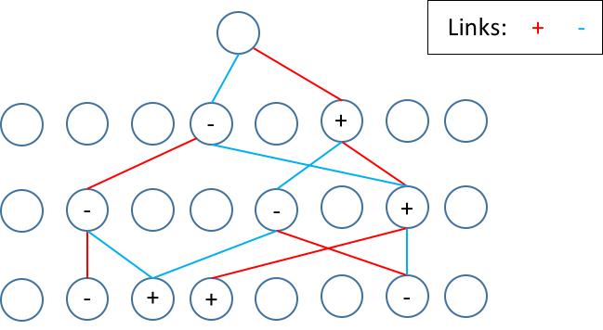
Fig. S8.3 Schematic representation of prioritization scheme for interpreting DSPN latent nodes and modules Circles represent nodes on three layers within the DPSN, along with a ‘node of interest’ on the upper layer. The prioritization shown uses a branching factor of 2, where red and blue links indicate the largest positive and negatively weighted edge respectively connected to each node from below. + and - signs represent the positive and negative prioritized sets for the node of interest at each of the lower levels, which are assigned based on the multiplication of signs along connecting paths (conflicting pathways would result in assignment to both positive and negative sets; not shown).

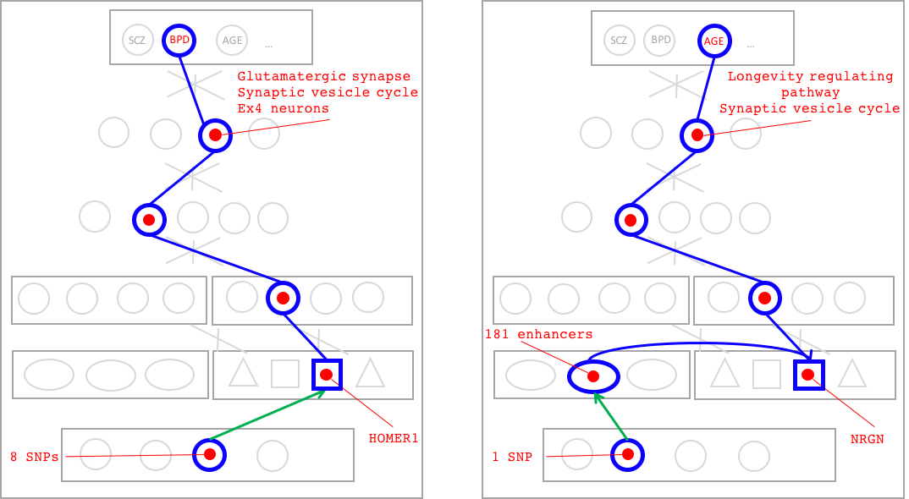
Fig. S8.4 Further DSPN traces for functional enrichment of prioritized modules in DSPN models Examples are shown of genes belonging to prioritized modules in BPD (left) and AGE (right) related DSPN models. HOMER1 has previously been associated with BPD, and NRGN was strongly associated with age in our differential expression analysis (as well as being a SCZ associated gene).
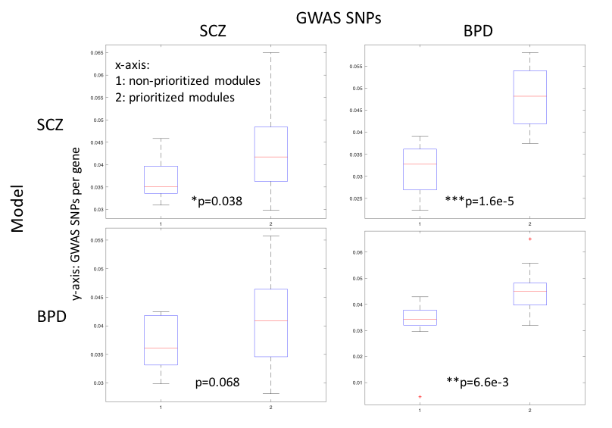
Fig. S8.5 Enrichment of GWAS SNPs in DSPN prioritized modules Figure shows enrichment of GWAS SNPs associated with SCZ and BPD in the DSPN modules prioritized in the SCZ and BPD models. SNPs are linked with prioritized modules using all eQTLs associated with genes they contain. Enrichment is tested using a 1-tailed Mann-Whitney test for an increase in the number of GWAS SNPs per gene in prioritized versus non-prioritized modules. We observe enrichments for both disease modules with their respective GWAS SNPs, and also an enrichment of BPD GWAS SNPs in the SCZ modules, consistent with an overlap in disease etiology.

S9. Resource website

http://adult.psychencode.org/
The website contains much supplementary information related to the project, including the raw and processed data files them. For convenience, we reproduce below some sections of the site related to the descriptions of the data files.

S9.1 Bulk RNA-seq and genotype data (The text in this section up to Study 8 was directly adapted from the Psychencode/Synapse Website).

S9.1 PsychENCODE and other brain consortia
We processed gene expression read count data (as quantified by FPKM and measured by RNAseq) from 9 studies: UCLA-ASD, Yale-ASD, BrainGVEX, the The Lieber Institute for Brain Development (LIBD), GTEx, the CommonMind Consortium (CMC), the CMC’s NIMH Human Brain Collection Core (CMC HBCC) and Bipseq a Bipolar cohorts and from Yale. The detailed descriptions of PsychENCODE related 8 studies were listed below and may also be found on supplemental Table S2.1, as well as in the PsychENCODE Knowledge Portal (https://www.synapse.org/#!Synapse:syn4921369/wiki/390659 ).

Study 1 (Freeze 1) - BrainGVEX
RNAseq data was generated from 427 postmortem prefrontal cortex from subjects with schizophrenia (n=95), bipolar disorder (n=73), and non-psychiatric controls (n=259), as part of the BrainGVEX study (Synapse accession doi:10.7303/syn4590909) within the PsychEncode Consortium (https://www.synapse.org/pec) (72). BrainGVEX study includes RNA samples collected as part of the “Array Collection”, “Consortium Collection”, “New Collection” and ”Extra Collection” from the Stanley Medical Research Institute (SMRI). Array collection and Consortium collection were from superior frontal gyrus (BA9) whereas those labelled EXTRA or NEW were from the middle frontal gyrus (BA46). Another 184 controls were obtained as fresh-frozen brain tissue from the Banner Sun Health Research Institute (BSHRI). All BSHRI samples were from frontal cortex. RNA were extracted from BSHRI samples by first homogenizing 20-50 mg of tissue in QIAzol (Qiagen) using the Lysin Matrix D and FastPrep®-24 system (MPBiomedicals). Total RNA were then isolated using the miRNeasy Kit (Qiagen) according to manufacturer’s instructions. RNA integrity was assessed with Agilent Technologies RNA 600 nano kit. Samples with RNA Integrity Number (RIN) lower than 5.5 were excluded from the study. RNA sequencing libraries were prepared using TruSeq Stranded Total RNA sample prep kit with RiboZero Gold HMR (Illumina). Libraries were multiplexed (3 per lane) for paired-end 100 bp sequencing on Illumina HiSeq2000 with read depth >70 million reads on average.

DNA genotyping were done using two different platforms. 144 samples (SMRI Consortium and Array Collections) were genotyped using the Affymetrix GeneChip Mapping 5.0K Array. Genotypes were called with the BRLMM-p algorithm (Affymetrix) with all arrays simultaneously (Zhang et al., 2010). The rest of samples (SMRI New and Extra Collection, and BSHRI Collection) were genotyped with the Human PsychChip, which is a custom version of the Illumina Infinium CoreExome-24 v1.1 BeadChip (#WG-331-1111) supplemented with content derived from GWASs and DNA sequencing studies of multiple psychiatric disorders by the Psychiatric Genomics Consortium (PGC). Genotypes were called using Illumina’s GenomeStudio software, Birdseed and Zcall, as described (Code found at: https://github.com/Nealelab/ricopili/blob/master/rp_bin/mergecall_10) (Pedersen et al., 2018).

GenomeStudio and Birdseed were used separately to initially call variants in 288 individuals. Accepted variants had a call frequency greater than 97% and a Hardy-Weinberg Equilibrium (HWE) p-value > 1 x 10⁻⁶. 24 of the 288 individuals were immediately excluded because they were missing calls for >5% of genotyped SNPs, when either caller was used. Birdseed and GenomeStudio variant calls were then merged by consensus. If both programs returned a different result for a single variant, the final call for that variant was set to “missing.” When a call was made with only one of the two programs, that successful call was deemed the consensus.

The resulting merged consensus data was filtered again according to the same call frequency, sample missingness, MAF and HWE criteria described above. Finally, valid rare variant calls were refined using Zcall. Meaning, genotype calls for variants with MAF < 0.01 in the merged and filtered dataset were replaced with zCall results when, in zCall, their HWE p-values > 1 x 10⁻⁶, missingness rates were below 3% and MAF < 0.05. Note that zCall only refines GenomeStudio calls, so zCall results are independent of Birdseed calls. Ultimately 577,643 variants were called, 242,272 being rare.

Study 2 (Freeze 1) - BrainSpan
RNAseq: RNA was extracted using RNeasy Plus Mini Kit (Qiagen) for mRNA. Either approximately 30 mg of pulverized tissue (12 PCW – 40 Y specimens) or entire amount of dissected brain piece (8 – 9 PCW, smaller than 30 mg) was processed. Tissue was pulverized with liquid nitrogen in a chilled mortar and pestle and transferred to a chilled safe-lock microcentrifuge tube (Eppendorf). Per tissue mass, equal mass of chilled stainless steel beads (Next Advance, cat# SSB14B) along with two volumes of lysis buffer were added. Tissue was homogenized for 1 min in Bullet Blender (Next Advance # SSB14B) at speed 6 and incubated at 37°C for 5 min. Lysis buffer up to 0.6 ml was again added, tissue homogenized for 1 min and incubated at 37°C for 1 min. Extraction was further carried out according to manufacturer’s protocol. Genomic DNA was removed by a proprietary column provided in RNeasy Plus Mini Kit (Qiagen) or by DNase treatment using TURBO DNA-free Kit (Ambion/ Life technologies). 260:A280 ratio and RNA Integrity Number (RIN) were determined for each sample with NanoDrop (Thermo Scientific) and Agilent 2100 Bioanalyzer system, respectively.

The mRNA-sequencing (mRNA-seq) Sample preparation Kit (Illumina) was used to prepare cDNA libraries per manufacturer instructions with some modifications. Briefly, polyA RNA was purified from 1 to 5 µg of total RNA using Oligo (dT) beads. Quaint-IT RiboGreen RNA Assay Kit (Invitrogen) was used to quantitate purified mRNA with the NanoDrop 3300. Following mRNA quantitation, 2.5 µl spike-in master mixes, containing five different types of RNA molecules at varying amounts (2.5 × 10-7 to 2.5 × 10-14 mol), were added per 100 ng of mRNA. Spike-in RNAs were synthesized by the External RNA Control Consortium (ERCC) by in vitro transcription of de novo DNA sequences or DNA derived from B. subtilis or the deep-sea vent microbe M. jannaschii and were a generous gift of Dr. Mark Salit at The National Institute of Standards and Technology (NIST). Each sample was tagged by adding two spike-in RNAs unique to the region from which the sample was taken. Besides, three common spike-in RNAs with gradient concentrations were added to each sample, aiming at the assessment of sequencing quality. Spike-in sequences are available at http://archive.gersteinlab.org/proj/brainseq/spike_in/spike_in.fa. The mixture of mRNA and spike-in RNAs was subjected to fragmentation, reverse transcription, end repair, 3’ end adenylation, and adapter ligation to generate libraries of short cDNA molecules, followed by PCR amplification. The PCR enriched product was assessed for its size distribution and concentration using Bioanalyzer DNA 1000 Kit.

Genotype data was not used in this study due to the small adult sample size.

Study 3 (Freeze 1) - CommonMind
Full details of the CommonMind study have been published (19). Data is available through the Sage Bionetworks Synapse system (https://www.synapse.org/cmc; doi:10.7303/syn2759792). Samples were acquired through brain banks at three institutions:The Mount Sinai NIH Brain Bank and Tissue Repository, University of Pennsylvania Brain Bank of Psychiatric illnesses and Alzheimer’s Disease Core Center, and the University of Pittsburgh NIH NeuroBioBank Brain and Tissue Repository. Details about brain banks, inclusion/exclusion criteria, and sample collection and processing are described here: https://www.synapse.org/#!Synapse:syn2759792/wiki/71104

RNAseq: RNAseq data from 613 total human postmortem dorsolateral prefrontal cortex (DLPFC) brain samples were obtained from 603 subjects with schizophrenia (n=263), bipolar disorder (n=47), affective disorder (8), and neurotypical controls (n=285), where 10 neurotypical controls were sequenced as biological replicates). Total RNA was extracted from 50 mg of homogenized DLPFC brain tissue using RNeasy kit. Samples with RIN < 5.5 (n=51) were excluded. The remaining samples had a mean RIN of 7.7. RNAseq library preparation was performed using ribosomal RNA depletion, with the Ribozero Magnetic Gold Kit. Samples were barcoded, multiplexed (n=10/lane), and sequenced across two lanes as 100 bp paired end sequencing on the Illumina HiSeq 2500 with an average of 85 million reads. Data is provided for those samples that passed all of the following QC filters: samples were required to have had a minimum of 50 million total reads and less than 5% rRNA alignment.

Genotyping: DNA was isolated from approximately 10 mg dry homogenized tissue coming from the same dissected samples as the RNA isolation using the Qiagen DNeasy Blood and Tissue Kit according to manufacturer’s protocol. Genotyping was performed using the Illumina Infinium HumanOmniExpressExome platform (Catalog #: WG-351-2301). All data were checked for discordance between nominal and genetically-inferred sex using Plink software to calculate the mean homozygosity rate across X-chromosome markers and to evaluate the presence or absence of Y-chromosome markers. In addition, pairwise comparison of samples across all genotypes was done to identify potentially duplicate samples (genotypes > 99% concordant) or related individuals using Plink.

Study 4 (Freeze 1) - Yale-ASD
RNAseq: Total RNA was extracted using mirVana kit (Ambion) with some modifications to the manufacturer’s protocol. Approximately 60 mg of tissue was pulverized with liquid nitrogen in a prechilled mortar and pestle and transferred to a chilled safe-lock microcentrifuge tube (Eppendorf). Per tissue mass, equal mass of chilled stainless steel beads (Next Advance, catalog # SSB14B) along with one volume of lysis/binding buffer were added. Tissue was homogenized for 1 min in Bullet Blender (Next Advance) and incubated at 37°C for 1 min. Another nine volumes of the lysis/binding buffer were added, homogenized for 1 min, and incubated at 37°C for 2 min. One-tenth volume of miRNA Homogenate Additive was added and extraction was carried out according to the manufacturer’s protocol. RNA was treated with DNase using TURBO DNA-free Kit (Ambion/ Life Technologies) and RNA integrity was measured using Agilent 2200 TapeStation System. Barcoded libraries for RNA-seq were prepared with 5ng of RNA using TruSeq Stranded Total RNA with Ribo-Zero Gold kit (Illumina) per manufacturer’s protocol. Paired-end sequencing (100bp x 2) was performed on HiSeq 2000 sequencers (Illumina) at Yale Center for Genome Analysis.

Genotype data is not available yet for this study.

Study 5 (Freeze 1) - UCLA-ASD
Full details of the UCLA-ASD study have been published (Parikshak, et al., 2016).

RNAseq data for replication was generated from 251 postmortem cortex brain samples from subjects with ASD and non-psychiatric controls, across frontal cortex (BA9/46), temporal cortex (BA41/42/22), and cerebellum.

Brain samples were obtained from the Harvard Brain Bank as part of the Autism Tissue Project (ATP). An ASD diagnosis was confirmed by the Autism Diagnostic Interview-Revised (ADIR) in 48 of the subjects. In the remaining two subjects, diagnosis was supported by clinical history. Frozen brain regions were dissected on dry ice in a dehydrated dissection chamber to reduce degradation effects from sample thawing or humidity. Approximately 50-100mg of tissue across the cortical region of interest was isolated from each sample using the miRNeasy kit with no modifications (Qiagen). For each RNA sample, RNA quality was quantified using the RNA Integrity Number (RIN) on an Agilent Bioanalyzer. Strand-specific, rRNA-depleted RNAseq libraries were prepared using TruSeq Stranded Total RNA sample prep kit with RiboZero Gold (Illumnia) kits. Libraries were randomly pooled to multiplex 24 samples per lane using Illumina TruSeq barcodes. Each lane was sequenced five times on an Illumina HiSeq 2500 instrument using high output mode with standard chemistry and protocols for 50 bp paired-end reads to achieve a target depth of 70 million reads.

Genotyping was performed using Illumina Omni 2.5 arrays.

Study 6 (Freeze 2) - BipSeq
RNAseq: same as below Study 8
Genotyping: same as below Study 8

Study 7 (Freeze 2) - CMC_HBCC
Brain specimens for the CMC_HBCC study were obtained from the the NIMH Human Brain Collection Core (HBCC) (https://www.nimh.nih.gov/labs-at-nimh/research-areas/research-support-services/hbcc/human-brain-collection-core-hbcc.shtml) under protocols approved by the CNS IRB (NCT00001260), with the permission of the next-of-kin through the Offices of the Chief Medical Examiners in the District of Columbia, Northern Virginia and Central Virginia. All specimens were characterized neuropathologically, clinically and toxicologically. A clinical diagnosis was obtained through family interviews and review of medical records by two psychiatrists based on DSMIV criteria. Non-psychiatric controls were defined as having no history of a psychiatric condition or substance use disorder.

RNAseq: Samples were dissected at the NIMH Human Brain Collection Core and shipped to Ichan School of Medicine - Mt Sinai (ISMMS) for sample preparation and RNA-sequencing. Samples for the study were dissected from either the left or right hemisphere of fresh frozen coronal slabs cut at autopsy from the dorsolateral prefrontal cortex. Total RNA from 468 HBCC samples was isolated from approximately 100 mg homogenized tissue from each sample by TRIzol/chloroform extraction and purification with the Qiagen RNeasy kit (Cat#74106) according to manufacturer’s protocol. Samples were processed in randomized batches of 12. The order of extraction was assigned randomly with respect to diagnosis and all other sample characteristics. The mean total RNA yield was 24.2 ug. The RNA Integrity Number (RIN) was determined by fractionating RNA samples on the 4200 Agilent TapeStation System. 69 samples with RIN <5.5 were excluded from the study. An additional 12 samples were removed post sequencing due to evidence of sample swap or contamination, resulting in a final dataset of 387 samples with a mean RIN of 7.5 and a mean ratio of 260/280 of 2.0. (Bipolar Disorder n=70, Schizophrenia n=97, neurotypical controls n=220) RNA sequencing raw and quantified expression data is provided for 387 samples consisting of data from 387 unique individuals. Data was generated, QCed, processed and quantified as follows: All samples submitted to the New York Genome Center for RNAseq were prepared for sequencing in randomized batches of 94. The sequencing libraries were prepared using the KAPA Stranded RNAseq Kit with RiboErase (KAPA Biosystems). rRNA was depleted from 1ug of RNA using the KAPA RiboErase protocol that is integrated into the KAPA Stranded RNAseq Kit. The insert size and DNA concentration of the sequencing library was determined on Fragment Analyzer Automated CE System (Advanced Analytical) and Quant-iT PicoGreen (ThermoFisher) respectively. A pool of 10 barcoded libraries were layered on a random selection of two of the eight lanes of the Illumina flow cell at appropriate concentration and bridge amplified to ~ 250 million raw clusters. One-hundred base pair paired end reads were obtained on a HiSeq 2500.

Genotyping: Genotyping was done on the Illumina_1M, Illumina_h650, and Illumina_Omni5 platform.

Study 8 (Freeze 2) - LIBD_szControl + BipSeq
RNAseq: Post-mortem tissue homogenates of dorsolateral prefrontal cortex grey matter (DLPFC) approximating BA46/9 in postnatal samples and the corresponding region of PFC in fetal samples were obtained from all subjects. Total RNA was extracted from ~100 mg of tissue using the RNeasy kit (Qiagen) according to the manufacturer’s protocol. The poly-A containing RNA molecules were purified from 1 µg DNAse treated total RNA and sequencing libraries were constructed using the Illumina TruSeq© RNA Sample Preparation v2 kit. Sequencing indices/barcodes were inserted into Illumina adapters allowing samples to be multiplexed in across lanes in each flow cell. These products were then purified and enriched with PCR to create the final cDNA library for high throughput sequencing using an Illumina HiSeq 2000 with paired end 2x100bp reads. More details are available in: https://www.biorxiv.org/content/early/2017/11/22/124321

Genotyping: SNP genotyping with HumanHap650Y_V3, Human 1M-Duo_V3, and Omni5 BeadChips (Illumina, San Diego, CA) was carried out according to the manufacturer’s instructions with DNA extracted from cerebellar tissue. Genotype data were processed and normalized with the crlmm R/Bioconductor package separately by platform.

There is an overlap in the donors and samples used for CMC_HBCC and LIBD_scControl and BipSeq came from, because they originate from the same brain bank (the NIMH human brain collection core). There is therefore a set of biological replicates from the same brain region where the samples have been processed separately. The same individual ID has been used on all 3 studies. The CMC data also has a set of 10 biological replicates (all controls). The individual IDs are the same (starting with CMC_..). We included all samples (including replicates) and accounted for them using random effect mixed model.

An initial quality control step was taken in which all datasets were first pre-processed to remove outliers using a hierarchical clustering based global outlier detection. Samples from UCLA were sub-divided into three different brain regions (vermis, Brodmann area 9, and Brodmann area 41).

The gene expression data from these 9 centers were merged into one gene expression matrix, and subsequently normalized using the protocol detailed by GTEx (GTEx Consortium, 2017).

S10. Supp. References
Darmanis S, Sloan SA, Zhang Y, Enge M, Caneda C, Shuer LM, Gephart MG, Barres BA, Quake SR. A survey of human brain transcriptome diversity at the single cell level. Proceedings of the National Academy of Sciences. 2015 Jun 9;112(23):7285-90.
Das S, Forer L, Schönherr S, Sidore C, Locke AE, Kwong A, Vrieze S, Chew EY, Levy S, McGue M, Schlessinger D, Stambolian D, Loh PR, Iacono WG, Swaroop A, Scott LJ, Cucca F, Kronenberg F, Boehnke M, Abecasis GR, Fuchsberger C. Next-generation genotype imputation service and methods. Nature Genetics 2016 (48):1284–1287
Delaneau O, Ongen H, Brown AA, Fort A, Panousis NI, Dermitzakis ET. A complete tool set for molecular QTL discovery and analysis. Nature communications. 2017 May 18;8:15452.
Demontis, D., R. K. Walters, J. Martin, M. Mattheisen, T. D. Als, E. Agerbo, R. Belliveau, J. Bybjerg-Grauholm, M. Bækved-Hansen, F. Cerrato, K. Chambert, C. Churchhouse, A. Dumont, N. Eriksson, M. Gandal, J. Goldstein, J. Grove, C. S. Hansen, M. Hauberg, M. Hollegaard, D. P. Howrigan, H. Huang, J. Maller, A. R. Martin, J. Moran, J. Pallesen, D. S. Palmer, C. B. Pedersen, M. G. Pedersen, T. Poterba, J. B. Poulsen, S. Ripke, E. B. Robinson, F. K. Satterstrom, C. Stevens, P. Turley, H. Won, O. A. Andreassen, C. Burton, D. Boomsma, B. Cormand, S. Dalsgaard, B. Franke, J. Gelernter, D. Geschwind, H. Hakonarson, J. Haavik, H. Kranzler, J. Kuntsi, K. Langley, K.-P. Lesch, C. Middeldorp, A. Reif, L. A. Rohde, P. Roussos, R. Schachar, P. Sklar, E. Sonuga-Barke, P. F. Sullivan, A. Thapar, J. Tung, I. Waldman, M. Nordentoft, D. M. Hougaard, T. Werge, O. Mors, P. B. Mortensen, M. J. Daly, S. V. Faraone, A. D. Børglum and B. M. Neale (2017). "Discovery Of The First Genome-Wide Significant Risk Loci For ADHD." bioRxiv.
Falconer, D.S. and MacKay T.F.C. (1996) Introduction to Quantitative Genetics, Ed 4. Longmans Green, Harlow, Essex, UK.
Finucane, H. K., B. Bulik-Sullivan, A. Gusev, G. Trynka, Y. Reshef, P. R. Loh, V. Anttila, H. Xu, C. Zang, K. Farh, S. Ripke, F. R. Day, C. ReproGen, C. Schizophrenia Working Group of the Psychiatric Genomics, R. Consortium, S. Purcell, E. Stahl, S. Lindstrom, J. R. Perry, Y. Okada, S. Raychaudhuri, M. J. Daly, N. Patterson, B. M. Neale and A. L. Price (2015). "Partitioning heritability by functional annotation using genome-wide association summary statistics." Nat Genet 47(11): 1228-1235.
Fromer M, Roussos P, Sieberts SK, Johnson JS, Kavanagh DH, Perumal TM, Ruderfer DM, Oh EC, Topol A, Shah HR, Klei LL. Gene expression elucidates functional impact of polygenic risk for schizophrenia. Nature neuroscience. 2016 Nov;19(11):1442.
Gandal, M.J. et al. Dysregulation of cortical splicing, isoform and noncoding gene regulatory networks in ASD, schizophrenia, and bipolar disorder. (Submitted).
Giambartolomei C, Vukcevic D, Schadt EE, Franke L, Hingorani AD, Wallace C, Plagnol V. Bayesian test for colocalisation between pairs of genetic association studies using summary statistics. PLoS genetics. 2014 May 15;10(5):e1004383.
Grove, J., S. Ripke, T. D. Als, M. Mattheisen, R. Walters, H. Won, J. Pallesen, E. Agerbo, O. A. Andreassen, R. Anney, R. Belliveau, F. Bettella, J. D. Buxbaum, J. Bybjerg-Grauholm, M. Bækved-Hansen, F. Cerrato, K. Chambert, J. H. Christensen, C. Churchhouse, K. Dellenvall, D. Demontis, S. De Rubeis, B. Devlin, S. Djurovic, A. Dumont, J. Goldstein, C. S. Hansen, M. E. Hauberg, M. V. Hollegaard, S. Hope, D. P. Howrigan, H. Huang, C. Hultman, L. Klei, J. Maller, J. Martin, A. R. Martin, J. Moran, M. Nyegaard, T. Nærland, D. S. Palmer, A. Palotie, C. B. Pedersen, M. G. Pedersen, T. Poterba, J. B. Poulsen, B. St Pourcain, P. Qvist, K. Rehnström, A. Reichenberg, J. Reichert, E. B. Robinson, K. Roeder, P. Roussos, E. Saemundsen, S. Sandin, F. K. Satterstrom, G. D. Smith, H. Stefansson, K. Stefansson, C. Steinberg, C. Stevens, P. F. Sullivan, P. Turley, G. B. Walters, X. Xu, D. Geschwind, M. Nordentoft, D. M. Hougaard, T. Werge, O. Mors, P. B. Mortensen, B. M. Neale, M. J. Daly, A. D. Børglum and a. R. Team (2017). "Common risk variants identified in autism spectrum disorder." bioRxiv.
GTEx Consortium. Genetic effects on gene expression across human tissues. Nature. 2017 Oct;550(7675):204.
Hill WG, Mackay TF. DS Falconer and Introduction to quantitative genetics. Genetics. 2004 Aug 1;167(4):1529-36.
Hinton GE. A practical guide to training restricted Boltzmann machines. In Neural networks: Tricks of the trade 2012 (pp. 599-619). Springer, Berlin, Heidelberg.
Howard, D. M., M. J. Adams, M. Shirali, T.-K. Clarke, R. E. Marioni, G. Davies, J. R. I. Coleman, C. Alloza, X. Shen, M. C. Barbu, E. M. Wigmore, S. Hagenaars, C. M. Lewis, D. J. Smith, P. F. Sullivan, C. S. Haley, G. Breen, I. J. Deary and A. M. McIntosh (2017). "Genome-wide association study of depression phenotypes in UK Biobank (n = 322,580) identifies the enrichment of variants in excitatory synaptic pathways." bioRxiv.
International Schizophrenia Consortium. Common polygenic variation contributes to risk of schizophrenia and bipolar disorder. Nature. 2009 Aug;460(7256):748.
Jaffe AE, Gao Y, Deep-Soboslay A, Tao R, Hyde TM, Weinberger DR, Kleinman JE. Mapping DNA methylation across development, genotype and schizophrenia in the human frontal cortex. Nature neuroscience. 2016 Jan;19(1):40.
Johnstone IM, Lu AY. On consistency and sparsity for principal components analysis in high dimensions. Journal of the American Statistical Association. 2009 Jun 1;104(486):682-93.
Kang HJ, Kawasawa YI, Cheng F, Zhu Y, Xu X, Li M, Sousa AM, Pletikos M, Meyer KA, Sedmak G, Guennel T. Spatio-temporal transcriptome of the human brain. Nature. 2011 Oct;478(7370):483.
Koller, D. and Friedmann, N.. Probabilistic Graphical Models, 2009.
Kundaje A, Meuleman W, Ernst J, Bilenky M, Yen A, Heravi-Moussavi A, Kheradpour P, Zhang Z, Wang J, Ziller MJ, Amin V. Integrative analysis of 111 reference human epigenomes. Nature. 2015 Feb;518(7539):317.
Lake BB, Ai R, Kaeser GE, Salathia NS, Yung YC, Liu R, Wildberg A, Gao D, Fung HL, Chen S, Vijayaraghavan R. Neuronal subtypes and diversity revealed by single-nucleus RNA sequencing of the human brain. Science. 2016 Jun 24;352(6293):1586-90.
Lambert, J. C., C. A. Ibrahim-Verbaas, D. Harold, A. C. Naj, R. Sims, C. Bellenguez, A. L. DeStafano, J. C. Bis, G. W. Beecham, B. Grenier-Boley, G. Russo, T. A. Thorton-Wells, N. Jones, A. V. Smith, V. Chouraki, C. Thomas, M. A. Ikram, D. Zelenika, B. N. Vardarajan, Y. Kamatani, C. F. Lin, A. Gerrish, H. Schmidt, B. Kunkle, M. L. Dunstan, A. Ruiz, M. T. Bihoreau, S. H. Choi, C. Reitz, F. Pasquier, C. Cruchaga, D. Craig, N. Amin, C. Berr, O. L. Lopez, P. L. De Jager, V. Deramecourt, J. A. Johnston, D. Evans, S. Lovestone, L. Letenneur, F. J. Moron, D. C. Rubinsztein, G. Eiriksdottir, K. Sleegers, A. M. Goate, N. Fievet, M. W. Huentelman, M. Gill, K. Brown, M. I. Kamboh, L. Keller, P. Barberger-Gateau, B. McGuiness, E. B. Larson, R. Green, A. J. Myers, C. Dufouil, S. Todd, D. Wallon, S. Love, E. Rogaeva, J. Gallacher, P. St George-Hyslop, J. Clarimon, A. Lleo, A. Bayer, D. W. Tsuang, L. Yu, M. Tsolaki, P. Bossu, G. Spalletta, P. Proitsi, J. Collinge, S. Sorbi, F. Sanchez-Garcia, N. C. Fox, J. Hardy, M. C. Deniz Naranjo, P. Bosco, R. Clarke, C. Brayne, D. Galimberti, M. Mancuso, F. Matthews, I. European Alzheimer's Disease, Genetic, D. Environmental Risk in Alzheimer's, C. Alzheimer's Disease Genetic, H. Cohorts for, E. Aging Research in Genomic, S. Moebus, P. Mecocci, M. Del Zompo, W. Maier, H. Hampel, A. Pilotto, M. Bullido, F. Panza, P. Caffarra, B. Nacmias, J. R. Gilbert, M. Mayhaus, L. Lannefelt, H. Hakonarson, S. Pichler, M. M. Carrasquillo, M. Ingelsson, D. Beekly, V. Alvarez, F. Zou, O. Valladares, S. G. Younkin, E. Coto, K. L. Hamilton-Nelson, W. Gu, C. Razquin, P. Pastor, I. Mateo, M. J. Owen, K. M. Faber, P. V. Jonsson, O. Combarros, M. C. O'Donovan, L. B. Cantwell, H. Soininen, D. Blacker, S. Mead, T. H. Mosley, Jr., D. A. Bennett, T. B. Harris, L. Fratiglioni, C. Holmes, R. F. de Bruijn, P. Passmore, T. J. Montine, K. Bettens, J. I. Rotter, A. Brice, K. Morgan, T. M. Foroud, W. A. Kukull, D. Hannequin, J. F. Powell, M. A. Nalls, K. Ritchie, K. L. Lunetta, J. S. Kauwe, E. Boerwinkle, M. Riemenschneider, M. Boada, M. Hiltuenen, E. R. Martin, R. Schmidt, D. Rujescu, L. S. Wang, J. F. Dartigues, R. Mayeux, C. Tzourio, A. Hofman, M. M. Nothen, C. Graff, B. M. Psaty, L. Jones, J. L. Haines, P. A. Holmans, M. Lathrop, M. A. Pericak-Vance, L. J. Launer, L. A. Farrer, C. M. van Duijn, C. Van Broeckhoven, V. Moskvina, S. Seshadri, J. Williams, G. D. Schellenberg and P. Amouyel (2013). "Meta-analysis of 74,046 individuals identifies 11 new susceptibility loci for Alzheimer's disease." Nat Genet 45(12): 1452-1458.
Langfelder P, Zhang B, Horvath S. Defining clusters from a hierarchical cluster tree: the Dynamic Tree Cut package for R. Bioinformatics. 2007 Nov 16;24(5):719-20.
Li, M. et al., Integrative Functional Genomic Analysis of Human Brain Development and Neuropsychiatric Risk. (Submitted).
Li H, Courtois ET, Sengupta D, Tan Y, Chen KH, Goh JJ, Kong SL, Chua C, Hon LK, Tan WS, Wong M. Reference component analysis of single-cell transcriptomes elucidates cellular heterogeneity in human colorectal tumors. Nature genetics. 2017 May;49(5):708.
Liu, J. Z., S. van Sommeren, H. Huang, S. C. Ng, R. Alberts, A. Takahashi, S. Ripke, J. C. Lee, L. Jostins, T. Shah, S. Abedian, J. H. Cheon, J. Cho, N. E. Dayani, L. Franke, Y. Fuyuno, A. Hart, R. C. Juyal, G. Juyal, W. H. Kim, A. P. Morris, H. Poustchi, W. G. Newman, V. Midha, T. R. Orchard, H. Vahedi, A. Sood, J. Y. Sung, R. Malekzadeh, H. J. Westra, K. Yamazaki, S. K. Yang, C. International Multiple Sclerosis Genetics, I. B. D. G. C. International, J. C. Barrett, B. Z. Alizadeh, M. Parkes, T. Bk, M. J. Daly, M. Kubo, C. A. Anderson and R. K. Weersma (2015). "Association analyses identify 38 susceptibility loci for inflammatory bowel disease and highlight shared genetic risk across populations." Nat Genet 47(9): 979-986.
Maaten LV, Hinton G. Visualizing data using t-SNE. Journal of machine learning research. 2008;9(Nov):2579-605.
Marshall, CR., et al. "Contribution of copy number variants to schizophrenia from a genome-wide study of 41,321 subjects." Nature genetics 49.1 (2017): 27.
McCarthy DJ, Campbell KR, Lun AT, Wills QF. Scater: pre-processing, quality control, normalization and visualization of single-cell RNA-seq data in R. Bioinformatics. 2017 Jan 14;33(8):1179-86.
McLean CY, Bristor D, Hiller M, Clarke SL, Schaar BT, Lowe CB, Wenger AM, Bejerano G. GREAT improves functional interpretation of cis-regulatory regions. Nature biotechnology. 2010 May;28(5):495.
Mnih V, Larochelle H, Hinton GE. Conditional restricted boltzmann machines for structured output prediction. arXiv preprint arXiv:1202.3748. 2012 Feb 14.
Morris, A. P., B. F. Voight, T. M. Teslovich, T. Ferreira, A. V. Segre, V. Steinthorsdottir, R. J. Strawbridge, H. Khan, H. Grallert, A. Mahajan, I. Prokopenko, H. M. Kang, C. Dina, T. Esko, R. M. Fraser, S. Kanoni, A. Kumar, V. Lagou, C. Langenberg, J. Luan, C. M. Lindgren, M. Muller-Nurasyid, S. Pechlivanis, N. W. Rayner, L. J. Scott, S. Wiltshire, L. Yengo, L. Kinnunen, E. J. Rossin, S. Raychaudhuri, A. D. Johnson, A. S. Dimas, R. J. Loos, S. Vedantam, H. Chen, J. C. Florez, C. Fox, C. T. Liu, D. Rybin, D. J. Couper, W. H. Kao, M. Li, M. C. Cornelis, P. Kraft, Q. Sun, R. M. van Dam, H. M. Stringham, P. S. Chines, K. Fischer, P. Fontanillas, O. L. Holmen, S. E. Hunt, A. U. Jackson, A. Kong, R. Lawrence, J. Meyer, J. R. Perry, C. G. Platou, S. Potter, E. Rehnberg, N. Robertson, S. Sivapalaratnam, A. Stancakova, K. Stirrups, G. Thorleifsson, E. Tikkanen, A. R. Wood, P. Almgren, M. Atalay, R. Benediktsson, L. L. Bonnycastle, N. Burtt, J. Carey, G. Charpentier, A. T. Crenshaw, A. S. Doney, M. Dorkhan, S. Edkins, V. Emilsson, E. Eury, T. Forsen, K. Gertow, B. Gigante, G. B. Grant, C. J. Groves, C. Guiducci, C. Herder, A. B. Hreidarsson, J. Hui, A. James, A. Jonsson, W. Rathmann, N. Klopp, J. Kravic, K. Krjutskov, C. Langford, K. Leander, E. Lindholm, S. Lobbens, S. Mannisto, G. Mirza, T. W. Muhleisen, B. Musk, M. Parkin, L. Rallidis, J. Saramies, B. Sennblad, S. Shah, G. Sigurethsson, A. Silveira, G. Steinbach, B. Thorand, J. Trakalo, F. Veglia, R. Wennauer, W. Winckler, D. Zabaneh, H. Campbell, C. van Duijn, A. G. Uitterlinden, A. Hofman, E. Sijbrands, G. R. Abecasis, K. R. Owen, E. Zeggini, M. D. Trip, N. G. Forouhi, A. C. Syvanen, J. G. Eriksson, L. Peltonen, M. M. Nothen, B. Balkau, C. N. Palmer, V. Lyssenko, T. Tuomi, B. Isomaa, D. J. Hunter, L. Qi, C. Wellcome Trust Case Control, G. Meta-Analyses of, I. Insulin-related traits Consortium, A. T. C. Genetic Investigation of, C. Asian Genetic Epidemiology Network-Type 2 Diabetes, C. South Asian Type 2 Diabetes, A. R. Shuldiner, M. Roden, I. Barroso, T. Wilsgaard, J. Beilby, K. Hovingh, J. F. Price, J. F. Wilson, R. Rauramaa, T. A. Lakka, L. Lind, G. Dedoussis, I. Njolstad, N. L. Pedersen, K. T. Khaw, N. J. Wareham, S. M. Keinanen-Kiukaanniemi, T. E. Saaristo, E. Korpi-Hyovalti, J. Saltevo, M. Laakso, J. Kuusisto, A. Metspalu, F. S. Collins, K. L. Mohlke, R. N. Bergman, J. Tuomilehto, B. O. Boehm, C. Gieger, K. Hveem, S. Cauchi, P. Froguel, D. Baldassarre, E. Tremoli, S. E. Humphries, D. Saleheen, J. Danesh, E. Ingelsson, S. Ripatti, V. Salomaa, R. Erbel, K. H. Jockel, S. Moebus, A. Peters, T. Illig, U. de Faire, A. Hamsten, A. D. Morris, P. J. Donnelly, T. M. Frayling, A. T. Hattersley, E. Boerwinkle, O. Melander, S. Kathiresan, P. M. Nilsson, P. Deloukas, U. Thorsteinsdottir, L. C. Groop, K. Stefansson, F. Hu, J. S. Pankow, J. Dupuis, J. B. Meigs, D. Altshuler, M. Boehnke, M. I. McCarthy, D. I. G. Replication and C. Meta-analysis (2012). "Large-scale association analysis provides insights into the genetic architecture and pathophysiology of type 2 diabetes." Nat Genet 44(9): 981-990.
Newman AM, Liu CL, Green MR, Gentles AJ, Feng W, Xu Y, Hoang CD, Diehn M, Alizadeh AA. Robust enumeration of cell subsets from tissue expression profiles. Nature methods. 2015 May;12(5):453.
Ng B, White CC, Klein HU, Sieberts SK, McCabe C, Patrick E, Xu J, Yu L, Gaiteri C, Bennett DA, Mostafavi S, De Jager PL. An xQTL map integrates the genetic architecture of the human brain's transcriptome and epigenome. Nat Neurosci. 2017;20(10):1418-26.
Okbay, A., J. P. Beauchamp, M. A. Fontana, J. J. Lee, T. H. Pers, C. A. Rietveld, P. Turley, G. B. Chen, V. Emilsson, S. F. Meddens, S. Oskarsson, J. K. Pickrell, K. Thom, P. Timshel, R. de Vlaming, A. Abdellaoui, T. S. Ahluwalia, J. Bacelis, C. Baumbach, G. Bjornsdottir, J. H. Brandsma, M. Pina Concas, J. Derringer, N. A. Furlotte, T. E. Galesloot, G. Girotto, R. Gupta, L. M. Hall, S. E. Harris, E. Hofer, M. Horikoshi, J. E. Huffman, K. Kaasik, I. P. Kalafati, R. Karlsson, A. Kong, J. Lahti, S. J. van der Lee, C. deLeeuw, P. A. Lind, K. O. Lindgren, T. Liu, M. Mangino, J. Marten, E. Mihailov, M. B. Miller, P. J. van der Most, C. Oldmeadow, A. Payton, N. Pervjakova, W. J. Peyrot, Y. Qian, O. Raitakari, R. Rueedi, E. Salvi, B. Schmidt, K. E. Schraut, J. Shi, A. V. Smith, R. A. Poot, B. St Pourcain, A. Teumer, G. Thorleifsson, N. Verweij, D. Vuckovic, J. Wellmann, H. J. Westra, J. Yang, W. Zhao, Z. Zhu, B. Z. Alizadeh, N. Amin, A. Bakshi, S. E. Baumeister, G. Biino, K. Bonnelykke, P. A. Boyle, H. Campbell, F. P. Cappuccio, G. Davies, J. E. De Neve, P. Deloukas, I. Demuth, J. Ding, P. Eibich, L. Eisele, N. Eklund, D. M. Evans, J. D. Faul, M. F. Feitosa, A. J. Forstner, I. Gandin, B. Gunnarsson, B. V. Halldorsson, T. B. Harris, A. C. Heath, L. J. Hocking, E. G. Holliday, G. Homuth, M. A. Horan, J. J. Hottenga, P. L. de Jager, P. K. Joshi, A. Jugessur, M. A. Kaakinen, M. Kahonen, S. Kanoni, L. Keltigangas-Jarvinen, L. A. Kiemeney, I. Kolcic, S. Koskinen, A. T. Kraja, M. Kroh, Z. Kutalik, A. Latvala, L. J. Launer, M. P. Lebreton, D. F. Levinson, P. Lichtenstein, P. Lichtner, D. C. Liewald, S. LifeLines Cohort, A. Loukola, P. A. Madden, R. Magi, T. Maki-Opas, R. E. Marioni, P. Marques-Vidal, G. A. Meddens, G. McMahon, C. Meisinger, T. Meitinger, Y. Milaneschi, L. Milani, G. W. Montgomery, R. Myhre, C. P. Nelson, D. R. Nyholt, W. E. Ollier, A. Palotie, L. Paternoster, N. L. Pedersen, K. E. Petrovic, D. J. Porteous, K. Raikkonen, S. M. Ring, A. Robino, O. Rostapshova, I. Rudan, A. Rustichini, V. Salomaa, A. R. Sanders, A. P. Sarin, H. Schmidt, R. J. Scott, B. H. Smith, J. A. Smith, J. A. Staessen, E. Steinhagen-Thiessen, K. Strauch, A. Terracciano, M. D. Tobin, S. Ulivi, S. Vaccargiu, L. Quaye, F. J. van Rooij, C. Venturini, A. A. Vinkhuyzen, U. Volker, H. Volzke, J. M. Vonk, D. Vozzi, J. Waage, E. B. Ware, G. Willemsen, J. R. Attia, D. A. Bennett, K. Berger, L. Bertram, H. Bisgaard, D. I. Boomsma, I. B. Borecki, U. Bultmann, C. F. Chabris, F. Cucca, D. Cusi, I. J. Deary, G. V. Dedoussis, C. M. van Duijn, J. G. Eriksson, B. Franke, L. Franke, P. Gasparini, P. V. Gejman, C. Gieger, H. J. Grabe, J. Gratten, P. J. Groenen, V. Gudnason, P. van der Harst, C. Hayward, D. A. Hinds, W. Hoffmann, E. Hypponen, W. G. Iacono, B. Jacobsson, M. R. Jarvelin, K. H. Jockel, J. Kaprio, S. L. Kardia, T. Lehtimaki, S. F. Lehrer, P. K. Magnusson, N. G. Martin, M. McGue, A. Metspalu, N. Pendleton, B. W. Penninx, M. Perola, N. Pirastu, M. Pirastu, O. Polasek, D. Posthuma, C. Power, M. A. Province, N. J. Samani, D. Schlessinger, R. Schmidt, T. I. Sorensen, T. D. Spector, K. Stefansson, U. Thorsteinsdottir, A. R. Thurik, N. J. Timpson, H. Tiemeier, J. Y. Tung, A. G. Uitterlinden, V. Vitart, P. Vollenweider, D. R. Weir, J. F. Wilson, A. F. Wright, D. C. Conley, R. F. Krueger, G. Davey Smith, A. Hofman, D. I. Laibson, S. E. Medland, M. N. Meyer, J. Yang, M. Johannesson, P. M. Visscher, T. Esko, P. D. Koellinger, D. Cesarini and D. J. Benjamin (2016). "Genome-wide association study identifies 74 loci associated with educational attainment." Nature 533(7604): 539-542.
Oldham MC, Konopka G, Iwamoto K, Langfelder P, Kato T, Horvath S, Geschwind DH. Functional organization of the transcriptome in human brain. Nature neuroscience. 2008 Nov;11(11):1271.
Parikshak NN, Swarup V, Belgard TG, Irimia M, Ramaswami G, Gandal MJ, Hartl C, Leppa V, Ubieta LT, Huang J, Lowe JK, Blencowe BJ, Horvath S, Geschwind DH. Genome-wide changes in lncRNA, splicing, and regional gene expression patterns in autism, Nature. 2016 Dec 15;540(7633):423-427.

Pardiñas AF, Holmans P, Pocklington AJ, Escott-Price V, Ripke S, Carrera N, Legge SE, Bishop S, Cameron D, Hamshere ML, Han J. Common schizophrenia alleles are enriched in mutation-intolerant genes and in regions under strong background selection. Nature genetics. 2018 Feb 26:1.
Pedersen CB, Bybjerg-Grauholm J, Pedersen MG, Grove J, Agerbo E, Baekvad-Hansen M, Poulsen JB, Hansen CS, McGrath JJ, Als TD, Goldstein JI. The iPSYCH2012 case–cohort sample: new directions for unravelling genetic and environmental architectures of severe mental disorders. Molecular psychiatry. 2018 Jan;23(1):6.
Pedersen BS, Quinlan AR. Who’s Who? Detecting and resolving sample anomalies in human DNA sequencing studies with peddy. The American Journal of Human Genetics. 2017 Mar 2;100(3):406-13.
Purcell S, Neale B, Todd-Brown K, Thomas L, Ferreira MAR, Bender D, Maller J, Sklar P, de Bakker PIW, Daly MJ & Sham PC. PLINK: a toolset for whole-genome association and population-base linkage analysis. American Journal of Human Genetics, 2007;81.
Rao, S. S., M. H. Huntley, N. C. Durand, E. K. Stamenova, I. D. Bochkov, J. T. Robinson, A. L. Sanborn, I. Machol, A. D. Omer, E. S. Lander and E. L. Aiden (2014). "A 3D Map of the Human Genome at Kilobase Resolution Reveals Principles of Chromatin Looping." Cell 159(7): 1665-1680.
Ruderfer, D. M., A. H. Fanous, S. Ripke, A. McQuillin, R. L. Amdur, C. Schizophrenia Working Group of the Psychiatric Genomics, C. Bipolar Disorder Working Group of the Psychiatric Genomics, C. Cross-Disorder Working Group of the Psychiatric Genomics, P. V. Gejman, M. C. O'Donovan, O. A. Andreassen, S. Djurovic, C. M. Hultman, J. R. Kelsoe, S. Jamain, M. Landen, M. Leboyer, V. Nimgaonkar, J. Nurnberger, J. W. Smoller, N. Craddock, A. Corvin, P. F. Sullivan, P. Holmans, P. Sklar and K. S. Kendler (2014). "Polygenic dissection of diagnosis and clinical dimensions of bipolar disorder and schizophrenia." Mol Psychiatry 19(9): 1017-1024.
Salakhutdinov, R. and Hinton, G. Deep Boltzmann Machines. AISTATS, 2009.
Shrikumar A, Greenside P, Kundaje A. Learning important features through propagating activation differences. arXiv preprint arXiv:1704.02685. 2017 Apr 10.
Schunkert, H., I. R. Konig, S. Kathiresan, M. P. Reilly, T. L. Assimes, H. Holm, M. Preuss, A. F. Stewart, M. Barbalic, C. Gieger, D. Absher, Z. Aherrahrou, H. Allayee, D. Altshuler, S. S. Anand, K. Andersen, J. L. Anderson, D. Ardissino, S. G. Ball, A. J. Balmforth, T. A. Barnes, D. M. Becker, L. C. Becker, K. Berger, J. C. Bis, S. M. Boekholdt, E. Boerwinkle, P. S. Braund, M. J. Brown, M. S. Burnett, I. Buysschaert, Cardiogenics, J. F. Carlquist, L. Chen, S. Cichon, V. Codd, R. W. Davies, G. Dedoussis, A. Dehghan, S. Demissie, J. M. Devaney, P. Diemert, R. Do, A. Doering, S. Eifert, N. E. Mokhtari, S. G. Ellis, R. Elosua, J. C. Engert, S. E. Epstein, U. de Faire, M. Fischer, A. R. Folsom, J. Freyer, B. Gigante, D. Girelli, S. Gretarsdottir, V. Gudnason, J. R. Gulcher, E. Halperin, N. Hammond, S. L. Hazen, A. Hofman, B. D. Horne, T. Illig, C. Iribarren, G. T. Jones, J. W. Jukema, M. A. Kaiser, L. M. Kaplan, J. J. Kastelein, K. T. Khaw, J. W. Knowles, G. Kolovou, A. Kong, R. Laaksonen, D. Lambrechts, K. Leander, G. Lettre, M. Li, W. Lieb, C. Loley, A. J. Lotery, P. M. Mannucci, S. Maouche, N. Martinelli, P. P. McKeown, C. Meisinger, T. Meitinger, O. Melander, P. A. Merlini, V. Mooser, T. Morgan, T. W. Muhleisen, J. B. Muhlestein, T. Munzel, K. Musunuru, J. Nahrstaedt, C. P. Nelson, M. M. Nothen, O. Olivieri, R. S. Patel, C. C. Patterson, A. Peters, F. Peyvandi, L. Qu, A. A. Quyyumi, D. J. Rader, L. S. Rallidis, C. Rice, F. R. Rosendaal, D. Rubin, V. Salomaa, M. L. Sampietro, M. S. Sandhu, E. Schadt, A. Schafer, A. Schillert, S. Schreiber, J. Schrezenmeir, S. M. Schwartz, D. S. Siscovick, M. Sivananthan, S. Sivapalaratnam, A. Smith, T. B. Smith, J. D. Snoep, N. Soranzo, J. A. Spertus, K. Stark, K. Stirrups, M. Stoll, W. H. Tang, S. Tennstedt, G. Thorgeirsson, G. Thorleifsson, M. Tomaszewski, A. G. Uitterlinden, A. M. van Rij, B. F. Voight, N. J. Wareham, G. A. Wells, H. E. Wichmann, P. S. Wild, C. Willenborg, J. C. Witteman, B. J. Wright, S. Ye, T. Zeller, A. Ziegler, F. Cambien, A. H. Goodall, L. A. Cupples, T. Quertermous, W. Marz, C. Hengstenberg, S. Blankenberg, W. H. Ouwehand, A. S. Hall, P. Deloukas, J. R. Thompson, K. Stefansson, R. Roberts, U. Thorsteinsdottir, C. J. O'Donnell, R. McPherson, J. Erdmann, C. A. Consortium and N. J. Samani (2011). "Large-scale association analysis identifies 13 new susceptibility loci for coronary artery disease." Nat Genet 43(4): 333-338.
Simonyan K, Vedaldi A, Zisserman A. Deep inside convolutional networks: Visualising image classification models and saliency maps. arXiv preprint arXiv:1312.6034. 2013 Dec 20.
Singh T, Kurki MI, Curtis D, Purcell SM, Crooks L, McRae J, Suvisaari J, Chheda H, Blackwood D, Breen G, Pietiläinen O. Rare loss-of-function variants in SETD1A are associated with schizophrenia and developmental disorders. Nature neuroscience. 2016 Apr;19(4):571.
Sniekers, S., S. Stringer, K. Watanabe, P. R. Jansen, J. R. I. Coleman, E. Krapohl, E. Taskesen, A. R. Hammerschlag, A. Okbay, D. Zabaneh, N. Amin, G. Breen, D. Cesarini, C. F. Chabris, W. G. Iacono, M. A. Ikram, M. Johannesson, P. Koellinger, J. J. Lee, P. K. E. Magnusson, M. McGue, M. B. Miller, W. E. R. Ollier, A. Payton, N. Pendleton, R. Plomin, C. A. Rietveld, H. Tiemeier, C. M. van Duijn and D. Posthuma (2017). "Genome-wide association meta-analysis of 78,308 individuals identifies new loci and genes influencing human intelligence." Nat Genet 49(7): 1107-1112.
Storey JD, Tibshirani R. Statistical significance for genomewide studies. Proc Natl Acad Sci U S A. 2003;100(16):9440-5.
van Dijk D, Nainys J, Sharma R, Kathail P, Carr AJ, Moon KR, Mazutis L, Wolf G, Krishnaswamy S, Pe'er D. MAGIC: A diffusion-based imputation method reveals gene-gene interactions in single-cell RNA-sequencing data. BioRxiv. 2017 Jan 1:111591.
Won, H., L. de la Torre-Ubieta, J. L. Stein, N. N. Parikshak, J. Huang, C. K. Opland, M. J. Gandal, G. J. Sutton, F. Hormozdiari, D. Lu, C. Lee, E. Eskin, I. Voineagu, J. Ernst and D. H. Geschwind (2016). "Chromosome conformation elucidates regulatory relationships in developing human brain." Nature 538(7626): 523-527.
Yang J, Lee SH, Goddard ME, Visscher PM. GCTA: a tool for genome-wide complex trait analysis. The American Journal of Human Genetics. 2011 Jan 7;88(1):76-82.
Yu G, Wang LG, Han Y, He QY. clusterProfiler: an R package for comparing biological themes among gene clusters. Omics: a journal of integrative biology. 2012 May 1;16(5):284-7.
Zhang B, Horvath S. A general framework for weighted gene co-expression network analysis. Statistical applications in genetics and molecular biology. 2005 Aug 12;4(1).
Zhang D, Cheng L, Badner JA, Chen C, Chen Q, Luo W, Craig DW, Redman M, Gershon ES, Liu C. Genetic control of individual differences in gene-specific methylation in human brain. The American Journal of Human Genetics. 2010 Mar 12;86(3):411-9.

