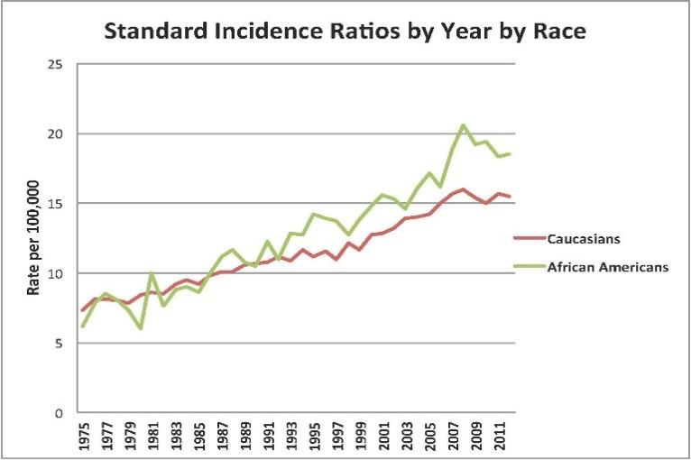

*Figure 1: Standardized incidence ratios of cancer of the kidney and renal pelvis for Caucasians (Green) and African Americans (Red). Data from the Surveillance Epidemiology and End Result program from 1975-2011 [83]*

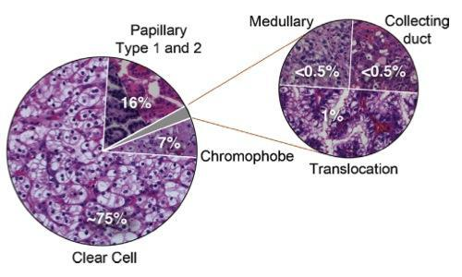

*Figure 2: Histologic distribution of kidney cancerschemes for kidney cancer [81]*

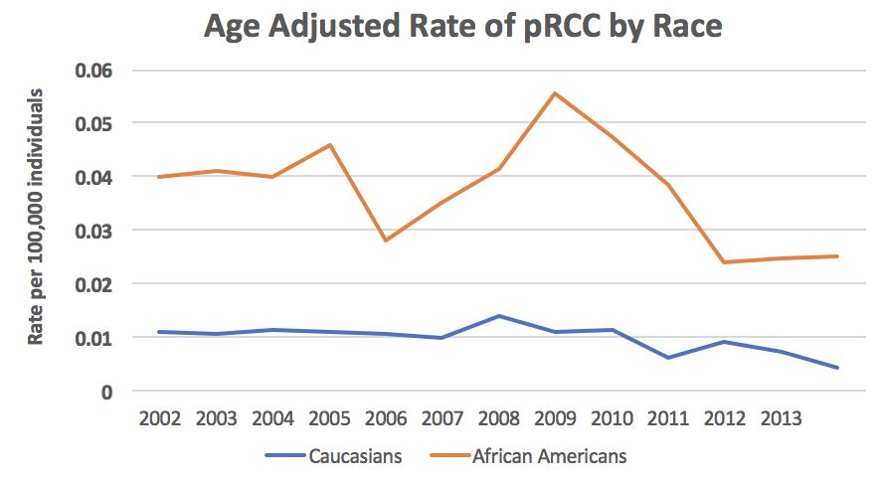

Figure 3: African Americans have much high age adjusted incident rate for pRCC compared with Caucasians.

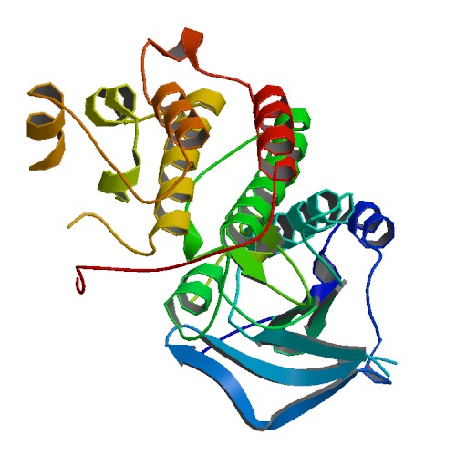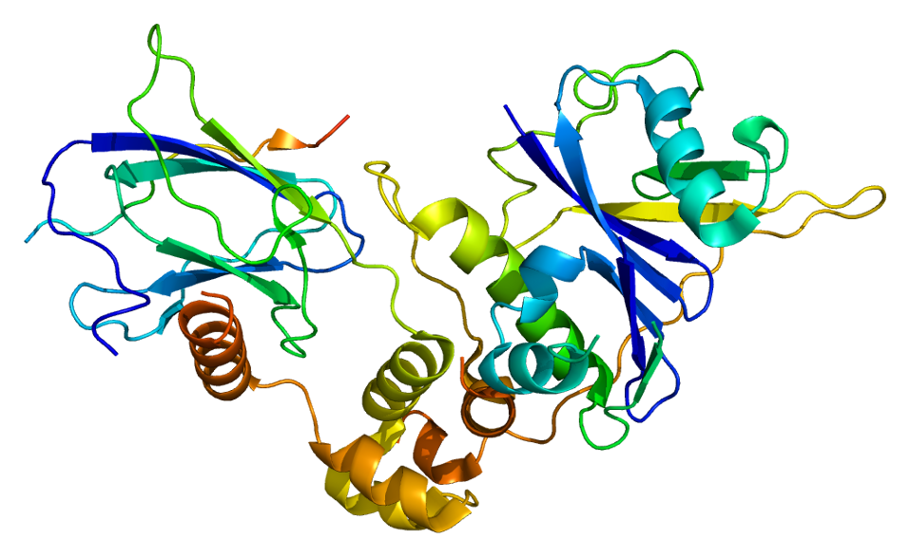

Figure 4: X-ray crystal structure of MET protein (left, pdb ID: 1R0P) and HIF-VHL complex (right, pdb ID: 1lm8)

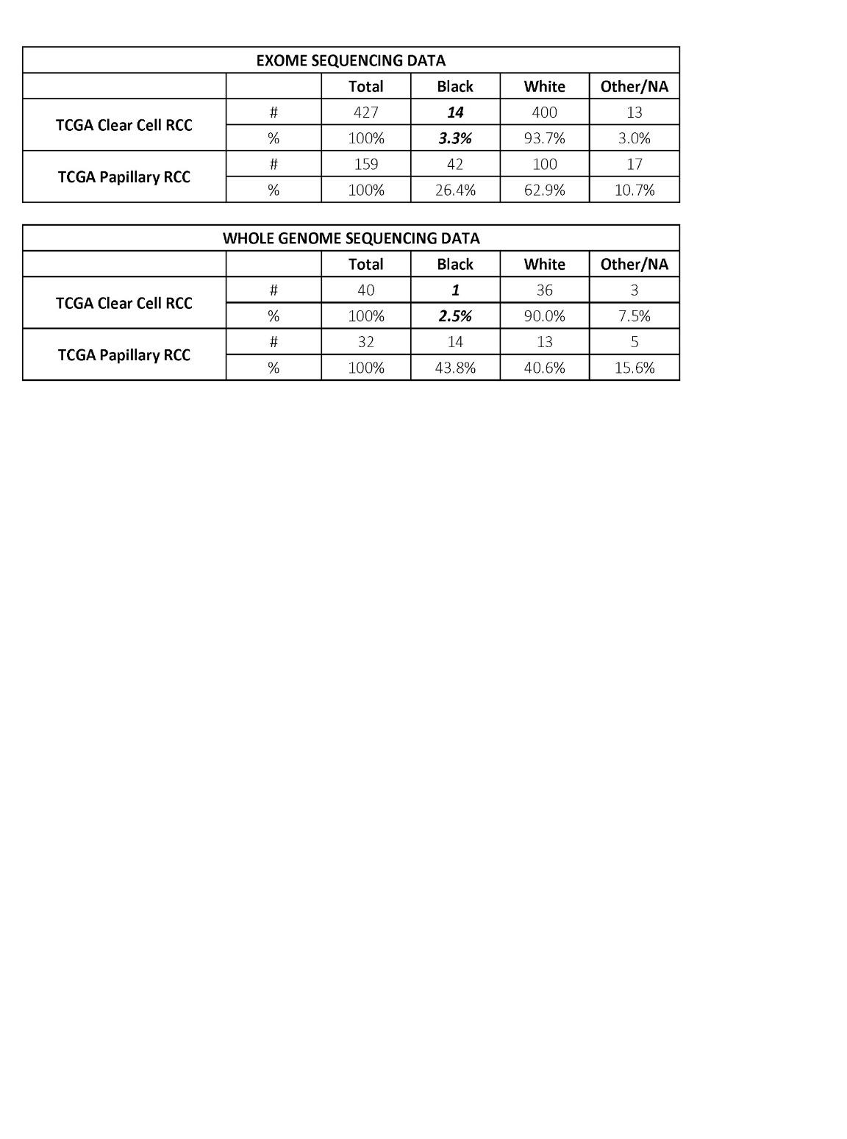

*Table 1: Racial and histologic distribution of available whole exome and whole genome data available from TCGA datasets.*

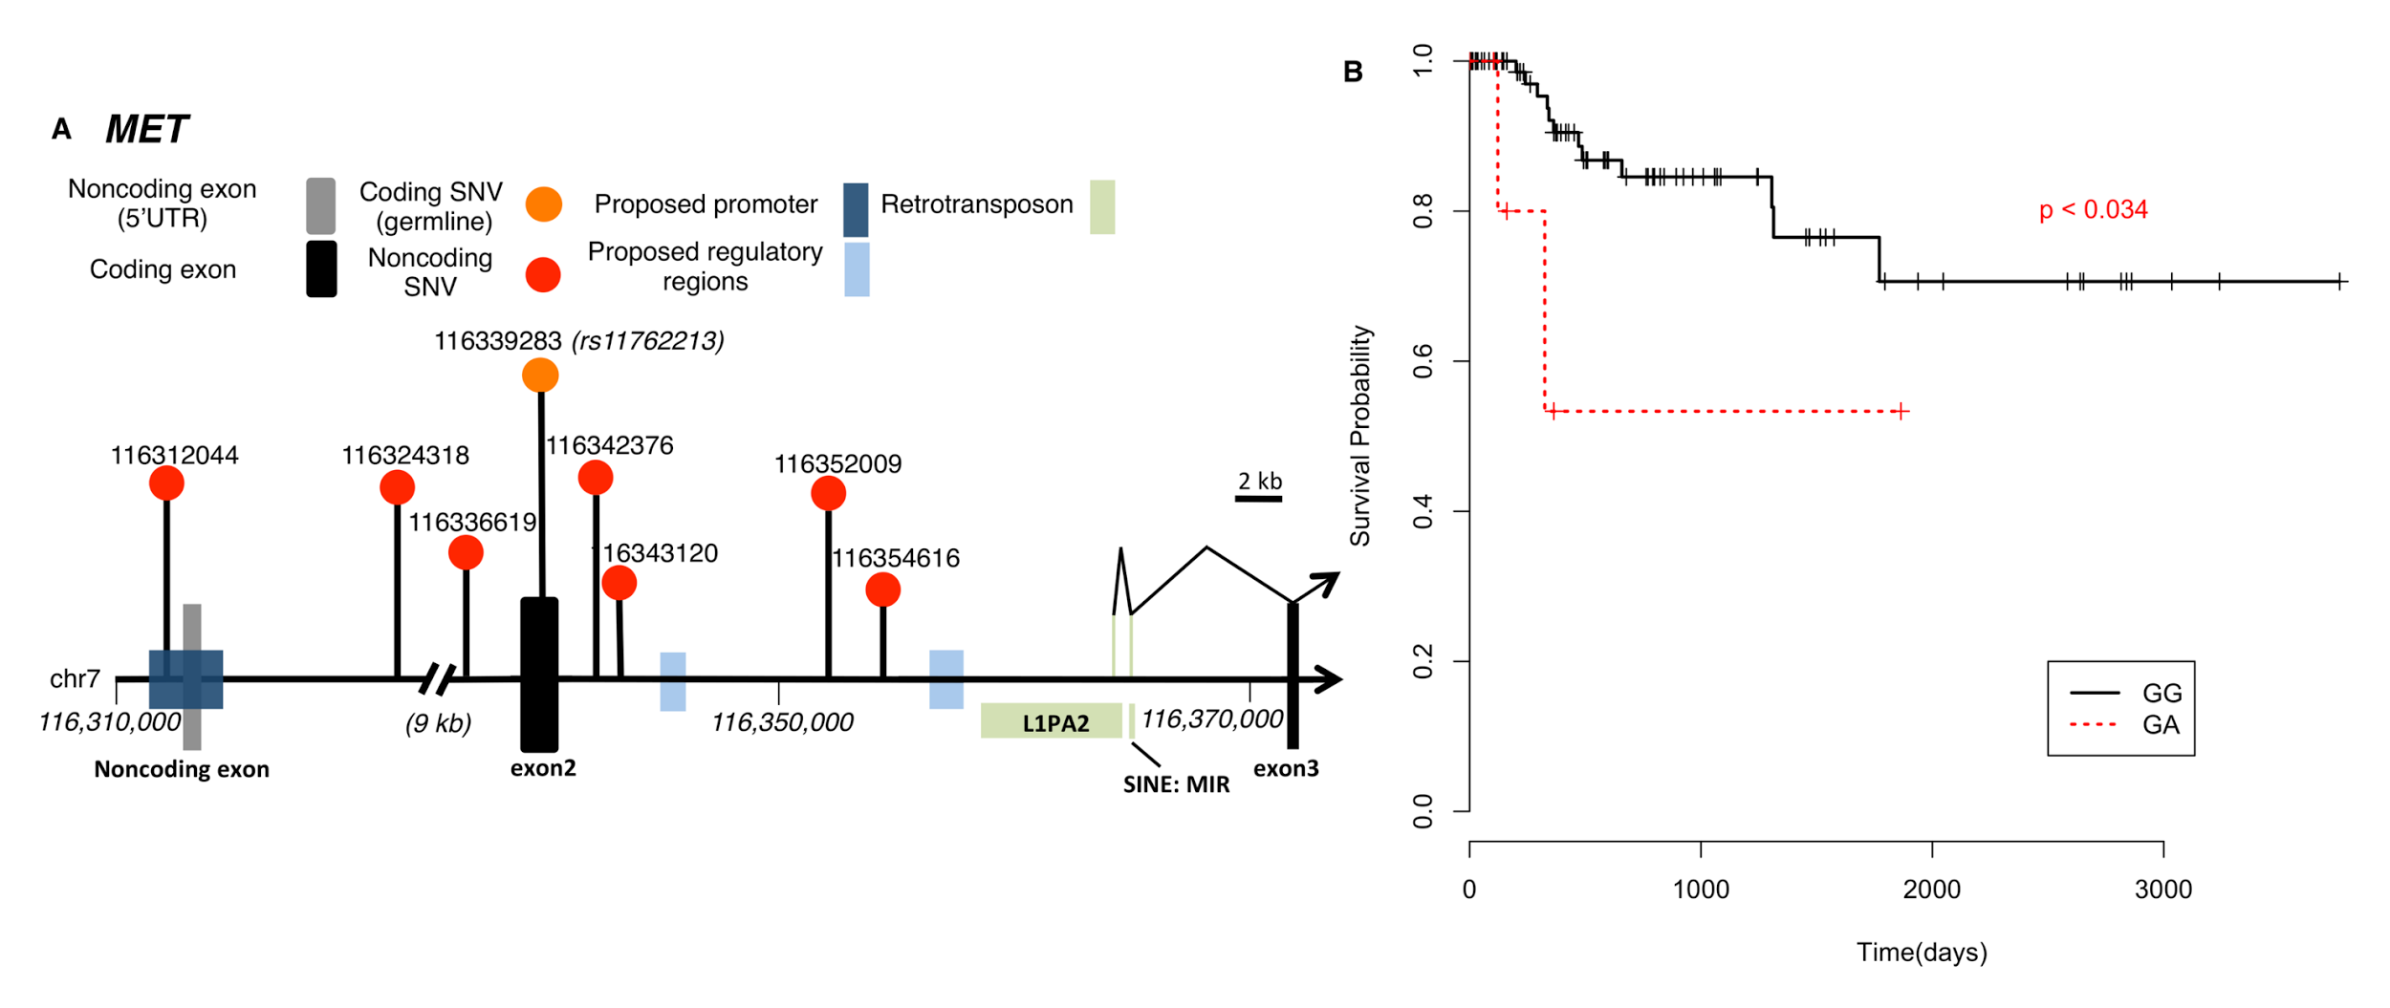

Figure 5: **A.** Whole genome analysis of 35 pRCC samples finds significant non-coding mutations in MET. **B.** A germline SNP (rs11762213) predicts survival in type 2 pRCC patients \cite{}.

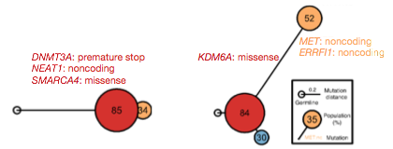

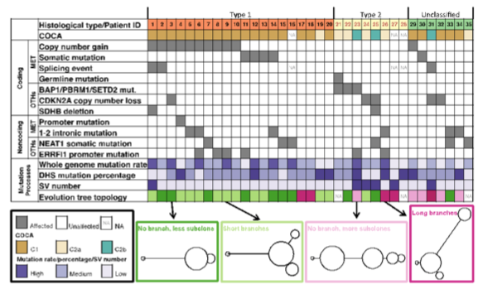

Figure 6: Evolutionary trees help elucidate pRCC tumor development and complete molecular subtyping \cite{5391127}.

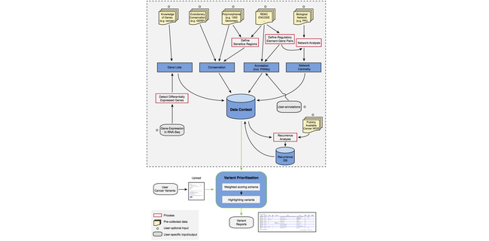

Figure 7: The workflow of FunSeq \cite{24092746}.

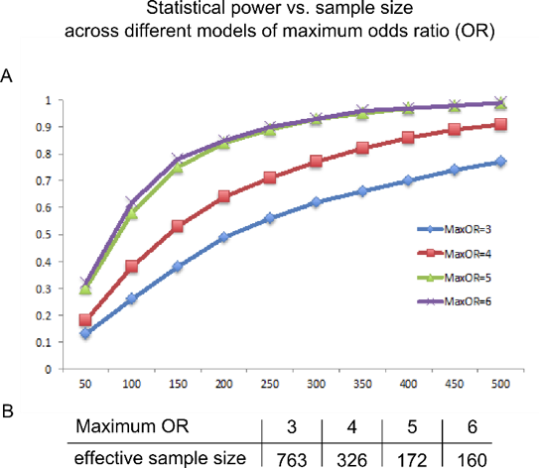

**This is FIGURE 8!**

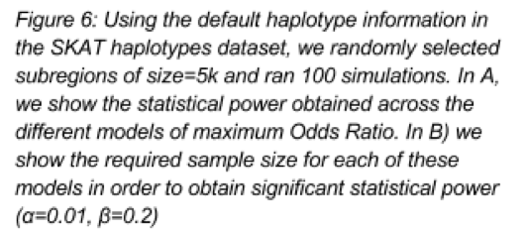

**Figure 9 & 10**

