'<https://beamandrew.github.io/deeplearning/2017/02/23/deep_learning_101_part1.html>

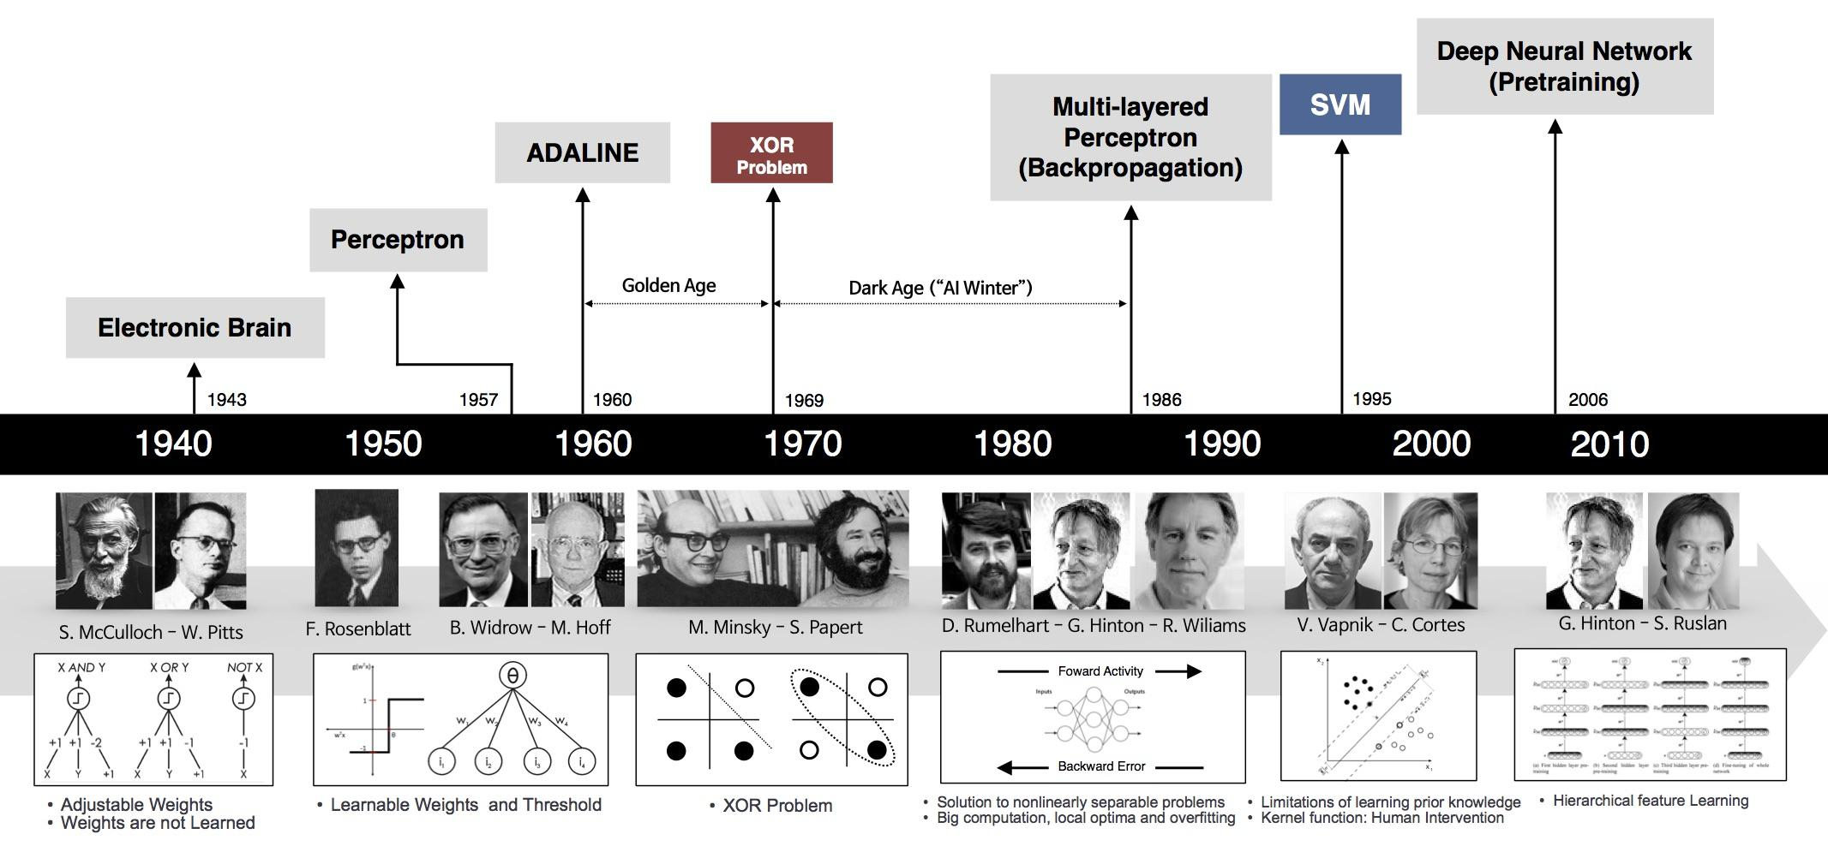

<http://www.nature.com/nature/journal/v493/n7433/full/493473a.html?foxtrotcallback=true>

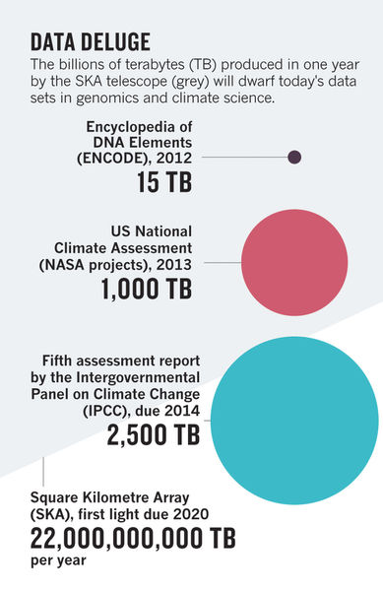

<http://www.sciencedirect.com/science/article/pii/S1532046413001007>

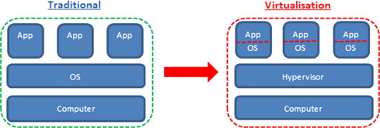

<http://science.sciencemag.org/content/331/6018/728.full>

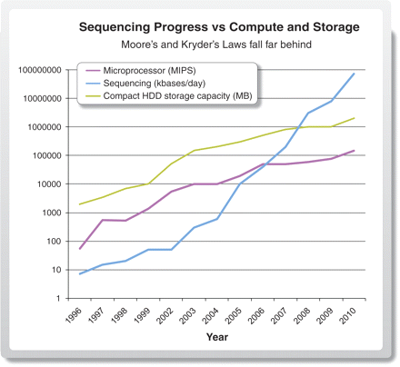

<https://www.nature.com/nature/journal/v498/n7453/full/498255a.html>

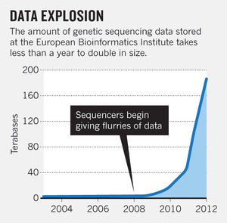

<http://genome.cshlp.org/content/25/10/1417.full>

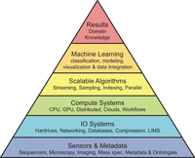

<https://link.springer.com/article/10.1007/s00702-015-1489-y>

<http://online.liebertpub.com/doi/abs/10.1089/big.2012.0002>

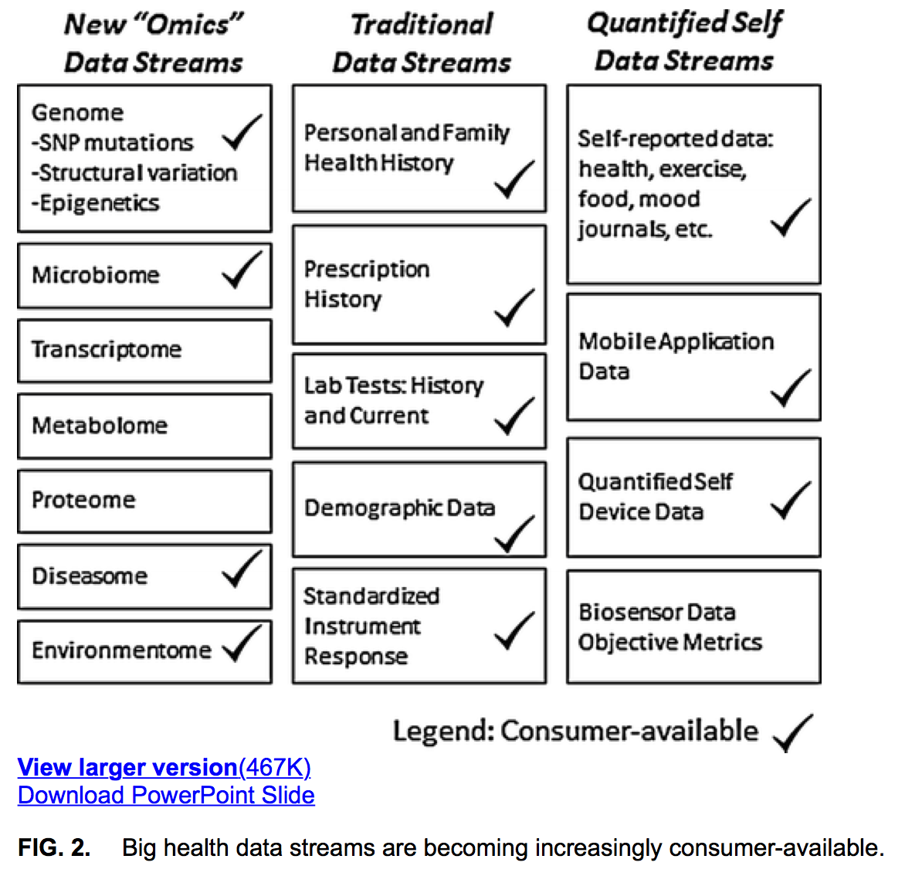

<https://www.genome.gov/10001735/computational-genomics-and-data-science-program/>

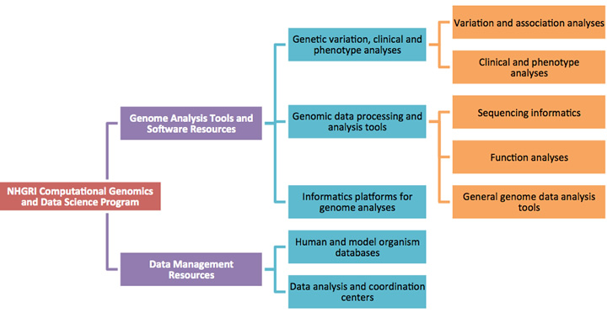

Refs:

1 Big Data: Astronomical or Genomical?

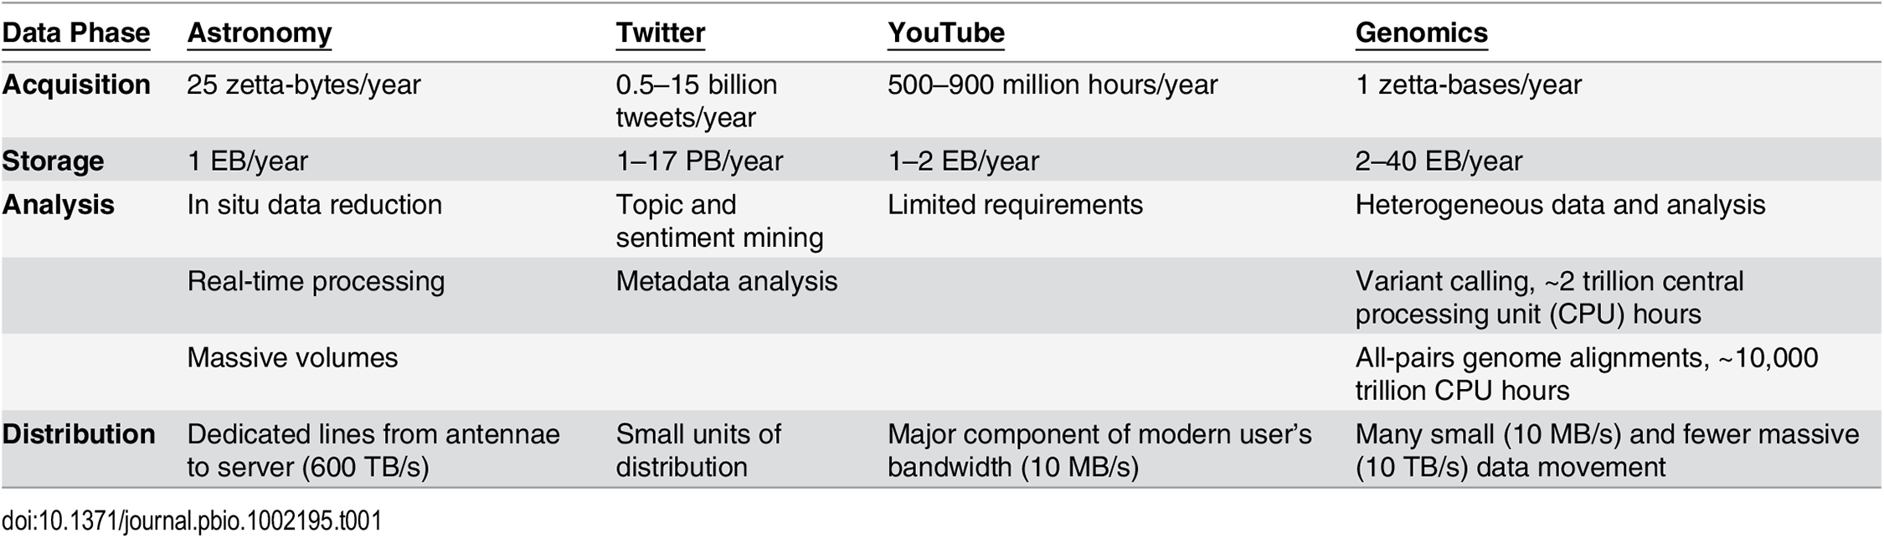

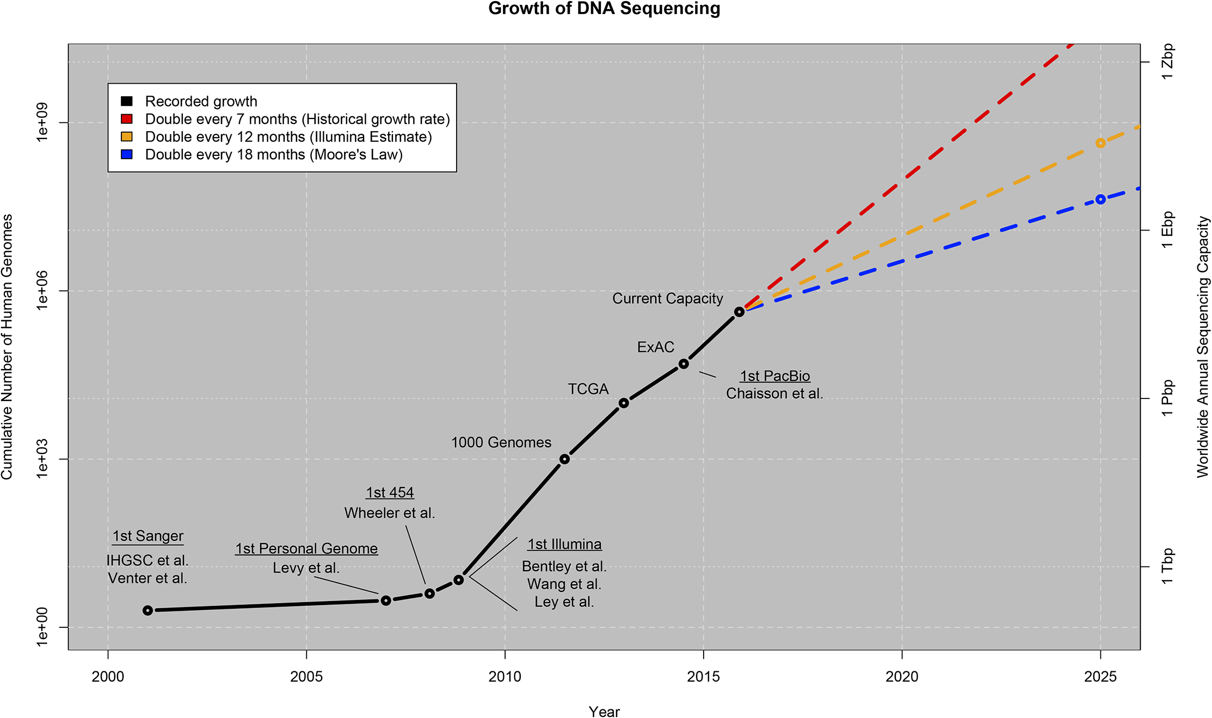

CERN:

27Tb raw + 10 Tb summary data

Astronomy

2. <https://arxiv.org/pdf/1111.0075.pdf> - HOW WILL ASTRONOMY ARCHIVES SURVIVE THE DATA TSUNAMI?

----

<http://www.kdnuggets.com/2015/02/history-data-science-infographic.html>

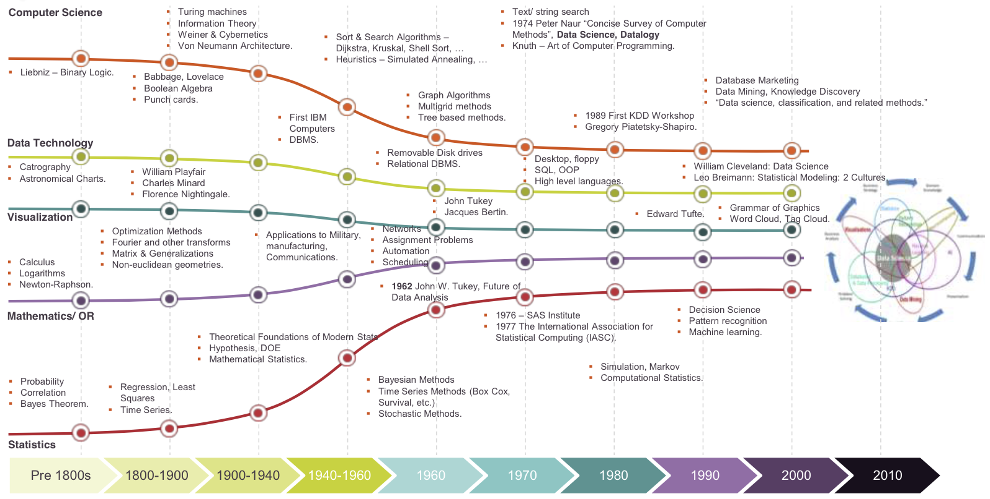

# A Very Short History Of Data Science

<https://www.forbes.com/sites/gilpress/2013/05/28/a-very-short-history-of-data-science/2/#64ec8bae699e>

<https://trends.google.com/trends/explore?date=2004-01-01%202017-08-16&q=%22data%20science%22,%22data%20mining%22,%22data%20processing%22,%22Knowledge%20Discovery%22>

<https://www.google.com/search?q=data+science+timeline&oq=data+science+timeline&aqs=chrome.0.0j69i57.4583j0j7&sourceid=chrome&ie=UTF-8>

<https://www.yourgenome.org/facts/timeline-history-of-genomics>

