List of Figures
Figure S1.1.1 Parent-child trios characterized for structural variation. 5
Figure S1.2.1 Insert size distribution of an example HGSVC liWGS library. 6
Figure S1.2.2 SMRT sequence coverage. 7
Figure S1.3.1 Data portal for IGSR samples. 8
Figure S2.1.2 Comparison between eagle2 population-based phasing (using 1000G panel) and trio-based phasing of YRI. 10
Figure S2.3.1 Map of meiotic recombination events for each family trio. 12
Figure S2.3.2 Level of overlap between Strand-seq and PacBio derived meiotic breakpoints 13
Figure S3.1.2 The number of phased SNVs in 60 kbp windows across the genome 15
Figure S4.1.1 Indel discovery summary 17
Figure S4.1.2 The number of insertions and deletions detected at each size from 0 to 49 bp were compared across all samples. 18
Figure S4.2.1 PacBioCovPermutationTest 19
Figure S4.2.2 Bionano Concordance 20
Figure 4.2.3 SVs from each sample were compared to a non-redundant set of variants previously reported in hydatidiform moles 21
Figure S4.2.4 SVs from each sample were compared to a 1000 Genomes call set (1kgp3) 22
Figure S4.2.5 Paternal and maternal read counts for heterozygous and homozygous calls for HG00514, HG00733, and NA19240. 23
Figure 4.2.6 Paternal and maternal read counts for heterozygous and homozygous calls for HG00514, HG00733, and NA19240, excluding tandem repeats. 24
Figure S4.2.7 BNGValidation 25
Figure S4.2.8 ALT Read Support For PacBio Called Variants 26
Figure S4.2.9 ALT Read Support For PacBio Called Variants 27
Figure S4.3.1 Example of a multiallelic CNV site with an apparent Mendelian violation in the CHS trio 28
Figure S4.3.2 Insert size distribution of an example HGSVC liWGS library. 29
Figure S4.3.4 SVs discovered in HGSVC trios by liWGS cluster individuals by ancestry and relatedness. 31
Figure S4.3.5 A rare, paternally-inherited complex delINVdel in the Puerto Rican family 32
Figure 4.3.6 Validation of the de novo Alu insertion 33
Figure S4.3.7 Pipeline to integrate SVs from multiple Illumina callsets. 34
Figure S4.3.8 Assessment of breakpoint accuracy of each Illumina algorithm 35
Figure S4.3.9. Comparison of integrated Illumina SV set against PacBio and hybrid callers 36
Figure S4.3.10 A The deletion can be confirmed by raw PacBio read-support in an alignment-free approach using dot-plots. 37
Figure S4.3.10B alignment pattern of a 14Kb deletion that was uniquely discovered by Illumina algorithms. 38
Figure S4.3.11 Illumina-genotyping 39
Figure S4.3.12. SGDP Sample Distribution 40
Figure S4.3.13 41
Figure S5.1.1 The number (axis 1) and fraction (axis 2) of of Illumina calls with a similar PB-SV call for HG00514, HG00733, and NA19240, both deletion and insertion. 44
Figure S5.1.2 The support for IL-SV calls from a PB-SV call for each of the three children, deletion and insertion, for the number of methods that support each call. 46
Figure 5.1.3 47
Figure 5.2.1. The data from IndividualCallerConcordance is plotted for the 13 methods. 48
Figure 5.2.2. Concordance of combinations of Illumina SV algorithms. Each pair of rows gives, gives union of two, union of three callers, and requirement of two of three callers, for deletion and insertion calls. 50
Figure 5.2.3. PCA of individual callers for insertion and deletion for PCA1 versus PCA2, and PCA2 versus PCA3, for deletion (DEL) and insertion (INS) calls. 52
Figure 5.3.3 55
Figure S6.1.1 Locating and genotyping inversions in Strand-seq data. 56
Figure S6.1.2 Putative Inversions discovered in Strand-seq composite files. 57
Figure S6.2.1 Haplotype structure of homozygous inversions discovered by Strand-seq. 58
Figure S6.2.2 Haplotype structure of heterozygous inversions discovered by Strand-seq 59
Figure S6.2.3 Haplotype structure of complex inversions discovered by Strand-seq. A 60
Figure S6.3.1 Summary of inversion callsets included in the integration analysis 61
Figure S6.3.2 Intersection test results for HG00733 62
Figure S6.3.3 Summary of results from the intersection test 63
Figure S6.3.4 Inversion lists used to generate the final unified inversion callset 64
Figure S6.4.1 66
Figure S7.1.1 68
Figure S7.1.2 69
Figure S7.1.3 70
Figure S7.1.4. Principal component analysis of genotyping of insertion and deletion SV from high coverage genomes using SMRT-Genotyper. 71
Figure S7.1.5 F_{ST} of SV detected with SMRT-Genotyper for insertions (black) and deletions (red) across all genotyped sites for each child. 72
Figure S7.2.1. Enrichment for SVs intersecting functional elements in the IL-SV and PB-SV callsets. CDS: coding sequences, PPS: processed pseudogenes, UPS: unprocessed pseudogenes. 73
Figure S7.2.2: Significance of gene expression effect by PB-SVs and IL-SVs that engulf protein coding genes. 74
Figure S7.2.3: A pipeline of the allele specific expression analysis for SNPs (Panel A) and SVs (Panel B). 75
Figure S7.2.4 The distribution of reference allelic ratio using both allele seen het-SNPs 76
Figure S7.2.5 Analysis of SNP and PB-SV ASE for indication against a haploblock effect 77
Figure S7.2.6 Change in exon length by haplotype 78
Figure 7.2.7 Differences in read counts for exons of different length in haplotype specific assembly 80
Figure 7.3.1 81

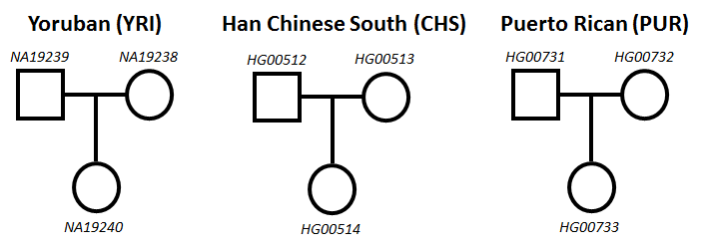
Figure S1.1.1 Parent-child trios characterized for structural variation. We refer to the children from each pedigree as YRI (Yoruban), CHS(Han Chinese South) and PUR(Puerto Rican).

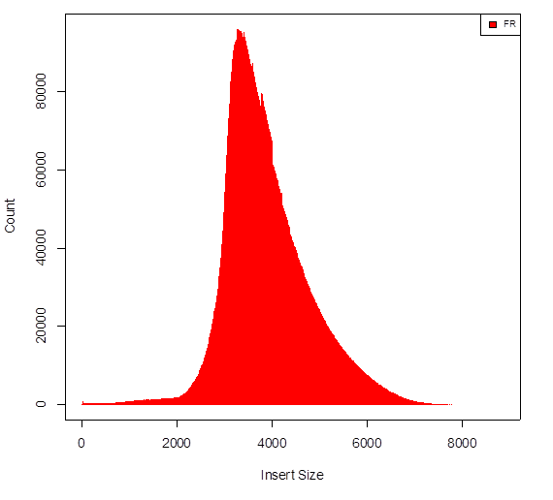
Figure S1.2.1 Insert size distribution of an example HGSVC liWGS library. We generated liWGS libraries for all nine HGSVC individuals following previously described protocols targeting a mean insert size of 3.5kb. As an example, the distribution of insert sizes from the library generated for the father from the Puerto Rican trio is shown here. All nine libraries closely resembled this distribution. This distribution was generated automatically by Picard tools (http://broadinstitute.github.io/picard/).

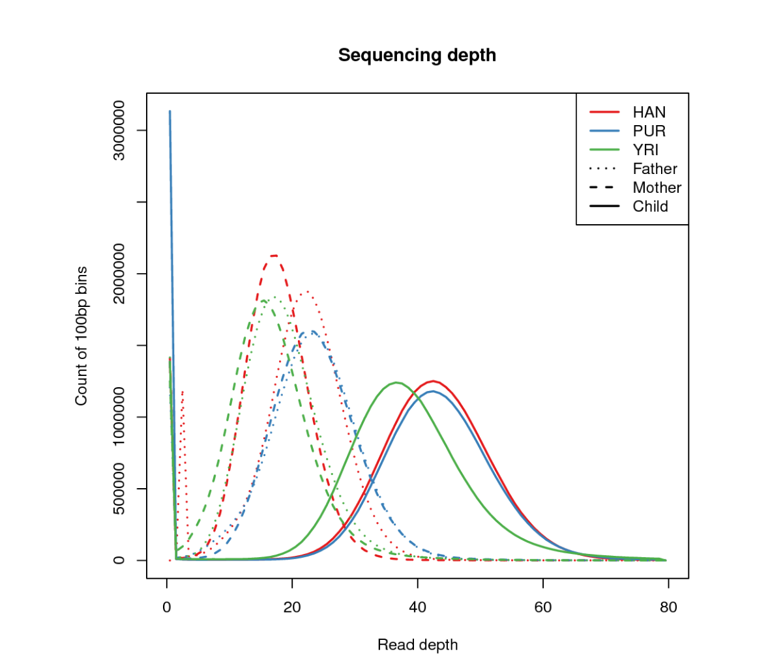

Figure S1.2.2 SMRT sequence coverage.

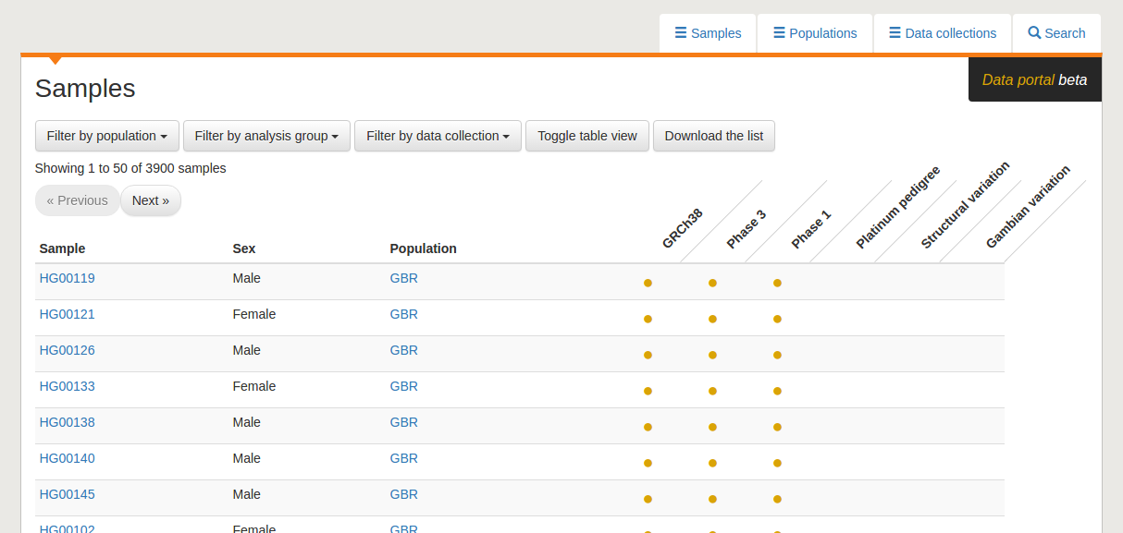
Figure S1.3.1 Data portal for IGSR samples. To assist in locating data, IGSR has created a data portal, which includes the major data collections hosted by the project. The data portal is illustrated in Figure 0.1 and a full description of IGSR, including the data portal is available in (Clarke et al. 2017). A page summarising data from the HGSVC can be found at http://www.internationalgenome.org/data-portal/data-collection/structural-variation.

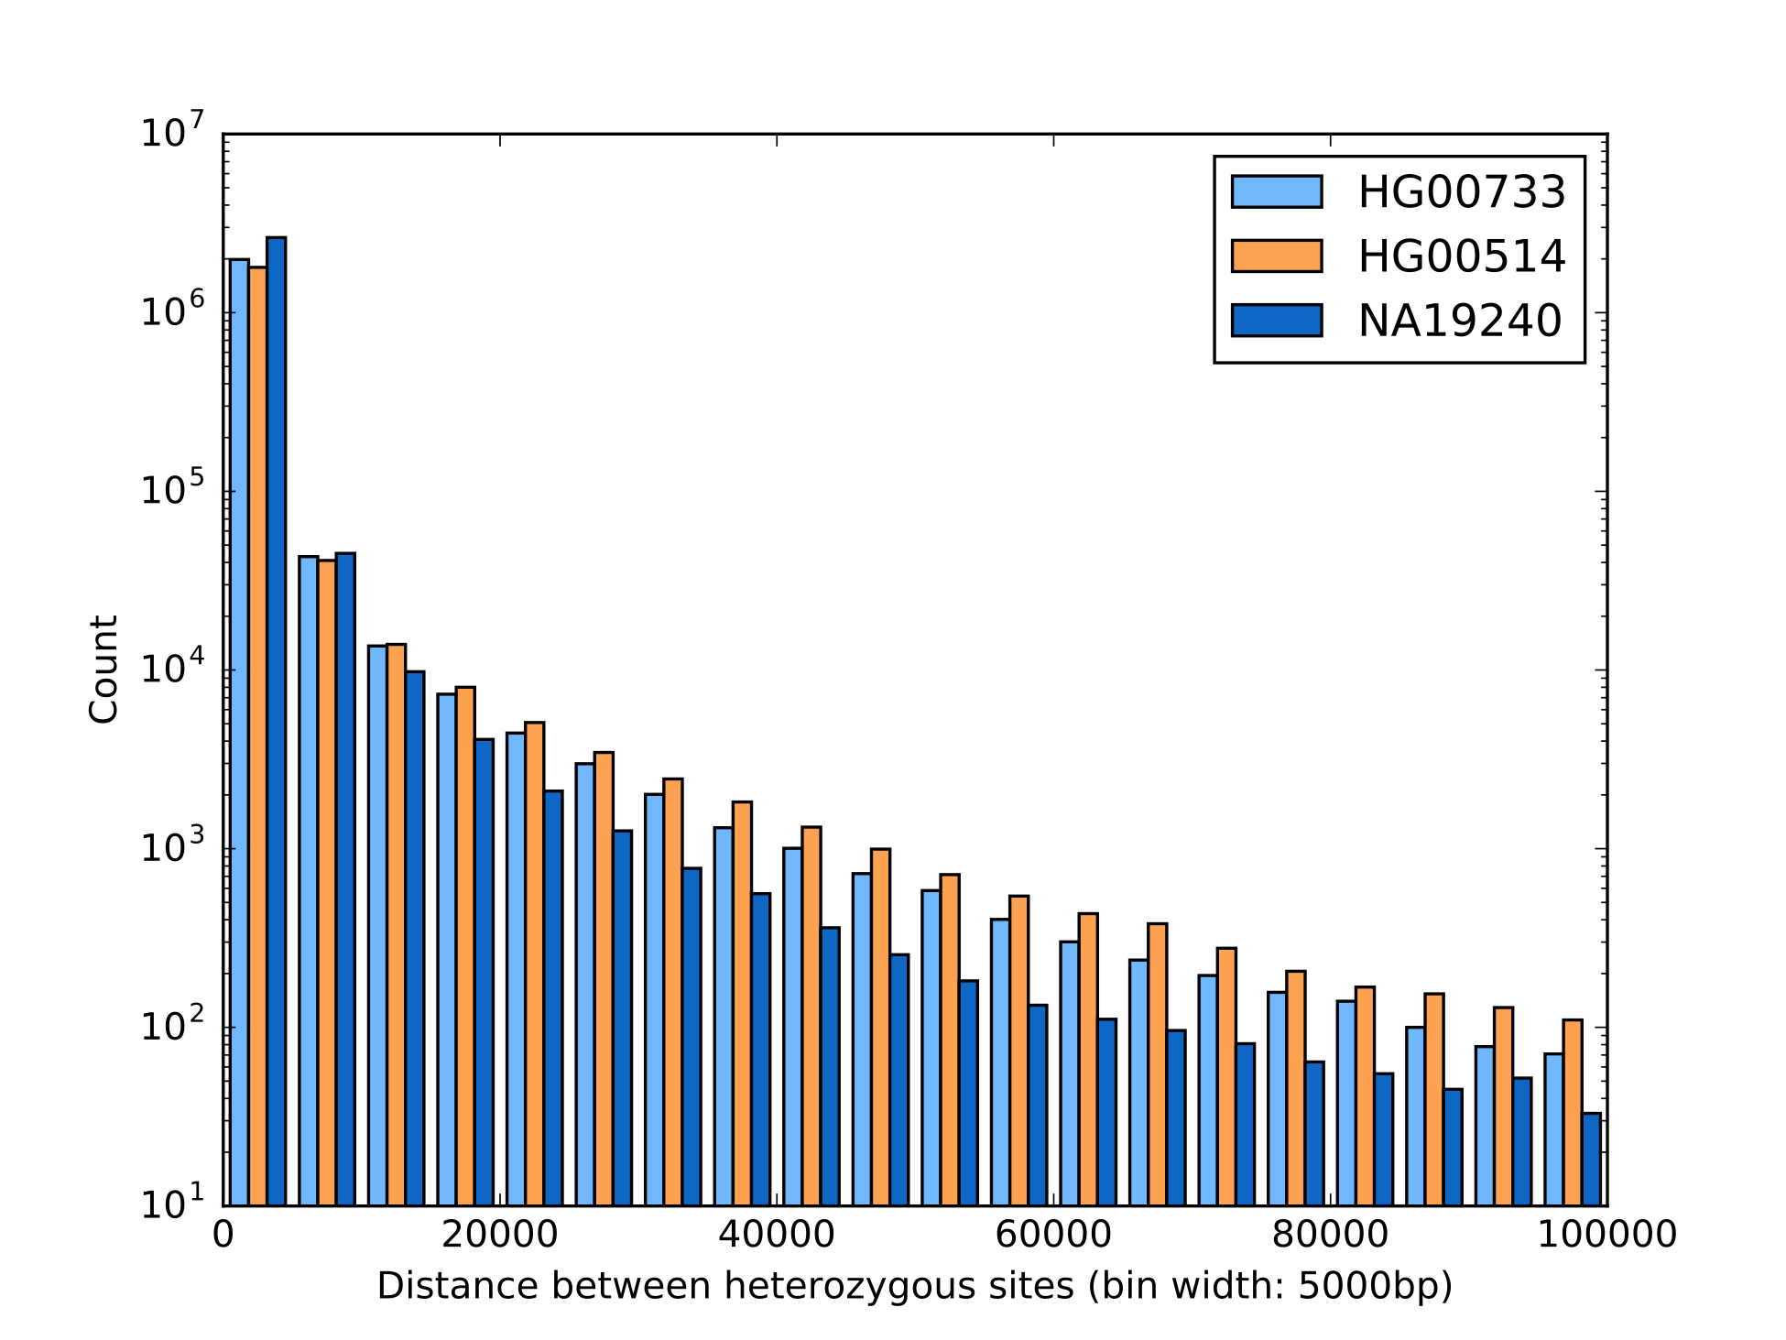Figure S2.1.1 Distance between heterozygous SNVs sites.

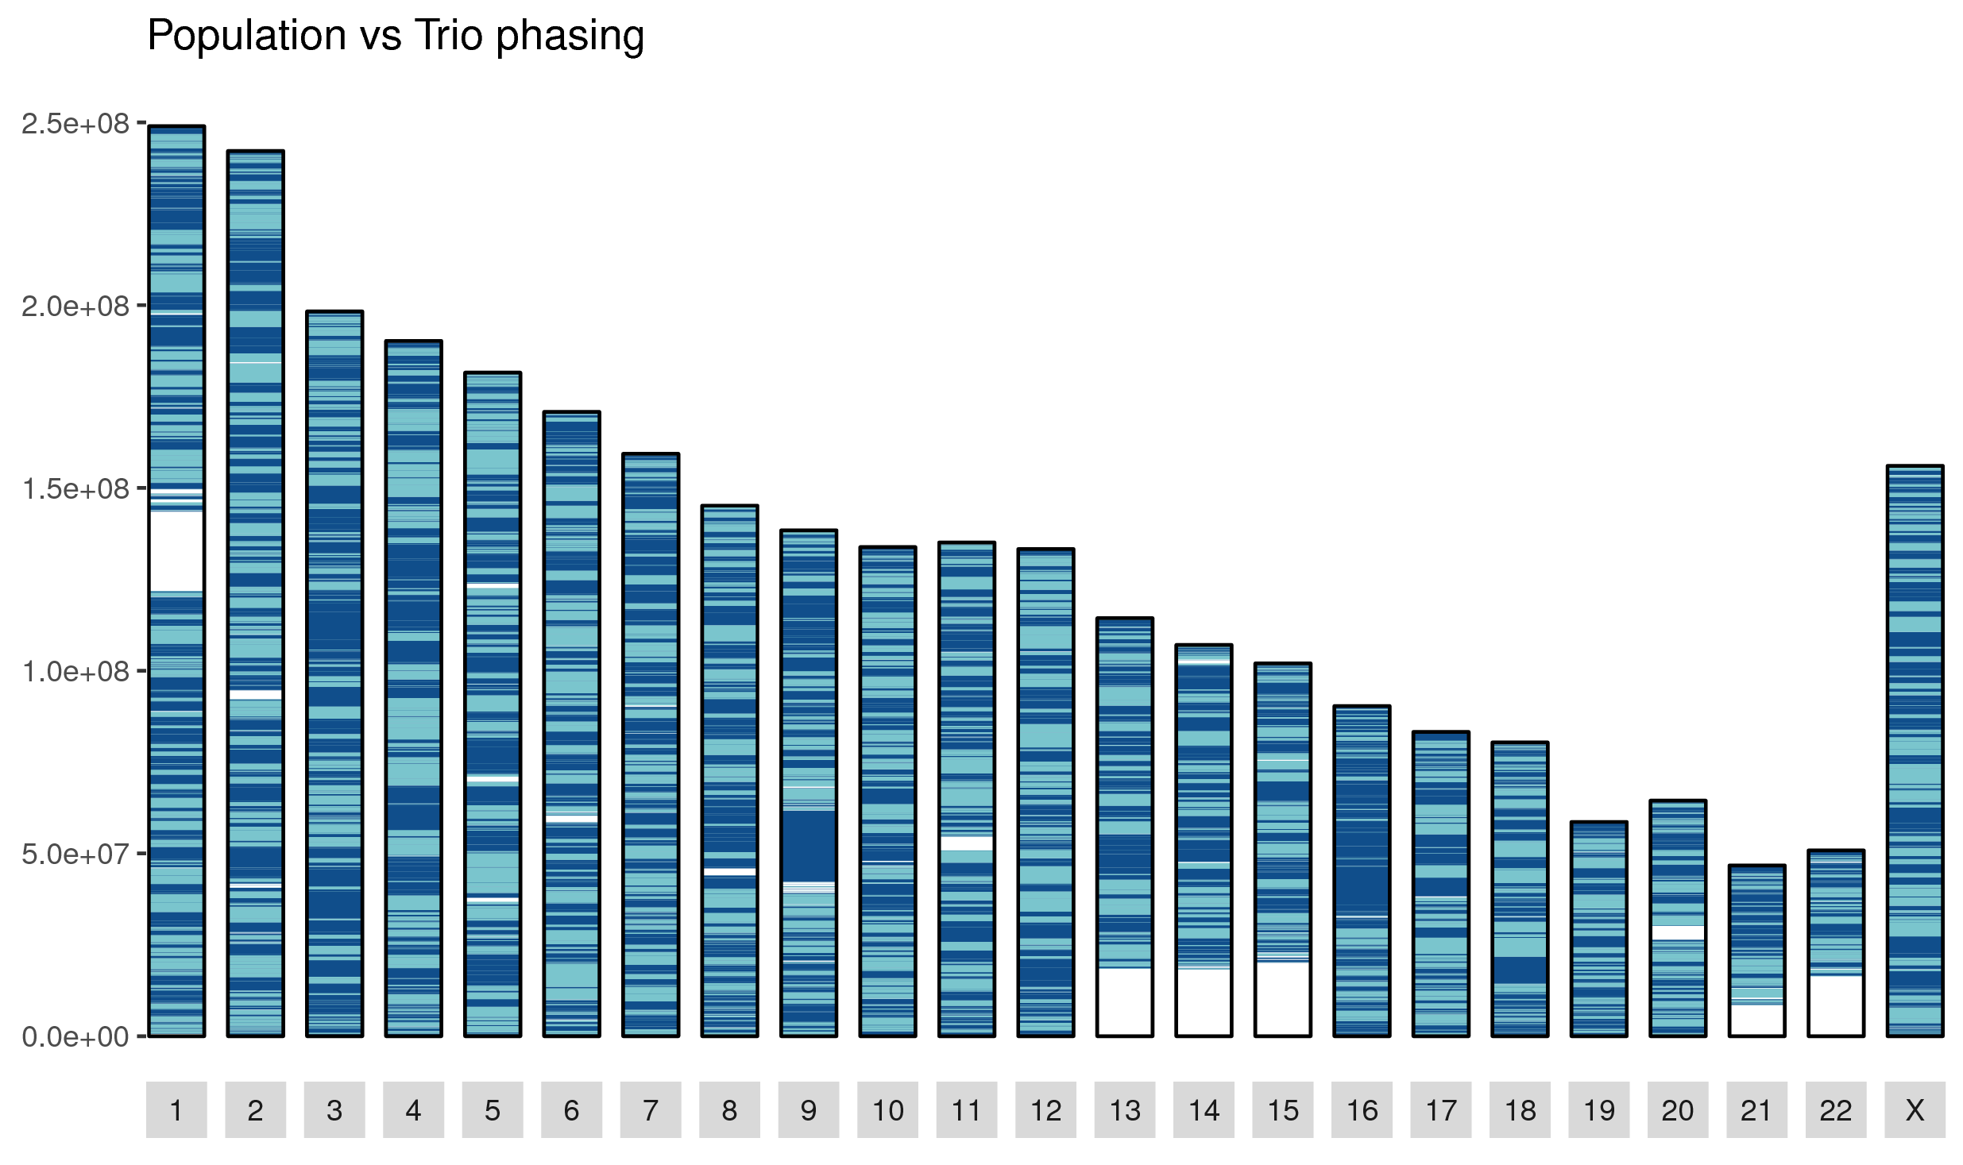
Figure S2.1.2 Comparison between eagle2 population-based phasing (using 1000G panel) and trio-based phasing of YRI. Dark blue indicates matches and light blue indicates mismatches.

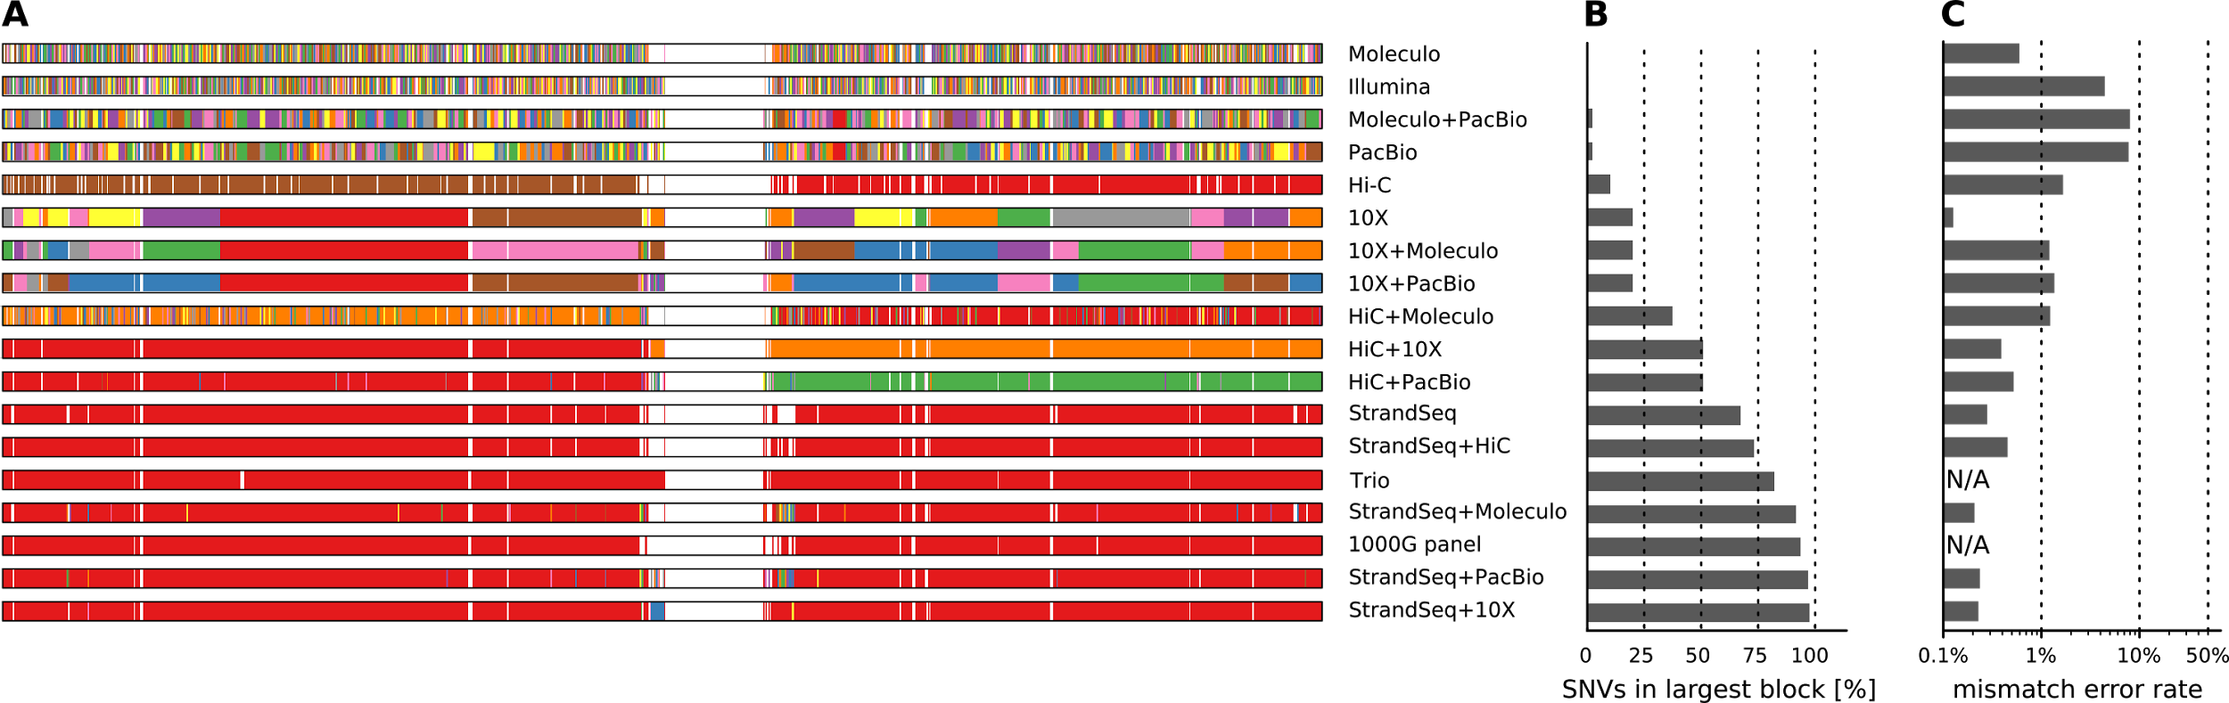Figure S2.2.1 Statistics for all combinations of technologies (as shown in Main Figure 1D-F for selected technologies). (A) Illustration of phased blocks on Chromosome 1 of the YRI child; each phased block is shown in a different color. The largest block is shown in red, i.e. all red regions belong to one block, even though interspaced by white areas (genomic regions where no variants are phased) or disconnected small blocks (different colors). (B) Fraction of heterozygous SNVs in the largest block shown in Panel A. (C) Mismatch error rate of largest block compared to trio-based phasing, averaged over all chromosomes of all proband genomes.

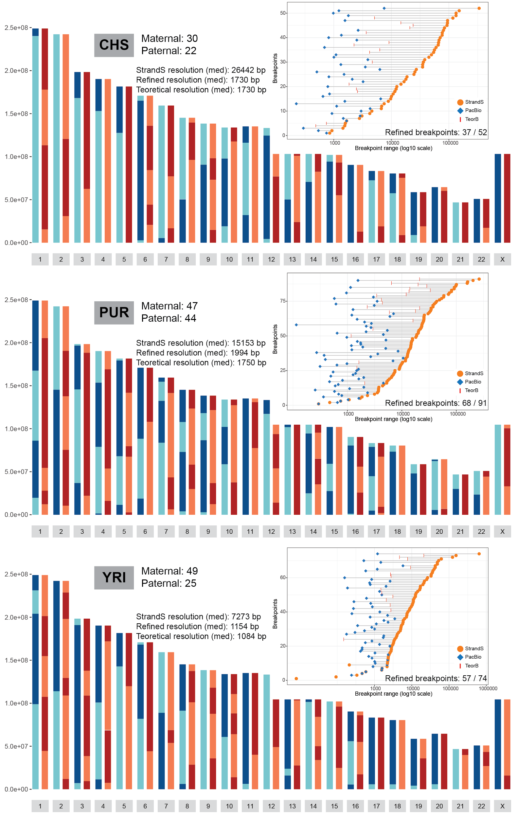
Figure S2.3.1 Map of meiotic recombination events for each family trio. Ideograms show map of meiotic breakpoints for each chromosome with inherited parts of paternal (Paternal homologue H1 – light blue, Paternal homologue H2 – dark blue) and maternal (Maternal homologue H1 – light red, Maternal homologue H2 – dark red) homologues. Inset figure in the right upper corner of each ideogram shows the size distribution of mapped meiotic recombination breakpoints using Strand-seq (yellow dots) and corresponding refined breakpoints using PacBio reads (blue squares) connected by a line. Meiotic breakpoints that in theory could be further refined by residual HET SNVs within the breakpoint are shown reb bar (TeorB).
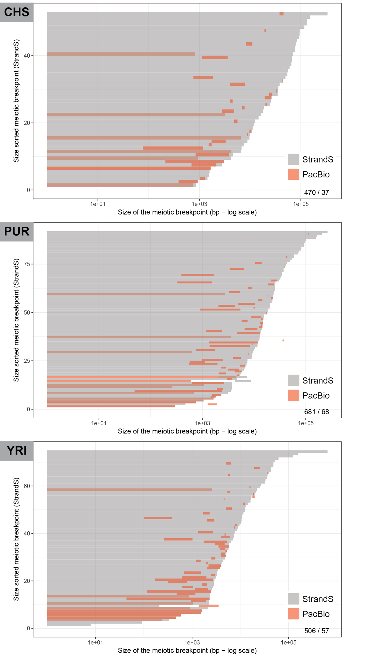
Figure S2.3.2 Level of overlap between Strand-seq and PacBio derived meiotic breakpoints. Figure shows an overlap between meiotic breakpoints mapped by Strand-seq and breakpoints predicted from PacBio reads. Strand-seq meiotic breakpoints are shown in gray color and are sorted by size. Overlapping breakpoints predicted from PacBio reads are depicted in red color. Number of overlapping breakpoints from the total number of breakpoints predicted from PacBio reads is shown in the lower right corner of each plot.

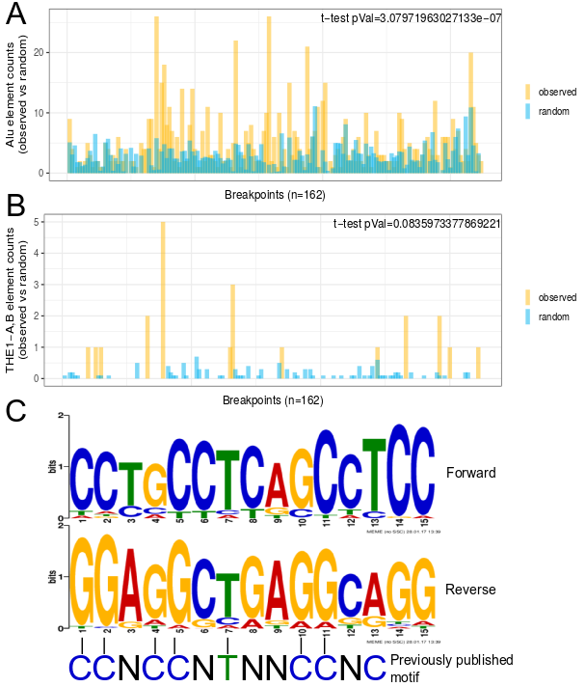
Figure S2.3.3 Enrichment analysis of Alu and THE1-A,B elements around mapped meiotic breakpoints.
Figure shows raw counts of Alu and THE1-A,B elements overlapping with our fine mapped meiotic breakpoints (n=162). Mapped breakpoint ranges were scaled to the largest mapped range (~10 kb). To test if the the above mentioned elements are enriched around meiotic breakpoints we have compared their counts for observed versus random meiotic breakpoints. To simulate random meiotic breakpoints in the genome we have randomly shuffled our mapped meiotic breakpoints around the chromosome they originate from. We have performed 10 independent trials and presented randomized counts represent mean values of all trials. We used t-test statistics to compare Alu and THE1-A,B elements counts between observed and random breakpoints.
- Distribution of Alu elements around the breakpoints versus randomized breakpoints.
- Distribution of THE1-A,B elements around the breakpoints versus randomized breakpoints.
- Consensus motif found in fine mapped meiotic breakpoints (n=162) using MEME suite (zoops mode). Motif significance level: E-value = 3.1e-179. Motif is compared to the previously published motif by Myers et al. (2008).
Note: Genomic positions of Alu and THE-1A,B elements were taken from the ‘GRCh38 RepeatMasker track’ from UCSC genome browser.

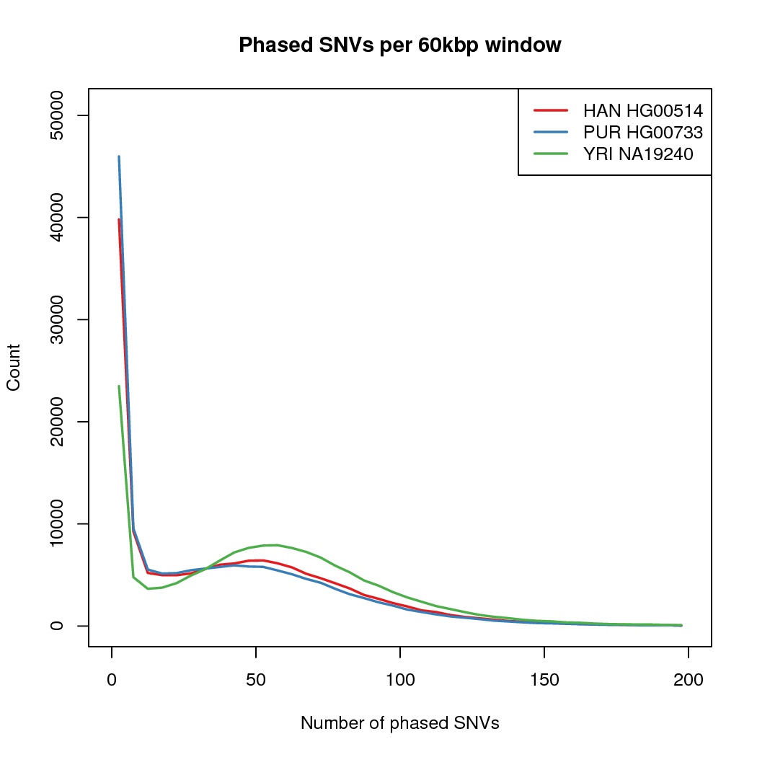
Figure S3.1.2 The number of phased SNVs in 60 kbp windows across the genome.

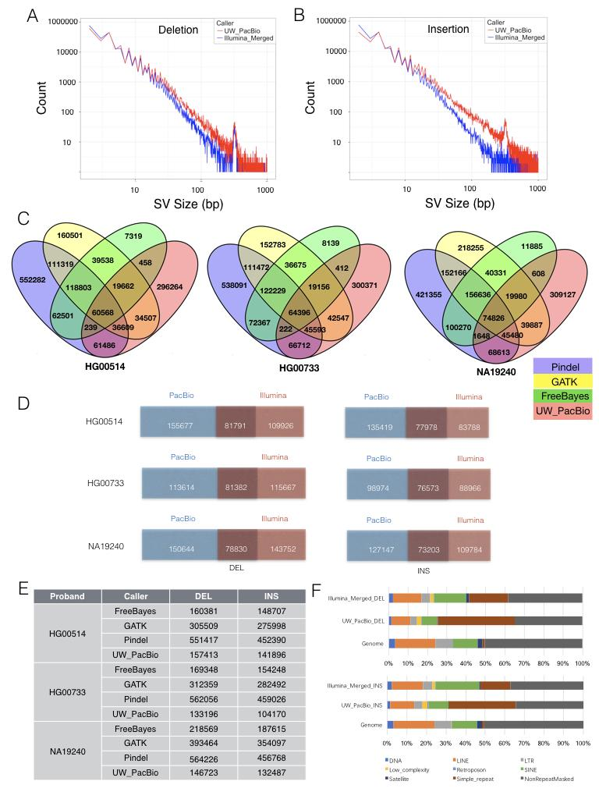
Figure S4.1.1 Indel discovery summary. Deletions and insertions are merged from GATK, Pindel and FreeBayes calls to give Integrated Illumina deletions and insertions respectively, which is then compared to PacBio calls. A. Size frequency distribution of merged Illumina deletions alongside PS/MP (UW_PacBio) deletions from 1bp to 1kb. B. Size frequency distribution of merged Illumina insertions alongside UW_PacBio insertions from 1bp to 1kb. C. Four-way Venn diagrams of indels (1-49bp) from GATK, Pindel, FreeBayes and UW_PacBio callsets for three children: HAN (HG00514), PUR (HG00733) and YRI (NA19240). D. Comparison of UW_PacBio and Illumina integrated indels (1-49bp). E. Table summarizing the number of deletions and insertions called by different methods for the three children. F. Stacked bar graph summarizing the proportion of deletions and insertions residing in various types of repeat regions and Non-repeat-masked region. “Genome” indicates the background proportion of repeat content in the human genome.

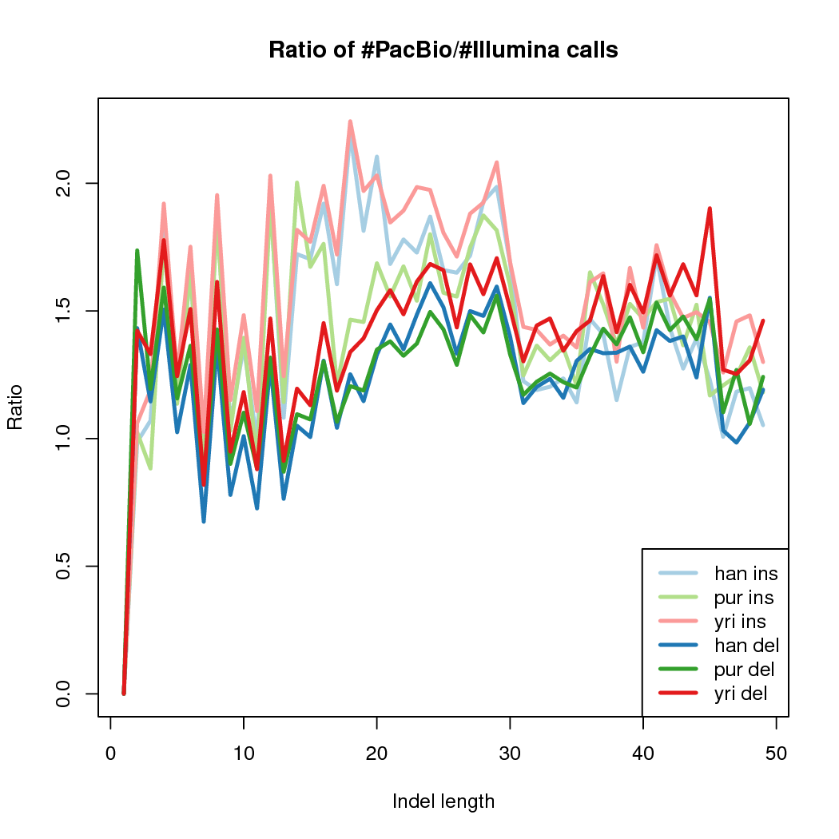

Figure S4.1.2 The number of insertions and deletions detected at each size from 0 to 49 bp were compared across all samples.

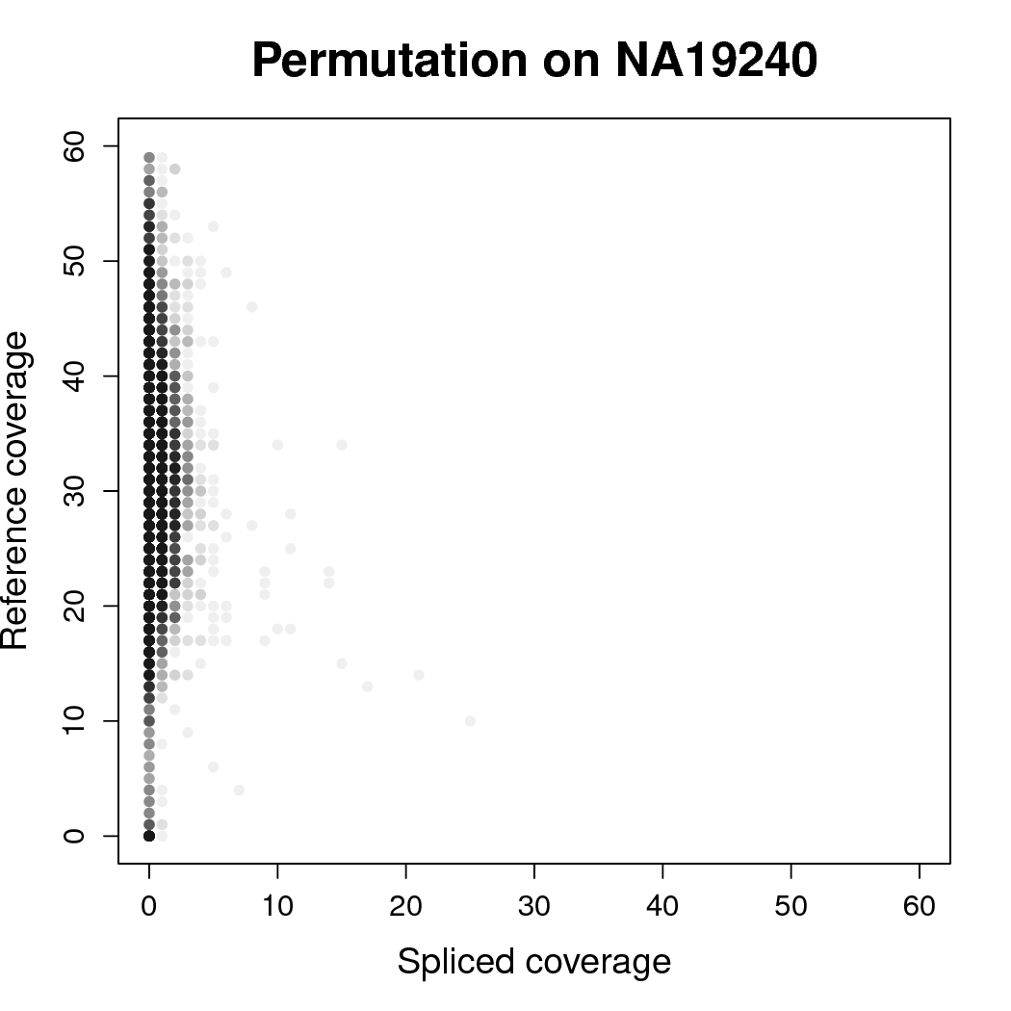

Figure S4.2.1 PacBioCovPermutationTest

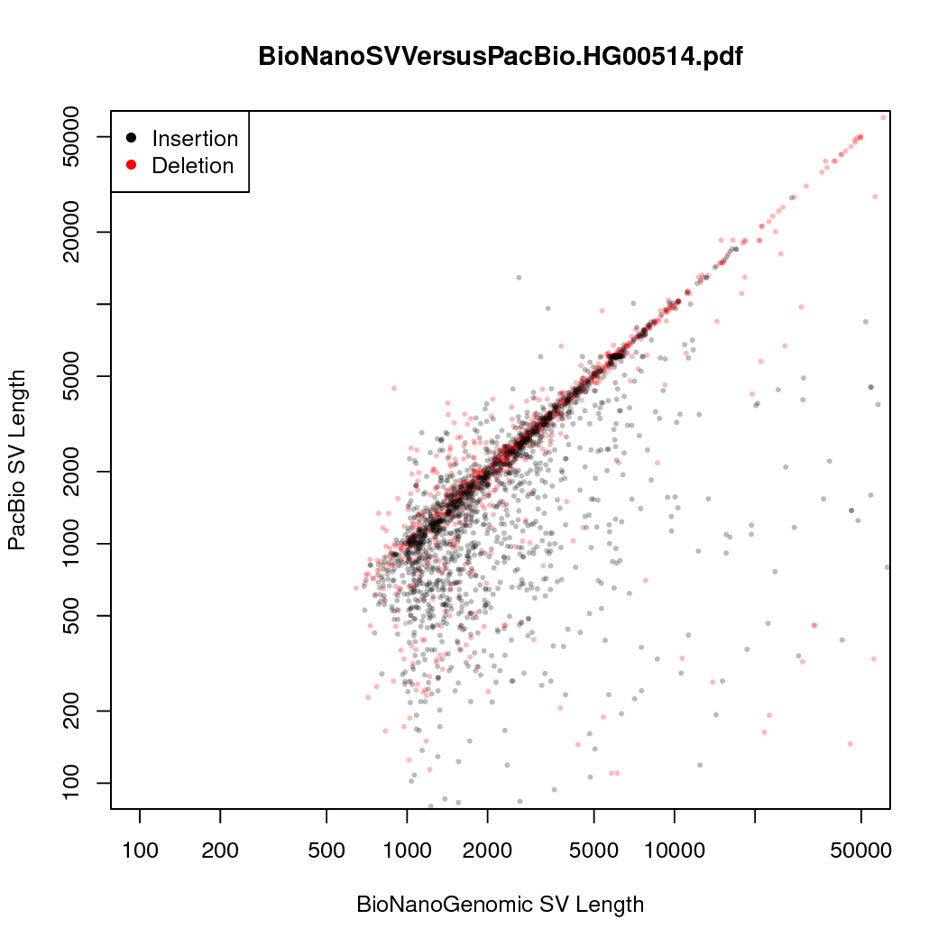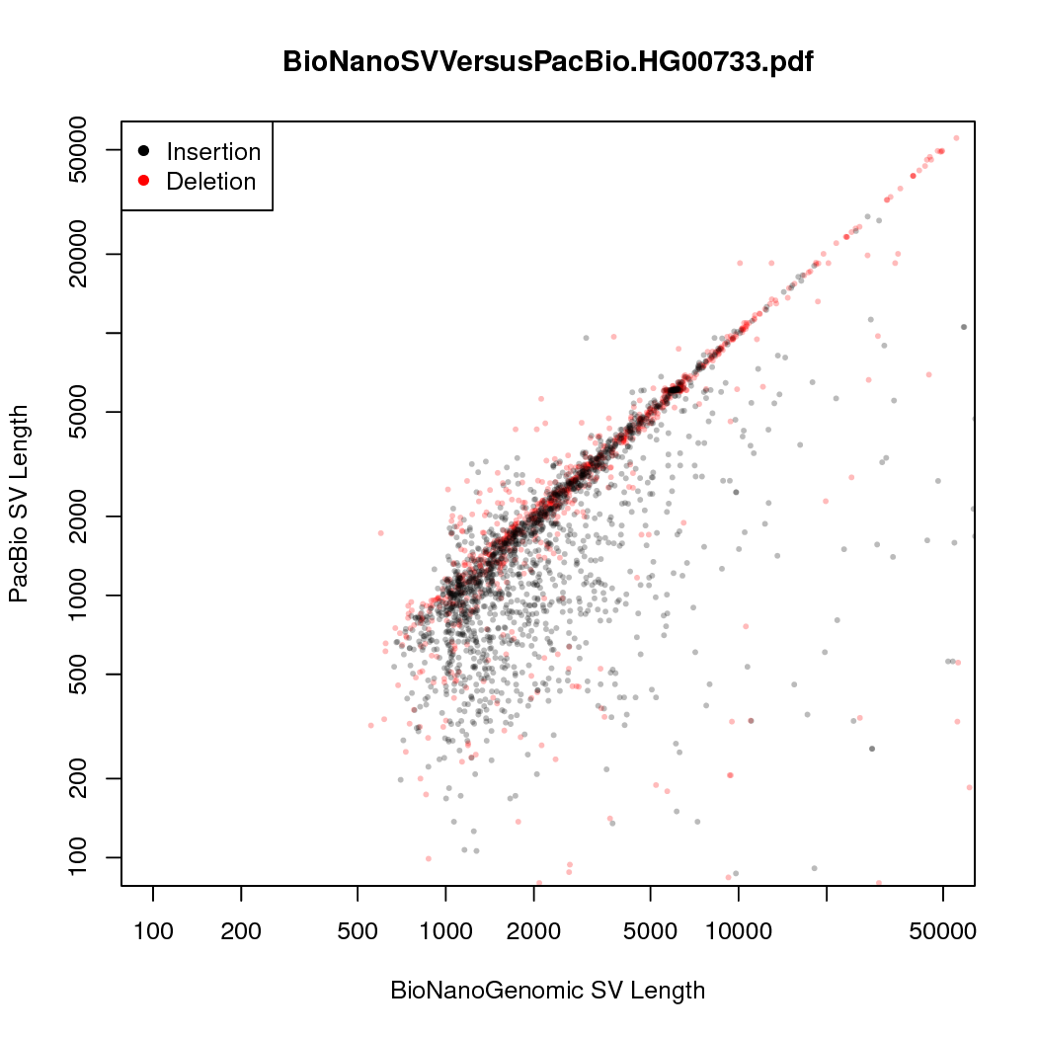
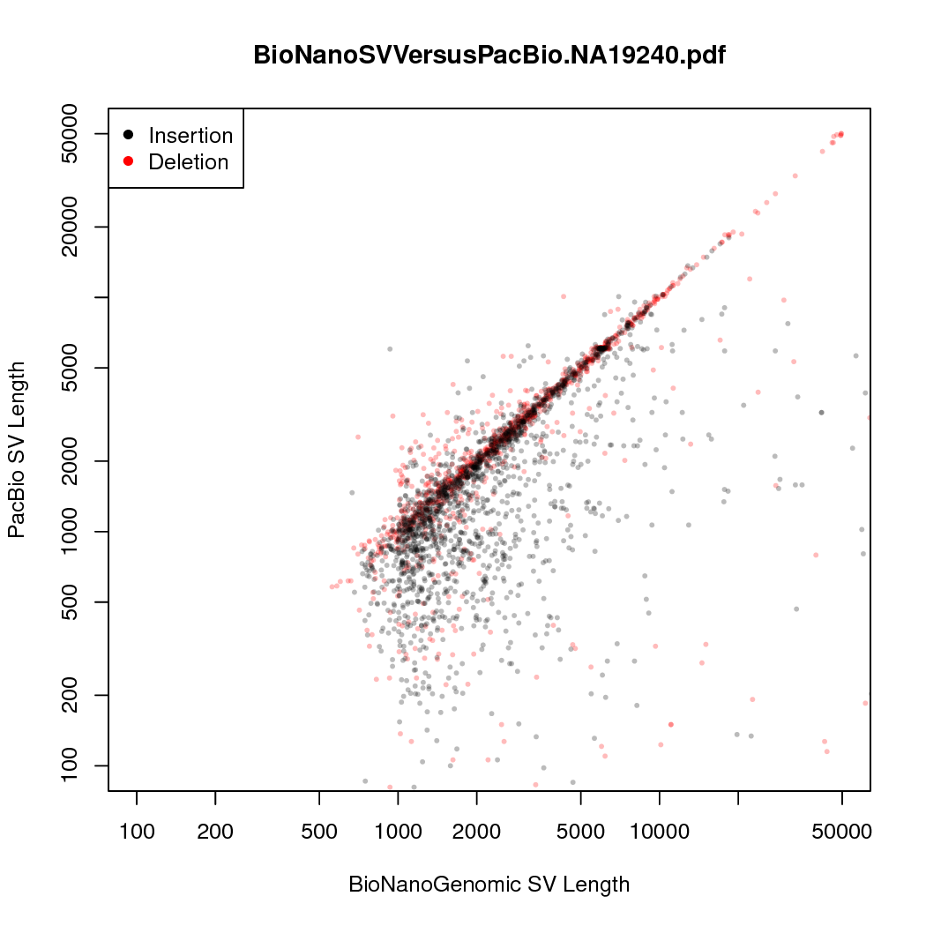
Figure S4.2.2 Bionano Concordance. The concordance defined as the closest matching SV lengths across the variant boundaries of each Bionano variant call is shown for insertions (black) and deletions (red), for HG00514, HG0073, and NA19240.

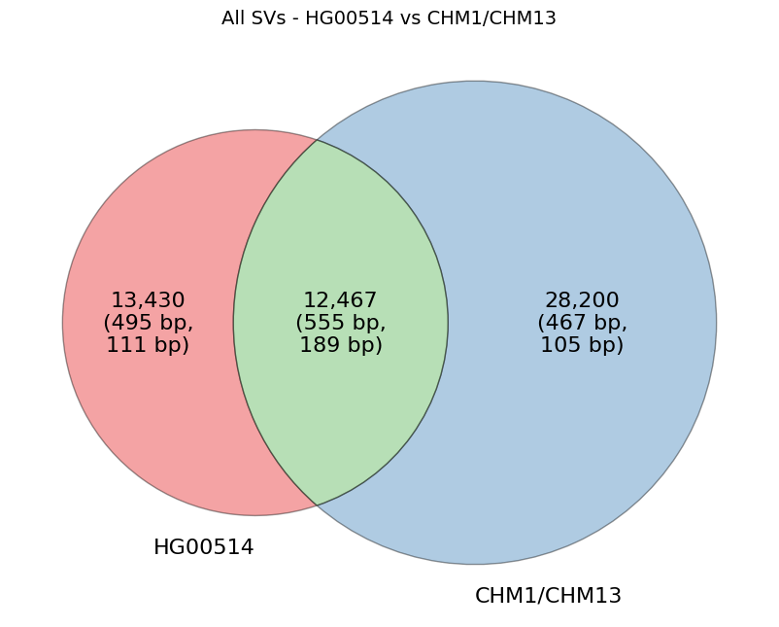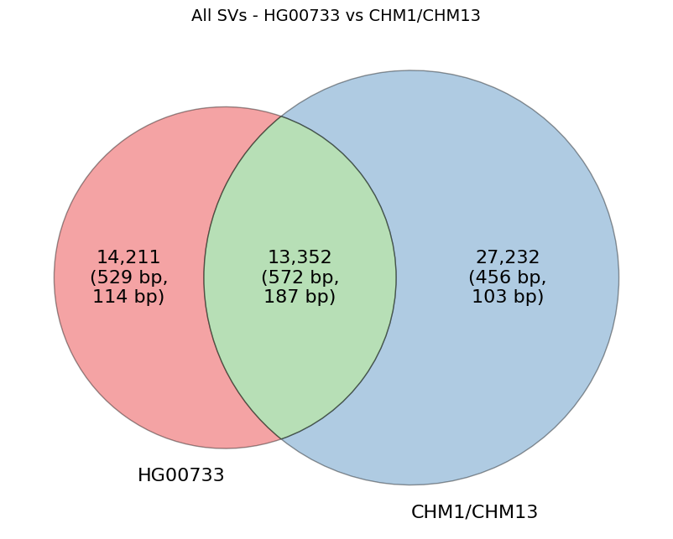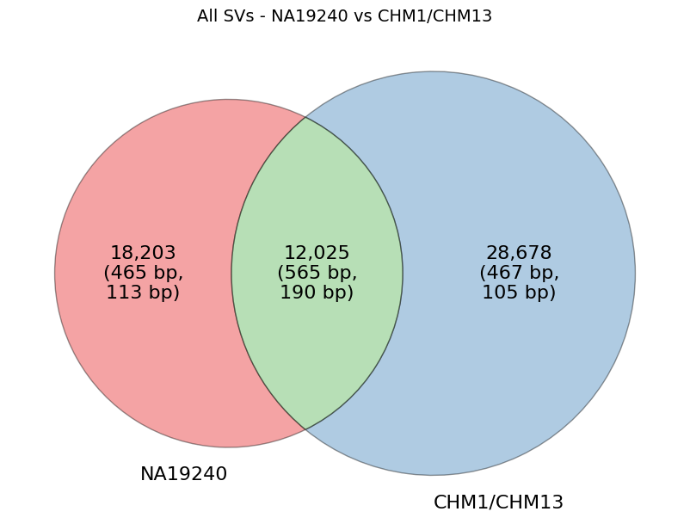
Figure 4.2.3 SVs from each sample were compared to a non-redundant set of variants previously reported in hydatidiform moles (CHM1/CHM13). Approximately half of the SVs were found to overlap (green), but many are unique to the sample (red) or the moles (blue).

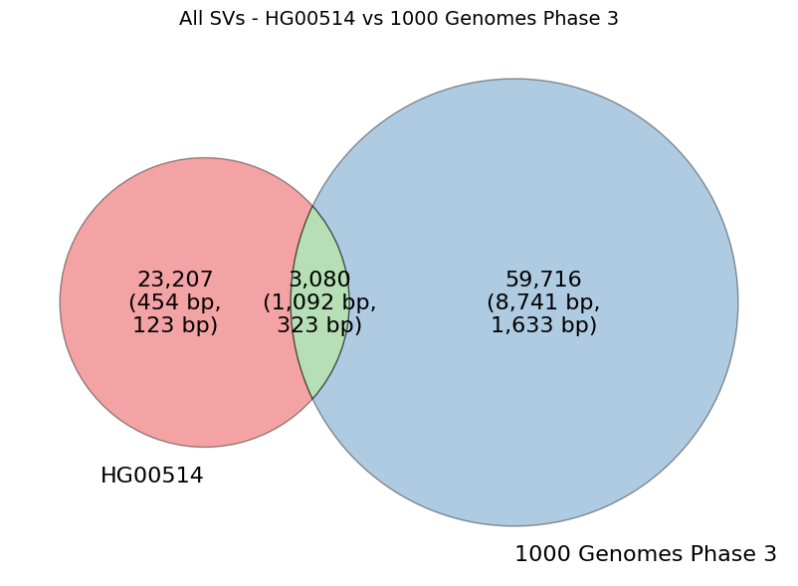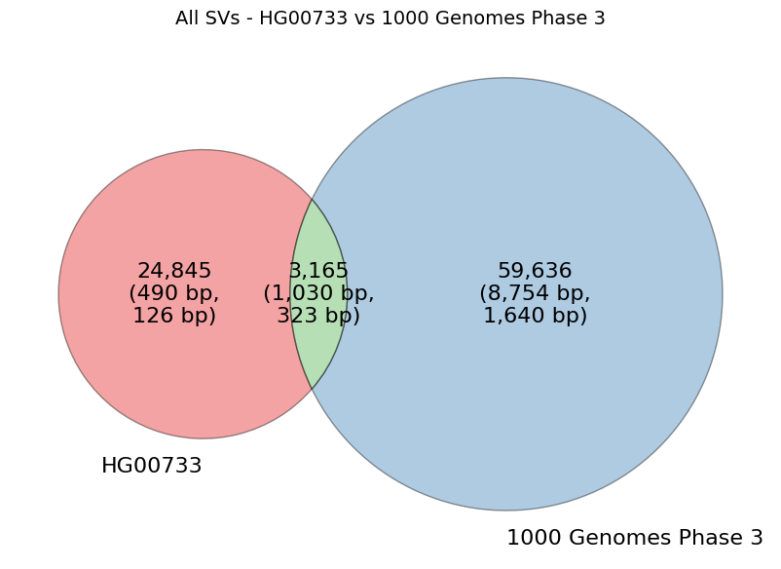
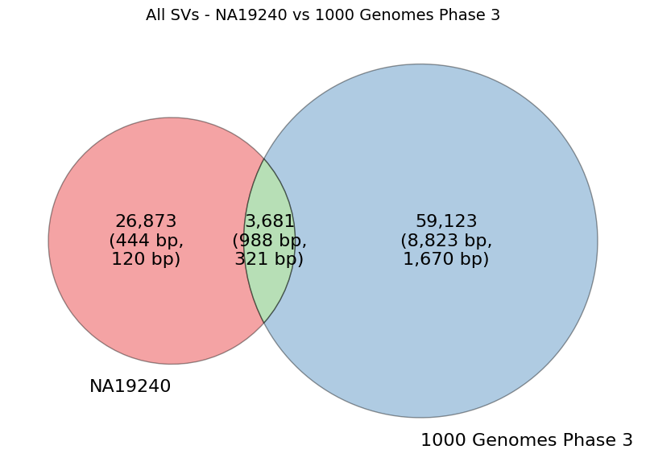
Figure S4.2.4 SVs from each sample were compared to a 1000 Genomes call set (1kgp3). Approximately half of the SVs were found to overlap (green), but many are unique to the sample (red) or the published variants (blue).

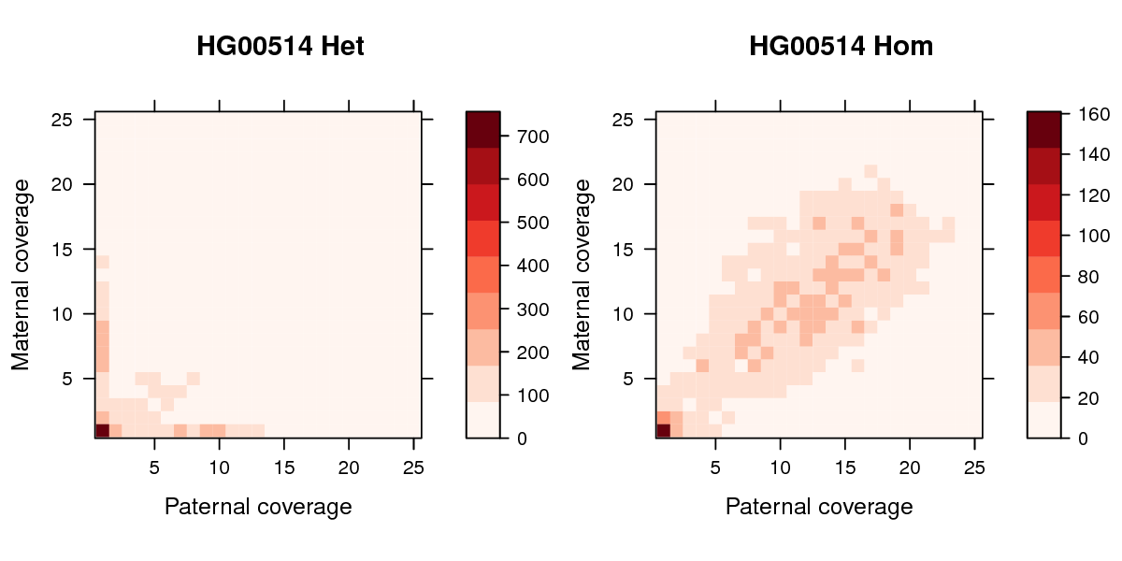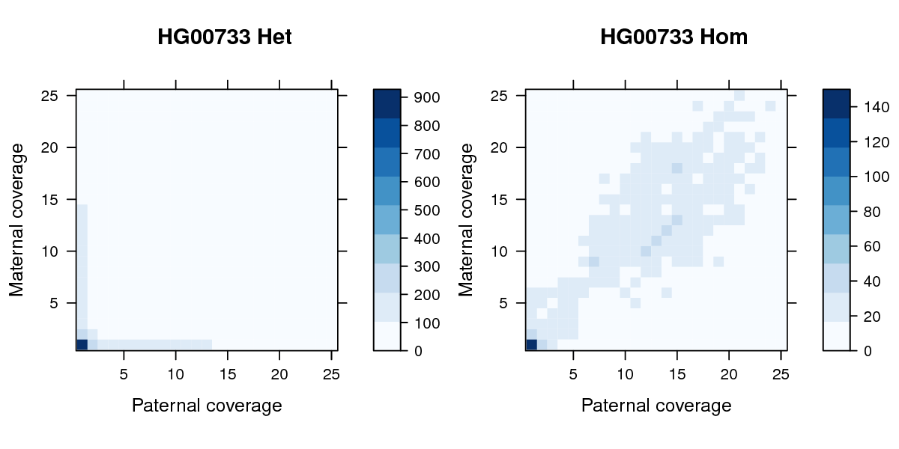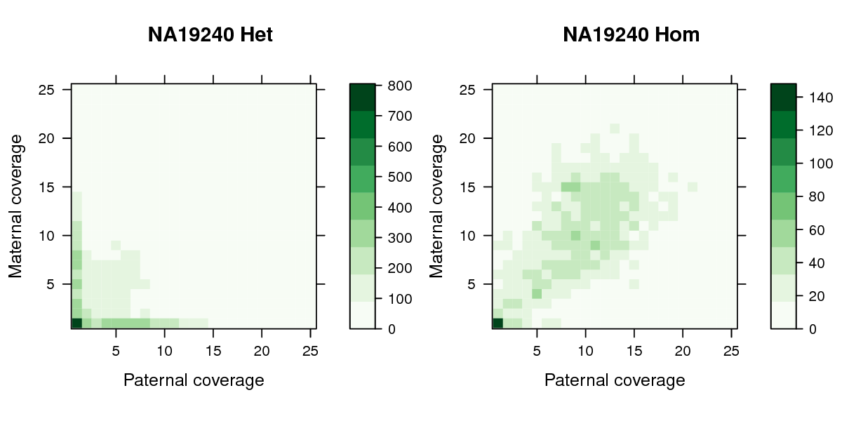

Figure S4.2.5 Paternal and maternal read counts for heterozygous and homozygous calls for HG00514, HG00733, and NA19240.

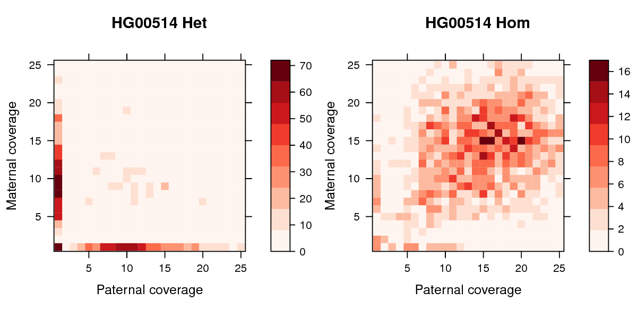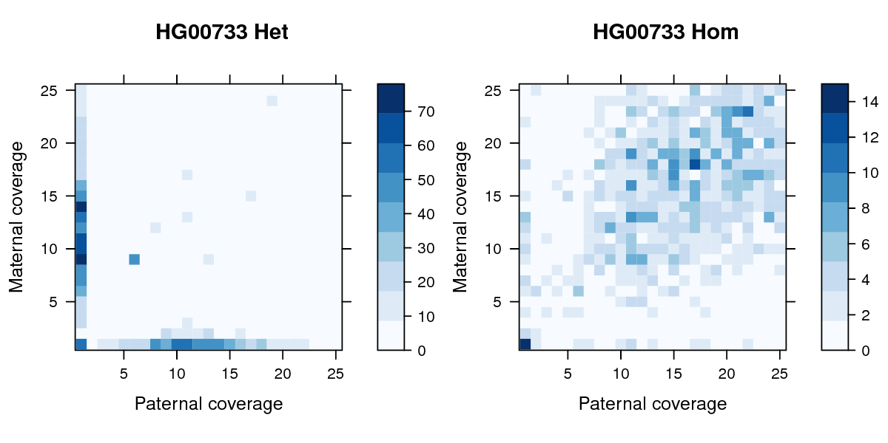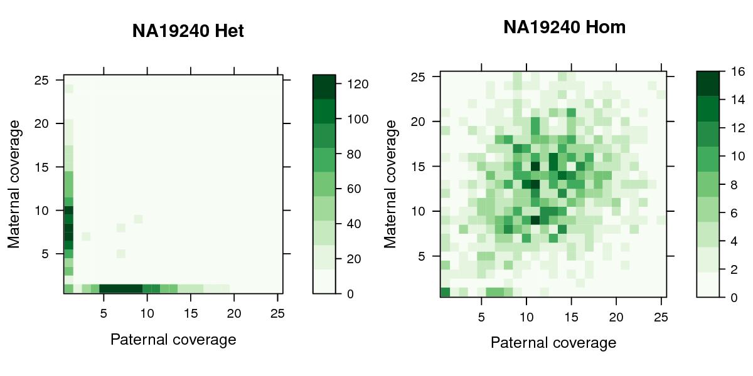

Figure 4.2.6 Paternal and maternal read counts for heterozygous and homozygous calls for HG00514, HG00733, and NA19240, excluding tandem repeats.

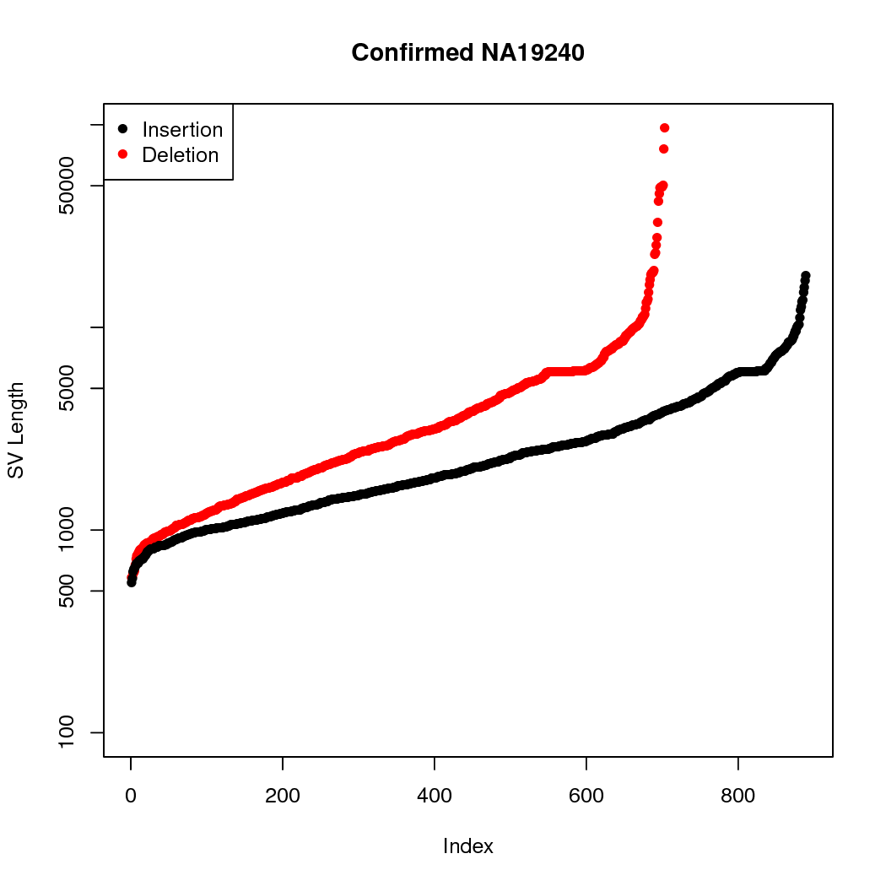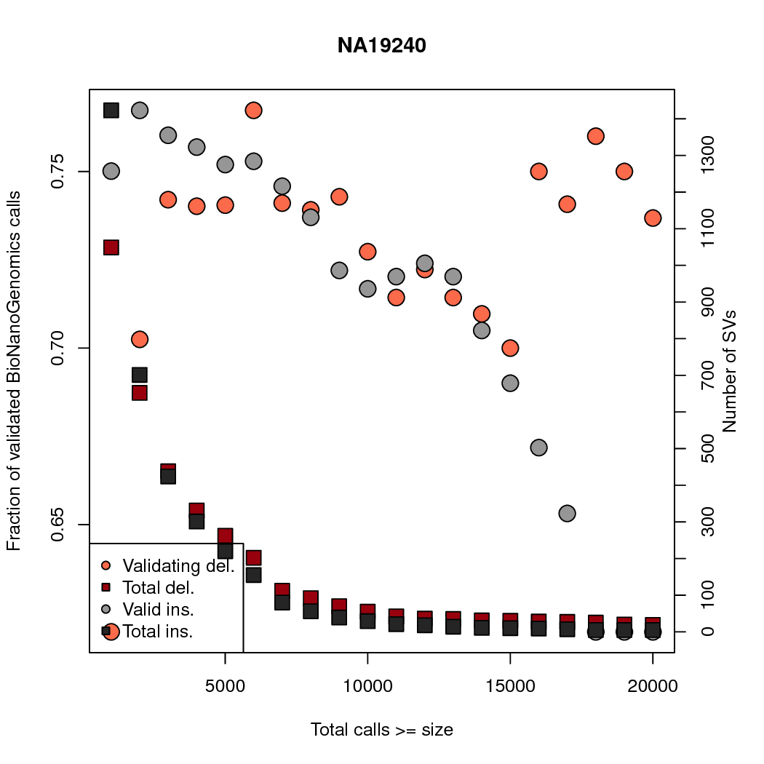
Figure S4.2.7 BNGValidation BNG Validation of Unified PacBio callset. (left) Concordance between BNG SV length and PacBio SV length, for all f_{BN}. (center) Validated PacBio SVs ranked by length. (right) proportion of PacBio SV calls validated by BNG by length. At each length, the number of SVs greater than or equal to that length are reported.

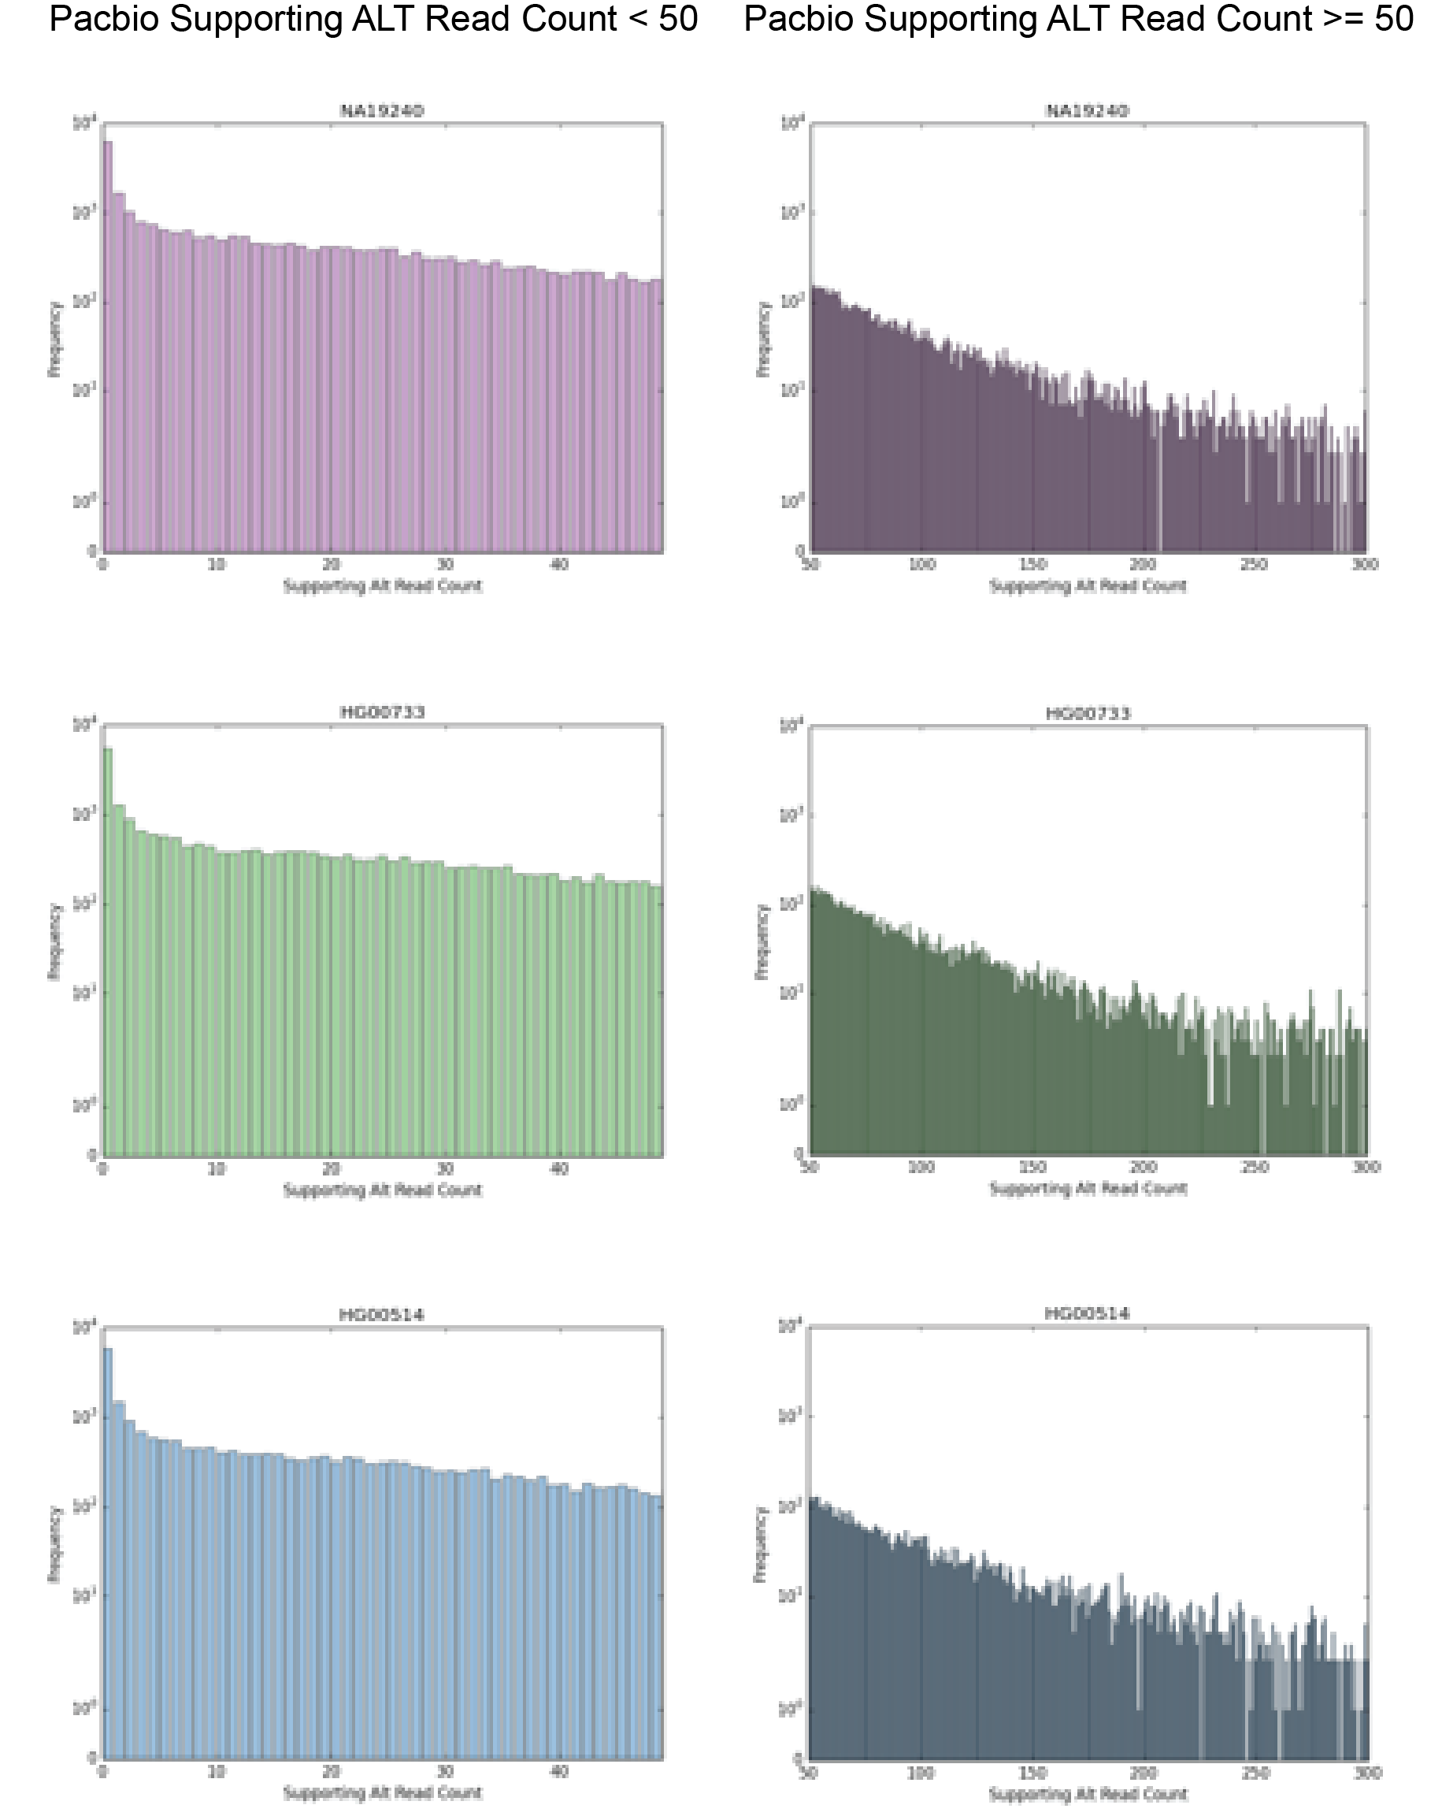
Figure S4.2.8 ALT Read Support For PacBio Called Variants. The bar charts represent the number of illumina reads that support PacBio called variants with respect to their frequency. The first column of images shows the supporting read count that is between 0 and 49 and the second column of images shows the supporting read count that is between 50 and 300. Each row represents a sample for each of the children, NA19240, HG00733, HG00514 respectively.

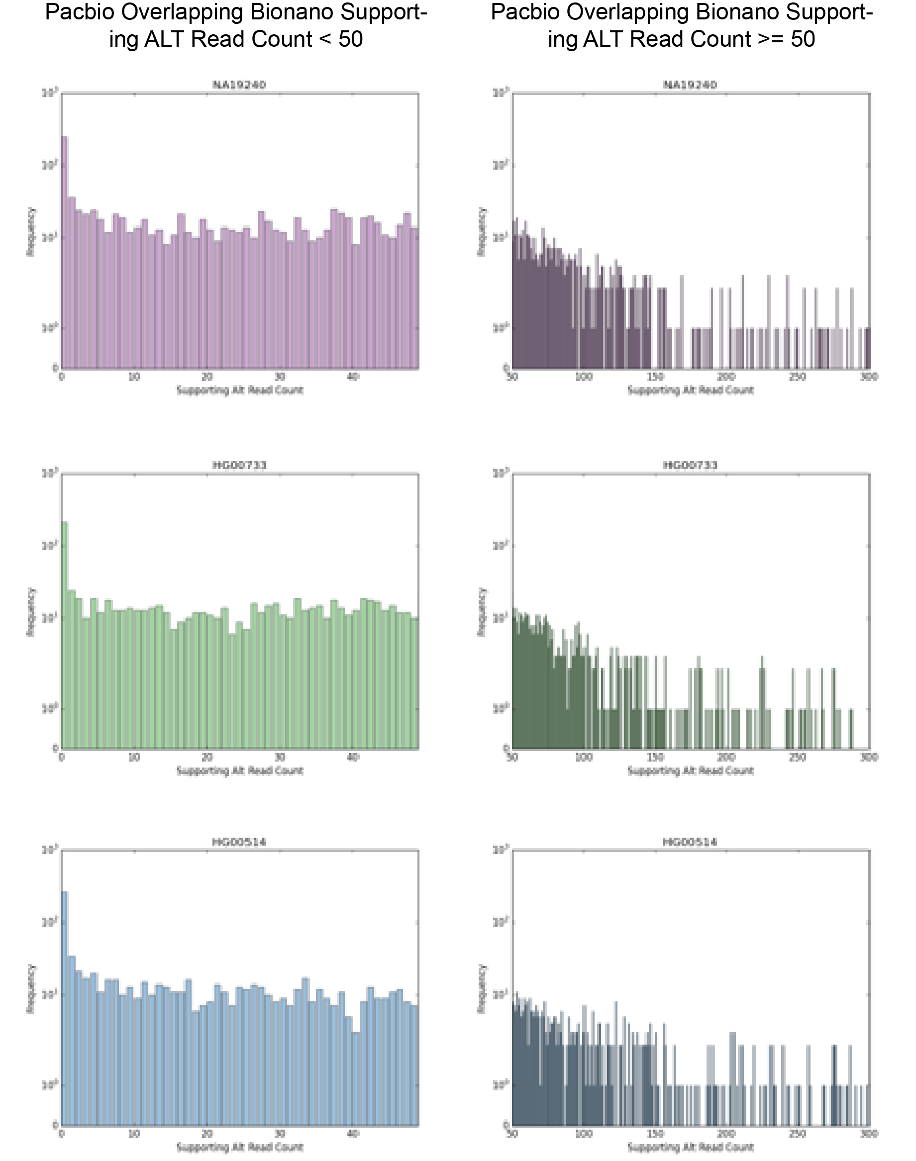

Figure S4.2.9 ALT Read Support For PacBio Called Variants. The frequency of illumina reads support for PacBio variants with high concordance with Bionano variants in the YRI, PUR, and HAN samples.
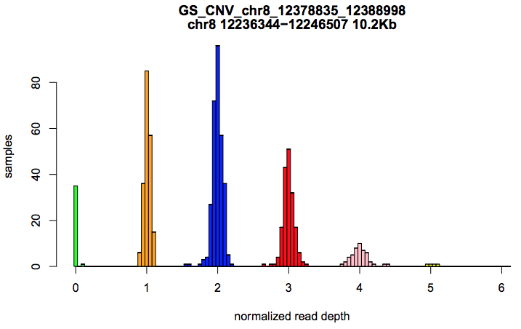

Figure S4.3.1 Example of a multiallelic CNV site with an apparent Mendelian violation in the CHS trio, genotyped in a larger cohort showing the full range of alleles. Colors indicate confidently called copy number genotypes.

Figure S4.3.2 Insert size distribution of an example HGSVC liWGS library. We generated liWGS libraries for all nine HGSVC individuals following previously described protocols targeting a mean insert size of 3.5kb. As an example, the distribution of insert sizes from the library generated for the father from the Puerto Rican trio is shown here. All nine libraries closely resembled this distribution. This distribution was generated automatically by Picard tools (http://broadinstitute.github.io/picard/).
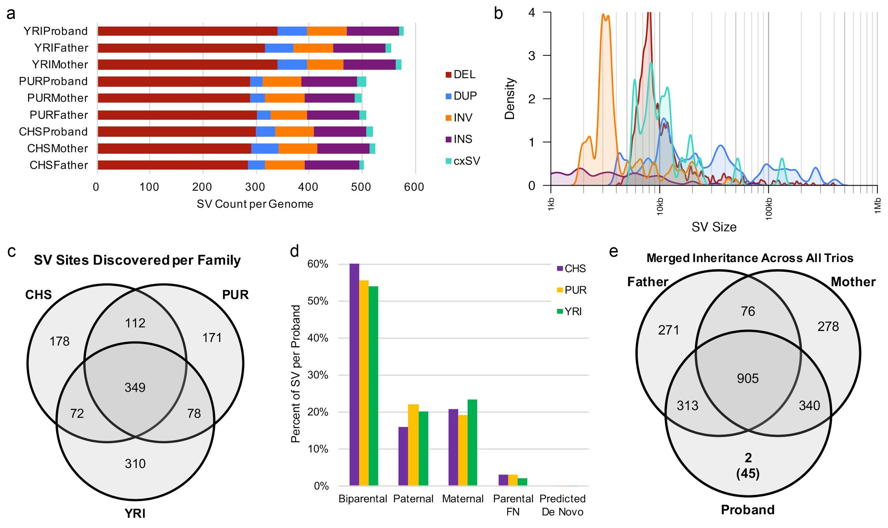
Figure S4.3.3 Summary of SV discovered by liWGS in the HGSVC dataset. a) Count of SV per individual by SV class. b) Density estimates of SV size distributions across all nine individuals. c) Venn diagram of distinct SV sites discovered across each family. d) Transmission rates per HGSVC child observed from liWGS. Parental FN = predicted parental false negative (i.e. variant observed in child and one other sample in the reference population [n=91] but neither parent). e) Venn diagram of transmission rates represented as the sum of all SVs across all trios. Number in parentheses is the sum of predicted parental false negatives and predicted de novo SV.

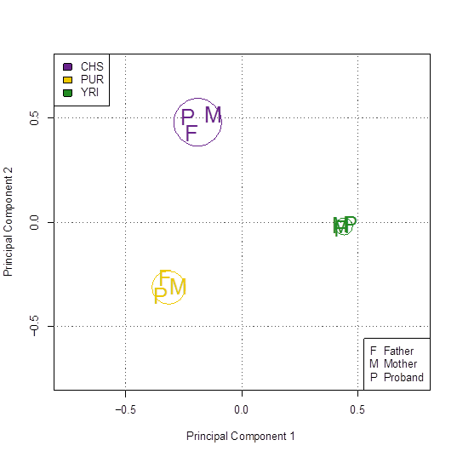
Figure S4.3.4 SVs discovered in HGSVC trios by liWGS cluster individuals by ancestry and relatedness. Principal component analysis of SVs shared across the nine HGSVC individuals clearly stratifies individuals by genetic ancestry and relatedness.

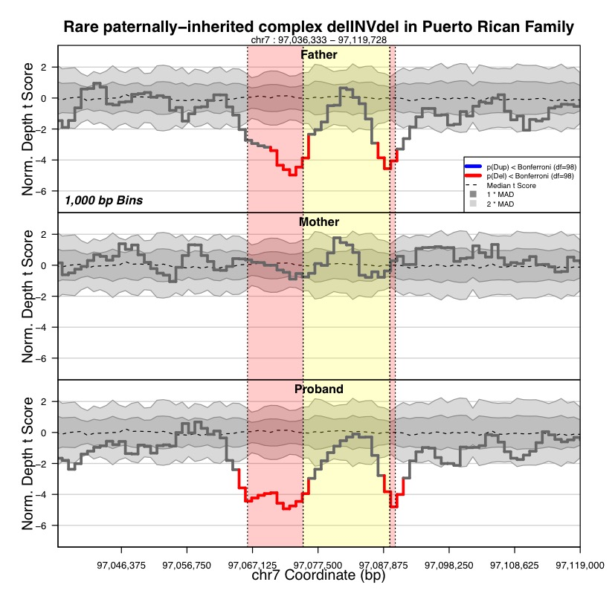
Figure S4.3.5 A rare, paternally-inherited complex delINVdel in the Puerto Rican family. liWGS analysis discovered and resolved a mean of 11 complex rearrangements (cxSVs) per individual, including the 25.3kb paired-deletion inversion (delINVdel) shown here. This variant was stably transmitted from the father to the proband in this family, and this variant did not appear in any of the other 98 individuals considered during this analysis. The variant is visualized here: each panel represents the normalized read-depth t-score in 1kb sequential bins as compared to the read depth distribution of all 100 samples jointly analyzed, which is demarcated by the grey background shading (dark grey: one median absolute deviation; light grey: two median absolute deviations). Red highlighted segments are deleted and the yellow highlighted segment is inverted in the father and proband. This plot was generated with CNView (Collins et al., bioRxiv 2016).
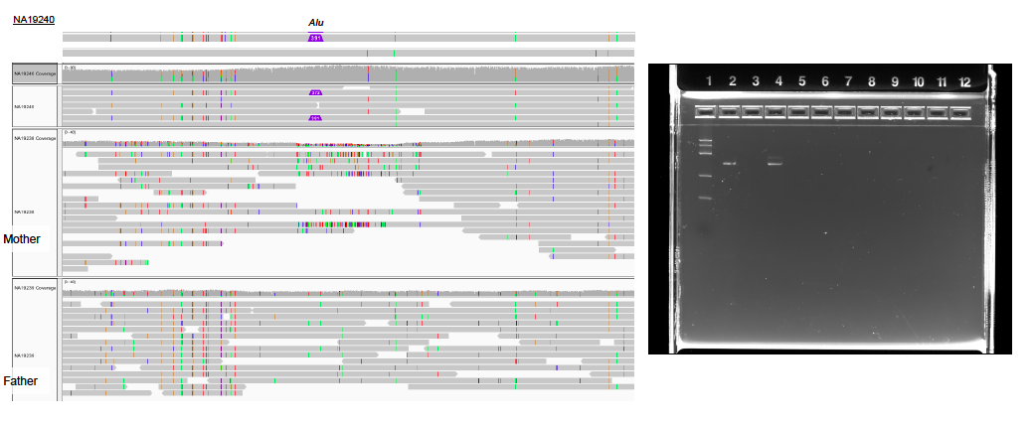
Figure 4.3.6 Validation of the de novo Alu insertion. a) The PacBio reads from YRI proband covering the region clearly indicate the existence of Alu, while the reads of the two parents do not have the insertion. b) The PCR validation of the Alu insertion. The column 4 indicates the bands from the probands, as it can be seen two bands in that column which indicate the Alu insertion. The column 2 and 3 indicate the paternal and maternal results (the maternal DNA did not amplify and is being REDONE).

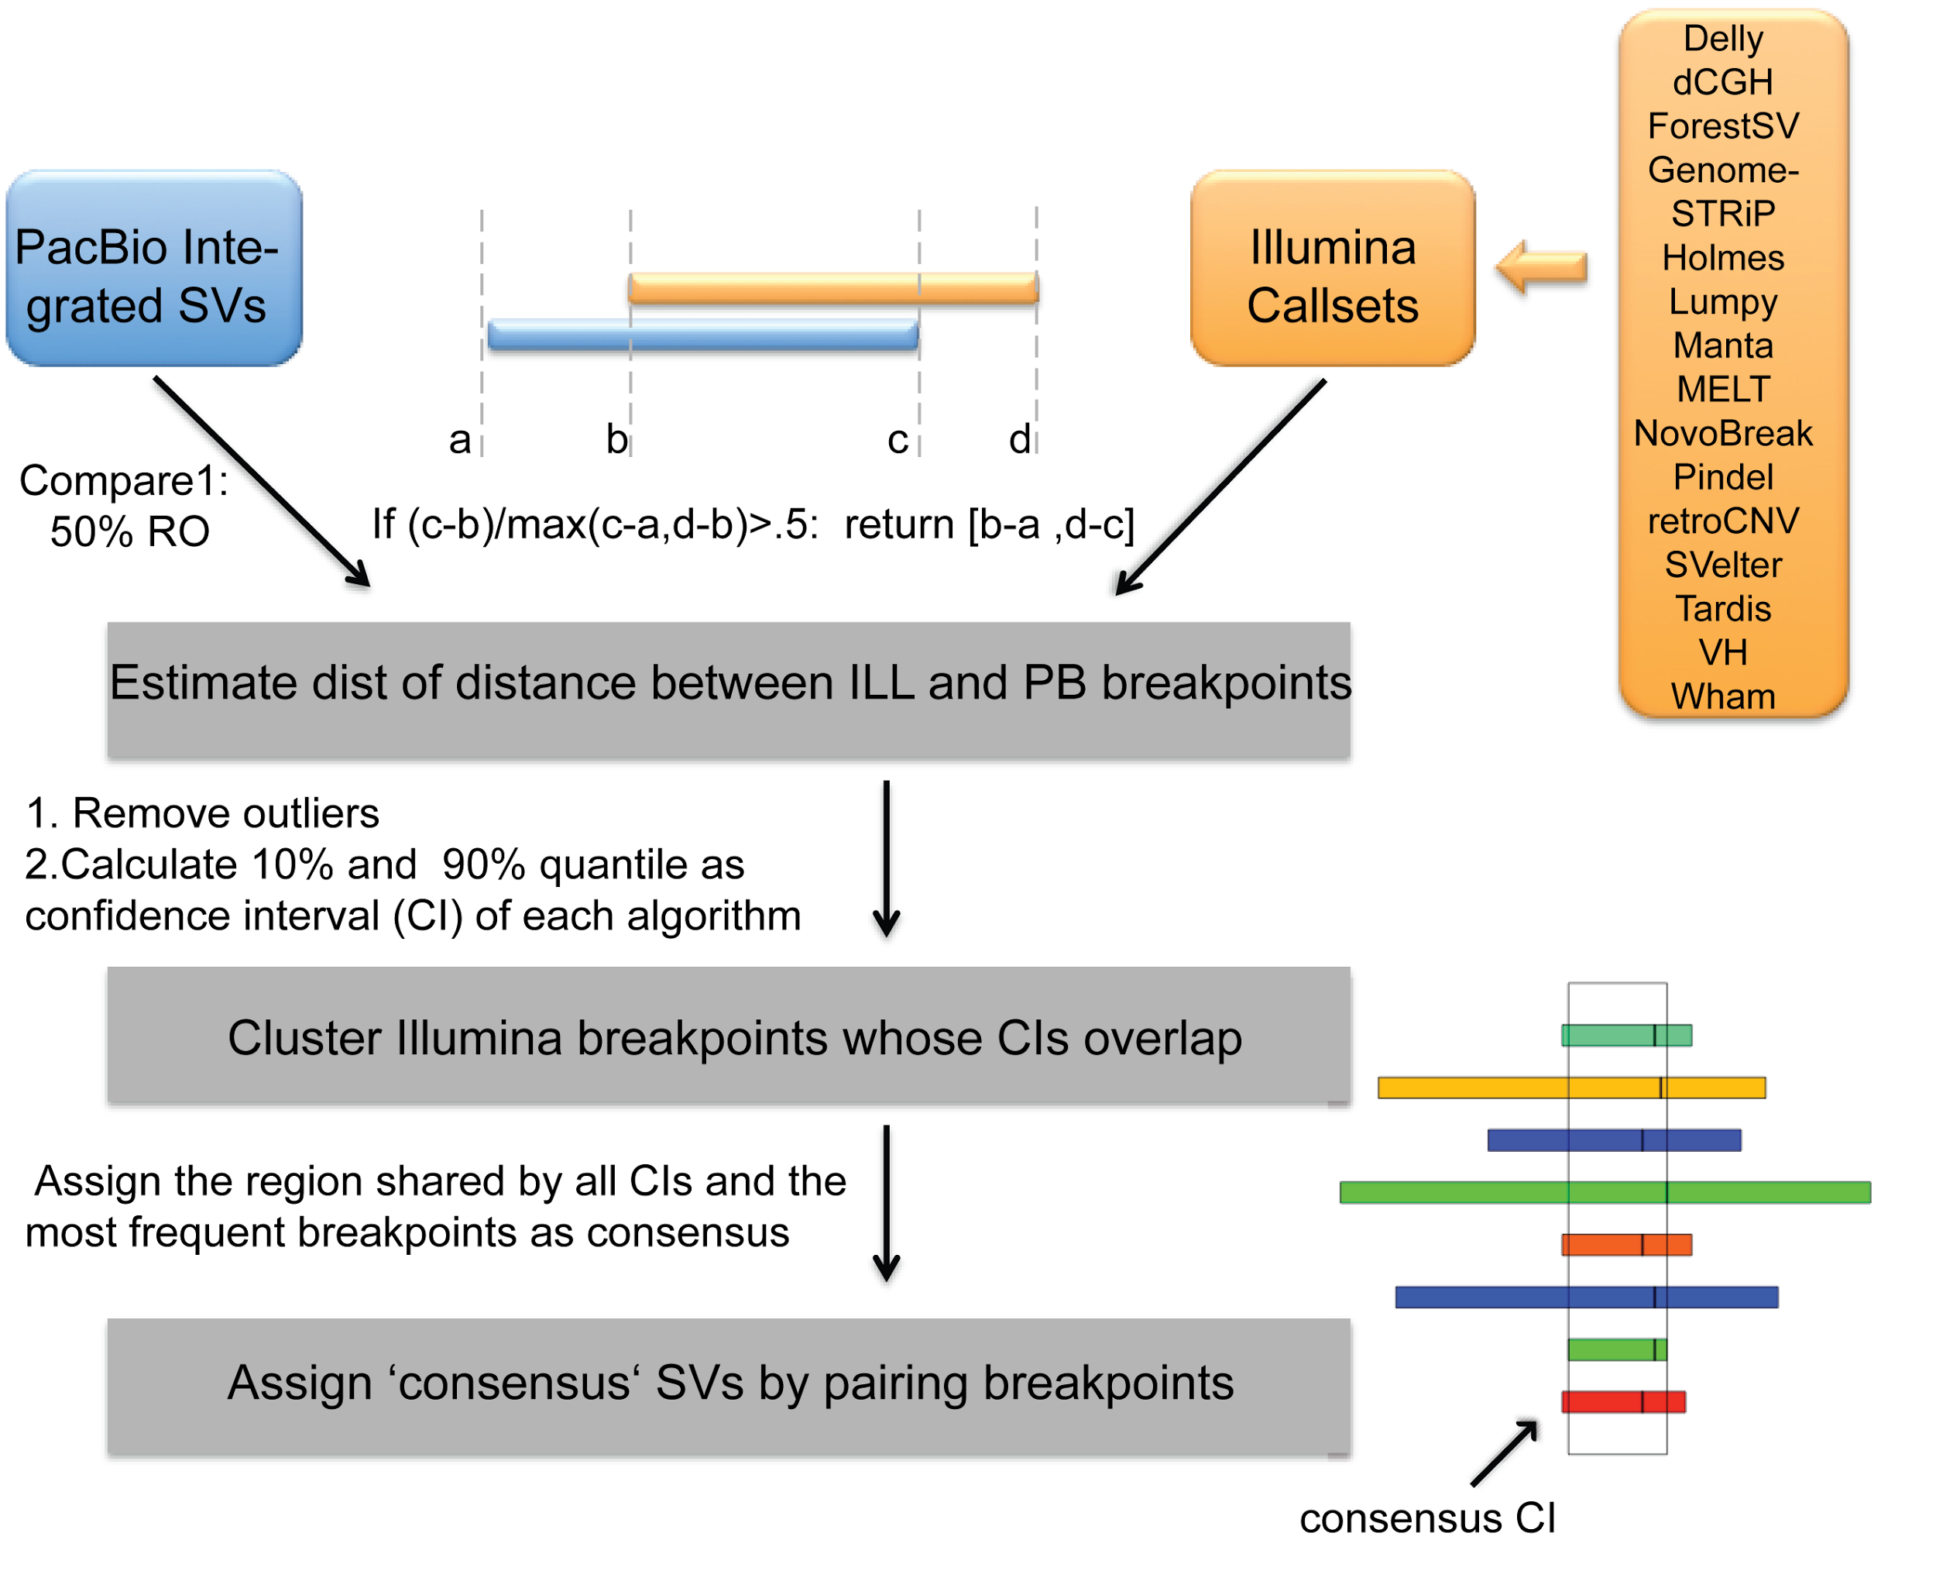

Figure S4.3.7 Pipeline to integrate SVs from multiple Illumina callsets.

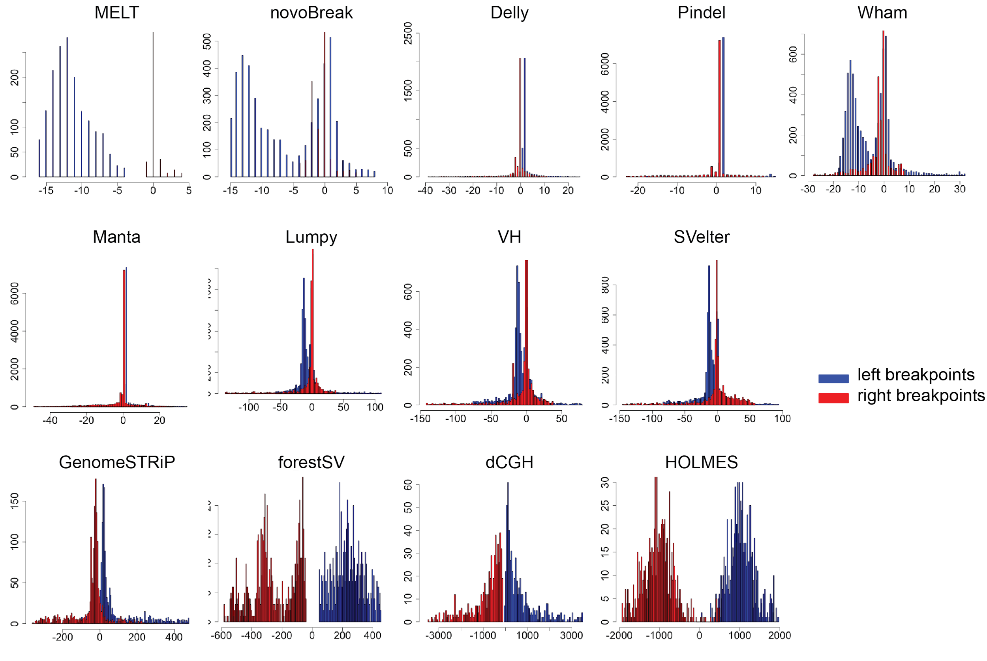

Figure S4.3.8 Assessment of breakpoint accuracy of each Illumina algorithm

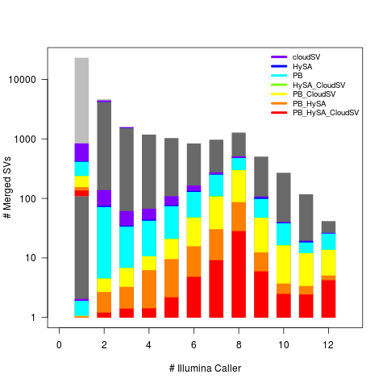
Figure S4.3.9. Comparison of integrated Illumina SV set against PacBio and hybrid callers. The integrated Illumina SVs were clusterd by number of supportive Illumina algorithms (each bar), and intersected with SVs discoverd by PacBio integration as well as IL-PB hybrid callers. High quality Illumina SVs(labeled as ‘PASS’, shown in dark grey) and low qual (light grey) were compared independently.

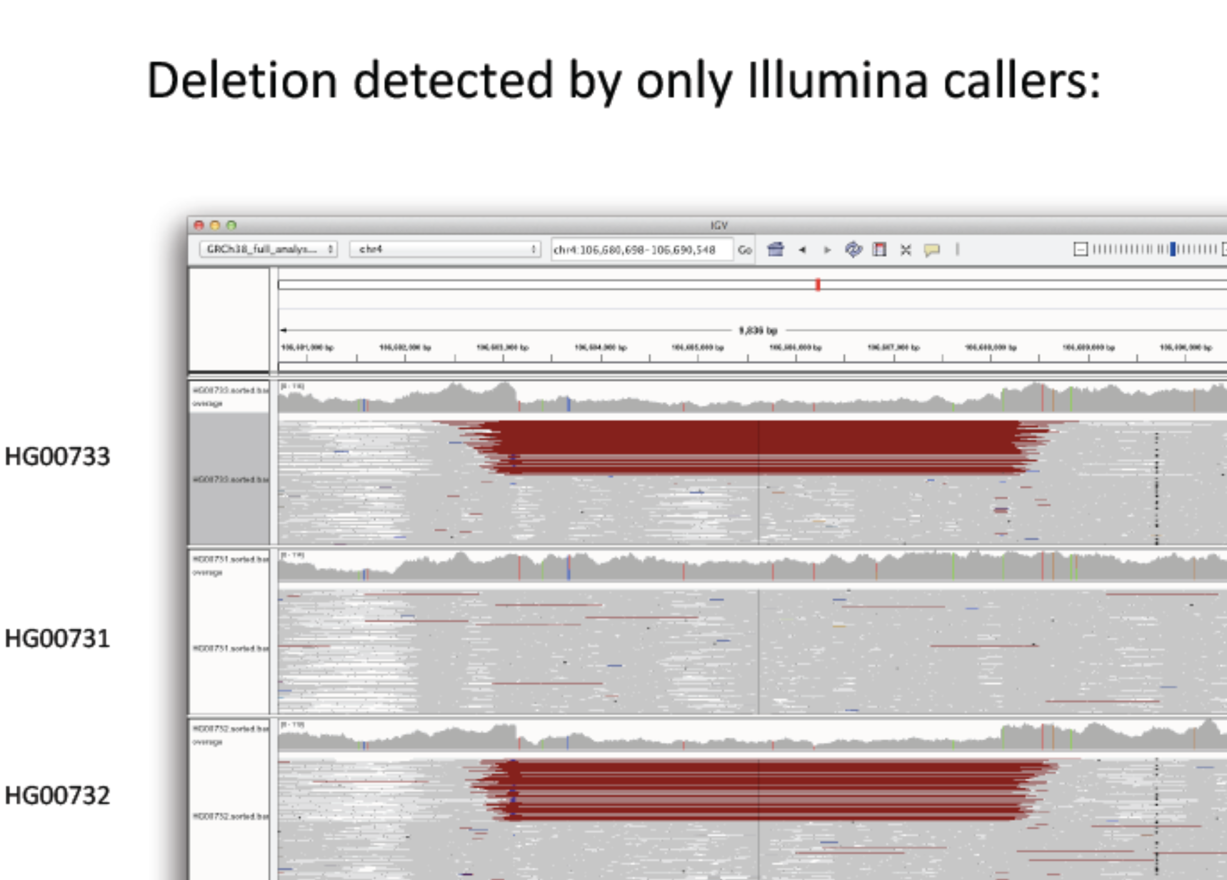
Figure S4.3.10 A The deletion can be confirmed by raw PacBio read-support in an alignment-free approach using dot-plots. A 6.5kbp PacBio read (m140817_221907_42175_c100689561270000001823145102281516_s1_p0/95354/0_6656) supporting the deletion is shown in the dotplot below.

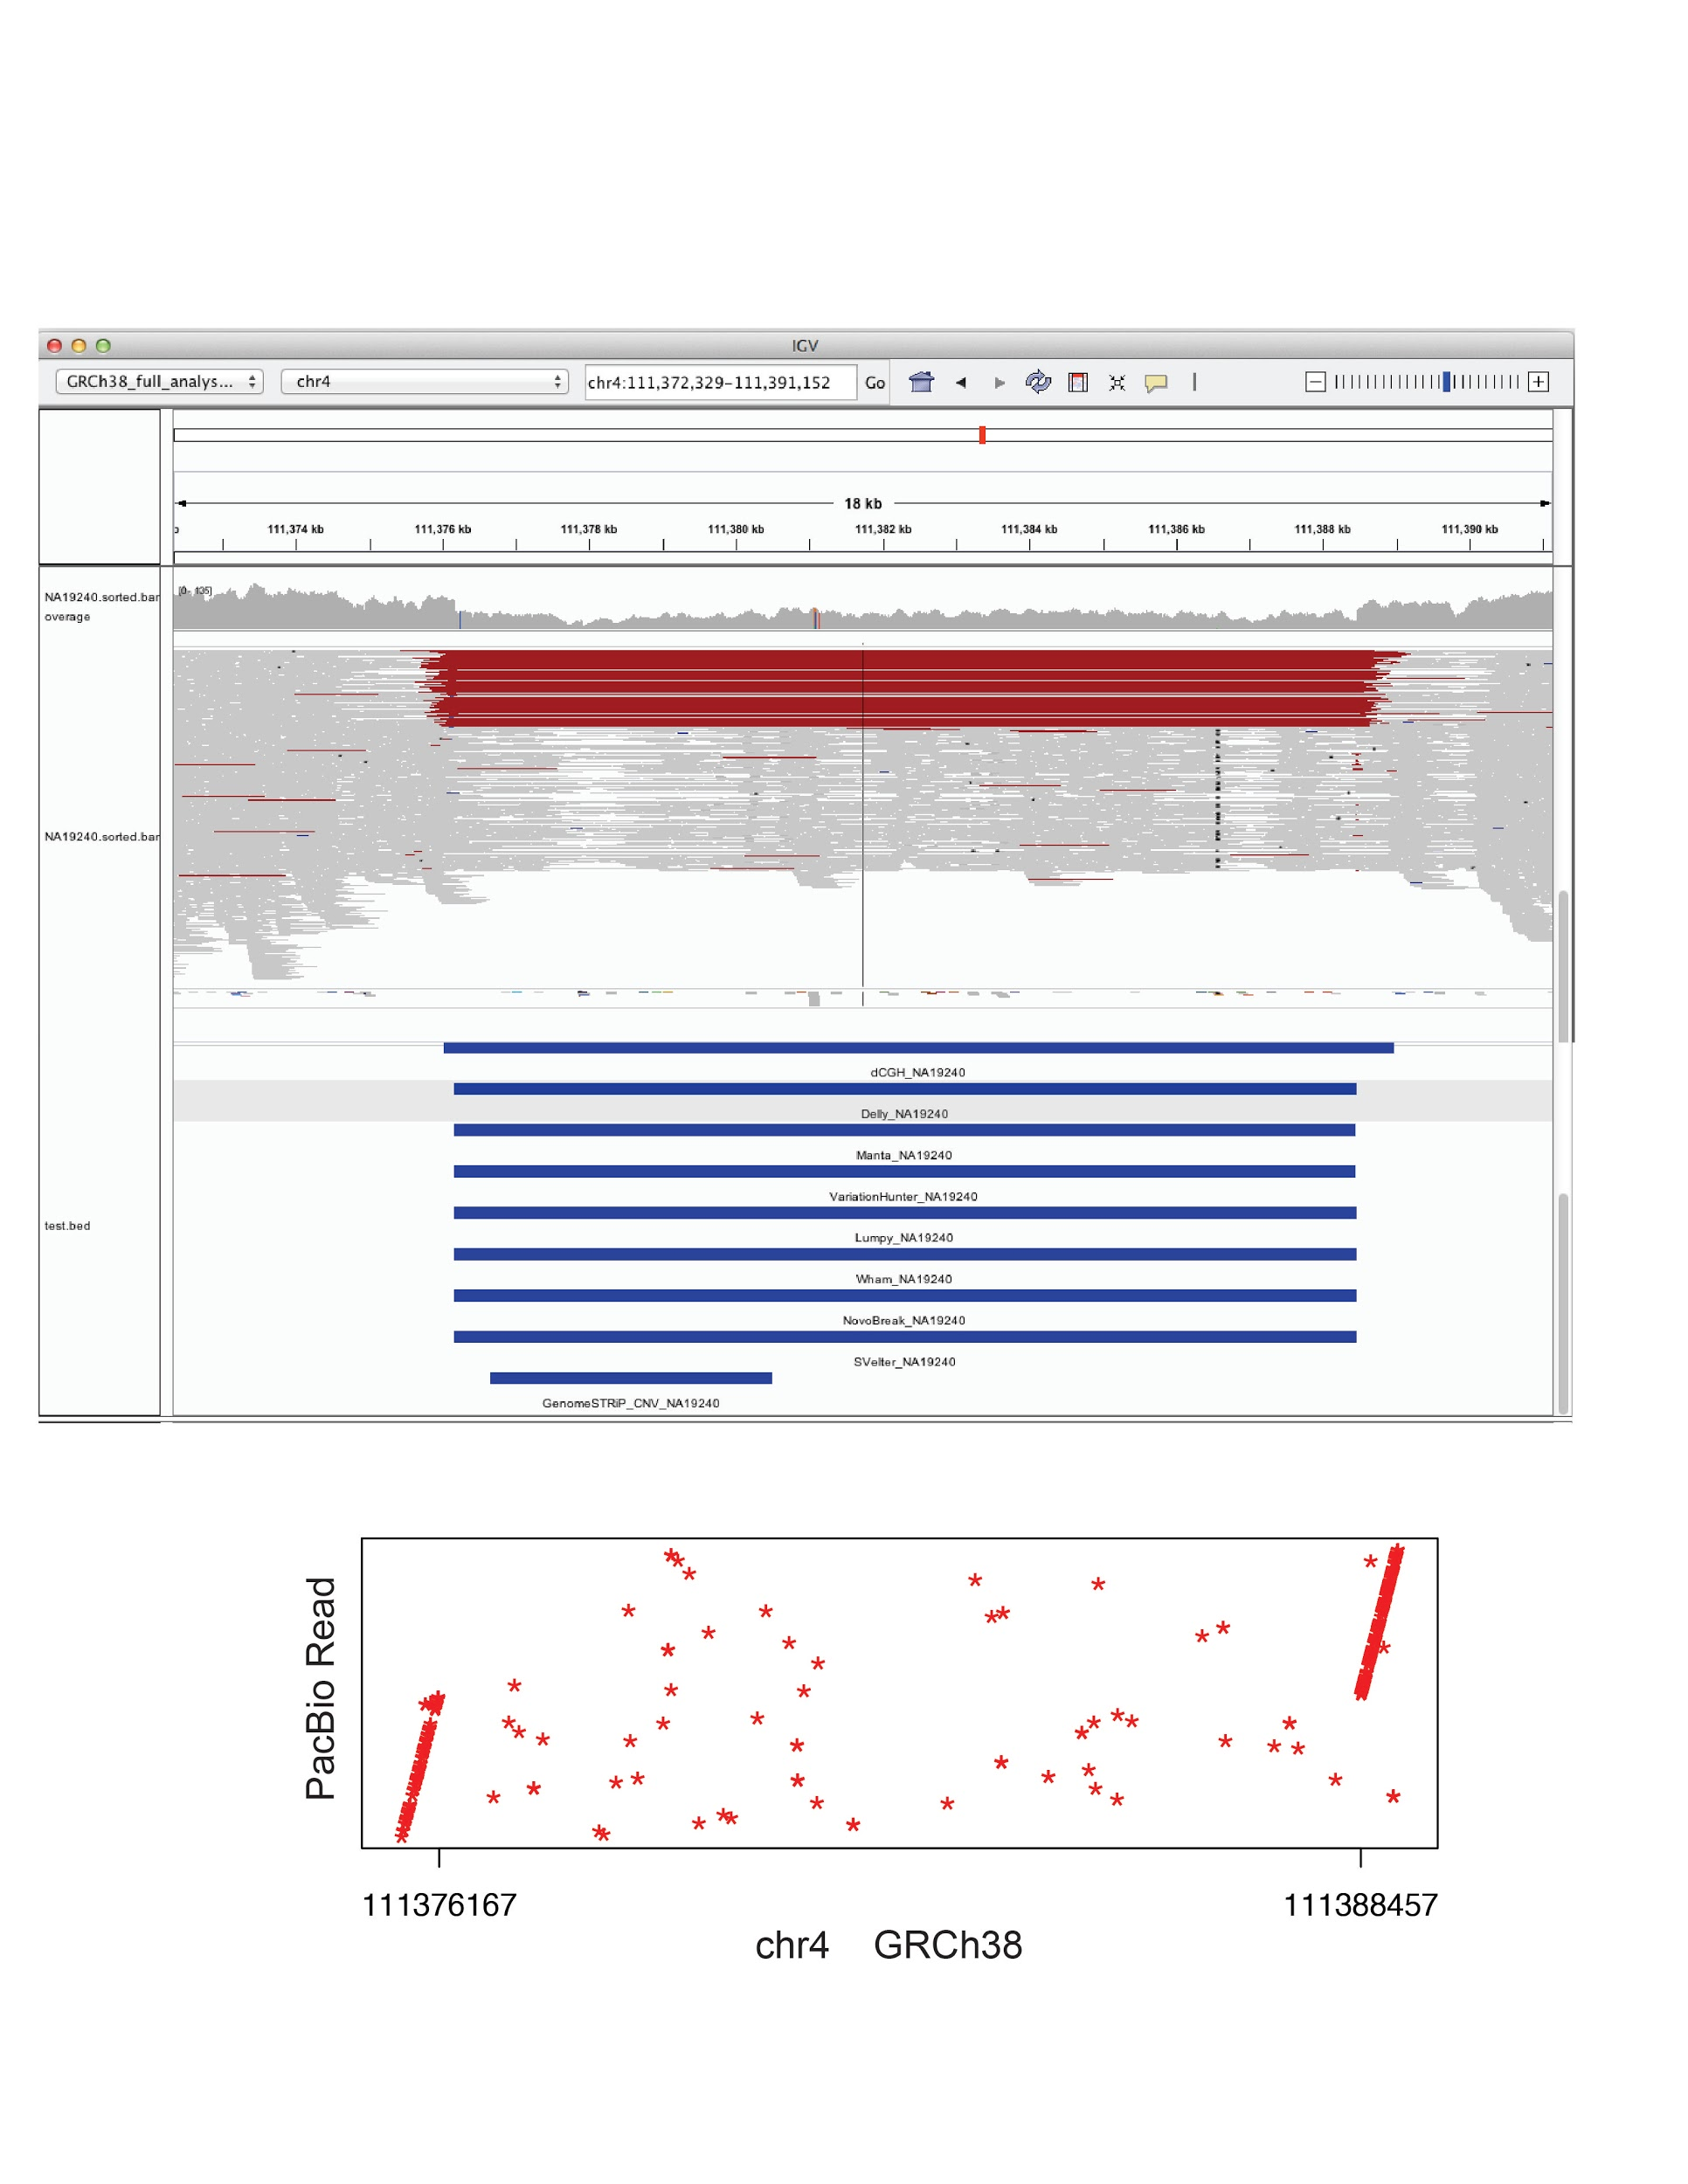

Figure S4.3.10B alignment pattern of a 14Kb deletion that was uniquely discovered by Illumina algorithms.

.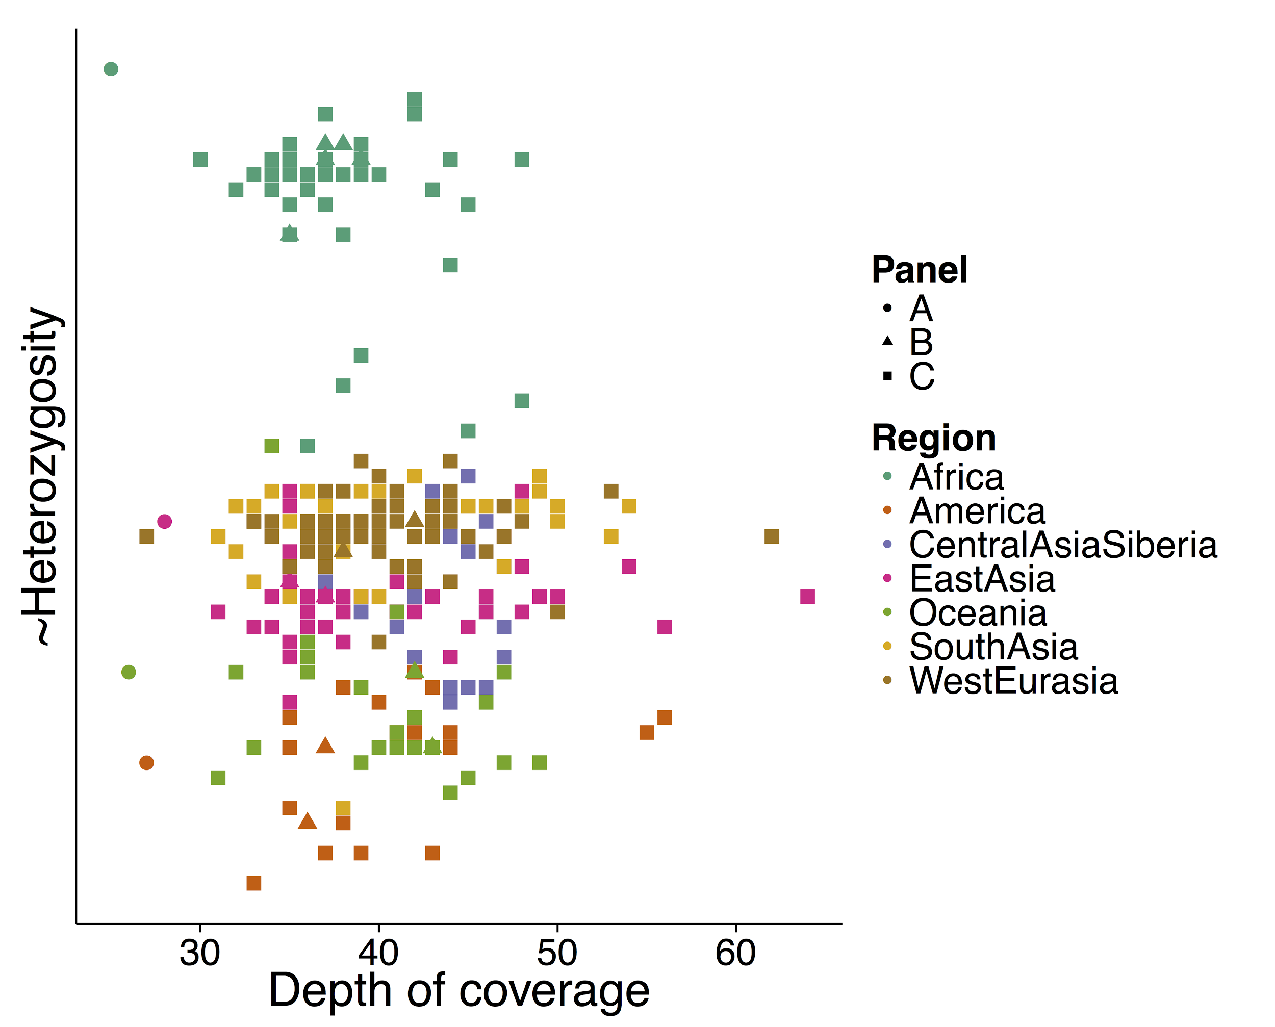
Figure S4.3.11 Illumina-genotyping. The depth and genetic diversity in each of the seven SGDP super populations.

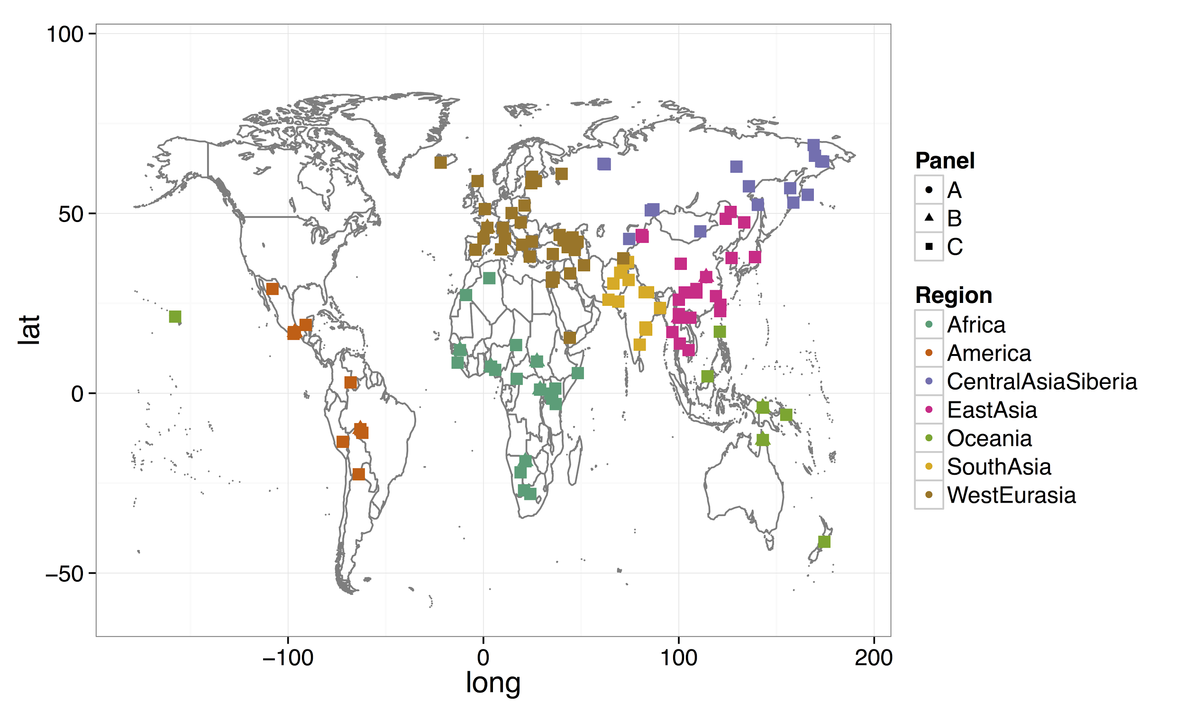
Figure S4.3.12. SGDP Sample Distribution Geographic distribution of the Simon’s Genome Diversity Project samples. Individuals without longitude/latitude data are excluded from this plot, e.g. Native north american.

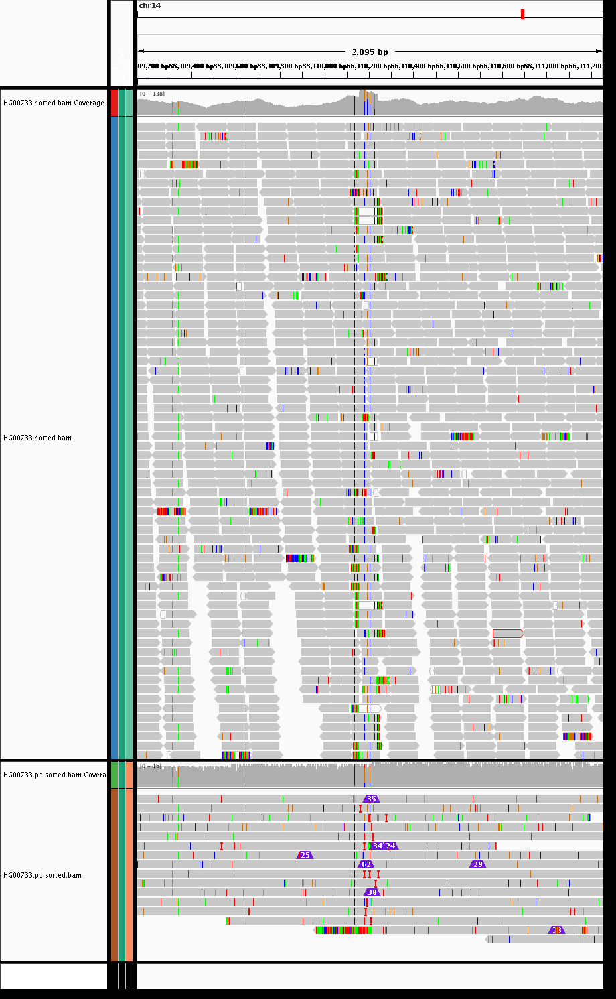

Figure S4.3.13

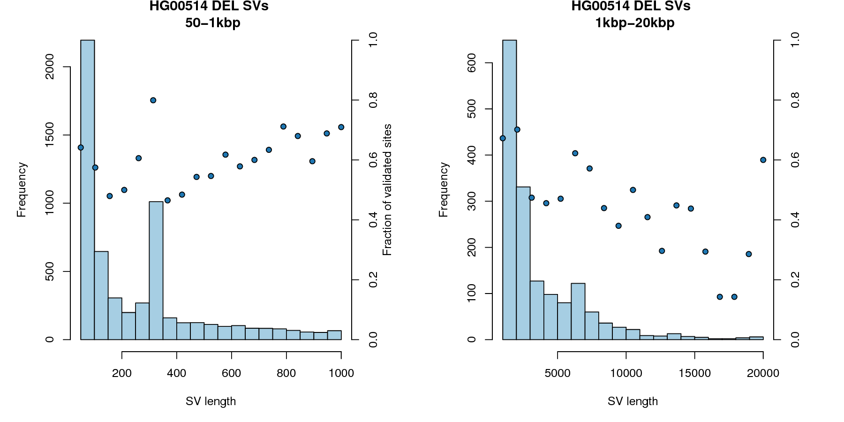
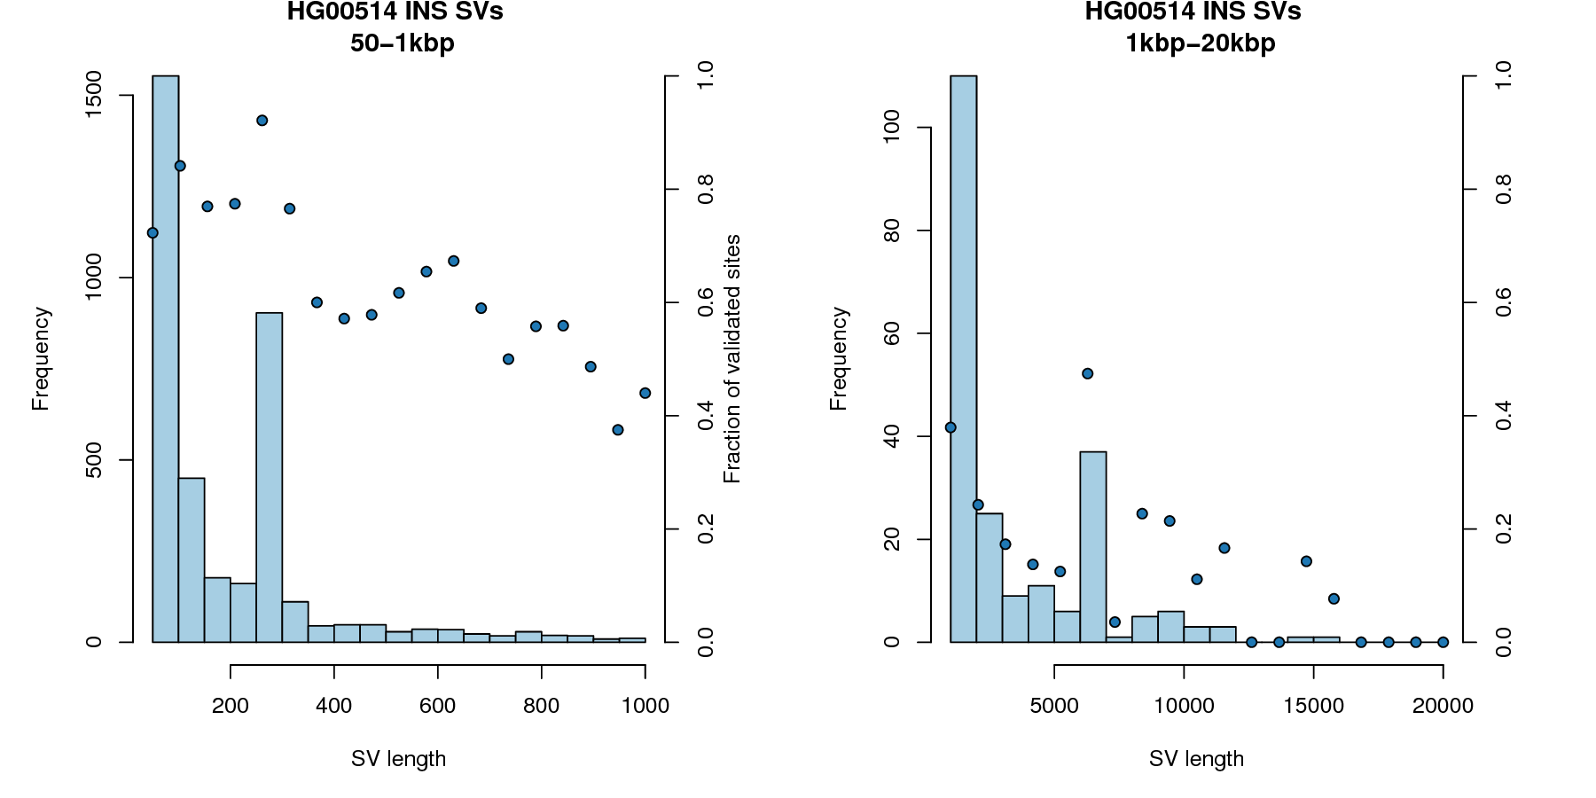
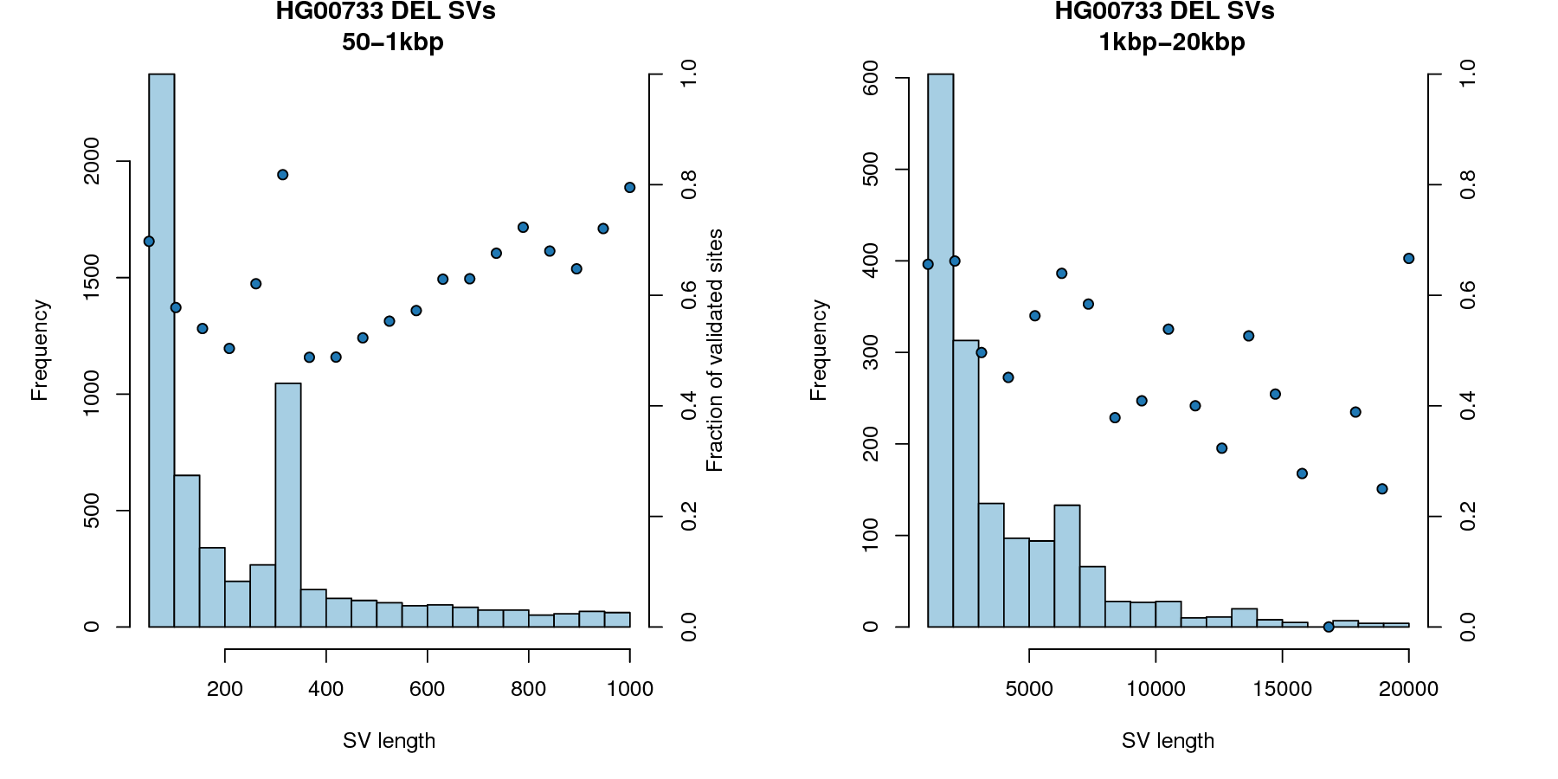
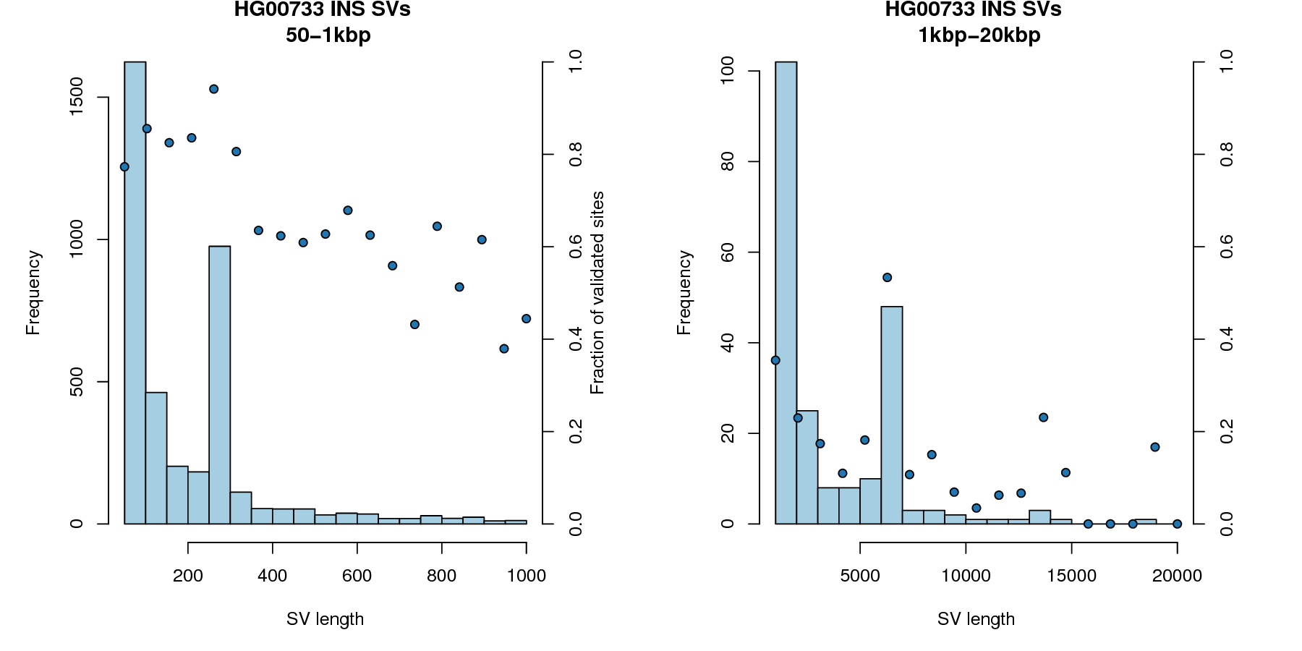
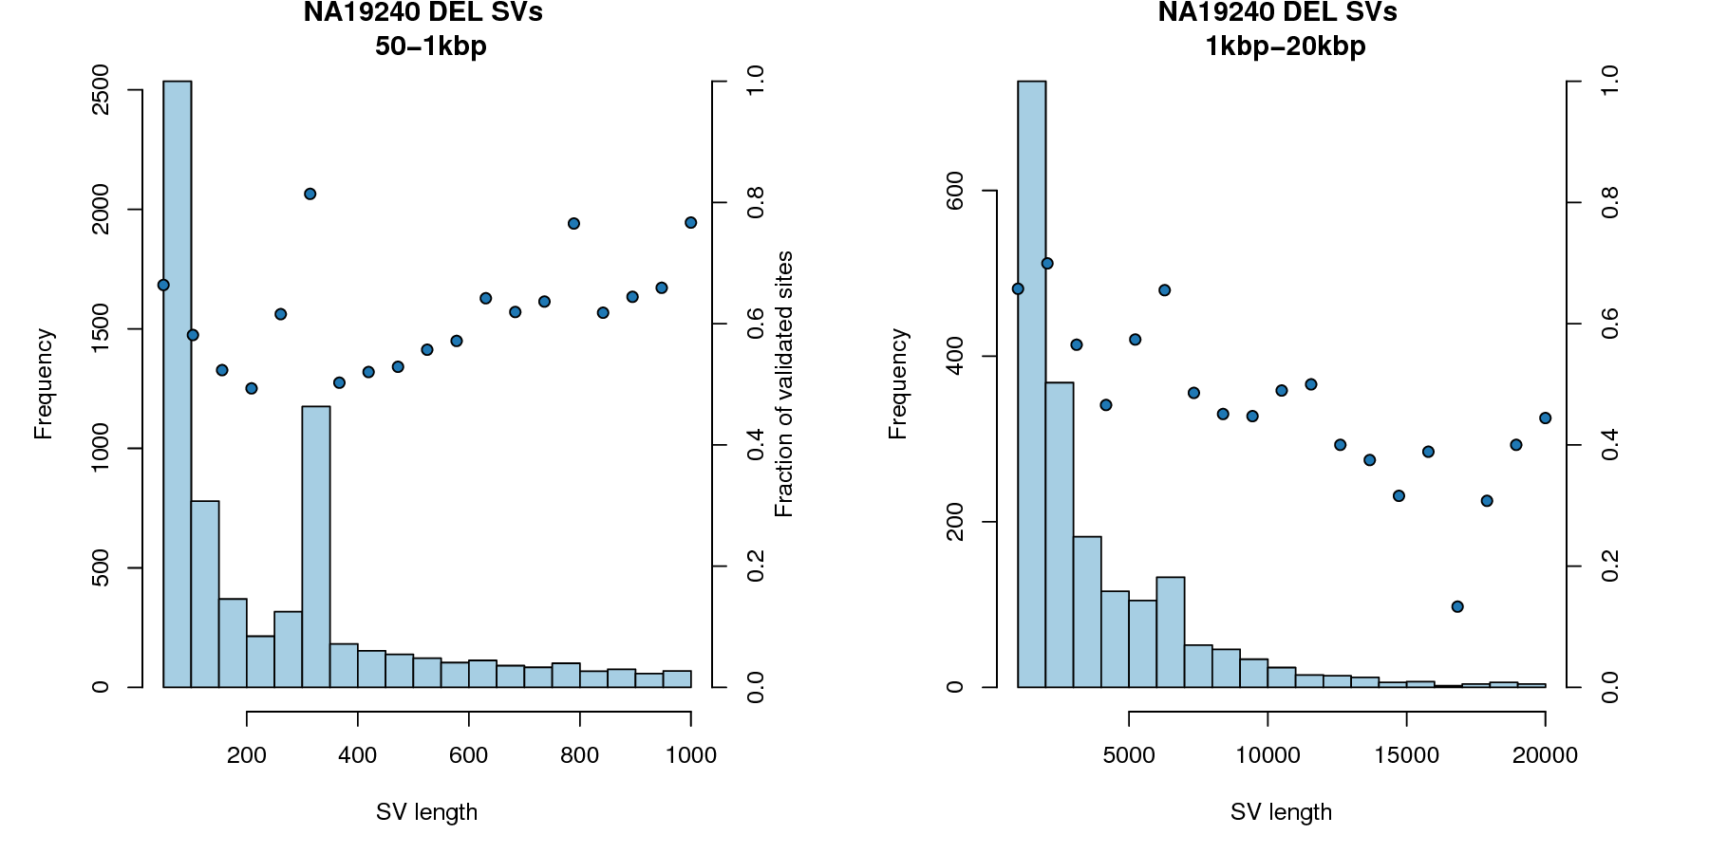

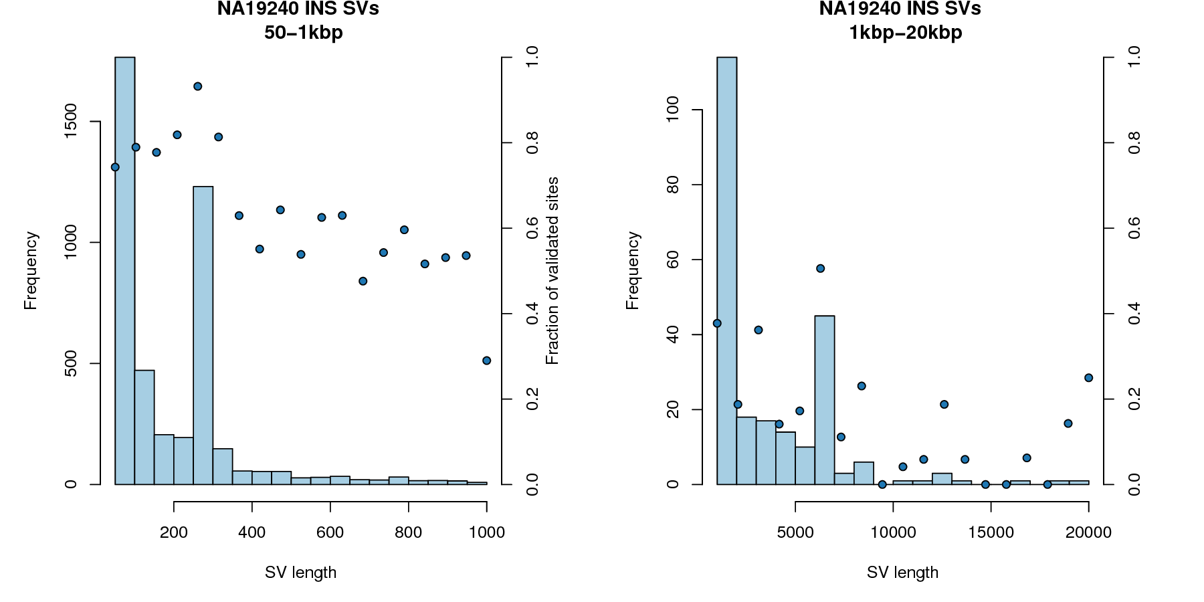

Figure S5.1.1 The number (axis 1) and fraction (axis 2) of of Illumina calls with a similar PB-SV call for HG00514, HG00733, and NA19240, both deletion and insertion.

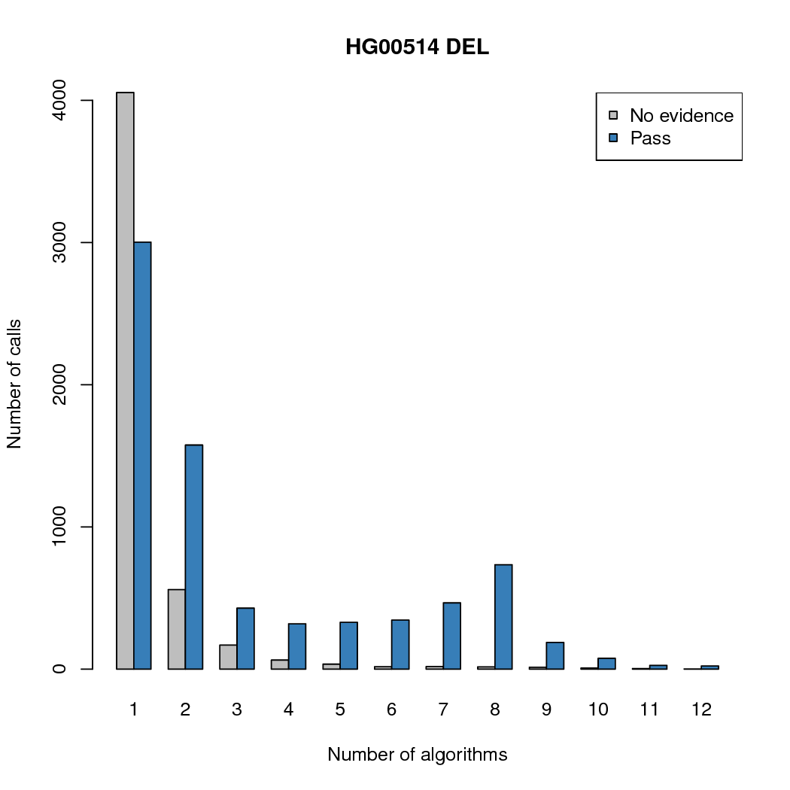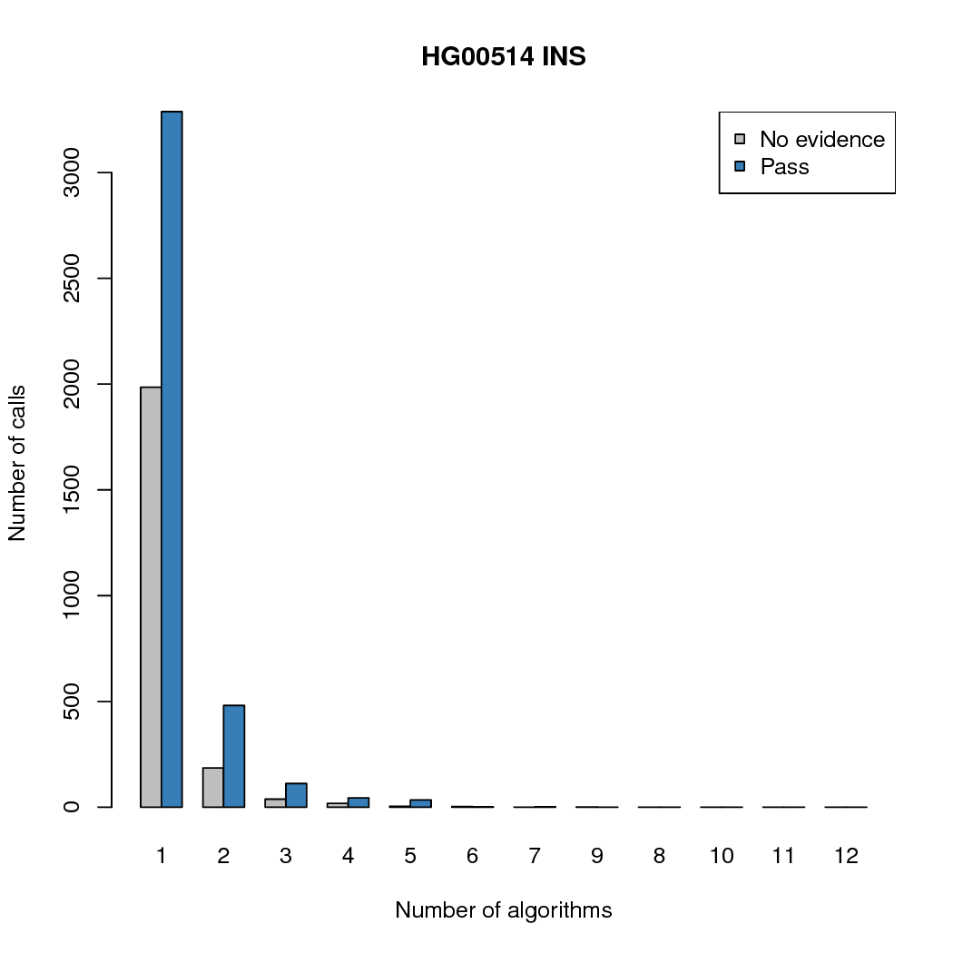

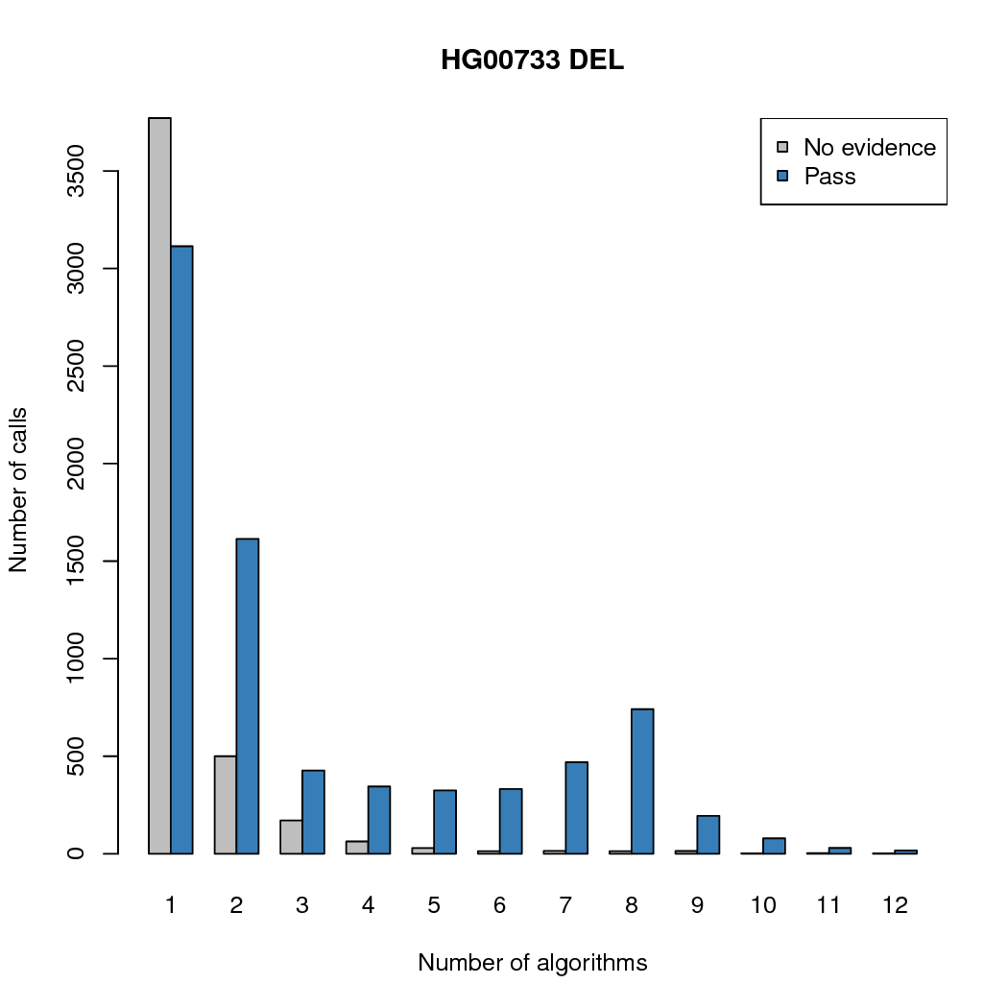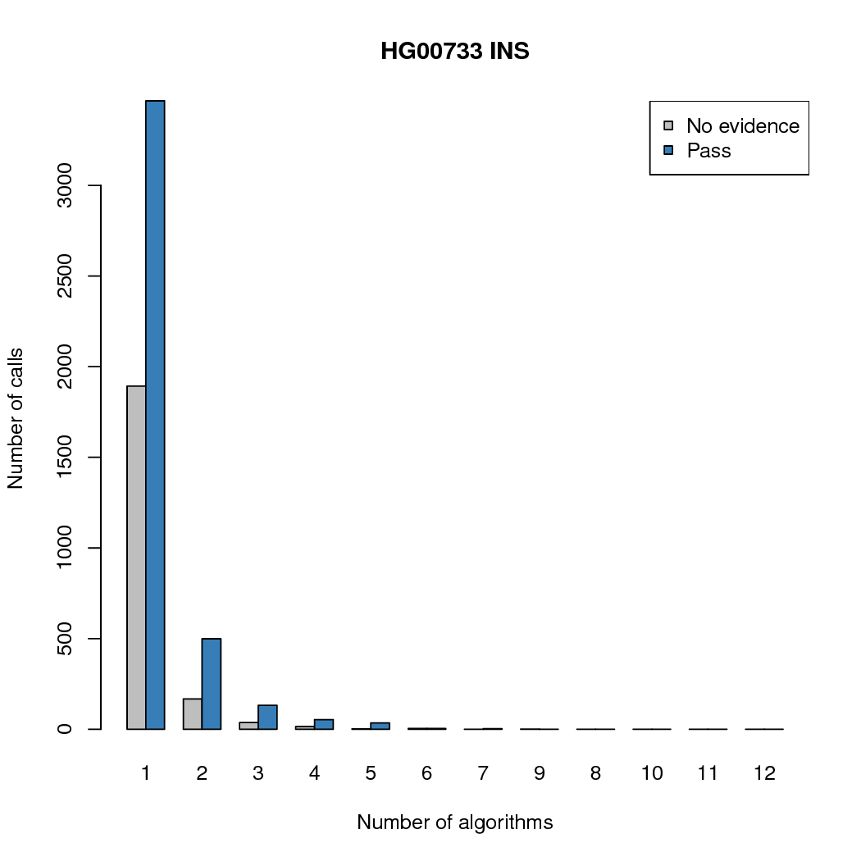

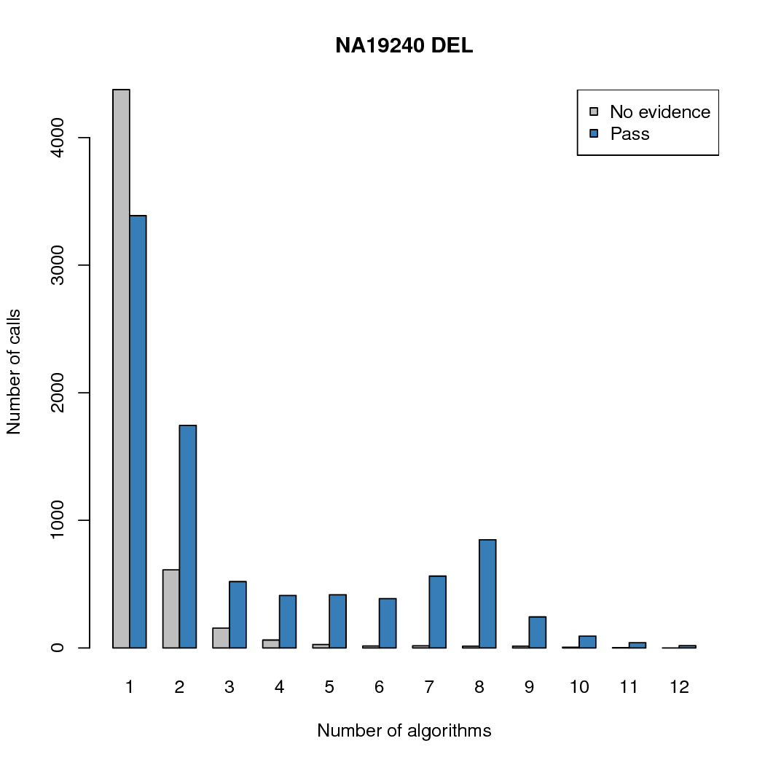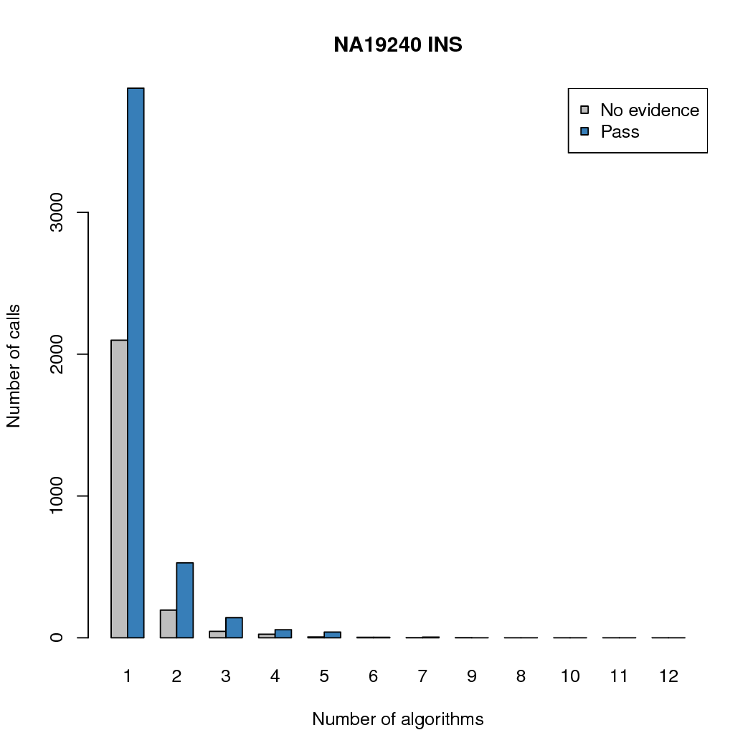

Figure S5.1.2 The support for IL-SV calls from a PB-SV call for each of the three children, deletion and insertion, for the number of methods that support each call.

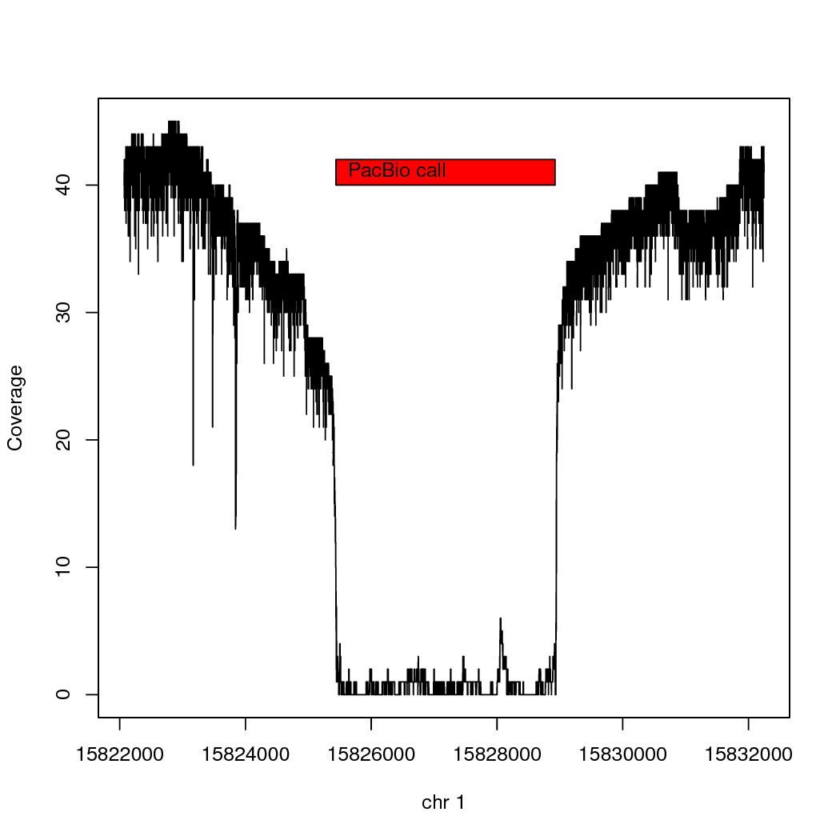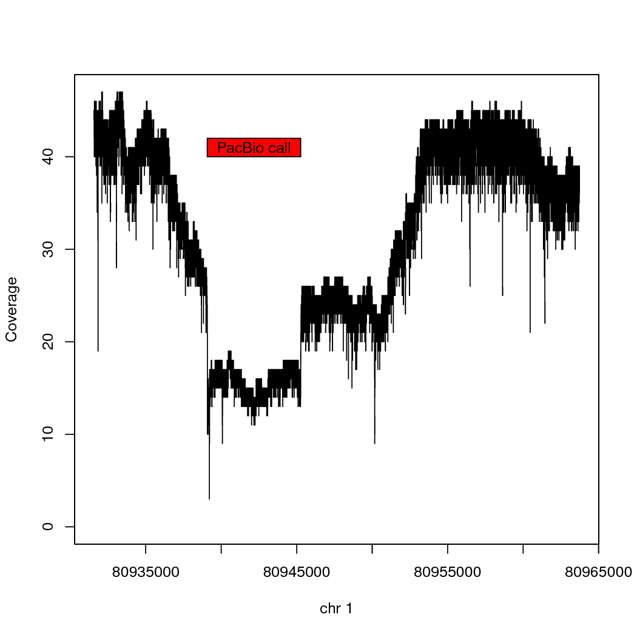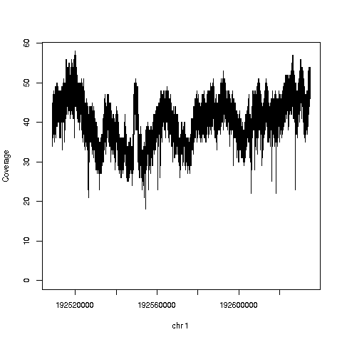

Figure 5.1.3

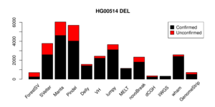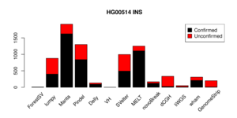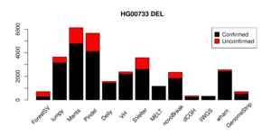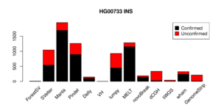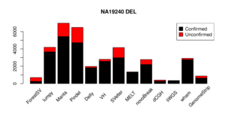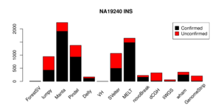

Figure 5.2.1. The data from IndividualCallerConcordance is plotted for the 13 methods.

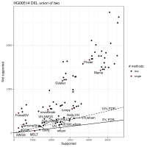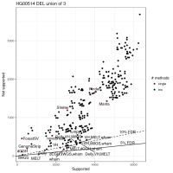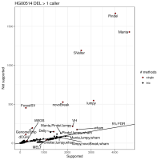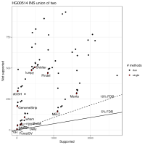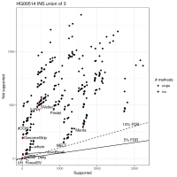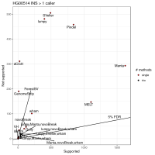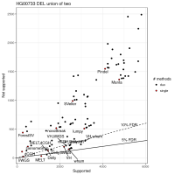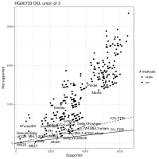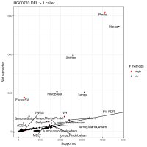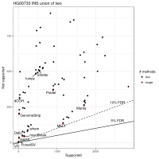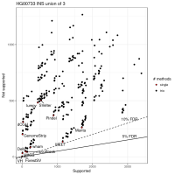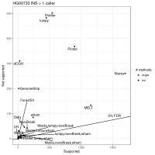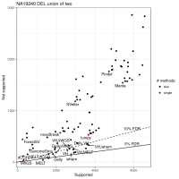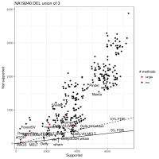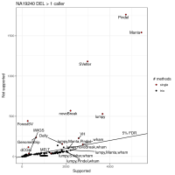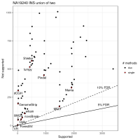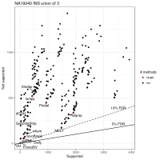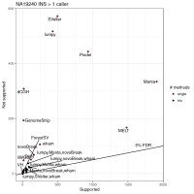

Figure 5.2.2. Concordance of combinations of Illumina SV algorithms. Each pair of rows gives, gives union of two, union of three callers, and requirement of two of three callers, for deletion and insertion calls.

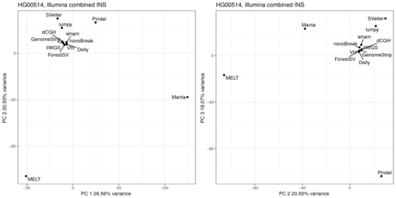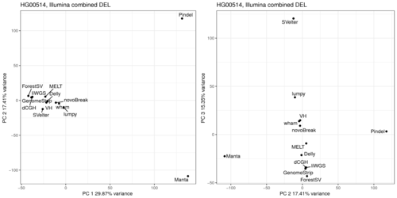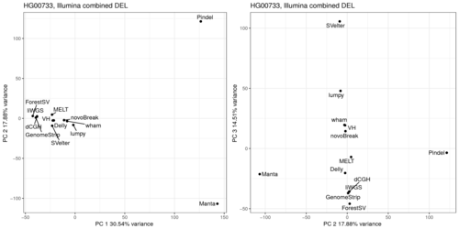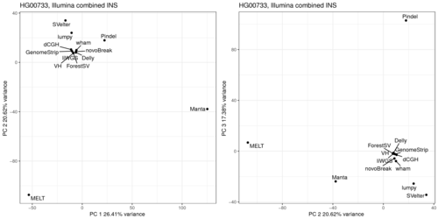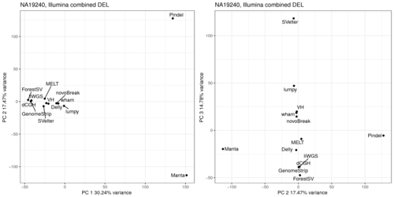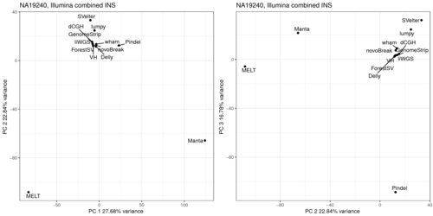

Figure 5.2.3. PCA of individual callers for insertion and deletion for PCA1 versus PCA2, and PCA2 versus PCA3, for deletion (DEL) and insertion (INS) calls.

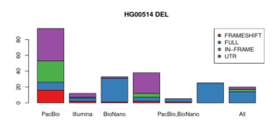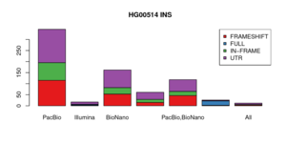
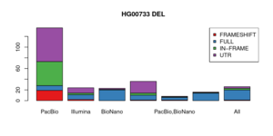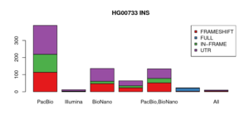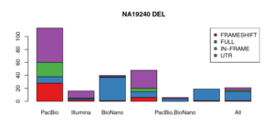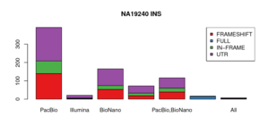Figure S5.3.1

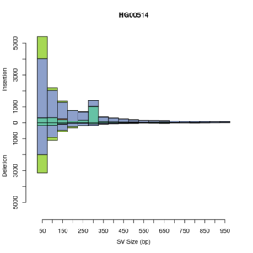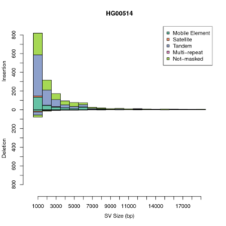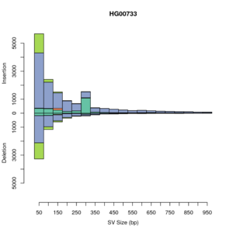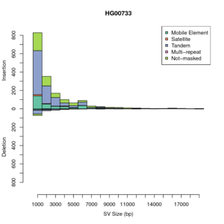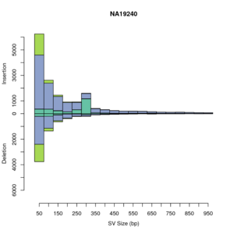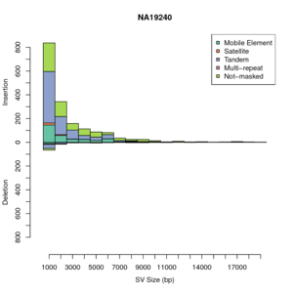
Figure 5.3.2 The regions of SV that were called in the IL-SV callset and not PB-SV are shown for the three children, and PB-SV only calls are shown for the YRI child.
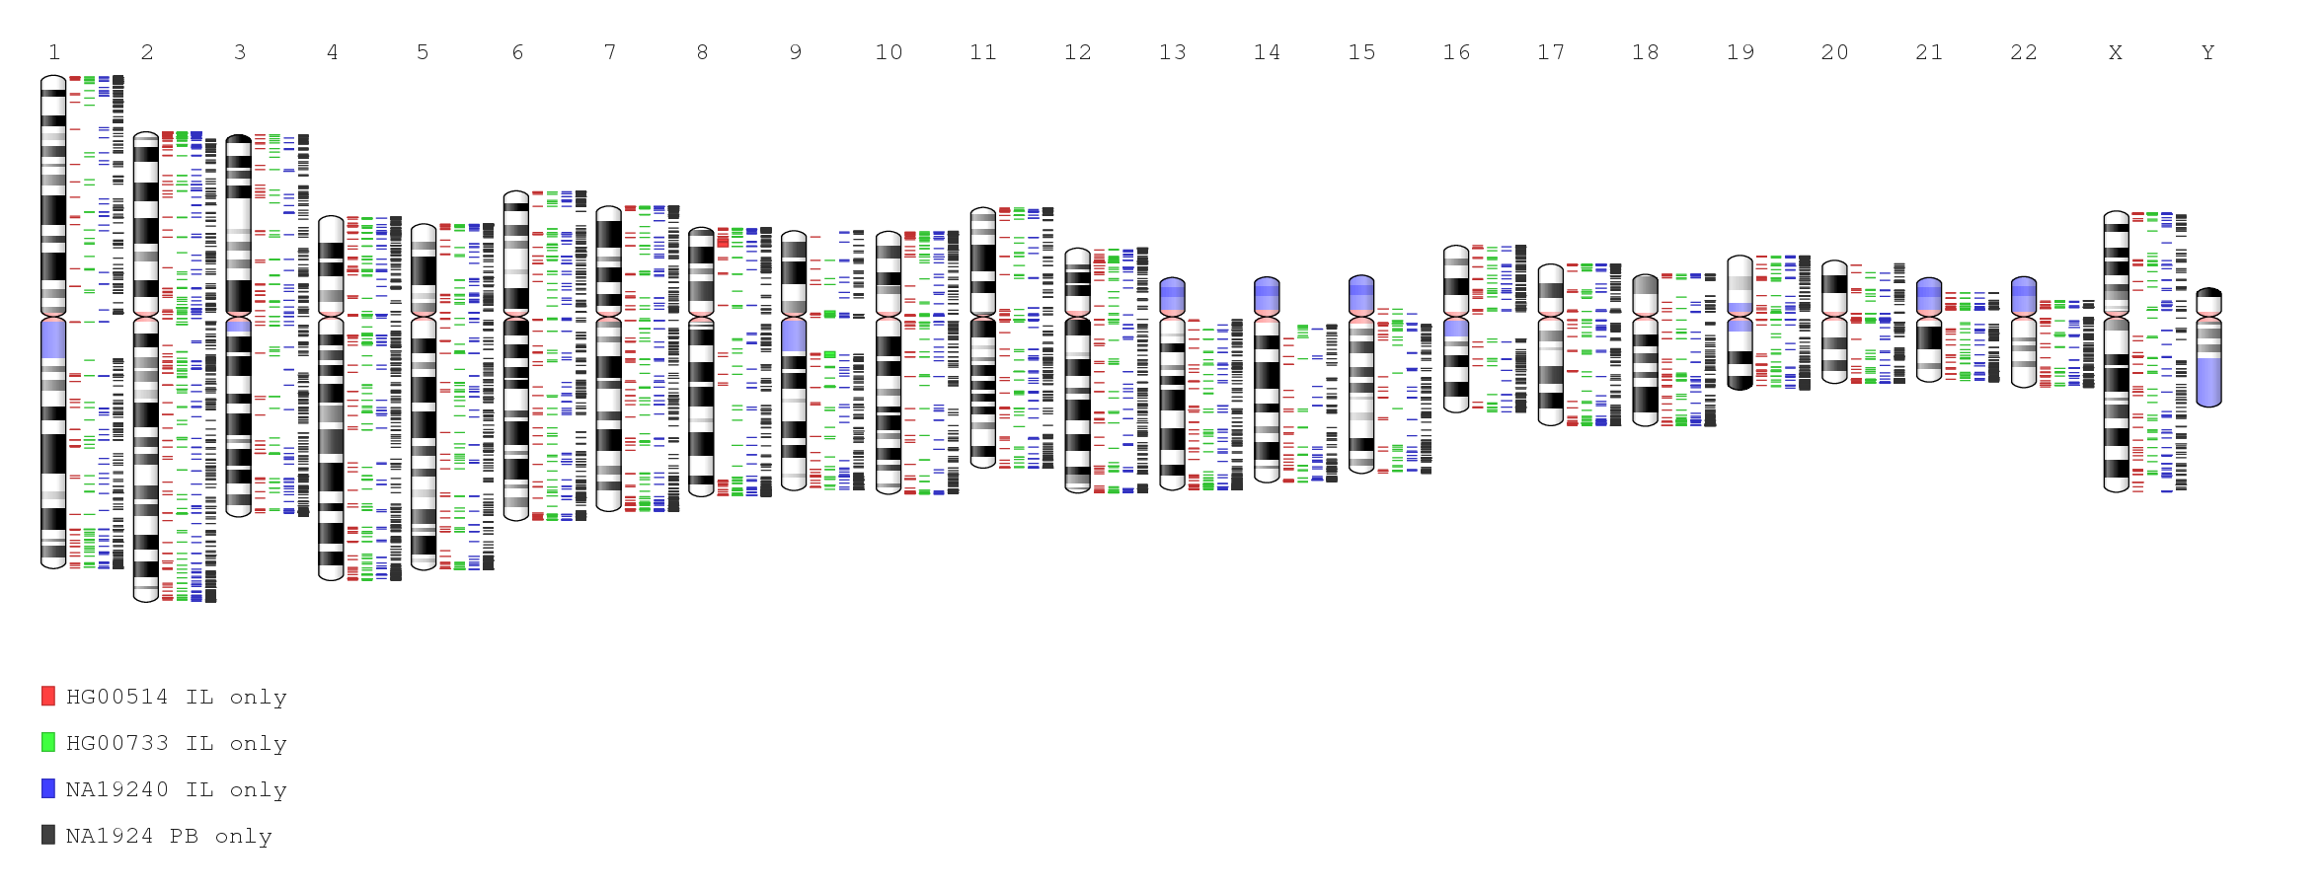

Figure 5.3.3

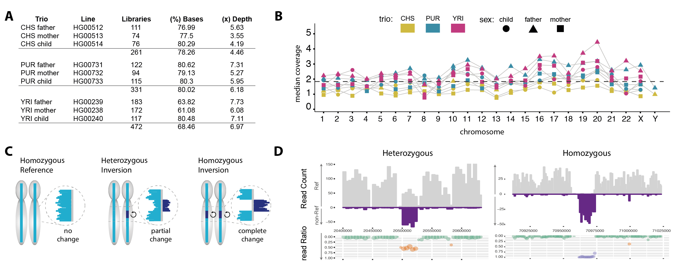
Figure S6.1.1 Locating and genotyping inversions in Strand-seq data. A) Summary of the Strand-seq libraries used to generate the merged composite files for each chromosome B) the final median coverage of the composite per chromosome shown for each sample. C) strategy for locating and genotyping inversion in composite files. D) examples of a heterozygous and homozygous inversion identified by the proportion of reads mapping to the reference assembly in each orientation, which is used to calculate the read ratio.

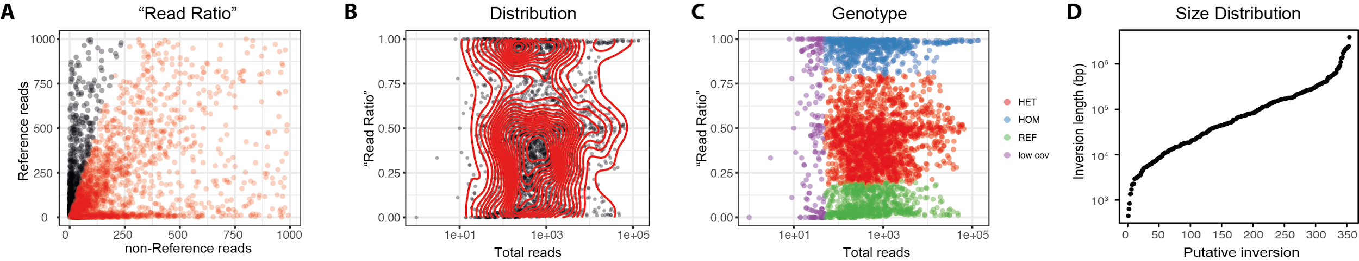
Figure S6.1.2 Putative Inversions discovered in Strand-seq composite files. A) Dotplot of local read ratios calculated for the Strand-seq composite files. Each point represents a putative inversion, and its position reflects the proportion of reads in reference and non-reference orientation at that locus. Loci with a read ratio > 15% are shown in red. The B) distribution of read ratios, and C) genotype, as determined by Fisher Exact Test, were used to further classify these events. D) Size length distribution of predicted inversions.

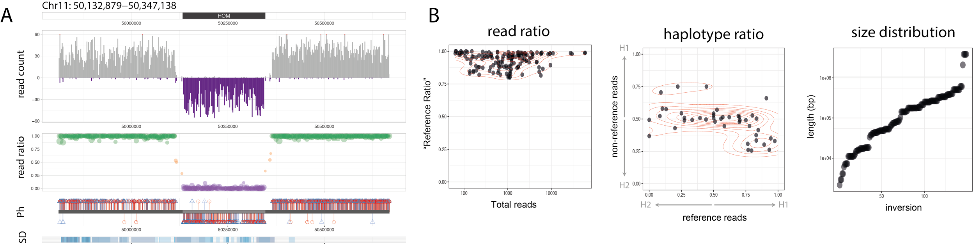
Figure S6.2.1 Haplotype structure of homozygous inversions discovered by Strand-seq. A) Illustrative examples of a simple homozygous inversion from the Strand seq discovery set that was supported by orthogonal phase data. The upper panel (read count) displays the number of reads in the reference (grey) and ‘non-reference’ (purple) orientation around the highlighted locus, and the read ratio (shown below) supports a homozygous inversion. The middle panel (Ph) displays the phase of these reads, with H1 ‘haplotagged’ reads in red, H2 reads in blue. In this panel, phased reads in the reference orientation are displayed above the ideogram, whereas phased reads in the ‘non-reference’ orientation are shown below (allowing for strand-aware analyses). The bottom panel (SD) highlights the location of annotated segmental duplications, with the intensity of blue indicative of the percent match. B) Scatter plots summarizing the high read ratios, mixed haplotype ratios, and size distribution of inversions classified as homozygous using this approach.

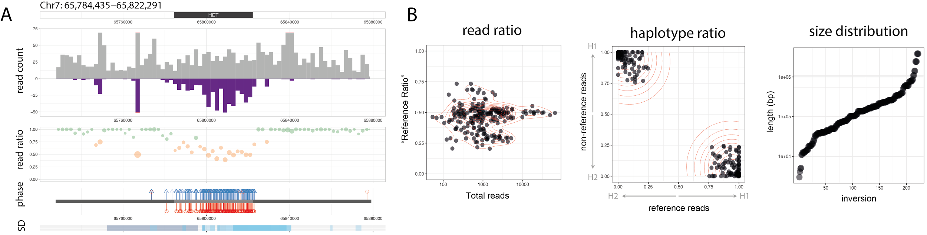
Figure S6.2.2 Haplotype structure of heterozygous inversions discovered by Strand-seq. A) Illustrative examples of a simple heterozygous inversion from the Strand seq discovery set that was supported by orthogonal phase data. Refer to Figure 6.2.1 legend for detailed description of each panel. B) Scatter plots summarizing the mixed read ratios, the partitioned haplotype ratios (which can be used to directly phase the inversion), and size distribution of inversions classified as heterozygous using this approach.

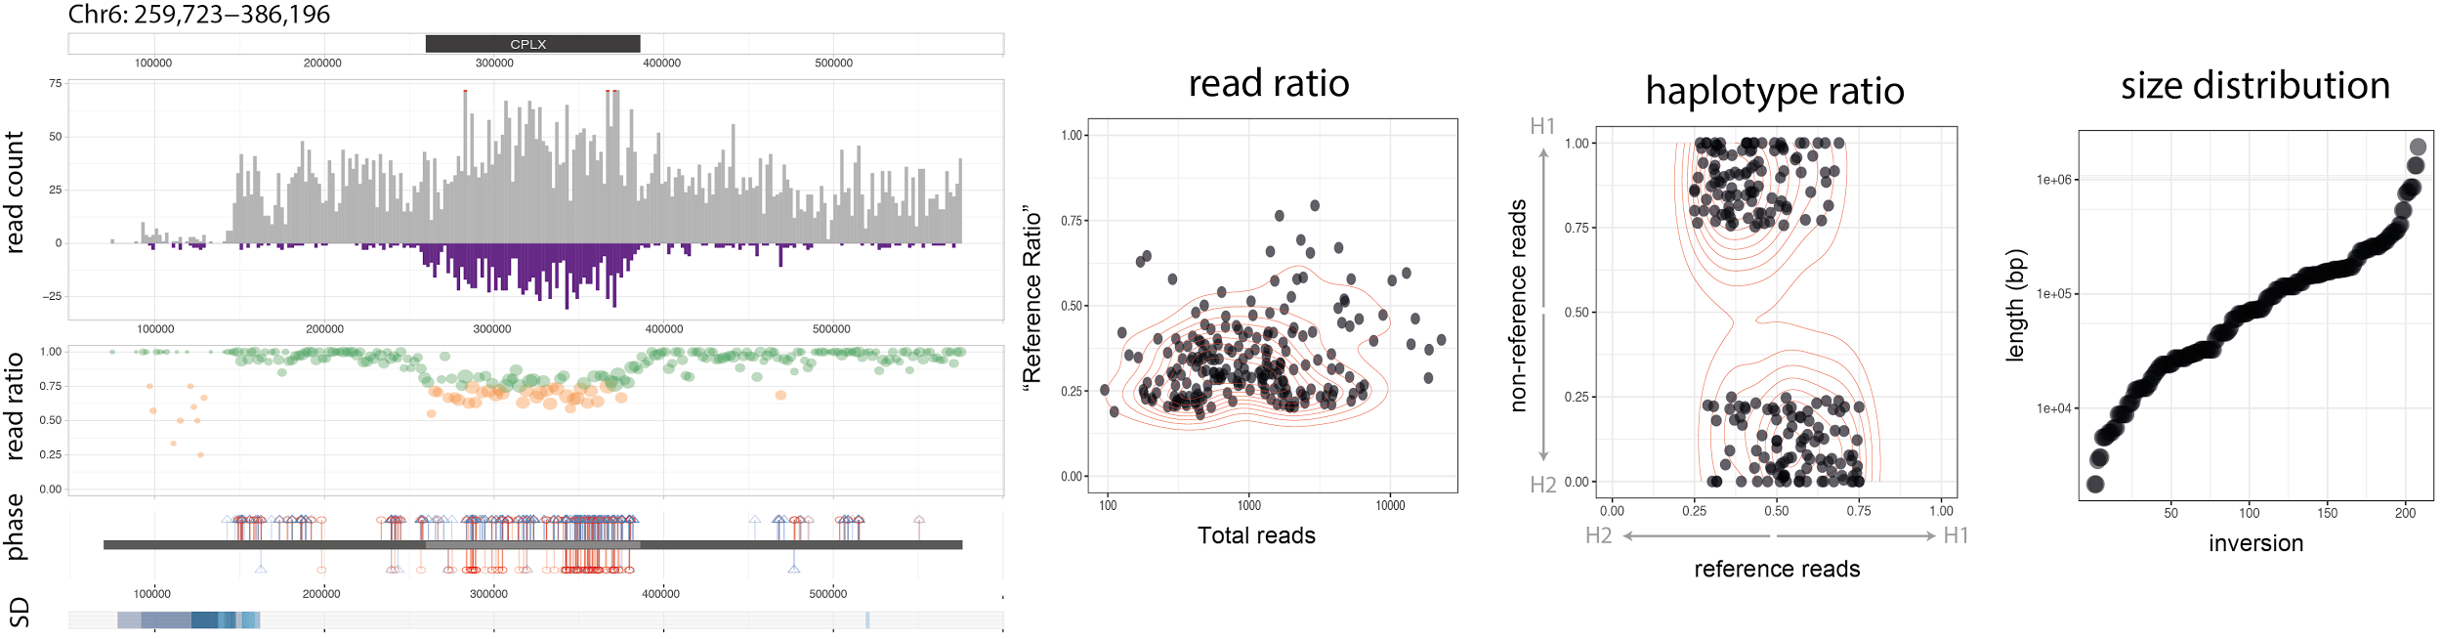
Figure S6.2.3 Haplotype structure of complex inversions discovered by Strand-seq. A) Illustrative examples of an inverted duplication (e.g. complex inverison) from the Strand seq discovery set that was supported by orthogonal phase data. Refer to Figure 6.2.1 legend for detailed description of each panel. B) Scatter plots summarizing the mixed read ratios (notice how this is shifted slightly downward from the simple heterozygous inversions), the distinct haplotype ratios (which are mixed for the reference reads but separated for the non-reference reads), and size distribution of inversions classified as heterozygous using this approach.

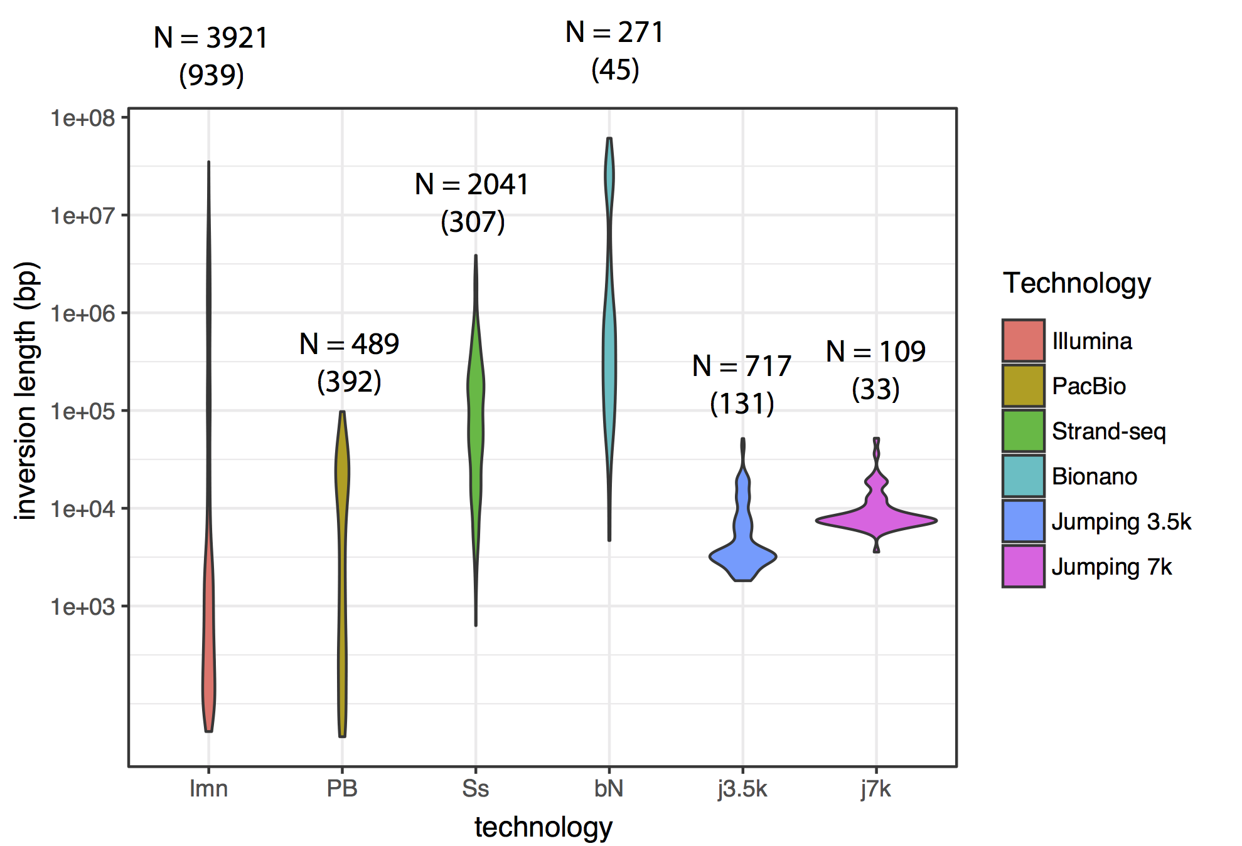
Figure S6.3.1 Summary of inversion callsets included in the integration analysis. Violin plots illustrating the size distribution of inversions predicted from various technologies, with the total number of inversion calls made for all individuals (N) listed above, and the unique number of calls in brackets.

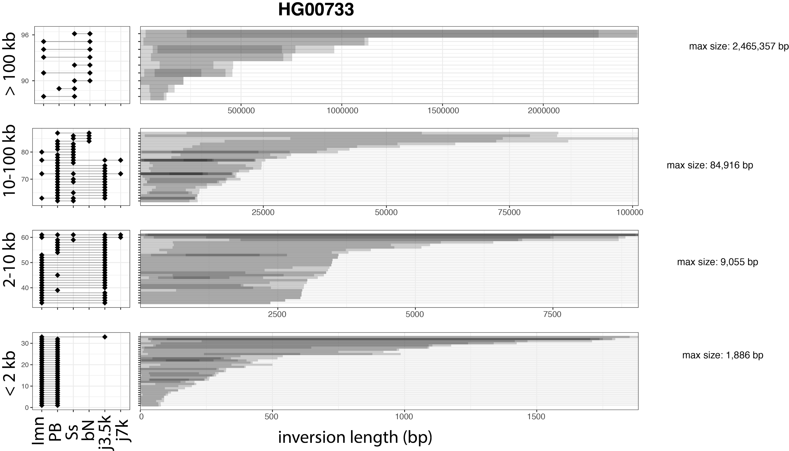
Figure S6.3.2 Intersection test results for HG00733. Example results of inversions showing > 50% reciprocal overlap between two independent technologies, sorted by inversion size. Each horizontal bar in the right panel represents a passing inversion and depicts the level of agreement between the overlapping orthogonal platforms, with the technologies intersecting at the locus listed in the left panel. Illumina (Imn); Pacific Biosciences (PB); Strand-seq (Ss); BioNano (bN); Jumping libraries with 3.5kb (j3.5k) and 7kb (j7k) insert lengths.

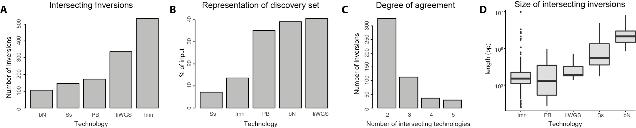
Figure S6.3.3 Summary of results from the intersection test. A) Total number of inversions showing > 50% reciprocal overlap between two independent methods, sorted by technology. B) Percent of inversions in the initial discovery callsets that passed the intersection test. C)Ssize lengths of passing inversions, sorted by technology. D) Number of methods intersecting at each inversion. Illumina (Imn); Pacific Biosciences (PB); Strand-seq (Ss); BioNano (bN); long-insert Whole Genome Sequence (a.k.a ‘jumping’) libraries (liWGS).

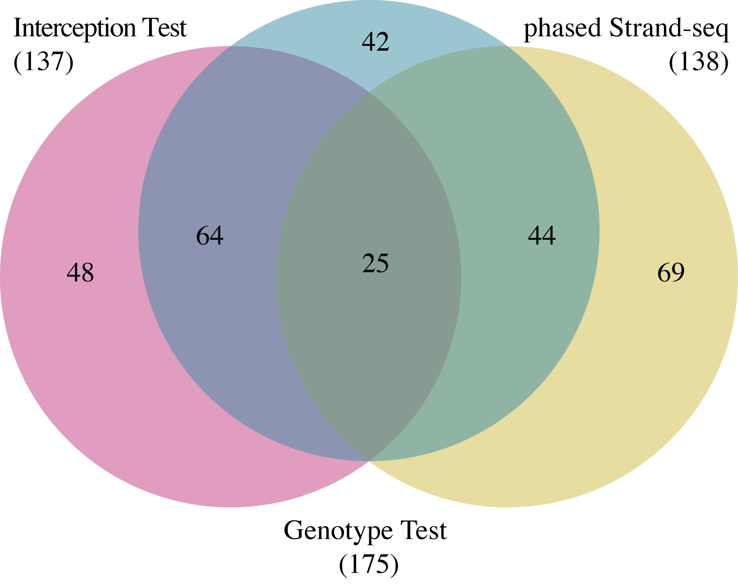
Figure S6.3.4 Inversion lists used to generate the final unified inversion callset. Venn diagram illustrating the degree of overlap between the three support lists that were merged together to generate the unified inversion callset.

a)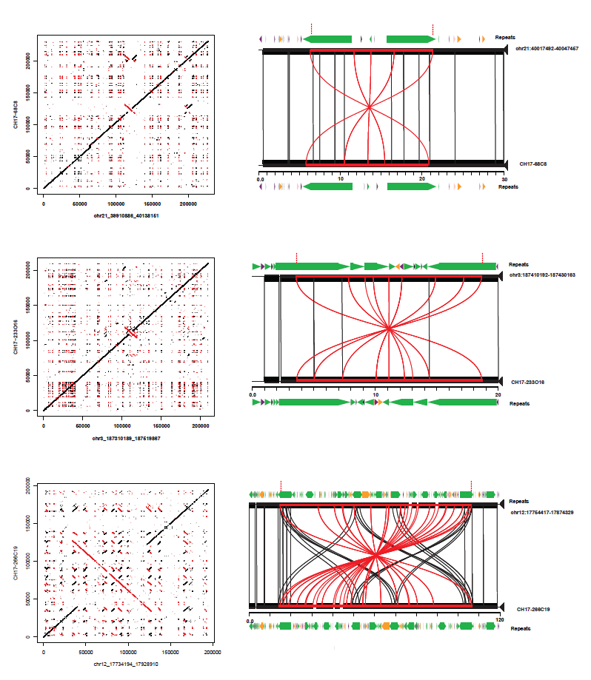

b)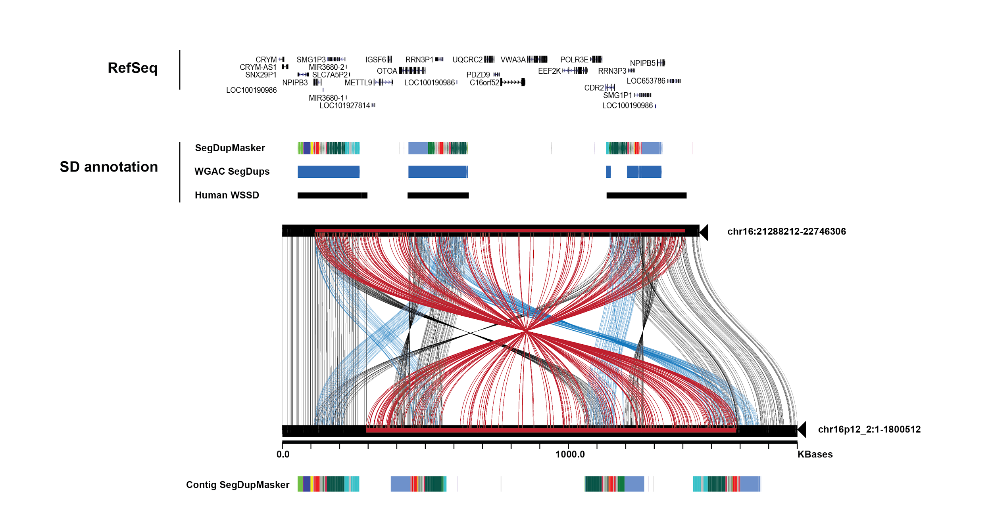
c)
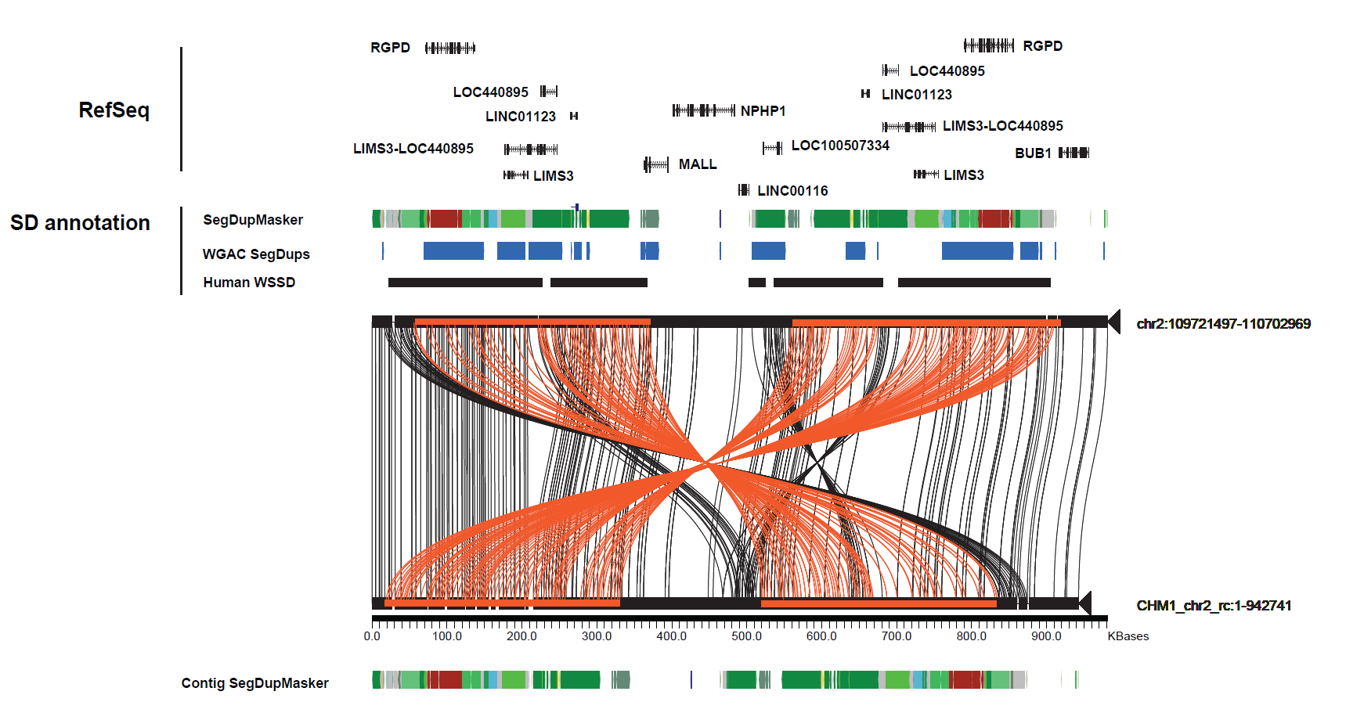
Figure S6.4.1 a) Misassemblies in the GRCh38 reference validated by large insert clone based sequence and assembly. Inversions detected by strand seq followed by sequence resolution using CH17 BAC clones. Inversions are validated by by aligning the corresponding BAC sequences to GRCh38 and visualized using Miropeats (Parsons 1995) and dot plots. The miropeats figures depict black lines indicating homologous sequence between the two assemblies and red lines correspond to inversion events. RepeatMasker annotation demonstrates that inversion events are flanked by inverted LINE/L1 repeats (green). b) An ~857 kbp sequence-resolved inversion on chromosome 16p12.1. Sequence and assembly of 16 CHM1 BAC clones to generate a ~1.8 Mbp alternate reference haplotype corresponding to chr16p12. A miropeats comparison between the alternate reference and the GRCh38 reference depicts a large inversion (red lines) and additional expansions of segmental duplication blocks (blue). Annotations include whole-genome shotgun sequence detection (WSSD) (Bailey et al. 2002), DupMasker (Jiang et al. 2008) and Refseq annotations. c) An 842 kbp chr2q13 alternate reference haplotype consistent with the GRCh38 reference assembly. Sequence and assembly of 6 CHM1 BAC clones to generate a ~843 kbp alternate reference haplotype corresponding to chr2q13. A miropeats comparison depicts large highly identical segmental duplication blocks (~358 kbp) mapping in inverted orientation (orange lines) flanking ~120 kbp of unique sequence. The alternate reference haplotype confirms the order and orientation of the GRCh38 reference assembly indicating that CHM1 represents the minor reference haplotype at this locus. Annotations include whole-genome shotgun sequence detection (WSSD) (Bailey et al. 2002), DupMasker(Jiang et al. 2008) and Refseq annotations.

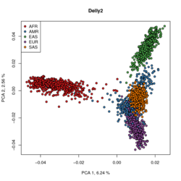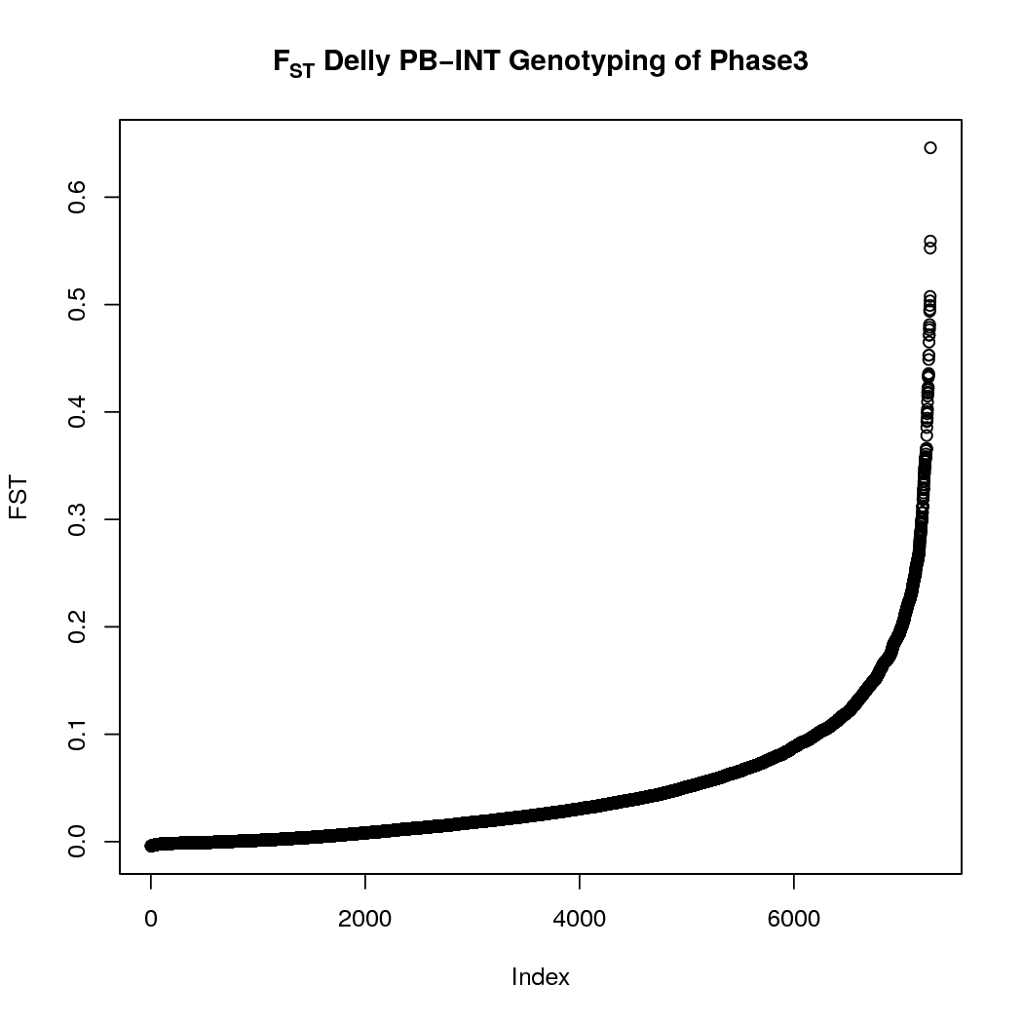

Figure S7.1.1

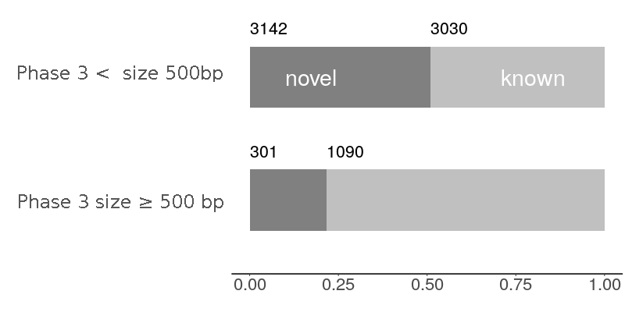

Figure S7.1.2

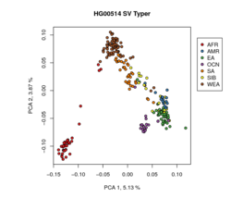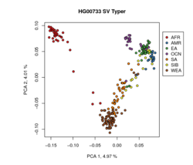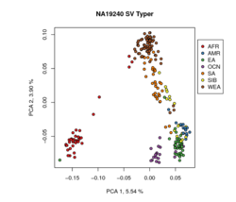

Figure S7.1.3

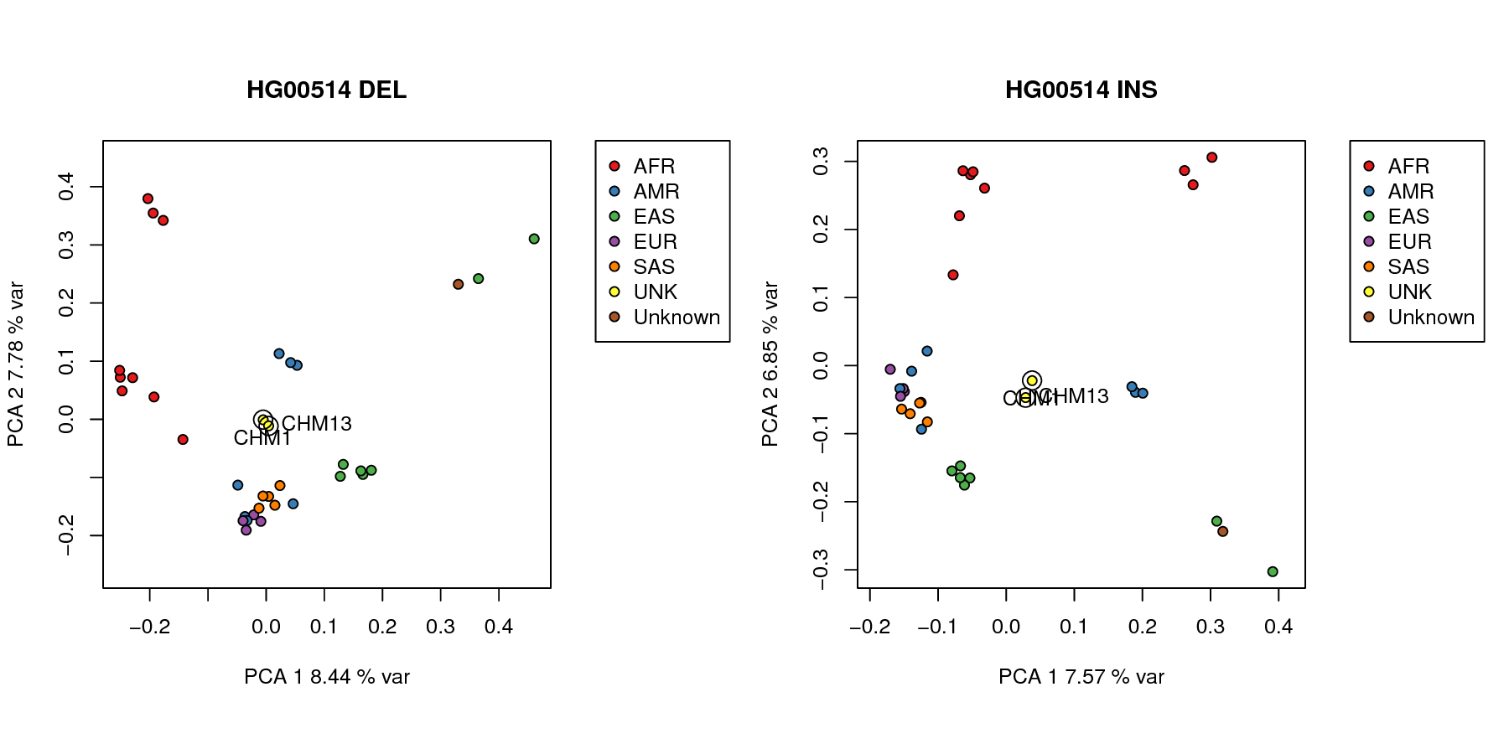
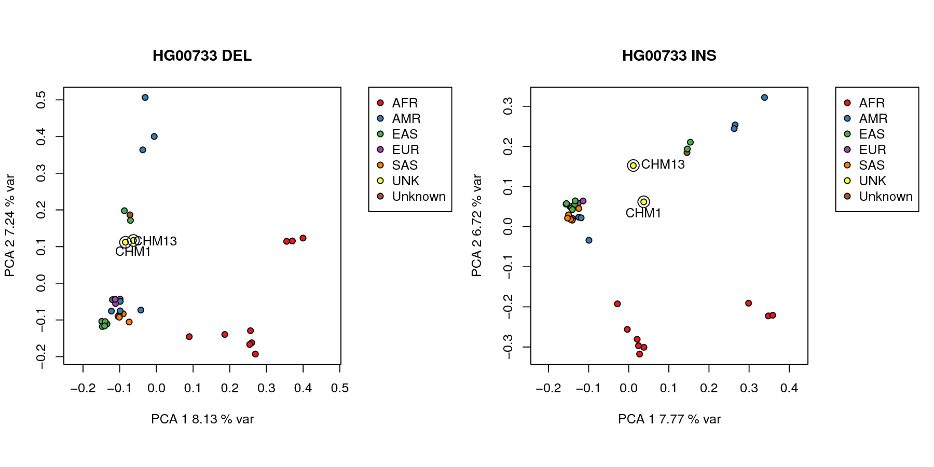

Figure S7.1.4. Principal component analysis of genotyping of insertion and deletion SV from high coverage genomes using SMRT-Genotyper.

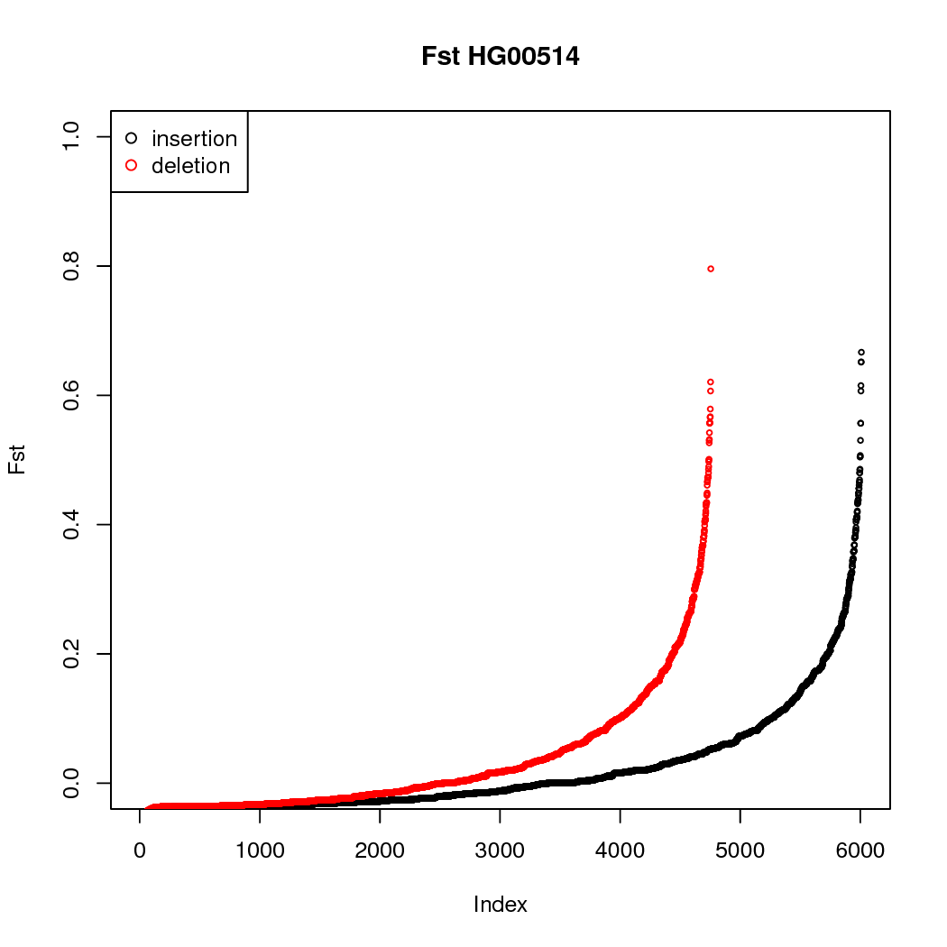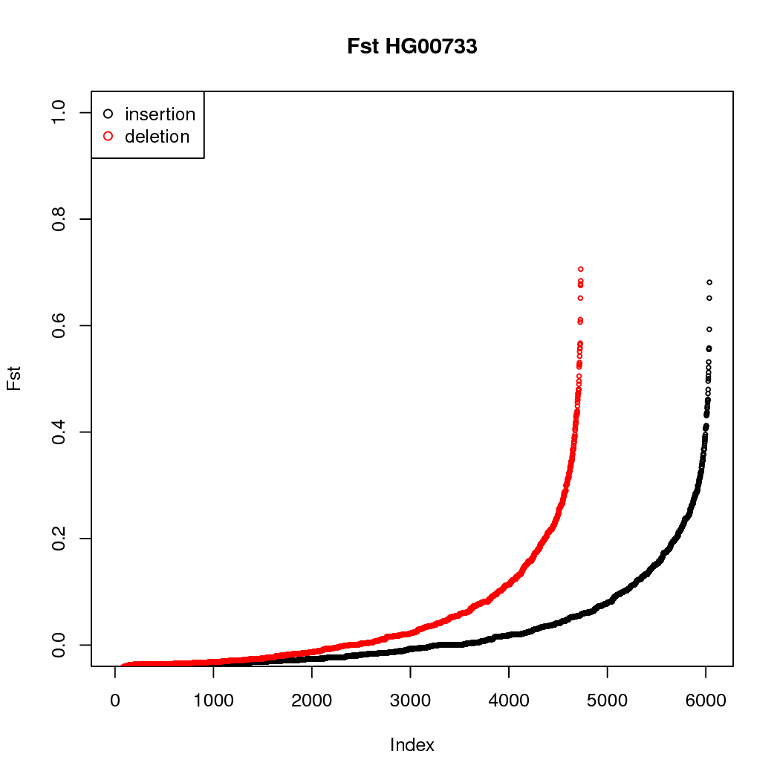
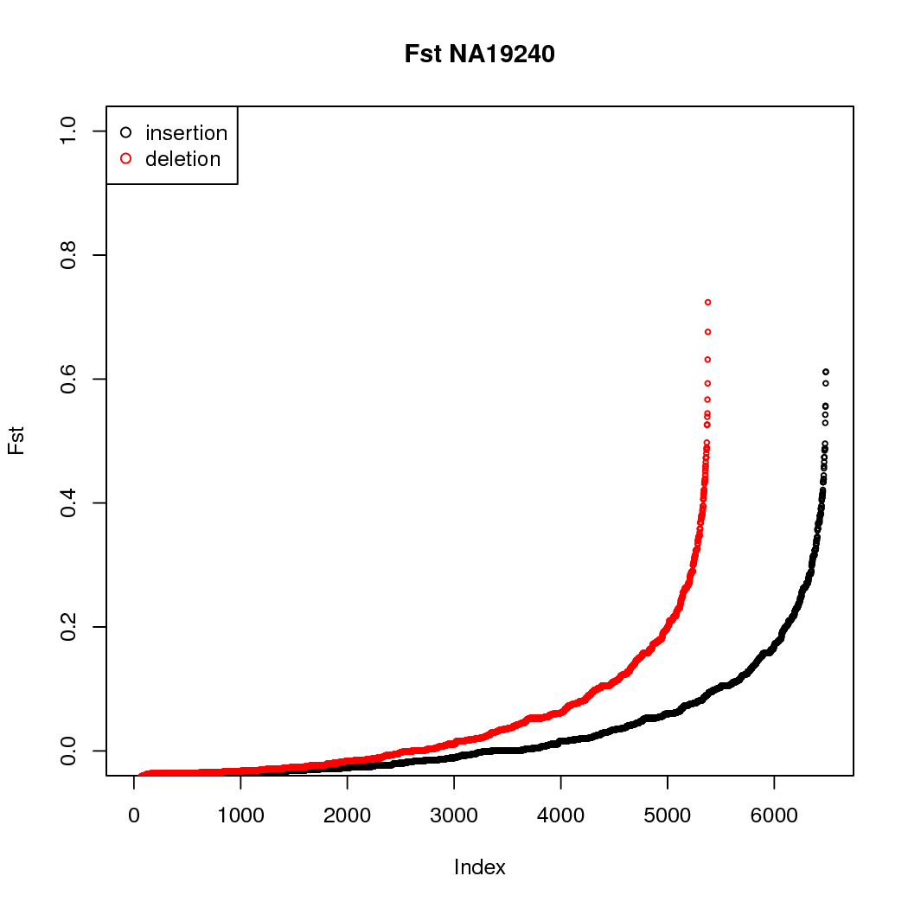

Figure S7.1.5 F_{ST} of SV detected with SMRT-Genotyper for insertions (black) and deletions (red) across all genotyped sites for each child.

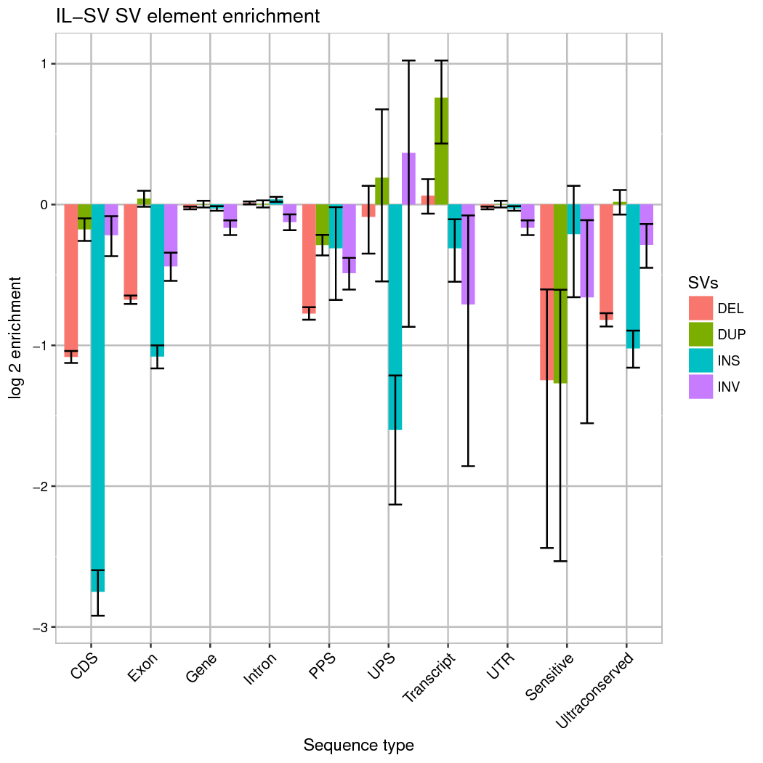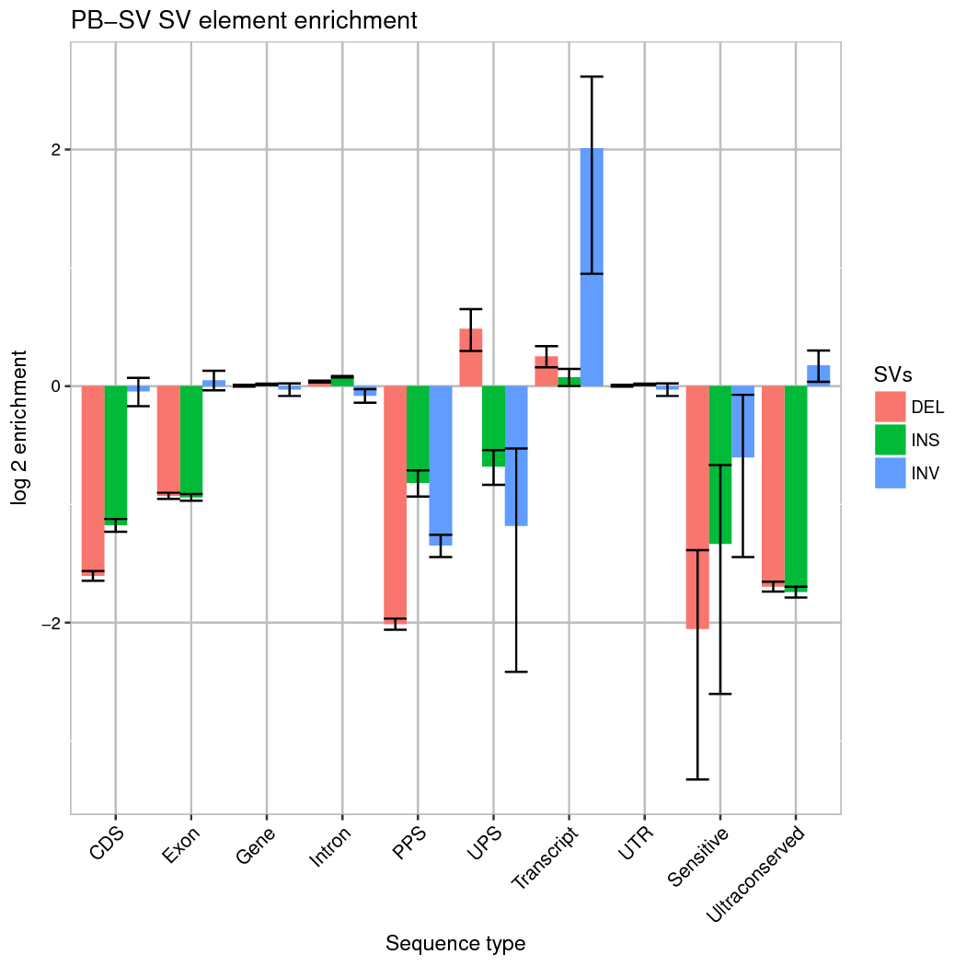

Figure S7.2.1. Enrichment for SVs intersecting functional elements in the IL-SV and PB-SV callsets. CDS: coding sequences, PPS: processed pseudogenes, UPS: unprocessed pseudogenes.

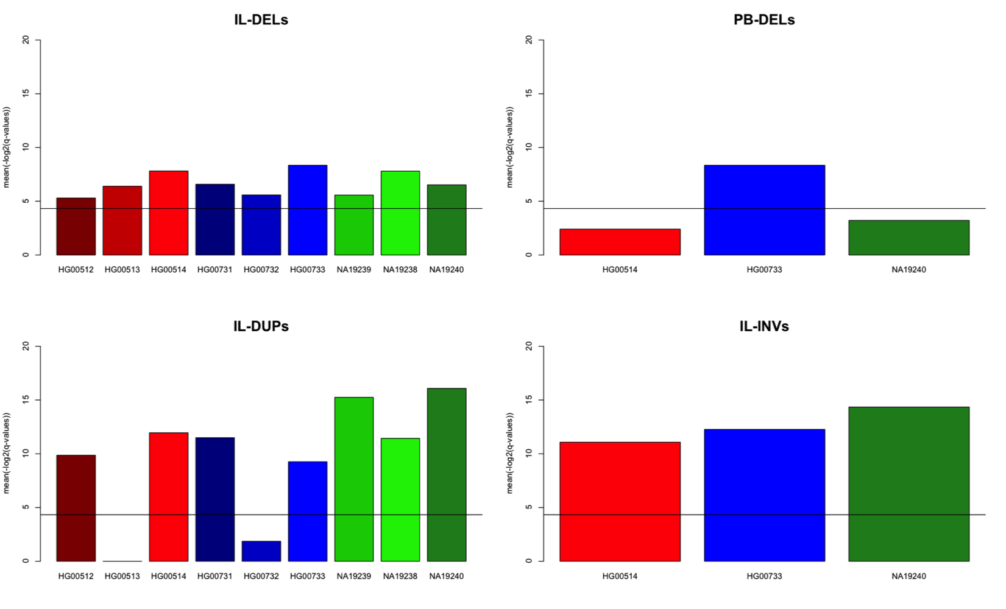
Figure S7.2.2: Significance of gene expression effect by PB-SVs and IL-SVs that engulf protein coding genes. Samples are given along the x-axis of each plot while vertical bars depict the average –log2(q-values) calculated from the group t-tests between the RPKM normalized expression values of genes engulfed by structural variants and that of genes engulfed by permuted chromosomal regions. Panel A. shows results for the integrated Illumina deletions (IL-DELs) for all 9 individuals, while Panel B. gives the results for PacBio deletions (PB-DELs) in trio daughters. Panel C. illustrates the results from the analysis of the integrated Illumina duplications (IL-DUPs) for the 9 samples, and Panel D. shows results from the analysis of Illumina inversions (IL-INVs) engulfed genes for the trio daughters. The position of the horizontal line in each panel corresponds to the significance threshold (q = 0.05).

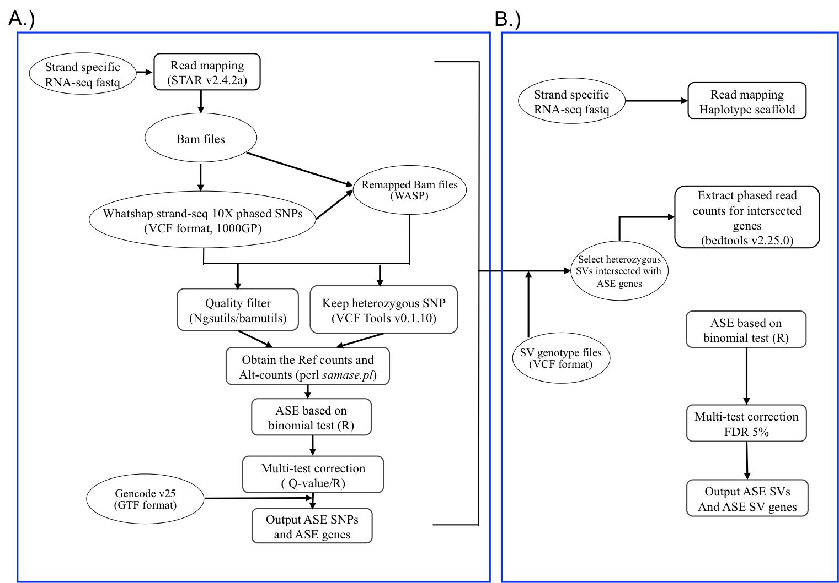

Figure S7.2.3: A pipeline of the allele specific expression analysis for SNPs (Panel A) and SVs (Panel B).

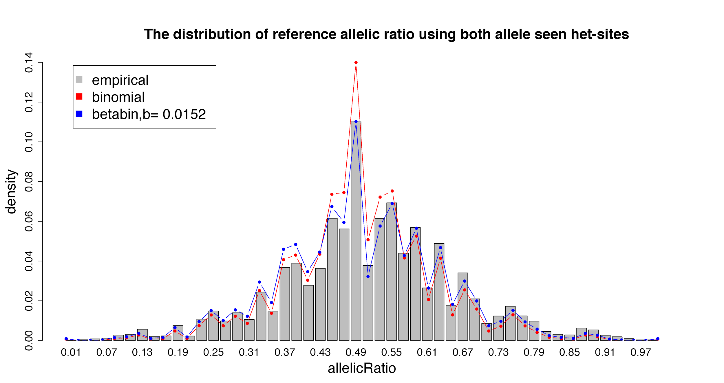
Figure S7.2.4 The distribution of reference allelic ratio using both allele seen het-SNPs. Grey bars shows the empirical reference allelic ratio distribution. Red and blue lines show the null expected allelic ratio distributions associated with the binomial and beta-binomial test, respectively. The overdispersion b is as low as 0.0152 which would give similar results for binomial and beta-binomial tests.

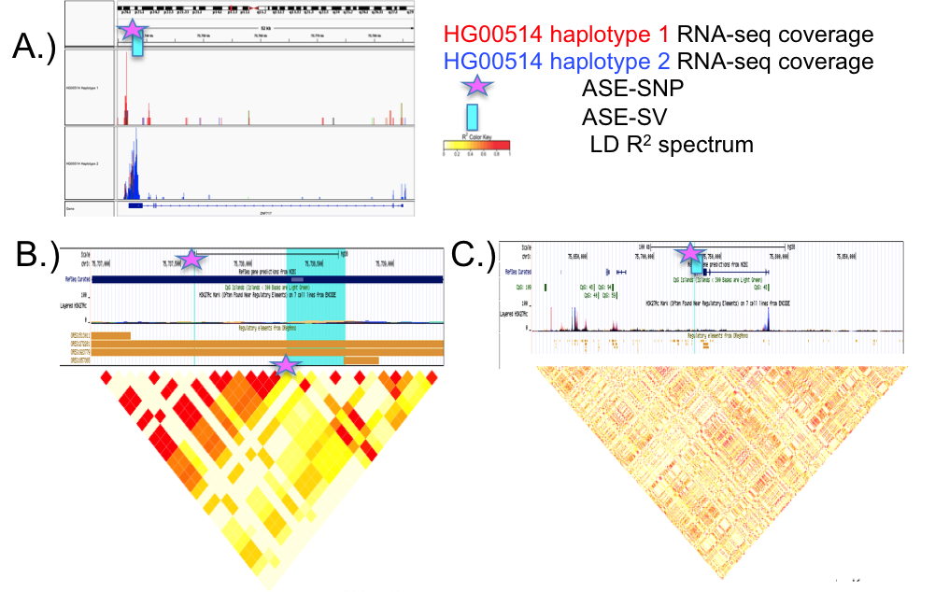
Figure S7.2.5 Analysis of SNP and PB-SV ASE for indication against a haploblock effect. A.) IGV plot of phased RNAseq read counts on HG00514 haplotype 1 (upper track) vs. haplotype 2 (lower track) with SV-ASE (PB-DEL, with a genotype of 1|0 meaning deletion on haplotype 1 and no deletion on haplotype 2) on ZNF717 gene; A nearby ASE-SNP was found 644 bp away from the SV-ASE affecting the same gene. B.) R² calculations for CHS population variants within exon 5 of ZNF717 show local LD surrounding IL-DEL site. C.) LD map for CHS population variants ± 100kb of ZNF717 gene shows little evidence of a regional haploblock effect.

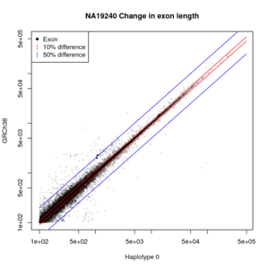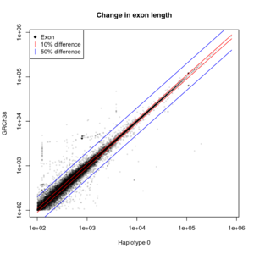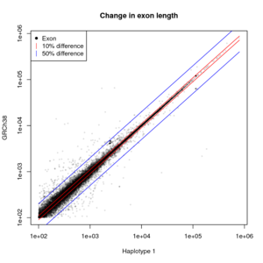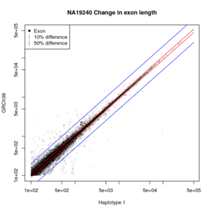
Figure S7.2.6 Change in exon length by haplotype.
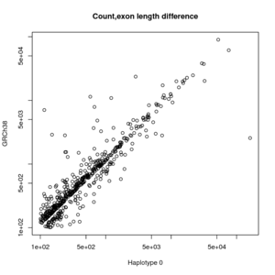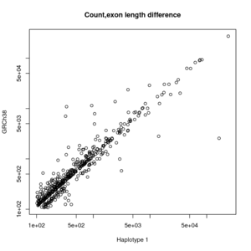
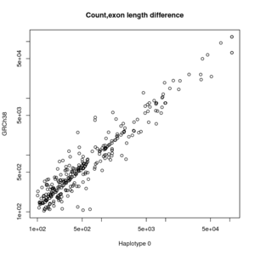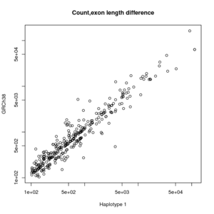
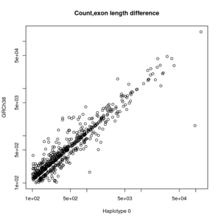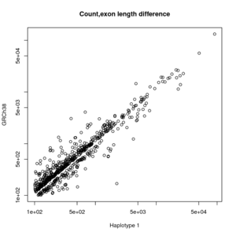
Figure 7.2.7 Differences in read counts for exons of different length in haplotype specific assembly, and GRCh38 for HG00514 (top row), HG00733 (middle row), and NA19240 (bottom row). Differences less than 2 bp are ignored.

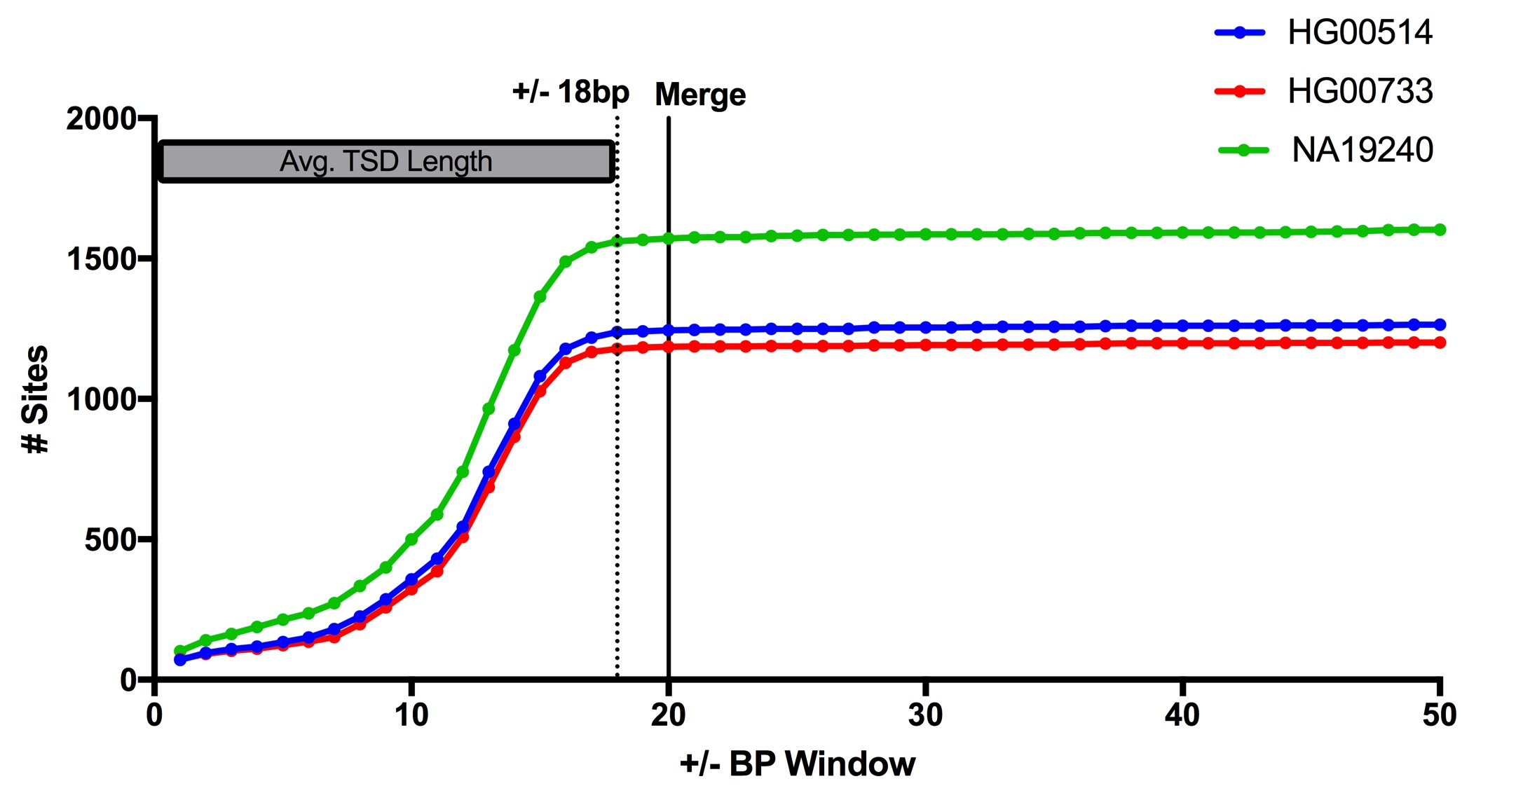

Figure 7.3.1 Variation in L1 source element profiles.

