GENOME ANALYSIS
Efficient Detection of Highly Mutated Regions with Mutations Overburdening Annotations Tool (MOAT)
Lucas Lochovsky^{1,2,†} , Jing Zhang^{1,2,†} and Mark Gerstein^{1,2,3*}
¹Program in Computational Biology and Bioinformatics, Yale University, New Haven, Connecticut 06520, USA
²Department of Molecular Biophysics and Biochemistry, Yale University, New Haven, Connecticut 06520, USA
³Department of Computer Science, Yale University, New Haven, Connecticut 06520, USA
Received on XXXXX; revised on XXXXX; accepted on XXXXX

Associate Editor: XXXXXXX

abstract
Identifying genomic regions with a higher-than-expected mutation burden has a number of useful applications. Regions overburdened with cancer somatic variants may be associated with cancer progression. Accumulations of germline rare variants could be indicators of positive selection, or precursors for genetic disease. Here, we release a new software tool, called MOAT (Mutations Overburdening Annotations Tool), to perform mutation burden analysis with great speed. MOAT makes no assumptions about the mutation process, except that the background mutation rate (BMR) changes smoothly with other genomic features. This nonparametric scheme randomly permutes the variants (or target regions) on a relatively large scale where the BMR is assumed to be constant to provide robust burden analysis in cancer driver detection. Furthermore, the MOAT software suite incorporates a somatic variant simulator called MOATsim, which randomly permutes the input variants with effective covariate control. MOAT also offers the option to evaluate the functional impact within annotations for burden analysis. In conclusion, MOAT is a useful for a broad range of analyses that would benefit from variant permutation.
Availability: MOAT is available at moat.gersteinlab.org

introduction
A common analysis strategy in cancer driver detection is to look for genomic elements with a high variant accumulation across many patients. However, it is well known that the background mutation rate (BMR) is highly heterogeneous across the whole genome due to numerous influences. Hence, our Mutations Overburdening Annotations Tool (MOAT) relies on no assumption except that the BMR remains approximately the same within a local context.[Peak calling discussion here]
whole genome variant density would appear to be a facile adaptation of standard peak calling algorithms that are more commonly used for finding regions of high read density. However, due to the aforementioned BMR heterogeneity, a mere scan for variant aggregations would not be a sufficiently specific evaluation of significantly elevated mutation burdens. This heterogeneity takes many forms, as indicated in Fig XX, resulting in patient-specific rates, region-specific rates, and local nucleotide context-specific rates. Hence, a proper mutation burden evaluation must accommodate a comparison of observed variant density to the expected density under these context-specific background rates, which is not possible with standard peak calling algorithms.
MOAT offers an annotation-centric algorithm (MOAT-a) and a variant-centric algorithm (MOAT-v). We also offer MOATsim, a somatic variant simulator. MOAT can also be used to gauge the functional impact of annotations relative to the surrounding genome. Given whole genome functional impact scores—or any functional whole genome signal track, such as GERP scores (Davydov, et al., 2010)—MOAT can be used to compare observed and permuted scores to evaluate functional impact significance. Here, we provide an example Funseq2 file (Fu, et al., 2014). In the following sections, we will describe MOAT’s implementation and recall of known noncoding cancer drivers.

methods
A number of covariates jointly affect the BMR in a complicated and dynamic manner, making variant burden analysis very challenging (Lawrence, et al., 2013). However, the length of the test region usually varies from hundreds of bases to thousands of bases, while external features, such as replication timing, work at up to megabase resolution. Therefore, MOAT circumvents the necessity for such parametric models by explicitly permuting the variants or annotations within a region that has essentially constant levels of all the covariates. One important issue with these permutation algorithms is that their running times do not scale well to whole genome annotation sets. We addressed this issue by taking advantage of large-scale GPU parallelization.

MOAT-a: Annotation-centric Permutation
MOAT takes two input files: the annotation file (afile) and the variant file (vfile). MOAT-a uses NVIDIA’s CUDA language (Nickolls, et al., 2008) for general purpose graphics processing unit (GPGPU) acceleration. MOAT-a’s steps are illustrated in Fig. 1a. MOAT-a iterates through each annotation, computing the intersecting variant count. It then defines a genomic block with user-defined boundaries for permuting the annotation n times. MOAT-a will find the variant counts of the n random bins, which are compared to the annotation’s observed variant count to provide p-values. If MOAT is run with the functional impact score option, the variants' scores are computed and used to calculate annotation scores by summing the scores of the intersecting variants.
The boundaries of the intervals for choosing permuted annotations—d_min and d_max—are adjustable to allow users to scale the surrounding genome context with respect to the size of the original annotation. The permutation intervals ideally will provide enough range to enable non-overlapping sampling. For example, in our analysis of transcription start site (TSS) mutation burdens, where TSSes are roughly 100 bp in length, we used a d_min of 2kb and a d_max of 10kb. As a rule of thumb, the choice of d_min must be large enough to avoid the possibility that a potential mutation burden signal may "bleed" into the permutation intervals, while the choice of d_max must be small enough that the BMR covariates are approximately constant within the permutation intervals.

MOAT-v: Variant-centric Permutation
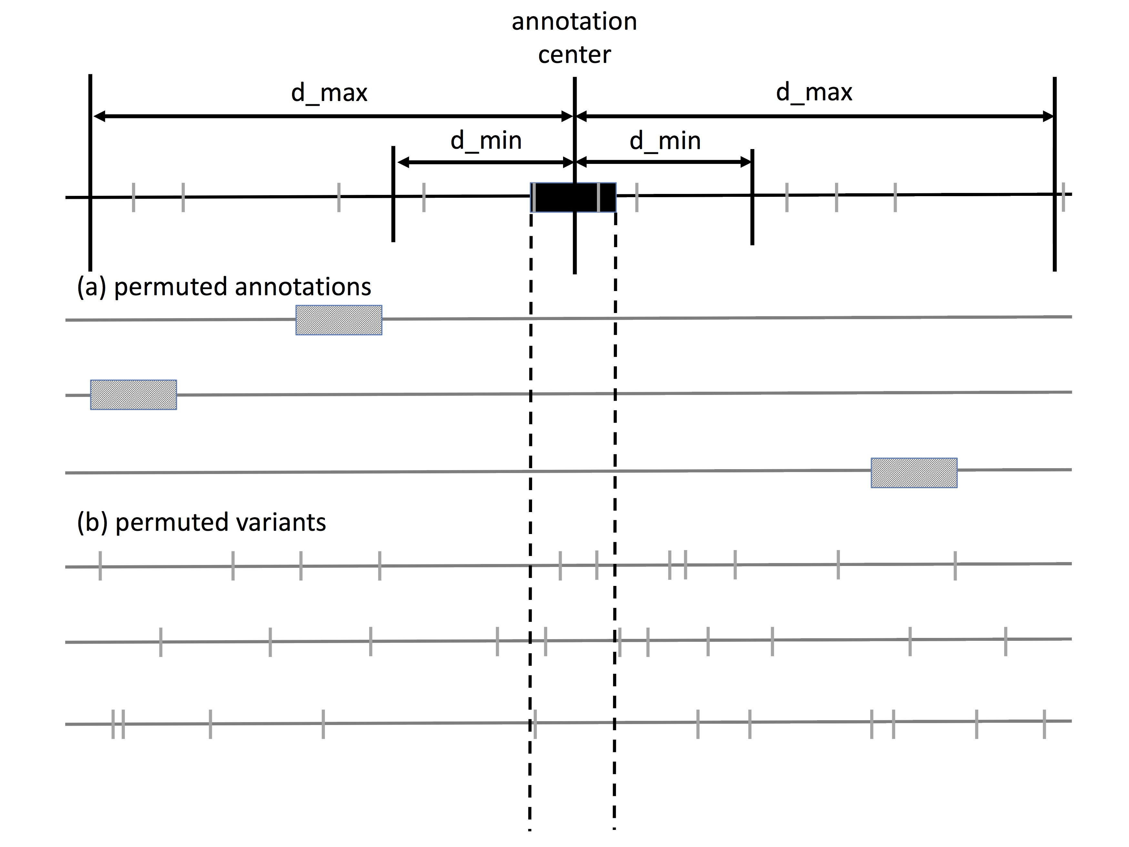
MOAT-v creates permuted datasets by assigning new coordinates to each variant within a local genome region to account for the covariate effects from known genomic features (Fig. 1b). MOAT-v offers the option to preserve the trinucleotide context of the original variant when choosing a new variant location. This constraint reflects the differential mutation probabilities of different trinucleotides. MOAT-v generates a permuted dataset by subdividing the genome into blocks of a user-defined size within which variants are permuted, generating n permutations. A p-value for each annotation is determined based on the fraction of the n permuted variant counts that are equal to or greater than the observed variant count.
Figure 1 (a) MOAT-a shuffles each annotation to a new location within the local genome context bounded by user-defined parameters d_min and d_max, producing n permutations. (b) In MOAT-v, the whole genome is divided into bins within which variants are moved to new coordinates, preserving the local mutation context. As with MOAT-a, n permutations are produced.
The ability to adjust the width of the whole genome bins in MOAT-v enables users to select a width that represents regions in which the BMR covariates are expected to be approximately constant. Hence, the permutations created by MOAT-v will honor the regional mutation density expected due to these covariates. Our analysis of a few of the most significant covariates, including DNA replication timing, histone marks and GC content, indicate that they are roughly constant at a 100kb resolution.

MOATsim: Simulated Somatic Variant Datasets
In addition to the main MOAT programs, we have developed a variant simulator, MOATsim, that reflects the levels of whole genome covariates that directly influence the background mutation rate. MOATsim evaluates covariate signals over a set of whole genome bins. These bins are then clustered based on their covariate signal profiles, and allows variants to be permuted not just within their local genome context, but across all bins with the same covariate signal profile. As with MOAT-v, bin width should be chosen based on the resolution at which the input covariates are approximately constant.
The whole genome bins are clustered using k-means clustering, which uses the distances between the bins' covariate signal profiles to group the bins into a predefined number of clusters. We selected k based on a within cluster sum of squares analysis (Fig XX)—the ratio of the within cluster sum of squares to the between cluster sum of squares did not change appreciably after k=30, and was subject to stochastic variation at higher values.

results

MOAT-a
We demonstrate the parallel speedup by running MOAT-a on datasets of various sizes. We took a dataset of ~8 million cancer variants from (Alexandrov, et al., 2013) and (Wang, et al., 2014), and used 3 different annotation sets to demonstrate MOAT-a’s scalability (Harrow, et al., 2012). From Table 1 (left half), it is clear that when scaling up to very large datasets, the GPU version’s runtime is dramatically faster.
Due to the relative lack of a golden standard, it is difficult to assess MOAT’s predictions. Nevertheless, we demonstrate MOAT-a’s usefulness for finding elevated mutation burdens in genomic elements by identifying highly mutated GENCODE elements, using the aforementioned cancer variant dataset. TERT, which has well-documented cancer-associated promoter mutations, was found to have two TSSes with significant mutation burden. Other well-known cancer-associated TSS sites, including TP53, LMO3, and AGAP5, also had significant mutation burdens.
Table 1. Speed benchmark of MOAT-a and MOAT-v parallel versions. MOAT-a’s runs involved generating 1000 permuted variant datasets, while MOAT-v’s runs involved generating one permuted variant dataset using ~8 million input variants, and 1,000,000-bp bins.
MOAT-a MOAT-v
Annotations | GPU speedup | Parallel CPUs | Speedup
~14,000 | 0.86x | 2 | 1.72x
~130,000 | 1.27x | 4 | 3.01x
~3,000,000 | 8.85x | 8 | 5.04x

MOAT-v
Using the same set of cancer variants used in the MOAT-a tests, we evaluate parallel MOAT-v’s running time. Table 1 (right half) demonstrates running time scales close to linear with the number of CPUs, indicating an even division of labor between each CPU core. MOATsim’s running time exhibited similar characteristics (data not shown).
MOAT-v was used on the same variant and annotation sets used to demonstrate MOAT-v’s usefulness for finding elevated cancer mutation burdens. MOAT-v produced comparable results—the same known cancer-associated TSSes flagged as significant in MOAT-a were also flagged in MOAT-v.

DISCUSSION
Identification of genomic elements with a high mutation burden is useful for narrowing down the exact site of functional disruption. We introduce Mutations Overburdening Annotations Tool (MOAT), a new software tool to facilitate such analyses. We demonstrate the usefulness of this tool for flagging putative noncoding cancer drivers, and provide parallelized versions that dramatically increase the speed of mutation burden analysis. Given the demand for efficient, meaningful analysis of genome sequence data that is now being produced at a very high rate, we consider MOAT’s provision of such analysis for genetic disease drivers quite timely.

Funding: This work was supported by the National Institutes of Health [5U41HG007000-04].
References
Alexandrov, L.B., et al. Signatures of mutational processes in human cancer. Nature 2013;500(7463):415-421.
Davydov, E.V., et al. Identifying a high fraction of the human genome to be under selective constraint using GERP++. PLoS Comput Biol 2010;6(12):e1001025.
Fu, Y., et al. FunSeq2: A framework for prioritizing noncoding regulatory variants in cancer. Genome biology 2014;15(10):480.
Harrow, J., et al. GENCODE: the reference human genome annotation for The ENCODE Project. Genome research 2012;22(9):1760-1774.
Lawrence, M.S., et al. Mutational heterogeneity in cancer and the search for new cancer-associated genes. Nature 2013;499(7457):214-218.
Nickolls, J., et al. Scalable parallel programming w/CUDA. Queue 2008;6(2):40-53.
Wang, K., et al. Whole-genome sequencing and comprehensive molecular profiling identify new driver mutations in gastric cancer. Nature genetics 2014;46(6):573-582.

*To whom correspondence should be addressed. †The authors wish it to be known that, in their opinion, the first two authors should be regarded as joint First Authors.

