***Comprehensive survey of LINE-1 transcriptional activity in human cell-lines, healthy somatic tissue and tumors.***

*Fabio CP Navarro 1,2; Jacob Hoops 1,2; Lauren Bellfy 4; Eliza Cerveira 4; Qihui Zhu 4; Chengsheng Zhang 4; Charles Lee 4;* Mark B. Gerstein 1,2,3

1 Program in Computational Biology and Bioinformatics, 2 Department of Molecular Biophysics and Biochemistry, and 3 Department of Computer Science, Yale University, Bass 432, 266 Whitney Avenue, New Haven, CT 06520 (Mark.Gerstein (at) Yale.edu); 4 The Jackson Laboratory for Genomic Medicine, Farmington, CT.

**Abstract**

LINE-1 is an important genomic element and it is the main source of variation in mammals and humans. However, LINE-1 activity is difficult to study because of its highly repetitive nature and the effects of pervasive transcription. We developed and validated a method to gauge its transcriptional activity accurately on the face of pervasive transcription. Our method allowed us to perform comprehensive, uniform and unbiased measurements of LINE-1 activity across cell lines, healthy somatic cells, and tumor cells. Previously, LINE-1 was found to be active in germline and tumor cells but not in healthy somatic tissue, with hints of activity in the human brain. We find activity in normal somatic cells with the amount of activity being related to the number of divisions with not much activity in the central nervous system, but more activity in the skin, then this again is contrary to the way people had found activity in the brain cells before. We also find a lot of activity in our tumor cells with the amount of activity associate with the amount of genomic instability and in fact we actually up suggest a mechanism where a LINE-1 actually gives rise to the bloodline when activity gives rise to this I genomic instability.

== v2 ==

LINE-1 is the main source of variation in mammals and humans. However, LINE-1 activity is difficult to study because of its highly repetitive nature and the effects of pervasive transcription. We developed and validated a method to gauge LINE-1 transcriptional activity accurately on the face of pervasive transcription. Our method allowed us to perform comprehensive, uniform and unbiased measurements of LINE-1 activity across cell lines, healthy somatic cells, and tumor cells. Previously, LINE-1 was found to be active in human germline and tumor cells but not in healthy somatic tissue, with hints of activity in the human brain. We find activity in normal somatic cells with the amount of activity being related to the tissue turn-over with limited activity in the central nervous system, contrary to what has been previously described in the brain cells. We also find high LINE-1 activity in tumor cells with the amount of activity associate with the amount of genomic instability. In fact, we suggest a mechanism where a LINE-1 activity gives rise to indels overlapping LINE-1 target sites.

**Introduction**

LINE-1 has attracted much attention in the last decade due to its capacity to create novelty in the human genome. LINE-1 is a DNA sequence capable of duplicating itself and other DNA sequences by mobilizing messenger RNA (mRNA) to new genomic locations via retrotransposition {Cost:2002ti, Kulpa:2006js, Ostertag:2001jl}; this process resulted in thousands of mostly inactive and truncated copies of LINE-1 across the human genome {Lander:2001hk}. Although LINE-1 activity has been described in both healthy and pathogenic tissues {Ostertag:2001jl, Hancks:2012ij, Burns:2017jv}, quantifying its activity is remarkably difficult due to its repetitive nature. LINE-1 activity was believed to occur in germ cells {Wang:2006hr, Ewing:2010da, Sudmant:2015kz}, and tumors {Skowronski:1985te, Belancio:2010df, Tubio:2014gm} but not in somatic tissues. However, building evidence suggest that LINE-1 is active in healthy somatic tissue {Muotri:2005go, Kano:2009dt, Belancio:2010ie, Evrony:2015it}.

As opposed to healthy tissues, most human tumors and cancer cell lines show a higher activity of LINE-1 {Belancio:2010df}, likely due to broad demethylation of LINE-1 promoter {Hata:1997wy}. The current literature describes many factors contributing to the constrain of the LINE-1 activity pre- and post-transcriptionally {Cordaux:2009ev}; however, little is known about its activation in healthy somatic tissue and tumors {Erwin:2014ir}. The assessment of LINE-1 activity requires either elaborate assays {Doucet:2016ke, Deininger:2017hq} or multiple and complementary datasets {Philippe:2016cx}, hindering estimation of LINE-1 activity on a large number of samples. Moreover, affordable methods to quantify LINE-1 activity, such as those based on RNA sequencing {Belancio:2010ie, Rangwala:2009bg, Criscione:2014dp}, are confounded by pervasive transcription and the highly duplicated nature of LINE-1 {Deininger:2017hq}.

Pervasive transcription refers to the idea that the majority of the genome is transcribed, beyond just the known genes {BUZFClark:2011cc}. It remains uncertain how much pervasive transcription influences the human transcriptome {Jacquier:2009hz, Clark:2011cc, Lee:2015cw}. Some scientists suggest that pervasive transcription is mostly derived from technical and biological noise and, therefore, might not be relevant in RNA sequencing experiments {vanBakel:2010bt}. Others suggest that pervasive transcription has a stochastic nature, and if sequenced at enough depth, the majority of the genome may be transcribed. Within both theories, pervasive transcription should not affect quantification of the transcription of protein coding genes, which are present either as a single copy or low copy numbers in the genome. However, the quantification of the transcriptional activity of transposable elements, including LINE-1, would be affected by pervasive transcription due to the multi-copy nature of these genes.

The activation of LINE-1 can lead to the expression of its major enzyme – ORF2p. ORF2p is a reverse transcriptase and also contains an endonuclease domain {Piskareva:2006do}. The endonuclease domain in ORF2p has been shown to create double-strand breaks on DNA molecules {Gasior:2006dp}, which are then corrected by endogenous DNA repair mechanisms. Furthermore, LINE-1 activation has been linked to poor prognosis in several types of cancers {Ogino:2008ey}. Recently, researchers have leveraged large-scale sequencing projects to search for evidence of LINE-1 mobilizations in cancer samples. However, LINE-1 has been shown to rarely activate oncogenes or disrupt tumor suppressor genes {Lee:2012cv, Shukla:2013bl, Helman:2014if, Tubio:2014gm, Scott:2016jq} .

The present paper presents a new method to remove the effect of pervasive transcription on RNA sequencing datasets and reliably quantify LINE-1 subfamily transcriptional activity. We describe and validate the LINE-1 transcription landscape in well-established human cell lines. We survey LINE-1 activity in a variety of heathy somatic tissues. Even though people have described retrotransposition activity in the human brain, we find surprisingly little transcription activity in most of the brain regions. However, the small amount activity in the brain is consistent with the overall trend that we find of lower LINE-1 activity in cells with low turnover than high turnover. Moreover, we show that L1Hs instances are highly active in tumors. We describe a high correlation between LINE1 transcription and genomic instability by demonstrating that the LINE-1 transcription drives the creation of small insertions and deletions (indels) in the tumoral genome.

**Results**

Recently amplified LINE-1 subfamilies, such as L1Hs, are frequently discarded from traditional transcript quantification assays due to the insufficient mapping specificity of LINE-1 instances. Before addressing the LINE-1 multi-mappability issue, we quantified the number of reads overlapping LINE-1 subfamilies in thousands of RNA sequencing experiments from human cell lines and healthy primary tissue {ENCODEProjectConsortium:2012gc, GTExConsortium:2015fb}. Figure 1A shows the high correlation between the average number of reads mapping to LINE-1 subfamilies and the number of bases annotated as the respective LINE-1 subfamily in the majority of RNA sequencing experiments (Spearman’s rank correlation c=0.94, p < 2.2e-16). We observed that the correlation is mostly driven by ancient LINE-1 subfamilies. Particularly, reads map ten times more frequently to ancient LINE-1 subfamilies, such as L1ME1 and L1M5, than recently active LINE-1 subfamilies. This is counter intuitive because most of LINE-1 reads appear to be deriving from subfamilies that are thought to be inactive (genomic fossils) and are not autonomously transcribed. Therefore, since ancient L1 subfamilies have no evidence of recent activity in the human lineage, we hypothesized that this “genomic-transcriptomic” correlation should be indicative of pervasive transcription. In this model, the stochastic nature of RNA polymerase II transcription drives the creation of RNA fragments proportionally to the number of copies of LINE-1 subfamilies in the genome.

We then divided samples per tissues of origin (Figure 1B) and noticed that many tissues had a smaller genomic-transcriptomic correlation, hinting at another confounding signal creating reads overlapping LINE-1 subfamilies. We hypothesize that deviations from a high genomic-transcriptome correlation could be derived from autonomous transcription of the LINE-1 subfamilies (see Methods for details). Thus, we modeled the number of reads mapping to LINE-1 elements as the sum of signals collectively emanating from pervasive transcription and from the autonomous transcription of LINE-1 subfamilies. We estimated the signal derived from pervasive transcription as previously described and the signal derived from autonomous transcription was calculated by simulating reads from LINE-1 subfamilies’ mature transcripts. We developed a software platform, TeXP (available at https://github.com/gersteinlab/TeXP), that creates signatures for pervasive and autonomous transcription and deconvolves reads overlapping L1 elements into pervasive and autonomous transcription (Figure 1C).

**LINE-1 transcriptional activity of in human cell lines**

As a first step, we benchmarked TeXP by estimating the autonomous transcription of LINE-1 subfamilies in well-established cell lines RNA sequencing experiments {ENCODEProjectConsortium:2012gc} (Table S1). Figure 2A shows the proportion of reads mapped to LINE-1 subfamilies using a naïve method (left panel) and signal proportions post TeXP processing (right panel) in three MCF-7 cell compartments (Cytoplasm, Nuclear and Whole Cell). As it can be seen in the naïve method panel (Figure 2A - left panel), Cytoplasm polyA+ and Whole Cell polyA+ have an enrichment of reads mapping to L1Hs and L1PA2 when compared to Whole Cell polyA- and Nuclear RNA sequencing experiments. This enrichment of L1Hs reads is consistent with the transcription of full-length L1Hs transcripts (Figure S1). Accordingly, the panel displaying estimates after applying TeXP (Figure 2A - right panel) shows two major signals in MCF-7 RNA-seq experiments: pervasive transcription and L1Hs autonomous transcription. This analysis suggests that reads mapped to ancient L1 subfamilies, such as L1PA3 and L1PA4, are mostly derived from pervasive transcription. Furthermore, TeXP also detects L1PA2 transcription but at lower intensity and frequency (Figure 2A and Figure S2). This result is in concordance with L1Hs and L1PA2 being the only LINE-1 subfamilies current described to be capable of mobilization in germinative tissues {Ovchinnikov:2002in, Sudmant:2015kz}.

MCF-7 is a cell line derived from breast cancer and was previously described as having remarkably high levels of L1Hs transcription {Philippe:2016cx, Belancio:2010ie}. To investigate the source of the L1Hs autonomous transcription, we analyzed RNA sequencing experiments from MCF-7 cell compartments and RNA fractions. ENCODE has carefully sequenced many cell compartments transcriptome. Using this dataset we were able to leverage human cancer cell lines datasets to assess L1Hs autonomous transcription in distinct cell compartments {ENCODEProjectConsortium:2012gc}. First, we observed that, in agreement with the literature, whole cell polyA+ experiments yield extremely high levels of L1Hs transcription (180.7 RPKM). Selecting whole cell transcripts without polyadenylated tail (whole cell polyA-) reduces the signal of L1Hs autonomous transcription by 73%, suggesting that most of the signal is derived from mature polyadenylated transcripts. Furthermore, we tested whether L1Hs transcripts are derived from cytoplasmic (mature) or nucleolar (pre-mRNA) portions of the cell. We find that nucleolar transcripts were enriched for pervasive transcription (autonomous/pervasive ratio 0.02), while cytoplasmic transcripts have an autonomous/pervasive ratio similar to transcripts derived from whole cell polyA+ (0.45 and 0.51 respectively). Together, these results suggest that most of the LINE-1 autonomous transcription signal is derived from mature transcripts in the cytoplasm and only a small fraction of signal is derived from fragmented LINE-1 transcripts in the nucleus (Figure S4). Analyzing other cancer-derived cell lines such as SK-MEL-5 and K-562, yielded no evidence of L1Hs autonomous transcription in most cell compartments or RNA fractions (Figure 2B). However, we found smaller levels of L1Hs autonomous transcription in whole cell polyA+ samples (2.4 and 8.8 RPKM, respectively). This reference panel of cell lines were then used to validate TeXP L1Hs autonomous transcription estimations.

**Validation of LINE-1 autonomous transcription**

To validate the quantification of L1Hs autonomous transcription we used droplet digital PCR (ddPCR) to detect autonomous and pervasive transcriptions of L1Hs in four cell lines, MCF-7, K562, SK-MEL-5, and GM12878. We quantified the autonomous and pervasive transcription levels based on the assumption that expression on the 5’ end of the L1Hs transcript was mostly derived from autonomous transcription, while expression on the 3’ end is a combination of autonomous and pervasive transcription. We had initially designed and tested multiple assays targeting different regions of the L1Hs locus, but subsequently proceeded with two of the best performing assays (Table 2). The first one was located in ORF1 directly adjacent to the 5’UTR and represented the 5’ end of the transcript. The second one was located in ORF2 about 1.5 kb upstream of the 3’ UTR and represented the 3’ end of the transcript. The same process was completed for ORF2 to find the copy numbers of the truncated L1Hs transcripts (i.e., the transcripts missing the 5’ end of L1H) (Table 3). Since the autonomous transcription results in a full-length transcript of L1Hs, we quantified the pervasive transcription level by subtracting the 5’ end expression (ORF1) from the 3’ end expression (ORF2).

Figure 2D shows the relative quantification of L1Hs transcripts in these four cell lines using *HPRT1* 5’ end as reference. The ddPCR analysis detected 12,600 copies of the full-length transcripts/ng in MCF-7. In agreement with our *in-silico* result, K562 and SK-MEL-5, had 1,512 copies and 1,708 copies of the full-length transcript/ng respectively. For GM12878 cell line, we expected no autonomous expression of L1Hs however, our ddPCR assays detected low levels of autonomous transcription of L1Hs (Fig. 2B., Table 2) (GM12878 had 655 copies of full-length transcript/ng). Overall, the quantification of L1Hs autonomous transcription using ddPCR is highly correlated to the TeXP quantification (spearman correlation, 0.99, p value = 3.803e-06); suggesting that TeXP can remove most of the noise derived from pervasive transcription, however, it can be insensitive to samples with little LINE-1 autonomous transcription.

**Landscape of LINE-1 subfamily transcription in healthy primary tissue and cells lines.**

It has been long thought that LINE-1 instances are completely silenced in most somatic cells. LINE-1 is silenced by the methylation of its promoter {Hata:1997wy}, which would preclude the transcription of mature LINE-1 mRNAs in healthy somatic tissue. To test whether LINE-1 subfamilies are completely silenced in somatic tissue we analyzed 7,429 GTEx primary tissue samples (Table S2). Similar to the cancer derived cell lines we found that only L1Hs is autonomously transcribed, and conversely, L1P1, L1PA2, L1AP3, and L1PA4 only have residual or spurious autonomous transcription in healthy tissues (Figure S5). Furthermore, we find that pervasive transcription is the major signal in RNA-seq datasets account for, on average, 91.7% of the reads overlapping LINE-1 instances (Figure S12). Overall, healthy tissues had a narrower range of L1Hs autonomous transcription levels when compared to cancer cell lines. Whereas the highest L1Hs autonomous transcription in healthy tissues was 46.66 RPKM (Figure 3; L1Hs RPKM histogram), the cancer cell lines reached 180 RPKM. By contrast, 2,520 (34.3%) GTEx RNA sequencing experiments from primary tissues had no or very little (<1 RPKM) evidence of L1Hs autonomous transcription. All together these results suggest that, differently from expected, L1Hs is broadly transcribed in healthy somatic tissues, are polyadenylated and present in the cytoplasm. Other major post-transcriptional mechanism could play a central role in constraining L1Hs retrotransposition. For example, during its translation, transportation to the nucleus or in later steps during integration. Otherwise, we expect that LINE-1 could play a major role in creating diversity across intra-individual somatic cells.

We then compared the landscape of LINE-1 subfamily transcription in Epstein-Barr Virus (EBV)-immortalized cell lines and their primary tissue to understand the changes induced by immortalization. EBV immortalization induces drastic changes in the expression of cell cycle, apoptosis and alternative splicing pathways {Bolotin:2014kt, Caliskan:2011kx, Min:2010in}. Overall, we found that EBV-transformed cell lines derived from different tissues (lymphoblastic and fibroblastic) have distinct patterns of L1Hs autonomous transcription; lymphoblast (blood-derived) cell lines have no or little autonomous transcription of L1Hs (Figure S6) with approximately 84% of samples having an estimated RPKM equal to zero, whereas fibroblastic (skin-derived) cell lines consistently have higher levels of L1Hs autonomous transcription (median 1.5 RPKM) with 58.7% of samples with an RPKM higher than 1. In general, EBV-immortalized cell lines reflect their tissue of origin. While most (74.6%) of the whole blood samples had no transcriptional activity of L1Hs, only one sample from skin had an L1Hs autonomous transcription level of smaller than 1 RPKM. We further selected patients with both primary and EBV-transformed cell lines to assess whether the EBV transformation could change L1Hs autonomous transcription. We find that both skin and lymphocytes have a drastic down-regulation of L1Hs autonomous transcription (Figure S11). This finding suggests that the EBV-transformed cell lines partially preserve the L1Hs transcription level from their tissue of origin and might also explain why fibroblast-derived induced pluripotent stem cells (iPSCs) support higher levels of LINE-1 retrotransposition {Klawitter:2016ff}.

Human tissues show remarkable variability of L1Hs autonomous transcription. We found that L1Hs autonomous transcription is inversely correlated to time cells to divide (cell turnover rate - spearman correlation: rho=-0.7551126; p-value = 0.01865). Tissues suggested to have low cell turnover, such as the human brain {Spalding:2005fa}, are amongst the tissues with the lowest levels of L1Hs autonomous transcription (Figure 3). In particular, the human cerebellum, which samples are likely to have strong repression of L1Hs autonomous transcription. This result is in apparent opposition to the literature that suggests that the human brain supports high levels of somatic LINE-1 retrotransposition, however, most of these studies are based on neuro-precursors which corresponds to the early development stage of the human brain {Thomas:2012km, Muotri:2010go, Muotri:2005go, Coufal:2009kb}. Conversely, brain samples extracted from the striatum, putamen and caudate – all regions associated with the basal ganglia; have higher levels of L1Hs autonomous transcription compared to the other brain regions (T-test basal ganglia vs. all other brain tissues, t = -7.0943; p value = 9.867e-12); importantly, these levels were still low compared to other tissues. Other tissues with low cell turnover rate such as liver, pancreas, and spleen samples also show very little or no autonomous transcription of L1Hs (91.2%, 82.9%, 88.9% of samples, respectively, had a L1HS RPKM < 1). On the other hand, germinative tissues have been proposed to support somatic activity of L1Hs elements {Iskow:2010gh}. In fact, our results (Figure 3) suggest that this trend is more general, and most tissues associated with the reproductive system sustain high levels of L1Hs autonomous transcription. In addition to the reproductive system association, we found that the tissues with highest L1Hs autonomous transcriptions are also enriched for high cell turnover. The nerve (tibia), skin (both exposed and not exposed to the sun), prostate, lung, vagina (Figure 3) are the five tissues with highest level of L1Hs transcription.

Previous research have suggested that LINE-1 activity could be correlated with an individual’s age {Bjornsson:2008fs, VanMeter:2014gs, Cho:2015bx}, specifically, as individuals age, methylation marks in LINE-1 promoters might be lost and LINE-1 are derrepressed. Having uniformly estimated the transcription level of L1Hs and having access to the phenotypes of the GTEx samples, we tested whether the autonomous transcription of L1Hs correlates with sample age. In most tissues, we did not observe significant correlations with subject age, most likely due to low levels of L1Hs autonomous transcription (Figure 3). However, we did observe significant positive correlations ranging from 0.17 to 0.28 with the samples’ age in lung, skeletal muscle, fibroblast cell lines, adipose tissue, skin, breast, and testis, (Figure 3, red triangles; Table S3). Intriguingly, contrary to the expectation of higher L1Hs transcriptional activity in older individuals, we found that prostate and whole blood samples show an inverse correlation with age; prostate samples had the highest L1Hs transcriptional activity in 20-30 years old individuals. Other tissues with relatively high autonomous transcription of LINE-1 showed no correlation (e.g., tibia nerve and ovary).

**Activity of LINE-1 elements in human cancer**

Finally, we investigated the impact of LINE-1 autonomous transcription in cancer samples. We hypothesized that tissues with a higher basal transcription of LINE-1 elements in a healthy context would be more susceptible to L1Hs activity and consequent genomic instability mediated by LINE-1 reverse transcriptase. We investigated the autonomous transcription level of L1Hs from over 2,500 cancer samples originating from six tumor types: lung adenocarcinoma, lung squamous cell carcinoma (LUSC), prostate adenocarcinoma, brain lower grade glioma, thyroid carcinoma, and skin cutaneous melanoma (SKCM). We found that SKCM tissue supported autonomous L1Hs transcription at levels slightly lower (2.38x) than healthy tissue. By contrast, tumors derived from lung consistently had higher levels of L1Hs autonomous transcription in their matched tissue, reaching up to 13x higher expression in LUSC (Figure S8).

We hypothesized that these genomes would have consistently higher genomic instability due to the activity of L1Hs endonuclease. Ideally, one would use somatic LINE-1 insertions or chromosomal rearrangements in order to assess the activity of LINE-1, however, these analysis demand large scale Whole Genome Sequencing structural variation calling. Therefore, to test this hypothesis, we assessed the frequency of indels in the exome of our samples as a proxy for the overall level of genomic instability. In total, we analyzed somatic indels from 2,504 tumors. We selected lung, skin, thyroid, and prostate samples from the Cancer Genome Atlas to search for signatures originating from L1Hs endonuclease activity. We first compared the correlation between exonic indels and the autonomous transcription of L1Hs. While not all tissues had a significant correlation between autonomous LINE-1 transcription and the number of indels (Figure 4A), all samples had a significantly high correlation (0.49, p value < 2.2e-16). To further assess the causation of these two variables we focused signatures created by LINE-1 endonuclease. Namely, we investigated the occurrence of indels close to the motif recognized by LINE-1 endonuclease. L1Hs endonuclease creates double-strand break points in TTT|AA loci {Feng:1996we, Gasior:2006dp}. We hypothesized that the double-strand breaks created by L1Hs are corrected by endogenous double-strand break correction mechanisms such as the non-homologous end joining (NHEJ) pathway {ODriscoll:2006cz}. The NHEJ pathway is known to be error-prone, specially active in the cancer context, creating small indels as well as large duplications, deletions, and translocations {Onozawa:2014cv}. We tested whether the LINE-1 endonuclease target motif (TTTAA) was enriched in sequences flanking indels and found that regardless of the tissue of origin, there was an enrichment of the motif TTTAA in the 50 nucleotides (nts) flanking the indel. We further select motifs closer to the indel coordinate (-3;+3 nt) and found that the effect was even more pronounced (Figure 4B). Finally, we evaluated the distribution of the endonuclease target motif relative to the position of the detected indel. We found that most TTTAA motifs were concentrated around position 0 or 1, meaning that they perfectly overlapped the break point of indels for both insertions (Figure 4C) and deletions (Figure 4D). Together, these results suggest that LINE-1 could lead to the creation of indels in somatic cells. We propose a model in which autonomously active LINE-1 instances are transcribed in somatic cells. These polyadenylated transcripts follow the expected life cycle of LINE-1. ORF1p and ORF2p proteins are translated and associate with its mRNA, creating a ribonucleoprotein particle complex that is imported back to the nucleus. In the nucleus, the endonuclease domain targets TTTAA motifs on nuclear DNA and creates double-strand breaks. Instead of initiating the reserve transcription of the LINE-1 mRNA, the endonuclease aborts the insertion and dissociates from the DNA molecule. Endogenous mechanisms detect and correct double-strand breaks using error-prone NHEJ creating small indels close to the target site (Figure 5).

**Conclusion**

Previous to our work, LINE-1 was found to be active in germline cells and also in tumor cells, but not much activity has been found in normal somatic cells, with the exception of some hints of activity in brain cells {Erwin:2014ir}. Here we perform a comprehensive and unbiased analysis of LINE-1 transcriptional activity across different cell types including across many normal somatic tissues. Surprisingly, we find that LINE-1 is active in normal cells, especially epithelial cells, however, it is not so much active in brain cells. This is in agreement with LINE-1 activity being correlated with cell proliferation rate. We also find that LINE-1 highly active in tumor cells and this appears to be associated with the particular type of mutation mechanism in the tumoral genome, contributing to the creation of INDELs.

**Methods**

**Tumor and Normal exon sequencing, INDEL and RNA sequencing data.**

Exonic data and INDEL calling were obtained from the Genomic Data Center data portal (https://gdc-portal.nci.nih.gov). RNA-seq raw files were downloaded from the legacy archive (<https://gdc-portal.nci.nih.gov/legacy-archive)>.

**GTEx raw RNA sequencing data.**

Raw RNA sequencing datasets from healthy tissues were obtained from Database of Genotypes and Phenotypes (DB-Gap - <https://dbgap.ncbi.nlm.nih.gov)> accession number phs000424.v6.p1.

**ENCODE raw RNA sequencing data.**

Raw RNA sequencing data from cancer cell lines were obtained from the ENCODE data portal (https://www.encodeproject.org/search). We selected RNA-seq experiments from immortalized cell lines with multiple cellular fractions and transcripts selection experiments. Accessions and cell lines are available in TableS1.

**TeXP model.**

TeXP models the number of reads overlapping L1 elements as the composition of signals deriving from pervasive transcription and full-length L1 autonomous transcripts from distinct L1 subfamilies.

Our model proposes the number of reads overlapping L1Hs instances as described by the **Equation 1**:



Where is the observed number of reads mapping to L1Hs, T is the total number of reads mapped to L1 instances, defines the proportion of L1 bases in the genome annotated as L1Hs, is the percentage of reads emanating from pervasive transcription, M is the mappability fingerprint (defined bellow) that describes what is the proportion of reads emanating from the signal that maps to L1 subfamily and is the percentage of reads emanating from the L1 Subfamily . This model can be further generalized as the **Equation 2**:



The number of reads mapped to each subfamily is measured by analyzing paired-end or single-end RNA sequencing experiments independently. TeXP extracts basic information from fastq raw files such as read length and quality encoding. Fastq files are filtered to remove homopolymer reads and low quality reads using in-house scripts and FASTX suite (http://hannonlab.cshl.edu/fastx_toolkit/). Reads are mapped to the reference genome (hg38) using bowtie2 (parameters: --sensitive-local -N1 --no-unal). Multiple mapping reads are assigned to one of the best alignments. Reads overlapping LINE-1 elements from Repeat Masker annotation of hg38 are extracted and counted per subfamily. The total number of reads T is defined as .



**Pervasive transcription and mappability fingerprints of L1 subfamily transcripts.**

Pervasive transcription is defined as the transcription of regions well beyond the boundaries of known genes {BUZFClark:2011cc}. We rationalized that the signal emanating from pervasive transcription would correlate to the number of bases annotated as each subfamily in the reference genome (hg38). We used Repeat Masker to count the number of instances and number of bases in hg38 annotated as the subfamily . We define as the proportion of LINE-1 bases annotated as the subfamily in the **Equation 3**:



On the other had mappability fingerprints, which represents how reads deriving from LINE-1 transcripts would be mapped to the genome, are created by aligning simulated reads deriving from putative L1 transcripts from each L1 subfamily. For each L1 subfamily, we extract the sequences of instances based on RepeatMasker annotation and the reference genome (hg38). Read from putative transcripts are generated using wgsim (<https://github.com/lh3/wgsim> - parameters: -1 [RNA-seq mean read length] –N 100000 -d0 –r0.1 -e 0). One hundred simulations are performed and reads are aligned to the human reference genome (hg38) using the same parameters described in the model session. The three-dimensional count matrix is defined as the number of reads mapped to the subfamily emanating from the set of full-length transcripts in the simulation . The matrix M is defined as the median percentage of counts across all simulations as in **Equation 4**:



We tested whether different aligners yield different mappability fingerprints. BWA, STAR, and bowtie2 yielded similar results (Figure S9). As L1 transcripts are not spliced, we decided to integrate bowtie2 as the main TeXP aligner. We further tested the effect of read length on L1Hs subfamily mappability fingerprints (Figure S10). To counter the effects of distinct read lengths TeXP constructs L1 mappability fingerprints libraries based on fastq read length.

We simulated reads emanating from their respective L1 subfamily transcripts and aligned these reads to the human reference genome creating a mappability fingerprint for each L1 subfamily (Figure S1). When we analyzed the L1 subfamily mappability fingerprints we observed that younger L1 subfamilies tend to have more reads mapped to other L1 subfamilies. For example, we find that only approximately 25% of reads from L1Hs (the most recent – and supposedly active L1) maps back to loci annotated as L1Hs. While older subfamilies such as L1PA4, have a higher proportion of reads mapping back to its instances (~70% - Figure S1).

**The hidden variables and**



The known variables , T, the vector the mappability fingerprint matrix are used to estimate the signal proportion and in **Equation 2** by solving a linear regression. We used lasso regression (L1 regression) to maintain sparsity. We used the R package penalized ({Goeman:2010db} - parameters: unpenalized=~0, lambda2=0, positive=TRUE, standardize=TRUE, plot=FALSE, minsteps=10000, maxiter=1000).



**TeXP**

TeXP was developed as a combination of bash, R and python scripts. The source code is available at https://github.com/fabiocpn/TeXP. A docker image is also available for users at dockerhub under fnavarro/texp. \

**TeXP consistency**

To test whether the TeXP LINE-1 subfamily quantification is consistent across distinct RNA sequencing experiments we used GTEx RNA sequencing of the K-562 transcriptome. GTEx resequenced K562 RNA sequencing libraries for 102 sequencing batches. K-562 samples showed remarkable consistency across different GTEx batches, with median RPKM at 12.14 (1.47 RPKM standard deviation – Figure S6).

**L1 endonuclease motif enrichment analysis**

The exonic indels were extracted from GDC. For small insertions, we extracted 50 nucleotides flanking the small insertion coordinate. For small deletions, we extracted 50 nucleotides flanking the small deletion and the deleted sequence. We counted the number L1-endonuclease recognition motif (TTTAA) close of indels. We used three different flanking regions threshold: 50nt (as extracted), 10nt and 3nt. All strategies yielded similar results and only the 5nt analysis is shown here. Using Agilent capture was used to define the exonic regions. The same number of indels for each cancer type was simulated across the exonic (as defined above) and we estimated the expected number INDELs close to the indel breakpoint by counting the number of simulated indels close to the TTTAA motif. The statistical significance of the enrichment of TTTAA motif was calculated using the chi-squared test.

**Passive versus Autonomous transcription of L1Hs transcripts.**

More ancient elements such as DNA transposons and LINE-2 have been shown to be primarily transcribed passively, hitchhiking the transcription of nearby autonomously transcribed regions {GTExConsortium:2015fb}. Therefore, we tested whether our estimation of L1Hs transcription level correlated with genes containing or adjacent to L1Hs instances. We found no significant difference between the correlation distribution of a random set of genes and genes with L1Hs in exons or introns or within 3kb upstream or 3kb downstream of L1Hs. This finding indicates that our estimation of L1Hs autonomous transcription is not significantly influenced by non-autonomous L1Hs transcription adjacent or contained by protein-coding genes’ loci.

***Cell Culture and Culture Conditions***

All the cell lines used in this study were obtained from the American Type Culture Collection (ATCC) (Manassas, VA, USA). MCF-7 cells were cultured in Dulbecco’s Modified Eagle Medium: Nutrient Mixture F-12 (DMEM/F12; Gibco). HeLa, SK-MEL-5, and HepG2 cells were cultured in Dulbecco’s Modified Eagle Medium (DMEM; Gibco). K562 and GM12878 cells were cultured in RPMI 1640 (Gibco). All cell culture media were supplemented with 10% fetal bovine serum (FBS) (Atlanta Biologics) and 1% penicillin/streptomycin (Fisher Scientific). All cells were cultured and expanded using the standard methods.

***RNA Extraction and cDNA Synthesis***

RNA was extracted using the RNeasy PLUS Mini Kit and the QIAshredders (Qiagen) following the manufacturer’s protocol. All samples were treated with DNase I (New England BioLabs Inc.) to remove any remaining genomic DNA. RNA concentration was determined by Qubit 2.0 Fluorometer (Invitrogen). RNA quality was determined by Nanodrop (Thermo Scientific) and 2100 BioAnalyzer with the Agilent RNA 6000 Nano kit (Agilent Technologies). Approximately 5 μg of RNA was used for synthesis of the cDNA using the iScript Advanced cDNA Synthesis Kit (Bio-Rad). The final cDNA product was quantified and a working solution of 10 ng/μL was prepared for the subsequent studies.

***Droplet Digital PCR (ddPCR)***

Droplet Digital PCR (ddPCR) System (Bio-Rad Laboratories) was utilized to quantify the L1H transcript expression in the cell lines described above. Since L1H is a highly repetitive and heterogeneous target, we had initially designed and tested a panel of primers and probes that targeted the 5’ untranslated region (5’UTR), the open reading frame 1 (ORF1), the open reading frame 2 (ORF2), and the 3’ untranslated region (3’UTR) of the L1H locus, respectively. After a pilot screening study, we selected the two assays covering ORF1 and ORF2, which not only exhibited overall better performance, but also could help us to distinguish autonomous and pervasive L1H transcriptions. We also designed two reference assays on the housekeeping gene *HPRT1*, which targeted the 5’ and 3’ ends of the transcript, respectively (Table 2). All the ddPCR primers and probes were designed based on the human genome reference hg19 (GRCh37) and synthesized by IDT (Integrated DNA Technologies, Inc. Coralville, Iowa, USA).

The ddPCR reactions were performed according to the protocol provided by the manufacturer. Briefly, 10ng DNA template was mixed with the PCR Mastermix, primers, and probes to a final volume of 20 μL, followed by mixing with 60 μL of droplet generation oil to generate the droplet by the Bio-Rad QX200 Droplet Generator. After the droplets were generated, they were transferred into a 96-well PCR plate and then heat-sealed with a foil seal. PCR amplification was performed using a C1000 Touch thermal cycler and once completed, the 96-well PCR plate was loaded on the QX200 Droplet Reader. All ddPCR assays performed in this study included two normal human controls (NA12878 and NA10851) and two mouse controls (NSG and XFED/X3T3) as well as a no-template control (NTC, no DNA template). All samples and controls were run in duplicates. Data was analyzed utilizing the QuantaSoft™ analysis software provided by the manufacturer (Bio-Rad). Data were presented in copies of transcript/μL format which was mathematically normalized to copies of transcript/ng to allow for comparison between cell lines.

***Reference house-keeping gene (****HPRT1****)***

We designed two assays targeting the 5’ and 3’ ends of the *HPRT1* transcript, respectively, and used as the reference controls in this study (Table 3­). The reference gene expression level was found to be constant within each cell line, but varied between cell lines. In addition, while 4 of the 6 cell lines had similar 5’ and 3’ end expression, K562 and GM12878 both had increased 3’ end expression. This could be from different isoforms being expressed with different frequencies3. For the 5’ end expression of *HPRT*,SK-MEL-5, GM12878, and HepG2 were all around 600 copies of transcript/ng. The remaining were all around 1200 copies of transcript/ng. When looking at the 3’ end expression, we found that SK-MEL-5 and HepG2 were around 750 copies of transcript/ng, while MCF-7, GM12878, and HeLa were around 1350 copies of transcript/ng, and K562 was close to 1800 copies of transcript/ng. The slight difference between the 5’ end and the 3’ end expression levels in the same cell line could be explained by a potential 3’ end bias in the cDNA synthesis. However, all the reference assays were consistent between experiments and did not affect the target expression.

**References**

**Table 2. Primer and probe sequences for L1H target regions and *HPRT1* reference regions**

|  |  |  |
| --- | --- | --- |
|  | Assay Name | Sequence (5’ → 3’) |
| FAM Labelled | L1H ORF1 FWD | ACAAAGCTGGATGGAGAATG |
| L1H ORF1 REV | GTTTGAATGTCCTCCCGTAG |
| L1H ORF1 Probe | ACGAGCTGAGAGAAGAAGGCT |
| L1H ORF2 FWD | AAATACCATTTGACCCAGCC |
| L1H ORF2 REV | ATACGTGTGCATGTGTCTTT |
| L1H ORF2 Probe | TCCCATTACTGGGTATATACCCA |
| HEX Labelled | *HPRT1* 5’ End FWD | ACCAGGTTATGACCTTGATTT |
| *HPRT1* 5’ End REV | TCCATGAGGAATAAACACCC |
| *HPRT1* 5’ End Probe | TGCATACCTAATCATTATGCTGAGGA |
| *HPRT1* 3’ End FWD | CCAGACAAGTTTGTTGTAGGA |
| *HPRT1* 3’ End REV | CCAGTTTCACTAATGACACAAA |
| *HPRT1* 3’ End Probe | CCCTTGACTATAATGAATACTTCAGGG |

**Table 3. Quantification of L1H transcripts.** Comparison of the expression of the copies of full-length transcript/ng of L1H autonomous transcript (ORF1) when run with both references and copies of truncated transcript/ng of L1H pervasive transcript (ORF2) when run with both references

|  |  |  |  |  |  |  |  |
| --- | --- | --- | --- | --- | --- | --- | --- |
|  | Reference | **MFC-7** | **K562** | **SK-MEL-5** | **GM12878** | **HeLa** | **HepG2** |
| **ORF1- Autonomous Transcription**  (copies of full-length transcript/ng) | *HPRT1*  5' End | 12600 | 1512 | 1708 | 655 | 696 | 964 |
| *HPRT1*  3' End | 14050 | 1604 | 1810 | 735 | 709 | 1028 |
| **ORF2- Pervasive Transcription**  (copies of truncated transcript/ng) | *HPRT1*  5' End | 4460 | 2838 | 3562 | 2855 | 4004 | 3916 |
| *HPRT1*  3' End | 3370 | 3136 | 3720 | 2975 | 4381 | 4482 |

**Figures**

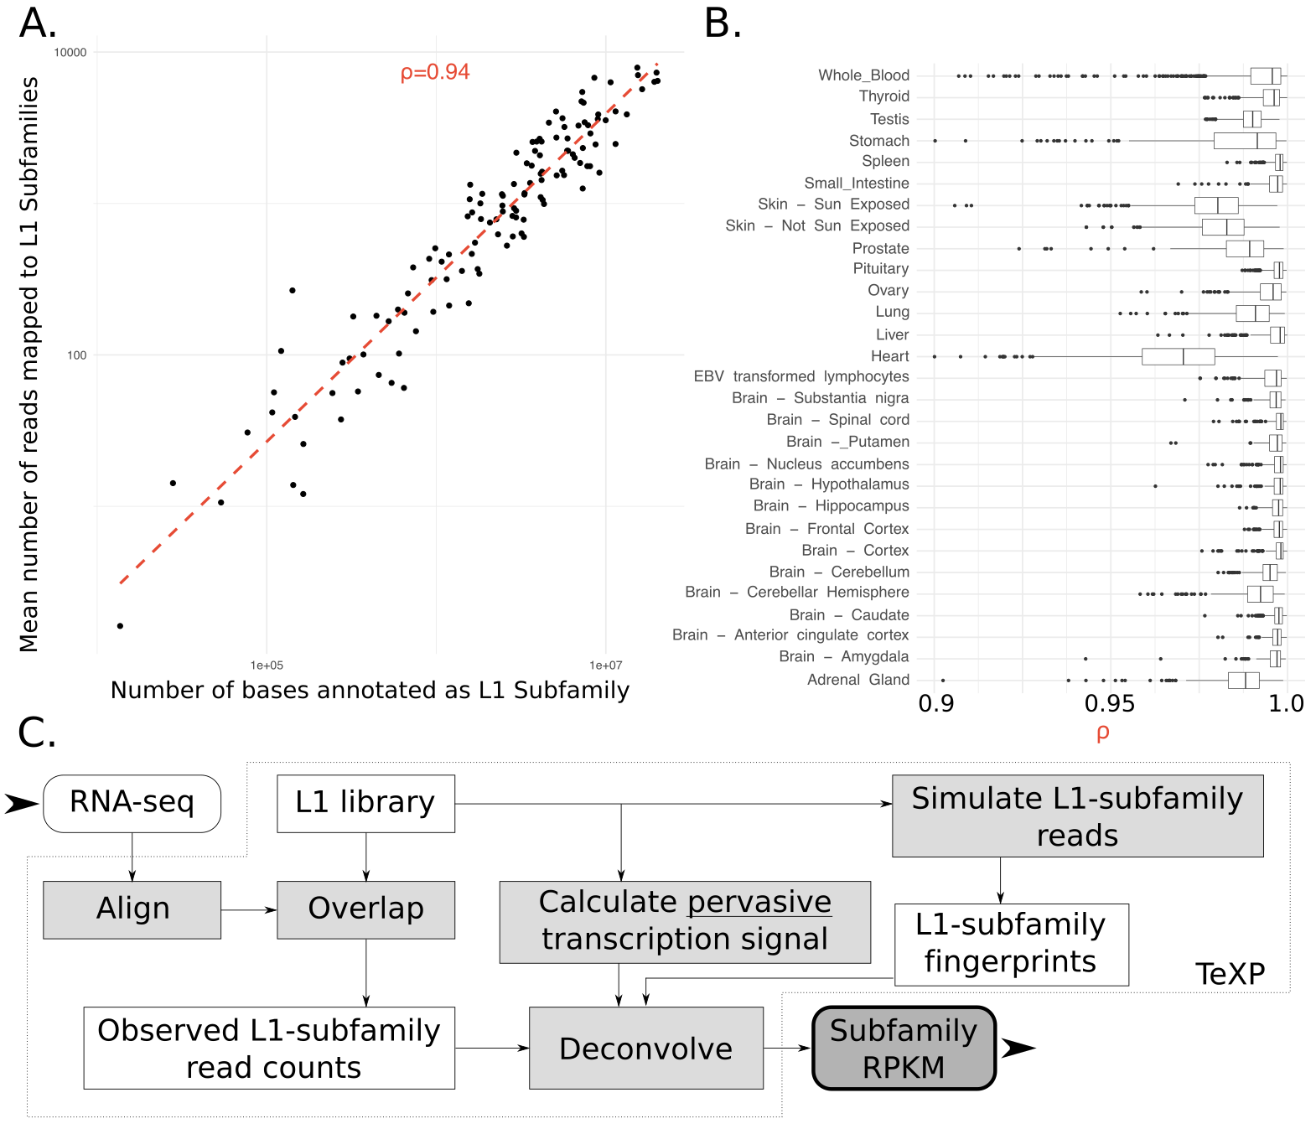

**Figure 1.** Pervasive transcription is a major factor leading to reads mapping to L1 instances and TeXP approach to decouple pervasive transcription from autonomous transcription (A) The number of reads mapped to LINE-1 subfamilies is proportional to the number of bases annotated as the subfamily for most RNA sequencing experiments. (B) Healthy human tissues show varied distributions of the genomic-transcriptomic correlation. (C) TeXP pipeline description.

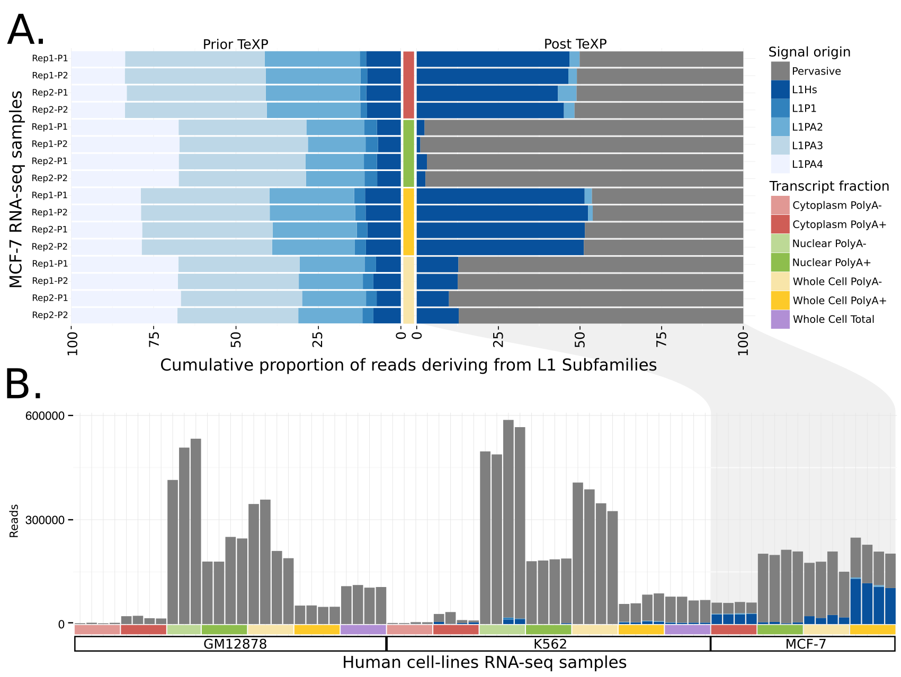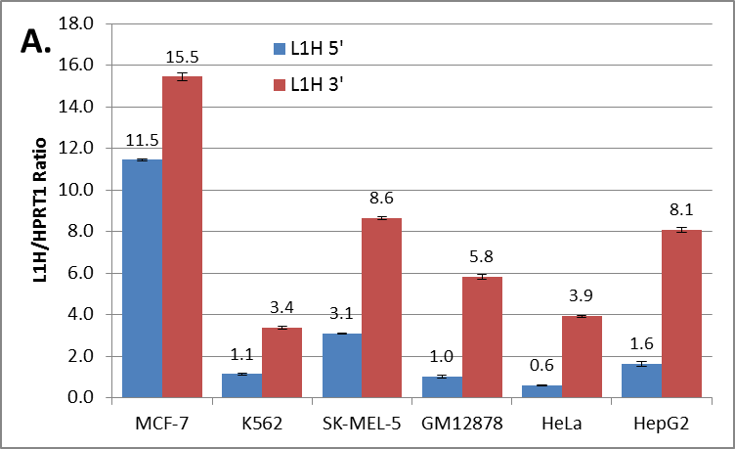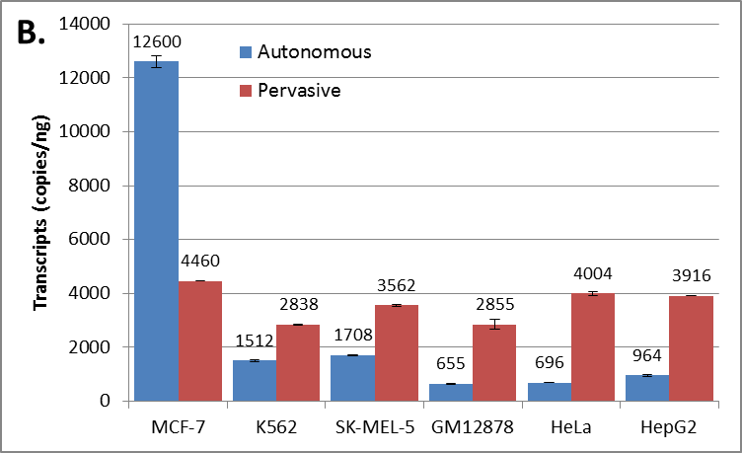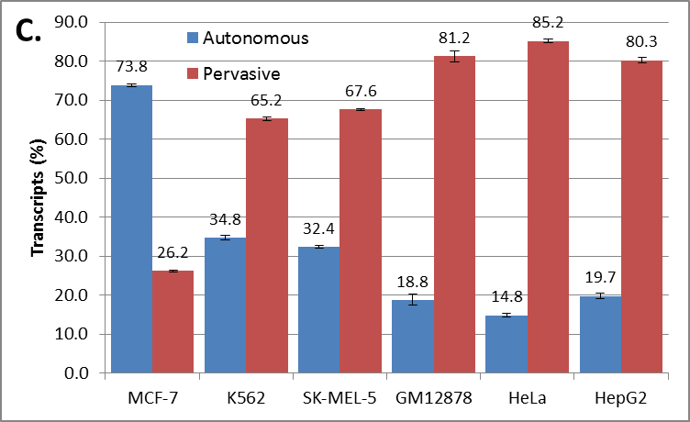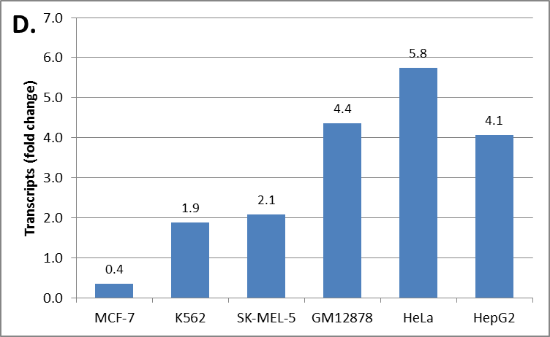

**Figure 2.** Quantification and validation of L1Hs autonomous transcription in human cell-lines. (A) The proportion of reads emanating from pervasive transcription and L1P1, L1PA2, L1PA3, L1PA4, and L1Hs subfamilies in MCF-7 RNA sequencing experiments are shown from the different cell compartments and transcript fractions prior to (left) and after (right) TeXP processing. (B) The absolute number of reads emanating from pervasive transcription and LINE-1 subfamilies are shown across the distinct cell and transcript fractions of the human-derived cell lines GM12878, K-562, and MCF7. Quantification of autonomous and pervasive transcripts of L1H in the cell lines using ddPCR. (**C)** Ratio of L1H 5’ and 3’ transcripts showing the enrichment of the 3’ end of L1H for all cell lines. (**D)** Absolute quantification of autonomous and pervasive transcripts showing higher expression of pervasive transcripts compared to autonomous in all cell lines except MCF-7. (**E)** Percentage of autonomous and pervasive transcription showing a higher expression of pervasive transcripts compared to autonomous in all cell lines except MCF-7. (**F)** Fold change between autonomous and pervasive transcription. Fold changes above 1.0 indicates higher pervasive transcription. Fold changes below 1.0 indicates higher autonomous transcription. The data were run against *HPRT1* 5’ end reference. All data were run in duplicate. All errors bars are mean ± SEM. These data represent two independent experiments.

**Figure 3.** L1Hs autonomous transcription level on human healthy primary tissues. The left panel describes the correlation between L1Hs autonomous transcription and the subject’s age (triangles) and BMI (circles). Significant correlations are colored. The right panel describes the panorama of L1Hs autonomous transcription on different tissues. Each point is an RNA sequencing experiment, separated by tissue of origin.

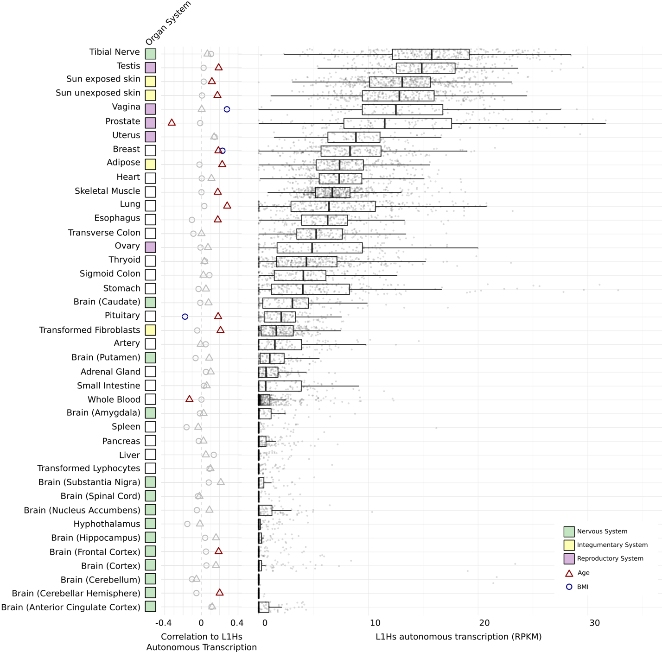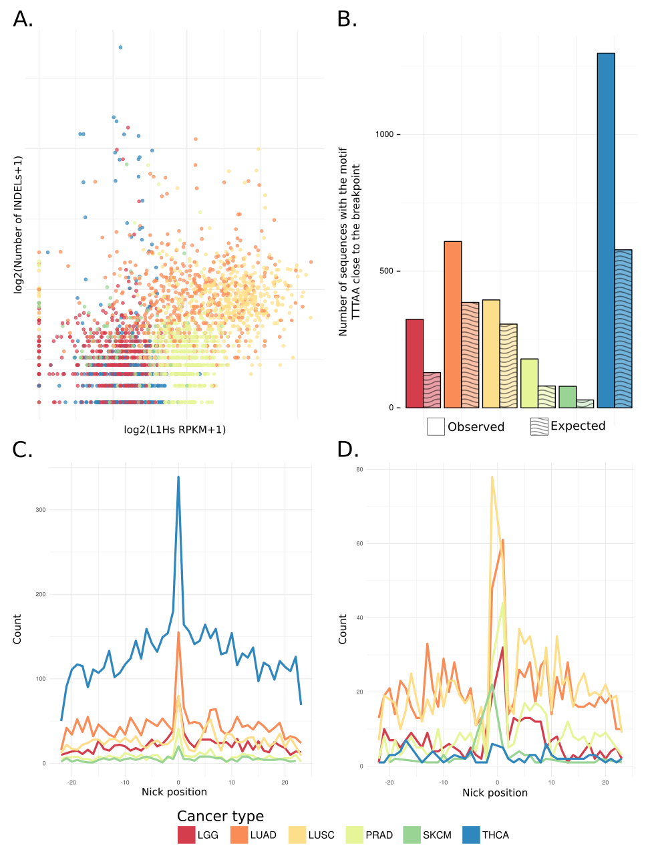

**Figure 4.** L1 Endonuclease contribute to genomic instability and creation of indels. (A) The correlation between L1Hs autonomous expression and the number of indels in tumor samples is shown. (B) An overrepresentation of the TTTAA motif close to (-3|+3nt) indels (dark) is shown compared to null (light). (C) An overrepresentation of the TTT|AA in the indel break point on small insertions is shown. (D) An overrepresentation of the TTT|AA in the indel break point on small deletions is shown.

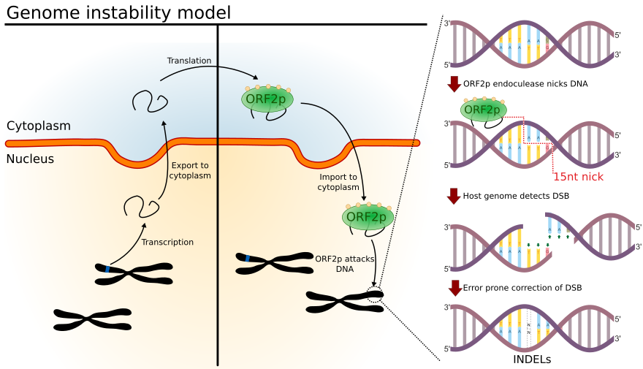

Figure 5. Model for LINE-1 favoring genome instability.