***Experience in non-coding genome annotation.*** Our expertise in non-coding DNA variant annotation stems from our experience analyzing a wide variety of genomic assays. We have developed widely used tools to identify ChIP-Seq peaks \cite{19122651,25292436}, perform RNA-Seq quantification \cite{21134889,22238592}, and identify new non-coding transcripts and categorize them according to function \cite{21177971,25164757}. Our tool to predict enhancer regions has undergone functional validation of its predictions \cite{22950945}. We have further linked enhancers to target genes \cite{25273974} and developed tools to process HiC data \cite{28369339,yan2017mrtadfinder}. In addition to identifying, quantifying, and linking non-coding genomic elements, we have built linear and nonlinear models that use epigenetic signals to predict gene expression \cite{22955978,21926158,21324173}. Moreover, we have extensive experience incorporating genomic data into networks to help explaining gene regulation and to identify key regulators \cite{22955619,25249401,27760135,25884877}.

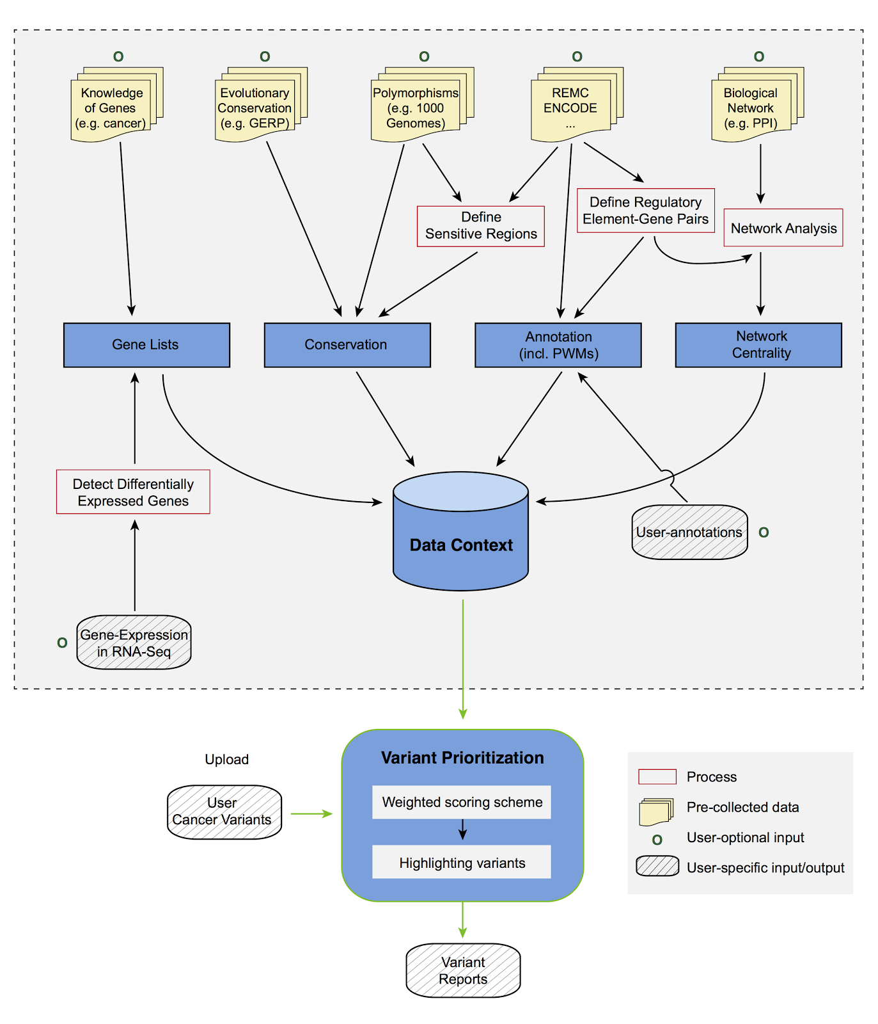

Figure 1. Funseq2 workflow and data context

***Experience in non-coding variant prioritization.*** We have extensively analyzed patterns of variation in non-coding regions and their coding targets \cite{21596777,22955619,22950945}. In recent projects \cite{24092746,25273974}, we integrated multiple methods into a comprehensive prioritization pipeline called FunSeq (**Fig. 1**). The pipeline identifies sensitive regions with annotations under high selective pressure, links non-coding mutations to their target genes, and prioritizes variants based on network connectivity. It also identifies deleterious variants in non-coding elements including TF binding sites, enhancers, and regions corresponding to DNase I hypersensitive sites. Using integrated data from large-scale resources (including ENCODE and 1000 Genomes Project) with cancer genomics data, Funseq can prioritize known TERT promoter driver mutations.

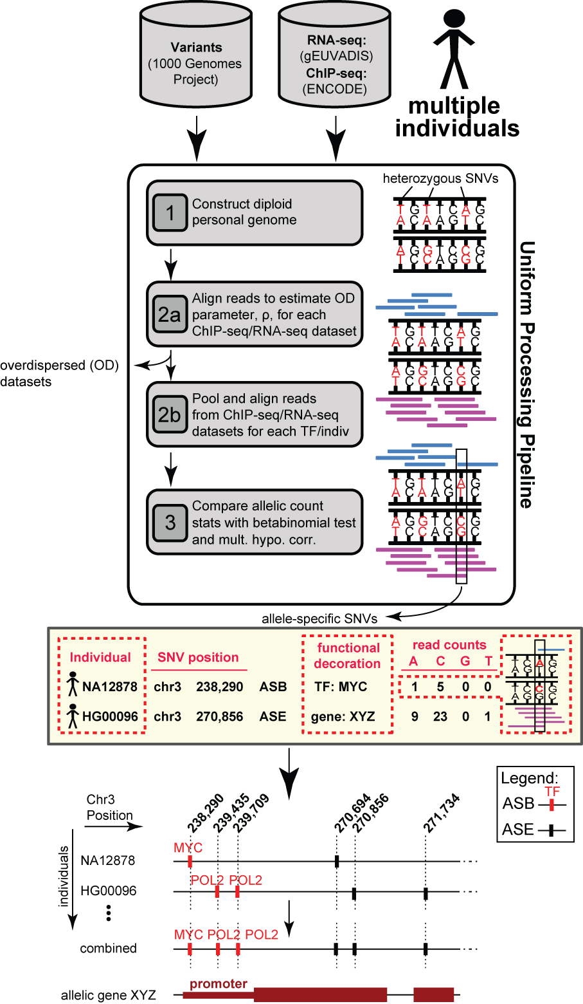

Figure 2. Workflow for generating allele-specific variants and elements

***Experience in allelic analysis.*** Our AlleleSeq pipeline quantifies allele-specific expression \cite{21811232}, which can provide a direct readout of the effects of allele-specific variants (ASVs). We also conducted a study of allele-specific activity from RNA-Seq and ChIP-Seq experiments conducted on 1000 Genomes Project \cite{23128226,27089393} individuals. After uniformly reprocessing all datasets, including ones from the gEUVADIS \cite{24037378} and ENCODE \cite{22955616}, we detected ASVs using a beta-binomial test to correct for overdispersion (**Fig. 2**). We then combined the effects of multiple ASVs to assign allelicity scores to genomic elements, indicating that these elements are sensitive to mutations \cite{27089393}.

***C.1.A.6. Experience in genomics and cancer genomics consortia.*** We have extensive experience in the ENCODE \cite{22955616,22955619,22955620}, modENCODE \cite{25164755,21177976}, 1000 Genomes \cite{20981092,26432246,24092746} and PsychENCODE \cite{26605881} consortia, where we served in a variety of leadership roles (i.e., co-lead of the AWG for modENCODE and leadership of the ENCODE & cancer workgroup).\cite{22955616,25164757,22955619,21177976}.[[add in psychencode marker paper ref]] We also have extensive experience analyzing cancer genomes through our participation in The Cancer Genome Atlas (TCGA) and Pan-cancer Analysis of Whole Genomes (PCAWG) consortium. We participated in the TCGA consortium studies of prostate \cite{26544944} and kidney \cite{26536169} cancers and recently conducted a detailed investigation of the non-coding variants in TCGA kidney papillary cancer samples \cite{28358873}. We have also developed tools for somatic variant calling \cite{26381235}. Currently, we are co-leading the PCAWG group investigating the impact of non-coding mutations.