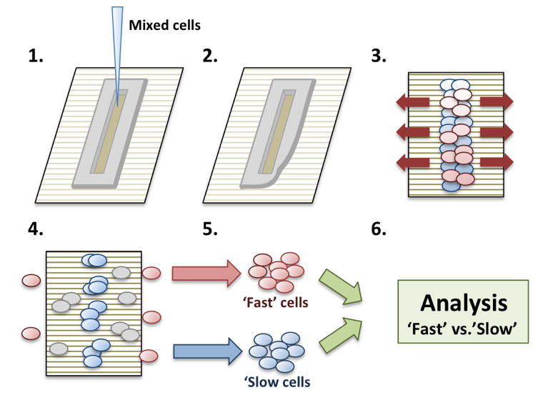
In our work, we will take advantage of collaborative interactions with the NCI-funded P54 Cancer Systems Biology Center at Yale (CaSB@Yale), directed by Prof. Andre Levcheno (see his letter attached). In particular, we will use the service of its Core 2 focused on the CRISPR-based generation of cell and animal cancer models, involving knockin and knockout of pre-determined molecular target. Previously and currently, researchers at the Center have applied in vivo somatic genome editing to generate tumor models of specific driver genes in cell lines and mouse models of different cancers (see Fig. 1 for an example of liver cancer). Cas9 was targeted to cells and animals to generate specific genetic changes that can promote oncogenesis or model other mutations (Xue et al., 2014). Viral delivery enables targeting of almost any tissue, including prostate tissues, constrained by the packaging capacity, which limits the number of sgRNAs, HDR donors, and other elements that will fit within the same vector as Cas9. For example, lentivirus mediated delivery was used to deliver Cas9 in mammalian cells to study cancer (Shalem et al., 2014, Wang et al. 2014, Chen et al. 2015). Adeno-associated viral (AAV) vectors are DNA-based and not prone to recombination, making the expression of multiple U6-sgRNA cassettes feasible. CaSB@Yale generated a Cre-conditional Cas9 mouse model, which facilitates rapid and efficient modeling of single and multi-genic mutations in specific tissue and cell types of interest. In this model, Cas9 is already present and dormant within the genome of all cells, which opens up a larger capacity for delivery of sgRNAs as well as other elements. We have combined this conditional Cas9 mouse with AAV vector-mediated expression of sgRNAs in the lung, and modeled lung cancer using a combination of the Kras oncogene and two tumor suppressor genes, p53 and Lkb1 (Stk11) (Platt et al. 2014). These enable novel viral vector based platforms to study the combinatorial contribution of mutations, defining tumor phenotypes and their evolution in vitro and in vivo.
Figure 2. The steps involved in the RACE based phenotypic filtering phenotypic filtering into relatively highly proliferative and highly migratory cells
The Director of CaSB@Yale, Andre Levchenko, will also participate in the proposed work by contributing the analysis platforms allowing to separate prostate cancer populations into sub-populations of highly migratory and highly proliferative cells. Co-existence of such sub-populations is common, stemming from what is commonly referred to as the ‘go or grow’ phenotypic switch, which can in turn be controlled by various genetic and environmental alterations. In our prior work, we have demonstrated that highly migratory and highly proliferative cells can be separated using anisotropically nanofabricated substrata (ANFS) that closely mimic the fibrous structure of ECM ¹⁸⁻²⁰. This ANFS, in addition to mimicking putative alignment of ECM fibers ²¹, converts cell migration from a 2D random walk to an essentially 1D persistent and unidirectional movement along the direction of nano-fibers – similar to cell migration and alignment observed in sparse 3D ECM (Fig 2A). This similarity of migration on ANFS to 3D cell migration in vivo not only suggests that the analysis is biomimetic and more relevant than the usual Petri dish experimentation, but also provides a convenient way to contrast the migration of differentially perturbed cells against each other. In this proposal, we will develop the initial screening of aggressive melanoma cells. We refer to this first test as the Rapid Analysis of Cell migration Enhancement (RACE).

Figure 3. Partial characterization of the ‘fast’ and ‘slow’ cell sub-populations with the cell population of SK-Mel-28 melanoma cell line.

Experimental design: We will introduce knockin-based perturbations of the top 120 highly scored genetic targets using the CRISPR techiques outlined above and study their effect on cell migration and proliferation using RACE. In our preliminary analysis, as a proof-of –principle, we employed the virally packaged, Doxycycline-inducible short hairpin RNAs (shRNAs) collection. The key aspect of this library, is that the silencing is inducible, and the constructs are barcoded. The cells have been transfected by a pool of shRNAs en-mass and scored for a phenotype of choice, e.g., cell migration and prolfieration. Cells achieving a high or low score can then be assayed for the presence of specific shRNAs by PCR-amplifying it using a set of unique primers. As described in Fig 2, the mixed populations of melanoma cells transduced with different shRNAs are plated on ANFS in a small slit of a poly-(di)-methyl-syloxene (PDMS) stencil. After cell attachment, the stencil is removed, allowing the cells to migrate along the direction of nano-ridges. The silencing of expression of sub-sets of specific genes by the corresponding shRNAs differentially affects cell movement or proliferation, so that the RACE results in cells ‘racing’ with different values of speed and persistence along the direction specified by the ANFS. After 1 week of RACE, we harvest the 1/3 of the ANFS area where cells were originally seeded (‘slow group’, high prolifeation) and the most distant 1/3 from the area of cell seeding (‘fast group’; high migration). The cells from the ‘fast’ and ‘slow’ groups are re-seeded separately and the RACE assay is repeated three times to enrich the ‘fast’ and ‘slow’ populations through sequential ‘racing’ periods. Finally, the cells were harvested, and the shRNA sequences were PCR-amplified to determine the genes whose silencing affected the phenotype. As a result, we can determine the role of silenced genes in driving cell migration/proliferation and thus potentially the propensity of cancera cells to initiate invasion and metastasis. Importantly, we have shown that this assay selects cells not only for increased migration but also for other characteristics (signaling, stem-ness, metabolic control, etc.) (a sample of the results in a melanoma cell line is shown in Fig 3).

