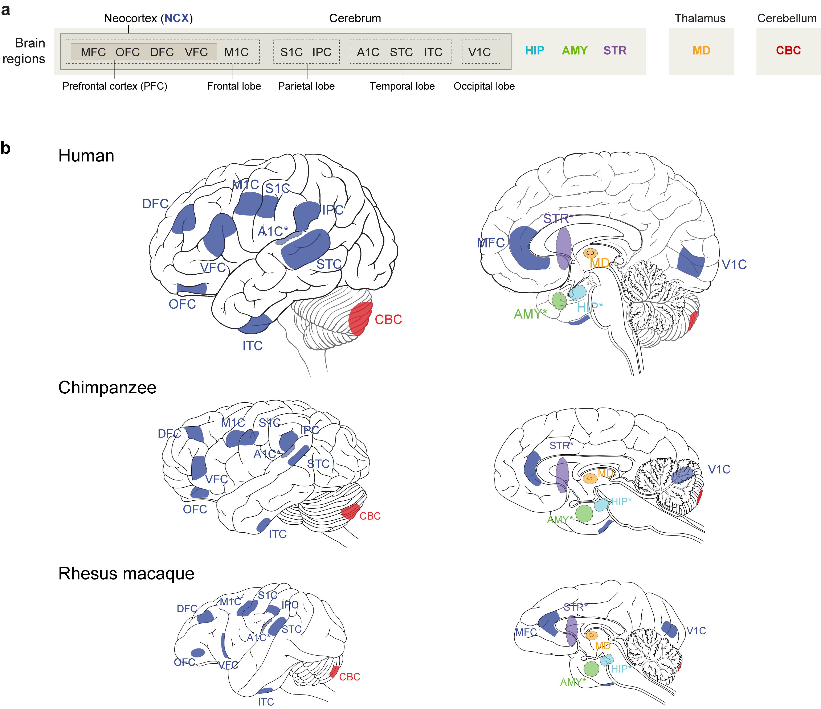

**Extended Data Figure 1 | Demarcation of brain regions and neocortical regions/areas areas of human, chimpanzee, and rhesus macaque. a**, Schematic representing the sampled regions from each brain lobe and non-cortical structures. **b**, Schematic shows anatomical positions of dissections of brain samples in human, chimpanzee, and macaque. OFC – orbital prefrontal cortex; DFC – dorsolateral prefrontal cortex; VFC – ventrolateral prefrontal cortex; MFC – medial prefrontral cortex; M1C – primary motor cortex; S1C – primary somatosensory cortex; IPC – inferior posterior parietal cortex; A1C – primary auditory cortex; STC – superior temporal cortex; ITC – inferior temporal cortex; V1C – primary visual cortex; HIP – hippocampus; AMY – amygdala; STR – striatum; MD – mediodorsal nucleus of the thalamus; CBC – cerebellar cortex. Asterisks denote structures that are internal and not visible from the view shown.

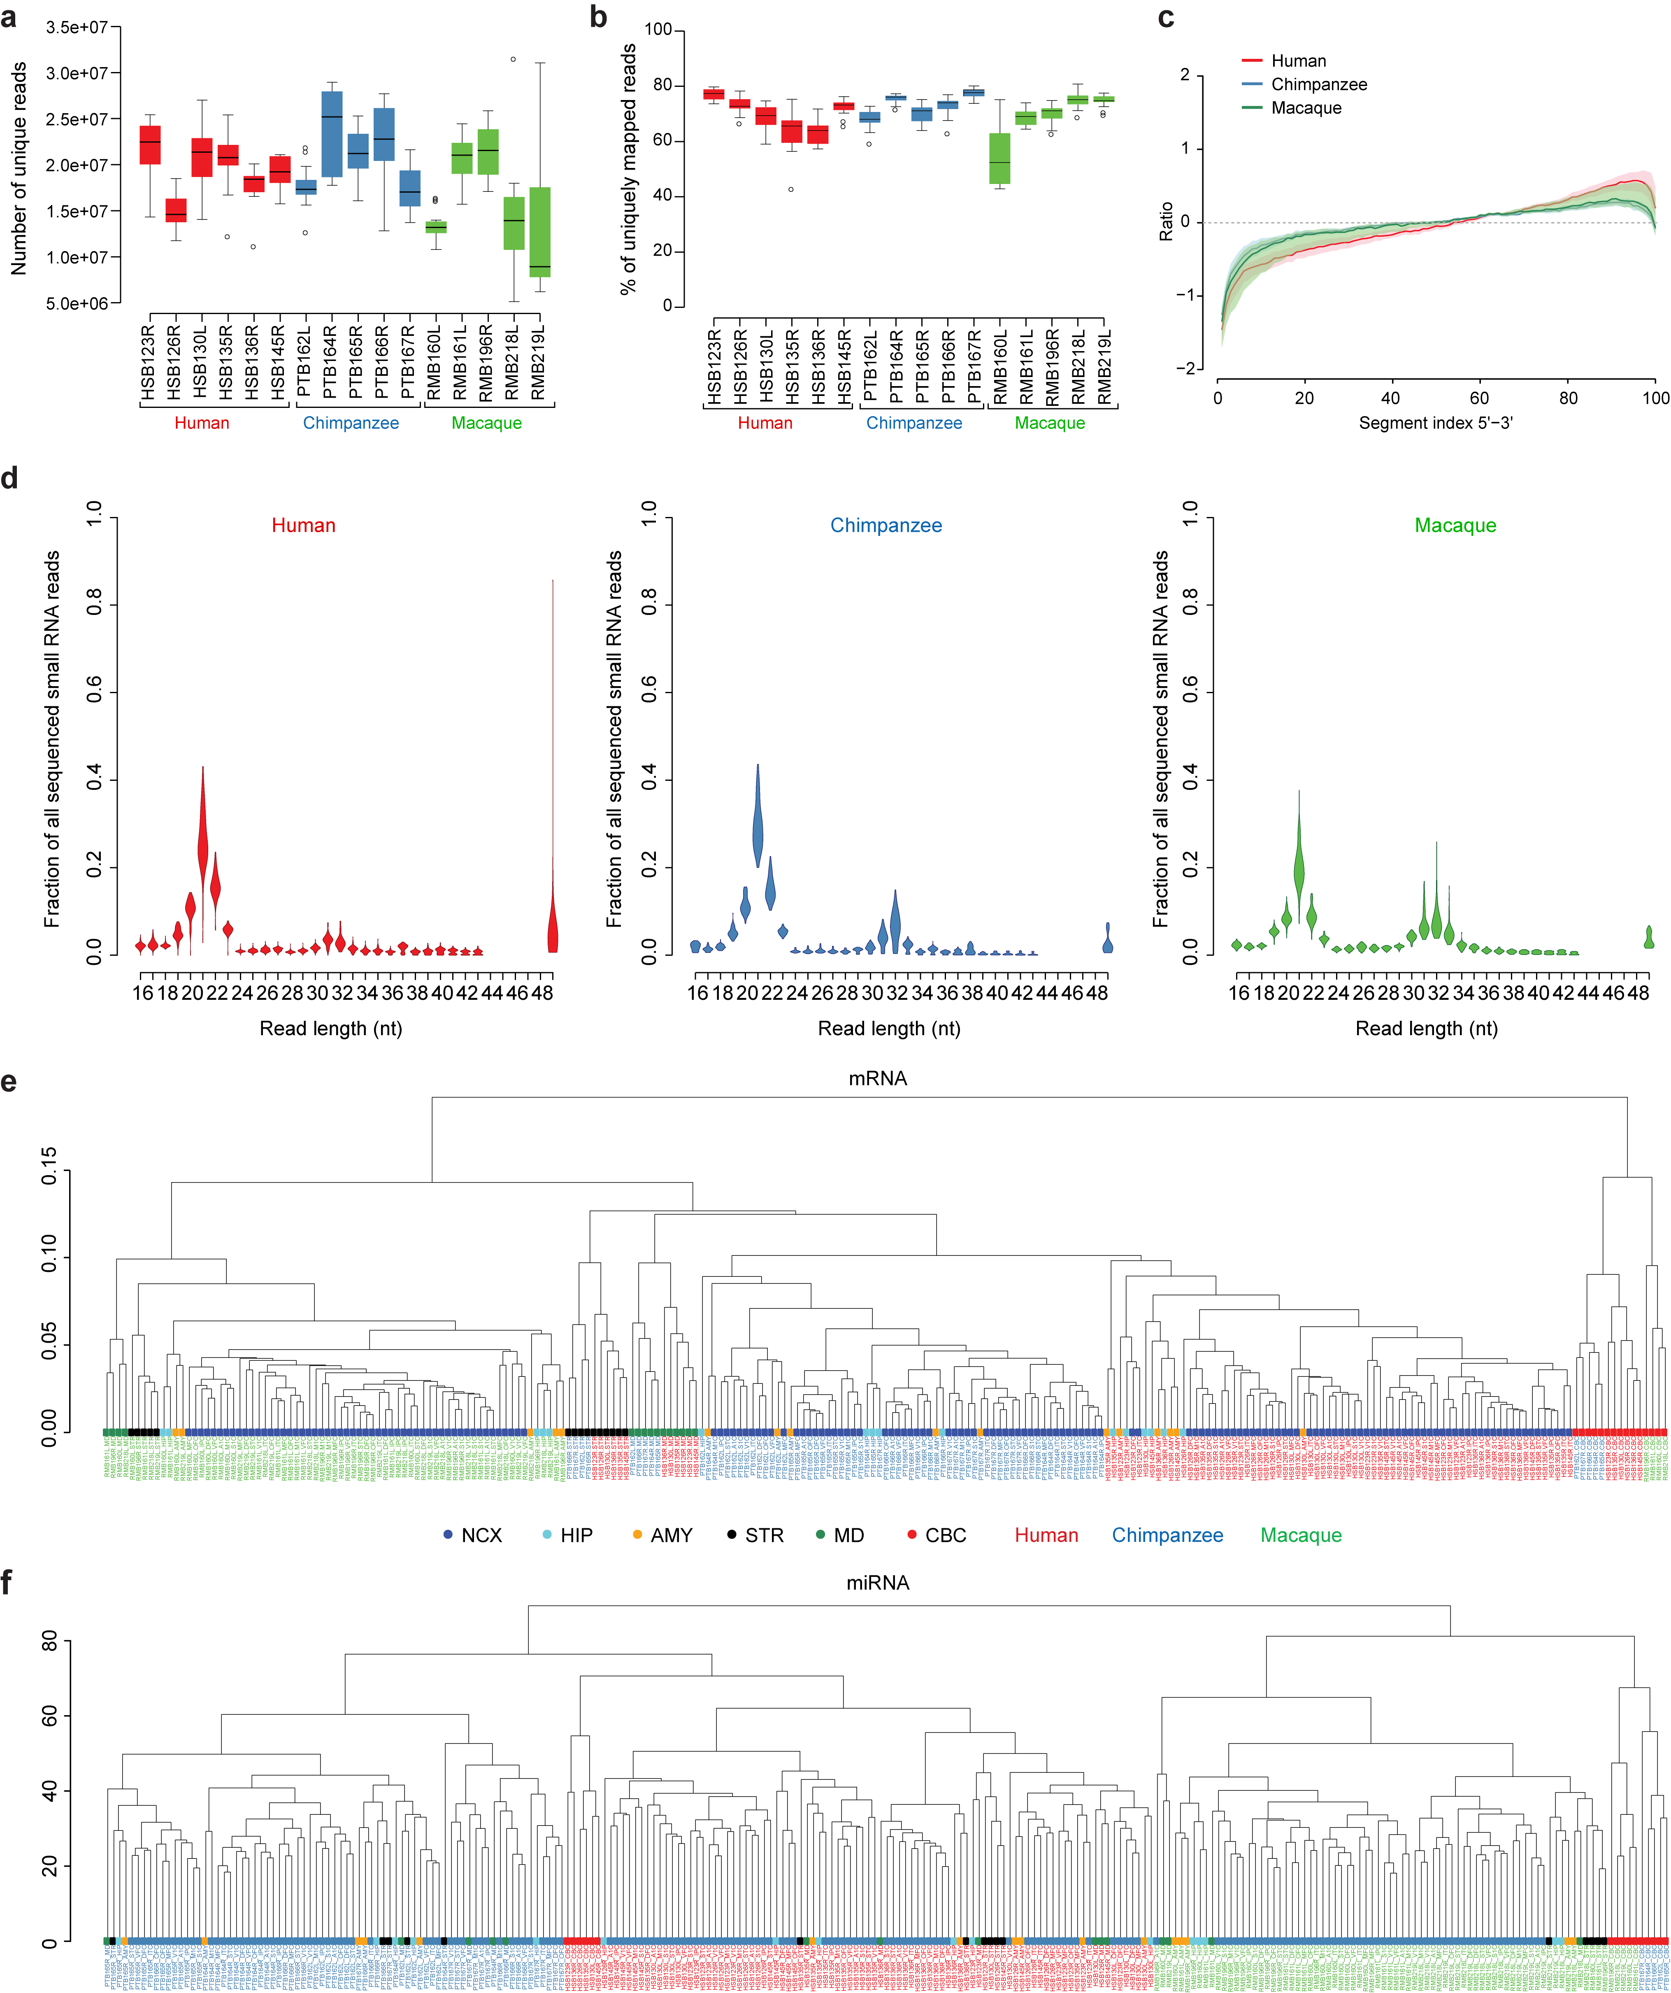

**Extended Data Figure 2 | Data quality control and hierarchical clustering of samples. a,** The number of reads that are uniquely mapped to the reference genome. **b,** The percentage of total reads that are uniquely mapped. Red: human; blue: chimpanzee; green: macaque. The boxes represent quartiles of the data and the whiskers represent 1.5 times interquartile range. **c,** Sequence coverage uniformity. All genes with more than 1000 nucleotides mapped were evenly divided into 100 segments from 5’ to 3’ end. The percentage of nucleotides (PN) mapped to each segment was calculated as the number of nucleotides in each segment divided by the total number of nucleotides mapped to the whole gene. The median of segmental PN for all genes was calculated to represent segmental PN of each sample. The median (solid line) and upper and lower quartiles (dash lines) of sample segmental PN were then plotted. **d,** The size distribution of small RNA reads obtained for each species. Distributions represent variability between samples. Reads between 20-22nt in length are most abundant, which suggests excellent enrichment for miRNAs. **e, f,** Hierarchical clustering of **e,** mRNA and **f,** miRNA samples. The nodes are colored by brain region and the sample names are colored by species. **e,** The hierarchical cluster first separates cerebellum samples from other samples, and then separates samples by species. The human samples and chimpanzee samples form a large cluster, which is separated from rhesus macaque samples. **f,** miRNA samples are clustered by species and macaque samples are in a different cluster from human and chimpanzee samples. Chimpanzee and macaque, but not human, CBC samples are clustered together.

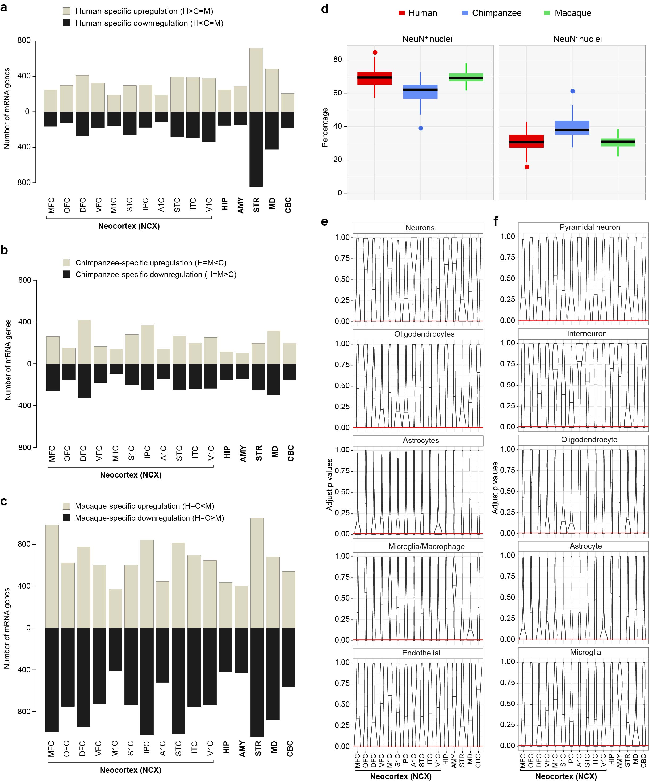

**Extended Data Figure 3 | Species-specific differential expression**

**a**, The number of human-specific upregulated (tan) and downregulated (black) genes in each brain region. The region with more human-specific DEX is STR, while the region with smallest number of human-specific DEX is A1C. **b**, The number of chimpanzee-specific upregulated (tan) and downregulated (black) genes in each brain region. The region with more chimpanzee-specific DEX is DFC, while the region with smallest number of chimpanzee-specific DEX is M1C. **c**, The number of macaque-specific upregulated (tan) and downregulated (black) genes in each brain region. STR is the region with more macaque-specific DEX; M1C has the lowest number of macaque-specific DEX genes. **d,** Boxplot representing the estimated percentage of NeuN+ and NeuN- cells in the tissue samples. **e, f**, The top 100 genes enriched in each cell type were selected using **e**, sorted-cell27 or **f,** single-cell RNA-seq24 of human neocortical cells. The violin plots represent the distribution of adjusted p values (FDR) of cell-type enriched genes in cross-species DEX analyses. The segments in the middle denote the median. The red line shows the cutoff for significance (FDR < 0.01). Although the inferred percentage suggests a lower Neu(+) cells in chimpanzee brains, the majority of the cell-type enriched genes are not inter-species DEX genes. This is consistent with the cell-type enrichment patterns in Figure 2a, where 27 out of 36 inter-species DEX modules show no cell type-specific enrichment, indicating that the inter-species DEX genes identified in our study are not due to global bias of cellular composition.

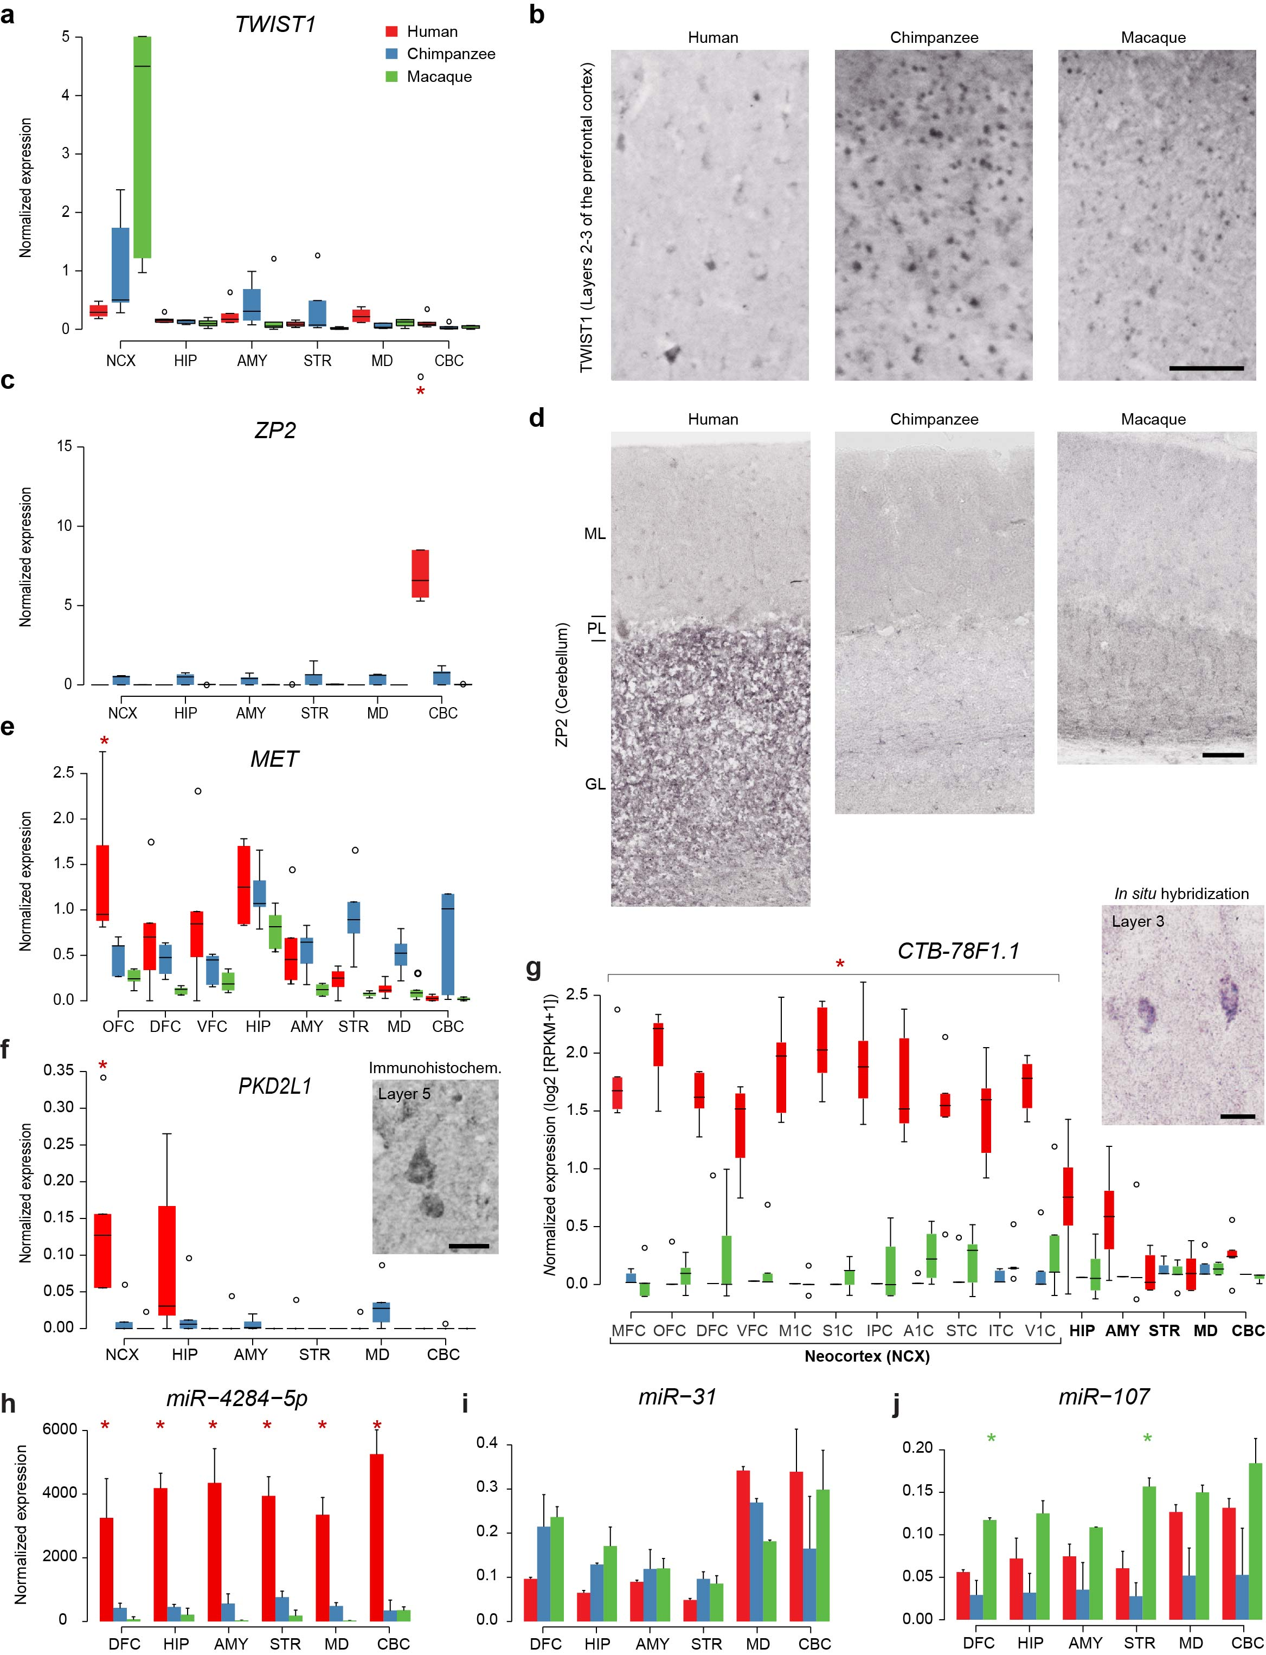

**Extended Data Figure 4 | ddPCR and IHC validation of human-specific DEX genes and select miRNAs. a,** ddPCR validation of *TWIST1* expression shows this gene is upregulated in the NCX of macaques and chimpanzees, when compared with humans. The boxes represent quartiles of the data and the whiskers represent 1.5 times interquartile range. **b,** Immunohistochemical detection using α**-**TWIST1 antibody shows that this protein is expressed in pyramidal cells of the neocortical plate, especially in neocortical layers 2 and 3. A small number of human and chimpanzee DCF pyramidal cells exhibited cytoplasmic staining. Scale bar represents 100 μm. **c,** ddPCR validation of *ZP2* expression shows this gene is upregulated in the CBC of humans. The boxes represent quartiles of the data and the whiskers represent 1.5 times interquartile range. **d**, Immunohistochemical detection using α**-**ZP2 antibody shows that ZP2 is expressed in granular cells of the human cerebellar cortex granular layer, but not in chimpanzee or macaque cerebellar cortices. A small number of human and chimpanzee Purkinje cells were also immunopositive. ML – Molecular layer; PL – Purkinje layer; GL – Granular layer. Scale bar represents 100 μm. **e,** ddPCR validation of *MET* expression shows this gene is upregulated in the prefrontal cortex of humans, especially in the orbital prefrontal cortex (OFC). The boxes represent quartiles of the data and the whiskers represent 1.5 times interquartile range. **f**, ddPCR validation of *PKD2L1* expression shows this gene is upregulated in the human neocortex. The boxes represent quartiles of the data and the whiskers represent 1.5 times interquartile range. Immunohistochemical detection using α**-**PKD2L1 antibody shows that PKD2L1 is expressed in deep-layer pyramidal cells of the human NCX. **g,** Expression profile of *CTB-78F1.1* shows species-specific upregulation in the human NCX. In situ hybridization of *CTB-78F1.1* shows that this lncRNA is expressed in upper-layer cells of the human NCX. Analysis of single-cell RNA-seq23 data confirmed that this gene is expressed in SATB2+ upper-layer excitatory neurons. Scale bar represents 10 μm. **h– i,** ddPCR validation of **h,** miR-4284-5p, **i,** miR-31, and **j,** miR-107 expression. Error bars represent standard deviation. In all ddPCR plots, asterisks represent species-specific expression (Tukey's honest significance test p < 0.05 comparing other species). Human-specific is in red and macaque-specific is in green.

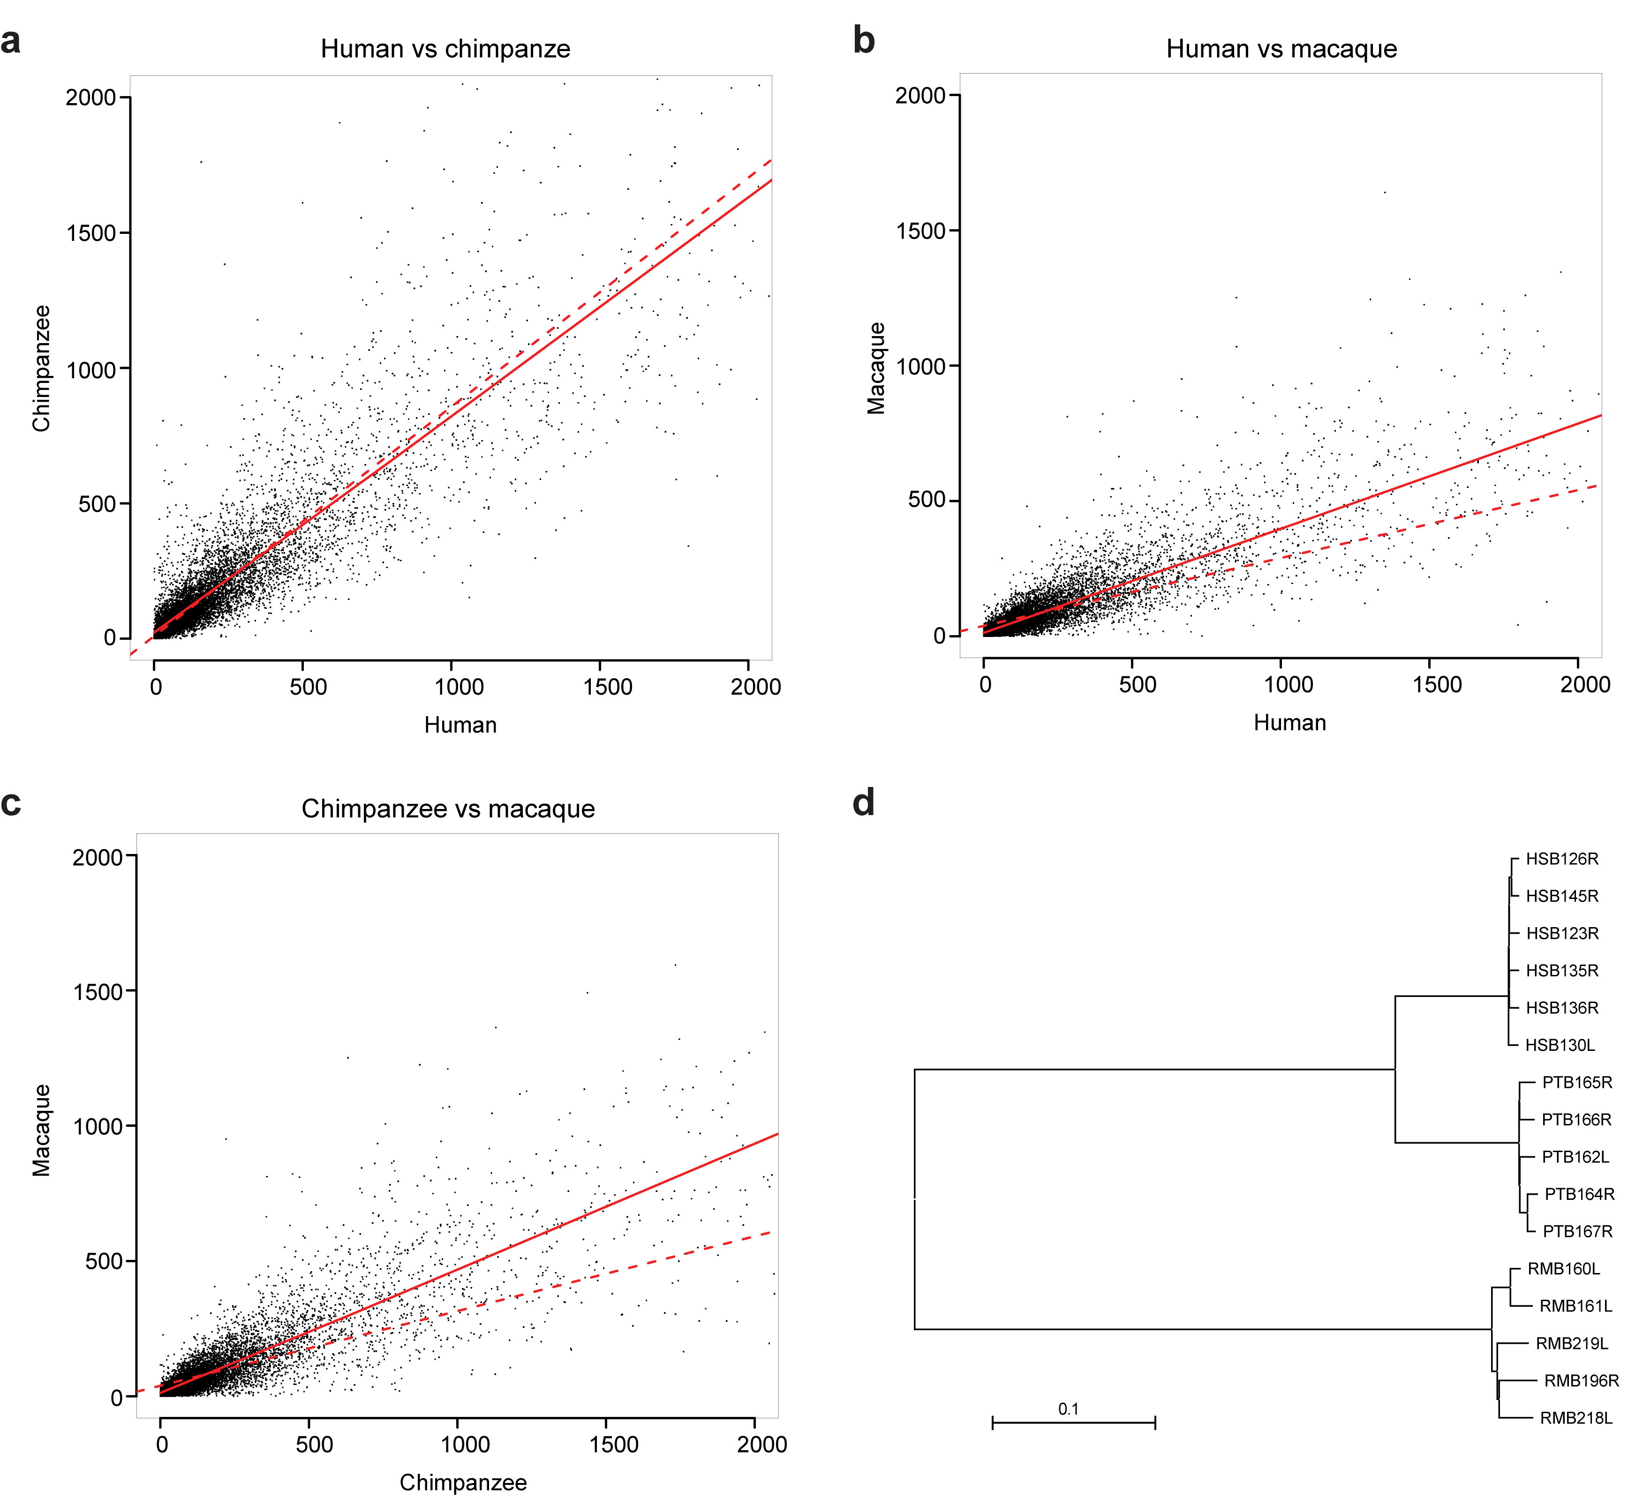

**Extended Data Figure 5 | Within-region variation in intra-species differential expression analysis and species neighbor-joining tree.**

**a-c,** For each species, we calculated the mean within-region variation of normalized counts across 16 brain regions and plotted it in square-root scale. **a,** Human and chimpanzee samples show similar within-region variation, while macaque samples show smaller within-region variation, compared with **b,** human and **c,** chimpanzee samples. The solid line displays locally weighted polynomial regression and the dash line displays linear regression of the data. **d,** Neighbor joining tree from the distance matrix obtained after the SNP calling. As expected, the regions cluster by species with no related individual detected. The distance is defined as the average number of positions in which two individuals have a different base over the total number of variable sites.



**Extended Data Figure 6 | Transcriptional architecture of the adult human, chimpanzee, and macaque brains.** Heat maps representing the unsupervised hierarchical clustering of brain regions of **a, b,** human, **c, d,** chimpanzee, and **e, f,** macaque based on expression correlations, using the union of regional DEX genes in each species. Colors represent Pearson correlation between all pairs of brain regions in each species. The lower left half of each heat map shows mRNA correlations, while corresponding miRNA values are plotted in the upper right. Clustering was performed relative to only the mRNA expression data; miRNA row and column ordering was adjusted accordingly for each species. Approximately unbiased (AU) p-values and bootstrap probability (BP) values are labeled in red and green, respectively, for **b,** human, **d,** chimpanzee, and **f,** macaque.

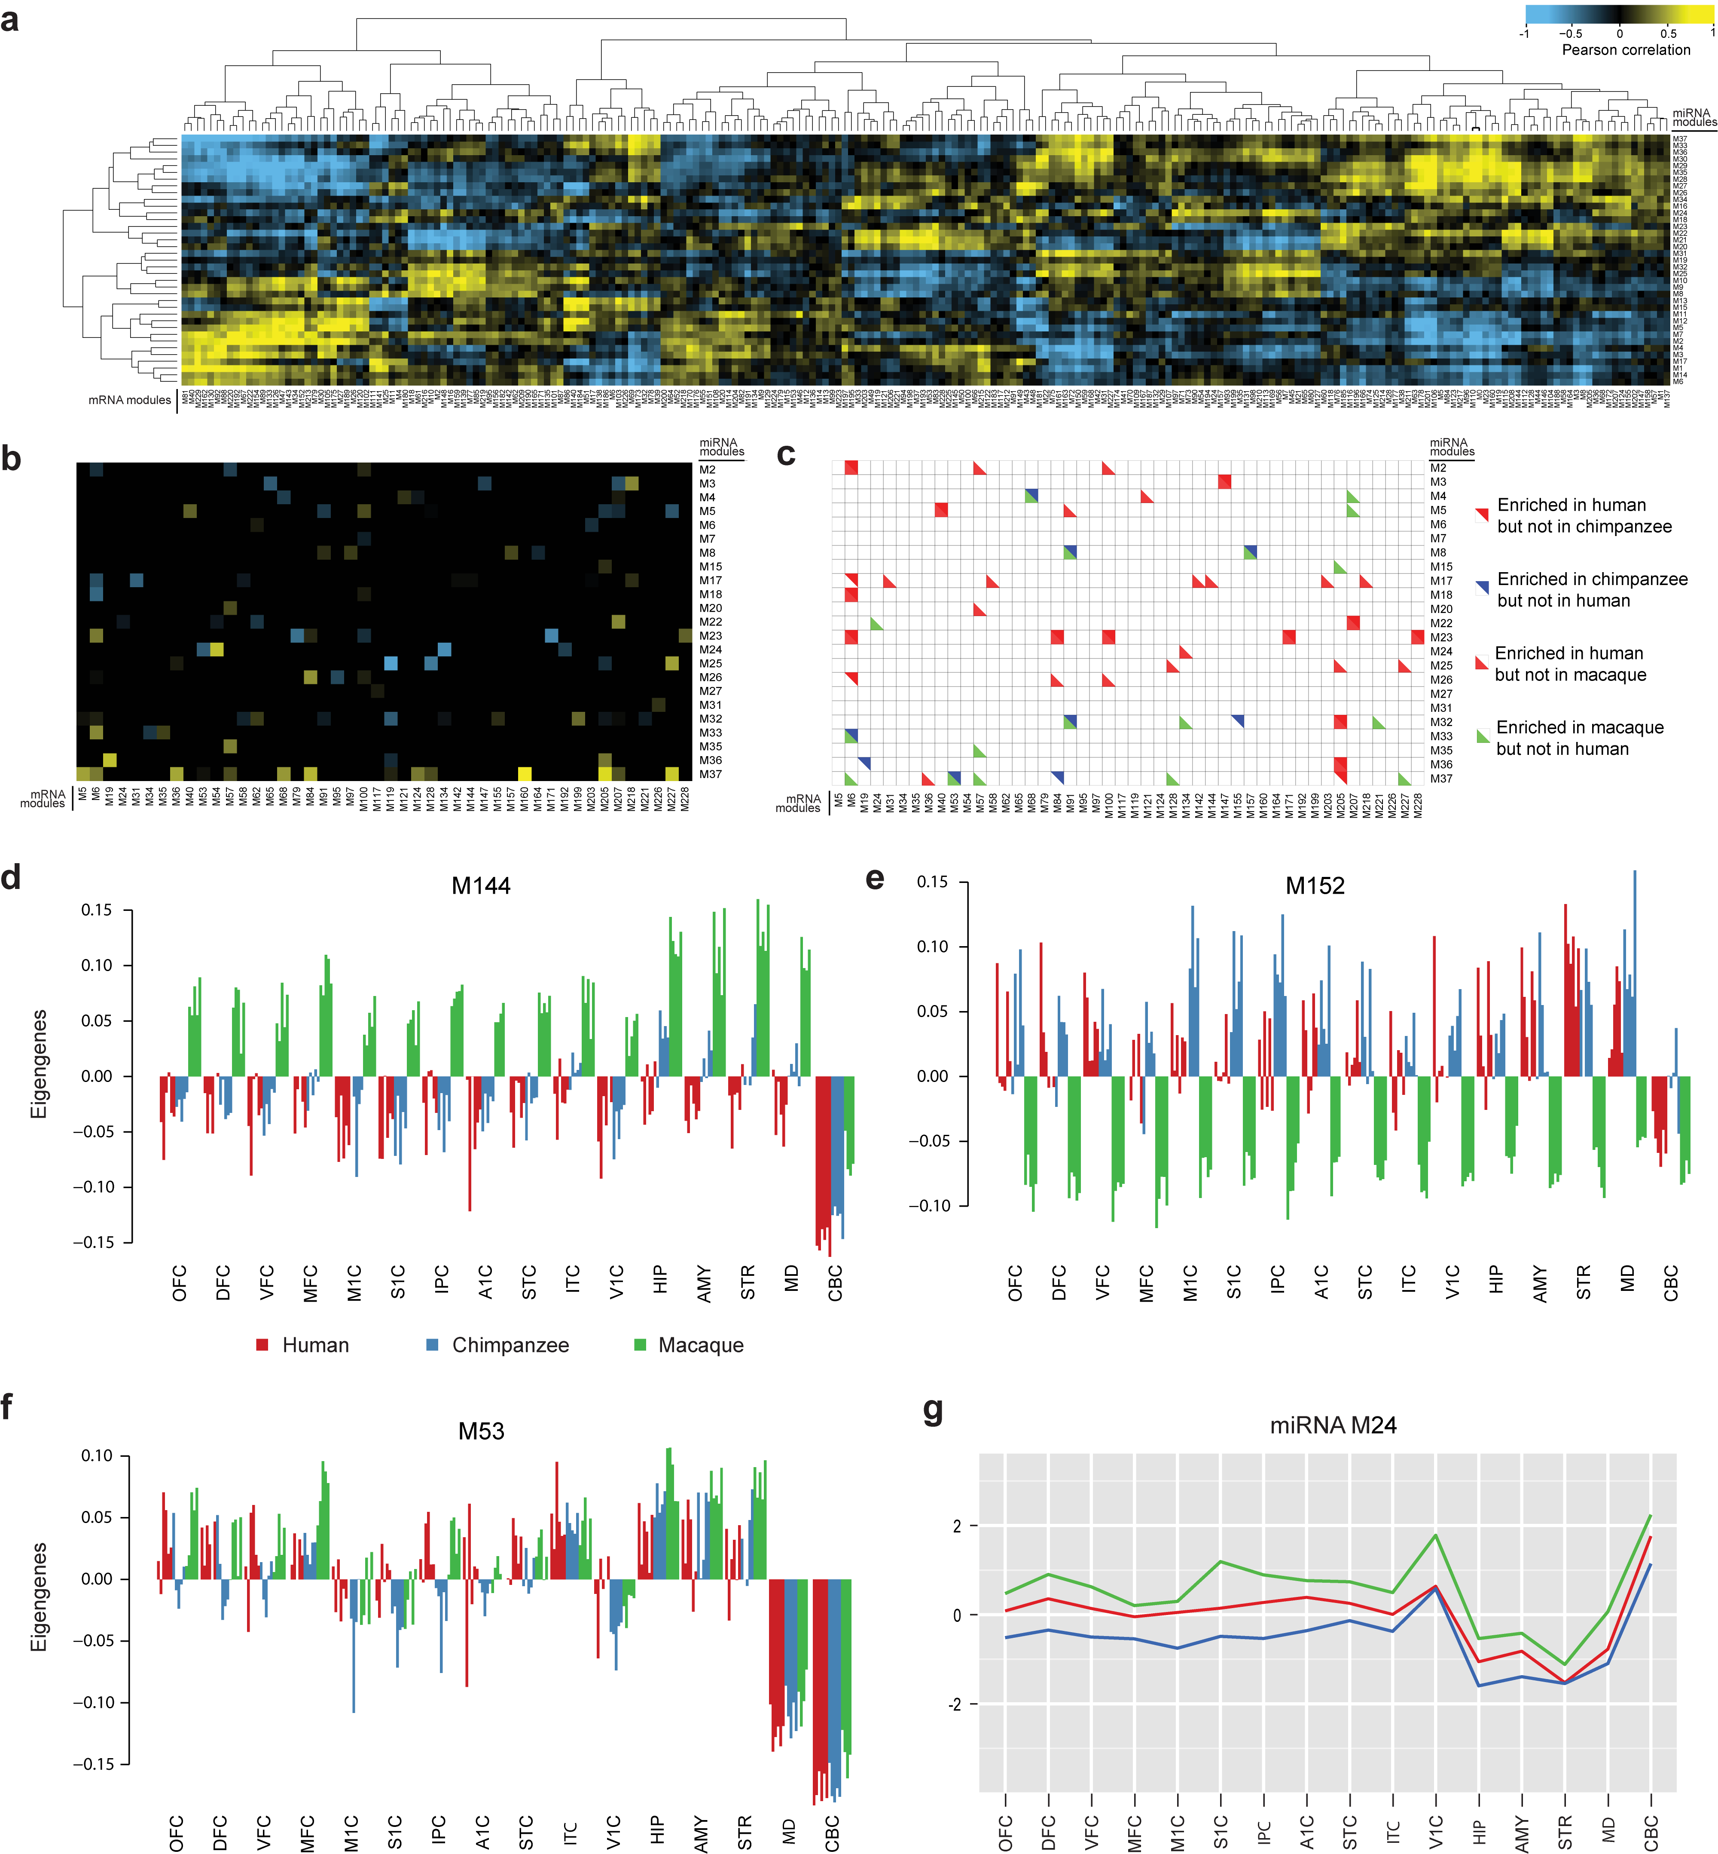

**Extended Data Figure 7 | Cell-type enrichment of co-expression modules and HiTS-CLIP filtering of miRNA/mRNA intersection. a,** Pearson correlation of all pairs of miRNA modules (rows) and mRNA modules (columns); yellow represents strong positive correlation and blue corresponds strong negative correlation. **b,** Pearson correlation of only those miRNA-mRNA cluster pairs with a significant enrichment of HiTS-CLIP targets; correlation colour scheme is the same as **a**. **c,** miRNA and mRNA module pairs that exhibit species-specific enrichment of miRNA-mRNA target pairs as defined by HiTS-CLIP; red triangles/squares highlight significant enrichment in human but not chimpanzee and/or macaque, blue represents enrichment in chimpanzee but not human, and green represents enrichment in macaque but not human. **d, e,** Bar plots showing the spatial expression pattern of eigengenes of modules 144 and 152. **f**, Bar plot showing the spatial expression of eigengene of module 53**. g**, Plot depicting the expression profile of miRNA module 24. These two modules (M53 and miRNA M24) have opposite expression profiles and are enriched for HiTS-CLIP miRNA-mRNA target pairs.

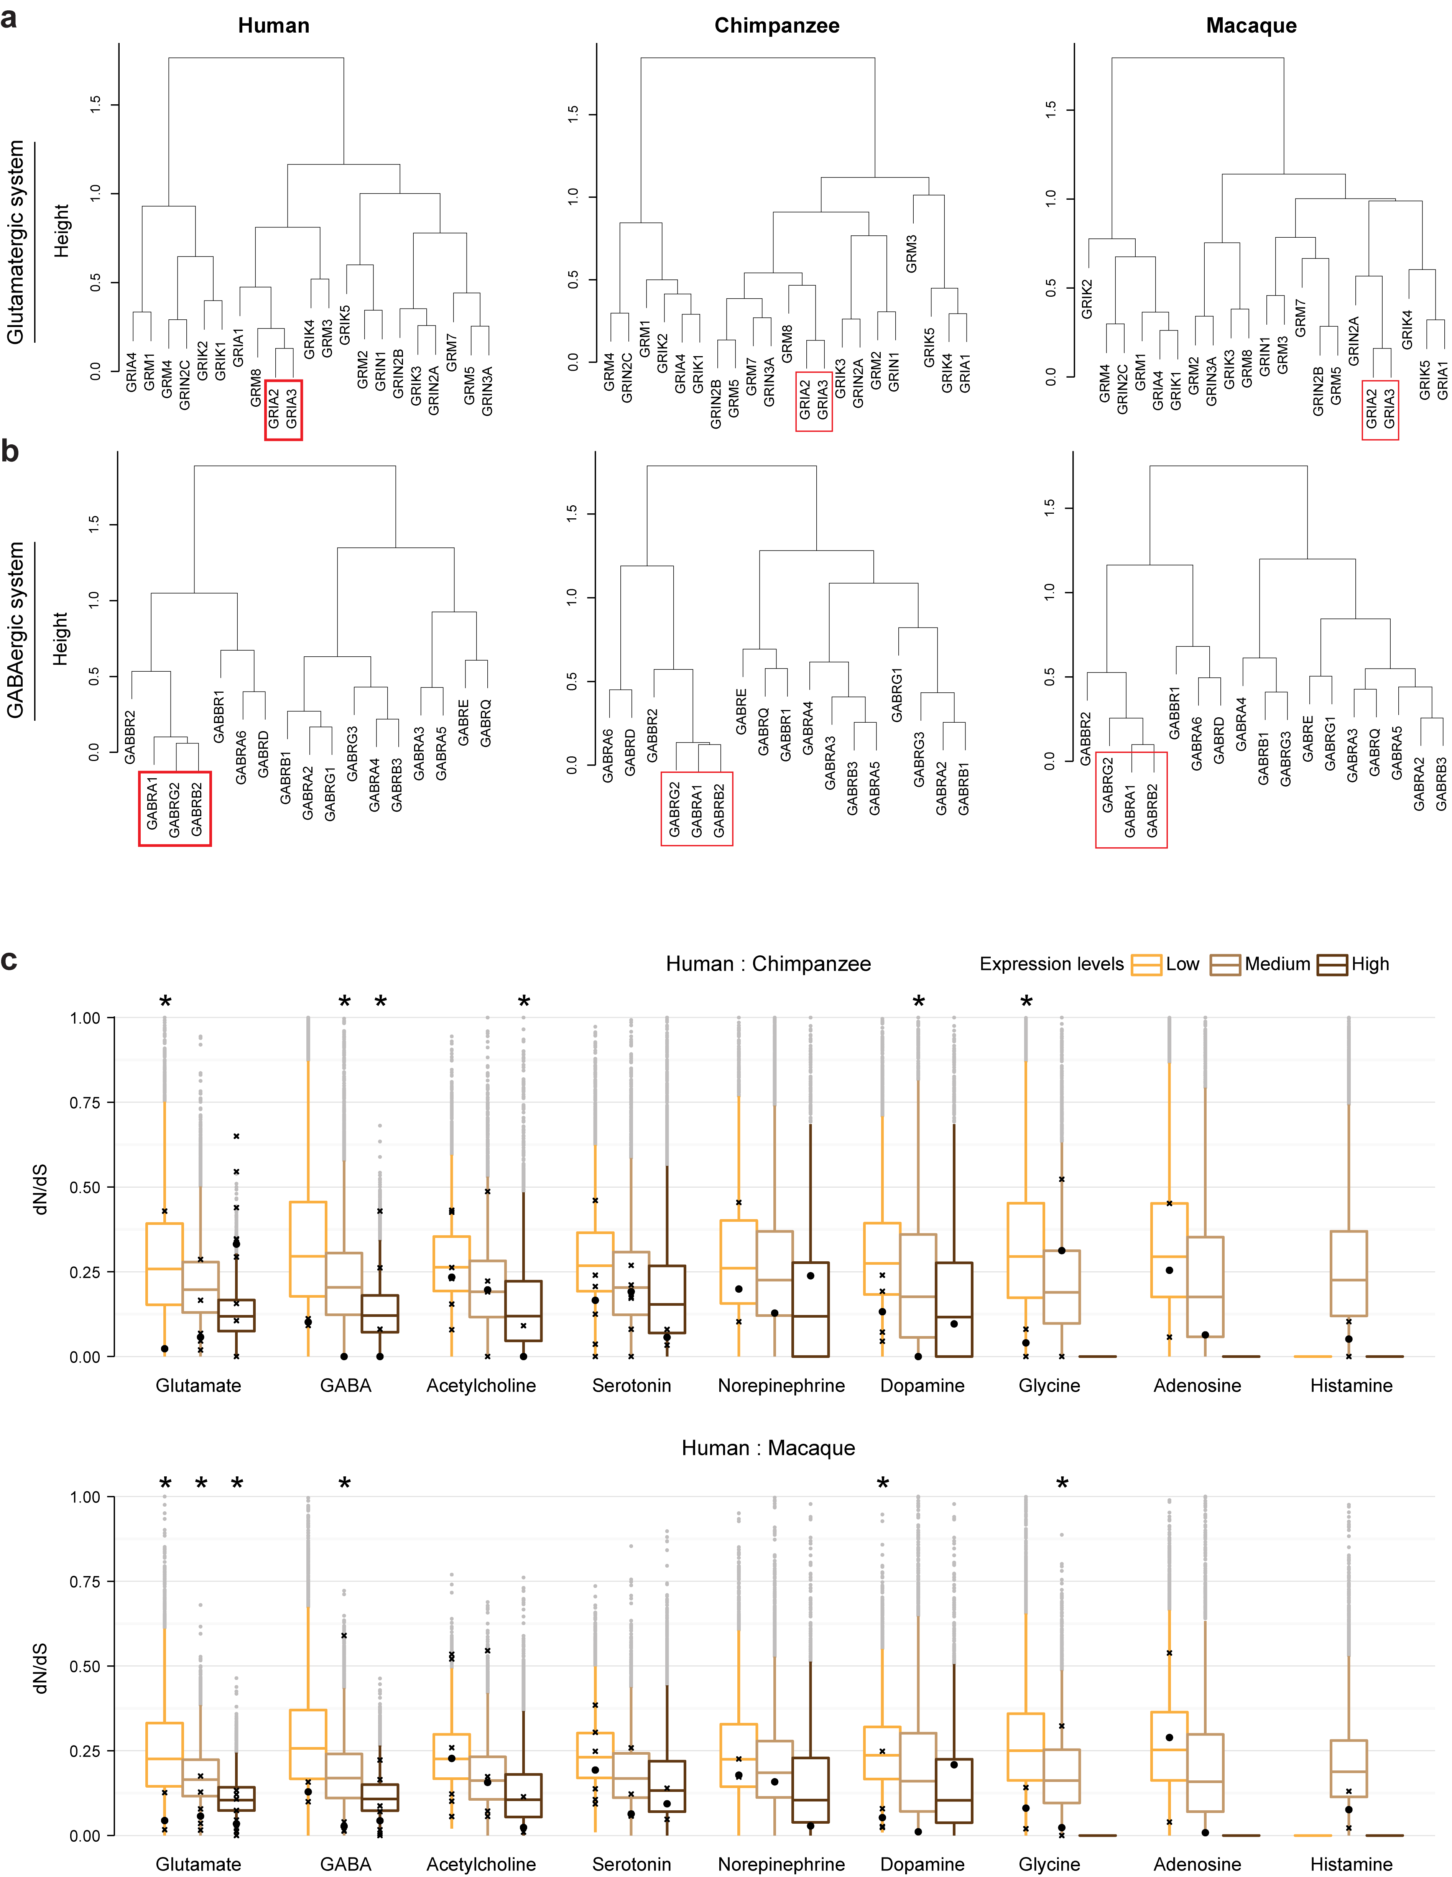

**Extended Data Figure 8 | Hierarchical clustering of genes encoding GABA and glutamate receptors’ subunits. a,** Hierarchical clustering of genes encoding glutamate receptors. The co-expression of GRIA2 and GRIA3 (red box), subunits of AMPA receptors, is conserved across species. **b,** Hierarchical clustering of genes encoding GABA receptors. The co-expression of GABRA1, GABRG2 and GABRB2 (red box), which represent the most common assembly of GABAA receptors (α1β2γ2), is conserved across species. **c,** Genes encoding glutamate and GABA receptor subunits are more conserved than randomly selected genes with similar expression levels. Furthermore, some genes encoding some acetylcholine, dopamine, or glycine receptors are more conserved than background, as well. Genes were categorized based on their expression level. Low: gene RPKM $≤$ median RPKM–1*sd(RPKM); medium: median RPKM-1*sd(RPKM) < gene RPKM < median RPKM+1*sd(RPKM); high: gene RPKM $≥$ median RPKM+1*sd(RPKM). The boxplot shows the distribution of dN/dS for 10,000 randomly selected genes. Receptors are labeled as crosses and the median value of receptors is plotted as a round point. Stars label significance (*P* < 0.05).



**Extended Data Figure 9 | *TH* expression in an independent primate dataset and expression pattern of genes involved in dopamine degradation and dopamine receptors. a,** The expression of *TH* constitutive aligned exons in 6 primates, according to a published data set18. The expression levels are indicated as log2-transformed RPKM. **b, c,** The expression of genes encoding dopamine degradation enzymes is not significantly differentially expressed across species in RNA-seq. Gene expression levels were calculated as log2(RPKM+1). **d,** The expression of dopamine beta-hydroxylase (*DBH*), an enzyme that uses dopamine as substrate, does not show significant differences among species. **e – h,** Genes encoding DRD1, DRD2 and DRD3 are downregulated in the human striatum. No significant differential expression of DRD4 was observed. Gene expression levels were calculated as log2(RPKM+1). The boxes represent quartiles of the data and the whiskers represent 1.5 times interquartile range. Red asterisks labels human-specific expression (see Methods).

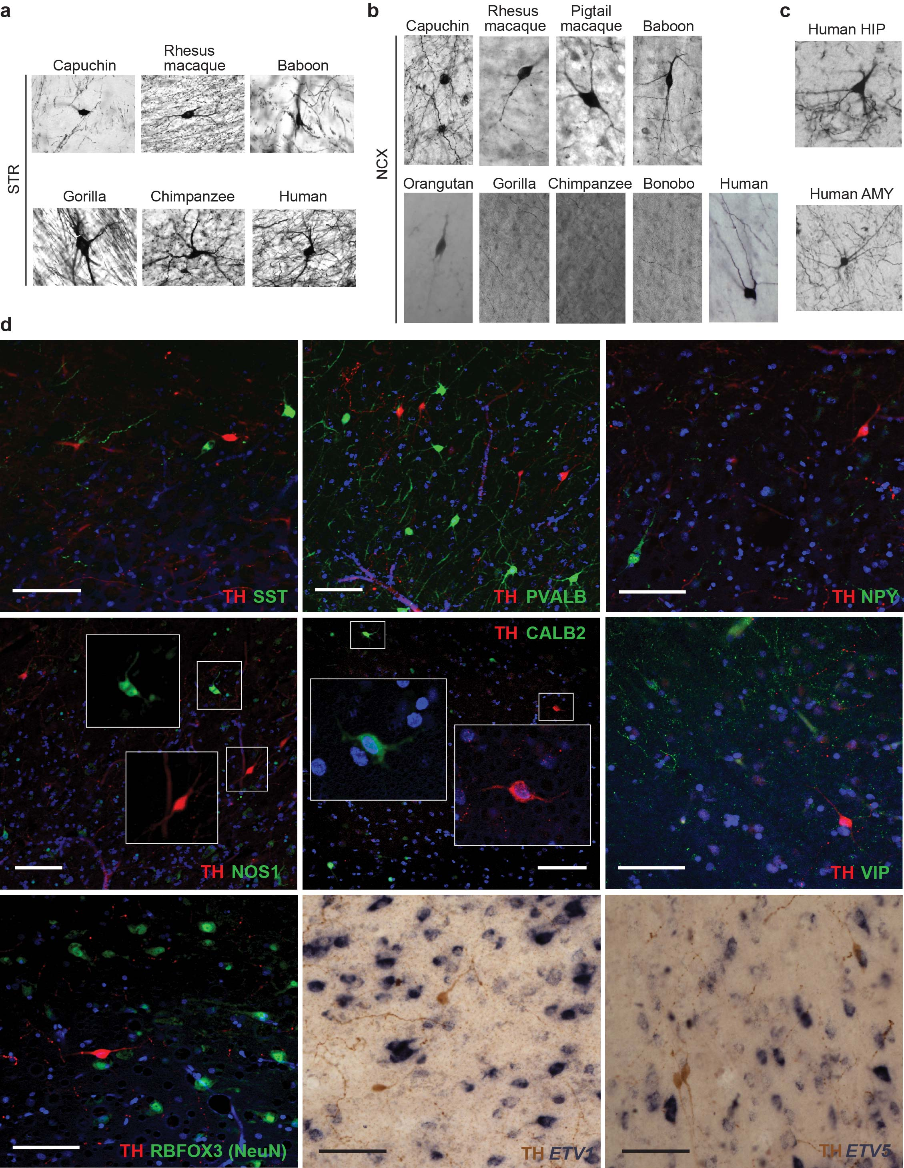

**Extended Data Figure 10 | Molecular characterization of cerebral cortical TH-expressing interneurons. a, b,** Immunohistochemical detection using α**-**TH antibody shows that (a) all the analyzed species have TH+ interneurons in the STR and **b,** no TH+ interneurons were detected in the great apes, with the exception of orangutan and human. **c,** TH immunostaining of HIP and AMY with shows that both brain regions have TH+ interneurons, in the human brain. **d,** Double immunolabeling of TH+ interneurons shows that they do not express somatostatin (SST), parvalbumin (PVALB), neuropeptide Y (NPY), nitric oxidase 1 (NOS1), calretinin (CALB2), vasointestinal peptide (VIP), and some do not express the hexaribonucleotide binding protein-3 (RBFOX3; NeuN antibody), commonly used as a pan-neuronal marker. In situ hybridization of *ETV1* and *ETV5* followed by immunohistochemical detection of TH shows that these molecules are not co-expressed in the same cells.