**Molecular and Cellular Reorganization of Neural Circuits in the Human Lineage**

**André M. M. Sousa1*, Ying Zhu1*, Mary Ann Raghanti2*, Robert R. Kitchen3,4, Andrew T. Tebbenkamp1, Kyle A. Meyer1, Mingfeng Li1, Yuka Imamura Kawasawa1,5, Marco Onorati1, Raquel Garcia Perez6, Marta Mele6, Tiago Carvalho6, Mario Skarica1, Mihovil Pletikos1,, Akemi Shibata1, John J. Ely7, Patrick R. Hof8, Joel E. Kleinman9, Daniel R. Weinberger9, Mark Reimers10, Richard P. Lifton11,12, Shrikant M. Mane13, James P. Noonan11, Matthew W. State14, Ed S. Lein15, James A. Knowles16, Tomas Marques-Bonet7,17,18, Chet C. Sherwood19, Mark B. Gerstein3, Nenad Sestan1, 20**

1Department of Neuroscience and Kavli Institute for Neuroscience, Yale School of Medicine, New Haven, Connecticut, USA

2Department of Anthropology and School of Biomedical Sciences, Kent State University, Kent, Ohio, USA

3Program in Computational Biology and Bioinformatics, Departments of Molecular Biophysics and Biochemistry and Computer Science, Yale University, New Haven, Connecticut, USA

4Department of Psychiatry, Yale School of Medicine, New Haven, Connecticut, USA

5Department of Pharmacology, Penn State University College of Medicine, Hershey, Pennsylvania, USA

6Institut de Biologia Evolutiva, CSIC-Universitat Pompeu Fabra, PRBB, Doctor Aiguader 88, Barcelona, Catalonia, Spain

7Alamogordo Primate Facility, Holloman Air Force Base, New Mexico, USA

8Fishberg Department of Neuroscience and Friedman Brain Institute, Icahn School of Medicine at Mount Sinai, New York, New York 10029, USA

9Lieber Institute for Brain Development, Johns Hopkins University Medical Campus, Baltimore, Maryland, USA

10Department of Biostatistics, Virginia Commonwealth University, Richmond, Virginia, USA

11Department of Genetics, Yale School of Medicine, New Haven, Connecticut, USA

12Howard Hughes Medical Institute, Yale University, Connecticut, USA

13Yale Center for Genomic Analysis, Yale School of Medicine, New Haven, Connecticut, USA

14Department of Psychiatry and Langley Porter Psychiatric Institute, University of California, San Francisco, San Francisco, California, USA

15Allen Institute for Brain Science, Seattle, Washington, USA

16Department of Psychiatry and Zilkha Neurogenetic Institute, Keck School of Medicine, University of Southern California, Los Angeles, California, USA

17Institució Catalana de Recerca i Estudis Avançats, Barcelona, Catalonia, Spain.

18Centro Nacional de Analisis Genomico, Barcelona, Catalonia, Spain

19Department of Anthropology, The George Washington University, Washington, District of Columbia, USA.

20Departments of Genetics and Psychiatry, Section of Comparative Medicine, Program in Cellular Neuroscience, Neurodegeneration and Repair, and Yale Child Study Center, Yale School of Medicine, New Haven, Connecticut, USA

*These authors contributed equally to this work

**Contact author:**

Nenad Sestan ([nenad.sestan@yale.edu](mailto:nenad.sestan@yale.edu))

**Summary**

**The general structure of the brain is largely conserved between humans and non-human primates, but underlying species differences in neural circuits remain elusive. Here, we performed transcriptome sequencing of sixteen regions of adult human, chimpanzee, and macaque brains. Integrative analyses with single-cell transcriptome data and histological validation revealed quantitative and qualitative global, regional, and cell-type specific species differences in protein-coding and noncoding genes representing different functional categories. Notably, we found that monoaminergic systems' gene expression patterns are less conserved than glutamatergic and GABAergic systems and exhibited human specificity. We found that this is partially due to the complete absence of rare interneurons expressing genes/proteins for dopamine biosynthesis and transport in the African ape, except human, cerebral cortex and their increased number in the human striatum. Thus, we generated primate genomic datasets for future evolutionary and neuroscience studies, and revealed molecular and cellular evidence for the reorganization of human neural circuits.**

**Introduction**

The human brain is, on average, three times larger than that of our closest living relatives, the non-human African apes1-3. However, despite this difference and the concomitant expansion of some areas of the cerebral cortex, there is only limited evidence that any brain regions are unique to humans1,2,4. Rather, multiple lines of evidence suggest that neural circuits in homologous regions have undergone microstructural and functional changes in the human lineage1-9, which, in turn, provided the basis for the emergence of most distinctly human aspects of cognition and behavior.

Divergence in the regulation of gene expression has long been postulated to play a major role in the evolution of human brain10,11. However, the extent of human-specific changes in the regional and cell-type specific architecture of brain transcriptome and how these features give rise to traits associated with the evolution of human brain development, structure, and function remain largely unknown. Although considerable progress has been made in profiling and understanding the comparative differences in gene expression between human and closely related non-human primate brains12-18, a systematic genome-wide transcriptome survey across many homologous regions of human and NHP brains is needed. Recent studies of the human brain transcriptome, at the tissue and single cell level19-25, have revealed substantial regional and cell type-specific differences, further emphasizing the importance of analyzing species differences in a wide range of brain regions and cell types. Here, we expand on these previous studies by using RNA-seq, the agnostic nature of which allows unbiased direct comparison of transcriptomes at a genome-wide scale of different species, to profile protein-coding and noncoding transcripts of 16 brain regions of high-quality post-mortem brain specimens of adult human (*Homo sapiens*), chimpanzee (*Pan troglodytes*) - our closest living relative - and rhesus macaque (*Macaca mulatta*) - the most commonly studied NHP in neuroscience. The comparison of these data and the integration with single-cell transcriptome data and histological validation allowed us to put transcriptional regional and cellular diversity into an evolutionary context.

**Global and regional patterns of inter-species transcriptome differences**

We used RNA-seq to survey the mRNA and small noncoding RNA (smRNA) transcriptomes of a total of 247 high-quality, histologically verified tissue samples representing sixteen regions (11 areas of the neocortex [NCX], hippocampus [HIP], amygdala [AMY], caudate-putamen [striatum, STR], mediodorsal nucleus of thalamus [MD] and cerebellar cortex [CBC]) systematically dissected using a standardized protocol from six adult humans, five adult chimpanzees, and five adult macaques (Supplementary Table 1 and Extended Data Fig. 1 and 2). Consistent and stringent quality control measures were applied at the level of tissue acquisition and dissection, sample preparation, RNA extraction, control spike-in RNAs, sequencing, and data processing (see Extended Data Fig. 2 and Methods for further description).

To minimize biases in comparative data analyses due to the disparate quality of gene annotation for the three species, we developed a computational framework named *XSAnno* (see Methods) to create a common annotation set of 26,514 1:1:1 orthologous mRNAs that includes 16,531 protein-coding genes and 3,253 long noncoding RNAs (lncRNAs), with the remainder being largely pseudogenes and antisense RNAs (see Supplementary Information – Analysis Pipeline). In the small RNA dataset, we focused on miRNAs. To overcome the limitations of the chimpanzee and macaque miRNA annotations, which are less comprehensive than those available for human, we performed a re-annotation of all chimpanzee and macaque miRNAs based on the full suite of annotated human precursor sequences (see Methods). Both mRNA and miRNA datasets were filtered based on RNA quality, sequencing error, and the number of uniquely mapped reads and subsequently analyzed by hierarchical clustering (see Methods, and Extended Data Fig. 2e and 2f).

While miRNA samples clustered by species, mRNA clustering showed that CBC samples from all species formed a distinct cluster separated from other brain regions (Extended Data Fig. 2e and 2f). Similarly, samples from the human and chimpanzee STR and MD clustered by region, rather than species, suggesting these regions are more similar to the corresponding region in these closely related species than to other regions within the same species. Conversely, the human and chimpanzee NCX, HIP, and AMY clustered by species, demonstrating that these regions are more similar to each other than they are to the homologous region in the other species.

We first identified genes having expression differences among species for at least one of the 16 brain regions assayed. For each region, differentially expressed (DEX) mRNAs and miRNAs were identified (FDR < 0.01) by comparing generalized linear models, with species as the main factor and batch as a cofactor. We found 6,866 mRNAs (25.9% of orthologous mRNAs generated by *XSAnno*) and 603 miRNAs (40.6% of mature miRNAs detected in any species [cumulative read counts over all samples > 50]) that were DEX between at least two species in one or more regions. Based on *post hoc* comparisons (Supplementary Table 2), DEX mRNAs and miRNAs were classified by the relationship among species (Fig. 1a and 1b). As expected based on evolutionary relationships, the two most frequent patterns of DEX mRNAs and miRNAs had similar expression levels in human and chimpanzee samples that together differed from the expression levels in macaque samples (H = C > M and H = C < M) (Fig. 1a and Extended Data Fig. 3a-c). 11.9% of orthologous mRNAs generated by *XSAnno* exhibited human-specific expression pattern (upregulation [H>C=M] or downregulation [H<C=M]) (Fig. 1a and 1b). While there has been conflicting evidence of a human-specific increase in the number of up-regulated mRNAs12,13,26, in our study, 15 of the 16 regions show more genes with human-specific upregulation than downregulation, with human STR being the only region with more downregulated than upregulated genes (Extended Data Fig. 3a). Alternatively, chimpanzee displayed an equal number of regions showing up- and downregulation (Extended Data Fig. 3b), while only 2 regions had more upregulated genes in macaque, with 14 showing more downregulated genes (Extended Data Fig. 3c). To test whether these quantitative differences reflect differences in the ratio of glia to neurons across the homologous brain regions, we performed an in silico estimation of neuronal and non-neuronal cell composition utilizing our newly generated RNA-seq dataset on neuronal (NeuN+) and non-neuronal (NeuN-) nuclei isolated from the adult human prefrontal neocortex (Extended Data Fig. 3d), single cell RNA-seq of human cerebral cortex24, and RNA-seq of purified cell types from human cortex27 (Extended Data Fig. 3e, d). These three analyses showed no or only slight variations, depending on the cell type, in the ratios of major cell types across the homologous regions that do not clearly explain, either in the magnitude or regional pattern, the global species transcriptome differences we observed, indicating that the widespread difference in gene expression between human, chimpanzee, and macaque are not likely due to changes in the proportion of neuronal vs non-neuronal cells.

Highlighting the importance of a multiregional analysis, this comparison between species also revealed substantial differences in the number of DEX genes in different brain regions. For the 3,154 mRNAs (11.9% of orthologous mRNAs generated by *XSAnno*) with human-specific up- or downregulation (H > C = M or H < C = M), the highest number of human-specific DEX genes were observed in STR, followed by MD, the primary visual cortex (V1C) and dorsolateral prefrontal cortex (DFC), brain regions involved in some of the most distinctively human aspects of cognition and behavior3,4,6,7. By contrast, the primary auditory and motor cortices (A1C and M1C, respectively), CBC, and HIP exhibited the lowest number (Extended Data Fig. 3) of human-specific DEX genes. There were no obvious differences in within-species variation across all the analyzed brain regions, suggesting that the regional pattern of differences in inter-species DEX genes are not likely to be caused by technical bias. Functional annotation of human-specific DEX genes (see Methods) revealed enrichment for categories such as “cell adhesion”, “plasma membrane part”, “extracellular matrix”, “glycosylation site:N-linked (GlcNAc...)”, and neurobiological processes like “neuron projection”, “dendrite”, and “synaptic transmission” (Bonferroni-adjusted *P* ≤ 2.79x10-5; Supplementary Table 4), potentially implicating these processes in human brain evolution.

Among the mRNAs with human-specific up- or downregulation, 31 were DEX across all analyzed regions (Supplementary table 3) while only 3 genes were significantly DEX (H > C = M or H < C = M) exclusively in all eleven NCX areas: *TWIST1, RP11-364P22.1*,and *CTB-78F1.1*. *TWIST1* was selectively downregulated in the human NCX compared to chimpanzee and macaque (Fig. 1e). *TWIST1* encodes a transcription factor mutated in in Saethre–Chotzen syndrome, a multi-organ disorder associated with intellectual disability28. TWIST1 also inhibits the function of the MEF2 transcription factor, which suppresses neocortical synaptogenesis in an activity-dependent manner29. Notably, previous studies in mice and some other animals have shown that *Twist1* is expressed by and required for the development of neural crest cells and mesoderm, but not CNS neurons30, suggesting that the differences in *TWIST1* expression we observe reflect species-specific differences in function. We validated neocortical expression of *TWIST1* in the three primates and confirmed its human-specific downregulation by droplet digital PCR (ddPCR). Furthermore, we found that TWIST1 protein is localized in neuronal nuclei predominantly in the upper layers (Extended Data Fig. 4a and 4b). In contrast to *TWIST1*, *RP11-364P22.1* and *CTB-78F1.1* encode putative non-coding RNAs whose functions have not yet been characterized. *CTB-78F1.1* is located in the second intron of *TENM2*, a gene involved in the development of neural circuits31. Interestingly, *CTB-78F1.1* is exclusively expressed by a subset of neurons in neocortical layers 2 and 3, as revealed by our *in situ* hybridization and analysis of single-cell RNA-seq data from the human cerebral cortex23,24 (Extended Data Fig. 4g).

We also found several protein-coding and lincRNA genes that display human-specific DEX in a subset of NCX areas (Supplementary Table 3). For example, the expression of *MET*, a gene implicated in autism spectrum disorder 32, is enriched in all analyzed areas of the human prefrontal cortex (Fig. 1d and Extended Fig. 4e). *PKD2L1*, a gene encoding a calcium-regulated nonselective cation channel 33 is enriched in all human NCX areas except M1C, which exhibited a non-statistical trend (Fig. 1c and Extended Fig. 4f). Interestingly, mouse *Pkd2l1* is expressed in a subset of taste receptor cells in the tongue and a discrete population of neurons surrounding the central canal of the spinal cord, but not in the brain 33. We confirmed human-specific expression of PKD2L1 in neocortical pyramidal neurons using ddPCR and immunohistochemistry (Extended Data Fig. 4f), suggesting that it has been repurposed for a novel functional role in the human NCX.

Genes that show human-specific DEX in only one brain region (Supplementary Table 3) were also identified. Among these was *ZP2* (Fig. 1f), a gene encoding a protein that mediates sperm-egg recognition 34 that is specifically enriched in the human CBC. The human- and CBC-specific expression pattern was confirmed by ddPCR and immunohistochemistry revealed that ZP2 is predominantly expressed in cerebellar granule cells (Extended Data Fig. 4c and 4d). However, the function of ZP2 in human granular cells is unknown.

Of the 202 miRNAs exhibiting statistically significant and more than 2-fold human-specific differential expression, 155 were upregulated and 47 were downregulated in the human brain (Fig. 1b). These include miRNAs not known to have species-specific expression patterns as well as miRNAs previously reported to be abundant in humans, including miR-941, a miRNA implicated in neurotransmitter signaling35. Based on their expression patterns, we used ddPCR to validate the expression of several miRNAs (Extended Data Figs. 4h-j). We confirmed that miR-4284-5p, a miRNA implicated in glioblastoma36, is consistently expressed across all human brain regions but not in chimpanzee and macaque samples (Extended Data Figs. 4h). Together, these findings show that protein-coding and noncoding genes with human-specific expression patterns represent different functional categories and play critical roles in the pathogenesis of major brain disorders.

**Species differences in transcriptional architecture of the brain**

In addition to species differences at the level of individual brain regions, we investigated how the regional transcriptional architecture differed among species. For each species, we determined the number of DEX genes between regions and found a smaller number of DEX genes in human, with macaque showing the highest number. Analysis of within-region variation indicated the higher number of DEX genes identified in macaque might partly result from smaller within-region variation in gene expression among macaque samples (Extended Data Fig. 5a-c). To test whether this was due to smaller genetic distances among rhesus macaques, we calculated genetic distances inferred from single-nucleotide polymorphisms in mRNA expressed in the dorsolateral prefrontal cortex (DFC) (see Methods and Extended Data Fig. 5d). As expected based on previous whole genome studies37, this analysis revealed that the human specimens exhibited the least intra-species variation while macaques had the greatest, indicating that the smaller within-region variation in gene expression among macaque samples was not due to a smaller genetic distance.

We also calculated pairwise correlation matrices of brain regions, using the union of the regional DEX genes of all species, and performed hierarchical clustering (Extended Data Fig. 6). Comparing the clusters among species revealed several differences in the transcriptional correlation between brain regions. As expected20, the CBC was the most divergent area of the brain in all species, followed by the STR and the MD. HIP and AMY also clustered in the three species, thus clearly separating NCX areas from non-NCX regions. NCX areas were more transcriptionally similar in humans than NCX areas were in either chimpanzees or macaques (Extended Data Fig. 6). Among these areas, several species differences in clustering were present. Interestingly, the human clustering is more similar to the macaque clustering, with a slight difference in the most distinct NCX area (V1C in human and MFC in macaque), than it is to the chimpanzee clustering. We confirmed the robustness of the clustering by multiscale bootstrap resampling (Extended Data Figs. 6b, 6d, and 6f). A similar pattern of clustering was observed in miRNA expression across the three species and, as seen in the mRNA clustering, CBC was the most distinct region, while NCX areas were highly correlated with each other.

**Species differences in coding and noncoding gene co-expression networks**

As the DEX analysis focused on single genes and on a limited number of expression patterns, we next applied weighted gene co-expression correlation network analysis (WGCNA; see Methods) to identify clusters (modules) of highly co-expressed genes by searching for genes with similar patterns of variation across samples and species. We identified 229 modules of co-expressed genes, many with distinct regional and/or species-specific expression patterns (Figure 2a; Supplementary Table 5; see www.sestanlab.org/resources for module visualization), often enriched for genes associated with distinct functional categories (Supplementary Table 4). For example, M92 (Fig. 2b and 2e) is selectively upregulated in human NCX regions. In contrast, M32 (Fig. 2c and 2f) is composed of genes, including *TWIST1*, that are upregulated in chimpanzee and macaque, but not human, cortical areas (Supplementary Table 5). Of particular interest, M130 is composed of genes that were upregulated in human AMY, HIP, and STR, which is the region with the most interspecies DEX genes (Fig. 2d and 2g). Interestingly, two genes in this module are involved in the synthesis of dopamine: *tyrosine hydroxylase* (*TH*) and *DOPA decarboxylase* (*DDC*). Modules composed by genes with human-specific up- or downregulation were enriched for categories such as “TSPN”, “SRP-dependent cotranslational protein targeting to membrane”, “viral transcription, nuclear-transcribed mRNA catabolic process”, “nonsense-mediated decay”, and “cytosolic large ribosomal subunit” (Bonferroni-adjusted *P* < 0.05). By integrating gene co-expression modules with previously published single cell data23,24 we identified some modules that display species differences and cell-type enrichment. For example, M144 exhibits upregulation in macaque across all brain regions and enrichment in interneurons, while M152 exhibits downregulation in macaque across all brain regions and enrichment in oligodendrocytes (Fig. 2a; Extended Fig. 7d and 7e). In contrast, no mRNA module enriched for genes that are up- or downregulated in the human brain showed enrichment for any particular cell type, indicating that the observable gene expression changes might be more widespread across different types of cells.

We also clustered all miRNAs based on their individual Pearson correlations to the average expression profile of each mRNA module (see Methods). Using this approach, we identified 37 stable modules of miRNAs (Extended Fig. 7a and Supplementary Table 6). Highlighting widespread differences between species and brain regions, each miRNA module exhibited a distinct expression profile (see [www.sestanlab.org/resources](http://www.sestanlab.org/resources) for module visualization). Modules were further refined with reference to data generated using high-throughput sequencing of RNAs isolated by crosslinking immunoprecipitation (HITS-CLIP) 38. The inclusion of the HITS-CLIP targets greatly improved the specificity of the association of miRNA modules with mRNA modules, based on those pairs with significant target enrichment (Extended Fig. 7b and Supplementary Table 7). Several pairs of miRNA/mRNA modules where the expression of these molecules correlated across samples also exhibited regional- or species-specific HITS-CLIP target enrichment (Extended Fig. 7c). For example, mRNA M53 and miRNA M24 exhibit opposite regional expression profiles, notably in V1C, MD, and CBC, and are also enriched for HITS-CLIP targets (Extended Fig. 7f and 7g). Together, these findings show that protein-coding and noncoding genes exhibiting species-differences can also be grouped into module of highly co-expressed genes enriched for distinct functional categories that may underlie evolutionary changes within the respective lineages.

**Species differences in expression of neurotransmitter systems genes**

As shown in our previous study20, most of the significant differences across brain regions during adulthood are functionally related to synaptic transmission and neural activity. Differences in neurotransmitter and synaptic proteins levels, as well as the composition of neuroreceptors may alter the physiological properties of neural circuits. To investigate how the human, chimpanzee, and macaque differ on these biological processes, we started by analyzing how neuroreceptor systems evolved. We generated co-expression networks between neuroreceptor subunits and measured the conservation of these networks among the three species. A Z-statistic and empirical p-values were calculated to evaluate the preservation of the networks based on permutation tests (see Methods). We limited further analysis to the glutamatergic, GABAergic, serotonergic, and cholinergic systems as those involved enough genes to provide reliable comparisons (Fig. 3). The glutamatergic and GABAergic systems, which function as the major excitatory and inhibitory systems in the brain, have similar correlation networks among species. Additionally, hierarchical clustering of receptor subunits revealed conserved co-expression of *GABRA1*, *GABRB2*,and *GABRG2*, the most common assembly of GABAA receptors39 (α1β2γ2; Extended Data Fig. 8b). Similarly, the AMPA receptor subunits *GRIA2* and *GRIA3* were co-expressed in all three species (Extended Data Fig. 8a). This conservation is also preserved at the level of the coding sequence, as the ratio between the nonsynonymous (dN) and synonymous (dS) substitution rates for genes in these two networks suggest significantly greater conservation than present in the genome as a whole (Extended Fig. 8c and Methods).

By contrast, the co-expression networks present among components of the cholinergic and serotonergic systems differ among the three species, with the human and chimpanzee networks more similar to one another than they are to macaque (Fig. 3e and 3f). Coding sequences are also not significantly conserved compared to the background (Extended Fig. 8c). Importantly, these two neuromodulatory systems seem to play a critical role in cognitive processes , reinforcing the idea that the neuromodulatory system differences revealed in our study might be relevant to species differences in cognition39.

**Species differences in cell type-specific gene expression**

As mentioned above, changes involving neurotransmitter receptors (and ion channels in general), on levels of neurotransmitters, and on synaptic proteins can alter the physiological properties of brain circuits. Furthermore, it is important to dissect in which cell-types and brain regions these modifications occur. Therefore, we analyzed the inter-species differential expression of neurotransmitter receptors, neurotransmitter metabolism enzymes, and disease related genes in the neocortex and investigated their enrichment in different cell types by integrating single-cell RNA-seq data23,24 (Fig. 3g). While many of the species-specific genes are expressed in multiple cell types, some of them demonstrated both species- and cell-type-specific expression patterns. *PKD2L1* is specifically upregulated in the human neocortex and enriched in Layer 5 *FEZF2*-expressing excitatory projection neurons. In addition to upregulation in the human STR, we also found *TH* to be downregulated in the chimpanzee neocortex and enriched in a cell population clustered with SST+ interneurons. Although the majority of cells robustly expressing *TH* also express *GAD1* and/or *GAD2*, only a small number of the *TH*-expressing cells express *SST*. Therefore, we could not confidently classify TH-expressing cells as a subpopulation of SST+ interneurons.

The observed differences in *TH* expression among species found in the gene co-expression networks and in the cell-specific differential expression led us to further analyze the dopaminergic system.

**Species-specific and cell type-specific expression of dopamine biosynthesis genes**

Dopamine is synthetized from L-tyrosine by the sequential action of TH and DDC (Fig. 4a). We found that *TH* and *DDC* show higher expression levels in both mRNA (Figure 4b and 4d; FDR = 3.5×10-4 and 1.4×10-3, respectively) and protein (Fig. 4c and 4e) in the STR of humans compared to chimpanzees and macaques. Interestingly, *TH* was also substantially downregulated, and was in some cases virtually undetected, in chimpanzee NCX and HIP, with no appreciable inter-species differences in AMY, MD, or CBC (Fig. 4b and 4d). To further validate this result, we examined the expression of TH in previously published RNA-seq data from different organs, including the cerebral cortex, of 9 mammalian species18. This extended analysis confirmed the downregulation of TH in independent chimpanzee cortex specimens compared to human, but also revealed downregulation of TH expression in the cerebral cortex of bonobo and gorilla (Extended Data Fig. 9a), indicating that TH expression is significantly downregulated and possibly lost in the cerebral cortex of African apes except humans. Notably, while we found that *DRD1*, *DRD2*, and *DRD3*, three genes encoding dopamine receptors, were downregulated in human STR, we observed no change in the neocortical expression of *MAOA*, and *COMT*, *DBH*, three genes encoding enzymes used to metabolize or convert dopamine to noradrenalin, respectively (Extended Data Fig. 9a-g)

We next tested whether these differences in *TH* expression levels might be due to evolutionary changes in the regulation of *TH* expression, but found no differences in putative regulatory regions of *TH* between species. Because telencephalic TH-immunopositive interneurons have been previously found in several mammalian species40-43, we next conducted a histochemical examination of TH expression on an independent set of 45 adult brains, including 16 human, 5 chimpanzee, 1 bonobo, 5 gorilla, 1 orangutan, 2 rhesus macaque, 5 pig-tailed macaque, 5 baboon, and 5 capuchin (Supplementary Table 11). TH immunostaining of the STR showed that humans have a significantly higher number of TH+ (Tukey's honest significance test all *P* values < 0.05; see Methods) interneurons in both the dorsal caudate nucleus and putamen when compared to all the other analyzed NHP species (Fig. 4i and Extended Fig. 10a). Furthermore, confirming and expanding upon our gene expression data and previous TH immunohistochemistry data41,42, numerous TH fibers (likely mainly axons of midbrain dopaminergic neurons) and sparsely distributed TH+ interneurons were present within all analyzed areas of the cerebral cortex in humans (Fig. 4j and Extended Fig. 10b). As previously reported, these TH+ neurons were present mainly within deep layers and the adjacent white matter. Similarly, TH+ interneurons were also found in all analyzed monkey species and orangutan (Fig. 4j and Extended Fig. 10b). In contrast, only TH+ fibers and no TH+ neurons were found in the cerebral cortex of chimpanzee, bonobo, and gorilla (Fig. 4j and Extended Fig. 10b), confirming our *TH* expression analysis results and indicating that TH expression and TH+ interneurons are absent from the cortex of all non-human African apes. This indicates that these cortical TH+ interneurons were probably lost in the common ancestor to the African great apes and reappeared in the human lineage or, in a more unlikely scenario, disappeared independently in the *Gorilla* and *Pan* lineages. Interestingly, we also found that TH+ interneurons are present in the olfactory bulbs of human, chimpanzee, gorilla, and macaque, without significant differences between species (Fig. 4k). These observations suggest that the evolutionary loss of these interneurons in non-human African apes might be restricted to the cerebral cortex.

**Developmental origin and characterization of human forebrain dopamine interneurons**

The findings on the homoplastic expression of TH in NCX neurons in monkeys, orangutan, and the human lineage led us to further characterize these TH+ interneurons. Using publically available Brainspan developmental human brain transcriptome data (*www.brainspan.org*), we observed that *TH* expression exhibits highly regionally and temporally dynamic trajectories (Fig. 5a). In concordance with the present study, the highest *TH* expression is observed in the developing STR, where its expression gradually increases from early fetal development to young adulthood. In contrast, more modest expression of TH in NCX increases perinatally and reaches a plateau around late infancy. Interestingly, TH expression in HIP and AMY also increases during perinatal development reaching steady levels during infancy and early childhood before again increasing sharply through late childhood, adolescence and young adulthood (Fig. 5a), indicating that TH expression continues to be regulated during late postnatal development and young adulthood. To test whether this expression pattern was the result of the appearance of TH+ interneurons in the analyzed regions, we performed an immunohistochemical analysis in the developing human brain. We found that TH+ axons were detected during late midfetal development in the STR (a 24 postconceptional week [pcw]-old specimen), and also in the NCX and the external capsule in the newborn brain. The TH+ fibers that are present in the external capsule of the newborn human are still unmyelinated, as shown by the lack of colocalization of TH and myelin basic protein (MBP; Fig. 5b). We also made a comparative analysis of a newborn chimpanzee brain and detected that it also presents the same pattern of unmyelinated fibers in the external capsule (Fig. 5c). Interestingly, several bipolar TH+ interneurons can be observed around the TH+ fibers in the external capsule of the human newborn brain, but no TH+ interneurons were detected in the chimpanzee newborn brain. We also detected the presence of TH+ interneurons in the adult human HIP and AMY (Extended Fig. 10), particularly in the periamygdalar area, preamygdalar claustrum, and temporal claustrum. Conversely, basomedial and lateral amygdaloid nuclei had no TH+ interneurons, though an extensive innervation by TH fibers could be observed.

After determining the timing and position of TH+ interneurons in the human brain, we performed a histochemical characterization to determine some of their molecular and physiological properties. We first confirmed that these interneurons are GABAergic (Fig. 5d). Intriguingly, these TH+ interneurons did not express classical markers of neocortical interneuronal subtypes, such as somatostatin, parvalbumin, neuropeptide Y, nitric oxide synthase 1, calretinin, and vasoactive intestinal peptide (Extended Data Fig. 10c). Also, not all TH+ interneurons expressed the neuronal marker NeuN (Extended Data Fig. 10c). Intriguingly, these interneurons did not express *ETV1*, a gene previously implicated in the differentiation of TH+ dopaminergic neurons in the mouse olfactory bulb and *C. elegans*, and its close homolog, *ETV5* 44 (Extended Data Fig. 10c). However, using triple immuofluorescent staining we found that most of the TH+/GABA+ interneurons also co-express DDC (Figs. 5d and 5e), the enzyme that converts L-DOPA to dopamine, but not DBH (data not shown), the enzyme that converts dopamine to noradrenaline, confirming that at least a subset of these interneurons is capable of producing dopamine.

To further characterize these putative dopaminergic interneurons and functionally test whether they are capable of actively transporting dopamine, we first sought to derive TH-immunopositive cells from human induced pluripotent stem cells (hiPSCs) and then assessed dopamine re-uptake. hiPSCs were generated form skin fibroblasts of clinically unremarkable donors and were exposed to a two-step directed neocortical differentiation protocol (see Methods), based on dual-SMAD signaling inhibition followed by terminal differentiation in the presence of neurotrophin and neuronal supplements. Mature neurons showed neocortical cell identity after 80 days in vitro as demonstrated by the expression of classical markers of early- and late-born excitatory projection neurons, interneurons, and glia (Fig. 5f; see Methods for detailed description). We found that a small number of cells in the 80 days old cultures were immunopositive for TH, confirming that these interneurons can be generated and differentiated *in vitro* from iPSCs after using a neocortical differentiation protocol.

We then assessed the heterogeneous hiPSC-derived neuronal culture with a monoamine uptake assay (Fig. 5f, see Methods). We found that 8.52% ± 1.90% of the interneurons were able to transport a fluorophor-labelled synthetic monoamine. From this population, 17.83% ± 14.53% of interneurons also expressed both TH and DDC, corroborating that these interneurons were able to produce and transport dopamine (Fig. 5g and 5h). We also found a small population that was able to transport dopamine and expressed TH but did not express DDC (4.22% ± 3.30%) and, therefore, could not produce dopamine.

Together, these experiments reveal that human forebrain TH+ interneurons are a rare subpopulation of molecularly diverse and unusual interneurons that appear later in development than most of other interneuron subtypes, and express key proteins for dopamine biosynthesis and transport.

**Concluding remarks**

Here we describe the generation and analysis of the most comprehensive comparative transcriptomic dataset (to our knowledge) of different regions of human, chimpanzee, and macaque brains to date, utilizing high-quality specimens and standardized tissue dissection and data generation. Furthermore, our *XSAnno* pipeline improved the accuracy of inter-species gene expression comparisons. All data are publicly available in the Non-Human Primate Brain Transcriptomes (www.sestanlab.org/resources), Brainspan (www.brainspan.org) and PsychENCODE ([www.psychencode.org](http://www.psychencode.org)) databases, providing a foundational resource for future evolutionary and neuroscience studies.

Our integrated analyses of the dataset found substantial differences in the number of protein-coding and noncoding genes that exhibited species-specific expression across the analyzed brain regions. The great majority of genes appeared to have a conserved expression pattern in the analyzed brain regions across the three species, with remaining genes (approximately 25.9% of mRNA genes) exhibiting global as well as region- and cell type-specific expression pattern differences. Many of these DEX genes, including several highly connected hub genes within coexpression modules, encode transcription factors or are putative targets of miRNAs with complementary species-specific expression patterns, suggesting differences in transcriptional and posttranscriptional co-regulation at multiple levels. These and other differences uncovered by our analysis therefore reveal the distinct regional and cellular transcriptional brain architecture of human, chimpanzee, and macaque, possibly reflecting differences in structural and functional connectivity as well as each species’ environment and lifestyle.

Of the genes and co-expression modules exhibiting human-specific gene expression patterns, many are associated with important biological processes and thus likely to contribute to human-specific aspects of development and function and, when disrupted, dysfunction. For example, our analyses of gene co-expression networks revealed species- and human- specific changes in many genes encoding ion channels, neurotransmitter biosynthesis enzymes and receptors. Interestingly, we found that receptors for both the glutamatergic and the GABAergic systems were well conserved among species and that this conservation was also present at the level of the coding sequence, indicating that glutamatergic and GABAergic receptor genes are probably under higher selective pressure. These systems are the major excitatory and inhibitory neurotransmitter systems, respectively, and their homeostatic regulation has to be fine-tuned in order to have a balance of excitation/inhibition in neural circuits; if this balance is disrupted it may lead to brain malfunction and disease45. Conversely, our analyses revealed that many genes associated with neuromodulatory systems show substantial species expression differences. Changes in the cellular composition of ion channels or neurotransmitter signaling proteins can have profound effects on neuronal and neural circuit functions and lead to circuit dysfunction45,46. Consistent with this, some of the human-specific DEX mRNAs and miRNAs identified here have previously been functionally linked to neuropsychiatric disorders. Thus, evolutionary changes in gene expression involving both excitatory and inhibitory neurons occurred in the different lineages, reflecting a molecular reorganization likely affecting the physiological properties of and functional outputs from brain circuits.

Most notably, our analyses revealed that the organization of monoaminergic systems is dramatically different between humans and other African apes, an observation highlighted by our characterization of a TH-immunopositive interneuron population enriched in the human striatum and absent from the cerebral cortex (NCX and HIP) of non-human African apes. These differences are clearly reflected at the circuitry level. Several scenarios may explain the absence of rare TH+ interneurons expressing other key genes/proteins for dopamine biosynthesis and transport from the cerebral cortex of non-human African apes. Previous studies in mice47 have shown that distinct interneuron populations generated in the ventral forebrain migrate to different forebrain structures through the influence of semaphoring-neuropilin interactions. It is conceivable that this or another relevant molecular interaction was disrupted in the common ancestor of African apes but that this disruption was reversed in the human lineage. An alternative, though unlikely, possibility is that these interneurons are present in the non-human African ape cortex but do not express TH or DDC, do so only transiently, or die prior to our ability to detect them. Consistent with these latter scenarios, it has been reported that 40% of developing cortical interneurons are eliminated through apoptosis during the first 3 postnatal weeks in mice48 and TH immunoreactivity is transiently expressed in some cortical interneurons during the first 3 postnatal weeks in the rat43, a rodent developmental age equivalent to the perinatal period and infancy in humans and chimpanzee. Furthermore, a recent study of the developing human brain49 found that a portion of the TH+ interneurons migrating via the rostral migratory stream to the olfactory bulb divert to the prefrontal cortex, especially the MFC. This region had the highest enrichment for TH+ interneurons in our study, possibly suggesting the etiology of the TH+ cells we observed. We also detected rare TH+ interneurons in the external capsule of the newborn human brain (Fig. 5b), with most interneurons exhibiting bipolar migratory-like morphology and processes extending parallel to dopaminergic axons likely originating from the midbrain. This may reflect immature interneurons en route to the STR and dorsal fronto-parietal cortices, and conceivably may represent one of several migratory corridors or streams that bring immature TH+ interneurons to regions of the cerebral cortex. Finally, we also observed a sharp increase in TH expression levels in the HIP and AMY from late childhood to young adulthood, suggesting that *TH* expression and/or the number of TH+ interneurons increases well into young adulthood..

Dopamine is involved in several cognitive processes, especially working memory, reasoning, reflective exploratory behavior, and overall intelligence39, all of which show substantial differences in humans. It is therefore possible that these differences might be partly explained by this increase in dopamine levels produced locally by a small subset of telencephalic interneurons. Surprisingly, we found that 3 genes that encode dopamine receptors – *DRD1*, *DRD2*, and *DRD3* – were downregulated in the human STR, suggesting that a homeostatic plasticity may exist in the expression of genes associated with dopamine signaling. It will be important to analyze the protein levels of the receptors to confirm that humans have lower amounts of these receptors in the STR. Nevertheless, further studies on this balance between neurotransmitters and their receptors are needed. Furthermore, it was reported that there is a selective depletion of TH+ neurons in the cerebral cortex of Parkinson’s disease50. The depletion of interneurons that are able to produce dopamine, thus altering the properties of cortical local circuitry, may therefore contribute to both deficits in midbrain dopaminergic projections and to the cognitive impairments observed in Parkinson’s disease patients.

In summary, this study provides a unique and comprehensive comparative primate brain transcriptome resource and new insights into molecular and cellular reorganizations of neural circuits that will facilitate future studies on human brain development, function, and disease.

**Online Content** Methods, along with any additional Extended Data display items and Source Data, are available in the online version of the paper; references unique to these sections appear only in the online paper.

**References**

1. Preuss, T. M. What is it like to be a human. *The cognitive neurosciences*, 5-22 (2004).

2. Sherwood, C. C., Subiaul, F. & Zawidzki, T. W. A natural history of the human mind: tracing evolutionary changes in brain and cognition. *J Anat* **212**, 426-454 (2008).

3. Bae, B. I., Jayaraman, D. & Walsh, C. A. Genetic changes shaping the human brain. *Dev Cell* **32**, 423-434 (2015).

4. Geschwind, D. H. & Rakic, P. Cortical evolution: judge the brain by its cover. *Neuron* **80**, 633-647 (2013).

5. Kennedy, H. & Dehay, C. Self-organization and interareal networks in the primate cortex. *Prog Brain Res.* **195**, 341-360 (2012).

6. Lui, J. H., Hansen, D. V. & Kriegstein, A. R. Development and evolution of the human neocortex. *Cell* **146**, 18-36 (2011).

7. Silbereis, J. C., Pochareddy, S., Zhu, Y., Li, M. & Sestan, N. The Cellular and Molecular Landscapes of the Developing Human Central Nervous System. *Neuron* **89**, 248-268 (2016).

8. Rilling, J. K. Comparative primate neurobiology and the evolution of brain language systems. *Curr Opin Neurobiol* **28**, 10-14 (2014).

9. Teffer, K. & Semendeferi, K. Human prefrontal cortex Evolution, development, and pathology. *Prog Brain Res* **195**, 191-218 (2012).

10. King, M. C. & Wilson, A. C. Evolution at two levels in humans and chimpanzees. *Science* **188**, 107-116 (1975).

11. Carroll, S. B. Genetics and the making of Homo sapiens. *Nature* **422**, 849-857 (2003).

12. Cáceres, M. *et al.* Elevated gene expression levels distinguish human from non-human primate brains. *Proc Natl Acad Sci U S A* **100**, 13030-13035 (2003).

13. Uddin, M. *et al.* Sister grouping of chimpanzees and humans as revealed by genome-wide phylogenetic analysis of brain gene expression profiles. *Proc Natl Acad Sci U S A* **101**, 2957-2962 (2004).

14. Khaitovich, P. *et al.* Parallel patterns of evolution in the genomes and transcriptomes of humans and chimpanzees. *Science* **309**, 1850-1854 (2005).

15. Babbitt, C. C. *et al.* Both noncoding and protein-coding RNAs contribute to gene expression evolution in the primate brain. *Genome Biol Evol* **2**, 67-79 (2010).

16. Konopka, G. *et al.* Human-specific transcriptional networks in the brain. *Neuron* **75**, 601-617 (2012).

17. Somel, M. *et al.* Transcriptional neoteny in the human brain. *Proc Natl Acad Sci U S A* **106**, 5743-5748 (2009).

18. Brawand, D. *et al.* The evolution of gene expression levels in mammalian organs. *Nature* **478**, 343-348 (2011).

19. Johnson, M. B. *et al.* Functional and evolutionary insights into human brain development through global transcriptome analysis. *Neuron* **62**, 494-509 (2009).

20. Kang, H. J. *et al.* Spatio-temporal transcriptome of the human brain. *Nature* **478**, 483-489 (2011).

21. Hawrylycz, M. J. *et al.* An anatomically comprehensive atlas of the adult human brain transcriptome. *Nature* **489**, 391-399 (2012).

22. Pletikos, M. *et al.* Temporal specification and bilaterality of human neocortical topographic gene expression. *Neuron* **81**, 321-332 (2014).

23. Lake, B. B. *et al.* Neuronal subtypes and diversity revealed by single-nucleus RNA sequencing of the human brain. *Science* **352**, 1586-1590 (2016).

24. Darmanis, S. *et al.* A survey of human brain transcriptome diversity at the single cell level. *Proc Natl Acad Sci U S A* **112**, 7285-7290 (2015).

25. Johnson, M. B. *et al.* Single-cell analysis reveals transcriptional heterogeneity of neural progenitors in human cortex. *Nat Neurosci* **18**, 637-646 (2015).

26. Gu, J. & Gu, X. Induced gene expression in human brain after the split from chimpanzee. *Trends Genet* **19**, 63-65 (2003).

27. Zhang, Y. *et al.* Purification and Characterization of Progenitor and Mature Human Astrocytes Reveals Transcriptional and Functional Differences with Mouse. *Neuron* **89**, 37-53 (2016).

28. Howard, T. D. *et al.* Mutations in TWIST, a basic helix-loop-helix transcription factor, in Saethre-Chotzen syndrome. *Nat Genet* **15**, 36-41 (1997).

29. Flavell, S. W. *et al.* Activity-dependent regulation of MEF2 transcription factors suppresses excitatory synapse number. *Science* **311**, 1008-1012 (2006).

30. Qin, Q., Xu, Y., He, T., Qin, C. & Xu, J. Normal and disease-related biological functions of Twist1 and underlying molecular mechanisms. *Cell Res* **22**, 90-106 (2012).

31. Young, T. R. *et al.* Ten-m2 is required for the generation of binocular visual circuits. *J Neurosci* **33**, 12490-12509 (2013).

32. Campbell, D. B. *et al.* A genetic variant that disrupts MET transcription is associated with autism. *Proc Natl Acad Sci U S A* **103**, 16834-16839 (2006).

33. Huang, A. L. *et al.* The cells and logic for mammalian sour taste detection. *Nature* **442**, 934-938 (2006).

34. Hoodbhoy, T. & Dean, J. Insights into the molecular basis of sperm-egg recognition in mammals. *Reproduction* **127**, 417-422 (2004).

35. Hu, H. Y. *et al.* Evolution of the human-specific microRNA miR-941. *Nat Commun* **3**, 1145 (2012).

36. Yang, F. *et al.* A novel berbamine derivative inhibits cell viability and induces apoptosis in cancer stem-like cells of human glioblastoma, via up-regulation of miRNA-4284 and JNK/AP-1 signaling. *PLoS One* **9**, e94443 (2014).

37. Prado-Martinez, J. *et al.* Great ape genetic diversity and population history. *Nature* **499**, 471-475 (2013).

38. Boudreau, R. L. *et al.* Transcriptome-wide discovery of microRNA binding sites in human brain. *Neuron* **81**, 294-305 (2014).

39. Herlenius, E. & Lagercrantz, H. Development of neurotransmitter systems during critical periods. *Exp Neurol* **190 Suppl 1**, S8-21 (2004).

40. Hökfelt, T., Johansson, O., Fuxe, K., Goldstein, M. & Park, D. Immunohistochemical studies on the localization and distribution of monoamine neuron systems in the rat brain II. Tyrosine hydroxylase in the telencephalon. *Med Biol* **55**, 21-40 (1977).

41. Benavides-Piccione, R. & DeFelipe, J. Distribution of neurons expressing tyrosine hydroxylase in the human cerebral cortex. *J Anat* **211**, 212-222 (2007).

42. Raghanti, M. A. *et al.* Species-specific distributions of tyrosine hydroxylase-immunoreactive neurons in the prefrontal cortex of anthropoid primates. *Neuroscience* **158**, 1551-1559 (2009).

43. Berger, B., Verney, C., Gaspar, P. & Febvret, A. Transient expression of tyrosine hydroxylase immunoreactivity in some neurons of the rat neocortex during postnatal development. *Brain Res* **355**, 141-144 (1985).

44. Flames, N. & Hobert, O. Gene regulatory logic of dopamine neuron differentiation. *Nature* **458**, 885-889 (2009).

45. Rubenstein, J. L. & Merzenich, M. M. Model of autism: increased ratio of excitation/inhibition in key neural systems. *Genes Brain Behav* **2**, 255-267 (2003).

46. Kullmann, D. M. Neurological channelopathies. *Annu Rev Neurosci* **33**, 151-172 (2010).

47. Marín, O., Yaron, A., Bagri, A., Tessier-Lavigne, M. & Rubenstein, J. L. Sorting of striatal and cortical interneurons regulated by semaphorin-neuropilin interactions. *Science* **293**, 872-875 (2001).

48. Southwell, D. G. *et al.* Intrinsically determined cell death of developing cortical interneurons. *Nature* **491**, 109-113 (2012).

49. Sanai, N. *et al.* Corridors of migrating neurons in the human brain and their decline during infancy. *Nature* **478**, 382-386 (2011).

50. Fukuda, T., Takahashi, J. & Tanaka, J. Tyrosine hydroxylase-immunoreactive neurons are decreased in number in the cerebral cortex of Parkinson's disease. *Neuropathology* **19**, 10-13 (1999).

**Supplementary Information** is available in the online version of the paper.

**Acknowledgements**

We thank A. Bauernfeind, M. Horn, B. Wicinski, G. Terwilliger, and S. Wilson for assistance with tissue acquisition and processing, D. Singh for technical assistance with preparing sequencing libraries, F. Gulden for discussions, and the Alamogordo Primate Facility and the Primate Brain Bank, Netherlands Institute for Neuroscience, Amsterdam, the Netherlands for providing primate tissue. We also thank members of the Yale University Biomedical High Performance Computing Center, the Yale Center for Genome Analysis, and the USC Epigenome Center. Support for predoctoral fellowships was provided by the China Scholarship Council (Y.Z.) and National Science Foundation Graduate Research Fellowship under Grant DGE-1122492 (K.A.M). The Brainspan Project Consortium was supported by grants MH089929, MH090047 and MH089921 from the National Institute of Mental Health (NIMH). Additional support was provided by the NIMH grant MH109904, MH103339, MH106934, Kavli Foundation (N.S.), James S. McDonnell Foundation Scholar Award (P.R.H., C.S., N.S.), and ERC Starting Grant (260372) and MICINN BFU2011-28549 (T.M.-B.). We apologize to all colleagues whose important work was not cited because of space limitations.

**Author Contributions**

A.M.M.S., M.P., J.J.E., C.C.S., P.R.H., and N.S. managed tissue procurement and examination, A.M.M.S., M.P., and N.S. contributed to tissue and sample processing, Y.Z., R.R.K., M.L., M.M., T.C., M.R., and T.M-B, contributed to sequencing data analysis and interpretation. A.M.M.S., M.A.R., K.A.M., Y.I.K., A.T.N.T., and M.S. contributed to validation data generation, analysis, and interpretation, J.A.K., E.S.L., S.M.M., J.N.P., M.B.G., M.W.S., N.S., and R.P.L. contributed to overall project design and consortium management. A.M.M.S., Y.Z., and N.S. designed the study. A.M.M.S., Y.Z., and N.S. wrote the manuscript with input from all of the other authors.

**Author information**

Reprints and permissions information is available at [www.nature.com/reprints](http://www.nature.com/reprints). The authors declare no competing financial interests. Readers are welcome to comment on the online version of the paper. Correspondence and requests for materials should be addressed to [nenad.sestan@yale.edu](mailto:nenad.sestan@yale.edu).

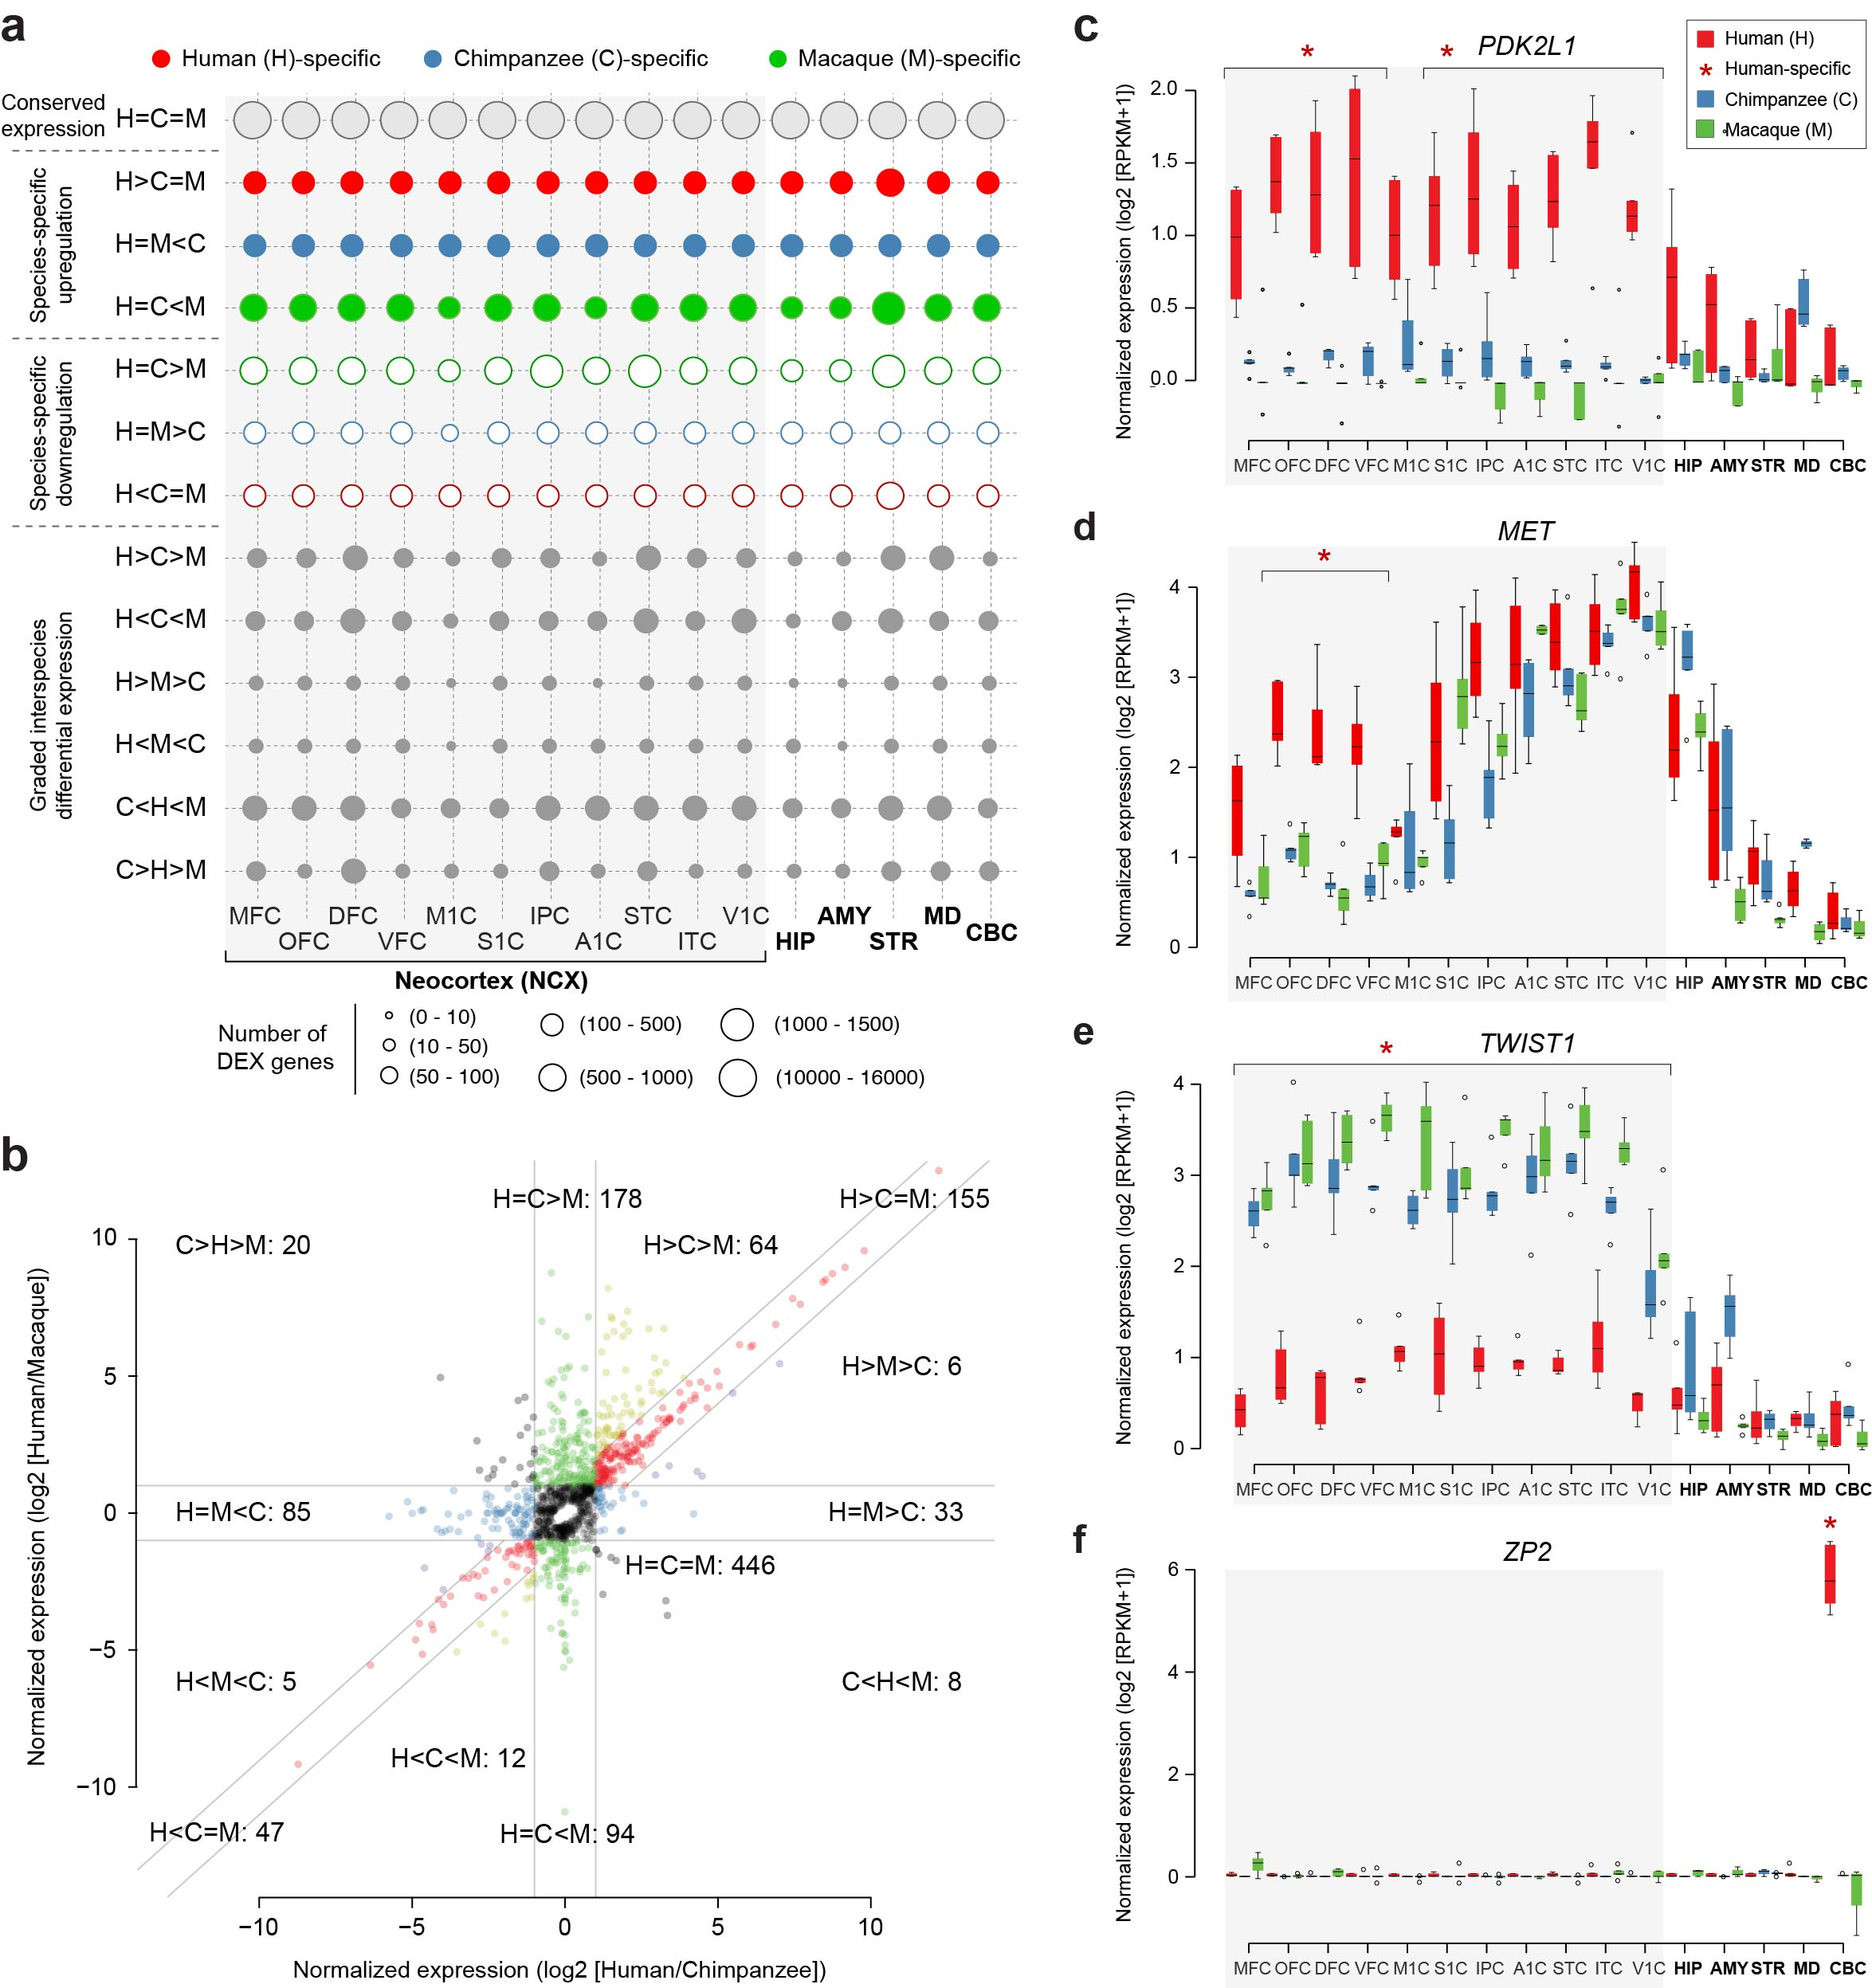

**Figure 1 | Inter-species differential expression. a**, Bubble matrix showing the number of mRNA genes that exhibit conserved expression (grey circles), species-specific upregulation (filled circles), species-specific downregulation (circles), or graded interspecies differential expression (filled grey circles). Post-hoc comparisons are decribed in Supplementary Table 2. **b**, Inter-species patterns of miRNA expression are illustrated based on log2 fold-change between human and chimpanzee (x-axis) vs human and macaque (y-axis). Guiding lines indicate ± 2-fold difference in abundance. **c, d**, **e**, **f**, Expression levels of *PKD2L1*, *MET*, *TWIST1*, and *ZP2*, respectively. Significant differences (FDR < 0.01) are labeled with an asterisk. The boxes represent quartiles of the data and the whiskers represent 1.5 times interquartile range.

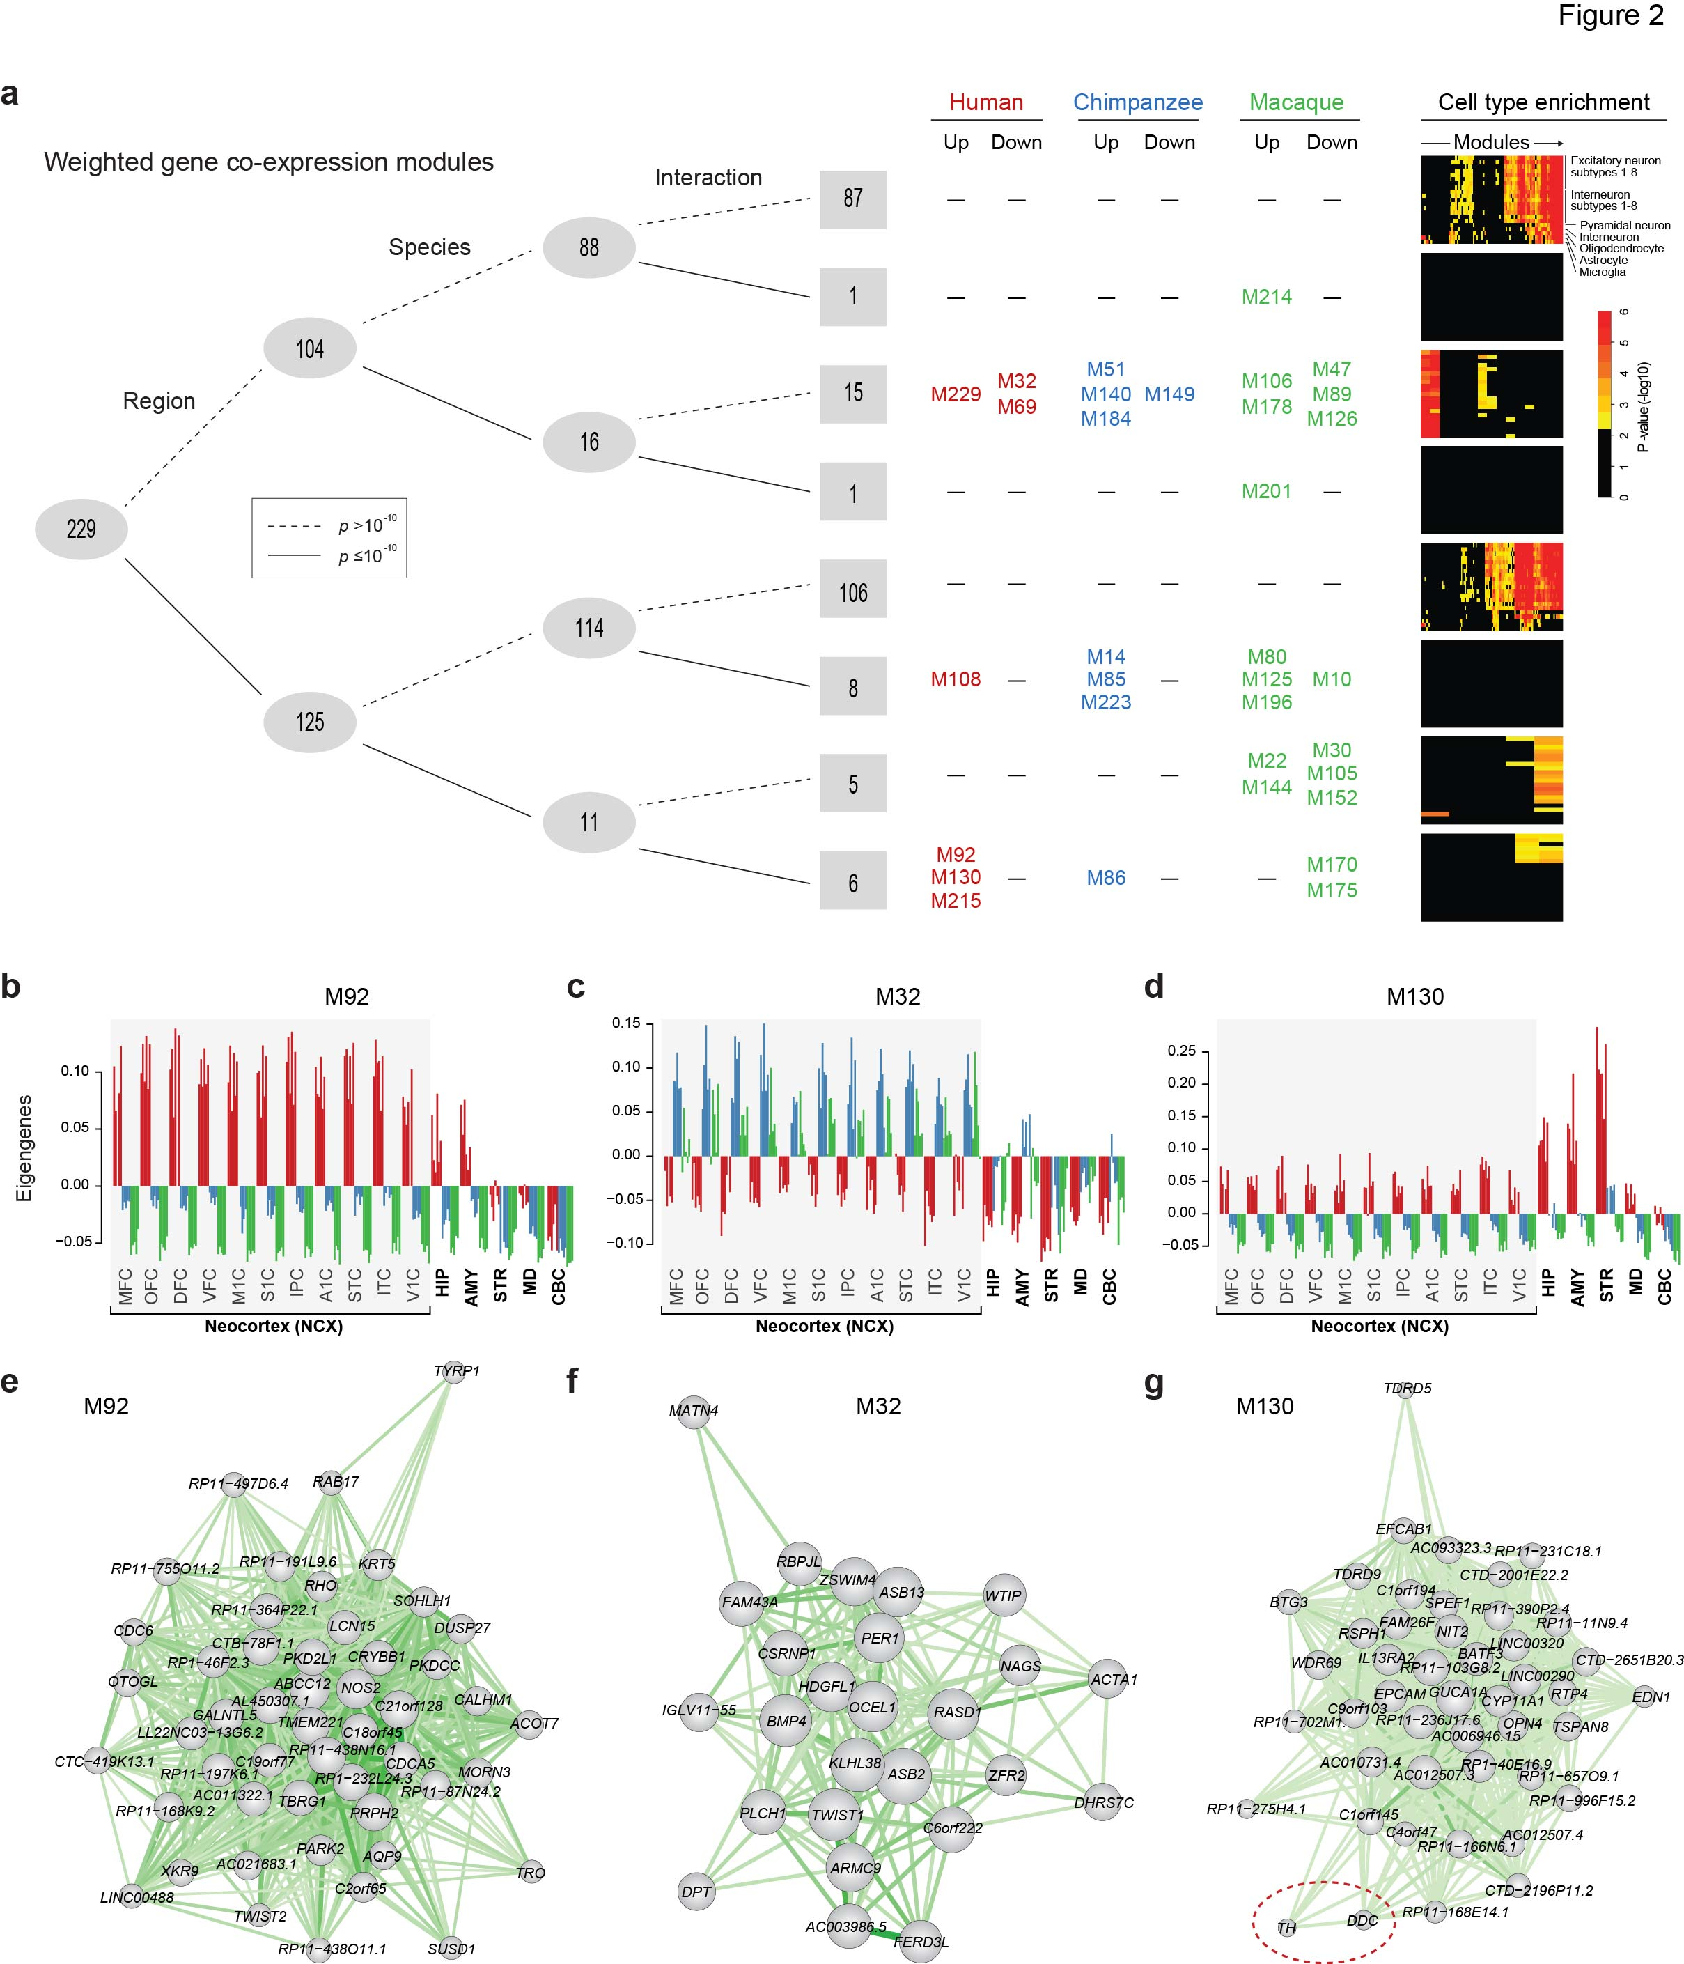

**Figure 2 | mRNA co-expression modules exhibit both conserved and species-specific expression patterns. a**, Left: mRNA co-expression modules are clustered by whether they are differentially expressed across regions and species, and whether the amount of inter-species difference is different across species (interaction). Significance is defined when ANOVA of eigengene p < 10-10. The number of modules in each category is listed. Middle: the modules showing human-, chimpanzee-, or macaque-specific up- or downregulation are listed in red (human), blue (chimpanzee), or green (macaque). Right: the enrichment of module genes in each cell type based on single-cell transcriptome data.The complete list of cell types enriched in each module can be found in Supplementary Table 5). **b, c, d,** Bar plots showing the spatial expression pattern of eigengenes of representative modules (M) (e.g., M92, M32, and M130) with region and human-specific patterns. **e, f, g,** Co-expression network illustration of the intramodular hub genes of these modules. M92 contains genes that are upregulated in human NCX areas, including *PKD2L1* whereas M32 is composed of genes that are upregulated in both chimpanzee and macaque NCX areas, including *TWIST1*. M130 contains genes that are upregulated mainly in the human STR, AMY, HIP and, to a lesser extent, NCX areas. *TH* and *DDC*, two genes involved in the biosynthesis of dopamine are hub genes of this module. The size of nodes represents the intramodular connectivity of the gene. Dark green represents higher connectivity between genes.

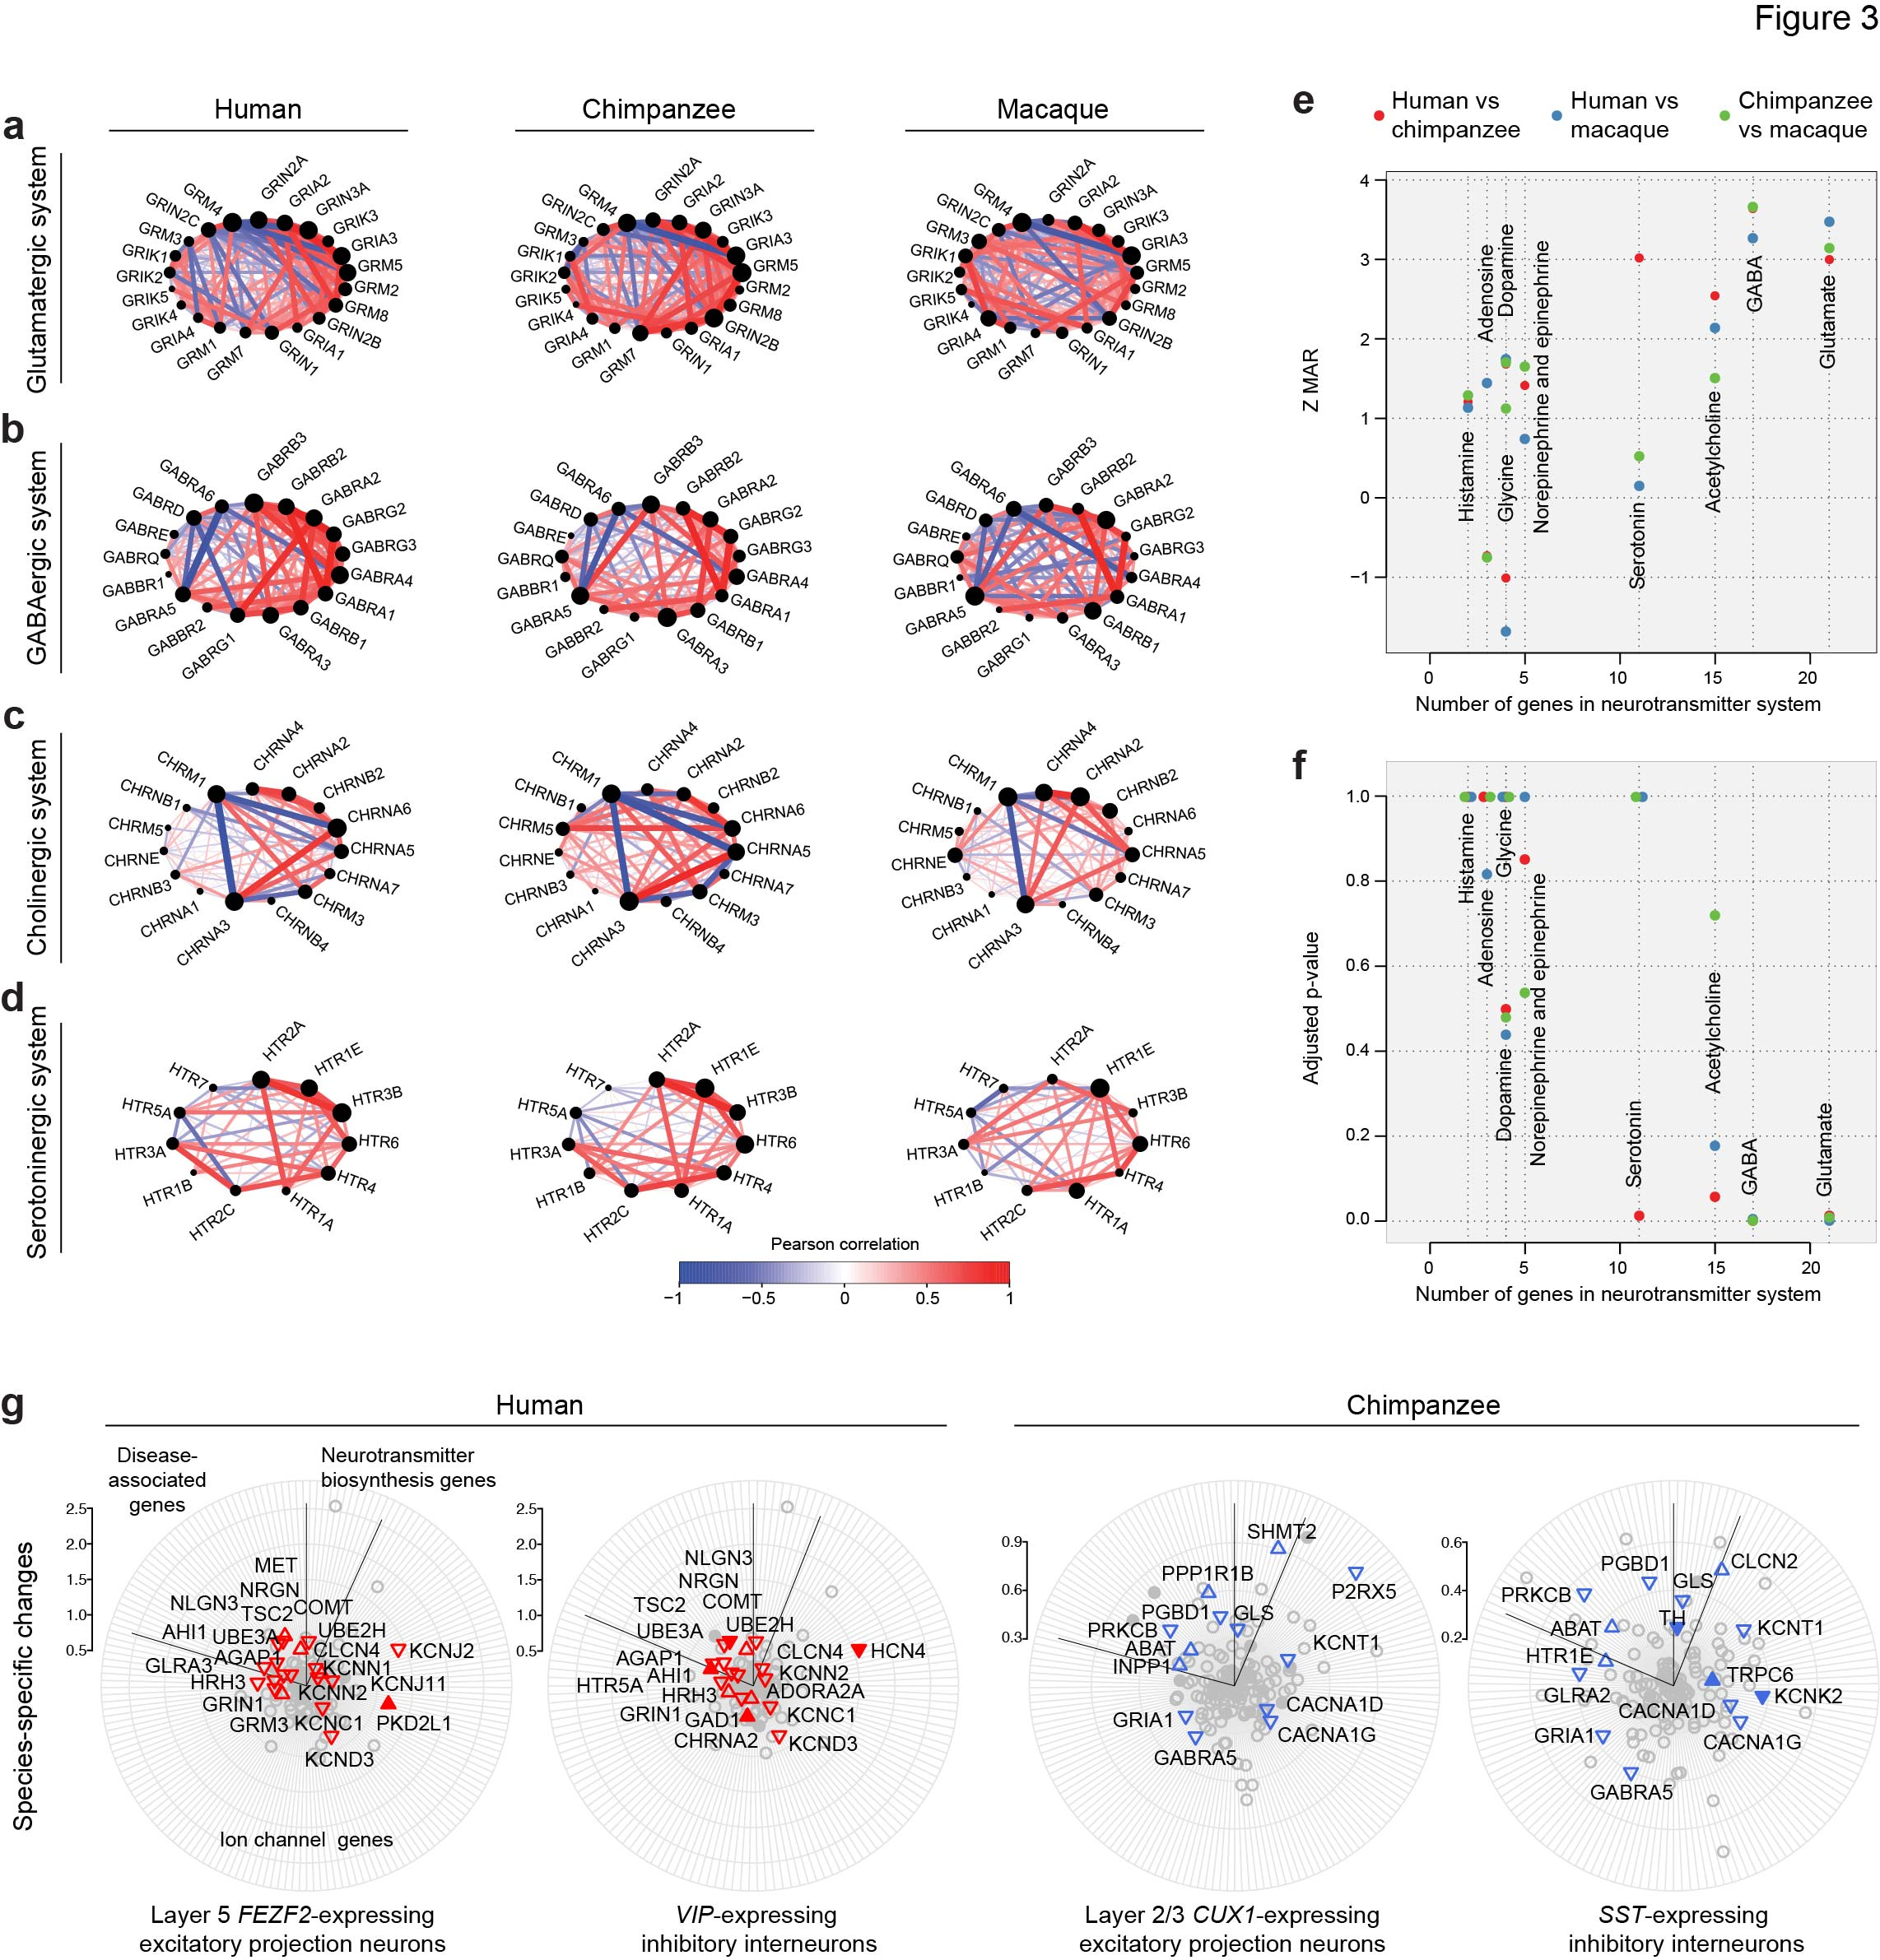

**Figure 3 | Evolution of neurotransmitter receptor gene co-expression networks and molecular reorganization of excitatory and inhibitory neurons. a** and **b**, Illustration of co-expression networks of mRNAs encodingglutamatergic (a) GABAergic (b)cholinergic (c), and serotoninergic (d) receptor subunits. Positive correlation (red) and negative correlation (blue) between genes are shown. The width of the edges shows the degree of co-expression. **e,** Z statistics of the Maximum Adjacency Ratio (MAR; see Methods) and **f,** the corresponding p-values of neurotransmitter receptor networks show that the GABAergic and glutamatergic systems are the most conserved (*P* < 0.05). Cholinergic and serotoninergic systems show lower conservation, especially in macaque (*P* > 0.05). All other neurotransmitter receptor networks analyzed show low conservation among the three species. **g** Radar plot depicting inter-species differences and cell-type enrichment of genes enconding neurotransmitter biosynthesis, degradation and transport, genes encoding ion channels, and disease-associated genes (clockwise). Only the genes expressed in the respective cell type are plotted. The distance of each gene to the center represents the differential expression between human and the average of the other two species (left) or between chimpanzee and the other two species (right). Genes with human- or chimpanzee-specific expression are labeled red and blue, respectively. The direction of a triangle denotes up- or down-regulation of that gene in that species; filled triangles represent cell-type specific expression (Pearson correlations > 0.5; see Methods).

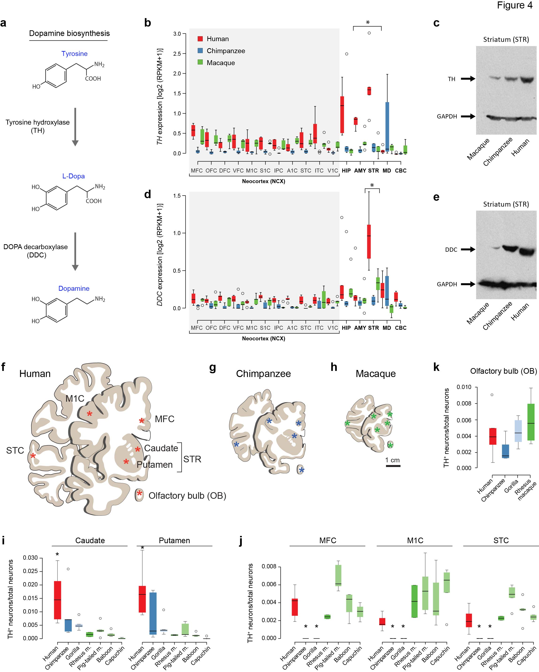

**Figure 4 | Human-specific upregulation of genes associated with dopamine biosynthesis.**

**a**, Schematic figure of the dopamine biosynthesis pathway. **b**, **d**, Expression [log2 (RPKM+1)] pattern of *TH* and *DDC*, respectively, showing higher expression in the human STR. The boxes represent quartiles of the data and the whiskers represent 1.5 times interquartile range. Asterisk represents human-specific differential expression (FDR < 0.01). **c**, **e**, Immunoblot of TH and DDC, respectively, in striatal lysate showing higher levels of protein in human than in chimpanzee and macaque. GAPDH serves as a control for equal protein loading. **f**, **g**, **h,** schematic representation of a human, chimpanzee, and macaque coronal section representing the areas sampled for TH+ counting in **i,** STR (caudate and putament); **j,** MFC, M1C, and STC; and **k,** olfactory bulb (OB). The number of TH+ interneurons per total number of neurons is statistically higher in the human dorsal caudate and putamen, confirming the higher expression of *TH* in this area. Importantly, TH+ neurons are totally absent of neocortical samples (MFC, M1C, and STC) of chimpanzee and gorilla. Asterisk represents Tukey's honest significance test p < 0.05 comparing with all other species.

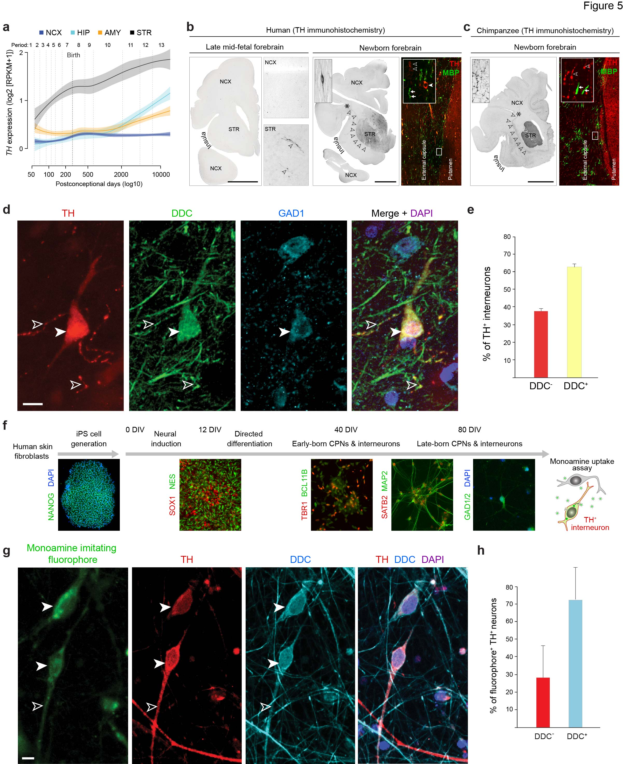

**Figure 5 |** **Developmental origin and characterization of cortical interneurons expressing dopamine biosthesis and transport genes/proteins. *.* a**, *TH* expression in human NCX, HIP, AMY, and STR. *TH* expression in STR increases steadily starting from early fetal development (period 2, as defined in ref. 20) to young adulthood (period 13). *TH* expression in AMY, HIP and NCX increases perinatally (periods 7 [late fetal development] and 8 [early infancy]) and remains stable in NCX, increasing again sharply from early childhood (period 10), to adolescence (period 23) and young adulthood in AMY and HIP. The shaded area corresponds to an interval of confidence of 50%. **b**, TH+ interneurons are detectable in the human newborn (period 7 to 8 transition) STR, and NCX, but not during late midfetal development (24 PCW; period 6), when mainly TH-positive fibers are observable in the STR. Immunofluorescence shows that the TH-positive fibers (arrowheads; likely midbrain dopaminergic projections) do not colocalize with MBP (arrows), indicating that these fibers are not myelinated in newborns. Bipolar TH+ interneurons (filled arrowhead) are present in parallel with the fibers in external capsule. Scale bar represents 1 cm. **c,** Immunostaining of TH+ interneurons of a newborn chimpanzee shows that TH-positive fibers are also present in the external capsule and that they also do not colocalize with MBP. However, no TH+ cell was detected in the chimpanzee external capsule. **d,** Immunofluorescence of TH+ interneurons show that they also express DDC (the enzyme that produces dopamine), and GAD1 (one of the enzymes that produces GABA). Scale bar represents 10μm. **e**, Bar plot displaying the percentage of TH+ interneurons that did not express DDC (red), and that expressed DDC (yellow) in the adult human MFC. All TH+ interneurons were GAD1+. **f**, Schematic representing the derivation and differentiation of cortical neural cells from human iPS cells. After 80 days of differentiation, early-born (TBR1+ and BCL11B+) and late-born (SATB2+) cortical excitatory projection neurons were present. GABAergic interneurons (GAD1/2+) were also detected. A monoamine uptake assay was performed using these cells to determine whether they were able to transport monoamines. **g,** A population of interneurons that were positive for the uptake assay expressed both TH and DDC. Scale bar represents 10μm. **h,** Bar plot representing the percentage of interneurons that were positive for the uptake assay and expressed TH and DDC (blue) or expressed TH but not DDC (red).