.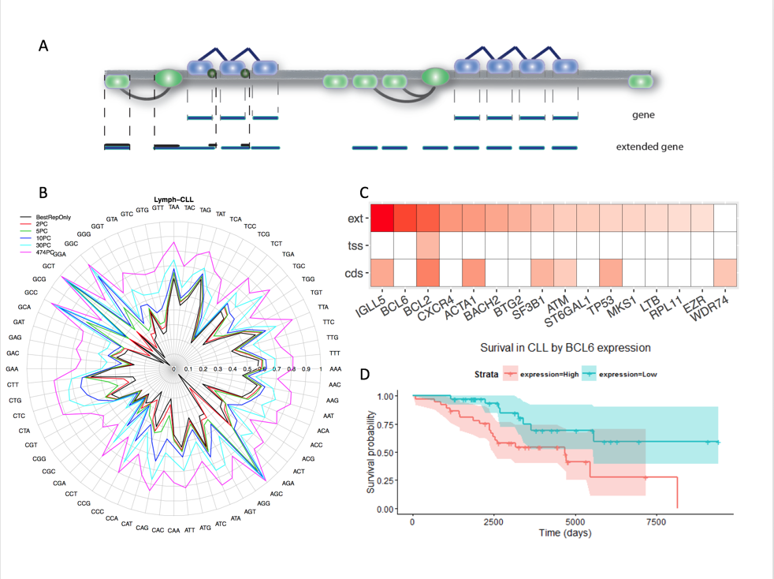

Fig 1

For B, still good to have a barplot.

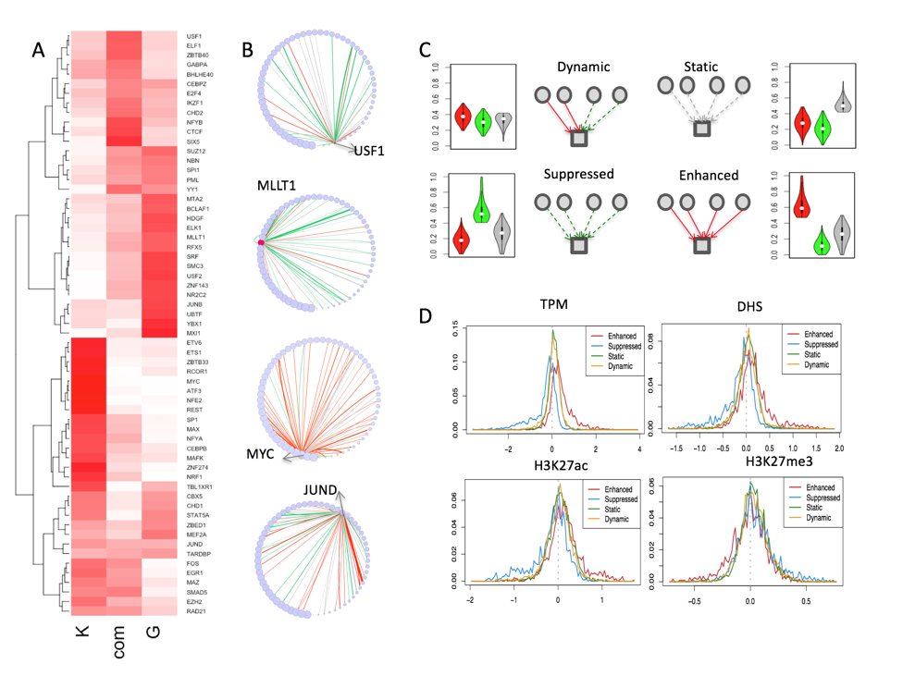

Fig2.

A - K, com, G labelling, this is a good figure, but little writing on the figure would help, group TFs by color

B

C - same color, label for TF viewpoint and Target viewpoint

D - it can be confused with aggregation plot. Linking with other part of figures

DL vers liked

Need to unify A to C & D simplifed & maybe barred

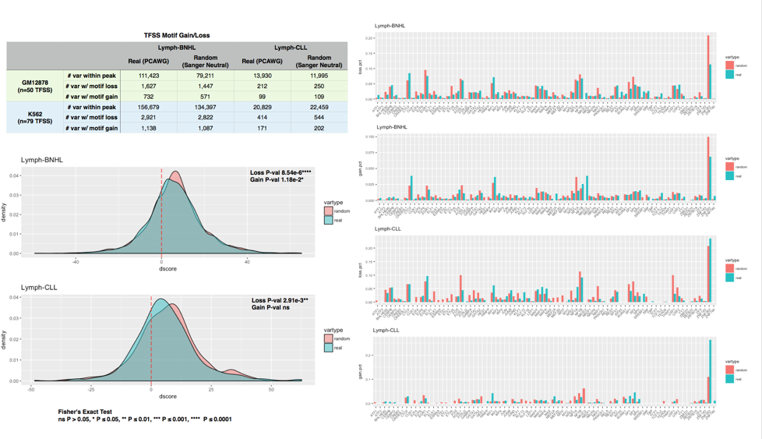

Fig3.

Unsure about & need to discuss

Look the giant table

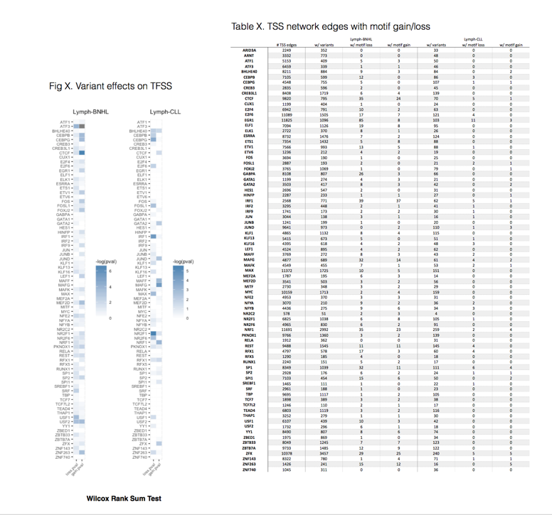

Fig4.

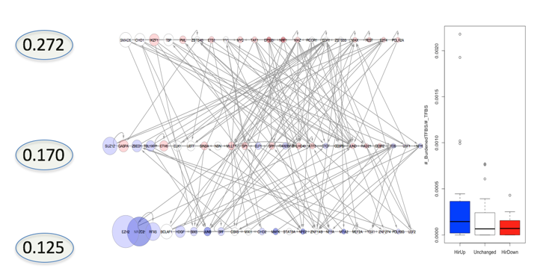

Fig5 (not main figure) hierarchy

Left - Very thin gray lines for full network, thicker lines for TIP network

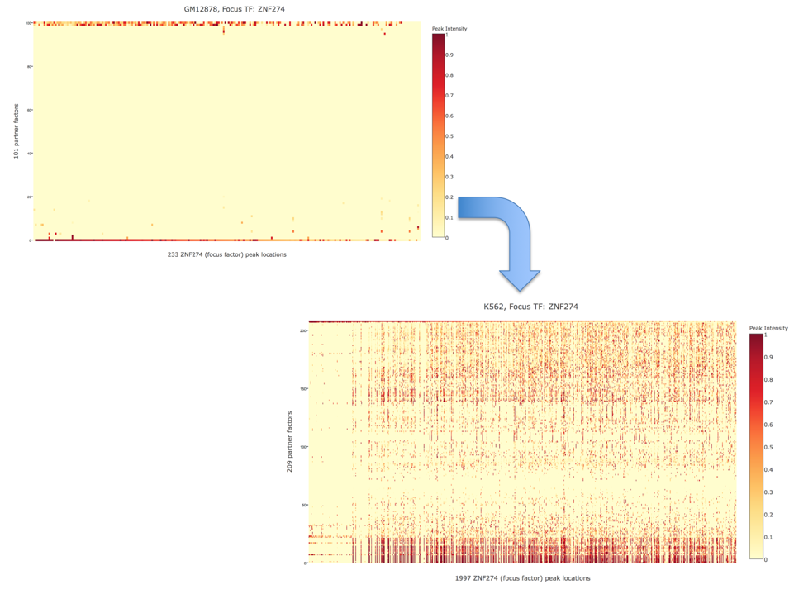

Fig6

More labels, date vs party hub(?)

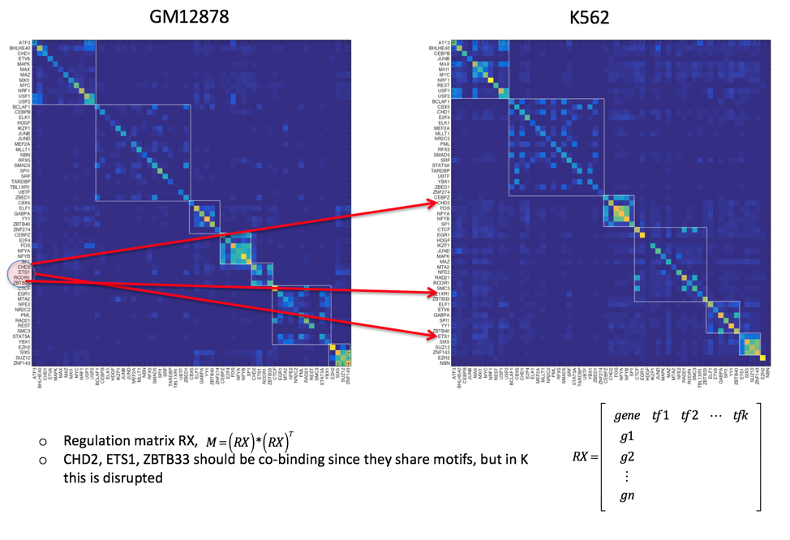

Fig7

Legend, don’t see which group is preserved or not,

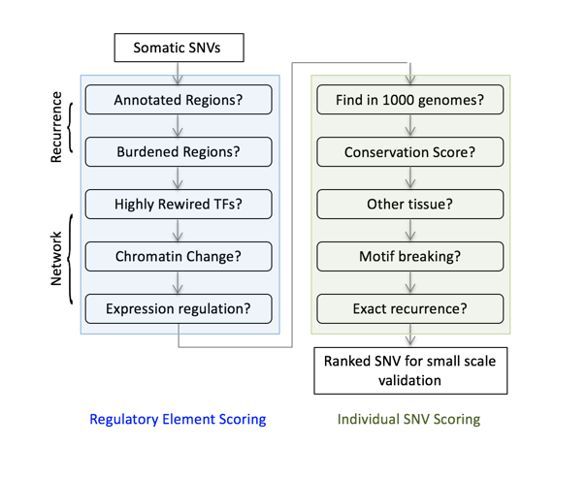

Fig8

Think about Rabit

1000 genomes?

Three levels of prioritization

Regulator > element > micro(base)

TF KD > enhancerseq > luciferase knockout (mutation)

Paste in the picture from the iphone

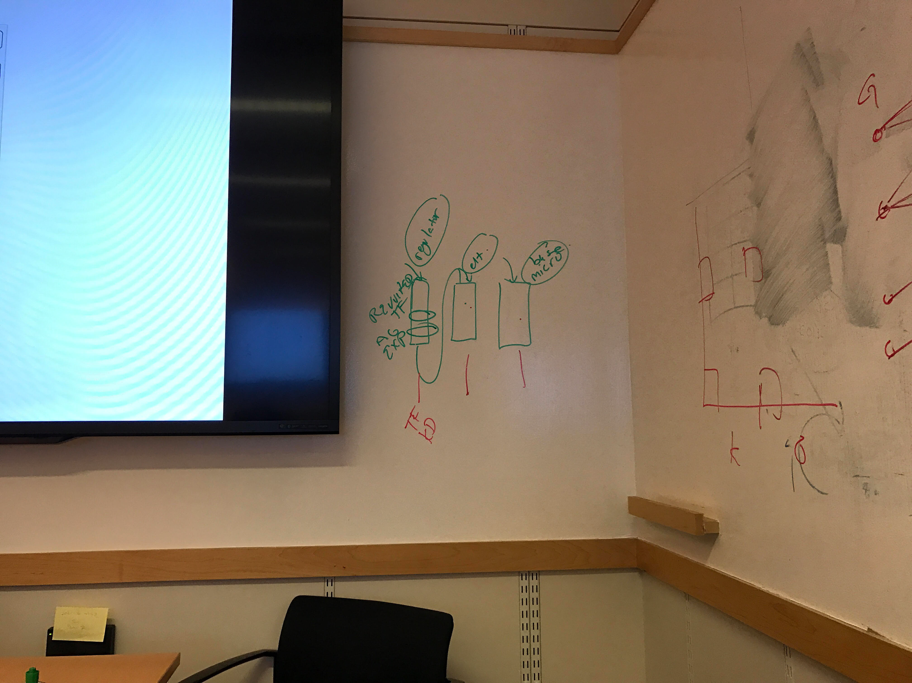

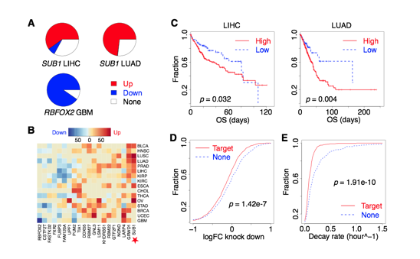

Fig9

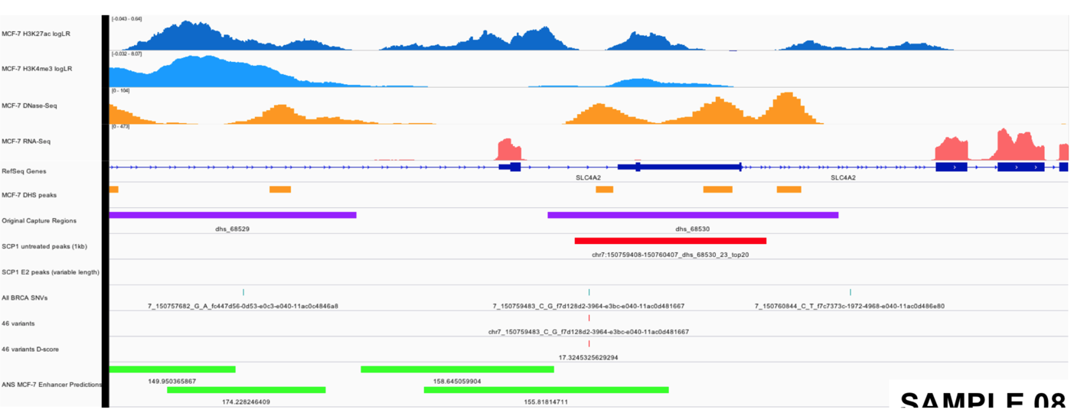

Include validation figure like this

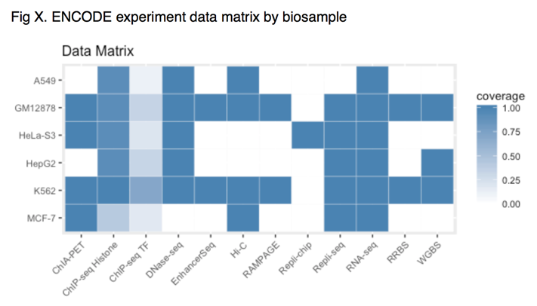

Cohort size for TCGA (de-PCAWG)

Matched normal (K&G, HepG2&liver) + mention the cancer

Liver data freely available

<Comments on supplementary table>

Cohort size for variants can go together with DL’s data table

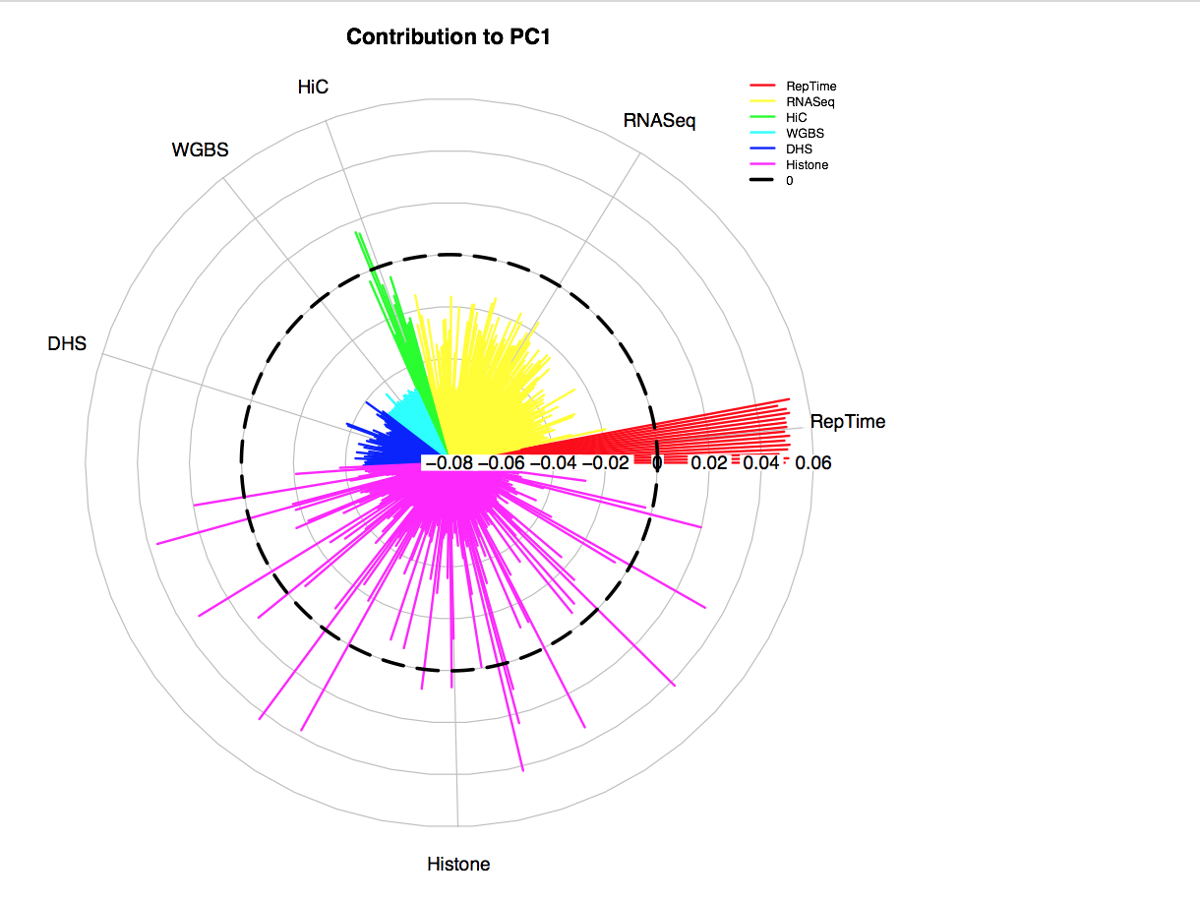

Performance plot may add them into the main figure. Barplot for performance improvement, radial plot for other all cancer pooled plot