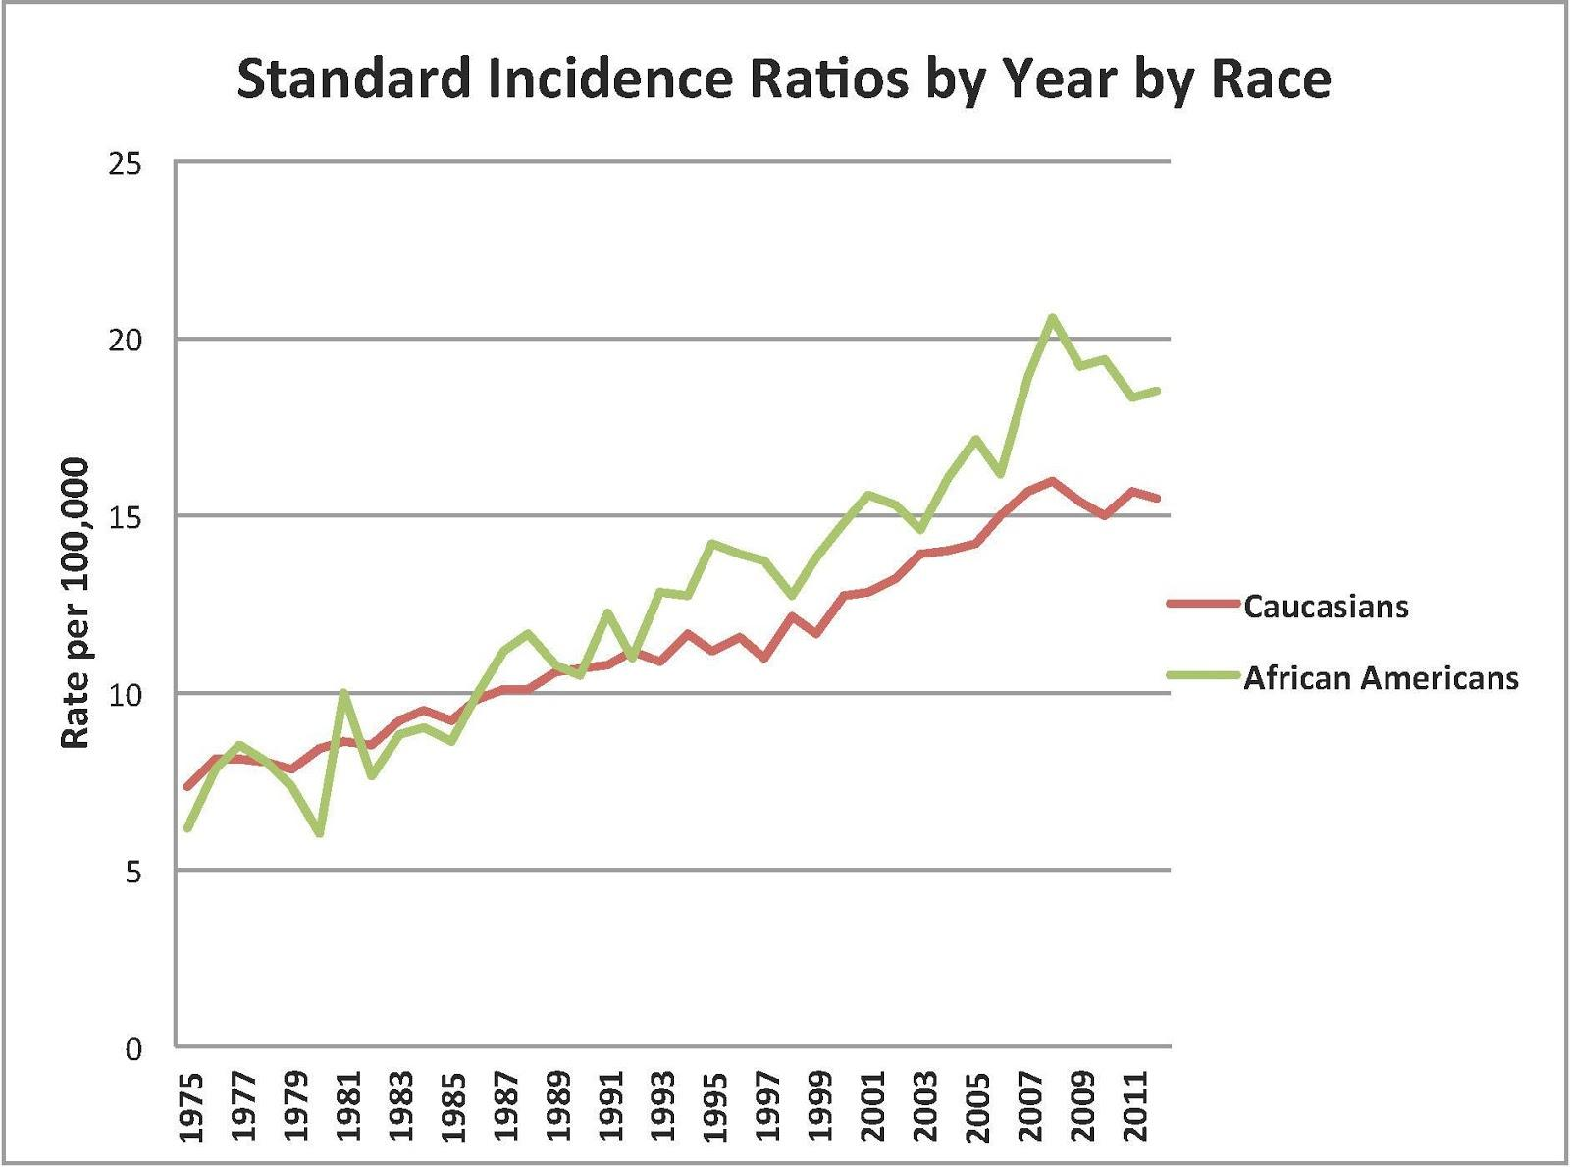

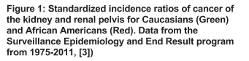

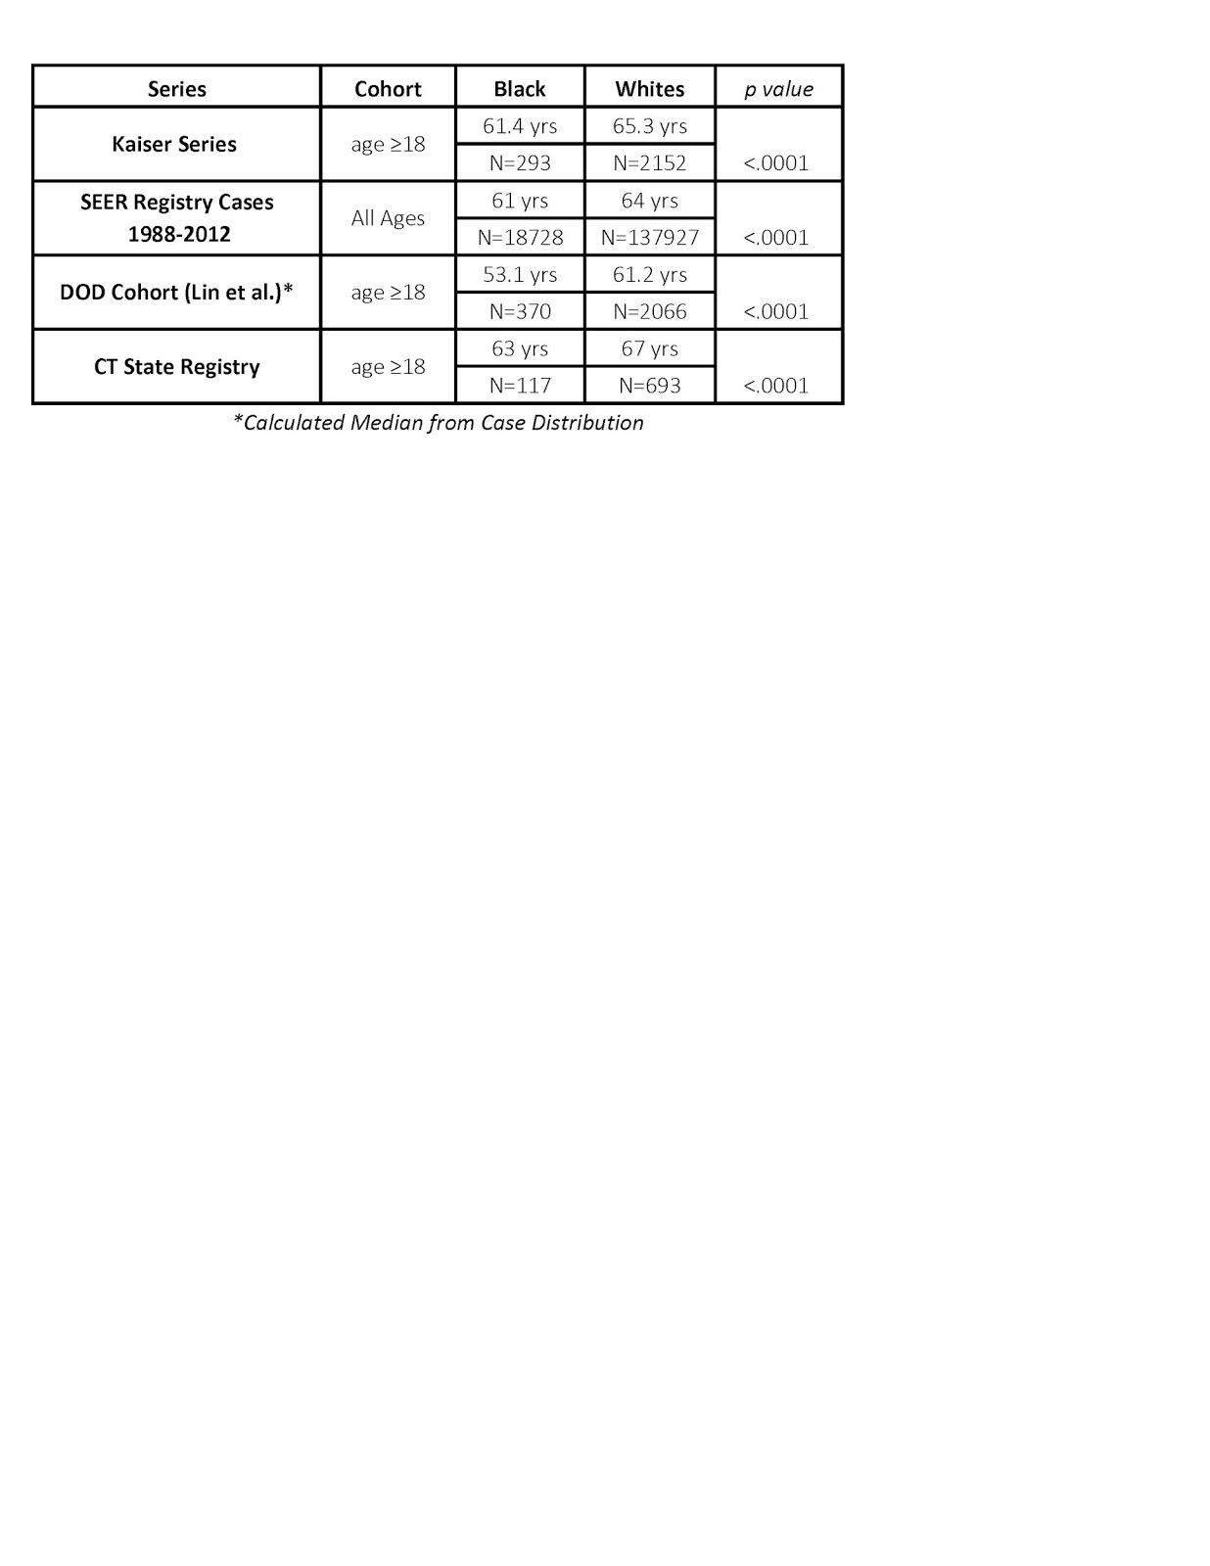

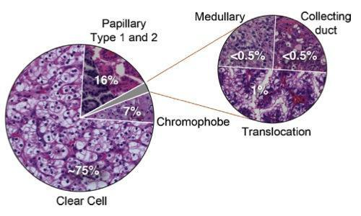





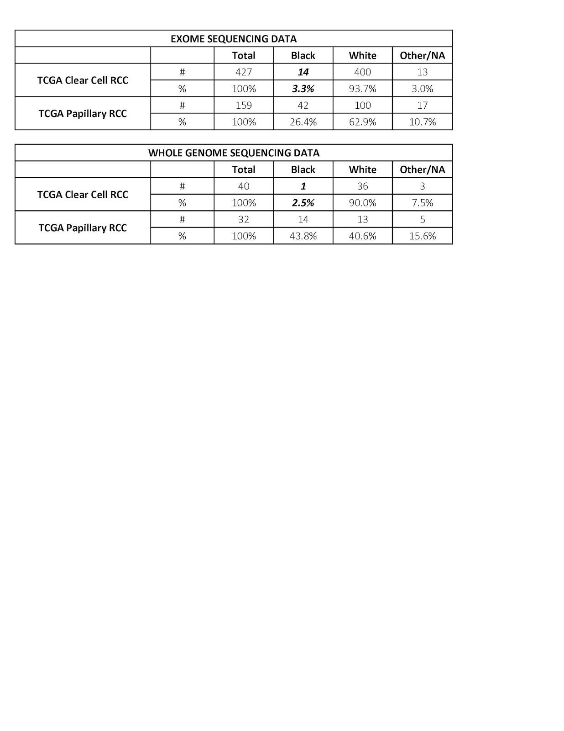



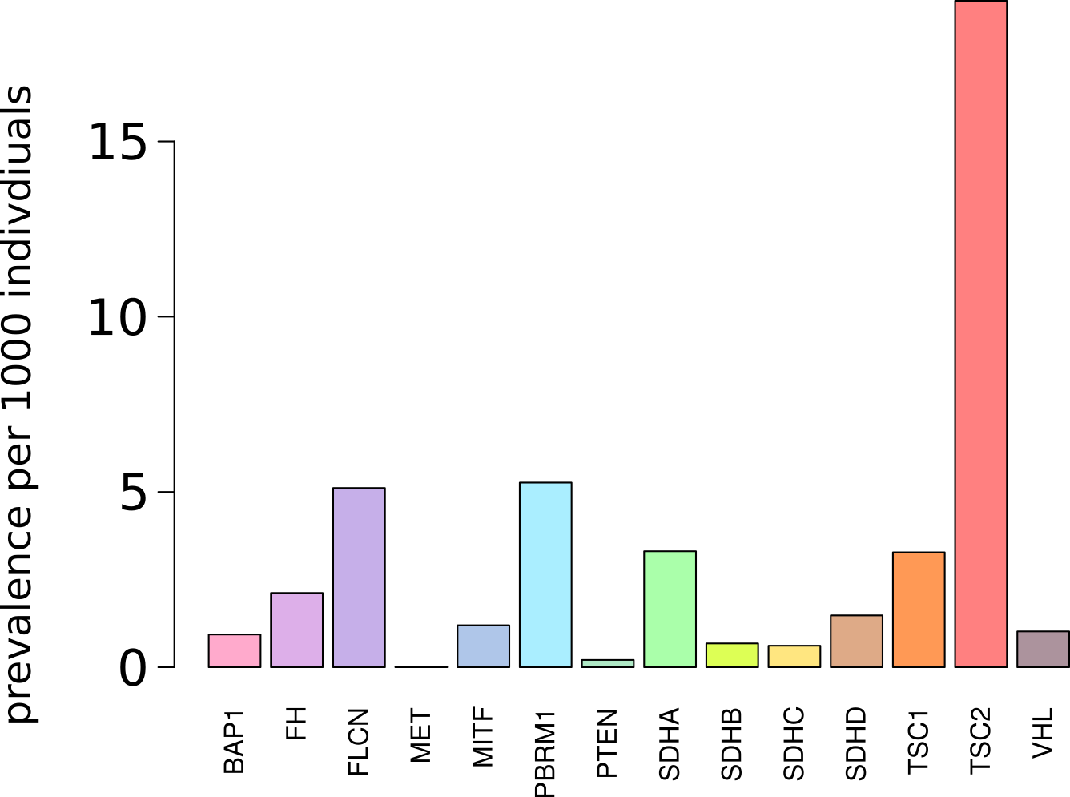

Figure ############# Prevalence of deleterious mutations in the ExAC database, for select kidney cancer associated genes.

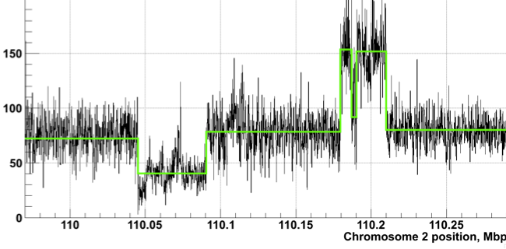



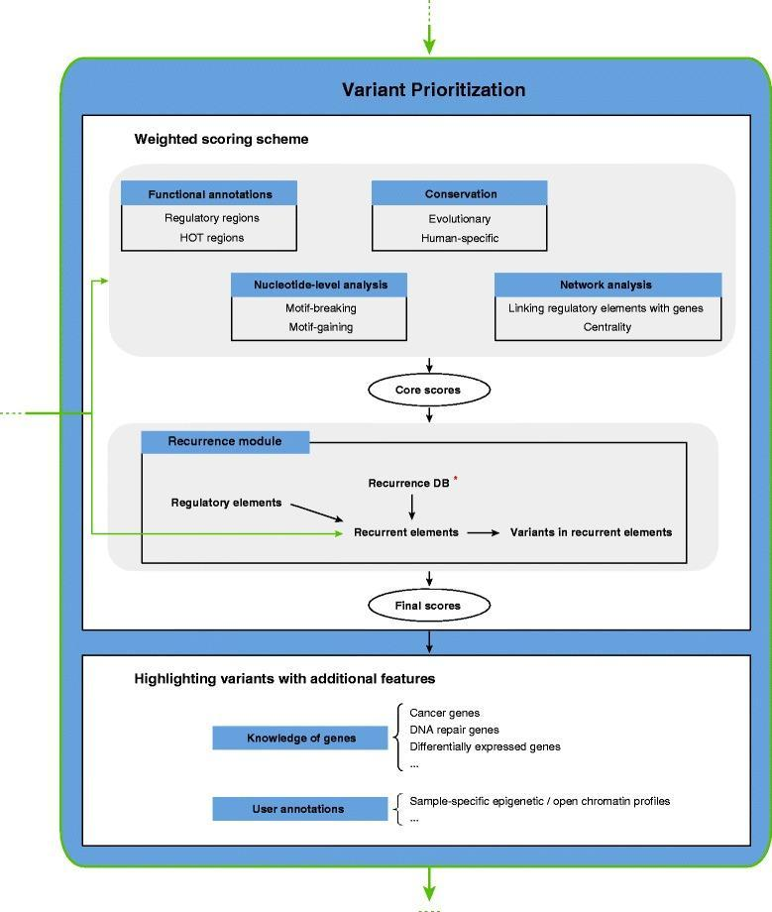



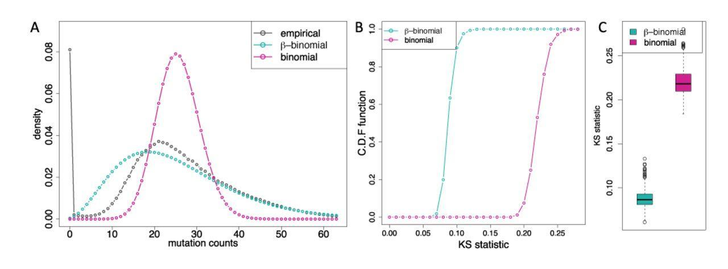

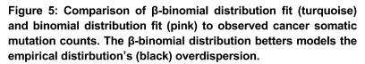

|  |  |  |  |
| --- | --- | --- | --- |
| *Overall* | *African American*    *(AFR)* | *Non-Finnish European (NFE)* | *Finnish*    *European*    *(FIN)* |
| 1/23 indiv. | 1/17* indiv | 1/20 indiv | 1/54 indiv. |
| *Highest rate among all races in the ExAC database | | | |

|  |  |  |  |  |
| --- | --- | --- | --- | --- |
| Derived allele frequency | | AFR | EUR | Overall |
| Potentially deleterious mutations | ExAC |  |  |  |
| 1000G | 4.7% | 3.6% | 4.5% |
| Potentially LoF mutations (1000G) | | 1.1% | 0.4% | 0.5% |
| ClinVAR (1000G) | | 0.3% | 1.2% | 0.6% |

