RESEARCH STRATEGY
SIGNIFICANCE
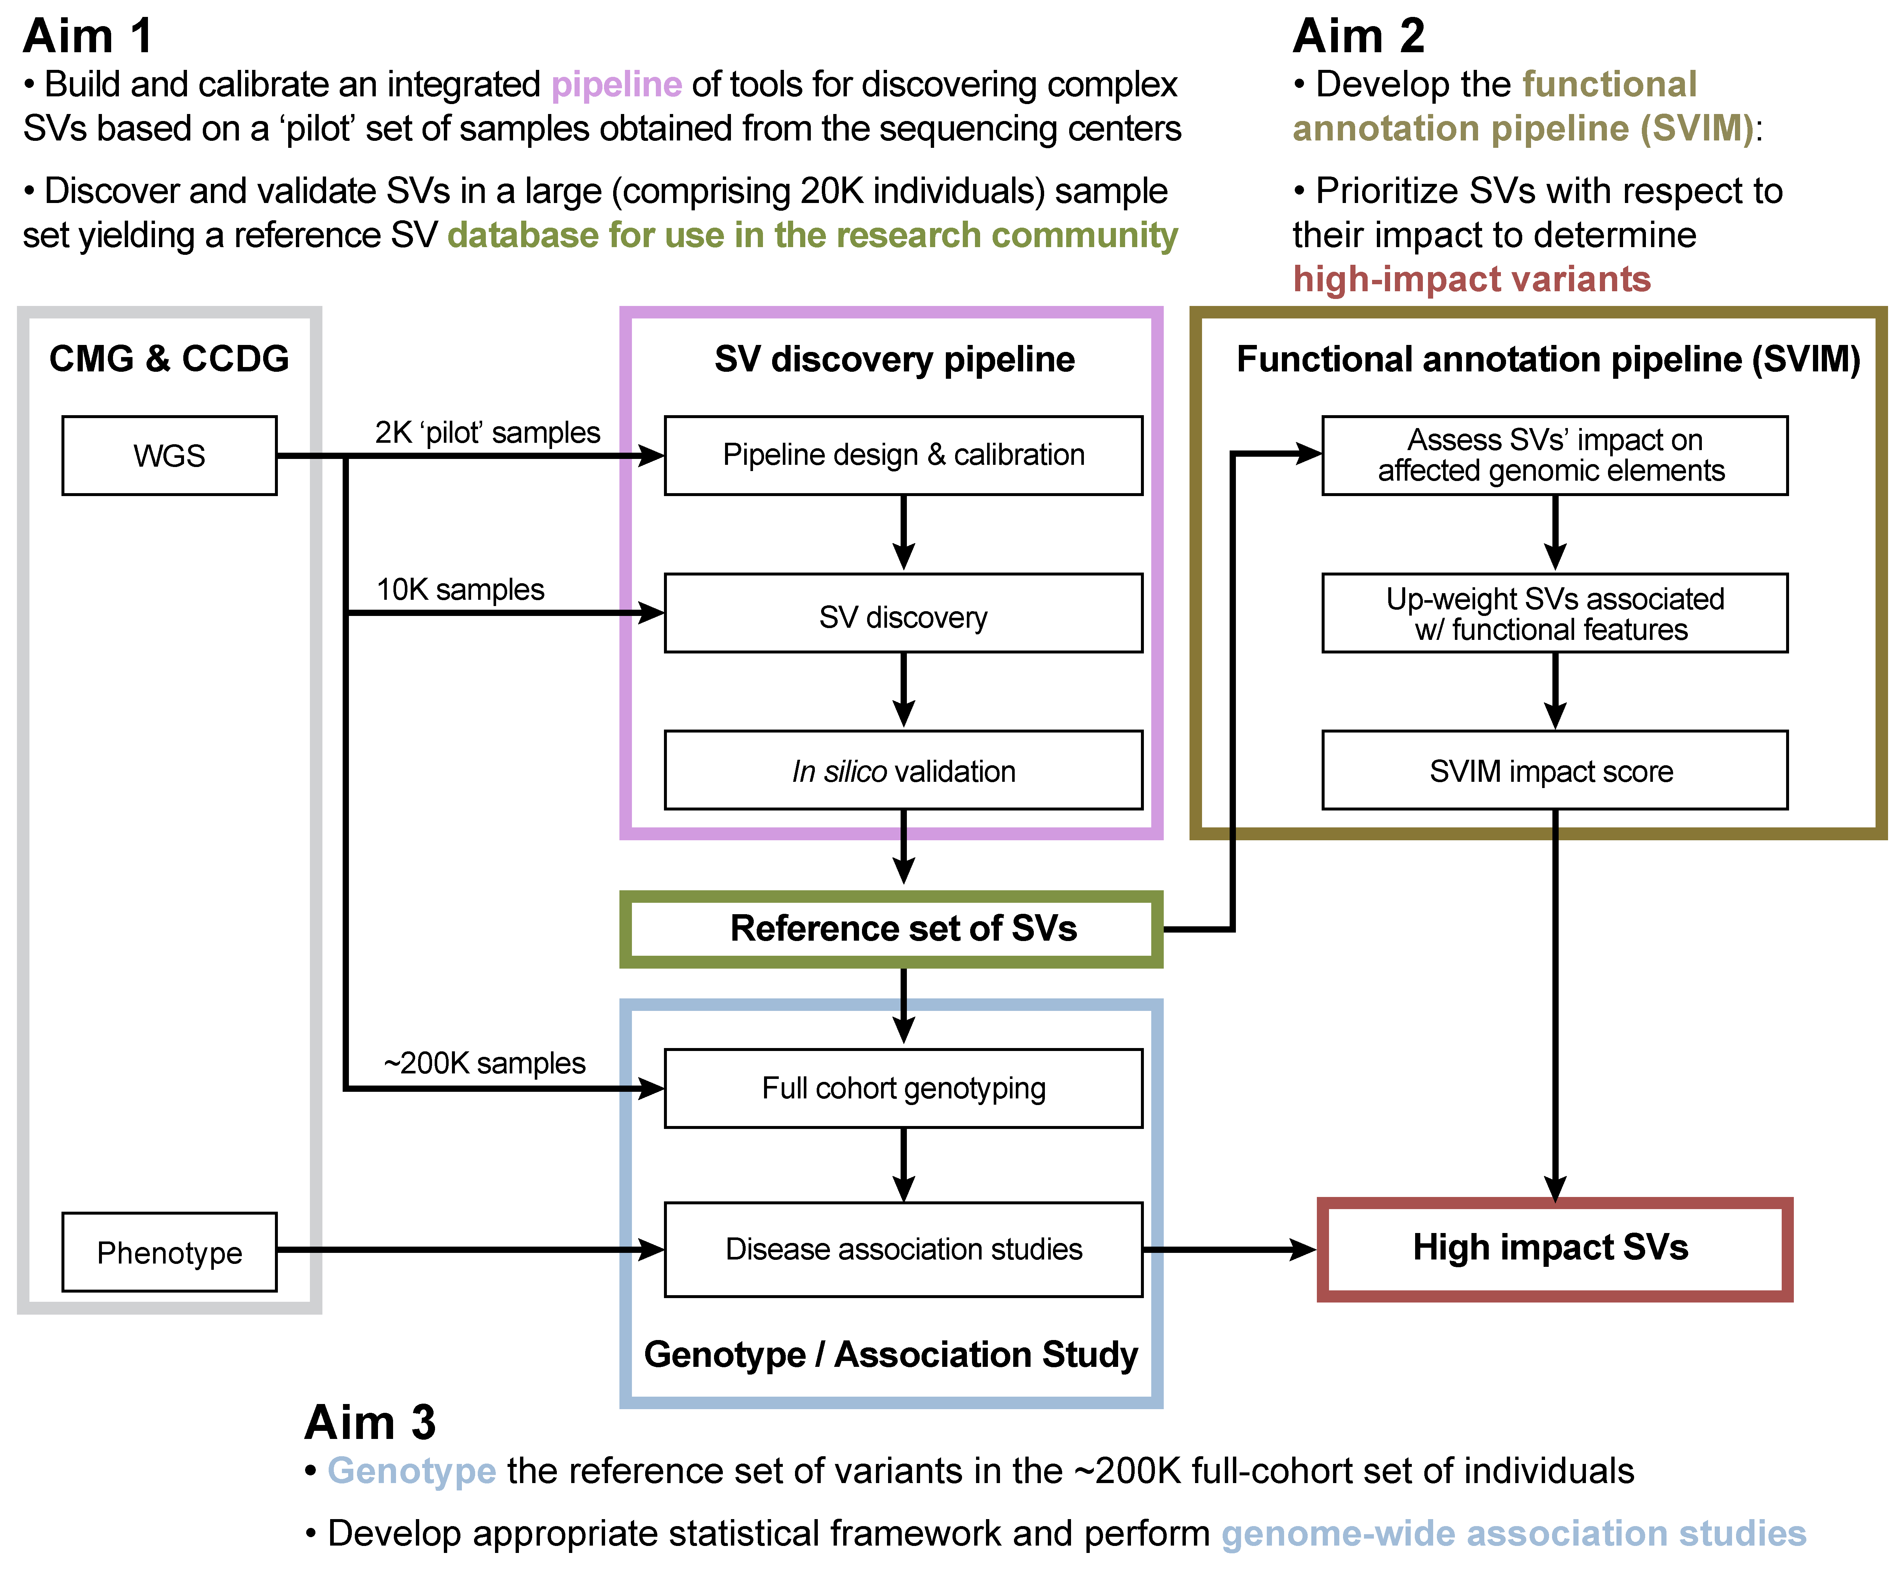
Structural variations (SVs), such as deletions, duplications, insertions, inversions and translocations, are among the most significant determinants of human genetic diversity to have been discovered. SVs affect far more bases than single-nucleotide polymorphisms (SNPs); thus, they can markedly affect phenotype in many ways, including modification of open reading frames, production of alternatively spliced mRNAs, alterations of transcription factor (TF) binding sites and structural gains or losses within the regulatory regions. Consortium efforts such as the 1000 Genomes Project (1000GP) estimate that a typical genome contains 2.1–2.5 thousand SVs, affecting ~20 million bases, or ~5–6 times that of SNPs. Beyond “simple” SVs, there is a growing appreciation for “complex” SVs in human genomes, which vary considerably in their architecture, ranging from small-scale insertions/deletions to complex patterns of rearrangements between distinct loci and/or even different chromosomes¹. Through the 1000GP, we found that a large fraction of SV events have much higher breakpoint complexity than previously estimated—suggesting that complex SVs, like simple SVs, are also widespread in human genomes.
Figure 1. Overall research plan for the JAX CSVA.

We are now compiling vital whole-genome data that will form the basis for comprehensive analyses of human genetic variation and will address current gaps in our understanding of complex diseases. In many disease contexts, known common single nucleotide variants (SNVs) account for a significant amount of phenotype variability. However, given that SVs are common, larger in size and highly structurally diverse, they are also poised to profoundly shape the regulation of many human phenotypes and disease states. Investigating SVs, and particularly complex SVs, could therefore hold the key to a deeper, more mechanistic understanding of common diseases. At present, most studies do not capture the spectrum of complex SVs present in genomes, and therefore this complexity is not adequately accounted for in disease association studies. Furthermore, the functional impact of SVs, especially in noncoding regions, has not been investigated systematically. Surmounting these issues will depend on novel computational methodologies for i) mining whole genome sequencing datasets for SV discovery at high resolution and large scale, ii) functionally interpreting their origins and phenotypic effects, and iii) establishing associations between specific SVs and disease.

We seek support to establish The Jackson Laboratory Center for Structural Variation Analysis (JAX CSVA), to advance the overarching goals of the GSP through computationally-driven discovery, functional validation and characterization of disease-associated SVs (Figure 1). We will integrate novel and powerful tools for high-resolution SV discovery and, in collaboration with the primary data-producing centers of the GSP, use these to comprehensively profile all types of SVs, including complex SVs, from a large subset of the genomes being sequenced (Aim 1). To examine the functional impact of the identified SVs, we will develop novel methodologies for functional annotation of variants and characterization of associated biological processes (Aim 2); these studies will also enable us to prioritize subsets of SVs for the association studies proposed in Aim 3. Finally, we will scale up SV detection and analysis through genotyping of all SVs detected in Aim 1 across the ~200,000 samples of the GSP, which will provide the necessary statistical power for meaningful genotype-phenotype associations for disease-based SV association studies (Aim 3). We will be able to make inferences about human population structure and adaptation at a scale much greater than anything attempted so far. Our deliverables will be the largest library of validated SVs discovered in humans, together with an unprecedented platform of pipelines for comprehensive, high-resolution and large-scale SV analysis.

INNOVATION
The originality of the JAX CSVA lies in the integration of cutting-edge computational methodologies—pioneered by the group—into a comprehensive platform for novel SV discovery, characterization and association with common human diseases. It is well known that our ability to generate large-scale genomic sequencing data is far outstripping our ability to analyze it at the scale and resolution required to make definitive functional associations. This issue is particularly relevant in the context of complex SVs, for which important details of their origin and functional effects cannot be appreciated without the proper tools for analysis at nucleotide resolution. Furthermore, the present approach combines high-resolution SV analysis balanced against the scale required for adequately powered association analyses. Our proposed detection and genotyping strategy provides higher power and resolution for investigating association between SVs spanning a large size spectrum and various phenotypes, surpassing previous standard approaches employed in current SV association studies. Briefly, the key innovations of our approach are: 1) Development of a scalable pipeline incorporating the latest, cutting-edge SV detection and integration tools, with a focus on high-resolution classification of complex SVs. 2) Tools for annotating variants with functional data from coding and non-coding (nc) parts of the genome, especially ncRNA and nc regulatory regions. 3) Tools for mechanistic interpretation of SVs across different classes, allowing us to make inferences about population structure and human adaptation and evolution. 4) Association tests that integrate weighting methods for various biological considerations, such as allele frequency and impact score, to a generalized linear model for capturing subtle association signals often missed by conventional approaches. 5) Genotyping the library of functionally and genetically relevant SVs across the entire cohort of GSP samples for well-powered genotype-phenotype associations in a disease context. This systematic review of complex SVs will yield the largest reference database of validated SVs to date, together with an unparalleled system for high-dimensional, high-resolution studies of SV architecture and function in health and disease.
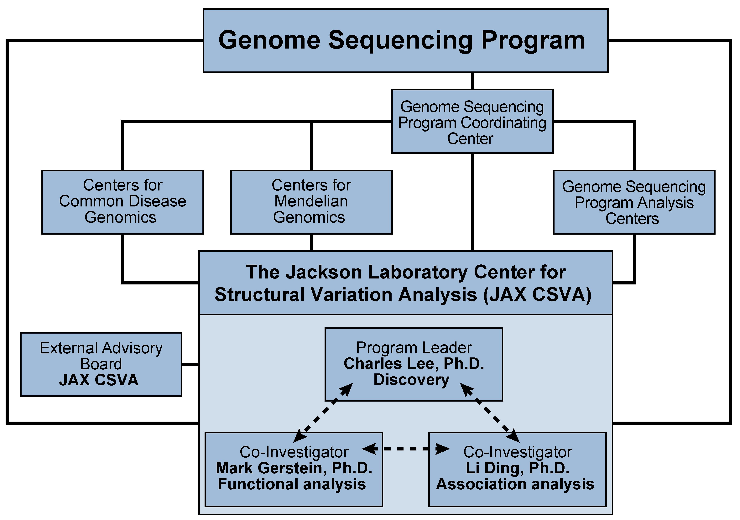
CENTER STRUCTURE AND ADMINISTRATION
Figure 2. Structure of the JAX Center for Structural Variation Analysis
We envision the JAX CSVA as a nexus that will connect the data-producing and analysis centers of the GSP (Figure 2). By focusing on the discovery and analysis of SVs—a widespread form of genomic variation observed across common and Mendelian diseases—we expect to inform the analyses conducted by other GSPACs. We anticipate frequent communication and exchange of data sets, analytical tools, and results, as this will be critical for maximizing the utility of the data and extracting meaningful biological insights. These exchanges will also be critical for facilitating program-related objectives, i.e., towards the definition of new standards and controls for complex common disease studies, which similarly cut across the goals of individual GSP components.

Scientists participating in the JAX CSVA are leaders in SV discovery and analysis. The three PIs, Charles Lee, Ph.D., Mark Gerstein, Ph.D. and Li Ding, Ph.D., have a history of productive scientific collaboration and bring complementary experience in SV detection (Lee), functional interpretation (Gerstein) and large-scale data analysis (all), particularly association analysis (all). Each also brings significant experience in leading (1000GP SV group; Lee) and participating in (1000GP, Lee/Gerstein/Ding; ENCODE, Gerstein; ICGC, Gerstein/Ding) large-scale sequencing consortia. Under Dr. Lee’s leadership, the 1000GP SV project identified SV events in ~2,500 healthy genomes and helped define the methodologies for identifying and characterizing SVs from “lower depth” (~4X) whole genome sequencing (WGS) datasets. This experience will be critical for facilitating cross-program goals, i.e., defining metrics for robust and comprehensive complex disease studies, and for ensuring seamless integration of the JAX CSVA within the broader GSP. The team includes investigators with broad knowledge and leadership experience in large-scale genomic sequencing consortia (Weinstock) and in mathematical and biostatistical tool development for the analysis of complex genomic datasets (Wendl, Chuang, Ye, Zhao, Ouyang and Malhotra).

The proposed program will be supported by an extensive computational infrastructure at The Jackson Laboratory for Genomic Medicine, the site for the proposed JAX CSVA. Generous institutional commitments (see letter from Dr. Liu) towards development of the JAX Cloud will furnish the data storage and computational power needed for the formidable requirements of the project. The JAX CSVA will further benefit from the information technology, computational, bioinformatics, and software expertise resident at JAX and will act as a hub for all intellectual, computing and resource sharing aspects of the proposed program, both among its members and between centers of the broader GSP.

RESEARCH STRATEGY
Specific Aim 1. Build an integrative pipeline for large-scale discovery of complex structural variation.
Rationale. Complex SV events are outside the design scope of available SV methods, yet are often of high impact and important for disease studies. To drive the discovery phase of the program, we propose an Integrated Analysis of Structural Variants (iASV), a pipeline of tools developed by our group to discover SVs in thousands of sequenced whole exomes and whole genomes. iASV would be applied to the discovery cohort of individuals being sequenced by the Centers for Common Disease Genomics (CCDG) and Centers for Mendelian Genomics (CMG). Using breakpoint assembly methods, we will perform in silico validation of the SV events and use the assembled contigs to investigate the inherent complexity prevalent at breakpoints. Ultimately, these studies will deliver the largest library of validated SVs discovered in humans and allow us to make novel biological inferences at the population level and in disease-specific contexts.
Figure 3. Breakpoint assembly for in silico validation. The top half of the figure shows a deletion SV event predicted by the readpairs spanning the event. All read pairs in the breakpoint locus are used for targeted de novo assembly and the resulting contig is aligned back to the genome.

Preliminary data.
A toolbox of methods for structural variation discovery. As part of the 1000GP SV project, we have provided the research community with an unprecedented set of germline SVs from more than 2,500 normal human genomes that have been sequenced at low depth and have developed a large toolbox of complementary tools and methods, including: (i) Read depth–based tools (CNVNator). We developed CNVnator² for copy number variant (CNV) discovery and genotyping from individual and trio-sequencing datasets. It utilizes a mean-shift approach, GC correction and bandwidth partitioning to identify a wide range of CNV events. CNVnator can detect CNVs and provide genotype information on a population level, and also detects atypical CNVs including de novo and multi-allelic events. (ii) Paired end–based tools (BreakDancer, Meerkat, Hydra-Multi, Pindel). Meerkat³, Hydra-Multi⁴ and BreakDancer⁵ cluster abnormally mapped paired-end reads to identify loci with a signature for an SV event. Meerkat remaps soft clipped and unmapped reads to generate clusters to identify breakpoints. Pindel⁶ utilizes a pattern-growth approach to detect large deletions and insertions from WGS data. These methods have individually already been successfully applied to hundreds of cancer genomes^{3,7}. (iii) Split read alignment–based tools (SRM, SRIC and BreakSeq). We have also developed SRM⁸ and SRIC⁹ for the high-resolution identification of SV events from WGS datasets. These tools specifically aim to provide base-pair resolution of breakpoints—an invaluable feature that enables functional interpretation of the biology of these SV events.

We also developed the Genome Variant Investigation Platform (GenomeVIP, manuscript in preparation) for analyzing very large cohorts. It is an initial pipeline framework that manages the use of individual algorithms for germline, somatic, and de novo SV analysis in the cloud or on traditional high-performance compute clusters. This Specific Aim will build on this framework and incorporate many other novel computer algorithms and improve performance.

Breakpoint assembly tools for in silico validation. We also developed algorithms for identifying breakpoints at nucleotide resolution, thereby allowing us to validate SV breakpoints “in silico”. As previously described⁷, we used assembly-based methods like SGA¹⁰ or TIGRA-SV¹¹ for generating sequence contigs at breakpoints. Aligning these contigs back to the genome in the expected location and orientation validates the SV call (Figure 3). Using this method, we validated 64.8% of somatic breakpoints and 58.5% of germline control breakpoints⁷. We also developed AGE¹², which performs sequence alignment at regions flanking SVs while considering large deletion and insertion blocks, which cannot be handled by conventional sequence alignment algorithms.

Tools for complex event identification and assembly. It is now recognized that a large fraction (10–20%) of SV events are complex in nature^{7,13}. We developed PEMer¹⁴ as an initial method for identifying complex rearrangements from WGS datasets. In another study, we comprehensively characterized complex SVs from a large cohort of TGCA WGS datasets⁷ and validated them in silico.

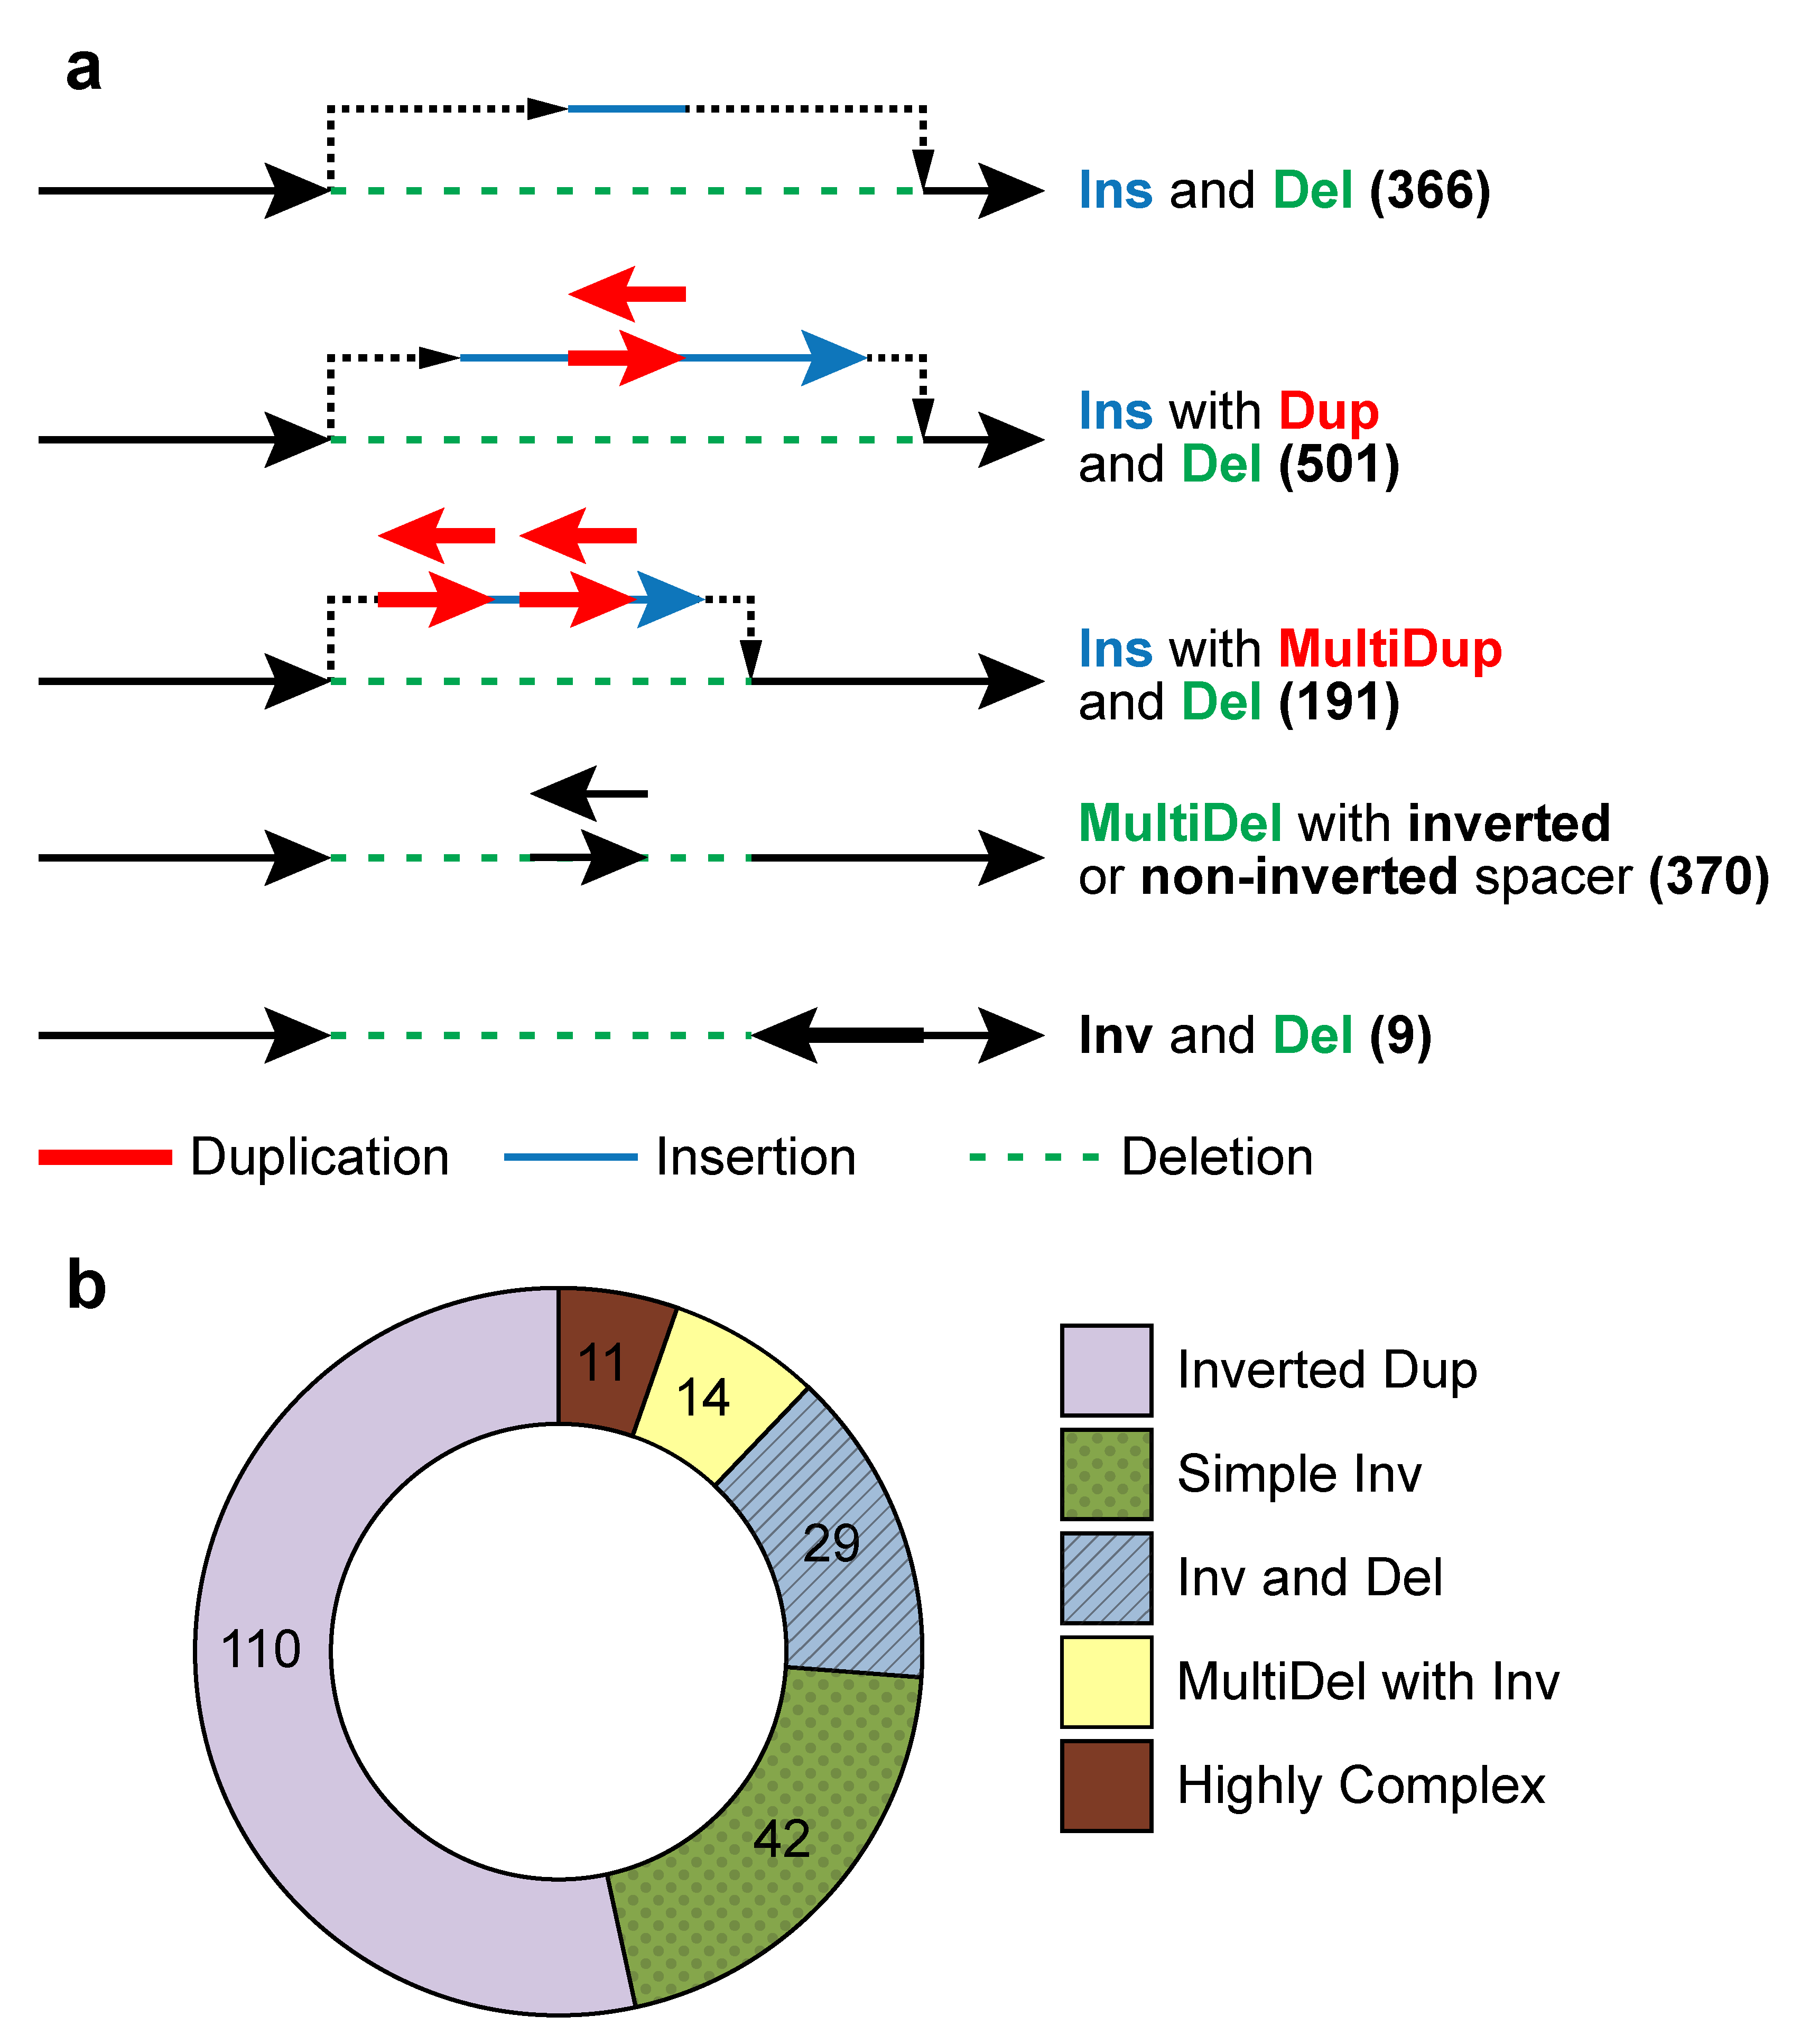
Extensive complexity at structural variation breakpoints. As part of the 1000GP SV analysis team, we assessed the complexity of deletions where breakpoints had been sequenced and assembled. Consistent with the clustering analysis and the observed repeated rearrangement of duplication sites, 7.1% (1822) of these deletions intersected another deletion with different breakpoints. A larger fraction (16%) of assembled deletion sites had additional inserted sequence at deletion breakpoints. To further examine variant complexity, we grouped 1,651 deletions with at least 10 bp of additional DNA sequence between the original SV site boundaries into four broad classes (Figure 4a). The most common class, Ins with Dup and Del, (N=501, 30%), exhibited a recognizable duplicated sequence interval within the respective inserted sequence. Not all SVs fit neatly into the classes depicted in Figure 4a, with 214 sites forming distinct patterns exhibiting increased breakpoint complexity. Within the 1000GP sample cohort, we also found that an appreciable fraction (80%) of inversions are complex (Figure 4b), likely involving DNA replication errors^{15,16}. These results reveal the extensive complexity of SV breakpoints and highlight the importance of mining this complexity at fine resolution for interpreting the biology of SVs.
Figure 4. Structural variant complexity. a) We analyzed complexity of ~30K deletions from the 1000 GP phase 3 dataset, and characterized the events into several categories based on amount of complexity observed at the locus. b) A similar study of breakpoint complexity was performed for inversion events and revealed much higher levels of complexity than expected.

Research Plan. We plan to develop new tools to identify and classify somatic and germline SVs across WGS datasets from the primary data-generating centers of the GSP. The new pipeline, iASV, will deliver i) integrated identification of a broad spectrum of SV types created by different molecular mechanisms; ii) compatibility with second- and third-generation-sequencing technologies and iii) breakpoint resolution identification based on AGE (and other tools) and local assembly for “in silico” validation of the SV event.

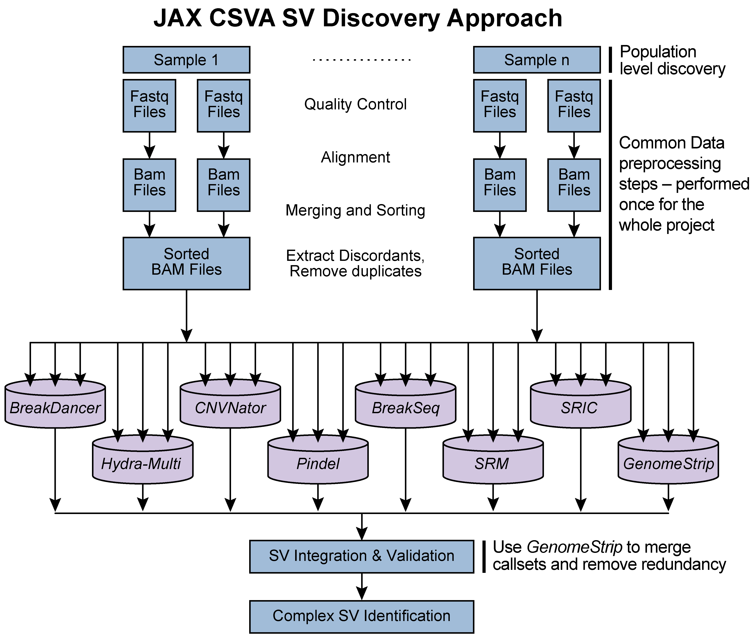
Sample selection. Data storage and compute requirements preclude SV discovery on the whole GSP sequencing cohort. Based on our power calculations (Aim 3), we will select a discovery cohort of 10K individuals across multiple CCDGs and CMGs for de novo SV calling. This will be important to assess the applicability and efficiency of our pipeline using datasets generated from different sites. We will prioritize sample selection based on availability of orthogonal datasets (e.g., RNA-Seq, Methyl-Seq etc) and phenotypic information (e.g., blood pressure, glucose levels, BMI, etc). Clearly, having additional genomic/phenotypic data would allow us to mine better biological inferences from the SV calls.
Figure 5. The iASV pipeline.

Pipeline for population-level structural variant discovery. During phase 3 of the 1000 GP SV project, we used an ensemble of nine algorithms for SV discovery. Individual call-sets were merged into a single release through a procedure that involved re-genotyping SV genomic loci using GenomeStrip with an emphasis on genotype concordance for overlapping sites. The proposed iASV pipeline (Figure 5) for SV discovery will extend this work with the following salient features: 1) MySQL database–based sample tracking of data files through the pipeline, 2) Standard steps for quality control, duplicate removal and alignment for all selected samples, 3) An ensemble of SV-calling methods including CNVNator, BreakDancer, Pindel, Hydra-Multi, Meerkat, SRM, SRIC and PEMer. This ensures that a particular algorithm does not bias the discovered SV set and increases our power to detect true SV events by asking for confirmation by multiple methods, 4) Unified methods for SV merging, genotyping and phasing using the lessons learnt from Phase 3 of the 1000GP¹⁷, 5) Validation for iASV and discovered set of SV sites using a library of known common variants and a targeted de novo assembly–based approach, 6) Complex SV identification using tools for assessing breakpoints at nucleotide resolution.

The SV calling will be performed in three phases:
Phase 1—Calibration: The pipeline will use a machine-learning approach to calibrate and test the parameters of the different SV-calling methods. We will initially focus on 100 “simulated truth” (ST) samples generated using WGSim (https://github.com/lh3/wgsim), 50 deep coverage “known truth” (KT) samples from the 1000GP SV Project¹⁷ and 200 test cohort (TC) samples (from the TCGA consortium). These datasets all have some known true-positive SVs and will be given different weights in the eventual determination of pipeline parameters depending on the level of confidence in the associated SV set (ST>KT>TC).
Phase 2—Optimization: After calibrating our methods on the ST, KT and TC cohorts, we will expand the analysis to ~1% (~2,000) of individuals being sequenced within the GSP. This cohort will be used to test for efficiency and eventual scale up in the next discovery phase. Based on the data access and compute strategies defined in the GSP, we will explore parallelization where the tools already support this capability. The compute-intensive steps in the discovery pipeline that would be primary candidates for optimization are 1) genome alignment of raw reads, 2) clustering of aberrant reads, 3) SV validation using assembly and 4) SV integration.
Phase 3—Discovery: The optimized system will be run on 10K of the proposed 200K individuals sequenced by the CMGs and CCDGs.

Calibration of method using known sites. Hundreds of sites across the human genome are polymorphic in a large fraction of the population^{18,19}. Copy number variation can have diverse effects on phenotype²⁰⁻²². For example, the opsin gene locus on chrX is highly polymorphic in ~11% of individuals²³ and could explain the high incidence of male color blindness²⁴. Phase 3 of 1000 GP SV project¹⁷ showed that a significant fraction of SVs (35%) occur at a high frequency in the population (VAF ≥ 0.2%). We will create a catalog of common copy number polymorphic sites across the genome and use them as validation sites for our SV-calling methods.

Validation of SV sites using in silico assembly–based methods. We demonstrated above that SVs can be validated in silico using targeted de novo assembly–based methods (TIGRA-SV and SGA). We will integrate the same methodology into the iASV and process every discovered SV site for validation.

Complex SV identification. We will use two methods for complex SV identification. The first⁷ identifies SV clusters present in the same genomic region that have similar allele frequencies and copy number ratios. This will help select SVs that are part of the same complex SV event. The second method¹⁷ involves inspecting the mapping patterns of various parts of the assembled contig at the SV site. This would allow us to identify mislabeled SVs and SVs with more complexity than annotated by the individual SV-calling methods.

Generating a population-level reference set of SVs. We expect that several different population groups will be represented in the complete cohort of individuals being sequenced at the CCDGs and CMGs. The resulting set of validated SVs from this aim (identified from the discovery cohort) will be further stratified according to underlying population substructure. The population-specific reference set of SVs will allow us to extend the observations from 1000GP Phase 3¹⁷ and will be critical for the population and disease-level association analyses proposed in Aim 3.

Data access strategies: The JAX CSVA Cloud. Total storage of the discovery cohort is expected to require ~4 PB based on TCGA WGS statistics. To deal with the data footprint and computing requirements, we propose to develop the JAX CSVA Cloud, which will be available to all members of the JAX CSVA. Our two-stage local and cloud approach is as follows:
i) The JAX local data center. In a traditional center, data are downloaded for analysis to local high-performance compute resources. JAX has extensive infrastructure, including an HPC cluster with 1700 cores and 1.4 PB of storage that will further expand over time (see Facilities and Resources). We can analyze the full discovery cohort by transient download and analysis of raw data with retention of only necessary results.
ii) Cloud-based data access model. After initial method development and analysis, we plan to disseminate methods to the broader research community using the cloud paradigm. JAX is currently expanding capabilities in cloud-based data analysis to address issues including access to increased compute power, co-localization of novel and reference datasets and reproducibility of analysis pipelines. JAX staff have adapted multiple pipelines for the Amazon cloud and evaluated the suitability of Amazon archival storage for genomics datasets. Dr. Ding’s group has been developing GenomeVIP, a secure, HIPAA-compliant web-driven variant discovery and annotation platform through which multiple independent analysis tools can be applied to a given dataset. As it can call upon both local HPC and Amazon cloud resources, GenomeVIP is a tool that we may initially use to assist with variant discovery and to download results to local disks for subsequent analyses.

JAX is now evaluating commercial genomics cloud service providers (CSPs) to partner with (see letters from Seven Bridges Genomics and IBM) and is now recruiting 2 full time employees for this effort. These activities are independent of this U01 proposal. JAX will choose a platform that will allow scientists without special training to analyze their datasets through a graphical interface for both local and cloud analysis methods. This goal parallels that of the U01, namely to ensure methods developed at the data center will be stable and easily usable by the general research community.

Expected results. These studies will yield a comprehensive catalog of validated complex SVs from healthy and diseased individuals that lay the foundation for subsequent functional interpretation and association studies (Aims 2,3). They will also help answer questions about complex SV formation and population-level associations of SVs across multiple studies, thereby adding value to GSP datasets. By making the iASV pipeline available as a community resource, we expect this work to propel future genome-level SV analyses.

Pitfalls and alternative approaches. A major challenge for this study is the lack of knowledge about the size and diversity of patient cohorts and details of common/Mendelian diseases being studied as part of the GSP. We also do not know what kind of phenotype data is being collected and what orthogonal data (genomic, transcriptomic, proteomic, etc.) might be available for these patient cohorts. In response, we will i) leverage the extensive experience of the team to handle complex datasets (see Prelim data section) and ii) design iASV to robustly handle diverse and complex datasets of the type that might be generated by the GSP.

Aim 2. Develop tools to analyze the functional impact of structural variants.
Rationale. SVs account for more nucleotide variation in the human genome than SNPs and therefore are likely to be associated with many genetic diseases. However, little is still known about their functional impact at a genome-wide level. SVs are disproportionately observed in the non-coding part of the genome; hence, comprehensive assessment of the functional impact of SVs will likely require the integration of large-scale data resources such as ENCODE, 1000GP and GTEx. This proposal will catalogue the largest number of SVs so far and, more importantly, functionally prioritize SVs in preparation for disease association studies.

Preliminary data.
Mutational mechanisms of structural variants. The sequence content of SVs, especially around breakpoints, carries important information about origin and functional impact. Using datasets from 1000GP, we have studied the distinct features of SVs originating from different mechanisms^{25,26}. For example, non-allelic homologous recombination (NAHR), is associated with active enhancers and an open chromatin environment. Our analysis also showed that microinsertions, flanking non-homologous breakpoints, originate from late-replicating genome loci with characteristic distances from breakpoints. These results inform us on the molecular mechanisms underlying SV formation and also indicate differences in functional impacts of different SV types.

We further performed SV mechanism annotations for the 1000GP Phase 3 deletions using BreakSeq²⁷, categorizing 29,774 deletions by their creation mechanisms. Among these, NHR proved to be the most prevalent mechanism (~73% of all categorized deletions)¹⁷.

Tools for assessing functional impact of genomic variation in genes and pseudogenes. We developed Variant Annotation Tool (VAT) to annotate the impact of protein sequence mutations. VAT provides transcript-specific annotations of mutations according to synonymous, missense, nonsense or splice-site-disrupting changes²⁸. We annotated variants from 1,092 humans in Phase 1 of the 1000GP²⁵ and observed that genes tolerant of loss-of-function (LoF) mutations are under the weakest selection and cancer-causal genes under the strongest selection. In 1000GP Phase 3, we found that a typical genome contains ~150 LoF variants and discovered significant depletion of SVs (including deletions, duplications, inversions and multiallelic CNVs) in the coding sequences, untranslated regions and introns of genes compared to a random background model, implying strong purifying selection.

Tools for evaluating functional impact of variation in non-coding (nc) RNAs and regulatory regions. We developed tools to specifically analyze ncRNAs. Our incRNA pipeline combines sequence, structural and expression features to classify newly discovered transcriptionally active regions into RNA biotypes such as miRNA, snRNA, tRNA and rRNA²⁹. Our ncVar pipeline further analyzes genetic variants across biotypes and subregions of ncRNAs, e.g., showing that miRNAs with more predicted targets show higher sensitivity to mutation in the human population³⁰.

To better understand nc regulatory regions, we developed tools to analyze ChIP-Seq data to identify genomic elements and interpret their regulatory potential. PeakSeq and MUSIC identify regions bound by TFs and chemically modified histones^{31,32}. PeakSeq has been widely used in consortium projects such as ENCODE^{31,33}. MUSIC is a newly developed tool that uses multiscale decomposition to help identify enriched regions in cases where strict peaks are not apparent and robustly calls both broad and punctate peaks³². Peak calls and ChIP-Seq signal data can also be used to model gene expression and annotate target genes. We have developed methods that use both supervised and unsupervised machine-learning techniques to identify these regulatory regions (such as enhancers) and predict gene expression from ChIP-Seq data³⁴⁻³⁷. In order to investigate the evolutionary importance of these regions, we have analyzed patterns of single nucleotide variation within functional nc regions, along with their coding targets³⁰ ^{37,38}. We used metrics, such as diversity and fraction of rare variants, to characterize selection pressure on various classes and subclasses of functional annotations³⁰. We have also defined variants that are disruptive to a TF-binding motif in a regulatory region³³.

Tools for helping annotate functional impact based on network and allelic expression analyses. We found that functionally significant and highly conserved genes tend to be more central in various biological networks³⁹ and are positioned at the top of regulatory networks³⁸. Further studies showed relationships between selection and protein network topology (e.g., quantifying selection in hubs relative to proteins on the network periphery^{39,40}). Incorporating multiple network and evolutionary properties, we developed NetSNP³⁹ to quantify the indispensability of genes. This method shows strong potential for interpreting the impact of variants involved in Mendelian diseases and in complex disorders probed by GWAS. We constructed regulatory networks for data from the ENCODE and modENCODE projects, identifying functional modules and analyzing network hierarchy³⁸. To quantify the degree of hierarchy for a given hierarchical network, we defined a metric called hierarchical score maximization (HSM⁴¹). Finally, we also developed AlleleSeq⁴² for the detection of candidate variants associated with allele-specific binding and allele-specific expression. These tools are based on the construction of a personal diploid genome sequence (and corresponding personalized gene annotation) using genomic sequence variants and can be used to prioritize variations disrupting allelic activity.

FunSeq: Tools for integrated functional prioritization. We recently developed a prioritization pipeline called FunSeq^{25,43} that identifies annotations under strong selective pressure as determined using genomes from many individuals from diverse populations. FunSeq links each nc single-nucleotide mutation to target genes and prioritizes based on scaled network connectivity. FunSeq identifies deleterious variants in many nc functional elements, including TF binding sites, enhancer elements and regions of open chromatin corresponding to DNase I hypersensitive sites, and detects their disruptiveness in TF-binding sites (both LoF and gain-of-function events). We further enhanced FunSeq (FunSeq2) and identified ~100 nc candidate drivers in ~90 WGS medulloblastoma, breast and prostate cancer samples²⁵.

Tools for identifying enrichment of variations in coding and non-coding regions. We have worked on statistical methods for analysis of nc regulatory regions. LARVA (Large-scale Analysis of Recurrent Variants in noncoding Annotations) identifies significant mutation enrichments in nc elements by comparing observed mutation counts with expected counts under a whole genome background mutation model. LARVA also includes corrections for biases in mutation rate owing to DNA replication timing. For coding region analysis, we developed MuSiC⁴⁴ to analyze genetic changes using standardized sequence-based inputs, along with multiple types of clinical data, to establish correlations among variants, affected genes and pathways, and to ultimately separate commonly abundant passenger events from truly significant events.
Figure 6. Overview of the functional prioritization and annotation pipeline.

Research plan. To enable identification of SVs with high functional impact, we will extend FunSeq/FunSeq2 within a new pipeline called SVIM (Structural Variation IMpact)(Figure 6). We will evaluate the impact score for each SV identified in Aim 1, taking into account the functional annotation of the affected genomic region and the fraction of functional elements (i.e., genes, ncRNAs and nc regulatory elements) overlapped by the SV. The impact score will also depend upon SV type (i.e., deletion, duplication, inversion or translocation).

For a given SV belonging to a particular SV type, we will evaluate the fraction of bases overlapping functional elements. Based on this fraction, we will categorize SVs into three classes (touch, cut, and engulf). Each overlapping class will have a different weight (F_{svtype, class}). We will divide genomic elements into three categories (coding region, nc region and TF binding site) and assign relative scores to them (S_{coding}, S_{non-coding}, S_{TFBS}), which will vary for different SV types. Relative scores F and S will be defined for class and functional elements analogous to the FunSeq2 tool²⁵.

SVs will be assigned an impact score by taking the sum over the product between weights of overlapping classes and scores of overlapping functional elements. The score (IS_{orig}) will also be upweighted based on activity of the affected region. The upweight factor is comprised of the product of three factors: i.e., allelic activity, network connectivity and ubiquitous transcription. Significance level of an Impact score (IS_{orig}) will be estimated by running a 1,000 monte-carlo simulations generated by randomly shuffling the location of SVs.

Evaluating effect of structural variants on protein-coding genes. We will further develop a protein-coding module for SVIM to substantially expand the analysis of LoF variants with mis-mapping, functional, evolutionary and network features. We will quantify the confidence of LoFs using features such as whether they are in highly duplicated regions and the number of paralogs. For functional features, we will incorporate protein structures. For evolutionary properties, we will quantify the conservation of LoF variants, as well as truncated sequences. For network features, we will quantify the distance between genes with LoF variants and known disease-causing genes. Finally, we will develop a machine-learning method to quantify whether LoFs will cause benign, recessive or dominant disease-causing effects. Given that most rare variants are heterozygous, developing methods to differentiate benign rare variants from disease-causing variants in terms of those that can lead to recessive or dominant disease are much needed.

Prioritizing non-coding transcripts from structural variant data. To prioritize the effects of SVs in ncRNAs, we will focus on overlaps with regulatory elements and other functional regions. To perform this analysis, we will define categories of RNA regions that are sensitive to mutation in the human population, and combine these features to generate RNA element scores. We will mine RNA interactions between proteins (e.g., CLIP-Seq) and miRNAs (e.g., TargetScan) to create a compendium of biochemical interactions with RNA⁴⁵⁻⁴⁹. We will further investigate RNA secondary structure, looking for structured regions that are highly sensitive to mutation. For these regions, we will assess deleteriousness of mutations by differences in predicted free energy or structure ensembles⁵⁰ relative to wildtype. We have found annotations of all of the above types—biochemical interactions, regulatory motifs, and structured regions—that are enriched for rare variants in the human population and will use these sensitive RNA regions to score and prioritize potential deleterious SVs in ncRNA.

Prioritizing non-coding regulatory elements from structural variant data. Unlike protein-coding genes and ncRNAs, TF binding motifs are relatively small in size. Thus, we are going to analyze duplications that occur close to these motifs and analyze where these duplications lead to the breakage of existing or creation of new motifs. In the prioritization scheme, we will also penalize changes in distance between motifs and newly created motifs if they occur close to an existing TF motif. We will first update the TF binding nc elements using better enhancer definitions provided by the Epigenome Roadmap⁵¹⁻⁵³ and ENCODE. We will further develop a new machine-learning framework that utilizes pattern recognition within the signal of various epigenomic features and transcription of enhancer RNA (eRNA) to predict active enhancers across different tissues.

Further variant prioritization based on networks, tissue specificity, and allelic activity. After performing annotation-based assessment of identified SVs, the following functional features will be used for prioritization.
i) Network connectivity. We will examine the network topological properties of the genomic elements affected by identified SVs. Variants disrupting regulatory elements with high connectivity—network hubs and bottlenecks—will be upweighted based on their scaled centrality scores.
ii) Ubiquitous specificity. We will evaluate the impact of SVs in an epigenetic context to identify tissue-specific phenotypic effects that are strongly influenced by SVs. We will prioritize SVs impacting genes, ncRNAs, and TF binding sites active in multiple tissues.
iii) Allelic activity. Allelic variants (rare and common) will be aggregated into a reference set of genomic elements displaying allele-specific behavior and each element will be assigned an “allelicity” score based on enrichment of allelic variants both within the element and across individuals (with allelic variants in a consistent allelic direction). We will develop a prioritization scheme for SVs overlapping these allelic elements.

Expected results. We expect that SVIM, a new software solution to estimate the impact scores of the SVs produced in Aim 1, will yield a prioritized set of SVs in Aim 2 that we can forward to Aim 3 (genotype and association) for further classification of their impact to disease or a specific phenotype. We plan to make the prioritization results broadly available; therefore, SVIM will incorporate the impact score into a standard Variant Call Format (VCF).

Pitfalls and alternative approaches. We anticipate that the greatest pitfalls are (i) possibly an overwhelming number of SV to be discovered in Aim 1 and (ii) the data that will be pre-processed to generate reliable annotation of nc component of analysis. In order to overcome (i), we plan to gradually process the results into specifics type of SVs. SVIM will also be based on the data context to efficiently prioritize variants from some WES datasets, but optimally from WGS datasets. The overall modularization offers a flexible framework for users to incorporate the ever-increasing amounts of genomic data to both rebuild the underlying data context and prioritize case-specific variants. In order to overcome pitfall (ii) we will make great efforts to make SVIM computationally efficient and able to support the large-scale computing proposed for this aim. To build the data context, we will integrate large-scale publicly available data resources, such as SVs from the 1000 GP⁵⁴, conservation data from Bejerano et al.⁵⁵ and Cooper et al.⁵⁶, functional genomics data from ENCODE³³ and Roadmap Epigenomics Mapping Consortium⁵⁷.

Aim 3. Scaling up to 200K samples and associating SVs with common and rare diseases.
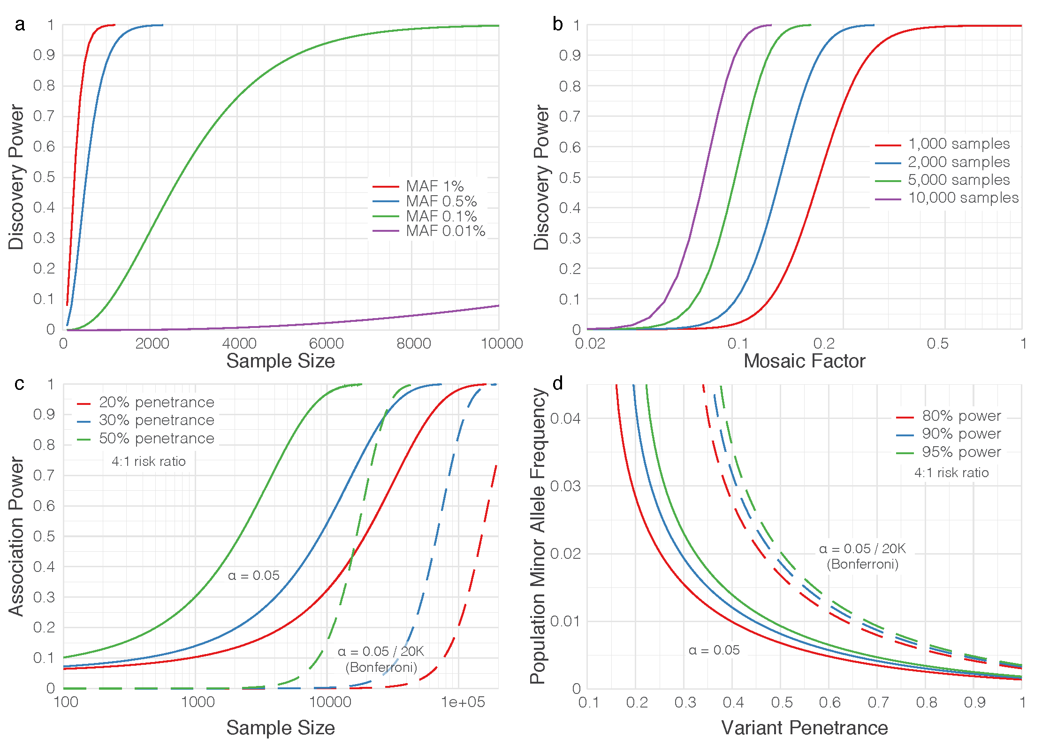
Rationale. Many of the SVs we discover will be relatively rare and thereby cannot be readily and robustly handled by conventional association tools. To extend the SV discovery and functional annotation phases of the proposed program, we will develop a new association pipeline tailored to finding SV-phenotype associations. We anticipate that building a reference database of complex SVs in healthy individuals (Aim 1) will be essential to this undertaking.
Figure 7. Power analysis for sample selection and association. a) Power vs sample size for selected MAFs from 0.01% to 1%. Events are assumed heterozygous and completely represented in the sample (no mosaicism). Curves are universal in that simple insertions and deletions, as well as complex indels, collapse and power is independent of indel size, since the “split reads” discovery mode dominates. b) Power vs “mosaic factor” (unity meaning event present in all cells; 0.5 meaning event present in half the cells, etc.) for selected samples sizes from 1K to 10K. All data plotted at 1% MAF. Split-read discovery again dominates and curves are universal. c) Association power for 10 collapsed variants (even numbers of cases and controls), each of 1% MAF and penetrance from 1% to 50%, at both single gene (α = 5%) and Bonferroni-corrected for 20K genes, as well as a 4:1 risk ratio for the Li and Leal (2008) collapsing strategy. d) Curves of constant power for 10K cases/10K controls, with other parameters the same as in c).

Preliminary data.
Power analysis for sample selection and association. An important aspect of this work will be to select a subset of the 200K samples (projected to be sequenced by the GSP) for full SV analysis. This “discovery phase” will furnish the prototype events that will subsequently be studied in the full population by genotyping the entire sample set. Total analysis cost (e.g., downloading, storage, compute time, manual review) must be balanced against the discovery probability for events having the lowest population minor allele frequency (MAF) we wish to include. There is no general theory for calculating the power to discover SVs with current algorithms, so we extended an existing statistical model of coverage⁵⁸ to estimate the discovery sample size. Briefly, Bernoulli probabilities for two standard SV discovery methods, split reads and discordant read pairs, can be derived using probability theory considering read length, average and variance of insert length, SV length, etc. and subsequent incorporation of a detection rule, e.g., “≥3 split or discordant reads”. Detection in each sample is binomial in the number of observations and discovery within a sample set is similarly binomial in detection and MAF probabilities.

Anticipated parameters for the Illumina data to be generated for this project are 30X coverage per genome, average insert size of 400–600bp (20% coefficient of variation), 150bp reads, event detection based on ≥3 split reads or ≥5 discordant read pairs, and observation in at least 3 samples to constitute “discovery”. The model predicts that split-read detection will predominate for simple SVs, as well as for complex events in which one sequence is replaced by another. Because split-reads depend only upon local alignment, power is essentially independent of the size of events (unlike for discordant read pairs), meaning it is primarily a function of sample size and MAF. Figure 7a shows power at MAF ≥0.1% and is essentially 100% for 10K samples. It drops rapidly for lower MAFs, whose events are unlikely to be discovered in this study. Mosaicism is a potential confounder, e.g., in blood samples where an event is not present in all cells. Figure 7b shows that power is not significantly impacted for 10K samples until mosaicism is quite significant.

The second aspect of “power” is variant-disease association. The issues are well-known⁵⁹, enabling the following “baseline” estimates of association power. General consensus⁵⁹ recommends “collapsing” variants for lower MAF in order to aggregate effects for increasing power. Analysis of the widely used Li & Leal method for 10 collapsed variants at 4:1 risk ratio (Figure 7c) shows that groupings of 1% MAF variants having high (~50%) penetrance will require 20–30K samples for 80% power when Bonferroni-corrected. Power drops rapidly for lower MAF, penetrance, risk ratio and sample size. Although it is not yet known how the 200K samples will be divided over various studies, it is instructive to examine the scenario of 10K cases/10K controls (Figure 7d). Variants ~2% MAF should have ≥90% association power for penetrances ≥50%, while variants regardless of MAF having penetrances <25% will likely remain ambiguous, as will variants from phenotypes having substantially smaller sample allotments. It is likely we will discover more variants than what solid associations can be established for.

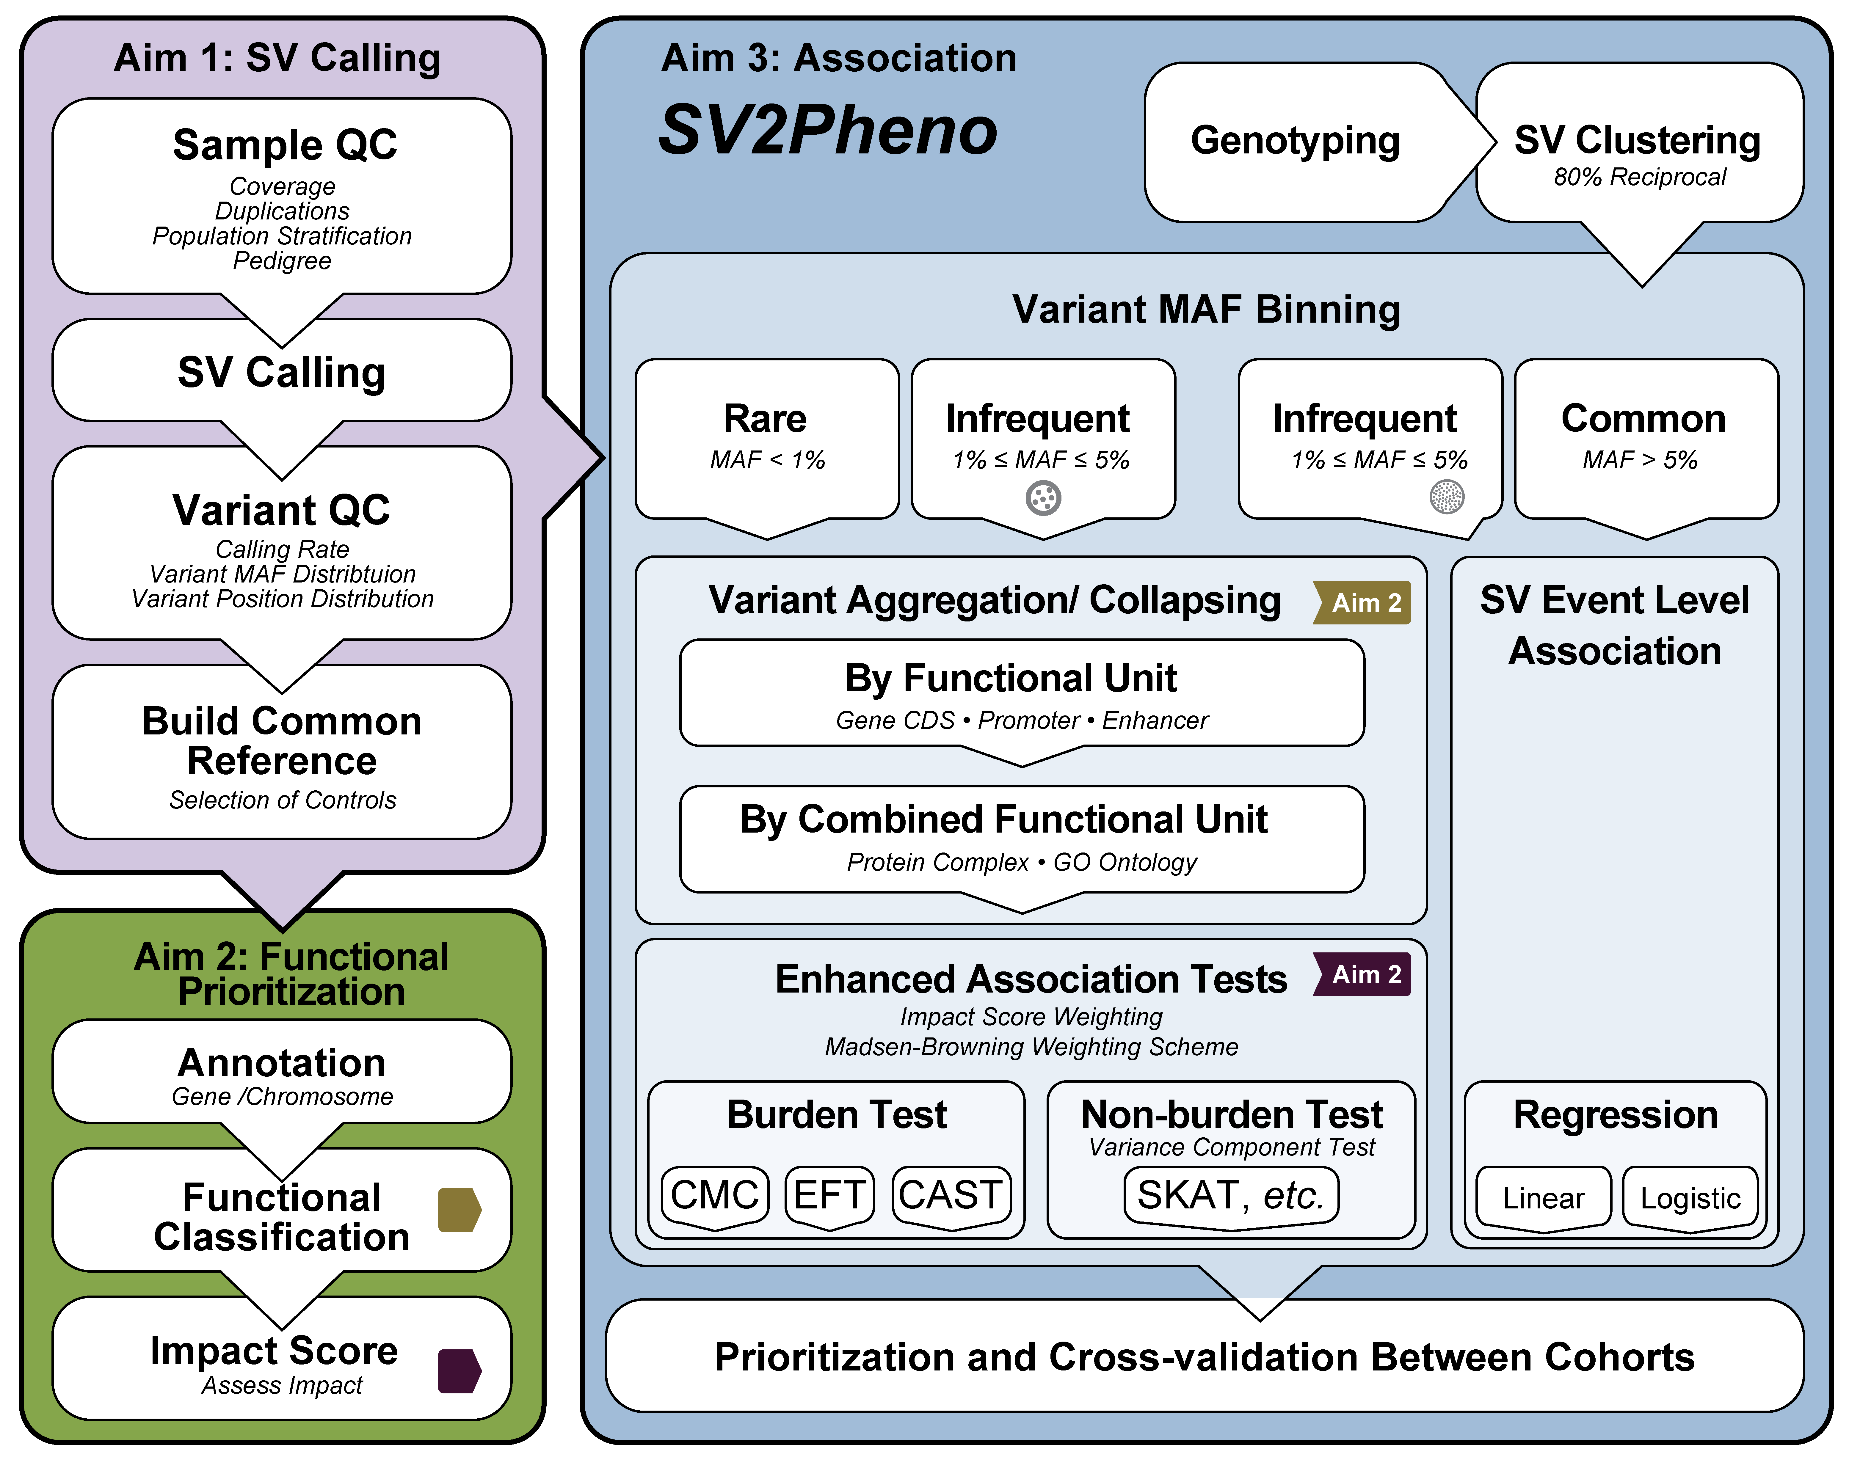
Association pipeline implementation and experience in discovering significant associations. We have developed a prototype pipeline incorporating extensive sample and variant level quality control (e.g, coverage, variant frequency and distribution), population stratification, pedigree segregation etc. for population/family-based association analysis. The pipeline sports popular aggregation tests, including burden tests such as the Combined Multivariate Collapsing (CMC)⁵⁹, Exclusive Frequency Test (EFT)⁶⁰, Total Frequency Test (TFT)⁶⁰, and Cohort Allele Sum Test (CAST)⁶¹, and variant component tests such as the Sequence Kernel Association Test (SKAT)⁶². We have already used this pipeline to discover associations by tailoring it to hypothesized genetic architectures of individual diseases. For example, assuming tumor suppressors are enriched for rare deleterious truncations, we grouped events by gene and used TFT to associate 13 genes with germline susceptibility in a cohort of >4,000 cancer cases. Dr. Hongyu Zhao (co-investigator) has also developed additional statistical methods⁶³⁻⁶⁷ for association tests that have identified genes linked to common diseases, including hypertension⁶⁸, inflammatory bowel disease⁶⁹ and heart disease⁷⁰.
Figure 8. The SV2Pheno Association Analysis Pipeline. The overall work flow includes QC, population stratification (Aim 1), functional classification and impact score generation (Aim 2) and single event test and burden analysis (Aim 3).

Research Plan. SVs are characterized by size, type, penetrance and multiple alleles. We plan to genotype all SVs detected in 10K discovery samples (Aim 1) across all ~200K samples to be sequenced by the CCDGs and CMGs to obtain sufficient statistical power for genotype-phenotype associations. A critical step for association analysis of SVs is meaningful classification/annotation. By building on infrastructure and tools mentioned above, we will develop a new pipeline called SV2Pheno to infer SV-phenotype associations (Figure 8). It will use the impact scores for each SV (Aim 2) for integrated analysis of SNVs, indels, and SV.

Genotyping of SVs detected in the discovery set across the entire sample set. Genotyping and annotation of discovered SVs in the whole population will allow accurate determination of prevalence and allele frequencies and, importantly, increase association analysis power. This process will use BreakSeq²⁷ to build a library of validated and assembled SV breakpoints for genotyping individual genomes. For imprecise SVs, a combined read-pair/read-depth approach using GenomeStrip⁷¹ will do population level genotyping. Conventional genotyping involves assembly of both reference and alternate sequence contigs, which are used as targets for mapping all reads present in the sample. However, given an expected data footprint of ~50PB for the full sample set, the traditional “bring data to the computing tools” approach will be upended to “bring compute tools to the data”. We will build on tools such as Sambamba (bam slicer function)⁷², TIGRA-SV assembler and Pindel. This will reduce the footprint to a fraction of the original and enable the methods to work in the cloud and access data over a secure network.

Develop the SV2Pheno pipeline, including improved burden tests considering impact score and annotation classification of various complex structure variants. We envision substantial extension of this pipeline in two major ways to address the ambitious goals of this proposal: 1) We plan to hybridize the pipeline with more recent methods that better account for non-contributing variants⁷³. Likewise, annotation and functional prediction can help identify irrelevant variants, which can subsequently be removed from analysis. The pipeline will also process the information from the ENCODE & Epigenetics Roadmap analysis. 2) Variants are known to be associated with various diseases⁷⁴⁻⁷⁶, but almost certainly contribute non-uniformly; assigning appropriate weights will be necessary to wring-out maximum power. Aggregation tests can be expressed in general by the linear equation $Y=α+β⋅Σw_{i}g_{i} +ε$, defined (left-to-right) as observed trait, intercept, collective effect coefficient, weight of variant i, tally of variant i (0, 1, or 2) and residual. Assignment of weights will be based on a novel combination of three considerations: the Madsen-Browning equation⁷⁷ to account for allele frequency, consideration of “direction” (negative association) using, e.g., aspects of the Pan-Shen approach⁷⁸, and incorporation of our impact score (Aim 2) to account for biological strength. In principle, such a general approach should capture signals that are too subtle for earlier-generation tests⁷⁹.

We are mindful that controls for each association analysis should be carefully matched with cases, and will pay close attention to population structure, sample coverage, etc. When sample size is fixed an even case-control split offers maximal power. However, it is likely that the GSP will furnish potentially many more controls, and this increases power. For such diseases, we will check the available literature for any known underlying genetic commonalities and choose extra controls in light of relevant covariates (e.g., age or smoking status). Since we anticipate that a high fraction of SVs will reside in nc regions, we will aggregate variants using a hierarchical approach based on three levels:

Level 1. Prototypical event–level association analysis. As the precise genomic region for a given SV may vary across samples, we will represent each set of similar SV events as a single prototypical SV event. The criterion constituting such events is given by the “80% reciprocal overlap” rule¹¹. For large insertions and inter-chromosomal translations, we will require the breakpoints to be within 1kb of one another. We will then assess the significance of the associations using impact scores generated in Aim 2.
Level 2. Functional unit (gene coding sequence/promoter/enhancer)–level association analysis. We will annotate the prototypical SV events from Level 1 to identify any specific transcriptional regions (e.g., exons/ coding sequences and cis-regulatory elements such as insulators, enhancers, and promoters) and gene(s). SVs in a given gene will be grouped as a single, effective functional unit (Figure 8). We will then perform an association analysis on these functional units. In cases where multiple SV events may be affiliated with a given functional unit, we will develop a weighting scheme to combine the impact scores of the contributing SVs. This approach may potentially reveal novel connections between nc functional regions and phenotypes.
Level 3. Combined Functional Unit level analysis. We will annotate the functional units in the previous step to identify any known affiliated higher-order units (e.g., protein complexes and gene pathways) by recruiting various resources, including databases for gene-phenotype relationships (e.g., OMIM), gene pathways (e.g., KEGG, Reactome) and gene ontology (e.g., GO database). The SVs affecting a given higher-order unit will be grouped as a single super-unit. We will again perform association analysis, considering the SV impact scores (Aim 2). This approach has the potential to discover novel combinations of SV-containing functional units.

We will apply this tiered approach and association analysis to all genotyped samples passing our extensive coverage and variant-calling QC from various cohorts to identify SVs associated with specific phenotypes.

Integrate various types of variants for association analysis. The most powerful analysis will come by combining information from SNVs, indels and SVs for association analysis. Traditionally, weights-in-burden tests account for variants with different MAFs, but favor those having lower MAFs^{62,77}. Bioinformatic information such as PolyPhen scores for SNVs and SV impact scores from Aim 2 will inform these weights. To the best of our knowledge, no previous approaches have aggregated variants of different types. Here, we propose two methods for such integration: 1) Based on our hypothesis that SVs would have stronger functional impacts than missense SNVs, on average, we will develop a weighing scheme based on the size and genetic architecture of various variant types using the framework of previous weighting schemes. SNV/indel/SV will be jointly calculated in a single burden analysis. 2) We hypothesize that alterations from functional regions, regardless of size, contribute to phenotype. Therefore, alternatively, we plan to use SNV/indel and SV for independent burden analyses and combine the P-values from these independent tests.

Association between SNVs/indels and # of SVs. Under the null hypothesis that variation occurs randomly, it should be possible to correlate the numbers of SNVs/indels versus number of SVs, the slope being indicative of differences in rates of occurrence, and also to check such correlation against established rates. We will perform association analysis for individual outlier cases in which SV census is significantly lower or higher than expected. It is possible that such outliers might harbor common germline alterations leading to genomic instability by affecting DNA repair pathways.

Expected results. This aim will culminate in the JAX CSVA SV2Pheno association pipeline and its associated/support tools for systematically discovering SVs associated with specific phenotype/disease. We expect to have the increased statistical power needed to discover rare, novel SVs associated with phenotypes previously missed due to smaller sample size. We further anticipate revealing genetic changes associated with increased frequency of SVs genome-wide. The initial version of SV2Pheno will be distributed for broader community use and cloud distribution.

Pitfalls and alternative approaches. Our preliminary analysis indicates that we are well powered to detect SVs with MAFs around 0.5% to 1% using 10K cases. Although it is very likely that we will discover more SVs than we can establish associations for (discussed above), there are still some issues of selection. There are several strategies for selecting datasets for initial discovery: 1) from one homogenous cohort, 2) from one CCDG center across multiple cohorts or 3) from multiple cohorts generated by multiple CCDG/CMG centers. Regardless of choice, we will maintain high standards regarding coverage, read length, insert size, mapping rate, % mismatch and other parameters to ensure accurate, representative SV detection across populations. To reduce the number of hypotheses to be tested, we can alternatively focus on SVs from regions indicated to have association with phenotype from the study of SNV/indels. The weighting methods discussed above may require tuning and we will use known disease–associated SVs as positive controls for calibration.

CONTRIBUTIONS TO CROSS-PROGRAM GOALS
The analyses to be undertaken by the JAX CSVA will contribute to the two primary cross-program goals of the GSP. These methodologies and analysis tools are integral to the investigator-driven activities of the proposal; thus, it will not be necessary to prioritize them as separate initiatives. This strategy ensures that these program-related goals will be achieved in line with Center-specific goals.

Delineating comprehensiveness in common disease studies. The JAX iASV approach will allow us to integrate samples from across the various centers of the GSP into a single meta-analysis of SVs across thousands of genomes. This allows for biological interpretation across the width of the GSP and will enable investigators to answer questions about population structure and their impact on phenotype. Thus, the JAX CSVA will contribute to cross-program objectives by integrating data from across centers in a disease agnostic manner. Furthermore, extensive calibration and optimization of the various tools that are part of the iASV, as well as the tight integration with cloud-based computing, will also help define the methodology and metrics for comprehensive studies of SVs in future large-scale consortium efforts.

Providing specifications for common controls. JAX CSVA will combine our well-curated, genotyped SVs with calls from CCDG and CMG centers to perform a SV saturation analysis⁸⁰ to assess the completeness of SV census across populations and disease types. We will also integrate SVs with SNVs/indels generated by other centers as part of this proposal and we anticipate this effort will yield a larger set of association hypotheses outside the scope of our proposal, but perhaps well-suited for other proposals in the GSP program. Furthermore, we will share our SV2Pheno association pipeline and its embedded tools through cloud or local installation, which may help other projects in the GSP program. As described above, we will choose appropriate controls for our SV discovery analysis based on population structure and other confounding factors. These sets of controls will be shared across the GSP and will help other centers when considering the choice of controls for their analysis.
REFRENCES.
1 Quinlan, A. R. & Hall, I. M. Characterizing complex structural variation in germline and somatic genomes. Trends Genet 28, 43-53, doi:10.1016/j.tig.2011.10.002 (2012).
2 Abyzov, A., Urban, A. E., Snyder, M. & Gerstein, M. CNVnator: an approach to discover, genotype, and characterize typical and atypical CNVs from family and population genome sequencing. Genome research 21, 974-984, doi:10.1101/gr.114876.110 (2011).
3 Yang, L. et al. Diverse mechanisms of somatic structural variations in human cancer genomes. Cell 153, 919-929, doi:10.1016/j.cell.2013.04.010 (2013).
4 Lindberg, M. R., Hall, I. M. & Quinlan, A. R. Population-based structural variation discovery with Hydra-Multi. Bioinformatics 31, 1286-1289, doi:10.1093/bioinformatics/btu771 (2015).
5 Fan, X., Abbott, T. E., Larson, D. & Chen, K. BreakDancer - Identification of Genomic Structural Variation from Paired-End Read Mapping. Curr Protoc Bioinformatics 2014, doi:10.1002/0471250953.bi1506s45 (2014).
6 Ye, K., Schulz, M. H., Long, Q., Apweiler, R. & Ning, Z. Pindel: a pattern growth approach to detect break points of large deletions and medium sized insertions from paired-end short reads. Bioinformatics 25, 2865-2871, doi:10.1093/bioinformatics/btp394 (2009).
7 Malhotra, A. et al. Breakpoint profiling of 64 cancer genomes reveals numerous complex rearrangements spawned by homology-independent mechanisms. Genome research 23, 762-776, doi:10.1101/gr.143677.112 (2013).
8 Malhotra, A. et al. Ploidy-Seq: inferring mutational chronology by sequencing polyploid tumor subpopulations. Genome Med 7, 6, doi:10.1186/s13073-015-0127-5 (2015).
9 Zhang, Z. D. et al. Identification of genomic indels and structural variations using split reads. BMC genomics 12, 375, doi:10.1186/1471-2164-12-375 (2011).
10 Simpson, J. T. & Durbin, R. Efficient de novo assembly of large genomes using compressed data structures. Genome research 22, 549-556, doi:10.1101/gr.126953.111 (2012).
11 Chen, K. et al. TIGRA: a targeted iterative graph routing assembler for breakpoint assembly. Genome research 24, 310-317, doi:10.1101/gr.162883.113 (2014).
12 Abyzov, A. & Gerstein, M. AGE: defining breakpoints of genomic structural variants at single-nucleotide resolution, through optimal alignments with gap excision. Bioinformatics 27, 595-603, doi:10.1093/bioinformatics/btq713 (2011).
13 Weckselblatt, B. & Rudd, M. K. Human structural variation: mechanisms of chromosome rearrangements. Trends Genet, doi:10.1016/j.tig.2015.05.010 (2015).
14 Korbel, J. O. et al. PEMer: a computational framework with simulation-based error models for inferring genomic structural variants from massive paired-end sequencing data. Genome Biol 10, R23, doi:10.1186/gb-2009-10-2-r23 (2009).
15 Hastings, P. J., Lupski, J. R., Rosenberg, S. M. & Ira, G. Mechanisms of change in gene copy number. Nat Rev Genet 10, 551-564, doi:10.1038/nrg2593 (2009).
16 Hastings, P. J., Ira, G. & Lupski, J. R. A microhomology-mediated break-induced replication model for the origin of human copy number variation. PLoS genetics 5, e1000327, doi:10.1371/journal.pgen.1000327 (2009).
17 Sudmant, P. H. An integrated map of structural variation in 2,504 human genomes. Nature Accepted, in print (2015).
18 Wong, K. K. et al. A comprehensive analysis of common copy-number variations in the human genome. American journal of human genetics 80, 91-104, doi:10.1086/510560 (2007).
19 Bailey, J. A., Kidd, J. M. & Eichler, E. E. Human copy number polymorphic genes. Cytogenet Genome Res 123, 234-243, doi:10.1159/000184713 (2008).
20 Iskow, R. C., Gokcumen, O. & Lee, C. Exploring the role of copy number variants in human adaptation. Trends Genet 28, 245-257, doi:10.1016/j.tig.2012.03.002 (2012).
21 Hehir-Kwa, J. Y., Pfundt, R., Veltman, J. A. & de Leeuw, N. Pathogenic or not? Assessing the clinical relevance of copy number variants. Clin Genet 84, 415-421, doi:10.1111/cge.12242 (2013).
22 Almal, S. H. & Padh, H. Implications of gene copy-number variation in health and diseases. J Hum Genet 57, 6-13, doi:10.1038/jhg.2011.108 (2012).
23 Drummond-Borg, M., Deeb, S. S. & Motulsky, A. G. Molecular patterns of X chromosome-linked color vision genes among 134 men of European ancestry. Proc Natl Acad Sci U S A 86, 983-987 (1989).
24 Vollrath, D., Nathans, J. & Davis, R. W. Tandem array of human visual pigment genes at Xq28. Science 240, 1669-1672 (1988).
25 Khurana, E. et al. Integrative annotation of variants from 1092 humans: application to cancer genomics. Science 342, 1235587, doi:10.1126/science.1235587 (2013).
26 Abyzov, A. et al. Analysis of deletion breakpoints from 1,092 humans reveals details of mutation mechanisms. Nat Commun 6, 7256, doi:10.1038/ncomms8256 (2015).
27 Lam, H. Y. et al. Nucleotide-resolution analysis of structural variants using BreakSeq and a breakpoint library. Nature biotechnology 28, 47-55, doi:10.1038/nbt.1600 (2010).
28 Habegger, L. et al. VAT: a computational framework to functionally annotate variants in personal genomes within a cloud-computing environment. Bioinformatics 28, 2267-2269, doi:10.1093/bioinformatics/bts368 (2012).
29 Lu, Z. J. et al. Prediction and characterization of noncoding RNAs in C. elegans by integrating conservation, secondary structure, and high-throughput sequencing and array data. Genome research 21, 276-285, doi:10.1101/gr.110189.110 (2011).
30 Mu, X. J., Lu, Z. J., Kong, Y., Lam, H. Y. & Gerstein, M. B. Analysis of genomic variation in non-coding elements using population-scale sequencing data from the 1000 Genomes Project. Nucleic Acids Res 39, 7058-7076, doi:10.1093/nar/gkr342 (2011).
31 Rozowsky, J. et al. PeakSeq enables systematic scoring of ChIP-seq experiments relative to controls. Nature biotechnology 27, 66-75, doi:10.1038/nbt.1518 (2009).
32 Harmanci, A., Rozowsky, J. & Gerstein, M. MUSIC: identification of enriched regions in ChIP-Seq experiments using a mappability-corrected multiscale signal processing framework. Genome Biol 15, 474, doi:10.1186/s13059-014-0474-3 (2014).
33 Consortium, E. P. An integrated encyclopedia of DNA elements in the human genome. Nature 489, 57-74, doi:10.1038/nature11247 (2012).
34 Cheng, C. et al. A statistical framework for modeling gene expression using chromatin features and application to modENCODE datasets. Genome Biol 12, R15, doi:10.1186/gb-2011-12-2-r15 (2011).
35 Cheng, C. et al. Understanding transcriptional regulation by integrative analysis of transcription factor binding data. Genome research 22, 1658-1667, doi:10.1101/gr.136838.111 (2012).
36 Gerstein, M. B. et al. Comparative analysis of the transcriptome across distant species. Nature 512, 445-448, doi:10.1038/nature13424 (2014).
37 Yip, K. Y. et al. Classification of human genomic regions based on experimentally determined binding sites of more than 100 transcription-related factors. Genome Biol 13, R48, doi:10.1186/gb-2012-13-9-r48 (2012).
38 Gerstein, M. B. et al. Architecture of the human regulatory network derived from ENCODE data. Nature 489, 91-100, doi:10.1038/nature11245 (2012).
39 Khurana, E., Fu, Y., Chen, J. & Gerstein, M. Interpretation of genomic variants using a unified biological network approach. PLoS Comput Biol 9, e1002886, doi:10.1371/journal.pcbi.1002886 (2013).
40 Kim, P. M., Korbel, J. O. & Gerstein, M. B. Positive selection at the protein network periphery: evaluation in terms of structural constraints and cellular context. Proc Natl Acad Sci U S A 104, 20274-20279, doi:10.1073/pnas.0710183104 (2007).
41 Cheng, C. et al. An approach for determining and measuring network hierarchy applied to comparing the phosphorylome and the regulome. Genome Biol 16, 63, doi:10.1186/s13059-015-0624-2 (2015).
42 Rozowsky, J. et al. AlleleSeq: analysis of allele-specific expression and binding in a network framework. Mol Syst Biol 7, 522, doi:10.1038/msb.2011.54 (2011).
43 Fu, Y. et al. FunSeq2: a framework for prioritizing noncoding regulatory variants in cancer. Genome Biol 15, 480, doi:10.1186/s13059-014-0480-5 (2014).
44 Dees, N. D. et al. MuSiC: identifying mutational significance in cancer genomes. Genome research 22, 1589-1598, doi:10.1101/gr.134635.111 (2012).
45 Blin, K. et al. DoRiNA 2.0--upgrading the doRiNA database of RNA interactions in post-transcriptional regulation. Nucleic Acids Res 43, D160-167, doi:10.1093/nar/gku1180 (2015).
46 Li, J. H., Liu, S., Zhou, H., Qu, L. H. & Yang, J. H. starBase v2.0: decoding miRNA-ceRNA, miRNA-ncRNA and protein-RNA interaction networks from large-scale CLIP-Seq data. Nucleic Acids Res 42, D92-97, doi:10.1093/nar/gkt1248 (2014).
47 Hafner, M. et al. Transcriptome-wide identification of RNA-binding protein and microRNA target sites by PAR-CLIP. Cell 141, 129-141, doi:10.1016/j.cell.2010.03.009 (2010).
48 Helwak, A., Kudla, G., Dudnakova, T. & Tollervey, D. Mapping the human miRNA interactome by CLASH reveals frequent noncanonical binding. Cell 153, 654-665, doi:10.1016/j.cell.2013.03.043 (2013).
49 Garcia, D. M. et al. Weak seed-pairing stability and high target-site abundance decrease the proficiency of lsy-6 and other microRNAs. Nat Struct Mol Biol 18, 1139-1146, doi:10.1038/nsmb.2115 (2011).
50 Ouyang, Z., Snyder, M. P. & Chang, H. Y. SeqFold: genome-scale reconstruction of RNA secondary structure integrating high-throughput sequencing data. Genome research 23, 377-387, doi:10.1101/gr.138545.112 (2013).
51 Roadmap Epigenomics, C. et al. Integrative analysis of 111 reference human epigenomes. Nature 518, 317-330, doi:10.1038/nature14248 (2015).
52 Ziller, M. J. et al. Dissecting neural differentiation regulatory networks through epigenetic footprinting. Nature 518, 355-359, doi:10.1038/nature13990 (2015).
53 Leung, D. et al. Integrative analysis of haplotype-resolved epigenomes across human tissues. Nature 518, 350-354, doi:10.1038/nature14217 (2015).
54 Genomes Project, C. et al. An integrated map of genetic variation from 1,092 human genomes. Nature 491, 56-65, doi:10.1038/nature11632 (2012).
55 Bejerano, G. et al. Ultraconserved elements in the human genome. Science 304, 1321-1325, doi:10.1126/science.1098119 (2004).
56 Cooper, G. M. et al. Distribution and intensity of constraint in mammalian genomic sequence. Genome research 15, 901-913, doi:10.1101/gr.3577405 (2005).
57 Bernstein, B. E. et al. The NIH Roadmap Epigenomics Mapping Consortium. Nature biotechnology 28, 1045-1048, doi:10.1038/nbt1010-1045 (2010).
58 Wendl, M. C. & Wilson, R. K. Statistical aspects of discerning indel-type structural variation via DNA sequence alignment. BMC genomics 10, 359, doi:10.1186/1471-2164-10-359 (2009).
59 Li, B. & Leal, S. M. Methods for detecting associations with rare variants for common diseases: application to analysis of sequence data. American journal of human genetics 83, 311-321, doi:10.1016/j.ajhg.2008.06.024 (2008).
60 Cohen, J. C. et al. Multiple rare alleles contribute to low plasma levels of HDL cholesterol. Science 305, 869-872, doi:10.1126/science.1099870 (2004).
61 Morgenthaler, S. & Thilly, W. G. A strategy to discover genes that carry multi-allelic or mono-allelic risk for common diseases: a cohort allelic sums test (CAST). Mutation research 615, 28-56, doi:10.1016/j.mrfmmm.2006.09.003 (2007).
62 Wu, M. C. et al. Rare-variant association testing for sequencing data with the sequence kernel association test. American journal of human genetics 89, 82-93, doi:10.1016/j.ajhg.2011.05.029 (2011).
63 Ferguson, J. et al. Statistical tests for detecting associations with groups of genetic variants: generalization, evaluation, and implementation. European journal of human genetics : EJHG 21, 680-686, doi:10.1038/ejhg.2012.220 (2013).
64 Ballard, D. H., Cho, J. & Zhao, H. Comparisons of multi-marker association methods to detect association between a candidate region and disease. Genetic epidemiology 34, 201-212, doi:10.1002/gepi.20448 (2010).
65 Chun, H., Ballard, D. H., Cho, J. & Zhao, H. Identification of association between disease and multiple markers via sparse partial least-squares regression. Genetic epidemiology 35, 479-486, doi:10.1002/gepi.20596 (2011).
66 Chen, M., Cho, J. & Zhao, H. Incorporating biological pathways via a Markov random field model in genome-wide association studies. PLoS genetics 7, e1001353, doi:10.1371/journal.pgen.1001353 (2011).
67 Hou, L., Chen, M., Zhang, C. K., Cho, J. & Zhao, H. Guilt by rewiring: gene prioritization through network rewiring in genome wide association studies. Human molecular genetics 23, 2780-2790, doi:10.1093/hmg/ddt668 (2014).
68 Ji, W. et al. Rare independent mutations in renal salt handling genes contribute to blood pressure variation. Nature genetics 40, 592-599, doi:10.1038/ng.118 (2008).
69 Jostins, L. et al. Host-microbe interactions have shaped the genetic architecture of inflammatory bowel disease. Nature 491, 119-124, doi:10.1038/nature11582 (2012).
70 Zaidi, S. et al. De novo mutations in histone-modifying genes in congenital heart disease. Nature 498, 220-223, doi:10.1038/nature12141 (2013).
71 Handsaker, R. E., Korn, J. M., Nemesh, J. & McCarroll, S. A. Discovery and genotyping of genome structural polymorphism by sequencing on a population scale. Nature genetics 43, 269-276, doi:10.1038/ng.768 (2011).
72 Tarasov, A., Vilella, A. J., Cuppen, E., Nijman, I. J. & Prins, P. Sambamba: fast processing of NGS alignment formats. Bioinformatics 31, 2032-2034, doi:10.1093/bioinformatics/btv098 (2015).
73 Lee, S. et al. Optimal unified approach for rare-variant association testing with application to small-sample case-control whole-exome sequencing studies. American journal of human genetics 91, 224-237, doi:10.1016/j.ajhg.2012.06.007 (2012).
74 Sebat, J. et al. Strong association of de novo copy number mutations with autism. Science 316, 445-449, doi:10.1126/science.1138659 (2007).
75 Walsh, T. et al. Rare structural variants disrupt multiple genes in neurodevelopmental pathways in schizophrenia. Science 320, 539-543, doi:10.1126/science.1155174 (2008).
76 Cooper, G. M. et al. A copy number variation morbidity map of developmental delay. Nature genetics 43, 838-846, doi:10.1038/ng.909 (2011).
77 Madsen, B. E. & Browning, S. R. A groupwise association test for rare mutations using a weighted sum statistic. PLoS genetics 5, e1000384, doi:10.1371/journal.pgen.1000384 (2009).
78 Pan, W. & Shen, X. Adaptive tests for association analysis of rare variants. Genetic epidemiology 35, 381-388, doi:10.1002/gepi.20586 (2011).
79 Lee, S., Abecasis, G. R., Boehnke, M. & Lin, X. Rare-variant association analysis: study designs and statistical tests. American journal of human genetics 95, 5-23, doi:10.1016/j.ajhg.2014.06.009 (2014).
80 Schnabel, Z. E. The Estimation of Total Fish Population of a Lake. American Mathematical Monthly 45, 348-352 (1938).

