October 3, 2016

Center for Scientific Review
Division of Receipt and Referral
National Institutes of Health
6701 Rockledge Dr., Suite 1040 MSC 7710
Bethesda, MD 20817

RE: Dear Sir/Madam:

A new application has been sent electronically on behalf of The Jackson Laboratory for Charles Lee, Ph.D., FACMG, Scientific Director and Professor. Below is the information requested in accordance with the SF424 R&R instructions.

Title
Correlating Drug Response with Landscape of Transposable Elements in Human PDX Cancer Models

Funding Opportunity Title
The Role of Mobile Genetic Elements in Cancer (R01) – PAR-16-227

Budget Period
July 1, 2017 through June 30, 2022

[If needed, add OTHER optional paragraph(s)/section(s). Please note that NIH study section assignment requests are now part of the application document and no longer included in the cover letter.]

Thank you for your consideration.

Sincerely yours,
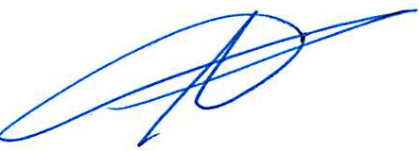

Adam Carter
Interim Director, Sponsored Programs

AC/lkc
Encs.
cc: C. Lee

