- Margins: 0.5 inches all around
- Normal: Arial 11 pt
- Spacing: 12 pt exactly (except for in-line figures, then automatic ‘single spacing’)
- Hyphenate! (Menu: Page Layout, Page Setup, Hyphenation, Automatic)
- Legends: Arial 8.5 pt, Spacing exactly 8.4 pt. Hyphenated.
- Titles: Cambria 12 pt looks nice, but flexible.
- References: NIH Style EndNote. [1]

NIH instructions write: “Use an Arial, Helvetica, Palatino Linotype, or Georgia typeface, a black font color, and a font size of 11 points or larger. (A Symbol font may be used to insert Greek letters or special characters; the font size requirement still applies.). Type density, including characters and spaces, must be no more than 15 characters per inch. Type may be no more than six lines per inch (1 inch = 72 points, six lines/inch = 12 pt exact spacing). Use standard paper size (8 ½" x 11) . Use at least one-half inch margins (top, bottom, left, and right) for all pages. No information should appear in the margins.Font: 11

For references, please use: {FirstAuthor, Year, #PMID}
Old text from the DAC3 proposal are in grey.

RFA

Writing Assignments:
Mark
- Organize enhancer prediction challenge - 2pg, 1 figure (Aim3, response to AWG)
- Detection of enhancers - 1pg, 1 figure (Aim 2, Encyclopedia)
- Enhancer-gene linkages - 2pg, 1 figure (Aim 2, Encyclopedia, moved the network portion to Aim 1)
- Personal genome - 2pg, 1 figure (need more connection to ENTEx, Aim 1),
- ENCODE and Cancer (Disease) AWG subgroup - 1pg (Aim 3, AWG subgroup)
- Integrating encode w/ other consortia - gtex,ihec, roadmap, 1000G [1pg]: old text (Aim 1.6)
- Consortium Authorship Network Analysis - 1/2 pg, 1 figure (Aim 3 Consortium paper writing)
- Consortium paper writing: update this old text. (Aim 3, consortium paper writing)
- Get support letter from Mike Snyder, Brent Graveley (both DONE)
- Editing help from native English speaker

Zhiping:
- Include RBP pipelines in the next DAC 1/2 pages (Aim 3, pipelines)
- DNAme pipeline and QC (Aim 3, pipelines)
- Encyclopedia (Aim 2)
- Letters from Bing Ren (DONE), Mike Cherry, Rick Myers

Manolis:
- Applying ChromHMM to ENCODE3 data, 1 pages, 1 figure. Any future development on ChromHMM? (Aim 2, part of Encyclopedia)
- Write 1/2 page on co-chairing the AWG GWAS sub-group. This is the most active AWG subgroup. Can you also summarize the main results of this subgroup? (Aim 3, AWG subgroup)
- QC and utility. Aim 4. 4 pages, 2 figures.
- ChromImpute: Aim 1=main (insert into Section 1.1.1). Aim4=application.
- Support letter from Brad Bernstein, John Stam?
- Skip: HaploReg and its future developments. 1 page, 1 figure. GWAS specifically excluded.
- Skip: Please update this old text on increasing the utility of ENCODE data for the GWAS community. (Aim 3, AWG subgroup)
Manolis todo list:
- ChromImpute (Aim 1.1) - done.
- Human Mouse (Aim 1.4) - done
- QC etc (Aim 4)

Anshul
- Add a paragraph to describe your expertise (In Innovation section, currently page 12)
- ATAC-seq pipeline 1/2 - 1 page, 1 figure (please insert into Aim 3, pipelines)
- ChIP-seq pipeline (TF and histone mark), 2 pages, 1 figure. Please include summary of existing pipelines and plan for future developments. (Aim 3, pipelines)
- I believe that you co-chair the Regulations AWG sub-group. If so, can you write 1 paragraph about your effort of co-chairing and products of the sub-group. (Aim 3, AWG subgroup)
- 2 pages plus 1-2 figures on the cool stuff we discussed on the phone, how to visualize encyclopedia on-demand, and deep learning to quantize the fine-scale of regulatory sites. (Aim 2, Encyclopedia)

Roderic
ZW comment: tighten on what we have done (in particular the RNA-seq pipeline) and expand on what we plan to do. Novel RNA-seq data-types, such as long-read RNA-seq, single cell RNA-seq, ribosomal profiling, Gro-seq. We should say that we are ready to analyze a large variety of RNA-seq related data types should they be produced in ENCODE4. We should include some general approaches on analyzing these new datatypes so that the reviewers would believe that we have the expertise. Please edit directly in this document. Preferably done (at least the drafty version) by Saturday 1pm EST.
Let us Skype on Tuesday 11am EDT, March 15.
- RNA-seq pipeline. 2-3 pages, 1 figure. Please include summary of existing pipelines and plan for future developments. (Aim 3)
- Can you write 2 paragraphs on your contribution to the RNA-calls and working with the RNA group? (Aim 3)
- Do you want to include 1 page, 1 figure on chromatin vs. splicing? (Aim 1)
- Do you want to include 1 page, 1 figure on your splicing method, or other things that your group is working on and plan to work on? (Aim 1)
- Get support letter from Tom Gingeras

Noble (link to pdf)
- Hi-C pipeline, 1 page, 1 figure (Aim 3)
- Applying Segway to ENCODE3 data, 2 pages, 1 figure. Any future development on Segway? (Aim 2, part of Encyclopedia)
- Assay selection, 1 page, 1 figure. Please include future development. (Aim 4)
- Please write 2 paragraphs on your contribution to the 3D nucleome AWG sub group. Please describe the main products of the nucleome group. (Aim 3)
- Can you write 2 paragraphs on how we can integrate ENCODE data with data generated by the 4D nucleome consortium? The goal is to increase the utility of ENCODE data. (Aim 1, integration with other consortia)
- 2 paragraphs on co-chairing 4D nucleome with Bing Ren (Aim 3)

Shirley
- target genes of transcription factors 1 page, 1 figure (Aim 2, Encyclopedia)
- expand the coverage of ENCODE data annotation by taking advantage of public DNase and H3K27ac datasets. For example, we have determined that the combination of DNase and H3K27ac is the best approach for predicting enhancers. However there are many cell types that have only DNase but not H3K27ac, also vice versa. Can we use public data to supplement? Talk about the collection of DNase and H3K27ac data in Cistrome. Need to be able to match meta data. 1 page, 1 figure (Aim 2, Encyclopedia)
- Prediction of silencers? 1/2-1 page, figure? (Aim 2, Encyclopedia)
- CRISPR DOI 10.1186/s13059-015-0843-6, which can help the Characterization centers, 1 page 1 figure (Aim 3)

Rafa
- QC for RNA-seq, DNase, histone makrs, etc..., 1 pg, 1 figure (Aim 3 or Aim 4, pipelines and QC)
- Identification of DMRs, 1 page 1 figure (Aim 2, Encyclopedia)
- Normalization of gene expression matrix, DNase signal matrix, histone mark level matrix etc. across the entire panel of ENCODE cell types. 1-2 pages, 1 figure. (Aim 2 or Aim 4?)
- How do we guard the Consortium against batch effects? 1 page, 1 figure (Aim 1 or Aim 4?)

Support letters:
Cover letter that precedes all the support letters
Mark: Mike Snyder, Brent Graveley
Manolis: John Stam?
Roderic: Tom Gingeras
Zhiping: Bing Ren, Rick Myers (emailed but did not respond), Brad Bernstein, Nadav Ahituv, Uwe Ohler, Job Dekker, Len Pennacchio, Ross Hardison, Ben Brown and Peter Bickle, Sunduz Keles, Mike Cherry, Steven Brenner

DAC3 old letters
Third DAC Annual Progress Report

Aim 1:
Current: 7K words.
Propose cuts: we are aiming to cut it to at least 4.5K by Thu.

Aim 2:
Current: 9.4K words.
Propose cuts: Zhiping's group to cut it to 6.5K

Aim 3.1
Current: 270 words.
Propose: Leave as it is.

Aim 3.2
Current: 8K words.
Propose cuts: Zhiping's group to cut it to 4K

Aim 3.3
Current: 3.3K words.
Propose cuts: we could cut it to 2.25K after Thursday. Unless we hear otherwise by Wed. at 7pm, we are going to commence on cuts on aim 3.3

Aim 4
Current: 5.3K words.
Propose cuts: Manolis's group to cut it to 3.5K. Please coordinate this with Manolis.

Note that even these cuts seem harsh, this plan is still 3 - 4K more words than the 20K targets. We are working on the specific aims to 1 page. We will also do the SWAT duty on Sat. and/or Sun., and Anurag will be the contacting person for that. We also assume your group will deal with the figures and references of the grant.

Project Summary and Relevance

SPECIFIC AIMS
This proposal aims to continue the Data Analysis Center (DAC) for the ENCODE project, towards completing the catalog of functional elements in the human genome using high-throughput experiments and computational methods. The proposed DAC will respond to the Analysis Working Group (AWG) and help process, integrate, analyze, and interpret data from all groups in the ENCODE Consortium. By leveraging expertise spanning multiple data types, the DAC aims to fully utilize data from ENCODE as well as from external consortia. The analyses we propose will substantially augment the value of ENCODE. The proposed DAC members (Z Weng, M Gerstein, M Kellis, R Guigo, R Irizarry, S Liu, A Kundaje, and W Noble) are leaders in their respective subfields of computational genomics. They have extensive experience working together, many having worked together since Pilot ENCODE (>12 years ago). Our proposed activities are grouped into four aims:
Aim 1. Analyzing & integrating data and metadata from a broad range of functional genomics projects.
The DAC will perform data integration of data generated by the Mapping and Characterization Centers and the computational groups of the ENCODE consortium, as well as other public data, with the goal of annotating different classes of functional elements. In particular, the DAC will carry out initial exploratory data analyses using state-of-the-art machine learning techniques in order to seek novel insights and correlations between classes of functional elements. These analyses will make use of various concepts in network analysis (e.g., hubs and motifs). To achieve the goal, the DAC will integrate data from large-scale genomic consortia (e.g., Roadmap, 1000 Genomes, GTex, TCGA, and iHEC), normalizing, calibrating and harmonizing these with the ENCODE annotations. As a key aspect of this integration, the DAC will use human variation data to construct personal genomes as platform for individual-specific annotation. Finally, the DAC will perform comparative analyses between human and mouse to understand the degree of conservation of regulatory mechanisms.
Aim 2. Serving as an informatics resource by supporting the activities of the ENCODE AWG.
The DAC will work with the AWG to prioritize analyses, administering AWG conference calls to receive requests for analysis and report on progress. The DAC will help define shared computational guidelines and infrastructure for data processing, common analysis tasks, and data exchange. In particular, the DAC will coordinate with the ENCODE Data Collection Center (DCC) to establish robust uniform analysis pipelines. Building on the pipelines developed by the current DAC in collaboration with other ENCODE members, the DAC aims to refine these and complete the development of uniform analysis for all major ENCODE data types. The DAC has currently built pipelines for ChIP-seq, RNA-seq, and methylation, which will be refined. We plan to further implement pipelines for Hi-C and ATAC-seq. For analyses that require more extensive interaction, the DAC will bring together data producers and analysis experts in focused groups, subgroups of the overall AWG, and develop specific, context-focused annotation (e.g., to best integrate with GWAS data). As novel biological insights emerge from these analyses, the DAC will facilitate writing manuscripts in coordination with the AWG.
Aim 3. Creating high-quality Encyclopedias of DNA elements in the human and mouse genomes.
Based on the integrative work in Aim 1 and the construction of analysis pipelines in Aim 2, the DAC will generate catalogs of functional elements in a cell-type specific manner, collectively called the Encyclopedia. The Encyclopedia comprises three levels. The ground level includes genomic regions that are enriched in various biochemical signals such as DNase accessibility, histone modifications, transcription factor (TF) occupancy, DNA methylation, RNA transcription, RNA-binding protein (RBP) occupancy, and chromatin-driven topologically associating domains (TADs). By taking advantage of the work of the Characterization Centers, the ground-level catalog will be integrated to predict the locations of functional elements such as enhancers, insulators, and silencers, forming the second level the Encyclopedia. The third level of the catalog includes higher-order interactions among the predicted elements—e.g., enhancer-target interactions and system-wide regulatory networks in a specific cell type. To make the Encyclopedia accessible to a broad range of biomedical researchers, we will develop and implement approaches to present it in an intuitive and detail-on-demand manner.
Aim 4. Assessing quality and utility of the ENCODE data and providing feedback to the Consortium.
The DAC will develop computational methods to assess the quality and utility of ENCODE data in a systematic and unbiased way. We will work with the consortium to standardize data-type specific metrics of dataset quality. We will further develop measures for assessing experiment quality based on systematic signal imputation. We will develop metrics and methods for evaluating the progress and completeness of the entire ENCODE corpus, towards the goal of covering all active functional elements in all cellular states. We will develop and apply methods for evaluating the per-nucleotide information content of each data type based on genomic coverage, resolution and reproducibility. We will evaluate the utility of an assay (or cell type) based on its ability to predict another assay (or cell type). We will then combine utility scores to rank datasets and prioritize the experiments that will be of greatest overall utility. Specifically in the context of disease, we will provide a ranking based on predictive ability for disease-associated genetic variants (e.g., from GWAS).

SIGNIFICANCE
The ENCODE Project is one of a number of ambitious projects building on the foundation of the Human Genome Project. The goal of ENCODE is to apply high-throughput, cost-efficient approaches to generate a comprehensive catalog of functional elements in the human genome, including transcribed regions, chromatin features, transcriptional control regions, and post-transcriptional control regions. The impact of this project is tremendous, broadly affecting biomedical research and personalized medicine, because functional genomic elements are the basis of all biological processes. As a coordinated effort, ENCODE members strategize common biological samples, enforce quality standards, and implement rapid data release policies. The value of ENCODE data is greatly enhanced by efforts to increase the breadth, depth, quality, and utility of the data. Although the individual datasets produced by the ENCODE project are highly effective in the study of any individual region, their true potential is achieved by integrative genome-wide analyses¹⁻³.
We propose an ENCODE Data Analysis Center (EDAC, DAC in short) to support, facilitate, and enhance integrative analyses of the ENCODE Consortium data on human and mouse. We will work closely with Consortium members to identify and prioritize integrative analyses that should be carried out, identify the best groups and methods to accomplish them, coordinate all necessary data transformations, and undertake these analyses with the other Consortium members. Our ultimate goal is to ensure a successful final product of high-quality annotation in human and mouse, called the ENCODE Encyclopedia, and gain new insights into the biology and gene regulation of animal genomes.
We envision that the DAC will minimally perform the following roles, organized into four aims of the proposal in direct response to the RFA: (Aim 1). Analyzing & integrating data and metadata from a broad range of functional genomics projects. (Aim 2). Serving as an informatics resource by supporting the activities of the ENCODE AWG. (Aim 3). Creating high quality Encyclopedias of DNA elements in the human and mouse genomes. (Aim 4) Assessing quality & utility of the ENCODE data & providing feedback to the Consortium.To achieve these four aims, the proposed DAC will work closely with members of the Consortium, and in particular two entities within it, the Analysis Working Group (AWG), consisting of all Principal Investigators (PIs) of the production centers, PIs of functional characterization centers, informatics PIs, and personnel from each of the groups; and the Data Coordination Center (DCC), responsible for all data and metadata submission, data formatting and uniform processing, and data sharing with the larger scientific community.
The four aims and the interactions needed to achieve them are greatly facilitated by the composition of the proposed DAC. The DAC members’ expertise spans human and mouse. We have experts in specific functional elements like promoters, enhancers, silencers, protein-coding and non-coding genes, micro-RNAs, sequence motifs, splicing, RNA binding proteins, and 3´-untranslated regions, as well as experts in analyses and various machine learning techniques such as principal component analysis, clustering, support vector machines, hidden Markov models, dynamic Bayesian networks, and deep learning. DAC members are collaborating directly with every production group in ENCODE, and thus will have intrinsic knowledge of the experimental intricacies of each data type. The team has the unique experts to take on any aspect of the integrative analysis, but is also highly integrative as all members have longstanding experience of working together in ENCODE and related consortia. We have established a strong leadership and organizational structure for the DAC, as described in the PI Leadership Plan. A three-person committee composed of Weng, Gerstein, and Kellis will jointly make decisions on all important matters. The three labs are located in physical proximity (~2 hours drive), in the same time zone, and thus can collaborate extensively and respond quickly to any analysis needs, which is particularly important during the final pushes of putting together the Encyclopedia and Consortium papers. See support letters from the PIs of several current production groups and the DCC of ENCODE: Drs. Mike Snyder, Brad Bernstein, Brent Graveley, Tom Gingeras, Bing Ren, and Mike Cherry.

INNOVATION
This project requires a different type of innovation from traditional R01s. The RFA requires that we follow the directions set by the AWG, although we can contribute to setting the directions. Thus, we are fundamentally limited in being innovative in taking direction. Nonetheless, we are highly innovative in putting together a multifaceted team to meet the enormous challenge of facilitating and performing the integrative analysis activities in ENCODE, a large and complex consortium. At present, our team consists of eight highly talented investigators with expertise covering broad biological areas: transcriptional regulation (Weng, Kellis, Gerstein, Guigo, and Liu), epigenetics (Kellis, Weng, Gerstein, Kundaje, and Liu), evolution (Kellis), genomics and proteomics (Noble, Gerstein, Weng, and Guigo), regulatory RNA (Kellis and Weng), and biophysics (Gerstein and Weng). The team also has a variety of expertise in computational biology, e.g., machine learning (Noble, Kellis, and Kundaje), biostatistics (Liu and Irizarry), networks (Gerstein and Weng), and gene annotation (Guigo and Gerstein).
We are confident that the assembled team can produce innovative science in a consortium framework. This is manifested by the many Consortium publications that the team members have led and participated. In particular, the team members have been highly innovative in building and applying state-of-the-art methods, with examples described in Aims 1-4, and a long history of producing computational tools that are widely used by the broader community. Importantly, most team members have a rich experience in various consortia: ENCODE (Weng, Gerstein, Kellis, Kundaje, Guigo, Noble, Irizarry, and Liu), modENCODE (Gerstein, Kundaje, Kellis, and Liu), the Epigenome Roadmap (Kundaje and Kellis), the 4D Nucleome Consortium (Noble), the 1000 Genomes Project (Gerstein), the PsychENCODE Project (Gerstein and Weng), the Extracellular RNA Communication Consortium (Gerstein), DOE KBase (Gerstein), and the 29 Mammals Project and the 12 Flies Project (Kellis). In summary, we have assembled a team with the right expertise, that has worked in large collaborative consortia and has delivered in that environment. The details of the team members are provided as follows:
Zhiping Weng (U. Mass. Medical School) Professor Zhiping Weng has an engineering background, and has worked for the last decade on biological problems ranging from genomic to protein-protein interaction analysis. She has participated in the ENCODE project since its inception in 2003, leading a technology development project in the pilot phase of ENCODE (2003-2007), a pilot project during the scale-up phase of ENCODE (2007-2011), and the DAC for ENCODE3 (2011-). She has participated in the integrative analysis in ENCODE since 2003, co-chaired the transcription regulation analysis group in the pilot phase of ENCODE, and was a member of the DAC in ENCODE2. She currently heads the ENCODE DAC and co-chairs the AWG. She has worked on transcription factor binding site detection, integrating histone modification signals to predict gene expression, and integrating chromatin features to predict enhancers and their target genes.
Manolis Kellis (MIT and the Broad Institute) Manolis Kellis is a professor of Computer Science and an Institute Member of the Broad Institute and has a background in computational genomics with 10+ years experience in comparative genomics, epigenomics, regulatory genomics, and disease genetics. He has led or co-led a large number of large-scale genomic studies, including the comparative analysis of 29 mammals, the integrative analysis of ENCODE chromatin datasets, the fly modENCODE integrative analysis, the comparative analysis of 12 Drosophila species, the comparative analysis of eight Candida genomes, and the first comparative studies of four yeast species.
Mark Gerstein (Yale U.) Professor Gerstein has been an integral part of the ENCODE Project since its inception, and within the project he has assumed a number of leadership roles. For instance, in ENCODE2 he co-directed the Networks/Elements Group, which resulted in his co-leading one of the ENCODE high-profile companions⁸, and in ENCODE3, he co-lead the ENCODE & Cancer subgroup. He was co-chair of the AWG in modENCODE and in this capacity led the worm integrative paper⁹ and the comparative transcriptome paper[[PMID: 25164755]]. He also led and participated in a number of sub-analyses resulting in >15 companion papers in various phases of ENCODE, particularly those focusing on pseudogenes, variant interpretation, ncRNAs, TF binding sites and networks¹⁰⁻¹⁹. [[Add these PMIDs 22972285 22950945 22955978 22951037 25249401 25164757]] He is also a member of a number of other genomics consortia, including the 1000 Genomes, PsychENCODE, exRNA, CMG, PCAWG and DOE Kbase and in these groups he has worked on connecting the ENCODE annotations with other genomic resources (eg PMIDs 24092746 & 25273974).
Roderic Guigo (Center for Genomic Regulation and University Pompeu Fabra) Professor Guigo has been active in the field of computational genomics for more than 25 years. He has developed widely used tools for gene finding and annotation, such as GENEID and SGP, as well as benchmark metrics and datasets to evaluate the accuracy of gene prediction methods. He has participated in many genome projects, often in leadership positions. He has been involved in the ENCODE Project since the pilot phase, in which he lead the GENCODE efforts to delineate the gene and transcript reference annotation of the human genome. The bulk of his current research focuses on the mechanisms underlying RNA production (transcription) and post-processing (splicing). He also participates in other large scale functional genomics projects such as GTEx and BluePrint.
Rafael Irizarry (Dana Farber Cancer Institute; Harvard U.) Professor Irizarry has over 15 years of experience developing methods for high-throughput genomics data. His dedication to producing tools that are useful to biologist and the wider research community is evidenced by the popularity of the methods he has developed, such as RMA, fRMA, GCRMA, CRLMM, CHARM, CQN and bumphunter. He has made these tools freely available through open source code. His expertise in dealing with bias, systematic errors, batch effects, and other unwanted variation in biological data will be extremely valuable for improving the quality of ENCODE data via statistical methods.
Anshul Kundaje (Stanford U.) Prof. Kundaje's lab develops computational approaches to decipher the context-specific regulatory architecture of the human genome and the genetic and molecular basis of complex traits and disease by integrating diverse types of large-scale functional genomic and genetic data. Dr. Kundaje was trained as a computer scientist with expertise in data mining and machine learning coupled with extensive experience with large-scale integrative analysis of functional genomic data. He was the lead computational analyst of ENCODE2 and the Roadmap Epigenomics Project. He is currently an active member of the ENCODE3 DAC and co-leads the Regulation Subgroup. Dr. Kundaje has developed machine learning methods for deciphering comprehensive maps of cell-type specific regulatory elements; deconvolving sequence, structural and functional heterogeneity of elements; learning predictive regulatory network models and interpreting the regulatory impact of natural and disease-associated non-coding genetic variation. He has developed state-of-the-art quality control measures and automated data processing pipelines for diverse functional genomic data types. Dr. Kundaje also has significant experience developing software infrastructure and web portals for rapid, cloud-based data mining and visualization of large-scale regulatory genomics data.
X. Shirley Liu (Dana-Farber Cancer Institute; Harvard T.H.Chan School of Public Health) Professor Liu is a computational biologist with expertise in on algorithm development and integrative modeling of gene regulation. She has been a member of the mod/ENCODE consortia and the director of the Center for Functional Cancer Epigenetics at the Dana-Farber Cancer Institute. Her group developed a number of widely used algorithms for transcription factor (TF) motif finding, ChIP-chip/seq, MNase/DNase-seq, and recently on CRISPR screen data analysis. Through integrating genome-wide transcription factor binding, chromatin dynamics, gene expression profiles, genetic and chemical screens, they model the specificity and function of transcription factors, chromatin regulators and lncRNAs in tumor development, progression, drug response and resistance. A key component of big data integration is data normalization and bias correction, she has been at the forefront of identifying and correcting biases in next-generation sequencing and epigenomics data.
William Noble (U. Washington) Professor Noble has a background in computer science and has applied a series of machine learning and statistical techniques to biological problems. He is one of the creators of the widely used MEME Suite of motif-based analysis tools, and he has led the use of support vector machines, wavelet analyses and dynamic Bayesian networks in genomic and proteomic analysis. Working in the Department of Genome Sciences at the University of Washington, he interacts with many high-throughput experimental groups and continues to have strong links to the machine learning community. He has been involved in the ENCODE Consortium since its inception in 2003.
A combined multi-site DAC with multiple investigators in geographical separation might potentially prevent the DAC from working as a cohesive team. We are going to discuss and mitigate the risk in the Section titled “Risk Assessment and Leadership” in the Multi-PI Leadership Plan. In fact, the geographic distribution of the members of the DAC is ideally suited for a consortium that is itself expected to be geographically distributed, and has been geographically distributed in the previous three phases of the ENCODE Project. Importantly, we have a strong track record of working together over the past thirteen years of analysis during the ENCODE Project, modENCODE Project, and other large-scale consortia. Overall, the difficulties of coordination are offset by the benefits of the many different environments and complementary expertise provided by the participating groups.

APPROACH
Aim 1. Analyzing and integrating data and metadata from a broad range of experimental and computational functional genomics projects.
1.1 Exploratory analyses of diverse types of ENCODE data
1.1.1 Dataset completion by imputation for histone marks, DNA accessibility, RNA-seq, and DNA methylation.
The ENCODE project has balanced the priorities of employing many types of experimental assays and performing these assays in as many different biological contexts as possible. The solution has been to conduct a small set of assays (e.g., mapping histone marks by ChIP-seq and chromatin accessibility by DNase-seq) in a large variety of cell types, and a much larger set of assays (e.g., mapping transcription factors or TFs by ChIP-seq and RNA-binding proteins or RBPs by eCLIP-seq) in a few cell types. This leaves many types of experiments that have not been conducted in all biological context, reducing the ability to carry out integrative analyses that require complete data matrices, and reducing the utility of ENCODE datasets for cell types and/or assays that were not profiled experimentally. To remedy this situation, we will develop and apply methods for imputation of missing datasets by exploiting the correlation structure of functional genomic data across cell types and across assays (Fig. 1.1.1a). In our preliminary studies, we showed that a regression tree approach, ChromImpute{Ernst, 2015 #PMID:25690853}, recovers missing datasets for diverse cell types and assays (Fig. 1.1.1b), giving us confidence that we can complete missing datasets systematically.
a.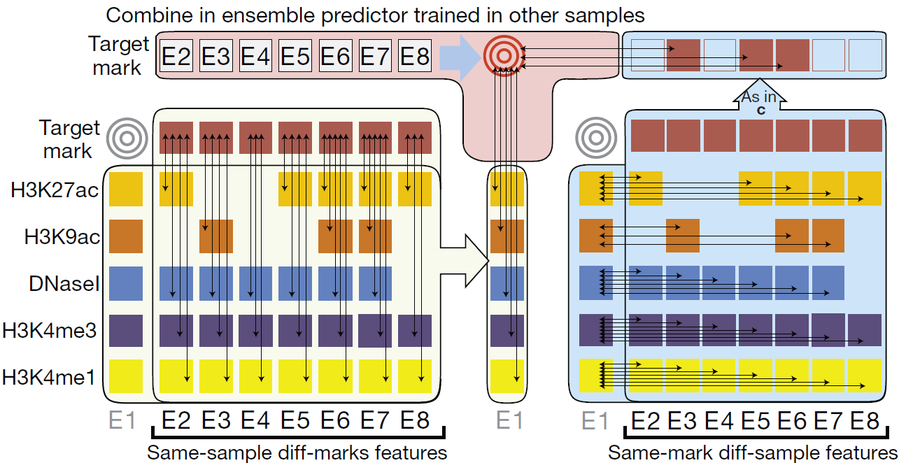b.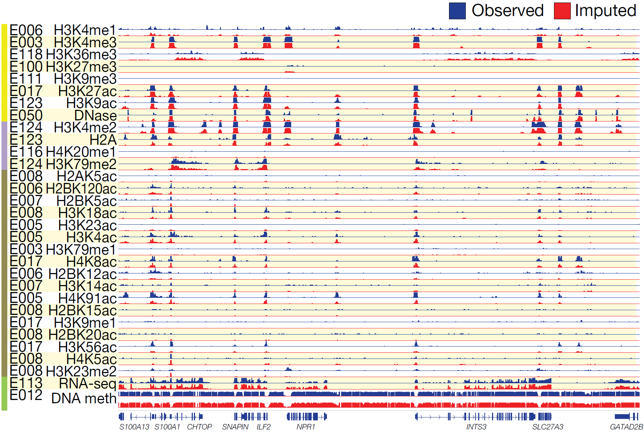
Figure 1.1.1: Imputation of missing datasets. a. Ensemble strategy for signal track imputation using features that exploit correlations between marks in the same sample (left) and correlations between samples for a given mark (right). We assume that no information is available for the target mark in the target sample (gray targets). Thus, we learn relationships between marks (left side) in other samples (column of E1 sample is not used) and learn relationships between samples (right side) using other marks from which we then compute same-mark features. The ensemble predictor that combines features across marks and across samples is learned only in other samples (top), and the marks in the target sample are used only during the actual application of the trained ensemble predictors to compute the imputed signals. b. Imputed data are a close match to observed datasets. Visualization of a randomly selected 200-kb region illustrates high-resolution concordance between observed (blue) and imputed (red) signal tracks. Imputed tracks are generated at 1-bp resolution for DNA methylation and 25-bp resolution for all other marks and trained without using the observed track.
1.1.2. Prediction of TF binding sites in a new cell type
One area where predictive models may help infer information that we don’t determine directly is the prediction of TF binding sites in cell types for which there is no ChIP-seq data for the TF but there are data on chromatin accessibility (DNase-seq) or histone modifications. Several DAC members have strong expertise in this area. We developed a method to predict TF binding sites by integrating histone modification data and TF motif information and applied it to modENCODE data on worm⁹ and also in yeast⁶². This model uses chromatin features (histone modifications, DNase hypersensitivity etc.) to infer the local accessibility of DNA regions, and then searches inferred accessible regions for TF binding motifs to predict binding sites. Similarly, we developed models to predict TF binding sites using DNAse-seq data. Their model, LR-DNase, uses logistic regression to combine several features captured by DNase-seq data (e.g., DNase reads, footprints in DNase read coverage, and strand bias in DNase cleavage) with the DNA sequence and TF ChIP-seq data from a separate cell type, to predict TF binding sites in a cell type of interest. LR-DNase outperforms state-of-the-art methods including CENTEPEDE, PIQ, and BinDNase. Application of these models will enable inference of TF binding profiles in the hundreds of cell types where DNAse-seq and histone modification ChIP-seq are being conducted.
We discovered that chromatin dynamics coupled with TF motif discovery could be used to infer functional TF binding and gene expression changes by taking into account the characteristics of the TFs⁶⁶. For example, estrogen receptor binding sites already show DNase hypersensitivity prior to estrogen activation, while androgen receptor binding sites only show DNase hypersensiticity upon activation. We will systematically identify distinct chromatin dynamics relative to different TF binding, differentiate signatures between transcriptional activators versus repressors, and model signatures associated with slow versus fast transcriptional responses upon perturbation.

1.1.3 Application of generalized machine learning methods to ENCODE data

The genome-wide experimental assays produced by ENCODE provide opportunities for data-driven research to complement traditional hypothesis-driven investigations, but also present unique challenges. We will implement a range of unsupervised machine learning methods to search for novel connections between elements of the ENCODE data, focusing on methods that scale to large data sizes and that are designed for the diverse statistical properties of data generated by different assays.
The premier method for integrating heterogeneous data is to use a probability model. These models are ideal for handling heterogenous data, as they enable inclusion of prior knowledge either through prior distributions or through the inherent structure of the chosen model. Applications of these models in ENCODE include hidden Markov models and their generalized form, dynamic Bayesian networks, for the semi-automated genome annotation (SAGA) methods ChromHMM and Segway. In addition to extending these SAGA methods (Section 3.2.3), we will, as appropriate, explore the use of unsupervised techniques such as Bayesian model-based clustering (Fraley and Raftery JASA 97:458, 2002), Gaussian process models (http://citeseerx.ist.psu.edu/viewdoc/summary?doi=10.1.1.86.3414), probabilistic topic models (http://dl.acm.org/citation.cfm?id=2133826) and other learning procedures for graphical models (M. I. Jordan, Learning in Graphical Models 1996).
Neural networks provide an increasingly popular alternative framework for analyzing massive datasets. Such networks use a series of non-linear transformations to project data into higher or lower-dimensional spaces, allowing for learning in arbitrary classification, regression or structured output problems. So-called "deep" neural networks, which contain many layers and typically require massive training datasets, have recently revolutionized a wide variety of fields, ranging from natural language processing and image analysis (PMID:26017442) to out-playing the world champion of the game "go" (PMID: 26819042). Deep neural networks have also been applied recently to genomics, including predicting the effects of non-coding variants (PMID:2630184), identification of replication domains (PMID: 26545821), population genetic inference (http://biorxiv.org/content/early/2015/10/02/028175), and predicting DNase hypersensitivity (http://biorxiv.org/content/early/2015/10/05/028399). Neural networks handle heterogeneity in a data-driven way by leveraging very large datasets to learn appropriate data projections that weight different data sources in a non-linear fashion. Unsupervised training of deep neural networks can be accomplished via the use of "auto-encoder" architectures, in which the same data is provided as both input and output to the model. Intermediate layers of the network can often be used for data visualization, compression, or to provide a unified input format to downstream analyses. Another class of unsupervised neural network, the self-organizing map, was used successfully in ENCODE2 to explore the latent state space of functional elements in the genome (PMID: 24170599), and we envision revisiting these maps using a deep architecture. Overall, for any unsupervised analysis of ENCODE data, deep neural networks will be an important component of the proposed DAC's analytical toolbox.
Kernel methods represent a third class of methods for learning from heterogeneous data. These techniques use a class of mathematical functions, known as kernel functions, to map data from its native format (the "input space") to a (typically) higher-dimensional “feature space”. Kernel methods have been used very successfully to solve a huge variety of problems in computational biology (reviewed in Scholkopf, Tsuda, Vert Kernel Methods in Computational Biology 2004). Furthermore, kernels provide a modular framework for representing heterogeneous data, because separate kernel functions can be defined for each data type (PMID: 15130933). Importantly, many "classical" analysis methods can be adapted to operate using kernel representations, including supervised methods like Fisher's linear discriminant (http://luthuli.cs.uiuc.edu/~daf/courses/learning/Kernelpapers/00788121.pdf) as well as unsupervised methods like principal components analysis (PCA) (http://pca.narod.ru/scholkopf_kernel.pdf) and kernel canonical correlation analysis (CCA) (http://www.ics.uci.edu/~welling/classnotes/papers_class/kCCA.pdf, PMID: 24671853).
We will also apply dimensionality reduction and manifold learning methods to glean structure from large, heterogeneous datasets. Dimensionality reduction methods are widely used for visualization, and include aforementioned techniques such as PCA and deep auto-encoders, as well as a variety of methods that project data non-linearly to a low-dimensional manifold. Recently, new dimensionality reduction methods such as t-SNE (Laurens van der Maaten, Geoffrey Hinton; JMLR; 9(Nov):2579--2605, 2008) have proven useful for visualizing, for example, single-cell RNA-seq data (PMID: 23685480). DDRTree is a similar technique that imposes a tree-like prior on the learned projection, enabling visualization of cancer datasets (Qi Mao, Li Wang, Steve Goodison, and Yijun Sun. Dimensionality Reduction via Graph Structure Learning. The 21st ACM SIGKDD Conference on Knowledge Discovery and Data Mining (KDD'15), Hilton, Sydney, Australia, August 19, 2015) or developmental trajectories from single-cell RNA-seq data (http://rpackages.ianhowson.com/cran/DDRTree/).
Finally, we will, as appropriate, apply standard clustering methods to help find structure in ENCODE data. Such methods include hierarchical clustering, k-means and k-medoids clustering, as well as a variety of biclustering methods on data defined in two dimensions (e.g., across cell types and assay types).

1.1.4 Inter-relating Chromatin & Splicing
We will also study the role of chromatin structure and modifications in the regulation of RNA processing, particularly splicing. Using integrative analysis of RNA-seq, ChIP-seq of histone modifications and of RNA polymerase, and ChIA-PET data produced during ENCODE2, we found significant positive association between H3K4me3, H3K9ac, H3K27ac, histone marks characteristic of active promoters, and exon inclusion in a small but well-defined class of exons, representing approximately 4% of all regulated exons. These exons are systematically maintained at comparatively low levels of inclusion across cell types, but their inclusion is significantly enhanced in particular cell types when in physical proximity to active promoters (Figure 2, [Curado J., 2015 PMID: 26498677]) .

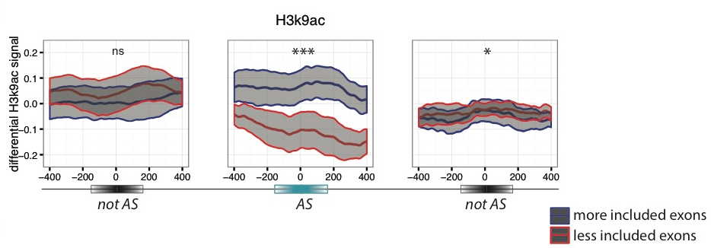
Figure 1.1.4A Differential accumulation of marks is generally specific of regulated exons. Differential ChIP-seq signals (average and standard error of the mean) for H3K9ac are represented for “more included” exons (blue) and “less included” exons (red) in pairwise comparisons between cell lines. The differential signal is computed on a 800 bp window around the regulated exon (AS) and the flanking not regulated (notAS) upstream (left) and downstream (right) exons. Significance levels are indicated by * (0.05>p>0.01), ** (0.01>p>0.001), *** (0.001>p) and ns (p>0.05). From [Curado J., 2015, PMID: 26498677]

In order to elucidate how chromatin state effects and modulates RNA processing, we have built a series of random forest models to predict exon inclusion based on chromatin marks, chromatin state, and RNA binding protein binding assays (eCLIP) in the K562 cell line. The highest predictive power was achieved when using RBP binding data and histone modifications as predictors. We also found signatures from RNA Pol-II ChIP that affect choices between cis and trans splicing and post-transcriptional exon duplication and rearrangement. Higher RNA Pol-II density after cassette exons, likely indicating accumulation of transcripts, correlates to increased chances of local trans-splicing over cis-splicing (Figure 1.1.4B). Meanwhile, the density of Pol-II is also significantly lower downstream of trans-splicing junctions that produce circular RNA products, compared to those that lead to exon shuffling (Figure 1.1.4B).

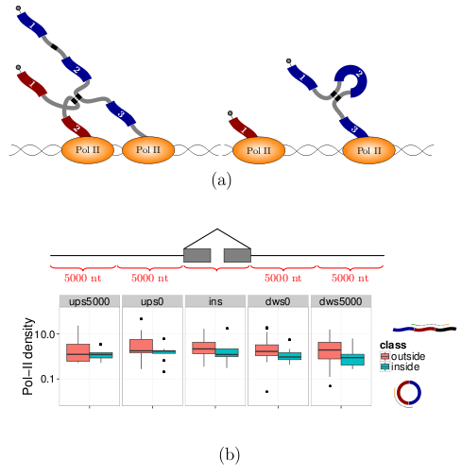
Figure 1.1.4.B Two regimes of RNA Pol-II lead to different splicing outcomes. Accumulation of pol-II leads to collision and promotes trans-splicing. C. The density of RNA pol-II (y-axis) is indeed higher downstream (x-axis) of cassette exons that have evidence of trans-splicing (green), compared to cassette exons that are spliced in cis- with the formation of circular products (red).
1.2 Analysis of biological network structure & dynamics.
We have developed a number of approaches for constructing and studying biological networks that can be applied to analyze ENCODE4 datasets. We integrated multiple genomic datasets to construct gene regulatory networks consisting of various regulatory factors including transcription factors and micro-RNAs and their target genes \cite{22955619, 25164757, 22125477}. For constructed gene regulatory networks, we developed methods to construct and analyze the gene regulatory networks of human and model organisms \cite{ 20439753, 21177976, 22125477, 21430782, 22955619} using ENCODE and modENCODE datasets. We also analyzed hierarchical structures of gene regulatory networks and found that the hierarchy rather than centrality ("hubiness") better reflects the importance of regulators \cite{ 22955619, 17003135, 21045205, 20523742, 20351254}. We also developed a novel and general purpose algorithm to determine and measure the hierarchical structure of any types of gene regulatory networks \cite{Cheng, 2015 25880651}. In addition, we integrated regulatory networks with gene expression to uncover different types of functional modules \cite{15372033, 19723326, 12902159, 14555624}. We also introduced several software tools for network analysis including Topnet, \cite{14724320}, tYNA \cite{17021160}, and PubNet \cite{16168087}.

In addition to the global features of the regulatory networks such as hierarchy, we also analyzed their local topologies such as network motifs. For example, we analyzed the feed-forward loops (FFLs), a common regulatory network motif in human, worm and fly gene regulatory networks \cite{22955619, 21177976, 25164757}. The motif analyses will allow a characterization of key regulatory mechanisms in each species and the further comparison between species will enable us to observe how these mechanisms evolve.

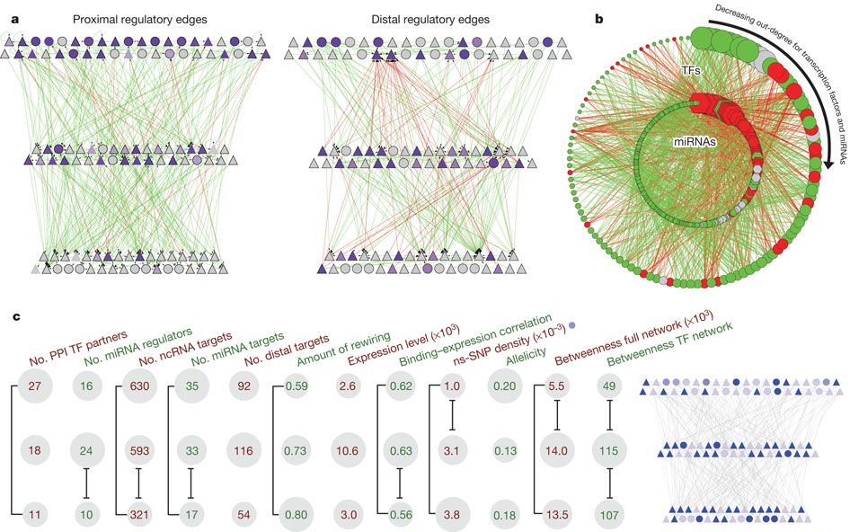
Figure Hierarchy of the human regulatory network derived from ENCODE data
a, Close-up representation of the transcription factor hierarchy. Nodes depict transcription factors. TFSSs are triangles, and non-TFSSs are circles. Left: proximal-edge hierarchy with downward pointing edges coloured in green and upward pointing ones coloured in red. The nodes are shaded according to their out-degree in the full network (as described in Table 1). Right: factors placed in the same proximal hierarchy but now with edges corresponding to distal regulation coloured green and red, and nodes re-coloured according to out-degree in the distal network. The distal edges do not follow the proximal-edge hierarchy. b, Close-up view of transcription-factor–miRNA regulation. The outer circle contains the 119 transcription factor, whereas the inner circle contains miRNAs. Red edges correspond to miRNAs regulating transcription factors; green edges show transcription factors regulating miRNAs. Transcription factors and miRNAs each are arranged by their out-degree, beginning at the top (12:00) and decreasing in order clockwise. Node sizes are proportional to out-degree. For transcription factors, the out-degree is as described in Table 1; for miRNAs, it is according to the out-degree in this network. Red nodes are enriched for miRNA–transcription factor edges and green nodes are enriched for transcription factor–miRNA edges. Grey nodes have a balanced number of edges (within ±1).

In this aim, we will study the structure and dynamics of inferred regulatory networks and relate these to other cellular networks. Our core networks will primarily consist of mixed TF/miRNA director regulatory networks discovered in Aim 3.5, but will also be populated by undirected networks, constructed using information regarding protein interaction and biological-relatedness, such as those utilized or discovered in Aim 3.2. Figure 9 illustrates the TF-miRNA regulatory network generated with previous ENCODE data \cite{22955619}. Extending our previous work, we will use graph algorithms to discover clusters of highly connected genes within these networks, network motif algorithms to discover recurrent patterns of connectivity, and specifically search for recurrent regulatory feedback and feed-forward subgraphs.

Furthermore, we can try to identify the gene regulatory mechanisms such as cooperative logics between multiple regulatory factors in the regulatory networks. We have recently developed a new computational method, Loregic to characterize the gene regulatory logics in complex systems \cite{25884877}. We already used this method to identify regulatory cooperative logics among TFs binding to promoters, TFs binding to distal regions like enhancers and miRNAs in leukemia by integrating ENCODE and TCGA data.

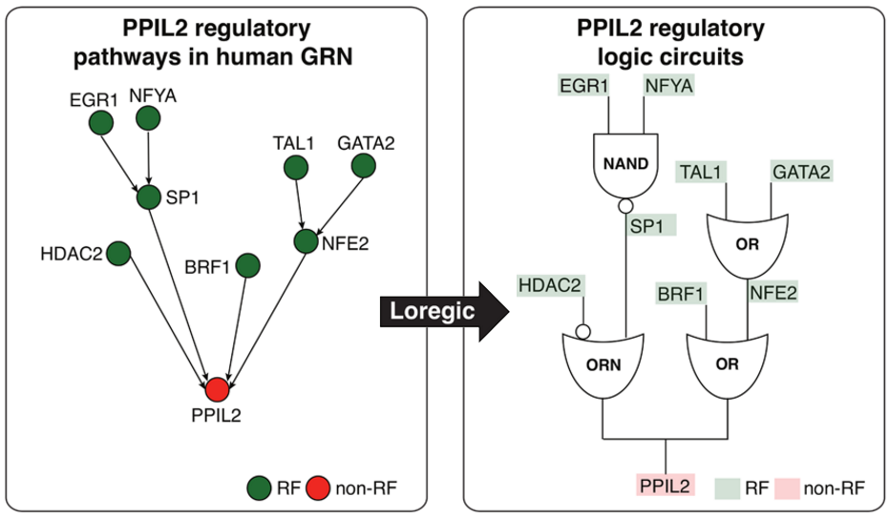
Figure Depiction of two logic circuit regulatory pathways targeting PPIL2.

1.3 Integration & Harmonization of ENCODE data with datasets from other consortia
The overall goal of the DAC is to make the ENCODE annotation and analyses a broad and useful resource for researchers focusing on the human genome. To ensure this, the ENCODE annotation needs to compatible with other large genomics datasets. The integration of ENCODE annotation with other datasets typically involves one or more of three different forms: 1) normalization and calibration of the ENCODE datasets relative to a somewhat differently normalized corpus; 2) the more developed annotations from other consortia can be related to the ENCODE corpus; 3) genomic variation (germline and/or somatic) inferred from other large genomics datasets can be used to infer evolutionary pressure within different ENCODE elements. In the sections below we go through a number of the large genomics datasets currently available, GTEx, Roadmap, Psych ENCODE, 4D Nucleome, TCGA etc. and talk about ways that we plan to integrate the ENCODE data with these other large datasets. Below we list the DAC investigators who are also members of these other consortia and will leverage these relationships to help connect the datasets and annotations in a positive way.

The Roadmap Epigenomics Project and International Human Epigenome Consortium. The DAC is working with the DCC to import consolidated epigenomes and unconsolidated experiments of Roadmap Epigenomics Project and the International Human Epigenomics Consortium into the ENCODE portal. The DAC compiled ~7,000 consolidated and ~15,000 unconsolidated data files, including alignments, signal, and peaks, into 127 epigenome objects in ENCODE.

The Genotype-Tissue Expression Project (GTEx). GTEx is a large-scale data resource that studies human gene expression and regulation and their relationship to genetic variation. Manolis Kellis and Roderic Guigo are also part of GTEx and will help to integrate the GTEx RNA-seq datasets into ENCODE pipelines for joint integrative analyses by the ENCODE AWG. In addition, the expression quantitative trait loci (eQTLs) identified by the GTEx project will be integrated with various ENCODE annotations.

PsychENCODE and BrainSpan. The PsychENCODE and BrainSpan projects are developing resources for genomics, regulatory, epigenomic, and proteomic landscapes in healthy and diseased, developing and adult brains, as well as in neural cell cultures. Mark Gerstein and Zhiping Weng are members of the PsychENCODE consortium and will ensure consistency of data processing and pipelines between the PsychENCODE and ENCODE consortia. In addition, the eQTLs identified in the PsychENCODE project will be integrated into the ENCODE annotations.

The Extracellular RNA (exRNA) Communication Consortium (ERCC). Mark Gerstein is in charge of the DAC of the exRNA consortium to develop the standardized RNA-seq pipelines for the analysis of exRNAs. We have developed a custom pipeline (exceRpt) for the analysis of small exRNA-seq data for the ERCC that is similar to the ENCODE small RNA-seq pipeline.

The 1000 Genomes Project. The Gerstein Lab aims to integrate different non-coding annotations with the germline variants identified by the 1000 Genomes Consortium. In this way, the non-coding annotation of each variant will be available to all users of the 1000 Genomes data and should serve as a valuable resource for the genetics community to identify the causal variant in GWAS.

The Cancer Genome Consortium (TCGA) and International Cancer Genome Consortium (ICGC).
The Gerstein and Liu labs will integrate different non-coding annotations with the somatic variants identified by TCGA and ICGC. We will also integrate the RNA-seq and miRNA gene expression in the TCGA and ICGC datasets with ENCODE data by running the ENCODE pipelines on these datasets.

The 4D Nucleome Nuclear Organization and Function Interdisciplinary Consortium
Bill Noble is part of the 4D Nucleome consortium and is co-chairing its steering committee. He is thus in an excellent position to ensure coordination between the ENCODE and 4D Nucleome consortia. He is currently developing methods to integrate information from Hi-C and imaging experiments from the the 4D Nucleome consortium with functional genomics datasets during genome segmentation and these methods will be applied to the ENCODE Hi-C data.

1.4 Detailed Integration of Variants: Personal genomes and their use to develop allelic annotations
1.4.1 Personal genome construction
The alignment of assay reads is one of the main steps in processing of functional genomic datasets. Conventionally, reads are aligned to the human reference genome. However, a systematic reference bias is introduced when reads are mapped to this haploid human reference sequence since reads that harbor alternate allele are less likely to be aligned. In addition, reads can be improperly mapped to the reference genome in regions (or samples) with more genetic variation, especially when indels and larger structural variants are involved. This reduced mappability impairs estimation of read abundance and therefore compromises any downstream analyses. We propose to use diploid personal genome as a more accurate representation of an individual’s genome.

For personal genome construction, we have developed a computational tool, vcf2diploid\cite{Rozowsky, 2011 21811232}. The tool integrates an individual’s genomic variation data (SNVs, indels, and SVs) into the reference genome. Phase information of heterozygous variants is also incorporated, producing maternal and paternal haplotypes. Chain files generated by the program can be used to account for coordinate offsets between the individual’s parental haplotypes and the original reference genomic sequence. The versatility to convert between reference and personal genome coordinates allows mapping of genomic annotated regions (e. g. gene or peak coordinates for RNA-seq and ChIP-seq, respectively) between the genomes using available tools, such as the UCSC LiftOver tool\cite{Rhead, 2010 19906737}

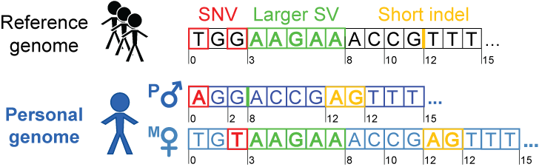
Figure 1.4.1. Personal genome construction. Each haplotype in the diploid personal genome is derived by incorporating phased or unphased variants (SNVs, indels and SVs) into the human reference genome. The coordinates can be mapped back to the human reference coordinates to facilitate comparisons with other reference-based resources, such as gene annotations from GENCODE.

We have previously constructed the personal diploid genome, splice-junction libraries and personalized gene annotations for NA12878 (also known as GM12878). We have made this assembly available as a resource at alleleseq.gersteinlab.org and have been updating it as new versions of the human reference genome, genomic annotations, and NA12878 genetic variation data are released. Furthermore, the availability of a computational tool enables the construction of personal genomes in a high-throughput fashion, as demonstrated in a recent publication\cite{Chen et al. Nat. Commun., in press} where we built 382 personal genomes using the variant call sets from the 1000 Genomes Project.

Since it has been demonstrated that using diploid genome with individual’s variants improves both mappability of the reads\cite{Rozowsky, 2011 21811232} and results of the downstream analyses (particularly for SVs) \cite{Sudmant, 2015 26432246}, we propose to incorporate our personal genome construction tool, vcf2diploid, into ENCODE pipelines.

1.4.2 Developing allelic annotations
We also have extensive experience in the use of personal genomes in analyses involving RNA-seq and ChIP-seq datasets. In particular, allele-specific (AS) analyses are very sensitive to mapping biases. Therefore in our pipeline AlleleSeq\cite{Rozowsky, 2011 21811232} the functional assay reads are aligned to a diploid personal genome, which alleviates the reference bias. We have spearheaded allele-specific analyses in several major consortia publications, including ENCODE and the 1000 Genomes Project \cite{Djebali, 2012 22955620; Gerstein, 2012 22955619; Khurana, 2013 24092746; Sudmant, 2015 26432246}.

More recently\cite{Chen et al. Nat. Commun., in press}, we annotated variants associated with allele-specific expression (ASE) and binding (ASB) in a large pool of individuals from the 1000 Genomes Project. For this analysis, we integrated matching functional datasets (955 RNA-seq and 165 ChIP-seq in total), which include ChIP-seq datasets from 14 lymphoblastoid cell lines in ENCODE\cite{ENCODE Consortium, 2012 22955616}. We developed a standardized framework and statistical approaches to aggregate and uniformly process them. Using the beta-binomial test, we first estimated overdispersion in allelic ratios distribution for each dataset (filtering ones with high overdispersion parameter) and then identified statistically significant AS events. We have also incorporated strategies to alleviate ambiguous mapping bias – bias occurring when reads originating from one of the two alleles map to multiple locations. Overall, we detected more than 6K and 63K SNVs associated with ASB and ASE, respectively. These results were made available as an online resource, AlleleDB (alleledb.gersteinlab.org) and serve as an allele-specific annotation for the 1000-Genome variant catalogue.

1.5 Comparative analyses between human & mouse
Mapping orthologous genes: We will work closely with the AWG, the DCC and the phylogenomics community to create a resource of human and mouse orthologs in both genic and intergenic regulatory regions. Such a resource will be of great use to transfer the biological knowledge gained from mouse models to human, and to improve our understanding of human biology and health. We will start with the ortholog resources from the established methods, such as Inparanoid, OrthoMCL and TreeFam, evaluate the different methodologies, and then propose a gold standard set of functional orthologs through integrating a variety of information from sequences, functional genomics and phylogenomics. We have developed a highly accurate tree-based phylogenomic pipeline for identifying orthologs and paralogs that overcomes the limitations of existing methods. In particular, we overcome common inaccuracies in the topology of individual gene trees, TreeFix{Wu, 2013 #PMID:22949484}, which, given a sequence alignment, maximum likelihood gene tree, and known species tree topology, outputs a highly accurate, error-corrected version of the gene tree. Using gene trees corrected by TreeFix, we minimized the effect of erroneous gene trees and greatly improved the accuracy of inferring orthologs and paralogs. Finally, we have developed an approach for integrating multiple ortholog sets using evidence from other species in order to benefit from the potentially complementary information available in discordant inferences.
Mapping orthologous non-coding regions: Given a strong focus of ENCODE on non-coding functional DNA elements, we will also develop and apply methods for mapping orthologous non-coding regions between human and mouse. Specifically, we will use sequence homology in the context of a syntenic map to recognize orthologous regions, and we will confirm their orthology based on functional genomics information. We have mapped promoter and enhancer regions between human and mouse based on orthologous annotations of chromatin states in the two species. We used peaks in H3K4me3 (promoter), H3K27ac (enhancer) and H3K27me3 (polycomb repressed) regions to define putative regulatory elements in mouse, and mapped each of them to the human genome using the UCSC multiple alignment chain files{Hinrichs, 2006, #PMID:16381938}. We calculated the human mouse pairwise alignment for each multiple alignment, and selected the highest-scoring pairwise alignment as the base for constructing an orthologous region in human, by extension on either side using lower-scoring multiple alignments. We found that the chromatin state of orthologous regulatory regions was highly concordant (Fig. 1.5), giving us confidence in our mapping strategy, and indicating that the function of orthologous non-coding regions can be conserved across such evolutionary distances.
a.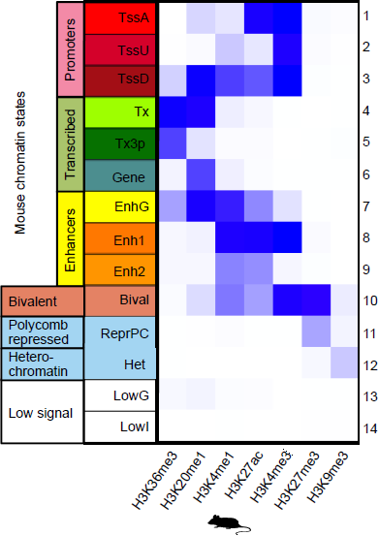b.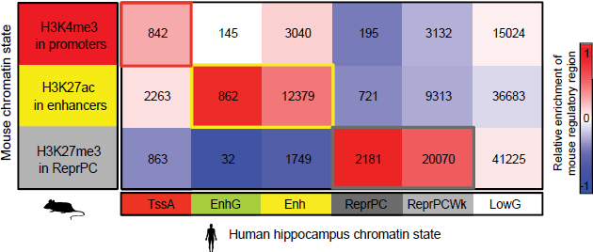
Figure 1.5. Chromatin state conservation in orthologous regulatory regions between human and mouse. a. Combinatorial patterns of the seven histone modifications profiled were used to define promoter, gene body, enhancer, bivalent, repressed Polycomb, heterochromatin, and low signal chromatin states. Darker blue indicates a higher enrichment of the measured histone mark (x axis) to be found in a particular state (y axis). b. Promoter, enhancer and repressed chromatin states in mouse hippocampus (rows), as profiled in this study, align to matching chromatin states in human (columns), as profiled by the Roadmap Epigenomics Consortium. Shading indicates enrichment relative to human chromatin state abundance (columns). The number of regions overlapping is shown in each cell of the heatmap.

Aim 2. Serving as an informatics resource by supporting the activities of the ENCODE Analysis Working Group (AWG)
2.1 Assist the AWG in defining and prioritizing integrative analysis
With the large amount of data generated by the ENCODE production groups, it is particularly important to prioritize and accurately define the types of computational analyses performed by the Consortium. Therefore, we will work very closely with the AWG to coordinate activity of the DAC. The AWG will formulate the most important and informative biological questions and the DAC will assist with the prioritization by providing feedback on resource and time requirements. Following directions set by the AWG and coordinating with the DCC, data producers, and other Consortium members involved in computational analysis, the DAC will develop infrastructure for processing, analysis, and integration of ENCODE data. The leadership will assign new AWG requests to one or more components of the DAC. Depending on the type of analysis and data, the DAC investigation groups will assess existing or develop new tools and build computational frameworks for processing and analysis of the data. The DAC will work closely with the DCC to implement robust pipelines for automated processing and analysis of subsequent datasets generated by the production groups.

To facilitate this close interaction with the AWG (as well as other members of the Consortium), we will organize semimonthly conference calls for the entire AWG, small group conference calls, as well as one-to-one Skype sessions. During the biweekly AWG calls, the DAC will report on progress on active tasks and receive new tasks from the AWG. For the latter, the DAC will provide assessments of resource requirements, suggest specific groups to work on the task, and estimate timelines, thus assisting the AWG in prioritization of current and future analysis directions. The DAC will be entirely open to communication and collaborations with other Consortium members and allow their participation in any analysis.

2.2 Define and further develop uniform processing pipelines for major ENCODE data types
Thousands of genomic experiments have been performed by the ENCODE members. Gaining novel biological insights using integrative analysis of these datasets relies on the fact that they are processed using accurate and consistent pipelines. The DAC has worked with various working groups during previous rounds of ENCODE to develop standardized reproducible pipelines for RNA-seq, TF and histone mark ChIP-seq, and whole genome bisulfite sequencing (WGBS) experiments. The DAC has also developed guidelines and practises for assessing the accuracy and replicability of each experiment. The current guidelines also assess antibody validation, experimental replication, sequencing depth, data and metadata reporting, and data quality. We have also worked with other international consortia such as IHEC and ICGC to ensure that the datasets produced from different consortia are processed in a similar fashion and can be compared with one another. The pipelines are available to the larger scientific community on DNAnexus, with all pipeline source code available on GitHub.

During ENCODE4, the DAC will continue to evaluate and further develop existing pipelines and quality metrics, because new computational algorithms and experimental techniques continue to emerge. We will also work with various working groups to develop new uniform processing pipelines for additional data types, e.g., fRIP-seq, eCLIP-seq, Hi-C, and ATAC-seq. In addition, the DAC is fully prepared to work with new data types and develop pipelines for them. Below we give an overview of the current state of ENCODE3 pipelines and the work that is planned for ENCODE4.

2.2.1 An RNA-seq pipeline
During ENCODE3, the DAC has been very active in the development of the RNA-seq pipeline, working closely with the DCC and data producers, in the context of the RNA working group. The DAC organized a benchmarking experiment to evaluate the RNA-seq pipeline, and performed extensive testing to guarantee reproducibility of the pipeline results independently from the computational platform used. The DAC has designed GRAPE, a robust, efficient and scalable open source software system for the storage, organization, access, and analysis of RNASeq data [Knowles D.G., 2013 PMID: 23329413] (https://github.com/guigolab/grape-nf). GRAPE has been implemented using the Nextflow (http://www.nextflow.io) and the Docker (https://www.docker.com/) technologies. Nextflow is a domain specific language for computational pipelines based on the Dataflow concurrency model which allows implicit task parallelization. Moreover, it supports the Docker container technology for improved reproducibility and software deployment, which allows effortless distribution and installation of the pipelines to different environments. The ENCODE3 pipeline, based on STAR [Dobin A., 2015 PMID: 26334920 ] for read mapping and RSEM [Li B., 2011 PubMed PMID: 21816040] for transcript quantification has been implemented within GRAPE, and can be seamlessly deployed at any site supporting Docker.
The DAC also attempted to harmonize RNA-seq processing pipelines across different projects. The Gerstein lab is part of the transcriptome working group in the ICGC/PCAWG project and is working closely with them on unifying the processing of RNA-seq datasets. The distribution of the reproducibility metrics scores across ICGC samples can also be used, as in the case of GTEx, as a guide to set the appropriate reproducibility thresholds for the ENCODE samples. Similarly the Guigo lab has been working with the Blueprint consortium (the European component of IHEC) to compare RNA-seq pipelines, and as a result, Blueprint has adopted the ENCODE RNA-seq pipeline.
The current RNA-seq pipeline focus on gene (and transcript) quantification. However, other biologically relevant measures that can be extracted from RNA-seq data, such as the use of alternative Transcription Start and Termination Sites (TSS and TTS), and most notably, the usage of alternative exons. The DAC has been involved in the implementation of the Integrated Pipeline for Splicing Analysis (IPSA) pipeline for detection and quantification of splice junctions (https://github.com/pervouchine/ipsa). IPSA is designed to provide a uniform and standardized processing protocol for different types of RNA-seq data, including stranded and unstranded data, data with or without biological replicates, etc. Its mission is to count split-mapped alignments corresponding to annotated and novel introns in a position-specific manner. Read counts are aggregated over offsets for each intron using Shannon entropy to control for the support level by distinct staggered positions and to exclude artefactual large counts. Introns receive a number of descriptors reflecting the annotation status, splice site nucleotides, and read counts in support of splicing as well as local intron retention at each splice site. These descriptors are used to compute PSI (percent-spliced-in) metric for exons and introns and coSI (completeness of splicing index). The results of ISPA were compared to exon inclusion rates computed by the MISO software on the set of ~15K human cassette exons and the results were consistent (Pearson correlation r=0.91). An earlier branch of the pipeline was applied to the comparative analysis of conservation of splicing events between human and mouse using ENCODE2 human and Mouse ENCODE data (https://github.com/pervouchine/hm-splice-pipe).
2.2.2 Pipeline for analyzing ChIP-seq data of transcription factors
During ENCODE3, the DAC has worked closely with the Binding Working Group in ENCODE to define and prototype a state-of-the-art computational analysis pipelines for transcription factor (TF) ChIP-seq data. Changes in protocols for generating and methods for analyzing TF ChIP-seq data required us to revise the well-established and robust ENCODE2 pipeline. Particularly, the pipeline needed to be updated to analyze paired-end (PE) data which was not generated in ENCODE2. We also updated the pipeline to include some of the latest computational peak calling algorithms that substantially improve the resolution and accuracy of TF binding site identification. The DAC (Kundaje) in collaboration with the Bickel lab also developed a new implementation of the Irreproducible Discovery Rate (IDR) framework {Li, 2011, http://projecteuclid.org/euclid.aoas/1318514284} for evaluating and thresholding datasets based on reproducibility (https://github.com/nboley/idr). The implementation is a significant refactoring of the older implementation and is over 100x faster. An average run (comparison of 300K peaks across 2 replicates) now takes less than 2 minutes. This collaboration is just one example of the many productive interactions between the DAC and computational groups and will be continued in DAC4 (see the support letter from Drs. Bickel and Brown, and the support letter from Dr. Keles, the PI of another computational PI).
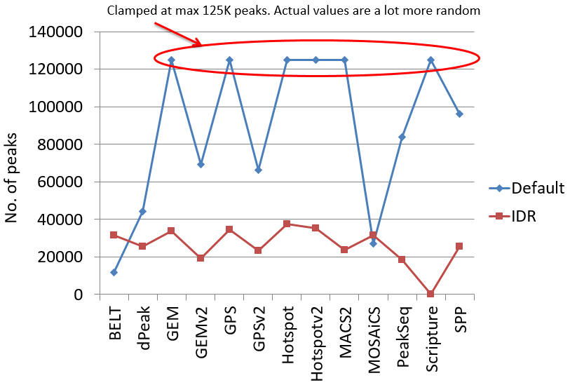
Figure 2.2.2a. The Irreproducible Discovery Rate (IDR) framework stabilizes peak calls across most peak callers. The results of peak calling with and without IDR for several popular peak callers are shown for a Pol2 ChIP-seq dataset in H1 embryonic stem cells. The default thresholds (shown in blue) for a majority of peak callers are highly unstable and indicate vast differences between peak callers. After IDR (shown in red), the results are significantly more similar across the peak callers.

The DAC led a coordinated effort across multiple labs and the ENCODE Binding Working Group to systematically compare and evaluate 10 peak calling algorithms (Figure 2.2.2.a). A collection of benchmarking datasets were selected so as to span a diversity of TFs with different binding characteristics and data quality. The peak callers were evaluated based on 3 criteria: (1) reproducibility of peak calls across replicate datasets; (2) accuracy and resolution of peak calls by comparing predicted point binding sites to known motif locations; (3) the ability to deconvolve closely spaced and overlapping binding events. The evaluation analysis was conducted by Kundaje and two Computational groups (Keles and Gifford). After extensive analyses and discussions, the Binding Working Group converged on three robust peak callers (SPP, PeakSeq and GEM) that all scored well in the evaluations. Each of these have complementary properties. SPP (from Peter Park’s lab) and PeakSeq (from the Gerstein lab in the DAC) are both backward compatible with ENCODE2 and have been heavily tested. SPP explicitly takes into account read distributions accounting for peak shape. GEM (from the Gifford lab) explicitly deconvolves closely spaced binding events and integrates peak calling with motif discovery. PeakSeq uses a relatively different peak calling algorithm that adjusts well to highly punctate binding events and broader regions of enrichment.

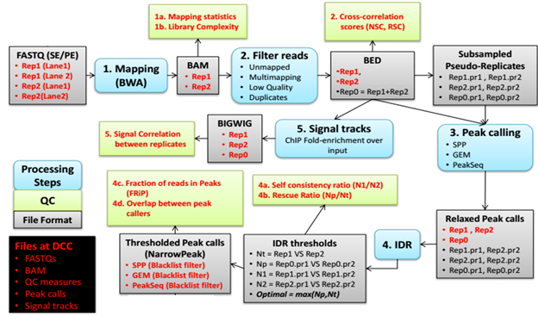
Figure 2.2.2b. Schematic of TF ChIP-seq pipeline.

The DCC has developed a free, open-source implementation of the pipeline specification https://github.com/kundajelab/TF_chipseq_pipeline which is a mirror of the open-source official pipeline implemented by the Data Coordination Center on the cloud-based DNAnexus platform. A publication on the protocol specification of the ENCODE3 TF ChIP-seq pipeline is currently in revision at Nature Protocols. The key steps of the pipeline are summarized in Figure 2.2.2.b.

2.2.3 A pipeline for analyzing ChIP-seq data of histone modifications
Histone modification ChIP-seq data has substantially different properties compared to TF ChIP-seq data requiring a unique analysis pipeline. The ENCODE2 Chromatin ChIP-seq pipeline was relatively underdeveloped due to the lack of effective peak callers and statistical methods for evaluating the highly variable sizes and patterns of thus called peaks. Also, the IDR method that is highly effective at adaptively thresholding TF ChIP-seq data does not transfer directly to the analysis of histone marks due to a broad range of peak sizes and the instability of peak callers to sequencing depth differences between replicates. During ENCODE3, the DAC had to develop a new method for evaluating the reproducibility of histone mark ChIP-seq data.

The DAC led a collaborative effort including members of the Binding Working Group evaluated six histone ChIP-seq peak callers to define a uniform histone ChIP-seq analysis pipeline. High quality, deeply sequenced benchmark datasets for six key histone modifications with narrow (H3K27ac, H3K9ac, H3K4me3, H3K4me1) and broad (H3K36me3, H3K27me3, and H3K9me3) regions of enrichment in the human lymphoblastoid cell line GM12878 were obtained from the Snyder lab. These were distributed to the participating peak caller groups and peak calls were generated and analyzed. The peak callers were evaluated based on (1) reproducibility of identifications, (2) stability of the peak calls to sequencing depth fluctuations (splitting and merging of peaks) and (3) accuracy and resolution by comparing with gold standards (e.g., H3K4me3 peaks compared with promoters, H3K36me3 peaks compared with transcribed gene bodies identified using RNA-seq data). After careful evaluations, MACS2 and MoSAICS-HMM were found to be the top performing peak callers.

The ENCODE3 histone ChIP-seq pipeline is similar to the ENCODE3 TF ChIP-seq pipeline outlined in the previous section with several key differences. MACS2 and MoSAICS-HMM are the peak callers for calling narrow peaks and broad domains respectively. Instead of using IDR, we have designed a simpler heuristic procedure to identify reproducible peaks and domains. For each sample, peaks/domains are called using reads pooled across replicates as well as those from individual replicates and pseudo-replicates generated using all pooled reads. We only retain peaks from the pooled data that significantly overlap (>50% length) peaks in both biological replicates or in both pseudo-replicates.

2.2.4 A motif pipeline for validating TF ChIP-seq data
Per request of the AWG, the DAC developed a motif-based antibody validation pipeline for ChIP-seq data of sequence-specific TFs. The pipeline evaluates the enrichment of known motifs in a given ChIP-seq dataset and provides a probabilistic assessment on how well the enrichment matches the labeled TF. The pipeline comprises the following steps: (1) The motif models (position weight matrix or PWM) are collected from public databases: TRANSFAC, JASPAR, PBM, and HT-SELEX (Fig. 2.2.4a). (2) The motif instances are defined by scanning the reference genome using the PWMs, excluding repeats, transposons, CDS and 3´-UTR. (3) The average of three motif enrichment scores are computed based on the motif instances in ChIP-seq peaks: a global enrichment score (compare the motif PWM with its shuffled version), positional bias score (compare peak center with the flanking regions) (Fig. 2.2.4b), and peak rank bias score (compare the high peak score regions to the low peak score regions) (Fig. 2.2.4c). (4) The known motifs are grouped by their PWM similarities and each motif group is ranked by the highest average enrichment score within the group. We found that the known motifs ranked top 2 in 80% of TF ChIP-seq datasets, while ~8% datasets failed to show enrichment for their corresponding known motifs, suggesting antibody problems or indirect binding of these TFs. Because different TFs (e.g., TFs that belong to the same protein family) may share the same motif and one TF may use multiple motifs, we developed a Bayesian framework for antibody validation that takes into account this ambiguity. Instead of setting one hard cutoff across all TFs, this Bayesian approach sets the cutoff according to the characteristics for each TF and the corresponding motifs, and it can also point out the antibodies of which TFs cannot be validated by our motif enrichment method due to their diverse binding preferences.

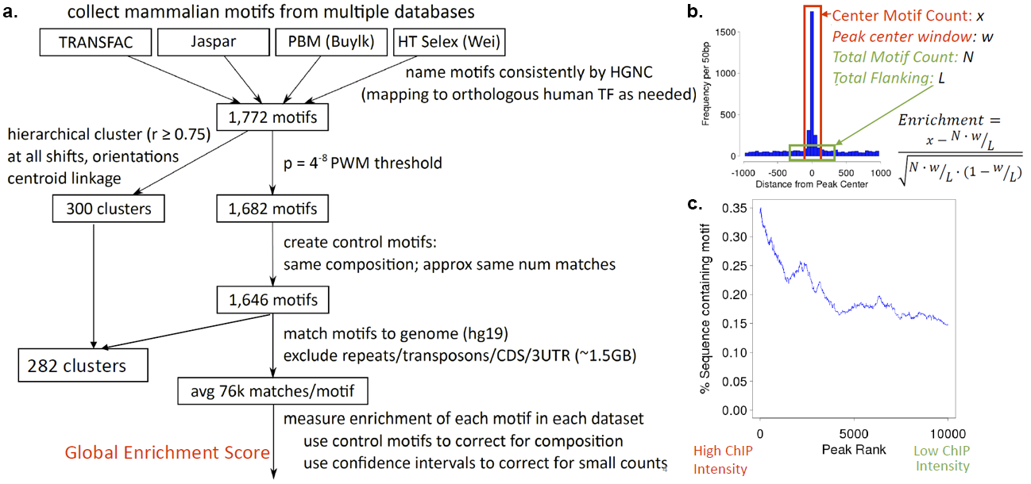
Figure 2.2.4. Criteria for assessing the validating the antibody of TF binding experiments based on regulatory motif enrichments. (a) Construction of the ENCODE motif catalog {Kheradpour, NAR 24335146} by processing and clustering of multiple databases and experimental techniques. (b) Positional enrichment score based on regulatory motif instances relative to cluster centers. (c) Rank-based enrichment test based on motif instances relative to TF binding intensity distribution using a Mann Whitney rank sum test.

2.2.5 A pipeline for analyzing whole genome bisulfite sequencing (WGBS) data
The DAC developed a uniform analysis pipeline for WGBS data. We tested the combinations of three types of pre-processing methods, five widely used WGBS mapping tools (Bismark with Bowtie or Bowtie2, BSMAP, and GSNAP, LAST and BRAT) with four different parameters of seed length for Bowtie and Bowtie2, and five types of post-processing criteria based on cytosine coverage and quality scores of mapping reads. Our results showed that Bismark+Bowtie and Bismark+Bowtie2 were the most accurate mapping algorithms throughout single-end and paired-end simulated datasets respectively. LAST showed comparable performance to Bismark. Because of the larger memory requirement for LAST, we selected Bismark with Bowtie and Bismark with Bowtie2 pipelines for the single-end and paired-end WGBS uniform pipelines for ENCODE. To assistant the DCC in implementing the WGBS pipelines on DNAnexus, we tested memory usage, disk usage and run time for both human and mouse datasets. We also advised the DCC on the file format required for DNAnexus and the use of the lambda genome for quality control. The DCC finalized the uniform WGBS analysis pipeline on DNAnexus and placed the source code of the pipeline on github (https://github.com/ENCODE-DCC/Bismark-ENCODE-WGBS).

2.2.6 Future developments of uniform processing pipelines
During the next ENCODE phase, the DAC will continue to assess the performance of existing uniform processing pipelines on the new experimental datasets. In collaboration with members of various working groups in ENCODE, we will update existing pipelines and the quality metrics. We plan substantial extensions or improvement on the RNA-seq, histone mark ChIP-seq, DNase-seq, and WGBS pipelines as described below. In addition, we will develop new pipelines for new data types depending on the needs of ENCODE4. We provide two example pipelines for Hi-C and ATAC-seq, because we expect these data types to be prominent during ENCODE4. We point out that the DAC has a broad coverage of expertise and should be able to develop analysis pipelines for a wide variety of new data types. We will also draw upon talents in the Consortium, by collaborating with computational groups. In addition, we have set aside budget for recruiting one more lab into the DAC to meet unforeseen needs. See a letter from Prof. Uwe Ohler, who has developed several algorithms for analyzing CLIP-seq and related data types for RNA binding proteins.

2.2.6.1 The RNA-seq pipeline and pipelines for other RNA types
The DAC will continue to benchmark the ENCODE3 RNA-seq pipeline in response to new developments of computational methods and sequencing technologies. Moreover, we will also continue to work with other consortia (e.g., ICGC, Blueprint, GTEx), by reaching out to the leaderships of these projects in an effort to harmonize RNA-seq pipelines and develop methods for normalizing the pipeline outputs across projects. An important challenge that we foresee is updating to new releases of a reference genome. Mapping of raw reads to the new genome for thousands of datasets in a large consortium like ENCODE demands considerable computing resources. The DAC will develop methods to lift-over transcript quantification across human and mouse genome assemblies that will not require remapping of the reads. The underlying idea is that only reads originating from altered regions of the genome will need to be remapped, while the quantification of genes and transcripts located in other regions can be updated without read remapping. The DAC will apply these “intelligent” lift-over methods to other data types, as well as to personalized genome analyses, e.g., running the RNA-seq analysis pipeline using reads mapping to the diploid personal genome corresponding to an individual from whom the samples was obtained (such as the ENTEx samples).

The DAC will also develop uniform processing pipelines for other RNA types, including small-RNA-seq, RAMPAGE, eCLIP-seq, fRIP-seq and other technologies that are currently in use in ENCODE3, as well as other technologies that could be used in ENCODE4, such as nascent RNA-seq, ribosome profiling, etc. Two technological developments appear to be particularly relevant in the field of RNA sequencing: single cell RNA-seq and sequencing of longer reads (i.e. those produced by technologies such as PacBio, Oxford Nanopore, 10x Genomics and others). We will thus pay particular attention to these areas, and plan our effort in accordance with the needs in ENCODE4. As an example, we outline a pipeline for long-read RNA-seq reads using the PacBio platform (Figure 2.2.6.1).
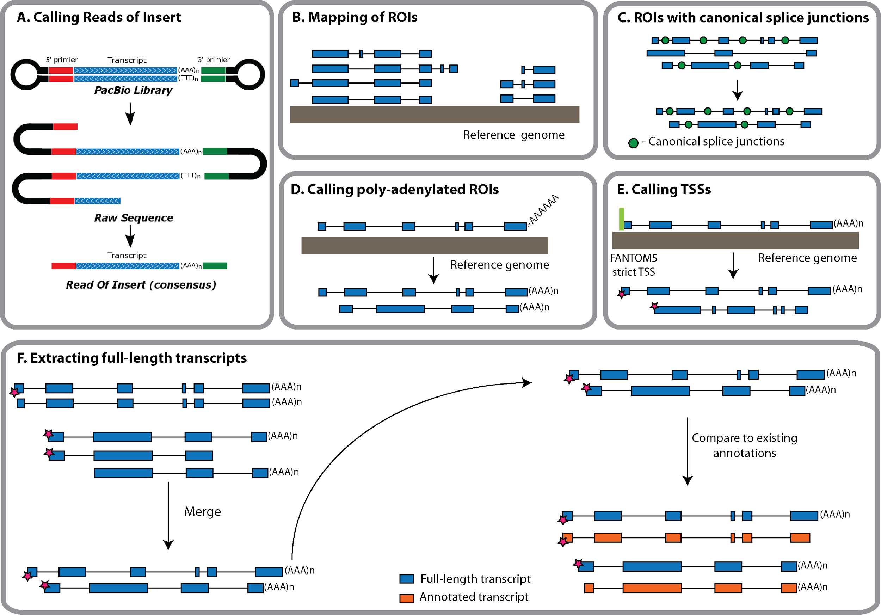
Figure 2.2.6.1. A Long-read RNA-seq pipeline. Reads of Insert (ROIs) will be extracted directly from the raw sequences using PacificBio’s SMRT software and output into a FASTQ file. We will keep only those reads fulfilling the “full-length” Iso-seq criterion (i.e. reads bounded by a library adapter at each end) for further analysis. Mapping of ROIs to the reference genome will be carried out using STAR or a comparable mapper. Given the relatively high error rate of the SMRT technology, we will analyze further only those spliced ROIs that are composed entirely of canonical introns, and take advantage of these splicing motifs to ‘strand’ the transcript. Mapped ROIs with polyA tails will be further analyzed, and used together with the splice junction information to infer the genomic strand of the corresponding transcript. The 5’ ends of ROIs will be collapsed into TSS clusters and compared to the FANTOM5 strict TSS set. Redundant ROIs will be merged into full-length transcripts using cuffmerge or a similar piece of software. Next, the intron structures, TSSs and TTSs of full-length Iso-seq transcripts will be compared to existing annotations.

2.2.6.2 Further development of the pipelines for ChIP-seq of histone marks and DNase-seq
Despite substantial effort of the DAC, the ENCODE3 pipeline for histone marks still requires improvement. The accuracy of calling weak peaks is low. Peak boundaries are unstable and highly affected by low sequencing depth. Furthermore, merging across replicates leads to peak splitting. Despite DAC’s initial effort on developing a DNase-seq pipeline, it was decided to simply adopt the lab pipeline of John Stamatoyannopoulos, because they are the only ENCODE3 lab generating DNase-seq data. The DAC is performing a systematic evaluation of ten histone ChIP-seq and five DNase-seq peak callers, aiming to improve the pipeline for punctate histone marks that are enriched in enhancers (H3K27ac, H3K9ac, H3K4me2 and H3K4me1) and the DNase-seq pipeline. During our effort of identifying enhancers, we observed that the strong peaks of these histone marks and the strong DNase peaks are highly concordant in a cell-type-specific manner, with DNase signal peaking in the troughs of the histone mark signals. Thus we can use this property to evaluate the performance of pipelines. Furthermore, we can use the results of functional assays, such as mouse transgenic assays and massively parallel reporter assays to guide our effort. See support letters from two pioneering scientists of these functional assays, Len Pennacchio at LBNL and Nadav Ahituv at UCSF, for their willingness to share their data and collaborate with the DAC.

The ENCODE3 pipeline on broad histone marks (H3K36me3, H3K9me3, and H3K27me3) needs to be improved using a different approach. The DAC developed a peak caller called MUSIC {Harmanci:2014gx} after the ENCODE3 histone mark pipeline evaluation. MUSIC utilizes multi-scale decomposition of the ChIP-seq signal profile in conjunction with a novel method for correcting the effects of the multiple mapping reads. MUSIC outperforms other methods in identifying enriched regions within broad histone marks such as H3K36me3 and in correlating these enriched regions with expression profiles measured using RNA-seq. For ENCODE4, we plan to develop a principled measure for evaluating reproducibility of broad histone ChIP-seq data using a multi-scale binning approach (similar to MUSIC) coupled with the IDR framework. This approach will be less sensitive to the problems that plague most histone ChIP-seq peak callers—instability of peak boundaries and the effects of peak splitting and merging across replicates. The method will compute signal enrichment scores in replicate datasets for non-overlapping bins at different scales. The IDR method will then be used to evaluate the number of reproducible and rank consistent bins across the true replicates. Contiguous reproducible bins will be merged and reproducible bins across multiple scales will be reconciled using a hierarchical merging strategy to obtain narrow and broad regions of variable size. These regions will then be refined using signal processing methods for boundary detection. An analogous analysis will be performed on pairs of pseudo-replicates obtained by randomly sub-sampling reads from each replicate or by sub-sampling reads pooled across all true replicates. The reproducible peaks identified across true replicates will then be compared to those obtained from the pseudo-replicates to obtain a robust measure of reproducibility.

2.2.6.3 Detection of Differentially Methylated Regions
The ENCODE3 pipeline on whole-genome bisulfite sequencing (WGBS) data described above (Section 2.2.5) does not have the capability of identifying statistically significant differentially methylated regions (DMRs) between two conditions (or two cell types), and the DAC plans to develop such a method in ENCODE4. The method will assess the statistical significance of DMRs even when only two biological replicates are available, which is the case for all ENCODE3 data.

Several existing methods identify individual differentially methylated CpGs, then group these, in some ad-hoc way, into regions {PMID 23034175, PMID 26184873, PMID 24565500, PMID 26559505, PMID 24962134}. Although most of these methods attach adjusted p-values to the single CpGs, they do not offer a rigorous assessment of significance for the regions themselves. Methods that do assess statistical significance on regions require large sample sizes due to parametric assumptions {PMID 24836530, PMID 23658421}. Other methods ignore biological variability all together {PMID 24423865, PMID 23034086} or ignore correlation of methylation states of nearby loci {PMID 24836530} which might lead to misleading conclusions or result in loss of power.

We propose a new two-stage approach that first groups loci into candidate regions and then explicitly evaluates statistical significance at the region level while accounting for variability among biological replicates. In the first stage, we first quantify differential methylation levels between two conditions at each CpG locus. We pool the reads from all technical replicates in each condition to achieve high coverage. Because the methylation levels of neighboring CpGs are highly correlated {PMID 23034175}, we will smooth the signal to further combat low coverage. We then define candidate DMRs by segmenting the genomes into groups of CpGs that show evidence of differential methylation in the same direction (e.g., higher in condition 1 than in condition 2). In the second stage, we compute a t-statistic for each candidate DMR, which takes into account variability between biological replicates and adjusts for overall trends within the region. Finally we compute an empirical p-value for each candidate DMR by permutation and control the false discovery rate using the Benjamini-Hochberg procedure {Benjamini and Hochberg, 1995}.

To demonstrate the feasibility of this approach we show encouraging preliminary results when applied to the mouse WGBS data during development, produced by Joe Ecker’s lab in ENCODE. We identified 313,927 DMRs between forebrain and liver at E11.5, ten times more than between forebrain and hindbrain at the same developmental time point. We also detected many more DMRs during early hindbrain development (E11.5 vs. E16.5) than during late hindbrain development (E16.5 vs P0). One example is shown in Figure 2.2.6.3. We observed a great gain in power from statistically borrowing strength across adjacent CpGs, including those with low coverage—DMRs cover 59-70% of CpGs found by a single-CpG approach; in contrast, only 12-23% of the CpGs covered by the DMRs are significant by the single-CpG approach. Another advantage of our proposed approach is that the statistical inference is based on a well-defined parametrized function. Therefore we can extend the approach to comparing multiple conditions. We can also extend the model to include terms that explain batch effect or systematic errors.
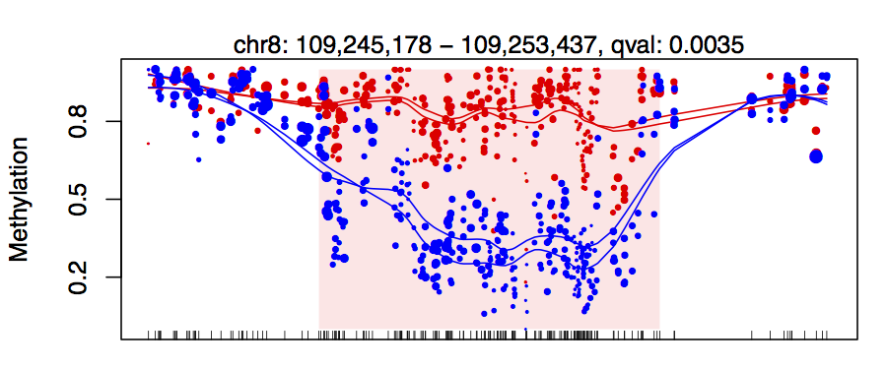
Figure 2.2.6.3. An example DMR. The points represent single CpG methylation level estimates which are plotted against genomic location. The size of the points is proportional to their coverage. The two colors denote the two conditions being compared. The shaded red area denotes the DMR reported to be statistically significant.

2.2.6.4 Develop a uniform processing pipeline for Hi-C
A standard Hi-C pipeline was not part of ENCODE3 and we plan to develop it in ENCODE4. The DAC (Noble) has been involved in the development of methods for high-throughput characterization of chromatin 3D architecture since the publication in 2010 (Duan 2010 20436457). Subsequently, the Noble lab has collaborated on the development of several novel chromatin conformation assays (Ma 2015 25437436; Ay 2015 25887659), and we have developed analytical methods for identifying colocalized sets of genomic loci (Witten 2012 22266657), calling statistically significant contacts (Ay 2014 24501021), inferring centromere positions (Varoquaux 2015 25940625), and inferring 3D structures from Hi-C data (Varoquaux 2014 24931992). We will bring this expertise to bear in the development and deployment of an analysis pipeline for Hi-C data generated by the ENCODE Consortium. The details of this pipeline will necessarily be worked out in collaboration with other members of ENCODE4, and based upon the pipelines being developed by the nascent 4D Nucleome Consortium. Noble is a co-chair of the Nuclear Organization and Function Interdisciplinary Consortium Steering Committee of 4D Nucleome, and he will work towards mantaining close ties between 4D Nucleome and ENCODE to ensure compatible pipelines, interoperability of data, and data standards. See support letters from Bing Ren and Job Dekker, PIs of two production centers of the 4D Nucleome Consortium, expressing enthusiasm about collaborating with the DAC.

We envision a pipeline with a number of core components (see our recent review (Ay 2015 26328929)): a mapping module that incorporates sophisticated prior knowledge about sources of noise in Hi-C assays (Ay 2015 26328929), an efficient normalization procedure (15-21), a QC module that calculates various quality measures about the data, a method such as our own Fit-Hi-C (Ay 2014 24501021) for identifying significant contacts at a specified false discovery rate threshold, a complementary method such as HICCUPS for identifying statistically significant chromatin loops (Rao 2014 25497547), and a method for calling domains at various scales, from fine-scale chromatin loops, through topologically associating domains (TADs) up to chromatin compartments (Dixon 2012 22495300; Filippova 2014 24868242; Levy-Leduc 2014 25161224). Importantly, the pipeline will be connected to a powerful visualization engine. Our recent evaluation suggests that the Wash U Epigenome Browser (Zhou 2011 22127213) is the best current visualization tool, though we will consider other alternatives as they develop. Current methods for inferring three-dimensional structures from Hi-C data do not scale to the full human genome and do not handle diploidy in a principled fashion. We are actively working on developing such methods, and if they become available, then they may be added to the pipeline.

2.2.6.5 Develop a uniform processing pipeline for ATAC-seq
The assay for transposase-accessible chromatin using sequencing (ATAC-seq) {Buenrostro, 2013} was recently developed to profile chromatin accessibility in low input samples. We anticipate that ATAC-seq experiments will be performed in ENCODE4 and the DAC proposes to develop a uniform processing pipeline. The DAC (Kundaje) in collaboration with the Greenleaf and Chang (the inventors of ATAC-seq) have developed a prototype. The pipeline will generate appropriately mapped and filtered alignment files, peak calls, genome-wide signal coverage tracks as well as a detailed report containing mapping and several novel quality control measures.

The ATAC-seq pipeline we plan will requires as input raw FASTQ files and tentatively will contain the following steps: (1) We first preprocess the FASTQ files to trim adapters and then align the reads/read-pairs to a reference genome using the Bowtie2 aligner {cite} allowing a maximum insert size of 2Kb. We filter the alignments to remove reads that are unmapped, unpaired, multi-mapping (MAPQ < 30) or are not primary alignments. We will use PICARD {cite} to mark and then remove duplicates. We will also remove all mitochondrial reads. The read coordinates are then adjusted by 4 bp in a strand-specific manner to obtain Tn5 insertion positions. (2) We will use the MACS2 {cite} peak caller to obtain narrow peaks and sub-peaks of enriched signal. Specifically, we use parameters that do not shift read positions (unlike ChIP-seq) and smooth the aggregate read counts by 150 bp (the approximate size of a nucleosome). We will also evaluate other peak callers for DNase-seq and punctate histone mark ChIP-seq data, as described in Section 2.2.6.2. The peaks are then filtered against the ENCODE blacklist regions {cite}. (3) In order to take advantage of the two replicates per sample, we use the Irreproducible Discovery Rate (IDR) {cite} framework to estimate high confidence, reproducible, rank-consistent peaks which is identical to the procedure outlined in the TF ChIP-seq pipeline (see Section 2.2.2). (4) We also use MACS2 to generate normalized genome-wide signal coverage tracks representing the fold-enrichment and -log10(p-value) of ATAC-seq signal at each base pair relative to a Poisson background distribution adjusted for local biases.

2.3 DAC’s Contribution to ENCODE working groups
The DAC carries out focused analysis in the context of various ENCODE working groups. As described in Section 2.2, the DAC participates actively in the Binding Working Group, and built the two ChIP-seq pipelines (one for TF and the other one for histone marks) and the motif pipeline for validating antibodies used in TF ChIP-seq experiments by working closely with the members of the Binding Working Group. Below briefly summarize DAC’s contribution to other ENCODE working groups.

2.3.1 The functional characterization working group:
During ENCODE3, H3K27ac peaks in ChIP-seq assays for two mouse tissues (heart and forebrain) at the E11.5 developmental stage were chosen and tested for regulatory activity by the Pennacchio group using transgenic assays. Approximately 40 regions were tested in each tissue and 50% of them showed regulatory activity on average. Working in the context of the functional characterization working group, the DAC organized the ENCODE Enhancer Challenge and solicited predictions from the Consortium prior to the release of experimental results. Twelve computational groups made predictions in response to the challenge.

The DAC assessed the accuracy of different methods as well as whether the predictions from different groups could be combined to make more accurate predictions. In particular, we developed an unsupervised ensemble approach to combine predictions from different algorithms for the ENCODE encyclopedia. We compared the accuracy of different unsupervised ensemble approaches from different machine learning algorithms. Our preliminary results indicated that a number of computational methods predict enhancers more accurately than individual epigenomic datasets and an unsupervised ensemble method consistently outperformed the most accurate individual machine learning models (Figure 2.3.1).

The DAC will continue to organize such challenges. The blind-test nature of these challenges greatly stimulates the development of new computational methods and critical assessment of existing methods. In the remaining time of DAC3, the DAC is planning to organize two challenges, one for predicting the target genes of 15 enhancers and 15 super enhancers based on CRISPR knock-out results from Bing Ren’s lab, and the other one for predicting enhancers based on the STARR-seq results from Kevin White’s lab. With the newly established Functional Characterization Centers in ENCODE4, we anticipate a rapid accumulation of functional results for future challenges. The DAC also coordinates participation of prediction challenges outside ENCODE, e.g., the DREAM challenge described below. See support letter from Steven Brenner, the organizer of the Critical Assessment of Genome Interpretation (CAGI), expressing great interest in working with the DAC on future CAGI challenges.

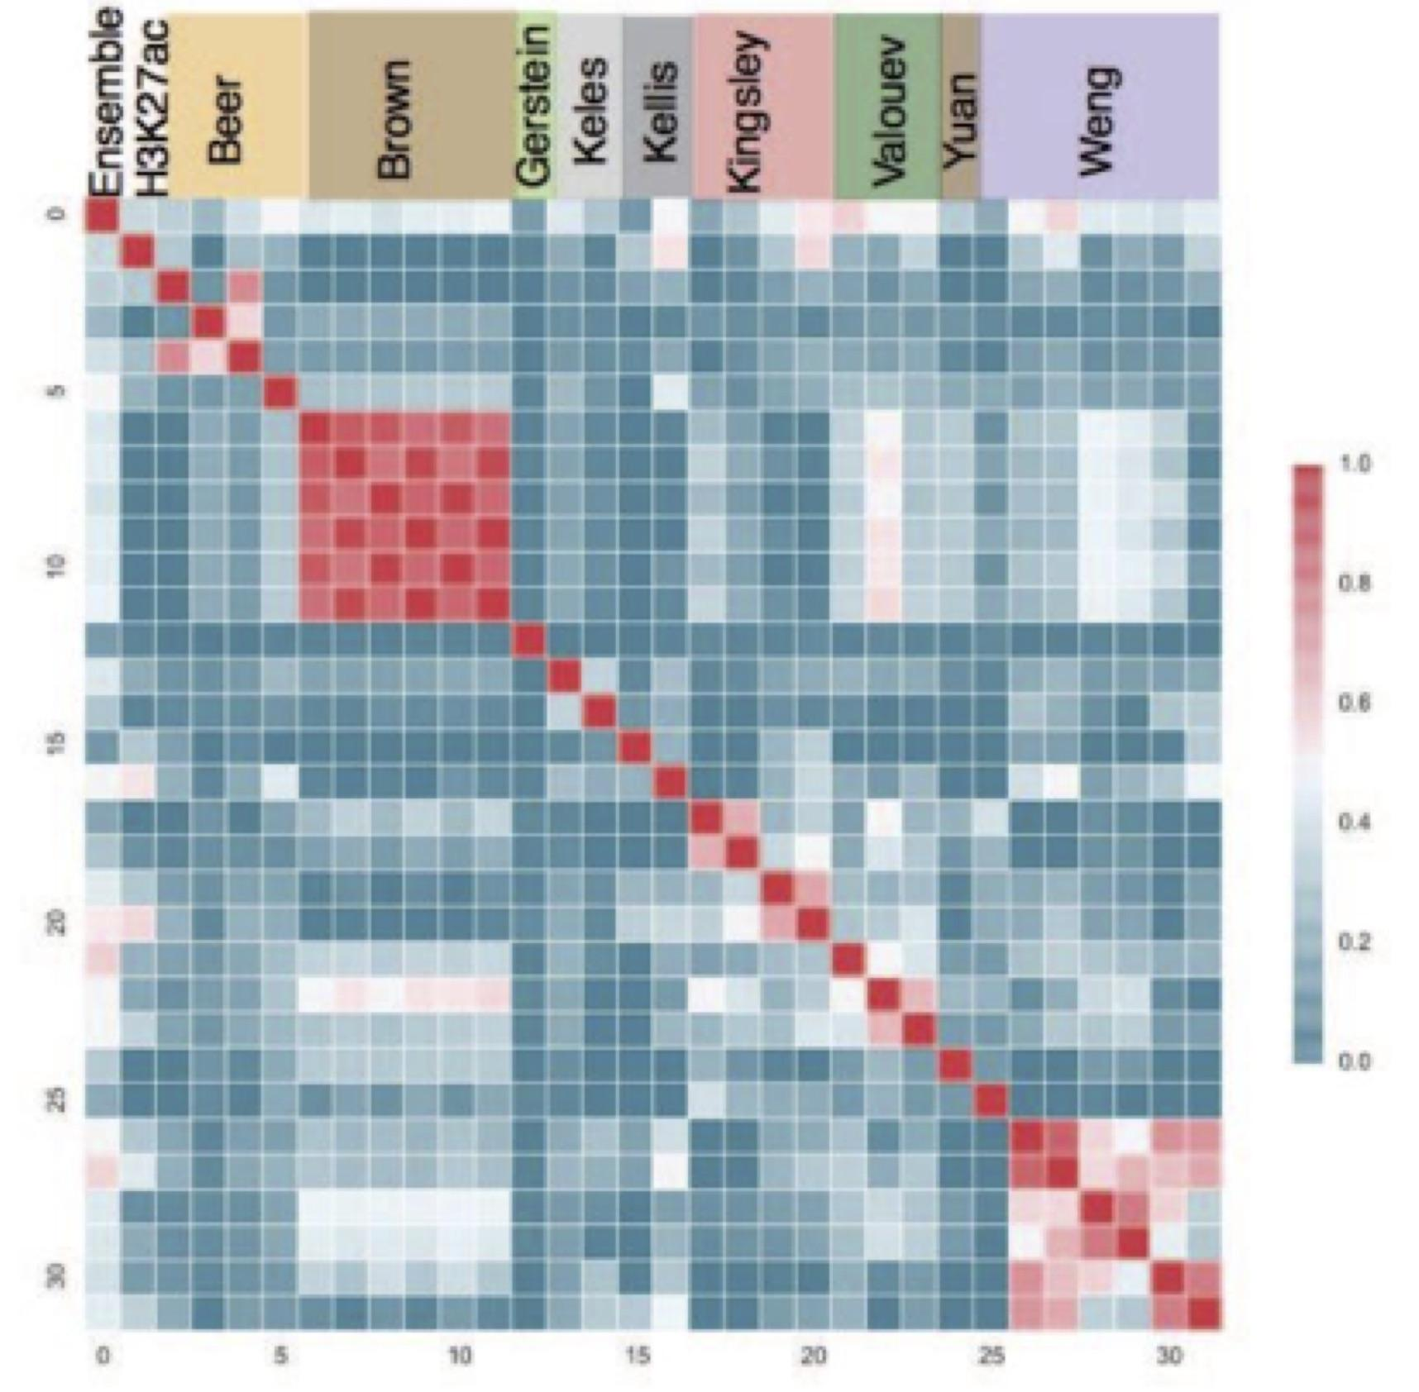
Figure 2.3.1. The ENCODE enhancer challenge. The heatmap shows comparison of the predictions made by different groups for H3K27ac peaks and the ensemble method. The different predictions from same group were highly correlated but predictions from different groups were very diverse.

2.3.2 The RNA working group
Working with the RNA working group, the DAC has been heavily involved in the development, implementation, and benchmarking of the ENCODE3 RNA-seq pipelines. We have computed gene expression matrices for human and mouse long RNA-seq experiments to store information about gene expression level across different ENCODE samples. The gene expression values are collected from the individual files processed with ENCODE3 long RNA-seq pipeline. Current version of this matrix includes TPM and FPKM values for annotated GENCODE genes per each long RNA-seq experiment. We have been exploring tools for visualization of RNA-seq expression values across multiple samples. We proposed prototype plots and developed specifications for the generation of graphical representations of gene expression data. We explored the impact of moving to the GRCh38 reference genome in the estimates of gene expression. The DAC processed the ENCODE3 benchmark dataset using different genome assemblies and GENCODE annotation versions. While variations were observed for some gene families, overall gene expression values remain stable across human genome assemblies. In addition, we will make the personal genomes for each of the ENCODE cell lines and assess impacts of using personal genomes for RNA-seq analyses.

2.3.3 The analysis working group (AWG) and four AWG sub-groups
As described above, most of DAC’s activities are carried out in the context of the AWG. The entire AWG meets during semimonthly conference calls. Many of the activities of the AWG are related to the production of the ENCODE Encyclopedia, described in Aim 3. AWG also has four sub-groups, cancer, GWAS, 3D Nucleome, and regulation, and they hold semimonthly or monthly conference calls. One DAC investigator co-chairs each of these five work groups. Below we summarize the DAC activities in the four subgroups.

The cancer AWG subgroup: Recent progress made by The ENCODE Consortium has provided detailed annotation non-coding regions of the human genome, and whole-genome sequencing of disease genomes has identified large volumes of variants in such regions, thereby making this an opportune time to interpret the function of these variants. We have summarized the current understanding of non-coding variants in cancer \cite{Khurana, 2016 26781813} and made several efforts to organize the ENCODE data as resource to help cancer research. (1) We extracted the cancerous tissue/cell lines from ENCODE and matched them to specific tumor types to maximize the usage of ENCODE data in the cancer field. We found that 1,423 cell lines out of the 2,055 human cell lines with ENCODE data are actually cancer cell lines (69.2%). Each of the cancerous cell lines has been carefully matched to the specific cancer type and the possible TCGA abbreviation was given for the convenience of the cancer community. (2) The current genome-wide functional characterization data from ENCODE provides the most comprehensive annotations of human genome. Hence, we tried to collect a full category of non-coding annotations from ENCODE and tailored them specifically to annotate the discovered mutational hot spots, which helps to interpret the biological mechanism of potential cancer driver events. (3) Many genomic features from ENCODE were found to be able to explain more than 90 percent of the variations of the background mutation process \cite{Lawrence, 2013 23770567}. Therefore, the appropriate usage of such data directly helps to separate the true driver events from those due to the mutational heterogeneity caused by such external process \cite{Luchovsky, 2015 26304545}. However, it is difficult for the cancer community to extract such correlated features from the raw data of thousands of ENCODE experiments. Therefore, we carefully explored the entire set of ENCODE data and specifically selected all potentially related features. Results from uniformly processed pipelines were extracted and reformatted for direct community use. (4) We have recently developed a new computational method, Loregic to characterize the gene regulatory logics in complex systems \cite{Wang, 2015 25884877}. We used this method to identify genome-wide regulatory cooperative logics in leukemia by integrating ENCODE and TCGA data.

The GWAS AWG subgroup: This subgroup is focused on maximizing the impact of the ENCODE resource on human diseases, and in particular the interpretation of the results of genome-wide associate association studies (GWAS). This has been one of the most active AWG subgroup, with 40-50 participants on the semimonthly conference calls. These calls include presentations from individual labs seeking to: coordinate activities; share methodological developments; publicize resources; establish guidelines; receive early feedback. Topics include guidelines on variant selection, methods for expanding on linkage disequilibrium (LD) and including LD in statistical enrichment tests, and for selecting regulatory annotations for enrichment analysis of genetic variants associated with complex traits and human disease. The DAC has also helped coordinate efforts with the ENCODE-CHARGE collaboration, by making presentations and giving tutorials on the computational tools developed by the DAC at the annual CHARGE meeting. One DAC lab also collaborates directly with the adiposity group in CHARGE. We are currently working with CHARGE to generate a phenotypic matrix for multi-phenotype analysis. The GWAS subgroup has also established a very active collaboration with the eMERGE consortium. This activity provides a unique opportunity to directly collaborate with the generators of GWAS studies, and the ability to share intermediate results across different ENCODE groups, by membership on the eMERGE consortium, coordinated through the institutions of interested ENCODE labs. This activity has been spawned off in an additional bi-weekly call which are well attended and highly productive, with active discussion on the specifics of GWAS analyses, variant selection, dealing with LD, and interpreting the resulting associations.

The 3D nucleome AWG subgroup: This group meets twice a month, and calls typically involve 25–35 participants. A primary function of the subgroup is to familiarize members of ENCODE with new datasets and novel analysis methodologies relevant to the analysis of 3D chromatin conformation. The 3D Nucleome subgroup is currently working on two manuscripts. One effort, led by David Gilbert and Job Dekker, focuses on experimentally characterizing changes in topologically associated domain architectures in rearranged genomes. The manuscript exploits a panel of Hi-C datasets from various cancer cell lines, generated by the Dekker lab, as well as complementary assays measuring rearrangements (from BioNano Genomics) and measuring replication timing. The second manuscript focuses on developing and comparing various measures of quality and reproducibility for Hi-C and ChIA-PET data. Work on the second manuscript is being led by the DAC (Noble) and a postdoc in the Noble lab, Gurkan Yardımcı. Dr. Yardımcı is carrying out a blind evaluation of a variety of metrics, by providing members of the 3D Nucleome subgroup with collections of real and simulated Hi-C contact matrices.

The regulation AWG subgroup: The subgroup is developing integrative computational methods to predict high-resolution context-specific regulatory elements by integrating diverse types of ENCODE data and to characterize high-resolution combinatorial transcription factor co-binding patterns and regulatory sequence grammars underlying cell-type specific regulatory elements. There are a diversity of methods for predicting in-vivo transcription factor binding events from DNA sequence and chromatin accessibility data. However, there is a need for systematic evaluation of these methods using matched datasets and performance measures. The Regulation subgroup is conducting an internal evaluation of methods developed by the consortium members. We are also teaming up with the organizers of the DREAM Challenge to set up an open in-vivo transcription factor binding challenge using ENCODE data. The Regulation subgroup will train models on the Tier1 and Tier 2 reference cell-lines that have DNase-seq data and a large number of TF binding profiles based on ChIP-seq. Cross-cell type prediction performance will be evaluated. Well-calibrated models will be used to infer high confidence binding maps of TFs in ~300 cell types and tissues that have DNase-seq data but lack comprehensive ChIP-seq experiments. These predicted maps will complement the primary functional element lists (derived primarily for specific experimental assays) in the Encyclopedia and will also provide high-resolution, base-pair level cell-type specific annotations of combinatorial binding events in regulatory elements.

2.4 Facilitating writing of Consortium papers and reports
A key continuing role of the DAC is facilitating the analysis, writing integrative Consortium papers (including standards and reports), integrating the data to be produced in ENCODE4, and leveraging these data to help interpret GWAS variants. The DAC will facilitate these by performing various integrative analyses and providing a technological infrastructure for the analyses specific to each paper.

The DAC will set up a technological infrastructure to facilitate the collaborative writing of consortia papers. It is important to keep in mind that many genomics papers are complex, often involving tens to hundreds of authors and contain many main figures and tables as well as supplementary exhibits. Tracking and sharing of figures and supplements are non-trivial tasks. To address that, in addition to coordinating paper writings with mailing lists and conference calls, we will make use of various online document management and collaboration systems, such as Wikis and Google Docs for editing and collaboration, Drupal and Joomla for content management, Endnote, Bookends and Papers for references management, Mendeley and BibTex for references and figures tracking, and Dropbox for distribution of files and figures. We will provide expertise in developing these infrastructures to the future consortium publications.

Another important responsibility of the DAC in writing consortium papers is connecting the underlying data, the genomic assays, the analyses results and the documents. We consider the papers in a roll out (number of papers based on a single data freeze) and their associated data as a hierarchical information structure. At the top of the hierarchy is a main paper, summarizing everything for the encyclopedia. The main paper will refer to companion papers focusing on specific studies. Each individual paper presents computes on a large dataset and connects them hierarchically to the tables and figures. The most referred datasets are secondary analyses results (e.g., peak calls and segments), which point to the actual underlying raw data (usually sequencing data) that are stored in central repositories (such as short-read archive). We will hierarchically link the tables and figures in each paper to a chain of specific analysis results, programming scripts, to the corresponding versions of subsidiary results, and to the raw data. These will be stored in paper supplements and project web sites. Hierarchical information structures will enable us to organize data intuitively and also the clear documentation will be essential for reproducibility.

The consortium publications that DAC has worked on have been cited highly for data usage by the larger scientific community. The DAC has analyzed the patterns of dissemination of ENCODE publications to study how the outside scientific community benefit from ENCODE data. In particular, using publication data related to the ENCODE consortium \cite{ENCODE Consortium, 2012 22955616}, we constructed co-authorship networks using temporal data from 2004 to 2014 (Figure 2.4). The networks show how the information from the consortium has diffused through the authorship relationships. We found that the Consortium works as a community whereas non-members collaborate on smaller scale and that a few brokers initiate the connections between the consortium and non-members. Thus, large scientific consortia should set up formal outreach groups to communicate with outside researchers.
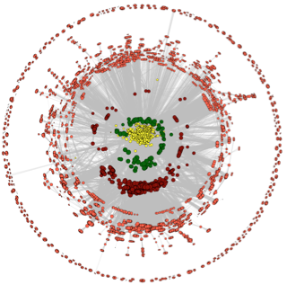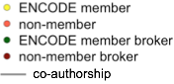
Figure 2.4. The ENCODE co-authorship network.

Aim 3. Creating high-quality Encyclopedias of DNA elements in the human and mouse genomes.
The ENCODE Consortium is generating rich data, both in quantity and in variety. Many integrative analyses are being performed on these data, especially across multiple data types. It is a major challenge to present the analysis results in a comprehensive and yet concise way that maximally facilitates the scientific community to further their research and clinical activities. The ENCODE Encyclopedia is a collection of analysis products with the goal of maximizing the impact of ENCODE data. An important function of the DAC is to produce the standardized outputs from the various pipelines and extract the basic elements into the encyclopedia. Working under the directions of the AWG, the DAC seeks to achieve high utility, high interpretability, and high accuracy when we choose a piece of analysis result to be included in the Encyclopedia. For instance, functional elements can be used for variant interpretation, or for analysis of more elaborate structures such as chromatin loops. We provide the Encyclopedia as downloadable files and supply tools for visualizing them. Working as an integral part of the AWG, the DAC generates files associated with the Encyclopedia and submit these files to the DCC along with metadata describing the analysis methods, including versions of programs and pipelines. The DAC also develops prototypes of visualization tools and work with the DCC to implement these tools at the ENCODE portal (https://www.encodeproject.org/data/annotations/).

In order to stay as truthfully as possible to the primary experimental data, we propose to build the Encyclopedia using a bottom-up approach which leads to three levels of annotations (Figure 3). The ground level of annotations stay close to raw experimental data, and are typically derived from individual types of experimental data. The middle level of annotations require the integration of multiple types of experimental data, and the top level of annotations require even greater integration. Below we describe the current and planned components of Encyclopedia from ground up.
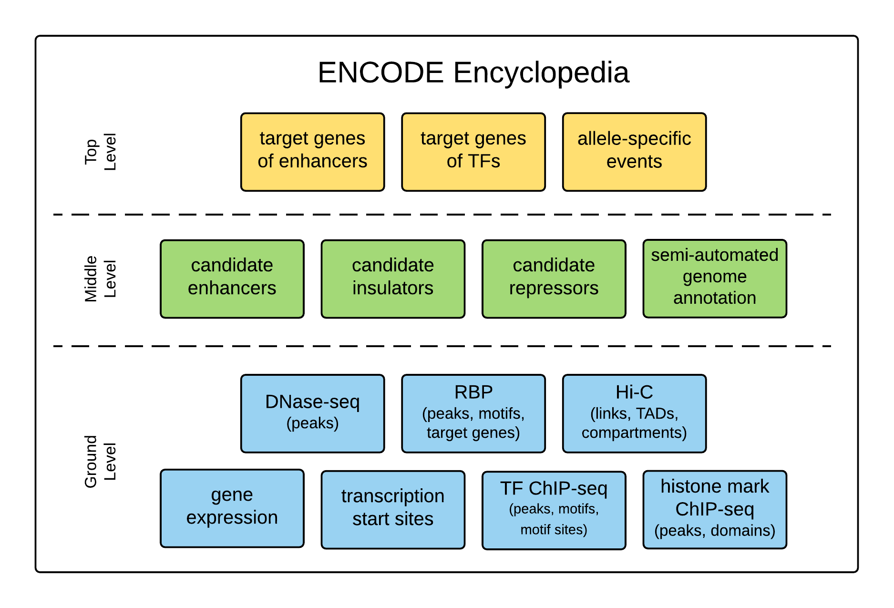
Figure 3. The structure and composition of the ENCODE Encyclopedia.

3.1 The ground level of annotations in the Encyclopedia
The main data types of the ENCODE Consortium currently include RNA-seq, RAMPAGE, ChIP-seq of TFs, ChIP-seq of histone marks, DNase-seq, WGBS, Hi-C, and eCLIP-seq, fRIP-seq, Bind-n-seq of RBPs. We propose to extract from most of these data type the most direct annotations for inclusion in the Encyclopedia. Here we describe our proposed Encyclopedia components based on existing ENCODE data types. We anticipate new data types in ENCODE4, and will build the Encyclopedia components for them using similar approaches to what is described in this section.

3.1.1 Transcription
The most direct result of analyzing a long-RNA-seq dataset (sequencing of RNA fragments longer than 200 nt) is the expression levels of all annotated genes. Thus for a collection of RNA-seq data in multiple cell types, we can build a gene expression matrix, with genes in one dimension, cell types in the other dimension, and each entry of the matrix being the expression level of a gene in a cell type. Working closely with the RNA group (Section 2.3.2), the DAC has released two versions of gene expression matrix at the ENCODE Portal. The first version is for all ENCODE2 RNA-seq datasets and the second version additionally includes ENCODE3 RNA-seq datasets up to Oct 15, 2016.

RAMPAGE {PMID: 22936248} is an assay for identifying transcription start sites (TSSs) at base-pair resolution and quantifying of their expression levels. ENCODE has released RAMPAGE data for 71 human cell types. Genomic regions that are significantly enriched for RAMPAGE signal indicate transcription start sites (TSS), and the DAC has developed a computational pipeline to confidently identify such regions. The pipeline outputs a list regions with associated expression and confidence scores. The confidence scores are calculated by comparing the number of reads in a TSS region to the background transcription rate estimated from a matching RNAseq experiment. Regions that are not consistently expressed between replicates are filtered using the IDR procedure (described in the TF ChIP-seq pipeline, Section 2.2.2), and the remaining TSS’s are merged across biological sample to produce a unified TSS list. Finally, a TSS expression matrix is produced by quantifying the RAMPAGE signal in each of these regions for each sample. We propose to curate lists of cell type specific TSSs and a TSS expression matrix (akin to the gene expression matrix) to be included in the Encyclopedia.

The DAC has also established a prototype for visualizing the gene and TSS expression matrices, and currently working with the DCC to implement it at the ENCODE portal. In the interim, the DAC has worked with Prof. Feng Yue to display the gene expression matrix (http://promoter.bx.psu.edu/ENCODE/). Prof. Yue’s website can display the expression levels of a user-specified gene across all cell types with ENCODE RNA-seq data. In addition to the capability of displaying the expression profile of one gene as a bar plot or a box plot, the visualizer that the DAC is building with the DCC will also display the expression profile of a set of user-specified genes as a heatmap. The user will be able to toggle between different scales of expression level (linear or log), cellular compartments (cytoplasm, nuclear, or nucleolar) and RNA-seq protocols (total, polyA+, or polyA–). We will maximize the similarity in appearance and functionality to the GTEx portal, in an attempt to minimize the learning overhead for the users who are already familiar with the GTEx portal. As will become apparent soon, the visualizer for expression matrices will be adapted to visualize other Encyclopedia components expressed in the matrix form.

Going forward, we will update the gene and TSS expression matrices and the visualizer for each data freeze. There are two main areas of development that we envision. First, the DAC is currently evaluating algorithms that quantify the expression levels of transcripts, with the goal of identifying a method for building a transcript expression matrix. The major challenge lies in that the RNA-seq analysis algorithms need to disambiguate the reads that come from different transcripts of the same gene. Development in sequencing technologies such as longer read length will greatly alleviate the challenge, and in Section 2.2.6.1 we describe our plan for building a long-read RNA-seq analysis pipeline . Second, it remains a challenge to normalize expression levels across multiple cell types, in particular to avoid batch effects. In ENCODE3 most human RNA-seq data are produced by the Gingeras lab and most mouse RNA-seq data are produced by the Wold lab. We need to minimize the lab effect so that we can perform the comparison between human and mouse. Similar considerations apply to RNA-seq data generated using different protocols, e.g. rRNA-depleted total RNA vs. polyA+ mRNA. We will perform normalization and calibration to minimize batch effects, described in Section 3.1.6.

In addition to the expression matrix for annotated genes and transcripts from long-RNA-seq datasets, we plan to generate similar expression matrices for genes and transcripts using short-RNA-seq datasets (RNA fragments shorter than 200 nt), for miRNAs using small-RNA-seq datasets (RNAs shorter than 35 nt). The processing pipelines for these other types of RNAs are not yet established and the DAC will work closely with the labs that produce these data to develop these pipelines, typically in the context of a working group (Section 2.3 describes how the DAC conducts its work in various working groups). In addition, ENCODE may perform new types of experimental assays for RNA level quantification, such as single-cell RNA-seq, GRO-seq, etc. As described in Section 2.2.6.1, the DAC will develop uniform processing pipelines for these new data types. We plan to generate expression matrices for them as well for inclusion in the Encyclopedia. The visualizer that we will develop for RNA-seq expression matrix can be applied to these expression matrices directly or with small adjustments (e.g., in the case of miRNA), and we will design a consistent and interactive platform for visualizing and comparing all types of expression matrices.

To summarize, the Encyclopedia components for transcription related data types, e.g., RNA-seq, RAMPAGE, small-RNA-seq, GRO-seq etc., will be a series of two-dimensional matrices, each with one dimension being genes or transcripts and the other dimension being cell types. These matrices will be carefully normalized to avoid batch effects. They can be downloaded. They can also be visualized in an interactive manner for individual genes or transcripts as bar plots, or for a set of genes or transcripts as heatmaps.

3.1.2 Transcription factor binding regions (ChIP-seq peaks), motifs, and motif sites
ENCODE has released over 1000 ChIP-seq datasets for transcription factors in human and mouse. The genomic regions that have significantly more reads in the ChIP sample compared with the input sample signify TF binding. These regions are commonly called ChIP-seq peaks (or peaks in short), and uniform processing pipelines established by the DAC can identify these peaks reliably. As described in Section 2.2.2, the pipeline outputs a list of peaks, each associated with a score which is computed based on the enrichment of reads in the ChIP sample over the input sample. The pipeline also takes advantages of two biological replicates per experiment using the irreproducibility discovery rate (IDR) framework, which requires that the ranks of a peak in the two replicates are “reproducible” with respect to each other. For ChIP-seq of TF data, the Encyclopedia will contain lists of ChIP-seq peaks, enriched motifs, and motif sites within the peaks. Users can query the ENCODE portal for a set of TF ChIP-seq data and download their corresponding peak lists, or visualize these peak lists using the UCSC genome browser or the WashU epigenome browser. The DAC will work closely with the DCC to implement the functionalities of selecting specific datasets for intuitive viewing using the browsers. Specifically we will build a recommender system to suggest datasets in related cell types or TFs with overlapping binding regions in the genome.

The DAC has developed a TF centric, web-based, wiki-style system for visualizing the entire set of ChIP-seq peaks for each TF at http://factorbook.org. Factorbook currently contains all of the released ENCODE ChIP-seq datasets for TFs, arranged in two TF-by-cell-type matrices, one for human and one for mouse (Figure 3.1.2a). Users can select a TF, or a ChIP-seq dataset of a TF in a particular cell type in the matrices, to get to a web page dedicated to the TF. The main idea behind Factorbook is to gather all ENCODE ChIP-seq data (on both TF and histone marks) related to a query TF and display them in an organized fashion centered on the query TF. Each TF page contains several panels: 1. functional annotations of the TF from major public sources. 2. Line plots showing average histone mark signal profiles in a ±2 kb window centered on the TF peak summits computed from ChIP-seq data in the same cell type (Figure 3.1.2b). 3. Sequence motifs enriched in top ranked peaks (Figure 3.1.2c). 4. heatmaps showing histone mark levels at individual ±2 kb windows around TF peaks, ranked in the same order as the TF peaks (Figure 3.1.2d). 5. heatmaps showing ChIP-seq levels of other TFs at individual ±2 kb windows around the query TF peaks, ranked in the same order as the query TF peaks. 6. average nucleosome occupancy signal around TF peaks.

The motif section contains up to five most enriched motifs in the top 500 ChIP-seq peaks computed using the MEME-ChIP method. Usually the cognate motif of the TF (the motif dictated by the biophysical binding preferences of the TF) is the most enriched motif, and additional enriched motifs may correspond to co-factors. In some cases however, the most significant motif corresponds to a co-factor and MEME-ChIP also predicts low-complexity false positives. In order to filter out spurious motifs, we require a motif to be enriched in the entire set of ChIP-seq peaks compared with flanking regions and GC-matched non-peak regions in the genome. In the motif section of Factorbook, we gray out the motifs that are filtered out. In addition, we implemented the crowd-sourcing capability for users to vote on a motif and provide comments and references that support the vote (Figure 3.1.2c).

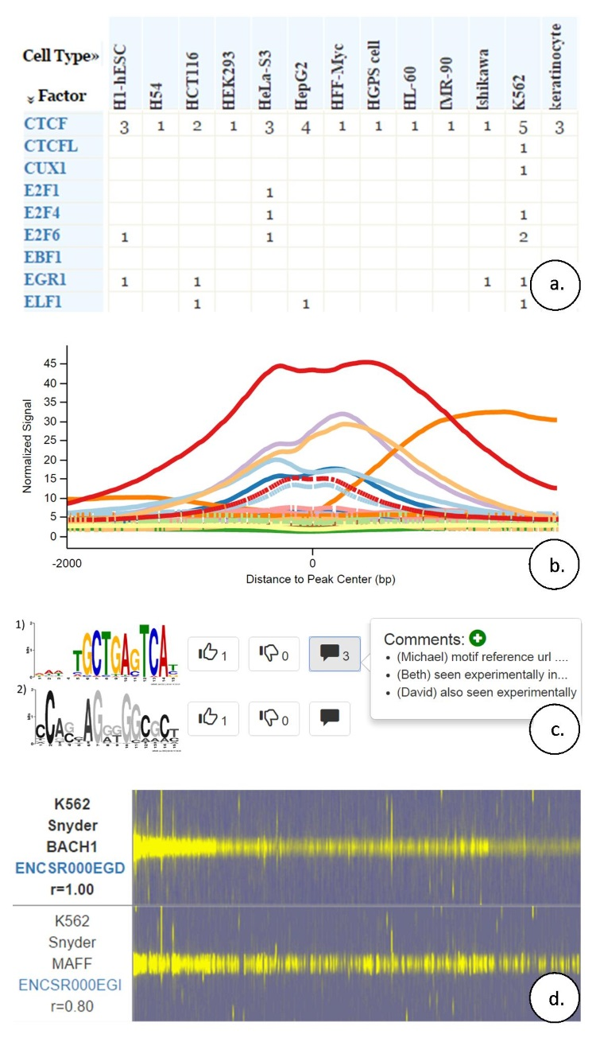
Figure 3.1.2. The TF-centric information resource Factorbook (http://factorbook.org). a. A TF-by-cell-type matrix. Users can select a TF (an entry in the factor column) or an entry of the matrix, indicating the number of ChIP-seq datasets that ENCODE has released for a TF in a cell type (when the number is greater than 1, multiple ENCODE labs have released datasets for the came TF in the same cell type). b. Average histone mark signal centered on the summits of TF peaks. Different histone marks are shown in different colors and the data are cell type specific. c. Sequence motifs enriched in ChIP-seq peaks. The lower motif is greyed out because it did not pass our filtering criteria. Users can vote on each motif and provide comments. d. Heatmaps show ±2 kb windows centered on the peaks of the BACH1 TF, with the strongest peak left most. TF ChIP-seq datasets for other TFs in the same cell type (K562 in this example) are shown as subsequent heatmaps, sorted in the descending order by the correlation coefficient (r) of signals across the peaks of the query TF (BACH1 in this example).

We envision several directions to improve Factorbook. (1) We will implement the capability to allow users to visualize the underlying ChIP-seq signal of the TF of interest along with other ENCODE data in specific loci by connecting to the UCSC and the Wash U genome browsers directly from Factorbook. We have built a visualizer for candidate enhancers (Section 3.2.1), which can be incorporated into Factorbook. (2) The DAC is currently evaluating several existing methods of predicting motifs and motif sites, and developing deep learning methods that can learn the motif and their sites in the entire set of ChIP-seq peaks (not just the top ranked peaks) using ChIP-seq signals at nucleotide resolution. Another direction is to explore more complex motif models, such as k-mers {ref} or incorporate DNA shape {ref}. (3) We will expand the crowd-sourcing capability in the motif section of Factorbook to other sections. (4) We will link the orthologous TFs in human and mouse and develop tools to compare their binding characteristics. (5) We will implement a recommender system to suggest datasets to the user, e.g., TFs with similar binding characteristics in a different cell type (but does not have ChIP-seq data in the cell type being queried). Such a system will become increasingly desirable when more datasets are available.

3.1.3 histone modification enriched regions and DNase hypersensitive sites
The DAC has developed a uniform processing pipeline for identifying genomic regions enriched in histone marks (Section 2.2.3). These regions are commonly called peaks in an analogous way to TF peaks. This pipeline is particularly effective for histone marks that have punctate signals, especially the marks that are enriched in promoters or enhancers (H3K4me3 and H3K27ac), but is less effective for histone marks with broad signals (e.g., H3K4me1) or occupying large domains (H3K27me3 and H3K9me3). As described in Section 2.2.6.2, the DAC will continue to develop and evaluate algorithms for identify histone mark peaks or domains, and improve the uniform processing pipeline. In that section, we also described plans to further improve the DNase-seq pipeline.

Thus for histone mark ChIP-seq and DNase-seq datasets, the Encyclopedia contains the peak lists for a large collection of cell types. We provide these as downloadable files and viewed using genome browsers, in much the same way as the peak lists of TF ChIP-seq data. We propose to extend the Factorbook framework by adding histone mark ChIP-seq datasets and DNase-seq datasets, so that aggregate analysis results can be viewed, and the capacity planned in the previous section will also allow individual loci to be visualized.

3.1.4 RNA binding regions and the target genes of RNA binding proteins (RBPs)
The Gravely team in ENCODE3 has released eCLIP-seq data for a large panel of RBPs in two cell lines (K562 and HepG2), as well as RNA-seq data in the corresponding cell types with or without each of the RBP being knocked down by shRNAs. In addition, in vitro binding assays (Bind-and-seq) are being performed to determine the binding motifs of these RBPs. Working with the Gravely group (see support letter), the DAC will include the following four component into the Encyclopedia.

One component will be the genes or transcripts that RBPs bind to, expressed in two matrices. Some RBPs prefer to bind mature transcripts with exons spliced out, while other RBPs prefer to bind primary RNAs which include introns. We propose to construct a RBP binding matrix in each of the two cell types for which eCLIP-seq experiments were performed. One dimension of the matrix denotes annotated genes or transcripts and the other dimension denotes RBPs, and the elements of the matrix denote the binding signal of a particular RBP to a particular gene. These two matrices can be visualized using the tool that we are building to visualize gene expression matrices (Section 3.1.1), with small modifications (the cell type dimension of the gene expression matrix is changed to the RBP dimension). The second component will be the peaks in the genes that RBPs bind to. These peaks are typically ~50-nt wide and can be identified by comparing eCLIP-seq datasets with their matching inputs, akin to peak finding of TF ChIP-seq datasets (except that TF peaks are bigger, several hundred bps). We currently do not have a uniform processing pipeline for eCLIP-seq data, and the DAC will work with the Yeo lab (the producer of eCLIP data) to establish such a pipeline. Thus, we will include in the Encyclopedia a set of peak lists for RBPs. The third component will be sequence motifs of RBPs. They can be derived from the Bind-and-seq experiments, and confirmed using the enrichments of reads in the eCLIP-seq peaks vs. input. The fourth component will be the target genes or transcripts of each RBP, which are the genes that show differential expression or differential splicing upon shRNA knockdown of the RBP. These results can also be expressed in two matrices (differential expression matrices), similar to the two RBP binding matrices and with the same dimensions, one for each cell type. For the RBP knockdown matrices, the elements indicate the differential expression of each annotated gene or transcript (expressed as log-fold-change) as measured by the RNA-seq experiments. Similarly, similar matrices can be produced to quantify differential splicing, using quantities such as percent-spliced-in (PSI).

Thus or RBP, the Encyclopedia will contain binding matrices, differential expression matrices, differential splicing matrices, motifs, and peaks. These files all can be downloaded. Furthermore, these matrices can be visualized using the tool we are building for visualizing gene expression matrices, the peaks can be visualized using the same methods as ChIP-seq peaks. One unique aspect about the RBP peaks is that they are restricted to within genes, which allows gene-based visualization across multiple RBPs. We also proposal to build a resource like Factorbook to present the results for RPBs.

3.1.5 Topologically associated domains (TADs) and compartments.
ENCODE3 (Dekker lab) has performed Hi-C experiments 12 human cell types and expect to produce data for 8 more cell types. These datasets are at 40 kb resolution, not high enough for detecting links between promoters and distal regulatory elements, but can be used for detecting TADs and compartments. TADs are in the order of 100-500 kb and regulatory elements are more likely to regulate genes in the same TAD than genes in a different TAD. Working with the Dekker lab (see support letter from Prof. Job Dekker), the DAC has calculated insulation scores at varying resolutions for each Hi-C experiment to detect TADs throughout the genome {Lajoie, Bryan R, Job Dekker, and Noam Kaplan. "The Hitchhiker’s guide to Hi-C analysis: practical guidelines." Methods 72 (2015): 65-75.}. Genomic compartments represent a larger scale pattern of chromatin organization, typically 1-10 Mb in size. Based on these large scale interaction patterns, the genome can be divided into two alternating compartments referred to as A and B {Lieberman-Aiden, Erez et al. "Comprehensive mapping of long-range interactions reveals folding principles of the human genome." science 326.5950 (2009): 289-293.} . Compartment A is typically associated with active transcription and compartment B is often associated with repressed transcription. By transforming Hi-C contact matrices to correlation matrices, these compartments may be identified via principal component analysis on the transformed matrices. Using compartment analysis tools, the DAC has identified genomic compartments for the cell types in each Hi-C experiment. As described in Section 2.2.6.4, the DAC plans to establish a uniform processing pipeline being part of the 3D Nucleome Working Group in ENCODE, in collaboration with Hi-C labs in 4D Nucleome consortia. The TADs and compartments are provided as BED files for download, and the DAC will provide visualization capacity via the Juicebox and WashU genome browser. We anticipate that high-resolution Hi-C datasets will be produced in ENCODE4, allowing detection of links between distal regulatory element and their target genes.

3.1.6 Normalizing across experiments and protecting against batch effects
As described above in Section 3.1, assembling the ground level components of Encyclopedia requires quantitative comparisons between expression or binding signals across different cell types and between human and mouse. The DAC will implement robust methods to normalize measurements across experiments. Even after proper normalization, many technical and organizational reasons can still lead to systematic biases (i.e., batch effects). The DAC will also implement robust methods to minimize batch effects. In this section we showcase results of our methods when applied to ENCODE3 data.

Figure 3.1.6a shows the quartile signal levels of H4K3me3 (a histone mark enriched in promoters) at the promoters of all protein-coding genes across 89 cell types. Before normalization (top panel in the figure), we detect a 10-fold difference in the median values across cell types and high variability in the signal distributions. We performed a Principal Component Analysis (PCA) and the first principal component is highly correlated with the number of promoters in each sample with signal value at 0 (correlation coefficient r=XXX), indicating that the variability is due to technical rather than biological reasons. We will implement a normalization approach that will treat the large variability in the number of reported 0s as a missing data problem. The bottom panel of the figure shows the results of applying a preliminary version of our approach.
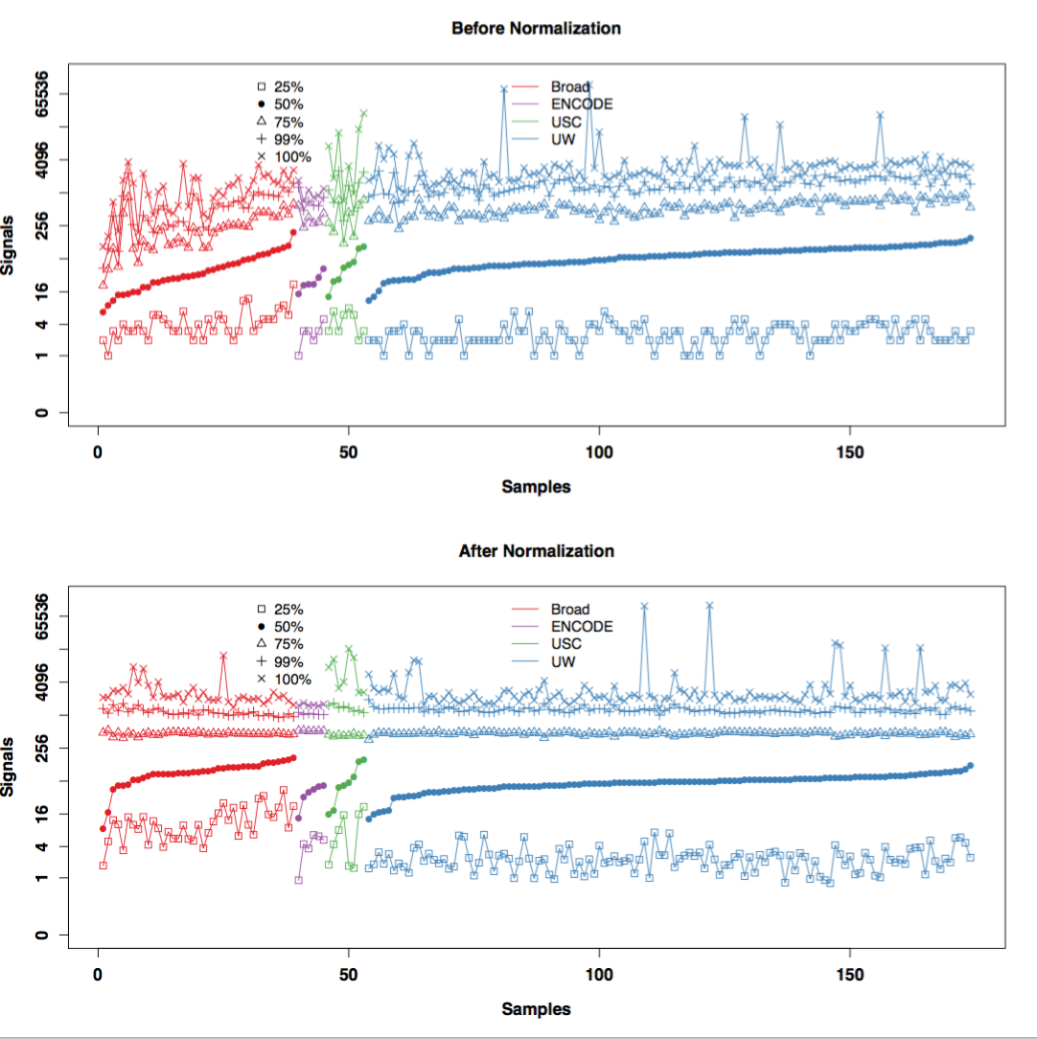
Figure 3.1.6a: Normalization across cell types. For each sample we compute and plot the quartiles, the 99th percentile and the highest value. Colors indicate production labs.

We use the ChIP-seq data of the insulator binding protein CTCF to illustrate our approach to minimizing batch effects that may be caused by differences among production centers. We analyzed CTCF ChIP-seq data in 9 human cell types for which data were produced by multiples ENCODE production centers. We first normalized the ChIP signals using the TMM algorithm {PMID 20196867} and then log-transformed them. we observe that some CTCF peaks show different signals in different cell types, representing true biological variability; whereas other CTCF peaks show consistently high signals for specific production centers regardless of cell types, suggesting potential strong batch effects (left panel in Figure 3.1.6b). Preliminary analysis shows that GC-bias may account for the batch effect—the signal in some datasets correlates positively with QC content of the genomic region (correlation coefficient r=XXX) while in other datasets the correlation is equally strong but negative. We applied some of our previously developed methods {PMID: 20838408} to correct for batch effect and indeed the samples now cluster by cell type (right panel of the figure). In ENCODE4 we will develop methods that minimize GC and other confounding effects. We will also develop experimental design strategies with the production centers that will permit us to estimate and correct for batch effects going forward.

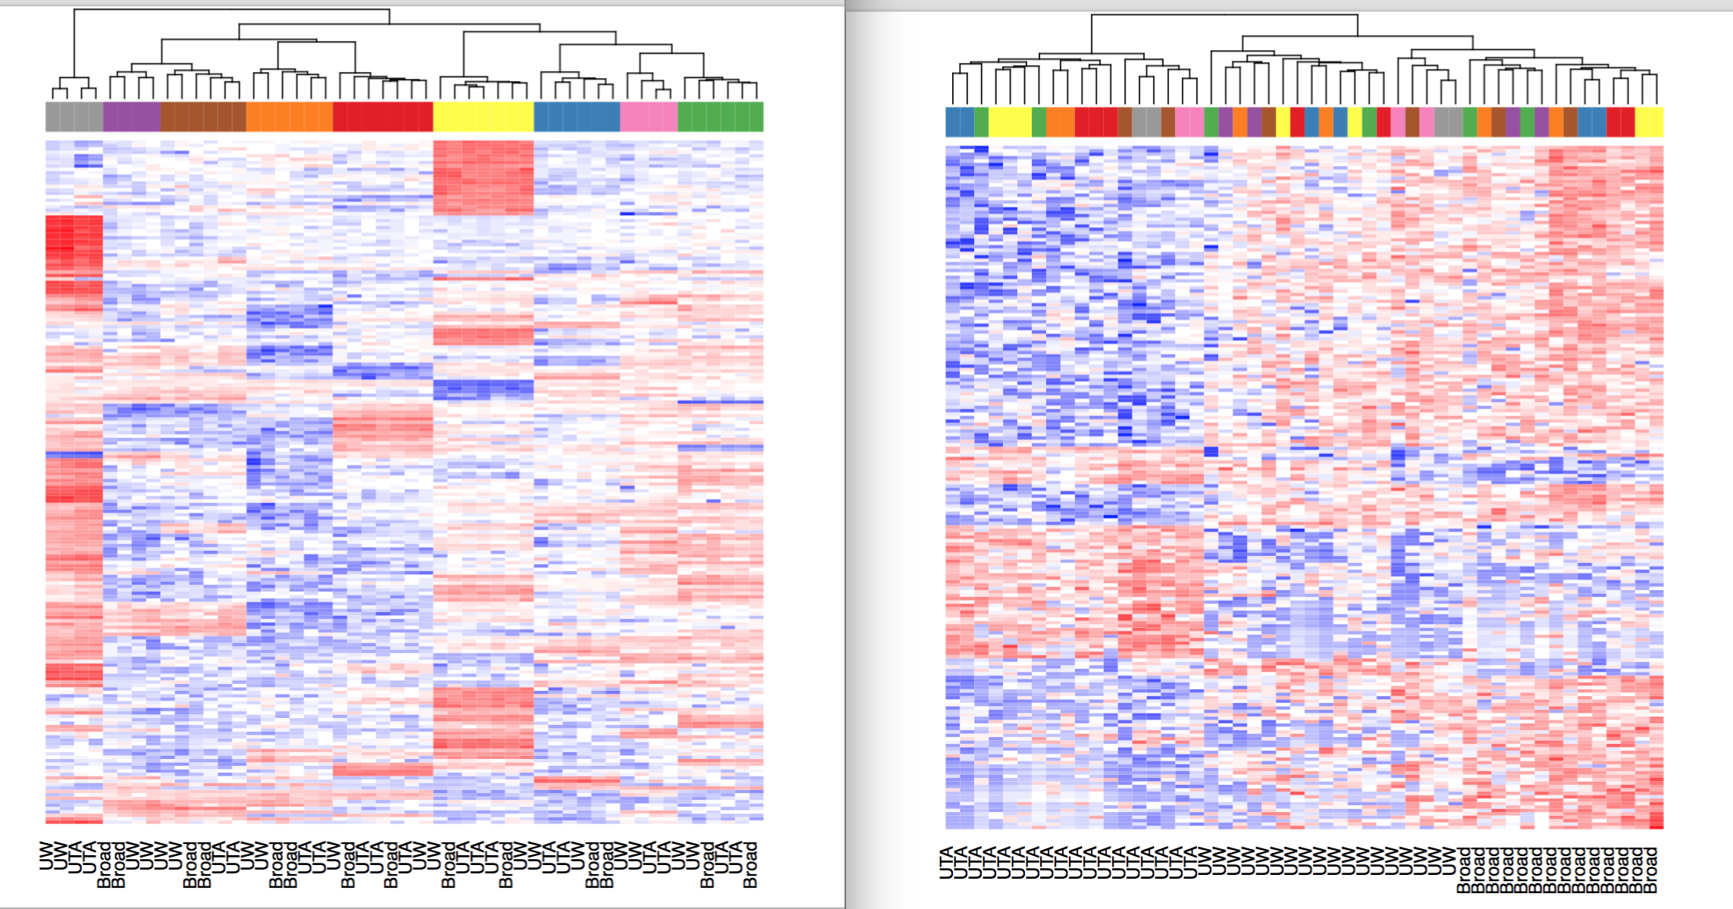
Figure 3.1.6b: Heatmap of CTCF binding signals. Each row is a genomic region (ChIP-seq peak) and each column is a sample. Color blocks on the top of the heatmap indicate cell types. Production centers are indicated at the bottom of the heatmap.

3.2 The middle level of annotations in the Encyclopedia
In the middle level of Encyclopedia we include annotations that require the integration of multiple types of experimental data and require interpretation using biological knowledge. First, we describe the identification of enhancers, then we describe the plan for identifying silencers and insulators. Last, we describe the plan for semi-automated genome annotation using Segway and chromHMM.

3.2.1 Enhancers
One essential component of the Encyclopedia is the collection of enhancers, a major type of regulator elements that can enhance the transcription of a target gene, often at a distance and specific to a cell type {Maston, 2006 16719718}. Active enhancers that have been experimentally tested in transgenic assays in a single mammalian tissue remains small in number and our knowledge of how these enhancers become active in each cell type remains surprisingly incomplete {Visel, 2007 17130149; Shlyueva, 2014 24614317}. Hence, computational predictions of active enhancers have typically focused on identifying the properties associated within the sequences of active enhancers such as inter-species conservation and identifying clusters of transcription factor binding sites \cite{Hallikas, 2006 16413481} as well as epigenetic signatures associated with enhancers such as nucleosome positioning, DNase-I hypersensitivity, histone marks associated with active regulatory regions of the genome, and/or eRNA transcription \cite{ENCODE Consortium, 2012 22955616; Kundaje, 2015 25693563}. How to precisely combine these features to obtain more accurate regulatory region predictions remains a challenge.

In an effort to stimulate computational efforts in predicting enhancers by integrating genomic and epigenomic information, the DAC organized a Consortium-wide blind test of enhancer prediction algorithms (Section 2.3.1). Len Pennacchio’s team performed mouse transgenic assays on roughly 80 putative enhancer regions identified based on their H3K27ac signals in forebrain and heart at the E11.5 stage of mouse embryos, but withheld the experimental results until the DAC had solicited computational predictions from the participating groups and submitted these predictions to the DCC. Only then the DAC evaluated these predictions and released the evaluation along with the experimental results to the participating groups. The DAC found that for both forebrain and heart, sophisticated computational methods performed better than simply calling H3K27ac peaks, but the leading computational methods differed between the two cell types. Another important finding was that the H3K27ac peaks called using the uniform processing pipeline developed by the DAC significantly outperformed the peaks called by a generic algorithm which was used to select the 80 regions initially.

In an attempt to develop an unsupervised method for defining enhancers in a cell type specific manner across as many ENCODE cell types as possible in both human and mouse, the DAC undertook a systematic evaluation of DNase, histone mark (H3K27ac, H3K9ac, H3K4me1, H3K4me2, H3K4me3, H3K9me3, and H3K27me3), and DNA methylation data on four mouse cell types (midbrain, hindbrain, neural tube, and limb), the cell types with sufficient numbers of regions that have been tested using mouse transgenic assays. DNase and H3K27ac performed equally well on average if they are used individually, much better than several other histone marks (H3K4me1, H3K9ac, H3K4me3, H3K27me3, and H3K9me3) and DNA methylation. Yet, DNase and H3K27ac claimed victories for different cell types. The DAC combined DNase and H3K27ac into one average ranking scheme which consistently outperformed DNase or H3K27ac alone across all four cell types. Another round of 150 regions have been newly identified based on the DNase-H3K27ac average rank and are currently being tested by the Pennachhio lab.
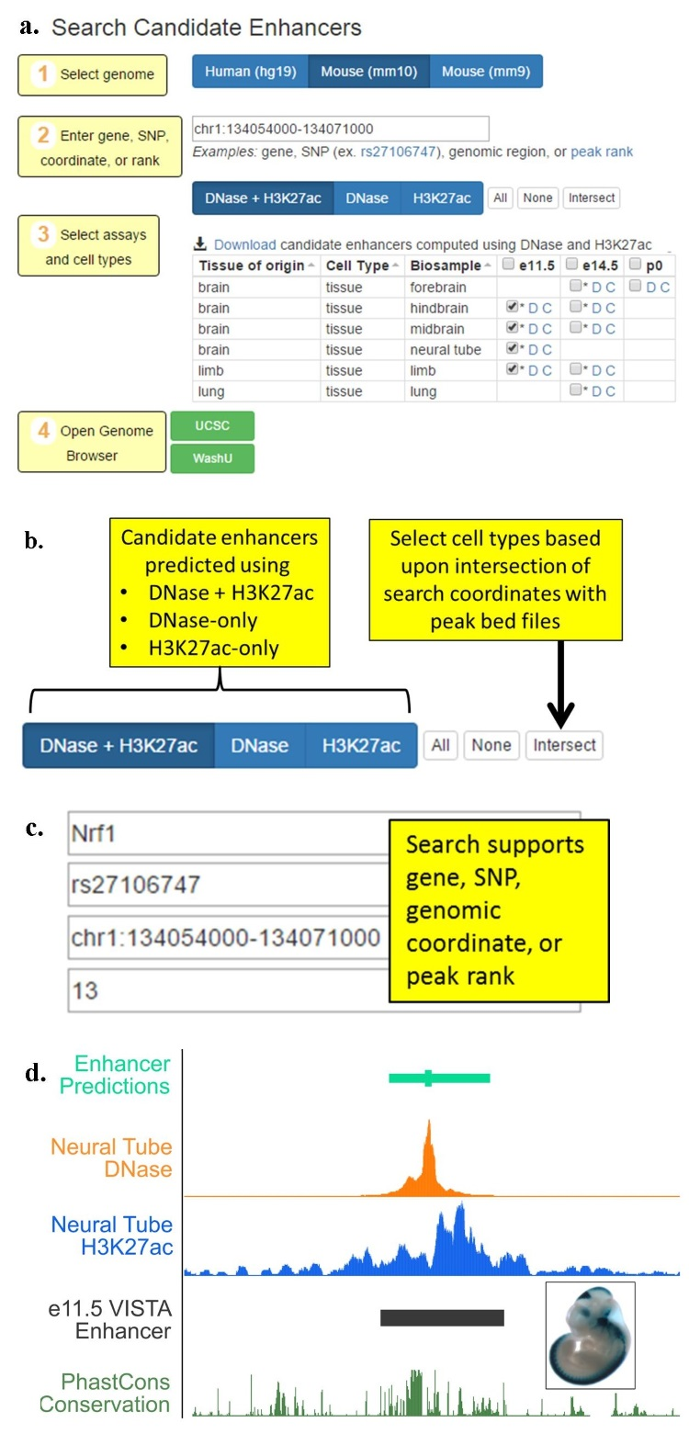
Figure 3.2.1A. An candidate enhancer visualizer. a. Four steps in using the visualizer. b. The user can choose the datasets depends on data availability. c. The user can choose a genomic region by specifying a gene, a SNP, the region’s coordinates, or the rank of a predicted enhancer. d. A top ranked candidate enhancer coincides almost completely with a VISTA region previously tested positive in neural tube.

The DAC subsequently implemented the DNase-H3K27ac average rank across 52 human cell types and 20 mouse cell types for which both DNase and H3K27ac data are available. The DAC has also developed a web server (http://zlab-annotations.umassmed.edu; Figure 3.2.1A) which allows users to query candidate enhancers by coordinates, nearby genes, or SNPs and visualize them in the UCSC genome browser or the WashU epigenome browser along with the supporting DNase and H3K27ac signals. The example figure shows such a top enhancer predicting in neural tube which coincides almost perfectly with a VISTA enhancer (Figure 3.2.1A.d).

Going forward, the DAC will continue to develop computational algorithms and visualization methods to identify candidate enhancers in all ENCODE cell types. We will continue to work with Dr. Pennacchio to further develop and validate our enhancer prediction algorithm (see supporter from Dr. Pennacchio). One natural extension is to develop a hidden Markov model which explicitly models the interplay between DNase and H3K27ac signals, i.e., DNase peaks often occur in the troughs of H3K27ac signals. Meanwhile, a number of massively parallel reporter assays (MPRA) such as STARR-seq and FIREWACh have been developed recently \cite{Arnold, 2013 23328393; Vanhille, 2015 25872643; Murtha, 2014 24658142; Patwardhan, 2012 22371081} providing us with much larger datasets to systematically study the precise combinations of genomic and epigenomic features that are most predictive of active regulatory regions in the genome. Prof. Nadav Ahituv is submitting a Characterization Center proposal to perform massively parallel reporter assays on 100,000 putative regulatory elements inserted into the genome using a lentivirus-based approach. He has expressed a strong interest in collaborating with the DAC (see support letter from Prof. Ahituv).

During the ENCODE enhancer prediction challenge (described earlier in this section and in Section 2.3.1), one of the top performing method for predicting forebrain enhancers was developed by a DAC lab (Gerstein). It use as pattern recognition algorithm called matched filter \cite{Book - Papoulis, S. U. Pillai, Probability, Random Variables, and Stochastic Processes 4th Edition} to identify a particular shape of H3K27ac ChIP-seq signal (two nucleosome-sized peaks flanking a nucleosome-sized valley) in the presence of noise. In ENCODE4, we plan to extend this method to incorporate additional histone marks, DNase-seq and transcription of enhancer RNA (eRNA) to predict active enhancers. The algorithm will be trained using enhancers identified by massively parallel regulatory assays. In addition, we will also develop a framework to combine the results from matched filter for different epigenomic datasets to make the most accurate predictions and to understand the properties that most likely contribute to enhancer establishment, maintenance, and recognition. We will use feature selection methods within a supervised learning framework, such as in random forests, support vector machines, Bayesian networks, and regression methods. While sequence information will not be used to make these predictions, we can test whether the predicted regions contain evolutionarily conserved clusters of TF motifs and we can also identify TF families (with known motifs) that are associated with these regulatory regions in a cell type specific manner. We can then annotate the regulatory regions active within each cell type and also annotate the likely TF binding site within these regulatory regions. Our ultimate goal is not only the systematic annotation of each functional element in these genomes, but also new mechanistic insights into the interplay between different functional elements, and we will work closely with the AWG and Consortium members to design computational and experimental tests to evaluate the role of the most informative features.

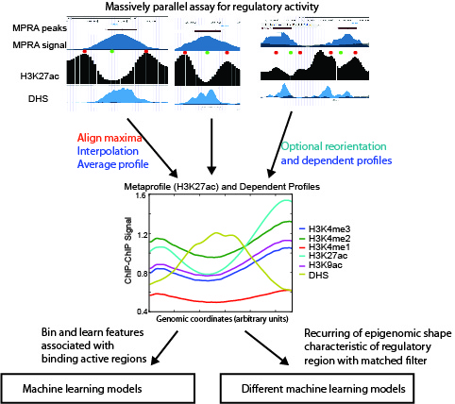
Figure 3.2.1B. Learning the meta-pattern of epigenetic signals in enhancers. The enhancers identified by massively parallel regulatory assays are aligned by the position of the maximal H3K27ac ChIP-seq signal and averaged to calculate the shape (meta-pattern) of enhancers. We can also calculate the meta-patterns on MNase-seq, DNase-seq, and other histone ChIP-seq datasets by simultaneously applying the same transformation to these datasets. We will combine the matched filter scores for each chromatin mark within a machine learning framework and this can improve the accuracy of the predictions.

3.2.2 Insulators and repressors
While there are no high-throughput technique specifically designed to identifying insulators or repressors, low and median throughput methods exist {PMID: 18436892}. We expect that many of the massively parallel reporter assays can be modified to find these elements, e.g., by measuring a decrease in the reporter signal. If ENCODE4 has production or characterization centers that will produce data on insulators or repressors, that we can develop similar approaches to the prediction of enhancers for predicting insulators and repressors.

3.2.3 Semi-automated genome annotation (SAGA)
In the previous two subsections we have described approaches for directly identifying regulatory elements such as enhancers, insulators and silencers, by identifying genomic and epigenomic features that are predictive of each type of regulatory elements and building computational models using these features. A complementary approach is to simultaneously partition and label the human genome based on a large number of genomic and epigenomic features, so that genomic regions with similar values for these features are assigned the same label. This approach uses unsupervised machine learning methodology without any prior knowledge of annotation information, and is called semi-automated genome annotation (SAGA) because the labels (also called states) produced by the model must be interpreted in a human post-processing step, assigned to promoter, enhancer, insulator, repressed, or quiescent regions of the genome. These states show distinct functional enrichments, confirming their respective biological functions. They also provide a chromatin context for understanding binding of sequence-specific factors, motif enrichments, and other diverse functional elements, such as origins of replication or insulator regions.

The DAC has developed a number of SAGA methods. During the pilot phase of ENCODE, we combined a hidden Markov model (HMM) with wavelet smoothing to produce a two-label annotation of the ENCODE pilot regions into “active” and “repressed” regions 27 (); 28 (), and we produced a software tool capable of automatically creating annotations using any user-specified number of distinct labels 29 (). A variety of SAGA methods have been described subsequently, employing HMMs with flat 30 (); 31 () or hierarchical structure 32 ()-34 (), or generalizing the HMM to a hierarchical change-point model 35 (). In particular, during the second phase of ENCODE, two research groups within the consortium (Noble and Kellis) independently developed SAGA algorithms, ChromHMM 36 () and Segway 37 (). The two methods employ closely related probabilistic models that offer multiple important advantages, including efficient algorithms for carrying out inference and a modeling paradigm in which the model’s internal variables have well-defined semantics. The two approaches are complementary, in the sense that ChromHMM aims for a birds-eye view of the data, opting to collapse each 200 bp of data to a single Boolean value, whereas Segway is capable of providing a more detailed view, operating on the raw data at up to its native 1 bp resolution. These complementary methods continue to be widely used, exemplified by the recent Roadmap Epigenomics Consortium papers (Figure 3.2.3A). They are both currently being applied systematically to the combined compendium of ENCODE3 and Roadmap Epigenomics data in both human and mouse.

As part of the current annotation effort, our Segway annotation incorporates several recent improvements, including the ability to train on the entire human genome using a minibatch training mode, and modeling of emission distributions within each state of the model using a mixture of Gaussians rather than a single Gaussian. In addition, we have developed and validated a method for automatically assigning human interpretable labels to an annotation. The method leverages the observation that, by now, a relatively large number of manually interpreted SAGA annotations have been published. We therefore trained a supervised classification algorithm to automatically assign one of ten labels (“Enhancer,” “Promoter,” etc.) to an integer label produced by Segway, using as features the pattern of histone modifications and gene enrichments associated with the labeled segments. In a cross-validated setting, this approach achieves an accuracy of 98.3%, and similar learned labels tend to cluster in a 2D projection.

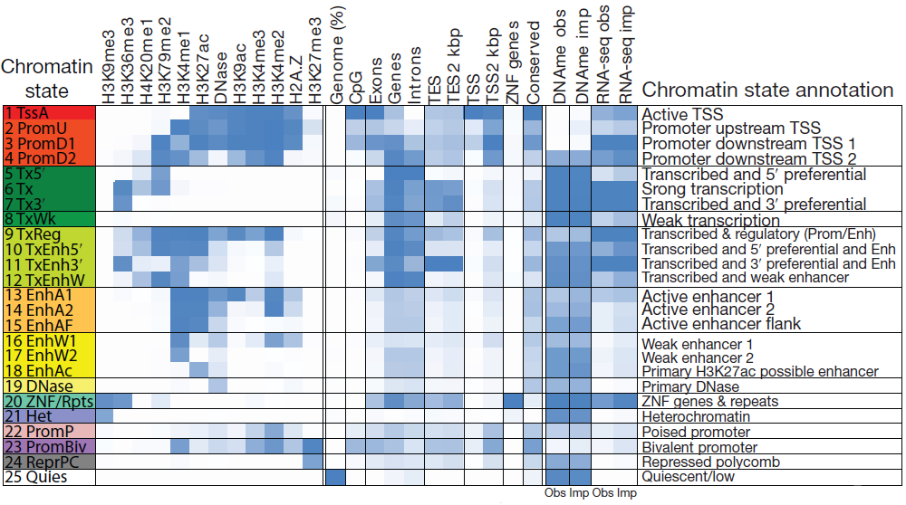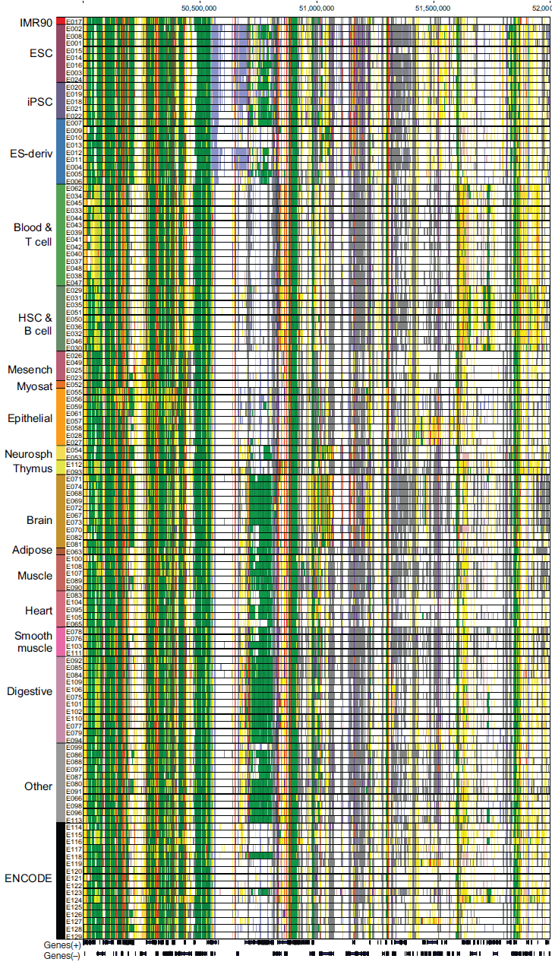
Figure 3.2.3A. Application of ChromHMM to analyzing Roadmap Epigenomic Consortium data. Left: Properties of 25 chromatin states. Right: the chromatin states in an example genomic region across 126 epigenomes (rows), showing regions with conserved states and cell type-specific states.

During the next phase of ENCODE, we intend to improve upon Segway in three significant ways. Many of these improvements will be adapted by ChromHMM with adjustment. Ultimately, these semi-automated learning methods will provide a scalable way to integrate all of the ENCODE data, along with human annotations, to provide a joint annotation that summarizes, at multiple scales, our knowledge of the functional landscape of the human genome in various cell and tissue types.

First, we will augment Segway with learned networks representing pairwise relationships between cell types and assay types. The idea here is to down-weight correlated contributions from related assay types and, in the context of multi-cell type annotation, to encourage related cell types to have similar annotations. The feasibility of this type of network learning has been demonstrated in recent work on learning complex chromatin states 39 (). A more scalable approach has also been outlined for large sets of histone modification assays 40 (). The Graphical Models Toolkit (GMTK) software with which Segway is implemented will allow us to easily augment Segway to incorporate priors derived from these learned networks. This will allow us to avoid the mean field approximation required by a previous method that infers a tree over cell types 34 ().

Second, we will extend Segway to implement a hierarchical state space. Our current Segway annotation effort is being performed at three different resolutions, 10 bp, 100 bp and 10 kbp. These complementary annotations capture phenomena at different scales, from fine-scale phenomena such as regulatory elements up to large-scale domains 41 (). Several published reports describe hierarchical approaches that jointly capture phenomena at different scales 42 (), including methods that employ hierarchical probability models akin to the one used by Segway 32 (); 33 (). We will implement within Segway our previously described conjugate priors approach 35 (), in which the parameters of a substate are generated by the emissions from its parent state. Each top-level label is associated with some number of sub-labels. A top-level labels might be “enhancer,” whereas a low-level label might be “H3K27ac region upstream of enhancer TF binding site” or “enhancer nucleosome free TF binding site.” We will also experiment with applying hierarchical models in the context of multi-cell type annotation. In such a setting, the model might learn a latent “potential activity types” vector at each position that specifies a distribution over possible labels for each position. Doing so would discourage one cell type from calling a position, say, “promoter” if no other cell types show evidence for having an promoter in that position.

Third, we will develop a variance stabilization method to cast the inputs to Segway into interpretable units. In general, the output of a genomics assay—the number of reads mapping to a given genomic position—has no natural units. In particular, a difference between 0 and 30 reads may have a very different statistical importance from a difference between 1,000 and 1,030 reads. This property is due to a relationship between the mean of the data-generating process (i.e. the genomics assay) and its variance. In practise, the different mean-variance relationships among the heterogeneous inputs to Segway make the statistical modeling problem much harder.

Currently, to attempt normalize for the mean-variance relationship of the sequencing read counts, we preprocess the inputs to Segway using an inverse hyperbolic sine transform. However, there is no theoretical basis for using this particular transformation. On the other hand, given a known mean-variance relationship, a dataset can be put into interpretable units using the variance-stabilizing transformation , where σ(x) is the standard deviation of a variable with a mean of x. The resulting signal is in units of standard deviation, so it has the useful property that all data points have a 95% confidence intervals of ∼2 units. We will therefore investigate methods to learn the mean-variance relationship of functional genomics datasets using the variation among biological replicates. This problem involves optimizing an objective of the form , whereas most existing approaches for learning functions—such as using splines or Gaussian processes—are designed for a squared-error objective of the form . We will then use the learned mean-variance relationship in combination with a negative binomial distribution to place Segway inputs into interpretable units. We expect this transformation to significantly improve the robustness and interpretability of the resulting models and annotations.

3.3 The top level of annotations in the Encyclopedia
We propose three components to be included in the top level of the Encyclopedia: the target genes of enhancers, the target genes of transcription factors, and allele specific binding or transcription events. This is not an exhaustive list and will be augmented upon formation of ENCODE4. For example, we can include the target genes of silencers if their experimental detection becomes reliable and there will be sufficient experimental data to train computational methods. The key feature of annotations in the top level of the Encyclopedia is that they require the most integration, hence they are the furthest away from the underlying raw experimental data, yet these annotations are of broad interest which warrants their inclusion in the Encyclopedia. Furthermore, these annotations are key components for building regulatory networks.

3.3.1 Linking enhancers to their putative target genes
Many DAC labs have done significant work on linking enhancers to the promoters of their target genes. We correlated histone marks between enhancers and promoters across multiple cellular context to identify links, and search for additional features supporting these enhancer-promoter assignments {PMID: 21441907}. We have also used ENCODE ChIP-seq data to identify enhancers and connect them to target transcripts {PMID: 22950945}. Other ENCODE labs have also developed correlation-based methods {Thurman 2012 PMID: 22955617} {Sheffield GR 2013, PMID: 23482648}. Methods that are based on static correlations of histone mark or DNase signals and gene expression across multiple cell types are potentially limited in their abilities in detecting cell type specific and dynamic links, as well as non-linear behaviors. Recent work developed more sophisticated metrics than correlation {Marstrand and Storey, 2014, PNAS, PMID: 24469817} {Corradin GR 2014 PMID: 24196873}. Alternatively, supervised approaches (e.g., {He 2014 PNAS PMID: 24821768} train computational models using links detected in Hi-C and ChIA-PET experiments {ref}.

The lack of reliable experimental data on enhancer-gene links, especially cell type specific links which are the most interesting in terms of understanding the dynamics of transcriptional regulation. The chromatin conformation type of experiments are typically of low resolution. In Section 3.1.5 we mentioned ENCODE Hi-C data from the Dekker lab on 12 cell types, but they are at 40 kb resolution, too low for reliably assigning enhancer-gene links. One study reported 1 kb resolution Hi-C maps on GM12878 and 5-kb resolution maps for eight other cell types {Rao 2014 Cell, PMID: 25497547}. We anticipate that more high-resolution maps will become available from production centers of the 4D Nucleome consortium. In addition, modified Hi-C or ChIA-PET technologies that perform promoter capture can significantly improve the detection of enhancer-gene links. Another source of experimental data The DAC will take advantage of these new data to train algorithms for detecting target genes.

The DAC recently evaluated correlation-based methods using the capture Hi-C data on GM12878 cells {Mifsud
2015 NG PMID: 25938943}

The DAC will continue to evaluate existing methods. In addition, we will also

[Goal: Manolis will turn this into at most 5.5 Word pages]
Aim 4. Assessing quality and utility of the ENCODE data and providing feedback to NHGRI and the Consortium. In Aim 4, we will develop and apply computational and statistical methods to assess the quality and utility of ENCODE datasets in a systematic and unbiased way, including: (1) data-type specific QC measures including for ChIP-seq, RNA-seq, ATAC-seq; (2) data-type agnostic measures of dataset quality; (3) measures of cumulative coverage and dataset completeness; (4) imputation-based and submodular-optimization-based methods for assay prioritization; (5) methods for cell type prioritization.
4.1. Data-type specific measures of dataset quality: The DAC will continue to work with the AWG and the PIs to standardize metrics of dataset quality, incorporating existing metrics (many of which were developed by the DAC in collaboration with ENCODE Working groups) and developing new metrics per Consortium needs.
QC for ChIP-seq: We use metrics based on antibody validation, replicate consistency, replicate rank consistency, strand cross-correlation analysis (Fig. 4.1a-c), and fraction of reads in peaks. We adopt a number of quality control (QC) measures to evaluate the quality of each ChIP-seq sample, mostly following ENCODE ChIP-seq QC standard with some additional criteria. They include sequence qualify (FASTQC), mapping quality (uniquely mapped read ratio), library complexity (PCR bottleneck coefficient), ChIP enrichment (number of ChIP-seq peaks passing false discovery rate and fold enrichment cutoffs), signal to noise (fraction of reads in peaks), regulatory region (overlap with union of all DNase-seq peaks), evolutionary conservation (PhastCons), and motif (enrichment in peak summit). Researchers could search ChIP-seq sample of interest, evaluate data quality on the site, browse the ChIP-seq signals on genome browsers, and download peaks and signals to their own computer for downstream analysis.
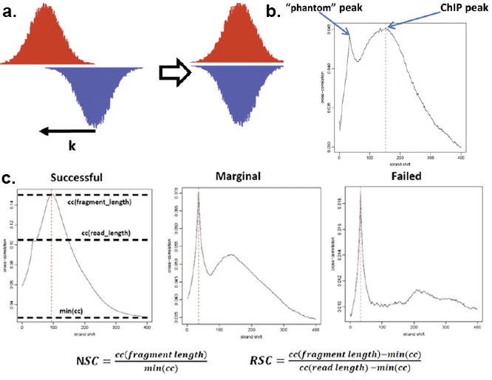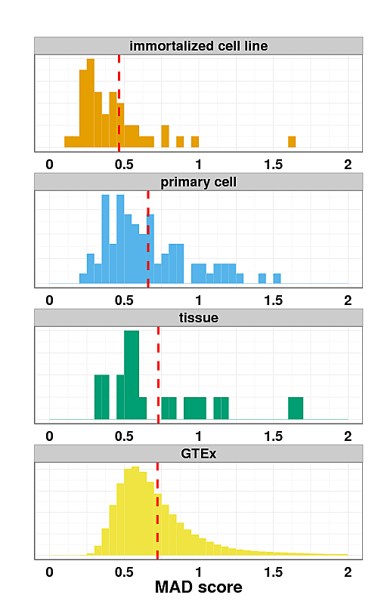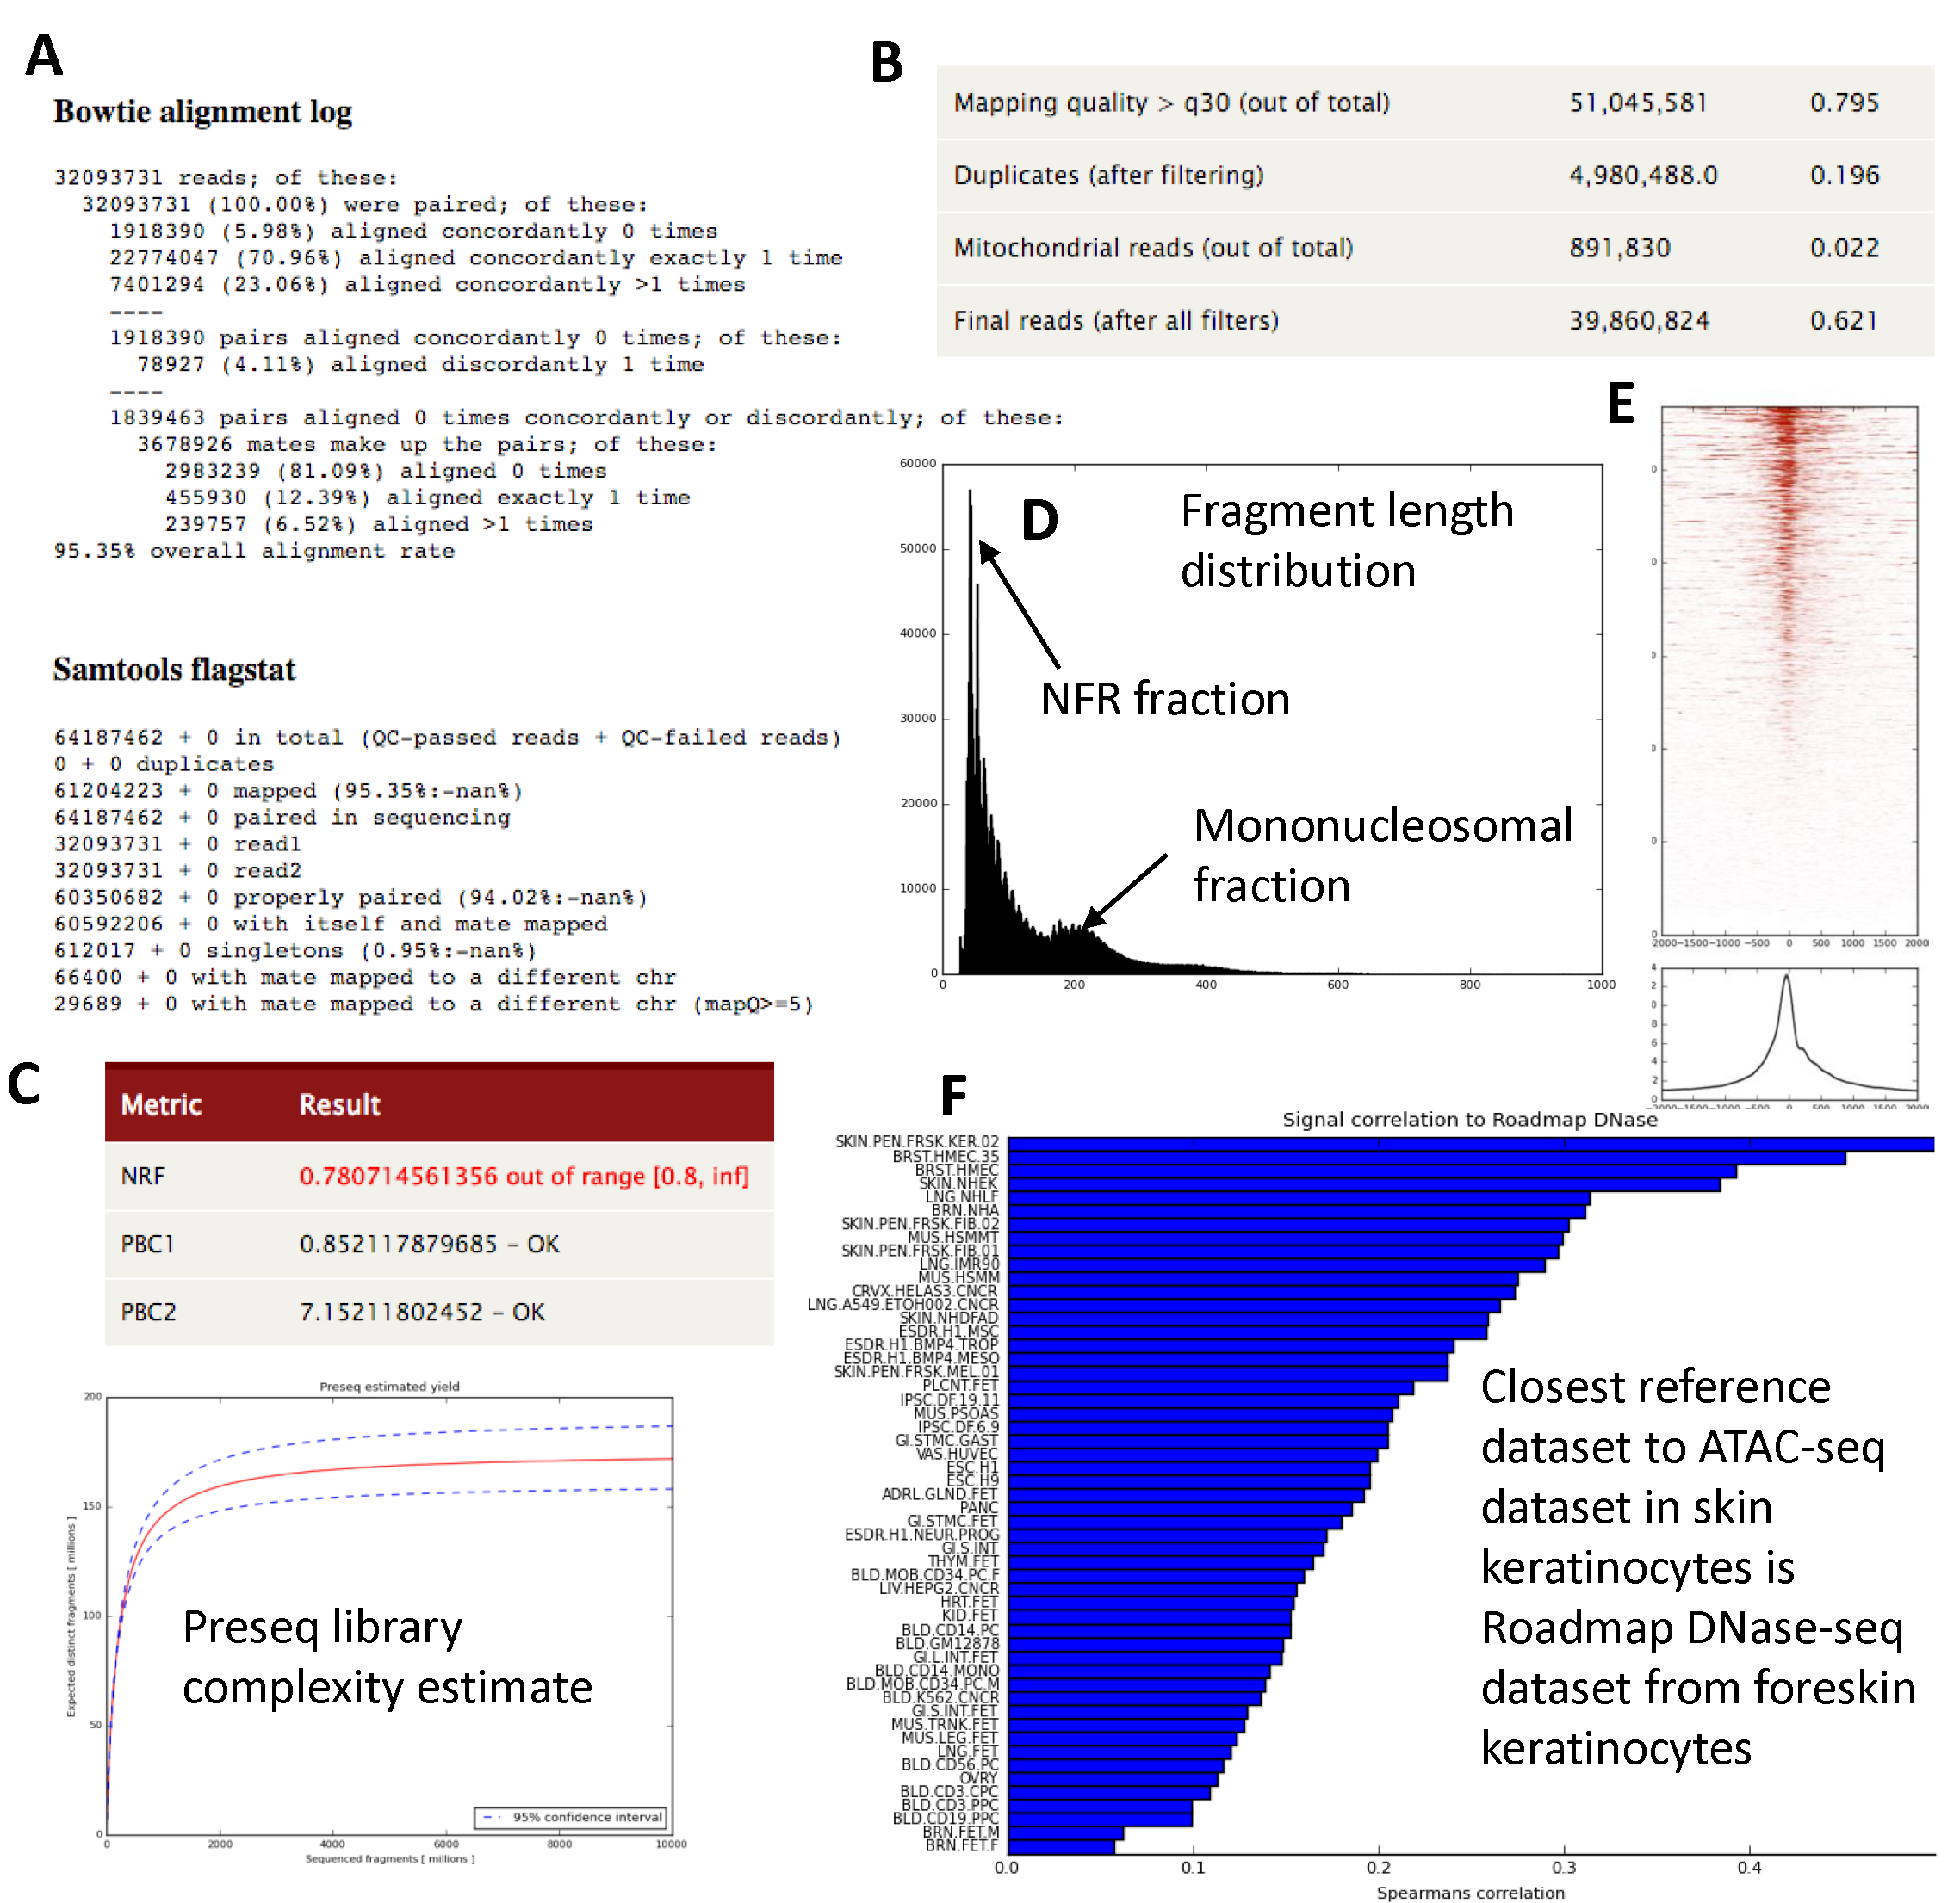
Figure 4.1. Data type-specific quality control critera. (a-c) Criteria for assessing the quality of a ChIP-seq experiment. (a) Cross-correlation analysis: reads are shifted in the direction of the strand they map to by an increasing number of base pairs and the Pearson correlation between the per-position read count vectors for each strand is calculated. Read coverage as wigglegram is represented. (b) Two cross-correlation peaks are usually observed in a ChIP experiment, one corresponding to the read length (phantom peak) and one to the average fragment length of the library. (c) Absolute and relative height of the two peaks help determine the success of a ChIP-seq experiment. A high-quality IP is characterized by a ChIP peak that is much higher than the phantom peak, while often very small or no such peak is seen in failed experiments. (d) RNA-seq quality control metric distribution for MAD scores (a measure of inter-replica reproducibility). The MAD score is lower for immortalized cell lines than primary cells than tissues for ENCODE data, where the distribution is comparable to that of GTEx. The dashed red line indicates the median. (e-j) ATAC-seq QC metrics. (e) Mapping statistics from Bowtie and Samtools (f) Read Filtering Statistics (g) Library complexity measures and Preseq library complexity estimate (h) Fragment length distribution including estimation of nucleosome free fraction (NFR) and mononucleosomal fraction (i) TSS enrichment plot (j) Estimation of nearest cell type based on similarity to reference DNase-seq datasets.
QC for RNA-seq: For RNA-seq, we use metrics based on sequencing depth, alignment rate, duplicate read rate, compositional biases, ncRNA content, intronic vs. exonic coverage, positional bias, and coverage continuity. We have learned that different reproducibility metrics are needed when comparing replicates from isogenic samples, such as those originated from cell lines, vs. when comparing replicates of more different biological source, such as those from tissues obtained in different individuals. To develop the appropriate metrics threshold, the DAC is extensively analyzing data produced by the GTEx project, where RNA-seq is produced in tissue samples from multiple donors (Fig. 4.1d). The aim is to produce the appropriate background distribution for the metrics depending on the biological source.
QC for DNA accessibility. For DNase-seq and ATAC-seq, we use several QC measures based on enrichment, reproducibility and detection of potential sample swaps or mislabeling. (1) We use mapping logs with percent aligned reads, percent reads above MAPQ 30, percent duplicate reads, mitochondrial fraction and the final number of useable reads, and QC bias distribution (Fig. 4.1e,f). (2) We compute measures of library complexity, including PCR Bottleneck coefficient (PBC) and non-redundant fraction (NRF){Landt}, and use PRESEQ{cite} and PICARD to estimate the true library complexity (Fig. 4.1g). (3) We use the fraction of reads in the nucleosome free fraction (NFR) relative to the mononucleosomal fraction (180-220 bp) using a mixture of gamma distributions (Fig. 4.1h). (4) We use the fraction of reads in all peaks, promoter peaks, non-promoter peaks, DNase-overlapping peaks from ENCODE and Roadmap Epigenomics, TSS bias, and fraction in ENCODE blacklist regions (Fig. 4.1i). (5) We use nearest reference cell type/tissue to detect mislabeled samples: We compare a target ATAC-seq dataset to reference DNase-seq datasets from ~300 diverse cell types and tissues from ENCODE and the Roadmap Epigenomics project. Specifically, we obtain a universal set of DNase-seq peaks (a union) across all cell types. We then compute the correlation of the ATAC-seq signal to the signal from each reference DNase-seq dataset across the universal peak set. We rank the reference cell types in descending order to correlation. The top 10 most similar reference samples should be biologically similar to the target cell-type/tissue of the ATAC-seq sample. This analysis allows us to identify potential gross sample swaps or mislabeling of datasets (Fig. 4.1j).
QC for personal genomics. Specifically for personal genomes, we have developed RNA-seq and ChIP-seq metrics within the diploid framework{Chen et al. Nat. Commun., in press} that quantify the deviation of the read distribution of allelic ratios across all heterozygous sites from the binomial distribution. An overdispersion metric on the fraction of reads mapped to the reference allele can identify datasets with unusual allelic ratio distributions, that indicate lower QC issues such as uneven or sparse read coverage.
4.2. Data-type agnostic measures of dataset quality. In addition to these data type-specific metrics, we will develop and apply general methods for assessing experiment quality.
Imputation-based QC metrics. In particular, we have demonstrated the use of systematic imputation of histone marks, DNA methylation, RNA-seq, and DNase datasets based on their correlation with datasets of the same data type and of different datatypes within the same cell type and within other cell types. Briefly, we use the correlation between an experimentally observed data track and an imputed data track (Fig. 4.2a), evaluated either across the entire genome (“GWcorr”), or in the 1% of regions that have greatest signal strength (“Match1”). We found that the agreement of a dataset with the imputed signal based on these correlation metrics provides a powerful and unbiased metric for evaluating dataset quality, flagging low-quality datasets that are sometimes missed by other quality metrics (Fig. 4.2b-d), including sample or antibody swap problems. We will extend these methods to incorporate additional data types and additional features in the prediction.
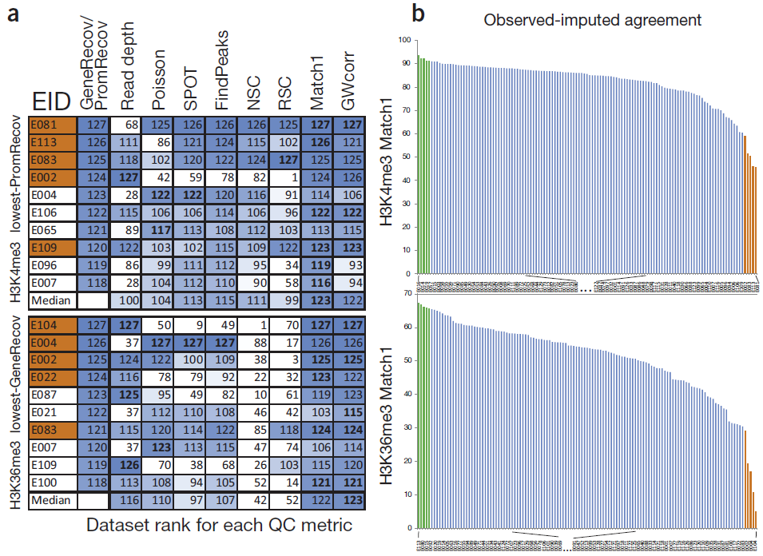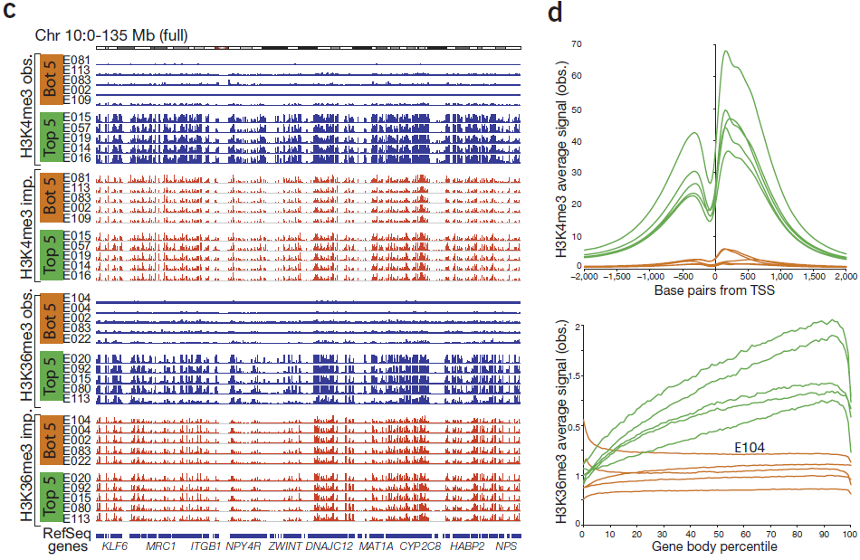
Figure 4.2. Imputation-based QC complements datatype-specific QC metrics. (a) Comparison of dataset-specific QC metrics (columns) for ten Roadmap Epigenomics datasets (rows) that show the lowest agreement with gene and promoter annotations, based on H3K4me3 (top) and H3K36me3 (bottom). Each entry shows rank (out of 127) for imputation-based QC (first column), read depth (second column) and each QC metric (Poisson statistic, Signal Proportion of Tags (SPOT), FindPeaks, Normalized and Relative Strand Correlation between forward and reverse strands (NSC and RSC)), and similarity between imputed and observed data, evalauted genome-wide (GWcorr) and in the highest-signal 1% regions (Match1). Orange-shaded EIDs denote the five worst-agreement datasets. (b) Distribution of match1 imputation-based QC metric highlights five worst-similarity (orange) and five highest-similarity (green) datasets. (c) Observed (blue) and imputed (red) signal tracks for worst-similarity (orange) and best-similarity (green) datasets for chromosome 10. Datasets with lowest imputation QC score show relatively flat signal, indicating successful flagging of low-quality datasets even when several datatype-specific QC metrics failed to detect them. (d) Aggregation of observed signal for H3K4me3 surrounding the TSS (top) and H3K36me3 in gene bodies (bottom) for the five best (green) and worst (orange) datasets according to the imputation-based Match1 QC metric, highlighting unusual profiles of flagged, indicating lower quality, even though they were not flagged by traditional datatype-specific QC metrics.
Developing new QC metrics by training on outlier datasets. Definitions of data quality depend on the specific applications for which the data is to be utilized. In the case of RNA-seq, the most common applications appear to be finding differentially expressed genes between two or more conditions, clustering transcripts or samples, and predicting sample types or outcomes. For ChIP-seq of histone marks and sequence-specific factors applications include the location of peaks, regions of differential binding, the inference of chromatin states, and of regulatory motifs. In our attempt to measure quality we will quantify the effect of removing bad quality data on the biological results. We will consider removing: one read from one sequencing run, all data points from mapped to a region across all samples, all data from an sequencing run, all data arising from a specific biological specimen, all data arising from a specific batch of samples, or even all data produced by a particular laboratory. We will identify cut-offs such that removing experiments that do not reach this cut-off improve downstream results. We will leverage the availability of dozens of ENCODE samples to derive QC metrics by jointly analysis the all samples, which can detect problems missing by single-sample quality metrics. For example, multi-dimensional scaling of all ENCODE gene expression data with Spearman correlation >0.9 between replicates shows outlier samples all processed by the same lab (Fig. 4.3), providing a benchmark target set for new measures of QC. Indeed, a new metric evaluating the “percent of genes quantified below 0.5 transcripts per million reads” (TPM) can flag these outliers.
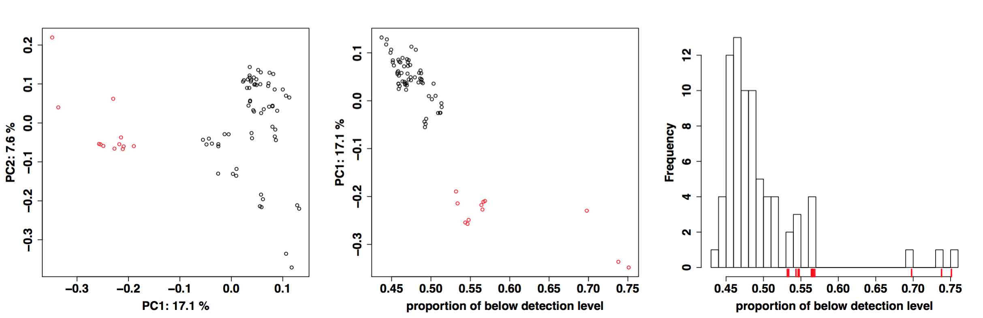
Figure 4.3. Exploiting outlier datasets for QC metric development: Left: Multidimensional scaling plot of ENCODE expression data on primary cells and cell lines with similar starting material for two different processing labs (color). Middle: First principal component (PC1) vs. proportion of genes with quantification below 0.5. Right: histogram of proportion of genes below detection level.
4.3. Measures of dataset completion. We will also develop metrics and methods for evaluating the progress and completeness of the entire ENCODE project, along multiple axes, including: (i) genomic coverage, towards identifying biochemically active nucleotides across all datasets and cell types; (ii) cell type coverage, towards identifying all distinct cellular states; (iii) data type diversity, for each cell type; (iv) activity pattern capture, for each functional element. We have previously applied these measures in ENCODE and modENCODE, to track the contribution of increasing numbers of experiments to the genomic coverage of human, Drosophila, and worm, for both conserved and non-conserved regions.
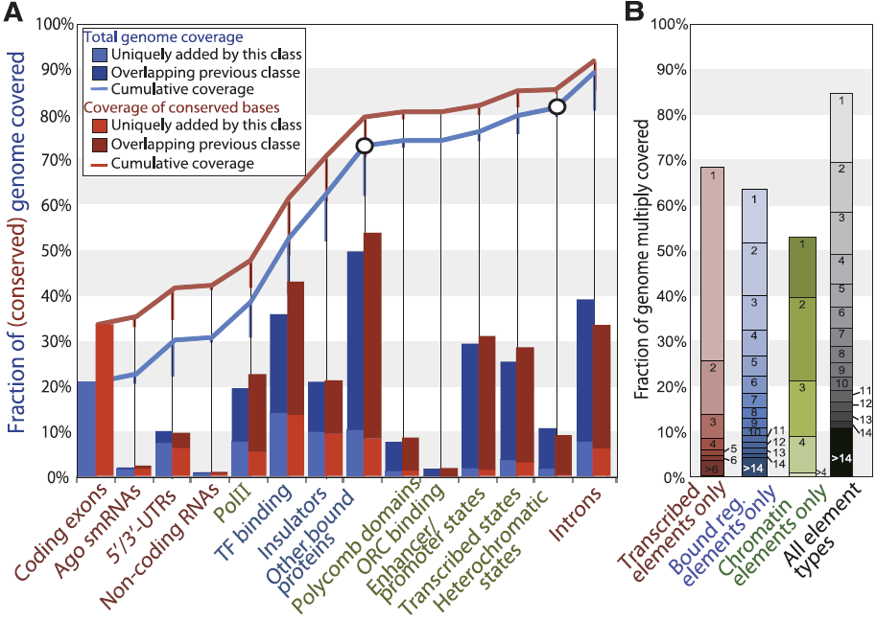c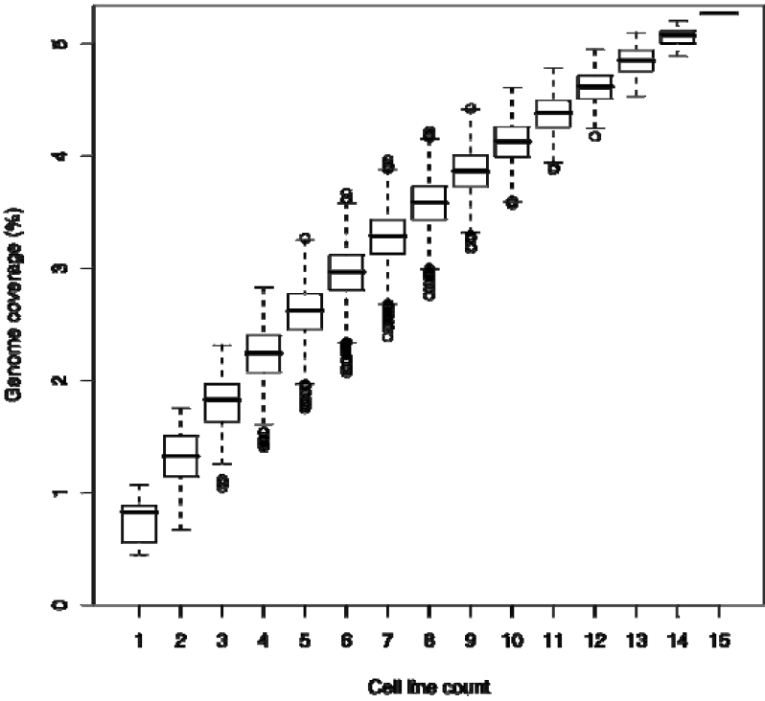d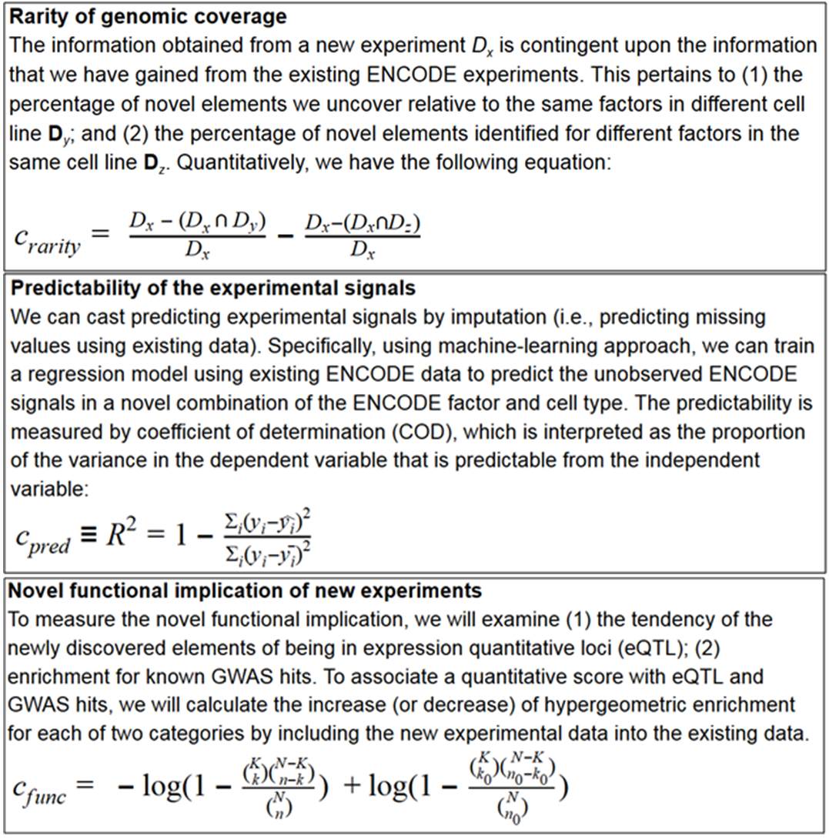
Figure 4.4. Genome coverage by ENCODE data types. (a) Unique (bars) and cumulative (lines) coverage of nonrepetitive (blue line) and conserved (red line) genome from Drosophila modENCODE. (b) Multiple coverage for datasets grouped into transcribed elements (red), bound regulators (blue), and chromatin domains (green) in Drosophila modENCODE. Across all three classes (black), 10.8% of the genome is covered 15 or more times, and 69.5% is covered at least twice. (c) Genomic coverage in human ENCODE with randomly reordered datasets as additional cell lines are added. Saturation plot for UW DNase1 over 15 cell lines, with all possible paths of random addition orders for cell lines. (d) Information-based measures of the contribution of individual assays towards completion of the ENCODE matrix covering DNA elements across diverse human cell types and diverse assays.
For each data type, we will develop and apply unbiased methods for evaluating the added per-nucleotide information content in a given cell type (Fig. 4.4d), based on: (i) genome-wide coverage, (ii) resolution, (iii) reproducibility. We will quantify the unique information each experiment provide in the context of the compendium using information-theoretic approaches that incorporate multiple factors: (1) the reproducibility of an assay between replicate experiments; (2) the resolution of the assay; (3) the robustness of the experiment to variation in experimental conditions; (4) the rarity of the element type; (5) the ability to predict of a given assay from other assays in the same cell type; (6) the ability to predict a given assay from same/other assays in other cell types; (7) the increase in enrichments for independent datasets e.g. GWAS variants, regulatory motif matches, evolutionary conservation. resulting from the incorporation of a given experiment to an existing compendium; (8) the increased ability to predict known regulatory motifs by incorporation of the additional experiments; (9) the increase in the ability to predict the activity pattern of a given element resulting from incorporation of the additional experiment in an existing data compendium. Each of these metrics is influenced by: (a) the type of assay; (b) the specific cell type selected; (c) the experimental conditions used; (d) the quality of antibodies (when applicable); (e) the cell type heterogeneity of the sample; (f) the sequencing depth at which the experiment is carried out; (g) the amount of DNA extracted (and thus effective depth of the library).
4.4. Assay prioritization. To guide the ENCODE Consortium in terms of prioritizing particular datasets for usage, we will work closely with other members of the AWG to define metrics for evaluating the uniqueness or redundancy of different types of datasets. As of February, 2016, the ENCODE and Roadmap Epigenomics consortia have performed a total of 270 types of assays on at least one cell type, and at least one assay on a total of 320 cell types (encodeproject.org). Applying all these assay types to all these cell types would require 86,500 assays; however, the two consortia have performed only 2342 assays, 3% of the possible number.
Assay prioritization by imputation.
Assay prioritization by submodular optimization. We have developed a principled method to identify the subset of maximally-informative assays for completing the ENCODE experiment matrix, borrowing methods from the field of submodular optimization{Wei 2015 http://dx.doi.org/10.1101/036137}. Submodular functions{Fujishige Submodula functions and optimization. Vol. 58. Elsevier Science, 2005} have the property that the incremental gain of adding an item to the an existing set decreases as the set grows, and are widely used in economics{X. Vives, Oligopoly Pricing: Old Ideas and New Tools. MIT Press, 2001; M. Carter, Foundations of Mathematical Economics. MIT Press, 2001}, game theory{D. M. Topkis, Supermodularity and complementarity Princeton UP 1998; L. S. Shapley. “Cores of conex games” Int. J. of Game Theory 1(1):11-26, 1971}, combinatorial optimization{50–52}, electrical networks{53}, operations research{54}, and more recently, machine learning{55–58}, but they are not yet widely used for problems in biology. Selecting a panel of genomics assays that maximize a submodular function subject to a constraint on the size of the reported set is NP-hard, but can be approximately solved by a simple greedy algorithm with a worst-case approximation factor (1−e⁻¹){59}. Based on extensive empirical investigation, we selected the facility location function [54] as our submodular objective, which intuitively takes high values when every assay has at least one similar representative in S, and corresponds to the objective function of the k-medoids clustering problem{63}. This function has been previously applied in many fields, including document summarization[61], feature selection [57], and exemplar based clustering [62].
a.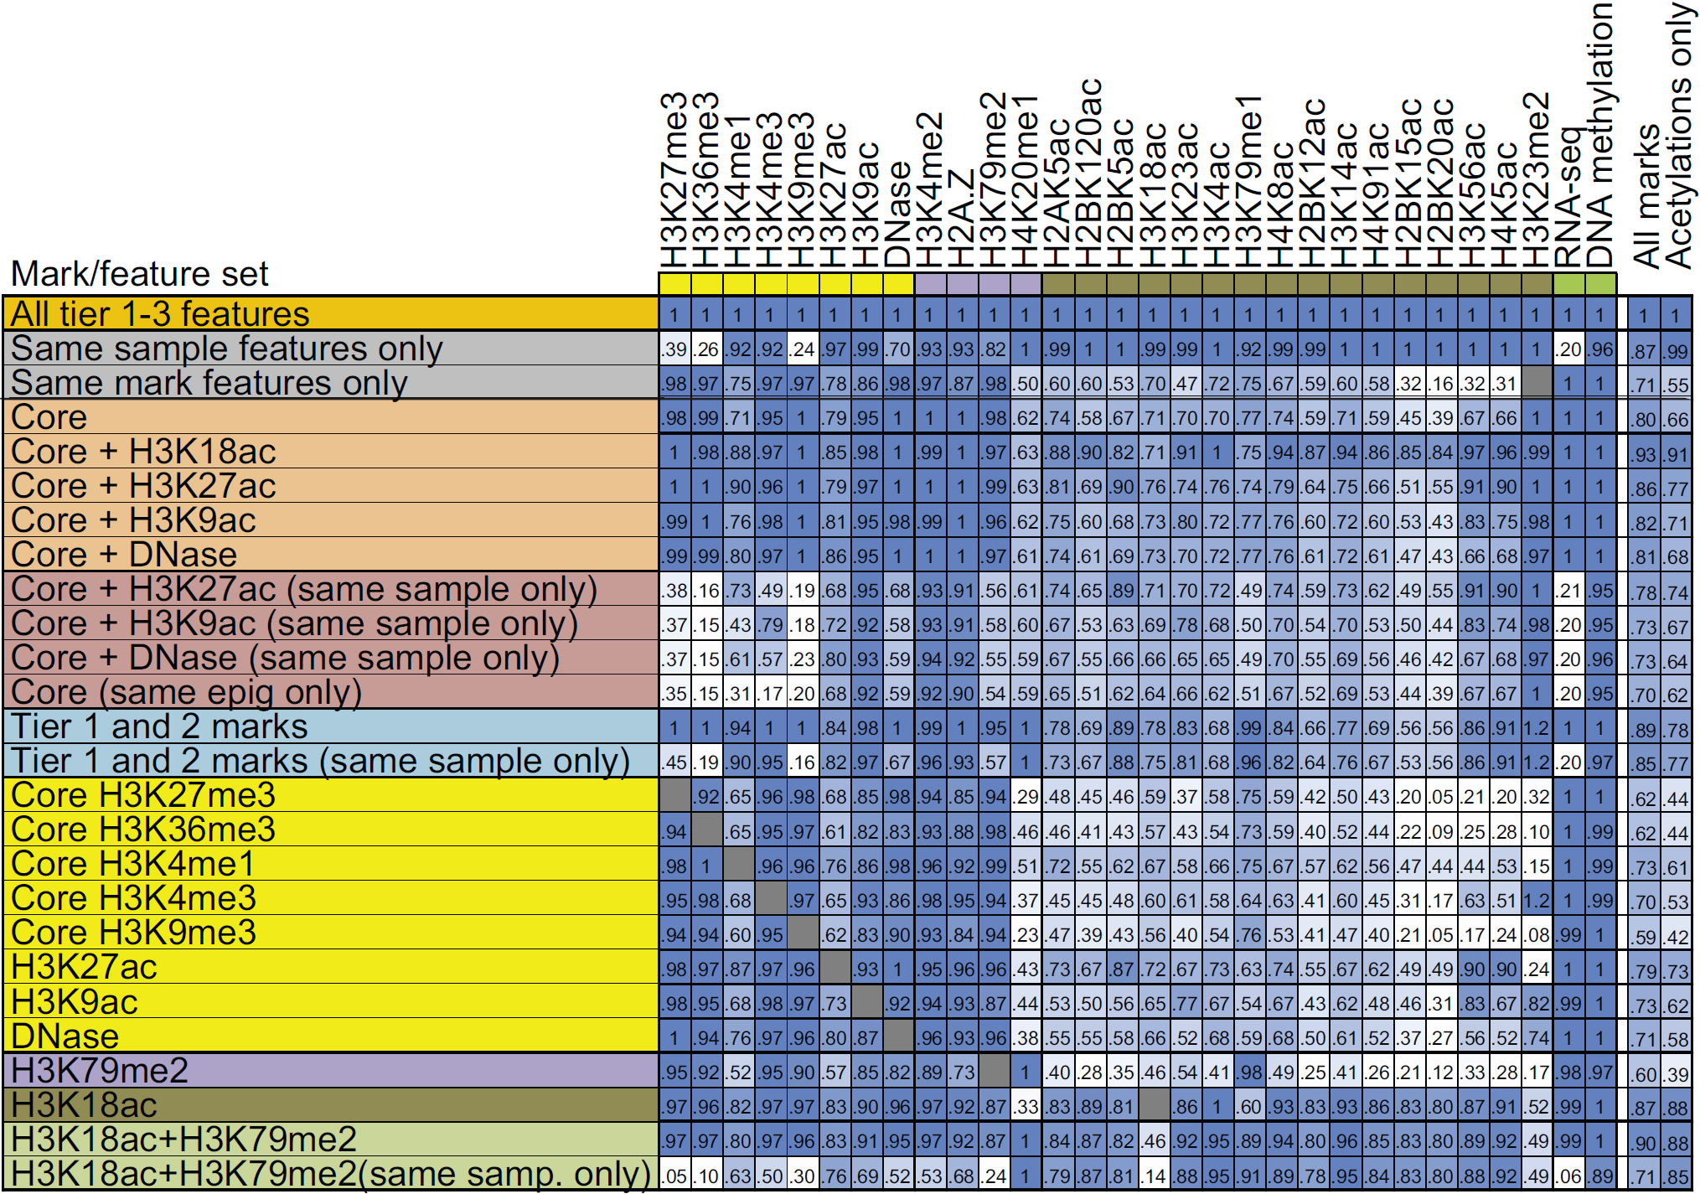b.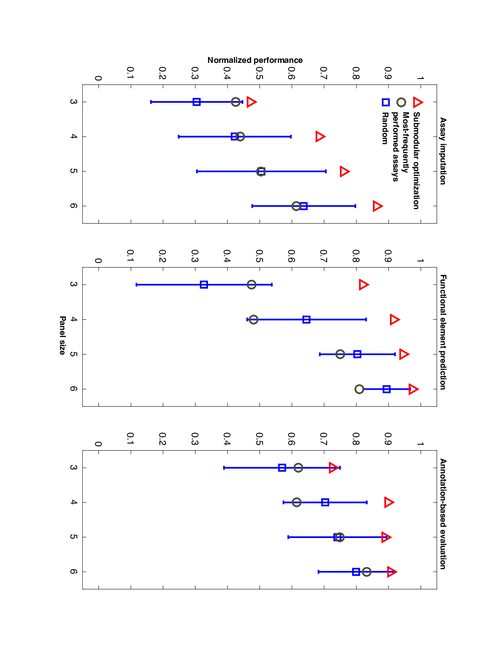
Figure 4.4: Assay prioritization. a. Imputation-based prioritization of assays based on their ability to impute other datasets, and the difficulty based on which they can be themselves imputed by other datasets, in the same cell type or across cell types. Each row denotes a feature set used as predictors. Each column denotes the dataset being imputed. Each entry denotes the imputation quality (blue=greater). Values denote fraction of signal correctly imputed compared to if that dataset was present. Core=H3K4me3, H3K4me1, H3K36me3, H3K27me3, H3K9me3. Same-sample features are most important for acetylation marks, and same-mark features are most important for H3K27me3, H3K36me3, H3K9me3 and RNA-seq. Profiling of only H3K18ac and H3K79me2 allows higher relative imputation agreement than all five core marks, assuming a compendium with uniform coverage of marks. The last two columns show the average performance of the feature subset over all target marks and specifically for acetylations. b. Submodular optimization outperforms current sampling approaches in GM12878. Boxplots show the distribution of evaluation metrics over 40 random subsets (blue). The most-frequently performed assays (grey circle) is composed of the top k most frequent assays in our dataset.
We have demonstrated empirically that this submodular optimization approach yields high quality panels of assays. To do so, we developed three evaluation schemes based on evaluating the panel’s ability to impute missing data, identify functional elements, and accurately annotate the genome in a cross-validated setting (Fig. 4.4b). The quality of the selected panel is higher than randomly selected panels, as well as panels selected based on their frequency in the ENCODE+Roadmap data matrix (Figure 3). We have produced similar results for panels of transcription factor ChIP-seq assays (not shown). In addition, we note that the panel of histone modifications selected by our method closely overlaps with the panel selected by the Roadmap Epigenomics Consortium (our panels of size 6 or greater contain the Roadmap panel of size 5). Moving forward, we aim to extend our methods in several directions. First, we will explore application of the submodular approach to important variants of the problem. We have already investigated selection of assays in three scenarios: (1) “I want to select a set of x assays to perform in a new cell type.” (2) “I have carried out x assays in a given cell type and want to select an additional set of y assays to perform.” (3) “I have carried out x assays in a given cell type and want to select a representative subset of y assays from among them, for use in training a statistical model.” We plan to use a similar approach to address the following scenarios: (1) “I have carried out x assays across a variety of cell types and assay types, and I would like to select a set of y additional assays in any combination of cell and assay types.” (2) “Based on orthogonal data such as gene expression profiles, which new cell types should I perform assays in?”. In addition, we plan to use our cross-validated evaluation strategy to investigate variants of our approach. For example, we will substitute alternative similarity measures in place of the Pearson correlation, to account for the non-uniform nature of the data across the genome or to allow for a more principled combination of similarities within the (additive) facility location function. We will also investigate weighting strategies to take into account, for example, the level of noise in individual experiments as measured by replicate experiments.
4.5. Cell type prioritization. For analyses whose goal is the definition of a particular type of element, we will use the predictive value of each data type as a way to prioritize datasets and assays. For unsupervised learning analyses, we will use information theory metrics to evaluate the information content of each type of dataset per nucleotide, based on the reproducibility of the dataset, the resolution with which elements are defined for that data type, and the genomic coverage of that data type. We will also compare datasets to each other, to ask how predictable a given dataset is based on the combination of other datasets, and to evaluate and prioritize its added value in the context of the data generated by the entire Consortium. Intuitively, this is like determining if a particular analysis can potentially be reproduced without that dataset or if it is reproduced how inaccurate or how much it changes if that particular dataset is left out. This last type of calculation is particularly useful when one is thinking of repeating the same experiment, say a particular ChIP-seq experiment, over many different cell lines. That is, one wonders how much incremental information one gets from each additional cell line. We will also study the saturation of coverage for ChIP-seq and RNA-seq datasets to provide recommendations on the sequencing depth that should be achieved for different types of chromatin features and different types of transcripts. In addition to these goal-agnostic measures of dataset utility, we will develop and apply methods for prioritizing datasets based on specific tasks of interest. Specifically in the context of disease, we will provide a ranking of cell types and assays based on their predictive ability for genetic variants (from GWAS) or epigenetic marks (e.g. from MWAS) are associated with specific diseases and traits.
a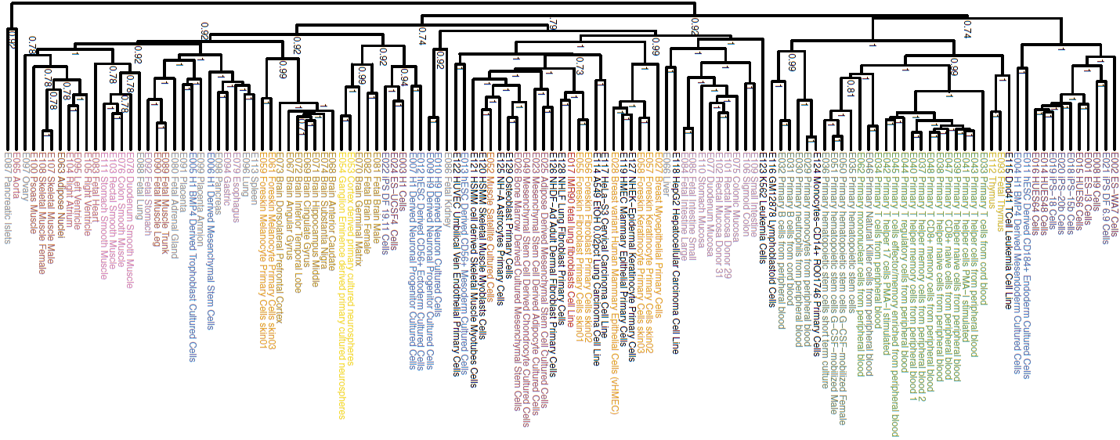b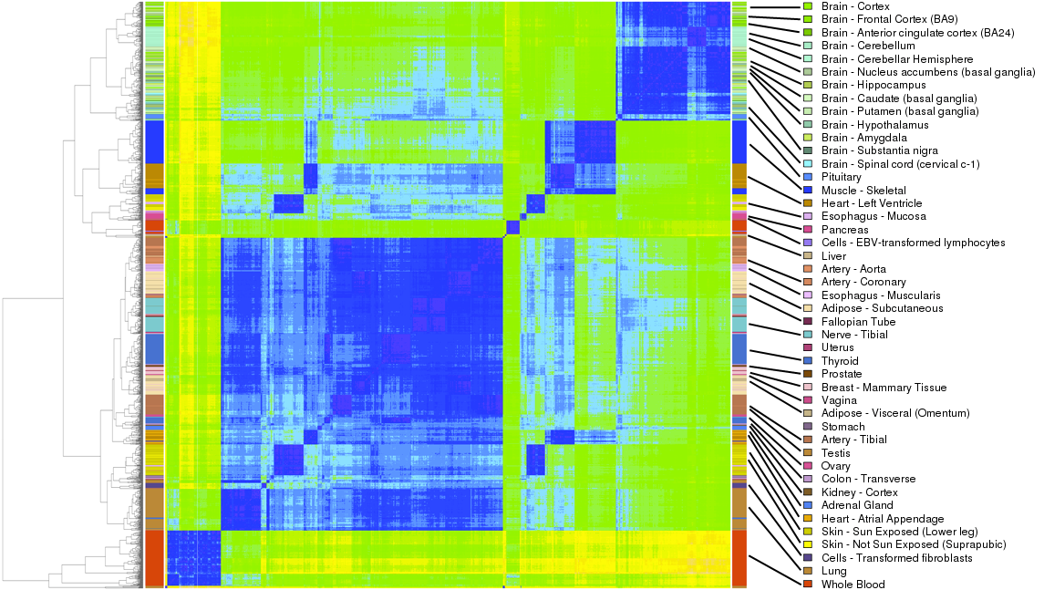c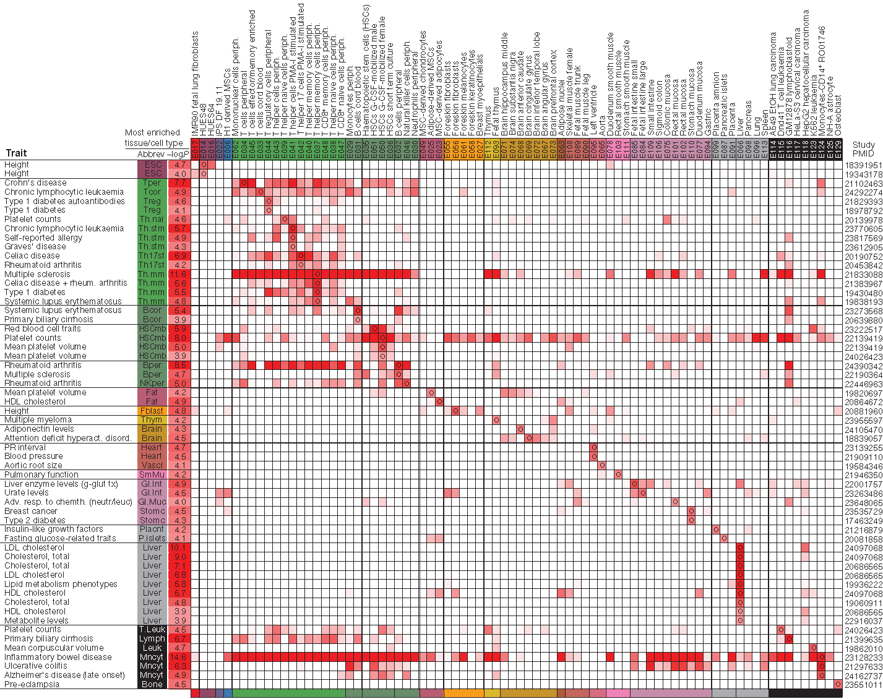
Figure 4.5. Cell type prioritization. (a) Cell type prioritization based on phylogenetic relationship of epigenomic information. H3K4me1 signal for existing cell types vs. all tissues and cell types profiled by related projects. (b) Cell type prioritization based on phylogenetic relationship of RNA-seq gene expression patterns. (c) Prioritizing cell types based on disease enrichment. Tissue-specific H3K4me1 peak enrichment significance (−log10 P value) for genetic variants associated with diverse traits. Circles denote reference epigenome (column) of most significant enrichment for SNPs reported by a given study (row), defined by trait and publication (PubMed identifier, PMID). Tissue (Abbrev) and P value (−log10) of most significant enrichment are shown. Only rows and columns containing a value meeting a FDR of 2% are shown.

REFERENCES CITED
1. Feingold, E., Good, P. & Guyer, M. The ENCODE (ENCyclopedia Of DNA Elements) Project. Science (2004).
2. ENCODE Project Consortium et al. Identification and analysis of functional elements in 1% of the human genome by the ENCODE pilot project. Nature 447, 799–816 (2007).
3. ENCODE Project Consortium An Integrated Encyclopedia of DNA Elements in the Human Genome. ENCODE Companion submitted to Nature
4. Wang, J. et al. Genome-wide mapping of the binding sites of 119 human transcription factors. ENCODE Companion submitted to Nature
5. Dong, X. et al. Correlating histone modifications and gene expression. ENCODE Companion submitted to Genome Res
6. Xi, H.S., Wang, J., Xu, J. & Weng, Z. Identification and Characterization of Allele-Specific Transcriptional Regulation in the Human Genome. ENCODE Companion submitted to Genome Res
7. Whitfield, T.W. et al. Functional analysis of transcription factor binding sites in human promoters. ENCODE Companion submitted to Genome Biol
8. Gerstein, M.B. et al. Architecture of the human regulatory network derived from ENCODE data. ENCODE Companion submitted to Nature
9. Gerstein, M.B. et al. Integrative analysis of the Caenorhabditis elegans genome by the modENCODE project. Science 330, 1775–1787 (2010).
10. Gerstein, M.B. et al. What is a gene, post-ENCODE? History and updated definition. Genome Res 17, 669–681 (2007).
11. Trinklein, N.D. et al. Integrated analysis of experimental datasets reveals many novel promoters in 1% of the human genome. Genome Res 17, 720–731 (2007).
12. Rozowsky, J.S. et al. The DART classification of unannotated transcription within the ENCODE regions: associating transcription with known and novel loci. Genome Res 17, 732–745 (2007).
13. Zhang, Z.D. et al. Statistical analysis of the genomic distribution and correlation of regulatory elements in the ENCODE regions. Genome Res 17, 787–797 (2007).
14. Zheng, D. et al. Pseudogenes in the ENCODE regions: consensus annotation, analysis of transcription, and evolution. Genome Res 17, 839–851 (2007).
15. Washietl, S. et al. Structured RNAs in the ENCODE selected regions of the human genome. Genome Res 17, 852–864 (2007).
16. Euskirchen, G.M. et al. Mapping of transcription factor binding regions in mammalian cells by ChIP: comparison of array- and sequencing-based technologies. Genome Res 17, 898–909 (2007).
17. Lu, Z.J. et al. Prediction and characterization of noncoding RNAs in C. elegans by integrating conservation, secondary structure, and high-throughput sequencing and array data. Genome Res 21, 276–285 (2011).
18. Cheng, C. et al. A statistical framework for modeling gene expression using chromatin features and application to modENCODE datasets. Genome Biol 12, R15 (2011).
19. Nègre, N. et al. A cis-regulatory map of the Drosophila genome. Nature 471, 527–531 (2011).
20. Habegger, L. et al. RSEQtools: a modular framework to analyze RNA-seq data using compact, anonymized data summaries. Bioinformatics 27, 281–283 (2011).
21. Sboner, A. et al. FusionSeq: a modular framework for finding gene fusions by analyzing paired-end RNA-sequencing data. Genome Biol 11, R104 (2010).
22. Montgomery, S.B. et al. Transcriptome genetics using second generation sequencing in a Caucasian population. Nature 464, 773–777 (2010).
23. Li, Q., Brown, J.B., Huang, H. & Bickel, P.J. Measuring reproducibility of high-throughput experiments. The Annals of Applied Statistics 5, 1752–1779 (2011).
24. Gonzalez-Porta, M., Calvo, M., Sammeth, M. & Guigó, R. Estimation of alternative splicing variability in human populations. Genome Res (2011).doi:10.1101/gr.121947.111
25. Djebali, S. et al. Landscape of transcription in human cells. ENCODE Companion submitted to Nature
26. Tilgner, H. et al. Nucleosome positioning as a determinant of exon recognition. Nat Struct Mol Biol 16, 996–1001 (2009).
27. Luco, R.F. et al. Regulation of alternative splicing by histone modifications. Science 327, 996–1000 (2010).
28. Tilgner, H. et al. Chromatin mediated regulation of alternative splicing. ENCODE Companion submitted to Genome Res
29. Tilgner, H. et al. Deep sequencing of RNA from distinct subcellular fractions shows that splicing in the human genome occurs predominantly during transcription. ENCODE Companion submitted to Genome Res
30. Ørom, U.A. et al. Long noncoding RNAs with enhancer-like function in human cells. Cell 143, 46–58 (2010).
31. Derrien, T. et al. The GENCODE v7 catalogue of human long non-coding RNAs: Analysis of their gene structure, evolution and expression. ENCODE Companion submitted to Genome Res
32. Kharchenko, P.V., Tolstorukov, M.Y. & Park, P.J. Design and analysis of ChIP-seq experiments for DNA-binding proteins. Nat Biotechnol 26, 1351–1359 (2008).
33. Zhang, Y. et al. Model-based analysis of ChIP-seq (MACS). Genome Biol 9, R137 (2008).
34. Rozowsky, J. et al. PeakSeq enables systematic scoring of ChIP-seq experiments relative to controls. Nat Biotechnol 27, 66–75 (2009).
35. Kheradpour, P. & Manolis, K. Systematic discovery and characterization of regulatory motifs in ENCODE TF binding experiments. ENCODE Companion submitted to Genome Res
36. Giardine, B. et al. Galaxy: a platform for interactive large-scale genome analysis. Genome Res 15, 1451–1455 (2005).
37. Liu, T. et al. Cistrome: an integrative platform for transcriptional regulation studies. Genome Biol 12, R83 (2011).
38. Niranjan, T.S. et al. Effective detection of rare variants in pooled DNA samples using Cross-pool tailcurve analysis. Genome Biol 12, R93 (2011).
39. Wu, H., Irizarry, R.A. & Bravo, H.C. Intensity normalization improves color calling in SOLiD sequencing. Nat Methods 7, 336–337 (2010).
40. Bravo, H.C. & Irizarry, R.A. Model-based quality assessment and base-calling for second-generation sequencing data. Biometrics 66, 665–674 (2010).
41. Hansen, K.D., Wu, Z., Irizarry, R.A. & Leek, J.T. Sequencing technology does not eliminate biological variability. Nat Biotechnol 29, 572–573 (2011).
42. McCall, M.N., Murakami, P.N., Lukk, M., Huber, W. & Irizarry, R.A. Assessing affymetrix GeneChip microarray quality. BMC Bioinformatics 12, 137 (2011).
43. Dohm, J.C., Lottaz, C., Borodina, T. & Himmelbauer, H. Substantial biases in ultra-short read datasets from high-throughput DNA sequencing. Nucleic Acids Res 36, e105 (2008).
44. Kao, W.-C., Stevens, K. & Song, Y.S. BayesCall: A model-based base-calling algorithm for high-throughput short-read sequencing. Genome Res 19, 1884–1895 (2009).
45. Yang, X., Dorman, K.S. & Aluru, S. Reptile: representative tiling for short read error correction. Bioinformatics 26, 2526–2533 (2010).
46. Zhao, X. et al. EDAR: an efficient error detection and removal algorithm for next generation sequencing data. J. Comput. Biol. 17, 1549–1560 (2010).
47. Schröder, J., Schröder, H., Puglisi, S.J., Sinha, R. & Schmidt, B. SHREC: a short-read error correction method. Bioinformatics 25, 2157–2163 (2009).
48. Kelley, D.R., Schatz, M.C. & Salzberg, S.L. Quake: quality-aware detection and correction of sequencing errors. Genome Biol 11, R116 (2010).
49. Kuan, P.F. et al. A Statistical Framework for the Analysis of ChIP-seq Data. Journal of the American Statistical Association 106, 891–903 (2011).
50. Lee, W. et al. The mutation spectrum revealed by paired genome sequences from a lung cancer patient. Nature 465, 473–477 (2010).
51. Hansen, K.D., Brenner, S.E. & Dudoit, S. Biases in Illumina transcriptome sequencing caused by random hexamer priming. Nucleic Acids Res 38, e131 (2010).
52. Li, J., Jiang, H. & Wong, W.H. Modeling non-uniformity in short-read rates in RNA-seq data. Genome Biol 11, R50 (2010).
53. Leek, J.T. et al. Tackling the widespread and critical impact of batch effects in high-throughput data. Nat Rev Genet 11, 733–739 (2010).
54. Leek, J.T. & Storey, J.D. Capturing heterogeneity in gene expression studies by surrogate variable analysis. PLoS Genet 3, 1724–1735 (2007).
55. Johnson, W.E., Li, C. & Rabinovic, A. Adjusting batch effects in microarray expression data using empirical Bayes methods. Biostatistics 8, 118–127 (2007).
56. ENCODE Project Consortium et al. A user's guide to the Encyclopedia of DNA Elements (ENCODE). PLoS Biol. 9, e1001046 (2011).
57. Kolasinska-Zwierz, P. et al. Differential chromatin marking of introns and expressed exons by H3K36me3. Nature genetics 41, 376–381 (2009).
58. Guttman, M. et al. Chromatin signature reveals over a thousand highly conserved large non-coding RNAs in mammals. Nature 458, 223–227 (2009).
59. Stark, A. et al. Discovery of functional elements in 12 Drosophila genomes using evolutionary signatures. Nature 450, 219–232 (2007).
60. modENCODE Consortium et al. Identification of functional elements and regulatory circuits by Drosophila modENCODE. Science 330, 1787–1797 (2010).
61. Cheng, C., Weng, Z. & Gerstein, M. Understanding transcriptional regulation by integrative analysis of transcription factor binding data. ENCODE Companion submitted to Genome Res
62. Cheng, C., Shou, C., Yip, K.Y. & Gerstein, M.B. Genome-wide analysis of chromatin features identifies histone modification sensitive and insensitive yeast transcription factors. Genome Biol 12, R111 (2011).
63. Cheng, C. & Gerstein, M. Modeling the relative relationship of transcription factor binding and histone modifications to gene expression levels in mouse embryonic stem cells. Nucleic Acids Res (2011).doi:10.1093/nar/gkr752
64. Barash, Y. et al. Deciphering the splicing code. Nature 465, 53–59 (2010).
65. Luco, R.F., Allo, M., Schor, I.E., Kornblihtt, A.R. & Misteli, T. Epigenetics in alternative pre-mRNA splicing. Cell 144, 16–26 (2011).
66. He, H.H. et al. Nucleosome dynamics define transcriptional enhancers. Nature genetics 42, 343–347 (2010).
67. Kheradpour, P., Stark, A. & Roy, S. Reliable prediction of regulator targets using 12 Drosophila genomes. Genome Res (2007).
68. Ernst, J. et al. Mapping and analysis of chromatin state dynamics in nine human cell types. Nature 473, 43–49 (2011).
69. Yip, K.Y. et al. Genome-wide analysis of the binding sites of more than 100 transcription-related factors defines different types of genomic regions with distinct biological properties. ENCODE Companion submitted to Genome Res
70. Sandberg, R., Neilson, J.R., Sarma, A., Sharp, P.A. & Burge, C.B. Proliferating cells express mRNAs with shortened 3' untranslated regions and fewer microRNA target sites. Science 320, 1643–1647 (2008).
71. Thurman, R.E., Day, N., Noble, W.S. & Stamatoyannopoulos, J.A. Identification of higher-order functional domains in the human ENCODE regions. Genome Res 17, 917–927 (2007).
72. Filion, G.J. et al. Systematic protein location mapping reveals five principal chromatin types in Drosophila cells. Cell 143, 212–224 (2010).
73. Kharchenko, P.V. et al. Comprehensive analysis of the chromatin landscape in Drosophila melanogaster. Nature 471, 480–485 (2011).
74. Jaschek, R. Spatial clustering of multivariate genomic and epigenomic information. Research in Computational Molecular Biology (2009).
75. Lian, H. et al. Automated mapping of large-scale chromatin structure in ENCODE. Bioinformatics 24, 1911–1916 (2008).
76. Ernst, J. & Kellis, M. Discovery and characterization of chromatin states for systematic annotation of the human genome. Nat Biotechnol 28, 817–825 (2010).
77. Hoffman, M.M. et al. Unsupervised pattern discovery in human chromatin structure through genomic segmentation. Submitted
78. Hoffman, M.M. et al. Integrative annotation of chromatin elements from ENCODE data. ENCODE Companion submitted to Genome Res
79. Day, N., Hemmaplardh, A., Thurman, R.E., Stamatoyannopoulos, J.A. & Noble, W.S. Unsupervised segmentation of continuous genomic data. Bioinformatics 23, 1424–1426 (2007).
80. Lieberman-Aiden, E. et al. Comprehensive mapping of long-range interactions reveals folding principles of the human genome. Science 326, 289–293 (2009).
81. Wang, J., Lunyak, V.V. & Jordan, I.K. Genome-wide prediction and analysis of human chromatin boundary elements. Nucleic Acids Res (2011).doi:10.1093/nar/gkr750
82. Pearl, J. Probabilistic Reasoning in Intelligent Systems: Networks of Plausible Inference. 552 (Morgan Kaufmann: 1988).
83. Reynolds, S.M., Käll, L., Riffle, M.E., Bilmes, J.A. & Noble, W.S. Transmembrane topology and signal peptide prediction using dynamic bayesian networks. PLoS Comput Biol 4, e1000213 (2008).
84. Entropic Graph Regularization in Non-Parametric Semi-Supervised Classification. 1803–1811 (2009).
85. Subramanya, A. & Bilmes, J. Semi-Supervised Learning with Measure Propagation. J. Mach. Learn. Res. 12, 3311–3370 (2011).
86. Parallel Graph-Based Semi-Supervised Learning. (2011).
87. Jee, J. et al. ACT: Aggregation and Correlation Toolbox for Analyses of Genome Tracks. Bioinformatics (2011).doi:10.1093/bioinformatics/btr092
88. Alexander, R.P., Fang, G., Rozowsky, J., Snyder, M. & Gerstein, M.B. Annotating non-coding regions of the genome. Nat Rev Genet 11, 559–571 (2010).
89. Frey, B.J. & Dueck, D. Clustering by passing messages between data points. Science 315, 972–976 (2007).
90. Reiss, D.J., Baliga, N.S. & Bonneau, R. Integrated biclustering of heterogeneous genome-wide datasets for the inference of global regulatory networks. BMC Bioinformatics 7, 280 (2006).
91. Bonneau, R. Learning biological networks: from modules to dynamics. Nat. Chem. Biol. 4, 658–664 (2008).
92. Bonneau, R. et al. The Inferelator: an algorithm for learning parsimonious regulatory networks from systems-biology datasets de novo. Genome Biol 7, R36 (2006).
93. Cheng, C. et al. Construction and analysis of an integrated regulatory network derived from high-throughput sequencing data. PLoS Comput Biol 7, e1002190 (2011).
94. Jansen, R., Greenbaum, D. & Gerstein, M. Relating whole-genome expression data with protein-protein interactions. Genome Res 12, 37–46 (2002).
95. Lu, L.J., Xia, Y., Paccanaro, A., Yu, H. & Gerstein, M. Assessing the limits of genomic data integration for predicting protein networks. Genome Res 15, 945–953 (2005).
96. Yu, H. & Gerstein, M. Genomic analysis of the hierarchical structure of regulatory networks. Proc Natl Acad Sci USA 103, 14724–14731 (2006).
97. Shou, C. et al. Measuring the evolutionary rewiring of biological networks. PLoS Comput Biol 7, e1001050 (2011).
98. Friedman, R.C., Farh, K.K.-H., Burge, C.B. & Bartel, D.P. Most mammalian mRNAs are conserved targets of microRNAs. Genome Res 19, 92–105 (2009).
99. Yip, K.Y., Yu, H., Kim, P.M., Schultz, M. & Gerstein, M. The tYNA platform for comparative interactomics: a web tool for managing, comparing and mining multiple networks. Bioinformatics 22, 2968–2970 (2006).
100. Yu, H., Kim, P.M., Sprecher, E., Trifonov, V. & Gerstein, M. The importance of bottlenecks in protein networks: correlation with gene essentiality and expression dynamics. PLoS Comput Biol 3, e59 (2007).
101. Bhardwaj, N., Kim, P.M. & Gerstein, M.B. Rewiring of transcriptional regulatory networks: hierarchy, rather than connectivity, better reflects the importance of regulators. Sci Signal 3, ra79 (2010).
102. Bhardwaj, N. et al. Analysis of combinatorial regulation: scaling of partnerships between regulators with the number of governed targets. PLoS Comput Biol 6, e1000755 (2010).
103. Bhardwaj, N., Yan, K.-K. & Gerstein, M.B. Analysis of diverse regulatory networks in a hierarchical context shows consistent tendencies for collaboration in the middle levels. Proc Natl Acad Sci U S A 107, 6841–6846 (2010).
104. Yan, K.-K., Fang, G., Bhardwaj, N., Alexander, R.P. & Gerstein, M. Comparing genomes to computer operating systems in terms of the topology and evolution of their regulatory control networks. Proc Natl Acad Sci U S A 107, 9186–9191 (2010).
105. Malmström, L. et al. Superfamily assignments for the yeast proteome through integration of structure prediction with the gene ontology. PLoS Biol. 5, e76 (2007).
106. Mu, X.J., Lu, Z.J., Kong, Y., Lam, H.Y.K. & Gerstein, M.B. Analysis of genomic variation in non-coding elements using population-scale sequencing data from the 1000 Genomes Project. Nucleic Acids Res 39, 7058–7076 (2011).
107. 1000 Genomes Project Consortium et al. A map of human genome variation from population-scale sequencing. Nature 467, 1061–1073 (2010).
108. Altshuler, D., Daly, M.J. & Lander, E.S. Genetic mapping in human disease. Science 322, 881–888 (2008).
109. Lango Allen, H. et al. Hundreds of variants clustered in genomic loci and biological pathways affect human height. Nature 467, 832–838 (2010).
110. Ward, L.D. & Kellis, M. HaploReg: a resource for exploring chromatin states, conservation, and regulatory motif alterations within sets of genetically linked variants. Nucleic Acids Res (2011).doi:10.1093/nar/gkr917
111. Rossin, E.J. et al. Proteins encoded in genomic regions associated with immune-mediated disease physically interact and suggest underlying biology. PLoS Genet 7, e1001273 (2011).
112. Raychaudhuri, S. et al. Common variants at CD40 and other loci confer risk of rheumatoid arthritis. Nature genetics 40, 1216–1223 (2008).
113. Raychaudhuri, S. et al. Identifying relationships among genomic disease regions: predicting genes at pathogenic SNP associations and rare deletions. PLoS Genet 5, e1000534 (2009).
114. Segrè, A.V. et al. Common inherited variation in mitochondrial genes is not enriched for associations with type 2 diabetes or related glycemic traits. PLoS Genet 6, (2010).
115. Raychaudhuri, S. et al. Genetic variants at CD28, PRDM1 and CD2/CD58 are associated with rheumatoid arthritis risk. Nature genetics 41, 1313–1318 (2009).
116. Franke, A., McGovern, D., Barrett, J. & Wang, K. Genome-wide meta-analysis increases to 71 the number of confirmed Crohn's disease susceptibility loci. Nature genetics (2010).
117. Gerstein, M. Annotation of the human genome. Science 288, 1590 (2000).
118. Seringhaus, M.R. & Gerstein, M.B. Publishing perishing? Towards tomorrow's information architecture. BMC Bioinformatics 8, 17 (2007).
119. Gerstein, M., Seringhaus, M. & Fields, S. Structured digital abstract makes text mining easy. Nature 447, 142 (2007).
120. Cheung, K.-H., Samwald, M., Auerbach, R.K. & Gerstein, M.B. Structured digital tables on the Semantic Web: toward a structured digital literature. Mol. Syst. Biol. 6, 403 (2010).
121. Yale Law School Roundtable on Data and Code Sharing Reproducible Research: Addressing the Need for Data and Code Sharing in Computational Science. Computing in Science and Engineering 12, 8–13 (2010).

Resource Sharing Plan, make sure to include text regarding software and analysis release document by the ENCODE

Multi-PI LEADERSHIP PLAN
Leadership and reporting relationships. The ENCODE DAC will be led by the contact PI, Prof. Zhiping Weng; around 25% of her time will be spent on DAC/ENCODE issues. All major decisions, including hiring of personnel, budgeting, etc., will be made jointly by a three-member leadership committee consisting of Profs. Zhiping Weng, Mark Gerstein, and Manolis Kellis. This will be supported by a project manager, hired at UMass. The remaining co-investigators (Guigo, Irizzary, Kundaje, Liu, and Noble) will report to the leadership committee. Finally, individual team members, including research scientists, postdocs, graduate and undergraduate students, will report to their respective co-investigators. The leadership committee as a whole will report to the AWG. This management structure is depicted in Figure 11.
The project manager (supporting the whole leadership team) will be an individual with postdoctoral experience in bioinformatics coupled with good interpersonal skills, ideally with large-consortium experience. The project manager will spend 50% effort on managing the day-to-day activities of the DAC in the larger context of the AWG, communicating priorities, monitoring results and being accessible to all Consortium members and the NHGRI program officers at short notice. The other 50% of the project manager’s effort will be spent on data analysis. The project manager will be hub of the communication network of the DAC.
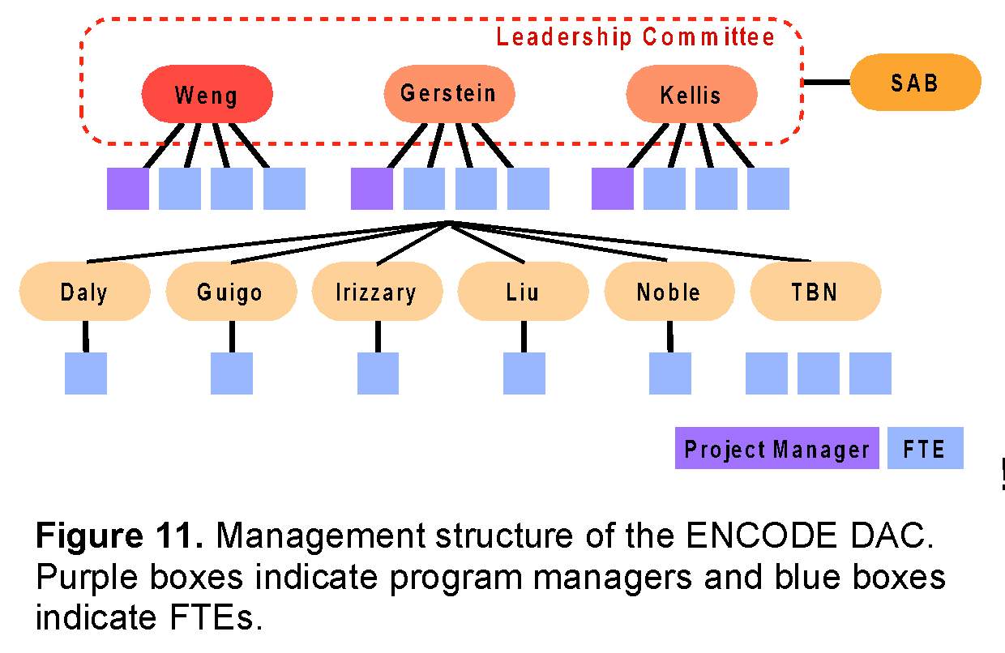
The Weng, Gerstein, and Kellis groups will each be staffed with the equivalent of four full time persons (FTEs in Figure 11, including the program manager for Dr. Weng, mostly postdocs with one or two graduate students), and the remaining groups will each be staffed with one postdoc. Roughly 70% of the FTEs will perform directed analysis, handling both “routine” analysis and more development or pipelining tasks, rapidly changing priorities as set by the leadership committee and directed by the project manager. The remaining 30% of the personnel will develop or adapt methods of interest to the DAC. They will be assigned tasks in a longer time frame, with priorities jointly set by the leadership committee and co-investigators.
The physical proximity of Weng, Gerstein, and Kellis (~2 hours door-to-door) will greatly facilitate the interactions among the DAC members in these three groups. The groups will have monthly physical meetings, rotating among the three universities. The three groups will be in constant communication. This close interaction will be particularly beneficial for completing analyses and formulating integration manuscripts.
All members of the DAC are expected to participate in open discussion forums. These include:
1. Use of a single AWG mailing list for email discussion.
2. A monthly priority-setting phone conference with the AWG.
3. At least two physical meetings per year of the entire group, often coordinated with Consortium-wide programs, but with a day before or after the Consortium meeting dedicated to analysis tasks. In some cases, these analysis meetings will be run in a mini-jamboree mode where intensive collaborative work occurs.
4. All postdocs, students, and the project manager will have Skype-based voice and instant messaging active during their working hours, allowing for quick and spontaneous interactions.
We will adopt the current chairing structure of the AWG calls (where the leaders are appointed by the NHGRI).
Integration of production efforts. We will begin the ENCODE DAC activities with a two-day project launch meeting that involves all of the funded members of the DAC, with representation from the funded DCC. This meeting will provide scientific background for new members of the Consortium, establish shared expectations among the co-investigators and the leadership team, and clarify individual roles within the larger AWG effort.
Thereafter, as in the current phase of ENCODE, the project manager of the DAC will organize a biweekly, minuted conference call. Scientific presentations will be made by each funded lab on a rotating basis. Attendance at this conference call will be mandatory for all funded members of the DAC.
Project documentation will be managed via the ENCODE Wiki, which will include a copy of the chart shown in Figure 11, as well as a list of all funded personnel. The Wiki will include one page dedicated to each participating group. These team-specific pages will serve as the primary reporting mechanism for each subcontract. Each page will be organized chronologically, and will include links to presentations made on the biweekly conference calls, results of interim analyses, in-progress or submitted manuscripts, etc.
Conflict Resolution. Most issues will be resolved by calls and meetings between the three members of the leadership committee. We will have a standing weekly 30-minute call where all issues arising will be brought up, discussed and resolved. Each member of the DAC will be able to contact any of the three members of the leadership committee, with the guarantee that any concerns will be brought up anonymously. Similarly, all members of the AWG will be able to address any concern they have anonymously to any member of the leadership committee. Similarly, the NHGRI will be able to raise its concerns with the leadership committee. Contentious issues about which complete agreement is not immediately reached among the three members of the leadership committee will be decided by majority vote.
Budget reassignments. Budget adjustments will be made yearly based on productivity of each member of the DAC and shifting priorities of the Consortium. This will only happen will full agreement of all three members of the leadership committee, and after notification of NHGRI staff.
Allocation of reserved funds for existing and additional investigators. Second, the five participating groups (Guigo, Irizarry, Kundaje, Liu and Noble) are each staffed with one postdoc, which represents the baseline effort because we do not know yet which production groups are going to be funded in the next round of ENCODE. When we obtain the information of the funded production groups, we will be able to assess the number of data types and amount of data in each type, and provide additional FTEs to the groups with the matching expertise.

Team expertise of the DAC
We have organized the DAC such that Weng, Gerstein, and Kellis are multiple-PIs and Guigo, Irizarry, Kundaje, Liu, and Noble are co-investigators. All eight of us have collaborated effectively, in particular as members of the current ENCODE DAC, and have highly complementary expertise. Each of us will participate in all four aims of the project, in response to the types and volumes of data as well as analysis needs. Nevertheless, due to the complexity of the Consortium, we have devised a management plan to maximize the effectiveness and responsiveness of the DAC.

Weng, Gerstein, and Kellis will jointly make decisions on all matters related to the DAC. They will jointly coordinate the integration of diverse data sources and oversee the running of the pipelines (Aim 1 & 3.2). Weng currently leads the development of the Encyclopedia and will continues to lead this effort (Aim 2). Gerstein has made important contributions to all aspects of the current DAC and he will oversee the DAC activities in support of the AWG (Aim 3, excluding 3.2). Kellis has perform extensive analysis on the quality and utility of ENCODE data and will continue to lead this effort (Aim 4).

Guigo has extensive expertise on analyzing RNA transcription data and will participate in all the DAC activities that involve RNA. Irizarry is a bio-statistician highly recognized for his work on identifying and minimizing batch effects. He will participate in the analysis whenever we compare datasets of the same type but generated by different labs. Kundaje has been instrumental for establishing the existing uniform analysis pipelines and quality assessment metrics for TF and histone mark ChIP-seq data, and will continue to update these and related analysis pipelines and data standards. Noble has built a number of algorithms for analyzing chromatin conformation data, and will play a key role in generating the third level catalogs of the Encyclopedia. Liu has built many methods and databases for integrating DNase-seq and ChIP-seq data (both TF and histone marks), and will work on expanding the coverage of the Encyclopedia by incorporating these and other relevant data from the public domain. For example, there are many H3K27ac ChIP-seq datasets in GEO and integrating these with ENCODE data can significantly increase the cell types for which we can make reliable enhancer predictions.

Risk assessment and Leadership
The proposed management structure is designed to achieve multiple aims simultaneously. Accordingly, the leadership committee brings together three co-leaders with complementary strengths and very broad expertise. Furthermore, this joint leadership plan will likely provide greater responsiveness to the many partners involved than would a single, overworked PI trying to lead the whole DAC. Indeed, one of the primary goals of the reporting mechanisms and conflict resolution procedures outlined above is to maintain clarity, efficiency, and agility about the changing priorities of the various Consortium members, including the ENCODE data production labs, the AWG, the DCC, the DAC and the NHGRI. In particular, it will be critical to balance the scientific expertise and interests of the various DAC co-investigators with the needs of the Consortium to ensure that we are achieving our aims.
There are a number of potential risks that a project of this size and complexity could encounter. We have discussed these in the group and feel that all the risks can be mitigated or handled appropriately if they occur.
1. Inefficient collaboration due to geographical separation. This problem is unlikely to occur, mainly because five of the eight groups are located within 100 miles and all eight groups (including the three distal groups Kundaje, Noble and Guigo) already work together well as part of the current ENCODE DAC. In addition, monthly phone calls (rising in tempo during publication drives) coupled with pervasive VoIP/instant messaging will provide a strong sense of virtual community. If one group is not responsive or integrating with others, we will discuss the issue at the PI level first, followed by personnel visits to encourage networking and integration. If the problem persists, the leadership committee will discuss it with the PIs involved together with the NHGRI program director. In the extremely unlikely scenario that there is a truly intransigent group, which is hard to imagine given the DAC membership, we would consider withdrawing funds from this group upon the NHGRI consent.
2. DAC groupthink excluding input from other groups. This problem is unlikely to occur because of our track record in working openly with all groups and the genuine collaborative nature we take to solving problems. The presence of the AWG to provide independent input and prioritization is a formal mechanism to ensure the DAC groups do not become a closed club. We are also happy to work with the NHGRI program directors to implement other approaches if desired. Equally important will be informal aspects of our openness to collaboration. All DAC discussions will be open to all members of the Consortium.
3. Too many tasks from the AWG or switching of priorities too rapidly. We believe there is an appreciable risk that there will be a far larger task list than the DAC can accommodate, requiring tough prioritization decisions. The transparency of our process is critical here, as the AWG will need to set sensible priorities with some month-to-month consistency. It will be critical to build a high level of trust between the AWG and the DAC early in the project, before complex prioritization becomes an issue. Again, given all eight of the groups are existing members of the ENCODE Consortium, there is already considerable trust between these groups and the AWG.
4. Too few tasks from the AWG. This is a potential issue at the start of the project, but there is a healthy list of pipelining tasks that will provide infrastructure later. ENCODE datasets are accumulating rapidly, so there are a lot of data to provide input into sensible biological questions early on.

Old Section 3:
,,,,,keeppar The wealth of data from the ENCODE Project will lead to biological insights only if well-defined analyses are performed with appropriate computational methods in a reasoned priority. The large number of possible analyses could lead to confusion or even stagnation if not prioritized wisely. Thus, the design of the DAC has placed a strong emphasis on posing questions that are potentially the most informative and prioritizing the work flow. The AWG is responsible for selecting the questions to be addressed and solved. This will be done in consultation with the DAC, which will provide feedback on feasibility, resource requirements, time-lines, etc. The DCC and data producers also play important roles in selecting the questions. The AWG includes other members, such as the production PIs, bioinformatics members of the production groups, members of the U01 groups interested in participating in integrative analysis, and other informatics groups loosely associated with the Consortium. The DAC will work on analyses formulated by the AWG, coordinating closely with the DCC and data producers, and to some extent with the computational groups funded by the U01s. The types and details of the analyses will be determined during the course of the project, and we provide example analyses throughout this proposal.
,,,nokeep The interactions among AWG, DAC, DCC, production groups, and interested U01-funded analysis groups are best explained in the context of the entire work-flow for DAC, from experimental data through to analysis results. Much of the initial specific analysis of each dataset will occur by the appropriate production group, e.g., peak finding in ChIP-seq data and transcript identification in RNA-seq data. The DAC aims to establish specific contacts with the bioinformaticians in each production group and the DCC, in order to keep up-to-date with the nuances of the specific data types which can benefit integrative analysis. Furthermore, the DAC can assist the primary analysis in several ways: controlling data quality, maintaining data format consistency, and providing analysis pipelines.
,,,,,keeppar Moving beyond the primary data processing, the main source of work will be biological questions or analysis directions posed by the AWG. The DAC leadership committee (Profs. Weng, Kellis, and Gerstein) will assign them to a group for investigation and determination of whether there are existing methods that have both appropriate statistics and are scalable to genome-wide techniques. When an existing method is appropriate, the analysis will be run. Depending on the type of the analysis, the results will be reported either as data integrated into the genome browser and/or a new pipelined approach provided for regular use by all users, in particular other members of the ENCODE Consortium.
For some questions, new statistical methods are required as some existing methods do not scale for genome-wide datasets. We may be able to draw upon the strengths of some U01 groups. An example is Prof. Peter Bickel or Prof. David Gifford. In these cases we will invite these U01 groups to perform or participate in the analysis. For other questions, we will create a small group of DAC members to focus on the problem, in many cases starting with developing new statistical methods, followed by algorithmic/engineering analysis for genome-wide scalability. The statistical methods are likely to be novel applications of the broad collection of statistical and machine-learning tool kits, but the precise outline of what models to build and test requires a complex interaction between statisticians, bioinformaticians, and biologists. Once a new method has been successfully created and scales well, this method can then be appropriately pipelined. Some problems will require us to recruit expertise outside the Consortium. We have established a procedure to invite outside investigators to join the AWG and fund some of their efforts through the DAC (see the PI Leadership Plan).
We expect to quickly have more tasks than resources, in particular because we expect to have a steady flow of tasks to change existing ad hoc analysis schemes into methods that can either be pipelined or provided as end-user tools. As the number of questions posed by the AWG mounts, they will need prioritization. We will schedule our work in a completely transparent manner, with any priority disputes being resolved, and with the AWG having the final say on priorities. Figure XXX outlines the management of the prioritized list of tasks being performed by the DAC.
,,,,,keeppar As in the current phase of ENCODE, we will organize a weekly conference call for the entire AWG. The call at the beginning of each month will be open to any member of the Consortium and used to report progress from the previous month and discuss the prioritization of the active tasks. DAC members will provide estimates on the relative “cost” of each task, and the optimal groups to handle each task. New tasks are generated by the AWG and by DAC members suggesting new pipelining or engineering approaches to make existing ad hoc methods more robust. Although the DAC members can suggest tasks and obviously must be involved in the assessment of matching tasks to groups, we will strictly enforce the prioritization by the AWG to ensure that the DAC does the analysis the Consortium needs.
The DAC will ensure openness by inclusiveness in its working practices and a formal prioritization process from the AWG. To ensure inclusiveness, the DAC will conduct all meetings in formats that allow any ENCODE Consortium member to join and participate as equal members in the analysis. The progress of analysis will be posted on the ENCODE Wiki, again allowing complete access by other Consortium members. The progress of DAC analysis tasks will be reviewed and future priorities set in an open forum with the AWG and related ENCODE Consortium members, under the working principle that the AWG is the final arbiter of any priority dispute. DAC members will be available, given practicalities, for any AWG-proposed meeting. AWG phone calls will be chaired by the three members of the DAC leadership committee, with the three members changing their roles between incoming, outgoing, and incumbent chairs in a weekly rotation. This structure is modelled on the existing ENCODE PI calls and has proven to work effectively.
The members and leadership of the proposed DAC recognize that the proposed work flow and management is quite different than the usual mode of working on investigator-initiated projects. The DAC will be responsive to a wide range of inputs, with problems defined and prioritized by the AWG, close coordination with the DCC, and inclusion of other members of the ENCODE Consortium and others with needed expertise. We will organize annual data analysis workshops to bring together researchers from both inside and outside of the Consortium including the data producers, experts in data analysis, and experts in the biology of different classes of functional elements for face-to-face interactions to promote better data analysis. We expect that these interactions will be collegial and that the expertise and experience of the DAC members will be weighed favorably as the AWG establishes priorities. Indeed, this community-based approach to problem solving will be exciting and lead to insights that may not be obtained in studies by single investigators. Below we summarize the intended interactions between the DAC and various entities in and beyond the ENCODE Consortium:
AWG: DAC members are active participants of the AWG, and the goal of the DAC is to perform and facilitate the analyses defined by the AWG. The DAC will assist the AWG in defining and prioritizing the tasks, performing the tasks in the most efficient and thorough manner, reporting analysis progress, and disseminating analysis results.
Production groups and U01 groups: A challenge in the AWG will be to coordinate between the diversity of groups participating in analysis, and to ensure not only that each planned analysis is successfully completed, but also that there is minimal replication of effort between different groups. Achieving these goals will require constant communication between the different members of the AWG. DAC members will work closely with each production group and the U01 analysis groups to coordinate analysis goals, plan deliverables, establish milestones, and ensure that different groups build on each other’s results. In particular, we will work with the PIs of the production groups who are ideally situated for understanding the subtleties of their datasets to establish optimal protocols, sequencing depth, and number of biological and technical replicates, and agree upon uniform processing pipelines based on the statistical expertise of the DAC and the AWG and the particularities of each data type. We will also work with the PIs of the production groups to establish goals for integrative analysis, and the specific integration plan for each type of data, interpret the analysis results, and adjust analysis goals based on their biological interpretation.
DCC: The DAC and DCC components of the EDCAC will work together on several issues, with five examples listed here. (1) Perform uniform primary processing of datasets and establish a single processing pipeline to be run by the DCC component on all datasets; (2) Establish uniform naming schemes for all datasets, a transparent directory structure, and ways to access the datasets; (3) Determine data processing priorities for data freezes and data quality standards for accepting and posting individual datasets; (4) Build a common computing platform for running common tools on all datasets; and (5) Disseminate the analysis results of the DAC.
NHGRI: On a regular basis, the DAC will update the ENCODE Consortium and the NHGRI on the progress towards completion of the comprehensive catalog of functional elements. We will also provide quarterly reports that will allow assessment of progress towards achieving DAC goals.
Additional informatics groups outside the Consortium: We will identify areas of expertise not represented in the AWG, and will invite outside investigators to join AWG analyses when necessary. We have specifically budgeted funding for the DAC to support some of these efforts. Candidates will be discussed among the DAC investigators and the AWG head, with the final decision made by the DAC leadership committee in consultation with the NHGRI.

[[cut this b/c it's in 1.7]] Other large consortia and outside production groups with complementary datasets: In addition to the ENCODE project, several large consortia are involved in systematic data generation activities involving the human genome, resulting in a wealth of functional information that would be of great value to ENCODE integrative analyses. We will work with the scientific leadership and analysis groups of each consortium to ensure that our analysis plans are synergistic, and to ensure mutual understanding of data use policies, embargo dates, and coordination in our published analyses. In addition to consortia, we will work with individual labs that systematically generate large-scale datasets of significant value to the ENCODE Project, based on the priorities set forth by the AWG, the ENCODE PIs and co-PIs, and the NHGRI.
3.2 Provide shared computational guidelines and infrastructure for data processing, common analysis tasks, and data exchange
To successfully accomplish the integrative analyses required in a consortium as diverse and complex as ENCODE, great care must be taken to ensure that in addition to uniform data production standards, uniform data processing standards are established and followed during each step of the analysis, in consultation with the AWG.
We have worked closely with the AWG and DCC to ensure that common analysis tasks are standardized. Such tasks include processing of RNA-seq datasets (short-read sequencing of mRNA), peak calling in ChIP-seq datasets (chromatin immunoprecipitation followed by deep sequencing), DNAme, and the identification of sequence motifs and transcription factor (TF) binding sites from TF ChIP-seq data. We will develop and evaluate different analysis methods for such frequently performed tasks, provide sound statistics for selecting among them, and work with the AWG to ensure uniformity in subsequent processing of each data type using the selected methods. The vast majority of ENCODE data is based on deep sequencing, a technology that only became widely practiced in the past few years. This presents potential biases and errors not yet completely understood, and thus we discuss plans for assessing the quality of ENCODE data. Lastly, we will work closely with the DCC to facilitate data import, access, and uniformity between ENCODE and the larger community. We will ensure that relevant public datasets are available in a common repository and in uniform formats to ENCODE members. We will also ensure that all analysis results by ENCODE members are shared with the larger community, in accordance with the software guideline.
Below, we describe two examples: RNA-seq data for transcript annotation, and ChIP-seq data for TF binding and chromatin marks.

References for DNA methyaltion section

1. Hansen, K.D., Langmead, B. & Irizarry, R.A. BSmooth: from whole genome bisulfite sequencing reads to differentially methylated regions. Genome biology 13, R83 (2012).
2. Wu, H. et al. Detection of differentially methylated regions from whole-genome bisulfite sequencing data without replicates. Nucleic acids research 43, e141 (2015).
3. Sun, D. et al. MOABS: model based analysis of bisulfite sequencing data. Genome biology 15, R38 (2014).
4. Lee, W. & Morris, J.S. Identification of Differentially Methylated Loci Using Wavelet-Based Functional Mixed Models. Bioinformatics (2015).
5. Dolzhenko, E. & Smith, A.D. Using beta-binomial regression for high-precision differential methylation analysis in multifactor whole genome bisulfite sequencing experiments. BMC Bioinformatics 15, 215 (2014).
6. Hebestreit, K., Dugas, M. & Klein, H.U. Detection of significantly differentially methylated regions in targeted bisulfite sequencing data. Bioinformatics 29, 1647-1653 (2013).
7. Saito, Y., Tsuji, J. & Mituyama, T. Bisulfighter: accurate detection of methylated cytosines and differentially methylated regions. Nucleic acids research 42, e45 (2014).
8. Akalin, A. et al. methylKit: a comprehensive R package for the analysis of genome-wide DNA methylation profiles. Genome biology 13, R87 (2012).
9. Park, Y., Figueroa, M.E., Rozek, L.S. & Sartor, M.A. MethylSig: a whole genome DNA methylation analysis pipeline. Bioinformatics 30, 2414-2422 (2014).
10. Marx, V. Genetics: profiling DNA methylation and beyond. Nature methods 13, 119-122 (2016).
11. Ziller, M.J., Hansen, K.D., Meissner, A. & Aryee, M.J. Coverage recommendations for methylation analysis by whole-genome bisulfite sequencing. Nature methods 12, 230-232, 231 p following 232 (2015).

We will keep close communication with the DCC to ensure timely and consistent processing of raw data through a uniform pipeline. The output of the pipeline will be cleansed and normalized, ready for downstream analyses. We will assemble a subgroup of DAC analysts responsible for various aspects of uniform data processing and the data transform that is necessary prior to the uniform data processing. In particular, the subgroup will include analysts who have been part of the uniform data processing during the current DAC and will be part of the next DAC. During the EDCAC kickoff meeting, these DAC analysts will meet with the appropriate DCC members to evaluate the status of uniform data processing pipelines. During the first three months of the project, all existing pipelines will be established and applied to all available datasets. This subgroup will be the point of contact with DCC on this issue. Whenever an analysis method has matured to the stage of a pipeline, it will be turned over to this subgroup to implement and apply to all existing data.

,,,,keeppar We will work closely with the AWG and DCC to ensure that all analysis results, similar to primary data, are available in uniform formats from all groups, and additionally that all metadata are stored, including versions of programs used to generate the data, which pipeline version was used, and that all tools and data processing methods remain available for the duration of the project. For each type of functional element, we will establish a unique and standardized representation, including for enhancers, promoters, transcripts, alternative splice forms, transcription start/end sites, genome segmentation etc. We will also make sure that all analyses done in parallel in human, mouse, fly, and worm use the same formats, parameters, and pipelines whenever possible, and that these are clearly documented to facilitate cross-species comparisons. To achieve this, we will establish a single coordinator within the DAC for each type of analysis who will be responsible for ensuring reproducibility and consistency within the Consortium.
All data exchange will also be stored at the DCC servers, and all results of validated analyses will be made public upon validation, following the ENCODE common Data Release Policy. Care will be taken to anticipate the versioning of ENCODE data generated for all three organisms between different genome builds. As the project progresses the data products generated earlier in the project will get updated to the most recent genome builds for each organism in a controlled fashion. This will either be done via simple liftOver or via uniform reprocessing. We also anticipate data freezes (approximately every six months) where the collective set of all primary processed data products generated up until that stage by the entire Consortium are frozen for more detailed integrative downstream analyses.
We will also store at the DCC all public datasets which have been reformatted for ENCODE use by members of the DAC or AWG to minimize duplication of efforts, and ensure consistency between different groups. The DCC will also serve as our intermediate repository for all datasets coming from the epigenome project, the 1000 Genomes Project, TCGA, GTEx, Brainspan, GEO, SRA, FlyBase, and WormBase. These clear guidelines and standards may appear cumbersome at first, but they will be invaluable in preparing the datasets for integration, and preparing the integrative analysis for publication. Lastly, all data shared with the larger community will be shared through the DCC servers and browsers, and through FlyBase, WormBase, and general genome browsers (such as NCBI, ENSEMBL, and NCBI) whenever possible.

,,,,,keeppar One of the main roles of the DAC is to facilitate the analysis and writing of integrative Consortium papers, specifically the paper that describes the Encyclopedia of human and mouse. In addition, the DAC will assist with other Consortium reports such as data and analysis standards documents. The leadership of these papers and documents naturally springs from the leadership of the AWG and involves the interplay of many different scientists, and the DAC is at the service of this leadership by The DAC will performing various integrative analyses and providing a technological infrastructure.

,,,,,,keep In writing these papers the data from multiple techniques and approaches must be combined in a standardized fashion in order to maximize their utility. The readers of the papers should also be able to see how large-scale genomic datasets have biological and medical utility. Thus, it is essential for the papers to provide a clear linkage between the prose describing the results and the actual data and analyses done. Moreover, clearly connecting the genomics data in a particular freeze to the literature has many scholarly advantages in terms of time stamping, attribution, and future citation^{117,118}.
Aims 1-3 discussed the necessary calculations to enable these integrative analysis papers, and ,,,,,keeppar,keep here we focus on the infrastructure that the DAC will provide to enable these papers to be written. There are two aspects of this infrastructure: social and technological. In terms of social infrastructure, the DAC will organize and moderate phone calls as well as setting up and moderating meetings targeting particular analysis papers. For the conference calls and meetings we will handle creation of precise agendas and the recording of detailed minutes and action items.
,,,,,keeppar There are a number of things to bear in mind regarding setting up a technological infrastructure for enabling collaborative papers. First of all, there is a vast and rapidly evolving industry in developing social media and computational infrastructure for collaboration, including companies such as Google, Facebook, and Twitter. In this regard, the DAC will provide a gateway for the entire Consortium to make use of such computational tools and services. Second, many genomics consortia papers are extremely complex from the perspective of paper writing, often involving many hundreds of authors and tens if not hundreds of main figures and tables as well as supplementary exhibits. Simply keeping track of all figures and supplements is a non-trivial task.
The DAC will facilitate the use of appropriate technology to help with this. Currently most of the genomics papers written by the ENCODE Consortium make use of mailing lists and conference calls for many of these interactions. To handle manuscript preparation addition they make use of resources such as Wikis, Google Docs, and reference managers such as Endnote, Bookends, and Papers. We will continue to use these types of infrastructures, and the DAC will provide expertise and resources in these areas for future Consortium publications. However we will also be aware of newly evolving tools that are currently being developed, including improved solutions for tracking references and figures (e.g., Mendeley and BibTeX). Also, online file sharing services such as Dropbox and SugarSync can be utilized for distribution of files and figures; we also intend to investigate the use of fully-fledged open-source content management systems such as Drupal or Joomla. It is important to keep in mind that while a lot of these technologies might be appealing from a purely computational perspective, they might not be of as much use practically when employed by the various members of the Consortium, and thus we will have to keep track of their usefulness in terms of actual paper writing.
The writing of Consortium standards documents that focus on protocols and methodologies for data analyses and experimental procedures will proceed in a similar way as the writing of integrative Consortium papers. One difference, however, is that the role of the DAC for creating standards documents is sometimes to produce standardized datasets and standardized analyses that illustrate standard practices and provide a better third-party working-knowledge of the standard beyond that from individual production laboratories.
,,,,,keeppar A third aspect of the DAC in writing large Consortium papers and standards documents is carefully connecting the underlying data to the prose. One can conceptualize a big genomics "roll out" (publishing a number of genomics papers commenting on a single underlying data freeze) as a hierarchical information structure, designed to present the Consortium's genomic data and results in an organized fashion. The "main" integrative paper sits at the top, synthesizing everything broadly, which provides pointers to other high-profile companion papers and further, more detailed companions focusing on specific sub-analyses. Each of these individual papers, in turn, often refers to a huge amount of supplementary calculations and datasets. Some of these are in formal paper supplements while others are on project Web sites. Moreover, the datasets most referred to in the papers are usually not the actual raw data but subsidiary analysis products that summarize the data (e.g., peak call lists, transcript structures, and segmentations). At the bottom of the hierarchy is the actual underlying raw data (usually sequencing reads), stored in central repositories (such as the short-read archive). Given that the raw data files and, to some degree the analysis summaries, are usually huge and unwieldy, it makes most sense to approach the information in a particular freeze from the top down, starting with the papers (assuming everything is linked together correctly). In the future one may see some machine readable, “structured” versions of the text of the paper (i.e., the structured digital abstract and structured digital table^{119,120}, which allow authors to make this hierarchy and its linkages even more explicit.
,,,,,keeppar There is an even more detailed micro-structure to the hierarchy: All of the data tables and figures in each paper rely on a considerable chain of small specific analysis results as well as programming scripts. These, in turn, connect to specific versions of the overall analysis summaries put out on the project website. One of the roles of genome analysts is to link these all together and make sure that it is clear which version of a particular analysis result goes with which version of the underlying data and how these in turn link with a specific paper figure. This can often be done through making available the small subsidiary analysis files underlying each exhibit (such as networks connecting particular genomic entities or Excel files or R data frames) in an organized fashion. (See modencode.org/publications/integrative_worm_2010 and modencode.org/publications/integrative_fly_2010 for examples.) Often in the rush to publish a large manuscript these smaller files are neglected but they are essential for truly reproducible research¹²¹. The DAC will strive to make all of these available through the DAC and DCC. It will also push out larger analysis product datasets such as peak calls and segmentations regularly as part of data freezes and we will version these along with the underlying data from the production groups.

[[From old DAC4 grant (was in Aim 1 & moved by MG on 12-Mar)]]

We will create and analyze a meta-network composed of the TF regulatory network and protein-protein interactions integrated with the miRNA data. To integrate the miRNA data, the TargetScan software will be used to obtain the miRNA-TF edges in this network⁹⁸ by assessing complementarity of the miRNA seed region coupled with conservation information. This expanded, integrated network will be analysed using the tools and methodologies described below, allowing us to look for new types of motifs, regulatory patterns, and relationships that would likely remain undetected in individual analyses of the separate networks.
The networks will be analyzed using several methods to calculate key statistics. One such method is 'tYNA'⁹⁹, a web system developed to compare and mine multiple networks in order to identify cliques and motifs, as well as calculating statistics on a network. Statistics such as ‘eccentricity' and ‘betweeness' can help explain the connectivity and behavior of nodes in a network¹⁰⁰. Eccentricity is defined as the maximum shortest path from a node to any other node in the network; this describes how a node interacts with all the other nodes it is connected to, i.e., a node with a small eccentricity is tightly connected to all nodes that it interacts with- including nodes to which it is not directly connected. Betweeness is defined as the number of shortest paths in the network that pass through a given node; this is a measure of a node’s centrality and is related to how involved a node is the communications between all other nodes in a network. These and other statistics can help in the definition and understanding of a particular network.
Connectivity statistics, in particular the difference between out- (O) and in- (I) degree, elucidate the direction of information flow in the network and can reveal hierarchical organization. In previous work, we employed a simple simulated annealing procedure to arrange TFs into discrete levels that maximize the number of edges propagating down from higher to lower levels. To complement these discrete level assignments we defined a continuous parameter h=(O-I)/(O+I), which can be interpreted as the height of a TF within the hierarchical structure. We plan to apply the same procedures to the transcriptional regulatory network in human, mouse, fly, and worm. Of particular interest is a comparison of the distribution of TFs between the different levels to determine, for example, the extent to which middle-level regulator nodes are conserved across different networks. Furthermore, it is important to evaluate the robustness of our results, as there exist several methods of constructing network hierarchies (e.g. breadth-first search) and we intend to assess the impact of various network construction methods on these results.
We have previously exploited the model of hierarchical organization by examining the degree of collaboration among different regulators¹⁰¹⁻¹⁰³. This is essentially the ratio of the number of genes co-regulated by two regulators (from the same or different levels) to the union of their target genes summed over all such pairs of regulators from the two levels^{102,103}. We found that in E. coli, yeast, and human the highest degree of collaboration is between regulators from the middle level, which is analogous to a corporate setting in which middle managers play an important organizational role. We plan to investigate the same arrangement using more comprehensive co-regulatory networks from human, mouse, worm, and fly. In addition to co-regulation we also studied the overlap between modules in terms of their position within the hierarchy. We defined a module as all accessible nodes downstream of a top regulator and investigated the overlap (share of regulators) between modules. We found that the modules in E. coli are more independent compared to those within the call-graph of the Linux kernel¹⁰⁴. We intend to examine the module-overlap in human, mouse, worm and fly, and other eukaryotes compared to our previous observations in E. coli. We speculate that these networks of more complex eukaryotes will be more similar to the Linux call-graph.

Building upon the expertise in dynamic Bayesian network (DBN) in the Noble lab in close collaboration with the Weng lab, we propose to develop computational methods to identify TF binding sites in a generalized way. We will focus in particular on the problem of predicting the results of a ChIP-seq assay for binding of a sequence-specific transcription factor in formulating the problem as follows. Other ENCODE data types (e.g., chromatin accessibility measured by DNase-seq) can be easily incorporated into our computational framework. In a particular cell line or tissue, we are given several generic chromatin architecture datasets—e.g., DNase accessibility plus a variety of informative histone modification ChIP-seq assays—as well as the results of ChIP-seq experiments for a set of “training” TFs. We are then asked to predict what would happen if we were to run a ChIP-seq experiment for a given “test” TF, knowing only its binding affinity sequence motif, as determined from a ChIP-seq assay in another cell line.
This problem is akin to what is known in the field of speech recognition as “speaker adaptation.” In that context, a system trained to produce a textual translation of a spoken utterance must learn to adapt to the peculiar characteristics of a new speaker. Similarly, our model will learn to adapt to the characteristics of a new TF, using methods developed in speech recognition. In particular, the model will predict the locations of in vivo binding events based upon features of the local chromatin architecture, while taking into account that some types of TF binding exhibit different local chromatin properties than others.
We will solve this problem using a combined classifier and DBN. The classifier (a support vector machine or a deep neural network) will learn to predict the binding of a given TF based on the observed local chromatin profile. We will train one such classifier for each TF in the training set. The scores produced by these classifiers will then be combined in the context of a DBN such as the one shown in Figure 6. In this model, MotifScore is an observed variable measuring how well the sequence starting at the current position matches the known motif of the target TF represented by its PSSM. The hidden variables state and Class indicate (respectively) whether a position is inside a binding site of the target TF and the identity of the training TF whose chromatin pattern is the closest match to those of the current position. In addition, the model contains one virtual evidence track for each of the N training TFs. Thus, V^{t}_{i} is a positional virtual evidence variable that tells how well the chromatin pattern associated with the sequence starting at position i matches the patterns learned for the training TF t. Because every virtual evidence track corresponds to exactly one class value, we introduce a binary variable I^{t}_{i}, indicating the corresponding virtual evidence track of each class value. The conditional probability of this indicator variable, Pr[I^{t}_{i} = 1|class_{i} = c], equals 1 only if c = t, and is 0 otherwise. As mentioned above, the virtual evidence, Pr[V^{t}_{i} = 1|I^{t}_{i}], is produced by the TF-specific classifier. Finally, the observed binary variable missing is used as a switching parent of the virtual evidence nodes to handle positions where the chromatin profile contains missing data.
The accuracy of this predictive model can be validated in a prospective fashion within the context of ENCODE, because the Consortium is constantly producing new data. Accordingly, we will make predictions for experiments that are currently in the pipeline, and directly measure the accuracy of our predictions once the data become available. In addition to providing a valuable resource for TFs that have not yet been fully characterized experimentally and shedding light on the relationship between local chromatin architecture and TF binding, this project will enable us to prioritize future experiments. By investigating the dependence of prediction accuracy upon properties of the cell line, available local chromatin data, and properties of the TF itself, we will be able to predict which entries in the 2D experimental matrix can be easily imputed and which entries will likely provide the most value in training future imputation models.

Using protein domains to identify and evaluate orthologs: In addition to phylogenetic approaches, we will use protein domain annotations to help map orthologous proteins and evaluate ortholog assignments by other methods. We will use the Proteome Folding Pipeline¹⁰⁵ to sequentially analyze primary, secondary, and tertiary structures of protein sequences encoded globally in these four genomes. The analysis of potential 3D structures can allow us to recognize very distant homologs, as structural relationships can often be identified well into the “twilight zone” of sequence identity (as low as ~15-25%). Protein domains and structure will also provide testable functional hypotheses at the molecular level for directed experimental studies. We will use these results to help evaluate ortholog assignments, and compare the domain content of orthologous proteins, especially with regard to functional differences between the species.
A unique opportunity with ENCODE comes from the parallel experiments in human and mouse. We will study the relative role of pre- and post-transcriptional regulation in the two organisms, the interplay between orthologous transcription factors and orthologous chromatin marks, and the expression patterns, onset stages, targets, and target expression for orthologous factors and miRNAs. We will also study patterns of alternative splicing and alternative polyadenylation for orthologous genes in corresponding stages, especially with respect to how they affect miRNA targeting and functional protein domains. More generally, we will compare the transcription factor and miRNA inventory of the two species, the relative distributions of target gene counts for orthologous regulators, and similarly the relative distribution and diversity of regulators bound for orthologous gene targets. We will also study whether discovered modules of biologically related genes in Aim 3.5 correspond to orthologous modules across species and for significantly conserved modules we will study the properties of gained and lost components. Using network properties discovered in Aim 4.3 we will compare the two species in terms of determining if similar network motifs are discovered in the regulatory networks of the two species, and the types of feedback loops that are found in mixed TF/miRNA regulatory networks.
Old Aim 1 text on integrating ENCODE with other consortia [[ANS on 03/15/2016]]
- Integrate and harmonize ENCODE with other datasets from all the other consortia - normalize or 4DN may have sophisticated pictures of chromatin that we (simplify) or variant kind of data
- IHEC, Roadmap - done
- GTex - Roderic, Manolis - Normalize data and harmonize eQTLs
- PsychENCODE, BrainSpan - MG/ZW are part of this and we need to normalize the data/consitency in pipelines. Also have eQTLs
- exRNA - Gerstein
- 1000G- MG - germline variants
- TCGA/ICGC/PCAWG - somatic variants + harmonizing RNA-seq
***Integration of ENCODE with Roadmap Epigenomics data and international human epigenome consortium (IHEC)*** [[already done, Manolis]]
The NIH Common Fund Epigenomics Roadmap Project (http://www.roadmapepigenomics.org/) and the International Human Epigenome Consortium (http://www.ihec-epigenomes.org/) have generated rich maps of histone modifications, including high-resolution maps of more than 20 modifications in a small number of cell lines, maps of a few modifications in a large number of cell types, as well as maps of DNA methylation and DNA accessibility. As each of these data types are widely used in the ENCODE Consortium, we will work with the data coordination centers and informatics groups participating in these consortia to integrate relevant datasets into ENCODE pipelines for joint integrative analyses by the ENCODE AWG. For those cases in which we seek to integrate non-ENCODE datasets into our existing pipelines, we will ensure that such data meet the same quality standards as ENCODE datasets. To optimize the compatibility with published papers by each of these consortia, we will use the processed files from the investigators as much as possible. However, when necessary, we will reprocess the primary data according to the ENCODE uniform pipelines to ensure that data quality standards are met.
Members of the DAC have been highly involved in the analysis of the Roadmap Epigenomics consortium datasets, and its continuation, the international human epigenome consortium (IHEC). In particular, we have jointly re-processed all raw datasets from ENCODE and the

***GTEx - Inter-relating ENCODE annotations with large-scale RNAseq & eQTLs [[Roderic, Manolis, normalize, harmonize eQTLs ]]

Other sources of complementary, large-scale human data include the NIH GTEx (Genotype-Tissue Expression) Project (http://genome.gov/gtex), the NIMH Brainspan Project (http://brainspan.org), and the NCI Cancer Genome Atlas (TCGA) Project (http://cancergenome.nih.gov). Over 1,200 data samples from primary tissues have already been collected and analyzed during the initial stages of the GTEx project. We propose combining the large amount of population-specific lymphoblastoid genotype and mRNA expression data in ENCODE with the GTEx samples to improve the identification of expression quantitative trait loci (eQTL). In addition, compilation and comparison of DNA methylation, mRNA/miRNA expression, as well as genotype data from ENCODE, GTEx, and Brainspan, will permit a robust analysis of the expression landscape of the human brain and provide a valuable resource for other investigators given the scarcity of such large-scale, high-quality datasets.
***PsychENCODE/BrainSpan [[Gerstein, Weng, normalize, look consistency in pipelines, connect w eQTLs]]
We will compare parameters like thresholds for calling peaks in ChIP-seq data, look at discrepancies between the two projects and calibrate parameters to reduce biases due to cross-project analyses. In addition to comparing the parameters in the uniform processing pipelines, we will also directly compare the annotated genomic regions or transcripts called by these pipelines. For example, we will identify the brain cell types studied by ENCODE and other consortia, match them with the most appropriate datasets in psychENCODE, and investigate whether the corresponding pipelines in the two consortia have detected a similar set of genomic elements. While performing this comparison, we will take into account the differences in cell sources and the inherent variation among biological replicates, and focus on the regions and transcripts deemed most significant by either or both pipelines. If we identify major differences, we will investigate whether they are due to the underlying raw data, or the differences in the pipelines.
***exRNA [[Gerstein, shorten, different types]]
Moreover, Gerstein lab has considerable expertise in developing standardized pipelines and quality control metrics for RNA-seq and evaluating them in many consortia including the Extracellular RNA Communication Consortium (ERCC). The lab has developed a custom pipeline developed for the analysis of small exRNA-seq data for the Extracellular RNA Communication Consortium (ERCC). The Gerstein Lab is in charge of the DIAC of the exRNA consortium to develop the standardized RNA-seq pipelines for the analysis of exRNAs.
***1000 Genomes & Germline Variants [[Gerstein]]
We aim to integrate different non-coding annotations with the variants identified by the 1000 Genomes Consortium. In this way, the non-coding annotation of each variant will be available to all users of the 1000 Genomes data and should serve as a valuable resource for the genetics community to identify the causal variant in GWAS. It will also provide easy access to downstream analyses for all the users. For instance, it will enable the calculation of selection pressure on variants in different annotation classes. The integration of ENCODE data with 1000 Genomes variants (SNPs, small insertions and deletions, and large structural variants) will be provided in the annotated Variant Call Format (VCF; http://www.1000genomes.org/node/101) These VCF files will contain the annotation of each genomic variant, including presence in non-coding RNA, TF peaks, TF motifs, and pseudogenes. Furthermore, SNPs which exhibit allele-specific behavior will also be identified with a distinct tag in the VCF files.
***TCGA/ICGC/PCAWG - Somatic Variants & Cancer Functional Genomics Data [[Shirley, Gerstein, somatic variants & also harmonizing RNA-seq]]
Finally, the integration of the large volume of ENCODE cancer data (from both primary tissue samples and immortalized cell lines) with over 500 clinical samples in TGCA will enable analyses of somatic mutations, mRNA/miRNA expression, copy number, and DNA methylation on an unprecedented scale.
***4D Nucleome Consortium - [[Noble, More elaborate chromatin annotations]]
Recently, Dr. Noble and and Dr. Jay Shendure, in collaboration with five other UW investigators, were awarded a U54 center grant as part of the NIH 4D Nucleome Consortium. With Bing Ren, Dr. Noble is co-chairing the steering committee for the 4D Nucleome Nuclear Organization and Function Interdisciplinary Consortium. Dr. Noble is thus in an excellent position to ensure coordination between the ENCODE and 4D Nucleome consortia.
We have already developed one computational method that will facilitate integration between ENCODE and 4DN data. Graph-based regularization (GBR) is a principled method for making use of Hi-C data during the semi-automated annotation of the genome 41 (); 64 (). GBR expresses a pairwise prior that encourages certain pairs of genomic loci to receive the same label in a genome annotation. We used GBR to exploit Hi-C data during genome annotation by encouraging positions that are close in 3D to occupy the same type of domain. Using this approach, we produced a model of chromatin domains in eight human cell types, thereby revealing the relationships among known domain types. Through this model, we identified clusters of tightly regulated genes expressed in only a small number of cell types, which we term “specific expression domains.” We also found that domain boundaries marked by promoters and CTCF motifs are consistent between cell types even when domain activity changes. During the next phase of the ENCODE project, we will deploy GBR in Segway, thereby making use of Hi-C data being generated both within ENCODE and by the 4D Nucleome Consortium.
We will also explore the use of Hi-C and other ENCODE data types to assist in 3D structural inference. One particularly valuable, orthogonal type of data that the 4D Nucleome Consortium will be generating is microscopy data. For example, oligopainting data can be used to visualize different types of topologically associated domains 65 (). We will use such data in combination with Hi-C data generated by ENCODE in a hierarchical extension of our existing Pastis 3D structure inference algorithm 13 (). In general, we expect within-domain contact probabilities to exhibit different scaling properties relative to genomic distance 66 (). Accordingly, a series of hyperparameters corresponding to domains of different sizes will adjust the Poisson distribution in the Pastis model, or the Poisson rates might be sampled from a prior distribution derived from the microscopy data. Additional constraints will come from ENCODE CTCF and PolII ChIP-seq data, which empirical evidence based on Hi-C suggests tend to bind to regions on the outside of the 3D structure 9 ().

2.XXX. Data integration for defining protein-coding and non-coding genes and transcripts.
To characterize coding and non-coding transcripts, we will integrate RNA-seq data, promoter-associated chromatin marks, transcription elongation-associated chromatin marks, and comparative genomics of related species.
Transcriptional evidence: Several types of data generated by ENCODE provide transcriptional evidence⁵⁶: RNA-seq can be used to derive the structure and level of transcripts, CAGE determines the precise positions of the 5’ ends of transcripts, and RNA-PET (also called diTAGs) provides connectivity for the 5’ and 3’ ends of transcripts. Moreover, ENCODE has generated transcript data with high-density (5 bp) tiling DNA microarrays for some cell lines.
Chromatin evidence: We have found that distinct combinations of chromatin marks and chromatin accessibility are associated with promoter regions, transcribed regions, and transcription termination regions. Surprisingly, internal exon-intron boundaries are also associated with distinct chromatin marks and nucleosome positioning biases⁵⁷, suggesting that these can be used as an additional line of evidence in defining transcript boundaries, especially with respect to low-expression genes for which the transcriptional evidence may be weaker. We have recently used such marks to discover more than a thousand novel long intergenic non-coding RNAs (lincRNAs) in mouse⁵⁸ and more recently in human²⁴.
Comparative evidence: The Kellis lab identified evolutionary signatures that are uniquely associated with each class of functional elements⁵⁹, with protein-coding genes showing distinct patterns of codon substitution frequencies and reading-frame conservation, non-coding RNAs showing compensatory changes and silent GU-involving substitutions, miRNAs showing a distinct conservation profile (high conservation in the star and mature arm and lower conservation in loop and flanking regions), and other structural conservation properties. We used these signatures to reveal at least 30 non-coding genes in the fly genome using modENCODE transcript data and comparative genomics of 12 Drosophila species⁶⁰. We will apply a similar approach to human and mouse ENCODE data.
Combinations of features: We will combine these transcriptional, chromatin, and comparative features to distinguish different classes of genes in a machine learning framework. We will use Support Vector Machines to classify each transcript into coding or non-coding. We will also apply a previously developed Conditional Random Field (CRF) framework to predict coding and non-coding exons and transcripts from the combined evidence. CRFs are graphical probabilistic models similar to Hidden Markov Models (HMMs) but they allow much richer feature sets due to their discriminative training nature. Lastly, we will associate non-coding RNAs with precursors of miRNAs, piRNAs, and other classes of small RNAs using short-RNA sequencing results.
Identification of non-coding RNA genes: We will utilize an integrative machine learning approach for identifying novel non-coding RNA (ncRNA) genes¹⁷. The method is based on support vector classification to classify non-coding RNAs from other elements like coding sequences and UTRs. For each non-coding RNA, a set of features are computed which are then used for training. These features comprise the quantities that are chosen to maximize the discriminatory power of the machine-learning algorithm. For example, high short RNA-seq expression levels, high secondary structure stability and conservation, medium nucleotide conservation, and low amino acid conservation are the expected characteristics for the non-coding RNAs. The machine learning algorithm enables combining these features for prediction of the new ncRNAs in a formal manner. The known non-coding RNAs are utilized as the training set for the method. We will then apply the method on the remaining unannotated parts of the genome to discover novel non-coding RNA genes.
2.XXX Correlating gene expression with TF binding and histone modifications: Transcriptome monitoring by RNA-seq can provide accurate genome-wide estimates of the steady-state abundance of transcripts. Such estimates are essential to fully understand the pathways involved in RNA biogenesis. A number of genetic and epigenetic factors cooperate to determine the abundance of a specific RNA species in a particular cellular compartment: 1. signals in genomic DNA and in intermediate RNA molecules, e.g., TF binding sites, splicing regulatory sites, and polyadenylation signals; 2. the structure and status of chromatin; and 3. the abundance and concentration of the regulatory molecules—including both proteins and RNAs themselves. The relative contribution of each of these factors and their mode of cooperation, are largely unknown. The goal of the ENCODE Project is to simultaneously monitor many of these factors across multiple cell conditions and types.
Given the gene expression data from RNA-seq and the TF binding or histone modification data from ChIP-seq experiments, the Gerstein and Weng labs have investigated their relationship in a quantitative fashion^{5,61}. We have previously constructed TF models and histone modification models in different species from yeast to human^{18,62,63}. Our results indicate that both TF binding and histone modifications are predictive of gene expression levels in a position dependent manner, and either account for at least 50% of gene expression level variation. The histone modification model accurately predicts gene expression in a wide chromatin region from the promoter to the transcribed regions, whereas the TF model achieves high accuracy only in a narrow chromatin region around transcription start sites (TSSs) of genes (Figure 4). Our study also indicates that TF and histone modifications are highly coordinated during transcriptional regulation and a combination of TF and histone modification signals does not further improve prediction accuracy relative to using each alone.
Based on the CpG content, promoters of genes can be divided into high CpG (HCP) and low CpG (LCP). Interestingly, we find that expression levels of HCPs are easier to predict than those of LCPs⁵. More detailed analysis indicates that the relative importance of TFs and histone modifications in the models are different between the two promoter categories. These results suggest different regulatory mechanisms between HCPs and LCPs. The prediction accuracy of TF and histone modification models to some extent reflects the quality of the expression data. For example, the models achieve significantly higher accuracy for expression measured by RNA-seq than by microarray. In addition, the models can also be used to predict the expression levels of non-coding RNAs (miRNAs) with fairly high accuracy. In the future, we suggest using the TF and histone modification models as a benchmark to understand transcription regulation.
Predicting alternative splicing using chromatin modifications and TF binding. We propose to investigate how inclusion levels of alternative exons covariate with histone modifications and TF binding, which will help us understand how these factors cooperate to modulate the specific abundance of RNA splice variants in the cell. Sophisticated probabilistic models have been recently developed to successfully predict tissue specific exonic inclusion⁶⁴. However, the splicing code delineated in such a way includes hundreds of variables, many of which are concomitant but unlikely to be mechanistically involved in splicing. Within the current phase of ENCODE the Guigo lab has used statistical models to explore the relationship between levels of histone modifications and inclusion of exons. We found that, even when controlled for gene expression, some histone marks (e.g., H3K9ac and H3K36me3) are consistently significant (albeit weak) predictors of exon inclusion, and we built a predictive model of exon inclusion by combining the signals of these marks^{25,28} (Figure 5). By computing a measure of splicing completion on RNA-seq datasets obtained in different sub-cellular compartments, we found strong evidence that splicing in the human genome occurs predominantly during transcription²⁹, providing a molecular justification to the increasing evidence connecting chromatin with splicing⁶⁵. We propose to further develop and apply statistical methods to the data obtained through the ENCODE Project, as well as to other publicly available data, to identify novel genetic and epigenetic factors involved in RNA processing, splicing in particular. We propose to:
1. Identify and characterize histone modifications that play a role in the regulation of alternative splicing, using correlation and modeling analysis.
2. Apply methods used to investigate the distribution of TF binding sites in promoter regions to investigate their distribution in exons and exon-intron boundaries. We will further correlate exon skipping events, as measured by RNA-seq, with differential binding of TFs.
3. Identify novel regulators of splicing by searching for co-variation between the levels of exon inclusion (or alternative splicing events in general) and gene expression. This approach will uncover protein coding genes not yet known to play a role in splicing regulation, and more interestingly, lncRNAs that may act as splicing regulators. The RNA expression levels of protein coding genes are only a proxy for protein expression—the latter is the effector of the biological function. In contrast, expression levels of lncRNAs are almost the actual physiological levels. Inferences based on co-variation between exon inclusion and abundances of lncRNAs are therefore more likely to be biologically meaningful.
4. We will investigate the relationship between RNA expression levels, protein expression levels, and protein binding activity—both to DNA and RNA—for transcription and splicing regulators, and determine how they relate to cellular abundance of the regulated RNAs.

2.XXX Associate TF/miRNA with their targets:
Given a high-quality annotation of enhancers, promoters, insulators, protein-coding genes (including all transcription factors, TFs), microRNAs, and other non-coding RNAs, we will work to piece together regulatory networks based on condition-specific TF binding, conserved TF motif instances in active promoter and enhancer regions, and conserved miRNA motif instances in 3’UTRs. We previously showed that comparative genomics of the 12 Drosophila genomes enables the high-accuracy definition of regulator targets, and that combining comparative genomics with condition-specific TF binding led to a further increase in signal⁶⁷.
Binding vs. regulation: We will use condition-specific changes in gene expression levels of TFs, miRNAs, and their targets to distinguish ‘biochemical’ binding from ‘biological’ transcriptional regulation. We previously showed that bound motifs associated with expression changes are under stronger selective pressure across related species, and show stronger functional enrichments⁶⁷. This suggests that we can use positive or negative expression changes to further annotate our inferred transcriptional networks with activation, repression, or simply binding edges, when no effect is detectable. We have further characterized the chromatin and sequence context of each of these three classes of edges, to search for predictive features of each class that could lead to new insights on the logic of gene regulation⁶⁸.

2.XXX miRNA regulation: A complete view of mixed TF/miRNA pre- and post-transcriptional networks requires accurate promoter and enhancer annotation for miRNA precursors, and accurate tissue- and stage-specific 3’UTRs for all miRNA target genes. Kellis led the fly modENCODE integrative paper and generated TF/miRNA regulatory networks⁶⁰ (Figure 7) and we will perform similar analysis on human and mouse ENCODE data. We will use chromatin marks to annotate miRNA promoters based on genomic proximity and tissue-correlated activity. We will use the longest 3’UTR from updated gene models combined with multi-species sequence alignments based on the most up-to-date genome alignments with all sequenced species to identify evolutionarily conserved 3’UTR target sites. We will search for and re-evaluate previously-discovered 3’UTR motifs that were not associated with miRNAs to determine whether we can now identify putative trans-acting agents that may mediate regulation through these sites. We will also evaluate the potential for other non-coding genes to serve as targets for miRNA regulation. Lastly, we will study the effect of alternative polyadenylation sites on miRNA regulatory networks. We have identified many such sites within protein-coding transcripts resulting in loss of key functional miRNA binding sites, which may play key roles in altering regulatory relationships during development and proliferation. We will look for anti-correlations between miR NAs and their predicted targets, and assess whether transcripts with short vs. long 3’UTR isoforms which exclude or include conserved miRNA binding sites, differ in expression in the presence of cognate miRNAs. This may have major implications for human gene regulation as well, as the Burge and Sharp labs reported that proliferating cells, and by extension cancer cells, preferentially shift towards shorter transcript isoforms that escape miRNA regulation⁷⁰.

