For references, please use: {FirstAuthor, Year #PMID;FirstAuthor, Year #PMID}
Old text from the DAC3 proposal are in grey.

RFA

Writing Assignments:
Mark
- Organize enhancer prediction challenge - 2pg, 1 figure (Aim3, response to AWG)
- Detection of enhancers - 1pg, 1 figure (Aim 2, Encyclopedia)
- Enhancer-gene linkages - 2pg, 1 figure (Aim 2, Encyclopedia, moved the network portion to Aim 1)
- Personal genome - 2pg, 1 figure (need more connection to ENTEx, Aim 1),
- ENCODE and Cancer (Disease) AWG subgroup - 1pg (Aim 3, AWG subgroup)
- Integrating encode w/ other consortia - gtex,ihec, roadmap, 1000G [1pg]: old text (Aim 1.6)
- Consortium Authorship Network Analysis - 1/2 pg, 1 figure (Aim 3 Consortium paper writing)
- Consortium paper writing: update this old text. (Aim 3, consortium paper writing)
- Get support letter from Mike Snyder, Brent Gravery (both DONE)
- Editing help from native English speaker

Zhiping:
- Include RBP pipelines in the next DAC 1/2 pages (Aim 3, pipelines)
- DNAme pipeline and QC (Aim 3, pipelines)
- Encyclopedia (Aim 2)
- Letters from Bing Ren (DONE), Mike Cherry, Rick Myers

Manolis:
- Applying ChromHMM to ENCODE3 data, 1 pages, 1 figure. Any future development on ChromHMM? (Aim 2, part of Encyclopedia)
- Write 1/2 page on co-chairing the AWG GWAS sub-group. This is the most active AWG subgroup. Can you also summarize the main results of this subgroup? (Aim 3, AWG subgroup)
- QC and utility. Aim 4. 4 pages, 2 figures.
- ChromImpute: Aim 1=main (insert into Section 1.1.1). Aim4=application.
- Support letter from Brad Bernstein, John Stam?
- Skip: HaploReg and its future developments. 1 page, 1 figure. GWAS specifically excluded.
- Skip: Please update this old text on increasing the utility of ENCODE data for the GWAS community. (Aim 3, AWG subgroup)

Anshul
- Add a paragraph to describe your expertise (In Innovation section, currently page 12)
- ATAC-seq pipeline 1/2 - 1 page, 1 figure (please insert into Aim 3, pipelines)
- ChIP-seq pipeline (TF and histone mark), 2 pages, 1 figure. Please include summary of existing pipelines and plan for future developments. (Aim 3, pipelines)
- I believe that you co-chair the Regulations AWG sub-group. If so, can you write 1 paragraph about your effort of co-chairing and products of the sub-group. (Aim 3, AWG subgroup)
- 2 pages plus 1-2 figures on the cool stuff we discussed on the phone, how to visualize encyclopedia on-demand, and deep learning to quantize the fine-scale of regulatory sites. (Aim 2, Encyclopedia)

Roderic
- RNA-seq pipeline. 2-3 pages, 1 figure. Please include summary of existing pipelines and plan for future developments. (Aim 3)
- Can you write 2 paragraphs on your contribution to the RNA-calls and working with the RNA group? (Aim 3)
- Do you want to include 1 page, 1 figure on chromatin vs. splicing? (Aim 1)
- Do you want to include 1 page, 1 figure on your splicing method, or other things that your group is working on and plan to work on? (Aim 1)
- Get support letter from Tom Gingeras

Noble (link to pdf)
- Hi-C pipeline, 1 page, 1 figure (Aim 3)
- Applying Segway to ENCODE3 data, 2 pages, 1 figure. Any future development on Segway? (Aim 2, part of Encyclopedia)
- Assay selection, 1 page, 1 figure. Please include future development. (Aim 4)
- Please write 2 paragraphs on your contribution to the 3D nucleome AWG sub group. Please describe the main products of the nucleome group. (Aim 3)
- Can you write 2 paragraphs on how we can integrate ENCODE data with data generated by the 4D nucleome consortium? The goal is to increase the utility of ENCODE data. (Aim 1, integration with other consortia)
- 2 paragraphs on co-chairing 4D nucleome with Bing Ren (Aim 3)

Shirley
- target genes of transcription factors 1 page, 1 figure (Aim 2, Encyclopedia)
- expand the coverage of ENCODE data annotation by taking advantage of public DNase and H3K27ac datasets. For example, we have determined that the combination of DNase and H3K27ac is the best approach for predicting enhancers. However there are many cell types that have only DNase but not H3K27ac, also vice versa. Can we use public data to supplement? Talk about the collection of DNase and H3K27ac data in Cistrome. Need to be able to match meta data. 1 page, 1 figure (Aim 2, Encyclopedia)
- Prediction of silencers? 1/2-1 page, figure? (Aim 2, Encyclopedia)
- CRISPR DOI 10.1186/s13059-015-0843-6, which can help the Characterization centers, 1 page 1 figure (Aim 3)

Rafa
- QC for RNA-seq, DNase, histone makrs, etc..., 1 pg, 1 figure (Aim 3 or Aim 4, pipelines and QC)
- Identification of DMRs, 1 page 1 figure (Aim 2, Encyclopedia)
- Normalization of gene expression matrix, DNase signal matrix, histone mark level matrix etc. across the entire panel of ENCODE cell types. 1-2 pages, 1 figure. (Aim 2 or Aim 4?)
- How do we guard the Consortium against batch effects? 1 page, 1 figure (Aim 1 or Aim 4?)

Support letters (underlined names have old letters):
Mark: Mike Snyder, Brent Gravery
Manolis: Brad Bernstein, John Stam?
Roderic: Tom Gingeras,
Zhiping: Bing Ren, Mike Cherry, Rick Myers
Third DAC Annual Progress Report

SPECIFIC AIMS
This proposal aims to continue the current Data Analysis Center (DAC) for the ENCODE project, towards completing the inventory of functional elements in the human genome using high-throughput experiments and computational methods. The proposed DAC will respond to directions from the ENCODE Analysis Working Group (AWG), and in particular help process, analyze, integrate, and interpret data from all groups in the ENCODE Consortium in an unbiased manner. The analyses we propose will substantially augment the value of the ENCODE data by integration of diverse data types, which are typically not available within a single production group, and require expertise spanning multiple data types.

The proposed DAC members (Zhiping Weng, Mark Gerstein, Manolis Kellis, Roderic Guigo, Rafael Irizarry, Shirley Liu, Anshul Kundaje, and William Noble) have extensive experience working together in the context of ENCODE, and are leaders in their respective fields of computational genomics, bioinformatics, data mining, machine learning, algorithm development, statistical theory, tool development, pipeline building, and application to genomic data, They have a strong track record of delivering collaborative analyses in the context of the ENCODE, Roadmap Epigenomics, GTEx, modENCODE, PsychENCODE, 1000 Genomes, The Cancer Genome Atlas (TCGA) and the 4D Nucleome projects. This group of researchers was responsible for much of the analyses and the majority of the figures and tables in published papers for several of these consortia. These researchers also have strong track records in the broader contexts of genomics and other statistical applications, in some cases beyond the life sciences.

Our proposed activities are directly responsive to the RFA and can be grouped into four aims:
Aim 1. Integrative analyses, really cool stuff. Batch effects.
“Analyzing and integrating data and metadata from a broad range of experimental and computational functional genomics projects.”
The DAC will facilitate and perform data integration of data and metadata generated by the mapping centers and annotation centers and the computational groups of the ENCODE consortium, as well as the data by other consortia and public data, with the goal of accurately annotating different classes of functional elements. In addition to integrating diverse data types in multiple cell types to annotate the locations, activity, and dynamics of functional elements, The DAC will carry out exploratory data analyses across multiple types of functional elements based on the guidelines provided by the AWG, in order to seek novel insights and correlations between classes of functional elements, and to pursue data-driven investigations that complement traditional hypothesis-driven investigations. The DAC will also facilitate and carry out comparative analyses between human and mouse using ENCODE and public data in both organisms, to study deeply conserved biological mechanisms as well as their differences.

Aim 2. Creating high quality Encyclopedias of DNA elements in the human and mouse genomes.
Based on the integrative analyses in Aim 1, the DAC will use stat-of-the-art methodologies to generate catalogs of functional elements in a cell type specific manner, collectively called the Encyclopedia. The Encyclopedia comprises several levels of catalogs, with increasing integration. The ground level of catalogs include genomic regions that are enriched in various biochemical signals such as DNase accessibility, histone modifications, transcription factor (TF) occupancy, DNA methylation, RNA transcription, RNA-binding protein (RBP) occupancy, chromatin-driven topologically associating domains (TAD) etc. Several of these catalogs are produced by by the current Data Coordination Center (DCC), using uniform data analysis pipelines developed by the current DAC in collaboration with other members of the ENCODE consortium. The DAC aims to complete the development of uniform data analysis pipelines for all major ENCODE data types and to continually refine these pipelines when new experimental techniques become available and by incorporating more advanced computational methods (Aim 3). The second level of catalogs in the Encyclopedia include integrative predictions of functional elements including enhancers, promoters, insulators, silencers, TF binding sites, and RBP binding sites. For example, histone modifications, DNA accessibility, RNA transcription, and DNA methylation are all informative of the locations of functional elements such as promoters, enhancers, insulators, and silencers, but sophisticated machine learning approaches are required for integrating these biochemical data to achieve the greatest predictive power. In particular, we plan to develop supervised machine learning algorithms to take advantage of the functional data generated by the Characterization Centers. The third level of catalogs in the Encyclopedia include higher order interactions among the predicted functional elements. For example, which genes does an enhancer target in a specific cell type, or which enhancer–target gene interaction does an insulator block. Existing algorithms for building these high-level catalogs have limited predictive power and we foresee great needs of new algorithm developments which the DAC will pursue in collaboration with the computational groups and the data producing centers in ENCODE. One important aspect of the Encyclopedia is its accessibility and utility to a broad range of biomedical researchers and clinicians. We will develop and implement approaches to present the Encyclopedia in an intuitive and detail-on-demand manner.

Aim 3. Pipelines. Coordination of activities with other consortia. ENTEx. GWAS. Cancer. TCGA.
Serving as an informatics resource by supporting the activities of the ENCODE Analysis Working Group (AWG). Interaction with other Consortia
The DAC will work with the AWG to define and prioritize integrative analyses of ENCODE data. We will administer bi-weekly conference calls with the AWG to receive requests for analysis, report on progress, and explain timetables to help guide the priorities set by the AWG. This will form the backbone of our organization and prioritization. The DAC will provide shared computational guidelines and infrastructure for data processing, common analysis tasks, and data exchange. Specific questions articulated and prioritized by the AWG will be addressed by one or more components of the DAC. This will require coordination with the ENCODE Data Collection Center (DCC) for particular data freezes. Whenever a frequently performed analysis becomes routine, an appropriate group within the DAC will establish it as a robust uniform analysis pipeline that are run by the DCC automatically on subsequently generated datasets. Other analyses will require more extensive interactions, and the DAC will bring together the data producers and analysis experts within and outside the DAC. Specifically, to facilitate integrative discovery of functional elements the DAC will help integrate and assimilate data from large-scale genomic consortia (e.g. Roadmap, 1000 Genomes, TCGA, iHEC). Furthermore, the DAC will perform integrative analyses to ensure that the functional elements identified are useful in interpreting variants—they are correctly sized and built in a LD-aware fashion. Overall, the DAC will work in an entirely open manner, allowing other ENCODE Consortium members to participate on an equal footing to DAC members in any analysis. As novel biological insights emerge from the integrative analysis, the DAC will facilitate writing manuscripts in coordination with the AWG and the ENCODE Consortium.

Aim 4. Assessing quality and utility of the ENCODE data and providing feedback to NHGRI and the Consortium.
The DAC will develop and apply computational methods to assess the quality and utility of ENCODE datasets in a systematic and unbiased way. We will work in four areas. (1) Data-type specific measures of dataset quality: We will work with the DAC and the PIs to standardize metrics of dataset quality. For example, for RNA, we will develop and apply metrics based on sequencing depth, alignment rate, duplicate read rate, compositional biases, ncRNA content, intronic vs. exonic coverage, positional bias, and coverage continuity. For ChIP-seq experiments, we will develop and apply metrics based on antibody validation, replicate consistency, replicate rank consistency, cross-correlation analysis, and fraction of reads in peaks. For DNA ChIP-seq of DNA binding proteins, we will additionally use motif-based metrics including enrichment, positional specificity, and rank-based enrichment. For DNase, we will use peak-based metrics for ChIP-seq, including fraction of reads in peaks, signal portion of tag analysis, shape analysis, replicate correlation analysis. (2) Data-type agnostic measures of dataset quality. In addition to these metrics, we will develop and apply general methods for assessing experiment quality. In particular, we have demonstrated the use of systematic imputation of histone marks, DNA methylation, RNA-seq, and DNase datasets based on their correlation with datasets of the same data type and of different datatypes within the same cell type and within other cell types. We found that the agreement of a dataset with the imputed signal based on this correlation analysis provides a powerful and unbiased metric for evaluating dataset quality, flagging low-quality datasets that are sometimes missed by other quality metrics, including sample or antibody swap problems. We will extend these methods to incorporate additional data types and additional features in the prediction. (3) Progress and completeness. We will develop metrics and methods for evaluating the progress and completeness of the entire ENCODE project, along multiple axes, including: (i) genomic coverage, towards identifying biochemically active nucleotides across all datasets and cell types; (ii) cell type coverage, towards identifying all distinct cellular states; (iii) data type diversity, for each cell type; (iv) activity pattern capture, for each functional element. (4) Metrics of independent dataset utility: In addition to quality control of individual datasets, we will develop and apply unbiased methods for evaluating the per-nucleotide information content of each data type in a given cell type independently of any other data, based on: (i) genome-wide coverage, (ii) resolution, (iii) reproducibility. (5) Prioritization of assays and cell types. In addition the independent metrics of dataset utility, we will evaluate the utility of datasets in the context of all other data across assays and across cell types. Within each cell type, we will evaluate the utility of each data type based on its ability to predict other data types, and the difficulty of predicting it by other data types. Conversely, for each data type we will use the same approach for evaluate the utility of different cell types, based predictive power and predictability. We combine the two approaches to rank each datasets in each cell type, and to prioritize the set of experiments that will be of greatest overall utility. (6) Disease-specific prioritization: In addition to these goal-agnostic measures of dataset utility, we will develop and apply methods for prioritizing datasets based on specific tasks of interest. Specifically in the context of disease, we will provide a ranking of cell types and assays based on their predictive ability for genetic variants (from GWAS) or epigenetic marks (e.g. from MWAS) are associated with specific diseases and traits.

Team expertise of the DAC
We have organized the DAC such that Weng, Gerstein, and Kellis are multiple-PIs and Guigo, Irizarry, Liu, Kundaje, and Noble are co-investigators. All eight of us have collaborated effectively, in particular as members of the current ENCODE DAC, and have highly complementary expertise. Each of us will participate in all four Aims of the project, in response to the types and volumes of data as well as analysis needs. Nevertheless, due to the complexity of the Consortium, we have devised a management plan to maximize the effectiveness and responsiveness of the DAC.

Weng, Gerstein, and Kellis will jointly make decisions on all matters related to the DAC. They will jointly coordinate the integration of diverse data sources (Aim 1). Weng currently leads the development of the Encyclopedia and will continues to lead this effort (Aim 2). Gerstein has made important contributions to all aspects of the current DAC and he will oversee the DAC activities in support of the AWG (Aim 3). Kellis has perform extensive analysis on the quality and utility of ENCODE data and will continue to lead this effort (Aim 4).

Guigo has extensive expertise on analyzing RNA transcription data and will participate in all the DAC activities that involve RNA. Irizarry is a bio-statistician highly recognized for his work on identifying and minimizing batch effects. He will participate in the analysis whenever we compare datasets of the same type but generated by different labs. Kundaje has been instrumental for establishing the existing uniform analysis pipelines and quality assessment metrics for TF and histone mark ChIP-seq data, and will continue to update these and related analysis pipelines and data standards. Noble has built a number of algorithms for analyzing chromatin conformation data, and will play a key role in generating the third level catalogs of the Encyclopedia. Liu has built many methods and databases for integrating DNase-seq and ChIP-seq data (both TF and histone marks), and will work on expanding the coverage of the Encyclopedia by incorporating these and other relevant data from the public domain. For example, there are close to 1000 H3K27ac ChIP-seq datasets in the GEO and integrating these with ENCODE data can significantly increase the cell types for which we can make reliable enhancer predictions.

SIGNIFICANCE
The ENCODE Project is one of a number of ambitious projects building on the foundation of the Human Genome Project. The goal of ENCODE is to apply high-throughput, cost-efficient approaches to generate a comprehensive catalog of functional elements in the human genome, including transcribed regions, chromatin features, transcriptional control regions, and post-transcriptional control regions. The impact of this project is large, broadly affecting biomedical research and personalized medicine, because functional genomic elements are the basis of all biological processes. As a coordinated effort, ENCODE members strategize common biological samples, enforce quality standards, and implement rapid data release policies. The value of ENCODE data is greatly enhanced by efforts to increase the breadth, depth, quality, and utility of the data. Although the individual datasets produced by the ENCODE project are highly effective in the study of any individual region, their true potential is achieved by integrative genome-wide analyses¹⁻³.
We propose an ENCODE Data Analysis Center (EDAC, DAC in short) to support, facilitate, and enhance integrative analyses of the ENCODE Consortium data on human and mouse. We will work closely with Consortium members to identify and prioritize integrative analyses that should be carried out, identify the best groups and methods to accomplish them, coordinate all necessary data transformations, and undertake these analyses with the other Consortium members. Our ultimate goal is to ensure a successful final product of high-quality annotation in human and mouse, and gain new insights into the biology and gene regulation of animal genomes.
We envision that the DAC will minimally perform the following roles, organized into four aims of the proposal in direct response to the RFA: to facilitate and carry out integrative analyses to identify diverse classes of functional elements (promoters, enhancers, silencers, insulators etc.) based on combinations of relevant datasets coming from multiple groups (Aim 1); to carry out exploratory data analyses across different data types to discover potentially novel correlations and insights relating diverse classes of elements, such as links between enhancers and their target genes (Aim 1); to to carry out comparative analyses between human and mouse (Aim 2); to define and prioritize additional integrative analysis activities in support of the Analysis Working Group (AWG) (Aim 3); to create high-quality human and mouse encyclopedias (Aim 2); to provide common computational guidelines and a common infrastructure for data processing in support of the AWG and the Encyclopedia (Aim 3); to summarize results of our integrative analysis in Consortium papers (Aim 3); and to critically assess ENCODE data for their quality and utility and to report these assessments to the NHGRI and the Consortium (Aim 4).
To achieve these four aims, the proposed DAC will work closely with members of the Consortium, and in particular two entities within it, the AWG, consisting of all Principal Investigators (PIs) of the production groups, all informatics PIs and personnel from each of the groups, and other Consortium members involved in the analysis; and the Data Coordination Center (DCC), responsible for all data sharing, data formatting, and data standards within the Consortium, and also for making all primary datasets and secondary datasets resulting from integrative analyses freely available for browsing and download by the larger scientific community.
The four aims and the interactions needed to achieve them are greatly facilitated by the composition of the proposed DAC. The DAC members’ expertise spans human and mouse, and includes element-specific expertise (promoters, enhancers, silencers, protein-coding and non-coding genes, miRNAs, motifs, splicing, 3´-UTRs), as well as genome-wide analyses and dimensionality reduction techniques (PCA, SVM, HMMs, clustering). DAC members are collaborating directly with every production group in ENCODE, and thus will have intrinsic knowledge of each data type and the experimental intricacies involved in its generation. This will make for a uniquely flexible team able to take on any aspect of the integrative analysis, but also a highly integrated team, as all members have longstanding experience of working together in ENCODE and related consortia. In addition, we have established a strong leadership and organizational structure for the DAC, as described in the PI Leadership Plan. Weng will be the head of the DAC, and a three-person committee composed of Weng, Gerstein, and Kellis will jointly make decisions on all important matters. These three labs are located in physical proximity of each other (~2 hours drive), in the same time zone, and thus can collaborate extensively and respond quickly to any analysis needs, which is particularly important during the final pushes of putting together Consortium papers. See support letters from the PIs of several current production groups and the DCC of ENCODE: Drs. Mike Snyder, Rick Myers, Brad Bernstein, Brent Gravery, Tom Gingeras, Bing Ren, and Mike Cherry.

INNOVATION
This project requires a different type of innovation from traditional R01s. The RFA requires that we follow the directions set by the AWG, although we can contribute to setting the directions. Thus, we are fundamentally limited in being innovative in taking direction. Nonetheless, we are highly innovative in putting together a multifaceted team to meet the enormous challenge of facilitating and performing the integrative analysis activities in ENCODE, a large and complex consortium. At present, our team consists of eight highly talented investigators with expertise covering broad biological areas: transcriptional regulation (Weng, Kellis, Gerstein, Guigo, and Liu), epigenetics (Kellis, Weng, Gerstein, Kundaje, and Liu), evolution (Kellis), genomics and proteomics (Noble, Gerstein, Weng, and Guigo), regulatory RNA (Kellis and Weng), and biophysics (Gerstein and Weng). The team also has a variety of expertise in computational biology, e.g., machine learning (Noble, Kellis, and Kundaje), statistical genetics (Liu and Irizarry), networks (Gerstein and Weng), and gene annotation (Roderic and Gerstein).
We are confident that the assembled team can produce innovative science in a consortium framework. This is manifested by the many Consortium publications that the team members have led and participated in. In particular, the team members have been highly innovative in building and applying state-of-the-art methods, with examples described in Aims 1-4, and a long history of producing computational tools that are widely used by the broader community. Importantly, most team members have a rich experience in various consortia: ENCODE (Weng, Gerstein, Kellis, Guigo, and Noble), modENCODE (Gerstein, Kellis, and Liu), the Epigenome Roadmap (Kellis), the 1000 Genomes Project (Gerstein), the Brainspan Project (Gerstein), DOE KBase (Gerstein), and the 29 Mammals Project and the 12 Flies Project (Kellis). In summary, we have assembled a team with the right expertise, that has worked in large collaborative consortia and has delivered in that environment. The details of the team members are provided as follows:
Zhiping Weng (U. Mass. Medical School) Professor Zhiping Weng has an engineering background, and has worked for the last decade on biological problems ranging from genomic to proteomic analysis. She has participated in the ENCODE project since its inception in 2003, leading a technology development project in the pilot phase of ENCODE (2003-2007) and a pilot project during the scale-up phase of ENCODE (2007-2011). She has also participated in the integrative analysis in ENCODE since 2003, co-chaired the transcription regulation analysis group in the pilot phase of ENCODE, and is currently a member of the ENCODE DAC. She led one of the high profile ENCODE companion papers, focused on transcription factor binding site detection⁴, and several other companion papers⁵⁻⁷.
Manolis Kellis (MIT and the Broad Institute) Professor Manolis Kellis is a professor of Computer Science and has a background in machine learning, computer science, and computational biology with 10+ years experience in genomics. He has led or co-led a large number of large-scale genomic studies, including the comparative analysis of 29 mammals, the integrative analysis of ENCODE chromatin datasets, the fly modENCODE integrative analysis, the comparative analysis of 12 Drosophila species, the comparative analysis of eight Candida genomes, and the first comparative studies of four yeast species.
Mark Gerstein (Yale U.) Professor Gerstein has been an integral part of the ENCODE Project since its inception, and within the project he has assumed a number of leadership roles. For instance, he co-directed the Networks/Elements Group, which resulted in his co-leading one of the ENCODE high-profile companions⁸. He was co-chair of the AWG in modENCODE and in this capacity led the worm integrative paper⁹. He also led and participated in a number of sub-analyses resulting in 10 companion papers in pilot ENCODE and modENCODE, particularly those focusing on pseudogenes, ncRNAs, and TF binding sites¹⁰⁻¹⁹. He is a member of a number of other genomics consortia, including the 1000 Genomes Project, Brainspan, and DOE Kbase and in these groups he has worked on connecting the ENCODE annotations with other datasets.
Roderic Guigo (Institut Municipal d'Investigació Mèdica) Professor Guigo has been active in the field of Computational Genomics for more than 20 years. He has developed widely used tools for gene finding and annotation, such as geneid and sgp. His lab has more recently developed tools for analysis of RNA-seq data, such as the GEM read mapper, and the Flux Capacitor for transcript quantification. He has participated in many genome projects, including in the leadership of the mouse genome project. He has been involved in the ENCODE Project since the pilot phase, in which he lead the GENCODE efforts to delineate the gene and transcript reference annotation of the human genome. In the current phase of ENCODE, he leads the Transcriptome Analysis Working group.
Rafael Irizarry (Dana Farber Cancer Institute; Harvard U.) Professor Irizarry has over ten years of experience developing methods for high-throughput genomics data. His dedication to producing tools that are useful to biologist and the wider research community is evidenced by the popularity of the methods he has developed, such as RMA, fRMA, GCRMA, CRLMM, and CHARM. He has made these tools and the computer code freely available. His expertise in dealing with bias, systematic errors, and unwanted variation in biological data will be extremely valuable for improving the quality of ENCODE data via statistical methods.
Anshul Kundaje (Stanford U.) Professor Kundaje XXX
X. Shirley Liu (Dana-Farber Cancer Institute; Harvard T.H.Chan School of Public Health) Professor Liu is a computational biologist with expertise in on algorithm development and integrative modeling of gene regulation. She has been a member of the mod/ENCODE consortia and the director of the Center for Functional Cancer Epigenetics at the Dana-Farber Cancer Institute. Her group developed a number of widely used algorithms for transcription factor (TF) motif finding, ChIP-chip/seq, MNase/DNase-seq, and recently on CRISPR screen data analysis. Through integrating genome-wide transcription factor binding, chromatin dynamics, gene expression profiles, genetic and chemical screens, they work to model the specificity and function of transcription factors, chromatin regulators and lncRNAs in tumor development, progression, drug response and resistance. A key component of big data integration is data normalization and bias correction, and she has also been at the forefront of identifying and correcting biases in next-generation sequencing and epigenomics data.
William Noble (U. Washington) Professor Noble has a background in computer science and has applied a series of computer science techniques to biological problems. He is one of the creators of the widely used cis-regulatory motif finding programs MEME and Meta-MEME, and he has led the use of support vector machines, wavelet analyses and dynamic Bayesian networks in genomic and proteomic analysis. Working in the Department of Genome Sciences at the University of Washington, he interacts with many high-throughput experimental groups and continues to have strong links to the computer science community.
A risk in creating such a combined multi-site DAC is that the multiple investigators and geographical separation potentially prevent the DAC from working as a cohesive team. This risk is discussed and mitigated in the Section titled “Risk Assessment and Leadership” in the PI Leadership Plan. In fact, the geographic distribution of the members of the DAC is ideally suited for a consortium that is itself expected to be geographically distributed, and has been geographically distributed in the previous two phases of the ENCODE Project. Importantly, we have a strong track record of working together over the past twelve years of analysis during the ENCODE Project, modENCODE Project, and other large-scale consortia. Overall, the difficulties of coordination are offset by the benefits of the many different environments and scientists provided by the participating groups.

APPROACH
In Aim 1, we describe the principles that we will follow to define and prioritize analysis tasks that the DAC will perform. Groups in the proposed DAC have performed a large number of ENCODE and genome-wide analyses. We highlight some of the most relevant ones to provides a concrete illustration of what the methodology and tools the DAC groups are capable of providing. During the ENCODE project, the AWG will prioritize the precise application of these tools as described in Aim 1. In Aim 7, we delineate our plans for disseminating the results of our integrative analyses.
Aim 1. Analyzing and integrating data and metadata from a broad range of experimental and computational functional genomics projects.
1.1. Dataset imputation and experimental matrix completion.
The space of all possible ENCODE experiments can be conceptually represented as a large two-dimensional matrix, in which one dimension corresponds to various types experimental assays and the other dimension corresponds to various cell or tissue types. Thus far, ENCODE has taken a two-pronged approach, in which a small set of assays (e.g., mapping histone marks by ChIP-seq and chromatin accessibility by DNase-seq) has been carried out in a large variety of cell types, and a much larger set of assays (e.g., mapping transcription factors or TFs by ChIP-seq and RNA-binding proteins or RBPs by eCLIP-seq) has been performed in a small number of cell types. Some rows and some columns in the experiment matrix are largely filled in; however, it is clearly not feasible to fill in the entire matrix in the near future. Thus it is of particular interest to fill the matrix using computational approaches.
1.1.1 Imputation of chromatin accessibility and histone modifications in new cell types
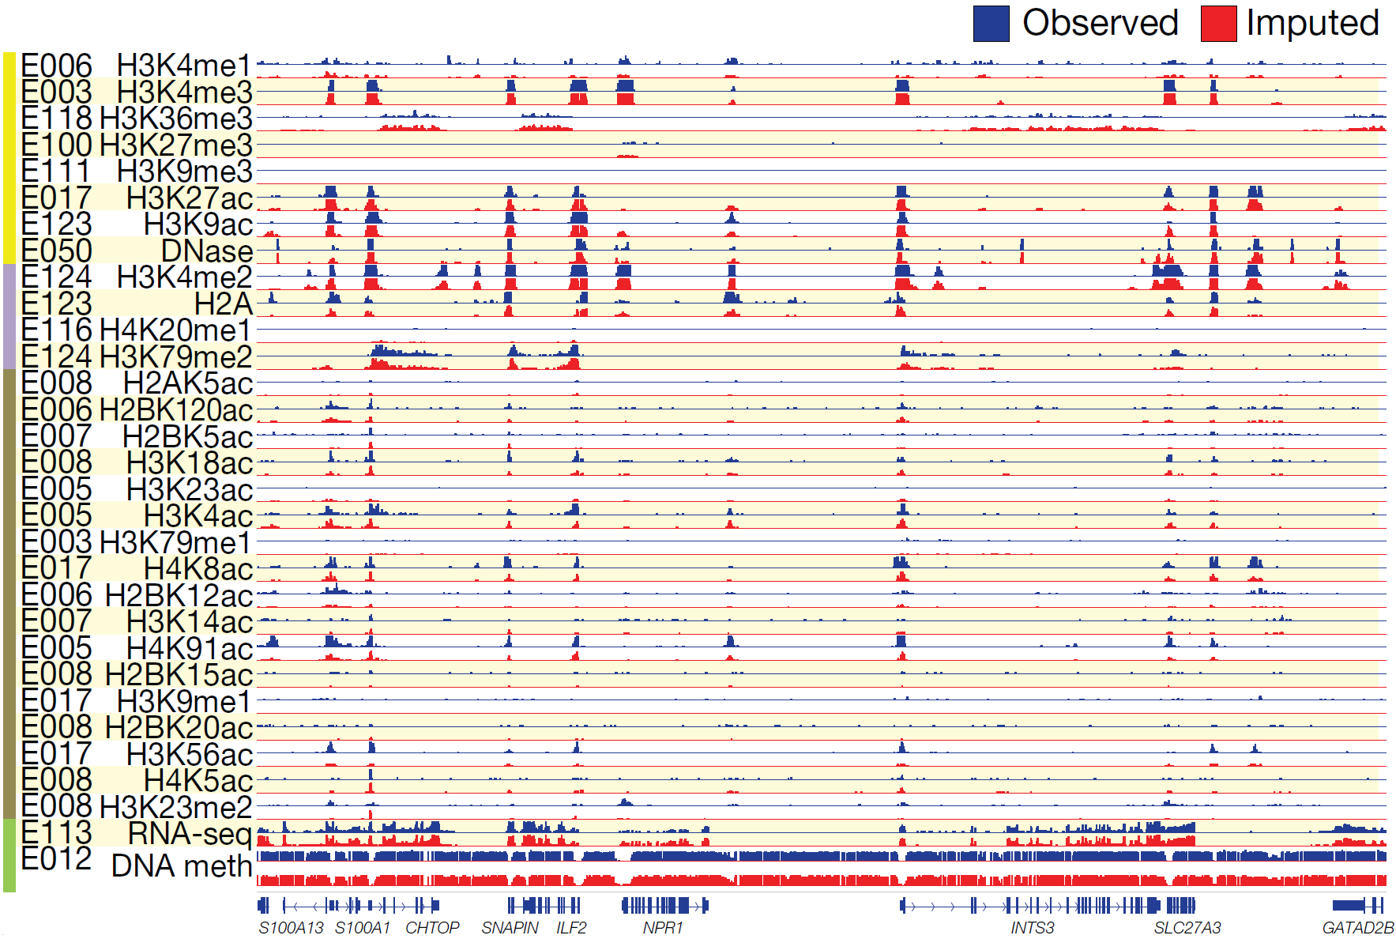

1.1.2. Prediction of TF binding sites in a new cell type
Another example is to predict TF binding sites in a new cell type for which there is no ChIP-seq data for the TF but there are data on chromatin accessibility (DNase-seq) or histone modifications. Several DAC members have strong expertise in this area. The Gerstein lab developed a method to predict TF binding sites based on the integration of histone modification data and TF motif information and applied it to the modENCODE data on worm⁹ and also in yeast⁶². First, a chromatin model is constructed to integrate different chromatin features (histone modifications, DNase hypersensitivity etc.) to infer the local accessibility of DNA regions. Then we search these regions for TF binding motifs to determine the binding sites of TFs. In this method, chromatin features provide non-TF-specific accessibility information in a tissue-specific manner, while motif information determines TF-specific bindings. When applied to ENCODE and modENCODE data, the method demonstrates substantial improvement of positively predicted binding sites.
The Liu lab discovered that chromatin dynamics coupled with TF motif discovery could be used to infer functional TF binding and gene expression changes by taking into account the characteristics of the TFs⁶⁶. For example, estrogen receptor binding sites already show DNase hypersensitivity prior to estrogen activation, and estrogen binding does not influence nucleosome positioning; in comparison, androgen receptor binding sites show little DNase hypersensitivity prior to androgen activation, and androgen binding is associated with nucleosome depletion at the binding sites. We will systematically identify distinct chromatin dynamics relative to different TF binding, differentiate signatures between transcriptional activators versus repressors, and model signatures associated with slow versus fast transcriptional responses upon perturbation. We can also adopt and revise the Bayesian epistasis association mapping approach developed for GWAS analysis to infer transcriptional regulatory modules from chromatin dynamics and explain transcriptome changes.
Building upon the expertise in dynamic Bayesian network (DBN) in the Noble lab in close collaboration with the Weng lab, we propose to develop computational methods to identify TF binding sites in a generalized way. We will focus in particular on the problem of predicting the results of a ChIP-seq assay for binding of a sequence-specific transcription factor in formulating the problem as follows. Other ENCODE data types (e.g., chromatin accessibility measured by DNase-seq) can be easily incorporated into our computational framework. In a particular cell line or tissue, we are given several generic chromatin architecture datasets—e.g., DNase accessibility plus a variety of informative histone modification ChIP-seq assays—as well as the results of ChIP-seq experiments for a set of “training” TFs. We are then asked to predict what would happen if we were to run a ChIP-seq experiment for a given “test” TF, knowing only its binding affinity sequence motif, as determined from a ChIP-seq assay in another cell line.
This problem is akin to what is known in the field of speech recognition as “speaker adaptation.” In that context, a system trained to produce a textual translation of a spoken utterance must learn to adapt to the peculiar characteristics of a new speaker. Similarly, our model will learn to adapt to the characteristics of a new TF, using methods developed in speech recognition. In particular, the model will predict the locations of in vivo binding events based upon features of the local chromatin architecture, while taking into account that some types of TF binding exhibit different local chromatin properties than others.
We will solve this problem using a combined classifier and DBN. The classifier (a support vector machine or a deep neural network) will learn to predict the binding of a given TF based on the observed local chromatin profile. We will train one such classifier for each TF in the training set. The scores produced by these classifiers will then be combined in the context of a DBN such as the one shown in Figure 6. In this model, MotifScore is an observed variable measuring how well the sequence starting at the current position matches the known motif of the target TF represented by its PSSM. The hidden variables state and Class indicate (respectively) whether a position is inside a binding site of the target TF and the identity of the training TF whose chromatin pattern is the closest match to those of the current position. In addition, the model contains one virtual evidence track for each of the N training TFs. Thus, V^{t}_{i} is a positional virtual evidence variable that tells how well the chromatin pattern associated with the sequence starting at position i matches the patterns learned for the training TF t. Because every virtual evidence track corresponds to exactly one class value, we introduce a binary variable I^{t}_{i}, indicating the corresponding virtual evidence track of each class value. The conditional probability of this indicator variable, Pr[I^{t}_{i} = 1|class_{i} = c], equals 1 only if c = t, and is 0 otherwise. As mentioned above, the virtual evidence, Pr[V^{t}_{i} = 1|I^{t}_{i}], is produced by the TF-specific classifier. Finally, the observed binary variable missing is used as a switching parent of the virtual evidence nodes to handle positions where the chromatin profile contains missing data.
The accuracy of this predictive model can be validated in a prospective fashion within the context of ENCODE, because the Consortium is constantly producing new data. Accordingly, we will make predictions for experiments that are currently in the pipeline, and directly measure the accuracy of our predictions once the data become available. In addition to providing a valuable resource for TFs that have not yet been fully characterized experimentally and shedding light on the relationship between local chromatin architecture and TF binding, this project will enable us to prioritize future experiments. By investigating the dependence of prediction accuracy upon properties of the cell line, available local chromatin data, and properties of the TF itself, we will be able to predict which entries in the 2D experimental matrix can be easily imputed and which entries will likely provide the most value in training future imputation models.
1.2 Facilitate and perform data analyses and integration across different types of regulatory elements
One important aspect of the systematic genome-wide experimental assays of ENCODE is the ability to discover novel insights and correlations between elements that were previously not known to be connected, and to pursue data-driven research which can help complement traditional hypothesis-driven investigations by formulating new hypotheses and pursuing new and perhaps unexpected findings.
To enable such data-driven exploratory analyses, we will apply dynamic Bayesian networks and several state-of-the-art dimensionality-reduction techniques to genome-wide coordinates and signals resulting from ENCODE experiments (Aim 4.1), apply bi-clustering techniques to discover co-expressed, co-bound, and co-regulated gene modules (Aim 4.2), and study the structure and dynamics of inferred regulatory networks (Aim 4.3).
We propose using various appropriate techniques to extract higher-level information from ENCODE data, given its size and complexity.

Genome-wide aggregation, Biplot, and PCA: More generally, we will integrate regulatory datasets over a list of genomic anchors using the ACT tool⁸⁷. These can be either single base pair locations (point anchors) or genomic segments (segment anchors) and are possibly stranded. Examples of point anchors include the 5’-ends of genes, precise TF binding sites, the centers of DNA hypersensitive sites, and splicing sites. Examples of segment anchors include genes and exons. Theoretically any set of defined genomic positions can be used as anchors, so long as a researcher is interested in some genomic signal occurring in a position-specific way with respect to the set. We can then study correlations between these genome-wide coordinates either as binary vectors (on/off values after applying a tunable cutoff) or as real-valued vectors that maintain intensity values. We will also use biplots, which make use of Principal Component Analysis (PCA) to plot both features (experiments/factors) and instances (gene regions) in the same plot, to aid in recognizing previously unseen correlations, such as the relationships between transcription factors and genes^{13,88}. Such techniques have already produced useful findings in the analysis of the ENCODE data. Besides PCA, we will also explore non-linear dimensionality reduction methods such as kernel PCA, ISOMAP, and autoencoders based on shallow or deep neural networks to embed instances into low-dimensional (for e.g., two- or three-dimensional) space to visualize relationships between instances directly.
In addition to reducing dimensionality of a dataset, principal component analysis is very useful for understanding the factors driving total variance and we have previously applied this technique to modENCODE data. Using tiling array data from six matched tissue samples taken from two C. elegans developmental stages (mixed embryo and L2), we found that the first principal component responsible for 50% of the total variance in the dataset separated the tissue samples by developmental stage⁹. Biplots can be used in a similar manner in that they show the relationships between observations along the two highest components of variance, but are more descriptive because the relationships between the variables are also represented as vectors from the origin on the same plot¹³. The same techniques can be applied to other types of data and summary statistics including RNA-seq expression values, total signal level in a region, etc.
Dimensionality reduction methods can also be used for data compression. In the ENCODE project, there are over 1,000 signal tracks generated from the read depth signals in the ChIP-seq experiments for probing binding sites of transcription factors and histone modifications. These signal tracks are valuable for quantifying binding and modification levels at nucleotide resolution. However, a very large amount of information generated as signal tracks is usually under-utilized since most of the analysis only concentrates on a small subset of the genome, e.g., the peak regions and the promoters. We are working on efficient genome-wide representations of the signal tracks by compressing the tracks. A good compression scheme reveals redundancy both within and between the signal tracks. In this way, the compressed signal is the minimum-description-length representation of all the signal tracks. We will use both linear and non-linear dimensionality reduction methods for hashing and storing signals of genomic anchors on the redundant signal tracks, and we will explore HMMs and general DBNs combined with dimensionality reduction methods to perform signal track alignment to reduce both within-track and between-track signal redundancy.
4.2. Biclustering: Identification of co-regulated modules and regulatory programs. Biological systems are inherently modular, with different groups of gene products functioning together in complexes, pathways, and co-regulated groups to achieve specific biological outcomes in different spatiotemporal cellular contexts. To computationally reveal biologically significant modules, we will employ scalable multi-dimensional clustering algorithms to reveal groups of genes that are coordinately regulated in their chromatin, binding, expression, replication, and modification patterns, and in their motif and sequence content. We will employ general clustering methodologies such as bi-clustering, hierarchical clustering, k-means and fuzzy k-means clustering,
(bi-)spectral clustering, or exemplar-based affinity propagation⁸⁹, and also specialized module-discovery procedures that search for biologically-meaningful relationships between groups of genes based on their motif content, co-expression patterns, and network connectivity⁹⁰. Such techniques can be useful for exploratory data mining to tease out functional associations between known genes, reveal candidate functions for novel genes based on related genes with known functions, and can also serve as a first stage in the construction of network models that aim to model regulatory relationships^{91,92}.
1.3 Biological network structure and dynamics.
The Gerstein lab has developed many approaches for studying biological networks. We developed methods to construct and analyze the regulatory networks of human and model organisms \cite{Yan, 2010 20439753; Gerstein, 2010 21177976; Cheng, 2011 22125477; Negre, 2011 21430782; Gerstein, 2012 22955619} based on ENCODE and modENCODE datasets. We constructed and analyzed a hierarchical regulatory network \cite{Gerstein, 2012 22955619; Yu, 2006 17003135; Bhardwaj, 2010 21045205; Bhardwaj, 2010 20523742; Bhardwaj, 2010 20351254}. Overall, we found that the hierarchy rather than centrality ("hubiness") better reflects the importance of regulators and that in many organisms, including humans, the highest degree of collaboration is between regulators from the middle level. We integrated regulatory networks with gene expression to uncover different types of functional modules \cite{Luscombe, 2004 15372033; Cheng, 2009 19723326; Yu, 2003 12902159; Qian, 2003 14555624}. We also introduced several software tools for network analysis including Topnet, \cite{Yu, 2004 14724320} tYNA \cite{Yip, 2006 17021160} and PubNet \cite{Douglas, 2005 16168087}. In addition, understanding the topology of the integrated networks is the first step toward understanding its dynamics and evolution. We have developed a novel algorithm to determine and measure the hierarchical structure of transcriptional regulatory networks \cite{Cheng, 2015 25880651}. The hierarchy captures the direction of information flow in the network. The algorithm is generally applicable to regulatory networks in prokaryotes, yeast and higher organisms.

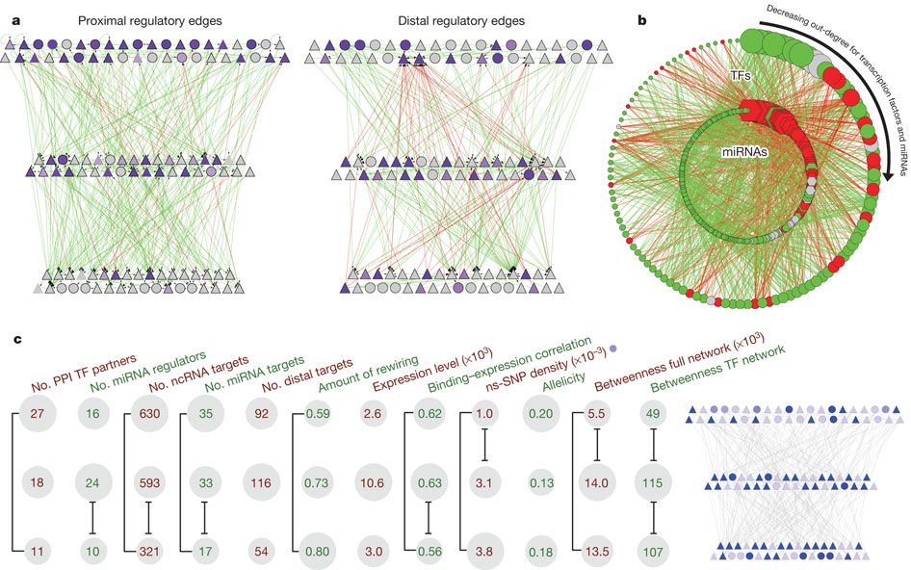
Figure Hierarchy of the human regulatory network derived from ENCODE data
a, Close-up representation of the transcription factor hierarchy. Nodes depict transcription factors. TFSSs are triangles, and non-TFSSs are circles. Left: proximal-edge hierarchy with downward pointing edges coloured in green and upward pointing ones coloured in red. The nodes are shaded according to their out-degree in the full network (as described in Table 1). Right: factors placed in the same proximal hierarchy but now with edges corresponding to distal regulation coloured green and red, and nodes re-coloured according to out-degree in the distal network. The distal edges do not follow the proximal-edge hierarchy. b, Close-up view of transcription-factor–miRNA regulation. The outer circle contains the 119 transcription factor, whereas the inner circle contains miRNAs. Red edges correspond to miRNAs regulating transcription factors; green edges show transcription factors regulating miRNAs. Transcription factors and miRNAs each are arranged by their out-degree, beginning at the top (12:00) and decreasing in order clockwise. Node sizes are proportional to out-degree. For transcription factors, the out-degree is as described in Table 1; for miRNAs, it is according to the out-degree in this network. Red nodes are enriched for miRNA–transcription factor edges and green nodes are enriched for transcription factor–miRNA edges. Grey nodes have a balanced number of edges (within ±1).

Furthermore, we can try to identify the gene regulatory mechanisms such as cooperative logics between multiple regulatory factors in the regulatory network. We have recently developed a new computational method, Loregic to characterize the gene regulatory logics in complex systems \cite{Wang, 2015 25884877}. For example, we used this method to identify regulatory cooperative logics among TFs binding to promoters, TFs binding to distal regions like enhancers and miRNAs in leukemia by integrating ENCODE and TCGA data.
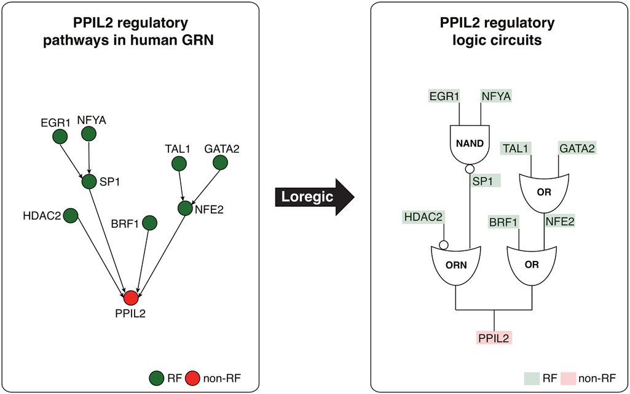
Figure Depiction of two logic circuit regulatory pathways targeting PPIL2. Two logic circuit regulatory pathways targeting the PPIL2 gene, an important cyclophilin member in immunological suppression, are found by Loregic: 1: PPIL2 is co-regulated by HDAC2 and SP1 forming the triplet of (RF1 is HDAC2, RF2 is SP1, T is PPIL2), which is consistent with the “T=~RF1+RF2” gate, and SP1 is co-regulated by EGR1 and NFYA forming the triplet of (RF1 is EGR1, RF2 is NFYA, T is SP1), which is consistent with the “T=~RF1*~RF2 (the NAND gate); 2: PPIL2 is also co-regulated by BRF1 and NFE2 forming the triplet of (RF1 is BRF1, RF2 is NFE2, T is PPIL2), which is consistent with OR gate, and NFE2 is co-regulated by TAL1 and GATA2 forming the triplet of (RF1 is TAL1, RF2 is GATA2, T is NFE2), which is also consistent with OR gate. We replace the triplets on these pathways using matched logic gates, and depict the pathways using logic circuits to summarize the regulatory logics targeting PPIL2 at the pathway level.

In addition to the identification of gene modules and their co-regulation, described in Aim 3.5, we will study the structure and dynamics of inferred regulatory networks and relate these to other cellular networks⁹³. Our core networks will primarily consist of mixed TF/miRNA director regulatory networks discovered in Aim 3.5, but will also be populated by undirected networks, constructed using information regarding protein interaction and biological-relatedness, such as those utilized or discovered in Aim 3.2 (http://papers.gersteinlab.org/papers/mirnet). Figure 9 illustrates the TF-miRNA regulatory network generated with ENCODE data⁸. Extending our previous work, we will use graph algorithms to discover clusters of highly connected genes within these networks, network motif algorithms to discover recurrent patterns of connectivity, and specifically search for recurrent regulatory feedback and feed-forward subgraphs⁹⁴⁻⁹⁶. We will also look at the degree of rewiring between networks⁹⁷.
We will create and analyze a meta-network composed of the TF regulatory network and protein-protein interactions integrated with the miRNA data. To integrate the miRNA data, the TargetScan software will be used to obtain the miRNA-TF edges in this network⁹⁸ by assessing complementarity of the miRNA seed region coupled with conservation information. This expanded, integrated network will be analysed using the tools and methodologies described below, allowing us to look for new types of motifs, regulatory patterns, and relationships that would likely remain undetected in individual analyses of the separate networks.
The networks will be analyzed using several methods to calculate key statistics. One such method is 'tYNA'⁹⁹, a web system developed to compare and mine multiple networks in order to identify cliques and motifs, as well as calculating statistics on a network. Statistics such as ‘eccentricity' and ‘betweeness' can help explain the connectivity and behavior of nodes in a network¹⁰⁰. Eccentricity is defined as the maximum shortest path from a node to any other node in the network; this describes how a node interacts with all the other nodes it is connected to, i.e., a node with a small eccentricity is tightly connected to all nodes that it interacts with- including nodes to which it is not directly connected. Betweeness is defined as the number of shortest paths in the network that pass through a given node; this is a measure of a node’s centrality and is related to how involved a node is the communications between all other nodes in a network. These and other statistics can help in the definition and understanding of a particular network.
Connectivity statistics, in particular the difference between out- (O) and in- (I) degree, elucidate the direction of information flow in the network and can reveal hierarchical organization. In previous work, we employed a simple simulated annealing procedure to arrange TFs into discrete levels that maximize the number of edges propagating down from higher to lower levels. To complement these discrete level assignments we defined a continuous parameter h=(O-I)/(O+I), which can be interpreted as the height of a TF within the hierarchical structure. We plan to apply the same procedures to the transcriptional regulatory network in human, mouse, fly, and worm. Of particular interest is a comparison of the distribution of TFs between the different levels to determine, for example, the extent to which middle-level regulator nodes are conserved across different networks. Furthermore, it is important to evaluate the robustness of our results, as there exist several methods of constructing network hierarchies (e.g. breadth-first search) and we intend to assess the impact of various network construction methods on these results.
We have previously exploited the model of hierarchical organization by examining the degree of collaboration among different regulators¹⁰¹⁻¹⁰³. This is essentially the ratio of the number of genes co-regulated by two regulators (from the same or different levels) to the union of their target genes summed over all such pairs of regulators from the two levels^{102,103}. We found that in E. coli, yeast, and human the highest degree of collaboration is between regulators from the middle level, which is analogous to a corporate setting in which middle managers play an important organizational role. We plan to investigate the same arrangement using more comprehensive co-regulatory networks from human, mouse, worm, and fly. In addition to co-regulation we also studied the overlap between modules in terms of their position within the hierarchy. We defined a module as all accessible nodes downstream of a top regulator and investigated the overlap (share of regulators) between modules. We found that the modules in E. coli are more independent compared to those within the call-graph of the Linux kernel¹⁰⁴. We intend to examine the module-overlap in human, mouse, worm and fly, and other eukaryotes compared to our previous observations in E. coli. We speculate that these networks of more complex eukaryotes will be more similar to the Linux call-graph.
In addition to the global features of the regulatory hierarchy we plan to study the networks from the perspective of their constituent building blocks, which are small connectivity patterns that carry out canonical functions and are referred to as network motifs. In previous work, we identified various enriched motifs including the feed-forward loops (FFLs) in the human regulatory network⁸ and we aim to apply the same analysis procedures for networks generated with ENCODE data and further compare the enrichment profiles. The motif analyses will allow a characterization of key regulatory mechanisms in each species and the further comparison between species will enable us to observe how these mechanisms evolve.
1.4 Chromatin vs. splicing
One ongoing topic of interest in the Guigo Lab is the role of chromatin structure and modifications in the regulation of RNA processing—splicing in particular. Using integrative analysis of RNASeq, ChIPSeq of histone modifications and of RNA polymeriase, and ChIA-PET data produced during ENCODE 2, the lab found significant positive association between H3K9ac, H3K27ac, H3K4me3, epigenetic marks characteristic of active promoters, and exon inclusion in a small but well-defined class of exons, representing approximately 4% of all regulated exons. These exons are systematically maintained at comparatively low levels of inclusion across cell types, but their inclusion is significantly enhanced in particular cell types when in physical proximity (in linear or on tri-dimensional space) to active promoters (Figure 2, [Curado J., 2015 PMID: 26498677]) .

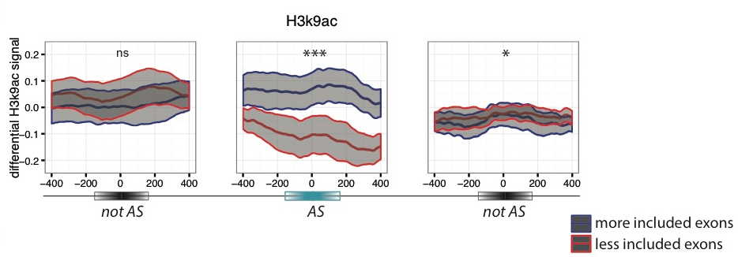
Figure 2. Differential ChIPSeq signals (average and standard error of the mean) for, H3K9ac are represented for “more included” exons (blue) and “less included” exons (red) in pairwise comparisons between cell lines. The differential signal is computed on a 800bp-window around the middle of the regulated exon (AS) and flanking not regulated (notAS) upstream (left) and downstream (right) exons. Significance levels are indicated by * (0.05>p>0.01), ** (0.01>p>0.001), *** (0.001>p) and ns (p>0.05). Differential accumulation of marks is generally specific of regulated exons. From Curado et al, 2015.

In order to elucidate how chromatin state effects and modulates RNA processing, the Guigo and Ben Brown’s lab have teamed up to built a series of machine learning models based on random forests to predict exon inclusion based on chromatin marks, chromatin state, and RNA binding protein binding assays (eCLIP) in K562 cell line (ongoing collaboration with Ben Brown lab). The highest predictive power was achieved when using RBP binding data and histone modifications as predictors. Intermediate results show an effect of the speed of pol-II progression on the switch between cis and trans splicing and post-transcriptional exon duplication and rearrangement (Figure 3A). According to the model, higher RNA Pol-II density after the cassette exon should lead to the accumulation of transcripts and increases the chances of local trans-splicing, while the absence of accumulation points of RNA Pol-II should lead to separate splicing in cis in each separate transcript. This hypothesis is supported by the combination K562 splicing data and Pol-II density assays (Figure 3B). The density of pol-II is significantly lower downstream of tail-to-head splice junctions that have the mate pair mapping inside the junction (circular RNA products) compared to the density of pol-II downstream of the junctions that have the mate pair mapping outside the junction (suggesting post-transcriptional exon shuffling).

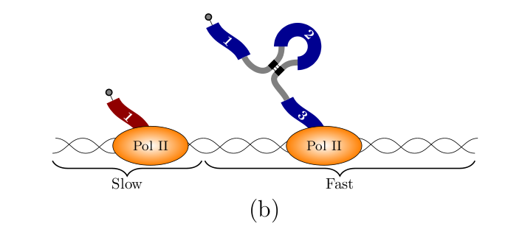
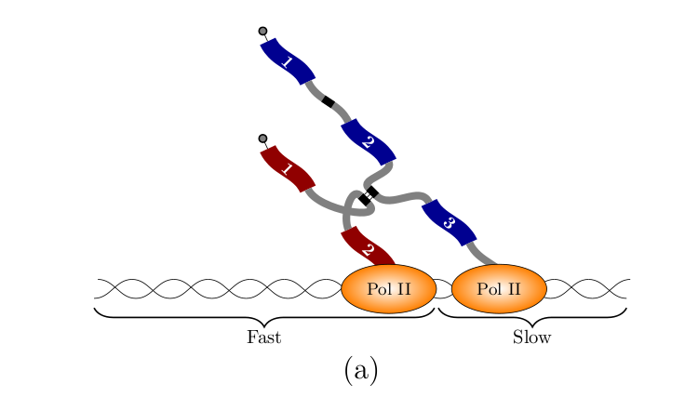
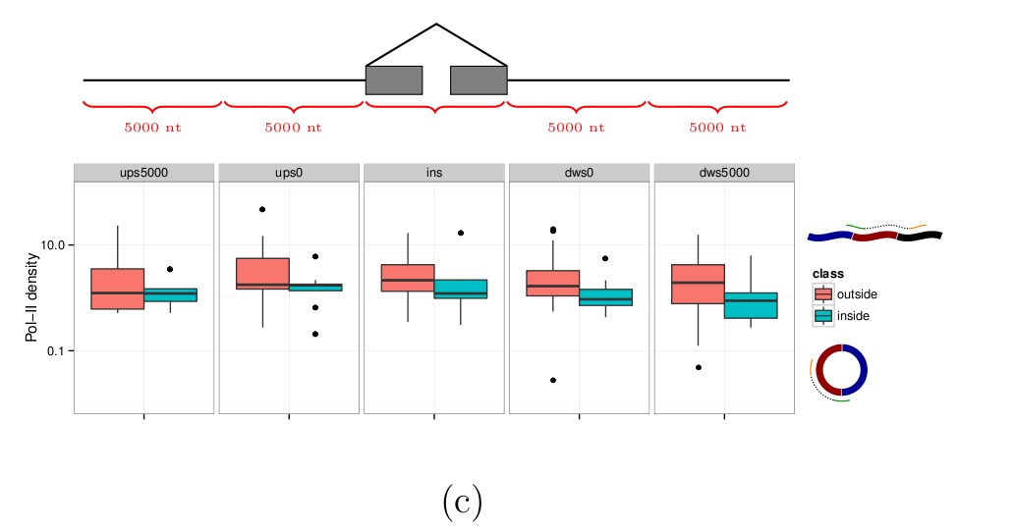
Figure 3. A,B. Two regimes of RNA Pol-II lead to different splicing outcomes. Accumulation of pol-II leads to collision and promotes trans-splicing. C.
The density of RNA pol-II (y-axis) is indeed higher downstream (x-axis) of cassette exons that have evidence of trans-splicing (green), compared to cassette exons that are spliced in cis- with the formation of circular products (red).

1.5 Personal genome and allelic-specific analysis
The alignment of assay reads is one of the main steps in processing of functional genomic datasets. Conventionally, reads are aligned to the human reference genome. However, a systematic reference bias is introduced when reads are mapped to the haploid human reference sequence; namely, reads that harbor the reference allele is more likely to be aligned. In addition, reads can be improperly mapped to the reference genome in regions (or samples) with more genetic variation, especially when indels and larger structural variants are involved. This reduced mappability impairs estimation of read abundance and therefore compromise any downstream analyses. To this end, we strongly advocate for the use of a diploid personal genome in the alignment of functional genomic reads from ENCODE4, as a more accurate representation of an individual’s human genome. We have previously demonstrated that using a diploid genome with an individual’s variants improves both mappability of the reads\cite{Rozowsky, 2011 21811232}, especially when SVs, in particular, are incorporated.\cite{Sudmant, 2015 26432246}

 | Ref genome | Pgenome: snvs only | Pgenome: snvs + indels only | Pgenome: snvs + indels + SVs
Reads processed | 208,051,087 | 208,051,087 | 208,051,087 | 208,051,087
# reads uniquely aligned | 171,944,588 (82.65%) | 172,591,380 (82.96%)  M: 171,965,218 (82.66%)  P: 171,969,566 (82.66%) | 172,738,321 (83.03%)  M: 171,982,014 (82.66%)  P: 171,982,614 (82.66%) | 172,743,175 (83.03%)  M: 171,977,765 (82.66%)  P: 171,978,147 (82.66%)
# reads that failed to align | 18,279,824 (8.79%) | M: 18,290,611 (8.79%)  P: 18,276,409 (8.78%) | M: 18,286,906 (8.79%)  P: 18,270,944 (8.78%) | M: 18,293,522 (8.79%)  P: 18,277,990 (8.79%)
# reads that multimap | 17,826,675 (8.57%) | M: 17,795,258 (8.55%)  P: 17,805,112 (8.56%) | M: 17,782,167 (8.55%)  P: 17,797,529 (8.55%) | M: 17,779,800 (8.55%)  P: 17,794,950 (8.55%)
Table XX. A table showing that the diploid personal genome allows more accurate alignment of functional assay reads, NA12878 with an ENCODE POL2 ChIP-seq dataset, than the human reference genome. The alignment improves as you increase the completeness of the variant call sets from SNVs, then adding indels and finally SVs.

For personal genome construction, we have developed a computational tool, vcf2diploid\cite{Rozowsky, 2011 21811232}. The tool uses the reference genome as the skeletal framework, and integrates an individual’s genomic variation data (SNVs, indels, and SVs) into the reference genome. Phase information of heterozygous variants are also incorporated, producing maternal and paternal haplotypes for the alignment of RNA-seq, ChIP-seq, or other functional genomic data. Chain files are generated by the program in order to account for coordinate offsets between the individual’s parental haplotypes and the original reference genomic sequence resulted from incorporation of indels and SVs. The versatility to convert between reference and personal genome coordinates allows mapping of genomic annotated regions (e. g. gene or peak coordinates for RNA-seq and ChIP-seq, respectively) between the genomes using available tools, such as UCSC LiftOver tool\cite{Rhead, 2010 19906737}
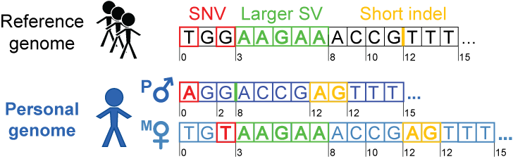
Figure XX. Each haplotype in the diploid personal genome is derived by incorporating phased or unphased variants (SNVs, indels and SVs) into the human reference genome. The coordinates can be mapped back to the human reference coordinates to facilitate comparisons with other reference-based resources, such as gene annotations from GENCODE.

We have previously constructed the personal diploid genome for NA12878, splice-junction libraries and personalized gene annotations. We believe the diploid sequence for NA12878 is a valuable resource for anyone performing any sequence-based analyses. Thus, we have made this available as a resource at alleleseq.gersteinlab.org and have been updating this assembly as new versions of the human reference genome, genomic annotations, and NA12878 genetic variation data are released. Furthermore, the availability of a computational tool enables the construction of personal genomes in a high throughput fashion, as demonstrated in a recent publication\cite{Chen et al. Nat. Commun., in press} where we were able to parallelize the construction of 382 personal genomes using the variant call sets from the 1000 Genomes Project.

In addition to personal genome construction, we also have extensive expertise and experience in the use of personal genomes in RNA-seq and ChIP-seq read alignment and subsequent downstream analyses. In particular, we have used the personal genomes to account for mapping biases seen in allele-specific (AS) analyses. More specifically, the personal genomes can alleviate reference bias, which occurs by virtue of the conventional mapping of reads to the human reference genome. Our AS analyses require alignment to a diploid personal genome using ChIP-seq or RNA-seq reads, when detecting variants associated with allele-specific binding (ASB) or allele-specific expression (ASE) respectively. Using a pipeline we developed, AlleleSeq, we have spearheaded allele-specific analyses in several major consortia publications, including ENCODE and the 1000 Genomes Project \cite{Djebali, 2012 22955620; Gestein, 2012 22955619; Khurana, 2013 24092746; Sudmant, 2015 26432246}. Overall, we found that there is a substantial number of genomic elements associated with ASB and ASE) \cite{Djebai, 2012 22955620} and that these allelic variants are under differential selection from non-allelic ones \cite{Gerstein, 2012 22955619; Khurana, 2013 24092746}. By constructing regulatory networks based on ASB of TFs and ASE of their target genes, we further revealed substantial coordination between allele-specific binding and expression \cite{Gerstein, 2012 22955619}. Our alleleseq.gersteinlab.org resource have been used in the scientific community, as exemplified by the number of publications using our data \cite{Ji, 2013 23569280; Younesy, 2014 24371156}.
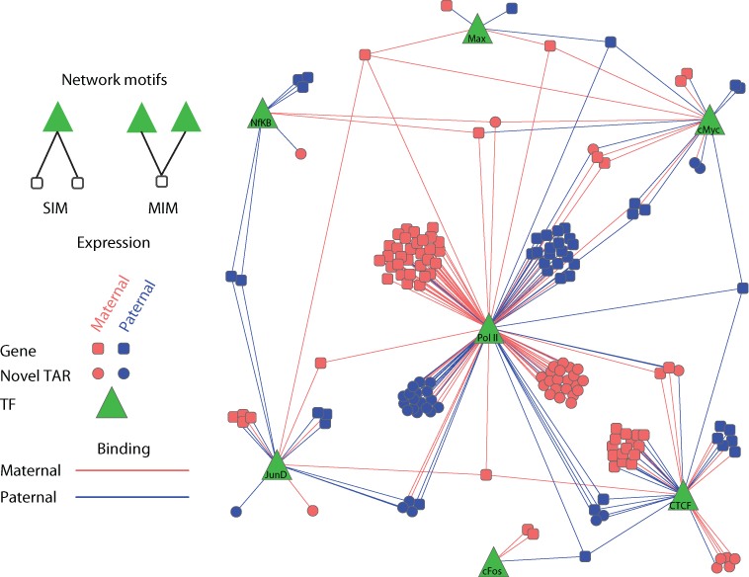
Figure XX. Resolved into their parental haplotypes (blue for paternal; red for maternal), and then building a regulatory network, show high coordination between ASB (triangles) and ASE (small circles and rounded squares)

More recently, we produced a catalog of more than 6K and 63K SNVs associated with ASB and ASE respectively \cite{Chen et al. Nat. Commun., in press}. We constructed the personal diploid genomes of hundreds of individuals using variants from the 1000 Genomes Project. We then aligned reads from the functional datasets corresponding to each individual (955 RNA-seq and 165 ChIP-seq in total) from eight publicly available studies, including ChIP-seq datasets from 14 lymphoblastoid cell lines in ENCODE\cite{ENCODE Consortium, 2012 22955616}. In this study, we used the personal genomes to alleviate reference and ambiguous mapping bias. The detected ASB and ASE SNV catalog can be used to annotate genomic regions that are most attuned to AS behavior. These results as well as 382 diploid personal genomes were made available as an online resource, AlleleDB, (alleledb.gersteinlab.org).
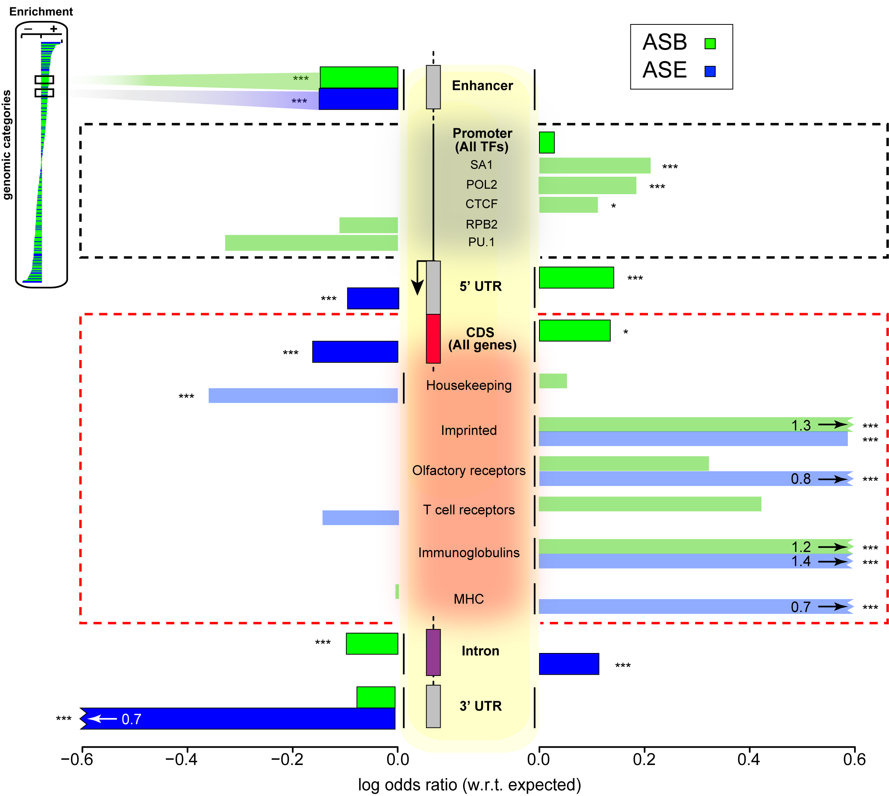
Figure XX. The ASB and ASE enrichment of various categories of genomic elements, such CDS regions, promoters and enhancers.

Since it has been demonstrated that using diploid genome with individual’s variants improves both mappability of the reads\cite{Rozowsky, 2011 21811232} and (particularly for SVs) results of the downstream analyses \cite{Sudmant, 2015 26432246}, we propose to map reads to personal genomes rather than the reference genome in functional data processing pipelines. Thus, we plan to incorporate our personal genome construction tool, vcf2diploid, into ENCODE pipelines and develop approaches to merge the two haplotypes after alignment for further analyses. In addition, the results of these pipelines can be directly used for allele-specific analyses as we slightly adapt the AlleleSeq framework.

1.6 Facilitate and carry out comparative analyses between human and mouse
ENCODE has invested tremendous efforts in the studies of human and mouse, with the ultimate purpose to further our understanding of biology, and also transfer the biological knowledge gained to human biology and health. An essential premise for such knowledge transfer is the accurate assignment of genes and regions of common descent and corresponding function (orthologs), and the ability to discover similarities and differences based on these orthologs assignments. We will work closely with the AWG, the DCC, and the phylogenomics community to develop an orthologs resource between human and mouse and undertake the comparison between human and mouse in both genic and intergenic regulatory regions.
Genome comparisons and ortholog finding has been an area of very active research, and several tens of ortholog resources have been developed in the past decade. We have already established close contact with the groups that have developed three of the most frequently used such resources, Inparanoid, OrthoMCL and TreeFam, which all include human, mouse, fly, and worm. Our initial analysis revealed that ortholog resources showed significant incongruence, and less than 20% of called orthologs are common in all three resources. Possible reasons for the discrepancy are methodological differences between best-bidirectional-hits and phylogeny methods, each of which has its advantages and shortcomings. Based on this set, we will work with the community to establish a gold standard set of functional orthologs based on biological function, evaluate the different methodologies, and propose changes to them. Given the difficulty of achieving high quality and high coverage in ortholog mapping, we will provide a smaller high-confidence ortholog set that includes some of the most highly studied genes and perhaps benefits of manual curation by TreeFam, and a larger but lower-confidence set to increase our coverage for studies that need to be genome-wide.
Using protein domains to identify and evaluate orthologs: In addition to phylogenetic approaches, we will use protein domain annotations to help map orthologous proteins and evaluate ortholog assignments by other methods. We will use the Proteome Folding Pipeline¹⁰⁵ to sequentially analyze primary, secondary, and tertiary structures of protein sequences encoded globally in these four genomes. The analysis of potential 3D structures can allow us to recognize very distant homologs, as structural relationships can often be identified well into the “twilight zone” of sequence identity (as low as ~15-25%). Protein domains and structure will also provide testable functional hypotheses at the molecular level for directed experimental studies. We will use these results to help evaluate ortholog assignments, and compare the domain content of orthologous proteins, especially with regard to functional differences between the species.
A unique opportunity with ENCODE comes from the parallel experiments in human and mouse. We will study the relative role of pre- and post-transcriptional regulation in the two organisms, the interplay between orthologous transcription factors and orthologous chromatin marks, and the expression patterns, onset stages, targets, and target expression for orthologous factors and miRNAs. We will also study patterns of alternative splicing and alternative polyadenylation for orthologous genes in corresponding stages, especially with respect to how they affect miRNA targeting and functional protein domains. More generally, we will compare the transcription factor and miRNA inventory of the two species, the relative distributions of target gene counts for orthologous regulators, and similarly the relative distribution and diversity of regulators bound for orthologous gene targets. We will also study whether discovered modules of biologically related genes in Aim 3.5 correspond to orthologous modules across species and for significantly conserved modules we will study the properties of gained and lost components. Using network properties discovered in Aim 4.3 we will compare the two species in terms of determining if similar network motifs are discovered in the regulatory networks of the two species, and the types of feedback loops that are found in mixed TF/miRNA regulatory networks.
1.7 Integration of ENCODE with other consortia
The DAC will perform integrated analyses of cross-platform data from all ENCODE projects as well as aggregate data from other relevant consortia and projects. The ENCODE project will also avail the data from other consortia including IHEC, GTEx, 1000 Genomes, psychENCODE, Brainspan and Roadmap epigenomics project. Consequently we aim to develop calibration methods that will generate unified scoring for all datasets. For example, one can compare parameters for calling enhancers between ENCODE and psychENCODE. We will compare parameters like thresholds for calling peaks in ChIP-seq data, look at discrepancies between the two projects and calibrate parameters to reduce biases due to cross-project analyses. In addition to comparing the parameters in the uniform processing pipelines, we will also directly compare the annotated genomic regions or transcripts called by these pipelines. For example, we will identify the brain cell types studied by ENCODE and other consortia, match them with the most appropriate datasets in psychENCODE, and investigate whether the corresponding pipelines in the two consortia have detected a similar set of genomic elements. While performing this comparison, we will take into account the differences in cell sources and the inherent variation among biological replicates, and focus on the regions and transcripts deemed most significant by either or both pipelines. If we identify major differences, we will investigate whether they are due to the underlying raw data, or the differences in the pipelines.

We plan to build this resource upon our experience on setting the standards within ENCODE and other consortia. For example, capitalizing on the uniformly processed and matched experimental data obtained by mod/ENCODE consortia, we have performed a series of comparative studies across distant metazoan phyla. A comparative analysis of human, worm, and fly revealed remarkable conservation of general properties of regulatory networks \cite{Gerstein, 2014 25164755}. Moreover, Gerstein lab has considerable expertise in developing standardized pipelines and quality control metrics for RNA-Seq and evaluating them in many consortia including ENCODE, exRNA, KBase et al. The lab is very experienced in developing and setting up pipelines for the processing of RNA-seq data; specially for long RNA-seq data for ENCODE, long and short RNA-seq data for the Brainspan project as well as a custom pipeline developed for the analysis of small exRNA-seq data for the Extracellular RNA Communication Consortium (ERCC). We have developed a range of tools that handle challenges in read quantification: RSEQtools, enabling expression quantification of annotated RNAs \cite{Habegger, 2011 21134889}; tools that detect, store and query unannotated transcripts \cite{Djebali, 2012 22955620; Nagalakshmi, 2008 18451266; Bertone, 2004 15539566; Agarwal, 2010 20565764; Rozowsky, 2007 17567993}; and methods (e.g. incRNA) that predict and analyze novel ncRNAs, which may be discovered in the course of this project \cite{Lu, 2011 21177971}. We have used many of these tools to conduct large-scale analyses, particularly for the ENCODE and modENCODE consortia \cite{Gerstein, 2014 25164755; Gerstein, 2010 21177976}. For example, the Gerstein Lab is in charge of DAC of exRNA consortium to develop the standardized RNA-seq pipelines for exRNAs.
Integrate ENCODE data with data generated by the 4D Nucleome Consortium
Recently, Dr. Noble and and Dr. Jay Shendure, in collaboration with five other UW investigators, were awarded a U54 center grant as part of the NIH 4D Nucleome Consortium. With Bing Ren, Dr. Noble is co-chairing the steering committee for the 4D Nucleome Nuclear Organization and Function Interdisciplinary Consortium. Dr. Noble is thus in an excellent position to ensure coordination between the ENCODE and 4D Nucleome consortia.
We have already developed one computational method that will facilitate integration between ENCODE and 4DN data. Graph-based regularization (GBR) is a principled method for making use of Hi-C data during the semi-automated annotation of the genome 41 (); 64 (). GBR expresses a pairwise prior that encourages certain pairs of genomic loci to receive the same label in a genome annotation. We used GBR to exploit Hi-C data during genome annotation by encouraging positions that are close in 3D to occupy the same type of domain. Using this approach, we produced a model of chromatin domains in eight human cell types, thereby revealing the relationships among known domain types. Through this model, we identified clusters of tightly regulated genes expressed in only a small number of cell types, which we term “specific expression domains.” We also found that domain boundaries marked by promoters and CTCF motifs are consistent between cell types even when domain activity changes. During the next phase of the ENCODE project, we will deploy GBR in Segway, thereby making use of Hi-C data being generated both within ENCODE and by the 4D Nucleome Consortium.
We will also explore the use of Hi-C and other ENCODE data types to assist in 3D structural inference. One particularly valuable, orthogonal type of data that the 4D Nucleome Consortium will be generating is microscopy data. For example, oligopainting data can be used to visualize different types of topologically associated domains 65 (). We will use such data in combination with Hi-C data generated by ENCODE in a hierarchical extension of our existing Pastis 3D structure inference algorithm 13 (). In general, we expect within-domain contact probabilities to exhibit different scaling properties relative to genomic distance 66 (). Accordingly, a series of hyperparameters corresponding to domains of different sizes will adjust the Poisson distribution in the Pastis model, or the Poisson rates might be sampled from a prior distribution derived from the microscopy data. Additional constraints will come from ENCODE CTCF and PolII ChIP-seq data, which empirical evidence based on Hi-C suggests tend to bind to regions on the outside of the 3D structure 9 ().

1.6.1 Roadmap Epigenomics data
The NIH Common Fund Epigenomics Roadmap Project (http://www.roadmapepigenomics.org/) and the International Human Epigenome Consortium (http://www.ihec-epigenomes.org/) have generated rich maps of histone modifications, including high-resolution maps of more than 20 modifications in a small number of cell lines, maps of a few modifications in a large number of cell types, as well as maps of DNA methylation and DNA accessibility. As each of these data types are widely used in the ENCODE Consortium, we will work with the data coordination centers and informatics groups participating in these consortia to integrate relevant datasets into ENCODE pipelines for joint integrative analyses by the ENCODE AWG. For those cases in which we seek to integrate non-ENCODE datasets into our existing pipelines, we will ensure that such data meet the same quality standards as ENCODE datasets. To optimize the compatibility with published papers by each of these consortia, we will use the processed files from the investigators as much as possible. However, when necessary, we will reprocess the primary data according to the ENCODE uniform pipelines to ensure that data quality standards are met.
1.6.2 Integration of ENCODE data with GTEx, Brainspan, and TCGA data
Other sources of complementary, large-scale human data include the NIH GTEx (Genotype-Tissue Expression) Project (http://genome.gov/gtex), the NIMH Brainspan Project (http://brainspan.org), and the NCI Cancer Genome Atlas (TCGA) Project (http://cancergenome.nih.gov). Over 1,200 data samples from primary tissues have already been collected and analyzed during the initial stages of the GTEx project. We propose combining the large amount of population-specific lymphoblastoid genotype and mRNA expression data in ENCODE with the GTEx samples to improve the identification of expression quantitative trait loci (eQTL). In addition, compilation and comparison of DNA methylation, mRNA/miRNA expression, as well as genotype data from ENCODE, GTEx, and Brainspan, will permit a robust analysis of the expression landscape of the human brain and provide a valuable resource for other investigators given the scarcity of such large-scale, high-quality datasets. Finally, the integration of the large volume of ENCODE cancer data (from both primary tissue samples and immortalized cell lines) with over 500 clinical samples in TGCA will enable analyses of somatic mutations, mRNA/miRNA expression, copy number, and DNA methylation on an unprecedented scale.
1.6.3 Integration of ENCODE data with 1000 Genomes Consortium data
We aim to integrate different non-coding annotations with the variants identified by the 1000 Genomes Consortium. In this way, the non-coding annotation of each variant will be available to all users of the 1000 Genomes data and should serve as a valuable resource for the genetics community to identify the causal variant in GWAS. It will also provide easy access to downstream analyses for all the users. For instance, it will enable the calculation of selection pressure on variants in different annotation classes. The integration of ENCODE data with 1000 Genomes variants (SNPs, small insertions and deletions, and large structural variants) will be provided in the annotated Variant Call Format (VCF; http://www.1000genomes.org/node/101) These VCF files will contain the annotation of each genomic variant, including presence in non-coding RNA, TF peaks, TF motifs, and pseudogenes. Furthermore, SNPs which exhibit allele-specific behavior will also be identified with a distinct tag in the VCF files.

Aim 2. Creating high-quality Encyclopedias of DNA elements in the human and mouse genomes.
The ENCODE con

“The Encyclopedias will be comprehensive catalogs of functional elements and will serve as resources to enable the broader scientific community to seek new advances in both basic and clinical knowledge, and may build on those currently under development (https://www.encodeproject.org/data/annotations/). The goal will be to generate catalogs of human and mouse functional elements that define features of the genome such as gene models, regions of open chromatin, regions enriched in select histone modifications, RNA transcripts, binding sites for transcription factors and binding sites for RNA-binding proteins on transcripts. These elements will be elucidated by high-throughput methods such as RNA-seq, ChIP-seq and DNase-seq. A key feature of the Encyclopedias will be integrative predictions of functional element subtypes such as enhancers, promoters, silencers, RNA-editing sites, and others.

Overall vision and specific plans to generate Encyclopedias that are comprehensive catalogs of functional elements capable of serving as resources to enable the broader scientific community to seek new advances in both basic and clinical knowledge.
Specific plans for presenting Encyclopedias in formats that are readily accessible and of high utility for a broad group of researchers.
Detailed descriptions of strategies for generating integrative predictions of functional elements, including subtypes of regulatory elements (e.g., enhancers, promoters, silencers, RNA-editing sites), transcripts, linkages between genes and regulatory elements, and others.”

Detection of Regulatory Regions:
Enhancers are a key feature of the noncoding genome that are involved in regulating the expression of genes in a cell type specific manner \cite{Maston, 2006 16719718}. The number of active enhancers that have been experimentally tested in transgenic assays in a single mammalian tissue remains small in number and our knowledge of how these enhancers become active in each cell type remains surprisingly incomplete \cite{Visel, 2007 17130149; Shlyueva, 2014 24614317}. Hence, theoretical predictions of active enhancers have typically focussed on identifying the properties associated within the sequences of active enhancers such as inter-species conservation and identifying clusters of transcription factor binding sites \cite{Hallikas, 2006 16413481} as well as epigenetic signatures associated with enhancers such as nucleosome positioning, DNase-I hypersensitivity, histone marks associated with active regulatory regions of the genome, and/or eRNA transcription \cite{ENCODE Consortium, 2012 22955616; Kundaje, 2015 25693563}. How to precisely combine these features to obtain more accurate regulatory region predictions remains a mystery. A number of massively parallel regulatory assays have been developed recently \cite{Arnold, 2013 23328393; Vanhille, 2015 25872643; Murtha, 2014 24658142; Patwardhan, 2012 22371081} providing us with a unique opportunity to systematically study the precise combinations of genomic and epigenomic features that are most predictive of active regulatory regions in the genome. In addition, mapping of regulatory region-associated chromatin marks (e.g., H3K4me3, H3K4me1, and H3K27ac) and enhancer binding proteins (e.g., p300) are being performed for many cell lines in ENCODE.

Our proposed work is based on our past experience in non-coding annotation, as part of our 10-year history with the ENCODE and modENCODE projects. Noncoding annotations derived primarily from ENCODE will include transcription-factor binding sites, DNA-hypersensitive sites, chromatin marks by histone binding, predicted enhancer regions, miRNA and pseudogenes. As part of these projects, we developed methods that integrate ChIP-seq, chromatin, conservation, sequence and gene annotation data to identify gene-distal enhancers\cite{Yip, 2010 20126643}, which we have partially validated\cite{Yip, 2012 22950945}. The Gerstein lab has also developed PeakSeq \cite{Rozowsky, 2009 19122651}, a versatile tool for identification of TF binding sites and a standard peak calling program used by the ENCODE and modENCODE consortia for ChIP-Seq datasets \cite{Rozowsky, 2009 19122651}. More recently, we developed MUSIC, a peak caller that performs multiscale decomposition of ChIP signals to enable simultaneous and accurate detection of enrichment at a range of narrow and broad peak breadths \cite{Harmanci, 2014 25292436}. This tool is particularly applicable to studies of histone modifications and previously uncharacterized transcription factors, both of which may display both broad and punctate regions of enrichment. In addition, the Gerstein lab has also developed FunSeq to prioritize both coding and noncoding variants that could be potential drivers of disease \cite{Khurana, 2013 24092746; Fu, 2014 25273974}. Briefly, the tool identifies potential regions of high functional impact in noncoding regions by understanding patterns of natural variation in human genomes and comparing these patterns in disease cases. We identified regions in the genome under purifying selection that are enriched for rare alleles using variation data from 1092 individuals (Phase1 of 1000 genomes project \cite{Khurana, 2013 24092746}). Such regions that we dubbed sensitive and ultrasensitive regions highlight regions that are under strong constraint. The Gerstein lab has used this method to successfully identify potential noncoding driver mutations in prostate cancer genome.

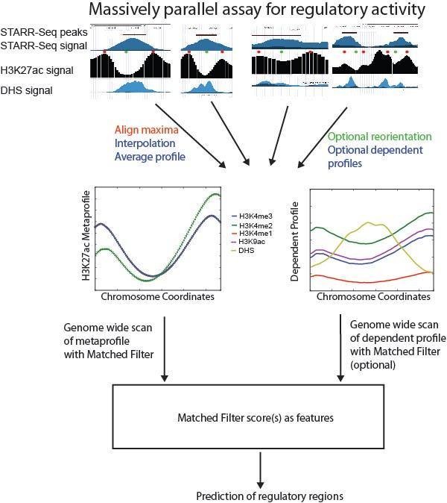
As part of the ENCODE consortium, we will use information learned from various massively parallel regulatory assays to make cell type dependent enhancer predictions based on epigenomic datasets generated as part of this project. In particular, we will utilize pattern recognition algorithms such as matched filter \cite{Book - Papoulis, S. U. Pillai, Probability, Random Variables, and Stochastic Processes 4th Edition} to identify a particular signal shape in the presence of noise within the signal of various epigenomic features (histone ChIP-Seq and DNase I-hypersensitivity experiments) and transcription of enhancer RNA (eRNA) to predict active enhancers across the different ENCODE cell lines. The pattern within the signal of different epigenetic datasets will be computed from regulatory regions identified using different massively parallel regulatory assays and this pattern is conserved across diverse species. This method will be used to predict cell type-specific active enhancers based on the different histone ChIP-Seq and DNase-I hypersensitivity datasets generated as part of the grant as well as epigenetic datasets generated by the Epigenome Roadmap, and IHEC projects. These methods have already been tested in the ENCODE Enhancer Prediction Challenge (discussed below) and was one of the top performing methods for mouse enhancer predictions within forebrain tissue at E11.5 lifestage.

In addition, we are also developing a framework to combine the results from matched filter for different epigenomic datasets to make the most accurate predictions and to understand the properties that most likely contribute to its establishment, maintenance, and recognition. We will use feature selection methods within a supervised learning framework, such as in random forests, support vector machines (SVMs), Bayesian, and regression methods. While sequence information will not be used to make these predictions, we can test whether the predicted regions contain evolutionarily conserved clusters of TF motifs and we can also identify TF families (with known motifs) that are associated with these regulatory regions in a cell-type dependent manner. We can then annotate the regulatory regions active within each cell type and also annotate the likely TF binding site within these regulatory regions. These annotations will be displayed on the ENCODE encyclopedia for each cell type as well as in a cell line independent manner.

Our ultimate goal is not only the systematic annotation of each functional element in these genomes, but also new mechanistic insights into the interplay between different functional elements, and we will work closely with the AWG and Consortium members to design computational and experimental tests to evaluate the role of the most informative features.
Caption for figure (above):
Learning the metapattern from Massively Parallel Regulatory Assays: The regulatory regions identified in massively parallel regulatory assays are aligned based on the position of the maxima within the histone ChIP-Seq data and averaged to calculate the shape (metaprofile) of the ChIP-Seq signal we expect to find within active regulatory regions in the genome. We can also calculate dependent profiles for other datasets such as MNase, DHS, and other histone ChIP-seq datasets that we expect on other datasets by simultaneously applying the same transformations to these datasets. These profiles can be used in a matched filter to make predictions for active regulatory regions in the genome. In addition we can combine the matched filter scores for each chromatin mark within a machine learning framework and this can improve the accuracy of the predictions.

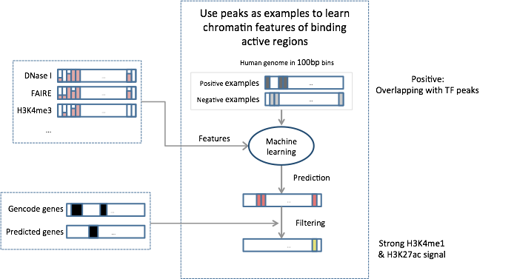

2.XXX While the goal of individual production groups includes the annotation of almost each known class of functional element (enhancers, promoters, insulators, coding and non-coding transcripts and splice forms, miRNAs, 3’UTRs), it is rare that any single element type uses only data from a single group. Thus, pairwise or multi-way data integration is needed in order to most accurately annotate each class of functional elements. Such analyses could be done by either group involved (using the other group’s data), or by ad-hoc consortia formed around specific analyses. However, as integrative analyses often requires rigorous statistical underpinnings, complex machine learning methodologies, and similar efforts in different species, they are best done by leveraging the combined computational and biological expertise of the entire Consortium, and thus best done in the context of the AWG, which the DAC can facilitate.
Methods: We have structured this aim around different classes of elements to be annotated, and for each class we propose specific analyses that we foresee as important, including enhancers, promoters, insulators, and other regions of active chromatin (Aim 3.1), transcribed protein-coding and non-coding RNAs and their upstream and downstream regulatory regions (Aim 3.2), prediction of gene expression level and alternative splice forms using chromatin and TF binding signals (Aim 3.3), prediction of TF binding sites in new cell lines (Aim 3.4), and the definition of pre- and post-transcriptional regulatory networks based on transcription factor binding in promoter and enhancer regions and miRNA targeting in 3’UTRs (Aim 3.5); although, these activities will be prioritized in our interactions with the AWG and be limited by data availability.
2.XXX. Data integration for defining promoters, enhancers, insulators, and repressors.
While the signals of transcription factors, chromatin remodelers, chromatin marks, histone variants, nucleosome positioning, and DNase hypersensitivity have all been shown to be predictive of regions of regulatory importance, the precise combinations of these signals that distinguish enhancers, promoters, and insulators are still unclear. With the number, density, and resolution of genome-wide assays that are currently becoming available, we have a unique opportunity to systematically study the precise combinations of genomic features that are most predictive of each type of element. Transcription start sites (TSSs) as defined by CAGE analysis provide true positives for promoter regions, and also allow us to distinguish between constitutive and condition-specific promoters, and between single-promoter genes and alternative promoter genes. Growing datasets of regions able to drive tissue-specific gene expression in enhancer assays provide true positives for enhancer regions. Mapping of enhancer-associated chromatin marks (e.g., H3K4me1 and H3K27ac) and enhancer binding proteins (e.g., p300) are being performed for many cell lines in ENCODE.
In each of these cases, we would like to know which combinations of genomic features are most predictive of each type of region and most likely contribute to its establishment, maintenance, and recognition. We will use feature selection methods within a supervised learning framework, such as in decision trees, support vector machines (SVMs), Bayesian, and regression methods. As input features we will use chromatin marks, binding of sequence-specific and general TFs, chromatin remodeling factors, chromatin accessibility, and nucleosome density. We will also include sequence features such as nucleotide composition, combinations of regulatory motifs, and sequence/motif conservation in closely related species.
Our ultimate goal is not only the systematic annotation of each functional element in these genomes, but also new mechanistic insights into the interplay between different functional elements, and we will work closely with the AWG and Consortium members to design computational and experimental tests to evaluate the role of the most informative features.
2.XXX. Data integration for defining protein-coding and non-coding genes and transcripts.
To characterize coding and non-coding transcripts, we will integrate RNA-seq data, promoter-associated chromatin marks, transcription elongation-associated chromatin marks, and comparative genomics of related species.
Transcriptional evidence: Several types of data generated by ENCODE provide transcriptional evidence⁵⁶: RNA-seq can be used to derive the structure and level of transcripts, CAGE determines the precise positions of the 5’ ends of transcripts, and RNA-PET (also called diTAGs) provides connectivity for the 5’ and 3’ ends of transcripts. Moreover, ENCODE has generated transcript data with high-density (5 bp) tiling DNA microarrays for some cell lines.
Chromatin evidence: We have found that distinct combinations of chromatin marks and chromatin accessibility are associated with promoter regions, transcribed regions, and transcription termination regions. Surprisingly, internal exon-intron boundaries are also associated with distinct chromatin marks and nucleosome positioning biases⁵⁷, suggesting that these can be used as an additional line of evidence in defining transcript boundaries, especially with respect to low-expression genes for which the transcriptional evidence may be weaker. We have recently used such marks to discover more than a thousand novel long intergenic non-coding RNAs (lincRNAs) in mouse⁵⁸ and more recently in human²⁴.
Comparative evidence: The Kellis lab identified evolutionary signatures that are uniquely associated with each class of functional elements⁵⁹, with protein-coding genes showing distinct patterns of codon substitution frequencies and reading-frame conservation, non-coding RNAs showing compensatory changes and silent GU-involving substitutions, miRNAs showing a distinct conservation profile (high conservation in the star and mature arm and lower conservation in loop and flanking regions), and other structural conservation properties. We used these signatures to reveal at least 30 non-coding genes in the fly genome using modENCODE transcript data and comparative genomics of 12 Drosophila species⁶⁰. We will apply a similar approach to human and mouse ENCODE data.
Combinations of features: We will combine these transcriptional, chromatin, and comparative features to distinguish different classes of genes in a machine learning framework. We will use Support Vector Machines to classify each transcript into coding or non-coding. We will also apply a previously developed Conditional Random Field (CRF) framework to predict coding and non-coding exons and transcripts from the combined evidence. CRFs are graphical probabilistic models similar to Hidden Markov Models (HMMs) but they allow much richer feature sets due to their discriminative training nature. Lastly, we will associate non-coding RNAs with precursors of miRNAs, piRNAs, and other classes of small RNAs using short-RNA sequencing results.
Identification of non-coding RNA genes: We will utilize an integrative machine learning approach for identifying novel non-coding RNA (ncRNA) genes¹⁷. The method is based on support vector classification to classify non-coding RNAs from other elements like coding sequences and UTRs. For each non-coding RNA, a set of features are computed which are then used for training. These features comprise the quantities that are chosen to maximize the discriminatory power of the machine-learning algorithm. For example, high short RNA-seq expression levels, high secondary structure stability and conservation, medium nucleotide conservation, and low amino acid conservation are the expected characteristics for the non-coding RNAs. The machine learning algorithm enables combining these features for prediction of the new ncRNAs in a formal manner. The known non-coding RNAs are utilized as the training set for the method. We will then apply the method on the remaining unannotated parts of the genome to discover novel non-coding RNA genes.
2.XXX Correlating gene expression with TF binding and histone modifications: Transcriptome monitoring by RNA-seq can provide accurate genome-wide estimates of the steady-state abundance of transcripts. Such estimates are essential to fully understand the pathways involved in RNA biogenesis. A number of genetic and epigenetic factors cooperate to determine the abundance of a specific RNA species in a particular cellular compartment: 1. signals in genomic DNA and in intermediate RNA molecules, e.g., TF binding sites, splicing regulatory sites, and polyadenylation signals; 2. the structure and status of chromatin; and 3. the abundance and concentration of the regulatory molecules—including both proteins and RNAs themselves. The relative contribution of each of these factors and their mode of cooperation, are largely unknown. The goal of the ENCODE Project is to simultaneously monitor many of these factors across multiple cell conditions and types.
Given the gene expression data from RNA-seq and the TF binding or histone modification data from ChIP-seq experiments, the Gerstein and Weng labs have investigated their relationship in a quantitative fashion^{5,61}. We have previously constructed TF models and histone modification models in different species from yeast to human^{18,62,63}. Our results indicate that both TF binding and histone modifications are predictive of gene expression levels in a position dependent manner, and either account for at least 50% of gene expression level variation. The histone modification model accurately predicts gene expression in a wide chromatin region from the promoter to the transcribed regions, whereas the TF model achieves high accuracy only in a narrow chromatin region around transcription start sites (TSSs) of genes (Figure 4). Our study also indicates that TF and histone modifications are highly coordinated during transcriptional regulation and a combination of TF and histone modification signals does not further improve prediction accuracy relative to using each alone.
Based on the CpG content, promoters of genes can be divided into high CpG (HCP) and low CpG (LCP). Interestingly, we find that expression levels of HCPs are easier to predict than those of LCPs⁵. More detailed analysis indicates that the relative importance of TFs and histone modifications in the models are different between the two promoter categories. These results suggest different regulatory mechanisms between HCPs and LCPs. The prediction accuracy of TF and histone modification models to some extent reflects the quality of the expression data. For example, the models achieve significantly higher accuracy for expression measured by RNA-seq than by microarray. In addition, the models can also be used to predict the expression levels of non-coding RNAs (miRNAs) with fairly high accuracy. In the future, we suggest using the TF and histone modification models as a benchmark to understand transcription regulation.
Predicting alternative splicing using chromatin modifications and TF binding. We propose to investigate how inclusion levels of alternative exons covariate with histone modifications and TF binding, which will help us understand how these factors cooperate to modulate the specific abundance of RNA splice variants in the cell. Sophisticated probabilistic models have been recently developed to successfully predict tissue specific exonic inclusion⁶⁴. However, the splicing code delineated in such a way includes hundreds of variables, many of which are concomitant but unlikely to be mechanistically involved in splicing. Within the current phase of ENCODE the Guigo lab has used statistical models to explore the relationship between levels of histone modifications and inclusion of exons. We found that, even when controlled for gene expression, some histone marks (e.g., H3K9ac and H3K36me3) are consistently significant (albeit weak) predictors of exon inclusion, and we built a predictive model of exon inclusion by combining the signals of these marks^{25,28} (Figure 5). By computing a measure of splicing completion on RNA-seq datasets obtained in different sub-cellular compartments, we found strong evidence that splicing in the human genome occurs predominantly during transcription²⁹, providing a molecular justification to the increasing evidence connecting chromatin with splicing⁶⁵. We propose to further develop and apply statistical methods to the data obtained through the ENCODE Project, as well as to other publicly available data, to identify novel genetic and epigenetic factors involved in RNA processing, splicing in particular. We propose to:
1. Identify and characterize histone modifications that play a role in the regulation of alternative splicing, using correlation and modeling analysis.
2. Apply methods used to investigate the distribution of TF binding sites in promoter regions to investigate their distribution in exons and exon-intron boundaries. We will further correlate exon skipping events, as measured by RNA-seq, with differential binding of TFs.
3. Identify novel regulators of splicing by searching for co-variation between the levels of exon inclusion (or alternative splicing events in general) and gene expression. This approach will uncover protein coding genes not yet known to play a role in splicing regulation, and more interestingly, lncRNAs that may act as splicing regulators. The RNA expression levels of protein coding genes are only a proxy for protein expression—the latter is the effector of the biological function. In contrast, expression levels of lncRNAs are almost the actual physiological levels. Inferences based on co-variation between exon inclusion and abundances of lncRNAs are therefore more likely to be biologically meaningful.
4. We will investigate the relationship between RNA expression levels, protein expression levels, and protein binding activity—both to DNA and RNA—for transcription and splicing regulators, and determine how they relate to cellular abundance of the regulated RNAs.

2.XXX Associate TF/miRNA with their targets:
Given a high-quality annotation of enhancers, promoters, insulators, protein-coding genes (including all transcription factors, TFs), microRNAs, and other non-coding RNAs, we will work to piece together regulatory networks based on condition-specific TF binding, conserved TF motif instances in active promoter and enhancer regions, and conserved miRNA motif instances in 3’UTRs. The Kellis lab previously showed that comparative genomics of the 12 Drosophila genomes enables the high-accuracy definition of regulator targets, and that combining comparative genomics with condition-specific TF binding led to a further increase in signal⁶⁷.
Binding vs. regulation: We will use condition-specific changes in gene expression levels of TFs, miRNAs, and their targets to distinguish ‘biochemical’ binding from ‘biological’ transcriptional regulation. The Kellis lab previously showed that bound motifs associated with expression changes are under stronger selective pressure across related species, and show stronger functional enrichments⁶⁷. This suggests that we can use positive or negative expression changes to further annotate our inferred transcriptional networks with activation, repression, or simply binding edges, when no effect is detectable. We have further characterized the chromatin and sequence context of each of these three classes of edges, to search for predictive features of each class that could lead to new insights on the logic of gene regulation⁶⁸.
2.XXX Associating enhancers with target genes
The logic by which enhancers are linked to promoters of their target genes is still unclear. We will evaluate the role of insulator regions, spatial proximity, chromatin marks, binding of complementary or synergistic TFs, motif content, and association with general and specific TFs in determining enhancer-promoter specificity. The Kellis lab uses co-expression of regulators and their targets to tentatively assign enhancers to promoters, and search for additional features supporting these assignments⁶⁸. The Gerstein lab has used ENCODE ChIP-seq data to identify enhancers and connect them to target transcripts⁶⁹. Using TF binding regions as the gold standard, a statistical model was trained on chromatin features (e.g., histone modifications from ChIP-seq experiments, DNase I hypersensitivity assay) to discriminate TF-binding regions from non-TF-binding regions. TF-binding regions that are distal from TSSs, evolutionarily conserved, and exhibit specific enhancer histone modification signals (e.g., H3K4me1) are deemed enhancers. They can then be connected to transcripts based on statistically significant correlation of histone mark intensity and transcript expression values across cell lines. A fraction of these predicted enhancers were validated by in vivo transgenic assays⁶⁹. We can apply these methods to ChIP-seq data in more tissues/cell-lines in human and in more organisms (mouse, worm, and fly). More ENCODE experiments in tissues/cell lines will help to increase the statistical power to pair enhancers and genes, which will facilitate better understanding on distal regulation of gene expression. Enhancers and other distal regulatory regions also drive evolution. We will apply the methods to more organisms to yield a valuable resource for cross-species dynamics comparison.
2.XXX miRNA regulation: A complete view of mixed TF/miRNA pre- and post-transcriptional networks requires accurate promoter and enhancer annotation for miRNA precursors, and accurate tissue- and stage-specific 3’UTRs for all miRNA target genes. Kellis led the fly modENCODE integrative paper and generated TF/miRNA regulatory networks⁶⁰ (Figure 7) and we will perform similar analysis on human and mouse ENCODE data. We will use chromatin marks to annotate miRNA promoters based on genomic proximity and tissue-correlated activity. We will use the longest 3’UTR from updated gene models combined with multi-species sequence alignments based on the most up-to-date genome alignments with all sequenced species to identify evolutionarily conserved 3’UTR target sites. We will search for and re-evaluate previously-discovered 3’UTR motifs that were not associated with miRNAs to determine whether we can now identify putative trans-acting agents that may mediate regulation through these sites. We will also evaluate the potential for other non-coding genes to serve as targets for miRNA regulation. Lastly, we will study the effect of alternative polyadenylation sites on miRNA regulatory networks. We have identified many such sites within protein-coding transcripts resulting in loss of key functional miRNA binding sites, which may play key roles in altering regulatory relationships during development and proliferation. We will look for anti-correlations between miR NAs and their predicted targets, and assess whether transcripts with short vs. long 3’UTR isoforms which exclude or include conserved miRNA binding sites, differ in expression in the presence of cognate miRNAs. This may have major implications for human gene regulation as well, as the Burge and Sharp labs reported that proliferating cells, and by extension cancer cells, preferentially shift towards shorter transcript isoforms that escape miRNA regulation⁷⁰.

2.XXX The volume of ChIP-seq data generated by the scientific community outside of ENCODE effort has been increasing exponentially in the last several years. Data analysis involving the integration of ENCODE data with other public ChIP-seq data may yield more reliable biological insights. In collaboration with Prof. Yong Zhang at Tongji University in Shanghai, the Liu lab is collecting and processing all ~5000 publicly available ChIP-seq data in human and mouse to make a Cistrome Data Collection. Once the data collection is in place, we will create data import functions to allow users to readily take advantage of these data for integrative analysis. We will deploy the quality control measures in the analysis pipeline described above to assess the quality of these data. We will also implement a community-based data ranking system. In ways similar to those used by Amazon to rank books, we will monitor and keep track of the number of times a dataset is downloaded or imported into Cistrome (by volume), and allow registered Cistrome users to rank the usability and quality of specific data (by stars). This will provide incentives for the data generators to provide higher quality data with better annotations, and enable more informed and efficient data reuse.

Applying Segway to ENCODE3 data
One of ENCODE’s primary activities is the generation of massive genomics data sets. A concomitant challenge is to develop sophisticated computational strategies to facilitate human interpretation of these data. During the pilot phase of ENCODE, we combined a hidden Markov model (HMM) with wavelet smoothing to produce a two-label annotation of the ENCODE pilot regions into “active” and “repressed” regions 27 (); 28 (), and we produced a software tool capable of automatically creating annotations using any user-specified number of distinct labels 29 (). We refer to the simultaneous partitioning and labeling of the human genome as “semi-automated genome annotation” (SAGA). It is semi-automated because the integer labels produced by the model must be interpreted in a human post-processing step.
A variety of SAGA methods have been described subsequently, employing HMMs with flat 30 (); 31 () or hierarchical structure 32 ()-34 (), or generalizing the HMM to a hierarchical change-point model 35 (). In particular, during the second phase of ENCODE, two research groups within the consortium (Noble and Kellis) independently developed SAGA algorithms, ChromHMM 36 () and Segway 37 (). The two methods employ closely related probabilistic models that offer multiple important advantages, including efficient algorithms for carrying out inference and a modeling paradigm in which the model’s internal variables have well-defined semantics. The two approaches are complementary, in the sense that ChromHMM aims for a birds-eye view of the data, opting to collapse each 200 bp of data to a single Boolean value, whereas Segway is capable of providng a more detailed view, operating on the data at up to its native 1 bp resolution. These complementary methods continue to be widely used, and are currently being applied systematically to the combined compendium of ENCODE+Roadmap data in both human and mouse.

A | 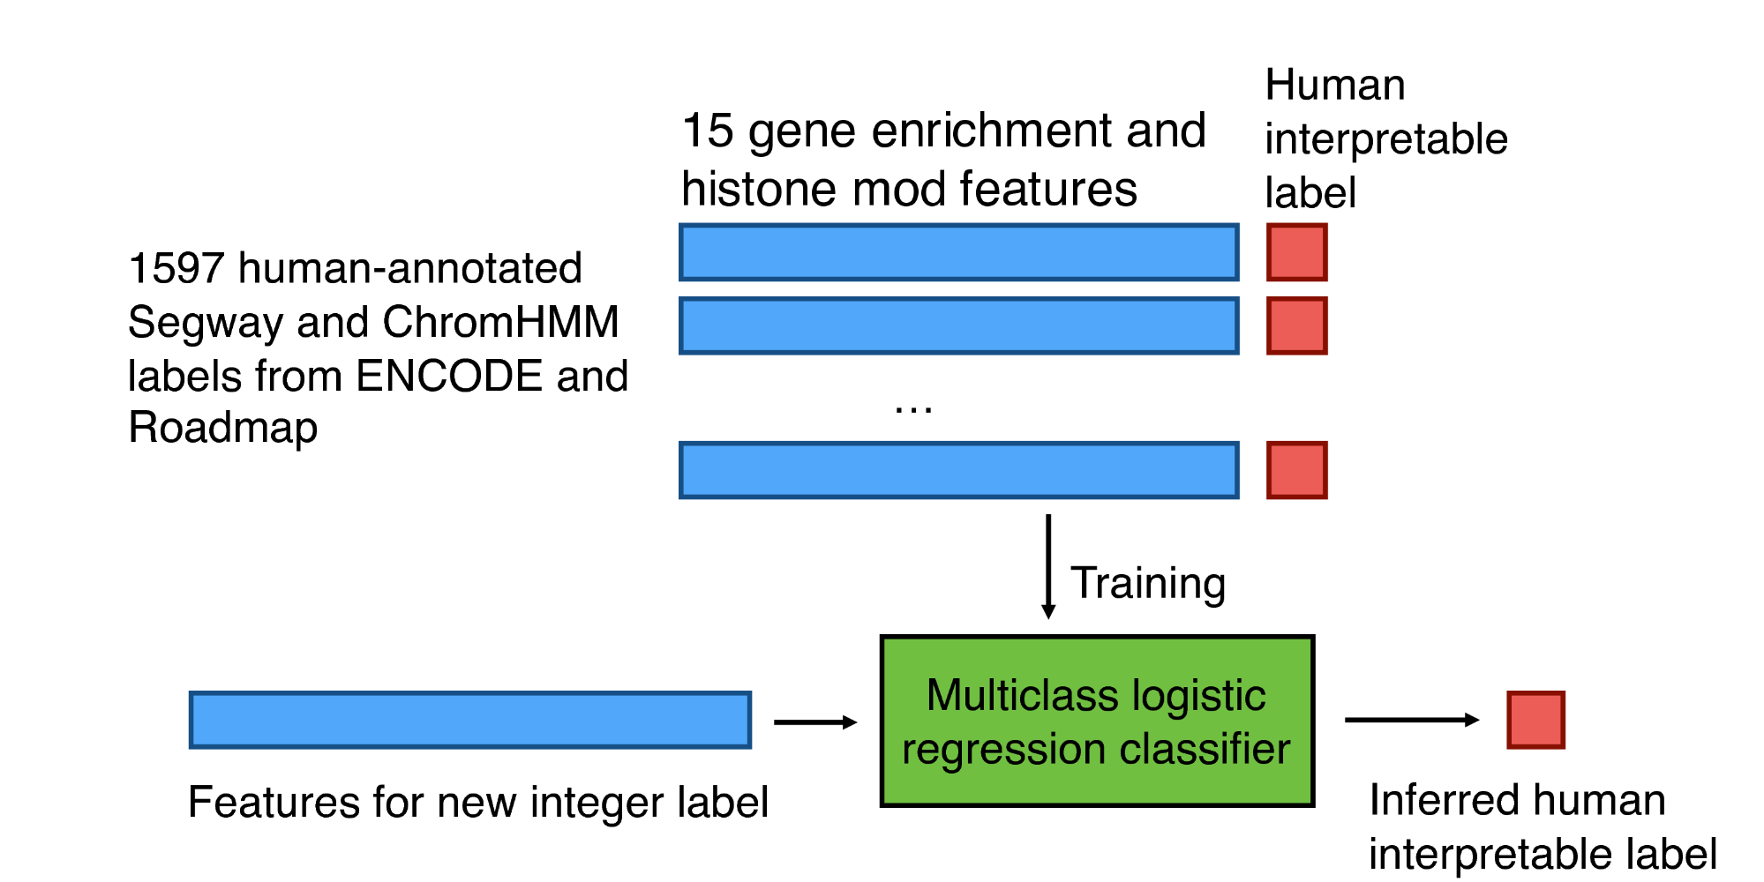 | B | 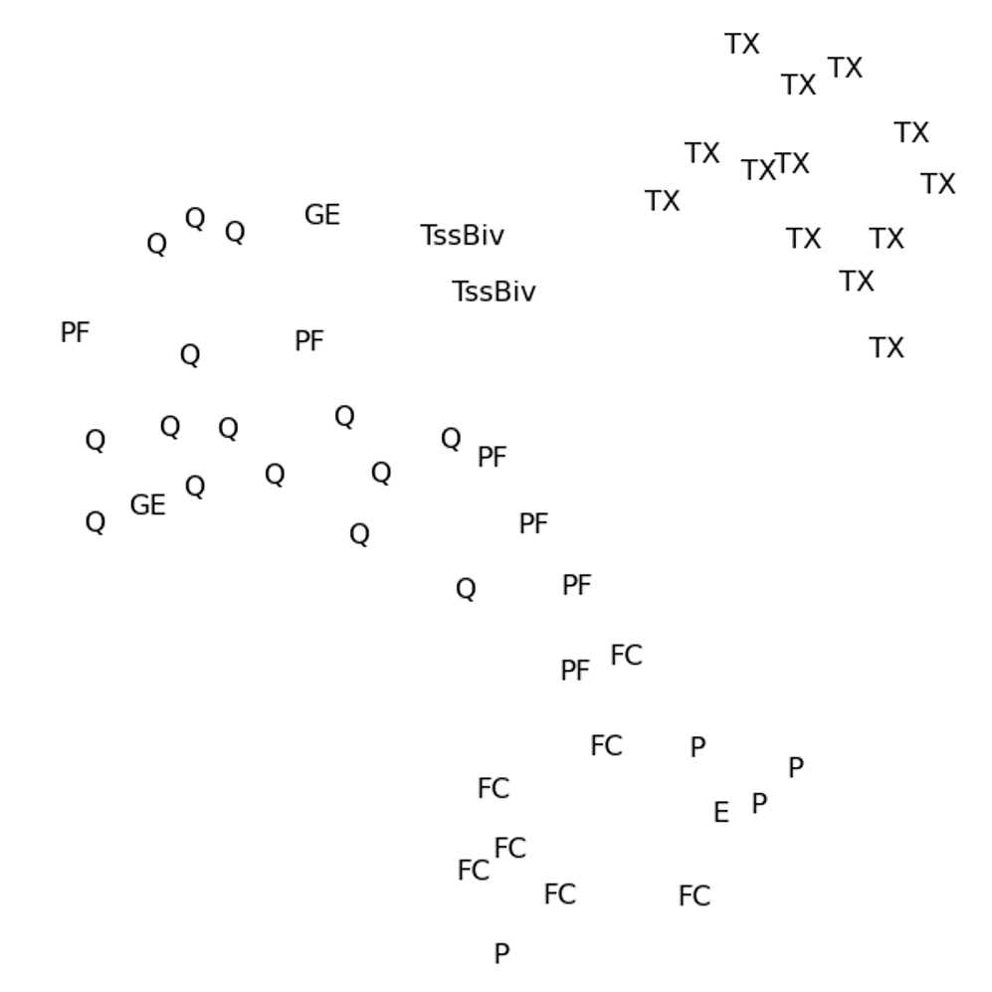

Figure 2: (A) Machine learning strategy for assigning human interpretable labels to Segway outputs. (B) 2D projection of the emission parameters of the labels from one cell type (GM12878), with mnemonic labels assigned by the classifier. Projection is done using t-SNE 38 (). The ten labels are P (promoter), PF (promoter flanking), E (enhancer), EB (bivalent enhancer), GE (enhancer inside a gene), TX (transcribed), CR (constitutively repressed region), FH (facultative heterochromatin), ZNF (zinc finger gene region) and Q (quiescent).
As part of the current annotation effort, our Segway annotation incorporates several recent improvements, including the ability to train on the entire human genome using a minibatch training mode, and modeling of emission distributions within each state of the model using a mixture of Gaussians rather than a single Gaussian. In addition, we have developed and validated a method for automatically assigning human interpretable labels to an annotation (Figure 2A). The method leverages the observation that, by now, a relatively large number of manually interpreted SAGA annotations have been published. We therefore trained a supervised classification algorithm to automatically assign one of ten labels (“Enhancer,” “Promoter,” etc.) to an integer label produced by Segway, using as features the pattern of histone modifications and gene enrichments associated with the labeled segments. In a cross-validated setting, this approach achieves an accuracy of 98.3%, and similar learned labels tend to fall close togther in a 2D projection (Figure 2B).
During the next phase of ENCODE, we intend to improve upon Segway in three significant ways.
First, we will augment Segway with learned networks representing pairwise relationships between cell types and assay types. The idea here is to down-weight correlated contributions from related assay types and, in the context of multi-cell type annotation, to encourage related cell types to have similar annotations. The feasibility of this type of network learning has been demonstrated in recent work on learning complex chromatin states 39 (). A more scalable approach has also been outlined for large sets of histone modification assays 40 (). The Graphical Models Toolkit (GMTK) software with which Segway is implemented will allow us to easily augment Segway to incorporate priors derived from these learned networks. This will allow us to avoid the mean field approximation required by a previous method that infers a tree over cell types 34 ().
Second, we will extend Segway to implement a hierarchical state space. Our current Segway annotation effort is being performed at three different resolutions, 10 bp, 100 bp and 10 kbp. These complementary annotations capture phenomena at different scales, from fine-scale phenomena such as regulatory elements up to large-scale domains 41 (). Several published reports describe hierarchical approaches that jointly capture phenomena at different scales 42 (), including methods that employ hierarchical probability models akin to the one used by Segway 32 (); 33 (). We will implement within Segway our previously described conjugate priors approach 35 (), in which the parameters of a substate are generated by the emissions from its parent state. Each top-level label is associated with some number of sub-labels. A top-level labels might be “enhancer,” whereas a low-level label might be “H3K27ac region upstream of enhancer TF binding site” or “enhancer nucleosome free TF binding site.” We will also experiment with applying hierarchical models in the context of multi-cell type annotation. In such a setting, the model might learn a latent “potential activity types” vector at each position that specifies a distribution over possible labels for each position. Doing so would discourage one cell type from calling a position, say, “promoter” if no other cell types show evidence for having an promoter in that position.
Third, we will develop a variance stabilization method to cast the inputs to Segway into interpretable units. In general, the output of a genomics assay—the number of reads mapping to a given genomic position—has no natural units. In particular, a difference between 0 and 30 reads may have a very different statistical importance from a difference between 1,000 and 1,030 reads. This property is due to a relationship between the mean of the data-generating process (i.e. the genomics assay) and its variance. In practice, the different mean-variance relationships among the heterogeneous inputs to Segway make the statistical modeling problem much harder.
Currently, to attempt normalize for the mean-variance relationship of the sequencing read counts, we preprocess the inputs to Segway using an inverse hyperbolic sine transform. However, there is no theoretical basis for using this particular transformation. On the other hand, given a known mean-variance relationship, a data set can be put into interpretable units using the variance-stabilizing transformation , where σ(x) is the standard deviation of a variable with a mean of x. The resulting signal is in units of standard deviation, so it has the useful property that all data points have a 95% confidence intervals of ∼2 units.
We will therefore investigate methods to learn the mean-variance relationship of functional genomics data sets using the variation among biological replicates. This problem involves optimizing an objective of the form , whereas most existing approaches for learning functions—such as using splines or Gaussian processes—are designed for a squared-error objective of the form . We will then use the learned mean-variance relationship in combination with a negative binomial distribution to place Segway inputs into interpretable units. We expect this transformation to significantly improve the robustness and interpretability of the resulting models and annotations.

Discovery and characterization of chromatin states: During the pilot phase of ENCODE, the Noble lab combined a hidden Markov model (HMM) with wavelet smoothing to produce a two-label segmentation of the ENCODE pilot regions into “active” and “repressed” regions^{2,71}. A variety of segmentation models have been described subsequently, employing HMMs with flat^{72,73} or hierarchical structure⁷⁴, or generalizing the HMM to a hierarchical change-point model⁷⁵. During the scale-up phase of ENCODE, the Kellis and Noble labs independently developed segmentation algorithms, ChromHMM⁷⁶ and Segway⁷⁷, and applied them to human ENCODE data⁷⁸ and fly modENCODE data⁶⁰ (Figure 8). The model summarized information from all one million combinations of chromatin tracks (n=2^20) into a small number of states (n=25), corresponding to distinct enhancer, promoter, and transcribed states, without any prior knowledge of annotation information. These states show distinct functional enrichments, confirming their distinct biological functions. They also provide a chromatin context for understanding binding of sequence-specific factors, motif enrichments, and other diverse functional elements, such as origins of replication or insulator regions. The two methods employ Could you closely related probabilistic models that offer multiple important advantages, including efficient algorithms for carrying out inference and a modeling paradigm in which the model’s internal variables have well-defined semantics. The two approaches are complementary: ChromHMM aims for a birds-eye view of the data, opting to collapse each 200 bp of data to a single Boolean value, whereas Segway provides a more detailed view, operating on the data at its native 1 bp resolution.
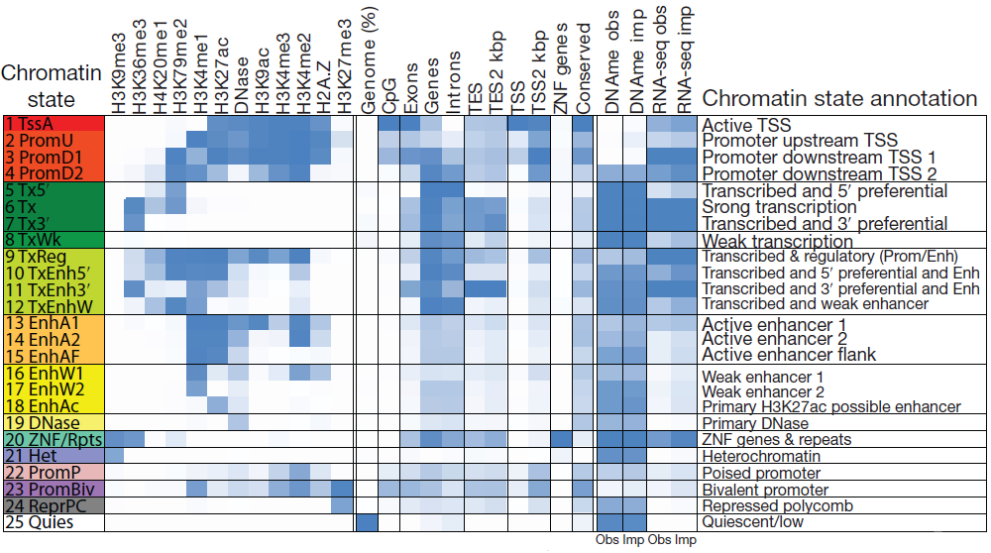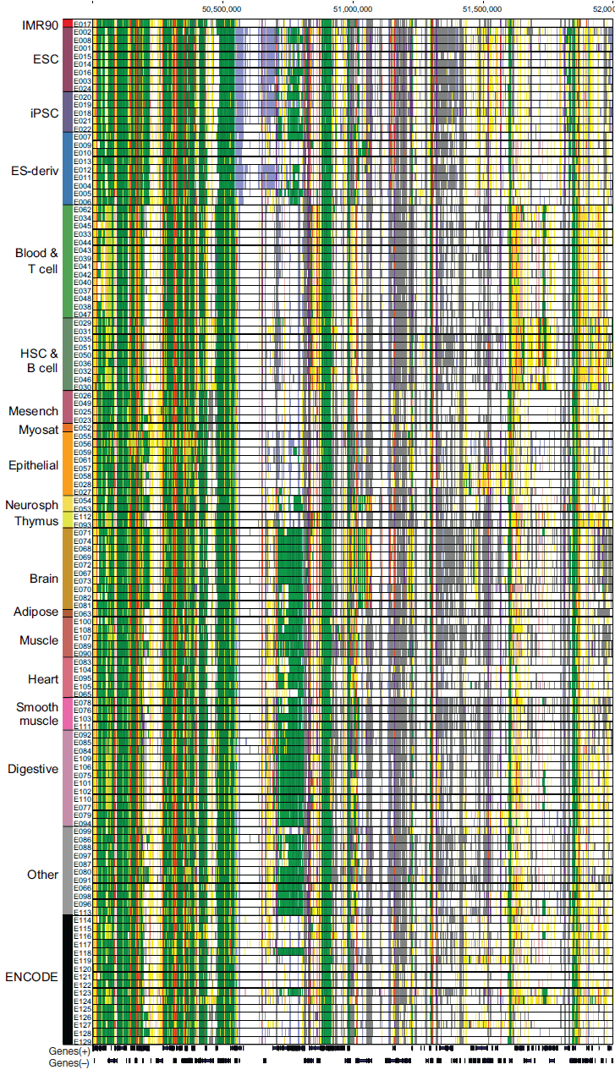
Application of ChromHMM

For the next phase of ENCODE, we propose to improve upon and extend these methods in three significant ways. Ultimately, these unsupervised and semi-supervised learning methods will provide a scalable way to integrate all of the ENCODE data, along with human annotations, to provide a joint annotation that summarizes, at multiple scales, our knowledge of the functional landscape of the human genome in various cell and tissue types.
1. Large-scale behavior. In addition to identifying relatively small functional elements such as exons, promoters, enhancers, etc., we will develop methods to automatically characterize structures that are >10 kbp in size. Such structures might correspond, for example, to chromatin domains that have important functional impacts on gene expression. To capture such phenomena, we will explore a three-pronged approach. First, we will apply a combination of interpolation and wavelet smoothing to pre-process the ENCODE data to a desired resolution, leading to segments of a desired size. This approach was used successfully in the pilot phase of ENCODE^{2,71,79}. Second, we will investigate the use of hard and soft constraints to automatically adjust the size of our inferred segments. These methods are already implemented within the Segway annotation algorithm, but have not yet been extensively tested. Third, we will implement a hierarchical model, in which the annotation consists of two layers of labels: small sublabels enclosed within larger superlabels. The emission distributions in the model will mimic the model topology, in the sense that the parameters of the sublabel emissions will themselves be random variables following a probability distribution defined at the superlabel level. A similar hierarchical model has been previously employed to model genome-scale data⁷⁵. We will validate all three of our approaches to modeling large-scale behavior by investigating the relationship between the domains identified by our algorithms to domains identified on the basis of the genome sequence or from Hi-C data⁸⁰, as well as by comparison with known boundary elements⁸¹.
2. Soft supervision. One of the major outputs of ENCODE is the high quality GENCODE annotation, but this information is not currently exploited by our automated annotation engines. We already have the ability to perform semi-supervised learning, in which examples of a known type of functional element are constrained to be assigned a specified label; however, such an approach requires cell type-specific annotations of elements. We will therefore implement a “soft” semi-supervised learning scheme in which a given set of genomic loci are encouraged, but not required, to receive a specified label. Such an approach can be easily implemented in a probability model using a method known as “virtual evidence”^{82,83}. Using this approach, for example, we might tell our annotation system about the existence of known TSSs without specifying whether any particular TSS is active in a given cell line or not.
3. Improved learning. A probability model that attempts to summarize dozens or even hundreds of genome-wide datasets necessarily contains a large number of trainable parameters. Consequently, optimization of these parameters may be subject to local optima, and in the presence of very high-dimensional data, may occur with respect to unrealistically complex optimization surfaces. Measure propagation is a recently described algorithm for graph-based semi-supervised learning that propagates distributions over a graph^{84,85}. It uses an objective function that consists of a sum of a number of KL-divergence terms. This objective is convex and is easily optimizable using a message-passing algorithm. We propose to interleave this measure propagation algorithm with our existing, expectation-maximization (EM) approach. In the measure propagation step, the graph will be formed from a similarity measure defined over loci in the genome, where the similarity may be based on a variety of types of biological knowledge or hypotheses. The output of the measure propagation would then be used as soft labels during the next round of EM training. This approach has the potential to vastly improve the learning power of our system by simultaneously integrating local context (via the Markov chain embedded in segmentation model) and global structure of the data (via the graph used in measure propagation). This computation is feasible: measure propagation scales to graphs of size 120 million nodes⁸⁶. We will directly measure the improved performance by cross-validated testing of our ability to identify known functional elements.

Linking enhancers to their putative target genes
Once we identified these gene regulatory regions such as enhancers, we want to construct gene regulatory networks based on regulatory regions. For example, in the regulatory networks, the regulatory factors can connect to their target genes if they bind to the enhancers and/or promoters of the target genes. We will comprehensively define associations between many non-coding regulatory elements and their target protein-coding genes. The correlation between enhancer and promoter activity across the ENCODE cell-lines and different tissues will be used to identify significant associations between regulatory elements and candidate target genes, as done by Yip et al \cite{Yip, 2012 22950945}.

We then can further identify the key regulatory factors such as ‘hub’ enhancers by analyzing regulatory networks. Recently, large-scale efforts (e.g., the Epigenome Roadmap and GTEx projects) have also been directed toward annotating human epigenome data, as well as understanding the influence of genomic variation on the gene expression profiles. These Expression Quantitative Trait Loci (eQTL) can further be utilized to infer enhancer gene linkage.

eQTL indicates the quantitative relationship between genomic variants and gene expression. It can be classified into two categories according to the underlining mechanism. eQTLs that affect the proximate gene are called cis- or local-eQTL, while eQTLs that stay far from its target gene are distal- or trans-eQTL. cis-eQTL usually tend to locate in promoter region of gene that have ASEs. trans-eQTLs act distantly by overlapping with distal regulatory elements and forming spatial chromatin structure, which can provide us a source to explore distal enhancer gene interaction pairs. To incorporate the eQTL effect, we will incorporate an eQTL score as a part of spatial structure feature to predict enhancer gene linkage. The LD region of trans-eQTL will be considered, and the mediation effect of a trans-eQTL acting as cis-eQTL on the proximate gene will be exclude if the proximate gene has high correlation with its distal target genes.

We are further developing a new method called ENGINE (Enhancer Gene Interaction detection) to detect enhancer gene linkage (Fig.xxx). ENGINE will integrate structural, static and dynamic genomic information. The sequence features are denoted by K-mer profile and co-occurrence matrix, while the dynamic features include DNase I, histone modification and TF binding information. We do the transformation for histone mark/DNase signals and extract informative features that can tell positive from negative datasets. Meanwhile, gene expression variance, is also integrated as an additional feature into a statistical model to predict enhancer gene linkage.

Please do not delete ,,,, marks in Aim 3
Aim 3. Serving as an informatics resource by supporting the activities of the ENCODE Analysis Working Group (AWG).
3.1 Assist AWG in defining and prioritizing integrative analysis
,,,,,keeppar The wealth of data from the ENCODE Project will lead to biological insights only if well-defined analyses are performed with appropriate computational methods in a reasoned priority. The large number of possible analyses could lead to confusion or even stagnation if not prioritized wisely. Thus, the design of the DAC has placed a strong emphasis on posing questions that are potentially the most informative and prioritizing the work flow. The AWG is responsible for selecting the questions to be addressed and solved. This will be done in consultation with the DAC, which will provide feedback on feasibility, resource requirements, time-lines, etc. The DCC and data producers also play important roles in selecting the questions. The AWG includes other members, such as the production PIs, bioinformatics members of the production groups, members of the U01 groups interested in participating in integrative analysis, and other informatics groups loosely associated with the Consortium. The DAC will work on analyses formulated by the AWG, coordinating closely with the DCC and data producers, and to some extent with the computational groups funded by the U01s. The types and details of the analyses will be determined during the course of the project, and we provide example analyses throughout this proposal.
The interactions among AWG, DAC, DCC, production groups, and interested U01-funded analysis groups are best explained in the context of the entire work-flow for DAC, from experimental data through to analysis results. Much of the initial specific analysis of each dataset will occur by the appropriate production group, e.g., peak finding in ChIP-seq data and transcript identification in RNA-seq data. The DAC aims to establish specific contacts with the bioinformaticians in each production group and the DCC, in order to keep up-to-date with the nuances of the specific data types which can benefit integrative analysis. Furthermore, the DAC can assist the primary analysis in several ways: controlling data quality, maintaining data format consistency, and providing analysis pipelines.
,,,,,keeppar Moving beyond the primary data processing, the main source of work will be biological questions or analysis directions posed by the AWG. The DAC leadership committee (Profs. Weng, Kellis, and Gerstein) will assign them to a group for investigation and determination of whether there are existing methods that have both appropriate statistics and are scalable to genome-wide techniques. When an existing method is appropriate, the analysis will be run. Depending on the type of the analysis, the results will be reported either as data integrated into the genome browser and/or a new pipelined approach provided for regular use by all users, in particular other members of the ENCODE Consortium.
For some questions, new statistical methods are required as some existing methods do not scale for genome-wide datasets. We may be able to draw upon the strengths of some U01 groups. An example is Prof. Peter Bickel or Prof. David Gifford. In these cases we will invite these U01 groups to perform or participate in the analysis. For other questions, we will create a small group of DAC members to focus on the problem, in many cases starting with developing new statistical methods, followed by algorithmic/engineering analysis for genome-wide scalability. The statistical methods are likely to be novel applications of the broad collection of statistical and machine-learning tool kits, but the precise outline of what models to build and test requires a complex interaction between statisticians, bioinformaticians, and biologists. Once a new method has been successfully created and scales well, this method can then be appropriately pipelined. Some problems will require us to recruit expertise outside the Consortium. We have established a procedure to invite outside investigators to join the AWG and fund some of their efforts through the DAC (see the PI Leadership Plan).
We expect to quickly have more tasks than resources, in particular because we expect to have a steady flow of tasks to change existing ad hoc analysis schemes into methods that can either be pipelined or provided as end-user tools. As the number of questions posed by the AWG mounts, they will need prioritization. We will schedule our work in a completely transparent manner, with any priority disputes being resolved, and with the AWG having the final say on priorities. Figure XXX outlines the management of the prioritized list of tasks being performed by the DAC.
,,,,,keeppar As in the current phase of ENCODE, we will organize a weekly conference call for the entire AWG. The call at the beginning of each month will be open to any member of the Consortium and used to report progress from the previous month and discuss the prioritization of the active tasks. DAC members will provide estimates on the relative “cost” of each task, and the optimal groups to handle each task. New tasks are generated by the AWG and by DAC members suggesting new pipelining or engineering approaches to make existing ad hoc methods more robust. Although the DAC members can suggest tasks and obviously must be involved in the assessment of matching tasks to groups, we will strictly enforce the prioritization by the AWG to ensure that the DAC does the analysis the Consortium needs.
The DAC will ensure openness by inclusiveness in its working practices and a formal prioritization process from the AWG. To ensure inclusiveness, the DAC will conduct all meetings in formats that allow any ENCODE Consortium member to join and participate as equal members in the analysis. The progress of analysis will be posted on the ENCODE Wiki, again allowing complete access by other Consortium members. The progress of DAC analysis tasks will be reviewed and future priorities set in an open forum with the AWG and related ENCODE Consortium members, under the working principle that the AWG is the final arbiter of any priority dispute. DAC members will be available, given practicalities, for any AWG-proposed meeting. AWG phone calls will be chaired by the three members of the DAC leadership committee, with the three members changing their roles between incoming, outgoing, and incumbent chairs in a weekly rotation. This structure is modelled on the existing ENCODE PI calls and has proven to work effectively.
The members and leadership of the proposed DAC recognize that the proposed work flow and management is quite different than the usual mode of working on investigator-initiated projects. The DAC will be responsive to a wide range of inputs, with problems defined and prioritized by the AWG, close coordination with the DCC, and inclusion of other members of the ENCODE Consortium and others with needed expertise. We will organize annual data analysis workshops to bring together researchers from both inside and outside of the Consortium including the data producers, experts in data analysis, and experts in the biology of different classes of functional elements for face-to-face interactions to promote better data analysis. We expect that these interactions will be collegial and that the expertise and experience of the DAC members will be weighed favorably as the AWG establishes priorities. Indeed, this community-based approach to problem solving will be exciting and lead to insights that may not be obtained in studies by single investigators. Below we summarize the intended interactions between the DAC and various entities in and beyond the ENCODE Consortium:
AWG: DAC members are active participants of the AWG, and the goal of the DAC is to perform and facilitate the analyses defined by the AWG. The DAC will assist the AWG in defining and prioritizing the tasks, performing the tasks in the most efficient and thorough manner, reporting analysis progress, and disseminating analysis results.
Production groups and U01 groups: A challenge in the AWG will be to coordinate between the diversity of groups participating in analysis, and to ensure not only that each planned analysis is successfully completed, but also that there is minimal replication of effort between different groups. Achieving these goals will require constant communication between the different members of the AWG. DAC members will work closely with each production group and the U01 analysis groups to coordinate analysis goals, plan deliverables, establish milestones, and ensure that different groups build on each other’s results. In particular, we will work with the PIs of the production groups who are ideally situated for understanding the subtleties of their datasets to establish optimal protocols, sequencing depth, and number of biological and technical replicates, and agree upon uniform processing pipelines based on the statistical expertise of the DAC and the AWG and the particularities of each data type. We will also work with the PIs of the production groups to establish goals for integrative analysis, and the specific integration plan for each type of data, interpret the analysis results, and adjust analysis goals based on their biological interpretation.
DCC: The DAC and DCC components of the EDCAC will work together on several issues, with five examples listed here. (1) Perform uniform primary processing of datasets and establish a single processing pipeline to be run by the DCC component on all datasets; (2) Establish uniform naming schemes for all datasets, a transparent directory structure, and ways to access the datasets; (3) Determine data processing priorities for data freezes and data quality standards for accepting and posting individual datasets; (4) Build a common computing platform for running common tools on all datasets; and (5) Disseminate the analysis results of the DAC.
NHGRI: On a regular basis, the DAC will update the ENCODE Consortium and the NHGRI on the progress towards completion of the comprehensive catalog of functional elements. We will also provide quarterly reports that will allow assessment of progress towards achieving DAC goals.
Additional informatics groups outside the Consortium: We will identify areas of expertise not represented in the AWG, and will invite outside investigators to join AWG analyses when necessary. We have specifically budgeted funding for the DAC to support some of these efforts. Candidates will be discussed among the DAC investigators and the AWG head, with the final decision made by the DAC leadership committee in consultation with the NHGRI.
[[,,,,elaborate - Roadmap, 1000G, TCGA....]] Other large consortia and outside production groups with complementary datasets: In addition to the ENCODE project, several large consortia are involved in systematic data generation activities involving the human genome, resulting in a wealth of functional information that would be of great value to ENCODE integrative analyses. We will work with the scientific leadership and analysis groups of each consortium to ensure that our analysis plans are synergistic, and to ensure mutual understanding of data use policies, embargo dates, and coordination in our published analyses. In addition to consortia, we will work with individual labs that systematically generate large-scale datasets of significant value to the ENCODE Project, based on the priorities set forth by the AWG, the ENCODE PIs and co-PIs, and the NHGRI.
3.2 Provide shared computational guidelines and infrastructure for data processing, common analysis tasks, and data exchange
To successfully accomplish the integrative analyses required in a consortium as diverse and complex as ENCODE, great care must be taken to ensure that in addition to uniform data production standards, uniform data processing standards are established and followed during each step of the analysis, in consultation with the AWG.
We have worked closely with the AWG and DCC to ensure that common analysis tasks are standardized. Such tasks include processing of RNA-seq datasets (short-read sequencing of mRNA), peak calling in ChIP-seq datasets (chromatin immunoprecipitation followed by deep sequencing), DNAme, and the identification of sequence motifs and transcription factor (TF) binding sites from TF ChIP-seq data. We will develop and evaluate different analysis methods for such frequently performed tasks, provide sound statistics for selecting among them, and work with the AWG to ensure uniformity in subsequent processing of each data type using the selected methods. The vast majority of ENCODE data is based on deep sequencing, a technology that only became widely practiced in the past few years. This presents potential biases and errors not yet completely understood, and thus we discuss plans for assessing the quality of ENCODE data. Lastly, we will work closely with the DCC to facilitate data import, access, and uniformity between ENCODE and the larger community. We will ensure that relevant public datasets are available in a common repository and in uniform formats to ENCODE members. We will also ensure that all analysis results by ENCODE members are shared with the larger community, in accordance with the software guideline.
Below, we describe two examples: RNA-seq data for transcript annotation, and ChIP-seq data for TF binding and chromatin marks.

3.2 Define and further develop uniform processing pipelines for major ENCODE datatypes

Development and evaluation of uniform data processing methods for different platforms.
To facilitate the integrative analysis of the ENCODE datasets produced by different groups, we will develop and evaluate methods for uniform data processing for all common platforms, e.g., ChIP-seq, RNA-seq, DNase-seq, FRIP-seq, eCLIP-seq.

3.2.1 RNA-seq pipeline
The Guigo lab has designed and implemented a number of tools complementary to those described above. Among these, the lab has recently focused on the development of GRAPE, a robust, efficient and scalable open source software system for the storage, organization, access, and analysis of RNASeq data [Knowles D.G., 2013 PMID: 23329413] (https://github.com/guigolab/grape-nf). The most recent version of GRAPE has been implemented using the Nextflow (http://www.nextflow.io) and the Docker (https://www.docker.com/) technologies. Nextflow is a domain specific language (DSL) for computational pipelines based on the Dataflow concurrency model which allows implicit task parallelization. By using Nextflow profiles, GRAPE allows the deployment of several different long RNASeq pipelines on any environment (local machine, computational grid, the cloud). Nextflow also provides an abstraction layer between the pipeline logic and the execution backend allowing for seamless execution on different platforms without the need to modify the pipeline codebase. Moreover, it supports the Docker container technology for improved reproducibility and software deployment, which allows effortless distribution and installation of the pipelines to different environments. The ENCODE3 pipeline, based on STAR [Dobin A., 2015 PMID: 26334920 ] for read mapping and RSEM [Li B., 2011 PubMed PMID: 21816040] for transcript quantification has been implemented within GRAPE.
[[,,,,,ans also pawg integ]] During ENCODE3, the Guigo and also Gerstein labs have been very active in the development of the ENCODE3 pipeline itself. The prototype of the pipeline was developed, working closely with the ENCODE DCC and with Alex Dobin from CSHL. Extensive testing was done to guarantee reproducibility of the pipeline results independently from the computational platform used. The lab participated actively in the initial benchmark of the pipeline and it participates on its ongoing evaluation. The Gerstein, Guigo, and Irizarry labs worked closely with the RNA working group (co-chaired by Tom Gingeras and Brenton Graveley) and organized a benchmarking experiment to evaluate the RNA-seq pipeline for ENCODE3. The experimental design for the datasets can be viewed at http://wiki.encodedcc.org/index.php/RNA_Evaluation:_Datasets. The Benchmark involved the generation of a number of RNASeq datasets at different labs using different protocols), and running multiple combinations of software for read mapping (STAR, TopHa2t, and Bowtie) and quantification (Cufflinks, eXpress, Flux Capacitor, RSEM and Sailfish). The Guigo lab participated with the DAC in the delineation of the metrics and data visualization techniques to evaluate the performance of RNASeq quantification methods (Teng et al., submitted). The lab is currently involved on modulating these metrics depending on the biological nature of the samples analyzed. It is becoming clear that the criteria for reproducibility should not be identical when comparing replicates from isogenic samples, such as those originated from cell lines, than when comparing anisogenic samples, such as those from tissues obtained in different individuals. To develop the appropriate metrics threshold, the Guigo lab is extensively analyzing data produced by the GTEx project, where RNASeq is produced in tissue samples from multiple donors. The distribution of the reproducibility metrics scores across these samples can be used as a guide to set the appropriate reproducibility thresholds for the ENCODE samples.
The Guigo lab is also involved in the ongoing evaluation of the ENCODE3 RNASeq pipeline and the comparison with other pipelines using in similar large-scale functional genomics project. In particular the lab analyzed the RNASeq pipeline used within the Blueprint project that used GEM [Marco-Sola S., 2012 PMID: 21816040] as the read mapper program and the Flux Capacitor [Montgomery S.B., 2010, PubMed PMID: 20220756] for transcript quantification. The correlation between the BluePrint and the ENCODE3 pipeline was very high at the level of gene expression (cc ~ 0.95). As expected the correlation at the transcript level was lower (corr ~ 0.76), however there was a quite good agreement between the two pipelines in terms of major isoform identified per gene (75% of genes with agreement with a dominance factor 2 and 96% with a dominance factor 5). Since the components of the ENCODE3 RNASeq pipeline are more commonly used and better supported, the Blueprint consortium has recently adopted the ENCODE3 RNASeq pipeline. This will facilitate comparisons across datasets from different projects.
The current RNASeq pipeline focus on gene (and transcript) quantification. However, there are other biologically relevant measures that can be extracted from RNASeq data, such as the use of alternative Transcription Start and Termination Sites (TSS and TTS), but most notably, the usage of alternative exons. The Guigo lab has been involved in the implementation of the Integrated Pipeline for Splicing Analysis (IPSA) pipeline for detection and quantification of splice junctions (https://github.com/pervouchine/ipsa). IPSA is designed to provide a uniform and standardized processing protocol for different types of RNA-seq data, including stranded and unstranded data, data with or without bioreplicates, etc. Its mission is to count split-mapped alignments corresponding to annotated and novel introns in a position-specific manner. Read counts are aggregated over offsets for each intron by using Shannon entropy to control for the support level by distinct staggered positions and to exclude artifactual large counts. Introns receive a number of descriptors reflecting the annotation status, splice site nucleotides, and read counts in support of splicing as well as local intron retention at each splice site. These descriptors are used to compute PSI (percent-spliced-in) metric for exons and introns and coSI (completeness of splicing index). The results of ISPA were compared to exon inclusion rates computed by MISO software on the set of ~15K human cassette exons and the results were consistent (Pearson correlation r=0.91). An earlier branch of the pipeline was applied to the comparative analysis of conservation of splicing events between human and mouse by using ENCODE2 and Mouse ENCODE data (https://github.com/pervouchine/hm-splice-pipe).

[[,,,,create next phase section & move there - During ENCODE, we will continue development of the pipelines. In particular,..... ]] During the next ENCODE phase, the Guigo lab will continue the efforts on pipeline prototype, benchmarking and implementation
- While substantial effort has been devoted to the long RNASeq pipeline, pipelines for other RNA types are less developed. This includes pipelines for small RNAs and RAMPAGE, among others. Speficically, the Guigo lab has been working, within the DAC, with the groups of Tom Gingeras at CSHL and Ali Mortazavi at UC Irvine to develop robust pipelines for small RNAs and miRNAs.,,,,,,n gen
- The ENCODE3 RNASeq pipeline will be in need of continuous benchmarking and evaluation in response to
  - Differnt applications of long RNA-Seq (i.e. Nascent RNASeq, Riboprofiling, CLIPSeq, etc. ) which may require specific pre-processing and fine-tunning of the parameters.
  - New software developments in the field of short read mapping and transcript quantification
  - New sequencing technologies (long vs short reads).
The Guigo lab will be tasked with the continuous benchmarking of the long RNASeq pipeline
- Many large scale projects are currently generating overall tens of thousands of RNASeq samples. Each project (i.e. BluePrint, the Epigenomics RoadMap, TCGA, GTEx, FANTOM, …) uses slightly different experimental and computational protocols, which makes cross-project analysis difficult. The Guigo Lab will 1) produce comparative benchmarkings of the pipelines used across these projects 2) reach out the projects’ leadership in an effort to armonize pipelines and 3) develop methods for normalization across projects. The Guigo lab is collaborating with the Group of Alvis Brazma, the team leader at Functional Genomics at the European Bioinformatics Institute, and who oversees ArrayExpress (https://www.ebi.ac.uk/arrayexpress/) and the Expression Atlas (https://www.ebi.ac.uk/gxa/home)
- An important challenge that all genome-reference data faces is the updating to new release of the human genome sequence. Moving from one assembly to the next involves the mapping of all primary raw read sequence data to the new assembly, which is time consuming and requires an increasing amount of resources. The Guigo Lab will explore methods to lift-over transcript quantifications across human genome assemblies that will not require remapping of the reads. The underlying idea is that only reads originating from altered regions of the genome will need to be remapped, while the quantifications of genes and transcripts located in other regions can be updated without read remapping.,,,,,,pers genome

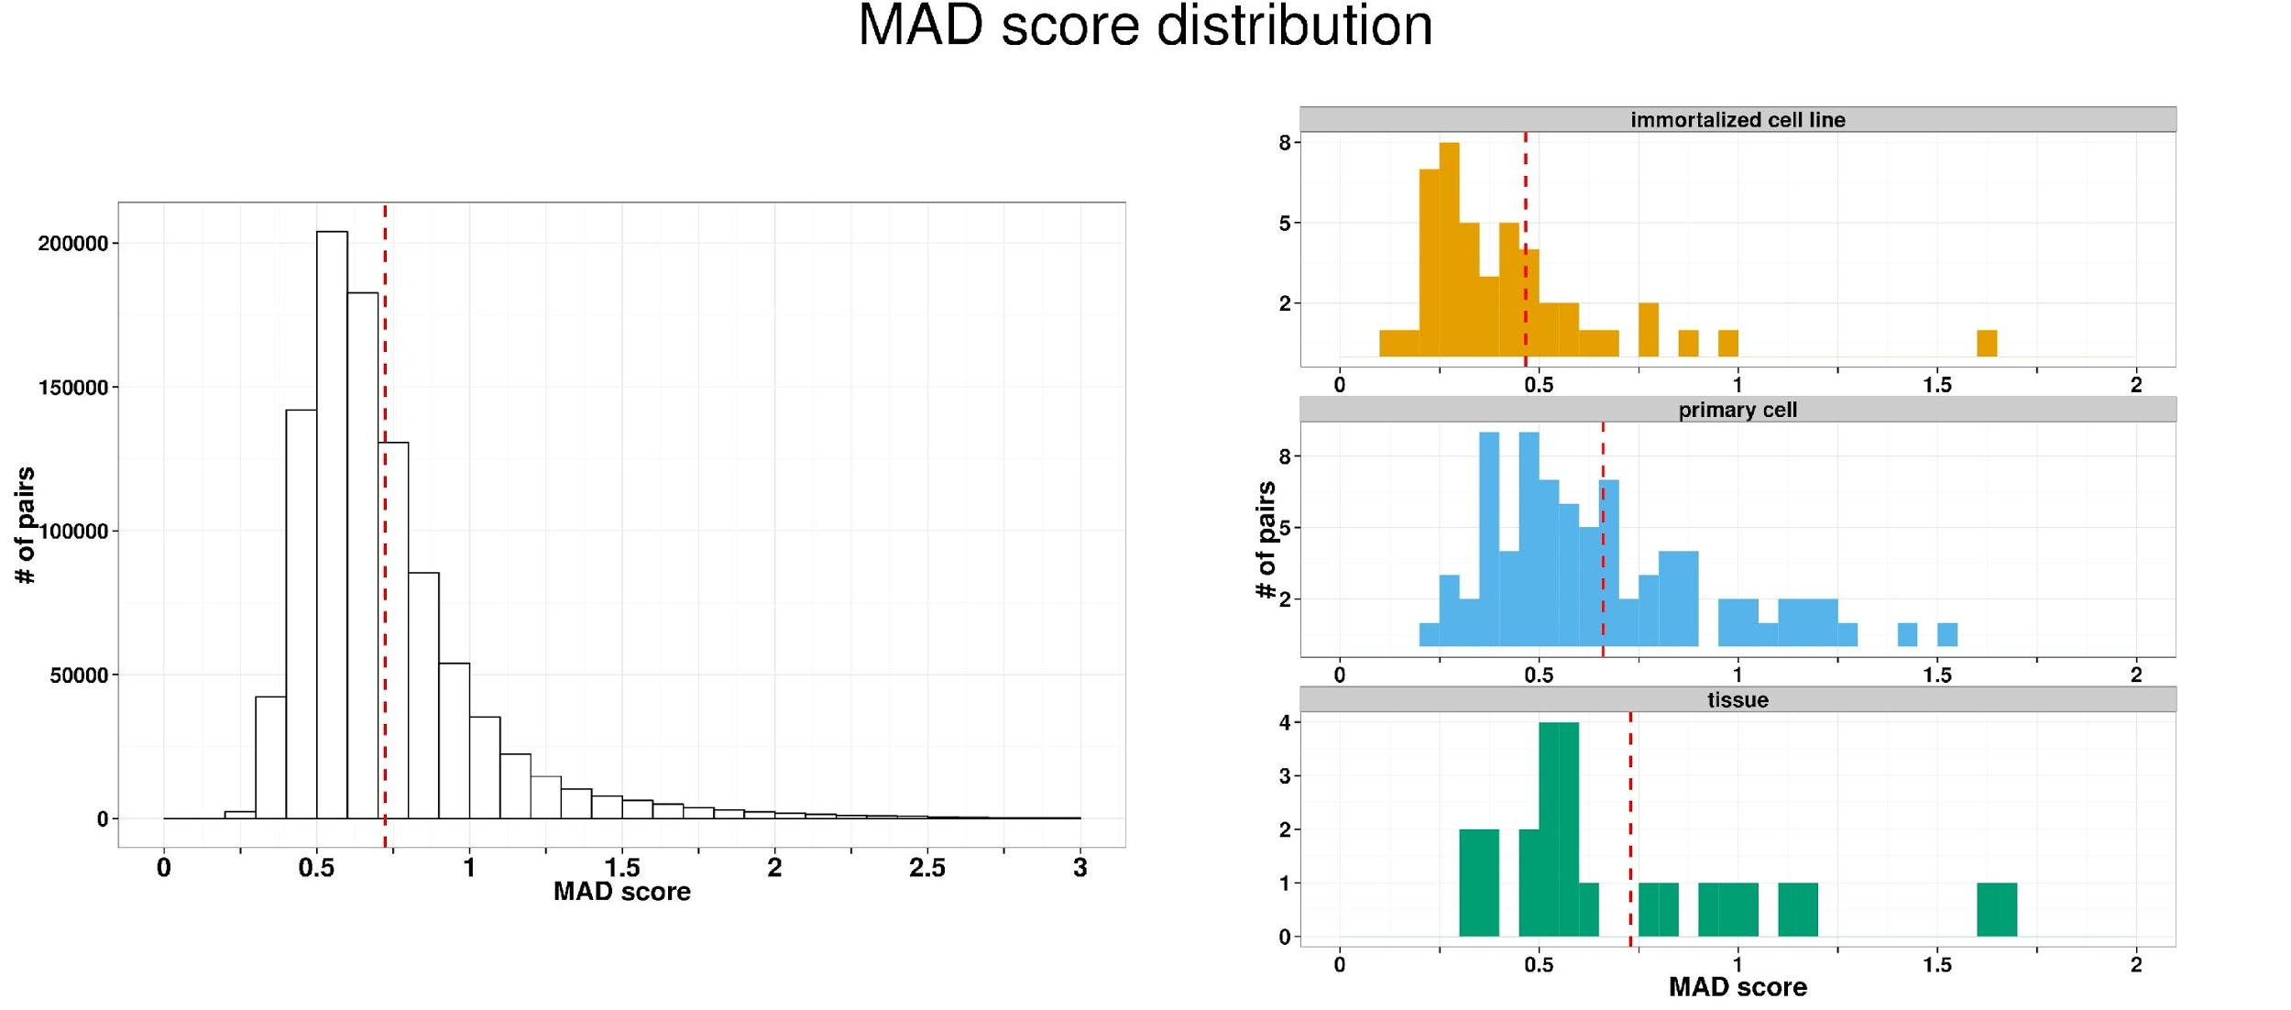
Figure 1. Distribution of MAD scores (a measure of inter-replica reproducibility) in GTEx (left) and ENCODE (right). The MAD score is lower for inmmortalized cell lines than for tissues and primary cells, where the distribution is comparable to that of ENCODE.

.

3.2.2 Pipeline for analyzing ChIP-seq data of transcription factors
The Kundaje, Kellis, and Weng labs have been working closely with the Binding Working Group to revise and finalize improved computational analysis pipelines for transcription factor (TF) ChIP-seq data and regulatory motif discovery.

Changes in protocols for generating and methods for analyzing TF ChIP-seq data required us to revisit and revise the well-established and robust ENCODE II TF ChIP-seq pipeline. Particularly, the pipeline needed to be updated to analyze paired-end (PE) data which was not generated in ENCODE II. We also wanted to update the pipeline to include some of the latest computational peak calling algorithms that substantially improve the resolution and accuracy of binding site identification for TF ChIP-seq data.

Anshul Kundaje led a coordinated effort across multiple labs and the Binding Working Group to systematically compare and evaluate 10 peak calling algorithms. A collection of benchmarking datasets were selected so as to span a diversity of TFs with different binding characteristics and data quality. The peak callers were evaluated based on 3 criteria: (1) reproducibility of peak calls across replicate datasets; (2) accuracy and resolution of peak calls by comparing predicted point binding sites to known motif locations; (3) the ability to deconvolve closely spaced and overlapping binding events. The evaluation analysis was conducted by Anshul Kundaje as well as members of the Keles and Gifford labs. After extensive analyses and discussions, the Binding Working Group converged on 3 robust peak callers (SPP, GEM and PeakSeq) that all scored well in the evaluations. Each of these have complementary properties. SPP (from Peter Park’s lab) and PeakSeq (from the Gerstein lab) are both backward compatible with ENCODE II and have been heavily tried and tested. SPP explicitly takes into account read distributions accounting for peak shape. GEM (from the Gifford lab) explicitly deconvolves closely spaced binding events and integrates peak calling with motif discovery. PeakSeq uses a relatively different peak calling algorithm that adjusts well to highly punctate binding events and broader regions of enrichment. The results from the SPP peak caller will be used as a default public view and results from GEM and PeakSeq will be provided as supplementary datasets. Additional details about the TF peak caller evaluation are available at http://wiki.encodedcc.org/index.php/TFBS_Peak_Calling_Evaluation
The ENCODE III pipeline summarized in the schematic below includes several additional changes and improvements relative to the ENCODE II pipeline.
(1) Uniform read mapping methods and parameters were established for SE and PE data.
(2) A new method known as FixSeq (developed by the Gifford lab) will be used to account for duplicate reads in SE data. This method results in significantly increased power over the standard method of simply removing all positional duplicates
(3) Anshul Kundaje modified the Irreproducible Discovery Rate (IDR) method (developed by the Bickel group and used extensively in ENCODE II) to handle high resolution and potentially overlapping peak calls from GEM and SPP. The method was also modified to allow more graceful transfer of peak calling thresholds learned on replicate datasets to peaks called on data pooled across all replicates. The IDR method is not only used to adaptively threshold datasets (identify high confidence reproducible binding events) but also to obtain objective, robust reproducibility measures and flag low quality replicates.
The ENCODE III pipeline (http://wiki.encodedcc.org/index.php/ENCODE3_TF_ChIP-seq_pipeline) is currently being implemented at the DCC and is scheduled to be operational shortly. Anshul Kundaje and Shirley Liu’s labs are coordinating efforts across the Binding Group and the DNase group in order to standardize common procedures such as read mapping protocols and quality control scores.

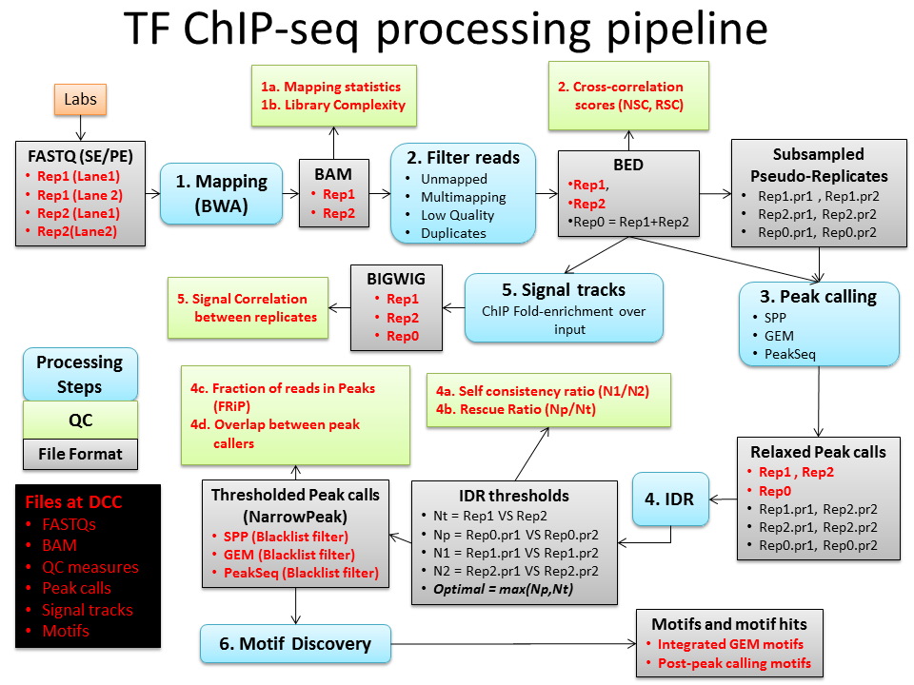
The pipeline for analyzing ChIP-seq data of histone modifications
Histone modification ChIP-seq data has substantially different properties compared to TF ChIP-seq data requiring a unique analysis pipeline. The ENCODE II Chromatin ChIP-seq pipeline was relatively underdeveloped due to the lack of effective peak callers and methods for dealing with the highly variable sizes and patterns of enriched chromatin ChIP-seq regions. Also, the IDR method that is so effective at adaptively thresholding TF ChIP-seq data requires substantial modifications to effectively process the broader chromatin ChIP-seq peaks. Novel measures for evaluating reproducibility of histone ChIP-seq data are also needed.

A collaborative effort (including DAC and Binding Group members) led by Anshul Kundaje evaluated 6 histone ChIP-seq peak callers to define a uniform histone ChIP-seq analysis pipeline (http://wiki.encodedcc.org/index.php/Chromatin_Peak_Calling_Evaluation). High quality, deeply sequenced benchmark datasets for 6 key histone modifications in the human GM12878 line were obtained from the Snyder lab. These were distributed to the participating peak caller groups and the first round of peak calls were generated and analyzed. The peak callers are being evaluated based on (1) reproducibility of identifications (using the method described above), (2) stability of the peak calls to sequencing depth fluctuations (splitting and merging of peaks) and (3) accuracy and resolution by comparing to gold-standard regions (e.g. H3K4me3 peaks compared to promoter regions, H3K36me3 peaks compared to transcribed gene bodies identified from RNA-seq data). The Gerstein lab has also recently developed a histone ChIP-seq multi-scale peak caller called MUSIC that is included in the evaluations. After careful evaluations, MACS2 and MoSAICS-HMM were found to be the top performing peak callers. These peak callers were adapted for integration with the revised IDR framework in order to obtain high-confidence thresholds based on reproducibility across replicates. Genome-wide normalized coverage tracks representing fold-enrichment of ChIP signal over input and -log10(p-value) of enrichment are generated using the MACS2 signal processing engine.

Anshul Kundaje has also developed a measure for evaluating reproducibility of histone ChIP-seq data using a peak-caller independent, multi-scale binning approach coupled with the IDR framework. The method computes signal enrichment scores in replicate datasets for non-overlapping bins at different scales. The IDR method is then used to evaluate the number of reproducible and rank consistent bins across the true replicates. An analogous analysis is performed on pairs of pseudo-replicates obtained by randomly subsampling reads from each replicate or by subsampling reads pooled across all true replicates. The reproducible peaks identified across true replicates are then compared to those obtained from the pseudo-replicates to obtain a robust measure of reproducibility. The method was tested on high quality and deeply sequenced histone ChIP-seq data from the human GM12878 line (Snyder lab) and independently calibrated datasets at different levels of quality and reproducibility in mouse from Bing Ren’s lab. The histone ChIP-seq pipeline specifications have been transferred over to the DCC for implementation into DNAnexus. We expect this pipeline to be operational shortly.

[[,,,,ah integ better]] The Gerstein lab developed and published a new method to identify enriched regions in ChIP-Seq experiments {Harmanci:2014gx}. MUSIC utilizes multiscale decomposition of the ChIP-Seq signal profile in conjunction with a novel mappability correction for mediating the effects of the data. MUSIC outperforms other methods in terms of accuracy of identifying enriched regions for broad histone marks such as H3K36me3 and correlating these enriched regions with expression profiles measured in the ENCODE project. MUSIC will also be compared to other broad peak callers that are part of the uniformed ChIP-Seq pipeline in the ENCODE project.

The pipeline for analyzing Bisulfite-seq data
The Weng lab continued to work the ENCODE3 uniform analysis pipeline for single-end and paired-end whole genome bisulfite sequencing (WGBS). Last year, the Weng lab tested 96 analysis patterns composed of three types of pre-processing methods, three widely used WGBS mapping tools (Bismark with Bowtie, BSMAP, and GSNAP) with two different parameters of seed length for Bismark with Bowtie (l=28 and 50), and 5 types of post-processing criteria based on cytosine coverage and quality scores of mapping reads. This year, the Weng lab further benchmarked 96 additional analysis patterns (192 pipelines in total) by incorporating three additional WGBS mapping tools (Bismark with Bowtie2, LAST, and BRAT) with two different parameters of seed length for Bismark + Bowtie2 (L=20 and 22).

Our results showed that Bismark with Bowtie and Bismark with Bowtie2 were the accurate mapping algorithms throughout single-end and paired-end simulated datasets respectively. LAST showed comparable performance to Bismark. Because of the larger memory requirement for LAST, we selected Bismark with Bowtie and Bismark with Bowtie2 pipelines for the single-end and paired-end WGBS uniform pipelines.

To assistant the DCC in implementing the WGBS pipelines on DNAnexus, we tested memory usage, disk usage and run time for several human and mouse libraries. We also advised the DCC on the file format required for DNAnexus and the use of the lambda genome for quality control. Based on our comprehensive evaluation, the DCC finalized the uniform WGBS analysis pipeline on DNAnexus and placed the source code of the pipeline on github. The source code can be found at https://github.com/ENCODE-DCC/dna-me-pipeline and https://github.com/ENCODE-DCC/Bismark-ENCODE-WGBS.

Development of methods for analyzing CLIP-seq data: Currently no ENCODE production group maps the binding sites of RNA-binding proteins.,,,,true If such projects are funded in the next round of ENCODE, the DAC will evaluate existing methods for such data, and will develop new methods if necessary. Depending on the protocol, these experiments involve the sequencing of the entire RNA molecule bound to the protein (for instance, those based on formaldehyde crosslinking). They can be considered RNA enrichment protocols, and standard RNA-seq analysis pipelines can be employed. Other protocols, such those based on UV crosslinking (i.e., CLIP), preferentially recover the RNA fragment specifically bound to the protein, and thus, are more similar to ChIP-seq assays. However, standard ChIP-seq processing pipelines, which rely on genome mapping of the reads, cannot be employed directly because of the split nature of RNA molecules and the prevalence of alternative splicing. Estimating the binding affinity of an RNA binding protein to the correct alternative splicing isoform (as estimated from CLIP-seq, for instance) is not a trivial problem. The DAC will collaborate with the groups eventually producing this novel data type to develop pipelines meeting the ENCODE standards, and ensure that the processing pipelines for such data are consistent with the ENCODE pipelines used for RNA-seq and ChIP-seq analysis.

Motif-based pipeline for validation of TF ChIP-seq data
The Kellis, Weng and Kundaje labs have also been leading a coordinated effort with the Binding Working Group to establish an analysis pipeline for regulatory motif discovery and annotation. The key topics being discussed include
(1) Motif representations: Position weight matrix models compared to more generalizable and predictive k-mer based representations
(2) Methods to combine motifs learned from different methods and external repositories into a unified database of ENCODE motifs
(3) A unified ‘motif instance’ track representing a non-redundant set of potential binding sites for all TFs.
(4) Methods for using motif-discovery as a secondary validation for TF ChIP-seq data

These discussions culminated in the development of a motif-based QC pipeline, as a secondary validation for TF ChIP-seq data, implemented by Zhizhuo Zhang and Pouya Kheradpour in Kellis lab. The developed computational pipeline evaluates the enrichment of known motifs in a given ChIP-seq dataset and provides a probabilistic assessment about how well those enrichments match the labeled antibody. The pipeline consists of the following steps.
(1) The motif models (Position weight matrix) are collected from public databases: TRANSFAC, JASPAR, PBM (Buylk Lab), HT-SELEX (Wei Lab).
(2) The motif instances are defined by scanning the reference genome using 4^-8 p-value cutoff and the regions of repeats, transposons, CDS and 3’UTR are excluded.
(3) Three types of motif enrichment scores are computed by overlapping the motif instances with the given ChIP-seq peak locations, which includes global enrichment score (compare the actual motif with the shuffled-version motif), positional bias score (compare peak center to the peak flanking region), and peak rank bias score (compare the high peak score regions to the low peak score regions). Then, a combined enrichment score can be derived from taking average of three enrichment scores listed above.
(4) The known motifs are grouped by their PWM similarities and each motif group is ranked by the highest combined enrichment scores within group.

We found the corresponding known motifs rank top2 in 80% of TF ChIP-seq in ENCODE2 and ~8% TF ChIP-seq with corresponding known motifs fail to enrich, which are due to known/unknown antibody problem or indirect binding mechanism of those TFs. Because different TFs may share the same motif and one TF may use multiple motif, we proposed a Bayesian framework for antibody validation by taking into account this ambiguity of motif enrichment. Instead of setting a uniform hard cutoff for different TFs, this Bayesian approach sets the cutoff according to the characteristics for each TF and corresponding motifs, and it can also point out which TFs cannot be validated by motif enrichment due to their diverse binding preferences.

Hi-C pipeline[[,,,,,,fix text - ask Bill]]
The Noble lab has been involved in the development of methods for high throughput characterization of chromatin 3D architecture since the publication in 2010 of our initial Hi-C-like method, developed collaboratively with several other labs in the Department of Genome Sciences at the University of Washington 1 (). Subsequently, the Noble lab has collaborated on the development of several novel chromatin conformation assays 2 (); 3 (), we have investigated the architecture of a variety of systems, including breast cancer 4 (), 22q11.2 deletion syndrome 5 (), the malaria parasite Plasmodium falciparum 6 (); 7 (), the mouse cell cycle 8 (), and the mouse X chromosome 9 (), and we have developed analytical methods for identifying colocalized sets of genomic loci 10 (), calling statistically significant contacts 11 (), inferring centromere positions 12 (), and inferring 3D structures from Hi-C data 13 ().

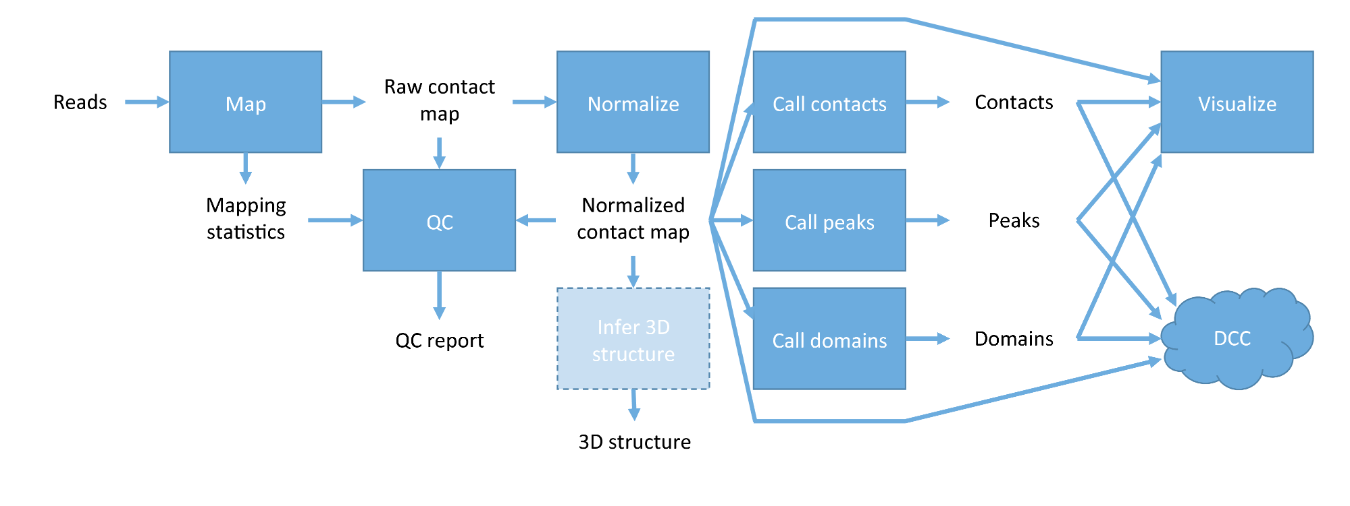
Figure 1: Hi-C analysis pipeline. The 3D structure inference module will only be implemented if scalable inference methods become available.
We will bring this expertise to bear in the development and deployment of an analysis pipeline for Hi-C data generated by the ENCODE Consortium. The details of this pipeline will necessarily be worked out in collaboration with other members of the AWG, and based upon the nascent pipelines being developed by the NIH’s 4D Nucleome Consortium. Nonetheless, we envision a pipeline with a number of core components (Figure 1, and see our recent review 14 ()): a mapping module that incorporates sophisticated prior knowledge about sources of noise in Hi-C assays 14 (), an efficient normalization procedure 15 ()-21 (), a QC module that calculates various quality measures about the data, a method such as our own Fit-Hi-C 11 () for identifying significant contacts at a specified false discovery rate threshold, a complementary method such as HICCUPS for identifying statistically significant chromatin loops (also known as “peaks”) 22 (), and a method for calling domains at various scales, from fine-scale chromatin loops, through topologically associating domains up to chromatin compartments 23 ()-25 (). Importantly, the pipeline will be connected to a powerful visualization engine. Our recent evaluation (presented on the 3D Nucleome subgroup call in August, 2015) suggests that the Wash U Epigenome Browser 26 () is the best current visualization tool, though we will consider other alternatives as they develop. Current methods for inferring three-dimensional structures from Hi-C data do not scale to the full human genome and do not handle diploidy in a principled fashion. We and other groups are actively working on developing such methods, and if they become available, then they may be added to the pipeline. Note that selecting each of the modules in Figure 1 will require extensive validation of existing methods.
DNA methylation pipeline

Detection of Differentially Methylated Regions

We will develop statistical methodology to identify significantly differentially methylated regions (DMRs) from whole-genome bisulfite sequencing (WGBS) data and attach uncertainty assessments. We will develop a method that can provide this assessment even in the presence of just replicates.

Existing methods generally identify differentially methylated loci, then group in some ad-hoc way into regions¹⁻⁵ and/or require large sample sizes due to parametric assumptions^{1, 5, 6}. Others ignore biological variability from sample to sample^{7, 8} or correlation of methylation states of nearby loci⁹, which might provide misleading conclusions or result in loss of power. We propose a new two-step approach that first groups loci into candidate regions and then explicitly evaluates statistical significance at the region level while accounting for biological variability within sample groups.

Although WGBS is the current gold standard for probing the methylation state of the entire genome¹⁰, cost limitations are still a barrier to acquiring more than a few individuals per biological condition in many studies¹¹. For example, the WGBS experiments in mice carried out as part of the ENCODE project are limited to two biological replicates per tissue type and developmental time point combination. As such, we aim to achieve reasonable power and Type I error control even with very small sample sizes (as few as two samples per condition).

We will develop a two-step procedure identify regions that have a significant difference in methylation levels among two or more conditions:

In step 1, we detect candidate regions that contain multiple loci showing evidence of a difference in the smoothed pooled methylation proportion between biological conditions. Briefly, we let the mean proportion in one condition be the sum of methylated reads from all samples in that condition divided by the sum of all reads (methylated and unmethylated; i.e. the coverage) from all samples in that condition. Note that this estimate ignores variability from sample to sample, but with only two or three replicates is robust to the influence of observations based on low coverage. We are able to address biological variability in step 2, where multiple loci are considered at once. The individual loci estimates are then smoothed to further reduce the influence of low coverage observations and because methylation signals are strongly correlated across the genome¹. Finally, candidate regions are defined by segmenting the genome into groups of at least 5 CpG loci that are spaced apart by a user-defined value (small values target local signals; larger values can detect long-range signals), where each loci has a smoothed pooled proportion difference in the same direction that is greater than some threshold value (say 0.10) in absolute value.

In step 2, the assessment of significance of candidate regions is carried out. For each region, we compute a test statistic, defined as the t-statistic for the weighted linear regression coefficient for the effect of interest on the logit-transformed methylation proportions. Weights proportional to the coverage are used to diminish the influence of observations based on very few reads. In addition, the model is also fit in the presence of a spline function (of genomic position) in order to adjust for overall trends in the region. A set of statistics is generated under the null hypothesis by first permuting the group labels, and then repeating step 1 in order to identify candidate regions. The empirical p-value is calculated by comparing the observed test statistic to the entire null set of statistics from all permutations. Control of FDR is carried out by adjusting the p-values using Benjamini-Hochberg.

To demonstrate the feasibility of this approach we used methylation data from the ENCODE porta as preliminary data. We obtained data from several different body sites (e.g. liver, limb, spleen, forebrain, midbrain, hindbrain, kidney, stomach, intestine, heart, neural tube, prominence) as well as time points (embryonic day 11.5, embryonic day 14.5, embryonic day 16.5, and postnatal day 0). Not all combinations of body sites and time points are available. For each combination that is available, there are two biological replicates. We aim to detect differentially methylated regions between two samples at two different body sites or time points.

Using a preliminary version of our approach we identified local (i.e. with a maximum inter-loci gap of 500bp) DMRs between two brain regions (see Table 1) as well as between two dissimilar tissue types (see Table 2) at the 11.5 days embryonic stage. As expected, the comparison between forebrain and liver identifies a larger number of DMRs than the comparison between two more similar tissue types (brain regions). The DMRs identified are potential regions of tissue-specific methylation region differences.

Table 1: Comparison of two similar tissue types at 11.5 days embryonic stage
Comparison | Median Coverage range | Number of CpG Loci | Number of Candidate Regions | Number Regions with FDR < 0.10 | Proportion demethylated
Hindbrain v Forebrain | 32 – 33 | 19,187,939 | 49,389 | 25,942 | 0.365

Table 2: Comparison of two dissimilar tissue types at 11.5 days embryonic stage
Comparison | Median Coverage range | Number of CpG Loci | Number of Candidate Regions | Number Regions with FDR < 0.10 | Proportion demethylated
Forebrain v Liver | 32 – 42 | 19,192,488 | 418,560 | 365,273 | 0.889

Figure 4: Top DMRs for the comparison of forebrain and midbrain (left); Top DMRs for the comparison of liver and forebrain (right) [ note which color denotes which condition ]
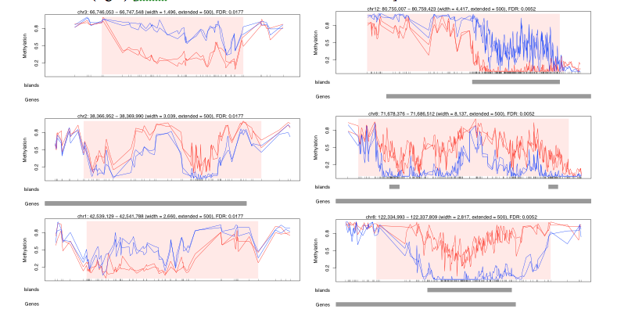

Table 3: Comparison of hindbrain tissue between consecutive time points
Time Point Comparison  E=Embryonic  P=Postnatal | Median Coverage range | Number of CpG Loci | Number of Candidate Regions | Number Regions with FDR < 0.10 | Proportion demethylated
E11.5 v E16.5 | 27 – 32 | 19,174,998 | 113,136 | 79,887 | 0.943
E16.5 v P0 | 30 – 35 | 19,183,528 | 35,709 | 0 (min FDR=0.16) | -

We also evaluated the comparison of hindbrain tissue at two different time points to identify DMRs associated with developmental changes. The summary of the comparison of hindbrain tissue along the development trajectory is shown in Table 3. Note that many DMRs (most indicating a loss of methylation) are identified as significant at the FDR level of 0.10 between the day 11.5 and 16.5 time points, but that no regions meet this threshold for the comparison of the later stages. We can see from the plot of the top regions in this comparison that the time point effect is not as striking as the tissue effects identified in Figure 1.

Figure 5: Top DMRs for the comparison of hindbrain at embryonic day 16.5 and postnatal day 0 [note which color denotes which condition]; FDR for these regions is 0.1609

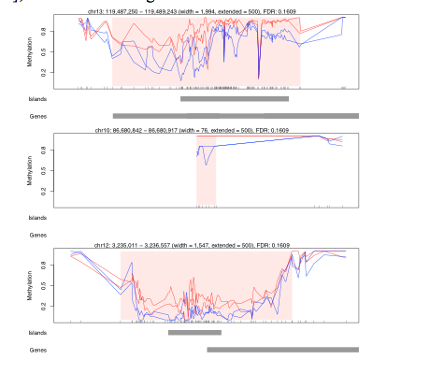

References for DNA methyaltion section

1. Hansen, K.D., Langmead, B. & Irizarry, R.A. BSmooth: from whole genome bisulfite sequencing reads to differentially methylated regions. Genome biology 13, R83 (2012).
2. Wu, H. et al. Detection of differentially methylated regions from whole-genome bisulfite sequencing data without replicates. Nucleic acids research 43, e141 (2015).
3. Sun, D. et al. MOABS: model based analysis of bisulfite sequencing data. Genome biology 15, R38 (2014).
4. Lee, W. & Morris, J.S. Identification of Differentially Methylated Loci Using Wavelet-Based Functional Mixed Models. Bioinformatics (2015).
5. Dolzhenko, E. & Smith, A.D. Using beta-binomial regression for high-precision differential methylation analysis in multifactor whole genome bisulfite sequencing experiments. BMC Bioinformatics 15, 215 (2014).
6. Hebestreit, K., Dugas, M. & Klein, H.U. Detection of significantly differentially methylated regions in targeted bisulfite sequencing data. Bioinformatics 29, 1647-1653 (2013).
7. Saito, Y., Tsuji, J. & Mituyama, T. Bisulfighter: accurate detection of methylated cytosines and differentially methylated regions. Nucleic acids research 42, e45 (2014).
8. Akalin, A. et al. methylKit: a comprehensive R package for the analysis of genome-wide DNA methylation profiles. Genome biology 13, R87 (2012).
9. Park, Y., Figueroa, M.E., Rozek, L.S. & Sartor, M.A. MethylSig: a whole genome DNA methylation analysis pipeline. Bioinformatics 30, 2414-2422 (2014).
10. Marx, V. Genetics: profiling DNA methylation and beyond. Nature methods 13, 119-122 (2016).
11. Ziller, M.J., Hansen, K.D., Meissner, A. & Aryee, M.J. Coverage recommendations for methylation analysis by whole-genome bisulfite sequencing. Nature methods 12, 230-232, 231 p following 232 (2015).

3.3. Establish data types, data repositories, and data sharing guidelines.
We will keep close communication with the DCC to ensure timely and consistent processing of raw data through a uniform pipeline. The output of the pipeline will be cleansed and normalized, ready for downstream analyses. We will assemble a subgroup of DAC analysts responsible for various aspects of uniform data processing and the data transform that is necessary prior to the uniform data processing. In particular, the subgroup will include analysts who have been part of the uniform data processing during the current DAC and will be part of the next DAC. During the EDCAC kickoff meeting, these DAC analysts will meet with the appropriate DCC members to evaluate the status of uniform data processing pipelines. During the first three months of the project, all existing pipelines will be established and applied to all available datasets. This subgroup will be the point of contact with DCC on this issue. Whenever an analysis method has matured to the stage of a pipeline, it will be turned over to this subgroup to implement and apply to all existing data.
,,,,keep We will work closely with the AWG and DCC to ensure that all analysis results, similar to primary data, are available in uniform formats from all groups, and additionally that all metadata are stored, including versions of programs used to generate the data, which pipeline version was used, and that all tools and data processing methods remain available for the duration of the project. For each type of functional element, we will establish a unique and standardized representation, including for enhancers, promoters, transcripts, alternative splice forms, transcription start/end sites, genome segmentation etc. We will also make sure that all analyses done in parallel in human, mouse, fly, and worm use the same formats, parameters, and pipelines whenever possible, and that these are clearly documented to facilitate cross-species comparisons. To achieve this, we will establish a single coordinator within the DAC for each type of analysis who will be responsible for ensuring reproducibility and consistency within the Consortium.
All data exchange will also be stored at the DCC servers, and all results of validated analyses will be made public upon validation, following the ENCODE common Data Release Policy. Care will be taken to anticipate the versioning of ENCODE data generated for all three organisms between different genome builds. As the project progresses the data products generated earlier in the project will get updated to the most recent genome builds for each organism in a controlled fashion. This will either be done via simple liftOver or via uniform reprocessing. We also anticipate data freezes (approximately every six months) where the collective set of all primary processed data products generated up until that stage by the entire Consortium are frozen for more detailed integrative downstream analyses.
We will also store at the DCC all public datasets which have been reformatted for ENCODE use by members of the DAC or AWG to minimize duplication of efforts, and ensure consistency between different groups. The DCC will also serve as our intermediate repository for all datasets coming from the epigenome project, the 1000 Genomes Project, TCGA, GTEx, Brainspan, GEO, SRA, FlyBase, and WormBase. These clear guidelines and standards may appear cumbersome at first, but they will be invaluable in preparing the datasets for integration, and preparing the integrative analysis for publication. Lastly, all data shared with the larger community will be shared through the DCC servers and browsers, and through FlyBase, WormBase, and general genome browsers (such as NCBI, ENSEMBL, and NCBI) whenever possible.

[[[,,,,move integrative paper writing here. Papers document annotation, provide a focus & testing ground for the encyclopedia. Provide a way of connecting ENCODE annotation to various contextx.... Then we need a head for the working group section. ]]

3.4 DAC’s Contribution to ENCODE working groups
Functional Characterization Working Group: ENCODE Enhancer Challenge
As part of the ENCODE consortium, we assessed the accuracy of enhancer predictions based on different machine learning algorithms. This is part of a continued effect as part of the ENCODE project to assess the accuracy of different enhancer prediction methods \cite{Yip, 2012 22950945}. During the third phase of ENCODE, H3K27ac peaks in ChIP-Seq assays for two mouse tissues (heart and forebrain) at E11.5 lifestage were chosen and tested for regulatory activity by the Pennacchio group using transgenic assays. Approximately 40 H3K27ac peaks were tested for activity in each tissue and 50% of these peaks showed regulatory activity at the E11.5 lifestage on average. The theoretical predictions for the ENCODE Enhancer Challenge were performed using diverse methods by twelve research groups within the ENCODE consortium. While some of these algorithms utilized just sequence-based information, other algorithms utilized a combination of different epigenetic datasets and/or sequence information.

The DAC assessed the accuracy of different methods for enhancer activity as well as whether the predictions from different groups could be combined to make more accurate predictions. In particular, we developed an unsupervised ensemble approach to combine predictions from different enhancer prediction algorithms for the ENCODE encyclopedia. The unsupervised ensemble approach is expected to be more accurate than the best underlying machine learning model used to predict enhancers. We compared the accuracy of different unsupervised ensemble approaches to combine the predictions of enhancers from different machine learning algorithms. Our preliminary results indicated that a number of theoretical methods predict enhancers more accurately than individual epigenomic datasets and an unsupervised ensemble method consistently outperformed the most accurate individual machine learning model for enhancer predictions.

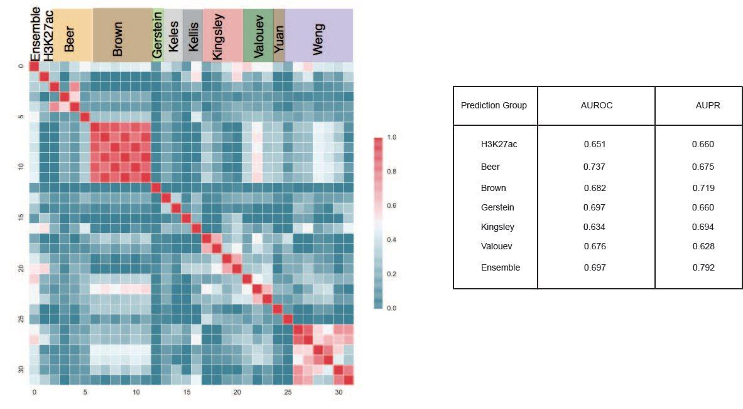
Caption: Comparison between all the predictions made by different groups for H3K27ac peaks and the ensemble method. The different predictions from same group were highly correlated but predictions from different groups were very diverse. The performance of some of the best predictions were compared to the performance of H3K27ac-based meaures using area under ROC and precision-recall curves.

The RNA working group

The Guigo lab has been heavily involved in the development, implementation and benchmarking of the ENCODE3 RNASeq pipelines (see above). In addition, the lab has been involved in a number of other activities related to the RNA data

,,,,,,shorten Gene expression matrix. The lab provides the gene expresion matrix for human and mouse long RNA-seq experiments to store information about gene expression level across different ENCODE samples. The gene expression values are collected from the individual files processed with ENCODE 3 long RNA-seq pipeline into a single file in tabular-separated (tsv) or JSON formats. Current version of this matrix includes TPM and FPKM values for annotated gencode genes per each long RNA-seq experiments, values from each bio-replicate are preserved. So far, gene expression matrices are being generated for long and short RNASeq data

Gene expression visualization. The,,,,,g lab has been worked together with the Weng lab and the DCC into exploring tools for visualization of RNASeq expression values across multiple samples. The lab proposed prototype plots and developed the specifications for the generation of graphical representations of the gene expression data.

Evaluation of the impact of adopting GRCh38 as the human genome reference assembly.,,,,,,,mention p g The ENCODE consortium is currently using.GRCh37, but planning to move to GRCh38, which it is available since 2014. The Lab explored the impact of this in the estimates of gene expression. The lab processed the ENCODE3 benchmark dataset using different genome assemblies and GENCODE annotation versions. While variations were observed for some gene families, overall gene expression values remain stable across human genome assemblies.

The AWG cancer subgroup
,,,,,,motivate-y Although variants in protein-coding regions have received the most attention, numerous studies have noted the importance of non-coding variants in cancer. Moreover, the overwhelming majority of variants, both somatic and germline, occur in non-coding portions of the genome. We have summarized the current understanding of non-coding variants in cancer \cite{Khurana, 2016 26781813}. Recent progress made by The ENCODE Consortium has provided detailed annotation of non-coding regions of the human genome, and whole-genome sequencing of disease genomes has identified large volumes of variants in such regions, thereby making this an opportune time to interpret the function of these variants, especially those in non-coding regions. Here, we have made several efforts to harmonize the ENCODE data as resource to help cancer research.

We scheduled a monthly call for the ENCODE and Cancer community for research groups from multiple institutes to present their computational and experimental progress related to this topic. Joint efforts have been made to explore the usage of ENCODE data on cancer genomics.

First, we explored all tissue/cell lines from the ENCODE project and extracted those from cancer patients. We found that till now 1,423 cell lines out of the 2,055 human cell lines are actually cancer cell lines (69.2%). Each of the cancerous cell lines has been carefully matched to the specific cancer type and the possible TCGA abbreviation was given for convenience of the community.

Second, due to the limited knowledge of non-coding annotation in the cancer community, rare variants in such regions are less investigated in such regions. Hence, we tried to collect a full category of non-coding annotations from ENCODE to help to interpret the biological mechanism of non-coding mutations, which in turn allows for targeted therapies in clinical studies.

,,,,,,motiv y Third, studies on the coding variants already proved that the mutation rates in cancer genomes demonstrate substantial cancer type, sample, and regional heterogeneity \cite{Lawrence, 2013 23770567}. Some passenger mutations are generated by other driver events, such as structural alterations and mutations in DNA replication or repair genes \cite{Hodgkinson, 2011 21969038}. Consistent with these statements, we observed that the somatic mutation counts in the noncoding elements exhibited substantially higher variance than expected, the so-called overdispersion. Hence, we developed a method called LARVA which uses regional genomic features such as replication timing to better estimate local mutation rates and mutational hotspots \cite{Luchovsky, 2015 26304545}. In order to help researchers to investigate how the mutation rate is affected by more covariates systematically, we further explored the whole ENCODE experimental data and carefully selected all potentially related features. Results from uniformly processed pipelines were extracted and reformatted for community use. We further directly generated the covariate matrix at various resolution for researchers to use directly.

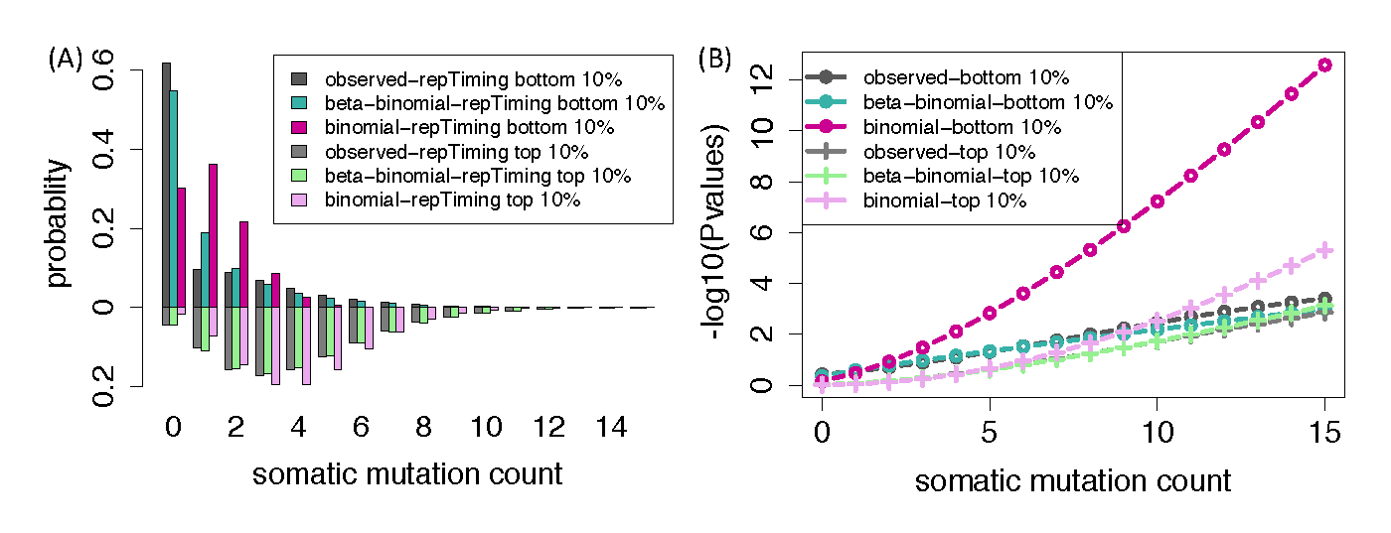

Finally, we have recently developed a new computational method, Loregic to characterize the gene regulatory logics in complex systems \cite{Wang, 2015 25884877}. For example, we used this method to identify genome-wide regulatory cooperative logics in leukemia by integrating ENCODE and TCGA data.

The GWAS-AWG subgroup, including collaborations with CHARGE and eMERGE consortia.
DAC member Manolis Kellis co-chairs the GWAS-AWG subgroup with Robert Klein, focused on maximizing the impact of the ENCODE resource on human disease, and in particular the interpretation of genetic association results from GWAS-AWG and studies of human variation. The GWAS-AWG subgroup meets bi-weekly, and has been one of the most active groups in ENCODE, with attendance typically reaching up to 40-50 participants, representing a wide array of labs, with very active discussion. The group carries out two types of activities, both internal (a) and external (b-c) covered during the bi-weekly phone calls and additional meetings and calls.

Internal activities of the GWAS-AWG group.
The GWAS-AWG calls include presentations of individual lab efforts seeking to: coordinate activities; share methodological developments; publicize resources; establish guidelines; receive early feedback. These include presentations and regular attendance by a large number of ENCODE groups, ample active discussion, and group coordination of activities. Topics have included guidelines on variant selection, methods for expanding on linkage disequilibrium (LD) and including LD in statistical enrichment tests, and for selecting regulatory annotations for enrichment analysis of genetic variants associated with complex traits and human disease.

ENCODE-CHARGE collaboration
,,,,,shorten The DAC has also helped coordinate efforts with the ENCODE-CHARGE collaboration, in the context of the GWAS-AWG working group co-led by Manolis Kellis and Robert Klein. Dr. Lucas D. Ward from the Kellis Lab led the presentation of HaploReg and RegulomeDB at the annual CHARGE meeting breakout workshop with ENCODE, introducing CHARGE participants to the data types, regulatory annotations, and tools for mining ENCODE datasets in interpreting QTLs and GWAS results. Anshul Kundaje led a session introducing participants to the different representations of raw and processed transcription factor and chromatin ChIP-seq data and ways to access, download and visualize these datasets as well as integrative analysis products such as chromatin state maps. In additional, Gerald Quon from Manolis Kellis’s lab has collaborated closely with the adiposity group, and helped interpret the resulting loci by leveraging tissue-specific regulatory networks learned in adipocytes, and genome-wide enrichments for targets of common regulators, revealing enrichments in adipose nuclei and preadipocytes that helped guide the group towards the next steps of data generation.

ENCODE-eMERGE collaboration.
A new activity of the GWAS-AWG subgroup, co-led by Manolis Kellis and Robert Klein, is a very active collaboration with the eMERGE consortium. This activity provides a unique opportunity to directly collaborate with the generators of GWAS studies, and the ability to share intermediate results across different ENCODE groups, by membership on the eMERGE consortium, coordinated through the institutions of ENCODE member labs. This activity has been spawned off in an additional bi-weekly call, which alternates presentations between different ENCODE groups and different CHARGE groups. The calls have been very well attended and very productive, with active discussion on the specifics of GWAS analyses, variant selection, dealing with LD, and interpreting the resulting associations. We are currently working with CHARGE to generate a phenotypic matrix for multi-phenotype analysis, which is one unique strength of the eMERGE consortium, and to set up a common compute cloud for sharing raw and intermediate results.

3D nucleome AWG sub group
Together with Job Dekker, Dr. Noble has coordinated the activities of the ENCODE “3D Nucleome” subgroup. This group meets twice a month, and calls typically involve 25–35 participants. A primary function of the subgroup is to familiarize members of ENCODE with new data sets and novel analysis methodologies relevant to the analysis of 3D chromatin conformation. Members of the labs of Job Dekker, Mike Snyder, and Bing Ren have presented descriptions of data sets. Analysis methods have been presented by members of the labs of Ferhat Ay, Job Dekker, Dave Gilbert, Mark Gerstein, Anshul Kundaje, Christina Leslie, Qunhua Li, William Noble, Mike Snyder, and Feng Yue as well as by external research groups from l’Institut Curie and BioNano Genomics.
The 3D Nucleome subgroup is currently working on two manuscripts. One effort, led by David Gilbert and Job Dekker, focuses on experimentally characterizing changes in topologically associated domain architectures in rearranged genomes. The manuscript exploits a panel of Hi-C data sets from various cancer cell lines, generated by the Dekker lab, as well as complementary assays measuring rearrangements (from BioNano Genomics) and measuring replication timing. The second manuscript focuses on developing and comparing various measures of quality and reproducibility for Hi-C and ChIA-PET data. Work on the second manuscript is being led by Dr. Noble and a postdoc in his lab, Gurkan Yardımcı. Dr. Yardımcı is carrying out a blind evaluation of a variety of metrics, by providing members of the 3D Nucleome subgroup with collections of real and simulated Hi-C contact matrices. Participants, including members of the Ay, Gifford, Kundaje, Leslie, Li and Yue labs, will compute quality and reproducibility measures on individual matrices and pairs of matrices, respectively. We are targeting completion of both manuscripts over the next 3–4 months.

The Regulation AWG subgroup
Anshul Kundaje co-leads the Regulation AWG subgroup with Mike Snyder and David Gifford. This group has just started to meet biweekly. The goals of the subgroup involve developing integrative computational methods to (i) predict high-resolution context-specific regulatory elements by integrating diverse types of ENCODE data, (ii) characterize high-resolution combinatorial transcription factor co-binding patterns and regulatory sequence grammars underlying cell-type specific regulatory elements, (iii) infer regulatory interactions between distal regulatory elements and target genes, (iv) learn regulatory networks and predictive models of transcriptional regulation and (v) model the effects of genetic variation on gene regulation. The Regulation subgroup will complement the primary functional element lists (derived primarily for specific experimental assays) in the Encyclopedia with integrative computationally-derived, fine-grained annotations of these functional elements and higher-order interactions and associations between these elements.

Consortium Authorship Network Analysis
[[,,,,,move Down n link after integ pub ]] In addition to the ENCODE data processing and analysis, DAC has also analyzed the publication patterns impacted by ENCODE consortium, especially how the outside scientific community benefit from ENCODE data. In particular, using publication data related to the ENCODE consortium \cite{ENCODE Consortium, 2012 22955616}, we identified 1,786 members and 8,263 non-members from 558 consortium papers supported by ENCODE funding and 702 community papers that used ENCODE data but were not supported by ENCODE funding. We constructed temporal co-authorship networks for these two groups cumulatively over a decade from 2004 to 2014 (Fig. XXX, the network in 2014). The networks visualized how the information from the consortium has diffused out through the co-authorships relationships among specific individuals. Our analysis revealed that the consortium members work closely as a community whereas non-members collaborate on the scale of a few laboratories. We found that there are a few brokers playing an important role by initiating the connections between the consortium and non-members. One corollary of this observation is that large scientific consortia should set up formal outreach groups or individuals to communicate with outside researchers. In future, it would be interesting to do various dynamic analyses when this detailed information becomes available. For example, one can also potentially study consortium’s impacts via other types of networks, such as citation networks for different data types like RNA-seq and ChIP-seq.
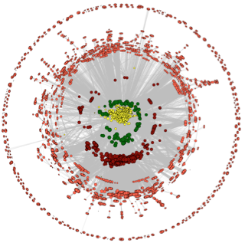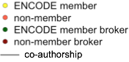

3.XXX To facilitate writing Consortium papers
,,,,,keeppar One of the main roles of the DAC is to facilitate the analysis and writing of integrative Consortium papers, specifically the paper that describes the Encyclopedia of human and mouse. In addition, the DAC will assist with other Consortium reports such as data and analysis standards documents. The leadership of these papers and documents naturally springs from the leadership of the AWG and involves the interplay of many different scientists, and the DAC is at the service of this leadership by The DAC will performing various integrative analyses and providing a technological infrastructure.
,,,,,,keep In writing these papers the data from multiple techniques and approaches must be combined in a standardized fashion in order to maximize their utility. The readers of the papers should also be able to see how large-scale genomic datasets have biological and medical utility. Thus, it is essential for the papers to provide a clear linkage between the prose describing the results and the actual data and analyses done. Moreover, clearly connecting the genomics data in a particular freeze to the literature has many scholarly advantages in terms of time stamping, attribution, and future citation^{117,118}.
Aims 1-3 discussed the necessary calculations to enable these integrative analysis papers, and ,,,,,keeppar,keep here we focus on the infrastructure that the DAC will provide to enable these papers to be written. There are two aspects of this infrastructure: social and technological. In terms of social infrastructure, the DAC will organize and moderate phone calls as well as setting up and moderating meetings targeting particular analysis papers. For the conference calls and meetings we will handle creation of precise agendas and the recording of detailed minutes and action items.
,,,,,keeppar There are a number of things to bear in mind regarding setting up a technological infrastructure for enabling collaborative papers. First of all, there is a vast and rapidly evolving industry in developing social media and computational infrastructure for collaboration, including companies such as Google, Facebook, and Twitter. In this regard, the DAC will provide a gateway for the entire Consortium to make use of such computational tools and services. Second, many genomics consortia papers are extremely complex from the perspective of paper writing, often involving many hundreds of authors and tens if not hundreds of main figures and tables as well as supplementary exhibits. Simply keeping track of all figures and supplements is a non-trivial task.
The DAC will facilitate the use of appropriate technology to help with this. Currently most of the genomics papers written by the ENCODE Consortium make use of mailing lists and conference calls for many of these interactions. To handle manuscript preparation addition they make use of resources such as Wikis, Google Docs, and reference managers such as Endnote, Bookends, and Papers. We will continue to use these types of infrastructures, and the DAC will provide expertise and resources in these areas for future Consortium publications. However we will also be aware of newly evolving tools that are currently being developed, including improved solutions for tracking references and figures (e.g., Mendeley and BibTeX). Also, online file sharing services such as Dropbox and SugarSync can be utilized for distribution of files and figures; we also intend to investigate the use of fully-fledged open-source content management systems such as Drupal or Joomla. It is important to keep in mind that while a lot of these technologies might be appealing from a purely computational perspective, they might not be of as much use practically when employed by the various members of the Consortium, and thus we will have to keep track of their usefulness in terms of actual paper writing.
The writing of Consortium standards documents that focus on protocols and methodologies for data analyses and experimental procedures will proceed in a similar way as the writing of integrative Consortium papers. One difference, however, is that the role of the DAC for creating standards documents is sometimes to produce standardized datasets and standardized analyses that illustrate standard practices and provide a better third-party working-knowledge of the standard beyond that from individual production laboratories.
,,,,,keeppar A third aspect of the DAC in writing large Consortium papers and standards documents is carefully connecting the underlying data to the prose. One can conceptualize a big genomics "roll out" (publishing a number of genomics papers commenting on a single underlying data freeze) as a hierarchical information structure, designed to present the Consortium's genomic data and results in an organized fashion. The "main" integrative paper sits at the top, synthesizing everything broadly, which provides pointers to other high-profile companion papers and further, more detailed companions focusing on specific sub-analyses. Each of these individual papers, in turn, often refers to a huge amount of supplementary calculations and datasets. Some of these are in formal paper supplements while others are on project Web sites. Moreover, the datasets most referred to in the papers are usually not the actual raw data but subsidiary analysis products that summarize the data (e.g., peak call lists, transcript structures, and segmentations). At the bottom of the hierarchy is the actual underlying raw data (usually sequencing reads), stored in central repositories (such as the short-read archive). Given that the raw data files and, to some degree the analysis summaries, are usually huge and unwieldy, it makes most sense to approach the information in a particular freeze from the top down, starting with the papers (assuming everything is linked together correctly). In the future one may see some machine readable, “structured” versions of the text of the paper (i.e., the structured digital abstract and structured digital table^{119,120}, which allow authors to make this hierarchy and its linkages even more explicit.
,,,,,keeppar There is an even more detailed micro-structure to the hierarchy: All of the data tables and figures in each paper rely on a considerable chain of small specific analysis results as well as programming scripts. These, in turn, connect to specific versions of the overall analysis summaries put out on the project website. One of the roles of genome analysts is to link these all together and make sure that it is clear which version of a particular analysis result goes with which version of the underlying data and how these in turn link with a specific paper figure. This can often be done through making available the small subsidiary analysis files underlying each exhibit (such as networks connecting particular genomic entities or Excel files or R data frames) in an organized fashion. (See modencode.org/publications/integrative_worm_2010 and modencode.org/publications/integrative_fly_2010 for examples.) Often in the rush to publish a large manuscript these smaller files are neglected but they are essential for truly reproducible research¹²¹. The DAC will strive to make all of these available through the DAC and DCC. It will also push out larger analysis product datasets such as peak calls and segmentations regularly as part of data freezes and we will version these along with the underlying data from the production groups.

Aim 4. Assessing quality and utility of the ENCODE data and providing feedback to NHGRI and the Consortium.
To guide the Consortium in terms of prioritizing particular datasets for usage, we keep track of which datasets are used for each of the analyses (figures) in every Consortium paper. We will work closely with other members of the AWG to define metrics for evaluating the uniqueness or redundancy of different types of datasets. For analyses whose goal is the definition of a particular type of element, we will use the predictive value of each data type as a way to prioritize datasets and assays. For unsupervised learning analyses, we will use information theory metrics to evaluate the information content of each type of dataset per nucleotide, based on the reproducibility of the dataset, the resolution with which elements are defined for that data type, and the genomic coverage of that data type. We will also compare datasets to each other, to ask how predictable a given dataset is based on the combination of other datasets, and to evaluate and prioritize its added value in the context of the data generated by the entire Consortium. Intuitively, this is like determining if a particular analysis can potentially be reproduced without that dataset or if it is reproduced how inaccurate or how much it changes if that particular dataset is left out. This last type of calculation is particularly useful when one is thinking of repeating the same experiment, say a particular ChIP-seq experiment, over many different cell lines. That is, one wonders how much incremental information one gets from each additional cell line. We will also study the saturation of coverage for ChIP-seq and RNA-seq datasets to provide recommendations on the sequencing depth that should be achieved for different types of chromatin features and different types of transcripts.
Aim 4. Assessing quality and utility of the ENCODE data and providing feedback to NHGRI and the Consortium.
The DAC will develop and apply computational methods to assess the quality and utility of ENCODE datasets in a systematic and unbiased way.
4.1. Data-type specific measures of dataset quality
We will work with the AWG and the PIs to standardize metrics of dataset quality. For example, for RNA, we will develop and apply metrics based on sequencing depth, alignment rate, duplicate read rate, compositional biases, ncRNA content, intronic vs. exonic coverage, positional bias, and coverage continuity. For ChIP-seq experiments, we will develop and apply metrics based on antibody validation, replicate consistency, replicate rank consistency, cross-correlation analysis, and fraction of reads in peaks. For DNA ChIP-seq of DNA binding proteins, we will additionally use motif-based metrics including enrichment, positional specificity, and rank-based enrichment. For DNase, we will use peak-based metrics for ChIP-seq, including fraction of reads in peaks, signal portion of tag analysis, shape analysis, replicate correlation analysis.
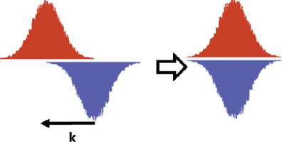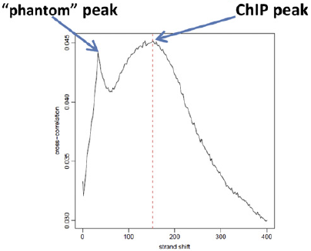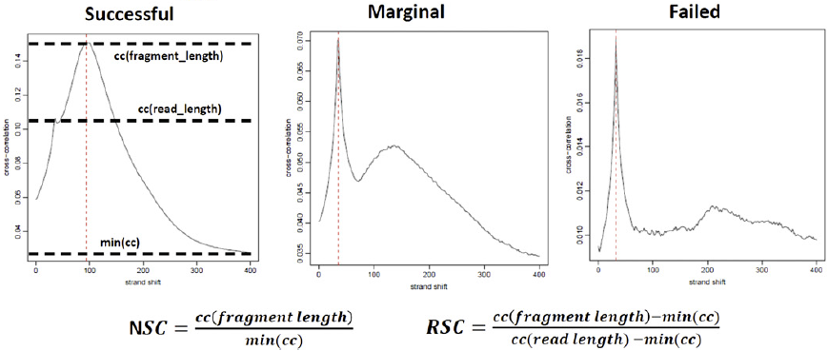
Figure 4.1. Criteria for assessing the quality of a ChIP-seq experiment. (a) Cross-correlation analysis: reads are shifted in the direction of the strand they map to by an increasing number of base pairs and the Pearson correlation between the per-position read count vectors for each strand is calculated. Read coverage as wigglegram is represented. (b) Two cross-correlation peaks are usually observed in a ChIP experiment, one corresponding to the read length (phantom peak) and one to the average fragment length of the library. (c) Absolute and relative height of the two peaks help determine the success of a ChIP-seq experiment. A high-quality IP is characterized by a ChIP peak that is much higher than the phantom peak, while often very small or no such peak is seen in failed experiments.

Leveraging Data Repositories to develop QC Metrics for ENCODE data [Rafa new text]
Defining quality in the context of a high-throughput data is a challenging task. The American Society for Quality (ASQ) defines quality as a subjective term for which each person has his or her own definition. Many technical definitions of quality exist but a common theme of most is the dependence of quality on the needs of the consumer. So what do users of high-throughput technologies want? In the case of RNA-Seq, the most common applications appear to be: finding differentially expressed genes between two or more conditions, clustering transcripts or samples, and predicting sample types or outcomes. For other enrichment scans, such as ChIP-Seq, users typically want to know the location of peaks, but detecting regions of differential binding, which is analogous to differential expression, is also of interest.
In our attempt to measure quality we need to quantify the effect of removing bad quality data on the biological results reported in a publication, which we refer to as downstream results. It is important to note that these downstream results depend on the application. Furthermore, various levels of the data can be considered for removal; we can consider removing: one read from one sequencing run, all data points from mapped to a region across all samples, all data from an sequencing run, all data arising from a specific biological specimen, all data arising from a specific batch of samples, or even all data produced by a particular laboratory. Thus, defining quality in the context of high-throughput experiments is indeed a difficult task. In this proposal we will focus the specific task of assigning a quality metric to each sequencing run and to identify cut-offs such that removing experiments that do not reach this cut-off improve downstream results.
The ENCODE project has already measured over 200 DNA binding proteins and histone marks on more than 100 human cell lines.
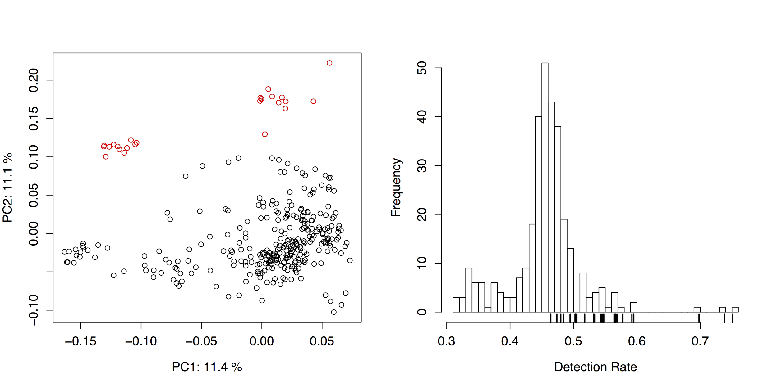
Figure 4.1 [rafa]. The fact that ENCODE data is being used for reanalysis implies that it is crucial to know whether the data being used in is of usable quality. In the latter case, poor quality arrays might taint the results of a large meta-analysis or cause a bioinformatics tool to provide erroneous information. In Figure XX we see a multi-dimensional scaling plot for all the gene expression data currently made public by ENCODE. Note that all the data shown here passed the current QC metric of a Spearman correlation larger than 0.9 between replicates. However the highlighted points appear to be outliers. We only detect this after we analyze the data as a group. Preliminary data shows that we should be able to detect these with metrics that can be computed from a single run. For example Figure XX shows the percent of transcripts that were called 0 for each sample. We notice that the outlier samples have high values. We can use the entire dataset to determine cutoffs.
We will develop general methods that leverage the existing resource to develop QC going forward. The general strategy is to first revisit widely-used statistical model and discussing its implications regarding quality. We will then propose a formal definition of quality based on downstream results and use this definition to assess the performance of current quality metrics as well as to set cut-off for these.
4.2. Data-type agnostic measures of dataset quality.
TODO: add RNA-Seq [Mark? Roderic?]
TODO: add DNase-Seq [Shirley?]
TODO: add DNA methylation [Zhiping?]
TODO: add RNA-Seq [mark?]
In addition to these metrics, we will develop and apply general methods for assessing experiment quality. In particular, we have demonstrated the use of systematic imputation of histone marks, DNA methylation, RNA-seq, and DNase datasets based on their correlation with datasets of the same data type and of different datatypes within the same cell type and within other cell types. We found that the agreement of a dataset with the imputed signal based on this correlation analysis provides a powerful and unbiased metric for evaluating dataset quality, flagging low-quality datasets that are sometimes missed by other quality metrics, including sample or antibody swap problems. We will extend these methods to incorporate additional data types and additional features in the prediction.
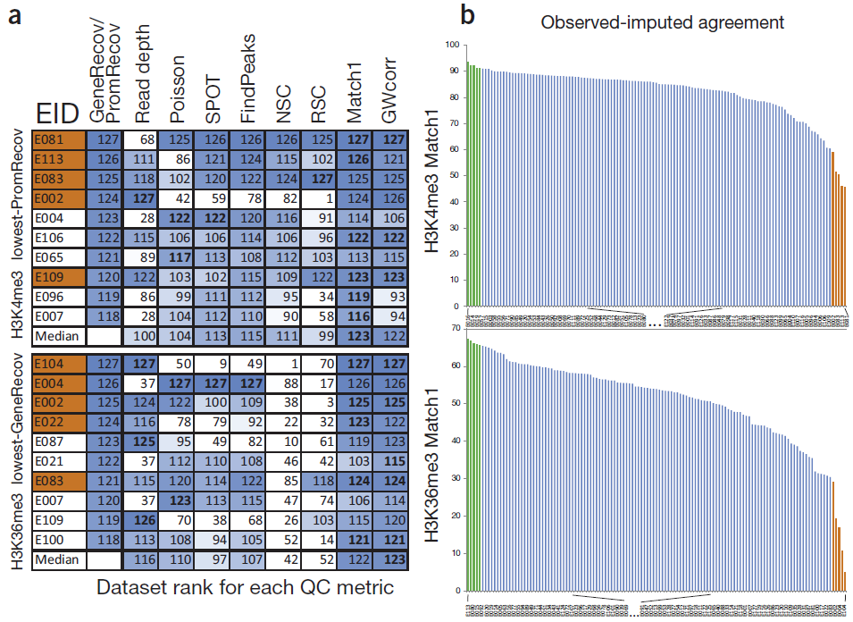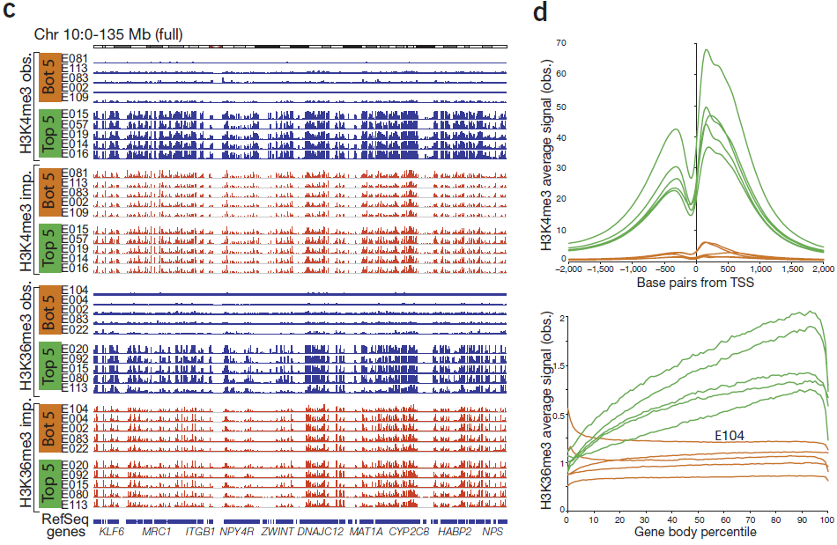
Figure 4.2. Datatype-agnostic quality control using imputation. (a) Comparison of dataset-specific QC metrics (columns) for ten Roadmap Epigenomics datasets (rows) that show the lowest agreement with gene and promoter annotations, based on H3K4me3 (top) and H3K36me3 (bottom). Each entry shows rank (out of 127) for imputation-based QC (first column), read depth (second column) and each QC metric (Poisson statistic, Signal Proportion of Tags (SPOT), FindPeaks, Normalized and Relative Strand Correlation between forward and reverse strands (NSC and RSC)), and similarity between imputed and observed data (Match1 and GWcorr). Orange-shaded EIDs denote the five worst-agreement datasets from b. Data sets with the same read depth (a result of highly sequenced datasets being previously downsampled to the same number of reads) are given the same expected rank if ties were broken randomly. Most-problematic datasets (based on lack of gene or ±2 kb TSS annotation recovery) are sometimes missed by traditional QC measures but consistently show low imputation agreement. (b) Distribution of agreement between top 1% observed signal and top 1% imputed signal locations for H3K4me3 (top) and H3K36me3 (bottom), highlighting five worst-similarity (orange) and five highest-similarity (green) datasets. (c) Observed (blue) and imputed (red) signal tracks for worst-similarity (orange) and best-similarity (green) datasets for H3K4me3 (top) and H3K36me3 (bottom) for the entire chromosome 10 (0–135 Mb). Datasets with the lowest agreement have a relatively flat signal, suggesting that when observed and imputed datasets disagree most, it is usually the observed datasets that are of lowest quality. (d) Aggregation of observed signal for H3K4me3 surrounding the TSS (top) and H3K36me3 in gene bodies (bottom) for the five best-agreement (green) and worst-agreement (orange) datasets, highlighting the unusual profiles of some worst-agreement datasets, suggesting they are of lower quality, even though they were not flagged by traditional QC metrics.
4.3. Saturation analysis.
We will develop metrics and methods for evaluating the progress and completeness of the entire ENCODE project, along multiple axes, including: (i) genomic coverage, towards identifying biochemically active nucleotides across all datasets and cell types; (ii) cell type coverage, towards identifying all distinct cellular states; (iii) data type diversity, for each cell type; (iv) activity pattern capture, for each functional element.
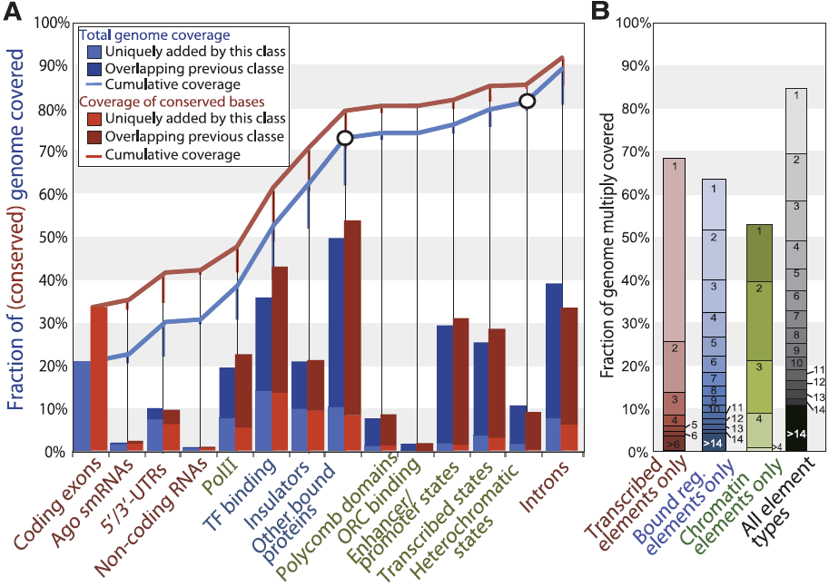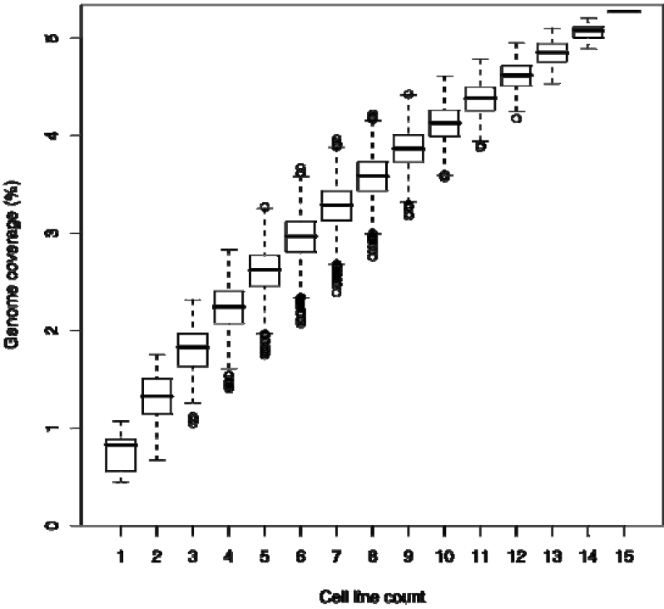
Figure 4.3. Genome coverage by ENCODE data types. (a) Unique (bars) and cumulative (lines) coverage of nonrepetitive (blue line) and conserved (red line) genome from Drosophila modENCODE. (b) Multiple coverage for data sets grouped into transcribed elements (red), bound regulators (blue), and chromatin domains (green) in Drosophila modENCODE. Across all three classes (black), 10.8% of the genome is covered 15 or more times, and 69.5% is covered at least twice. (c) Genomic coverage in human ENCODE with randomly reordered datasets as additional cell lines are added. Saturation plot for UW DNase1 over 15 cell lines, with all possible paths of random addition orders for cell lines.
4.4. Metrics of independent dataset utility.
In addition to quality control of individual datasets, we will develop and apply unbiased methods for evaluating the per-nucleotide information content of each data type in a given cell type independently of any other data, based on: (i) genome-wide coverage, (ii) resolution, (iii) reproducibility.
Quantify the unique information each experiment provide in the context of the compendium using information-theoretic approaches.
Several factors need to be taken into account :
1.the reproducibility of an assay between replicate experiments
2.the resolution of the assay
3.the robustness of the experiment to variation in experimental conditions
4.the rarity of the element type
5.the ability to predict of a given assay from other assays in the same cell type
6.the ability to predict a given assay from same/other assays in other cell types
7.the increase in enrichments for independent datasets e.g. GWAS variants, regulatory motif matches, evolutionary conservation. resulting from the incorporation of a given experiment to an existing compendium
8.the increased ability to predict known regulatory motifs by incorporation of the additional experiments
9.the increase in the ability to predict the activity pattern of a given element resulting from incorporation of the additional experiment in an existing data compendium
Factors influencing these properties:
a)the type of assay;
b)the specific cell type selected;
c)the experimental conditions used;
d)the quality of antibodies (when applicable);
e)the cell type heterogeneity of the sample;
f)the sequencing depth at which the experiment is carried out;
g)the amount of DNA extracted (and thus effective depth of the library).
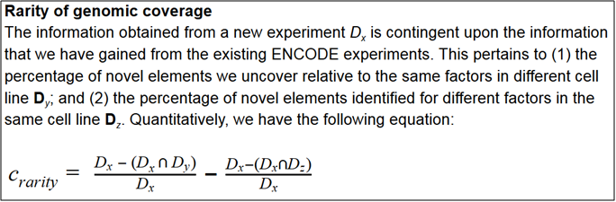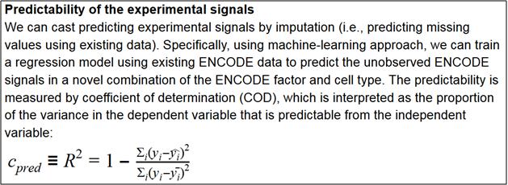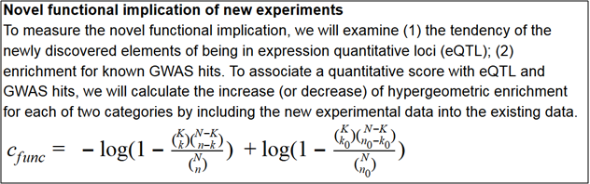

4.5. Prioritization of assays and cell types.
In addition the independent metrics of dataset utility, we will evaluate the utility of datasets in the context of all other data across assays and across cell types. Within each cell type, we will evaluate the utility of each data type based on its ability to predict other data types, and the difficulty of predicting it by other data types. Conversely, for each data type we will use the same approach for evaluate the utility of different cell types, based predictive power and predictability. We combine the two approaches to rank each dataset in each cell type, and to prioritize the set of experiments that will be of greatest overall utility.
[from Bill Noble]
A key question facing the ENCODE Consortium has always been which assays to perform in which cell types. In principle, to fully characterize a given cell type, one would like to perform every possible type of assay: DNase-seq, ChIP-seq for all histone modifications and transcription factors for which antibodies are available, RNA-seq on a wide variety of subcellular fractions, etc. However, at current sequencing prices, performing a single genomics assay with reasonable sequencing depth costs on the order of $400 (https://www.scienceexchange. com/services/chip-seq). As of February, 2016, the ENCODE and Roadmap Epigenomics consortia have performed a total of 270 types of assays on at least one cell type, and at least one assay on a total of 320 cell types (encodeproject.org). Applying all these assay types to all these cell types would require 86,500 assays; however, the two consortia have performed just 2342 assays, 3% of the possible number.
In practice, carrying out all of the remaining assays would not only be expensive but also wasteful because many pairs of assay types yield redundant information. For example, the transcription factors REST and RCOR1 are cofactors and therefore bind almost the same set of genomic positions [43]. Similarly, the histone modification H3K36me3 primarily marks gene bodies, which are also transcribed and therefore measured by RNA-seq. Therefore, a great deal of what can be learned from the full set of assays can likely be learned by performing a small subset of the possible assays. This redundancy among assay types suggests that a carefully chosen panel of assays is likely to produce most of the information that performing all assays would.
We have developed a principled method to identify a small panel of maximally informative assay types by borrowing methods from the field of submodular optimization [44]. A submodular function [45] is defined as follows: given a finite size m set V = {1, 2, . . . , m}, a discrete set function f : 2V → R that offers a real value for any subset S ⊆ V is submodular if and only if f (S) + f (T ) ≥ f (S ∪ T ) + f (S ∩ T ), ∀S, T ⊆ V. Defining f (s|S) _Q f (s ∪ S) − f (S), submodularity can equivalently be defined as f (s|S) ≥ f (s|T ), ∀S ⊆ T and s ∈/
T . That is, the incremental gain of adding item s to the set decreases when the set to which s is added to grows from S to T . In our approach, the V represents a set of genomics assays and the set function f (S) represents a measure of “quality” of a subset of assays S ⊆ V , or roughly, how well the subset S captures the information present in the full set V . Submodular functions have a long history in economics [46, 47], game theory [48, 49], combinatorial optimization [50–52], electrical networks [53], operations research [54], and more recently, machine learning [55–58], but they are not yet widely used for problems in biology.
In selecting a panel of genomics assays, we are interested in the problem of maximizing a submodular function subject to a constraint on the size of the reported set. That is, we are interested in solving the problem
maximize f (S), subject to |S| ≤ k (1) for some integer k ≤ |V |.
Although this problem is NP-hard, it can be approximately solved by a simple greedy
algorithm with a worst-case approximation factor (1 − e−1) [59], which is the best solution obtainable in polynomial time unless P = N P [60].

On the basis of extensive empirical investigation (not shown), the particular submodular objective that we selected is called the facility location function [54], ffac : 2V → R:
ffac(S) = '\" max rst,s,(2)
s∈S
st∈V
where rst,s measures the pairwise similarity between assays st and s. For r, we use the Pearson correlation between the two assay types, averaged over the cell types in which both have been performed. Intuitively, the facility location function takes a high value when every assay in V has at least one similar representative in
S. This function has been previously applied in many fields, including document summarization [61], feature selection [57], and exemplar based clustering [62]. The facility location function also corresponds to the objective function of the k-medoids clustering problem [63].
We have demonstrated empirically that this submodular optimization approach yields high quality panels of assays. To do so, we developed three evaluation schemes based on evaluating the panel’s ability to impute missing data, identify functional elements, and accurately annotate the genome in a cross-validated setting (Figure 3A). The quality of the selected panel is higher than randomly selected panels, as well as panels selected based on their frequency in the ENCODE+Roadmap data matrix (Figure 3). We have produced similar results for panels of transcription factor ChIP-seq assays (not shown). In addition, we note that the panel of histone modifications selected by our method closely overlaps with the panel selected by the Roadmap Epigenomics Consortium (our panels of size 6 or greater contain the Roadmap panel of size 5).
Moving forward, we aim to extend our methods in several directions. First, we will explore application of the submodular approach to important variants of the problem. We have already investigated selection of assays in three scenarios:
1. “I want to select a set of x assays to perform in a new cell type.”
2. “I have carried out x assays in a given cell type and want to select an additional set of y assays to perform.”
3. “I have carried out x assays in a given cell type and want to select a representative subset of y assays from among them, for use in training a statistical model.”
We plan to use a similar approach to address the following scenarios:
1. “I have carried out x assays across a variety of cell types and assay types, and I would like to select a set of y additional assays in any combination of cell and assay types.”
2. “Based on orthogonal data such as gene expression profiles, which new cell types should I perform assays in?”
3. A
Assay imputation
SSA-future SSA-past
Most-frequently performed assays Random
Functional element prediction
Annotation-based evaluation
Figure 3: (A) Schematic of the cross-validated evaluation strategy. The box labeled “Evaluate” contains an imputation scheme using support vector regression, a functional element predictor using support vector machine classification, or a semi-automated genome annotation method. The corresponding performance measures are R2 between the true and imputed data, the area under the precision-recall curve, and the percentage of variance explained by the annotation. (B) Performance of panel selection strategies on cell type GM12878. Boxplots show the distribution of evaluation metrics over 40 random panels. The panels of most-frequently performed assays are composed of top k most frequent assay types available in our data set, where k is the size of the panel. Each evaluation metric is normalized to lie within [0, 1] by subtracting the lowest value and dividing by the highest. Results on other cell types are similar (not shown).
4. “Which genomic positions should I target with a genomics assay such as Nanostring?”
In addition, we plan to use our cross-validated evaluation strategy to investigate variants of our approach. For example, we will substitute alternative similarity measures in place of the Pearson correlation, to account for the non-uniform nature of the data across the genome or to allow for a more principled combination of similarities within the (additive) facility location function. We will also investigate weighting strategies to take into account, for example, the level of noise in individual experiments as measured by replicate experiments.

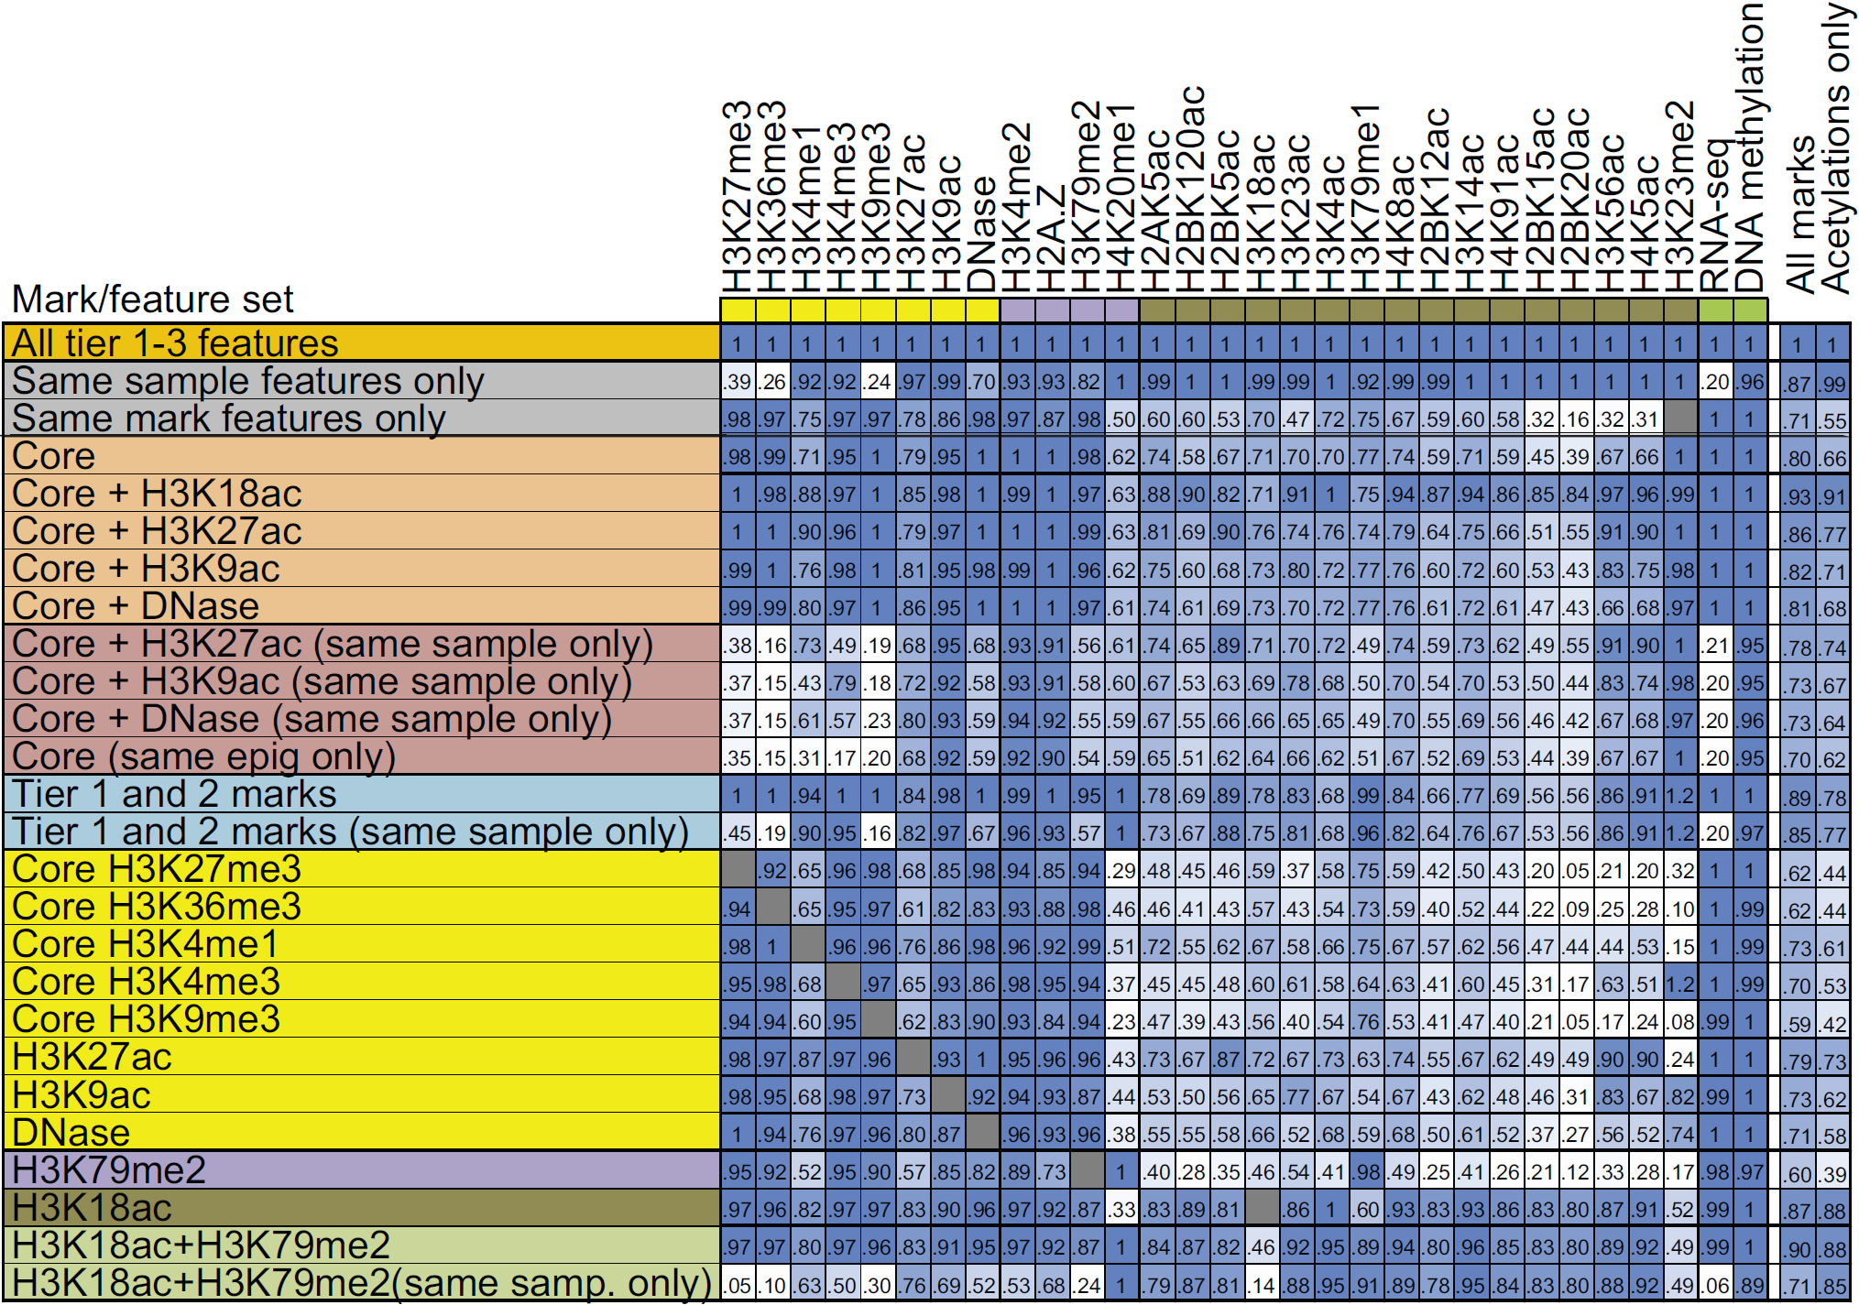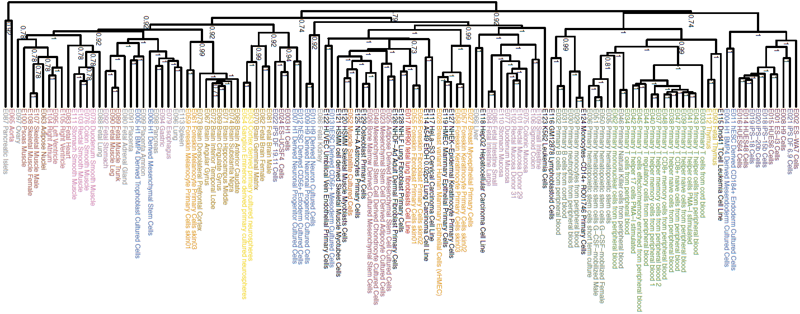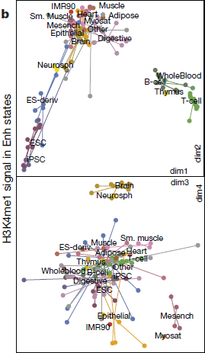
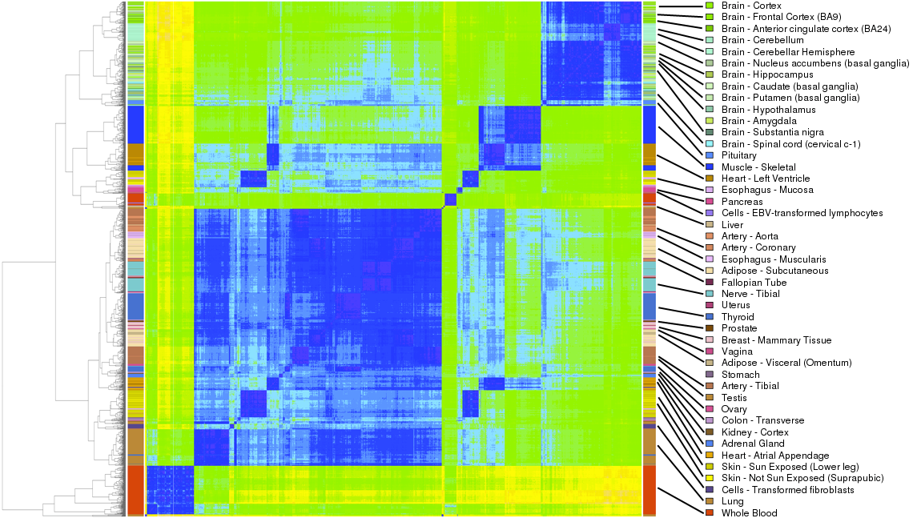
Figure 4.5. Assay and cell type prioritization. (a) As a metric of dataset priority, we use imputation agreement for each data type (columns) using subsets of features (rows) in top 1% signal bins or 0.25 concordance measure for DNA methylation (shown here for Chr10) relative to agreement achieved when using all features based on the seven samples with deep mark coverage without making distinctions between the tier 1–3 marks. Same-sample features are most important for acetylation marks, and same-mark features are most important for H3K27me3, H3K36me3, H3K9me3 and RNA-seq. Profiling of only H3K18ac and H3K79me2 allows higher relative imputation agreement than all five core marks, assuming a compendium with uniform coverage of marks. Performance for additional subsets is shown in Supplementary Figure 42. The last two columns show the average performance of the feature subset over all target marks and specifically for acetylations. Core=H3K4me1, H3K4me3, H3K36me3, H3K27me3, H3K9me3. For the purpose of computing these averages for mark subsets, if the target mark was included in the subset then a value of 1 was used for the target mark; the imputation performance restricted to other marks in the subset, when available, is provided in the table. The H3K18ac+H3K79me2 and tier 1 and 2 mark evaluations were limited to the five samples that were deeply profiled across marks and also had experimentally profiled H3K79me2. (b) As a metric of cell type priority. (d)
4.6. Disease- and trait-specific prioritization.
In addition to these goal-agnostic measures of dataset utility, we will develop and apply methods for prioritizing datasets based on specific tasks of interest. Specifically in the context of disease, we will provide a ranking of cell types and assays based on their predictive ability for genetic variants (from GWAS) or epigenetic marks (e.g. from MWAS) are associated with specific diseases and traits.
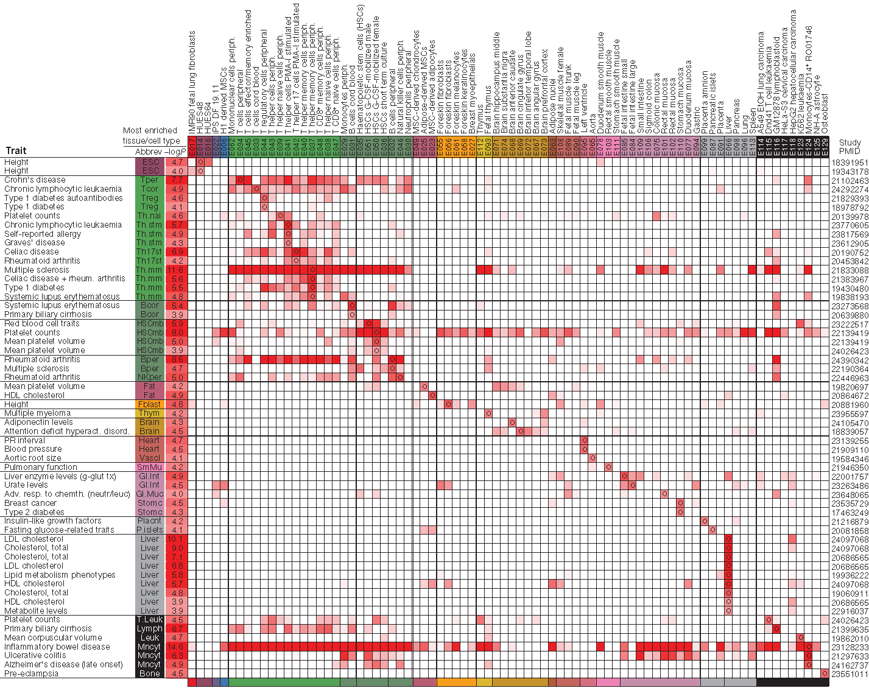
Figure 4.6. Tissue-specific H3K4me1 peak enrichment significance (−log10 P value) for genetic variants associated with diverse traits. Circles denote reference epigenome (column) of most significant enrichment for SNPs reported by a given study (row), defined by trait and publication (PubMed identifier, PMID). Tissue (Abbrev) and P value (−log10) of most significant enrichment are shown. Only rows and columns containing a value meeting a FDR of 2% are shown.

Assessing the quality of ENCODE data and upholding ENCODE data standards. [Rafa old text]
The Irizarry Lab has developed several computational methods for preprocessing high-throughput sequencing data³⁸⁻⁴¹. We will apply these and develop new methods to assess the quality of ENCODE data. To measure quality, we quantify the effect of removing bad quality data on the final biological results reported by ENCODE, which we refer to as the ‘bottom-line’ results. We will assess the quality for individual sequencing runs as well as batches, as we have learned from microarray experiments that these appear to have the largest number of outliers⁴². Because most results from ENCODE will be a combination of data from various samples, a single bad sequencing run can easily taint the final results. Therefore, quality control becomes even more important than before. Currently, quality metrics for high-throughput sequencing data have been an ad-hoc procedure, with each lab implementing its own approach. We plan to standardize quality metrics in preparation for combined data from different sources. We will leverage both our experience with ENCODE data as well as our experience with other high-throughput methods such as those employed in microarray data; the literature in microarrays is particularly mature (see ⁴² for review). We will implement techniques that model data from various samples and explore summary statistics such as cross-sample correlations, data distributions, and exploratory tools based on principal component analysis.
There are several sources of errors and biases in data generated using deep sequencing. (1) Base-calling quality computed using manufacturer-supplied tools and protocols is not a sufficient indicator of error-rate and is too coarse a measure to quantify bias in sequencing error. (2) Base-call errors are not randomly distributed across the cycle positions in sequenced reads⁴³ and although we developed a normalization method for the SOLiD platform³⁹, this issue has not been studied extensively. Alternative base-calling methods that reduce the cycle-related bias in error rates have been developed^{40,44}. Numerous error correction methods have also been developed to reduce errors from reads after bases have been called⁴⁵⁻⁴⁸. (3) A long-observed phenomenon in high-throughput sequencing data is the strong, reproducible effect of local sequence content (such as GC content) on the coverage of a genomic region by sequencing reads^{43,49}. For sequencing projects where coverage levels are compared across regions, such as RNA-seq, ChIP-seq or copy number detection, this can be particularly problematic. Adjusting signal for GC content leads to improved results in both ChIP-seq and copy number estimation with sequencing data^{49,50}. (4) Genomic regions that are identical or highly similar to one another create ambiguity in alignment to the genome and these ambiguous reads are generally discarded. The low coverage in these regions can produce biased measurements or remove the regions from consideration in downstream analysis. Methods have been developed for taking this ‘mappability’ property into account to adjust for the observed signal in these regions⁴⁹. (5) There are some other types of biases such as spatial bias that seems to be unique to the sample preparation protocol being used. Hansen et al. have shown that random hexamer priming can lead to coverage bias in RNA-seq analyses⁵¹, and Li et al. present a model for the non-uniformity of RNA-seq read coverage⁵². Both papers provide solutions to adjust for these biases and achieve more uniform coverage. We will develop computational methods to correct these different types of experimental biases.
Finally, batch effects, which are complications typical to high-throughput studies, occur when measurements are affected by laboratory conditions and reagent lots⁵³⁻⁵⁵. Previously, the Irizarry Lab has demonstrated that batch effects are widespread and critical to address⁵³. Unfortunately, the sources of batch effects are often unknown. As the ENCODE Project grows and data from different sources are incorporated, assessing and removing batch effects will be a major challenge. The primary way to avoid batch effects is through careful experimental design. Randomization of all experimental variables across treatment conditions should be employed to avoid systematic effects within a condition. In order to correct for these batch effects, they need to first be detected and then adjusted for. We will develop detection and correction methods, be it through the use of covariates in linear models or more involved procedures such as surrogate variables.
Normalization methods for ChIP-Seq, DNAse data, RNA-Seq [Rafa new text]

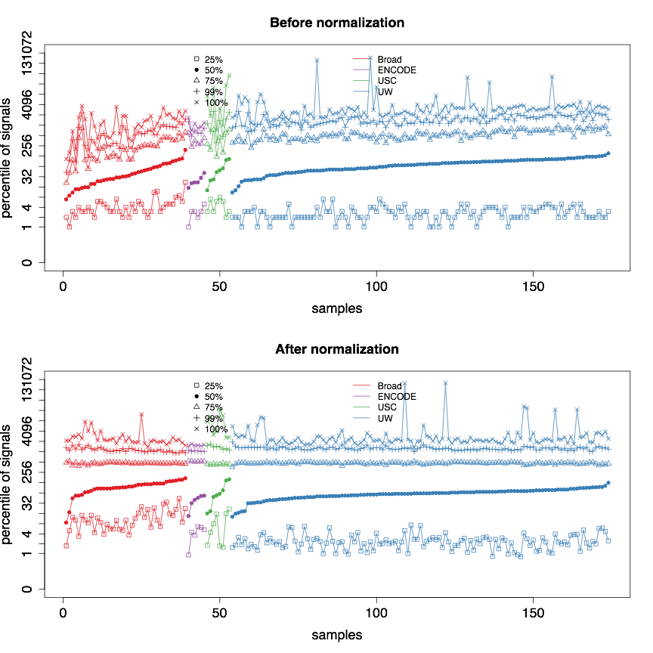
To illustrate the need for normalization techniques for the current ENCODE binding data we downloaded CTCF and H3K4Me3 ChIP-Seq. We picked these because they represent the two marks for which the most experiments have been run. In total, CTCF data includes 90 cell types, most of which have two replicates and some of processed in multiple data production centers. H3K4Me3 data includes 89 cell types that were processed in multiple data production centers as well. We downloaded BAM files are downloaded from ENCODE data portal (https://www.encodeproject.org/).

We generated data matrices with rows representing genome location, column representing samples, and the cells containing binding destimates. Specifically, we recorded the CTCF binding sites reported by ENCODE (detected with peak detectors) and we also computed coverage in genome-wide 10k windows. Because H3K4Me3 is know to be an active histone marks of gene expression², we limit the analysis to promoter regions of protein coding genes.Thus, signal matrices are generated for CTCF or H3K4Me3, where rows indicate regions and columns indicate samples.

The need for normalization in these can easily be observed by plotting the quartiles of each sample (Figure 2 top panel). Notice that we see a 10 fold difference in the median values. The variability in distribution is particularly large in the data produced by the lab denoted in red. Furthrer data exploration revealed that the first principal component of these data was highly correlated with the percent of 0s in the data (Figure 3 below). This points to technical problem driving the difference.
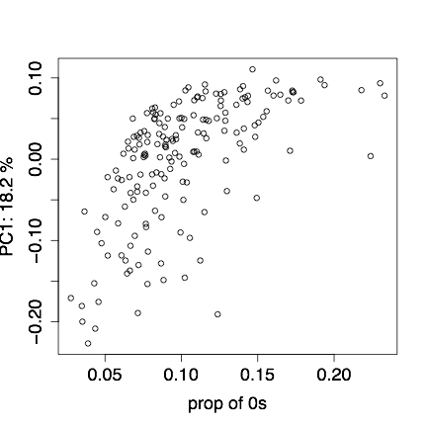
We will implement a normalization approach that will treat the fact that there is such a large variability in the number of reported 0s as missing data problem. We will assume that some of these 0s are actually due to detection problems. The bottom pane of Figure 2 shows the results of applying a a preliminary version of our approach.

Protecting against Batch effects [Rafa new text]

We use CTCF data to illustrate potential downstream results of batch effects. Signal matrix of annotated CTCF binding sites was first normalized by TMM algorithm³ and log transformed. Then, mixed effect hierarchical model (see below) was fitted for each binding site to estimate potential effects from cell biology, production center batch and other factors. To avoid confounding, estimation was performed based on 9 selected cell types for which ChIP-Seq experiments were conducted by multiples data production centers. Based on estimation, we observe that some sites show different signals in different cell types, representing true biological variability; whereas some sites show consistently high signal in specific centers regardless of their cell types, suggesting potential strong batch effects (Figure 3).

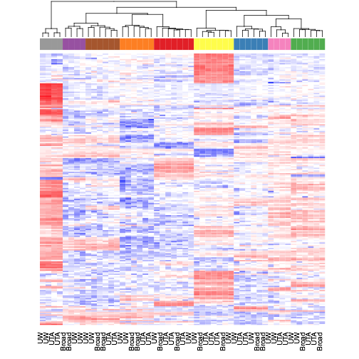 | 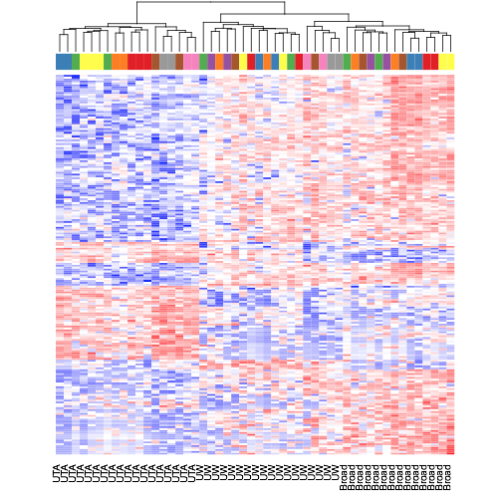 | 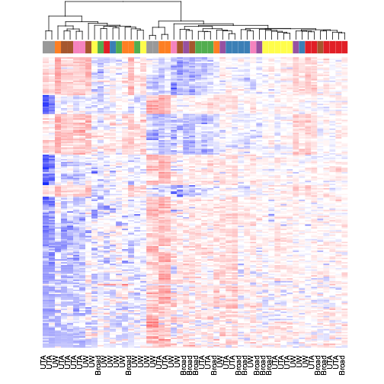
Figure 6

We also checked signals of these binding sites in all 90 cell types. The patterns are actually consistent for some binding sites, suggesting batch effects might be intrinsic for them (Figure 7).

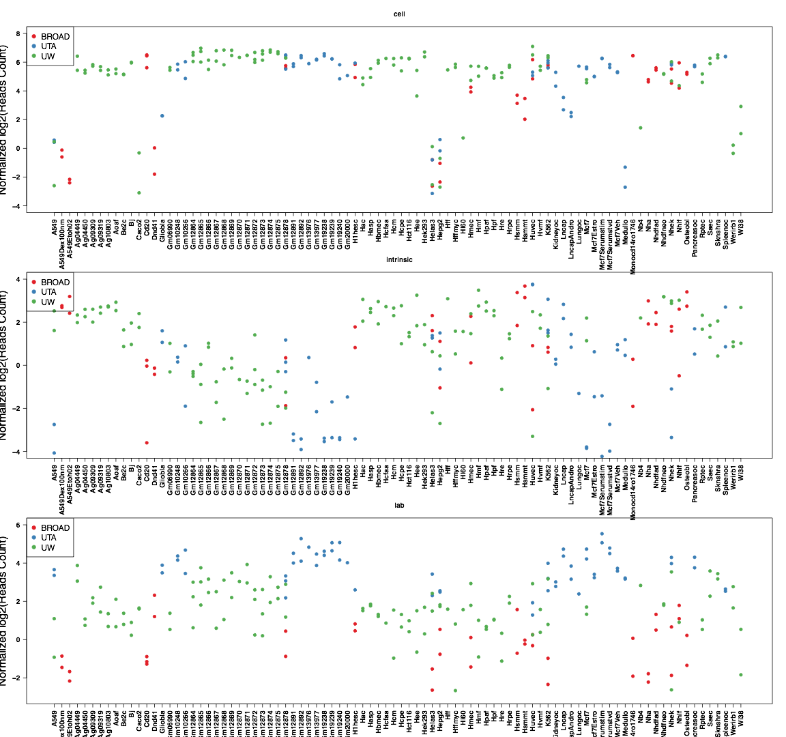
Figure 7

One possible explanation for batch effects is GC-content bias. We measuring GC content on 150 bp window sizes (i.e. 150bp for ENCODE annotated sites) .Below we see threee example o of how GC cotent can vary across different samples. We will develop corrections to remove this source of variability.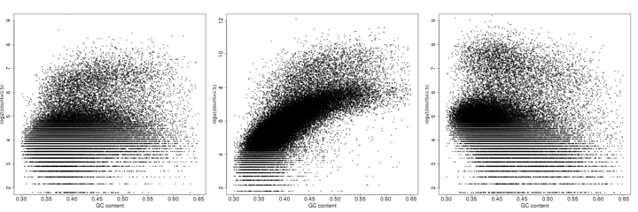
Figure 5

We will also develop experimental design strategies that will permit us to estimate and correct for batch effects going forward.

1. Consortium, E.P. An integrated encyclopedia of DNA elements in the human genome. Nature 489, 57-74 (2012).
2. Lauberth, S.M. et al. H3K4me3 interactions with TAF3 regulate preinitiation complex assembly and selective gene activation. Cell 152, 1021-1036 (2013).
3. Robinson, M.D. & Oshlack, A. A scaling normalization method for differential expression analysis of RNA-seq data. Genome Biol 11, R25 (2010).

TIMELINE
The DAC is ultimately responsive to the needs of the AWG, which includes the heads of all ENCODE production groups. The AWG and DAC will set priorities and time-lines during their bi-weekly interactions, based on data production and availability, based on new results, insights, and technologies, and the aims proposed here may be altered to better fit the analysis needs of the Consortium.
Tentatively, we have established the following timeline involving two publication cycles during the four years of project: an initial production data freeze is planned by the end of Year 1.5, with coordinated pipelined analyses to be completed in two months, and an initial integrative analysis will begin soon after, focusing on Aims 2 and 3. We will plan an analysis group meeting by the end of Year 2, and we expect an initial analysis results freeze for this initial analysis to be completed by Year 2, and a manuscript to be completed and submitted by the end of 2014.
We expect a second data freeze in Year 3.5, tentatively set for the end of 2015, with formatted dataset freeze set two months after, to launch a second analysis cycle for a joint paper summarizing findings of the ENCODE Project. Priorities will be on Aims 3-5, to be completed by 2016, and a second manuscript submitted by the end of the project.

REFERENCES CITED
1. Feingold, E., Good, P. & Guyer, M. The ENCODE (ENCyclopedia Of DNA Elements) Project. Science (2004).
2. ENCODE Project Consortium et al. Identification and analysis of functional elements in 1% of the human genome by the ENCODE pilot project. Nature 447, 799–816 (2007).
3. ENCODE Project Consortium An Integrated Encyclopedia of DNA Elements in the Human Genome. ENCODE Companion submitted to Nature
4. Wang, J. et al. Genome-wide mapping of the binding sites of 119 human transcription factors. ENCODE Companion submitted to Nature
5. Dong, X. et al. Correlating histone modifications and gene expression. ENCODE Companion submitted to Genome Res
6. Xi, H.S., Wang, J., Xu, J. & Weng, Z. Identification and Characterization of Allele-Specific Transcriptional Regulation in the Human Genome. ENCODE Companion submitted to Genome Res
7. Whitfield, T.W. et al. Functional analysis of transcription factor binding sites in human promoters. ENCODE Companion submitted to Genome Biol
8. Gerstein, M.B. et al. Architecture of the human regulatory network derived from ENCODE data. ENCODE Companion submitted to Nature
9. Gerstein, M.B. et al. Integrative analysis of the Caenorhabditis elegans genome by the modENCODE project. Science 330, 1775–1787 (2010).
10. Gerstein, M.B. et al. What is a gene, post-ENCODE? History and updated definition. Genome Res 17, 669–681 (2007).
11. Trinklein, N.D. et al. Integrated analysis of experimental data sets reveals many novel promoters in 1% of the human genome. Genome Res 17, 720–731 (2007).
12. Rozowsky, J.S. et al. The DART classification of unannotated transcription within the ENCODE regions: associating transcription with known and novel loci. Genome Res 17, 732–745 (2007).
13. Zhang, Z.D. et al. Statistical analysis of the genomic distribution and correlation of regulatory elements in the ENCODE regions. Genome Res 17, 787–797 (2007).
14. Zheng, D. et al. Pseudogenes in the ENCODE regions: consensus annotation, analysis of transcription, and evolution. Genome Res 17, 839–851 (2007).
15. Washietl, S. et al. Structured RNAs in the ENCODE selected regions of the human genome. Genome Res 17, 852–864 (2007).
16. Euskirchen, G.M. et al. Mapping of transcription factor binding regions in mammalian cells by ChIP: comparison of array- and sequencing-based technologies. Genome Res 17, 898–909 (2007).
17. Lu, Z.J. et al. Prediction and characterization of noncoding RNAs in C. elegans by integrating conservation, secondary structure, and high-throughput sequencing and array data. Genome Res 21, 276–285 (2011).
18. Cheng, C. et al. A statistical framework for modeling gene expression using chromatin features and application to modENCODE datasets. Genome Biol 12, R15 (2011).
19. Nègre, N. et al. A cis-regulatory map of the Drosophila genome. Nature 471, 527–531 (2011).
20. Habegger, L. et al. RSEQtools: a modular framework to analyze RNA-seq data using compact, anonymized data summaries. Bioinformatics 27, 281–283 (2011).
21. Sboner, A. et al. FusionSeq: a modular framework for finding gene fusions by analyzing paired-end RNA-sequencing data. Genome Biol 11, R104 (2010).
22. Montgomery, S.B. et al. Transcriptome genetics using second generation sequencing in a Caucasian population. Nature 464, 773–777 (2010).
23. Li, Q., Brown, J.B., Huang, H. & Bickel, P.J. Measuring reproducibility of high-throughput experiments. The Annals of Applied Statistics 5, 1752–1779 (2011).
24. Gonzalez-Porta, M., Calvo, M., Sammeth, M. & Guigó, R. Estimation of alternative splicing variability in human populations. Genome Res (2011).doi:10.1101/gr.121947.111
25. Djebali, S. et al. Landscape of transcription in human cells. ENCODE Companion submitted to Nature
26. Tilgner, H. et al. Nucleosome positioning as a determinant of exon recognition. Nat Struct Mol Biol 16, 996–1001 (2009).
27. Luco, R.F. et al. Regulation of alternative splicing by histone modifications. Science 327, 996–1000 (2010).
28. Tilgner, H. et al. Chromatin mediated regulation of alternative splicing. ENCODE Companion submitted to Genome Res
29. Tilgner, H. et al. Deep sequencing of RNA from distinct subcellular fractions shows that splicing in the human genome occurs predominantly during transcription. ENCODE Companion submitted to Genome Res
30. Ørom, U.A. et al. Long noncoding RNAs with enhancer-like function in human cells. Cell 143, 46–58 (2010).
31. Derrien, T. et al. The GENCODE v7 catalogue of human long non-coding RNAs: Analysis of their gene structure, evolution and expression. ENCODE Companion submitted to Genome Res
32. Kharchenko, P.V., Tolstorukov, M.Y. & Park, P.J. Design and analysis of ChIP-seq experiments for DNA-binding proteins. Nat Biotechnol 26, 1351–1359 (2008).
33. Zhang, Y. et al. Model-based analysis of ChIP-seq (MACS). Genome Biol 9, R137 (2008).
34. Rozowsky, J. et al. PeakSeq enables systematic scoring of ChIP-seq experiments relative to controls. Nat Biotechnol 27, 66–75 (2009).
35. Kheradpour, P. & Manolis, K. Systematic discovery and characterization of regulatory motifs in ENCODE TF binding experiments. ENCODE Companion submitted to Genome Res
36. Giardine, B. et al. Galaxy: a platform for interactive large-scale genome analysis. Genome Res 15, 1451–1455 (2005).
37. Liu, T. et al. Cistrome: an integrative platform for transcriptional regulation studies. Genome Biol 12, R83 (2011).
38. Niranjan, T.S. et al. Effective detection of rare variants in pooled DNA samples using Cross-pool tailcurve analysis. Genome Biol 12, R93 (2011).
39. Wu, H., Irizarry, R.A. & Bravo, H.C. Intensity normalization improves color calling in SOLiD sequencing. Nat Methods 7, 336–337 (2010).
40. Bravo, H.C. & Irizarry, R.A. Model-based quality assessment and base-calling for second-generation sequencing data. Biometrics 66, 665–674 (2010).
41. Hansen, K.D., Wu, Z., Irizarry, R.A. & Leek, J.T. Sequencing technology does not eliminate biological variability. Nat Biotechnol 29, 572–573 (2011).
42. McCall, M.N., Murakami, P.N., Lukk, M., Huber, W. & Irizarry, R.A. Assessing affymetrix GeneChip microarray quality. BMC Bioinformatics 12, 137 (2011).
43. Dohm, J.C., Lottaz, C., Borodina, T. & Himmelbauer, H. Substantial biases in ultra-short read data sets from high-throughput DNA sequencing. Nucleic Acids Res 36, e105 (2008).
44. Kao, W.-C., Stevens, K. & Song, Y.S. BayesCall: A model-based base-calling algorithm for high-throughput short-read sequencing. Genome Res 19, 1884–1895 (2009).
45. Yang, X., Dorman, K.S. & Aluru, S. Reptile: representative tiling for short read error correction. Bioinformatics 26, 2526–2533 (2010).
46. Zhao, X. et al. EDAR: an efficient error detection and removal algorithm for next generation sequencing data. J. Comput. Biol. 17, 1549–1560 (2010).
47. Schröder, J., Schröder, H., Puglisi, S.J., Sinha, R. & Schmidt, B. SHREC: a short-read error correction method. Bioinformatics 25, 2157–2163 (2009).
48. Kelley, D.R., Schatz, M.C. & Salzberg, S.L. Quake: quality-aware detection and correction of sequencing errors. Genome Biol 11, R116 (2010).
49. Kuan, P.F. et al. A Statistical Framework for the Analysis of ChIP-seq Data. Journal of the American Statistical Association 106, 891–903 (2011).
50. Lee, W. et al. The mutation spectrum revealed by paired genome sequences from a lung cancer patient. Nature 465, 473–477 (2010).
51. Hansen, K.D., Brenner, S.E. & Dudoit, S. Biases in Illumina transcriptome sequencing caused by random hexamer priming. Nucleic Acids Res 38, e131 (2010).
52. Li, J., Jiang, H. & Wong, W.H. Modeling non-uniformity in short-read rates in RNA-seq data. Genome Biol 11, R50 (2010).
53. Leek, J.T. et al. Tackling the widespread and critical impact of batch effects in high-throughput data. Nat Rev Genet 11, 733–739 (2010).
54. Leek, J.T. & Storey, J.D. Capturing heterogeneity in gene expression studies by surrogate variable analysis. PLoS Genet 3, 1724–1735 (2007).
55. Johnson, W.E., Li, C. & Rabinovic, A. Adjusting batch effects in microarray expression data using empirical Bayes methods. Biostatistics 8, 118–127 (2007).
56. ENCODE Project Consortium et al. A user's guide to the Encyclopedia of DNA Elements (ENCODE). PLoS Biol. 9, e1001046 (2011).
57. Kolasinska-Zwierz, P. et al. Differential chromatin marking of introns and expressed exons by H3K36me3. Nature genetics 41, 376–381 (2009).
58. Guttman, M. et al. Chromatin signature reveals over a thousand highly conserved large non-coding RNAs in mammals. Nature 458, 223–227 (2009).
59. Stark, A. et al. Discovery of functional elements in 12 Drosophila genomes using evolutionary signatures. Nature 450, 219–232 (2007).
60. modENCODE Consortium et al. Identification of functional elements and regulatory circuits by Drosophila modENCODE. Science 330, 1787–1797 (2010).
61. Cheng, C., Weng, Z. & Gerstein, M. Understanding transcriptional regulation by integrative analysis of transcription factor binding data. ENCODE Companion submitted to Genome Res
62. Cheng, C., Shou, C., Yip, K.Y. & Gerstein, M.B. Genome-wide analysis of chromatin features identifies histone modification sensitive and insensitive yeast transcription factors. Genome Biol 12, R111 (2011).
63. Cheng, C. & Gerstein, M. Modeling the relative relationship of transcription factor binding and histone modifications to gene expression levels in mouse embryonic stem cells. Nucleic Acids Res (2011).doi:10.1093/nar/gkr752
64. Barash, Y. et al. Deciphering the splicing code. Nature 465, 53–59 (2010).
65. Luco, R.F., Allo, M., Schor, I.E., Kornblihtt, A.R. & Misteli, T. Epigenetics in alternative pre-mRNA splicing. Cell 144, 16–26 (2011).
66. He, H.H. et al. Nucleosome dynamics define transcriptional enhancers. Nature genetics 42, 343–347 (2010).
67. Kheradpour, P., Stark, A. & Roy, S. Reliable prediction of regulator targets using 12 Drosophila genomes. Genome Res (2007).
68. Ernst, J. et al. Mapping and analysis of chromatin state dynamics in nine human cell types. Nature 473, 43–49 (2011).
69. Yip, K.Y. et al. Genome-wide analysis of the binding sites of more than 100 transcription-related factors defines different types of genomic regions with distinct biological properties. ENCODE Companion submitted to Genome Res
70. Sandberg, R., Neilson, J.R., Sarma, A., Sharp, P.A. & Burge, C.B. Proliferating cells express mRNAs with shortened 3' untranslated regions and fewer microRNA target sites. Science 320, 1643–1647 (2008).
71. Thurman, R.E., Day, N., Noble, W.S. & Stamatoyannopoulos, J.A. Identification of higher-order functional domains in the human ENCODE regions. Genome Res 17, 917–927 (2007).
72. Filion, G.J. et al. Systematic protein location mapping reveals five principal chromatin types in Drosophila cells. Cell 143, 212–224 (2010).
73. Kharchenko, P.V. et al. Comprehensive analysis of the chromatin landscape in Drosophila melanogaster. Nature 471, 480–485 (2011).
74. Jaschek, R. Spatial clustering of multivariate genomic and epigenomic information. Research in Computational Molecular Biology (2009).
75. Lian, H. et al. Automated mapping of large-scale chromatin structure in ENCODE. Bioinformatics 24, 1911–1916 (2008).
76. Ernst, J. & Kellis, M. Discovery and characterization of chromatin states for systematic annotation of the human genome. Nat Biotechnol 28, 817–825 (2010).
77. Hoffman, M.M. et al. Unsupervised pattern discovery in human chromatin structure through genomic segmentation. Submitted
78. Hoffman, M.M. et al. Integrative annotation of chromatin elements from ENCODE data. ENCODE Companion submitted to Genome Res
79. Day, N., Hemmaplardh, A., Thurman, R.E., Stamatoyannopoulos, J.A. & Noble, W.S. Unsupervised segmentation of continuous genomic data. Bioinformatics 23, 1424–1426 (2007).
80. Lieberman-Aiden, E. et al. Comprehensive mapping of long-range interactions reveals folding principles of the human genome. Science 326, 289–293 (2009).
81. Wang, J., Lunyak, V.V. & Jordan, I.K. Genome-wide prediction and analysis of human chromatin boundary elements. Nucleic Acids Res (2011).doi:10.1093/nar/gkr750
82. Pearl, J. Probabilistic Reasoning in Intelligent Systems: Networks of Plausible Inference. 552 (Morgan Kaufmann: 1988).
83. Reynolds, S.M., Käll, L., Riffle, M.E., Bilmes, J.A. & Noble, W.S. Transmembrane topology and signal peptide prediction using dynamic bayesian networks. PLoS Comput Biol 4, e1000213 (2008).
84. Entropic Graph Regularization in Non-Parametric Semi-Supervised Classification. 1803–1811 (2009).
85. Subramanya, A. & Bilmes, J. Semi-Supervised Learning with Measure Propagation. J. Mach. Learn. Res. 12, 3311–3370 (2011).
86. Parallel Graph-Based Semi-Supervised Learning. (2011).
87. Jee, J. et al. ACT: Aggregation and Correlation Toolbox for Analyses of Genome Tracks. Bioinformatics (2011).doi:10.1093/bioinformatics/btr092
88. Alexander, R.P., Fang, G., Rozowsky, J., Snyder, M. & Gerstein, M.B. Annotating non-coding regions of the genome. Nat Rev Genet 11, 559–571 (2010).
89. Frey, B.J. & Dueck, D. Clustering by passing messages between data points. Science 315, 972–976 (2007).
90. Reiss, D.J., Baliga, N.S. & Bonneau, R. Integrated biclustering of heterogeneous genome-wide datasets for the inference of global regulatory networks. BMC Bioinformatics 7, 280 (2006).
91. Bonneau, R. Learning biological networks: from modules to dynamics. Nat. Chem. Biol. 4, 658–664 (2008).
92. Bonneau, R. et al. The Inferelator: an algorithm for learning parsimonious regulatory networks from systems-biology data sets de novo. Genome Biol 7, R36 (2006).
93. Cheng, C. et al. Construction and analysis of an integrated regulatory network derived from high-throughput sequencing data. PLoS Comput Biol 7, e1002190 (2011).
94. Jansen, R., Greenbaum, D. & Gerstein, M. Relating whole-genome expression data with protein-protein interactions. Genome Res 12, 37–46 (2002).
95. Lu, L.J., Xia, Y., Paccanaro, A., Yu, H. & Gerstein, M. Assessing the limits of genomic data integration for predicting protein networks. Genome Res 15, 945–953 (2005).
96. Yu, H. & Gerstein, M. Genomic analysis of the hierarchical structure of regulatory networks. Proc Natl Acad Sci USA 103, 14724–14731 (2006).
97. Shou, C. et al. Measuring the evolutionary rewiring of biological networks. PLoS Comput Biol 7, e1001050 (2011).
98. Friedman, R.C., Farh, K.K.-H., Burge, C.B. & Bartel, D.P. Most mammalian mRNAs are conserved targets of microRNAs. Genome Res 19, 92–105 (2009).
99. Yip, K.Y., Yu, H., Kim, P.M., Schultz, M. & Gerstein, M. The tYNA platform for comparative interactomics: a web tool for managing, comparing and mining multiple networks. Bioinformatics 22, 2968–2970 (2006).
100. Yu, H., Kim, P.M., Sprecher, E., Trifonov, V. & Gerstein, M. The importance of bottlenecks in protein networks: correlation with gene essentiality and expression dynamics. PLoS Comput Biol 3, e59 (2007).
101. Bhardwaj, N., Kim, P.M. & Gerstein, M.B. Rewiring of transcriptional regulatory networks: hierarchy, rather than connectivity, better reflects the importance of regulators. Sci Signal 3, ra79 (2010).
102. Bhardwaj, N. et al. Analysis of combinatorial regulation: scaling of partnerships between regulators with the number of governed targets. PLoS Comput Biol 6, e1000755 (2010).
103. Bhardwaj, N., Yan, K.-K. & Gerstein, M.B. Analysis of diverse regulatory networks in a hierarchical context shows consistent tendencies for collaboration in the middle levels. Proc Natl Acad Sci U S A 107, 6841–6846 (2010).
104. Yan, K.-K., Fang, G., Bhardwaj, N., Alexander, R.P. & Gerstein, M. Comparing genomes to computer operating systems in terms of the topology and evolution of their regulatory control networks. Proc Natl Acad Sci U S A 107, 9186–9191 (2010).
105. Malmström, L. et al. Superfamily assignments for the yeast proteome through integration of structure prediction with the gene ontology. PLoS Biol. 5, e76 (2007).
106. Mu, X.J., Lu, Z.J., Kong, Y., Lam, H.Y.K. & Gerstein, M.B. Analysis of genomic variation in non-coding elements using population-scale sequencing data from the 1000 Genomes Project. Nucleic Acids Res 39, 7058–7076 (2011).
107. 1000 Genomes Project Consortium et al. A map of human genome variation from population-scale sequencing. Nature 467, 1061–1073 (2010).
108. Altshuler, D., Daly, M.J. & Lander, E.S. Genetic mapping in human disease. Science 322, 881–888 (2008).
109. Lango Allen, H. et al. Hundreds of variants clustered in genomic loci and biological pathways affect human height. Nature 467, 832–838 (2010).
110. Ward, L.D. & Kellis, M. HaploReg: a resource for exploring chromatin states, conservation, and regulatory motif alterations within sets of genetically linked variants. Nucleic Acids Res (2011).doi:10.1093/nar/gkr917
111. Rossin, E.J. et al. Proteins encoded in genomic regions associated with immune-mediated disease physically interact and suggest underlying biology. PLoS Genet 7, e1001273 (2011).
112. Raychaudhuri, S. et al. Common variants at CD40 and other loci confer risk of rheumatoid arthritis. Nature genetics 40, 1216–1223 (2008).
113. Raychaudhuri, S. et al. Identifying relationships among genomic disease regions: predicting genes at pathogenic SNP associations and rare deletions. PLoS Genet 5, e1000534 (2009).
114. Segrè, A.V. et al. Common inherited variation in mitochondrial genes is not enriched for associations with type 2 diabetes or related glycemic traits. PLoS Genet 6, (2010).
115. Raychaudhuri, S. et al. Genetic variants at CD28, PRDM1 and CD2/CD58 are associated with rheumatoid arthritis risk. Nature genetics 41, 1313–1318 (2009).
116. Franke, A., McGovern, D., Barrett, J. & Wang, K. Genome-wide meta-analysis increases to 71 the number of confirmed Crohn's disease susceptibility loci. Nature genetics (2010).
117. Gerstein, M. Annotation of the human genome. Science 288, 1590 (2000).
118. Seringhaus, M.R. & Gerstein, M.B. Publishing perishing? Towards tomorrow's information architecture. BMC Bioinformatics 8, 17 (2007).
119. Gerstein, M., Seringhaus, M. & Fields, S. Structured digital abstract makes text mining easy. Nature 447, 142 (2007).
120. Cheung, K.-H., Samwald, M., Auerbach, R.K. & Gerstein, M.B. Structured digital tables on the Semantic Web: toward a structured digital literature. Mol. Syst. Biol. 6, 403 (2010).
121. Yale Law School Roundtable on Data and Code Sharing Reproducible Research: Addressing the Need for Data and Code Sharing in Computational Science. Computing in Science and Engineering 12, 8–13 (2010).

Multi-PI LEADERSHIP PLAN
Leadership and reporting relationships. The ENCODE DAC will be led by the PI, Prof. Zhiping Weng; around 25% of her time will be spent on DAC/ENCODE issues. All major decisions, including hiring of personnel, budgeting, etc., will be made jointly by a three-member leadership committee consisting of Profs. Zhiping Weng, Mark Gerstein, and Manolis Kellis; each will be supported by a project manager, hired at the respective university. The remaining co-investigators (Guigo, Irizzary, Liu, and Noble) will report to the leadership committee. Finally, individual team members, including research scientists, postdocs, graduate and undergraduate students, will report to their respective co-investigators. The leadership committee as a whole will report to the AWG. This management structure is depicted in Figure 11.
The three project managers (supporting Profs. Weng, Gerstein and Kellis respectively) will be individuals with postdoctoral experience in bioinformatics coupled with good interpersonal skills, ideally with large-consortium experience. There are a number of excellent candidates available currently. Each project manager will spend 50% effort on managing the day-to-day activities of the DAC in the larger context of the AWG, communicating priorities, monitoring results and being accessible to all Consortium members and the NHGRI program officers at short notice. Their other 50% effort will be spent on data analysis. The project managers will be hubs of the communication network of the DAC.
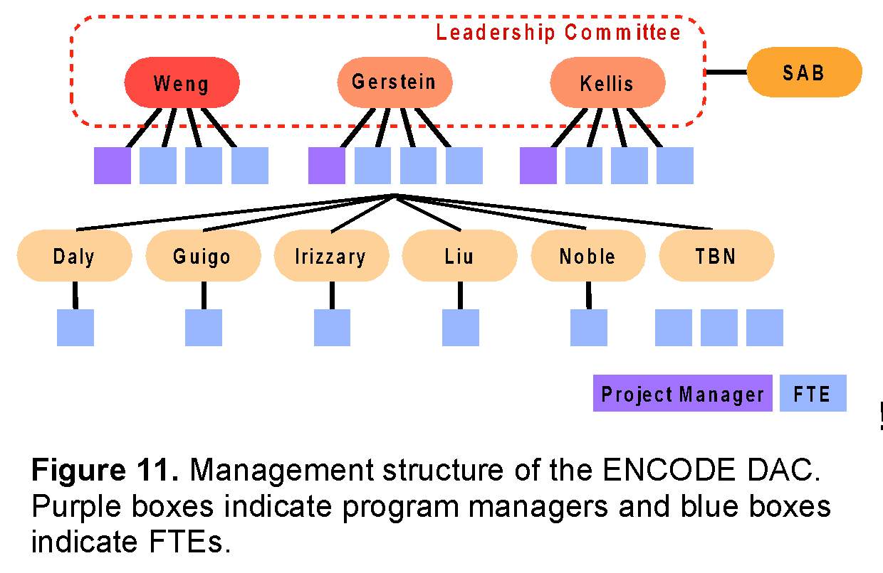
The Weng, Gerstein, and Kellis groups will each be staffed with the equivalent of four full time persons (FTEs in Figure 11, including the program manager, mostly postdocs with one or two graduate students), and the remaining groups will each be staffed with one postdoc. Roughly 70% of the FTEs will perform directed analysis, handling both “routine” analysis and more development or pipelining tasks, rapidly changing priorities as set by the leadership committee and directed by the project managers. The remaining 30% of the personnel will develop or adapt methods of interest to the DAC. They will be assigned tasks in a longer time frame, with priorities jointly set by the leadership committee and co-investigators.
The physical proximity of Weng, Gerstein, and Kellis (~2 hours door-to-door) will greatly facilitate the interactions among the DAC members in these three groups. The groups will have monthly physical meetings, rotating among the three universities. The three program managers will be in constant communication. This close interaction will be particularly beneficial for completing analyses and formulating integration manuscripts.
All members of the DAC are expected to participate in open discussion forums. These include:
1. Use of a single AWG mailing list for email discussion.
2. A monthly priority-setting phone conference with the AWG.
3. At least two physical meetings per year of the entire group, often coordinated with Consortium-wide programs, but with a day before or after the Consortium meeting dedicated to analysis tasks. In some cases, these analysis meetings will be run in a mini-jamboree mode where intensive collaborative work occurs.
4. All postdocs, students, and project managers will have Skype-based voice and instant messaging active during their working hours, allowing for quick and spontaneous interactions.
Chairing of AWG calls. We will adopt the current chairing structure of the ENCODE PI calls for the AWG calls, with an incoming, outgoing, and incumbent chair, rotating the chair amongst Weng, Gerstein, and Kellis. This arrangement will ensure continuity between the calls, with a specific PI being responsible for action items raised during the previous call, and those items to be raised during the next call.
Integration of production efforts. We will begin the ENCODE DAC activities with a two-day project launch meeting that involves all of the funded members of the DAC, with representation from the funded DCC. This meeting will provide scientific background for new members of the Consortium, establish shared expectations among the co-investigators and the leadership team, and clarify individual roles within the larger AWG effort.
Thereafter, as in the current phase of ENCODE, the project managers of the DAC will organize a weekly, minuted conference call. Scientific presentations will be made by each funded lab on a rotating basis. Attendance at this conference call will be mandatory for all funded members of the DAC.
Project documentation will be managed via the ENCODE Wiki, which will include a copy of the chart shown in Figure 11, as well as a list of all funded personnel. The Wiki will include one page dedicated to each participating group. These team-specific pages will serve as the primary reporting mechanism for each subcontract. Each page will be organized chronologically, and will include links to presentations made on the weekly conference calls, results of interim analyses, in-progress or submitted manuscripts, etc.
To maintain clarity about the direction of the DAC and to identify potential problems quickly, the project managers will conduct a survey of the entire AWG every six months. The survey will be brief, with the aim of gathering feedback for the leadership committee regarding what aspects of the project are working well, what aspects the members would like to see change, specific feedback for the leadership committee, and an overall rating of the effectiveness of the group. This survey will be anonymous, but participation by all funded members of the DAC will be required. A summary of the survey results will be shared with the whole group.
At the start of the project, we will recruit three individuals to form a scientific advisory board for the DAC. The SAB members will attend one DAC/AWG meeting annually and will thereafter provide written feedback to the leadership committee concerning both scientific and managerial issues. The SAB will also be available to assist in adjudicating disputes that may arise within the DAC.
Conflict Resolution. Most issues will be resolved by calls and meetings between the three members of the leadership committee. We will have a standing weekly 30-minute call where all issues arising will be brought up, discussed and resolved. Each member of the DAC will be able to contact any of the three members of the leadership committee, with the guarantee that any concerns will be brought up anonymously. Similarly, all members of the AWG will be able to address any concern they have anonymously to any member of the leadership committee. Similarly, the NHGRI will be able to raise its concerns with the leadership committee. Contentious issues about which complete agreement is not immediately reached among the three members of the leadership committee will be brought forward to the ENCODE steering committee for discussion. If agreement is not reached, the steering committee will cast an anonymous vote to resolve the issue.
Budget reassignments. Budget adjustments will be made yearly based on productivity of each member of the DAC and shifting priorities of the Consortium. This will only happen will full agreement of all three members of the leadership committee, and after notification of the NHGRI staff.
Allocation of reserved funds for existing and additional investigators. We have budgeted the equivalent funding for 25% of co-investigator effort and three postdoc-level FTEs (the TBN co-investigator box and three unconnected boxes in Figure 11), to be allocated in two ways. First, we envision the need to recruit new investigators as new areas of expertise are required. The decision to recruit additional members will be made upon full agreement of the leadership committee, in consultation with the NHGRI and the head of the AWG. Subcontracts will be made for six-month intervals and will be extended contingent upon successful progress and meeting deliverables. Subcontracts will be terminated only after full agreement of all three members of the leadership committee. Second, the five participating groups (Guigo, Irizarry, Liu, Kundaje and Noble) are each staffed with one postdoc, which represents the baseline effort and lower than the effort level per group in the current ENCODE DAC because we do not know yet which production groups are going to be funded in the next round of ENCODE. When we obtain the information of the funded production groups, we will be able to assess the number of data types and amount of data in each type, and provide additional FTEs to the groups with the matching expertise.
Risk assessment and Leadership
The proposed management structure is designed to achieve multiple aims simultaneously. On the one hand, having a single PI ensures consistency and provides a single point of contact for the NHGRI, the AWG, the DCC, and the production PIs. On the other hand, no single individual has the scientific, computational and statistical expertise to span the entire range of DAC activities. Accordingly, the leadership committee brings together three co-leaders with complementary strengths and very broad expertise. Furthermore, this joint leadership plan will likely provide greater responsiveness to the many partners involved than would a single, overworked PI trying to lead the whole DAC. Indeed, one of the primary goals of the reporting mechanisms and conflict resolution procedures outlined above is to maintain clarity, efficiency, and agility about the changing priorities of the various Consortium members, including the ENCODE data production labs, the AWG, the DCC, the DAC and the NHGRI. In particular, it will be critical to balance the scientific expertise and interests of the various DAC co-investigators with the needs of the Consortium to ensure that we are achieving our aims.
There are a number of potential risks that a project of this size and complexity could encounter. We have discussed these in the group and feel that all the risks can be mitigated or handled appropriately if they occur.
1. Inefficient collaboration due to geographical separation. This problem is unlikely to occur, mainly because five of the eight groups are located within 100 miles and six groups (including the two distal groups Noble and Guigo) have been working together in the ENCODE/modENCODE Project. In addition, monthly phone calls (rising in tempo during publication drives) coupled with pervasive VoIP/instant messaging will provide a strong sense of virtual community. If one group is not responsive or integrating with others, we will discuss the issue at the PI level first, followed by personnel visits to encourage networking and integration. If the problem persists, the leadership committee will discuss it with the PIs involved together with the NHGRI program director. In the extremely unlikely scenario that there is a truly intransigent group, which is hard to imagine given the DAC membership, we would consider withdrawing funds from this group upon the NHGRI consent.
2. DAC groupthink excluding input from other groups. This problem is unlikely to occur because of our track record in working openly with all groups and the genuine collaborative nature we take to solving problems. The presence of the AWG to provide independent input and prioritization is a formal mechanism to ensure the DAC groups do not become a closed club. We are also happy to work with the NHGRI program directors to implement other approaches if desired. Equally important will be informal aspects of our openness to collaboration. All DAC discussions will be open to all members of the Consortium.
3. Too many tasks from the AWG or switching of priorities too rapidly. We believe there is an appreciable risk that there will be a far larger task list than the DAC can accomondate, requiring tough prioritization decisions. The transparency of our process is critical here, as the AWG will need to set sensible priorities with some month-to-month consistency. It will be critical to build a high level of trust between the AWG and the DAC early in the project, before complex prioritization becomes an issue. Again, given that six of the groups are existing members of the ENCODE/modENCODE Consortium, there is already considerable trust between these groups and the AWG.
4. Too few tasks from the AWG. This is a potential issue at the start of the project, but there is a healthy list of pipelining tasks that will provide infrastructure later. ENCODE datasets are accumulating rapidly, so there are a lot of data to provide input into sensible biological questions early on.

