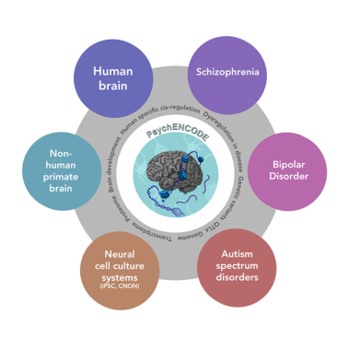**PsychENCODE Consortium Workshop**

February 9, 2016

6001 Executive Blvd, 1st Floor Conference Rooms C, D, & E

Bethesda, MD

8:30 AM – 5:30 PM EST

**9:00 AM – 11:15 AM: Open Session Presentations**

**9:00 – 9:10: Welcome and Introductions** – *Geetha Senthil, Ph.D. and Thomas Lehner, Ph.D., M.P.H.*

**9:10 – 9:20: Transcriptional and Epigenetic Signatures of Human Brain Development and Autism & Functional Genomics of Human Brain Development**, *Nenad Sestan, Yale University*

**9:20 – 9:30: Cis-Regulatory Epigenome Mappings in Schizophrenia**, *Schahram Akbarian & Pamela Sklar, Icahn School of Medicine at Mount Sinai*

**9:30 – 9:40: Genetic variants affect brain gene expression and risks of psychiatric disorders**, *Chunyu Liu & Kevin White, University of Illinois at Chicago*

**9:40 – 9:50: The USC and LIBD PsychENCODE Consortium**, *James Knowles & Peggy Farnham, University of Southern California*

**9:50 – 10:00: Gene regulatory elements and transcriptome in iPSCs and embryonic human cortex**, *Flora Vaccarino, Yale University*

**10:00 – 10:10: Epigenetic and Transcriptional Dysregulation in Autism Spectrum Disorder**, *Daniel Geschwind, University of California, Los Angeles*

**10:20 – 10:30: Decoding schizophrenia-From GWAS to functional regulatory variants**, *Gregory Crawford, Duke University & Patrick Sullivan, University of North Carolina – Chapel Hill*

**10:30 – 10:40: RNA Sequencing of the Limbic System in Bipolar Disorder** – *Peter Zandi,* *Johns Hopkins University and Thomas Hyde, Lieber Institute for Brain Development*

**10:40 – 10:50: Establishing comprehensive and quantitative maps of DNA methylation in the developing brain**, *Andrew Jaffe, Lieber Institute for Brain Development*

**10:10 – 10:20: Long non-coding RNAs in gene regulatory networks underlying Autism**, *Dalila Pinto, Icahn School of Medicine at Mount Sinai*

**10:50 – 11:00: GABA Epigenomes in Autism**, *Stella Dracheva, Icahn School of Medicine at Mount Sinai*

**11:00 – 11:10: Data Coordination through Synapse**, *Mette Peters, Sage Bionetworks*

**11:15: Adjourn**



**PsychENCODE Consortium Workshop**

February 9, 2016

6001 Executive Blvd, 1st Floor Conference Rooms C, D, & E

Bethesda, MD

8:30 AM – 5:30 PM EST

**11:15 AM – 5:00 PM**: **Closed Session (Consortium members and NIMH Program staff only)**

**11:15 – 12:15: Working Lunch**

**12:15 – 1:450: Consortium-wide reference tissue project progress updates** – *Nenad Sestan and Schahram Akbarian*

1. Milestone updates from each group
   1. Distribution of cells/tissue
   2. Timeline for completion – progress report
2. Data coordination with GTEx and ENCODE
   1. Distribution of cells/tissue

**1:20 – 4:45:** **Joint Consortium-wide analyses** – **Moderators**: *Pamela Sklar, Mark Gerstein,* an*d Nenad Sestan*

1. Update on data submissions and downloads – *Mette Peters* (10 min)
2. Bionimbus data transfer – *Kevin White* (10 min)
3. Analytic platforms for RNA-Seq and ChIP-Seq – *Mark Gerstein and Zhiping Weng* (15 min)
4. Joint analyses and analytic foci – *Mark Gerstein, Pamela Sklar, Nenad Sestan, Daniel Geschwind, Flora Vaccarino*
   1. Timeline for short-term vs. long-term goals – *Mark Gerstein, Nenad Sestan, Daniel Geschwind*
   2. Individual vs. joint publications – *Nenad Sestan*
      1. ENCODE presentation – *Mark Gerstein*
      2. Joint publication authorship rights/guidelines and data sharing

**4:45 – 5:00: Wrap-up discussion**

**5:00:** **Adjourn**