# **Section of gtechr01**

***D. Approach***

**D-1 Approach Aim 1 - Convert & extend the FunSeq somatic variant pipeline for germline prioritization**

**D-1-a Preliminary results for Aim 1**

**D-1-a-i We have experience in annotating non-coding regions of the genome, including both TF-binding sites and non-coding RNAs**

Our proposed work is based on our past experience in non-coding annotation, as part of our 10-year history with the ENCODE and modENCODE projects. Our TF work includes the development of methods to define the binding peaks of TFs\cite{19122651}, prediction of a TF’s target genes\cite{22039215}, and new machine learning techniques\cite{19015141}. Furthermore, we developed methods that integrate ChIP-seq, chromatin, conservation, sequence and gene annotation data to identify gene-distal enhancers\cite{20126643}, which we have partially validated\cite{22950945}. We also constructed linear and non-linear models that utilize TF binding and histone modification signals to accurately predict the transcriptional output of a gene in different cell types of several organisms including yeast, worm, fly, and human. \cite{22060676,21177976,21324173,21926158,22955978} We have also constructed regulatory networks for human and model organisms\cite{22955619}\cite{21430782}, and completed many analyses on them (Fig 1)\cite{22125477,21177976,20439753,15145574,14724320,17447836,15372033,19164758,16455753,22955619,22950945,18077332,24092746,23505346,21811232,2160691,21253555}. Furthermore, we conducted large-scale multi-organism regulatory and coexpression network comparisons, along with transcriptome and pseudogene lineage analyses\cite{25164757,25164755,25157146,21253555,25249401}. We also have extensive experience conducting integrated analyses of RNA-Seq datasets generated by the ENCODE, modENCODE, BrainSpan and exRNA consortia\cite{22955616,22955620,21177976,0000001,0000002}. In particular, we developed RSEQtools and IQseq for gene model creation and transcript quantification\cite{21134889,22238592}. We also developed tools that specifically analyze features of ncRNAs, including incRNA and ncVAR for finding and characterizing these elements\cite{21177971, 21596777}.

[[ANS: Need better transition]]

**D-1-a-ii We have experience in allelic analyses**

A specific class of regulatory variants is one that is related to allele-specific events. These are variants that are associated with allele-specific binding (ASB), particularly of transcription factors or DNA-binding proteins, and allele-specific expression (ASE)\cite{20567245,20846943}. We have previously developed a tool, AlleleSeq,\cite{21811232} for the detection of candidate variants associated with ASB and ASE. Using this we have generated comprehensive lists of allelic variants for ENCODE and 1000 Genomes and found that allelic variants are under differential selection from non-allelic ones\cite{22955619,24092746}\cite{22955620,22955619,24092746}. By constructing regulatory networks based on ASB of TFs and ASE of their target genes, we further revealed substantial coordination between allele-specific binding and expression\cite{22955619}. Furthermore, we have constructed a personal diploid genome and transcriptome of NA12878 on\cite{0000003}.

**D-1-a-iii Experience in relating annotation to variation: the FunSeq pipeline**

We have extensively analyzed patterns of variation in non-coding regions, along with their coding targets\cite{21596777,22950945,22955619}. We used metrics, such as diversity and fraction of rare variants, to characterize selection on various classes and subclasses of functional annotations\cite{21596777}. In addition, we have also defined variants that are disruptive to a TF-binding motif in a regulatory region\cite{22955616}. Further studies showed relationships between selection and protein network topology (for instance, quantifying selection in hubs relative to proteins on the network periphery\cite{18077332,23505346}).

In recent studies\cite{24092746,25273974}, we have integrated and extended these methods to develop a prioritization pipeline called FunSeq (Fig 2). It identifies sensitive and ultra-sensitive regions (i.e., those annotations under strong selective pressure, as determined using genomes from many individuals from diverse populations). FunSeq links each non-coding mutation to target genes, and prioritizes such variants based on scaled network connectivity. It identifies deleterious variants in many non-coding functional elements, including TF binding sites, enhancer elements, and regions of open chromatin corresponding to DNase I hypersensitive sites. It also detects their disruptiveness in TF binding sites (both loss-of and gain-of function events). Integrating large-scale data from various resources (including ENCODE and The 1000 Genomes Project) with cancer genomics data, our method is able to prioritize the known TERT promoter driver mutations, and it scores somatic recurrent mutations higher than those that are non-recurrent. Using FunSeq, we identified ~100 non-coding candidate drivers in ~90 WGS medulloblastoma, breast and prostate cancer samples \cite{24092746}. Drawing on this experience, we are currently co-leading the ICGC PCAWG-2 (analysis of mutations in regulatory regions) group.

**D-1-b  Research plan for Aim 1**

We plan to convert and extend the current FunSeq prototype from its focus on somatic variants to allow the identification of germline variants associated with large gene expression changes (Fig 3). Our new approach called ReEnAct (Regulation of Enhancer Activity) will iteratively create a model of high impact variant.  It will have several features tailoring it to germline analysis, including 1) identifying functional sites among the conserved regions of the human genome and ncRNA regulatory elements; 2) investigating the allelic elements. We will iteratively train and test our model on the results of the Stro-seq experiments to refine its parameters.

[[LS: Remove the discussion of rare variants. Now we’re just looking at variants]]

**D-1-b-i Consistently prioritizing non-coding elements from polymorphism data**

In order to define rare variants with highly impactful events, we will use both intra-human variation data (from The 1000 Genomes Project) as well as cross-species evolutionary conservation (using classical measures such as GERP score\cite{15965027}).

Due to the development of a number of massively parallel assays for identifying regulatory regions in the genomes, we have been able to identify the epigenetic signatures underpinning active enhancers.  We will use this information to make  better enhancer predictions and utilize information provided by the Epigenome Roadmap \cite{25693563,25533951,25693566}, and more recently from ENCODE projects. In particular, we will develop a new machine learning framework that combines pattern recognition within the signal of various epigenomic features and transcription of enhancer RNA (eRNA) with sequence-based features to predict active enhancers across different brain regions and other tissues in the Epigenome Roadmap project. – [[ANS: change to whatever cells HY is using. This paragraph may need a transition]]

We will first update the TF binding non-coding elements from the original FunSeq approach. Here, we will use the better enhancer definition provided by the Epigenome Roadmap \cite{25693563,25533951,25693566}, and more recently from ENCODE. In particular, we will develop a new machine learning framework that utilizes pattern recognition within the signal of various epigenomic features and transcription of enhancer RNA (eRNA) to predict active enhancers across different tissues.

[[deleted ncRNA stuff]]

**D-1-b-ii Identifying high-impact mutations: breaking & creating motifs**

For impactful events at TF binding sites, we will use motif breakers and formers to define loss-of- and gain-of-function events, respectively, as these events are more likely to have deleterious consequences\cite{23512712,24092746,21596777,23348503,23348506,23530248,23887589}. Variants altering the position-weight matrix (PWM) scores for TF binding sites could potentially either decrease (loss-of-function) or increase (gain-of-function) the binding strength of TFs. A key improvement that we plan to utilize is to employ ancestral alleles to get a more accurate determination of these events.

[[deleted ncRNA stuff]]

**D-1-b-iii Variant prioritization based on allelic activity** [[SKL may add a paragraph about his new method on allelic activity]]

Allele-specific variants potentially provide a most direct readout of the functional impact of a variant. For example, if we can associate the differential binding effect of a particular transcription factor with different alleles of an SNV, then we can identify loci that have potential functional impacts in regulation. However, because allelic variants are enriched for rare variants\cite{24037378}, it will be difficult to match the specific variants in a personal genome of interest to prioritize against those earlier determined to be allelic in a functional genomics experiment on a cell line. Hence, instead of prioritizing by the direct overlap of allelic variants, we need to prioritize by the presence of allelic variants within 'allelic elements', or allelic regions in the genome (Fig 4).

We derive allelic elements by first identifying allelic variants from hundreds of individuals. These individuals will be amassed from The 1000 Genomes Project\cite{23128226}. We will match them with their corresponding RNA-Seq and ChIP-seq experiments from multiple disparate studies, such as gEUVADIS\cite{24037378} and ENCODE\cite{22955616}. Because these separate studies typically have various inconsistencies in terms of tools and parameters used in processing their data, we have to reprocess and harmonize the heterogeneous data and detect allelic variants in a uniform fashion. Also, while the conventional way to detect allelic variants is using the binomial test, previous studies have found that the distributions of the allelic ratios in ChIP-seq and RNA-seq experiments have been empirically observed to give a broader, or an ‘overdispersed’, distribution than a binomial distribution\cite{25223782,20671027,22499706}. To identify and remove problematic "outlier" datasets and to account for overdispersion of read distributions, we will extend our detection pipeline (AlleleSeq) to include the calculation of an overdispersion parameter for each ChIP-seq and RNA-seq dataset; the beta-binomial test (which parametrizes the overdispersion) will be used to detect allelic variants instead of the binomial test.

Subsequently, allelic variants (rare and common) identified across hundreds of genomes can be aggregated into ‘allelic genomic elements’. Each element will be assigned an ‘allelicity’ score based on not only its enrichment of allelic variants within the element (in comparison to accessible variants within the elements and having sufficient coverage to make an allelic activity call), but also across the number of individuals having allelic variants in a consistent allelic direction. The scoring system by element is useful in two ways: (1) it allows continuous ranking of genomic elements based on its allelic impact across multiple individuals (as opposed to defining a threshold to make a binary decision of whether an element is ‘allelic’) and (2) it enables incorporation of ASE and ASB into the main prioritization scheme; input variants (even those which are rare, but lie in highly-ranked allelic genomic elements) will be upweighted according to their scores.

**D-1-b-iv Identifying likely target genes for distal regulatory elements & assessing the impact of variants on network connectivity**

To interpret the likely functional consequences of non-coding variants, we will comprehensively define associations between many non-coding regulatory elements and their target protein-coding genes. The correlation between enhancer and promoter activity across the ENCODE cell-lines and different tissues will be used to identify significant associations between regulatory elements and candidate target genes, as done by Yip et al\cite{20126643}. A single regulatory variant may affect the expression of multiple genes, either because it directly regulates multiple genes or because the target gene is itself a regulatory factor.

We will use the regulatory element-target gene pairs to connect the non-coding variants into a variety of networks -- e.g. regulatory network, metabolic pathways, etc. We will examine their network centralities, such as hubs, bottlenecks and hierarchies, as we know that disruption of highly connected genes or their regulatory elements is more likely to be deleterious\cite{23505346,18077332}.

[[Deleted RNA stuff]]

[[SKL to add something about ENGINE]]

**D-1-b-v We will use a unified weighted scoring scheme for combining all ReEnAct features to prioritize variants**

To integrate the various features mentioned above, we plan to elaborate the weighting system in FunSeq.\cite{25273974}. Constrained by selective pressure, common variations tend to arise in functionally unimportant regions. Thus, features that are enriched with common polymorphisms are less likely to contribute to the deleteriousness of variants and are weighted less. In general, features can be classified into two classes: discrete (e.g., within or outside of a given functional annotation) and continuous (e.g., the PWM change in ‘motif-breaking’). We will weigh these two sets of features with different strategies.

For each discrete feature $d$, such as sentitive region overlap, ultraconserve region overlap, and HOT region overlap, we calculate the probability $p_{d}$ that it overlaps with common polymorphisms. We then calculate the information content to denote the value of discret features $s_{d}=1+p_{d}*\log_{2}p_{d}+(1-p_{d}) *\log_{2}(1-p_{d})$ + $θ_{d}$, where $θ_{d}\sim N(0,σ)$ and can be used for score optimization.

The situation is more complex for continuous features, as different feature values have different probabilities of being observed in natural polymorphisms. Thus, one weight cannot suffice for varied feature values. For a continuous feature $c$, such as motif gain, motif break and GERP etc, which is associated with a value $v_{c}$, the probability $p_{c}^{v_{c}}$ is firstly estimated using common variants: $p_{c}^{v_{c}}=\frac{\#common variant v≥v_{c}}{\#common variant}$. The score of continuous feature is defined as $s_{c}^{v_{c}}=1+p_{c}^{v_{c}}*\log_{2}p_{c}^{v_{c}}+(1-p_{c}^{v_{c}}) *\log_{2}(1-p_{c}^{v_{c}})$. We then fit a smoothing curve and estimate parameters $θ_{c}$’s according to empirical distribution $S_{c }\sim v_{c}$.

The eleVAR score (eS) is calculated by summing up the values of all its features $eS=\sum_{d}{s_{d}}+\sum_{c}{s_{c}^{v_{c}}}=\sum{s(θ)}$. We will also consider the feature dependency structure when calculating the scores (e.g., removing redundant features or performing dimension reduction techniques).

**D-2-b-i Statistical framework for parameter tuning using Bayesian updates**

[[Very important, need to update. Will have many rounds of testing/training.]]

The initial feature parameter $θ$ ($θ_{1},θ_{2},…{,θ}_{m}$) (given $m$ number of features) assigned in D-1-b-v will be further optimized with newly available “gold standard” datasets. We plan to tune these parameters using an incremental Bayesian learning strategy. For a variant $A$, given eleVAR score $eS$ (equation 3 in D-1-b-v), the probability that $v$ is functional ( $y_{v}=1$ designates a positive result, whereas $y_{v}=0$ denotes a negative result) follows a logistic function $P\left(y_{i}=1 | θ, eS\right)= \frac{1}{1 +\exp\left(-k * \left(eS-a\right)\right)}=\frac{1}{1+exp⁡(-k*(\sum{S\left(θ\right)}-α)}$ ( $k,a$ are scaling parameters). To update $θ$ with training data $Y$, we implement Bayes’ rule: $P(θ|Y, eS) ∝ P(Y|θ, eS)P(θ)$.

The likelihood ratio is defined as: $Q=\frac{L(Y|θ_{proposed})}{L(Y|θ_{current})}$, and then MCMC (Monte Carlo Markov Chain) will be used to find the most probable $θ$. The updated $θ$ will then be used as tuned parameters in eleVAR to prioritize variants. The procedure will be iterated in several rounds. In the first round of tuning, feature weights obtained in D-1-b-v will be used to construct priors $P(θ)$. In subsequent rounds, the updated weights will be set as new priors.

**D-2-b-iii Generating an initial list of prioritized variants & then running them through eleVAR**

We’ll get variants from 1000G Phase 3. [[MG: remove to PCAWG]][[SKL: to cut this part?

**D-2-b-iv Round 1 of tuning based on publicly available datasets**

To perform the initial round of performance assessment and parameter tuning, we plan to use publicly available datasets from various resources. These datasets include known disease-causing mutations from molecular studies, high throughput reporter assays on enhancer activities .

The Human Gene Mutation Database (HGMD)\cite{12754702} and ClinVar\cite{24234437} catalogue large numbers of regulatory disease-causing mutations discovered in molecular studies. Several high-throughput technologies have also been developed to test the phenotypic impacts of non-coding genomic variants. For example, Kwasnieski et al used CRE-seq\cite{23129659} to assay over 1,000 single- and double-nucleotide mutations in promoter regions. Kheradpour et al.\cite{23512712} used MPRA to test variants affecting regulatory motifs in over 2,000 human enhancers. We will utilize these datasets to perform comparisons with other variant prioritization methods, such as CADD\cite{24487276}, to obtain a preliminary evaluation of method performance. We will then tune our parameters using the scheme described above.

**D-2-b-v Round 2 [[How many rounds of tuning?]] of tuning using high-throughput experiments done in this project**

We expect an average of ~40K rare germline variants per genome\cite{23128226}. Since they rarely recur at the exact same position, we anticipate a prioritized list of ~8M variants (=40K * 250 genomes, based on the the expected size of the prostate compendium). We will select 500 functional regions of appreciable size that contain highly ranked variants. Assuming ~8M variants are distributed evenly across the human genome, taking an average element size of 3kb, the number of variants per element will be ~4. Variants on the same element are expected to have different functional impacts. For each element, we will prioritize at least one of these variants to be of high impact, and the remaining variants to be of a lower impact. Specifically, we will have a total of 1000 variants (500 with a high impact and 500 with a low impact). Subsequent tuning and refinement of the eleVAR parameters will be based on further experimental characterization of these 1000 variants (500 highly prioritized and 500 lowly, respectively). We will validate these variants through functional genomic screens using the [[change cloneseq]] [[SKL:Done]]**STRO-seq** technology coupled with luciferase reporter assays. Overall, this refinement will be accomplished in two rounds, each round per year, as detailed in Aim 3 and the timeline (Fig 6). Finally, during the last year of the proposed work, we will perform a careful assessment of our model. We will again prioritize our full list of variants and select a final set of 200 top ranked variants for an unbiased validation. This will allow us to construct a precise ROC curve in order to measure the accuracy of our predictions.

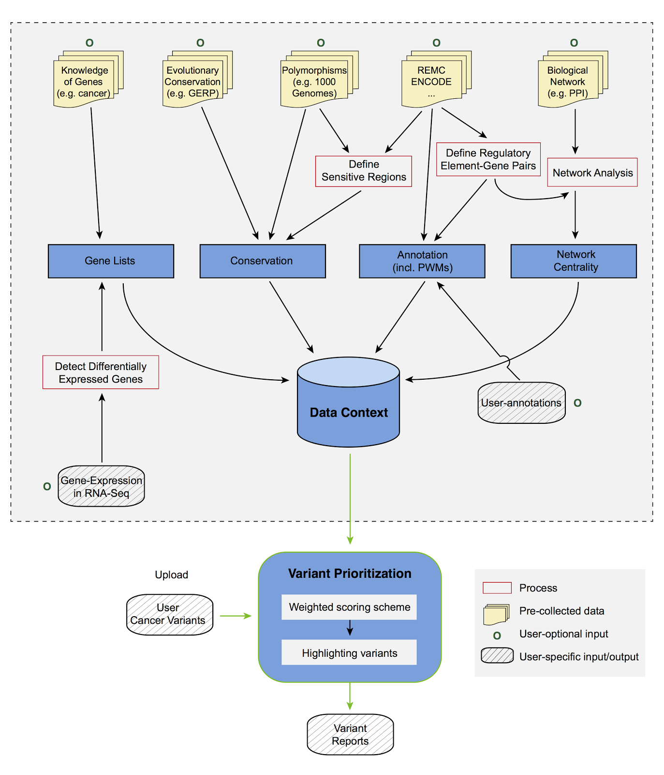(PDF in the dropbox )

FIG 3 - Description of  eleVAR workflow & data context

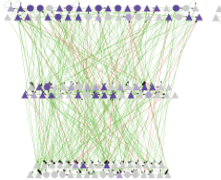

FIG 1 - ENCODE regulatory network analysis

(original in paper ) [[Probably won’t be included in final version, because we are de-emphasizing networks]]

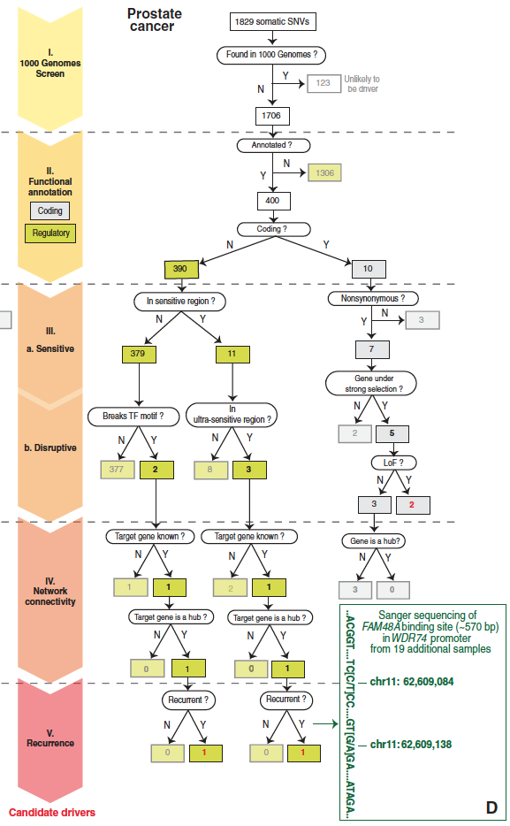

FIG 2 - Filtering of somatic variants from a prostate cancer sample leading to identification of candidate drivers

(original in the paper)

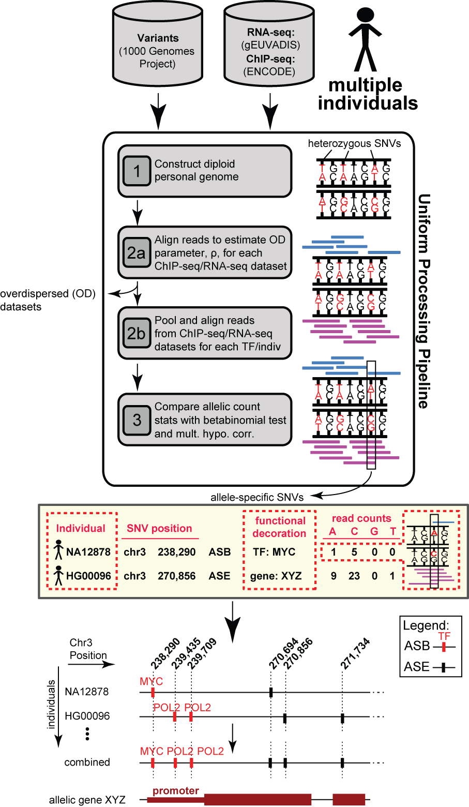

PDF in the dropbox

FIG 4 - Workflow for generating allelic variants and elements