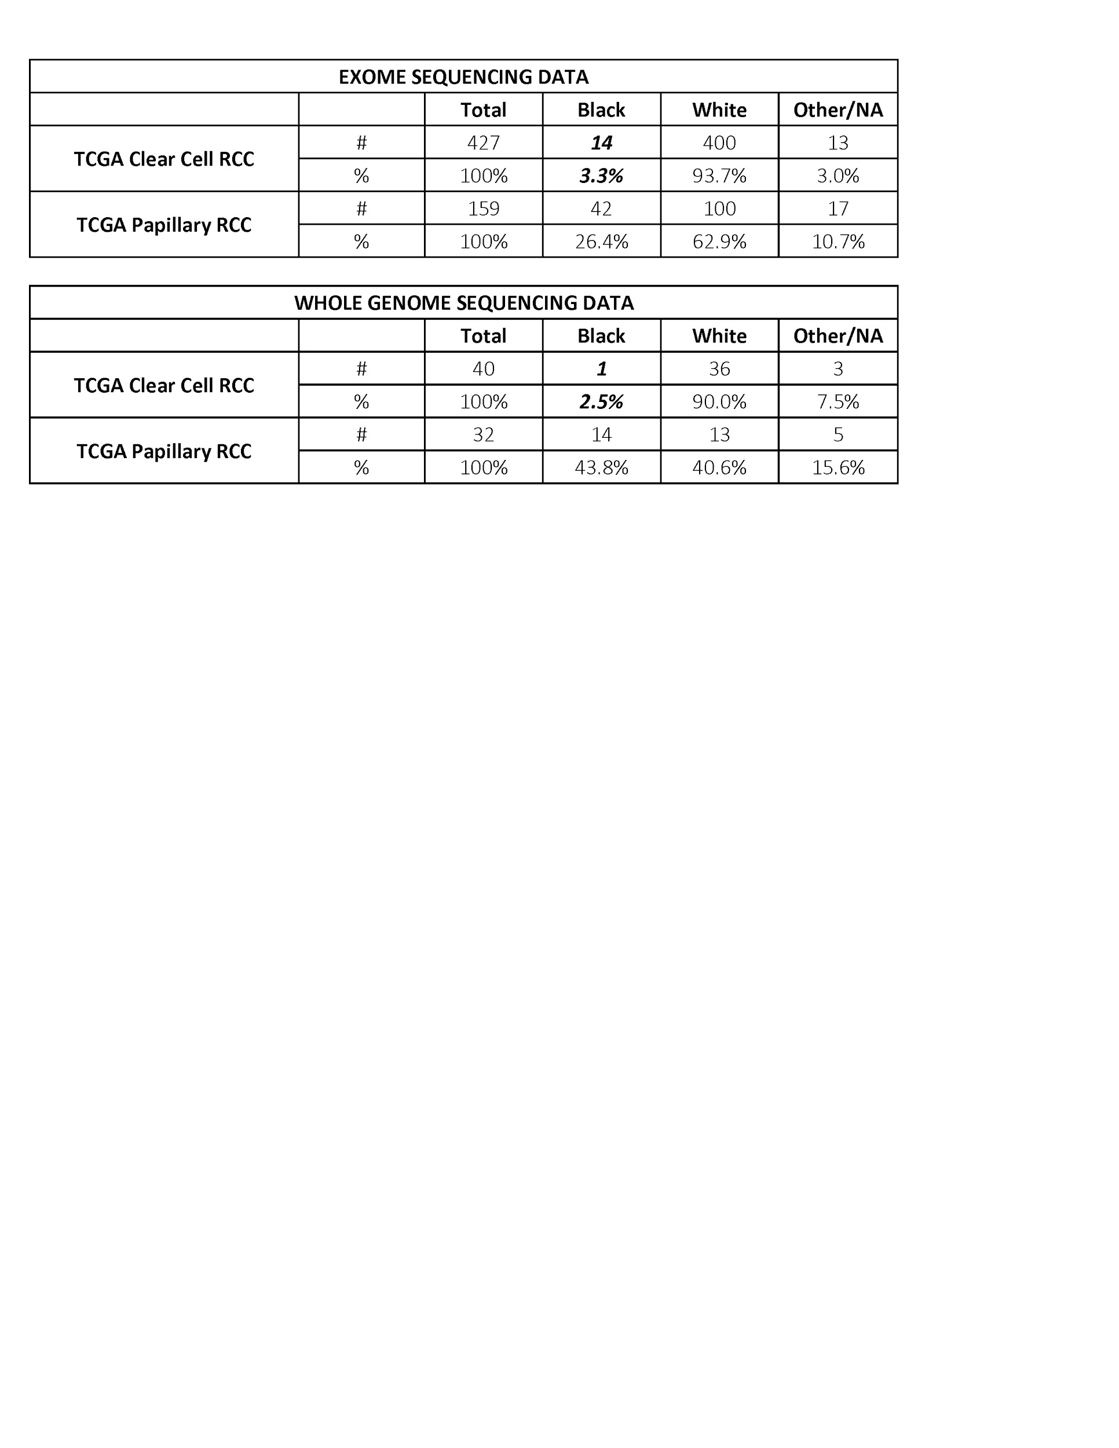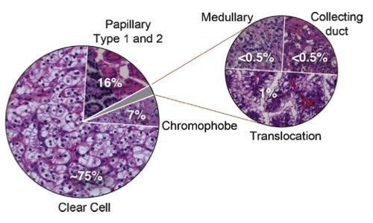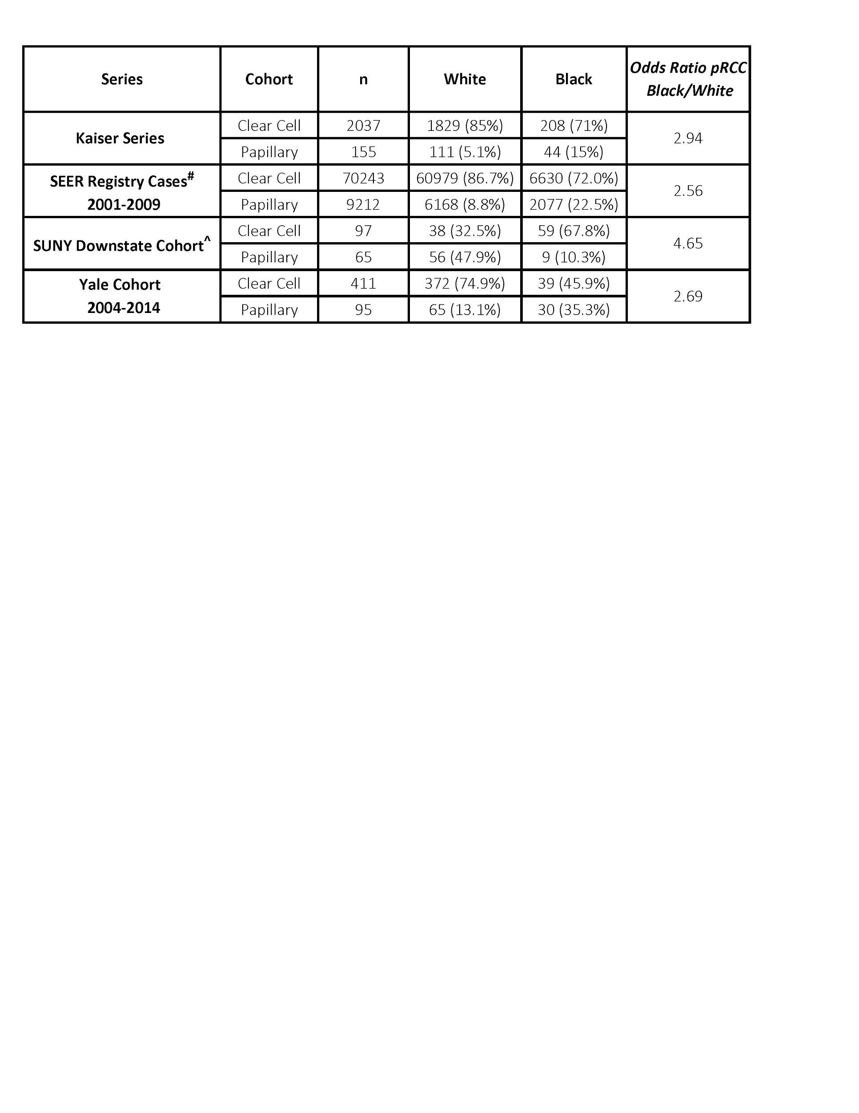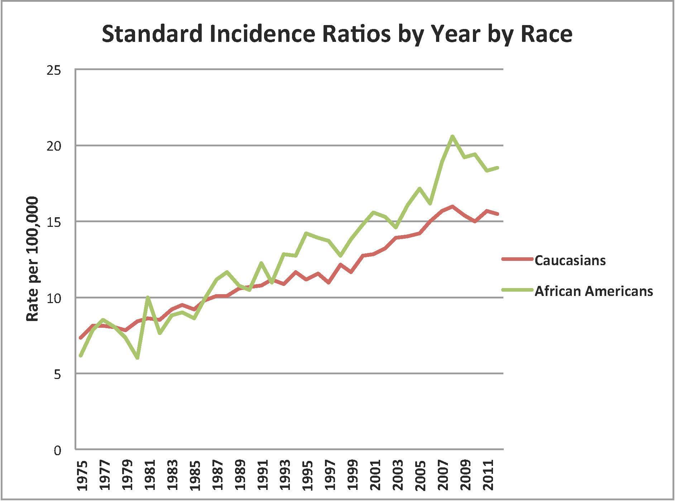

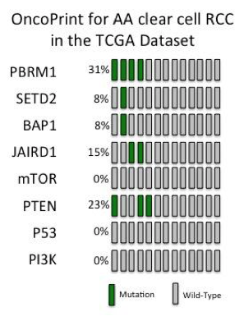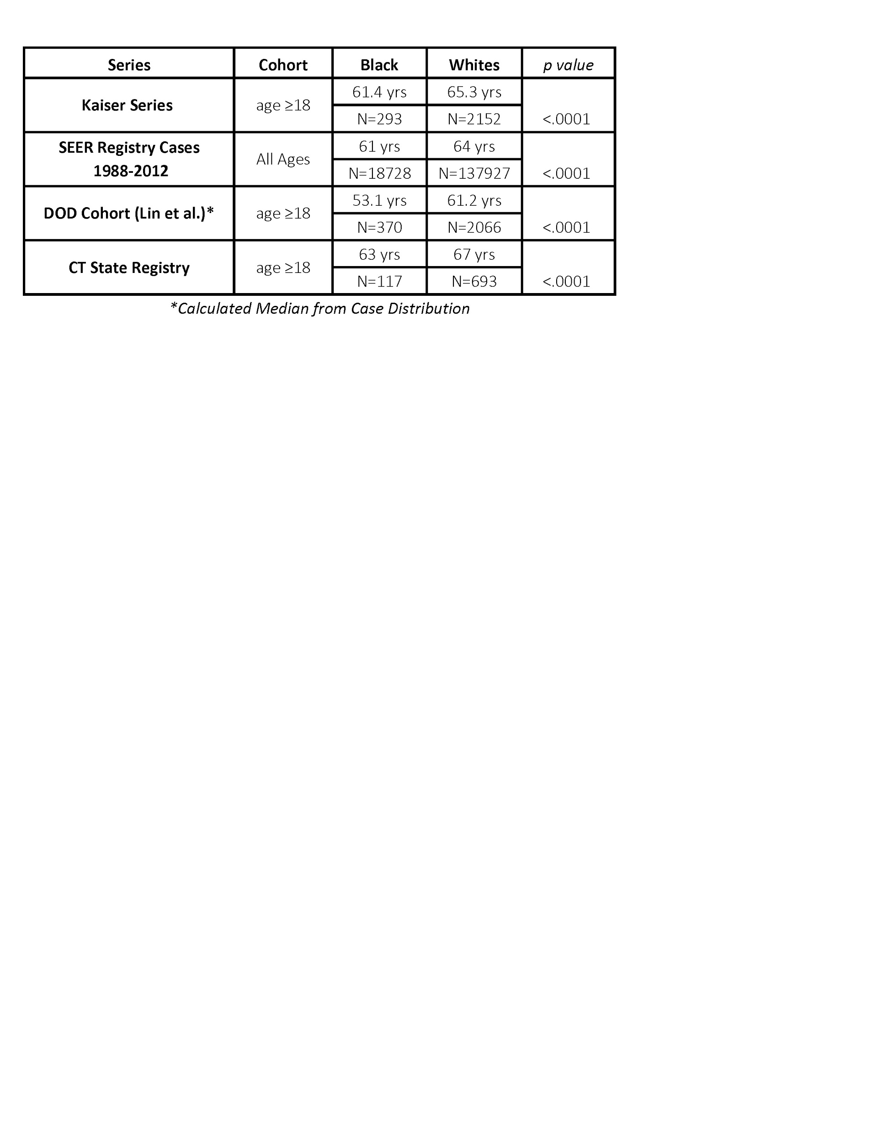

|  |  |  |  |
| --- | --- | --- | --- |
| **Service** | **Units** | **$/Unit** | **Total** |
| **DNA QC and Sample Shipment** | **10** | **$16** | **$160** |
| **Human Whole Genome Seq, 135Gb (45X) ('Normal' samples)** | **5** | **$2,100** | **$10,500** |
| **Human Whole Genome Seq, 135Gb (60X) ('Tumor' samples)** | **5** | **$2,800** | **$14,000** |
| **Data handling fee (fastq only) 45X** | **5** | **$24** | **$120** |
| **Data handling fee (fastq only) 60X** | **5** | **$30** | **$150** |
| **Total** |  |  | **$24,930** |

# MassSpec.jpg