# Significance

Privacy is one of the most important topics of debate in data science and stands at the corner of many different fields, including ethics, sociology, law, political science, and forensic science. Recently, genomics has emerged as one of the major foci of studies on privacy. This can mainly be attributed to the advancement of technologies for high-throughput biomedical data acquisition that bring about a surge of datasets[1, 2]. Among these, high throughput molecular phenotype datasets, like functional genomic and metabolomic measurements, substantially grow the list of the *quasi-identifiers* (such as birth date, ZIP code, gender[3]) for participating individuals, which can be used by an adversary for re-identification of the identities. With the recent announcement of the Precision Medicine Initiative[4], a large body of datasets are to be generated and shared among researchers[5]. The National Institutes of Health also released the plans to encourage public access to biomedical datasets from scientific studies [5–7]. Considering the fact that one does not need many identifiers to uniquely pinpoint an individual[3, 8, 9], these datasets have the potential to exacerbate the risk of privacy breach.

Many consortia, like GTex[10], ENCODE[11], 1000 Genomes[12], and TCGA[13], are generating large amount of personalized biomedical datasets. Coupled with the generated data, sophisticated analysis methods are being developed to discover correlations between genotypes and phenotypes, some of which can contain sensitive information like disease status. Although these correlations are useful for discovering how genotypes and phenotypes interact, they could also be used by an adversary in a linking attack for matching the entries in genotype and phenotype datasets. For example, when a phenotype dataset is available, the adversary can utilize the genotype-phenotype correlations to statistically predict the genotypes, and compare the predicted genotypes with the entries in another dataset that contains genotypes. For the entries that are correctly matching, he/she can reveal sensitive phenotypes of the individuals and characterize them. Even when the strength of each genotype-phenotype correlation is not high, the availability of a large number of genotype-phenotype correlations increases the scale of linking. In fact, an adversary can perform correct linking with relatively small number of genotypes[14, 15].

Different aspects of privacy have been intensely studied. Recently, genomic privacy is receiving much attention as a result of the deluge of personalized genomics datasets that are being generated[16, 17]. With the increase in the number of large scale genotyping and phenotyping studies, the protection of privacy of participating individuals has emerged as an important issue. Homer et al[18] proposed a statistical testing procedure that enables testing whether a genotyped individual is in a pool of samples, for which only the allele frequencies are known. Im et al[19] showed that, given the genotypes of a large set of markers for an individual, an attacker can reliably predict whether the individual participated in a QTL study or not. These attacks, which we refer to as “detection of a genome in a mixture”, are one type of attacks on privacy (Fig S6). There is yet another important attack in which the attacker links two or more datasets to pinpoint individuals in datasets and reveal sensitive information. One well-known and illustrative example of these “linking attacks”, although not in a genomic context, is the linking attack that matched the entries in the Netflix Prize Database and the Internet Movie Database (IMDB)[20]. For research purposes, Netflix released an anonymized dataset of movie ratings of thousands of viewers, which they thought was secure since the viewers’ names were removed. However, Narayanan et al[20] used the IMDB database, a seemingly unrelated and very large database of movie viewers, linked the two databases, and revealed identities and personal information (movie history and choices) of many viewers in the Netflix database. The fact that Netflix and IMDB host millions of individuals in their databases renders the question of detection of an individual in these database irrelevant since any random individual is very likely to be in one or both of these databases but the focus of attacks turns to matching individuals in the databases. Consequently, as the databases grow, the attacks for detection of an individual in a database become unimportant and the linking attacks become more possible in order to characterize individuals’ sensitive information. In the genomic privacy context, as the size and number of the genotype and phenotype datasets increase, the possibility of potentially linkable datasets will increase, which may make scenarios similar to the Netflix attacks a reality in genomic privacy.

# Innovation

There is currently a significant scarcity of tools that enable analysis and protection of genomic and phenotypic datasets. We will focus on characterizability of the individuals’ sensitive information in the context of linking attacks, in which the adversary exploits the genotype-phenotype correlations to link different datasets and potentially reveal sensitive information. In general, the high dimensional phenotype datasets generated in genomic studies harbor a number of phenotypes that contain sensitive information, such as disease status, and other phenotypes, while not sensitive, may have subtle correlations with genomic variant genotypes. We will perform large scale analysis of the potential genotypic information leakage that different QTL datasets can enable. We will build tools that enable reporting of objective measures for genotypic information leakage from phenotype datasets. These tools will enable generating uniform and systematic analysis of privacy risks imposed by releasing new phenotype, genotype, and QTL datasets. We will also evaluate how accurately the predicted genotypes can characterize an individual. We will study the different routes for linking the phenotype and genotype datasets.

For generating a set of initial results that will be presented, we will use the expression quantitative trait loci (eQTL) the expression dataset s generated by the GEUVADIS project[21] and the genotype dataset from the 1000 Genomes Project. We will generalize the formalisms, however, to be applicable to any type of QTL, genotype, and phenotype datasets

# Approach

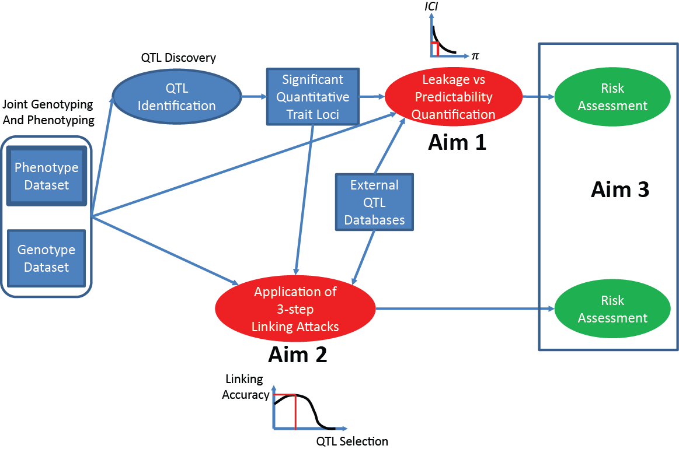We will address the need for new computational approaches for analyzing sensitive information leakage within 3 aims. In the first aim, we will develop statistical formalisms for quantification of the leakage of information that enables pinpointing of individuals in genotype and phenotype datasets with use of QTLs. In the second aim, we will focus on specific linking attacks and work on instantiations of the linking attacks using outliers in the phenotype datasets. In the third aim, we will focus on proposing file formats and methodologies that enable privacy preserving sharing and publishing of the phenotype datasets. Figure 1 shows how the methodologies proposed in each aim can be combined for an integrated risk assessment for releasing QTL, phenotype, and genotype datasets.

Figure : Generalized Risk Assessment Scenario for Genotype-Phenotype Datasets

## AIM1: Development of a Statistical Formalism for Leakage from QTL Sets

In this aim, we will develop a statistical framework for analysis and quantification of the information leakage that can be used for pinpointing and linking individuals in the phenotype and in the genotype datasets using QTL datasets.

### Overview of the Individual Characterization Scenario by Linking Attacks

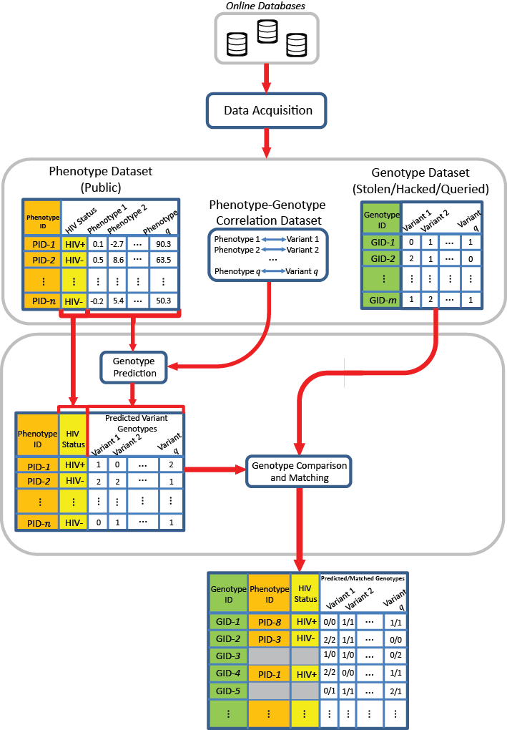Figure 2 illustrates the general privacy breaching scenario that is considered. There are three datasets in the context of the breach. The first dataset contains the phenotype information for a set of individuals. The phenotypes can include sensitive information such as disease status in addition to several molecular phenotypes such as gene expression levels. The second dataset contains the genotypes and the identities for another set of individuals. The third dataset contains correlations between one or more of the phenotypes in the phenotype dataset and the genotypes. In this dataset, each entry contains a phenotype, a variant, and the degree to which these values are correlated. We will focus on the gene expression datasets as the representative phenotype dataset. The abundance of gene expression-genotype correlation (eQTL) datasets makes these datasets most suitable for linking attacks.

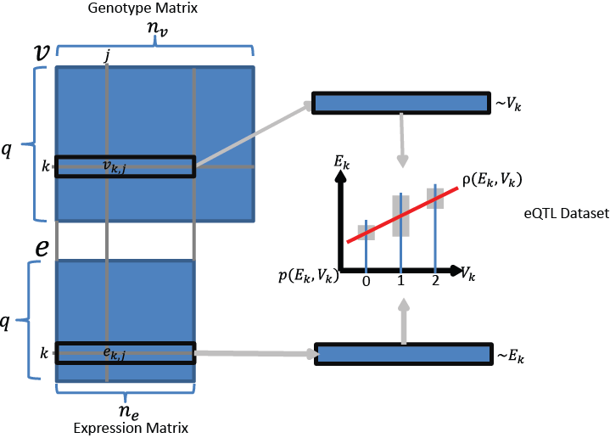Figure 3 illustrates the eQTL, expression, and genotype datasets. The eQTL dataset is composed of a list of gene-variant pairs such that the gene expression levels and variant genotypes are significantly correlated. We will denote the number of eQTL entries with $q$. The eQTL (gene) expression levels and eQTL (variant) genotypes are stored in $q×n_{e}$ and $q×n_{v}$ matrices $e$ and $v$, respectively, where $n_{e}$ and $n_{v}$ denotes the number of individuals in gene expression dataset and individuals in genotype dataset. The $k^{th}$ row of $e$, $e_{k}$, contains the gene expression values for the $k^{th}$ eQTL entry and $e_{k,j}$ represents the expression of the $k^{th}$ gene for $j^{th}$ individual. Similarly, the $k^{th}$ row of $v$, $v_{k}$, contains the genotypes for $k^{th}$ eQTL variant and $v_{k,j}$ represents the genotype ( $v_{k,j}$ ϵ {0,1,2}) of $k^{th}$ variant for the $j^{th}$ individual. The coding of the genotypes from homozygous or heterozygous genotype categories to the numeric values are done according to the correlation dataset. We assume that the variant genotypes and gene expression levels for the $k^{th}$ eQTL entry are distributed randomly over the samples in accordance with random variables (RVs) which we denote with $V_{k}$ and $E_{k}$, respectively. We denote the correlation between the RVs with $ρ(E_{k},V_{k})$. In most of the eQTL studies, the value of the correlation is reported in terms of a gradient (or the regression coefficient) in addition to the significance of association (p-value) between genotypes and expression levels. The absolute value of $ρ(E_{k},V_{k})$ indicates the strength of association between the eQTL genotype and the eQTL expression level. The sign of $ρ(E_{k},V_{k})$ represents the direction of association, i.e., which homozygous genotype corresponds to higher expression levels. This forms the basis for correct predictability of the eQTL genotypes using eQTL expression levels: The homozygous genotypes associate with the extremes of the gene expression levels and the heterozygous genotypes associate with moderate levels of expression. The eQTL studies utilize linear models to identify the gene and variant pairs whose expressions and genotypes that are significantly correlated. Given this knowledge, the adversary aims at reversing this operation so as to predict genotypes for each individual, using the respective gene expression levels and the genotype-phenotype correlation. For general applicability of the analysis, we will assume that he/she utilizes a prediction model that estimates correctly the *a posteriori* distribution of the eQTL genotypes given the eQTL expression levels, i.e., $p(V_{k}|E_{k})$. This will enable us to perform quantifications independent of the prediction methodology utilized by the attacker.

Figure 3: The representation of the genotype and expression datasets.

Figure 2: Schematic Representation of a Linking Attack: The attacker links the phenotype and genotype datasets using the genotype predictions. In the predictions, the attacker utilizes the QTL datasets. The resulting attack generates the linked genotype (green), phenotype(orange), and sensitive phenotype (yellow) dataset.

### Quantification of Tradeoff between Correct Predictability of Genotypes and Leakage of Individual Characterizing Information

We will study the tradeoff the correct predictability of genotypes and the number of individuals that can be characterized with the information leakage (Figure 4). In the context of the linking attack, the attacker aims to correctly characterize $n_{e}$ individuals in the expression dataset among $n_{v}$ individuals in the genotype dataset. In order to correctly characterize an individual, he/she should select a set of eQTLs that he/she believes he/she can predict correctly. Next, given the individual’s expression levels, the attacker should predict the genotypes for the selected eQTLs correctly such that the predicted set of genotypes are not shared by more than 1 individual, i.e., the predicted genotypes can be matched to the correct individual. In other words, the joint frequency of the set of predicted genotypes for the selected eQTLs should be $\frac{1}{n_{v}}$. We can rephrase this condition as following in information theoretic terms: Given the genotypes of an individual, if the attacker can correctly predict a subset of genotypes that contain at least $\log_{2}{(n_{v})}$ bits of information, the individual is vulnerable to characterization of his/her phenotypes. Following this statement, we can quantify the leakage from a set of correctly predicted eQTL variant genotypes as the logarithm of their joint frequency. Assuming that the genotypes of different eQTLs are independent from each other, we can decompose the quantity of individual characterizing information that is leaked for a set of $n$ correctly predicted eQTL genotypes:

|  |  |  |
| --- | --- | --- |
|  | $$ICI\left(\{V_{1}=g_{1},V_{2}=g_{2},…,V_{n}=g_{n}\}\right)=\overset{\begin{aligned}Sum individual characterizing \\ information from all variants\end{aligned}}{\overbrace{\sum_{k=1}^{n}{\underset{\begin{aligned}Convert the genotype \\ frequency to number of bits \\ that can be used to characterize \\ individual\end{aligned}}{\underbrace{-\log\left(p\left(V_{k}=g_{k}\right)\right)}}}}}$$ | (1) |

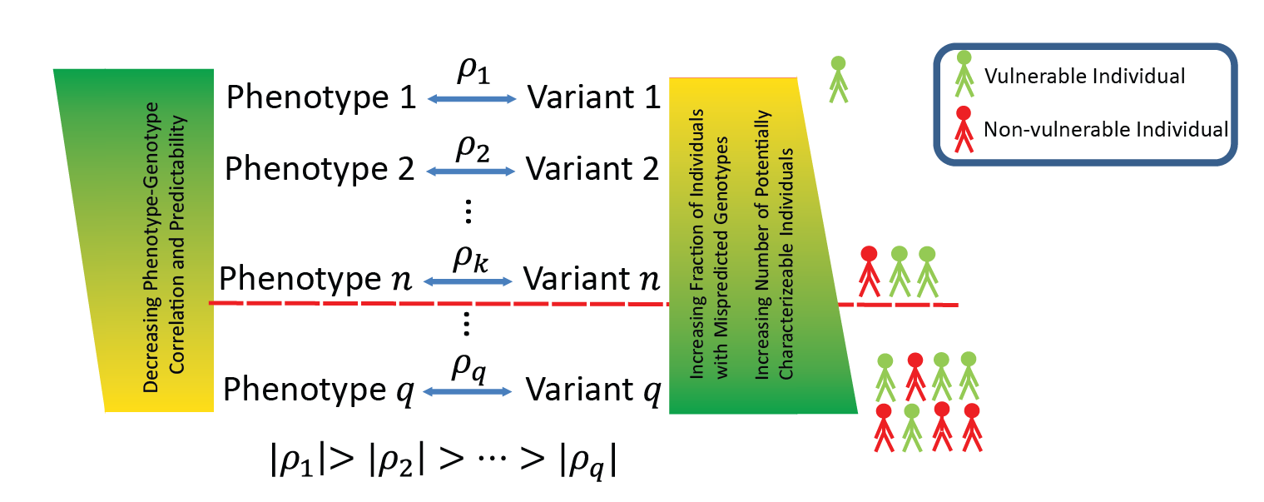where $V_{k}$ is the random variable that corresponds to the genotypes for the kth eQTL, $g_{k}$ is a specific genotype, and $p\left(V_{k}=g_{k}\right)$ denotes the genotype frequency of $g_{k}$ within the population, and *ICI* denotes the total individual characterizing information. Evaluating the above formula, *ICI* increases as the frequency of the variant’s genotype $g_{k}$ decreases. In other words, the more rare genotypes contribute higher to *ICI* compared to the more common ones. Thus, individual linking information can be interpreted as a quantification of how rare the predicted genotypes are. The attacker aims to predict as many eQTLs as possible such that *ICI* for the predicted genotypes is at least $\log{(n_{v})}$. *ICI* can also be interpreted as the number of rare SNP genotypes that an individual harbors.

Figure 4:The tradeoff between correct predictability of the genotypes and number of individuals that can be characterized.

In order to maximize the amount of *ICI*, the attacker will aim at correctly predicting as many eQTL genotypes as possible. The (correct) predictability of the eQTL genotypes from expression levels, however, varies over the eQTL dataset as some of the eQTL genotypes are more highly correlated (i.e., more correctly predictable) with the expression levels compared to others, given in $|ρ\left(E_{k},V_{k}\right)|$. Thus, the attacker will try to select the eQTLs whose genotypes are the most correctly predictable to maximize *ICI* leakage. Although $ρ\left(E_{k},V_{k}\right)$ is a measure of predictability, it is computed differently in different studies. In addition, there is no easy way to combine these correlation values when we would like to estimate the joint predictability of multiple eQTL genotypes. In order to uniformly quantify the joint (correct) predictability of the eQTL genotypes using the expression levels, we use the exponential of entropy of the conditional genotype distribution given gene expression levels. Given the expression levels for $j^{th}$ individual, we compute the predictability of the $k^{th}$ eQTL genotypes as

|  |  |  |
| --- | --- | --- |
|  |  | (2) |

where $π$ denotes the predictability of $V_{k}$ given the gene expression level $e_{k,j}$. $π$ can be interpreted as the average probability (when sampling individuals from the population) that the attacker can correctly predict the eQTL genotype at the given expression level. In the above equation for $π$, the conditional entropy of the genotypes is a measure for the randomness that is left in genotype distribution when the expression level is known. In the case of high predictability, the conditional entropy is close to 0, and there is little randomness left in the genotype distribution. Taking the exponential of the negative of the entropy converts the entropy to average probability of correct prediction of the genotype. In the most predictable case (conditional entropy close to 0), $π$ is close to 1, indicating very high predictability.

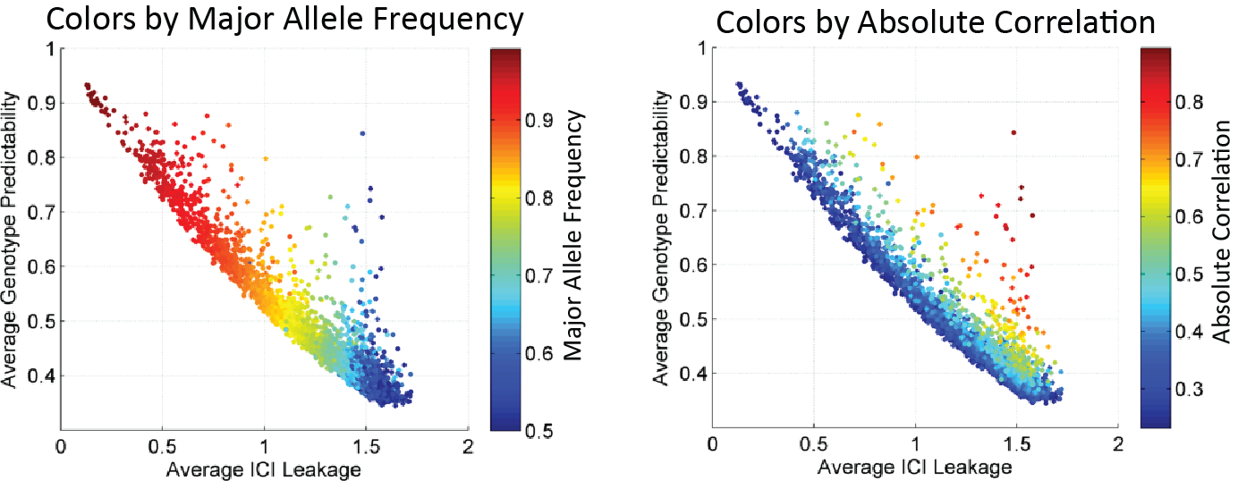As an initial study to show how these measures can be used jointly, we considered each eQTL and evaluated the genotype predictability versus the characterizing information leakage. We use the gene expression data from the GEUVADIS project as a representative dataset for this computation. We computed, for each eQTL, average $π$ and average *ICI* over all the individuals (Figure 5). Most of the data points are spread along the diagonal, which indicate that there is a natural tradeoff between correct predictability and *ICI* leakage. The eQTL variants with high frequency major allele frequencies have high predictability and low *ICI* and vice versa for eQTL variants with lower major allele frequency (Fig 5, left). This is expected because the genotypes of the high frequency variants can be predicted, on average, easily (most individuals will harbor one dominant genotype) and consequently does not deliver much characterizing information. The genotypes for the eQTLs with smaller major frequency alleles, however, are harder to predict as they are mostly uniformly distributed among population. On the other hand, these eQTLs contain high *ICI* on average. The eQTLs with high correlation (Fig 5, right) deviate from the diagonal with high ICI and high predictability. In principle, the adversary will aim at identifying and using these highly informative eQTLs.

Figure 5: The scatter plot of ICI leakage (x-axis) versus the predictability (y-axis) of SNP genotypes. Each dot represents a SNP. SNPs are colored as per major allele frequencies (left) and per absolute eQTL correlation (right).

## AIM2: Instantiating the Linking Attacks

In this aim, we will study how an attacker can instantiate linking attacks using different techniques for linking the genotype and phenotype datasets.

### A General Framework for Analysis of Individual Characterization using Linking Attacks

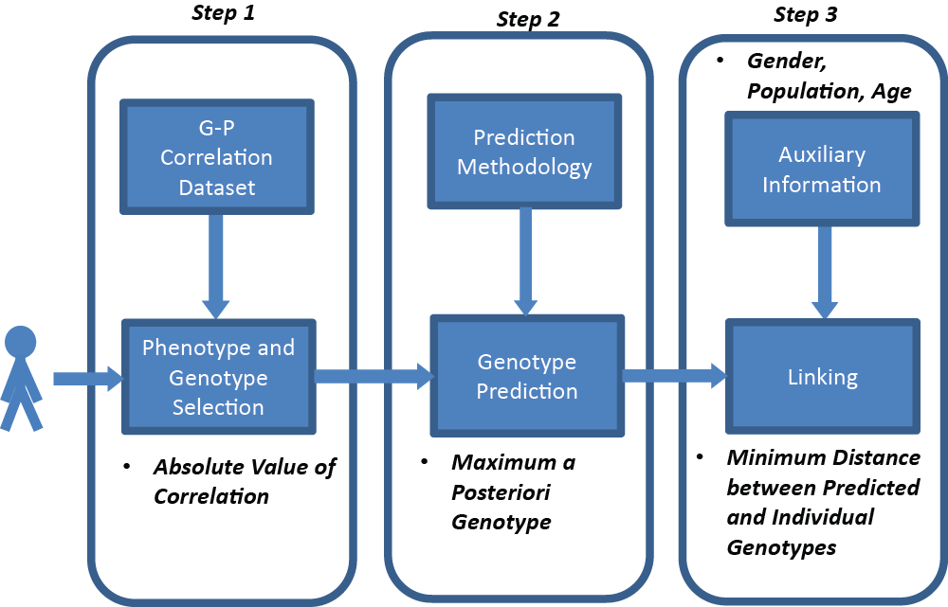We first present a tentative 3 step framework for individual characterization in the context of linking attacks. Figure 6 summarizes the steps in the individual characterization for each individual. The input is the phenotype measurements for $j^{th}$ individual. The aim of the attacker is to correctly link the disease state of the individual to the correct identity in the genotype dataset. In the first step, the attacker selects the QTLs, which will be used in linking $j^{th}$ individual. The selection of QTLs can be based on different criteria. As described in the previous section, the most accessible criterion is selection based on the absolute gradient or the absolute strength of association between the phenotypes and genotypes. In the case of eQTLs, this is the reported correlation coefficient, $|ρ\left(E_{k},V_{k}\right)|$. We will study different eQTL selection criteria and how they affect the linking accuracy. The second step is genotype prediction for the selected QTLs using a prediction model. We will use different models of genotype prediction with varying complexities and study how the linking accuracy changes when different models are utilized (Figure 9). The third and final step of a linking attack is comparison of the predicted genotypes to the genotypes of the $n_{v}$ individuals in genotype dataset to identify the individual that matches best to the predicted genotypes. In this step, the attacker links the predicted genotypes to the individual in the genotype dataset. We will study different linking methodologies that the adversaries can utilize.

Figure 6: 3 steps of individual characterization with linking attacks.

### Modeling Genotype-Expression Distribution for Genotype Prediction

In the second step of a linking attack, the attacker performs genotype predictions. The genotype predictions are used, as an intermediate information, as input to the 3rd step (Fig 3), where linking is performed. The main aim of the attacker is to maximize the linking accuracy (not the genotype prediction accuracy), which depends jointly on the genotype prediction accuracy and the accuracy of the genotype matching in the 3rd step. Other than the accuracy of linking, another important consideration, for risk management purposes, is the amount of auxiliary input data (such as training data for a prediction model) that the genotype prediction takes. The prediction methods that require a high amount of auxiliary data would decrease the applicability of the linking attack as the attacker would need to gather extra information before performing the attack. On the other hand, the prediction methods that require little or no auxiliary data makes the linking attack much more realistic and prevalent. We will, therefore study complexities of genotype prediction methods and evaluate how these translate into assessing the accuracy and applicability of the linking attack. We will study different simplifications of genotype prediction, and illustrate different levels of complexity for genotype prediction.

We will study several models of the genotype-phenotype distribution, which can be used in genotype prediction. Figure 9a shows the joint genotype-expression distribution for an eQTL. Figure 9b shows the modeling of the joint distribution using 3 conditional distributions of expression levels at each genotype. First, the means and variances of the distributions are assumed to be independent. Assuming that mean and variance are sufficient statistics for the conditional distributions (e.g., normally distributed), the joint distributions can be modeled when the 6 parameters (3 means and 3 variances) are trained. We will study different approaches for training the model, e.g. unsupervised methods such as Expectation Maximization. This would, however, increase the required auxiliary data and decrease the applicability of the linking attack. Figure 9c shows a simplification of the model by assuming the variances of the conditional expression distributions are same for each genotype. This decreases the number of parameters to be trained to 4 (3 means and 1 variance). Figure 9d shows an equally complex model with 4 parameters where the conditional distributions are uniform at non-overlapping ranges of expression for each genotype. This model requires 4 parameters to be trained corresponding to the expression range limits. Figure S9e shows the final simplification of the genotype prediction, which requires only one parameter to be trained. In this model, the expression-genotype domain is divided into two parts with respect to whether expression is higher or lower than $e_{mid}$, and joint probabilities are assigned uniformly: When the expression level is higher (lower) than $e_{mid}$, and genotype is the homozygous genotype corresponding to high (low) expression extremity, uniform probability is assigned to genotypes. The joint probability is 0 for all other expression-genotype values. This brings up an important point: this simplified model is exactly the distribution that is utilized in the extremity-based genotype prediction. In the extremity based prediction, we estimate $e_{mid}$ simply as the mid-point of the range of gene expression levels within the expression dataset (Equations 3 and 4-6).

### Instantiation of Linking Attacks using Extremity based Genotype Prediction

We will study how the attacker can utilize a priori knowledge about the relation between gene expression levels and genotypes and build the joint genotype-expression distributions using models with varying complexities and parameters. Even though the genotype prediction with these models may not be very accurate, the attacker can utilize a large number of eQTLs to maximize the accuracy of linking. We will first focus on highly simplified models to evaluate the risk levels associated with simple models for genotype prediction. We will assume the attacker exploits the knowledge that the eQTL genotypes and expression levels are correlated such that the allelic effects on expression are additive and extremes of the gene expression levels (highest and smallest expression levels) are observed with extremes of the genotypes (homozygous genotypes). Therefore, given the gradient of association, the attacker can coarsely estimate the joint distribution of the genotypes and expression levels. This idea is illustrated in Fig 7. Using an estimate of the joint distribution, the attacker can compute the *a posteriori* distribution of genotypes given gene expression levels. To quantify the extremeness of expression levels, we will use a statistic we termed $extremity$, which we will briefly introduce here. For the gene expression levels for $k^{th}$ eQTL, $e_{k}$, the $extremity$ of the $j^{th}$ individual’s expression level, $e_{k,j}$, is defined as

|  |  |  |
| --- | --- | --- |
|  | $$extremity\left(e_{k,j}\right)=\frac{rank of e_{k,j}in \{e_{k,1},e_{k,2},…, e_{k,n_{e}}\}}{n_{e}}-0.5.$$ | (3) |

Extremity can be interpreted as a normalized rank, which is bounded between -0.5 and 0.5. Following from the above discussion, the adversary builds the posterior distribution for $k^{th}$ eQTL genotypes as

|  |  |  |  |  |
| --- | --- | --- | --- | --- |
|  |  | | | (4) |
|  |  | | |  |
|  | |  | | (5) |
|  | |  | |  |
|  |  | | (6) | |

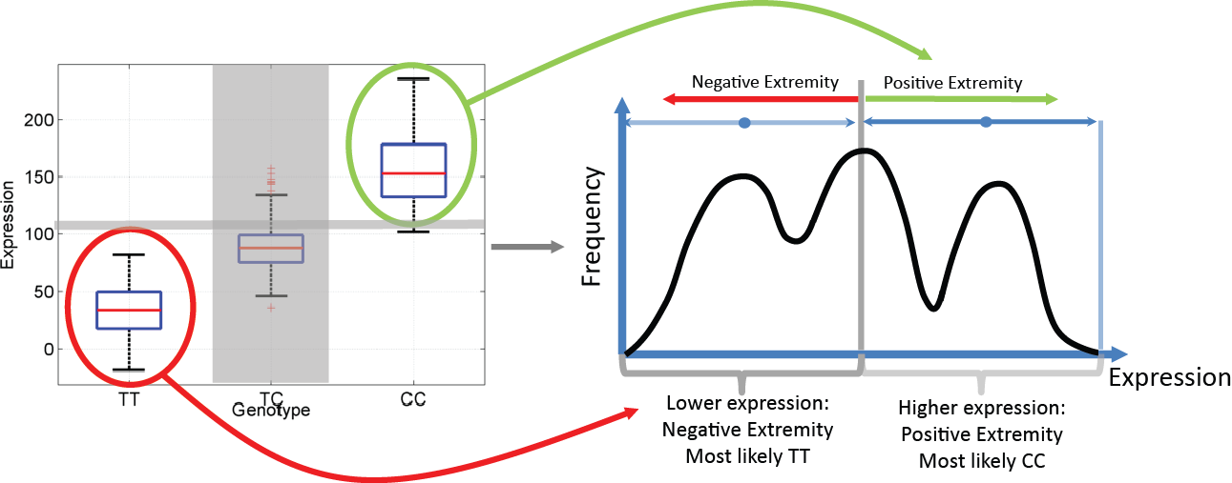From the *a posteriori* probabilities, when the sign of the extremity and the reported correlation are the same, the attacker assigns the genotype value 2, and otherwise, genotype value 0. Finally, the genotype value 1 is never assigned in this prediction method, i.e., the *a posteriori* probability is zero. This is expected since we are focusing on the extremes and heterozygous genotype is observed at medium levels of expression. The posterior distribution of genotypes in equations (4-6) can be derived from a simplified model of the genotype-expression distribution that utilizes just one parameter.

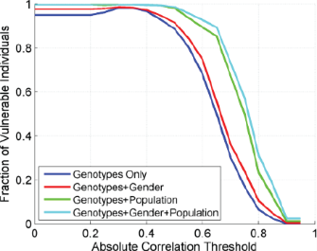As a next step of initial evaluation of how effective the proposed approach is, we utilized extremity based genotype prediction in the 2nd step of the individual characterization framework (Fig 6) and evaluated the fraction of characterizable individuals in the GEUVADIS dataset. We utilized the correlation based eQTL selection in step 1, then extremity-based genotype prediction in step 2. In order to demonstrate the utility of the 3-step analysis framework; we evaluated two different distance measures for linking the predicted genotypes to the individuals in genotype dataset in the 3rd step of the attack. The first is based on comparison of the predicted genotypes to all the genotypes in the genotype dataset. The second is based on comparison of the predicted genotypes to only the homozygous genotypes in the genotype dataset. The motivation for using this distance measure is that the extremity based genotype prediction never assigns heterozygous genotypes. Thus the heterozygous genotypes are excluded from distance computation.

Figure 7: Extremity based genotype for an eQTL. The joint genotype versus expression distribution is shown on left. Given the distribution and the extremity, the genotypes are assigned.

For each measure, the attacker links the predicted genotypes to the individual whose genotypes minimize the selected distance measure. Figure 8 left and right show the fraction of vulnerable individuals for both distance measures. More than 95% of the individuals are vulnerable for most of the parameter selections for both distance measures. The homozygous genotype matching distance measure has slightly higher linking accuracy. When the gender and/or population information is present as auxiliary information (red and green plots), the fraction of vulnerable individuals increases to 100% for most of the eQTL selections. These results show that linking attack with extremity based genotype prediction, although technically simple, can be extremely effective in characterizing individuals. We will focus on homozygous genotype matching based distance computation in the rest of the paper for simplicity of presentation. We will extend the linking attack analysis on different QTL, phenotype, and genotype datasets.

Figure 8: The accuracy of extremity based linking attack with changing eQTL selection correlation threshold.

## AIM3: Building Privacy Enhancing File Formats

### Rationale

In this section, we will describe a practical software implementation to simulate a privacy attack on a dataset and give a consenting subject a sense of how much information leaks in various presentations of a dataset. We will also describe the development of a file format that protects privacy, and still maintains a high level of usability of genomic data.

### C:\Users\Arif\Box Sync\Papers\PrivaSeq_May.2015\BD2K_2015_Privacy_Grant\9.16.2015\figures\fig9.png Previous experience in tool development and file formats for anonymizing sequence information

We have developed a number of tools and data formats to handle the increasingly large quantities for data generated by RNA-Seq experiments. For example, we have developed the Mapped Read Format (MRF), a compact data summary format for short, long and paired-end read alignments that enables the anonymization of confidential sequence information.

### Previous experience in RNA-seq and ChIP-seq computational technology development and data analyses

We have extensive experience in RNA-seq tool development and analysis[22]. For RNA-seq, we have developed RSEQtools, a suite of tools that enables anonymization of sequence information and quantification of annotated RNAs and identification of splice sites and gene models [23].

These tools consist of a set of modules that perform common tasks such as calculating gene and exon expression values, generating signal tracks of mapped reads and segmenting that signal into actively transcribed regions. RSEQtools is implemented in C and the source code is available at<http://rseqtools.gersteinlab.org/>. In addition, we have developed IQseq, a computationally efficient method to quantify isoforms for alternatively spliced transcripts [24]. Our Database of Annotated Regions with Tools (DART) package contains tools for identifying unannotated genomic regions enriched for transcription, as well as a framework for storing and querying this information[25]. We developed incRNA, a method that uses known ncRNAs of various classes as a gold-standard training set to predict and analyze novel ncRNAs [26]. We have also worked on characterizing the sources of transcription in the genome. A large fraction of the transcription comes from genomic regions not associated with standard annotations, representing ‘non-canonical transcription’. We also have extensive experience in characterizing the functions of genes and non-coding elements via expression data through clustering and network analyses.A group of genes in a co-expression cluster have often been demonstrated to be responsible for a common function. While there are well-known algorithms for expression clustering such as hierarchical clustering, spectral clustering and K-means, we have developed several novel methods. We developed a spectral biclustering method for co-clustering genes and conditions. More recently, we developed a new clustering framework, OrthoClust, for simultaneously clustering network data across different contexts[27]. OrthoClust is able to identify conserved and specific components across different networks. We also have extensive experience in tool development for ChIP-Seq datasets [11, 28–30].

Figure 9: Different Models of Joint Genotype-Expression Distribution with changing Complexities

We have collaborated with many groups on RNA regulation analyses, and our studies have involved the development of new methodologies for RNA-Seq analysis and highly customized applications of existing tools. First, we discovered large number of natural alternative splice forms that appear to be targets for nonsense mediated decay, and we have seen that this is a mode of gene regulation. All conserved members of the SR family of splice regulators have an unproductive alternative mRNA isoform targeted for NMD[31]. We have used RNA-Seq to explore the pervasiveness of NMD in numerous species and to understand its behavior, finding that 20% of expressed human genes make isoforms targeted for degradation. We are now detailing the evolution of this gene-expression regulation mechanism, having initially discovered that the oldest known alternative splicing is for regulation, targeting transcripts for degradation[32].

Furthermore, we continue to play a substantial role in large consortia. We have been heavily involved in the ENCODE consortium[33]. For example, a recent ENCODE publication involved the processing and integration of all ENCODE and modENCODE RNA-seq and ChIP-seq data, involving 575 experiments and more than 65 billion reads from human, *C. elegans* (worm), and *D. melanogaster* (fly) organisms [34].We discovered a conserved RNA regulatory map between fly and humans[35]. This study used early Illumina data, in which we developed methods to identify biases in Illumina RNA-Seq protocols due to random hexamer priming[36]. We also developed a tool, JuncBASE (Junction-Based Analysis of Splice Events), which remains one of the most reliable means of interpreting RNA-Seq data. We collaborated applying our methods to the transcriptome of *Drosophila* over the course of development, including creating a definitive set of fly isoforms, expanding those reliably known dramatically. We also found conservation of splicing regulatory elements between fly and human[37]. Using knockdowns of 56 RNA binding proteins, we discovered the repertoire of targets for alternative splicing in the fly[38]. Of particular note, we found unexpected relationships between the developmental program expression of orthologous genes in development of fly and worm: there is a very significant correspondence in genes expressed, which the fly repeats over the course of development but worm expresses this program only once[39]. This work has informed comparative regulatory analyses[40].

We also serve as the data integration hub in the exRNA consortium (<http://exrna.org/>), which is generating hundreds of RNA-seq and small RNA-seq samples. Other notable consortia for which we have been involved in pipeline construction and big data processing and analyses include the BrainSpan project ([http://www.brainspan.org](http://www.brainspan.org/)/), which collected RNA-seq data for 8-16 brain structures in each of 13 brain developmental stages[41], as well as the PsychENCODE project (<http://psychencode.org/>).

### Previous work on various social and practical aspects of privacy

We also have been active in raising privacy concerns with regard to large-scale genomic datasets. Genomic information axiomatically uniquely identifies its owner. Moreover, and perhaps more problematic, individuals represented in genomic datasets implicitly add the genomic information of their close relatives (who share much of the genomic data by relatedness) who likely have not consented to having their data included in the dataset. We have suggested in a number of publications that a combination of technological, regulatory and policy changes might best serve to protect individuals described by this arguably unanonymizable data[42]. The policy and regulatory changes would reflect changing norms where we, as a society, no longer dogmatically desire anonymity in many areas of our lives, or at the minimum, have come to peace with the lack of privacy in the modern age[43]. In acknowledging the changing realities, instead of regulating how to seek out data, we suggest that regulations focus on limiting instances wherein DNA related data can be used to harm; for example, by limiting employment or insurance opportunities. We expect that such regulatory changes might further reduce the need for anonymity of heretofore sensitive data. Corresponding technological changes might include considering both how data is stored as well as where that data should be stored[44]. We have suggested, for example, using cloud based storage options to control and monitor access to data sets and limiting the ability and need to download data to inherently more insecure personal and/or portable computers[45]. We have also proposed creating "stub-datasets" that have the look and feel of the typical online data sets, but that would be freely available to all researchers. Holding no personal information, these data sets, while sharing many of the same statistical characteristics, with their larger cousins, would not present privacy concerns, and consequently, could be used to develop and profile code before deployment on real datasets.

## Approach

### Building a pipeline for privacy risk management of biological datasets

Our study focuses on the individual privacy breaches in the context of linking attacks, where an individual’s existence in two seemingly independent datasets (e.g., the phenotype and the genotype) can cause a privacy concern when an attacker links statistically the datasets using the *a priori* information about correlation of different entries in the datasets. The fact that the available molecular phenotypes are (i.e., gene expression levels) are generally very high in dimension makes this attack much more probable.

The obvious risk management strategy against these attacks is restricting access to the phenotype datasets, via the use of statistical techniques like k-anonymization and differential privacy. These, however, have associated drawbacks about loss of biological utility, and high computational complexity. Moreover, some studies have also demonstrated that there are still risks associated with linkability of the anonymized data[46–49]. Hence, we will create a pipeline and implement our protection and risk management strategy for serving utility-maximized and privacy-aware high-dimensional phenotype datasets. The aim is to balance the efficiency and effectiveness of the data anonymization process with the usability of the anonymized dataset. Our pipeline will allow versatility such that privacy and usability can be tuned depending on the user. Briefly, we first quantify the amount of information leakage in a dataset, using this information, we anonymize the dataset in a data format based on the amount of privacy required by the user and yet preserving its utility. The main idea behing the anonymization procedure is that the major utility of RNA-seq datasets for quantification of gene expression levels do not depend on the sequence information, which can be removed using the privacy-aware file formats. The next step is then quantification of sensitive information in the expression levels, which will be anonymized using more elaborate statistical methods.

### Quantify Information Leakage

In the first step, we will measure the amount of information leakage in an RNA-seq dataset. This quantification of information leakage requires the knowledge of all accessible variants that can be obtained from a typical RNA-seq dataset. The set of accessible variants is dataset-dependent, deriving from a number of factors, including: (1) the type and (2) coverage of the RNA-seq dataset, and (3) the alignment parameters of the RNA-seq reads. For instance, gEUVADIS data is mostly poly-A RNA-seq data, hence they are limited to variants mostly found in the exome, while the ENCODE total cell RNA-seq data can encompass variants from both the exome and non-coding genes. The coverage of the RNA-seq dataset will also determine how reliable a variant call is. We will use only variants with significant read coverage as a quality control. For alignment, we will construct the diploid personal genomes of all the individuals in gEUVADIS, using a software we developed previously [50] and then align RNA-seq reads to them using Bowtie2[51]. We have previously shown that reads from functional genomics assays such as ChIP-seq and RNA-seq map better to the personal genomes than the reference genome[50]. Better alignments will aid us by providing more reads for variant calling.

Subsequently, we will expand the accessible variant pool, by imputing variants and inferring their genotypes based on their haplotypic association, or linkage disequilibrium (LD), with the accessible variants. Imputation will be performed using IMPUTE2[52] and the LD haplotype reference panel from SHAPEIT2 [53]. This expanded variant pool (accessible and imputed variants) will be used to quantify the information leakage of each RNA-seq dataset.

### Minimize information leakage and allow public usability of data via data encryption by MRF and CRAM

The quantification will allow us to detect the eQTLs that convey the highest sensitive information to an attacker and also the most identifiable (the ‘outliers’) individuals. These two pieces of information can be managed in two ways in order to minimize information leakage and yet still allow the dataset to be available publicly. (1) The outliers and the most leaking eQTLs can be systematically managed, and (2) It can serve to inform the pertinent individual regarding the extent to which his identity will be compromised; these can be, for instance, more conveniently conveyed in a consent form. The identification of outlier individuals will be performed systematically by starting from the most “leaking” eQTLs, which can render an individual as an outlier. In the anonymization step, these eQTLs will then be either removed from the eQTL dataset or the expression levels corresponding to these genes will be changed by addition of noise. The amount of data removal or noise addition will be done to meet the requirements of the policies of data utility and of individual privacy.

In order to maintain the overall usability and public accessibility of the dataset, the original data and information will be stored in a Mapped Read Format (MRF), which we previously published as part of our RSEQtools (Fig 10) [23]. The MRF is a compact data file format for storing both short and long reads in functional genomics assays. It decouples sequence and alignment information, and stores only the latter, thereby anonymizing confidential sequence information. CRAM, a highly optimized and widely used data compression tool, is very similar to MRF, but was created specifically for BAM files[54]. We will adapt both MRF and CRAM to current 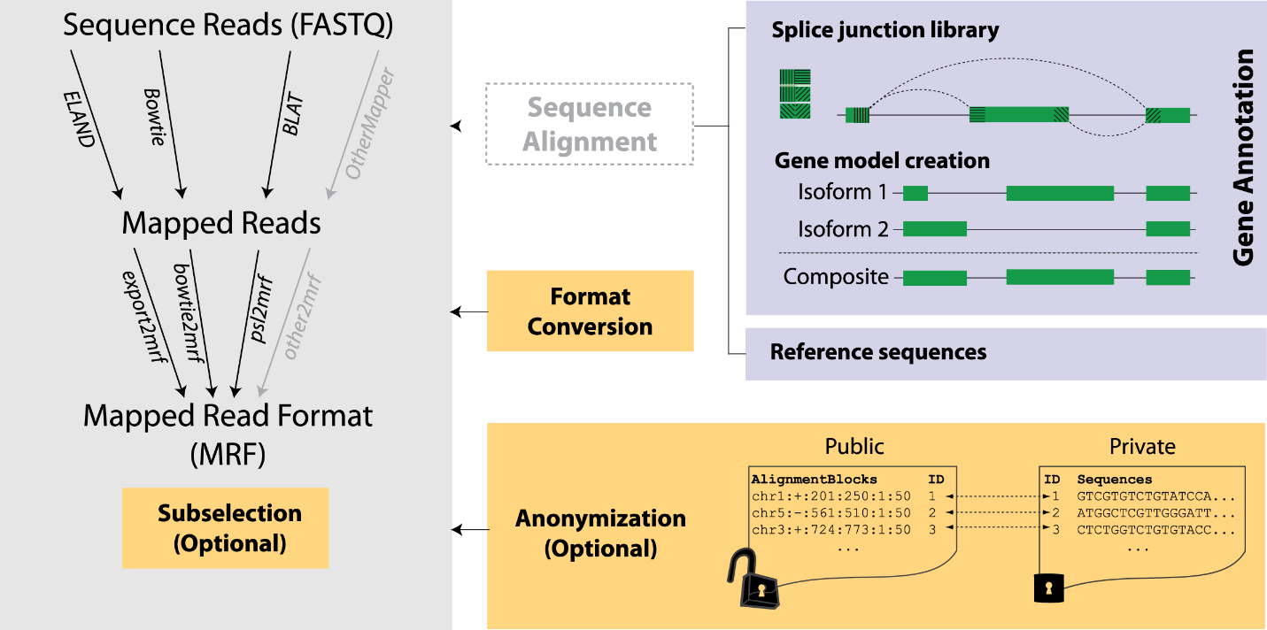context, by decoupling actual genotype or variant information from their genomic coordinates and storing only the coordinate information. Ultimately, using the file format, we will generate an anonymized dataset that could possibly be more easily shared with less risk of privacy issues.

Figure 30: Anonymization Strategy for protection of RNA sequencing read datasets.

### Simulation of ‘outlier’ attack

The last step in the pipeline creates a simulation of a privacy attack on gene expression levels that are the most extreme, as described in Aim 2. Such an extremity, or ‘outlier’, most easily serves as an quasi-identifier and can potentially be used to identify its associated variants, which can then be used for sensitive information leakage. Then, reads associated with these outlier gene expression levels can either be removed or the read counts can be modified to the mean gene expression level in a variety of fashions.

In addition to gEUVADIS, we intend to apply our software to all major functional genomic datasets, such as GTex[10], ENCODE[11], and TCGA[13], and variant calling datasets such as the 1000 Genomes Project [12] and the Hapmap 3 project [55]. Some examples are provided in Table 1. In doing such a large-scale calculation we aim to see the distribution of leakage over a variety of RNA-seq data sets.

|  |  |  |
| --- | --- | --- |
|  | **Publication** | **Citation** |
| ENCODE | ENCODE Project Consortium, *Nature*, 2012 | [11] |
| Montgomery et al | Montgomery et al., *Nature* (2010) | [56] |
| Pickrell et al | Pickrell et al., *Nature* (2010) | [57] |
| Kilpinen et al | Kilpinen et al., *Science* (2013) | [58] |
| Kasowski et al | Kasowski et al., *Science* (2013) | [59] |
| Toung et al | Toung et al., *Genome Res* (2011) | [60] |
| Wang et al | Wang et al., *Cell Rep* (2014) | [61] |
| Li et al. | Li et al., *Science* (2011) | [62] |

Table 1. Some examples of large-scale RNA-seq datasets with individuals from variant datasets 1000 Genomes Project   
and Hapmap 3

### Investigating other sources of ‘extremities’

We will also extend the analysis of how much privacy compromising information there is in different types of information sources that can be extracted from an RNA-seq dataset. Specifically, we will evaluate the sources of extremities that can serve as quasi-identifiers to characterize an individual. We will study quantification of information leakage in these sources, how one can design linking attacks using these information sources, and finally how risks associated with these attacks can be managed by different data anonymization techniques. We will also build software tools that implement the quantification approaches and risk management strategies.

For studying the sources of characterizing information, we will first focus on RNA splicing events and evaluate how diverse RNA splicing measurements are among different populations and how these can be used as quasi-identifiers that can be used to identify and characterize individuals. We will also study the splice QTLs (sQTLs [56]), which can be used to predict genotypes from quantification of the splicing events and be used in linking attacks. We will also use our expertise on non-canonical transcription and utilize the sources of characterizing information that can be extracted from non-canonical transcription measured by RNA-seq signal tracks [23, 34]. For example, individual specific deletions and duplications can be inferred with high confidence by evaluating the read depth signal profile of RNA-seq datasets. We will utilize signal processing tools, like CNVnator [63], to process and segment RNA-seq signal tracks and extract individual characterizing information from non-canonical transcription.

# REFERENCES

1. Sboner A, Mu X, Greenbaum D, Auerbach RK, Gerstein MB: **The real cost of sequencing: higher than you think!** *Genome Biology* 2011:125.

2. Rodriguez LL, Brooks LD, Greenberg JH, Green ED: **The Complexities of Genomic Identifi ability**. *Science (80- )* 2013, **339**(January):275–276.

3. Sweeney L, Abu A, Winn J: **Identifying Participants in the Personal Genome Project by Name**. *SSRN Electron J* 2013:1–4.

4. **infographic-printable.pdf** [http://www.nih.gov/precisionmedicine/infographic-printable.pdf]

5. Collins FS: **A New Initiative on Precision Medicine**. *N Engl J Med* 2015, **372**:793–795.

6. **Plan for Increasing Access to Scientific Publications - NIH-Public-Access-Plan.pdf** [https://grants.nih.gov/grants/NIH-Public-Access-Plan.pdf]

7. **GENOMIC DATA SHARING (GDS) Home** [http://gds.nih.gov/index.html]

8. Sweeney L: *Uniqueness of Simple Demographics in the U.S. Population, LIDAP-WP4*. 2000.

9. Golle P: **Revisiting the uniqueness of simple demographics in the US population**. In *Proceedings of the 5th ACM workshop on Privacy in electronic society*; 2006:77–80.

10. Consortium TG: **The Genotype-Tissue Expression (GTEx) project.** *Nat Genet* 2013, **45**:580–5.

11. Bernstein BE, Birney E, Dunham I, Green ED, Gunter C, Snyder M: **An integrated encyclopedia of DNA elements in the human genome.** *Nature* 2012, **489**:57–74.

12. The 1000 Genomes Project Consortium: **An integrated map of genetic variation**. *Nature* 2012, **135**:0–9.

13. Collins FS: **The Cancer Genome Atlas ( TCGA )**. *Online* 2007:1–17.

14. Pakstis AJ, Speed WC, Fang R, Hyland FCL, Furtado MR, Kidd JR, Kidd KK: **SNPs for a universal individual identification panel**. *Hum Genet* 2010, **127**:315–324.

15. Wei YL, Li CX, Jia J, Hu L, Liu Y: **Forensic Identification Using a Multiplex Assay of 47 SNPs**. *J Forensic Sci* 2012, **57**:1448–1456.

16. Church G, Heeney C, Hawkins N, De Vries J, Boddington P, Kaye J, Bobrow M, Weir B: **Public access to genome-wide data: Five views on balancing research with privacy and protection**. *PLoS Genetics* 2009.

17. Lunshof JE, Chadwick R, Vorhaus DB, Church GM: **From genetic privacy to open consent.** *Nat Rev Genet* 2008, **9**:406–411.

18. Homer N, Szelinger S, Redman M, Duggan D, Tembe W, Muehling J, Pearson J V., Stephan DA, Nelson SF, Craig DW: **Resolving individuals contributing trace amounts of DNA to highly complex mixtures using high-density SNP genotyping microarrays**. *PLoS Genet* 2008, **4**.

19. Im HK, Gamazon ER, Nicolae DL, Cox NJ: **On sharing quantitative trait GWAS results in an era of multiple-omics data and the limits of genomic privacy**. *Am J Hum Genet* 2012, **90**:591–598.

20. Narayanan A, Shmatikov V: **Robust de-anonymization of large sparse datasets**. In *Proceedings - IEEE Symposium on Security and Privacy*; 2008:111–125.

21. Lappalainen T, Sammeth M, Friedländer MR, ’t Hoen PAC, Monlong J, Rivas MA, Gonzàlez-Porta M, Kurbatova N, Griebel T, Ferreira PG, Barann M, Wieland T, Greger L, van Iterson M, Almlöf J, Ribeca P, Pulyakhina I, Esser D, Giger T, Tikhonov A, Sultan M, Bertier G, MacArthur DG, Lek M, Lizano E, Buermans HPJ, Padioleau I, Schwarzmayr T, Karlberg O, Ongen H, et al.: **Transcriptome and genome sequencing uncovers functional variation in humans.** *Nature* 2013, **501**:506–11.

22. Wang Z, Gerstein M, Snyder M: **RNA-Seq: a revolutionary tool for transcriptomics.** *Nat Rev Genet* 2009, **10**:57–63.

23. Habegger L, Sboner A, Gianoulis TA, Rozowsky J, Agarwal A, Snyder M, Gerstein M: **RSEQtools: A modular framework to analyze RNA-Seq data using compact, anonymized data summaries**. *Bioinformatics* 2011, **27**:281–283.

24. Du J, Leng J, Habegger L, Sboner A, McDermott D, Gerstein M: **IQSeq: Integrated isoform quantification analysis based on next-generation sequencing**. *PLoS One* 2012, **7**.

25. Rozowsky JS, Newburger D, Sayward F, Wu J, Jordan G, Korbel JO, Nagalakshmi U, Yang J, Zheng D, Guigó R, Gingeras TR, Weissman S, Miller P, Snyder M, Gerstein MB: **The DART classification of unannotated transcription within the ENCODE regions: Associating transcription with known and novel loci**. *Genome Res* 2007, **17**:732–745.

26. Lu ZJ, Yip KY, Wang G, Shou C, Hillier LW, Khurana E, Agarwal A, Auerbach R, Rozowsky J, Cheng C, Kato M, Miller DM, Slack F, Snyder M, Waterston RH, Reinke V, Gerstein MB: **Prediction and characterization of noncoding RNAs in C. elegans by integrating conservation, secondary structure, and high-throughput sequencing and array data**. *Genome Res* 2011, **21**:276–285.

27. Yan K-K, Wang D, Rozowsky J, Zheng H, Cheng C, Gerstein M: **OrthoClust: an orthology-based network framework for clustering data across multiple species.** *Genome Biol* 2014, **15**:R100.

28. Rozowsky J, Euskirchen G, Auerbach RK, Zhang ZD, Gibson T, Bjornson R, Carriero N, Snyder M, Gerstein MB: **PeakSeq enables systematic scoring of ChIP-seq experiments relative to controls.** *Nat Biotechnol* 2009, **27**:66–75.

29. Harmanci A, Rozowsky J, Gerstein M: **MUSIC: identification of enriched regions in ChIP-Seq experiments using a mappability-corrected multiscale signal processing framework.** *Genome Biol* 2014, **15**:474.

30. Gerstein MB, Lu ZJ, Van Nostrand EL, Cheng C, Arshinoff BI, Liu T, Yip KY, Robilotto R, Rechtsteiner A, Ikegami K, Alves P, Chateigner A, Perry M, Morris M, Auerbach RK, Feng X, Leng J, Vielle A, Niu W, Rhrissorrakrai K, Agarwal A, Alexander RP, Barber G, Brdlik CM, Brennan J, Brouillet JJ, Carr A, Cheung M-S, Clawson H, Contrino S, et al.: **Integrative analysis of the Caenorhabditis elegans genome by the modENCODE project.** *Science* 2010, **330**:1775–1787.

31. Lareau LF, Inada M, Green RE, Wengrod JC, Brenner SE: **Unproductive splicing of SR genes associated with highly conserved and ultraconserved DNA elements.** *Nature* 2007, **446**:926–929.

32. Lareau LF, Brenner SE: **Regulation of splicing factors by alternative splicing and NMD is conserved between kingdoms yet evolutionarily flexible.** *Mol Biol Evol* 2015, **32**:1072–9.

33. Washietl S, Pedersen JS, Korbel JO, Stocsits C, Gruber AR, Hackermüller J, Hertel J, Lindemeyer M, Reiche K, Tanzer A, Ucla C, Wyss C, Antonarakis SE, Denoeud F, Lagarde J, Drenkow J, Kapranov P, Gingeras TR, Guigó R, Snyder M, Gerstein MB, Reymond A, Hofacker IL, Stadler PF: **Structured RNAs in the ENCODE selected regions of the human genome**. *Genome Res* 2007, **17**:852–864.

34. Mark B. Gerstein\*, ... AOH: **Comparative Analysis of the Transcriptome across Distant Species**. *Nature* 2014.

35. Graveley BR, Brooks AN, Carlson JW, Duff MO, Landolin JM, Yang L, Artieri CG, van Baren MJ, Boley N, Booth BW, Brown JB, Cherbas L, Davis CA, Dobin A, Li R, Lin W, Malone JH, Mattiuzzo NR, Miller D, Sturgill D, Tuch BB, Zaleski C, Zhang D, Blanchette M, Dudoit S, Eads B, Green RE, Hammonds A, Jiang L, Kapranov P, et al.: **The developmental transcriptome of Drosophila melanogaster.** *Nature* 2011, **471**:473–479.

36. Hansen KD, Brenner SE, Dudoit S: **Biases in Illumina transcriptome sequencing caused by random hexamer priming**. *Nucleic Acids Res* 2010, **38**.

37. Brooks AN, Aspden JL, Podgornaia AI, Rio DC, Brenner SE: **Identification and experimental validation of splicing regulatory elements in Drosophila melanogaster reveals functionally conserved splicing enhancers in metazoans**. *RNA* 2011:1884–1894.

38. Brooks AN, Duff MO, May G, Yang L, Bolisetty M, Landolin J, Wan K, Sandler J, Celniker SE, Graveley BR, Brenner SE: **Regulation of alternative splicing in Drosophila by 56 RNA binding proteins.** *Genome Res* 2015:gr.192518.115–.

39. Li JJ, Huang H, Bickel PJ, Brenner SE: **Comparison of D. melanogaster and C. elegans developmental stages, tissues, and cells by modENCODE RNA-seq data**. *Genome Res* 2014, **24**:1086–1101.

40. Boyle AP, Araya CL, Brdlik C, Cayting P, Cheng C, Cheng Y, Gardner K, Hillier LW, Janette J, Jiang L, Kasper D, Kawli T, Kheradpour P, Kundaje A, Li JJ, Ma L, Niu W, Rehm EJ, Rozowsky J, Slattery M, Spokony R, Terrell R, Vafeados D, Wang D, Weisdepp P, Wu Y-C, Xie D, Yan K-K, Feingold EA, Good PJ, et al.: **Comparative analysis of regulatory information and circuits across distant species**. *Nature* 2014, **512**:453–456.

41. Miller J a, Ding S-L, Sunkin SM, Smith K a, Ng L, Szafer A, Ebbert A, Riley ZL, Royall JJ, Aiona K, Arnold JM, Bennet C, Bertagnolli D, Brouner K, Butler S, Caldejon S, Carey A, Cuhaciyan C, Dalley R a, Dee N, Dolbeare T a, Facer B a C, Feng D, Fliss TP, Gee G, Goldy J, Gourley L, Gregor BW, Gu G, Howard RE, et al.: **Transcriptional landscape of the prenatal human brain.** *Nature* 2014, **508**:199–206.

42. Greenbaum D, Harmanci A, Gerstein M: **Proposed social and technological solutions to issues of data privacy in personal genomics**. In *2014 IEEE International Symposium on Ethics in Science, Technology and Engineering*. IEEE; 2014:1–4.

43. Greenbaum D: **Genomic Data Disclosure: Time to Reassess the Realities**. *Am J Bioeth* 2013, **13**:47–50.

44. Greenbaum D, Sboner A, Mu XJ, Gerstein M: **Genomics and privacy: Implications of the new reality of closed data for the field**. *PLoS Computational Biology* 2011.

45. Greenbaum D, Gerstein M: **The Role of Cloud Computing in Managing the Deluge of Potentially Private Genetic Data**. *The American Journal of Bioethics* 2011:39–41.

46. Machanavajjhala A, Kifer D, Gehrke J, Venkitasubramaniam M: **L -diversity**. *ACM Trans Knowl Discov Data* 2007, **1**:3–es.

47. Ninghui L, Tiancheng L, Venkatasubramanian S: **t-Closeness: Privacy beyond k-anonymity and ℓ-diversity**. In *Proceedings - International Conference on Data Engineering*; 2007:106–115.

48. Wong RC-WW, Fu AW-CC, Wang K, Pei J: **Minimality attack in privacy preserving data publishing**. In *Proceedings of the 33rd international conference on Very large data bases*; 2007:543–554.

49. Fredrikson M, Lantz E, Jha S, Lin S: **Privacy in Pharmacogenetics: An End-to-End Case Study of Personalized Warfarin Dosing**. In *23rd USENIX Security Symposium*; 2014.

50. Rozowsky J, Abyzov A, Wang J, Alves P, Raha D, Harmanci A, Leng J, Bjornson R, Kong Y, Kitabayashi N, Bhardwaj N, Rubin M, Snyder M, Gerstein M: **AlleleSeq: analysis of allele-specific expression and binding in a network framework.** *Mol Syst Biol* 2011, **7**:522.

51. Langmead B, Salzberg SL: **Fast gapped-read alignment with Bowtie 2**. *Nature Methods* 2012:357–359.

52. Howie B, Marchini J, Stephens M, Chakravarti A: **Genotype Imputation with Thousands of Genomes**. *G3&#58; Genes|Genomes|Genetics* 2011:457–470.

53. O’Connell J, Gurdasani D, Delaneau O, Pirastu N, Ulivi S, Cocca M, Traglia M, Huang J, Huffman JE, Rudan I, McQuillan R, Fraser RM, Campbell H, Polasek O, Asiki G, Ekoru K, Hayward C, Wright AF, Vitart V, Navarro P, Zagury JF, Wilson JF, Toniolo D, Gasparini P, Soranzo N, Sandhu MS, Marchini J: **A General Approach for Haplotype Phasing across the Full Spectrum of Relatedness**. *PLoS Genet* 2014, **10**.

54. Fritz MHY, Leinonen R, Cochrane G, Birney E: **Efficient storage of high throughput DNA sequencing data using reference-based compression**. *Genome Res* 2011, **21**:734–740.

55. The International HapMap 3 Consortium: **Integrating common and rare genetic variation in diverse human populations.** *Nature* 2010, **467**:52–8.

56. Montgomery SB, Sammeth M, Gutierrez-Arcelus M, Lach RP, Ingle C, Nisbett J, Guigo R, Dermitzakis ET: **Transcriptome genetics using second generation sequencing in a Caucasian population.** *Nature* 2010, **464**:773–777.

57. Pickrell JK, Marioni JC, Pai AA, Degner JF, Engelhardt BE, Nkadori E, Veyrieras J-B, Stephens M, Gilad Y, Pritchard JK: **Understanding mechanisms underlying human gene expression variation with RNA sequencing.** *Nature* 2010, **464**:768–772.

58. Kilpinen H, Waszak SM, Gschwind AR, Raghav SK, Witwicki RM, Orioli A, Migliavacca E, Wiederkehr M, Gutierrez-Arcelus M, Panousis NI, Yurovsky A, Lappalainen T, Romano-Palumbo L, Planchon A, Bielser D, Bryois J, Padioleau I, Udin G, Thurnheer S, Hacker D, Core LJ, Lis JT, Hernandez N, Reymond A, Deplancke B, Dermitzakis ET: **Coordinated effects of sequence variation on DNA binding, chromatin structure, and transcription.** *Science* 2013, **342**:744–7.

59. Kasowski M, Kyriazopoulou-Panagiotopoulou S, Grubert F, Zaugg JB, Kundaje A, Liu Y, Boyle AP, Zhang QC, Zakharia F, Spacek D V, Li J, Xie D, Olarerin-George A, Steinmetz LM, Hogenesch JB, Kellis M, Batzoglou S, Snyder M: **Extensive variation in chromatin states across humans.** *Science (New York, NY)* 2013:750–752.

60. Toung JM, Morley M, Li M, Cheung VG: **RNA-sequence analysis of human B-cells**. *Genome Res* 2011, **21**:991–998.

61. Wang IX, Core LJ, Kwak H, Brady L, Bruzel A, McDaniel L, Richards AL, Wu M, Grunseich C, Lis JT, Cheung VG: **RNA-DNA differences are generated in human cells within seconds after RNA exits polymerase II**. *Cell Rep* 2014, **6**:906–915.

62. Li M, Wang IX, Li Y, Bruzel A, Richards AL, Toung JM, Cheung VG: **Widespread RNA and DNA sequence differences in the human transcriptome.** *Science* 2011, **333**:53–58.

63. Abyzov A, Urban AE, Snyder M, Gerstein M: **CNVnator: An approach to discover, genotype, and characterize typical and atypical CNVs from family and population genome sequencing**. *Genome Res* 2011, **21**:974–984.