Approach

Personalized medicine aims to predict, diagnose, monitor and treat patients according to their specific genetic composition and molecular phenotype. The advent of genome sequencing for both personal genomics and for disease studies makes prediction of disease risk a possibility, albeit difficult to implement with accuracy. Many complex diseases, such as diabetes, neurological disorders and cancer, likely involve a large number of different genes and biological pathways, as well as environmental contributors to disease. As such it is expected that the combination of genomic information along with a detailed molecular analysis of samples will be important for predicting, diagnosing and treating diseases as well as for understanding of disease states and their onset and progression.
[[MG(4jan): feel that there should be more of a transition betw. the para above and the one after this.]]

Participant enrollment and scale of project
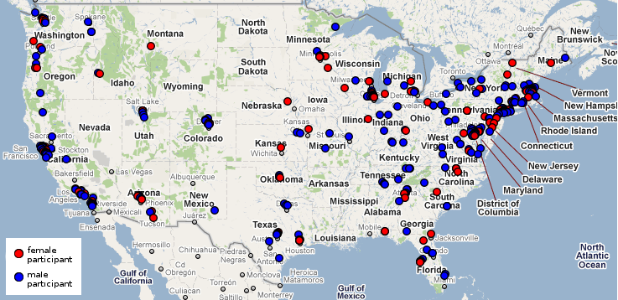
All volunteers will be enrolled under an open consent process pioneered by Harvard’s Personal Genome Project, which our Institutional Review Board (IRB) has approved for the enrollment of up to 100,000 individuals (Lunshof et al., 2008). Our automatic enrollment system currently has over 1,000 health records uploaded by consented PGP volunteers from a diverse population of individuals, illustrating broad interest in participation (Figure). Collection of outcomes data at regular three monthly intervals is also facilitated by our participants’ consent for recontact and automated infrastructure.
Enrolled participants will have whole genome sequencing performed and medical data imported with funding support from private donors. Detailed phenotypes and genomes are, by definition, identifiers but names and photographs are not released unless initiated by the participant. Additional medical tests and/or research studies relevant to the target cohort will also be performed to create a standardized dataset that integrates genome and phenotype data. In addition, each participant will have cell lines established and made available through the Coriell Institute. Such cell lines can be used for functional studies validating hypotheses of variant pathogenicity or epigenetic effect,
Our 2012 funding projections--based on existing private donations--will permit our project to obtain whole genome sequences from hundreds of enrolled participants. We will select a few of these individuals for more in-depth measurement with technologies contemplated in this proposal. Our aim is to utilize this existing resource to integrate and enhance numerous new whole genome sequencing, other omics profiling technologies and other measurements of scientific and clinical interest on a small number of these individuals (see budget justifications).
Our initial pilot sequencing project, has provided valuable information regarding the process of national enrollment of participants, sample-collection and data interpretation. We can now draw on this resource to integrate numerous Omics technologies -- initially via time-series analysis of individual participants, subsequently on analysis of (healthy and diseased) surgical samples from representative body sites, and finally by developing a molecular “body-map” of a deceased participant.
In addition, our experience is that clinical analysis of whole genome sequencing currently results in a high rate of incidental findings (Kohane et al., 2006). Openly consented individuals are critical to this work as they allow us to recontact individuals and perform additional measurements to follow-up on such findings. This motivates the need for a broad array of measurements focused on detecting causal variations in participants.

Cheaper, Higher Quality, More Integrated Omics Profiling of Arbitrary Tissues
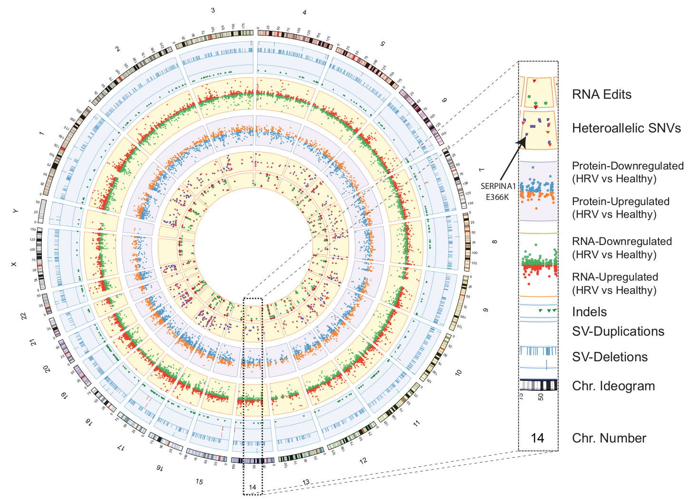
We have made considerable progress developing integrated “Omics Profiling” applicable to many tissues (Figure ). We will continue to simultaneously lower the cost and improve quality per unit of variation measured by these technologies. These measurements will be applied to both readily accessible minimally invasive participant samples (i.e. blood and saliva) as well as surgical samples and, by year 5, samples from autopsy. Where possible samples from the same tissue of origin will be analyzed in a time-series so variation can be measured both tissue to tissue and over time.

In Figure , we survey variation in genomic data (SNVs, Indels, Structural Variants - Duplications & Deletions) as well as transcriptomic and proteomic data (before and after rhinovirus exposure).

Sequencing technologies
Current low-cost sequencing technologies, which have short read lengths, are inherently limited and unable to report on some types of genetic variation important in genetic diagnosis. This includes trinucleotide repeats (important in diagnosis of Huntington’s disease and Fragile X syndrome), extensive insertions and deletions, copy number variations (CNVs), chromosome rearrangements, and haplotype information. We plan to address this issue through two different methods: technological improvements extending read-lengths to kilobases or even megabases as well as bioinformatic and/or sample preparation improvements combined with shorter read-lengths.
There are several different cutting edge sequencing technologies which promise to provide greatly increased read lengths – these technological improvements would address almost all current issues with unreported variation in current technology. We plan to continue working with these sequencing companies, including: Halcyon Molecular (which uses electron microscope imaging of DNA molecules), NABSys (nanopore sequencing), Pacific Biosystems (real time single molecule sequencing) and Oxford Nanopore (nanopore sequencing); see letters of support: FOO, BAR, XYZ, ABC respectively.
Alternatively, it is possible to address many of the problems with short-reads with improved bioinformatics and better sample preparation. To that end, we are continuing our collaboration with Complete Genomics on their “Long Fragment Read” technology. For only $100 in additional sample-preparation and informatics costs, this improves sequencing accuracy by more than an order of magnitude to 1 x 10⁻⁷ while simultaneously phasing the whole genome (see letter of support Rade Drmanac).

Epigenomics
Gene activity is correlated with CpG methylation in DNA – this epigenetic phenomenon may be associated with multigenerational effects and effects of environment on gene expression and phenotype. Our lab has applied MIP targeting technology to sequence bisulfite-treated DNA and profile cytosine methylation [Ball et al., 2009]. To translate this technology into a targeted method for high-throughput, cost-effective epigenetic profiling we plan to design MIPs that target sites which research groups have implicated as being variable and/or indicative of gene expression differences.
We believe such a targeted approach will greatly enable epigenetic profiling across large populations by reducing the amount of cost needed per sample or individual analyzed. Profiling DNA methylation with bisulfite DNA sequencing has several advantages over microarray approaches: it provides a clearly quantitative signal, and it potentially detects non-CpG cytosine methylation, and it takes advantage lowering costs in next generation sequencing (which is emerging as a convergent platform for different techniques).
Alternatively, new sequencing technologies may permit measurement of epigenetic modifications simultaneously with DNA readout if modified bases are distinguishable from unmodified bases.

Transcriptomics
Allele-specific expression represents an important source of causal variation leading to numerous physiological effects. We have been developing technologies for complete, phased genomes that when combined with RNA-sequencing data can measure allele specific expression with extremely high accuracy. It might not seem obvious but for a number of reasons reconstruction of a diploid personal genome sequence and using it instead of the reference genome is a critical step preceding allele-specific analysis. First, using reference genome introduces biases in read mapping—reads originated from non-reference allele are more susceptible to mismapping since, when aligned to the reference allele, they contain at least one mismatch (in case of SNPs) or gap (in case of indels)—the reference bias effect, that is, both alleles are not treated equally by default. Second, expression or binding in regions of genome SV could be misinterpreted as allele specific expression (ASE) or binding (ASB). For example, duplication of an allele in the studied genome will double binding signal for the allele while signal for the allele on another haplotype will be unchanged. Furthermore, SNP calling in the regions of SV is likely to be less precise and contain more false positives compared with non-SV regions (1). Thus, for each sample we profile we will construct a personal diploid genome either directly or by utilizing its genomic variations determined from sequencing and array experiments.
To accomplish this, we will use vcf2diploid tool, which we previously used for analysis of ASE and ASB (2). The tool uses as input VCF files with all the SNPs, indels, and SVs available for an individual of interest and outputs fasta sequences for each allele for each chromosome, along with equivalence map files that map nucleotide positions between paternal, maternal, and reference haplotypes. The map file allows for mapping annotation (i.e., genes) from the reference genome to the personal genome sequences, as well as finding equivalent nucleotide positions between produced haplotypes. After maternal- and paternal-derived haploid sequences are constructed, sequenced reads are aligned against the maternal and paternal sequences separately. Locations of mapping are determined by selecting the best alignment to both genome sequences. In very rare case of equally well mapping to each haplotype but at different (not equivalent) positions, the mapping location is chosen randomly.
Read counts for the maternal and paternal alleles are then generated at each heterozygous SNP nucleotide positions, and ASE/ASB events are reported by applying a binomial test followed by correction for multiple hypothesis testing. We correct for multiple hypothesis testing by estimating the false-discovery rate
(FDR) by explicit simulation of the number of false positives given an even null background (i.e., no allele-specific events). We also align reads to the maternal and paternal splice-junction libraries and determine splice-junction ASE SNPs in a similar way.

Proteomics
Proteins will be analyzed using liquid chromatography and mass spectrometry after peptide framgentation (LC-MS/MS).. Briefly, proteins lysates are prepared, digested with trypsin and peptides separated using a reverse phase HPLC direclty coupled to a Velos OrbiTrap mass spectrometer. Peaks are further fragmented and subjected to another round of mass spectrometry (MS/MS) and high condence peaks identified using XXX. When samples are analyzed in triplcate ~7000 proteins can be identified at high confidence (two peptide match 1% FDR).
To quantify protein levels, two strategies can be employed. First, to obtain relative levels, a large reference sample can be prepared from the sample tissue and the labeling of both the reference sample and sample of interest using isobaric tag (TMT from ThermoFinnegan) can be used to identify experimental/realtive levels for each peak. Second, absolute protein levels can be quantified using isotoically labeled “detectable” peptide for each protein which are run in parallel. Several groups (notably Aebersold/Agilent) are working to generate such peptides for all human proteins. It is likely that such peptide libraries will become univerally available for all humna proteins durign the course of this study.

Metabolomics
Metabolites will be analyzed using an Agilent Q-TOF 6538. Metabolites can be extrated from serum or relvant tissues using a 4 four volume of equal mixture of methanol, acetonitrile and acetone. Proteins are precipipated at -20°C and the extracted metabolites separated using Agilent 1260 liquid chromatography that is directly coupled in-line with an Agilent 6538 accurate mass Q-TOF MS with electrospray ionization (ESI) operated at positive and negative mode. To assure the mass accuracy of the recorded ions, continuous internal calibration ions will be infused. Each sample is run in triplicate at MS mode first at both positive and negative modes. Metabolites of interest are further subjected to MS/MS. Over 5,000 diverse metaoblites can be sepearated from serum using this procedure. Additonal solvent fractionation conditions can be explored to further maximize the number of metabolite peaks that can be detected. Moreover, we will attempt fractionations using sizing columns and solid phase extraction conditions to selective extract compouns from compelx mixtures.
A significant challenge in metabolomics is the identification of the metabolite peaks. Presently approximately 1000 peaks (20%) can be tentatively assigned a chemical composition or compound name based on retention time and molecular mass using MassHunter Workstation software (Agilent Technologies); the majority can not be assigned. Analysis of purified reference metabolites can allow the identification of additional metabolites and we will attempt to prepare mixtures of purified metabolites and separate them under similar conditions to further identify the metabolites that can be anlayzed. Our goal will be to increase the number of metabolites that can be monitored to >2000 peaks representing >1000 distinct compounds. The use of isotopically labeled reference compounds will allow quantification of metabolite levels.

Anonymization of Integrated sub-sets of Personal Omics data
New data reduction file formats will allow us to store data from NGS experiments so as to protect individual privacy, while allowing a broad range of data analysis. Variant Call Format (VCF), initially proposed by the 1000 Genomes Project (Danacek et al.), is now widely used for efficiently storing variant calls, including single nucleotide polymorphisms (SNPs), short deletions and insertions (indels), and structural variations (SVs), from NGS datasets. However, conventional VCF provides little protection to personal genomic privacy; an individual in the set can be uniquely identified based on only a few dozen independent variants. Instead, we aim to develop a software tool to encrypt VCF files with a key that is known only to the researcher, while still allowing for a wide variety of calculations -- that, for instance, can be used to test pipelines and do demographic analyses. The encrypted file would still appear to be typical human genome from a particular population, albeit de-personalized, and action of the key would uniquely restore the original non-anonymizable information. In addition, given the current migration trend of large-scale data sets to the cloud, we will develop a software workflow to optimize our VCF encryption for cloud computing. The workflow would also enable researchers to retrieve the output from their analyses and map it back to the correct personal genome safely in a local environment. This would add further security for NGS data analyses in the context of cloud computing.
Different experiments may require retention of different genomic features, depending on the nature of downstream analyses of the variant calls. To this end, multiple anonymization options will be provided. One possibility in development is to blur the variations within a dataset, as with non-military global positioning system devices, building ‘synthetic’ personal genomes from a pool of individual genomes in a group. Specifically, we would permute the variants or variant blocks between individual genomes, such that the representative variations of the entire group are readily seen, but not those of any particular individual. While the exact manipulation of the eVCF file would be reversible and uniquely determined by the encryption key, persons without the key would never have adequate information to recover the data, and genomic privacy would remain protected.
Further, we aim to develop a Mapped Read Format (MRF) that can protect the sequences data—as well as reduce the file size, while retaining the ability to perform data analyses. The format is being developed within RSEQtools - a modular framework to analyze RNA-Seq data using compact and anonymized data summaries. Much of the relevant information in gene expression data resides in the localization of the reads rather than the sequence. Our MRF decouples the genomic coordinates of reads from the actual sequences (see Figure). By using only the genomic coordinates, researchers and clinicians can determine which genes are expressed, quantify the expression of genes, exons, isoforms, identify novel regions of active transcription, and detect chimeric transcripts. Anonymized and small MRF files could potentially enable centralized repositories to make these files available to the research community, similar to what exists for gene expression microarray data. The clear separation of “private” information (sequences) from “public” information (alignment location) information would allow better control of functional genomic data to ensure that privacy requirements of individuals are met.

Expression Quantitative Trait Loci (eQTL) has been used to uncover the genetic variations underlying expression variations in both human and model organisms (Schadt et al., 2003, Yvert et al., 2003, Stranger et al., 2007). Some eQTL approaches have even been used to identify causal genetic variations of diseases (Schadt et al., 2005, Chen et al, 2008).
When performing eQTL analysis, linear regression models (with possible l1 and l2 regularization constraints) are among the most popular approaches due to their simplicity and interpretability (Stranger et al., 2007, Lee et al., 2009). However, due to linkage disequilibrium and population structures, identifying causal genetic variations underlying complicated high-level phenotypes remains a challenging task, especially in humans, which poses great challenges for the clinical applications of personal genomics. Previous researchers often performed simple case controls or simple population corrections and tended to ignore detailed population structures and genetic structures (Stranger et al., Nature Genetics, 2007). We plan to develop more advanced regression models by incorporating prior biological expert domain knowledge to tackle these problems.
With the availability of more and more clinical record data, we can easily apply similar eQTL or eQTL-like approaches to integrate gene expression data, genetic variation data, and clinical record data together. Thereby, we can identify disease-related genes and genetic variations, predict risks and outcomes of medical treatments, and predict the most effective treatment based on patients’ expression data and personal genetic variation data.

Other measurements of scientific or clinical interest
To build integrated data associated with an individual that explores the interaction of Genomes, Environments and Traits, we will accept participant data of scientific or clinical interest and associate this data with the participant profile in a downloadable and searchable manner.
We will also select important, high-throughput methods of profiling biological features for more comprehensive technology development and improvement. In Year 1 we will focus on high-throughput technologiesfor microbiome profiling (as an individual’s bacterial flora reflects diet and drug exposures) and antibody profiling (as these reflect an individual’s viral and bacterial exposures).
Other measurement technologies will be prioritized for enhancement based on consistency with the central theme of lowering cost per new unit of information, increasing accuracy and improving scalability.

Microbiome profiling
Our microbiome profiling builds upon our experience with metagenomic studies [Dantas et al., 2008, Sommer et al., 2009]. The gut microbiome is implicated in playing a role in obesity, crohn’s disease, and irritable bowel syndrome. An individual’s environment in the form of diet and antibiotic drugs also interacts with their microbiome. To study how genetic and environmental factors interact to affect microbial diversity in human guts, we plan to recruit subjects who volunteer to collect the required samples, as well as record dietary and drug information.
Our ongoing microbiome research has been extending our work molecular inversion probe (MIP) capture technology [Porreca et al., 2007, Li et al., 2009, Ball et al., 2009] to develop a low cost methods of capturing specific subsets of microbial genes from complex microbiomes. To broadly capture phylogenetic biomarker information we will design MIPs specific for the 16S ribosomal DNA (rDNA). Microbiome characterization will include the capture of clinically relevant biomarkers such as pathogenicity islands, mobilization elements and antibiotic resistance genes. Barcode DNA sequences on the probes will allow sample parallelization, allowing us to realize very low cost for microbiome profiling ($200 per sample).
As part of this work we plan to extend apply this technology to PGP participants to create data which integrates microbiome data, medical history, and genotype information. Low cost microbiome technology will allow us to collect extensive longitudinal data for each individual and across many individuals. To expand the group of potential volunteers with genome and genotype data associated with microbiomes, we plan to recruit volunteers who have donated to the PGP their privately collected genotype data obtained from direct to consumer (DTC) genetic testing.

Immune system profiling
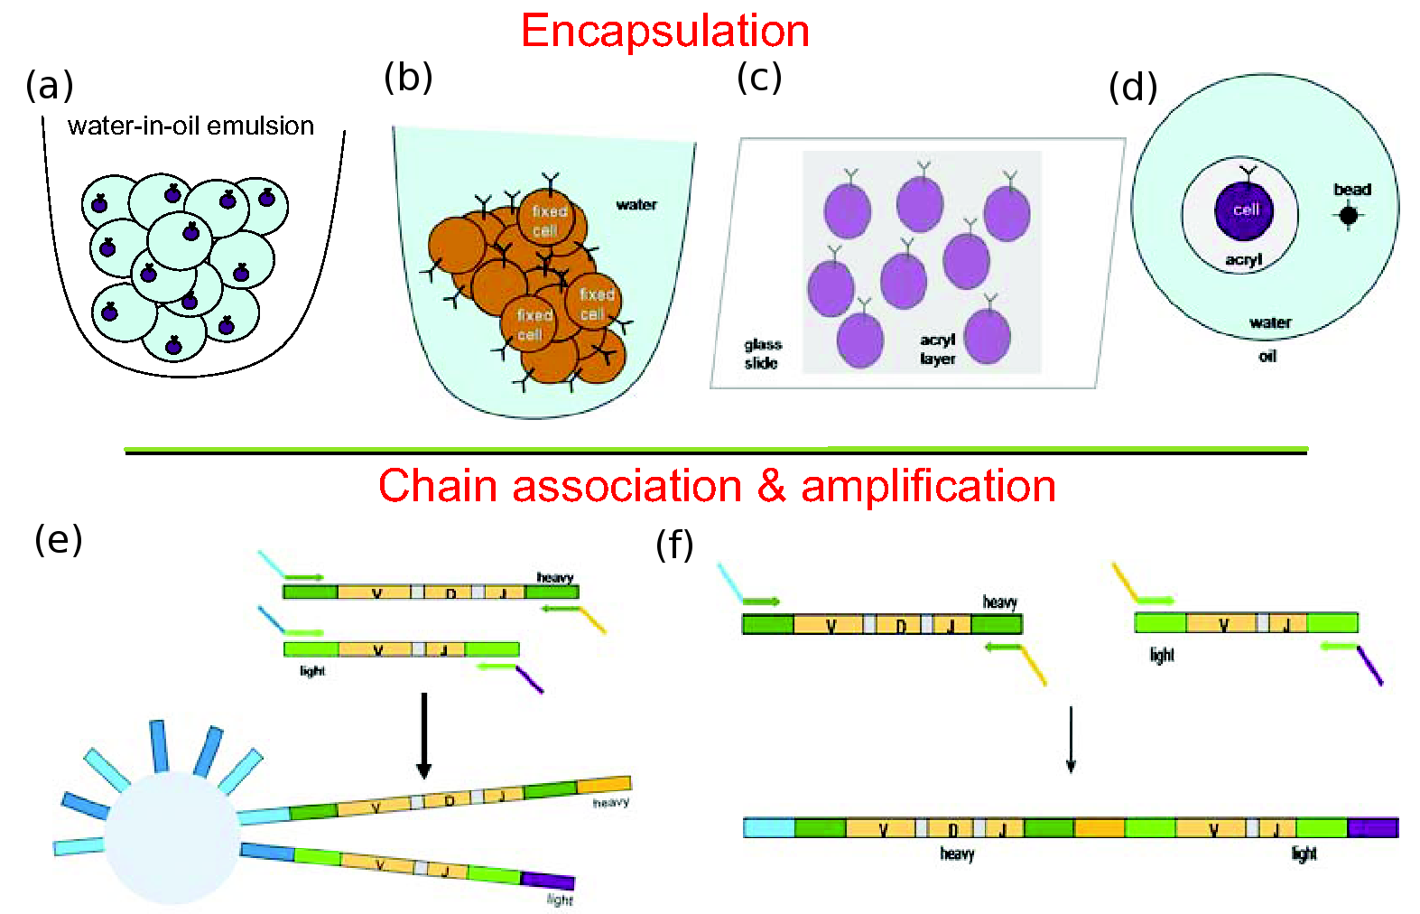
An individual’s history of viral and bacterial exposures is recorded in the antibodies present in their immune system. Our group is interested in developing biotechnology for surveying an individual’s antibody repertoire. Understanding a cell’s antibody structure requires isolating and sequencing both heavy and light chain components, which consist of separate transcripts on different chromosomes. To that end, we are exploring different methods for isolating polyacrylamideencapsulated lymphocytes combined with multiplex PCR to produce libraries linking heavy and light chain sequences from individual cells.
Single cell isolation may be achieved through one of four methods, described in Figure : (a) Adapting emulsion PCR protocols currently in use for polony bead PCR in the Church Lab to include cells so that a large number of compartments are formed that contain single cells, (b) performing PCR in fixed, solublized cells, (c) performing a variant of gel polony PCR developed in the Church Lab in which PCR products amplified from cells sparsely dispersed in the gel remain localized in the gel and do not mix, and (d) in collaboration with the Weitz Lab at Harvard University, we are developing a microfluidic device for high-fidelity emulsion formation in which single cells and polony microbeads can be placed together in emulsion compartment. Second, the PCR must be performed in a way that physically co-localizes the products of the heavy chain VDJ and light chain VJ segments of the individual cells. Figure (bottom) illustrates two possible methods: (e) Use distinct primer extensions for the two PCR reactions along with polony beads bearing sequences complementary to these extensions, so that the same beads may be sequenced in turn for the VDJ and VJ segments starting from different sequencing primers. (f) Use overlap extension PCR to generate a single product in which VJ and VDJ sequences are concatenated.
In addition to profiling at the RNA level, we will determine the autoantibody profile. Serum from each individual will be used to profile an array of ~9,000 unique proteins from Invitrogen. Reactive antigens will be scored using ProCat; we expect 30-60 antigens they exhibit >3 standards deviations over background for each antigens that is spotted in duplicate on the array. We will correlate the antigen activity with that of the VDJ sequences and other omics as described below.

Another type of measurement goes here
A.B.C.

Open software platform for Genome-Environment-Trait (GET) Evidence Integration

Variant prioritization in whole genomes
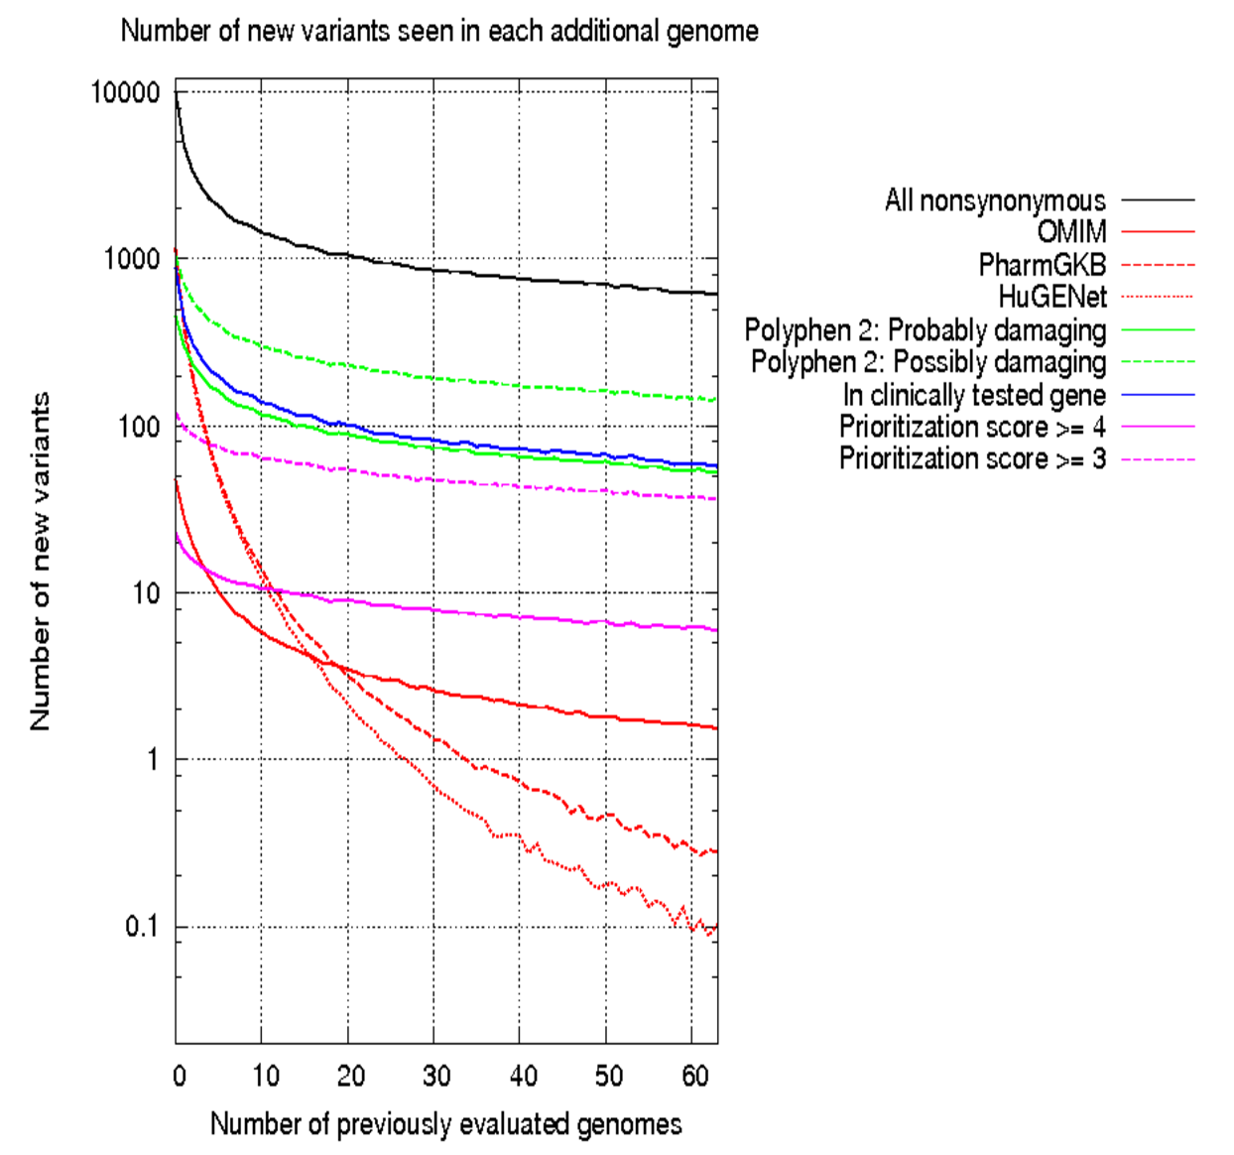
Whole genome analysis is currently hampered by a lack of genome-scale methods for prioritizing clinical review of genetic variants and by shortcomings in current genetic variant databases. These issues have become clear in our own work with genome review [Ashley et al., 2010, Kim et al., 2009, Drmanac et al., 2010, Dewey et al, 2011]. Our “Trait-o-matic” tool [Drmanac et al., 2010, Kim et al., 2009] combines data from several genome wide databases to give lists of all variants found within them, including: Online Mendelian Inheritance in Man (OMIM), the Pharmacogenomics Knowledge Base (PharmGKB), and the Human Genome Epidemiology Network (HuGENet). Integration of disease-specific databases is an important first step in establishing a central tool for genome interpretation. The MutaDATABASE project, led by Patrick Willem and Heidi Rehm, is bringing together experts from these groups and offers their support (see letter from Patrick Willems and Heidi Rehm). In addition, pharmacogenomics is an important area that has the potential to be widely applicable as drug metabolism variants are often common variants in the population. We look forward to working together with PharmGKB to explore how such variants apply to PGP participants (see letter from Russ Altman).
We find that comparing against these genome-wide variant databases produces a large number of variants needing literature review, and none of the databases provide a method for prioritizing which variants have well established, severely pathogenic effects. Interpretation of a whole genome thus involves a large amount of labor, and this work is often redundant as many variants will be seen again in other genomes. The number of new variants in each additional genome declines dramatically – we find that the number of new variants in an additional genome drops 10-fold after ~20 genomes have been reviewed (Figure). We believe this redundancy is best addressed with a shared system where genome reviewers may record analyses of relevant literature and form a consensus interpretation of genetic variants.
Our GET-Evidence system, attempts to address these issues and we plan extensive improvements in the course of this research. It will serve as a unifying resource to bring currently fragmented information present on disease-specific databases. In keeping with the public nature of PGP participant data, the associated software for analysis and user contributions will be released under free software and creative commons licenses (see Resource Sharing Plan).

Facilitate “machine readable” literature review
“Peer production” is a model that coordinates many contributors to improve small aspects of a large project – examples include Linux and Wikipedia. A peer production model for interpreting genetic variants would enable users to correct mistakes, update pages in response to new publications, and form a community within which consensus may be formed regarding variant interpretation. These models are also ideal for synthesizing a consensus understanding of material – the growing number of private companies interpreting genome and genotype data clearly demonstrates the need for such a public forum for discussing genetic variant interpretations.
This project aims to facilitate the literature review to produce evidence that allowing for the sorting and reporting of variants. To do this we strongly believe that standardized recording and interpretation of evidence is necessary to distinguish potential false positive incidental findings from well-established strongly pathogenic variants. Whole genome sequencing has the potential to reveal many false positives as variants implicated as potentially pathogenic by published literature turn out to be apparantly spurious and are found in healthy individuals. Our work with the “validation” subset of all cohorts (20% of each) will be used to help us establish evidence guidelines: these individuals contain variants with weak evidence supporting pathogenic effect. Understanding which, if any, of these are “false positives” (e.g. carrying a second explanatory variant) will guide the establishment of evidence requirements. Establishing such evidence guidelines is critical to addressing the issue of incidental findings that occur when translating rare variant data from literature, private data, and disease-specific databases into whole genome analysis.
Currently GET-Evidence requires users to interpret literature according to a scoring system along several evidence and clinical categories – we plan to use annotation tools and natural language processing to
facilitate literature interpretation and partially automate this process. Variants will be associated with disease nomeclatures and a standardized nomenclature / format for supporting evidence (including pedigree data, case/control data, in vitro and in vivo findings). This more detailed recording of literature evidence will create data appropriate for machine learning algorithms – these will then be used for automatic scoring systems assesing evidence and clinical importance. Associating information with variants in a way that allows sorting and prioritization is critically needed for whole genome interpretations.

Enable discovery of new causal variations
In the absence of existing reviews within the system, the multitude of potentially interesting variants in a whole genome needs to be prioritized to enable interpretation. There are two different goals in doing this: (1) prioritize variants reported on in published literature and/or present in other databases and (2) prioritize variants which computational methods predict as likely to have a pathogenic effect. The first goal should become less important as the system becomes populated with existing reviews, while the second goal will become more important for interpretation of unpublished variants.
Our work with the “discovery” subset of all cohorts (80%) will be used to motivate the development of tools for discovering new causal variants. We plan to pursue integrating of current computational predictions (e.g. Polyphen 2) with other evidence important to assessing whether a variant is likely to have a significant pathogenic effect, including: allele frequency, evolutionary conservation, prediction of amino acid disruption (BLOSUM score), and presence in a gene known for which other mutations are known to have pathogenic effects (indicated by presence in the GeneTests database of genes for which clinical testing is available). Gene-specific and disease-specific annotation systems will also be introduced as data from these are important in the interpretation of novel variants. We expect computational predictions will be improved using our resource-enriched variant, gene, and disease data and are currently collaborating with the Sunyaev lab and Polyphen 2 authors to anticipate the types of data that will be useful to them.
Data from close relatives will also be collected as it is invaluable for narrowing the number of potential hypotheses when diagnosing a novel causal variant. In our work with these cohorts we will be integrating such tools for analysis into our genome analysis system, which will be shared with the community through open source licenses and our shared hardware resource (below).

Automated prioritization of new measurements
Functional information supporting the impact of genetic variants is critical to genetic interpretation, and genetic linkage often means that it is difficult to tell which genetic variant is causal when a particular genomic region is implicated in an association study. This is particularly difficult for noncoding variants, which do not directly impact protein structure but may have a functional effect through modification of transcription factor binding sites, thereby affecting gene expression. Current technology has been limited in its ability to test these variants.
As a member of the Centers for Excellence in Genomic Science, our Harvard group has been pioneering technologies to enable study of these variants in a high throughput manner. In the course of this work we will be establishing the cell lines that can be used for this research (see section) – these cell lines can be used to test functionality in a variety of cell types through induced pluripotency and differentiation. We plan to pilot our technology by investigating noncoding variants from PGP participants.
In brief, our currently-funded ongoing technology development has been attacking this problem from multiple angles to develop a high-throughput system. We are using allele-specific expression profiling to associate individual haplotypes with expression differences [Lee et al., 2009]. Working with engineered DNA-targeting nucleases (zinc finger nucleases, TALNs) and multiplex oligonucleotide-based targeted genome alteration [Wang et al., 2009] we are developing methods to introduce designed changes in a high throughput manner. Finally, pioneering work with high throughput single cell sequencing promises high throughput association of single-cell transcriptional differences with various introduced DNA changes in a diverse population of modified cells.
In the course of this research project we will be producing publicly shared cell lines (through the Coriell Institute) that may be used for this research. We plan to extend and apply our technology development to characterize clinically interesting non-coding variants in our PGP participants.

Integration of multiple variants, medical history, and phenotypes for analysis in all individuals
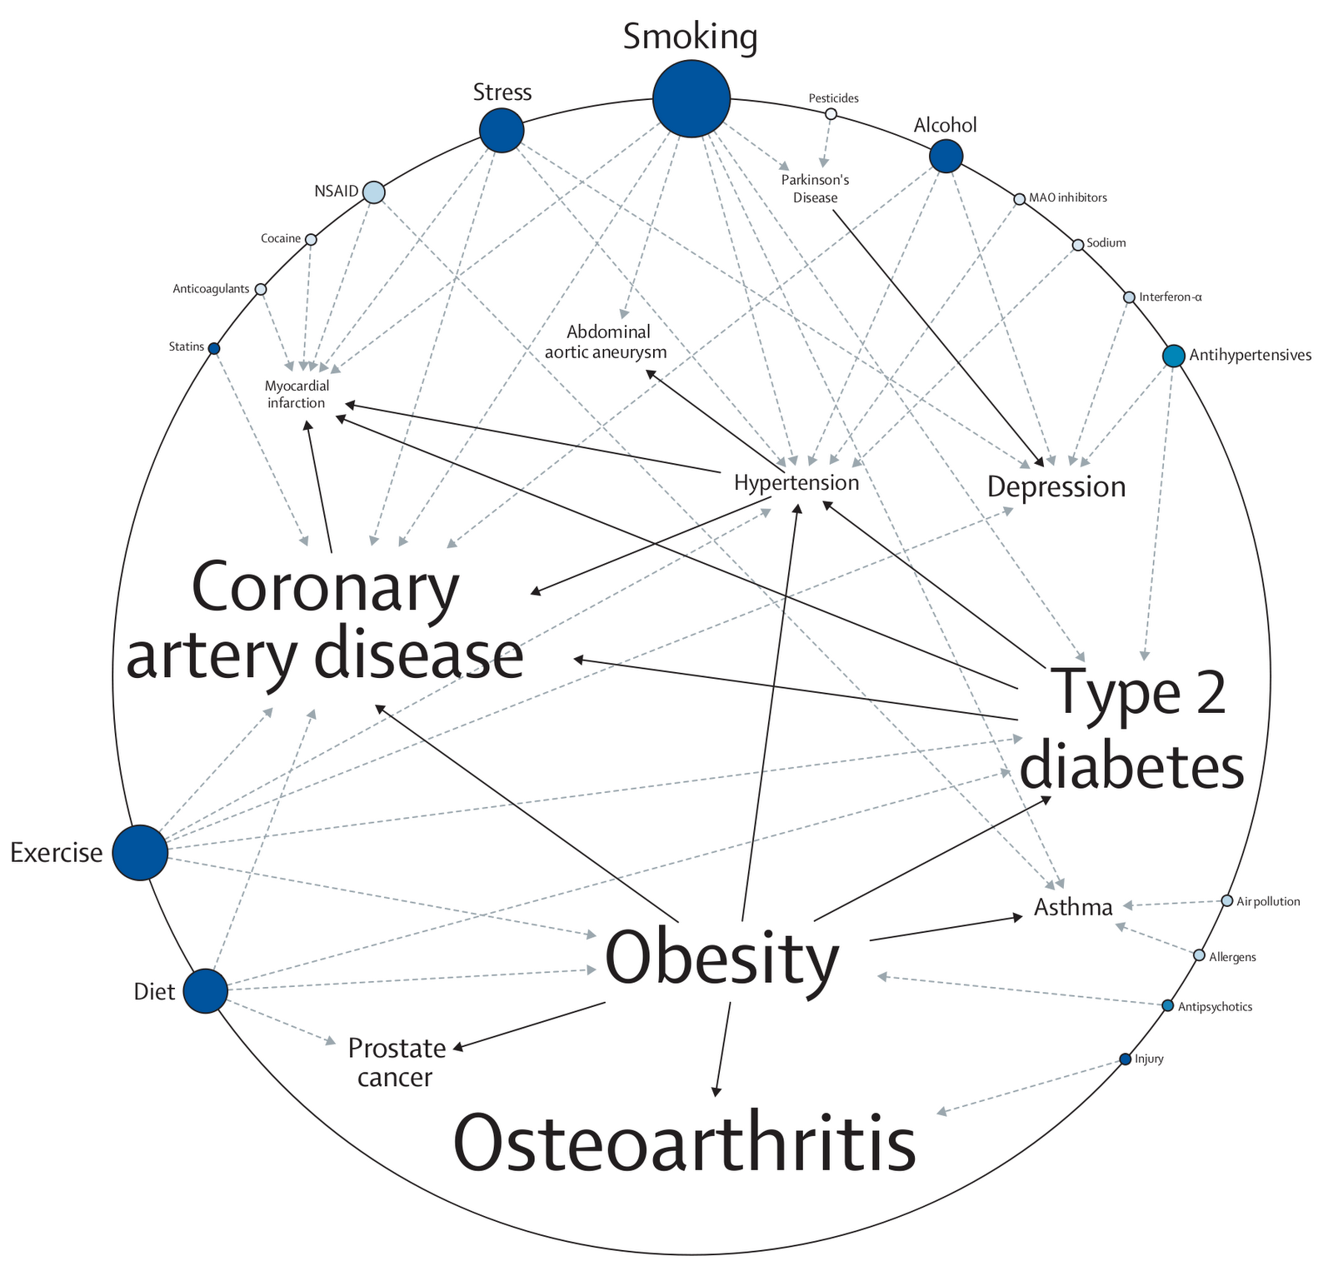
The cost of whole genome sequencing continues to drop and, especially in light of the growing movement for direct-to-consumer genetic testing, we anticipate that clinicians will soon be presented with the need to interpret genomes regardless of their utility as a medical diagnostic. Patients will present with genome data and expect clinical responses. A resource facilitating genome interpretation in the context of individuals with no known genetic issues will be critically needed by the medical community.
Unaffected relatives from all cohorts (which are sequenced to assist the discovery process) will represent the application of genomes in the context of all individuals. We plan to extend our existing work with integrating risk ratio data from multiple genetic variants [Ashley et al., 2010], along with integrating medical history and phenotype data, to develop standardized methods and tools for interpreting these genomes (Figure). These resources will be a critically needed check upon private/commercial methods for genome and genotype interpretation.

Open shared hardware resource for community analysis
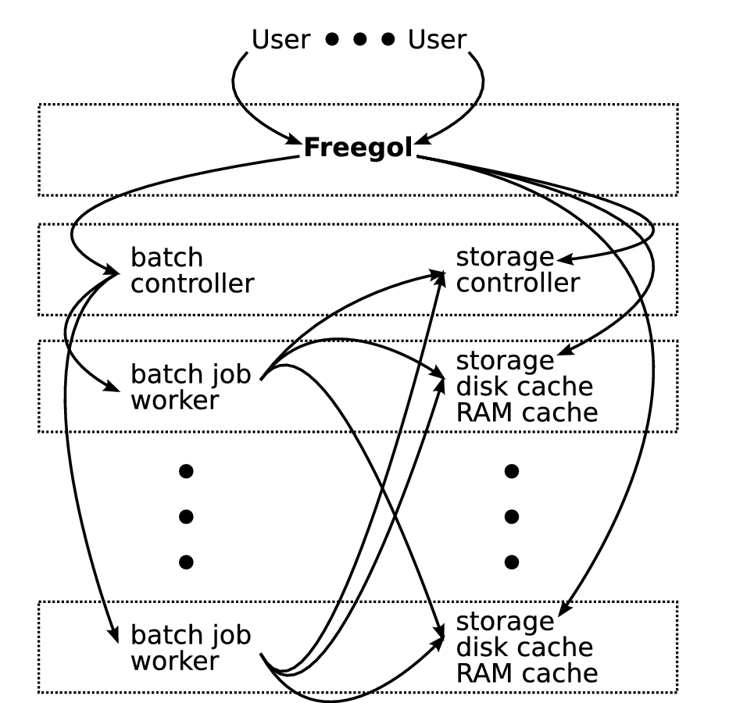
We anticipate a high volume of data will be produced by this project and we are committed to creating infrastructure which allows this data to be shared freely. Our “compute and storage clouds” provide hosting, data storage, and batch processing services for a number of web applications [Zaranek et al., 2008, 2010]. These applications involve data-intensive computation: they are conducive to asynchronous parallel processing, but their performance is limited by the available disk I/O bandwidth. Their demands for CPU time are highly variable, so it is sensible for them to share a pool of CPU resources by submitting batch jobs. They also tend to share data sets with one another, so it is sensible to share a large data storage system. The application developers have common goals rather than being in competition, so it is beneficial to let them see the source code and results of one another’s batch processing jobs. The applications themselves may be maintained by different development teams, so each should run in its own independent virtual machine.
We identify the following roles in our cloud environment (See Figure for example user interaction). “Users” – scientists, physicians, and members of the general public – are interested in a web service and interact with it via a web browser. “Administrators” maintain the “free factory” (which we, typically, consider to include data-acquisition instruments) or “cloud” infrastructure (which we, typically, consider to only include computers but which we design as part of a larger “factory” system). A “Trustee” sets policy and obtains funds to pay for staff, hardware, and hosting. “Developers” are the application developers and scientists who maintain Freegols. “Freegols” are web services that utilize cluster computing and storage resources. The term Freegol, or Free Golem, emphasizes the idea that the web services are developed and maintained independently
of the cluster infrastructure, and independently of one another.

{The above is still pretty random}

