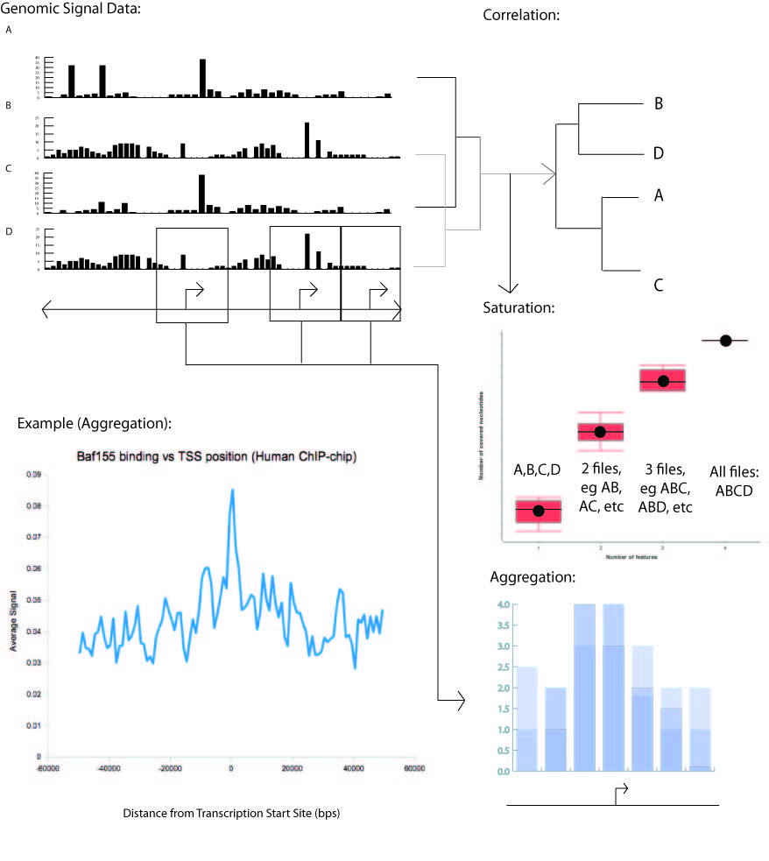
Fig. #. Uses of ACT using signal tracks from various sources. (Aggregation) Signal around all TSS's is aggregated to give an average signal profile, for example of Baf155 binding around TSS's (Encode Project). (Correlation) Multiple signal tracks are correlated to show which tracks are more or less related to each other. (Saturation) Each additional signal track increases the number of basepairs covered. When the addition of signal tracks is considered in all possible combinations, the average increase in coverage, with error bars, can be visualized by a Saturation plot.

